MOBILE PLATFORM FOR SOURSOP LEAVES (ANNONA MURICATA) PLANT DISEASES DETECTION

ABSTRACT
This study presents the development of a mobile-based intelligent system for the detection and classification of soursop (Annona muricata Linn) leaf diseases using deep learning. Recognizing the limitations of traditional visual inspection methods used by smallholder farmers, the project integrates a convolutional neural network (CNN) model with a mobile application capable of operating fully offline. The CNN, based on MobileNetV2 architecture, was trained using the publicly available SoursopBD dataset containing 3,838 annotated images across six categories: Cutting Caterpillar, Cutting Weevil, Die Back, White Fly, Yellowing, and Healthy. Data augmentation techniques were applied to enhance robustness against real-world imaging conditions. The optimized model, quantized to TensorFlow Lite (TFLite) float16 format, achieved a test accuracy of 97.74% with macro-averaged precision, recall, and F1-scores of 0.98. When deployed on Android devices, the app-maintained inference times averaging 0.68 seconds per image and remained stable during extended testing, confirming suitability for low- to mid-range mobile hardware. Usability evaluation involving 21 participants utilized the UTAUT2 framework, yielding high mean scores for Behavioral Intention (4.79), Performance Expectancy (4.76), and Price Value (4.74). Slightly lower but still positive scores were observed in Trust in Diagnosis (4.63) and Facilitating Conditions (4.55), indicating opportunities for feature refinement and user support. The study concludes that the developed system is technically robust, operationally efficient, and socially acceptable for real-world agricultural deployment. It demonstrates the feasibility of using AI-powered, mobile-first tools to enhance plant disease management in resource-constrained environments.
Keywords: Soursop (Annona muricata Linn); plant disease detection; convolutional neural network (CNN); MobileNetV2; deep learning; smart farming; mobile-based diagnosis; agricultural technology

INTRODUCTION

1.1 Background of the Study
Soursop (Annona muricata Linn) is a tropical fruit valued for its nutritional characteristics, medicinal properties, and economic potential. It is a rich source of essential nutrients such as carbohydrates and minerals, and it contains bioactive compounds believed to possess therapeutic and health-promoting effects (Agu & Okolie, 2017). Previous studies have revealed that soursop exhibits both healing and toxic characteristics, thereby supporting its classification as a functional food (Coria-Téllez et al., 2018). Beyond its medicinal and nutritional importance, recent research underscores its emerging industrial value, particularly in waste reuse and product development, creating new opportunities for commercial expansion (Santos et al., 2023).
The Philippines, with its tropical climate, provides ideal conditions for cultivating soursop. In 2018, national production was recorded at approximately 7,807 metric tons (DOST-PCAARRD, 2022). Despite its potential, soursop remains underutilized and contributes minimally to the country’s agricultural economy. While global demand for soursop and its processed products continues to rise, local production still faces challenges, primarily due to the prevalence of plant diseases that reduce yield and fruit quality. Currently, disease detection on farms relies heavily on manual visual inspection process dependent on farmers’ experience and affected by environmental factors such as lighting and humidity. This traditional approach is time-consuming, error-prone, and often results in delayed intervention, ineffective treatment, and increased production costs (Barbedo, 2016). Furthermore, misdiagnosis can lead to the misuse of pesticides or unnecessary labor expenditures, creating additional financial strain on smallholder farmers (Drenth & Guest, 2016). Recent advancements in artificial intelligence (AI), particularly in image recognition through convolutional neural networks (CNNs), have greatly improved the accuracy and efficiency of plant disease detection. CNN-based models have demonstrated high performance in identifying diseases in crops such as tomatoes, bananas, and rice (Mustofa et al., 2024; Udutalapally et al., 2020). However, the integration of such AI-based technologies in smallholder farming remains limited due to the lack of consistent field records and the scarcity of labeled image datasets required for model training (Fairfood, 2020).
To address these challenges, this research focuses on developing an AI-driven mobile application tailored for smallholder farmers in the Philippines. Mobile technology is increasingly influential in agriculture, providing farmers with real-time access to data, crop monitoring tools, and market linkages. With the rising adoption of smartphones among Filipino farmers, creating an accessible and user-friendly machine learning-based tool for detecting soursop leaf diseases presents a practical and cost-effective strategy for improving disease management. Ultimately, this innovation seeks to empower farmers with accurate, timely, and data-driven decision-making capabilities.
1.2 Significance of the Study
This study represents an important contribution to both agriculture and artificial intelligence. It introduces a machine learning system designed specifically for identifying diseases in soursop leaves, addressing a critical gap in current plant disease management practices. By enabling accurate and efficient diagnosis, the study enhances disease control and supports smallholder farmers in optimizing their yield and productivity. The research demonstrates how AI-powered mobile tools can strengthen precision farming efforts, particularly in resource-constrained areas.
The localized focus of this study on Filipino soursop growers is its core strength, as it bridges advanced AI technologies with the practical realities of marginalized agricultural communities. By providing farmers with a decision-support tool for disease identification and management, this study contributes to improved livelihoods, food security, and agricultural sustainability.

1.3 Advancement in AI-Based Agricultural Technology
This study advances the integration of artificial intelligence in agriculture by demonstrating the role of machine learning and image analysis in crop disease detection and decision-making. While AI-based detection systems have been successfully implemented in crops such as rice, tomatoes, and bananas, their application in soursop farming remains limited due to the absence of adequate datasets and customized models.
The development of an AI-powered mobile application specifically for soursop leaf disease detection addresses this gap. Its user-centered design ensures accessibility and usability for small-scale farmers. Furthermore, this innovation has potential applications beyond soursop cultivation, paving the way for AI-based disease detection in other tropical crops and contributing to the growing trend of precision agriculture and digital transformation in farming.

METHODOLOGY

2.1 Research Design

This study adopted a structured Software Development Life Cycle (SDLC) methodology to design and develop an AI-based mobile intelligence system for detecting diseases in soursop leaves. The SDLC provided a systematic framework comprising planning, analysis, design, implementation, testing, and deployment phases. Development was conducted in two closely connected iterations, allowing progressive refinement to meet both machine learning and mobile usability requirements.
The first iteration emphasized model prototyping, which involved dataset preparation, CNN development, and model validation to establish a baseline for six-class leaf disease classification. The second iteration focused on integrating the trained model into a functional mobile application and preparing it for field deployment. Iterative feedback from usability testing guided enhancements to the interface, hyperparameter tuning, and overall system performance. This cyclic approach ensured both technical accuracy and practical adaptability, maintaining responsiveness to user needs throughout development.

2.2 Initial Planning
The planning phase established the foundation for the project’s development workflow, identifying the tool chain, data resources, and phased deliverables. The SoursopBD dataset (Mustofa et al., 2024) was adopted after confirming sufficient annotation quality and class representation for CNN training. Key tools included Python for model development, TensorFlow and Keras for deep learning, OpenCV for image preprocessing, and Flutter for mobile application development. The project deliverables were structured to ensure traceability between model training and mobile deployment, while evaluation metrics accuracy, precision, recall, and F1-score—were established to measure performance objectively.
This phase also defined the model optimization strategy and application scope. The mobile app was intended to function entirely offline, reflecting limited internet access in rural areas. Consequently, design priorities included computational efficiency, lightweight architecture, and real-time inference capability on mid-range Android devices.

2.3 First Iteration: Model Development and Baseline Construction

Figure 1: Iterative software development life cycle.
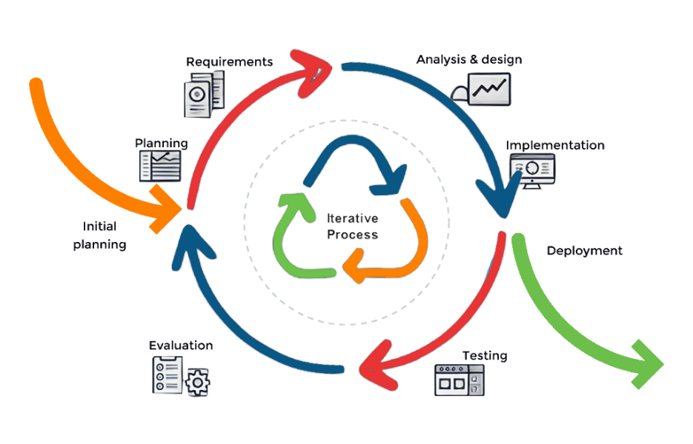

2.3.1 Planning

The first iteration’s planning focused on defining the prototype’s technical scope and aligning resources with project goals. The dataset was organized for six-class classification—Cutting Caterpillar, Cutting Weevil, Die Back, White Fly, Yellowing, and Healthy leaves. The model was to perform image-based diagnosis without external data dependencies. Given mobile deployment constraints, the MobileNetV2 architecture was chosen for its balance of accuracy and computational efficiency. Preliminary schedules were set for data preprocessing, augmentation, training, and evaluation.

2.3.2 Requirements

The system was guided by specific functional, non-functional, and technical requirements.
- Functional: The model classifies leaf images into six predefined categories and provides confidence scores.
- Non-functional: Offline operation, rapid inference (<1 second), and user-friendly design.
- Technical: Use of Python and TensorFlow with pretrained ImageNet weights for transfer learning. Image augmentation techniques (rotation, zoom, shearing, brightness adjustment) were implemented to improve robustness under field conditions.
After achieving the target accuracy, the trained model was exported to TensorFlow Lite (TFLite) using float16 quantization to minimize memory usage while maintaining classification precision, ensuring compatibility with Android devices.

Figure 2

Conceptual framework of the study
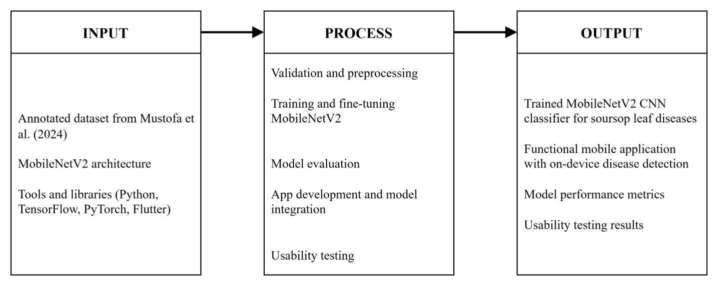
This study adopts an extended Input–Process–Output (IPO) framework to structure the development of an intelligent, mobile-based system for early soursop leaf disease detection. The framework maintains alignment with the study’s scope, objectives, and the sytem development methodology adapted.

2.4 Analysis and Design
This phase established the structural framework for both the machine learning pipeline and mobile application. Initially, a deep CNN with 11 convolutional layers was tested but proved too resource-intensive for mobile devices. To address this, the design transitioned to MobileNetV2, leveraging depthwise separable convolutions for efficiency. The adapted architecture incorporated a GlobalAveragePooling2D layer, followed by dense layers (1024, 512, 256 neurons) with dropout for regularization, and a softmax output layer for six-class classification.
The SoursopBD dataset contained 3,838 labeled images representing the six target conditions. It was analyzed for balance and quality, and augmentation was applied using TensorFlow’s ImageDataGenerator to simulate real-world variations in lighting, rotation, and background. These enhancements ensured that the final model-maintained generalization across diverse conditions likely encountered by farmers.

2.5 Implementation

The implementation phase focused on training and validating the optimized CNN model. Using Python, TensorFlow, and Keras on a GPU-enabled Jupyter Notebook environment, the MobileNetV2 architecture was initialized with pretrained ImageNet weights and fine-tuned for soursop leaf classification. The dataset was divided into 70% training, 15% validation, and 15% testing subsets. The Adam optimizer with categorical cross-entropy loss was applied, and early stopping prevented overfitting. Hyperparameters such as batch size and learning rate were tuned iteratively based on validation performance.
The resulting model achieved stable accuracy and generalization, confirming its readiness for mobile integration. The trained MobileNetV2 model was then converted to TensorFlow Lite format for on-device inference, forming the basis of the next iteration focused on application deployment.

2.6 Testing and Evaluation

Testing evaluated the model’s technical accuracy and generalization capability using unseen test data. Metrics included accuracy, precision, recall, and F1-score, computed per class. A confusion matrix visualized classification performance and identified frequent misclassifications among visually similar conditions (e.g., Die Back, White Fly, and Yellowing). To assess robustness, the model underwent five-fold cross-validation and was tested on additional images collected from Philippine soursop farms under varying lighting and background conditions.
Although the model demonstrated strong accuracy, it faced challenges distinguishing between diseases with similar symptoms due to reliance solely on visual data (Barbedo, 2016; Ibarra et al., 2023). These findings informed the second iteration, emphasizing usability testing, interface optimization, and field readiness for practical deployment.

2.7 Summary
The methodology integrated iterative SDLC principles and modern machine learning practices to ensure a reliable and user-centered disease detection system. By combining technical optimization with practical design considerations, the research achieved a balance between model performance and accessibility for smallholder farmers. The resulting mobile application offers an efficient, offline-capable diagnostic tool supporting sustainable and technology-driven agriculture.

3. RESULTS AND DISCUSSION

3.1 Overview of Results

The study followed two major development cycles: (1) model development and evaluation, and (2) mobile integration and deployment. Each iteration corresponded to the methodological phases of planning, requirements analysis, design, implementation, testing, and evaluation. The first cycle focused on developing an efficient convolutional neural network (CNN) for soursop leaf disease classification, while the second focused on embedding the model in a functional mobile application optimized for offline use.

3.2 Model Development and Training

The baseline model employed a custom CNN architecture trained on the SoursopBD dataset (Mustofa et al., 2024), comprising 3,838 labeled images representing six soursop leaf conditions. MobileNetV2 was later adopted due to its balance between efficiency and accuracy on mobile hardware. The final model incorporated a GlobalAveragePooling2D layer followed by three dense layers (1024, 512, and 256 units) with dropout regularization and a six-class softmax output.
Training was conducted using TensorFlow/Keras with GPU acceleration. Data augmentation techniques including rotation, shear, zoom, and brightness adjustments—enhanced robustness against real-world distortions. The model achieved a validation accuracy of 97.06% and a test accuracy of 97.74%, with macro-averaged precision, recall, and F1-scores of 0.98, indicating consistent classification performance across all disease categories.
The confusion matrix showed minimal misclassifications, primarily between Cutting Caterpillar and Die Back, due to visual similarity in symptoms. Field testing using locally collected images confirmed similar performance, demonstrating the model’s resilience under uncontrolled lighting and background conditions.

Model Summary:
Total Parameters: 32,370,730
Trainable Parameters: 32,370,730
Non-trainable Parameters: 0
Total Model Size (Approx.): 123.48 MB
The limitations of the baseline led to a strategic pivot toward MobileNetV2, consistent with the methodological plan for efficient architecture. MobileNetV2’s depthwise separable convolutions reduced parameter count substantially while maintaining high classification accuracy. The architecture was adapted with a GlobalAveragePooling2D layer and three dense layers (1024, 512, 256 neurons), each regularized with dropout, followed by a softmax output layer for six-class classification. This shift resulted in a model that balanced diagnostic accuracy with mobile feasibility.
Training and validation performance confirmed the effectiveness of this design. As shown in Figure 1, accuracy rose sharply in the first ten epochs, stabilizing near 97% validation accuracy with minimal overfitting. Fluctuations in training accuracy reflected the regularization effects of dropout and batch augmentation, while validation curves remained stable.

Figure 3
Training and validation accuracy curves over 60 epochs. The model demonstrates rapid convergence with minimal overfitting, stabilizing around 97% validation accuracy.
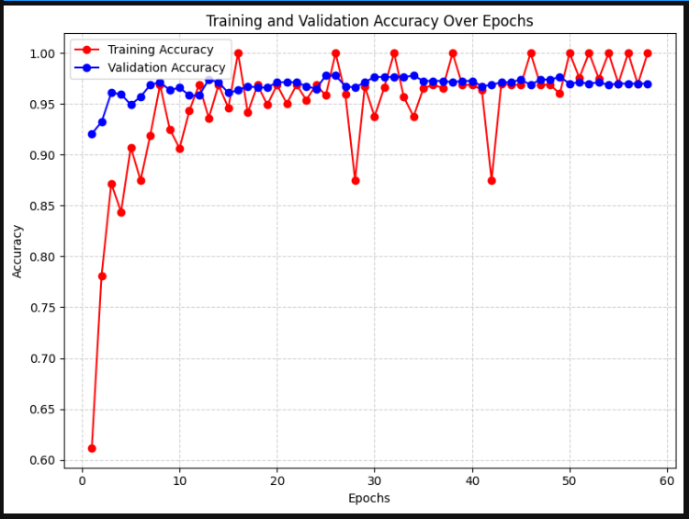

The outputs of this phase produced a compact, accurate classification pipeline aligned with methodological expectations: a pivot to MobileNetV2 for efficiency, an augmentation pipeline for robustness, and a validated dataset for training. These elements formed the technical foundation for subsequent implementation.
Figure 4
Confusion matrix showing the distribution of predicted versus actual class labels for the test set.
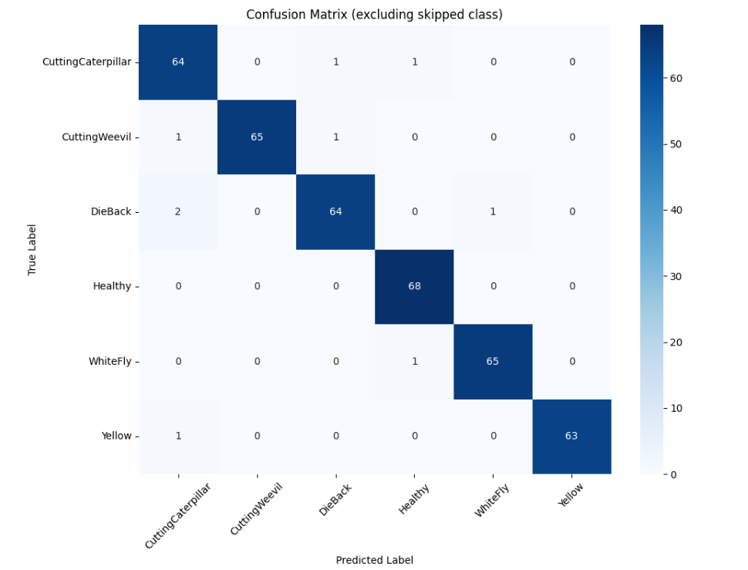

The classifier achieved a test accuracy of 97.74%, with macro-averaged precision, recall, and F1-scores all at 0.98, indicating balanced performance across all classes regardless of class frequency. Class-wise evaluation further confirmed this consistency, with the Healthy and Yellowing categories achieving the highest F1 scores at 0.99. As detailed in Figure 2, all classes achieved F1-scores above 0.95, with Yellowing and Healthy leading at 0.9921 and 0.9855, respectively. CuttingWeevil and WhiteFly also demonstrated nearly perfect precision and recall. The slightly lower performance of CuttingCaterpillar (F1 = 0.9552) reflects its confusions with DieBack and Yellowing, as observed in the confusion matrix. These metrics confirm that the model not only performed well in aggregate but also maintained high reliability across individual disease categories.

3.3 Mobile Application Integration
The optimized MobileNetV2 model was converted to TensorFlow Lite format with float16 quantization, reducing the file size from approximately 31 MB to under 9 MB without loss of accuracy. This enabled efficient deployment of low- and mid-tier Android devices. The average inference latency ranged from 560–621 ms per image, ensuring sub-second response times suitable for real-time diagnosis.
The Flutter-based mobile application integrated into the TFLite model for fully offline classification. Users could capture or select a leaf image, receive instant predictions with confidence scores, and operate the app without internet connectivity. The interface design emphasized simplicity, language-free icons, and minimal navigation, ensuring accessibility for smallholder farmers with limited digital literacy.

3.4 Technical Evaluation
Comprehensive testing confirmed that the deployed application met both functional and non-functional requirements. The quantized model preserved its predictive accuracy while remaining stable across extended usage. The application demonstrated reliable memory management, low power consumption, and consistent performance under repeated classification sessions and background operations. No crashes, lags, or overheating incidents were observed during testing.

3.5 Usability and User Acceptance
Structured usability testing was conducted among 21 local farmers and farm workers using a standardized UTAUT2-based questionnaire. Results indicated high acceptance and trust in the application’s performance. Behavioral Intention (M = 4.79), Performance Expectancy (M = 4.76), and Price Value (M = 4.74) received the highest scores, reflecting users’ intention to adopt and recommend the system. Facilitating Conditions (M = 4.55) and Trust in Diagnosis (M = 4.63) were slightly lower, suggesting minor concerns related to technical accessibility and diagnostic confidence. Overall, users found the system easy to operate, beneficial to crop management, and valuable as a free, offline tool.

3.6 Discussion
The experimental outcomes demonstrate that lightweight CNN architectures like MobileNetV2 can achieve high diagnostic accuracy while remaining deployable on mobile devices for agricultural disease detection. The integration of quantization and augmentation strategies ensured model robustness and operational efficiency under real-world conditions.
Minor classification confusions were attributed to biological similarity among certain disease symptoms rather than model deficiencies. The application’s usability results affirm its potential adoption in rural agricultural communities, especially where connectivity and technical resources are limited. These findings confirm that deep learning–driven mobile tools can effectively bridge diagnostic gaps in resource-constrained farming environments.

4. CONCLUSION

This study successfully developed and deployed an intelligent mobile application for detecting diseases in soursop leaves using a lightweight deep learning approach. Through an iterative Software Development Life Cycle (SDLC), the project integrated a MobileNetV2-based convolutional neural network (CNN) into a Flutter-built mobile platform, achieving both technical efficiency and practical usability. The model demonstrated a high classification accuracy of 97.74%, validating its reliability for real-time field use.
Quantization and optimization using TensorFlow Lite enabled offline operation on mid-range Android devices without significant performance degradation. Usability testing among farmers confirmed strong acceptance, emphasizing the system’s accessibility, ease of use, and perceived value in supporting timely disease diagnosis and management. Overall, the study confirms that mobile-based deep learning systems can bridge diagnostic gaps in agriculture, particularly in rural settings with limited connectivity. Future work will focus on expanding the dataset with locally sourced images, integrating multimodal data (such as environmental conditions), and extending the model’s scope to other tropical crops to enhance generalization and practical deployment.

COMPETING INTERESTS DISCLAIMER:
Authors have declared that they have no known competing financial interests OR non-financial interests OR personal relationships that could have appeared to influence the work reported in this paper.
Disclaimer (Artificial intelligence)

The authors declare that no generative artificial intelligence tools or technologies such as ChatGPT, Copilot, or any text-to-image generation systems were used in the preparation, writing, or editing of this manuscript. All content, analysis, and interpretations presented in this paper were developed entirely through the authors’ own effort, expertise, and critical judgment without the help of AI.

REFERENCES

- Afzaal, M., Saeed, F., Asghar, A., Shah, Y. A., Ikram, A., Ateeq, H., Hussain, M., Ofoedu, C. E., & Chacha, J. S. (2022). Nutritional and Therapeutic Potential of Soursop. In Journal of Food Quality (Vol. 2022). Hindawi Limited. https://doi.org/10.1155/2022/8828358
- Agu, K. C., & Okolie, P. N. (2017). Proximate composition, phytochemical analysis, and in vitro antioxidant potentials of extracts of Annona muricata (Soursop). Food Science and Nutrition, 5(5), 1029–1036. https://doi.org/10.1002/fsn3.498
- ‌Ahmed, A. A., & Reddy, G. H. (2021). A Mobile-Based System for Detecting Plant Leaf Diseases Using Deep Learning. AgriEngineering, 3(3), 478–493. https://doi.org/10.3390/agriengineering3030032
- Al Ohali, Y. (2011). Computer vision based date fruit grading system: Design and implementation. Journal of King Saud University - Computer and Information Sciences, 23(1), 29–36. https://doi.org/10.1016/j.jksuci.2010.03.003
- Barbedo, J. G. A. (2018). Impact of dataset size and variability on the performance of deep learning models for plant disease classification. Computers and Electronics in Agriculture, 153, 46–53. https://doi.org/10.1016/j.compag.2018.08.013
- Bhola, A., & Kumar, P. (2024). Deep feature-support vector machine based hybrid model for multi-crop leaf disease identification in Corn, Rice, and Wheat. Multimedia Tools and Applications, 1–21. https://doi.org/10.1007/S11042-024-18733-8/METRICS
- Chen, J., Zhang, D., Suzauddola, M., Nanehkaran, Y. A., & Sun, Y. (2021). Identification of plant disease images via a squeeze-and-excitation MobileNet model and twice transfer learning. IET Image Processing, 15(5), 1115–1127. https://doi.org/10.1049/ipr2.12090
- Coria-Téllez, A. V., Montalvo-Gónzalez, E., Yahia, E. M., & Obledo-Vázquez, E. N. (2018). Annona muricata: A comprehensive review on its traditional medicinal uses, phytochemicals, pharmacological activities, mechanisms of action and toxicity. In Arabian Journal of Chemistry (Vol. 11, Issue 5, pp. 662–691). Elsevier B.V. https://doi.org/10.1016/j.arabjc.2016.01.004
- Datiles, M. J., & Acevedo-Rodríguez, P. (2022). Annona muricata (soursop). CABI Compendium, CABI Compendium. https://doi.org/10.1079/cabicompendium.5812
- Department of Science and Technology (DOST). (2024, October 15). AI Got It: HAWKS AI technology to provide solution to disease detection and crop management among others. DOST News. Retrieved from https://www.dost.gov.ph/knowledge-resources/news/84-2024-news/3797-ai-got-it-hawks-ai-technology-to-provide-solution-to-disease-detection-and-crop-management-among-others.html
- Drenth, A., & Guest, D. I. (2016). Fungal and Oomycete Diseases of Tropical Tree Fruit Crops. Annual Review of Phytopathology, 54(1), 373–395. https://doi.org/10.1146/annurev-phyto-080615-095944
- Enkvetchakul, P., & Surinta, O. (2021). Effective Data Augmentation and Training Techniques for Improving Deep Learning in Plant Leaf Disease Recognition. Applied Science and Engineering Progress. https://doi.org/10.14416/j.asep.2021.01.003
- Fabregas, R., Kremer, M., & Schilbach, F. (2019). Realizing the potential of digital development: The case of agricultural advice. Science, 366(6471), eaay3038. https://doi.org/10.1126/science.aay3038
- Fairfood. (2020). 3 challenges in the digital era: Data collection in agriculture. Retrieved from https://fairfood.org/en/resources/challenges-in-the-digital-era-data-collection-farmers/
- Feng, J., Zeng, L., & He, L. (2019). Apple fruit recognition algorithm based on multi-spectral dynamic image analysis. Sensors (Switzerland), 19(4). https://doi.org/10.3390/s19040949
- Galvan, A. A., Calmorin, L. P., Mendoza, E. M. T., & Anselmo, R. J. (2020). Analysis of post-harvest losses in mango production in Iloilo, Philippines. International Journal of Innovation, Creativity, and Change, 13(1), 504-517. Retrieved from https://www.ijicc.net/images/vol_13/13145_Galvan_2020_E_R.pdf
- González-Ruíz, A. V., Palomino-Hermosillo, Y. A., Balois-Morales, R., Ochoa-Jiménez, V. A., Casas-Junco, P. P., López-Guzmán, G. G., Berumen-Varela, G., & Bautista-Rosales, P. U. (2021). Pathogenic Fungi Associated with Soursop Fruits (Annona muricata L.) during Postharvest in Nayarit, Mexico. Horticulturae, 7(11), 471. https://doi.org/10.3390/horticulturae7110471
- Guyabano (Soursop) Production Guide. (n.d.). Retrieved September 22, 2024, from https://businessdiary.com.ph/2258/guyabano-soursop-production-guide/
- Hendrycks, D., Mu, N., Cubuk, E. D., Zoph, B., Gilmer, J., & Lakshminarayanan, B. (2020). AugMix: A Simple Data Processing Method to Improve Robustness and Uncertainty. ArXiv:1912.02781 [Cs, Stat]. https://arxiv.org/abs/1912.02781
- Ibarra, N. C., Rivera, M. P., & Manlises, C. O. (2023). Detection of Panama Disease on Banana Leaves Using the YOLOv4 Algorithm. https://doi.org/10.1109/iccae56788.2023.10111416
- Inkalaba, G., Londanda, , Kubenga, M., Nzingula, O., Misengabu, N., Luvandu, M., Duki, A., & Kule-Koto, K. (2023). Evaluation of the Nutritional Value and Acute Toxicity of the Seeds of the Fruit of <i>Annona muricata</i> L. (Sursop) Consumed in Kinshasa. Journal of Biosciences and Medicines, 11(02), 265–274. https://doi.org/10.4236/jbm.2023.112021
- John, M. A., Bankole, I., Ajayi-Moses, O., Ijila, T., Jeje, T., & Lalit, P. (2023). Relevance of Advanced Plant Disease Detection Techniques in Disease and Pest Management for Ensuring Food Security and Their Implication: A Review. American Journal of Plant Sciences, 14(11), 1260–1295. https://doi.org/10.4236/ajps.2023.1411086
- John, S., & Rose, A. L. (2021). MACHINE LEARNING TECHNIQUES IN PLANT DISEASE DETECTION AND CLASSIFICATION - A STATE OF THE ART. INMATEH - Agricultural Engineering, 65(3), 362–372. https://doi.org/10.35633/INMATEH-65-38
- Khattak, A., Asghar, M. U., Batool, U., Asghar, M. Z., Ullah, H., Al-Rakhami, M., & Gumaei, A. (2021). Automatic Detection of Citrus Fruit and Leaves Diseases Using Deep Neural Network Model. IEEE Access, 9, 112942–112954. https://doi.org/10.1109/access.2021.3096895
- ‌Kumar Panda, C., Divakar, S., Paswan, A., Azad, C., & Tyagi, S. (2020). Smallholder Farmers’ Perception on Mobile Phone Advisory Potential in Farming in Bhagalpur, India. Current Journal of Applied Science and Technology, 1–8. https://doi.org/10.9734/cjast/2019/v38i630442
- Labonne, J., & Chase, R. S. (2009). The power of information: The impact of mobile phones on farmers' welfare in the Philippines. World Bank Policy Research Working Paper, 4996, 1–33.
- Linjordet, T., & Balog, K. (2019). Impact of training dataset size on neural answer selection models. Lecture Notes in Computer Science (Including Subseries Lecture Notes in Artificial Intelligence and Lecture Notes in Bioinformatics), 11437 LNCS, 828–835. https://doi.org/10.1007/978-3-030-15712-8_59
- Liu, D., Shen, J., Yang, H., Niu, Q., & Guo, Q. (2019). Recognition and localization of actinidia arguta based on image recognition. Eurasip Journal on Image and Video Processing, 2019(1). https://doi.org/10.1186/s13640-019-0419-6
- Magabilin, Ma. C. V., Fajardo, A. C., & Medina, R. P. (2023). Classification of Philippine Guyabano fruit maturity based on visual properties using deep learning. TRANSPORT, ECOLOGY - SUSTAINABLE DEVELOPMENT: EKOVarna2022, 2868, 020007. https://doi.org/10.1063/5.0163591
- Mahlein, A.-K. (2016). Plant Disease Detection by Imaging Sensors – Parallels and Specific Demands for Precision Agriculture and Plant Phenotyping. Plant Disease, 100(2), 241–251. https://doi.org/10.1094/pdis-03-15-0340-fe
- Meen, T.-Hang. (2019). IOT, Communication and Engineering : 2019 IEEE Eurasia Conference on IOT, Communication and Engineering (IEEE ECICE 2019) : Yunlin, Taiwan, October 3-6, 2019. International Institute of Knowledge Innovation and Invention (IIKII).
- Mohanty, S. P., Hughes, D. P., & Salathé, M. (2016). Using deep learning for image-based plant disease detection. Frontiers in Plant Science, 7(September). https://doi.org/10.3389/fpls.2016.01419
- Moupojou, E., Retraint, F., Tapamo, H., Nkenlifack, M., Kacfah, C., & Tagne, A. (n.d.). Date of publication xxxx 00, 0000, date of current version xxxx 00, 0000. Segment Anything Model & Fully Convolutional Data Description for Plant Multi-disease Detection on Field Images. https://doi.org/10.1109/ACCESS.2017.DOI
- Mrisho, L. M., Mbilinyi, N. A., Ndalahwa, M., Ramcharan, A. M., Kehs, A. K., McCloskey, P. C., Murithi, H., Hughes, D. P., & Legg, J. P. (2020). Accuracy of a Smartphone-Based Object Detection Model, PlantVillage Nuru, in Identifying the Foliar Symptoms of the Viral Diseases of Cassava-CMD and CBSD. Frontiers in Plant Science, 11, 590889. https://doi.org/10.3389/fpls.2020.590889
- Mustofa, S., Taimur Ahad, M., Sadekur Rahman, M., Song, B., & Li Professor, Y. (2024). A comprehensive study on deep feature extraction to detect and classify Soursop Leaf Disease. https://ssrn.com/abstract=4845099
- Mutakin, M., Fauziati, R., Fadhilah, F. N., Zuhrotun, A., Amalia, R., & Hadisaputri, Y. E. (2022). Pharmacological Activities of Soursop (Annona muricata Lin.). In Molecules (Vol. 27, Issue 4). MDPI. https://doi.org/10.3390/molecules27041201
- Negi, C. (2021). Exploring the Impact of Data Augmentation on Deep Learning Models for Plant Disease Detection in PlantVillage Dataset. ˜the œPhilippine Statistician (Quezon City), 70(2), 1372–1382. https://doi.org/10.17762/msea.v70i2.2329
- Panchal, A. V., Patel, S. C., Bagyalakshmi, K., Kumar, P., Khan, I. R., & Soni, M. (2023). Image-based Plant Diseases Detection using Deep Learning. Materials Today: Proceedings, 80, 3500–3506. https://doi.org/10.1016/j.matpr.2021.07.281
- Parhizkar, T., Vinnem, J. E., Utne, I. B., & Mosleh, A. (2021). Supervised Dynamic Probabilistic Risk Assessment of Complex Systems, Part 1: General Overview. Reliability Engineering and System Safety, 208. https://doi.org/10.1016/j.ress.2020.107406
- Pascual, E. J. A. V., Plaza, J. M. J., Tesorero, J. L. L., & De Goma, J. C. (2019). Disease Detection of Asian Rice (Oryza Sativa) in the Philippines Using Image Processing. Proceedings of the 2nd International Conference on Computing and Big Data - ICCBD 2019. https://doi.org/10.1145/3366650.3366676
- Philippine Council for Agriculture, Aquatic and Natural Resources Research and Development (PCAARRD). (2021, Novembe 25). Banana diseases surveillance system. Retrieved from https://ispweb.pcaarrd.dost.gov.ph/banana-diseases-surveillance-system/
- Plant-Disease-Detecting Robot in the Philippines – OpenGov Asia. (2022, September 13). Opengovasia.com. https://opengovasia.com/2022/09/13/plant-disease-detecting-robot-in-the-philippines/
- POLICY BRIEF A publication of the Policy Advocacy Group (PAG) of the Department of Science and Technology- Philippine Council for Agriculture, Aquatic and Natural Resources Research and Development (DOST-PCAARRD). (2022.). https://pcaarrd.dost.gov.ph/index.php/services/policy-analysis-advocacy/3860-development-of-an-r-d-framework-for-underutilized-fruits-guava-soursop-sugar-apple-and-tamarind-in-the-philippines/file
- Pytorch Documentation. (n.d.). Transforming and augmenting images . https://pytorch.org/vision/stable/transforms.html
- Ramanjot, Mittal, U., Wadhawan, A., Singla, J., Jhanjhi, N. Z., Ghoniem, R. M., Ray, S. K., & Abdelmaboud, A. (2023). Plant Disease Detection and Classification: A Systematic Literature Review. In Sensors (Vol. 23, Issue 10). MDPI. https://doi.org/10.3390/s23104769
- Rishiikeshwer, B. S., Shriram, T. A., Raju, J. S., Hari, M., Santhi, B., & Brindha, G. R. (2020). Farmer-friendly mobile application for automated leaf disease detection of real-time augmented data set using convolution neural networks. Journal of Computer Science, 16(2), 158–166. https://doi.org/10.3844/JCSSP.2020.158.166
- Sánchez-Monteón, A. L., Luna-Esquivel, G., Ramírez-Guerrero, L. G., & Rodríguez-Rodríguez, B. B. (2019). Comparative study between natural, entomophilic and manual pollination in soursop (Annona muricata L.). Journal of Enviromental Sciences and Natural Resources, 18–22. https://doi.org/10.35429/jesn.2019.15.5.18.22
- Santos, I. L., Rodrigues, A. M. da C., Amante, E. R., & Silva, L. H. M. da. (2023). Soursop (Annona muricata) Properties and Perspectives for Integral Valorization. Foods, 12(7), 1448. https://doi.org/10.3390/foods12071448
- ‌Savary, S., Nelson, A., Willocquet, L., Pangga, I., & Aunario, J. (2012). Modeling and mapping potential epidemics of rice diseases globally. Crop Protection, 34, 6–17. https://doi.org/10.1016/j.cropro.2011.11.009
- Selvaraj, M. G., Vergara, A., Ruiz, H., Safari, N., Elayabalan, S., Ocimati, W., & Blomme, G. (2019). AI-powered banana diseases and pest detection. Plant Methods, 15, 92. https://doi.org/10.1186/s13007-019-0475-z
- Setyaningsih, E., & Harjoko, A. (2017). Survey of hybrid image compression techniques. International Journal of Electrical and Computer Engineering, 7(4), 2206–2214. https://doi.org/10.11591/ijece.v7i4.pp2206-2214
- Shafik, W., Tufail, A., Abdallah Namoun, Silva, & Rosyzie Anna Apong. (2023). A Systematic Literature Review on Plant Disease Detection: Motivations, Classification Techniques, Datasets, Challenges, and Future Trends. IEEE Access, 11, 59174–59203. https://doi.org/10.1109/access.2023.3284760
- Singh, V., Sharma, N., & Singh, S. (2020). A review of imaging techniques for plant disease detection. Artificial Intelligence in Agriculture, 4. https://doi.org/10.1016/j.aiia.2020.10.002
- Sohi Assistant Professor, N. (2023). Article ID: IJCET_14_03_013 Cite this Article: Neelofar Sohi, Detection of Plant Diseases in Image Processing. International Journal of Computer Engineering and Technology (IJCET), 14(3), 2023.
- Suharjito, Elwirehardja, G. N., & Prayoga, J. S. (2021). Oil palm fresh fruit bunch ripeness classification on mobile devices using deep learning approaches. Computers and Electronics in Agriculture, 188. https://doi.org/10.1016/j.compag.2021.106359
- Udutalapally, V., Mohanty, S. P., Pallagani, V., & Khandelwal, V. (2020). sCrop: A Internet-of-Agro-Things (IoAT) Enabled Solar Powered Smart Device for Automatic Plant Disease Prediction. http://arxiv.org/abs/2005.06342
- United Nations Centre for Sustainable Agricultural Mechanization (UN-CSAM). (2021). Post-harvest technology in the Philippines: Current status and challenges. Retrieved from https://un-csam.org/sites/default/files/2021-01/Post-harvest%20Technology%20in%20the%20Philippines.pdf
- Vijaya Vardan Reddy, S., Suresh, T., Naresh Kumar Thapa, K., Ramkumar, V., & Mahabhoob Basha, S. (n.d.). European Journal of Molecular & Clinical Medicine Plant Disease Identifer Using K-Means and GLSM in Convolution Neural Network. 7, 2020.
- Visayas State University (VSU). (n.d.). Plant Disease Diagnostic Laboratory. Retrieved from https://www.vsu.edu.ph/gs/21-content-main/informational/373-plant-disease-diagnostic-laboratory
- Wang, Y., Deng, Y., Zheng, Y., Chattopadhyay, P., & Wang, L. (2025). Vision Transformers for Image Classification: A Comparative Survey. Technologies, 13(1), 32–32. https://doi.org/10.3390/technologies13010032
- Xiang, Q., Zhang, G., Wang, X., Lai, J., Li, R., & Hu, Q. (2019, October 22). Fruit image classification based on Mobilenetv2 with transfer learning technique. ACM International Conference Proceeding Series. https://doi.org/10.1145/3331453.3361658
- Puślecki ZW (2022). On The New Trends in the Theory and Politics of International Affairs. SunText Rev Econ Bus 3(4): 170. USA; Puślecki Z.W. (2022), Bilateral Trade Agreements and the Rise of Global Supply Chains in the Modern International Business, Chapter 5 of the book, Current Aspects in Business, Economics and Finance Vol. DOI:10.9734/bpi/cabef/v2/16886D;
- Puślecki Zdzisław W. Sztuczna inteligencja (AI), internet rzeczy (IoT) i sieć piątej generacji (5G) w nowoczesnych badaniach naukowych
Artificial Intelligence (AI), the Internet of Things (IoT), and the Fifth Generation (5G) Network in the Modern Science Research, https://doi.org/10.14746/cis.2021.52.7;

