Original Research Article
CFD Analysis of Hydrodynamic Drag Characteristics in Amphibious Robots with Different Bow Angles

ABSTRACT
To investigate the effect of bow angle on the hydrodynamic resistance characteristics of an amphibious robot during water navigation, CFD simulations were performed using the SST k-ω model. Five bow angles (30.00°, 45.00°, 60.00°, 75.00°, and 90.00°) were analyzed under six navigation speeds to compare their resistance performance in still water. The results indicate that the bow angle significantly influences water resistance, with the optimal angle varying with speed. At medium-low—speeds (≤2 knots(kn)), the 60° bow achieves the minimum resistance, with a maximum drag reduction of 47.20%. At high—speeds (≥ 3 kn), the 45.00° bow yields the lowest total resistance at 3 kn and 6 kn (maximum drag reduction: 16.09%), while the 30.00° bow is optimal at 4 — 5 kn (maximum drag reduction: 35.06%). The 90.00° bow exhibits the highest total resistance across all speeds. This study provides guidance for the optimal bow angle matching different speeds and directions for drag optimization in amphibious robot bow design under various navigation scenarios.
Keywords: Amphibious Robot; CFD; Total Drag; Bow Angle
1.INTRODUCTION
As an intelligent device capable of autonomous movement in both terrestrial and aquatic environments, amphibious robots boast broad application prospects. However, the cross—medium nature of these robots also presents significant challenges in their design. When navigating in water, complex configurations generate substantial hydrodynamic drag, which not only severely impairs endurance but also restricts maneuverability. Limited endurance prevents the robot from performing long-duration tasks in expansive water areas, while insufficient maneuverability hinders its ability to adapt flexibly to complex and dynamic underwater environments. The geometric shape of the robot's forepart, particularly the bow angle—as the leading edge during water entry—directly determines the flow separation point and pressure distribution. It exerts a critical influence on underwater drag, thereby affecting the robot's movement performance in water. Therefore, investigating the impact of the bow angle on the underwater drag performance of amphibious robots holds important practical significance for optimizing their design and enhancing underwater operational capabilities.
Most existing studies focus on the terrestrial motion performance, sealing technology, or underwater propulsion systems of robots, while relatively few studies have been conducted on the optimization of their underwater hydrodynamic shape, especially the drag reduction optimization of the bow section.ZHANG Yuxin ^{[1]} et al. optimized the structure by comparing the drag reduction performance of underwater vehicles with different hull lines. Bao Haimo ^{[2]} et al. adopted a bionic design for the pressure hull of the robot, which effectively improved its drag performance. Xue Xiafeng ^{[3]} et al. optimized the modeling of the underwater vehicle by integrating the NSGA-II genetic algorithm module, thereby reducing the navigation drag. Shuping H ^{[4]} et al. designed a new Response Surface Methodology (RSM) model to optimize the vehicle shape and enhance its drag performance. Bao Haimo ^{[5]}, Dong Sude ^{[6]}, and their colleagues explored the overall bionic design of the robot to optimize its drag performance. Wang Haichao ^{[7]} et al. proposed the use of a special mucosal layer to reduce friction, thereby
decreasing drag. Kaisheng Z ^{[8]} et al. applied a method simulating the mucus on fish bodies, achieving a drag reduction rate of 17%. On the basis of bionic robots, Bao Haimo ^{[9]} et al. installed manipulators to improve drag performance. Wang Chao ^{[10]} et al. proposed an underwater robot with a configuration of "cavitator + strake + ellipsoidal streamlined body," with a maximum drag reduction rate of 50%.Feng Yikun ^{[11]} et al. optimized the drag performance through the coupling of the hull and the water-jet propulsor. Chao G Z ^{[12]} et al. established an intelligent optimization platform and used the Multi-Island Genetic Algorithm (MIGA) to optimize drag performance. Zhou Lilan ^{[13]} et al. conducted numerical simulations on the drag and attitude changes of amphibious vehicles with and without openings, and studied the proportion of different drag components in various navigation stages.Qian Hao ^{[14]} et al. regarded the water inlet channel as an accessory, and their comparative analysis showed that adding the channel would increase the ship's drag. Fan J ^{[15]} et al. proposed the measure of installing stern flaps for drag reduction optimization, achieving a drag reduction rate of 23%. However, none of the above studies have systematically analyzed the impact of the bow angle—a key parameter—on drag. The bow angle primarily determines flow separation and pressure distribution, directly influencing underwater drag. At present, systematic research on the relationship between the bow angle of amphibious robots and underwater drag is still insufficient.
This paper conducts a systematic comparative study on the bow angle of amphibious robots, which differs from existing Computational Fluid Dynamics (CFD) analyses. While most existing studies focus on the robot's overall performance or the optimization of other components, this research centers on the bow angle as a key parameter. By establishing an accurate numerical model, comprehensive and systematic numerical simulations are performed on the straight-line navigation of robot designs with different bow angles in still water. This systematic research method can reveal the intrinsic relationship between the bow angle and underwater drag in greater depth and detail, providing more targeted theoretical support for the design of amphibious robots.
METHODLOGY
2.BASI THEORY AND RESEARCH METHODS
2.1 Control Equations
For incompressible viscous fluids in FLUENT software, the fluid follows the laws of mass conservation, momentum conservation, and energy conservation. When simulating the waterborne movement of amphibious robots, heat conduction and heat exchange can be ignored, so the energy conservation equation can be neglected. The mass conservation equation is the continuity equation for fluid motion, and its differential form is:
(1)
The differential form of the momentum conservation equation is
(2)
ρ represents the density of the fluid；u_{i} is the Reynolds-averaged velocity component without the average symbol；p is the mean value of the pressure；$u_{i}^{’}$ is the pulsation value of the velocity component；$a_{ij}$ is the component of the stress tensor.
2.2 Turbulence model
Currently, the commonly used turbulence models for the Reynolds-Averaged Navier-Stokes (RANS) equations in FLUENT are two—equation models. These models mainly include the standard k- ε turbulence model, the RNG k-ε turbulence model, the standard k-ω turbulence model, and the Shear Stress Transport (SST) k-ω ^{[16]} turbulence model. Among them, the SST k-ω turbulence model combines the advantages of the k-ω and k-ε models: it adopts the k-ω model in the near-wall region to accurately capture the boundary layer flow, and switches to the k-ε model in the far-field to adapt to free shear flow. As a result, it performs excellently in simulating separated flows and reattachment phenomena in complex geometries. Compared with other turbulence models, it requires less computation time. Therefore, the SST k-ω turbulence model is used in this paper.
The transport equation of k is
(3)
The transport equation of ω is
(4)
G_{K} is the production term of turbulent kinetic energy $k$ caused by the mean velocity gradient，and G_{ω} is the production term in the $ω$ equation；$Γ_{K}$and $Γ_{ω}$ represent the effective diffusion of k and $\text{ω}$ respectively；$Y_{K}$and$Y_{ω}$are the dissipations generated by turbulence；$S_{K}$and$S_{ω}$are user-defined terms;$D_{ω}$ is the cross-diffusion term.
2.3 Empirical formula for total hydrodynamic resistance
Due to the irregular shape of the tracked robot, the resistance of the robot in water can only be estimated when calculating it, and the empirical formula for this calculation is:
(5)
ρ is the water density; v is the robot's navigation speed on water; A is the robot's drag area; C_{d} is the fluid drag coefficient, ranging from 0.800 to 1.200,In this paper, the value of C_{d} is taken as 1.00.
RESULT & DISCUSSION
3.SIMULATION EXPERIMENT
The model designed in this paper integrates a ship and a vehicle by extracting their respective advantages. After determining the basic model, SolidWorks is used to design 7 vehicle body models with different bow angles. The bow angle takes the horizontal line on the upper surface of the vehicle body as the reference line, referring to the angle that the stem (forwardmost part of the bow) travels when rotating clockwise from below the reference horizontal line to the designed horizontal line. To ensure as much as possible that the bow angle is the only influencing factor, only the bow angle is adjusted when modifying the models, while other factors (such as draft and stern structure) remain unchanged. During the simulation, since the amphibious rescue robot has relatively complex structures such as main crawler tracks and swing arms, which have a significant impact on the simulation results, the experimental simulation in this paper only focuses on the robot's vehicle body and does not consider other structures for the time being.
The main parameters of the vehicle body are shown in Table 1, and its shape is illustrated in Fig.1.
Table 1.Main Parameters of the Vehicle Body
Bow Angle(°) | Vehicle Length(m) | Vehicle Width(m) | Draft(m)
30.00 | 1.49 | 0.70 | 0.12
45.00 | 1.49 | 0.70 | 0.12
60.00 | 1.49 | 0.70 | 0.12
75.00 | 1.50 | 0.70 | 0.12
90.00 | 1.50 | 0.70 | 0.12

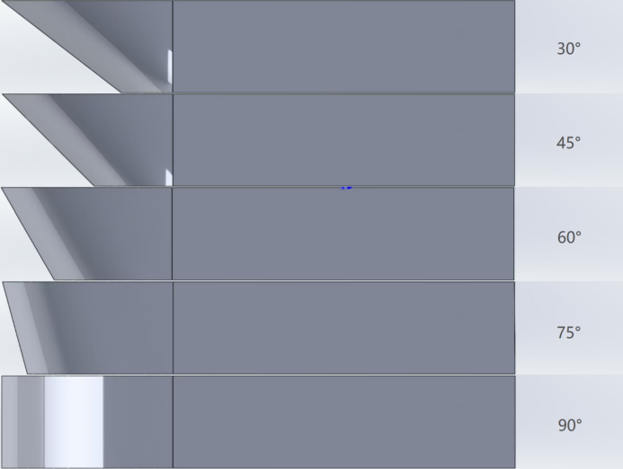
Fig.1.Shape of the Vehicle Body
3.1 Boundary Conditions and Numerical Methods
Boundary conditions are determined based on the computational fluid domain's size, as well as the flow field's convergence and stability. The fluid domain inlet is set as a velocity inlet, the outlet as a pressure outlet, the left and right edges as symmetry boundaries, and the vehicle's surface along with other surfaces as no-slip walls.
The Volume of Fluid (VOF) model from the multiphase flow models is used to address the free liquid surface issue. The Finite Volume Method (FVM) is applied to discretize the governing equations. For the flow around the vehicle body, the SIMPLE algorithm is used to iteratively solve for pressure and velocity, employing a time step of 0.001 seconds.
3.2 Grid Independence Verification
Grid independence is one of the most important steps in simulations. A high-quality grid that meets application requirements can not only improve calculation speed but also ensure result accuracy.To better and more accurately reflect grid independence in the simulation, an intermediate variable was selected: the calculation condition was set to a speed of 3.50 kn, and the calculation case used a vehicle body with a bow column angle of 60.00°. Key parts were subjected to grid refinement, and the entire flow domain was divided into five grid quantities. Starting from the medium grid quantity, adjacent grids were analyzed at intervals of 500,000, specifically 1.00 million, 1.50 million, 2.00 million, 2.50 million, and 3.00 million. The calculated results of vehicle body resistance under different schemes are shown in Table 3.
Table 2.Grid Quantity and Resistance Results
Underwater Speed | Grid Quantity | Total Resistance | Relative Error
 | 1.00 million | 152.10 | 0.00%
 | 1.50 million | 149.95 | 1.44%
3.50 kn | 2.00 million | 149.59 | 0.24%
 | 2.50 million | 149.35 | 0.16%
 | 3.00 million | 149.41 | 0.04%
3.3 Computational domain and Mesh generation
To minimize the impact of boundary reflection, after multiple rounds of practice, this paper adopts the SST k-ω turbulence model to establish the fluid domain. The upper boundary of the computational domain is 0.40 times the vehicle length away from the top of the vehicle, while the lower boundary is 0.60 times the vehicle length away from the bottom of the vehicle. The two lateral sides are symmetric, each 1.00 time the vehicle length away from the centerline of the vehicle body. The inlet is 1.00 time the vehicle length away from the bow, and the outlet is 3.00 times the vehicle length away from the stern.
In this section, mesh generation is performed using FLUENT Meshing, a tool built into FLUENT. To better capture the flow characteristics, mesh refinement is applied to the vehicle body. The total number of meshes in the entire fluid domain is 2.50 million, and the overall mesh distribution of the fluid domain as well as the refined regions are shown in Fig. 2.
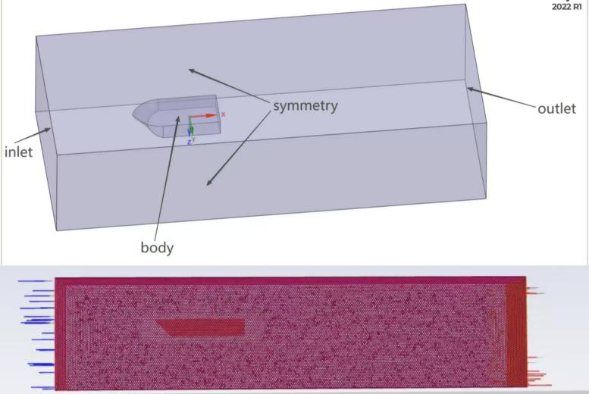
Fig. 2.Computational domain and Mesh generation
3.4 Numerical Computation and Analysis
The amphibious robot travels in water at a speed of 1.00—6.00 kn. The Froude number (Fr) varies under different speed conditions, and its resistance composition also differs accordingly. The Fr values at different speeds are presented in Table 2.
Table 3.Navigation Speed Parameters Under Six Operating Conditions
Operating Condition | Speed (kn) | Fr | Speed Classification
Operating Condition 1 | 1.00 | 0.131 | Low—Speed
Operating Condition 2 | 2.00 | 0.258 | Medium—Speed
Operating Condition 3 | 3.00 | 0.389 | High—Speed
Operating Condition 4 | 4.00 | 0.518 | High—Speed
Operating Condition 5 | 5.00 | 0.647 | High—Speed
Operating Condition 6 | 6.00 | 0.776 | High—Speed
Note：Low—Speed，＜0.18；Medium—Speed，0.18＜＜0.3；High—Speed，＞0.3；.
3.5 Total Drag of Robots with Various Bow Angles
The line chart of the total resistance of robots with 5 different bow angles under six operating conditions is shown in Fig 3, where R_{T} represents total resistance..
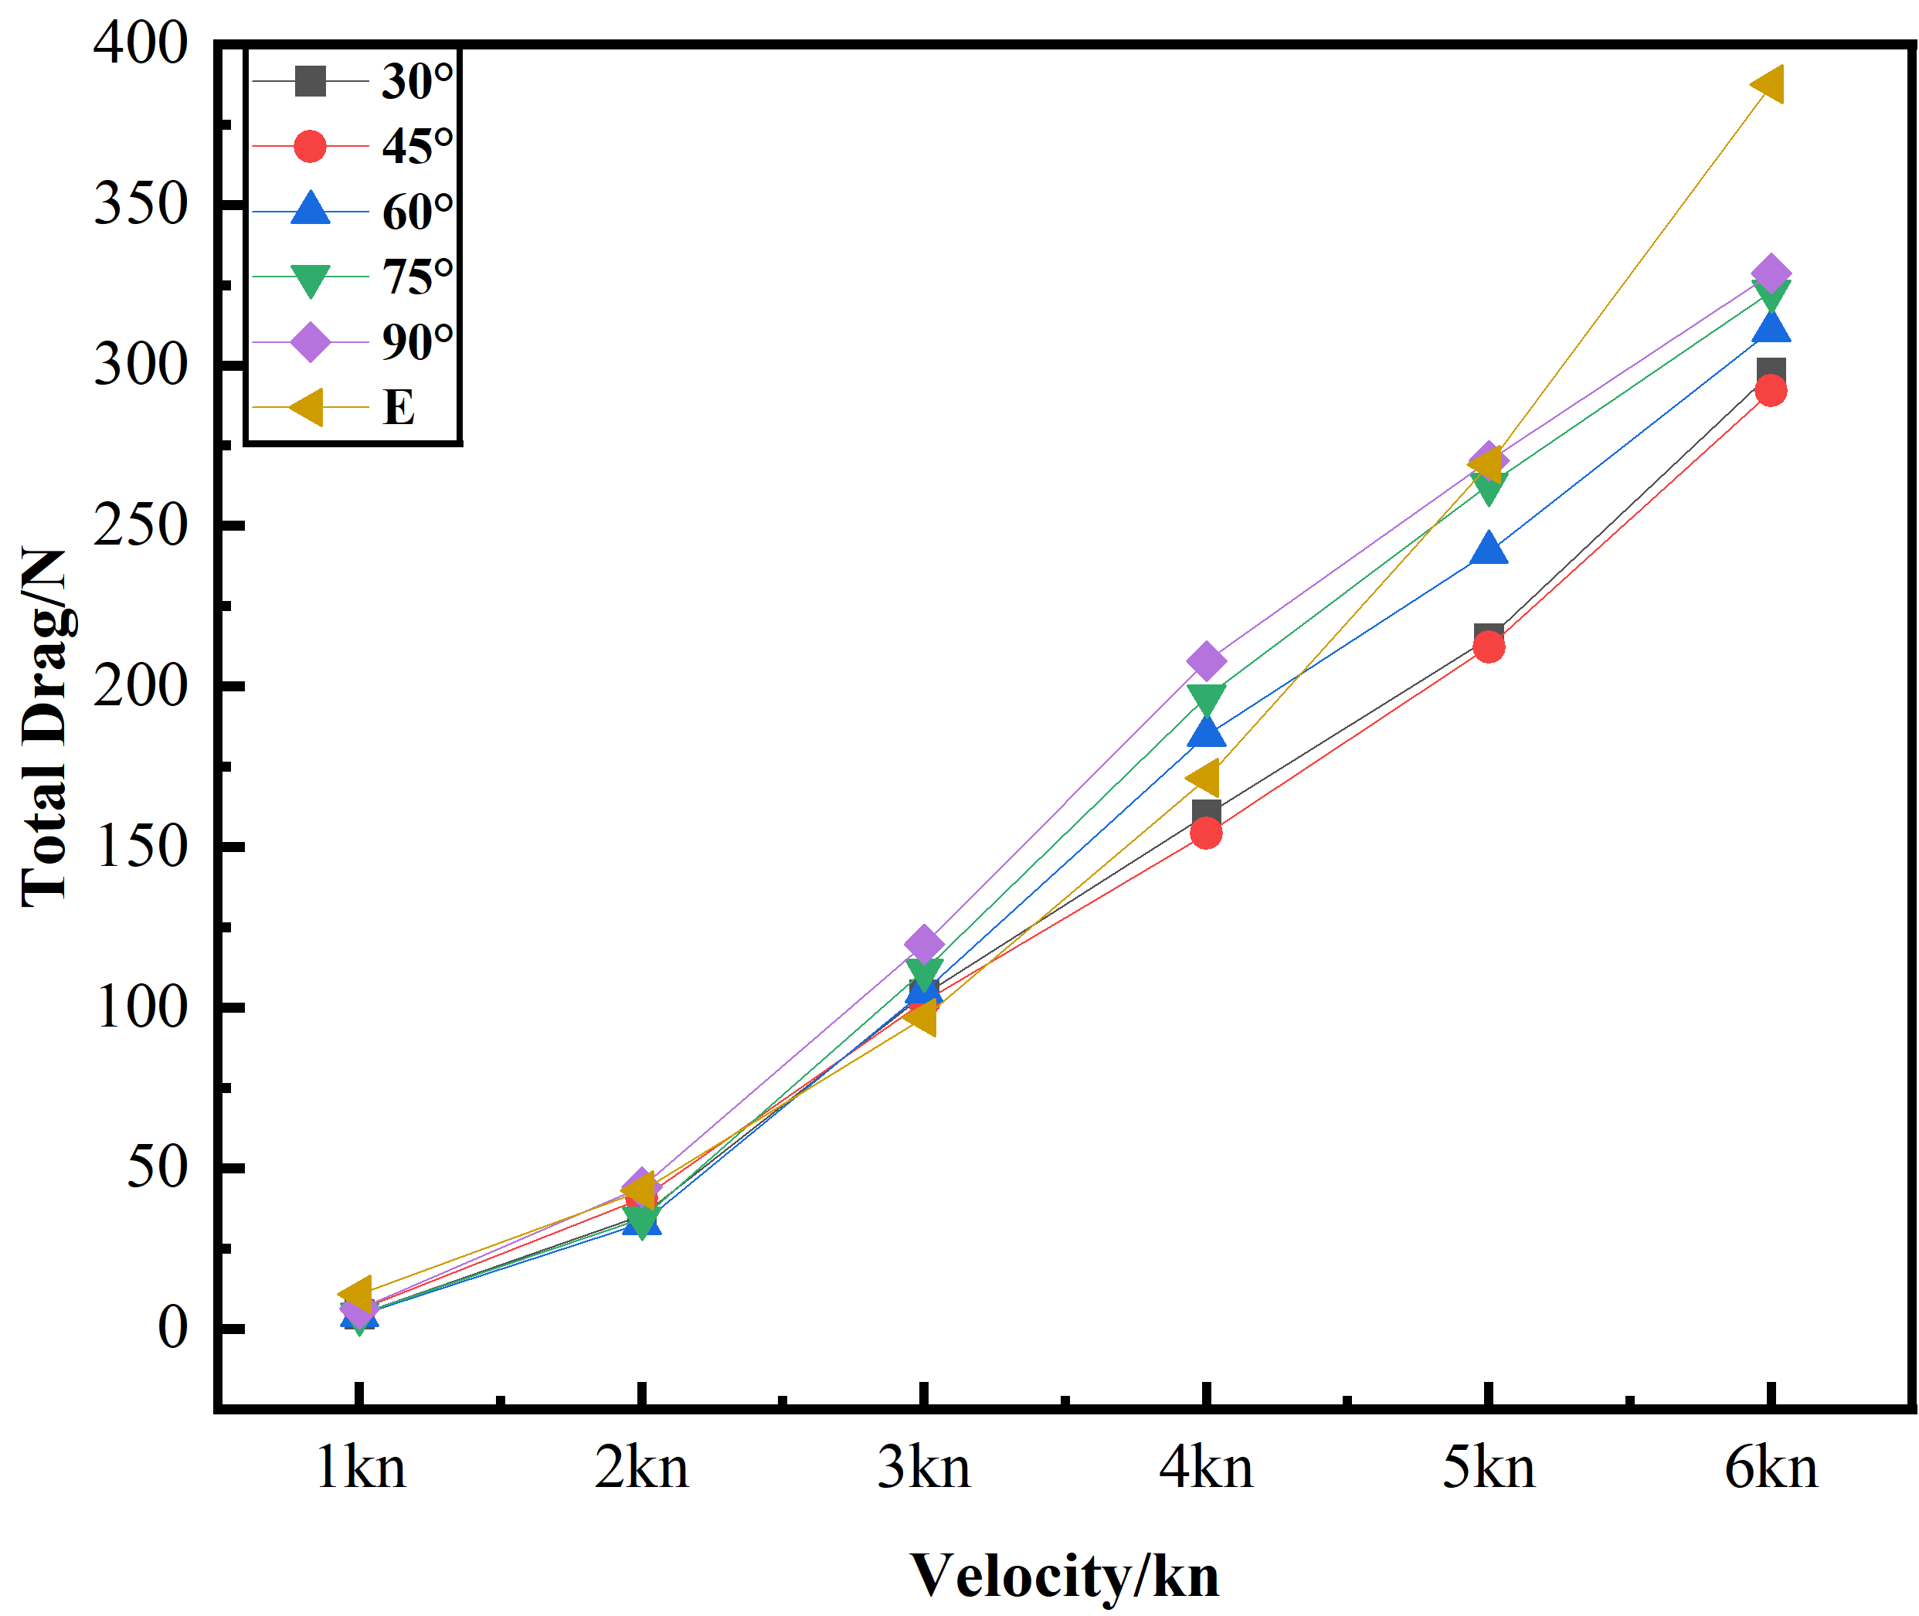
Fig. 3.R_{T}—Speed Line Chart
Analysis of Resistance Variation TrendsIn the figure, E represents the total resistance calculated by the empirical formula in Section 2.3. It can be observed that before reaching the maximum speed, this resistance and the resistance obtained from the simulation show roughly the same variation trend—both total resistances increase continuously with the increase of speed, and present an exponential growth trend overall after entering the high—speed stage. This indicates that the resistance obtained through simulation is relatively accurate.As can be seen from the figure, the variation trend differs in different speed ranges. This is mainly because the resistance of the robot in water is mainly composed of frictional resistance and wave-making resistance, and changes in speed have a significant impact on wave-making resistance. Especially when the robot enters the high—speed stage in water, wave-making resistance becomes the main resistance, leading to a rapid increase in resistance during the high—speed stage.At medium and low—speed (speed ≤ 2.00 kn), the robot with a 60.00° bow has the minimum total resistance. After entering the high—speed stage (speed ≥ 3.00 kn), the robot with a 45.00° bow has the minimum total resistance at speeds of 3 kn and 6.00 kn. At speeds of 4.00 — 5.00 kn, the robot with a 30° bow has the minimum total resistance. In the full speed range (1.00 kn ≤ speed ≤ 6.00 kn), the robot with a vertical (90.00°) bow has the maximum total resistance. Particularly when the robot sails at high—speed, the gap in total resistance between the vertical (90.00°) bow robot and other bow robots is more obvious.
Table 4 shows the total resistance and the relative error of each total resistance (using the 30.00° bow angle as the reference) to better compare the differences in total resistance among different schemes under various operating conditions.
Table 4.Total Resistance Values and Their Relative Errors Under Different Operating Conditions
Bow Inclination Angle/(°) | Resistance at 1 kn/N | Relative Error/% | Resistance at 2 kn/N | Relative Error/%
30.00° | 4.47 | 0.00 | 35.2 | 0.00
45.00° | 5.85 | 30.87 | 40.7 | 15.63
60.00° | 4.19 | -6.26 | 33.00 | -6.25
75.00° | 4.51 | 0.89 | 34.3 | -2.56
90.00° | 6.30 | 40.94 | 44.1 | 25.28
Bow Inclination Angle/(°) | Resistance at 3 kn/N | Relative Error/% | Resistance at 4 kn/N | Relative Error/%
30.00° | 110.00 | 0.00 | 154.00 | 0.00
45.00° | 102.00 | -7.27 | 162.00 | 5.19
60.00° | 105.00 | -4.55 | 185.00 | 20.13
75.00° | 111.70 | 1.55 | 197.00 | 27.92
90.00° | 119.70 | 8.82 | 208.00 | 35.06
Bow Inclination Angle/(°) | Resistance at 5 kn/N | Relative Error/% | Resistance at 6 kn/N | Relative Error/%
30.00° | 215.00 | 0.00 | 297.60 | 0.00
45.00° | 226.00 | 5.12 | 292.00 | -1.88
60.00° | 242.00 | 12.56 | 311.00 | 4.50
75.00° | 262.90 | 22.28 | 323.00 | 8.53
90.00° | 270.30 | 25.72 | 328.55.00 | 10.39
As can be seen from the table, as the amphibious robot’s navigation speed on water increases, the total resistance of the robot with different bow angles increases continuously. At low to medium—speed (speed ≤ 2.00 kn), the robot with a 60.00° bow angle has the smallest total resistance. When the navigation speed on water is 1.00 kn, the gap between the total resistance of the robot with a 60.00° bow angle (4.19 N) and that of the robot with the largest total resistance among other bow angles (6.30 N) reaches up to 47.20%. After entering high—speed conditions (speed ≥ 3.00 kn), the robot with a 45.00° bow angle has the smallest total resistance at speeds of 3.00 kn and 6.00 kn; at speeds of 4.00–5.00 kn, the robot with a 30.00° bow angle has the smallest total resistance. When the navigation speed on water is 4 kn, the gap between the total resistance of the robot with a 30.00° bow angle (154.00 N) and that of the robot with the largest total resistance among other bow angles (208.00 N) reaches up to 35.06%. At all speeds (1.00 kn ≤ speed ≤ 6.00 kn), the robot with a vertical bow angle has the largest total resistance. When the speed is 1.00 kn, the gap between the total resistance of the robot with a vertical bow angle (6.30 N) and that of the robot with the smallest total resistance among other bow angles (4.19 N) reaches up to 47.20%.
The above results indicate the following:
1.Under low to medium—speed operating conditions, the robot with a 60.00° bow angle has the smallest total resistance; under high—speed operating conditions, the robot with a 45.00° bow angle has the smallest total resistance at speeds of 3.00 kn and 6.00 kn; and at speeds of 4.00 — 5.00 kn, the robot with a 30.00° bow angle has the smallest total resistance.
2.Under all speed operating conditions, the robot with a vertical (90.00°) bow angle has the largest total resistance.
3.6 Analysis of Surface Wetting Coverage of Robots with Different bow angles
To illustrate the impact of different bow angles on the surface wetting coverage of the robot, this section selects three working conditions (low, medium, and high) with Froude numbers (Fr) of 0.131, 0.258, and 0.776 respectively. It analyzes the surface wetting coverage states of the robot under these different bow angles, which are shown in Figure 4, Figure 5, and Figure 6 respectively.
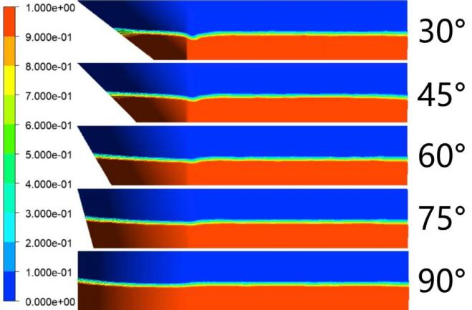
Fig. 4.Surface Wetting Coverage of the Robot with Different bow angles(Fr=0.131)
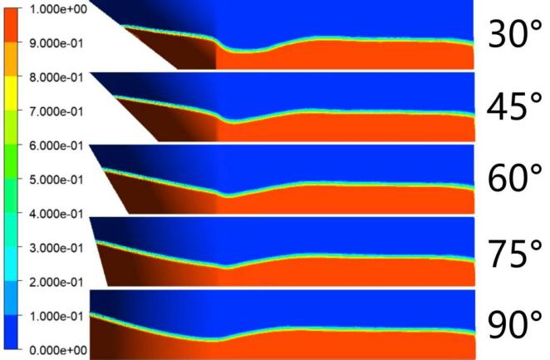
Fig. 5.Surface Wetting Coverage of the Robot with Different bow angles(Fr=0.258)
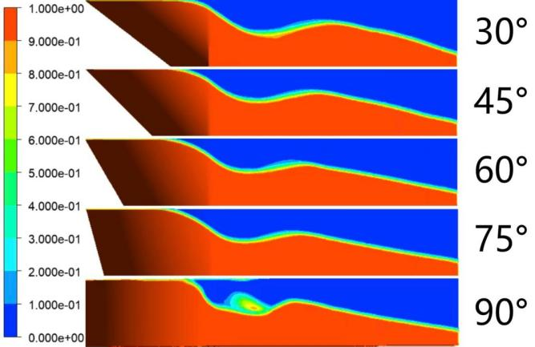
Fig. 6.Surface Wetting Coverage of the Robot with Different bow angles(Fr=0.776)
It can be seen from Figure 4, Figure 5, and Figure 6 that under the three working conditions of low, medium, and high—speeds (with Froude numbers Fr = 0.131, Fr = 0.258, and Fr = 0.776 respectively), the wetting coverage areas are mainly concentrated at the rear part of the robot's bow. Under the same working condition, changing the robot's bow angle does not cause a qualitative change in the wetting coverage area of the robot body, and the change trend is roughly the same. With the increase in speed, the surface wetting coverage area becomes larger and larger; especially when entering the high—speed range, the surface wetting coverage area of the robot body increases rapidly.
3.7 Analysis of Robot Surface Pressure with Different bow angles
To illustrate the impact of different bow angles on the surface pressure of the robot, this section selects three working conditions (low, medium, and high) with Froude numbers (Fr) of 0.131, 0.258, and 0.776 respectively. It analyzes the surface pressure states of the robot under these different bow angles, which are shown in Figure 7, Figure 8, and Figure 9 respectively.
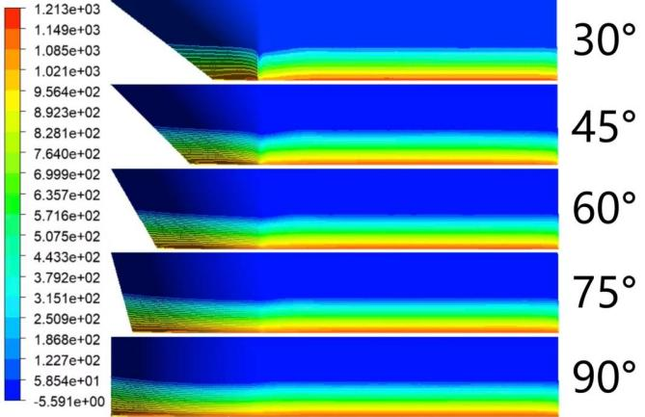
Fig. 7.Surface Pressure of the Robot with Different bow angles(Fr=0.131)
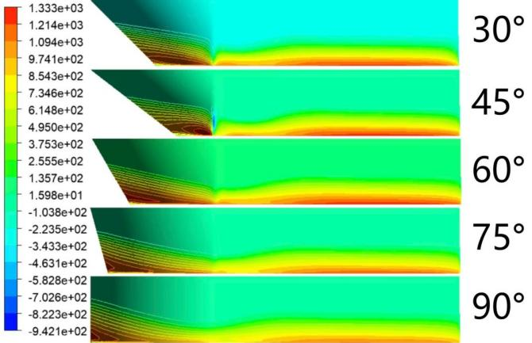
Fig. 8.Surface Pressure of the Robot with Different bow angles(Fr=0.258)
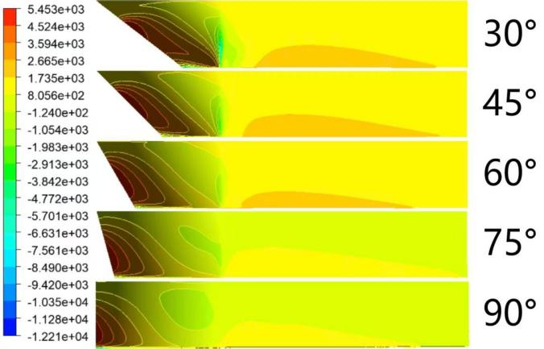
Fig. 9.Surface Pressure of the Robot with Different bow angles(Fr=0.776)
It can be seen from the figures that under the three working conditions of low, medium, and high—speeds (with Froude numbers Fr = 0.131, Fr = 0.258, and Fr = 0.776 respectively), the surface pressure of the robot body shows an obvious upper-lower stratification. This is mainly caused by the difference between the two distinct fluid media: air and water. With the increase in traveling speed, it can be clearly observed that the high-pressure area at the robot's bow gradually expands and the pressure value gradually increases, and the pressure gradient between the bow and the tail of the robot also increases gradually. As the speed increases, it is evident that the maximum pressure area of the robot body is located at the bow. This is because the wave-making resistance becomes concentrated as the speed increases.。
3.8 Wave-Making Analysis of Robots with Different bow angles
To illustrate the impact of different bow angles on wave-making at the free surface, this section selects three working conditions (low, medium, and high) with Froude numbers (Fr) of 0.131, 0.258, and 0.776 respectively. It analyzes the wave-making states at the free surface under these conditions, which are shown in Figure 10, Figure 11, and Figure 12 respectively.
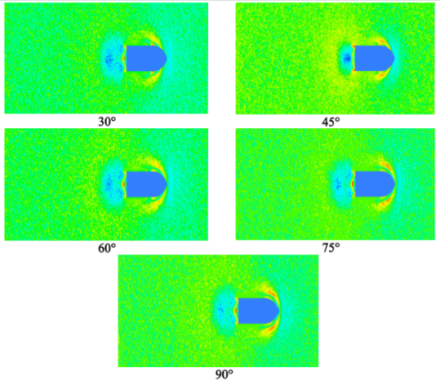
Fig. 10.Wave-Making Cloud Diagrams Corresponding to Different Robot bows(Fr=0.131)
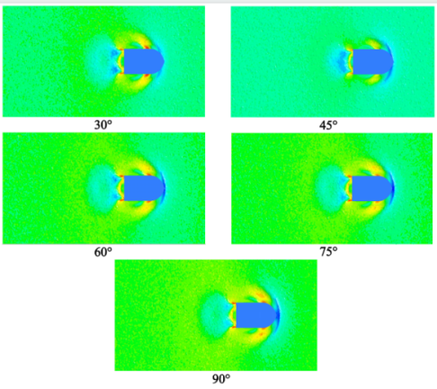
Fig. 11.Wave-Making Cloud Diagrams Corresponding to Different Robot bows(Fr=0.258)
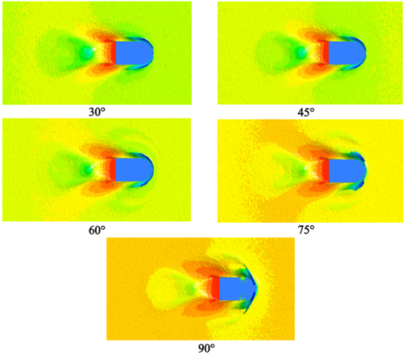
Fig. 12 Wave-Making Cloud Diagrams Corresponding to Different Robot bows(Fr=0.776)
In the above figures, the arrow shape at the robot's bow represents the shape of waves induced at the free surface when the robot sails on water. It can be seen from Figure 10, Figure 11, and Figure 12 that under the same working condition, the wave-making shapes at the free surface of the five schemes are relatively similar, but there are also subtle differences. The differences are mainly reflected in the following aspects:
With the increase of the Froude number (Fr), the waves induced at the free surface by the five schemes become more obvious. As the speed increases, the wave crests at the robot's tail increase significantly, the diffusion range of the wave shape also expands obviously, and the waves generated at the robot's bow gradually increase.
The areas with relatively high waves induced by the robot body all appear at the robot's bow, near the bow, and at the tail, and a backflow phenomenon is formed behind the robot body. This situation becomes more obvious as the speed increases.
4.CONCLUSON
This study mainly investigates the influence of different bow angles on the resistance performance of the vehicle body when sailing in water, and the following conclusions are drawn:
1.Under low and medium—speed conditions, the robot with a 60.00° bow angle exhibits the minimum total resistance.
2.Under high—speed conditions:At speeds of 3.00 kn and 6.00 kn, the robot with a 45.00° bow angle has the minimum total resistance;At speeds of 4.00 — 5.00 kn, the robot with a 30.00° bow angle shows the minimum total resistance.
3.Under the full speed range, the robot with a vertical (90.00°) bow angle has the maximum total resistance.
4.Under low and medium—speed conditions, the wave—making induced by the robot with a 45.00° bow angle is relatively small; while under the full speed range, the robot with a vertical (90.00°) bow angle causes the most severe wave-making.
Through the analysis of total resistance, wetted surface area, pressure distribution, and free surface wave shape, the differences in hydrodynamic performance among different bow configurations are further verified. This study provides a reference for the hull form optimization of amphibious robots, indicating that the matching bow angle should be selected according to the typical sailing speed to achieve the optimal design of hydrodynamic performance.
Due to technical and time constraints, a more in-depth study cannot be conducted, so several future research directions are proposed.Firstly, future studies can integrate more complex environmental factors, such as waves, currents, and different water depths, to explore the adaptability of optimal bow angles in real marine environments. Secondly, the coupling effect between bow angle and other structural parameters (e.g., stern shape, hull width, and draft) can be investigated to achieve a more comprehensive hydrodynamic optimization of the entire robot body. Thirdly, experimental verification using physical prototypes can be conducted to validate the numerical simulation results, enhancing the reliability and engineering applicability of the research findings. Moreover, with the development of intelligent navigation technology, dynamic adjustment mechanisms for bow angles can be explored, enabling the robot to adaptively switch the optimal bow angle according to real-time speed and environmental changes, thereby maximizing drag reduction efficiency. Finally, extending the research to amphibious robots of different scales and application scenarios (e.g., shallow-water rescue, deep-sea exploration) can broaden the scope of application of the conclusions, providing more extensive technical support for the design and development of high-performance amphibious robots.
DISCLAIMER (ARTIFICIAL INTELLIGENCE)
Author(s) hereby declare that NO generative AI technologies such as Large Language Models (ChatGPT, COPILOT, etc) and text-to-image generators have been used during writing or editing of manuscripts.

COMPETING INTERESTS:
Authors have declared that they have no known competing financial interests OR non-financial interests OR personal relationships that could have appeared to influence the work reported in this paper.
REFERENCES
- Alam, K., Ray, T., & Anavatti, S. G. (2014). Design and construction of an autonomous underwater vehicle. Neurocomputing, 142, 16-29.
- Cui, Z., Li, L., Wang, Y., Zhong, Z., & Li, J. (2023). Review of research and control technology of underwater bionic robots. Intelligent Marine Technology and Systems, 1(1), 7.
- Gao, T., Wang, Y., Pang, Y., & Cao, J. (2016). Hull shape optimization for autonomous underwater vehicles using CFD. Engineering applications of computational fluid mechanics, 10(1), 599-607.
- SHUPING H, ZEJIANG Z, HONGTAI L, et al. Hull shape optimization of small underwater vehicle based on Kriging-based response surface method and multi-objective optimization algorithm [J]. Brodogradnja: Teorija i Praksa Brodogradnje i Pomorske Tehnike, 2022, 73(3): 111-134.
- Tian, G., Fan, D., Feng, X., & Zhou, H. (2021). Thriving artificial underwater drag-reduction materials inspired from aquatic animals: progresses and challenges. RSC advances, 11(6), 3399-3428.
- Yang, W., Zhou, F., Chen, X., & Zhang, Y. (2021). Performance analysis of axial air cooling system with shark-skin bionic structure containing phase change material. Energy Conversion and Management, 250, 114921.
- Yuh, J. (2000). Design and control of autonomous underwater robots: A survey. Autonomous Robots, 8(1), 7-24.
- KAISHENG Z, CHAOFAN M, BAOCHENG Z, et al. Numerical simulation study on bionic mucus drag reduction of underwater vehicle [J]. International Journal of Fluid Mechanics Research, 2020, 47(4): 371-385.
- Hachicha, S., Zaoui, C., Dallagi, H., Nejim, S., & Maalej, A. (2019). Innovative design of an underwater cleaning robot with a two arm manipulator for hull cleaning. Ocean Engineering, 181, 303-313.
- Jiang, C., & Li, F. (2015). Experimental study on the characteristics of ventilated cavitation around an underwater navigating body influenced by turbulent drag-reducing additives. Science China physics, mechanics & astronomy, 58(9), 594703.
- FENG Y K, ZHANG G Q, XU X J. Study on the influence of vehicle-body-jet-propulsor coupling on hydrodynamic performance of amphibious vehicles [J]. Journal of Hydrodynamics, Ser. A, 2024, 39(2): 139-145.
- CHAO G Z, LIANG X Y. Studies of the resistance optimization of underwater vehicle based on multiple-speed approximate model [J]. MATEC Web of Conferences, 2019, 272: 01029.
- ZHOU L L, ZHANG L L. Numerical study on navigation resistance characteristics of amphibious vehicles [J]. Journal of South China University of Technology (Natural Science Edition), 2021, 49(12): 133-142.
- QIAN H, SONG K W, GUO C Y, et al. Influence of jet propulsor flow channel on ship resistance performance [J]. Chinese Journal of Ship Research, 2017, 12(2): 22-29.
- FAN J, CHANG Y, ZHU H, et al. Simulation study on the navigation resistance and shape optimization of a new type of amphibious vehicle [J]. Symmetry, 2025, 17(2): 193.
- Menter R F.Two-equation eddy-viscosity turbulence models for engineering applications[J].AIAA Journal,2012,32(8):1598-1605.DOI:10.2514/3.12149.

