Lightweight Design of a Multi-Axis Drilling Box Based on Topology Optimization

ABSTRACT
Background and objective：Under the backdrop of the manufacturing industry achieving leapfrog improvements through technological innovation, the modular drilling multi-spindle head, with its advantages of modularization and customizability, has emerged as one of the critical equipment in mechanical processing. However, current drilling multi-spindle heads still face challenges such as excessive weight and high production costs. To address these issues, ‌it was decided to conduct a lightweight design of the modular machine tool's drilling multi-spindle head.
Method: Through analyzing the machining process of the horizontal dual-station modular machine tool's drilling multi-spindle head, a three-dimensional structural model of the multi-spindle head was developed. Subsequently, static structural analysis and topology optimization were conducted on the spindle head using ANSYS software.
Findings: Through topology optimization analysis, The optimized design achieved a mass reduction of 23 kg (4.583%), and the maximum deformation was reduced by 0.1875×10⁻³ mm (5.809%).Although the maximum stress increased, it remained within the allowable limit.
Conclusions: The optimized design proves more advantageous for modular machine tool processing, which validates the effectiveness of the optimization method and provides a valuable direction for future green manufacturing processes.

Keywords: Modular machine tool; Multi-spindle drilling head; Topology optimization.

1. INTRODUCTION
‌Multi-spindle Head‌ is a critical component of modular machine tools, encompassing hole positions, cutting parameters, and spindles that transmit motion from the power unit to each spindle. Based on operational characteristics, multi-spindle heads are categorized into two main types: universal and specialized. They derive power from a standard power unit and are mounted together with it on a feed slide, enabling processes such as reaming and drilling.
This facilitates the continuous automated production of workpieces, optimizing and enhancing the efficiency of the automated production process while accelerating the transformation and flow of production inputs. The application and development of mechanical automation technology serve as the primary means for technological transformation and advancement in the machinery manufacturing industry, representing a key direction for technological progress. The level of mechanical automation technology not only impacts the development of the entire machinery manufacturing sector but also significantly influences the technological capabilities of various national economic departments.
The machining capability of the multi-spindle head also affects the service life of the machine tool. If the quality of the multi-spindle head is subpar or its strength is limited, it can severely compromise the machine tool's operational longevity. Additionally, the stability of its transmission affects the machining accuracy of the drilling machine, potentially resulting in non-conforming parts. For these reasons, optimizing the performance of the multi-spindle head has become a method to modernize current production modes, and improving its machining technology plays a crucial role in enhancing the performance of modular machine tools [1].

Modular machine tools have consistently been a highly sought-after development project both domestically and internationally.‌ Due to their multi-spindle design, which offers higher processing efficiency compared to single-spindle universal machine tools, modular machine tools have gained widespread popularity in the manufacturing industry, particularly in the high-volume production sectors such as internal combustion engine manufacturing [2].

The design of modular machine tools involves determining parameters such as the number and position of holes based on processing requirements, with the power transmission for spindle movement primarily provided by the multi-spindle box. The multi-spindle box, together with the power unit, is mounted on the feed slide to perform processes such as reaming and boring, fully demonstrating its versatility in processing capabilities [3]. The processing capacity of the multi-spindle box also affects the service life of the machine tool. If the multi-spindle box is overly heavy or has limited strength, it can significantly shorten the machine tool's operational lifespan. Additionally, the stability of its transmission affects the machining accuracy of the drilling machine, potentially resulting in non-compliant components. Therefore, optimizing the multi-spindle box has become a method to modernize current production practices.

Current optimization methods increasingly rely on computer-aided techniques, with topology optimization being one such approach. Unlike traditional methods that depend heavily on practitioner experience, topology optimization is a design method that utilizes computer-aided and mathematical techniques to alter the internal structure of an object without changing its overall shape, thereby meeting engineering requirements while adhering to strength and stiffness design criteria [4]. This approach more effectively reduces material consumption and manufacturing energy usage, aligning with the trend of green manufacturing. For instance, Pan Xiaohui [5] used the finite element method to establish stress and deformation cloud diagrams of the box, conducted parameter sensitivity analysis, and developed an optimization model for key dimensional parameters to achieve lightweight objectives. Li Yang et al. [6] employed derivative design for spindle box components, comparing the mass and maximum equivalent stress of different models to identify a significantly optimized box structure. Jiang Ang [7] analyzed the dynamic characteristics of the box, comparing modal vibration patterns and optimal stiffness convergence curves before and after topology optimization, effectively improving the static and dynamic performance of the spindle box.

The parameters of multi-spindle boxes are characterized by uncertainty and vary across different machine tools, making them one of the most critical components in modular machine tools. Their primary function is to arrange the machine tool spindles, transmission components, and corresponding auxiliary mechanisms. Their operational stability directly impacts the machine tool's lifespan and product quality, underscoring the importance of optimization. Optimization design plays a vital role in reducing the mass and volume of the multi-spindle box while maintaining the same processing efficiency and product quality, thereby realizing the concept of lightweight design. An optimized frame structure not only facilitates more efficient machining with modular machine tools but also extends the machine tool's service life. Additionally, it enhances the energy conversion ratio, reducing waste.

To address issues such as excessive mass and material wastage in spindle boxes, this study focuses on lightweight analysis. Taking the drilling multi-spindle box as the optimization target and considering its stress conditions under working environments, structural parameters are modified through topology optimization. Finally, a static analysis of the optimized box is conducted, demonstrating that it meets practical application requirements and aligns with lightweight objectives.[8]

2. Figure of the Multi-spindle Box Body Model
The multi-spindle drilling head studied in this paper belongs to a horizontal two-station modular machine tool, primarily used for machining automobile cylinder blocks. Automobile cylinder blocks require high dimensional accuracy and stringent geometric tolerance specifications. Internally, the system is driven by an electric motor that transfers power to the main shafts, with gears transmitting motion to the drive shafts for machining operations. It is capable of simultaneously processing six holes in an automobile cylinder block. As a critical automotive component, the cylinder block demands strict machining standards to ensure proper assembly of other parts and guarantee optimal vehicle performance.
The automated machine tool drilling line multi-spindle box mainly consists of components such as the box body, rear cover, top sealing cover, and drilling tools [9].The multi-spindle box body, as the core structural component of the entire device, is typically manufactured from materials such as cast iron or aluminum alloy through casting or machining processes. Its primary functions include providing a solid and stable installation foundation with rigid support for the internal transmission system, spindles, and auxiliary mechanisms. Simultaneously, it forms an enclosed space that effectively isolates external contaminants like cutting fluid, chips, and dust, thereby playing a critical role in protecting the internal precision components.
‌1) Top Cover‌: Located at the top of the box body, the top cover serves as an essential sealing and load-bearing component. Its design generally must account for the connection interface with the spindle drive motor. It not only seals the box body to prevent contaminants from entering from above but also acts as a critical structure for supporting and protecting the drive motor. In some designs, the top cover may also integrate features such as cooling fins or lubrication pipeline interfaces to meet specific functional requirements.
‌2) Base‌: As the foundational part of the box body, the structural design of the base is of utmost importance. Commonly, the base adopts a large-area cover plate structure, characterized by high flatness and rigidity. Its core roles include, first and foremost, supporting the total weight of the entire multi-spindle box and the various dynamic and static loads generated during the machining process. Secondly, it securely fastens the box body to the feed slide or worktable of the machine tool. Finally, its cover plate design facilitates disassembly, providing convenience for the installation, debugging, and maintenance of bottom transmission components.
‌3) Shell‌: Also referred to as the housing or the main body of the box, the shell is the core part that connects the top cover and the base to form a complete box-shaped structure. It is usually constructed as an integral or split-frame structure made from materials such as high-strength cast iron, steel plate weldments, or aerospace aluminum alloy. The inner walls of the shell are designed with precisely machined reference surfaces and high-precision bearing seat holes, directly responsible for the positioning, support, and fixation of all internal transmission components, including shafts, gears, and bearings. Its structural stiffness, natural frequency, and thermal stability directly determine the operational accuracy and dynamic performance of the multi-spindle box under high-speed and heavy-load conditions.
The three-dimensional software was used to model the drilling multi-spindle box. Since this optimization targets the box body and aims to improve computational efficiency, components such as gears, shafts, and other parts not involved in the optimization design were omitted, retaining only the box body. The resulting 3D model diagram of the drilling multi-spindle box body is shown in Figure 1.

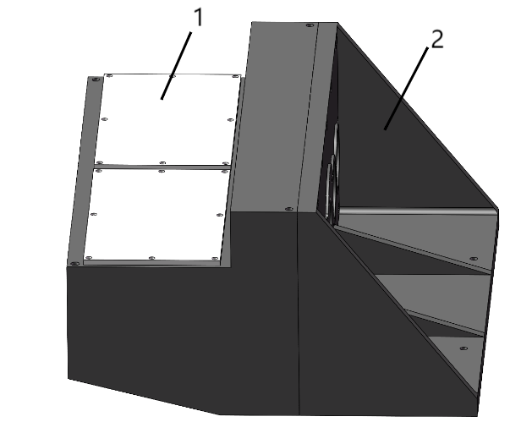
Fig. 1. 3D model of the drilling multi-spindle box body
Table 1. Multi-spindle Box Structure Table
1 Rear Cover of the Box Body
2 Box Body
The box body and rear cover of the drilling multi-spindle box are made of HT200(gray cast iron), with a density of 7200 kg/m³, a Poisson's ratio of 0.31, and an elastic modulus of 148 GPa, The yield strength of HT200 is approximately 200 MPa, and its tensile strength is also approximately 200 MPa.The upper sealing cover is made of Q235-AF, with a density of 7860 kg/m³, a Poisson's ratio of 0.277, and an elastic modulus of 208 GPa. Through software measurement, the mass of the drilling multi-spindle box before optimization is 504.965 kg, and the volume is 6,993,352.971 mm³.

3. ‌Structural Analysis of the Multi-spindle Box Body

3.1 Static Analysis of the Multi-spindle Box Body
ANASYS is an industry-leading finite element simulation software, with its core solver based on the powerful finite element method. As a numerical calculation technique, the finite element method has flourished since the 1980s alongside rapid advancements in computer technology and has now become a cornerstone technology for addressing complex engineering challenges. By discretizing intricate physical systems into a finite number of elements, ANASYS enables efficient performance of various types of structural mechanics analyses. Consequently, it is widely used for the rapid analysis, precise computation, and in-depth optimization of complex material properties and innovative structural designs, providing critical insights for engineering research and development [10].
The three-dimensional model of the drilling multi-spindle box body was imported into Workbench software. Within the software, HT200 and Q235-AF were assigned as the material properties., and 10 base plate bolt holes were constrained to prevent movement during the optimization process. Coordinate axes (X, Y, Z) were defined to position and describe geometric objects of the modular machine tool model. The model was then meshed with an element size of 0.03 m, resulting in a total of 93,305 nodes and 54,390 elements. Bearing loads were subsequently applied to the assembly. Considering the simultaneous presence of angular contact bearings and tapered roller bearings inside the box body, the connection areas of the box are required to withstand both axial and radial loads. Based on the known data, an analysis of the force conditions in the mechanical system supported by the bearings indicates that it is subjected to an axial load of 780N and a radial load of 686.8N from various bearings.

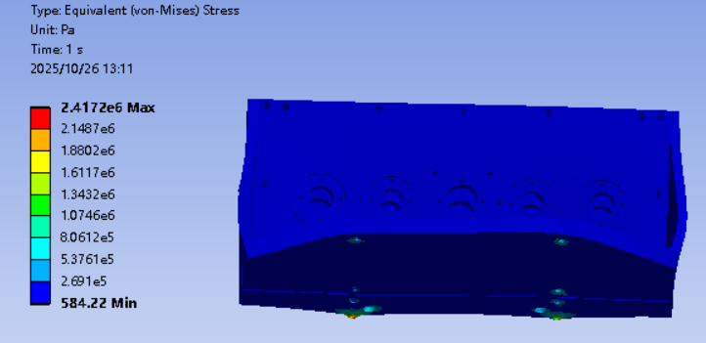Fig. 2. ‌Stress Diagram of the Multi-spindle Box Body

3.2 Strength Analysis of the Multi-spindle Box Body
Under the working conditions of the drilling multi-spindle box body, the operating time was set to 1 second. By solving the model based on the applied forces, the total deformation and equivalent stress of the box body in its initial state were obtained, as shown in Figure 2. The maximum equivalent stress is located at the bottom connection of the box body, with a value of 2.4172 MPa, while the stress distribution in other areas remains relatively low. This indicates that the applied stress is lower than the allowable stress of the multi-spindle box material, demonstrating significant optimization potential for the box body.
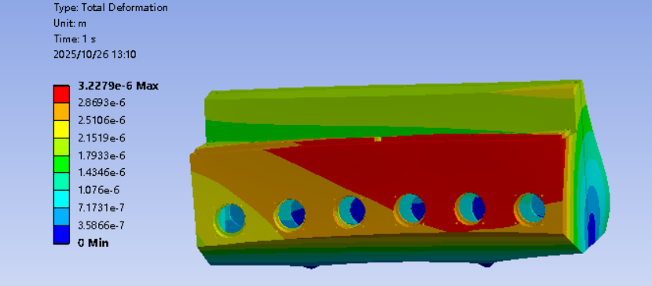Fig. 3. ‌ Deformation Diagram of the Multi-spindle Box Body

3.3 ‌Analysis of the Multi-spindle Box Body Deformation
Under the working conditions of the drilling multi-spindle box body, the total deformation is shown in Figure 3. The maximum total deformation is 3.2279 × 10⁻³ mm, located at the connection between the rear cover and the box body, as well as at the output shaft connection. Due to the presence of both axial and radial loads, the box body exhibits a tendency to be pressed downward.

4. Topology Optimization of a Multi-Spindle Drilling Head Box Body
As can be clearly observed from Figure 3, the deformation of the box body during the 1-second machining time of the modular machine tool's drilling multi-spindle head is evident. Analysis reveals that although the spindle receives power transmitted by the motor, the front end of the box body does not bear significant loads. Instead, the maximum deformation occurs at the rear wall of the box body, as it is subjected to relatively larger loads. Therefore, special attention should be paid to the loads on the rear wall during optimization. After conducting a kinematic analysis of the multi-spindle head box body, a static analysis was performed on the machine tool, with additional conditions applied to enhance its stiffness [11].
Upon obtaining the deformation information, topology optimization was carried out on the box body. Topology optimization is a commonly used method in structural design. It is a mathematical approach that determines the topological relationship of a structure through material distribution, while satisfying the given design space, constraints, objective functions, and load distribution conditions [12]. As a widely used structural optimization method, the rapid advancement of topology optimization technology has made its implementation through finite element methods a mainstream approach in lightweight design [13]. primarily applied during the conceptual design phase of product development [14]. The basic steps for conducting topology optimization in ANSYS are as follows:
1) Define the topology optimization task
Specify the required optimization task, including topology structure optimization, energy minimization, etc. Different optimization algorithms can be selected as needed.
2) Run the topology optimization
Execute the topology optimization in ANSYS and monitor the optimization process and results in real time through the interface.
3) Analyze the results
ANSYS provides comprehensive result analysis tools, including visualization and analysis of information such as molecular structures, bond lengths, and angles
In the field of modular machine tool frame engineering, traditional mechanical standards such as stiffness, reliability, and cost remain key driving factors in the design of new connection technologies [15]. These standards form the foundation of the structural integrity and long-term economic efficiency of machine tools. This study focuses on the drilling multi-spindle head of modular machine tools, which serves as a core unit in factory automated production lines. The machining methods of such machine tools are typically fixed, designed specifically for high-volume, low-variety production scenarios. This process stability minimizes adjustments and downtime in the production line, thereby significantly enhancing the overall economic efficiency of the automated machining system and making it indispensable in industries such as automotive and hydraulic components manufacturing.‌
‌The power transmission mechanism of the multi-spindle head relies on a precision gear meshing system, which effectively distributes and transmits the torque from the main motor to each spindle, driving tools such as drill bits for synchronous machining. After completing operations at one station, the workpiece is automatically transferred to the next workstation until all processes of the entire automated line are finished. The advantages of this design are multifaceted: it has relatively lenient requirements for the manufacturing precision of individual components, achieving lower manufacturing costs through standardized gears and shaft systems. At the same time, it combines high automation, very short cycle times, long service life, and excellent overall economic efficiency. As a result, modular machine tools hold a significant share in the global manufacturing equipment market. It is noteworthy that China has become the world's largest producer and consumer of modular machine tools. This market position makes the optimization of multi-spindle head structure not only a technical issue but also an urgent strategic task for China's manufacturing industry.‌
‌Structural optimization of the multi-spindle head holds profound significance. The primary goal is to achieve lightweight design through topology optimization, material substitution (e.g., using high-strength aluminum alloys or composite materials), and bionic structural design, significantly reducing the mass of the box while ensuring stiffness. Lightweighting not only reduces material consumption and inertial loads but also lowers the demands on the drive system, thereby achieving energy savings. Furthermore, optimization can comprehensively enhance product performance. For example, by improving the gear transmission layout and bearing support methods, vibrations and noise can be reduced, machining accuracy and surface finish can be improved, and ultimately, production efficiency and product consistency can be greatly enhanced.‌
‌The parameters of multi-spindle heads are highly uncertain, as their structures vary depending on specific machining tasks, workpiece materials, and accuracy requirements. This makes them one of the most complex and critical components in modular machine tools. As an integrated platform, its main function is to precisely arrange all machine tool spindles, corresponding transmission components (such as gears, transmission shafts, and bearings), and necessary auxiliary mechanisms (such as lubrication pipelines and tool release mechanisms). Its operational stability directly determines the dynamic performance of the entire machine, its service life, and even the quality of the final product. Therefore, any optimization of it holds immense engineering value.‌
‌The optimization design process itself is a core aspect of modern mechanical design. It requires systematically reducing the mass and volume of the multi-spindle head box while maintaining or even improving existing work efficiency and product quality. Optimizing the frame structure can make the overall machine tool more stable, thereby achieving higher machining efficiency and extending equipment life. Ultimately, an efficient and lightweight multi-spindle head can improve the energy conversion efficiency of the entire machine, minimizing energy waste, which aligns closely with the green manufacturing and sustainable development concepts advocated by the global industry
The purpose of optimizing the combined machine tool box body is to enhance its performance and stability, making it more suitable for machining workpieces with high precision and quality. A transmission design scheme is specified to ensure that the product balances both performance and cost-effectiveness under given design requirements. This study employs the Workbench topology optimization method to investigate the multi-spindle drilling box.
In the research, it is known that the box body supports the output shaft and transmission shaft. Although it bears certain loads, optimization cannot be directly applied to these components. Therefore, their connection areas are designated as non-optimizable regions, while the response constraint is set to 65% of the total mass. The remaining areas are defined as optimizable regions, as shown in Figure 4, and the solution is subsequently carried out.
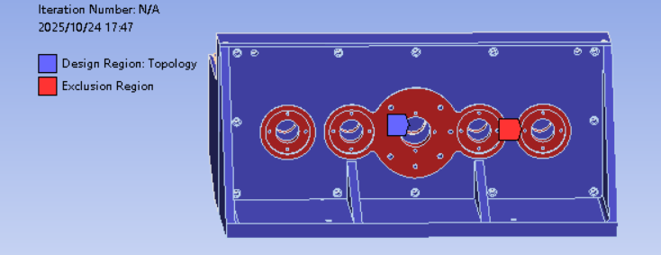
Fig. 4. Optimization Region Setup
After 19 iterative calculations, the convergence curves for the composite objective and mass constraint are obtained, as shown in Figure 5. These curves indicate that during the iterative process, the objective convergence met the composite target convergence criteria, and the mass response satisfied the response criteria, thereby demonstrating the feasibility and effectiveness of the optimization. The resulting optimization outcome is presented in Figure 6.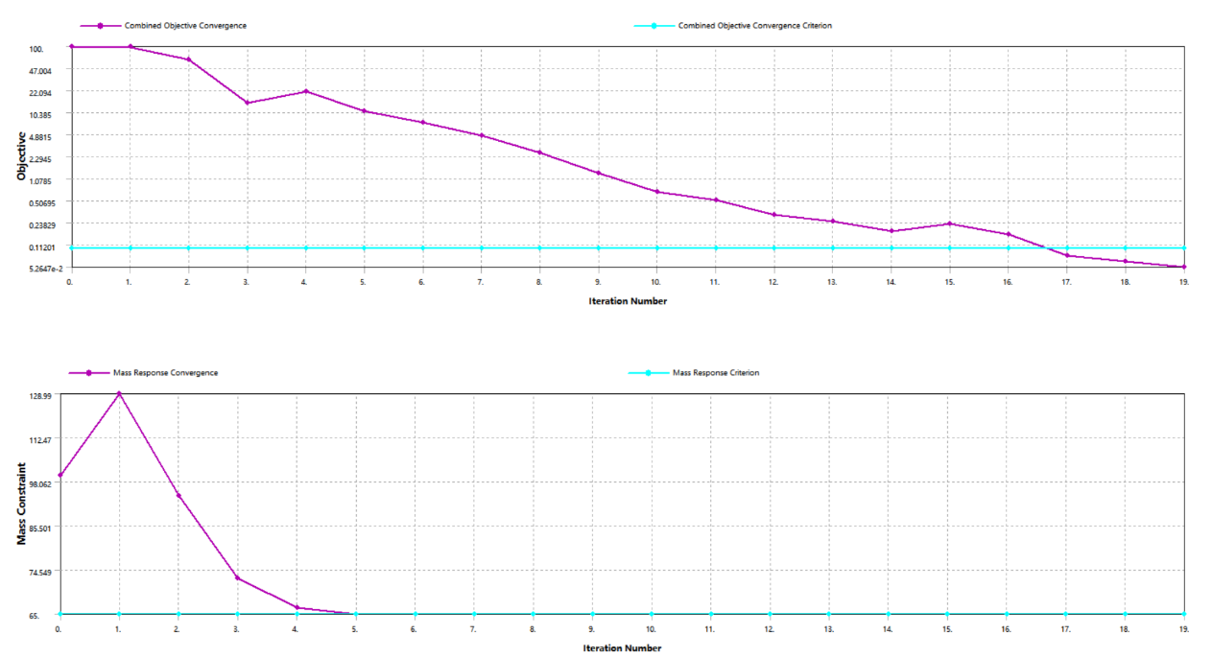
Fig. 5. Graph of Mass and Response Constraints

Fig. 6. Topology Optimization Result
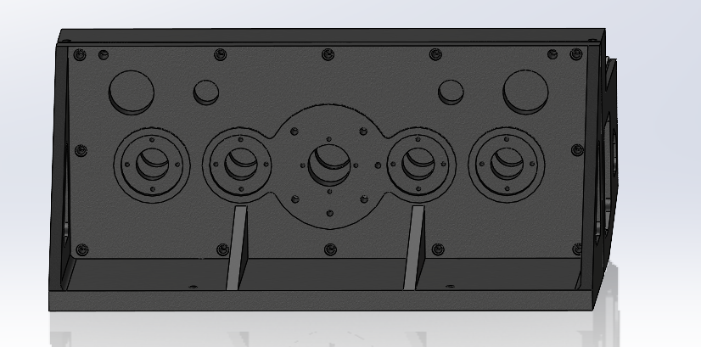
According to Figure 6, after topology optimization, the internal non-load-bearing sections were simplified by omitting optimizable components, effectively optimizing the multi-spindle drilling box to meet lightweight standards. By disregarding the influence of small-sized apertures and minor feature transformations on the multi-spindle drilling box, and based on the optimization results, material was removed from the rear cover and selected sections of the box while ensuring structural integrity. The optimized outcomes are illustrated in Figures 7 and 8.
Fig. 7. Optimized Model of the Cabinet Front

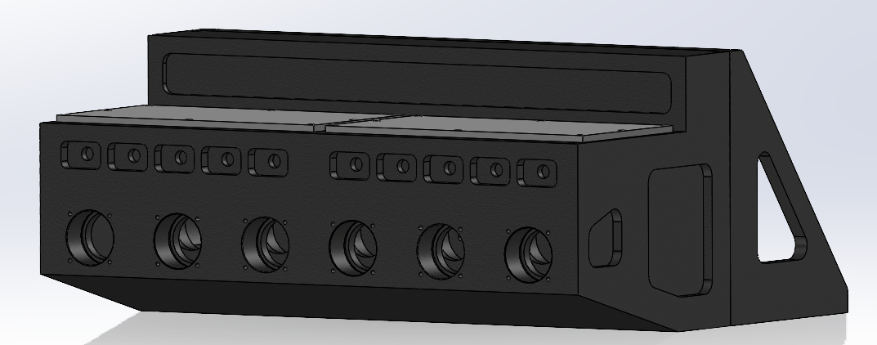
Fig. 8. Optimized Model of the Cabinet Rear

Perform a strength analysis on the optimized modular machine tool gearbox using the same conditions as the initial design. Under the load case applied to the bottom of the gearbox, the equivalent stress distribution is shown in Figure 9. The maximum equivalent stress is located at the connection area of the gearbox base, with a value of 2.469 MPa, while the rest of the structure exhibits uniform and relatively low stress levels. The deformation plot after optimization is presented in Figure 10. The maximum deformation occurs at two locations: the connection between the rear cover and the gearbox housing, and the interface of the output shaft. The maximum deformation magnitude is 3.0404×10⁻³ mm. Due to the combined effect of axial and radial loads, the gearbox exhibits a tendency to be pressed downward.
Fig. 9. ‌Stress Diagram of the Optimized Casing
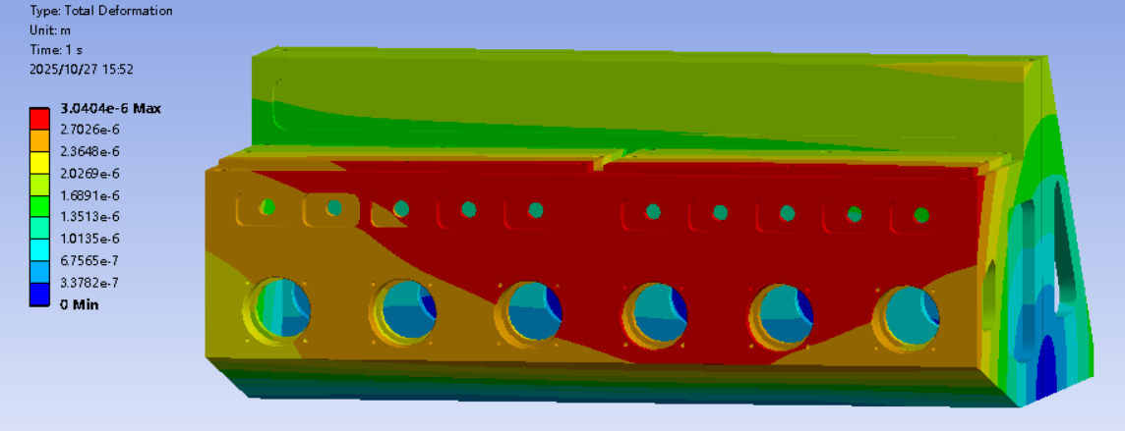
Fig. 10. Deformation Diagram of the Optimized Casing

5. Comparative Analysis Before and After Optimization
The comparative analysis of the static performance between the initial design and the topology-optimized version of the multi-spindle headstock's box structure is summarized in Table 2. Results indicate a mass reduction of 23.142 kg in the base, along with a decrease in maximum deformation by 0.1875×10⁻³ mm. Although the maximum equivalent stress shows a slight increase, it remains within the acceptable strength limits.
Table 2. Comparative Static Analysis of the Multi-spindle Headstock Box Before and After Optimization
Performance | Initial Solution | Optimized Solution | Performance Change Rat
Mass/kg | 504.965 | 481.823 | -4.583%
Maximum Equivalent Stress/MPa | 2.4172 | 2.469 | 2.143%
Maximum Deformation/mm | 3.2279×10⁻³ | 3.0404×10⁻³ | -5.809%

6. CONCLUSION

This study begins with the structure of a modular machine tool's drilling multi-spindle headstock to establish a three-dimensional model, including the rear cover and the main box. Through topology optimization, the key structures of the modular machine tool (such as the multi-spindle drilling box housing, rear cover, and internal frame) achieved significant weight reduction while maintaining load-bearing performance. The optimized model removed 4.583% of redundant material, The maximum deformation is reduced by 5.809,with the maximum stress value still within the allowable range, demonstrating that the lightweight design meets engineering reliability requirements. Specifically, the simplification of small aperture structures and local features in non-load-bearing regions improved material utilization efficiency while controlling stress concentration.
This study implemented a topology optimization strategy combining parametric modeling and cross-referencing, enabling visualization of force transmission paths under complex loading conditions of the multi-spindle system. The final configuration demonstrated superior static stiffness compared to the initial design.
The optimization results provide new insights and methodologies for designing high-dynamic-response machine tool structures. On the manufacturing level, it reduces casting defect risks and material costs; on the operational level, the lightweight structure decreases drive system energy consumption while extending the service life of the modular machine tool's multi-spindle box through rational mass distribution.[16]
On the transfer line of modular machine tools, the components to be processed are not singular but determined by user demands. This study specifically focuses on the machining of automotive engine blocks. When processing different components, the spindle load-bearing requirements of the multi-spindle head on modular machine tools vary. Although this study achieved only a mass reduction of 23 kg and a maximum deformation reduction of merely 0.1875×10⁻³ mm, it provides valuable optimization insights for modular machine tools in industrial settings. This approach enables modular machine tools to leverage their advantages when handling diverse machining environments, thereby extending their service life and advancing toward greener manufacturing processes.

COMPETING INTERESTS DISCLAIMER:
Authors have declared that they have no known competing financial interests OR non-financial interests OR personal relationships that could have appeared to influence the work reported in this paper.

Disclaimer (Artificial intelligence)
Option 1:
Author(s) hereby declare that NO generative AI technologies such as Large Language Models (ChatGPT, COPILOT, etc.) and text-to-image generators have been used during the writing or editing of this manuscript.
Option 2:
Author(s) hereby declare that generative AI technologies such as Large Language Models, etc. have been used during the writing or editing of manuscripts. This explanation will include the name, version, model, and source of the generative AI technology and as well as all input prompts provided to the generative AI technology
Details of the AI usage are given below:
1.
2.
3.

REFERENCE
- Bernd Peukert,Stephan Benecke,Janire,Clavell,Sabrina Neugebauer,Nils F. Nissen,Eckart Uhlmann,Klaus-Dieter Lang,Matthias Finkbeiner. Addressing Sustainability and Flexibility in Manufacturing Via Smart Modular Machine Tool Frames to Support Sustainable Value Creation[J]. Procedia CIRP,2015,29.
- Jin YanAn. A Brief Analysis of the Design and Manufacturing History of Transfer Machines in the Automotive Industry [J]. World Manufacturing Technology and Equipment Market,2021,No.175(04):76-77.
- Wang LiZhen. ‌Design of Control System for Double-Sided Drilling Combined Machine Tool [J]. Mechanical Engineering and Automation, 2017, No. 205(06):180-181+184.
- Huang, H., Zhang, J., Xu, B., Liu, G., Luo, Q., & Wang, X. (2021). Topology optimization design of a lightweight integrated manifold with low pressure loss in a hydraulic quadruped robot actuator. Mechanical Sciences, 12(1), 249-257.
- Wang, T., Liu, X., Liu, Z., Liu, Y., Zhang, Y., & Wang, Z. (2018). ANSYS is used on drilling Inner Blind Hole on Deep Hole. Wireless Personal Communications, 103(1), 1077-1088.
- Li Yang,Cao GuiFu,Yang Lin. Structural Optimization of Machine Tool Spindle Box Based on Generative Design[J]. Modern Machinery,2022,(03):88-91. DOI:10.13667/j.cnki.52-1046/th. 2022.03.001.
- Ligang, C. A. I., Shiming, M. A., Yongsheng, Z. H. A. O., Zhifeng, L., & Wentong, Y. A. N. G. (2012). Finite element modeling and modal analysis of heavy-duty mechanical spindle under multiple constraints. Journal of Mechanical engineering, 48(3), 165-173.
- Ana Vafadar,Majid Tolouei-Rad,Kevin Hayward. An integrated model to use drilling modular machine tools[J]. The International Journal of Advanced Manufacturing Technology,2019,102(5-8).
- Xia Tian,Si JianXing,Xu Ling,Wang LiHua. Structural Design of Machine Tool Headstock[J]. Machine Tool & Hydraulics.2014,42(04):116-117.
- Chan, T. C., Ullah, A., Roy, B., & Chang, S. L. (2023). Finite element analysis and structure optimization of a gantry-type high-precision machine tool. Scientific Reports, 13(1), 13006.
- Jong Kweon Park,Sungcheul Lee. Experimental Verification of Dynamic Behavior of a Capsule-Type Modular Machine Tool for Multifunctional Processes[J]. Journal of Manufacturing Science and Engineering,2017,140(1).
- Chang Bei. ‌Topology Optimization Design of the Column Structure for a Heavy-Duty Vertical Machining Center [D]. Guangzhou University.,2020.DOI:10.27040/d.cnki.ggzdu.2020.000109.
- Yan Yang,Li Hang,Xu HuiBing,Xu ShengRong,Chrn ChaoYing,Li Ping.Topology Optimization Design of a Certain Model Rear Swing Arm Based on ANSYS [J]. Automobile Parts.,2023,No.178(04):46-50.DOI:10.19466/j.cnki.1674-1986.2023.04.009.
- Xie Jun,Liao,YingHua,Liao Chuan. ‌Static and Dynamic Characteristic Analysis and Topology Optimization of Vertical Machining Center Spindle Headstock [J]. Machine Tool & Hydraulics,2020,48(23):166-170.
- Eckart Uhlmann,Mihir,Saoji,Bernd Peukert. Principles for Interconnection of Modular Machine Tool Frames[J]. Procedia CIRP,2016,40.
- Jiang, K., Wang, J., Chen, Z., Zhou, Q., & Jiang, S. (2023). Influence of coupling factors on structural reliability based on polynomial response surface optimization model. Advances in Mechanical Engineering, 15(8), 16878132231184145.

