Original Research Article
DESIGN AND ANALYSIS OF A MULTIPURPOSE POWER TILLER WITH CG 125 PRIME MOVER

.
ABSTRACT

Aims: the aim of the study was to design a relatively low-cost power tiller with an irrigation system to ease the laborious nature of the conventional method of ploughing and irrigation.
Study design: the power tiller incorporated with spray gun for irrigation was designed using several key steps. The design process typically included defining the requirements, conceptualising the design, detailing the design, prototyping, testing, and refining the final product. the system was simulated using Autodesk inventor 2023, for Von Mises Stress (MPa) and Minimum Safety Factor (ul).
Place and Duration of Study: University for Development Studies, for the period of three months.
Methodology: A relatively low-cost power tiller with an irrigation system was designed and simulated using AutoCAD and Autodesk Inventor. Finite Element Analysis was done to determine the stresses on the frame with total weight acting on the frame (450 N) was applied as a distributed load. The engine weight (305N) was applied to the seats as distributed load. The force applied at the end of the plough was 2525 N. The control bars were considered a cantilever beam, and load of 157.5 N was applied on the two ends of the handle. The total vertical load acting on the shaft (550 N), was applied, and a torsional load of 8090 N due to the driving force from the engine, was also applied. The values of the Von Mises Stress for all the components were below the yield strength of the material used. The safety factor was above one, indicating that the components can function without failures.
Results: The simulation results showed that the values of the Von Mises Stress for all the components were below the yield strength of the material used (Frame-17.3815, Front Engine Seat-1.67239, Back Engine Back seat-13.656, Mouldboard Plough-220.727, Control Bars- 0.0909601 and Driving Wheel Shaft-74.8531). The safety factors of the components were all above one, indicating that the components can function without failures (Frame-3, Front Engine Seat-3, Back Engine Back seat-3, Mouldboard Plough-1.2 Control Bars-3 and Driving Wheel Shaft-2.7). This implies that the system can integrate the tilling activities and functions of irrigation.
Conclusion: The findings of the study indicate that the Von Mises Stress and factor of safety were desirable, therefore they if deployed physical can help to reduce the labour intensiveness of tilling and irrigation in Ghana. The implementation of the system will further reduce cost of farming, thereby increasing food security in the country.

Key Words: Mechanization, Design, Analysis, Multipurpose, Power Tiller, Mouldboard plough

1. INTRODUCTION
Mechanization is a labor-saving technology that allows farmers to extend their fields where there is accessible land while also freeing up labor for other agricultural activities or off-farm income generating (Diao et al., 2018). Industrial revolution has resulted in agriculture becoming much less labour-intensive. Tractors, trucks, combine harvesters, numerous agricultural instruments, aircraft, and other vehicles are all used in modern mechanized agriculture. Precision farming even employs computers connected with satellite photography and navigation to boost profits (Sung, J. (2018).
There is sufficient evidence that increasing the level of agricultural mechanization (AM) leads to a large rise in production. Countries having the highest levels of AM, such as China, the United States of America, South Korea, and Japan dominate in global food production (Khetigaadi 2016). According to Statista (2019), Asia was the largest producer of fresh vegetables, accounting for 834.2 million metric tons, or 73.23% of global production. Africa produced only 79.14 million metric tons in 2017, accounting for approximately 7.23% of the global production of fresh vegetables of 1094.34 million metrics. Labour for agricultural activities is extremely difficult to obtain, and the number is steadily declining in Africa, where it was highest. This can be linked in part to the trauma associated with it, as well as the job's impermanence (Sutton, 1983). In Ghana, the restricted availability of agricultural machinery is a significant barrier to AM. Due to limited access, only 16% of agricultural land is machine-cultivated, while 11% of arable land is irrigated (Panel, 2018).
Ghana's agricultural mechanization, particularly in the irrigation sector, is extremely poor, lagging behind many other countries, including those in Africa. It has not made good progress, and better and upgraded machinery for land preparation and irrigation are needed to support the deployment of enhanced farming methods (Diao et al., 2018). However, because small-scale farmers dominate the agricultural industry in Ghana, the vast majority of farmers cannot afford tractors and other large and complex equipment. This story is similar to what is happening in the rural farming communities in India (Upadhyaya, et al. 2022).
One solution is to employ low-power, multi-purpose portable equipment like single-axle tractors, commonly known as power tillers. Today, an imported power tiller in Ghana costs more than GH¢ 20,000 to GH¢25,000. As a result, many small-scale farmers are unable to purchase them. According to Benin (2015), small-holder farmers perform practically all agricultural tasks with hand tools and human strength. This old technique is marked by various problems, including drudgery since farmers who use hand tools must exert more work, limited farm size, delayed land preparation, insufficient water supply, and so on. As a result, these small-scale farmers cannot achieve maximum yields without timely soil preparation and adequate water delivery (Nyagumbo et al., 2017). In many situations, farmers have been unable to feed their own families and are unlikely to have a surplus of produce to market and sell. As a result, there is a need for a locally built power tiller that is less expensive than imported ones, as well as a small-scale irrigation system for effective water supply, to assist small-holder farmers in Ghana and neighboring countries.

2. MATERIAL AND METHODS

2.1 Design Process
In the design of the Multipurpose Power Tiller (MPT), several key steps are involved. The design process typically includes defining the requirements, conceptualizing the design, detailing the design, prototyping, evaluation, and refining the final product.
2.2 Design Considerations
Designing the power tiller with a small-scale irrigation system, using Cg 125 engine, requires careful consideration of various factors to ensure efficiency, functionality, and ease of use. Key requirements were set for designing the Multi-purpose Power Tiller (MPT) regarding power, size, versatility in attachments, irrigation system integration, operator ergonomics, engine efficiency, adjustability of depth, safety features, and cost-effectiveness in manufacturing. With these design considerations, the resulting MPT can offer a practical and efficient solution for farmers with limited resources.
2.3 Key Components of the machine
The design and analysis of the multipurpose power tiller require a careful selection of materials (Table 1) to ensure durability, efficiency, and safety. The key components in this design include the engine, frame, front and back engine seats, mouldboard plough, control bars, and driving wheel shaft, and all these components and parts were modelled in AutoCAD 2022 (Figures 1 to 7).
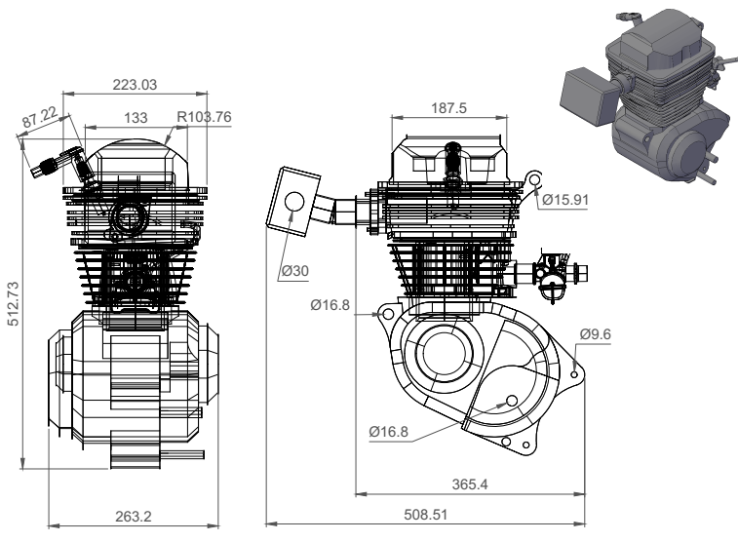

Fig. 1 The Engine

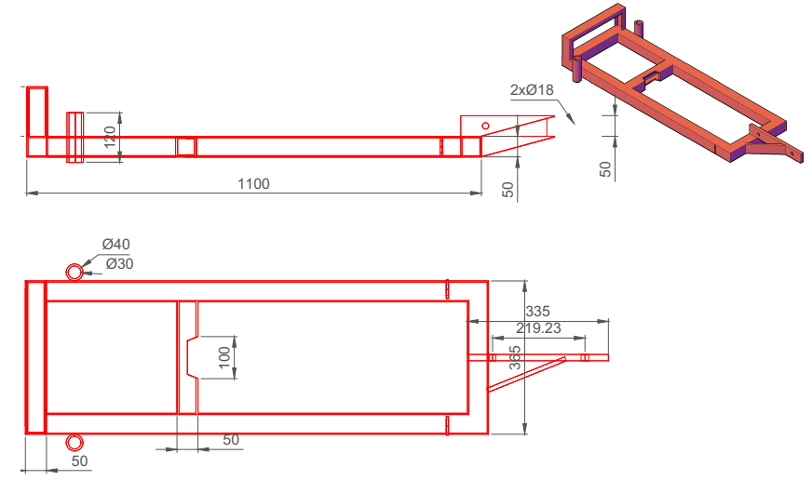Fig. 2 The Frame

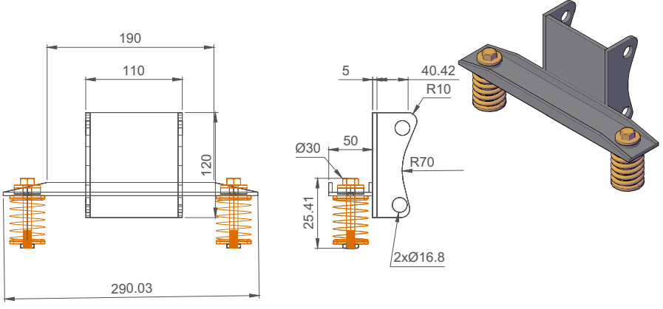

Fig. 3 Front Engine Seat

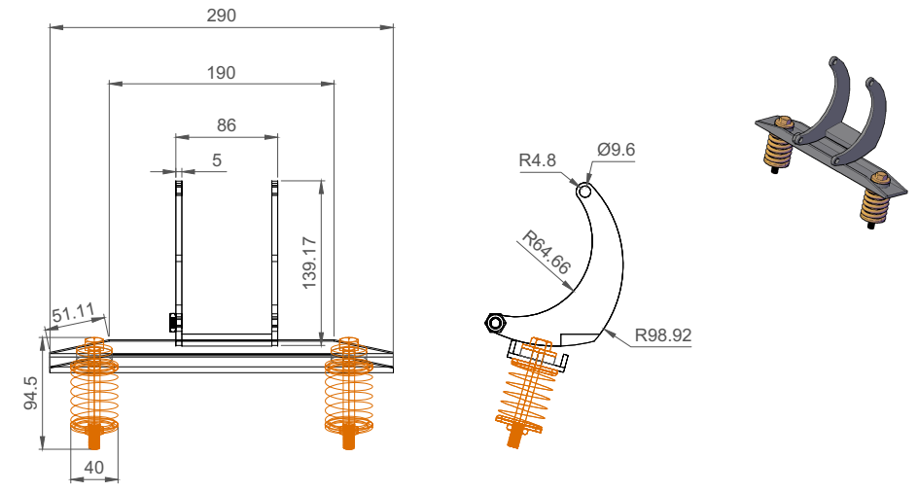

Fig. 4 Back Engine Seat

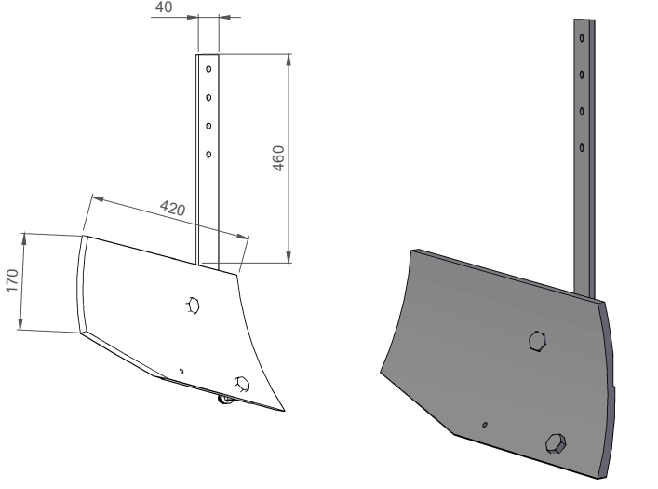
Fig. 5 Mouldboard plough

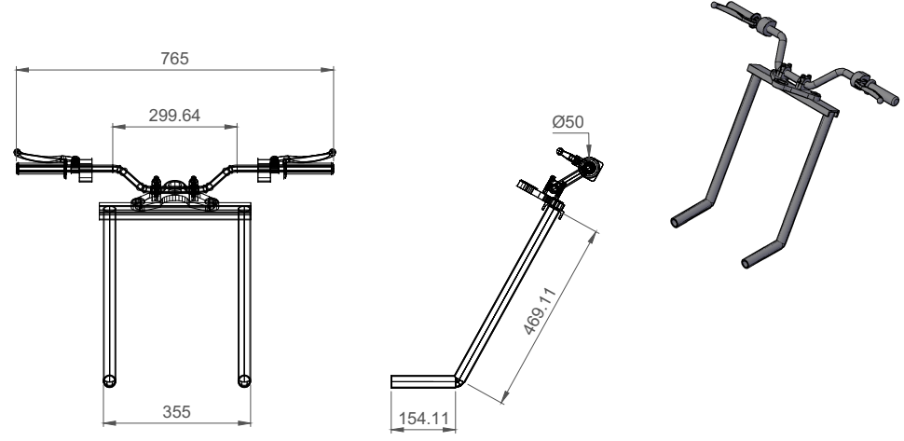

Fig. 6 Control Handle

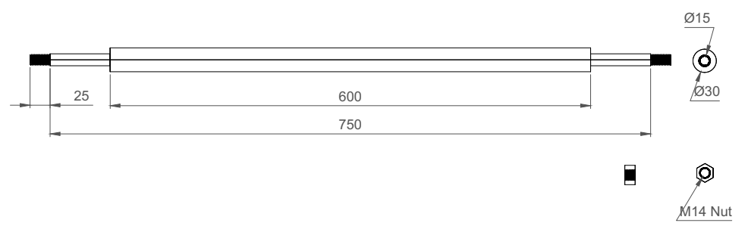

Fig. 7 Driving wheel Shaft

2.4 The Main Assembly of the MPT
Finally, all the sub-assemblies were joined to complete the MPT (Figure 8). The engine with the seats, is mounted on the frame. The sprocket and pulley are mounted on the output shaft of the engine's gearbox, to drive the wheel and water pump respectively. The pump and its support sub-assembly are also mounted on the frame, and the reel is attached. The driven pulley is mounted on the pump shaft, and a V-belt is used to connect it to the driving pulley on the engine. The plough sub-assembly is then attached to the plough mount at the back of the frame.
The control bars sub-assembly is fixed through Ø30 mm holes at the back edges of the frame into its support. The cage wheels are attached to the frame through a shaft and bearings with the sprocket using an M16 x 300 mm bolt and nut. The driving sprocket is then linked to the sprocket on the wheel with a chain size of 428. Finally, the front balance wheels are attached to the frame through 130 mm circular guides, which permit the upward and downward adjustment of the wheel.

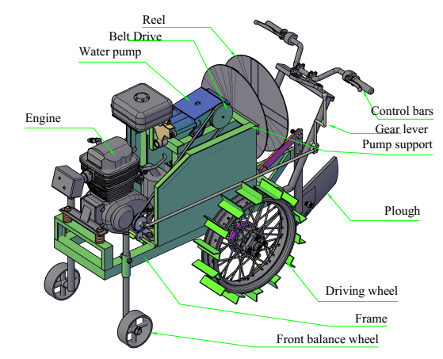

Fig. 8 The Main Assembly of the MPT

2.4 Finite Element Analysis (FEA)
2.4.1 Creating the Model
Initially, the models were created in AutoCAD's 2D sketch space using the proper units (mm). The neutral file formats were then used to turn the models into 3D space and upload them into Autodesk Inventor, another CAD design program. Thankfully, if a model is made in the program with, say, a unit of millimetres, the units of the model in the software stay the same when the model is imported; otherwise, the results can be off scale and fall short of final expectations.

2.4.2 FEA of the Frame
The frame was modelled in AutoCAD 2022 version and imported into Autodesk inventor 2023 software. The static analysis was selected, and mild steel applied from the built-in material library. The total weight acting on the frame (450 N), which comprises the weight of the engine, the water pump, and the pump support, was applied as a distributed load. Fixed constrain was applied to the ends and Tetrahedral mesh applied to the frame. The study was then computed.

2.4.3 FEA of the Engine Seats
In this analysis, the engine seat sub-assemblies (both front and rear seats) were modelled in AutoCAD 2022 version and imported into Autodesk Inventor 2023 software. The weight of the engine (305N) was applied on the seats as a distributed load. Fixed constrain was then applied to the ends of the seat after which the study was computed.

2.4.4 FEA of the Mouldboard
Like the engine seat, the geometry of the mouldboard was modelled in AutoCAD 2022 and imported into Autodesk Inventor 2023. The force applied at the end was 2525 N (the soil penetration resistance) which induces a tensile stress. Fixed constraints were applied to the ends of the holder after which the study was computed.

2.4.5 FEA of the Control bars
The control bars, just like the other parts, was modelled in AutoCAD 2022 and imported into Autodesk Inventor 2023. It was considered a cantilever beam, and loads were applied on the two ends of the handle. On both ends, a 157.5 N which is half of the force an average human being can apply was applied downwards to each end (Giambattista et al., 2023). Fixed constraint was applied to the middle of the handle. The default mesh was used, and the study was computed.

2.4.6 FEA of the Driving Wheel Shaft
The shaft was modelled in AutoCAD 2022 version and imported into Autodesk Inventor 2023 software. The static analysis was selected, and mild steel was applied from the built-in material library. The total vertical load acting on the shaft (550 N), which comprises the weight of the engine, the water pump, and the pump support, was applied, and a torsional load of 8090 Nmm due to the driving from the engine, was also applied. Fixed constrain were applied to the ends and Tetrahedral mesh was applied to the shaft.

2.4.7 Boundary Conditions
A model is likely to accelerate when a load is applied. To prevent it from rushing endlessly through the virtual ether of the computer, at least one limitation or boundary condition needs to be in place. All of the machine's parts were restrained by fixed support in this investigation to avoid acceleration. This made it clear that the boundary condition would only act in the (y-y) direction. For the design problem to be accurately solved, the right boundary conditions must be applied.

3. RESULTS AND DISCUSSIONS
The results of the FEA of the frame, the engine seats, the plough, the control bars, and the shaft are systematically presented here. The results showed a maximum Von Mises stress of 17.3815 MPa of the frame (Figure 9) which is less than the yield strength of the material used (207 MPa), indicating that the frame can safely carry the 450 N. The colours in the legend show red for the most stressed portion concentrated in the middle of the frame. The blue colour indicates the less stressed portions of the frame. The maximum and minimum values of the 1st principal stress were 15.6227 MPa and -1.34991 MPa respectively which represent the maximum and minimum tensile stresses induced in the frame. This is usually less than the Von Mises stress and occurs at the bottom side of the middle portion of the frame. The minimum and maximum values for the 3rd principal stress were -19.7014 MPa and 1.38881 MPa, representing the compressive stresses induced in the frame. The top side of the middle portion of the frame suffered the maximum compressive stress.
The maximum displacement occurred in the middle portion of the frame. This is expected since the middle of the frame is far from the wheels supporting it. The frame's maximum displacement recorded during analysis was 0.0112926 mm, which is minimal and will not affect the machine. The results are in line with the maximum displacement of 0.0305 mm reported by (Gopal et al, 2020). Saygili & Çakmak (2025) also use FEA to analyze different operational conditions of the strength of tillage machines (the strength of the chassis, strength of tractor protective equipment and agricultural carts). The results were closer to the real experimental data obtained. Unlike the other parameters, designers typically work with the minimum safety factor value rather than the maximum value. The minimum safety factor achieved in this design is 3 ul as shown in Figure 9. This is acceptable since the recommended safety factor for most engineering designs is between 1ul and 5ul (Tooley, 2009). A design having a safety factor of less than 1 is not recommended.
In the case of the front engine seat, the maximum Von Mises stress of 1.67239 MPa (Figure 10), which is less than the yield strength of the material used (207 MPa), indicates that the engine seat can safely carry the 305N. The colours in the legend show red for the most stressed portion concentrated in the holes of the engine seat. The minimum safety factor achieved in this design is 3 ul as shown in Figure 10.
The FEA results of the back engine seat show a maximum Von Mises stress of 13.656 MPa (Figure 11), which is less than the yield strength of the material used (207 MPa), indicating that the engine back seat can safely carry the 305N. The maximum displacement occurred near the holes of the seat (Figure 11). This is expected since the seat support is far from the holes where the load is applied. The maximum displacement was 6.08 x 10⁻⁵ mm, which is negligible and will not have any impact on the machine.
The maximum Von Mises stress of the Mouldboard Plough was 220.727 MPa (Figure 12) which is less than the yield strength of the material used (275.8 MPa), indicating that the plough can safely carry the 707.107 N load. The minimum safety factor achieved for the plough in this design is 1.24951 ul as shown in Figure 12. This is acceptable since the recommended safety factor for most engineering designs is between 1 and 5 (Tooley, 2009).
The analysis of the control bars revealed a peak Von Mises stress of 0.0909601 MPa (see Figure 13), which is below the material's yield strength of 207 MPa, confirming that the control bars can adequately support the 157.500 N load. The greatest displacement occurred at the control bars' handles, which is anticipated due to their distance from the welding points on the frame. The highest recorded displacement was 0.151546 mm. The lowest safety factor obtained for the control bars is 3 ul, as illustrated in Figure 13.
In the analysis of the driving wheel shaft, the results indicated a maximum Von Mises stress of 74.8531 MPa (Figure 14), which is below the material’s yield strength of 207 MPa. This suggests that the driving wheel shaft is capable of supporting the applied load of 550.00 N without issue. The maximum displacement recorded was 0.089977 mm. The minimum safety factor calculated for the driving wheel shaft is 2.7ul. This newly developed multifunctional agricultural equipment was successfully modelled based on its 3D design. The machine is less cumbersome than earlier multifunctional models since all components are interconnected, facilitating easy reconfiguration or rapid assembly using fasteners. The newly created power tiller can operate more quickly than traditional versions due to its adjustable gear ratios, thereby reducing the effort required by farmers during tillage. Consequently, it enhances the farmers' ability to cover larger areas promptly, especially when planting periods are constrained. The lightweight construction of the power tiller makes it suitable for use in wet and dry land conditions.
The forward speed of the locally developed power tiller is comparable to that of the imported power tiller, as it operates similarly to the first and second gears of the imported model. Nevertheless, the locally developed power tiller features five speeds, capable of functioning effectively up to the third gear. Generally, the locally developed power tiller will operate with less effort than the imported version. Priced at GH¢8,742.24, the machine is significantly more affordable than the imported ones, which range from GH¢20,000 to GH¢25,000.

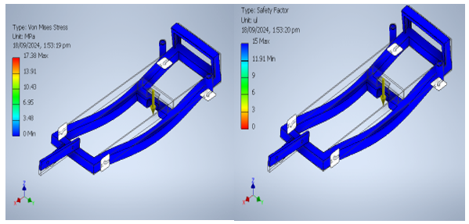Fig. 9 Von Mises stress and Safety Factor of the Frame

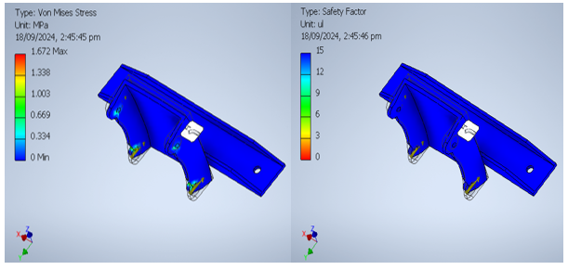Fig. 10 Von Mises Stress and Safety Factor of the Front Engine Seat
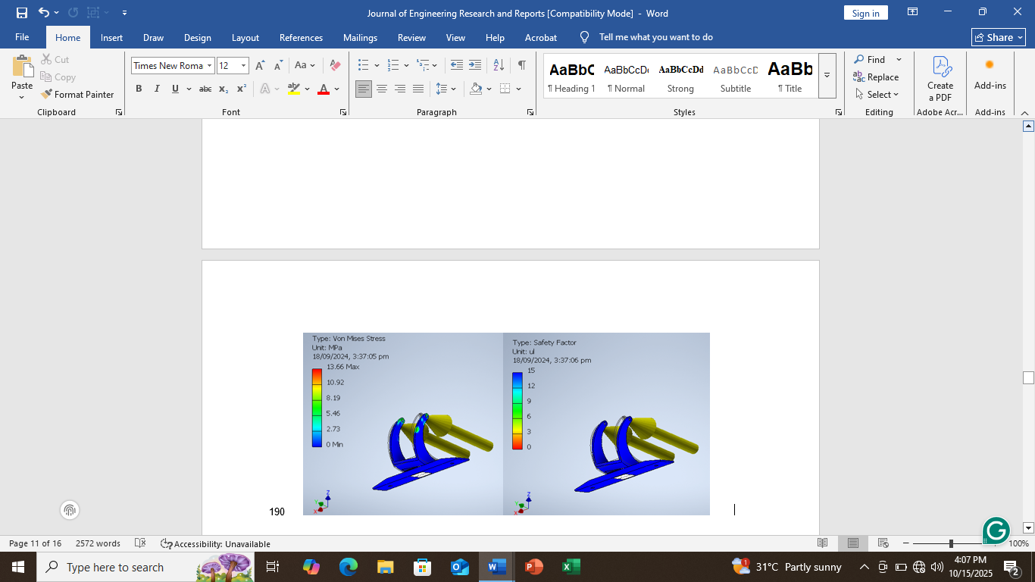Fig. 11 Von Mises Stress and Safety Factor of the Back Engine Seat

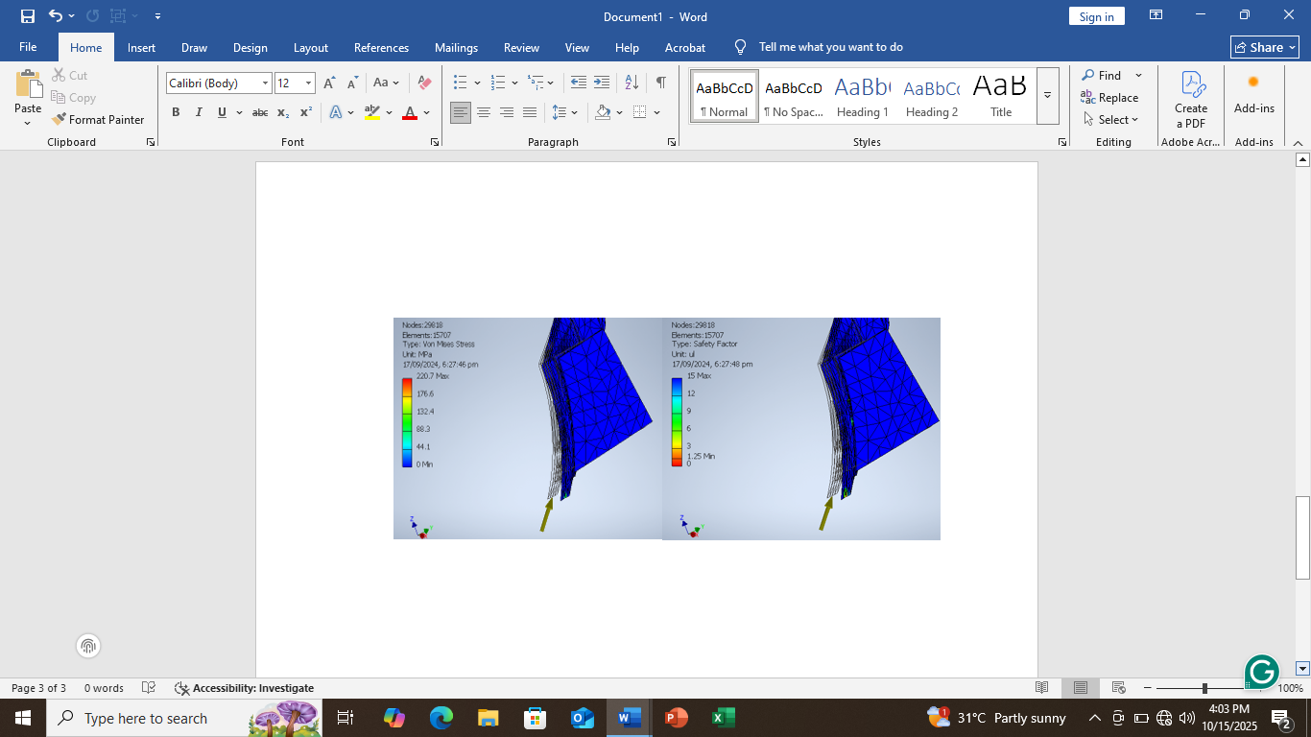
Fig. 12 Von Mises Stress Safety Factor of the Plough

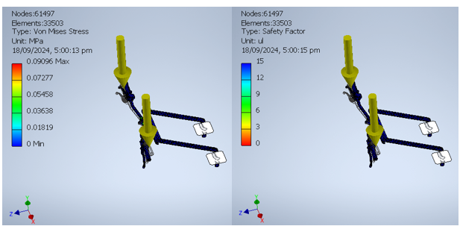Fig. 13 Von Mises Stress and Safety Factor of Control Bars

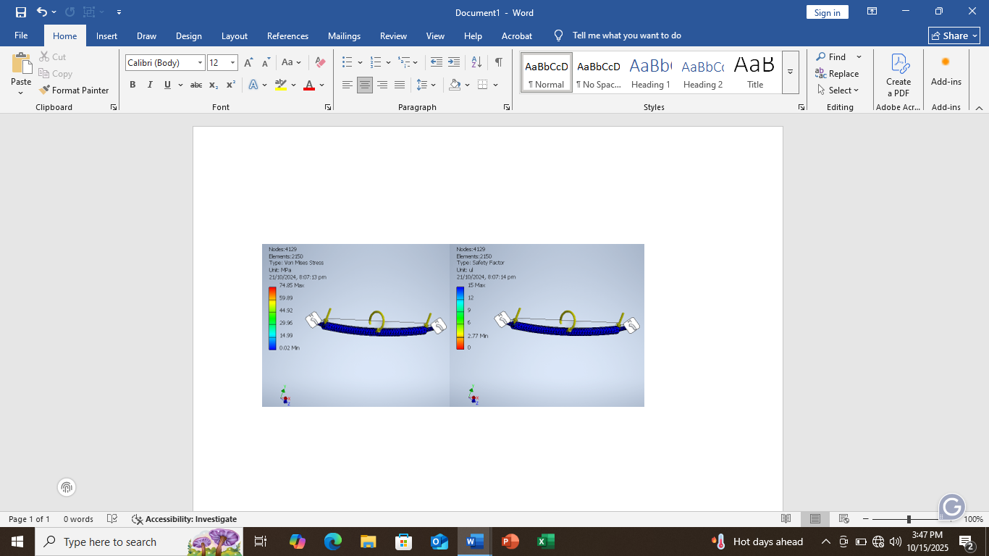
Fig. 14 Von Mises Stress and Safety Factor of the Drive Shaft

Table 1. Components and their Von Misses Stress and Safety Factor
S/N | Component | Material | Yield Strength  (MPa) | Maximum Von Mises Stress (MPa) | Minimum Safety Factor (ul)
1 | Frame | Steel, Mild | 207 | 17.3815 | 3
2 | Front Engine Seat | Steel, Mild | 207 | 1.67239 | 3
3 | Back Engine Back seat | Steel, Mild | 207 | 13.656 | 3
4 | Mouldboard Plough | High Strength, Low Alloy Steel | 275.8 | 220.727 | 1.2
5 | Control Bars | Steel, Mild | 207 | 0.0909601 | 3
6 | Driving Wheel Shaft | Steel, Mild | 207 | 74.8531 | 2.7

4. Conclusion

One of the most labor-intensive agricultural practices is farm tilling. Hand field tiling is a laborious task. Modern agricultural equipment is more expensive and out of the reach of the majority of farmers with little resources. Due to their low-income levels, most farmers cannot invest in the purchase of significant machinery. Given the aforementioned circumstances, it is necessary to design and fabricate this smart machinery for small-scale irrigation farmers that can be used for a variety of tasks, including ploughing, irrigation, etc. By decreasing human effort at a very low cost, this portable power tiller with an irrigation system provides an all-in-one modern solution to improve traditional farming methods. It also helps reduce drudgery on the field and carries out operations promptly. The machine is purposely designed for small-scale irrigation farmers.

Consent (where ever applicable)

Not applicable

Ethical approval (where ever applicable)

Not applicable

COMPETING INTERESTS DISCLAIMER:
Authors have declared that they have no known competing financial interests OR non-financial interests OR personal relationships that could have appeared to influence the work reported in this paper.

Disclaimer (Artificial intelligence)
Author(s) hereby declare that NO generative AI technologies such as Large Language Models (ChatGPT, COPILOT, etc.) and text-to-image generators have been used during the writing or editing of this manuscript.

References
Benin, S. (2015). Impact of Ghana’s agricultural mechanization services center program. Agricultural Economics, 46(S1), 103–117.
Diao, X., Agandin, J., Fang, P., Justice, S. E., Kufoalor, D. S., & Takeshima, H. (2018). Agricultural mechanization in Ghana: Insights from a recent field study (Vol. 1729). Intl Food Policy Res Inst.
Giambattista, Alan, Betty MacCharthy Richardson, R. C. R. (2023). College Physics With an Integrated Approach to Forces and Kinematics (3rd Edition). New York, NY: McGraw-Hill. https://online.fliphtml5.com/lijqd/uhcr/#p=2
Gopal, A., Elavendhan, E., Tarun, S., & Sankar, S. L. (2020, December). Design, development and fabrication of multipurpose agricultural machine. In AIP Conference
Khetigaadi. (2016). India Vs World Farm Mechanization and Technology. https://blog.khetigaadi.com/author/admin.
Nyagumbo, I., Mkuhlani, S., Mupangwa, W., & Rodriguez, D. (2017). Planting date and yield benefits from conservation agriculture practices across Southern Africa. Agricultural Systems, 150, 21–33.
Panel, M. M. (2018). Mechanised: Transforming African’s Agricultural Value Chains. Dakar: Malabo Montpellier Panel. www.mamopanel.org
Sung, J. (2018). The fourth industrial revolution and precision agriculture. In Automation in Agriculture-Securing Food Supplies for Future Generations. IntechOpen.
Statista. (2019). Global production of vegetables in 2017. Statista. www.statista.com/statistics/264065
Sutton, I. (1983). Labour in commercial agriculture in Ghana in the late nineteenth and early twentieth centuries. The Journal of African History, 24(4), 461–483.
SAYGILI, Y. S., & ÇAKMAK, B. (2025). Use of finite element method in agricultural
machinery and application examples. Ege Üniversitesi Ziraat Fakültesi Dergisi, 62(3).
Upadhyaya, V., Shankar, M., Kumar, N., & Karinka, S. (2022). Design and development of multipurpose power tiller gear box for paddy cultivation. Materials Today: Proceedings, 52, 2148-2153.
Tooley, M. (Ed.). (2009). Design engineering manual. Elsevier.

