Experimental Optimization and Performance Evaluation of a Socket-Wheel Sesame Seed Metering Device
Abstract
To address the practical challenges in sesame cultivation such as low efficiency in manual sowing, labor-intensive and time-consuming thinning and fixing of seedlings after emergence, and the lack of suitable precision hole-seeding devices leading to issues like reseeding and missed seeding -an optimized design of a precision sesame seed metering device with a cell wheel mechanism has been developed. Key parameters of the seed metering device's critical components have been systematically optimized. Taking the rotational speed of the seed metering wheel, the number of cells, and the cell diameter as experimental factors, and using the qualified rate of seeds per hill, the reseeding rate, and the miss-seeding rate as evaluation indices, a three-factor, three-level quadratic orthogonal rotational composite design was conducted. The optimal parameter combination for the seed metering device was determined through analysis as follows: a seed metering wheel speed of 15（r/min）, 30 cells, and a cell diameter of 7 mm. Bench test results demonstrated that the qualified seed spacing rate reached 95.56%, with a reseeding rate of 2.61% and a miss-seeding rate of 1.83%, providing a design basis for the development of the socket-wheel sesame seed Metering Device.

Keywords: socket wheel; seed metering device; precision seeding; sesame

Introduction
Sesame, an important oilseed crop for producing high-quality edible oil in China, poses significant challenges to mechanized precision seeding due to the physical characteristics of its seeds. The seeds are small, irregularly shaped (dicot seeds), lightweight, and easily damaged. Predominant sowing techniques, including manual broadcasting, manual hill dropping, and mechanical row drilling, are characterized by excessive seed usage and non-uniform seed placement. Taking the traditional artificial sowing as an example, 5 ~ 8 seeds[] are usually sown per hole, and 1 ~ 2 seedlings are left per hole in the later stage of artificial seedling[], which is heavy workload and low seedling rate. Sesame mechanized precision hole sowing can achieve 3 ~ 5 seeds [][]per hole, with high sowing precision and uniform field distribution, which is conducive to improving sesame yield.
The core working part of sesame seeding machine is the seed metering device. The seeding performance of the seed metering device is closely related to the seeding quality[]. At present, it is not widely used.Mechanical seed-metering device is the most widely used type of seeder at present[]. Xinjiang Production and Construction Corps has carried out the mechanized production operation of the ' double low ' rape by using the outer groove wheel seed metering device, which basically meets the requirements of agronomic sowing, and this kind of seed metering device has the advantage of not blocking the hole[].Zhang Yuwen[] proposed a mechanical multi-functional precision seed-metering device to solve the problem of seed blockage and missed sowing in the socket wheel seed-metering device.Tang Chuzhou[] et al. developed a variable-capacity hole-wheel seed-metering device, which solved the problem of difficulty in adjusting the seeding rate of the seed-metering device. Variable seeding can be realized by changing the adjusting tongue and the adjusting ring. Liao Qingxi []et al.proposed a compact centralized metering device for rapeseed crops, which can simultaneously realize the precision seeding of 4 rows of rapeseed, and doubled the seeding efficiency. The aforementioned research indicates that by optimizing the cell structure, the seed damage rate can be reduced and the seed-metering performance can be improved. Furthermore, adopting a reclining seed-filling method can significantly lower the probability of seed damage in mechanical seeders.
In this paper, combined with the agronomic requirements of sesame breeding, aiming at ' Aerospace New Zhibaizhi ', based on the working principle of socket wheel metering, a socket wheel precision metering device was designed by using cone-column holes which are more suitable for irregular seeds, and bench test was carried out. The purpose of this study is to optimize the key parameters of sesame socket wheel metering device ( rotation speed of metering wheel, number of holes and diameter of holes ) by using discrete element simulation and response surface method, so as to improve the qualified rate of seed number and reduce the rate of replay and missed seeding.

Structure and Working Principle of Seed-metering Device

1.1 The structure composition and characteristics of seed metering device
Owing to the flat, elliptical, and irregular shape of sesame seeds, and considering that pneumatic seeders are technologically complex, require high manufacturing precision, and incur greater costs and power consumption, a mechanical seeder was selected. Specifically, an eye-type wheel precision seeder was adopted for its cost-effectiveness and operational stability[]. The seed metering device mainly includes the following parts : the seed-metering device front shell, the seed-metering device rear shell, the seed metering wheel, the unloading plate, the front shell and the end cover, as shown in Figure 1. The brush is fixed by a bolt to the seeder housing. The seed metering wheel is embedded within the housing and is fitted with rolling bearings via an interference fit. The outer side of the bearings is similarly mounted to the rear housing with an interference fit. The seed metering wheel contains cells on its surface and is assembled with a clearance fit to the seeder housing. The seed protection housing effectively shields the seeds.
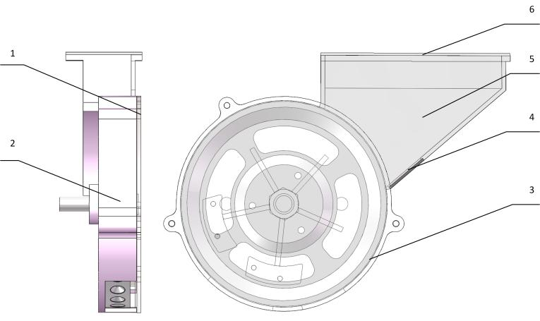
Fig. 1 Structure diagram of the seed metering device

Table 1 : Seed metering device structure
1 | Seed-metering device front shell
2 | Seed-metering device rear shell
3 | Seed-metering wheel
4 | Unloading plate
5 | Front shell
6 | End cover

When working, sesame relies on its own gravity and the friction between seeds to enter the socket wheel hole, and then the seeding wheel rotates to achieve seed filling. The excess seeds that leak out of the socket are cleared by the clearing wheel and retained in the population. The seeds in the hole pass through the seed protection area with the rotation of the seeding wheel. After entering the seed throwing area, they fall on their own under the action of gravity, fall off the socket and fall into the seed bed, and the seeding ends.

1.2 Working principle
The working process of the pit eye wheel precision seed metering device is mainly divided into four stages, namely, the filling stage, the clearing stage and the protecting stage[].The metering device is fixed on the frame, and the metering wheel rotates through the external power transmission device connected to it, and the rotation shaft drives the metering wheel to rotate. When the socket hole on the seeding wheel reaches the filling area on the upper part of the shell of the metering device under the driving of the shaft rod rotation, the sesame seeds enter the hole and complete the filling process due to the gravity of the seeds and the effect of the population. When the seeding wheel continues to rotate to the position of the upper brush, the equipped brush can remove the excess seeds at the orifice of the type hole, so that each type hole can hold 3 ~ 5 seeds, and then the seeds enter the seed protection area, and the seeds in the protection hole are separated from the hole. When the seeding wheel continues to rotate to the bottom seeding area, the seeds fall by their own gravity and from the hole of the seeding wheel to complete the seeding. The seeding wheel continues to rotate to the filling state, reciprocating cycle, to achieve continuous seeding operation of the metering device.

- Discrete element simulation analysis and optimization design of seed metering device

2.1 Discrete element simulation
The filling performance of the seed-metering device has a great influence on the seeding accuracy of the seed-metering device. In this section, the discrete element analysis method is used to analyze the working process of the seed-metering device, and the SolidWorks software is used to model the components of the seed-metering device. The model IGS file was imported into the discrete element analysis software EDEM, and the simulation seed particle model is established. The particle generation rate was set to 10,000 particles per second, with a simulation time step of 25% and an output time step of 0.01 seconds. The total simulation time was 10 seconds, and the total mesh count for the seeder simulation model was less than 100,000. The simulation analysis of the seed filling process of the seed metering device is carried out to provide the basis for the structural improvement of the seed metering device. By simulating the movement of sesame seed particle model in the seed metering device, the dynamic analysis of each stage of seed filling of the seed metering device is carried out. EDEM is mainly used to simulate and analyze the filling situation of the wheat particle model inside the seed metering device. In order to improve the operation rate, the simplified seed metering device structure model is used for simulation analysis. The simplified seed metering device only has the seed metering wheel and the seed metering device shell. According to the relevant literature[], the material parameters are defined as shown in Table 2 and Table 3.

Table.2 Physical parameter of materials
Material name | Poisson ratio | Density（kg·m⁻³） | Shear modulus（Pa）
Sesame seeds | 0.4 | 652 | 1.3×10⁸
Engineering Plastics | 0.39 | 1060 | 8.95×10⁸
Ordinary carbon steel | 0.3 | 2700 | 2.7×10¹⁰
Nylon brush | 0.4 | 1.12 | 1.02×10⁸

Table.3 Material contact parameters of seeder simulation model
Form of contact | Coefficient of  restitution | Coefficient of  static friction | Coefficient of  rolling friction
Sesame-sesame | 0.4 | 0.6 | 0.04
Sesame-engineering plastics | 0.5 | 0.65 | 0.04
Sesame - plain carbon steel | 0.3 | 0.71 | 0.04
Sesame-nylon brush | 0.5 | 0.45 | 0.04

Sesame seed model is shown in Fig.2. The simulation results are shown in Fig.3.
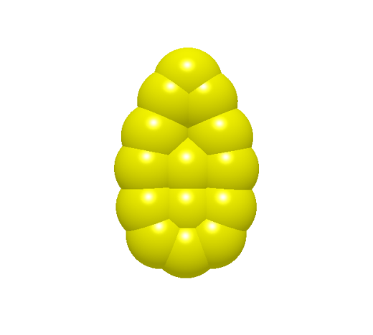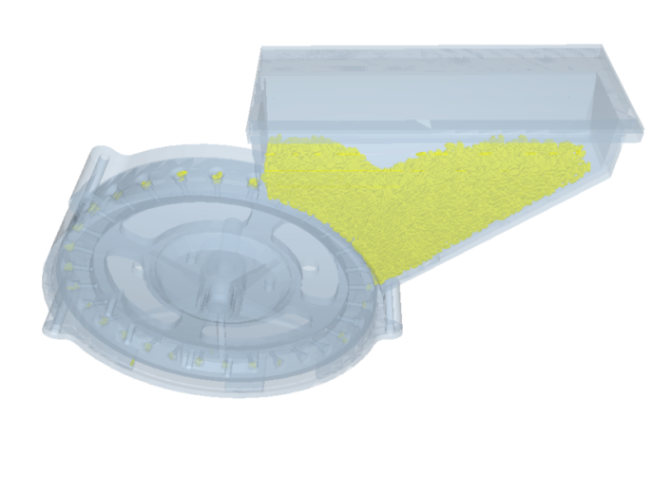
Fig.2 Sesame Seed Model Fig.3 Simulation Results

2.2 Optimization of seed metering device

As shown in Figure 3, when the holes on the seed metering wheel enter the seed filling area, the seed filling process is not completed immediately. Some holes only achieve full seed filling after moving for a period within the seed filling area, while others may fail to complete the filling process entirely and directly enter the seed protection stage. This results in a decrease in seed filling efficiency and leads to missed seeding during the operation. To improve the seed filling rate of the seed metering device, the holes on the seed metering wheel are arranged in two staggered rows. This design ensures that seeds, regardless of their distribution position, have a higher probability of rapid filling during the operation. It enhances the mobility of seeds in the filling area and improves the overall seed filling efficiency. Simulation of the motion process reveals that the sesame particle models move along the rotation direction of the seed metering wheel, leading to accumulation on one side. During the seeding process, this results in bridging phenomena, which reduce the seed filling rate in the filling area. According to discrete element simulation results, the rotational speed of the seed metering wheel, the number of holes, and the hole diameter significantly affect the seeding performance. The influencing factors on the qualified rate of seeds per hill are ranked as follows: rotational speed of the seed metering wheel > number of holes > hole diameter. When the rotational speed ranges from 18 to 22 r/min, the number of holes is between 28 and 32, and the hole diameter measures 6 to 8 mm, the seeding requirements can be satisfied with a qualified rate exceeding 90%, while both the reseeding rate and miss-seeding rate remain below 5%.

- Experimental study on performance of seed metering device

3.1 Test method

The seeds of ' Aerospace Xinzhi Baizhi ' were used as experimental materials, according to the relevant literature[][][][],The test indexes were the qualified rate of seed spacing Y₁, the rate of seed reseeding Y₂ and the rate of seed leakage Y₃.According to the simulation results, the value range of each influencing factor is determined as follows : the rotation speed of the metering wheel is 12.5 ~ 17.5（r / min）， the number of socket holes is 28 ~ 32, and the diameter of socket holes is 6 ~ 8 mm. The experimental design adopts three factors and three levels of quadratic orthogonal rotation combination test[][][],The experimental factors are coded as shown in table 3. The test scheme and results are shown in table 4. A total of 17 groups of tests were carried out, each group of tests was carried out 5 times, and the average value of the 5 test results was taken as the test results of the group.

Table.4 Test factor level table
Parameter | Factor
Parameter | rotate speed of seed plate A | Number of holes  B | Hole diameter  C
Parameter | /（r/min） | /one | /mm
-1 | 12.5 | 28 | 6
0 | 15 | 30 | 7
1 | 17.5 | 32 | 8

Table. 5 Test design and test results
Test | Factor |  |  | Index
Test | Rotate speed of seed plate  A/（r/min） | Number of holes  B/one | Hole diameter  C/mm |  | Qualified index  S/% | Replay index  D/% | Spread index  M/%
1 | -1 | -1 | 0 | 93.28 |  | 3.14 | 3.58
2 | 1 | -1 | 0 | 89.98 |  | 6.05 | 3.97
3 | -1 | 1 | 0 | 91.19 |  | 4.85 | 3.96
4 | 1 | 1 | 0 | 88.02 |  | 7.34 | 4.64
5 | -1 | 0 | -1 | 92.18 |  | 3.17 | 4.65
6 | 1 | 0 | -1 | 89.12 |  | 6.38 | 4.50
7 | -1 | 0 | 1 | 92.03 |  | 5.15 | 2.82
8 | 1 | 0 | 1 | 87.99 |  | 7.45 | 4.56
9 | 0 | -1 | -1 | 92.58 |  | 3.59 | 3.83
10 | 0 | 1 | -1 | 90.73 |  | 4.36 | 4.91
11 | 0 | -1 | 1 | 92.61 |  | 4.81 | 2.58
12 | 0 | 1 | 1 | 90.70 |  | 6.16 | 3.14
13 | 0 | 0 | 0 | 94.55 |  | 3.63 | 1.82
14 | 0 | 0 | 0 | 93.89 |  | 3.51 | 2.60
15 | 0 | 0 | 0 | 95.48 |  | 1.87 | 2.65
16 | 0 | 0 | 0 | 95.23 |  | 3.41 | 1.36
17 | 0 | 0 | 0 | 94.40 |  | 2.12 | 3.48

3.2 Test result analysis

Table.6 Analysis of Variance of the Experiment
Evalua-  ting indicator | Source of variance | Quad-  ratic  sum | Degree of freedom | Mean square | F | P | Signif-  icance
Qualified index | Model | 87.09 | 9 | 9.68 | 35.24 | <0.0001 | **
Qualified index | A | 23.02 | 1 | 23.02 | 83.82 | <0.0001 | **
Qualified index | B | 7.62 | 1 | 7.62 | 27.76 | 0.0012 | **
Qualified index | C | 0.2048 | 1 | 0.2048 | 0.7458 | 0.0064 | **
Qualified index | AB | 0.0042 | 1 | 0.0042 | 0.0154 | 0.9048
Qualified index | AC | 0.2401 | 1 | 0.2401 | 0.8743 | 0.3809
Qualified index | BC | 0.0009 | 1 | 0.0009 | 0.0033 | 0.9559
Qualified index | A² | 30.89 | 1 | 30.89 | 112.50 | <0.0001 | **
Qualified index | B² | 8.06 | 1 | 8.06 | 29.36 | 0.0010 | **
Qualified index | C² | 11.76 | 1 | 11.76 | 42.82 | 0.0003 | **
Qualified index | Residu-  als | 1.92 | 7 | 0.2746
Qualified index | Loss of fit | 0.2649 | 3 | 0.0883 | 0.2131 | 0.8827
Qualified index | Error | 1.66 | 4 | 0.4144
Qualified index | Total | 89.01 | 16
Replay index | Model | 43.13 | 9 | 4.79 | 11.44 | 0.0020 | **
Replay index | A | 14.88 | 1 | 14.88 | 35.52 | 0.0006 | **
Replay index | B | 3.28 | 1 | 3.28 | 7.82 | 0.0266 | *
Replay index | C | 4.61 | 1 | 4.61 | 10.99 | 0.0128 | *
Replay index | AB | 0.0441 | 1 | 0.0441 | 0.1053 | 0.7551
Replay index | AC | 0.2070 | 1 | 0.2070 | 0.4942 | 0.5048
Replay index | BC | 0.0841 | 1 | 0.0841 | 0.2007 | 0.6677
Replay index | A² | 11.08 | 1 | 11.08 | 26.45 | 0.0013 | **
Replay index | B² | 2.80 | 1 | 2.80 | 6.67 | 0.0363 | *
Replay index | C² | 4.27 | 1 | 4.27 | 10.20 | 0.0152 | *
Replay index | Residu-  als | 2.93 | 7 | 0.4189
Replay index | Loss of fit | 0.0984 | 3 | 0.0328 | 0.0463 | 0.9849
Replay index | Error | 2.83 | 4 | 0.7085
Replay index | Total | 46.06 | 16
Spread index | Model | 14.69 | 9 | 1.63 | 3.86 | 0.0043 | **
Spread index | A | 0.8844 | 1 | 0.8844 | 2.09 | 0.0012 | **
Spread index | B | 0.9045 | 1 | 0.9045 | 2.14 | 0.1869
Spread index | C | 2.87 | 1 | 2.87 | 6.79 | 0.0352 | *
Spread index | AB | 0.0210 | 1 | 0.0210 | 0.0498 | 0.8299
Spread index | AC | 0.8930 | 1 | 0.8930 | 2.11 | 0.1893
Spread index | BC | 0.0676 | 1 | 0.0676 | 0.1600 | 0.7011
Spread index | A² | 4.97 | 1 | 4.97 | 11.76 | 0.0110 | *
Spread index | B² | 1.36 | 1 | 1.36 | 3.23 | 0.1155
Spread index | C² | 1.86 | 1 | 1.86 | 4.39 | 0.0443 | *
Spread index | Residu  -als | 2.96 | 7 | 0.4226
Spread index | Loss of fit | 0.2726 | 3 | 0.0909 | 0.1354 | 0.9339
Spread index | Error | 2.69 | 4 | 0.6713
Spread index | Total | 17.64 | 16
Note : * means significant difference ( 0.01 < P < 0.05 ), * * means extremely significant difference ( P < 0.01 ).
The Design-Expert software was used to analyze the data, and the qualified rate model of the number of points was obtained ( P < 0.01 ), indicating that the model was statistically significant. Among the factors, the rotation speed of the seeding wheel has the greatest influence on the qualified rate of the number of seeds per hole, followed by the number of holes, and the smallest is the diameter of the hole. The seed reseeding rate model( P < 0.01), indicating that the model was statistically significant ; among the factors, the rotation speed of the seeding wheel has the greatest influence on the seed replay rate, followed by the diameter of the hole, and the minimum is the number of holes. It can also be obtained that the seed missing rate model (P < 0.01), indicating that the model has statistical significance ; among the factors, the rotation speed of the metering wheel had the greatest influence on the seed leakage rate, followed by the diameter of the hole, and the number of holes was not significant. The variance analysis of the qualified rate of the number of grains, the rate of replay and the rate of missed broadcast is shown in table 6.

- Verification of seed-metering device bench test

Five repeated experiments were carried out on the STB-700[] seed metering device test bench with the eye-wheel seed metering device. The rotation speed of the eye-wheel was 15(r / min), the number of holes was 30, and the diameter of the holes was 7mm. The sowing performance of the sesame eye-wheel seed metering device was tested.
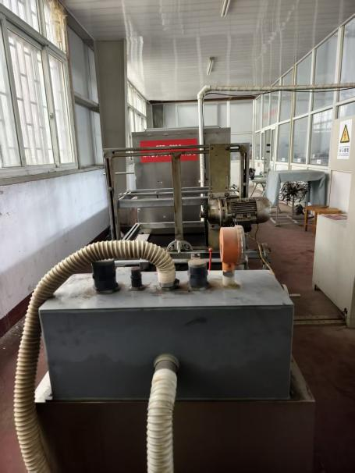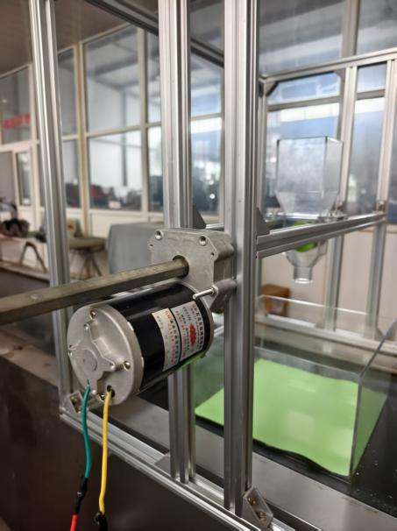
（a）STB-700 Seed Metering (b) Drive Mechanism of
Device Test Bench the Seed Metering Device
Fig.4 Bench test
The results of the bench test are as shown in table 7, the qualified rate is 94.12 %, the missed seeding rate is 2.49 %, and the replay rate is 3.39 %. The indicators basically meet the seeding requirements.
Table. 7 Bench test results
Serial number | Qualified index | Replay index | Spread index
1 | 93.83 | 2.21 | 3.96
2 | 93.51 | 3.36 | 3.13
3 | 94.52 | 2.41 | 3.07
4 | 93.79 | 2.52 | 3.69
5 | 94.95 | 1.95 | 3.10
Mean value | 94.12 | 2.49 | 3.39

- Conclusion

（1）In order to improve the phenomenon of uneven seeding and replay leakage of small particle seed precision seed metering device, a socket wheel sesame compact seed metering device was designed and improved.
（2）Using three factors and three levels of quadratic orthogonal rotation combination test, the mathematical model between the qualified rate of the number of seeds, the rate of seed reseeding, the rate of seed leakage and the three factors of the rotation speed of the seeding wheel, the number of holes and the diameter of the holes was established, and the orthogonal test was carried out. The effects of various factors on the qualified rate of seed number, seed replay rate and seed leakage rate were analyzed, and the optimal parameter combination of each factor was determined : the rotation speed of the seeding wheel was 15 (r / min), the number of holes was 30, and the diameter of the holes was 7mm.
（3）The bench test was carried out using the STB-700 seed metering device test bench, and the results showed that the sesame pit-eye wheel seed metering device met the agronomic requirements of sesame, the qualified rate of seed spacing was 94.12 %, the seed replay rate was 2.49 %, and the seed leakage rate was 3.39 %, which provided the design basis for the development of the pit-eye wheel sesame precision metering device.

Disclaimer (Artificial intelligence)
Option 1:
Author(s) hereby declare that NO generative AI technologies such as Large Language Models (ChatGPT, COPILOT, etc.) and text-to-image generators have been used during the writing or editing of this manuscript.

Option 2:
Author(s) hereby declare that generative AI technologies such as Large Language Models, etc. have been used during the writing or editing of manuscripts. This explanation will include the name, version, model, and source of the generative AI technology and as well as all input prompts provided to the generative AI technology
Details of the AI usage are given below:
1.
2.
3.

REFERENCES

[] ] Gong Yufen. Application of new high-yield cultivation techniques of sesame [ J ].Agricultural technology and equipment, 2013, ( 14 ) : 54-55.
[]
[] Wei Lingen, Xiao Yunping, Lv Fengjuan, et al. Effects of integrated mechanical sowing method of sesame cultivation and fertilization on sesame emergence [ J ].Hunan Agricultural Sciences, 2016, ( 03 ) : 28-29 + 33.
[] Wang Qiang, Zhao Li, Zhang Zifu, et al. Sesame planting machinery research and agricultural machinery agronomic matching technology research [ J ].Chinese Journal of Oil Crops, 2014,36 ( 02 ) : 224-230.
[] Cui Qingliang, Qin Gang, Wang Mingfu. Comparative Analysis of Several Typical Precision Seed Metering Devices [ J ]. Journal of Shanxi Agricultural University ( Natural Science Edition ), 2003, ( 01 ) : 69-71.
[] Huo Wenguo, Lv Zhaoqin. The development and research status of pneumatic precision seeder [ J ].Agricultural machinery, 2003, ( 04 ) : 50-51.
[] Zhou Haibo, Liang Qiuyan, Wei Tianlu, etc. Design and experiment of external groove wheel quantitative seed supply device for two-stage vibration precision seed metering device [ J ]. Agricultural Machinery Journal, 2016,47 ( S1 ) : 57-61 + 83.
[] Zhang Yuwen, Luo Quanwei. ANALYSIS OF THE TOOTH CURVED SURFACE OF THE PUSHING GEAR OF THE MULTI-FUNCTION PRECISION SEEDER [ J ]. JOURNAL OF AGRICULTURAL MACHINERY, 2006, ( 01 ) : 43-46.
[] Wu Wei, Huang Zhen, Tang Chuzhou. Study on seed adaptability of variable capacity hole-wheel seed-metering device [ J ].Journal of Hunan Agricultural University ( Natural Science Edition ), 2012,38 ( 05 ) : 551-554.
[] Tan Yu, Zhang Yi, Jin Ying, et al. Design and experiment of pneumatic-assisted guide seed collector for wheat and rape [ J ].ACTA AGRICULTURAL MACHINERY, 2025, 56 ( 09 ) : 105-116 + 187.
[] Zhang Juncai, Liu Junfeng.Development of 2BXGF-8 ( 200 ) rotary tillage and fertilization sesame seeder [ J ].Agricultural development and equipment, 2019, ( 02 ) : 103-104.
[] Zhang Hengbang, Zhao Jian, Hu Guangrui, et al. Experimental study on parameter optimization of socket wheel wheat seed metering device [ J ].Agricultural Mechanization Research, 2020,42 ( 09 ) : 139-144.
[] Lin Pian. Experiment and analysis of rapeseed and sesame dual-purpose precision seed metering device [ D ]. Huazhong Agricultural University, 2021.
[] National Agricultural Machinery Standardization Technical Committee. Test method of single seed ( precision ) seeder : GB / T 6973-2005 [ S ].China Standard Press, 2005.
[] Bo Li,Ying Chen,and Jun Chen."Modeling of soil–claw interaction using the discrete element method (DEM)."Soil & Tillage Research 158.(2016):177-185.
[] Ning Liang, et al."Optimized installation angle and distance of a grading channel for dried jujube fruit with a push-pull actuating mechanism."Computers and Electronics in Agriculture 150.(2018):134-142.
[] China Academy of Agricultural Mechanization Science. Manual of Agricultural Machinery Design ( Volume I ) [ K ].Beijing : China Agricultural Science and Technology Press, 2007.
[] Liao Qingxi, Cao Mei, Wang Baoshan, et al. Design and experiment of air-conveyed sesame precision collector with toothed spoon [ J ].Journal of Agricultural Machinery, 2023,54 ( 08 ) : 65-76.
[] Liu Na. Improved design and experimental study of pit eye wheel corn precision seed metering device [ D ]. Northwest A & F University, 2019
[] Li Bohai, Yi Shujuan, Chen Tao, et al. Performance test of pneumatic eye-wheel combined millet hill-drop seeder [ J ]. Agricultural mechanization research, 2023,45 ( 05 ) : 180-185
[] Zhou Shuxian, Song Jiannong, Wang Jicheng, et al. Design and Experimental Study of the STB-700 Type Seed Metering Device Test Bench[J]. Journal of China Agricultural University, 2009, 14(05): 116-120.

