Original Research Article
COMPARATIVE ANALYSIS OF SIGNAL LATENCY ON 4G NETWORK IN KARU SITE ABUJA, NIGERIA

ABSTRACT
Despite the advantages of 4G network the challenges of dynamic nature of wireless channels, interference from other users and devices, high latency, and ever-increasing demand for higher data rates and seamless connectivity are still common. This study carried out a comparative analysis of network latency on 4G network in Karu site Abuja, Nigeria. Using the speed test ooakla application the latency and jitter across the residential, commercial, and educational zones were recorded every 2 hours from 6am to 8pm for complete one month (April 2025) at each zones within Karu site FCT Abuja. The round-trip time (RTT) for data packets sent to and from a server was analyzed. Result shows significant variability of network latency across zones. The mean latency for the residential zone was 41.4ms, while that of commercial zone was 40.8ms and that of educational zone was 55.9ms. Standard deviation of 6.4 for residential and commercial zones and 7.5 for educational zone. This implies heightened network congestion due to high user density and under-optimized infrastructure at the educational and residential areas. Therefore, it is important for network engineers and service providers to focus on dynamic resource allocation in high-density user environments, infrastructural efficiency, bandwidth allocation and user dynamics to address congestion and temporal demand fluctuations for improving 4G network quality and user experience.

Keyword: Signal latency, jitter, uplink, downlink, speed test app, round-trip time,

1. Introduction
In the fast-evolving landscape of telecommunications, the advent of 4G networks represents a significant milestone, promising high levels of data speed, capacity, and reliability (Agarwal & Agarwal, 2014; Okafor et al., 2023). However, as the demand for high-quality, uninterrupted connectivity continues to soar, so do the challenges associated with ensuring robust communication in 4G networks. One critical aspect in addressing these challenges lies in the development of advanced signal processing techniques tailored specifically for 4G networks (Yadav, 2017; Kumar et al., 2024). This sets the stage for understanding the importance of advanced signal processing in achieving robust communication in 4G networks, delving into the key motivations, challenges, and research objectives (Kumar et al., 2024). The journey of communication networks has been marked by a series of transformative leaps, from the early analog systems of 1G to the digital revolution of 2G and the broadband capabilities of 3G. With each generation, there have been remarkable advancements in data speed, capacity and functionality (Kumar et al., 2019; Slalmi et al., 2020).
The emergence of 4G technology has been a success, culminating in faster, more reliable mobile internet that enabled new services and applications, offering unprecedented levels of performance and efficiency. 4G networks, based on technologies such as LTE (Long-Term Evolution) and WiMAX (Worldwide Interoperability for Microwave Access), promise data rates up to several hundred megabits per second, low latency and seamless mobility, making them the backbone of modern communication systems (Pandiaraj, 2013; Akintoye, 2013; Fan & Huo, 2021; Okafor et al., 2023). Signal processing serves as the backbone of modern communication systems, encompassing a wide range of techniques aimed at enhancing the quality, efficiency and reliability of transmitted signals. In the context of 4G networks, signal processing plays a pivotal role in addressing the aforementioned challenges and optimizing network performance. By intelligently processing incoming signals, it becomes possible to mitigate the effects of channel impairments, reduce interference, improve spectral efficiency, and enhance overall system resilience (Li & Seshadri, 2011; Rappaport, 2010). However, as reported by Slalmi et al. (2020), the 4G specifications are designed for smartphones and not for critical network services.
Despite their many advantages, 4G networks face a myriad of challenges that threaten to compromise their performance and reliability. These challenges stem from various factors, including the dynamic nature of wireless channels, interference from other users and devices, high latency, the ever-increasing demand for higher data rates and seamless connectivity (Smith et al., 2022; Turchet & Casari, 2023; Akintoye, 2013). Additionally, the proliferation of multimedia applications, IoT (Internet of Things) devices, and smart infrastructure further exacerbates the complexity of 4G networks, necessitating robust solutions to ensure uninterrupted communication under diverse conditions (Martin et al., 2011; Slalmi et al., 2020; Harahap et al., 2021). In the case of Nigeria, majority of the population are still using 3G and 4G as 5G has not been fully deployed. Despite efforts by telecommunication companies to expand coverage, 5G is only available in few urban areas due to inadequate infrastructure development and significant gaps in service remain, affecting the daily lives of population (Emeruwa, 2015; Yusuf et al., 2024). The finding of this research is expected to have vast importance for 4G communication network. The research thereby enhances the efficacy of communication, thereby meeting modern communication network. The study will provide a guide for network engineers on areas that may requires upgrading network infrastructure and optimization for fair network distribution.
Materials and Methods
The materials used for this study includes 4G mother board 4000mAh phone used as instrument for data collection, Network latency testing tool (Speed test by Ookla) used to measure network latency at various times intervals, Power bank (20000mAh) used to ensure device stay charged throughout the study period, GPS logging device (Geo tracker) used to ensure accurate geographical mapping of the data, Data collection sheet used to record test results and device usage patterns, and HP Elite Book computer used to analyze the collected Data.
Study Area
Karu, located in the northeastern part of the Federal Capital Territory (FCT) Abuja, serves as an ideal study area for testing improvements in battery capacity and latency in the 4G network due to its unique blend of urban and suburban characteristics. As one of the rapidly developing areas within the FCT, Karu encompasses a diverse demographic profile that includes residential neighborhoods, commercial establishments, and educational institutions. This diversity provides a comprehensive setting for evaluating 4G network performance across different user scenarios. The area is characterized by a mix of high-density housing complexes and more spacious residential zones, ensuring varied data collection points. Additionally, Karu's proximity to Abuja's central business district makes it a critical node for network providers aiming to optimize service delivery. The presence of numerous small businesses, schools, and markets offers a wide range of environments to assess how 4G network improvements can affect battery life and latency in real-world applications. The infrastructure in Karu, including modern roads and connectivity facilities, further supports detailed and reliable data collection. This area's dynamic socio-economic environment and strategic importance within Abuja's metropolitan framework make it a representative and valuable location for this study. The map of FCT Abuja showing the location of Karu is shown in Figure 1.
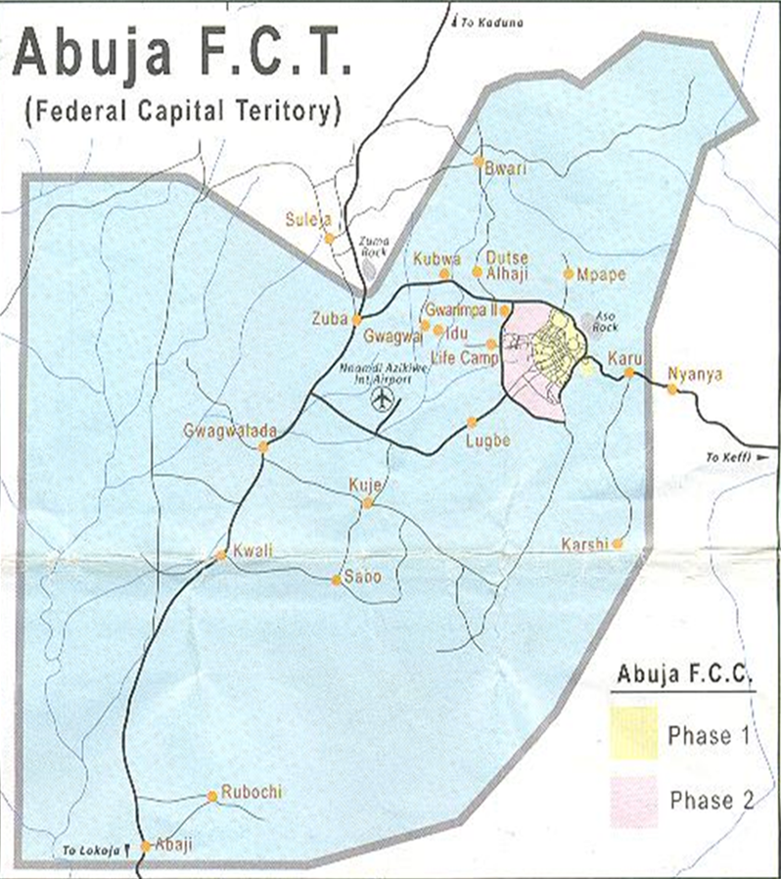
Figure 1: Map of Abuja (FCT) Showing Karu (Ibrahim et al., 2022)
Method of Data Collection
The application speed test ooakla was downloaded into a 4G enhanced phone or motherboard. The device was used to collect data on latency at three different locations in Karu site Abuja including educational, commercial and residential areas from 6am to 8pm at two hours’ time interval. Measurements was carried out concurrently in the 3 locations for one month (April, 2025) using research assistance who were trained on how to use the APP. Three readings were taken at each time interval and the mean value was recorded. The speed test apps on the mobile device measured the ping/ latency, which is the round-trip time (RTT) for data packets sent to and from a server, jitter, upload speed and download speed. The result was recorded on a data collection sheet and the mean value for the month for each of the three different locations were used for analysis. Lower numbers indicate better latency. The
Round Trip Time: This indicates how long it takes for data to travel from the device to a server and back (Wylie-Green & Svensson, 2010; Xu & Fischione, 2012). The practical formula used by speed test is given as:
RTT = Receive Time - Send Time (1)
A more theoretical calculation for one-way latency is given as:
$Latency=\frac{Distance}{Propagation Speed}$ (2)
Which for round-trip time (RTT), it is given as:
RTT = 2 x One-Way Latency (3)
The practical formula using the speed test app was used for this study because network latency is most accurately and practically measured using such tools as ping or speed test app. This is because real-world latency includes many factors beyond just distance and speed that can add up to the latency, such as, time spent by network devices (routers, switches) to process the data, time a packet spends waiting in queues at network devices due to congestion, time taken to push all the bits of the packet onto the link, and time taken to put the bits onto the wire, which depends on packet size and link speed (Cirelly, 2025). A sample of the speed test APP by ooakla is shown in Figure 2.
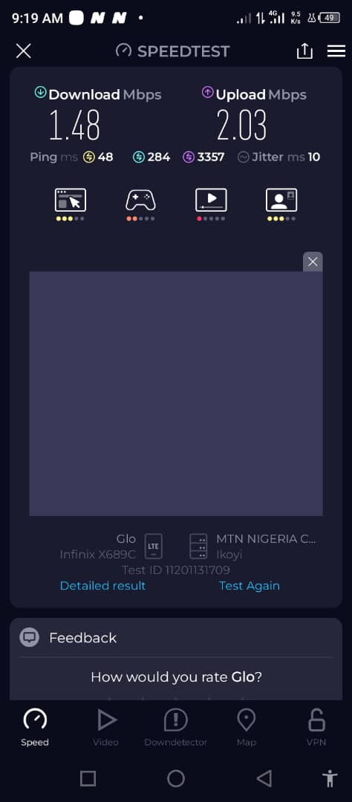
Figure 2: Speed test App by Ookla
Jitter: This is the variation in ping/ latency across a network over time; it measures the inconsistency of the arrival time of data packets measured in milliseconds (ms). It occurs when the delay between data packet deliveries fluctuates, causing packets to arrive at their destination out of order. High jitter means your connection is unstable and can cause data packets to arrive at irregular intervals resulting in issues like pixelation and buffering video, stuttering audio, choppy video or audio, distorted voice calls and lag in games, even if your average ping is low (Uberuaga-Rodgers, 2024; Zoom, 2025). The acceptable values of latency and jitter for application specific are shown in Table 1.
Standard Deviation: this shows how much the values in a dataset are spread out from their mean value. A low standard deviation means the data points are clustered closely around the mean, while a high standard deviation indicates the data is more spread out (Laerd Statistics, 2018; Hargrave, 2025). The sample standard deviation formula is:
$S=\sqrt{\frac{\sum{{\left(X-\overline{X}\right)}^{2}}}{n-1}}$ (4)
where X is the latency value in the data distribution, $\overline{X}$ is the sample mean latency and n is the total number of observations.
Table 1: Application specific guidelines for latency and jitter
Application | Latency (ms) | Jitter (ms)
Ideal | 0 | < 10
VoIP | < 150 | < 30
Video Calls & Conferencing | < 150 | < 30 – 50
Online Gaming | < 50 (ideally < 20) | < 20
Streaming Media | < 100 | < 50 – 100
General Data Transfers or Web Browsing | < 150 | < 100
(Uberuaga-Rodgers, 2024; Zoom, 2025; Cirelly, 2025)
Result and Discussion
The result of the latency for the residential, commercial and educational zones within karu site are presented in Tables 2 to 4.
Table 2: Download, upload speed, ping and jitter for the residential Zone
Time (S) | 6am | 8am | 10am | 12am | 2pm | 4pm | 6pm | 8pm
Download (mbps) | 5.51 | 3.60 | 0.90 | 4.69 | 3.20 | 1.96 | 1.75 | 1.25
Upload (mbps) | 5.67 | 12.60 | 9.16 | 12.50 | 9.15 | 8.81 | 16.50 | 9.00
Ping (ms) | 57 | 38 | 33 | 40 | 35 | 38 | 44 | 46
Jitter (ms) | 17 | 10 | 31 | 10 | 15 | 32 | 22 | 17

Table 2 shows the result for the download, upload speed, ping and jitter for residential zone taking from 6am to 8pm every 2 hours interval. The latency was within the acceptable value throughout < 150ms. Users can enjoy almost all services within the residential areas including VoIP, video calls and conferencing, streaming media and general data transfer. However, services like VoIP, video calls and conferencing, and online gaming may suffer little fluctuation due to unstable network at 10am and at 4pm especially online gaming (jitter > 30). Overall, the network is very good at the residential area Figure 2 shows the variation in latency with time of the day for the residential zone.

Figure 2: Latency across Residential Zones
Table 3: Download, upload speed, ping and jitter for the commercial zone
Time (S) | 6am | 8am | 10am | 12am | 2pm | 4pm | 6pm | 8pm
Download (mbps) | 21.4 | 16.10 | 5.03 | 42.80 | 35.00 | 27.50 | 17.70 | 14.90
Upload (mbps) | 28.10 | 21.60 | 12.50 | 36.80 | 36.10 | 20.10 | 46.00 | 6.14
Ping (ms) | 27 | 59 | 40 | 42 | 39 | 37 | 42 | 40
Jitter (ms) | 5 | 75 | 12 | 9 | 2 | 6 | 19 | 12

Table 3 shows the result for the download, upload speed, ping/latency and jitter for the commercial zone taking from 6am to 8pm every 2 hours interval. The latency was within the acceptable value throughout the day < 150ms. Users can enjoy almost all services within the commercial areas including VoIP, video calls and conferencing, streaming media and general data transfer. However, services like VoIP, video calls and conferencing, and online gaming may suffer heavy fluctuation due to unstable network at 8am (jitter > 30). Overall, the network is very good at the commercial area. These shows a decline in latency and network performance. Figure 3 shows the variation in latency with time of the day for the commercial zone.

Figure 3: Latency across Commercial Zone
Table 4: Download, Upload Speed, Ping and Jitter for the Educational Zone
Time (S) | 6am | 8am | 10am | 12am | 2pm | 4pm | 6pm | 8pm
Download (mbps) | 16.80 | 0.71 | 13.40 | 0.46 | 0.97 | 13.40 | 17.00 | 21.10
Upload (mbps) | 29.20 | 9.05 | 6.62 | 0.94 | 3.72 | 11.30 | 26.60 | 19.30
Ping (ms) | 34 | 106 | 39 | 67 | 53 | 40 | 57 | 51
Jitter (ms) | 8 | 197 | 23 | 65 | 18 | 23 | 19 | 13

Table 4 shows the result for the download, upload speed, ping and jitter for the educational zone taking from 6am to 8pm every 2 hours interval. The latency was within the acceptable value throughout the day < 150ms except at 8am where it is very high > 150ms. Users can enjoy almost all services within the educational areas except at 8am where there will be heavy delay. Also, the network may be very unstable with heavy fluctuations experienced at 8am and at 12noon (jitter > 30). Overall, the network is fairly good at the educational area. Figure 4 shows the variation of latency with time of the day for educational zone.

Figure 4: Latency across Educational Zone

Figure 5: Comparison of latency across residential, commercial and education zones in Karu
Figure 5 reveals a clear temporal pattern in latency, with peak values observed during the morning and evening hours, aligning with high user activity periods. The sinusoidal trend demonstrates lower latency during off-peak hours, such as late at night and early afternoon. Comparing the trend for the three zones, educational zone shows higher latency values compared to residential and commercial areas. These findings emphasize the impact of user demand on network performance and the necessity for adaptive traffic management systems. Implementing dynamic resource allocation strategies during peak hours could mitigate latency spikes, ensuring a consistent user experience throughout the day. This insight is critical for developing time-sensitive optimization protocols for 4G networks.
Table 5: Summary of latency across zones
Zone | Metric | Mean | Median | Standard Deviation | Minimum
Residential | Latency (ms) | 41.4 | 36.5 | 6.4 | 33
Commercial | Latency (ms) | 40.8 | 38 | 6.4 | 27
Educational | Latency (ms) | 55.9 | 46.5 | 7.5 | 34

A detailed comparison of network latency across residential, commercial, and educational zones reveals notable variations in latency across different zones as shown in Table 5. Educational zones showed the worst efficient network performance, with the highest average latency (55.9 ms) and the greatest variability, as indicated by the larger standard deviation attributed to network congestion or longer routes and dynamic user activities. Residential zones exhibited the next higher average latency (41.4 ms) with significant variability, as shown by the standard deviation of 6.4 ms, reflecting challenges like higher user density and less optimized infrastructure and are more prone to network congestion. While, Commercial zones, having lower latency (mean 40.8 ms), indicating intensive app usage and network demand typical of business environments or better infrastructure design. These results emphasize the need for targeted network optimization and improvements especially in educational and residential areas to address congestion and to ensure equitable service quality across all zones.
Discussion

The trends in latency across zones revealed key disparities in network performance, particularly in educational zones, which showed the highest average latency (55.9 ms) with significant variability. This finding aligns with the work of Roettker, (2010) and Goswami et al. (2025), who identified residential areas as hotspots for network congestion due to high user density and sporadic traffic patterns. The variability in latency observed in these zones can be attributed to the mix of devices and activities, from high-bandwidth streaming to intermittent browsing, due to the additional trafﬁc and scheduling overhead necessary to manage additional users in educational network as also reported by Smith et al. (2022). These factors highlight the need for infrastructural upgrades, including enhanced bandwidth allocation and load-balancing technologies, to mitigate congestion in residential areas.
In contrast, the high latency (55.9 ms) and minimal variability observed in educational zones are indicative of structured and controlled network environments, which corroborates findings by Goswami et al. (2025). The lowest latency which is the best was found in the commercial zone and was found to be 40.8ms which is very good. Their research emphasized that well-managed networks in commercial settings benefit from a predictable user base and tailored resource allocation, resulting in consistent performance. Commercial zones' superior latency metrics revealed the importance of strategic network design and traffic management, which could serve as a model for addressing challenges in residential zones. When compared to commercial areas, where latency is typically lower than residential zones but higher than educational zones Smith et al. (2022), the findings further illustrate how infrastructural efficiency and user dynamics influence network performance across different zones. These insights underline the critical need for customized network solutions that cater to the unique demands of each zone.
Conclusion
The findings highlight the challenges and variations in network performance and energy consumption across different zones, emphasizing the need for targeted optimizations. The latency in the research was found to be fair in network delivery. The latency in residential zone is 41.4ms which is good, that of commercial zone is 40.8ms which is better while that of educational zone is 55.9ms which is fair. Physical distance to the cell tower and server is a primary factor that affect latency determined by the distance data packets have to travel i.e. how far away the device making requests is located from the servers or databases responding to those requests. The total size and load time of the page that carry heavy content, large images, or load content from several third-party websites may cause network congestion, as browsers need to download larger files to display them. End-user issues is another problem i.e. network problems or the end-user device being low on memory or CPU cycles to respond in a reasonable time frame. Another possibility is the physical issues i.e. physical cabling such as routers, switches and WiFi access points. In addition, latency can be influenced by other network devices like application load balancers, security devices, firewalls and delays when accessing a stored data packet resulting in a hold up caused by intermediate devices like switches and bridges. Addressing network congestion and quality of the wireless link in education and residential zones, alongside adaptive resource management for temporal demand fluctuations, is crucial for improving 4G network quality and user experience. However, further examination of the technical characteristics of the latency measurement and the influence of the environmental factors, or the work equipment was not examined in this study and is recommended for future research.

Disclaimer (Artificial intelligence)
Option 1:
Author(s) hereby declare that NO generative AI technologies such as Large Language Models (ChatGPT, COPILOT, etc.) and text-to-image generators have been used during the writing or editing of this manuscript.
Option 2:
Author(s) hereby declare that generative AI technologies such as Large Language Models, etc. have been used during the writing or editing of manuscripts. This explanation will include the name, version, model, and source of the generative AI technology and as well as all input prompts provided to the generative AI technology
Details of the AI usage are given below:
1.
2.
3.

References
Agarwal, A. & Agarwal, K. (2014). The Next Generation Mobile Wireless Cellular Networks - 4G and Beyond. American Journal of Electrical and Electronic Engineering, 2(3), 92-97.
Akintoye, S. B. (2013). Wireless Mobile Communication-A study of 4G Technology. Arabian Journal of Business and Management Review (Kuwait Chapter), 2(9), 42-52.

Cirelly, J. (2025). Jitter vs Latency – What’s The Difference and Why it Matters. Message posted to “Network Management Softwares”. Accessed on 18th Sept., 2025 from https://www.networkmanagementsoftware.com/jitter-vs-latency/.

Emeruwa, C. (2015). Comparative analysis of signal strengths of some cellular networks in Umuahia Eastern Nigeria. Journal of Electronics and Communication Engineering Research, 2(10), 01-05.

Fan, X. & Huo, Y. (2021). An overview of low latency for wireless communications: an evolutionary perspective. arXiv preprint arXiv:2107.03484. https://doi.org/10.48550/arXiv.2107.03484.

Goswami, S., Raj, K. S., Durdi, V. B., Naik, T. H., Sunil, M. P., Harish, K. K. & Dash, S. (2025). Latency Minimization Techniques in Dense Urban 5G Mobile Networks. Journal of Wireless Mobile Networks, Ubiquitous Computing, and Dependable Applications (JoWUA), 16(2), 154-167. DOI: 10.58346/JOWUA.2025.I2.010.
Harahap, P., Pasaribu, F. I. & Siregar, C. A. (2021, April). Network Quality Comparison 4g LTE X and Y in Campus UMSU. In Journal of Physics: Conference Series (Vol. 1858, No. 1, p. 012010). IOP Publishing.
Hargrave, M. (2025, June). Standard Deviation Formula and Uses, vs. Variance. Message posted to “Investopedia”. Accessed on 12th October, 2025 from https://www.investopedia.com/terms/s/standarddeviation.asp.

Kumar, A., Gaur, N. & Nanthaamornphong, A. (2024). Improving the latency for 5G/B5G based smart healthcare connectivity in rural area. Scientific Reports, 14(1), 6976.

Kumar, P. P., Kumar, S. N., Thirupathi, V. & Sandeep, C. (2019). QOS and security problems in 4G networks and QOS mechanisms offered by 4G. International Journal of Advanced Science and Technology, 28(20), 600-606.

Kurian, A. (2018). Latency analysis and reduction in a 4G network. Master’s thesis. Delft University of Technology.

Laerd Statistics (2018). Standard Deviation. Accessed on 15th October, 2025. Available at https://statistics.laerd.com/statistical-guides/measures-of-spread-standard-deviation.php.
Li, Y. & Seshadri, N. (2011). Orthogonal Frequency Division Multiplexing for Wireless Communications. Springer, 2(3), 4-6.
Martin, J., Amin, R., Eltawil, A. & Hussien, A. (2011, June). Limitations of 4G wireless systems. In Proceedings of Virginia Tech Wireless Symposium (Blacksburg, VA).
Okafor, C. S., Alagbu, E. E., Onyeyili, T. I. & Maduka, N. C. (2023). Performance analysis and evaluation of 4G network based on handoff process. Unizik Journal of Technology, Production and Mechanical Systems, 2(1), 81-88.
Pandiaraj, T. (2013). Power Control Optimization and Improving Throughput for LTE Advanced Relay Networks. International Journal of Innovative Technology and Exploring Engineering, 3(2), 86-88.
Rappaport, T. S. (2010). Wireless Communications: Principles and Practice. 2/E. Pearson Education India.
Roettker, R. W. (2010). Urban Latency: Potential in the Suburban Retail Landscape [Master's thesis, University of Cincinnati]. OhioLINK Electronic Theses and Dissertations Center. http://rave.ohiolink.edu/etdc/view?acc_num=ucin1275666916.
Slalmi, A., Chaibi, H., Chehri, A., Saadane, R., Jeon, G. & Hakem, N. (2020). On the ultra-reliable and low-latency communications for tactile internet in 5G era. Procedia Computer Science, 176, 3853-3862.
Smith, S., Darwhekar, I., Blakley, J., Eiszler, T. & Harkes, J. (2022). Segmenting Latency in a Private 4G LTE Network. Tech. Rep. Technical Report CMU-CS-22-115, School of Computer Science Carnegie Mellon University.
Turchet, L. & Casari, P. (2023). Latency and reliability analysis of a 5G-enabled Internet of Musical Things system. IEEE Internet of Things Journal, 11(1), 1228-1240.

Uberuaga-Rodgers, L. (2024). Jitter vs Latency: Definitions and Differences for Better Network Performance. Message posted to “Auvik”. Accessed on 18th Sept., 2025 from https://www.auvik.com/franklyit/blog/jitter-vs-latency.

Wylie-Green, M. P. & Svensson, T. (2010, December). Throughput, capacity, handover and latency performance in a 3GPP LTE FDD field trial. In 2010 IEEE Global Telecommunications Conference GLOBECOM 2010 (pp. 1-6). IEEE.

Xu, Y. & Fischione, C. (2012, May). Real-time scheduling in LTE for smart grids. In 2012 5th International Symposium on Communications, Control and Signal Processing (pp. 1-6). IEEE.
Yadav, R. (2017, March). Challenges and evolution of next generations wireless communication. In Proceedings of the International Multi-Conference of Engineers and Computer Scientists (Vol. 2).
Yusuf, S. D., Mohammed, K. O. & Loko, A. Z. (2024). Analysis of the signal strength of the key telecommunication networks in Nasarawa State, Nigeria. Journal of Engineering Research and Reports, 26(12), 220-230. DOI: https://doi.org/10.9734/jerr/2024/v26i121353.
Zoom Blog (2025, February). What is jitter on a speed test and how do you fix it? Accessed on 20th October, 2025. Available at https://www.zoom.com/en/blog/what-is-jitter/.
.

