Original Research Article
Drying Process Factors Effect on Cassava Chips

ABSTRACT
This study evaluates the influence of drying process parameters on cassava chips. Sun drying and oven drying methods were studied. Two key factors of drying time and drying temperature were investigated independently during oven drying. For each cassava variety, the chips were exposed to varying drying durations at constant temperature and to different temperatures at constant time to observe their effects on the moisture loss, cyanide degradation, and drying rate. It was discovered that temperature had a significant impact on the drying efficiency, in that, it governed the rate of moisture evaporation and further influenced the retention or degradation of cyanide compounds. Conversely, the effect of drying time alone showed limited variation in outcomes when temperature remained unchanged, suggesting that temperature is a more dominant variable. In sun drying process, solar intensity, ambient temperature, and relative humidity were inherently variable and were monitored daily. Chips were spread on clean concrete floors and turned intermittently from 10:00 a.m. to 5:00 p.m. over six days. Sample B recorded highest moisture diffusivity ($D_{eff}$) of 8.86 × 10⁻⁸ m²/s, suggesting that the specie allowed moisture to migrate more efficiently from the interior to the surface while Sample C showed lowest $D_{eff}$ of 5.77 × 10⁻⁸ m²/s, indicating slowest internal moisture movement and potentially denser chip structure. Diffusion dominated the drying process between 30–50% moisture content. Despite variability in sunlight, the results indicated that sun drying achieved better cyanide removal compared to oven drying, due to lower thermal degradation thresholds that favor cyanogen elimination. The analysis confirms that both temperature and species type are crucial process factors, and that their careful regulation can significantly improve drying performance, ensuring food safety and product stability.

Keywords: Drying parameters, Temperature Effects, Drying Duration, Moisture Reduction, Process Variables

1 INTRODUCTION
Reducing post-harvest losses and getting rid of the cyanide toxicity that comes with raw cassava tubers depend on drying cassava chips well. Cassava drying, whether by conventional sun drying or controlled oven methods, has two benefits: it reduces moisture content and makes it easier for cyanogenic compounds to break down. However, among other environmental factors, important process parameters including temperature, drying duration, drying technique, slice thickness, air velocity, relative humidity of drying air, and drying rate have a significant impact on drying efficiency. These elements affect not just the rate of drying but also the degree of detoxification and the cassava chips' ultimate quality.
Despite the widespread use of sun drying, it remains inconsistent due to its dependency on climatic conditions, leading to variable product quality and extended drying periods. Conversely, oven drying offers better control over drying environments, yet may not always optimize cyanide removal if temperatures exceed thresholds for enzymatic degradation.
Drying is a critical step in cassava processing as it significantly impacts moisture removal, cyanide reduction, and the preservation of cassava chips (Udoro et al., 2018). The effectiveness of this process is strongly influenced by multiple factors, notably the geometry (shape and size) of the chips, loading density, air velocity, temperature, humidity, and the initial moisture content of the fresh chips (Abok et al., 2016; Doren & Pequeno, 2019). Smaller and uniformly shaped chips tend to dry faster due to shorter diffusion paths and greater surface area, yet overloading or chip compaction can impede airflow and reduce drying efficiency (Olusegun et al., 2017; Soyoye et al., 2015). It has been shown that chips shaped into bar forms (5 × 1 × 1 cm) allow better airflow and enhance drying rates, particularly under natural conditions (Soyote et al., 2015).
Sun drying is widely adopted due to its simplicity and low cost. Typically, cassava chips are spread on concrete floors or elevated trays and manually turned to achieve even exposure. The slice thickness plays a vital role, as thicker slices may appear dry externally while retaining internal moisture (Odebode & Stella 2008). Critical sun-drying variables include wind speed, air temperature, humidity, and chip arrangement, all of which affect drying time and final moisture content. The drying process under sun exposure occurs in two phases: a rapid surface drying phase down to ~20% moisture content, followed by a slower diffusion-controlled phase, requiring relative humidity below 65% to reach ~13% final moisture (Pornpraipech et al., 2017).
Oven drying, a form of artificial drying, provides better control over these parameters. It eliminates reliance on weather, reduces microbial contamination risk, and allows precise manipulation of drying temperature and airflow, leading to higher product consistency (Alamu et al., 2023; Ojediran et al., 2020). Oven drying is commonly done between 45°C and 165°C, but temperatures below 100°C have shown superior results in preserving chip quality and maximizing cyanide removal (Stephenus et al (2023). The original chip moisture content and drying temperature significantly determine the drying rate and final product safety (Egbosiuba et al., 2021).
In both drying methods, the rate of drying is highly dependent on chip shape, size and loading thickness, which control airflow and heat transfer (Michael 2023). For example, cube-shaped chips (10 × 10 × 10 mm) have shown superior drying efficiency under artificial drying in static bed dryers (Menya et al., 2020; Carvalho et al., 2023). Additionally, solar radiation varies by latitude, time of day, and weather conditions, making oven drying more predictable and adaptable for commercial processing (Nirmaan et al., 2020). Thus, understanding and optimizing these process factors are essential for achieving safe, high-quality cassava chips while reducing spoilage and improving shelf stability. Each drying method and condition presents specific challenges and advantages that influence both moisture removal rate and cyanide detoxification outcomes (Zhang et al., 2018; Sanni 2015).

Pechaporn et al. (2022) evaluated the effect of chip shape (rectangular and circular) and air temperature (60°C–120°C) on drying behavior. The Page model satisfactorily described the drying of rectangular chips, which performed better in terms of drying time and color retention, especially at 100°C. Their findings supported the conclusion that both physical geometry and thermal parameters significantly affect drying performance and model fit. In Okeke et al. (2023), a comparison of oven and sun drying techniques, resulted in higher drying rates in oven-dried samples (0.15–0.20 g/min) than sun drying (0.022–0.025 g/min). Although sun drying showed greater effectiveness in cyanide reduction due to lower temperature ranges favorable for cyanogen degradation. These results highlight the temperature-dependent nature of cyanide volatilization and the implications for drying model accuracy.
Moreover, Chinedu et al. (2023) established that increasing oven drying temperatures led to faster moisture and cyanide reduction across cassava varieties, indicating the direct impact of temperature on drying rate. Ujevwerume et al. (2020) confirmed similar results in sun drying, where increased drying time significantly reduced both moisture and cyanide content. These empirical studies provide foundational data for drying model calibration under real-world conditions. Altogether, these works emphasize that drying kinetics of cassava chips are highly influenced by drying method, temperature, air velocity, chip geometry, and cassava variety, and that appropriate mathematical modeling—particularly Modified Henderson and Pabis, Page, and Logarithmic models offers reliable tools for simulating drying behavior under diverse conditions.

In order to ascertain the impact of drying temperature, time, and cassava species on moisture reduction and cyanide degradation, it becomes essential to examine the separate and combined effects of these process parameters on cassava drying results. Standardizing processing methods and enhancing product stability and safety require an understanding of how these factors impact drying efficiency. The results will aid in the creation of evidence-based cassava drying recommendations, allowing for more effective preservation techniques and wider industrial applicability, particularly in areas where cassava is a staple food and source of income.

2 MATERIALS AND METHOD
2.1 Chemical and Reagents
The synthetic substances deployed during the analytical classification include Sulphuric Acid (H₂SO₄), Sodium - Hydroxide (NAOH), Boric Acid, Bromo - Crisol Green, Hydrochloric Acid (HCl), N – Hexane, Acetone, Petroleum Ether, 2,6 - Dichlorophenolindophenol, Picric Acid, and Potassium Cyanide.

2.2 Equipment and Instruments
Equipment utilized in experimentation processes were Laboratory Electric Dry Oven, Anemometer, Hygrometer, Mercury - in - Glass - Thermometer, Digital Scale, Stopwatch, Laboratory Glass Desiccators, Micrometer Screw Gauge, Wire Gauze, Spectrophotometer, Atomic Absorption Spectrophotomete, Kjeldahl Flask, Soxhlet Apparatus, Muffle Furnace, Platinum Crucible, Filter Papers, Ram Bottom Flasks, Conical Flasks, Beakers, Shovel, Sharp Stainless Knife and Rake.

2.3 Sample Collection, Preparation and Dry Procedure
Five cassava varieties namely: Game-Changer, Obasanjo-II, Poundable, Hope, and Baba-70—harvested nine months from planting date were used. In Mujaffar (2020), the process of preparing cassava chips was followed. The tubers were peeled, sliced into uniform chips, and categorized as samples A, B, C, D and E. Drying was performed using an electric oven at different temperatures (70°C–130°C) and times (10–60 minutes) according to a two-factor, full factorial experimental design.

2.4 Experimental design
To systematically determine the impact of these variables, statistical and experimental design, Design Expert Software (v9.0.7.1) was deployed to facilitate modeling and simulation to identify optimal drying conditions. Variables were coded and analyzed through polynomial regression:
$$Y=β_{O}+\sum_{i=1}^{4}{β_{i}X_{i}+\sum_{i=1}^{4}{β_{ii}X_{i}^{2}+\sum_{i=1}^{4}{\sum_{j=1+1}^{4}{β_{ij}X_{I}X_{j} (1)}}}}$$

To assess the interactive effects of temperature and time on drying rate and moisture loss. Every chip sample was cooled in desiccators, weighed both before and after drying, and its moisture content was measured using AOAC (2020) techniques. To determine the drying rate and moisture ratio, the weight loss was measured at predetermined intervals during the procedure. Response surface plots that show the best drying conditions for reducing moisture in each cassava variety were created using the results.

3 RESULTS AND DISCUSSION

  - Data Analysis

    - Moisture Content (MC)

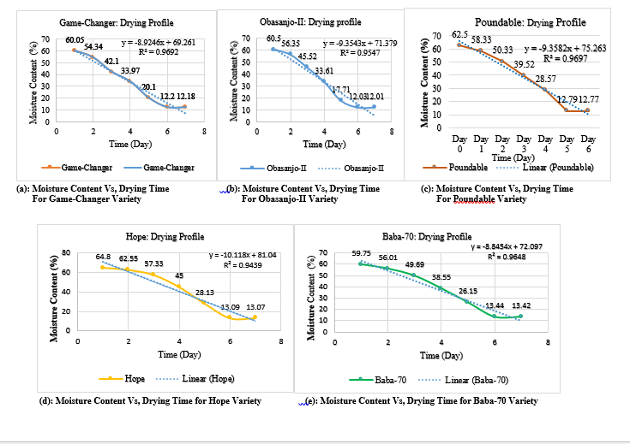Fig 1: Samples Drying Profiles for Samples Moisture Content (%) Vs. Time (Days)

Figures 1 displays the moisture content (MC) of the samples over time and their drying profiles respectively, tracking how much water is lost over time. As a process factor, MC measurement helps determines the starting point of moisture loss and further influences drying behavior. In the different cassava chips drying profiles in figure 1, all samples show a steady decline in MC over 6 days, indicating effective drying. Hope variety (Sample D) starts with the highest MC of 64.8% and Baba-70 (Sample E) had the lowest MC of 59.75%. By Day 6, MC levels converge around 12–13%, revealing the natural drying limit under sun conditions. In all samples there is a steady decrease in moisture content. Samples D and C which had an initial highest MC of 65% and 62.5% respectively reduced to 13%, indicating high moisture loss while Sample A reaches a low MC of 12.18% being the fastest and most efficient drying species.

3.1.2 General Moisture Reduction Trend
The most significant moisture losses occur within the first 3 days, confirming that initial drying rate is high when surface moisture is readily available. However, as drying progresses, the rate slows due to reduced surface moisture and increasing internal moisture diffusion resistance in the manner reported in Alamu et al (2023). Below is the Sample-by-Sample Analysis:
Sample A: This variety displays an initial MC of 60.05% and a final MC of 12.18% with a total MC reduction of 47.87%. The sharp decrease occurs between Days 1 and 4. By Day 5, the moisture content stabilizes around 12% indicating the nearness of the drying curve to equilibrium condition.
Sample B: Obasanjo-II (Sample B) displays an initial and final MC of 60.50% and 12.01% respectively, showing a steady decline, especially from Day 0–4. The drying process appears slightly faster than Sample A, with Day 4 moisture already at 17.71%.
Sample C: Poundable (Sample C) starts with the highest MC of 62.50%) and ends at 12.77%, exhibiting a total reduction of 49.73%. This sample recorded a slower reduction rate than A and B in the first 3 days, possibly due to higher initial MC or denser structure. Sample D still reaches similar endpoint moisture as Samples A and B, but took slightly more time.
Sample D: Hope variety (Sample D) possesses the highest initial MC of 64.80% and slowest initial drying rate. MC at Day 2 remains at 57.33% indicating less water lost in early days. By Day 4, the curve accelerates sharply, which suggests initial higher internal resistance to moisture migration, possibly due to microstructure variation.
Sample E: Moisture content process factor of Baba-70 (Sample E) starts at 59.75% and ends at 13.42%. This Sample follows a moderately consistent drying pattern, showing a good drying efficiency, particularly after Day 2. The final MC of is slightly higher than others, indicating the need for longer drying or higher energy input.

    - Drying Rate (DR) of Samples

Fig. 2: Samples Drying Rate Vs. Drying Time

The drying rate (DR) trend displayed in figure 2 provides understanding into the speed of how moisture content of the different samples of cassava chips are rapidly being lost per unit time as it was reported by (Okeke et al., 2023). The drying rate increased with time, peaking between Days 3–5, after which it plateaued. Sample C reached a maximum drying rate of 0.027 g/min, indicating high drying efficiency during the middle phase. Highest peak DR of 0.028g/min is observed in Sample D, indicating fastest moisture loss while Sample E shows the lowest DR values, suggesting a slower drying process and possible internal resistance to moisture migration. However, all samples stabilized at a similar rate within the range of 0.025 to 0.028 g/min toward the end, suggesting a common diffusion limit being approached. This shows that initial moisture content and internal cell structure largely govern early drying rate, while later drying is diffusion-limited and uniform across varieties. From the samples drying profile on figure 2, all samples exhibited high R² values of 0.94 and above, suggesting a strong model fit and significant drying process factors influences.

    - Moisture Ratio and Diffusivity ($D_{eff}$): Gives insight into moisture migration inside the chip.
Effective diffusivity quantifies the ease with which moisture migrates within the solid matrix. The diffusivity values for the five samples fell within the range of 5.77 × 10⁻⁸ to 8.86 × 10⁻⁸ m²/s, which is typical for agricultural products undergoing low-temperature drying (Faridz et al., 2025).

Fig. 3: Moisture Ratio (MR) of Samples Vs. Time (s)

Fig. 4 (a): Effective Moisture Diffusivity ($D_{eff}$) of Sample A Vs. Time (s)

In the plot of moisture diffusivity ($D_{eff}$) of Sample A, the value of $D_{eff}$ falls within the expected range for sun-dried agricultural products, typically 10⁻¹²m²/s to 10⁻⁷m²/s. A higher $D_{eff}$ means faster internal moisture migration, implying better drying efficiency. Sample A’s diffusivity suggests moderate water migration, which may be influenced by porosity of cassava structure, sun exposure consistency and initial moisture content.

Fig. 4 (b): Effective Moisture Diffusivity ($D_{eff}$) of Sample B Vs. Time (s)

Fig 4 (c): Effective Moisture Diffusivity ($D_{eff}$) of Sample C Vs. Time (s)

Fig. 4 (d): Effective Moisture Diffusivity ($D_{eff}$) of Sample D Vs. Time (s)

Fig. 4 (e): Effective Moisture Diffusivity ($D_{eff}$) of Sample E vs. Time (s)

For all samples displayed in figures 4 (a-e), $D_{eff}$ represent the internal transport rate of moisture from inside the cassava chips of each sample to the surface. Sample B showed the highest${ D}_{eff}$, indicating the most efficient internal moisture migration, likely due to structural or compositional factors. Samples C and E had the lowest $D_{eff}$ values, suggesting slower moisture movement, possibly due to denser cell matrices or less porous surfaces. All samples reach near-final MC by Day 5–6, but Samples B and E level off earlier, suggesting that longer drying times during the cassava chip processing conditions offer diminishing returns; and this collaborates (Faridz et al., 2025 & Mardiyani et al., 2021).

Fig. 5: Moisture Diffusivity of Samples vs. Time (Day)

3.2 Drying Time
The drying process was tracked over six intervals, up to 518,400 seconds (6 days). The natural logarithm of the moisture ratio (MR), which is a dimensionless measure of how much water remains in the sample over time compared to its initial water content was observed for Samples A–E. On efficient drying time evaluation, cassava Samples that reach low moisture levels quicker than others and with high $D_{eff}$ are considered more efficient in drying. Based on the moisture curves and${ D}_{eff}$, Sample B again stands out as the most drying-efficient variety under sun drying. The design implications are that drying conditions such as air flow, humidity, and temperature be further optimized for better varieties like Sample B, which already exhibit good drying performance. Samples like C and E may benefit from pre-treatment of thinner slices and blanching to enhance moisture diffusion.

Fig. 6: Ln(MR) Vs.Time

Figure 4, 5, 6 contain the moisture diffusivity behaviors of the different samples of the examined cassava chips and the corresponding process parameters performances are as discussed hereunder:
- Initial Stage: During the initial Stage (0 – 172,800 s), all samples started with Ln(MR) = 0 at time zero, implying MR = 1and all samples have full moisture content. After 1 day (86,400 s), moisture loss begins, but at different rates. Sample A dries fastest (Ln(MR) = -0.127) while Sample D dries slowest (-0.04447). After 2 days (172,800 s), moisture loss becomes more pronounced as samples A and B are seen to exhibit Ln(MR) of -0.47 and -0.37 respectively, suggesting higher diffusivity.
- Middle Stage (172,800 – 345,600 s): The negative values increase in magnitude, meaning faster drying. Sample B overtakes A in moisture loss rate by day 4 (Ln(MR) = -2.14 vs. -1.80). Sample D remains the slowest throughout, with relatively small magnitude changes.
- Approach to Terminal Stage (432,000 s and beyond): At 432,000 s (~5 days), the Ln(MR) values drop sharply to around -7.78 for all samples, indicating they have reached very low moisture content, approaching equilibrium. At 518,400 s (~6 days), all samples are at Ln(MR) ≈ -6.91, a plateau that reflects no significant further moisture loss — drying equilibrium.
- Early-phase differences: The first 2–4 days show distinct drying rates between samples, suggesting differences in effective moisture diffusivity ($D_{eff}$) possibly due to Material structure (porosity, density), Pretreatments (blanching, chemical soaking, etc.) and Ambient conditions (if not perfectly controlled)
- Middle-phase acceleration: Moisture loss rate accelerates before hitting a steep drop, likely due to falling rate period drying where internal diffusion dominates over surface evaporation.
- End-phase convergence: By the last 2 days, all samples converge to similar final moisture content. This is typical — once bound water is reached, drying rate becomes extremely slow and independent of earlier differences.
- Industrial drying optimization: Since differences are largest in the first 2–3 days, energy savings could be achieved by adjusting drying conditions during that phase for faster samples (A, B) and extending time slightly for slower ones (D). In terms of product quality, uniform final moisture content is achieved, which is important for shelf life.

    - Slice Thickness
Slice thickness is seen to affect diffusion length, thinner slices dry faster and affect the surface area and internal moisture diffusion rate of all cassava chips samples. Geometrically, the chips face of 15cm² with volume of 3.0cm³ and surface-to-volume ratio of 10.0cm⁻¹ enables the chips to undergo faster drying as more surface per unit water-containing volume is seen to high surface-area to volume (SA/V) drying of the chips. For a thin slab such as the cassava chip, the characteristic length is the half-thickness which implies that thickness = 0.2 cm = 0.002 m → half-thickness L = 0.001 m.
It can be inferred that a rough order-of-magnitude drying time scale from internal diffusion is given by:
$$Drying time \left(t\right)=\frac{L^{2}}{D_{eff}} (2)$$
Where $D_{eff}$ is effective moisture diffusivity (m²/s). Typically, foods of the likes of cassava chips range widely (∼10⁻¹¹ to 10⁻⁹ m²/s). Apply equation (2),
- When $D_{eff}$ = 1×10⁻⁹ m²/s: $L^{2}$= (0.001)² =1×10⁻⁶ m²/s and $t=1 x {10}^{-6} ÷1 x {10}^{-9}=1 x {10}^{3}s=1000s=16.7min.$
- At $D_{eff}$ =1×10⁻¹⁰ m²/s: $t=1 x {10}^{-6} ÷1 x {10}^{-10}=1 x {10}^{4}s=10,000s=2.78hrs$
- When $D_{eff}=$ 1x${10}^{-11}m^{2}/s$: $t=1 x {10}^{-6} ÷1 x {10}^{-11}=1 x {10}^{5}s=10,000s=27.78hrs$
From the above estimations, it implies that with a half-thickness of 0.001m, drying by internal diffusion can be minutes to a few hours for the examined cassava chips which is much faster than for thicker chips.
    - Effects of Chips Thickness on Key Process Parameters
The study reveals that thinner chip sizes exhibit shorter diffusion pathways, facilitating faster internal moisture movement and reduced drying times. Chips of 0.2 cm thickness primarily undergo drying through surface evaporation, benefiting from a high surface area to volume ratio (SA/V) of 10 cm⁻¹, which promotes higher initial and uniform drying rates. Thinner chips show minimal temperature fluctuations and moisture gradients, leading to reduced thermal and mechanical stress, decreasing the risk of cracking compared to thicker pieces. However, rapid drying at elevated temperatures can cause over-drying and surface browning, while extremely thin chips are more susceptible to early crispness and sensitivity to slight over-processing. The findings suggest that external convective resistance becomes more significant with thinner chips, indicating that increasing air speed enhances drying efficiency but with limited impact once internal diffusion is negligible. Overall, optimizing process conditions can leverage shorter diffusion times, noting that thin chips are fragile, require gentle handling, and necessitate rapid cooling post-drying to avoid moisture re-adsorption.
    - Influence of Air Velocity (wind speed), Relative Humidity (RH), and the weather Condition on Drying of Cassava Chips
As temperature remains fairly stable hovering around 29°C to 31°C, the weather having a decent breeze with wind speed between 4.36 and 4.81 m/s and a moderately high or slightly variable relative humidity ranging from 63.8% to 67.5%, the drying time per day is constant at 420 min (7 hours).

Fig. 7: Average Weather Conditions during Sun Drying of Cassava Chips

Wind speed, relative humidity (RH), and air temperature significantly influence the drying process. Higher air velocity enhances convective heat and mass transfer, speeding moisture removal from drying chips as illustrated in Figure 7. A maximum wind speed of 4.81 m/s was observed, promoting effective surface drying despite lower air temperature and higher RH. Approximately 10% variation in wind speed led to minor shifts in drying rates, particularly during constant rate periods. RH affects drying potential, with the lowest RH of 63.8% on Day 1 promoting rapid moisture evaporation. Higher RH of 67.5% on Day 3 decreased the vapor pressure gradient, slowing drying rates despite wind speed. Drying rates diminish significantly when RH exceeds 65%. Rising drying temperatures reduce equilibrium moisture content, enhancing drying speed, with the most optimal conditions recorded at 31.4℃ on Day 1 with low RH and moderate wind speed.

    - Interactions Between Parameters
In this study, the influences of process parameters of temperature, relative humidity and wind speed were not independent; in that high temperature in combination with low humidity and high wind speed resulted in faster drying condition as experienced on Day 1. Then high relative humidity was seen to hinder the chips from utilizing high wind speed for faster drying on Day 3 while increase in wind speed facilitated better drying when relative humidity was low due to favorable vapor pressure gradient was observed throughout the drying processes. Although the chips were dried for 420 minutes each day, dying variabilities were noted in actual moisture loses based on the combination of prevailing weather parameters. With wind speed of 4m/s to 5m/s, good convective regime and high RH conditions were observed and further increase in speed yielded diminishing returns. A relatively moderate RH in the range of 64% – 67% resulted in slow bound water removal at the final stage of chips drying. The use of drying racks maximized airflow and further exposed the chips to the wind direction while extending drying duration and low level artificial heating localized RH reductively. The drying effect of the different samples per day is summarized on table 1. This is in accordance with the finding by (Pornpraipech et al., 2017).

    - Drying Rate Dynamics
The drying rate provides understanding on how moisture content of the different samples of cassava chips are rapidly being lost per unit time. From Figure 2, drying rate increased with time, peaking between Days 3–5, after which it plateaued. Sample C reached a maximum drying rate of 0.027 g/min, indicating high drying efficiency during the middle phase. All samples stabilized at a similar rate within the range of 0.025 to 0.028 g/min toward the end, suggesting a common diffusion limit being approached. This shows that initial moisture content and internal cell structure largely govern early drying rate, while later drying is diffusion-limited and uniform across varieties.

Table 1: Qualitative Drying Effect of Cassava Chips per Day
Day | Conditions | Drying Rate Impact
1 | High Temperature, Low Relative Humidity, Moderate Wind Speed | Fastest Drying
2 | Slightly lower temperature, Slightly higher relative humidity, higher wind speed | Slightly lower drying than Day 1
3 | Lower temperature, high relative humidity, highest wind Speed | Moderate drying compensated for by high relative humidity
4 | Medium temperature, medium RH, moderate wind speed | Moderate drying
5 | Lowest temperature, Medium-High RH, Medium-High wind speed | Slowest drying

Table 2: Drying Efficiency Comparison
Sample | Total Moisture Loss (%) | Final Moisture (%) | Drying Remark
A | 47.87 | 12.18 | Efficient drying
B | 48.49 | 12.01 | Very efficient drying
C | 49.73 | 12.77 | Efficient, slightly slower drying
D | 51.73 | 13.07 | Initial resistance but later accelerated drying
E | 46.33 | 13.42 | Consistent drying but slower to stabilize

From tables 1 & 2, all samples dry faster in the first 3 days, after which they approach an asymptote, indicating that the freest moisture has evaporated and bound water is more difficult to remove. The varietal differences in drying behavior may result from fiber content and internal structure, cell wall resistance to moisture migration, chip thickness, porosity and exposed surface area of the chips. At the drying endpoint, all samples converge around 12–13% MC, which is acceptable for storage and shelf-life. Thus tables 1 and 2 support process optimization by providing information on the optimal drying duration which shows that Day 5-6 drying time is sufficient, identifying samples B and A as being the most responsive species to natural sun dying process; and further estimating energy efficiency and drying schedules for application in industrial and rural settings. This drying kinetics collaborates similar studies as reported by (Sanni 2015; Chigbo et al 2024).

    - Drying Time Efficiency and Process Parameters Relativity
These intrinsic characteristics govern both moisture evaporation at the surface and internal diffusion rates. This justifies the need to tailor drying strategies to the specific cassava variety to optimize energy use and product quality. The efficiency of the drying process is highly dependent on the cassava variety, as it influences both the external drying rate and internal moisture diffusivity. Optimizing drying practices for each variety can significantly improve drying efficiency, reduce processing time, and ensure better product quality.
- Moisture Diffusivity and Drying Time (days) shows how drying method and chip thickness affect diffusivity over time which is displayed in figure 8(a).

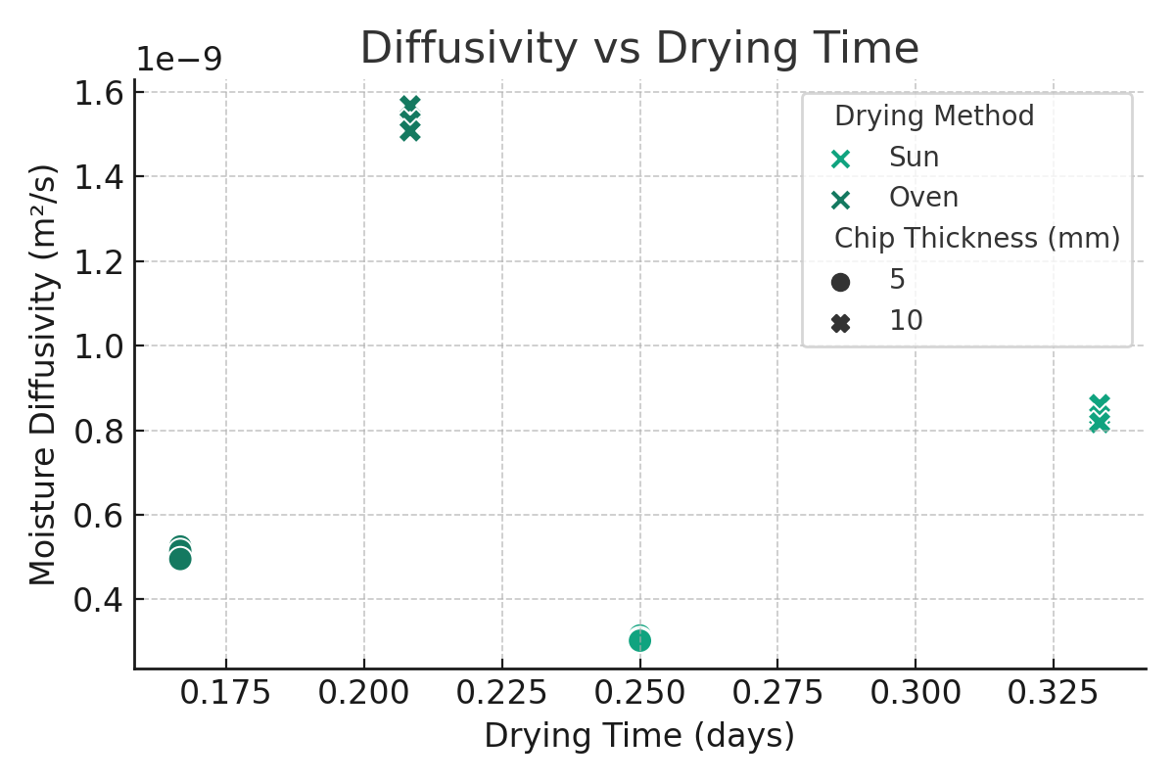
Fig. 8(a): Moisture Diffusivity vs. Drying Time (days)

The trend on figure 8(a) shows a generally longer sun drying times which correlate with lower diffusivity values. Oven drying reaches high diffusivity in shorter timeframes due to elevated temperature (60°C vs 35°C). Thicker chips (10 mm) have higher diffusivity than 5 mm, likely due to sustained internal moisture gradient. The trends revel that higher drying temperature (Oven) and increased thickness both increase diffusivity, contrary to initial expectations and later scenario may be due to internal moisture retention promoting gradient-driven migration.

(b) Diffusivity and Chip Thickness highlights the effect of thickness for each drying method as shown on figure 5(b).
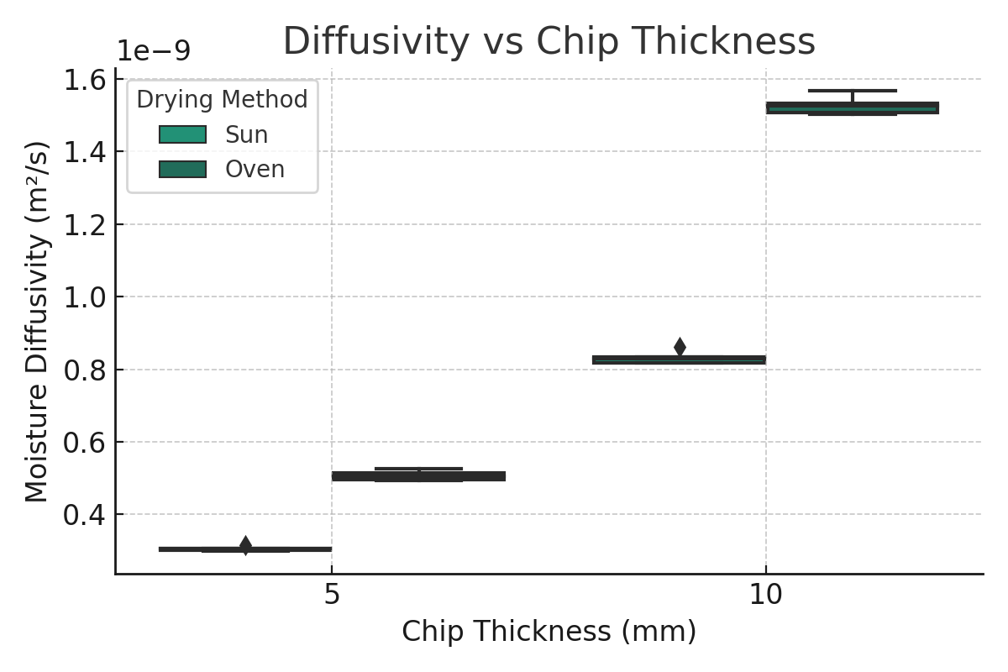
Fig. 8(b): Diffusivity vs Chip Thickness

In figure 8(b), the 10 mm chips is seen to consistently show higher diffusivity for both sun and oven drying methods. By interaction, the impact of chip thickness is more pronounced in Oven drying. This implies that thicker chips maintain moisture longer, allowing for sustained diffusion, especially under high thermal conductivity in Oven drying.

(c) Diffusivity by Drying Method compares Sun and Oven drying performance as contained in figure 5(c).
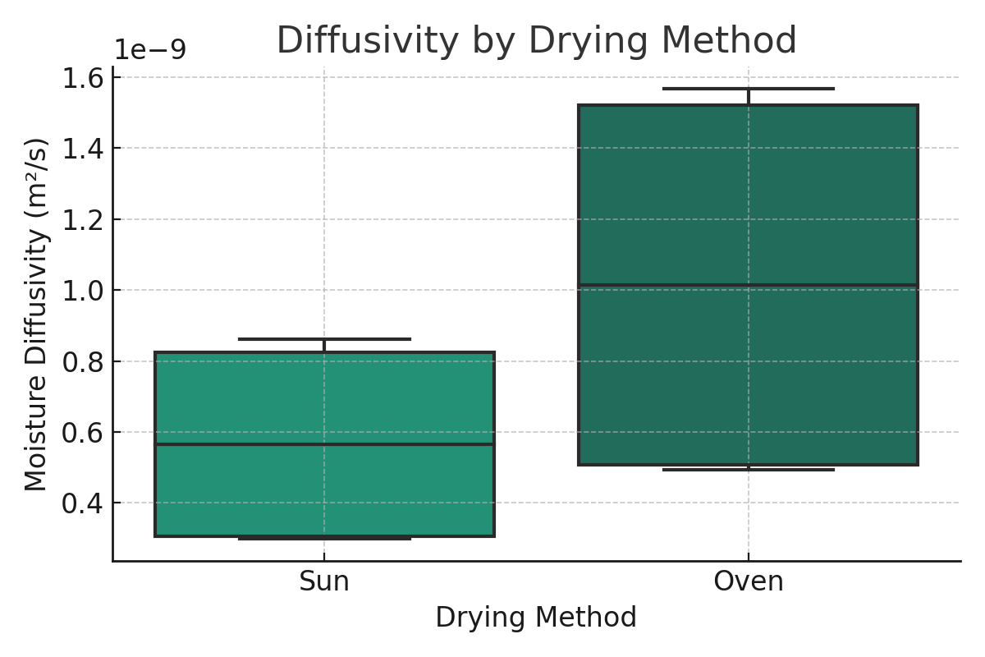
Fig. 8(c): Diffusivity by Drying Method

Based on figure 5(c), Oven drying clearly outperforms Sun drying in terms of moisture diffusivity. Narrower spread in Oven indicates better control and uniformity.

3.2.7 Analysis of Moisture Diffusivity Data, Graphs and Fickian Drying Kinetics
Based on Fick’s law, the drying kinetics logarithmic regression model from $\ln\left(MR\right)= -k*t+C$ results in drying rate constant (k) = 1.47 x 10⁻⁶ s⁻¹ and R² of 0.94 which is an excellent fit to Fick’s model. This implies that cassava drying follows Fickian diffusion very well under the tested conditions

3.2.8 Response Surface Optimization
The efficiency of the drying process is highly dependent on the cassava variety, as it influences both the external drying rate and internal moisture diffusivity. Optimizing drying practices for each variety significantly improved drying efficiency, reduced processing time, and ensure better product quality. In line with Akinola and Ezeorah (2019); Nainggolan et al. (2023), the cassava chip drying kinetic, moisture diffusivity and a multi-objective optimization that targets minimal final moisture and cyanide content of the chips yielded the drying Response Surface plots displayed on figures 9 (a-e); and the process evaluation of the five different varieties of cassava, the chips thickness and their drying methods are as described specie by specie as follows:

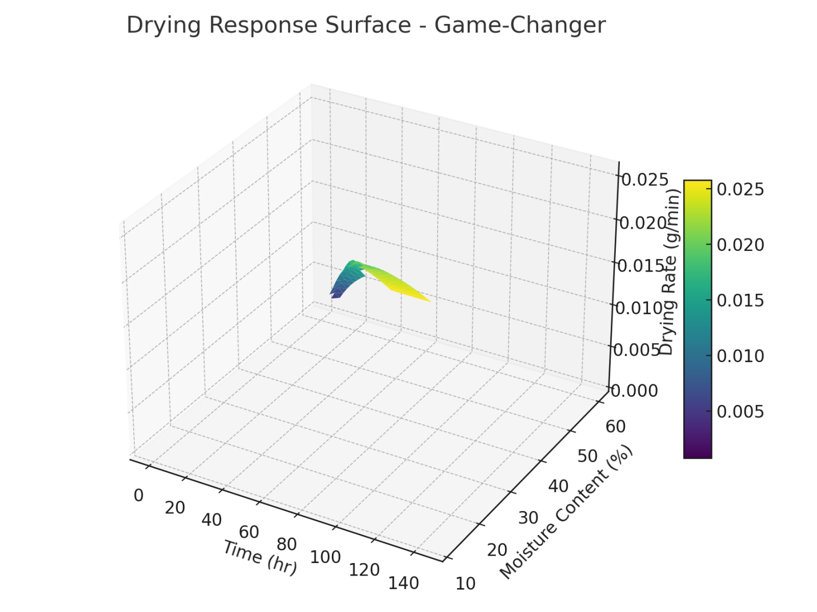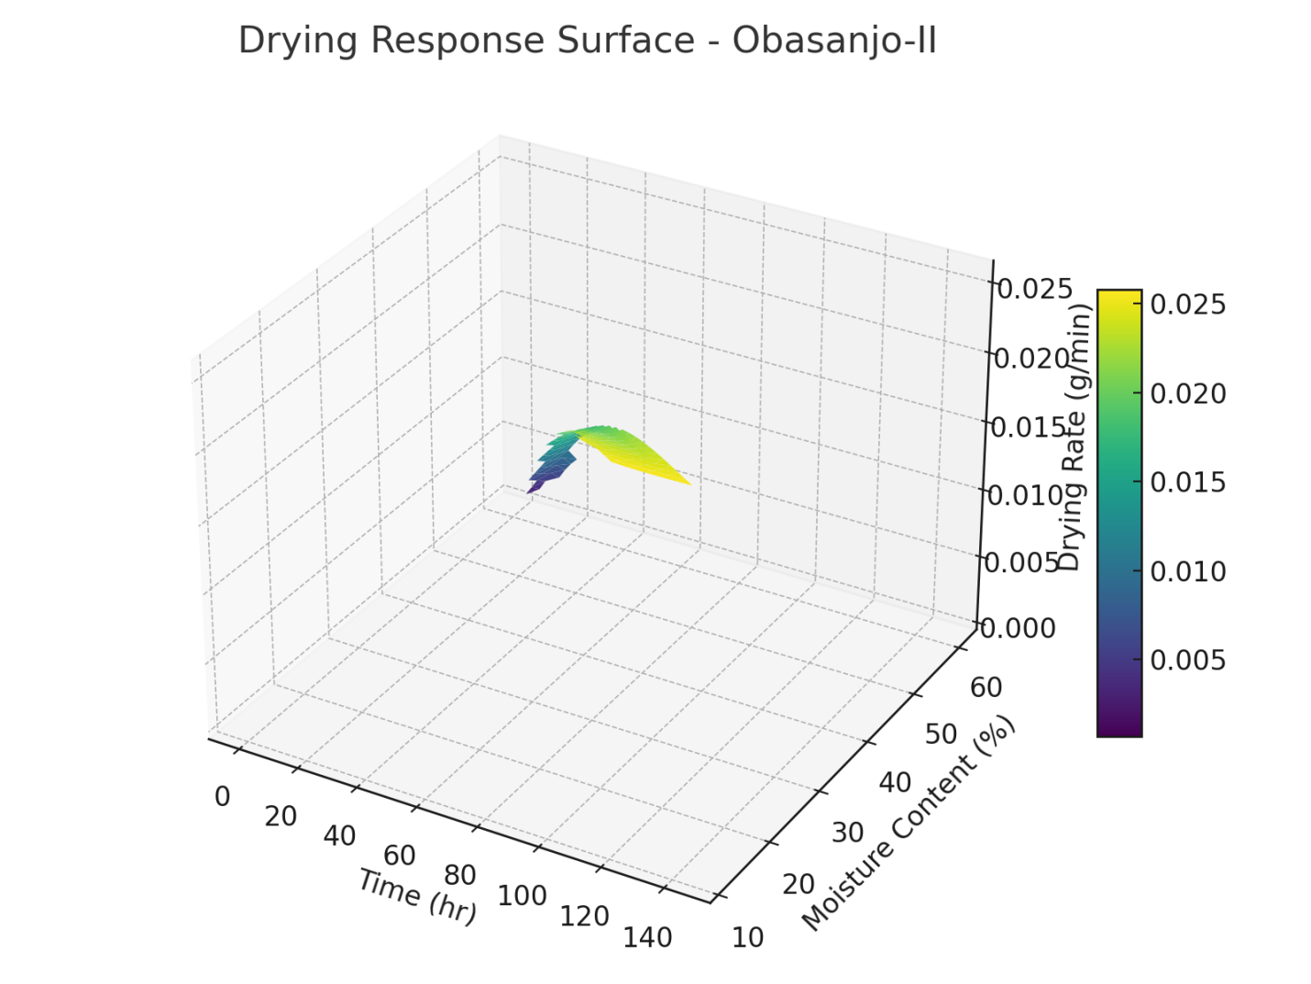
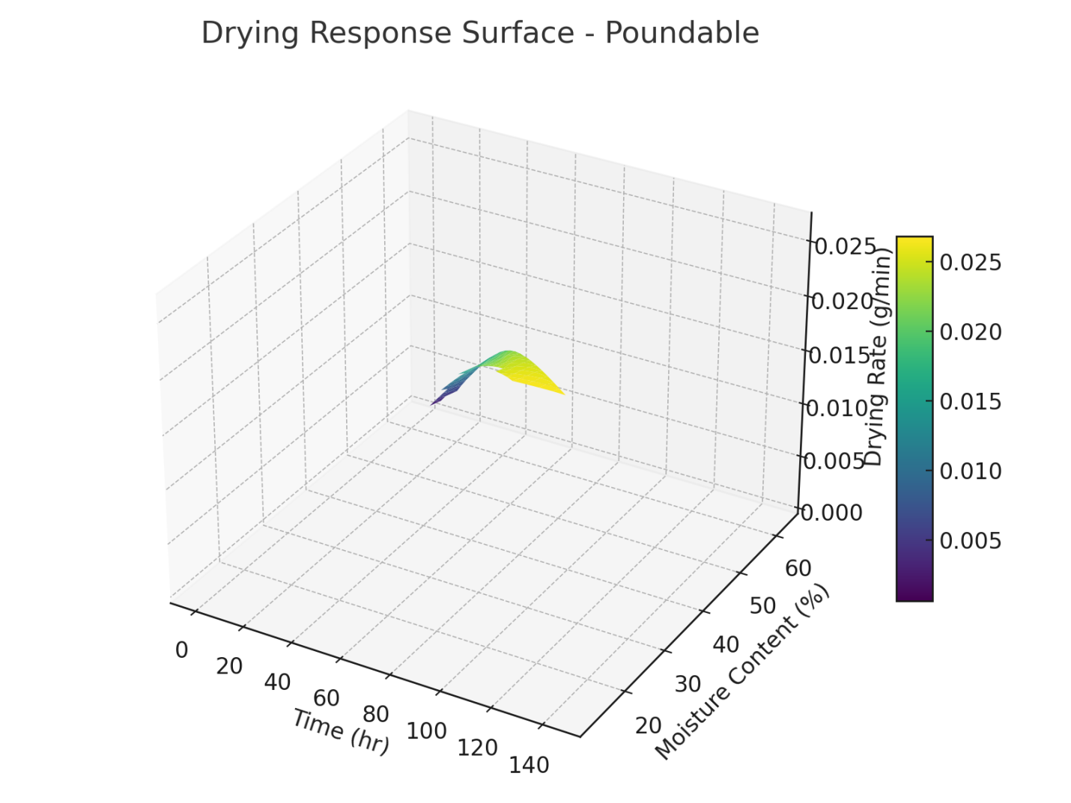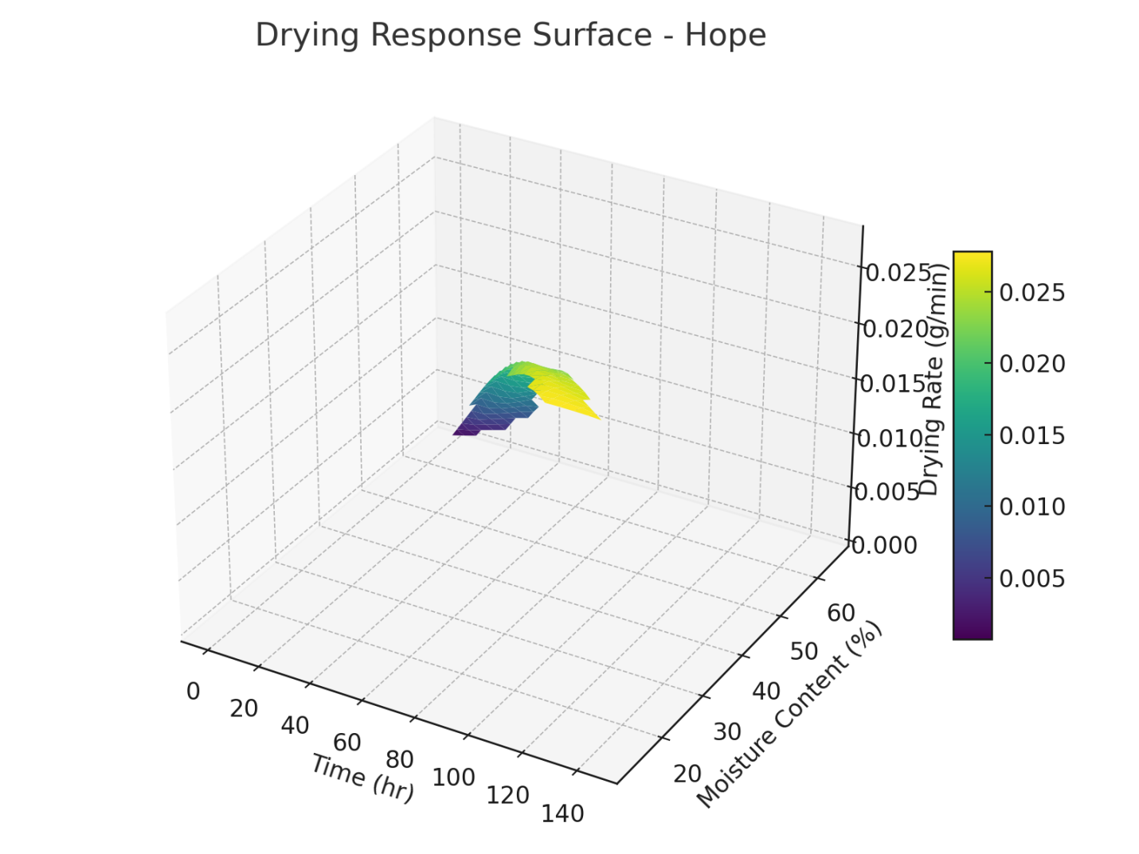

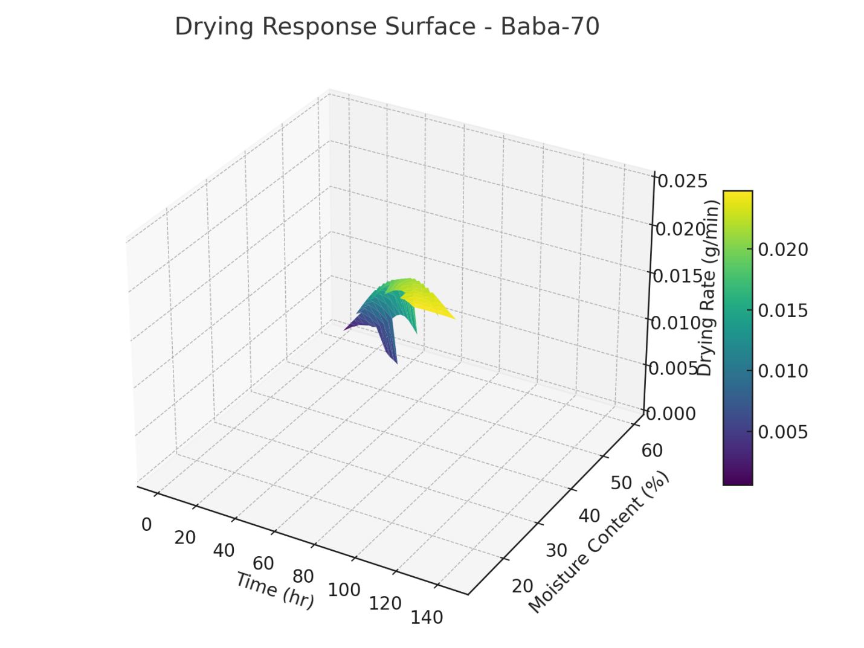
Fig. 9(a-e): Response Surface of Samples

4 DISCUSSION
The drying process effects on various cassava species chips reveal distinct performance characteristics across the varieties tested. The Game-Changer variety exhibits a consistent drying rate that increases to 0.026 g/min by Day 5, with moisture diffusivity improving until the content decreases below 20%. The optimal drying efficiency occurs between 50–25% moisture at 72–96 hours, with significant slowing as moisture approaches 12%, indicating reached internal diffusion limits. The Efficient Zone for this variety is identified at approximately 90 hours of sun drying.
Obasanjo-II shows an initially slower drying rate than Game-Changer but experiences a peak at 0.026 g/min around Days 5–6. The Response Surface presents a less steep profile, suggesting gradual moisture removal and indicates optimal efficiency between 80–96 hours and 20–30% moisture content, implying a potentially higher energy requirement for the drying process.
The Poundable species demonstrates the fastest drying rate, with the highest peak at 0.027 g/min noted between Days 3–5. Its significant mid-drying performance is marked by a rapid moisture content drop from 50% to 12% within 72–120 hours, with an efficient drying zone seen at 84 hours, making it the top performer for moisture removal under sun drying conditions.
The Hope variety begins with a high moisture content of 64.8% and shows a lower drying rate initially, stabilizing post-Day 3. The Response Surface indicates a more gradual drying performance, with a moderate efficiency zone at 96 hours and 30% moisture, suggesting the need for longer drying times or thinner chip production.
Lastly, Baba-70 presents the most stable drying rate, characterized by a flat profile at 0.025 g/min from Days 3–6. Its Response Surface indicates a consistent but slow drying process, with a narrower effective moisture removal range peaking around 96 hours with 28% moisture content. This species appears to have lower drying dynamism due to structural resistance to moisture migration.

- CONCLUSION
As a result of investigating the drying process of five cassava samples (Game-Changer, Obasanjo-II, Poundable, Hope, and Baba-70), it was found that drying behavior is significantly influenced by factors such as initial moisture content, rate of water loss, internal moisture migration, and drying duration. The study revealed distinct patterns reflecting the interaction between the physical structure of the cassava varieties and the sun drying process’s effectiveness. All samples displayed a notable decrease in moisture content during the 6-day drying period, particularly in the first three days, where a substantial drop was observed. After this initial phase, moisture loss slowed, transitioning to a diffusion-controlled drying stage. Drying performance varied by variety, affected by chip thickness, cell wall permeability, moisture binding, and surface area. Although oven drying is faster, it doesn't always yield lower final moisture or cyanide levels. In contrast, sun drying at a thickness of 10 mm resulted in the lowest moisture and cyanide, despite requiring longer drying times. An optimal sun drying duration of 5-6 days was identified to reach a target moisture content of below 13%, thereby minimizing microbial spoilage risk and aiding cassava processors, especially in rural settings reliant on natural drying techniques. Given that fresh cassava cannot be stored for extended periods due to its perishable nature and the presence of hydrocyanic acid, improved processing methods are essential to lower moisture and cyanide levels. The research demonstrated that both oven and sun drying methods ensured acceptable moisture and cyanide levels conforming to standards for dried cassava chips. It is advised that sun drying facilitates greater cyanide breakdown and that focus on the mid-drying period can optimize processing time and energy.

COMPETING INTERESTS DISCLAIMER:
Authors have declared that they have no known competing financial interests OR non-financial interests OR personal relationships that could have appeared to influence the work reported in this paper.

DISCLAIMER (ARTIFICIAL INTELLIGENCE)
Author(s) hereby declare that NO generative AI technologies such as Large Language Models (ChatGPT, COPILOT, etc.) and text-to-image generators have been used during the writing or editing of this manuscript.

REFERENCES
Abok, E. O., Ooko, G. A., & MW, O. (2016). Cassava chips quality as influenced by cultivar, blanching time and slice thickness. African Journal of Food, Agriculture, Nutrition and Development, 16(4), 11457-11476.

Akinola, A. A., & Ezeorah, S. N. (2019). Moisture Diffusivity and Activation Energy Estimation of White Yam (Dioscorea rotundata) Slices Using Drying Data from a Refractance WindowTM Dryer. FUOYE Journal of Engineering and Technology, 4(1). https://doi.org/10.46792/fuoyejet.v4i1.319
Alamu, E. O., Manda, N., Ntawuruhunga, P., Abass, A., & Maziya-Dixon, B. (2023). Elite cassava clones (Manihot esculenta) grown in Zambia: effects of drying techniques on their chemical, functional, and pasting properties. Frontiers in Sustainable Food Systems, 7. https://doi.org/10.3389/fsufs.2023.1129779.
Carvalho, G. R., Santos, K. C., Guedes, J. S., Bitencourt, B. S., Rojas, M. L., & Augusto, P. E. D. (2023). Drying of roots and tubers. In Elsevier eBooks (pp. 587–628). https://doi.org/10.1016/b978-0-12-819895-7.00018-3
Chigbo, K. S., Linus-Chibuezeh, A., Moufunanya, U. F., Adindu-Linus, C. O., Adepoju, F. O., Eke, A. B., & Okechukwu, Q. N. (2024). Mathematical modeling of the effects of thickness and temperature on thin-layer drying kinetics of oven-dried cooking bananas (Musa spp., sub. grp. ABB) slices. Food Production Processing and Nutrition, 6(1). https://doi.org/10.1186/s43014-024-00233-9.
Chinedu, L.O., Anthony, O. O., Imhade, P. O., Ugochukwu, C. O., Emeka, S. N., Muyiwa, O., and Ronke, I. O. (2023). Evaluation of drying behaviour of cassava chips under open sun and oven drying technologies. International Journal of Design & Nature and Ecodynamics, 18(3): 547-556.
Egbosiuba, Titus & O.D., Agbajilola & Abdulkareem, A. & Okafor, Joseph & Jimoh, Abdulfatai. (2021). Production and characterization of bioethanol from cassava peel: alternative energy source. Advances in Chemical Engineering and Science. 71. 25097-25105.
Faridz, R. ., & Firmasyah, R. A. (2025). Investigating drying kinetics of cassava chips under continuous and intermittent drying operation . Asia-Pacific Journal of Science and Technology, 30(03), APST–30. https://doi.org/10.14456/apst.2025.39.
Mardiyani, S. A., Sumarlan, S. H., Argo, B. D., & Leksono, A. S. (2021). Determination of moisture diffusivity and activation energy on fixed bed drying of red pepper (Capsicum annum) on convective solar drying. Advances in Food Science Sustainable Agriculture and Agroindustrial Engineering, 4(2), 110–116. https://doi.org/10.21776/ub.afssaae.2021.004.02.4.
Menya, J., Tumutegyereize, P., & Kabenge, I. (2020). Performance evaluation of cassava drying technologies: a case study from Uganda. MOJ Food Processing & Technology, 8(2), 46–51. https://doi.org/10.15406/mojfpt.2020.07.00241.
Michael, Edaba. (2023). Production and Utilization of Cassava in Nigeria: Prospects for Food Security and Infant Nutrition. PAT 2008; 4 (1): 38-52: ISSN: 0794-5213..
Mujaffar, S. (2020). Drying behaviour of cassava (manihot esculenta) chips. Proceedings of the International Conference on Emerging Trends in Engineering & Technology (IConETech-2020). https://doi.org/10.47412/HJAK5456.
Nainggolan, E.A., Banout, J. & Urbanova, K. (2023). Chemical and Thermal Treatment for Drying Cassava Tubers: Optimization, Microstructure, and Dehydration Kinetics. Life (Basel), 13(12), 2355. Https://doi.org/10.3390/life13122355.
Nirmaan, A.M.C., Rohitha Prasantha, B.D., Peiris, B.L. (2020). Comparison of microwave drying and ovendrying techniques for moisture determination of three paddy (Oryza sativa L.) varieties. Chemical and Biological Technologies in Agriculture, 7(1): 1-7. https://doi.org/10.1186/s40538-019-0164-1
Odebode, Stella O. (2008) "Appropriate Technology for Cassava Processing in Nigeria: User’s Point of View," Journal of International Women's Studies: Vol. 9: Iss. 3, Article 15. Available at: https://vc.bridgew.edu/jiws/vol9/iss3/15.
Okeke, C. L., Onokwai, A. O., Okokpujie, I. P., Okonkwo, U. C., Nnochiri, E. S., Oladimeji, M., & Ogundele, R. I. (2023). Evaluation of Drying Behaviour of Cassava Chips under Open Sun and Oven Drying Technologies. International Journal of Design & Nature and Ecodynamics, 18(3), 547–556. https://doi.org/10.18280/ijdne.180306.
Ojediran, J. O., Okonkwo, C. E., Adeyi, A. J., Adeyi, O., Olaniran, A. F., George, N. E., & Olayanju, A. T. (2020). Drying characteristics of yam slices (Dioscorea rotundata) in a convective hot air dryer: Application of ANFIS in the prediction of drying kinetics. Heliyon, 6(3).
Olusegun, A. O., Kapila, P. F., & Ainamensa, G. (2017). Effect of Selected Processing and Modification Methods on Quality of Cassava and its Starch. Asian Journal of Agricultural Research, 11(3), 48–56. https://doi.org/10.3923/ajar.2017.48.56.
Pechaporn, P., Morakot, K., Raksuda, S., Prysathryd, S., and Chimathan, A. (2022). Effect of temperature and shape on drying performance of cassava chips. Agriculture and Natural Resources, (51):402-409.
Pornpraipech, P., Khusakul, M., Singklin, R., Sarabhorn, P., Areeprasert, C. (2017). Effect of temperature and shape on drying performance of cassava chips. Agricultural and Natural Resources, 51(5): 402-409. https://doi.org/10.1016/j.anres.2017.12.004
Sanni, L. A. (2015). Effect of dryer parameters on the drying characteristics and quality of cassava flour. African Journal of Food Science and Technology, 06(07). https://doi.org/10.14303/ajfst.2015.045.
Soyoye, B. O., Olukunle, O. J., & Alakhumen, O. J. (2015). Development and performance evaluation of a mini horizontal flash dryer. Agricultural Engineering International: CIGR Journal, 17(4), 211–228. https://cigrjournal.org/index.php/Ejounral/article/view/2942.

Stephenus, F. N., Benjamin, M. a. Z., Anuar, A., & Awang, M. A. (2023). Effect of Temperatures on Drying Kinetics, Extraction Yield, Phenolics, Flavonoids, and Antioxidant Activity of Phaleria macrocarpa (Scheff.) Boerl. (Mahkota Dewa) Fruits. Foods, 12(15), 2859. https://doi.org/10.3390/foods12152859.
Udoro E. O., Gbadamosi, O. S., Taiwa, K. A., (2018). Studies on the production and utilization of dried cassava chips as human food. International Union of Food Science and Technology, pp. 154-172.
Ujevwerume, I. W., and Edema, A.O. (2020). Sun drying technique for education of moisture and cyanide in cassava chips. Innovative Journal of Engineering Technology, (01): 38 – 47.

