Original Research Article

ANALYSIS OF THE ECONOMIC IMPACT OF TRAFFIC CONGESTION ON HIGHWAYS WITH A HIGH-VOLUME CAPACITY (VC) RATIO IN THE SPECIAL REGION OF YOGYAKARYA

.
ABSTRACT

Traffic congestion poses significant challenges to mobility and economic productivity in the Special Region of Yogyakarta, particularly along highways characterized by high Volume-to-Capacity (V/C) ratios. This study aims to quantify the economic impact of traffic congestion by integrating Value of Time (VoT), Vehicle Operating Cost (VOC), and Degree of Saturation (DS) parameters. Using mixed-method quantitative analysis and traffic data from the Yogyakarta Transportation Office (2023), the study calculates the total economic loss caused by congestion across six arterial corridors. Results indicate that the average V/C ratio ranges from 0.82 to 0.95, resulting in a 15–20% increase in VOC and daily time losses equivalent to IDR 18.6 million per corridor. The findings demonstrate that congestion significantly reduces travel efficiency and contributes to rising operational costs, underscoring the need for adaptive traffic management and data-driven infrastructure investment.

Keywords: Congestion, Volume-to-Capacity Ratio, Degree of Saturation, Economic Loss, Vehicle Operating Cost, Special Region of Yogyakarta

1. INTRODUCTION
The growth of the population in several cities in Indonesia has spurred an increase in urban mobility. The progress of transportation is certainly responsible for the high mobility of the population (Permana et al., 2020). The high level of transportation needs in various regions raises transportation problems, such as network operational, financial, economic, environmental, and safety aspects (Handayani, 2021). The imbalance between the increase in population activities and the available public service infrastructure causes inequality in services, as well as in the transportation sector. Congestion is one of the common problems in Indonesian cities. According to (Scott, N.Y., 2019), traffic congestion occurs when the capacity of the road remains while the number of road users continues to increase, which causes the travel time to be longer. Traffic jams are never the same from day to day on the same highway due to the various events that affect traffic (Godoi et al., 2021). Transportation is an activity of moving people and goods from one place to another (Aprianto et al., 2025).
Congestion will be very detrimental to road users, as it will hinder their travel time. Congestion occurs if the traffic flow is close to capacity, Total congestion occurs when the vehicle has to stop or move very slowly. Congestion, reviewed from the level of road service (Level Of Service) =LOS), at the time of LOS < C.LOS < C, the traffic flow condition began to be unstable, the operating speed decreased relatively quickly due to the obstacles that arose and the freedom of movement was relatively small. Highways are vital infrastructure that plays a central role in various aspects of human life as a means of supporting social interaction (Haque et al., 2025). The increase in uncontrolled use of vehicles will increase existing traffic congestion so that it has an impact on the economy such as wasted time and waste of Fuel Oil (BBM). The current transportation needs have become essential needs due to the increase in economic, political, and social activities of the community (Safira & Khuluqi, 2023).
This study will analyze the economic impact of congestion on road sections that have a high Volume Capacity (V/C) ratio (value V/C ratio > 0.8) in the Special Region of Yogyakarta based on data from the Yogyakarta Special Region Transportation Office, namely: Wates Street, Simpang Wojo Street (Kulonprogo Regency), Mataram Street (Yogyakarta City), Pleret Street (Bantul Regency), Seturan Street, Monjali North Artery Street, UPN North Artery Road and Jalan Laksda Adisucipto Amplaz. In order to support the analysis of traffic congestion in the Special Region of Yogyakarta, this study will map the existing conditions of traffic congestion and analyze the economic impact caused by the existence of highway congestion using an analysis of the time of value and BOK BBM analysis. BOK is the total cost required to operate a vehicle in a traffic and road condition for one type of vehicle per kilometer of mileage where the average is Rp/Km (Adatta et al., 2024). In the system, there is a concept of cost, one of which is the concept of social cost (Bolla et al., 2017). Traffic jams have caused 20% of the fuel used by four-wheelers to burn only for nothing because the engine is running without producing movement (Fatimah et al., 2022).

2. material and methods
To achieve this goal, this study integrates both qualitative and quantitative approaches. Primary data were collected through field surveys, while secondary data were obtained from the Central Statistics Agency (BPS) and the Yogyakarta Transportation Office (2023). The analysis includes parameters of Degree of Saturation (DS), Vehicle Operating Cost (VOC), and Value of Time (VoT). DS reflects the Level of Service (LOS) and congestion intensity, VOC represents the operating expenses incurred by vehicle users, and VoT quantifies time lost in monetary terms.
Economic loss estimation formula:
Economic Loss = (VOC + VoT) × DS × Average Delay Time.
VOC is calculated following the Indonesian Highway Manual (Bina Marga, 2021), while VoT adopts Jasa Marga standards adjusted for 2023 inflation. The analysis identifies congestion-prone roads: Wates, Mataram, Seturan, Monjali, Laksda Adisucipto, and Pleret.

3. results and discussion
Congestion significantly affects the regional economy through time delays, fuel inefficiency, and increased logistics costs. The analysis shows that during peak hours (16:30 WIB), the V/C ratio exceeds 0.90 in major corridors. Average VOC rises by 17.8%, with total economic losses ranging from IDR 16.4 to 20.3 million per day per corridor. Annualized, the total loss reaches approximately IDR 5.9 billion across all six corridors.
Adaptive traffic management systems, signal coordination, and enforcement of public transport usage are proposed as key mitigation strategies. The adoption of Electronic Road Pricing (ERP) and digital traffic monitoring is recommended to enhance road efficiency and reduce economic waste.

3.1. Time Value Traffic
The traffic data used in the preparation of this study is secondary data obtained from the Directorate General of Highways, Ministry of Public Works and Housing. The data contains the volume of vehicles that cross the Yogyakarta-YIA National Road. Secondary data was obtained from Average Daily Traffic (LHR) data issued by Bina Marga, Special Region of Yogyakarta. In this survey, vehicle categories are divided into eight categories according to Highway.
To make the calculation easier, the eight types are further grouped into six types of vehicles based on the Decree of the Minister of Public Works No. 370/KPTS/M/2007, namely:
Type I : Sedans, jeeps, pick-ups/small trucks, and buses
Type II : Truck with 2 (two) axles
Type III : Trucks with 3 (three) axles
Type IV : Trucks with 4 (four) axles
Type V : Truck with 5 (five) axles
Type VI : 2 (two) wheeled motor vehicles
The analysis of time value in this study is calculated using the Jasa Marga formula by considering the study of past time values. The formula used is as follows:
Time Value = Max {(K x Base Time Value); Minimum Time Value}
The following is the basic time value used in this study which is a reference from PT. Jasa Marga (1990-1996) as follows:
Type I =Rp13,768/hour/vehicle | Type II a = Rp 18,534/hour/vehicle | Type II=Rp 13,768/hour/vehicle
Then it is the minimum time value used in this study which is also a reference for PT Jasa Marga (other than DKI Jakarta).
Type I = IDR 6,000/hour/vehicle | Type II a = Rp 9,051/hour/vehicle | Type II= IDR 6. 723/hour/vehicle
This comparison amount will be used in calculating the base time and minimum time value in 2023. The following is a calculation to find out the amount of the rupiah value comparison, for the results of adjusting the base time value and the minimum time value shown in below.
1996 Rupiah Value = Rp 2,365 | 2023 Rupiah = IDR 15,225 | Comparison = 6.43
3.2. Vehicle Operating Cost Analysis (BOK)
Vehicle Operating Cost Analysis (BOK) to find out the amount of costs incurred in vehicle operation. Therefore, it is necessary to know the fuel consumption in the vehicle. This calculation is carried out using Google Maps with reference to the predetermined start and end points. In this study, it was carried out in two circumstances, namely during weekdays (Monday-Friday) and Weekends (Saturday-Sunday) in determining the level of congestion at a predetermined point.
Limit Roads Based on Engine Fuel and Oil Consumption
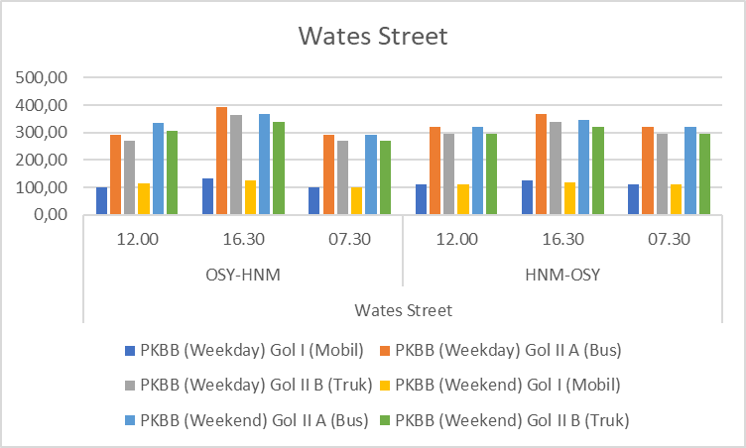
Source: Data Processed by Researchers, 2024
Figure 1. Vehicle Fuel Consumption on Jalan Wates in 2024
- On graph 1 This shows that the average fuel consumption for all types of vehicles in the direction of OSY-HNM is above the average fuel consumption in the direction of HNM to OSY. This is because the volume of the vehicle is higher than the direction of OSY to HNM which causes congestion so that the vehicle has to stop and run repeatedly where of course the fuel consumption is higher.
- Both routes have the highest score in Gol II A Bus at 16.30 WIB on weekdays , meaning the most in using fuel.
- In the existing condition, Jalan Wates is also too narrow and many roads have potholes, this results in a slowdown in driving, resulting in an increase in traffic volume. In addition, many driver behaviors are disorderly in traffic.
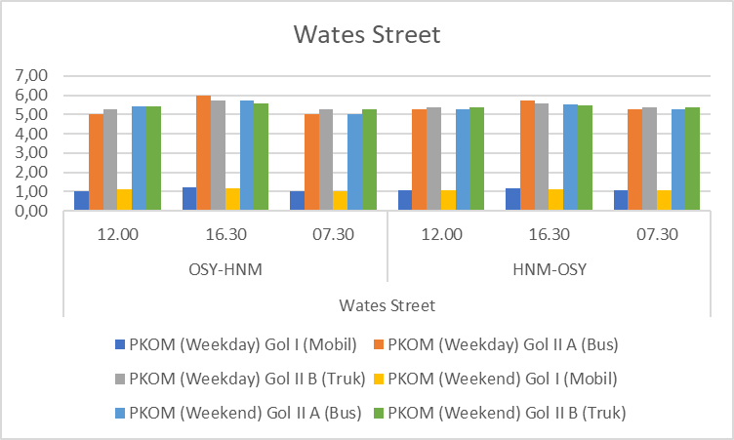
Source: Data Processed by Researchers, 2024.
Figure 2. Vehicle Engine Oil Consumption on Wates Road in 2024
- Graph 2 shows that the average engine oil consumption for all types of vehicles in the direction of HNM-OSY is below the average fuel consumption in the direction of OSY to HNM. This is because the volume of the vehicle is higher than the direction of OSY to HNM which causes congestion so that the vehicle has to stop and run repeatedly where of course the engine oil consumption is higher.
- Both routes have the highest score in Gol II A Bus at 16.30 WIB on weekends , meaning the most in using engine oil.
- In the existing condition, Jalan Wates is also too narrow and many roads have potholes, this results in a slowdown in driving, resulting in an increase in traffic volume. In addition, many driver behaviors are disorderly in traffic.
Mataram Road Based on Fuel and Engine Oil Consumption
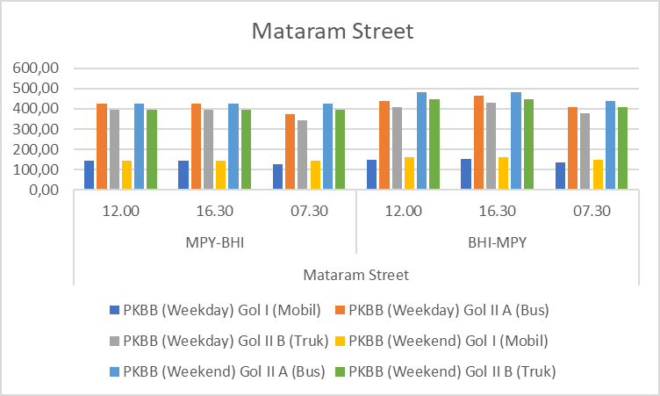
Source: Data Processed by Researchers, 2024.
Figure 3. Vehicle Fuel Consumption on Mataram Road in 2024
- In graph 3 This shows that the average fuel consumption for all types of vehicles in the MPY-BHI direction is below the average fuel consumption in the direction of BHI to MPY. This is because the volume of the vehicle is higher than the direction of BHI to MPY which causes congestion so that the vehicle has to stop and run repeatedly where of course the fuel consumption is higher.
- Both routes have the highest score in Gol II A Bus at 16.30 WIB on weekends , meaning the most in fuel consumption.
- In the existing condition, Mataram Road is also too narrow considering that it is around the Malioboro area which is a tourist attraction, this results in a slowdown in driving so as to increase the volume of congestion.
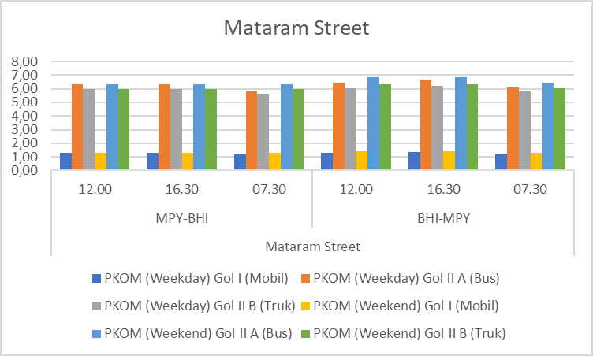
Source: Data Processed by Researchers, 2024.
Figure 4. Vehicle Engine Oil Consumption on Mataram Road in 2024
- Graph 4 shows that the average fuel consumption for all types of vehicles in the MPY-BHI direction is below the average fuel consumption in the BHI to MPY direction. This is because the volume of the vehicle is higher than the direction of BHI to MPY which causes congestion so that the vehicle has to stop and run repeatedly where of course the engine oil consumption is higher.
- Both routes have the highest score in Gol II A Bus at 16.30 WIB on weekends , meaning the most in using engine oil.
- In the existing condition, Mataram Road is also too narrow considering that it is around the Malioboro area which is a tourist attraction, this results in a slowdown in driving so as to increase the volume of congestion.

Repair Roads Based on Engine Fuel and Oil Consumption
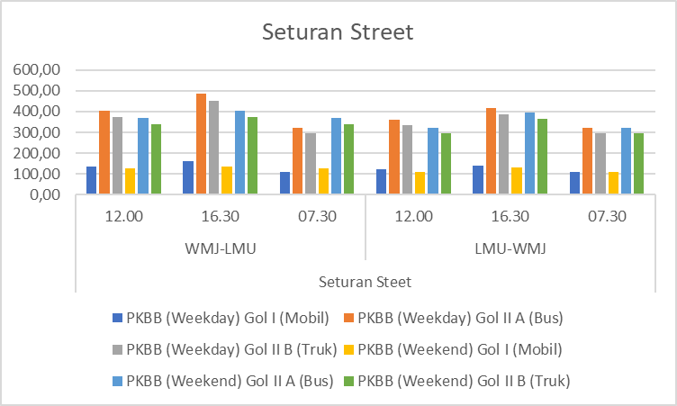
Source: Data Processed by Researchers, 2024.
Figure 5. Vehicle Fuel Consumption on Seturan Road in 2024
- On graph 5 This shows that the average fuel consumption for all types of vehicles in the direction of WMJ-LMU is above the average fuel consumption in the direction of LMU to WMJ. This is because the volume of the vehicle is higher than the direction of WMJ to LMU which causes congestion so that the vehicle has to stop and run repeatedly where of course the fuel consumption is higher.
- Both routes have the highest score in Gol II A Bus at 16.30 WIB on weekdays , meaning the most in using fuel.
- In the existing condition, Jalan Seturan is also too narrow considering that it is around campus areas such as UPN Veteran Yogyakarta and STIE YKPN where many students are active, this results in a slowdown in driving thus increasing the volume of congestion.
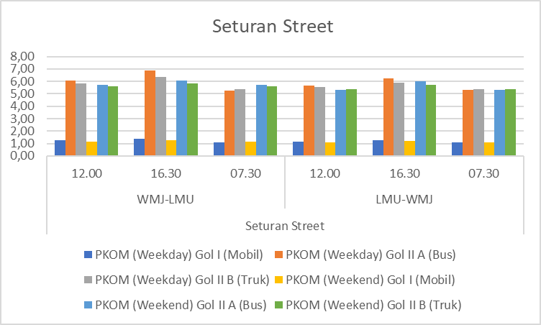
Source: Data Processed by Researchers, 2024.
Figure 6. Vehicle Engine Oil Consumption on Seturan Road in 2024
- In graph 6 It shows that the average engine oil consumption for all types of vehicles in the direction of WMJ-LMU is above the average engine oil consumption in the direction of LMU to WMJ. This is because the volume of the vehicle is higher than the direction of WMJ to LMU which causes congestion so that the vehicle has to stop and run repeatedly where of course the engine oil consumption is higher.
- Both routes have the highest score in Gol II A Bus at 16.30 WIB on weekdays , meaning the most in using engine oil.
- In the existing condition, Jalan Seturan is also too narrow considering that it is around campus areas such as UPN Veteran Yogyakarta and STIE YKPN where many students are active, this results in a slowdown in driving thus increasing the volume of congestion.
Monjali Road Based on Fuel and Engine Oil Consumption
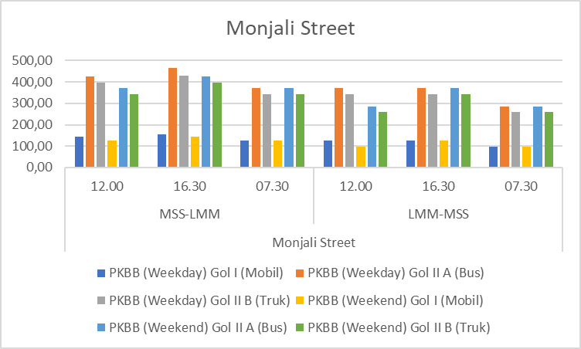
Source: Data Processed by Researchers, 2024.
Figure 7. Vehicle Fuel Consumption on Jalan Monjali in 2024
The average fuel consumption for all types of vehicles on weekdays is above the average fuel consumption on weekends.
- Graph 7 shows that the average fuel consumption for all types of vehicles in the direction of MSS-LMM is above the average fuel consumption in the direction of LMM to MSS. This is because the volume of vehicles is higher than the direction of MSS to LMM which causes congestion so that the vehicle has to stop and run repeatedly where of course the fuel consumption is higher.
- Both routes have the highest score in Gol II A Bus at 16.30 WIB on weekdays , meaning the most in using fuel.
- In the existing condition of Jalan Monjali during peak hours, usually in the afternoon, especially around intersection four and U-turn. Jalan Monjali is also relatively narrow, but there is a lot of traffic that occurs both in the direction of entering and exiting Yogyakarta and Magelang.
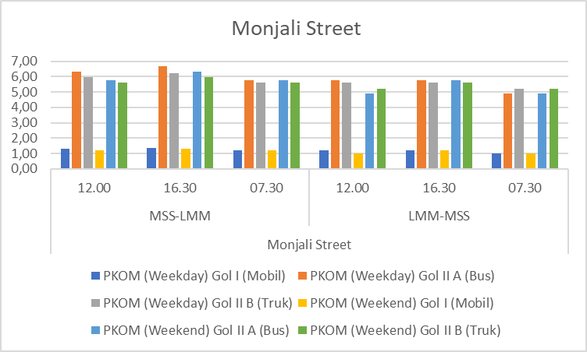
Source: Data Processed by Researchers, 2024.
Figure 8. Vehicle Engine Oil Consumption on Jalan Monjali in 2024
- On the 8 graph. This shows that the average engine oil consumption for all types of vehicles in the direction of MSS-LMM is above the average fuel consumption in the direction of LMM to MSS. This is because the volume of the vehicle is higher than the direction of MSS to LMM which causes congestion so that the vehicle has to stop and run repeatedly, where of course the engine oil consumption is higher.
- Both routes have the highest score in Gol II A Bus at 16.30 WIB on weekdays , meaning the most in using engine oil.
- In the existing condition of Jalan Monjali during peak hours, usually in the afternoon, especially around intersection four and U-turn. Jalan Monjali is also relatively narrow, but there is a lot of traffic that occurs both in the direction of entering and exiting Yogyakarta and Magelang
Jalan Laksda Adisucipto Based on Fuel and Engine Oil Consumption
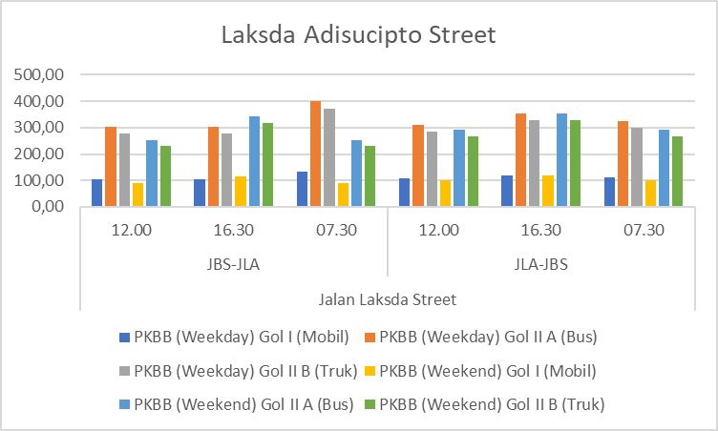
Source: Data Processed by Researchers, 2024.
Figure 9. Vehicle Fuel Consumption on Jalan Laksda Adisucipto in 2024
- Graph 9 shows that the average fuel consumption for all types of vehicles in the JBS-JLA direction is above the average fuel consumption in the direction of JLA to JBS. This is because the volume of vehicles is higher than the direction of JBS to JLA which causes congestion so that the vehicle has to stop and run repeatedly where of course the fuel consumption is higher.
- Both routes have the highest score in Gol II A Bus at 07.30 WIB on weekdays , meaning the most in fuel consumption.
- In the existing condition of Jalan Laksda Adisucipto during peak hours, usually in the morning, especially around the ringroad intersection. Jalan Monjali was once estimated to be jammed due to the existence of Adisutjipto Airport but at this time also experienced the same thing although not as severe as before YIA.
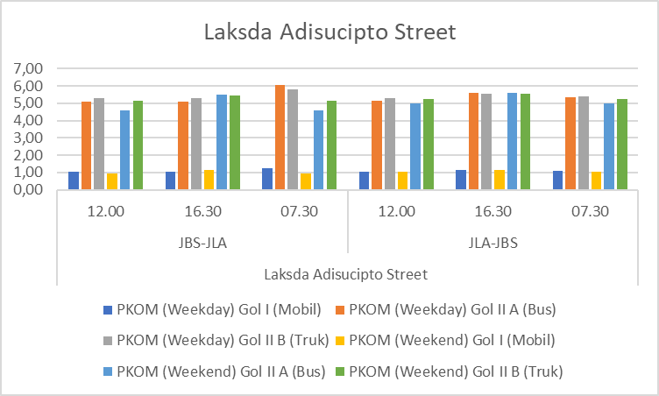
Source: Data Processed by Researchers, 2024.
Figure 10. Vehicle Engine Oil Consumption on Jalan Laksda Adisucipto in 2024
- Graph 10 shows that the average engine oil consumption for all types of vehicles in the JBS-JLA direction is above the average engine oil consumption in the direction of JLA to JBS. This is because the volume of the vehicle is higher than the direction of JBS to JLA which causes congestion so that the vehicle has to stop and run repeatedly where of course the engine oil consumption is higher.
- Both routes have the highest score in Gol II A Bus at 07.30 WIB on weekdays , meaning the most in using engine oil.
- In the existing condition of Jalan Laksda Adisucipto during peak hours, usually in the morning, especially around the ringroad intersection. Jalan Monjali was once estimated to be jammed due to the existence of Adisucipto Airport but at this time also experienced the same thing although not as severe as before YIA.

Jalan Pleret Based on Fuel Consumption
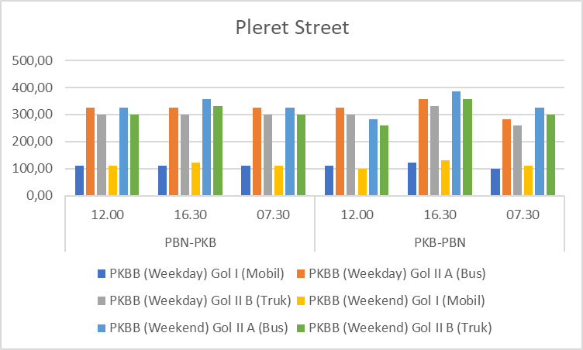
Source: Data Processed by Researchers, 2024.
Figure 11. Vehicle Fuel Consumption on Jalan Pleret in 2024
- The 11 graph shows that the average fuel consumption for all types of vehicles in the direction of PBN-PKB is below the average fuel consumption in the direction of PKB to PBN. This is because the volume of vehicles is higher than the direction of PKB to PBN which causes congestion so that the vehicle has to stop and run repeatedly where of course the fuel consumption is higher.
- Both routes have the highest score in Gol II A Bus at 16.30 WIB on weekends , meaning the most in fuel consumption.
- In the existing condition of Jalan Pleret during peak hours, usually in the afternoon. Jalan Pleret is also relatively narrow plus the volume of vehicles is quite dense. Jalan Pleret is usually an access to tourist attractions such as Evidence Pinus so that the tendency of Weekends is more congested than on Weekdays.
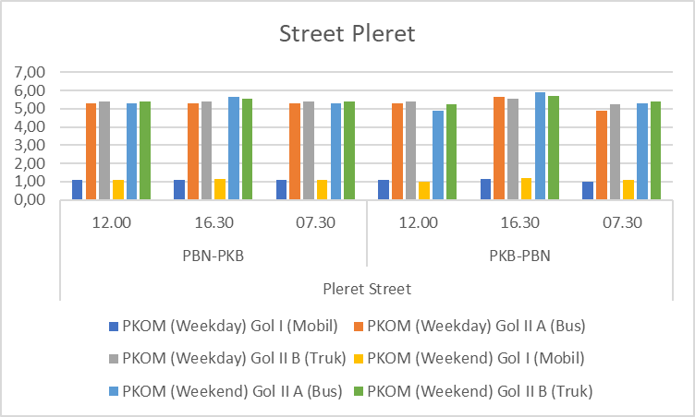
Source: Data Processed by Researchers, 2024.
Figure 12. Vehicle Engine Oil Consumption on Jalan Pleret in 2024
- The graph 12 shows that the average engine oil consumption for all types of vehicles in the direction of PBN-PKB is below the average engine oil consumption in the direction of PKB to PBN. This is because the volume of the vehicle is higher than the direction of PKB to PBN which causes congestion so that the vehicle has to stop and run repeatedly where of course the engine oil consumption is higher.
- Both routes have the highest score in Gol II A Bus at 16.30 WIB on weekends , meaning the most in using engine oil.
- In the existing condition of Jalan Pleret during peak hours, usually in the afternoon. Jalan Pleret is also relatively narrow plus the volume of vehicles is quite dense. Jalan Pleret is usually an access to tourist attractions such as Evidence Pinus so that the tendency of Weekends is more congested than on Weekdays.
The following are the results of congestion mapping based on time and conditions on weekends and weekdays. This is taken based on normal working hours in Indonesia compared to weekends.
Fig 13-Congestion Map
Hit | Weekend | Weekdays
07.30 PM | 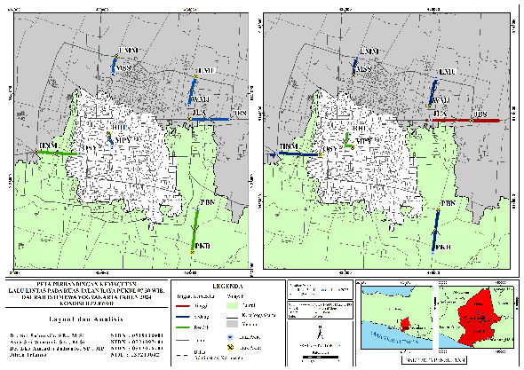 | 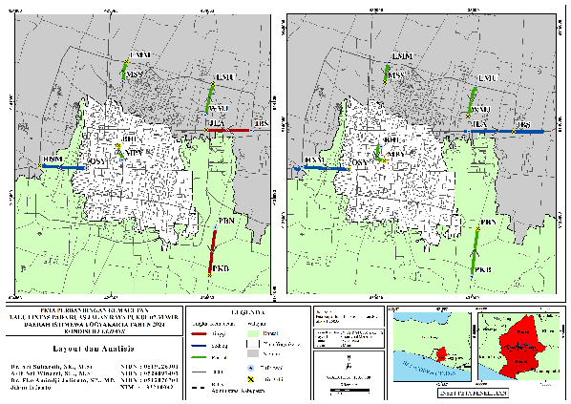
12.00 PM | 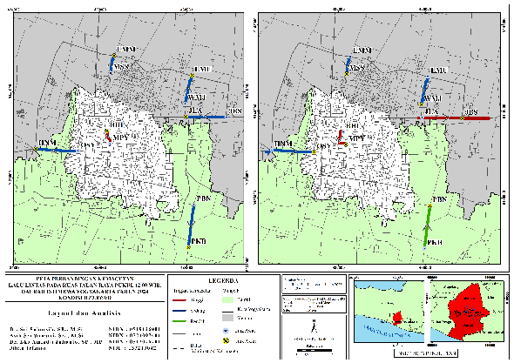 | 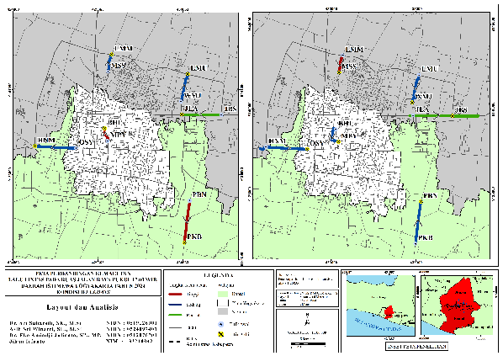
04.30 PM local time | 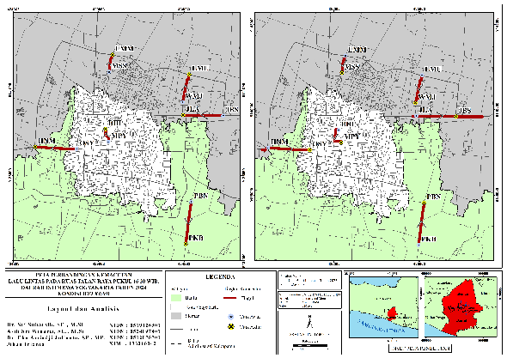 | 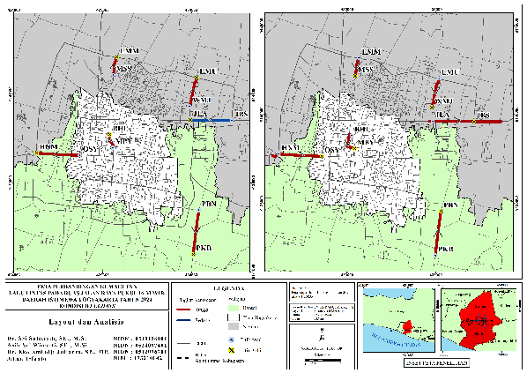

4. Conclusion
Traffic congestion in Yogyakarta has a measurable economic impact, resulting in higher vehicle operating costs and productivity losses. Quantitative analysis confirms that congestion contributes to a 15–20% cost escalation in VOC and time value across major arterial corridors. Implementing adaptive traffic control, enhancing public transportation, and promoting demand management policies are essential to mitigate these impacts and improve urban mobility sustainability.

Disclaimer (Artificial intelligence)

Author(s) hereby declare that generative AI technologies such as Large Language Models, etc. have been used during the writing or editing of manuscripts. This explanation will include the name, version, model, and source of the generative AI technology and as well as all input prompts provided to the generative AI technology

Details of the AI usage are given below:
1. Model used: OpenAI ChatGPT (GPT-5, 2025 version).
2. Purpose: Language refinement, technical phrasing in transportation economics, reference formatting, and abstract clarity.
3. Scope: AI support was limited to linguistic and editorial enhancements; all research design, data analysis, and conclusions were performed independently by the authors.

References

AASHTO. (2018). Highway Capacity Manual. Washington DC: Transportation Research Board.

Aprianto, R., Yunanta, O. A. I., Hadi, S., & Tohom, F. (2025). Predictions and recommendations for handling traffic performance in the Ngawen Toll Exit area in 2025 and 2028. Region: Journal of Regional Development and Participatory Planning, 20(2), 462. https://doi.org/10.20961/region.v20i2.90245
Fatimah, S., Syakdiah, S., & Kusumawiranti, R. (2022). Government Policy in Overcoming Congestion in the City of Yogyakarta (Research Study on Malioboro Street on Student Army Street). Politics, 10(1), 24–41. https://doi.org/10.37631/populika.v10i1.473
Godoi, F. C., Prakash, S., & Bhandari, B. R. (2021). Federal Highway Administration. Review of 3D Printing and Potential Red Meat Applications, 1(23 February 2021), 1–61. http://libdcms.nida.ac.th/thesis6/2010/b166706.pdf
Haque, R. D., Aulia, M. D., Falderika, F., & Syafriharti, R. (2025). Economic Feasibility Study of the Cibiru Roundabout Underpass. CRANE: Civil Engineering Research Journal, 6(1), 38–47. https://doi.org/10.34010/crane.v6i1.15679
JICA. (2019). Urban Transport Cost Evaluation Guide. Tokyo: Japan International Cooperation Agency
Kurniawan, G. P., Shalikhah, S. Z., Shofiati, H., Azizah, N. N., & Mochtar, M. (2021). Analysis of Transportation Problems in Cities: A Case Study in Urban Areas of Yogyakarta. Journal of Mana Management, 2(1), 44–49. https://doi.org/10.33648/jtm.v2i1.119
La Rusli, Nindyo Cahyo, Kresnanto, R. B. U. (2019). Transportation losses due to traffic congestion in Yogyakarta. UII Civil Engineering.
PIARC. (2022). Congestion and Road Performance Indicators: Technical Report. Paris: World Road Association
Safira, E., & Khuluqi, F. S. (2023). Analysis of the level of congestion and factors causing traffic congestion on Jalan Sultan Hamid II, South Pontianak District. Georeference, 1(1), 36. https://doi.org/10.26418/gr.v1i1.64495
Su, Y., Liu, X., Li, X., & Oh, K. (2020). Research on Traffic Congestion Based on System Dynamics: The Case of Chongqing, China. Complexity, 2020. https://doi.org/10.1155/2020/6123896
World Bank. (2021). Urban Mobility in Southeast Asia: Costs and Policy Challenges. Washington DC: World Bank
Yevizal, M., Mulyadi, A., & Fatnanta, F. (2021). Analysis of the effect of V/C ratio of vehicle traffic on air pollution levels based on vehicle traffic volume (study in the intersection area of SKA Mall Pekanbaru City). Journal of Zoning, 1(2), 64–74. https://doi.org/10.52364/jz.v2i2.26

