Analysis and Enlightenment of Power System Massive Blackout Accidents

.
ABSTRACT

The occurrence of massive blackouts has had a severe impact on both the social-economic fabric and the daily lives of the public. This paper analyzes massive blackout accidents worldwide to explore their primary causes, including natural disasters, equipment issues, imperfect management mechanisms, and human factors. The research indicates that natural disasters are the leading cause of massive blackouts, accounting for over 52% of cases. Equipment issues and human factors also contribute to a significant proportion. To ensure the safe and stable operation of power systems, this paper proposes targeted recommendations, including enhancing the resilience of power systems, improving management mechanisms, strengthening protections against human-induced incidents, and bolstering cybersecurity defenses. These measures aim to draw on lessons from past accidents while improving the overall risk resistance ability of power systems to better address potential future power crises.

Keywords: power system; massive blackout; accident cause

1. INTRODUCTION

As is well known, the source of power generation and electricity users are connected through the power system. As a result, if the power system is damaged, massive blackouts can occur, leading to significant property losses for people. In some cases, the consequences can be more severe, even endangering the safety of people's lives and property [1-3]. In recent years, massive blackouts have occurred worldwide from time to time, the phenomenon that has attracted the attention of various countries [4].
To ensure the safety of China's power grid, scholars have conducted extensive research on massive blackouts from abroad, learning from these experiences and lessons. The research mainly focuses on natural disasters, machine failures, the management model of power networks, and hacker attacks on power networks. Regarding natural disasters, Literature [4] studies the massive blackouts in Brazil caused by extreme weather from three periods: occurrence, development, and recovery. Literature [5] outlines the massive blackout event in Australia in 2016 due to the inability to fully utilize electricity generated from new energy sources, resulting in the discarding of excess electricity. Literatures [6-8] studies the large-scale cascading accidents caused by the breakage of 400 kV main transmission lines in India. Literatures [9-11] analyzed an overload protection event that occurred in Brazil in 2017. Literatures [12] has conducted an in-depth study on the overloading tripping of high-voltage cables in the transmission channels of eastern and western Turkey, triggering the disintegration of the European interconnected system and a massive blackout event. Literatures [13,14] studies the abnormal disconnection events that occurred at two wind farms in the UK in August 2019.The results show that the operation frequency of the wind turbine generator exceeded its normal operating capacity, triggering a massive blackout. Literature [15] analyzes the massive blackouts that occurred in Europe in November 2006, and the main cause of the accident was that E. ON did not comply with the "N-1" standard requirements, resulting in non-cooperation from multiple network operators. Literature [16] analyzes the massive blackout event in the United States and Mexico in September 2011. Literatures [17,18] discusses a cyber-hacking incident that occurred in 2015, which led to a massive blackout in Ukraine's power grid. Literature [19] studies the two massive blackouts that occurred in Venezuela. Literature [20] provides a comprehensive review of massive blackouts and cascading events that occurred over the past decade, with a particular focus on power system blackouts in the United States and their causes. Five massive blackouts that occurred in 2024 due to extreme weather and impacted multiple regions of the United States are reviewed in [21], measures that can help ensure organizational continuity of operations during extreme weather events are listed. Literatures [22-24] has many existing research achievements in the evaluation of losses from massive blackouts, strategies for power grid recovery, and risk prevention mechanisms. Literature [25] proposes a probabilistic assessment method for static voltage stability in distributed photovoltaic distribution networks, and assesses the static voltage stability of the distribution network.
Chinese and international scholars have conducted extensive discussions on massive blackouts in power systems. This article combines blackouts from both China and abroad, extensively researching a large number of literatures, accident analyses, and news articles. These articles meticulously document significant blackouts worldwide from the 1990s to the 2020s, a span of about 30 years. It summarizes and analyzes the causes and characteristics of these accidents and provides specific policies and guidance that can be applied to massive blackouts in China.

2. Global blackout accidents

This article, drawing on data summarized by WikiMili and referencing some formal analysis reports on massive blackout events, summarizes the massive blackouts worldwide since the 1990s.The number of massive blackouts per year between 1990 and 2024 is shown in Table. 1, among which the two most harmful occurred in India. Although the United States has experienced the most frequent massive blackouts, apart from the 1965 massive blackout which affected 30 million people, other blackouts have only impacted around 10 million people. In recent years, frequent major natural disasters have also greatly impacted the stable operation of China's power grid.
Table 1. Number of massive blackouts per year from 1990 to 2024 (data from WikiMili)

Year | Blackout times
1990 | 0
1991 | 1
1992 | 1
1993 | 0
1994 | 0
1995 | 1
1996 | 3
1997 | 0
1998 | 6
1999 | 4
2000 | 3
2001 | 2
2002 | 4
2003 | 5
2004 | 1
2005 | 4
2006 | 5
2007 | 7
2008 | 9
2009 | 8
2010 | 9
2011 | 14
2012 | 7
2013 | 10
2014 | 8
2015 | 8
2016 | 4
2017 | 9
2018 | 12
2019 | 15
2020 | 6
2021 | 11
2022 | 7
2023 | 9
2024 | 11 (As of November)

According to data on massive blackouts worldwide, the United States, Canada, Australia, Brazil, India, and several other countries are among the top in terms of the number of massive blackout accidents, as shown in Fig. 1.

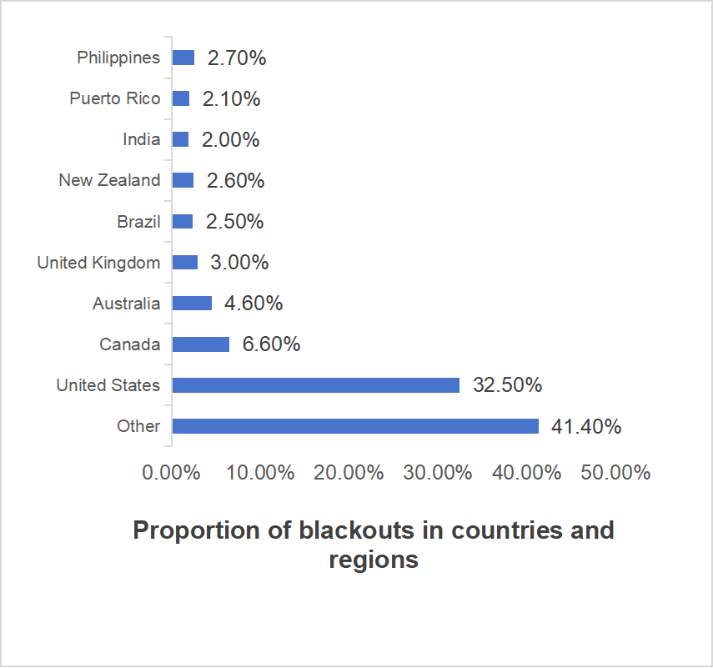

Fig. 1. Proportion of blackouts in countries and regions (data from WikiMili)

- Analysis of the causes of massive blackouts

There have been 173 massive blackouts worldwide for which causes have been identified, which can be attributed to the following four reasons:(1) Natural disasters caused 90 accidents, accounting for 52% of these accidents; (2) Equipment issues resulted in 60 accidents, making up 35% of these accidents; (3) Human factors led to 19 accidents, accounting for 11% of these accidents; (4) Cyberattacks caused 4 accidents, which accounted for 2% of these accidents. The distribution of causes is shown in Fig. 2.

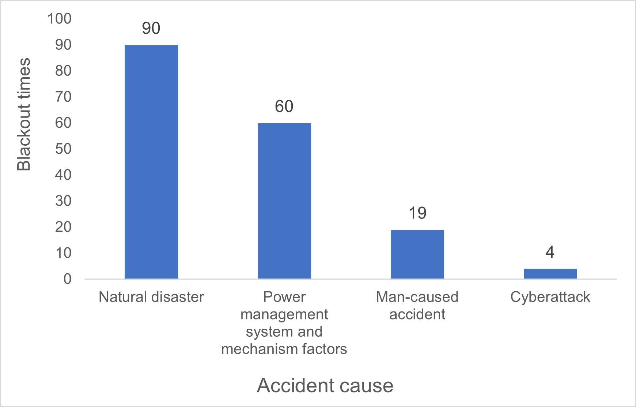
Fig. 2. Distribution of main causes of massive blackouts since the 1990s (data from WikiMili)

  - Causes of natural disasters

Natural disasters are unpredictable, so there is no way for human beings to accurately predict blackouts caused by disasters. Among these, typical examples include the blackouts caused by the snowstorm in southern China in 2008, the hurricanes in Brazil and Paraguay in 2009, and the massive earthquake in Japan in 2011.
(1) There is insufficient prevention and preparation for disasters, and there is inadequate coordination between the power grid and various departments. During the course of human development, there have been many instances of massive blackouts due to inadequate coordination between power grids and other entities, and the failure to establish emergency plans in a timely manner. Consequently, as an inevitable result, power grids become extremely vulnerable when facing natural disasters. During the occurrence of a disaster, there were no timely and effective control measures, thus it was impossible to minimize the losses caused by the disaster within the stipulated time frame. After the disaster, the process of restoration was very difficult, which made the restoration work proceed very slowly. For example, during the summer of 2003, due to excessively high temperatures, there was a tripping of power transmission lines in the northeastern United States. However, the power supply companies in the United States and Canada did not communicate effectively in a timely manner, which ultimately led to the "August 14" blackout affecting 55 million people [26].
(2) Key and vulnerable parts of the power grid have not been sufficiently protected, making them most prone to widespread equipment failures during extreme weather conditions. For example, Brazil experienced massive blackouts in both 2009 and 2011, primarily due to issues at the Itaipu hydroelectric power plant, which caused system oscillations and ultimately led to a collapse.
It is worth noting that most massive blackouts are caused by natural disasters, but the losses that ultimately occur are the result of a combination of various factors, such as the failure of disaster defense systems, inadequate emergency response, malfunctions in key equipment, incorrect disaster relief methods, etc., which directly cause localized failures to trigger a chain reaction leading to systemic breakdowns.

  - Reasons for the management system and mechanisms

The second reason for the massive blackouts is the imperfect management mechanism.
Notable examples of such failures include the massive blackouts in India in 2012 and in Argentina in 2019, both of which resulted in severe consequences. The shortcomings in management systems can be attributed to several factors, including design flaws, the fragmentation of management structures, and insufficient investment in the power sector.
- The design of the power market mechanism is imperfect. In the process of improving the market, the management department is not comprehensive enough for the extreme situations in the process of market work, such as the power price control is too strict, the medium-term and long-term market imbalance, the lack of attractive capacity mechanism, etc. In the case of external interference, this problem will be rapidly expanded. A typical example of this is the massive blackouts that occurred in California in 2001. In an effort to promote competition and control electricity prices, the government implemented policies that, due to rising generation costs, severely harmed the interests of public utilities responsible for distributing power. The market was structured in such a way that only short-term contracts were allowed, preventing electricity suppliers from entering into medium- and long-term agreements to hedge against price volatility. As a result, companies such as Pacific Gas and Electric, along with many other public utility providers, faced severe financial losses and even the threat of bankruptcy. This situation ultimately led to the massive blackouts.
- The flaws in the power grid management mode. In some countries, they are relatively scattered in the mode of power grid dispatching, where the decision-making authority is dispersed across various entities and lower levels do not adhere to the directives from higher levels. Due to mismatches in grid planning and grid connection standards, as well as an incomplete management system between grids, the power grid is unable to effectively and accurately monitor its actual operational status. When a fault occurs, dispatch personnel at various levels are unable to quickly coordinate with each other and dispose of the issue promptly, leading to a rapid expansion of the accident scale. As a typical example, in the process of massive blackouts in three districts in India, because the division of responsibilities of each dispatching department was not clear, the orders of the superior could not be effectively implemented, and the problems were not effectively controlled when the accident occurred, thus causing the consequences of the accident. The authority and authority of the adjustment agencies at all levels in India are separate, and the power of integration and coordination is also greatly lacking, so it is difficult to adopt synchronous disposal methods. The dispersion of power allocation systems has also led to slower power recovery in India, Now and then, this led to intermittent blackouts for extended periods.
- Lack of investment in power generation. Due to the relatively low electricity prices, especially during the transmission process, government departments closely supervise and manage the costs of transmission and distribution. As a result, grid companies have little to no profit margin, which prevents them from carrying out repairs, maintenance, and upgrades of aging transmission and distribution lines; Due to the investment constraints in the power system and the demands of the electricity market, the investment capacity of the power system has been greatly restricted. Therefore, it is difficult for the power system to expand its capacity efficiently according to the changes of power supply capacity and load [27]. A massive blackout occurred in Jakarta, Indonesia, for example, the Indonesian government asked people to bear electricity below the market price, Indonesia's state-run power company to bear the corresponding losses, every year to congress electricity subsidies, congress passed, by the Ministry of Finance in the bill in the form of installment to congress, the distorted price mechanism cannot guarantee to power grid, plus many "aged" power plant overload operation, substation aging damage, eventually led to more than half of the people lost the power supply capacity.
Regulations and management system is an issue that needs special attention, and as a representative technology industry, its management system is of great significance to ensure the safety of power grid operation. If the regulation system is improper, it will pose a threat to the energy security of a country or a region.

  - Man-caused accidents

Blackouts caused by human factors are not uncommon. These massive blackouts caused by human error are characterized by their suddenness, lack of warning, and the potential for significant damage to electrical equipment. Among them, the massive blackout in Turkey is one of the most representative examples, as 90% of the country's population was affected due to planned maintenance on critical power lines.
The power system failure caused by human factors can be summarized into two aspects:
(1) Violation of operating procedures by the operators: This includes breaches of the "Electricity Safety Work Regulations" and instances where operators lack sufficient technical skills or responsibility.
(2) Damage to electrical equipment during construction: This refers to damage caused to electrical equipment during construction work or due to infrastructure projects such as water and gas supply systems.

  - Cyber security reasons

Blackouts caused by cyber hacker attacks often have specific characteristics such as being covert, difficult to handle the system, and having strong physical resistance. Two typical examples of such accidents are the massive blackout in Ukraine in 2015 and the one in Venezuela in 2019, which affected 230,000 and 32 million people, respectively. In recent years, massive blackouts resulting from cyberattacks have been attributed to the following two causes:
(1) As the power grid and information networks have become increasingly integrated, a phenomenon has emerged where faults in the power grid can impact the information network, and vice versa. With the advancement of technology, power grids have become more efficient and convenient, but, like any system, they also face potential drawbacks—specifically, they can be disrupted by information systems.
(2) Information technology is changing so fast that has made it increasingly difficult to defend against hackers. Today, the defensive measures available to organizations and systems are often struggling to keep up with the evolving tactics of hackers.

4.The enlightenment of MASSIVE blackoutS to the safe and stable operation of power systemS

The goals of "carbon peak and carbon neutrality" have become a top priority, and the development of new energy sources has become a shared vision for countries worldwide. Ensuring the safe and stable operation of power systems is a long-term process. By learning from massive blackouts and the development experiences of various countries, the following insights can be drawn:
(1) Adopt technical measures to improve the flexibility of the power system itself. Improving the flexibility of the power grid is mainly reflected in improving the interconnection of the power grid, enhancing the system regulation capacity, and improving the emergency response capacity of the power grid.
a. Promoting the development of the network itself: It is important to strengthen the construction of inter-provincial transmission corridors, improve the network structure at both the transmission and receiving ends of transmission lines, and enhance the connectivity and the mutual provision of the power grid. In all aspects of information collection, sensing, and processing, the application of the "Big Cloud-Connected Smart Chain" should be reinforced. Accelerating the development of "Strong Smart grids" is also essential.
b. Enhancing environmental adaptability: Efforts should be made to expand the construction of regulatory sources such as pumped storage power stations and grid-side energy storage, and to promote the flexible transformation of coal-fired power plants to improve the grid’s peak-shaving capabilities. The forecasting ability for renewable energy output should be improved, and multi-level grid coordination and rapid response capabilities should be strengthened. Additionally, enhancing the coordination and regulation ability of source-grid-load-storage systems is crucial, alongside scaling up the use of controllable loads represented by the demand side to make their application more regular and scale. This will improve the grid's overall regulation mechanisms.
c. Strengthening the power system's self-defense against disasters: Power companies must prepare for different types of emergencies with tailored protection measures. In areas such as disaster early warning information, prediction, and assessment, the power grid must coordinate and collaborate with emergency management, meteorological, and transportation departments. This will improve the grid’s disaster prevention and reduction capabilities, ensuring it can respond quickly and effectively to various crises.
(2) Improve the business mechanism. China has long implemented the growth model of "unified planning, unified deployment and unified management". Establish a unified national market, establish a perfect means of production capacity, enhance the profit space of power generation enterprises, optimize and improve the management mode.
a. Accelerating the establishment of a unified national market. Steadily advance the complete liberalization of electricity plans for commercial customers, while strengthening the construction of dispatch capabilities, and gradually abolish the electricity plans for commercial customers. Enhance cross-regional and cross-time scale trading, and orderly promote the development of a spot market. A series of measures are proposed in this regard, including: system clearing mechanisms, settlement mechanisms, and information disclosure mechanisms.
b. Improving the mechanism for promoting production capacity. It is important to distinguish between stock and increment. For existing power plants, a capacity compensation mechanism can be studied, where the government’s regulatory authorities determine the cost of generation capacity and set the capacity compensation price. For new power generation enterprises, a production capacity bidding mechanism can be explored, making full use of market mechanisms to promote the development of the electricity industry and ensure the long-term capacity adequacy of the power system.
c. Enhancing the profitability of power generation enterprises. To achieve the strategic goals of "carbon peak and carbon neutrality," China draws on the experiences of countries like the UK and the US. Policy support is provided for power grid upgrading and transformation and unit supporting investment in terms of power transmission and distribution price verification, arrangement of investment scale, and project approval.
(3) Strengthening protection against human-induced accidents. China's power network covers a wide range and involves a lot of equipment, so there are higher requirements for the reliability of the power system. Currently, with the rapid development of urbanization and grid construction, many infrastructures planning and construction projects lack a unified coordination mechanism. Gas, road construction, and other sectors can easily damage power facilities, leading to blackouts. Therefore, efforts should be made in these areas.
a. Actively introduce smart technologies: Increase investment in the research and application of advanced technologies such as "big data, cloud computing, Internet of Things, mobile, and AI" to enhance the smart level of the power grid, thereby reducing blackouts caused by improper human operations.
b. Strengthen overall planning and construction of urban infrastructure: Many power accidents are caused by inadequate construction in other industries. Therefore, it is urgent for the country to strengthen the unified deployment of industrial standards for roads, water conservancy, electricity, communications, and gas. There should be standardized regulations for infrastructure construction to minimize blackouts caused by the construction and maintenance activities of other enterprises.
(4) Enhancing defense against hackers. Currently, companies in China's power network, grid, and smart electrical equipment sectors are vigorously promoting the digitalization and artificial intelligence of their products. Various external access devices, smart network terminals, communication transmission systems, and other components have become "springboard" for cyberattacks. The focus of security protection has shifted from the enterprise's production and operational systems to various terminals and transmission paths.
As a result, the complexity of network security issues has increased, requiring efforts in the following areas:
a. Strengthening and improving the network's ability to resist risks. In-depth research has been conducted on the security protection systems for the power IoT, systematically building security frameworks from aspects such as network device hardware, operating systems, communication technologies, and cloud servers. Detailed elaboration have been made on security strategies, design specifications, and logical functions for cloud, edge, and terminal layers, resulting in the development of a multi-layered, three-dimensional defense system.
b. Proactively implementing security measures. Taking full responsibility for the network leadership within the power sector, power companies collaborate with upstream and downstream equipment manufacturers, research institutions, and other stakeholders to accelerate the research of security protection technologies suitable for the high proportion of power electronic devices connected to the grid. This includes improving threat detection technologies, security protection methods, attack path blocking and isolation techniques, and enhancing proactive defense capabilities to strengthen the depth of network defense.
c. Accelerating the development of security standards for the power IoT. Power companies should actively participate in the formulation of various cybersecurity standards for power systems, creating precise specifications for different types of power electronic devices and diverse application scenarios. In each stage of power network security protection, the formulation and implementation of standards are strengthened from the aspects of safety assessment, prevention and disposal.

5. Conclusion

This paper reviews and analyzes 173 massive blackouts accidents with known causes that have occurred globally since 1990, encompassing a wide range of factors including natural disasters, equipment issues, human errors, and even cyberattacks. It reveals the underlying vulnerabilities within power systems. We found that among the various triggering factors, natural disasters dominate, accounting for 52% of the incidents, highlighting the unpredictability and destructive power of the natural world. It can also not be ignored that system design defects, management omissions and human operation errors and other factors are also important parts of safety risks, accounting for 35% and 11% respectively, which reflects the importance of internal management in the power industry. Notably, with the advent of the information age, cybersecurity threats in cyberspace have gradually risen to a critical level, emerging as a new source of instability. At the same time, in the past four years, the proportion of massive blackouts caused by equipment issues has significantly increased.
Against this backdrop, this paper thoroughly explores the mechanisms behind massive blackouts in different scenarios, drawing on specific examples such as the Northeast U.S. grid collapse and the nationwide blackout in Brazil. Through these iconic incidents, valuable lessons and insights are extracted. We advocate starting from a pluralistic perspective to build more robust power infrastructure, optimize operational processes, enhance personnel training systems, and strengthen cybersecurity measures. These efforts are essential for constructing a comprehensive defense framework to withstand potential risks. Our analysis indicates that only when power systems possess sufficient resilience and adaptability can they effectively mitigate or even avoid the crisis of massive blackouts.
As a dedicated and concise research review, this paper presents a comprehensive overview of the current state of power system security, based on an extensive collection of historical data and in-depth analysis. It not only serves as a compilation of past knowledge but, more importantly, outlines the path forward—how to incorporate innovative thinking and technological solutions into future design and practice to create a safer and more reliable energy supply system. It also provide a new path for research in the field of power system protection and monitoring. In light of the increasingly complex external environment and internal challenges, this paper calls on all stakeholders to collaborate in exploring and implementing more advanced solutions, thus driving the sustainable development of the power industry.

Disclaimer (Artificial intelligence)
Author(s) hereby declare that NO generative AI technologies such as Large Language Models (ChatGPT, COPILOT, etc.) and text-to-image generators have been used during the writing or editing of this manuscript.

References

- Yuan, H., Song, X., Han, Z., Hua,Z., Xinxin, F., & Chenghui, T. et al. (2021). Cause Analysis and Enlightenment of Global Blackouts in the Past 30 Years. ELECTRIC POWER, 54(10), 204-210.
- Ming, D., Weisheng, W., Xiuli, W., Yunting, S., Dezhi, C., & Ming, S. (2014). A Review on the Effect of Large-scale PV Generation on Power Systems. Proceedings of the CSEE, 34(1), 1-14.
- Yusheng, X., Xing, L., Feng, X., Chen, Y., Zhaoyang, D., & Fushuan, W. et al. (2014). A Review on Impacts of Wind Power Uncertainties on Power Systems. Proceedings of the CSEE, 34(29), 5029-5040.
- Hui, Z., Feng, S., Tie, L., Qiang, Z., Junci, T., & Tao, Z. (2017). Analysis of “9·28” Blackout in South Australia and Its Enlightenment to China. Automation of Electric Power Systems, 41(13), 1-6.
- Xinghua, S. (2017). Revelations from the blackout in South Australia. STATE GRID, (1), 58-61.
- Rui, G., Kun, W., & Yiyu, W. (2017). "9.28" and "2.8" South Australian power grid blackouts Enlightenment to the dispatching operation of China's power grid. CHINA ELECTRICAL EQUIPMENT INDUSTRY, (8), 66-71.
- Huadong, S., Tao, X., Qiang, G., Yalou, L., Weifang, L., & Jun, Y. et al (2019). Analysis on Blackout in Great Britain Power Grid on August 9th, 2019 and Its Enlightenment to Power Grid in China. Proceedings of the CSEE, 39(21), 6183-6191.
- Chen, F., Jiangguo, Y., Qibin, Z., Chunlei, X., Hui, R., & Renhui, D. (2020). Reflection and analysis for oscillation of the blackout event of 9 August 2019 in UK. Electric Power Engineering Technology, 39(4), 34-41.
- Sudan, T., Yiyu, G., Pu, Z., & Xiangyu, L. (2020). Analysis of Great Blackout Accident in Britain on August 9, 2019 and Enlightenment to Beijing Power Network. ELECTRIC POWER SURVEY & DESIGN, (2), 5-8.
- Weisheng, W., Weifang, L., Guoqing, H., Wenhui, S., & Shuanglei, F. (2021). Enlightenment of 2021 Texas Blackout to the Renewable Energy Development in China. Proceedings of the CSEE, 41(12), 4033-4042.
- Daobo, Y., Jinyu, W., Zhi, D., Dongjun, Y., Wei, Y., & Hongsheng, Z. et al. (2021). Analysis of Texas blackout in 2021 and its enlightenment to power system planning management. Power System Protection and Control, 49(9), 121-128.
- Yanqiu, H., Yi, D., Minglei, B., Ziyang, L., Yonghua, S., & Chao, G. (2022). Analysis of Texas Blackout from the Perspective of Electricity-gas Coupling and Its Enlightenment to the Development of China’s New Power System. Proceedings of the CSEE, 42(21), 7764-7774.
- Xiacheng, W., Sifa, G., Zhouyi, W., & Jia, L. (2021). The safety of the energy system in the context of low carbon cannot be ignored: reflections on power outages in Texas and London, the United Kingdom. Industrial & Science Tribune, 20(9), 67-69.
- Agustriadi, Ngapuli I., S., Kevin M, B-N., & Yvon, B. (2019). Modeling, simulation, and Prevention of July 23, 2018, Indonesia’s Southeast Sumatra Power System Blackout. 2019 North American Power Symposium (NAPS), Wichita, KS, USA.
- Ruifeng, Y., Masood, N-A., Saha, T.K., Feifei, B., & Huajie, G. (2018). The Anatomy of the 2016 South Australia Blackout: A Catastrophic Event in a High Renewable Network. IEEE Transactions on Power Systems, 33(5), 5374-5388.
- Gaoqi, L., Weller, SR., Junhua, Z., Fengji, L., & Zhaoyang, D. (2017). The 2015 Ukraine Blackout: Implications for False Data Injection Attacks. IEEE Transactions on Power Systems, 32(4), 3317-3318.
- Imal, S., Novosel, D., Karlsson, D., & Apostolov, A. (2023). Unexpected Consequences: Global Blackout Experiences and Preventive Solutions. IEEE Industry Applications Magazine, 21(3), 16-29.
- Robertson, F.R., & Boston, W.T. (2023). The Utility Operational Response to the 14 August 2003 Blackout: Analysis and Case Studies. IEEE Power and Energy Magazine, 21(3), 43-50.
- Carreras, B.A., & Newmen, D.E. & Dobson, I. (2016). North American Blackout Time Series Statistics and Implications for Blackout Risk. IEEE Transactions on Power Systems, 31(6), 4406-4414.
- Haes Alhelou H, Hamedani-Golshan ME, Njenda TC, Siano P. A survey on power system blackout and cascading events: Research motivations and challenges. Energies. 2019 Feb 20;12(4):682.
- POWER. (2024). Takeaways from 2024’s Biggest Outage Events, 15, 12. https://www.powermag.com/takeaways-from-2024s-biggest-outage-events
- Feng, W., Lijuan, L., Canbing, L., Qiuwei, W., Yijia, C., & Bin, Z. et al. (2018). Fractal Characteristics Analysis of Blackouts in Interconnected Power Grid. IEEE Transactions on Power Systems, 33(1), 1085-1086.
- Alhelou, H.H., Hamedani-Golshan, M.E., Njenda, T.C., & Siano, P. (2019). A Survey on Power System Blackout and Cascading Events: Research Motivations and Challenges. Energies, 12(4).
- Cummings, R.W. (2023). System Disturbance and Blackout Analysis: Identifying Trends in System Behavior. IEEE Power and Energy Magazine, 21(3), 30-42.
- Gao, Yuan, Li, Sheng, & Yan, Xiangyu (2024). Assessing Voltage Stability in Distribution Networks: A Methodology Considering Correlation among Stochastic Variables. Applied Sciences, 14(15), 6455.
- Goran, A., Peter J., D., Richard G., F., Nikos D., H., Innocent, K., & Prabha, K. (2005). Causes of the 2003 major grid blackouts in North America and Europe, and recommended means to improve system dynamic performance. IEEE Transactions on Power Systems, 20(4), 1922-1928.
- Yusheng, X., & Shije, X. (2013). Generalized congestion of power systems: insights from the massive blackouts in India. Journal of Modern Power Systems and Clean Energy, 1(2), 91-100.

