Short Research Article

Integrated IoT-Based Smart Billing and LPG Gas Leakage Detection System for Energy Efficiency and Safety in Smart Living

ABSTRACT

Smart resource management and safety systems are becoming essential in modern living by integrating seamlessly into everyday life, ensuring efficient energy use and proactive hazard detection. This research presents a Smart Billing Meter and LPG Gas Leakage Detection System, emphasizing cost-effectiveness while maintaining high performance, particularly for developing regions. The system offers real-time energy monitoring, dynamic billing, and remote load control, allowing users to optimize energy consumption and reduce costs effectively. The LPG gas detection module enhances safety by identifying hazardous gas levels and triggering automated responses, including exhaust fan activation and instant user alerts, ensuring timely intervention. A user-friendly interface ensures ease of interaction, while IoT integration delivers real-time data and notifications for enhanced transparency and control. The proposed system leverages advanced sensors and IoT technologies to combine energy efficiency with safety, providing a scalable and practical solution for residential and industrial applications. Beyond its technical features, this research explores the system's potential in energy conservation and hazard prevention, offering a forward-thinking approach to smart living. By aligning with global sustainability goals and addressing essential safety concerns, this system fosters a safer, more energy-efficient, and environmentally friendly future.

Keywords: Hazard; Billing Meter; LPG Gas; Monitoring; Wireless Sensors; GSM Module; Automated; Low-Cost.

1. INTRODUCTION

In an era where technological innovation drives the transformation of everyday systems, the integration of IoT (Internet of Things) into utility management and safety mechanisms has emerged as a groundbreaking approach to modernizing essential services [1]. Traditional metering systems for utilities, along with conventional gas leakage detection devices, have long served their purpose but often lack the precision, automation, and connectivity necessary to meet the demands of contemporary living and industrial safety standards. The development of Smart Billing Meters and LPG Gas Leakage Detection Systems represents a confluence of innovation, addressing critical gaps in accuracy, real-time monitoring, and automated control [2]. Smart billing meters stand at the forefront of this transformation, offering precise, automated, and transparent tracking of utility consumption, such as electricity, water, and gas. Unlike conventional meters that rely on manual readings and estimations, these smart meters leverage advanced communication protocols like Zigbee, LoRa WAN, GSM, and Wi-Fi to transmit real-time data to utility providers and end-users [3]. This seamless flow of information not only improves billing accuracy but also facilitates energy efficiency through demand-side management. Studies have demonstrated how the integration of IoT platforms enables consumers to monitor their usage patterns, optimize consumption, and contribute to reduced peak loads on utility grids. Additionally, smart billing systems provide utility providers with insights into consumption trends, enabling better resource allocation and infrastructure planning. Similarly, LPG gas leakage detection systems are critical to ensuring safety in residential, commercial, and industrial environments [4]. Traditional gas detectors are limited in their capabilities, often restricted to raising audible alarms without offering proactive safety measures. The advent of smart gas detection systems has redefined safety standards by integrating advanced gas sensors, such as the MQ-series, with IoT-enabled automation. These systems can detect gas leaks in real time, alert users via smartphone notifications, and automatically trigger safety mechanisms such as shutting off gas supply valves or activating ventilation systems. This proactive approach minimizes the risks associated with gas leaks, reducing potential hazards and offering peace of mind to users [5]. The integration of smart billing meters with LPG gas leakage detection systems forms a unified, comprehensive solution for utility management and safety. These hybrid systems combine the strengths of real-time monitoring, automated control, and IoT connectivity to deliver a centralized platform for managing utility consumption while ensuring safety. Platforms like Blynk and Thing Speak provide intuitive dashboards that allow users to monitor energy usage and gas safety status remotely, enabling greater flexibility and operational control [6]. Furthermore, these systems enhance accessibility by offering remote control features, allowing users to respond to critical situations from any location. Despite their transformative potential, the adoption of such systems is not without challenges. The high initial costs of implementation, the need for robust cybersecurity measures to protect sensitive data, and limited infrastructure in rural areas pose significant barriers to widespread adoption. Additionally, integrating advanced technologies such as machine learning and predictive analytics into these systems is an underexplored opportunity that could unlock further potential [7]. Predictive algorithms could analyze historical data to detect patterns, predict anomalies, and optimize resource usage, thus enhancing the system's effectiveness. This research focuses on the design, development, and implementation of a Smart Billing Meter and LPG Gas Leakage Detection System, emphasizing cost-effectiveness, scalability, and practicality [8]. The system leverages advanced sensors, microcontrollers like Arduino and Node MCU, and IoT platforms to provide real-time monitoring, automated controls, and user-friendly interfaces. By addressing the limitations of traditional systems, this study aims to offer a comprehensive solution that promotes sustainability, efficiency, and safety [9].
In this research, it lies in its potential to address global challenges, including energy efficiency, safety in gas usage, and resource optimization. By integrating IoT technology and automation, the proposed system bridges the gap between traditional utility systems and modern technological advancements. This study not only seeks to validate the feasibility of such systems through rigorous testing and analysis but also explores their scalability for widespread adoption in diverse environments, ranging from urban households to industrial settings. Through this innovation, the research aims to contribute to the advancement of smart infrastructure, empowering users and utility providers with the tools needed for a safer, more efficient, and sustainable future.

2. LITERATURE REVIEW

The evolution of smart metering and safety systems in recent years has been driven by the integration of IoT, sensor technologies, and real-time monitoring capabilities. Traditional utility meters and standalone gas detection systems, while functional, often lack the precision, automation, and connectivity required to meet modern standards for safety and efficiency [10]. Smart billing meters and LPG gas leakage detection systems represent a convergence of these needs, addressing challenges such as accurate billing, real-time consumption tracking, and proactive safety measures. Smart billing meters are revolutionizing the utility industry by enabling automated and accurate measurements of electricity, water, and gas consumption [11]. Unlike traditional meters that require manual readings, smart meters leverage IoT to provide real-time data transmission to utility providers and end-users through secure communication protocols. These systems often incorporate technologies such as Zigbee, LoRa WAN, and Wi-Fi for seamless connectivity [12]. Research highlights the advantages of smart billing meters, including reduced operational costs, enhanced billing accuracy, and the ability to monitor consumption patterns for energy efficiency. Studies have also explored the role of smart meters in enabling demand-side management. For instance, demonstrates how real-time data analytics from smart meters can help consumers optimize their energy usage and reduce peak demand on utility grids [13]. Furthermore, advancements in mobile applications integrated with smart meters provide users with intuitive dashboards for monitoring their consumption and making informed decisions’ gas leakage detection systems are essential for ensuring safety in residential and industrial environments. Traditional gas detectors are often limited to alarm-based notifications, leaving little room for preventive actions [14]. Smart gas leakage detection systems overcome these limitations by combining advanced sensors with IoT technology. MQ-series gas sensors, widely used for detecting combustible gases, have proven to be reliable and cost-effective components in these systems [15]. Research emphasizes the importance of integrating such sensors with microcontrollers like Arduino and Node MCU for real-time monitoring and control. Recent advancements in IoT have enabled the integration of gas detectors with smartphone applications, allowing users to receive real-time alerts and take immediate actions remotely [16]. Studies have shown that combining gas detection with automated safety measures, such as shutting off gas supply valves or activating ventilation systems, significantly reduces the risks associated with gas leaks [17]. For instance, proposed a system that triggers automatic valve closures upon detecting gas leaks, ensuring rapid response to potential hazards. Integrating smart billing with gas leakage detection creates a comprehensive solution for managing utility consumption and safety. Such systems not only monitor energy or gas usage but also ensure preventive measures against accidents [18]. Propose a unified system that combines smart billing meters with gas leakage detection to provide users with real-time updates on consumption and safety statuses. This dual functionality enhances user convenience and trust while promoting energy conservation and safety awareness. Hybrid systems employing IoT platforms like Blynk and Thing Speak have gained traction due to their ability to centralize data from multiple sensors and provide actionable insights [19]. These systems utilize GSM or Wi-Fi modules to send alerts, ensuring accessibility even in remote areas. Studies have also investigated the role of machine learning in these systems for predicting gas leaks or anomalous consumption patterns, further enhancing their reliability and utility. Despite their advantages, smart billing meters and gas detection systems face challenges such as high initial costs, the complexity of integration, and the need for robust cybersecurity measures. Ensuring data accuracy and reliability in varied environmental conditions remains a critical area of research [20]. Future advancements are expected to focus on developing more energy-efficient systems, integrating renewable energy sources, and employing AI for predictive analytics [21]. Collaboration with regulatory bodies will be essential to standardize these technologies and promote widespread adoption. The integration of smart billing meters with LPG gas leakage detection systems represents a significant leap in utility management and safety [22]. By leveraging IoT, advanced sensors, and automation, these systems offer a holistic approach to addressing modern challenges in energy efficiency and hazard prevention. Continued research and innovation in this field will pave the way for more accessible, reliable, and sustainable solutions, benefiting both consumers and utility providers globally.

3. METHODOLOGY

The operation of the proposed Smart Billing Meter is illustrated in the block diagram shown in Fig. 1. Initially, designated sensors measure the voltage drop and electricity consumption across the load. An Arduino Mega collects all the data related to the consuming load and calculates the bill. This data is then transmitted to the Blynk IoT server using the Wi-Fi module of the Node-MCU. Every six hours, the Node-MCU will receive data from the Arduino and transfer it synchronously to the Blynk IoT server. At the same time, the Arduino will send information to the customer's mobile device. Customers can view their electricity usage and corresponding charges in local currency every six hours. After a month, a time sensor will send a notification to the customer. Additionally, a vibration sensor will alert them if someone attempts to tamper with the energy meter. A "Meter Tampering Alert" notification will be sent via Blynk. Throughout this process, customers will receive notifications from two sources: mobile messaging alerts and the Blynk IoT server. All data used by the customer over a given month will be stored on an SD card.

For detecting LPG gas leaks, the suggested setup uses DHT-22 and MQ-135 sensors, as shown in Fig. 1. The DHT-22 sensor (Sensor 1) measures both humidity and temperature. Generally, gas leaks in homes or businesses lead to a significant concentration of gas in the air, which typically causes a rise in temperature. If the temperature exceeds the room temperature, Sensor 1 will transmit this data to the Node MCU. The MQ-135 sensor detects smoke; if a fire occurs in a home or business, smoke will fill the area. The MQ-135 sensor measures this smoke and sends the data to the Node MCU. Both sensors are connected to the same Internet of Things (IoT) platform.

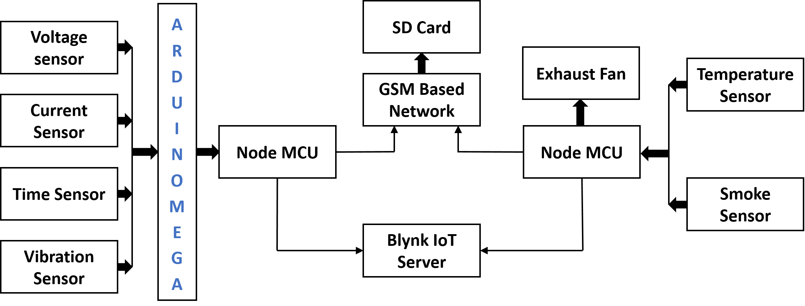

Fig. 1. Block Diagram of the suggested work.

3.1 Smart Billing Meter System

The Smart Billing Meter system is designed to accurately calculate electricity consumption and generate bills dynamically based on the type of connected load and predefined tariff rates. The system begins by initializing the input parameters, including the load in watts, voltage, and current. The flowchart depicted in Fig. 2. outlines the operational process of the Smart Billing Meter System using the given values of Load = 120W, Voltage = 30V, and Current = 0.13A. The system starts by initializing these parameters and determining the type of load. For this scenario, the load is considered resistive, so the power factor is set to 1. The system calculates the power based on the provided inputs and updates the total power to reflect the cumulative consumption. The total power is then converted into standard units of electricity for billing purposes. Based on the consumption, the system checks the tariff rates. Since the consumption is minimal, falling below 50 units, the system applies to a rate of 4.50 per unit. The calculated bill is a product of the units consumed, and the rate applied. The system displays the power consumption and the final bill amount on an LCD screen for the user. This process operates continuously, recalculating the total power and updating the bill as new loads are connected or removed. The iterative and automated nature of the system ensures accurate monitoring and efficient billing in real-time.
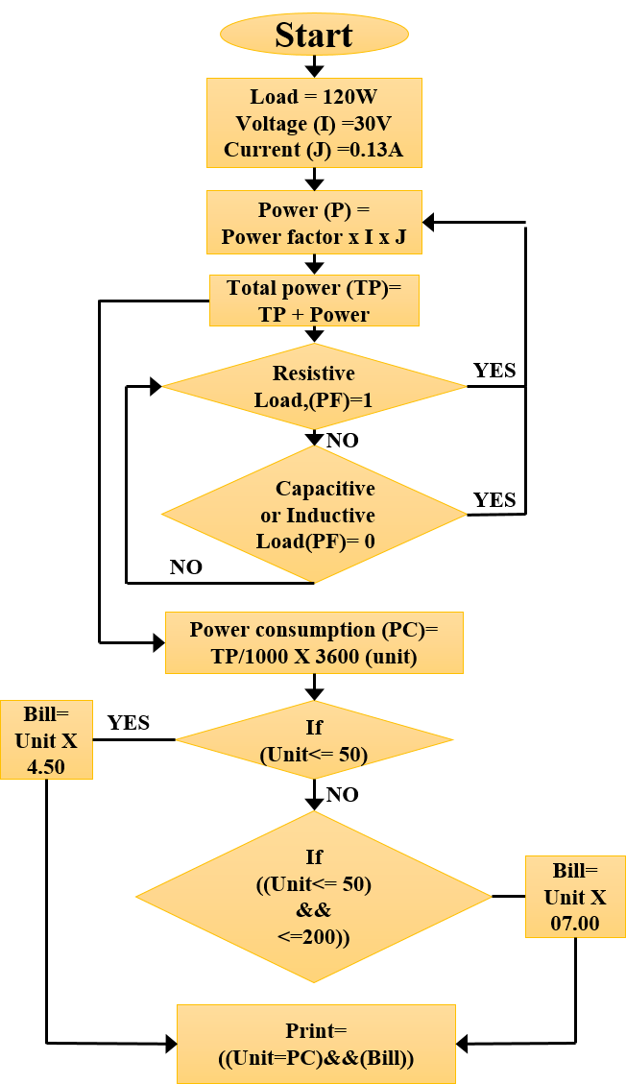
Fig. 2. Flowchart of the proposed work.
3.2 LPG Gas Leakage Detector
The proposed system integrates advanced IoT technology to monitor environmental conditions and ensure safety through the use of two key sensors: the DHT-22 and the MQ-135 showed in Fig 3. The DHT-22 sensor is tasked with detecting real-time temperature and humidity levels, while the MQ-135 sensor specializes in detecting harmful gases and smoke, crucial for identifying potential gas leaks or fire hazards. The system operates using a Node MCU microcontroller, which gathers data from both sensors and transmits it to the Blynk IoT server. This ensures that users receive instant notifications via the Blynk app on their smartphones, allowing them to stay informed of any changes in environmental conditions. In the event of gas leakage or smoke detection, the system activates an automated safety protocol. The Arduino microcontroller triggers an alert notification to the Blynk server, ensuring that the user is notified immediately. Simultaneously, the system activates a high-decibel alarm to warn occupants within the premises, enabling them to take swift action and evacuate if necessary. To mitigate the situation further, the Node MCU initiates the exhaust fan, expelling smoke or harmful gases from the house to reduce the concentration of pollutants and improve air circulation. This integrated system offers a multi-layered approach to safety by combining real-time monitoring, instant notifications, audible alarms, and automated ventilation. By leveraging IoT connectivity and sensor technology, it provides a robust, efficient, and user-friendly solution for safeguarding homes and ensuring peace of mind for occupants.
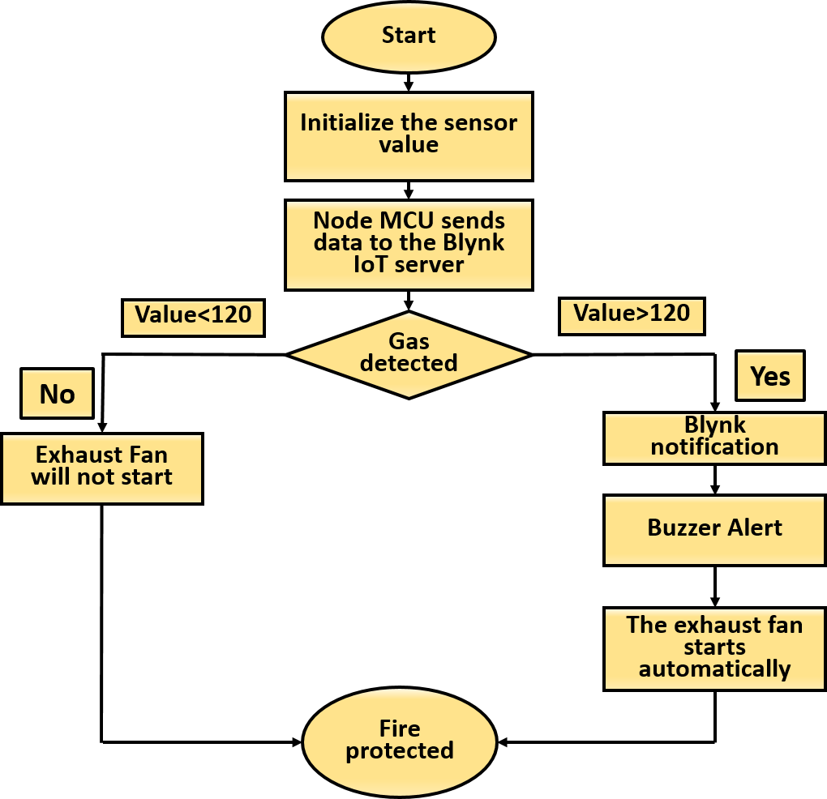
Fig. 3. Flowchart of the proposed work.
4. Working Principle
The proposed system employs multiple sensors and IoT-enabled components to ensure comprehensive environmental monitoring and safety management. The DHT-22 sensor is utilized to measure temperature and humidity levels in real-time. This data helps monitor environmental conditions, which can play a crucial role in maintaining a safe and comfortable living space. Simultaneously, the MQ-135 sensor detects the presence of harmful gases or smoke, which is critical for identifying gas leaks or potential fire hazards. The data collected from these sensors is processed by the Node MCU microcontroller, which serves as the central hub for data acquisition and communication. The Node MCU transmits sensor data to the Blynk IoT server, enabling users to monitor real-time environmental parameters through a mobile application. Notifications are sent to the user’s smartphone in case of any abnormalities, ensuring immediate awareness of critical conditions. In the event of gas leakage or smoke detection, the Arduino microcontroller activates a series of automated safety measures. First, it sends an alert notification to the Blynk IoT server, ensuring that the user is informed instantly. Simultaneously, the system triggers an alarming mechanism, producing a high-decibel sound to alert occupants and prompt evacuation. Additionally, the Node MCU initiates the operation of an exhaust fan, which helps ventilate the area by expelling harmful gases or smoke, thereby reducing the concentration of pollutants within the space. These automated responses work in tandem to mitigate potential hazards and ensure occupant safety. The system’s ability to collect, process, and respond to environmental data dynamically ensures an effective safety solution. The integration of real-time notifications, audible alarms, and ventilation mechanisms creates a robust framework for proactive hazard management, making the system ideal for residential and industrial safety applications.
5. IMPLEMENTATION
The implementation of the Smart Gas Monitoring and Safety System integrated with IoT involved a structured approach that combined simulation and hardware validation to ensure reliability and efficiency. In the simulation phase, tools like PROTEUS and Arduino IDE were used to replicate the system’s operation, including the integration of the DHT-22 sensor for temperature and humidity monitoring, the MQ-135 sensor for gas detection, and the Node MCU microcontroller for data transmission. Simulated alerts were tested on the Blynk IoT platform, demonstrating the system's capability to notify users in real time. The virtual LCD display provided insights into environmental conditions, while automated safety responses, such as alarm activation and exhaust fan operation, were validated in controlled scenarios. In the hardware phase, physical components were connected and calibrated to predefined thresholds. The DHT-22 sensor accurately recorded temperature and humidity, while the MQ-135 sensor effectively detected gas concentrations. The system transmitted real-time data to the Blynk IoT server, ensuring users received instant notifications via the mobile app. Additionally, a GSM module was integrated as a backup notification system, enabling SMS alerts during emergencies. The alarm system and exhaust fan were activated simultaneously in response to detected gas leaks, ensuring occupant safety through audible alerts and ventilation. Rigorous testing validated the system's accuracy, responsiveness, and reliability under real-world conditions. The combination of simulation and hardware implementation ensured that the system was robust and scalable, capable of providing comprehensive monitoring and automated safety responses for residential and industrial applications.
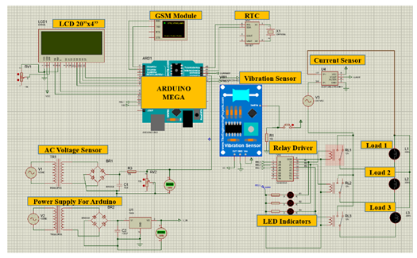
Fig. 4(a). Simulation design of the Smart Energy Monitoring and Control System, illustrating the integration of sensors (AC voltage, current, and vibration), relay driver, GSM module, RTC module, and Arduino Mega microcontroller.
The proposed Smart Energy Monitoring and Control System was developed and validated through a combination of simulation and hardware implementation, leveraging both software tools and real-world components to ensure functionality and reliability. The simulation phase, executed using PROTEUS and Arduino IDE, modeled the key components of the system, including the AC voltage sensor, current sensor, vibration sensor, GSM module, RTC module, relay driver, and connected loads, as shown in Fig. 4(a). This phase was instrumental in evaluating the interaction between components, identifying potential issues, and optimizing the system's design before transitioning to the hardware implementation. In the simulation, the AC voltage sensor and current sensor monitored the power supply parameters, providing real-time data on voltage and current consumption. The vibration sensor detected abnormal mechanical vibrations in connected appliances, which could indicate potential failures. These inputs were processed by the Arduino Mega microcontroller, which acted as the core processing unit for the system. The simulation also included functionality for displaying real-time data on an LCD screen and automating actions, such as load switching through the relay driver based on predefined thresholds. The GSM module was configured in the simulation to send alerts via SMS in case of abnormalities such as high current, low voltage, or excessive vibrations, ensuring prompt notifications to the user. Additionally, the RTC module was integrated into timestamp events for accurate tracking and logging of system activities. The virtual terminal in the simulation environment provided a detailed overview of system operations, displaying voltage, current, and vibration levels, as well as the status of connected loads, offering a comprehensive platform for testing and validation. Following successful simulation, the system was implemented in hardware using the same components as those modeled in the simulation phase. The Arduino Mega microcontroller served as the core unit for data acquisition and processing. Sensors were physically deployed to monitor power supply parameters and detect anomalies in connected appliances. The relay driver was used to control the switching of three connected loads dynamically based on the input data from the sensors. The hardware implementation also included an LCD module for on-site monitoring of system parameters, enabling users to view voltage, current, and load status in real time. The GSM module was tested in real-world scenarios to ensure timely alerts for critical conditions, such as high current surges or excessive vibration. This notification mechanism was validated by sending SMS alerts to predefined user contacts, ensuring reliability even in the absence of internet connectivity. The system's automation capabilities were rigorously tested during the hardware validation phase. The relay driver demonstrated its ability to activate or deactivate loads based on sensor inputs, enhancing energy efficiency and safety. The vibration sensor successfully identified abnormal conditions, triggering alarms and switching off loads to prevent further damage. In Fig. 4(a) illustrates the simulated circuit design, detailing the integration of sensors, actuators, and the Arduino Mega microcontroller. The iterative process of simulation and hardware validation ensured that the system was robust, scalable, and capable of addressing real-world challenges in energy monitoring and management. This comprehensive development approach not only validated the system’s functionality but also underscored its potential for real-world applications in industrial and residential energy management. By combining real-time monitoring, automation, and alert mechanisms, the system provides a reliable, user-friendly, and scalable solution for energy optimization and appliance protection.
6. RESULTS AND DISCUSSION
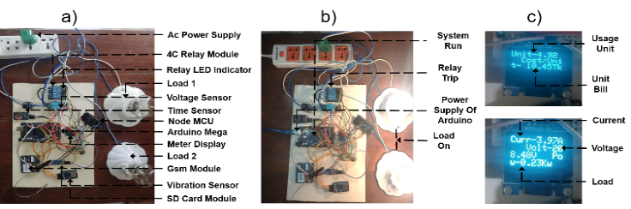
The performance of the Smart Energy Monitoring and Control System was thoroughly analyzed through hardware implementation and real-world testing, demonstrating its reliability, functionality, and adaptability for practical energy management. The system incorporated various components, including the microcontroller, sensors, relay driver, GSM module, and LCD display, all working in harmony to provide real-time monitoring, control, and feedback, as illustrated in Fig. 5(a) and Fig. 5(b), The hardware setup effectively captured critical parameters such as voltage, current, power consumption, and unit costs, which were dynamically displayed on the LCD for user awareness and operational transparency, as depicted in Fig. 5(c), The system's automation capabilities were thoroughly validated, with the relay driver actively managing connected loads based on sensor inputs. It responded efficiently to abnormal conditions such as excessive vibrations or fluctuations in current, ensuring safety by disconnecting the affected loads. Simultaneously, the GSM module sent immediate alerts to users, ensuring timely awareness and intervention. This layered response mechanism enhanced the overall reliability and safety of the system. The integration of IoT functionalities allowed users to remotely

Fig. 5. (a) Hardware setup of the Smart Energy Monitoring and Control System, showcasing the integration of sensors, microcontroller, and relay driver for real-time energy monitoring and control, (b) System in operation with connected loads, demonstrating automation and safety features, (c) LCD display showing real-time energy consumption and cost, providing users with actionable insights, LCD display highlighting voltage, current, and power readings for detailed monitoring of electrical parameter.
monitor and control the system through real-time notifications and updates. The GSM module enabled instant alerts, ensuring critical conditions were addressed promptly, even when users were off-site. This feature highlighted the system’s potential for scalability, making it suitable for both residential and industrial applications requiring centralized control. During testing, the system demonstrated seamless communication between its sensors and actuators, ensuring consistent performance. The vibration sensor effectively detected anomalies in connected devices, prompting the system to take preventive actions. The current and voltage sensors accurately monitored energy parameters, enabling efficient power management and decision-making. The system's automated processes dynamically adjusted to varying conditions, ensuring optimal performance while prioritizing safety and energy efficiency. This comprehensive evaluation of the system underscored its ability to deliver real-time monitoring, proactive safety measures, and automated control. The iterative development and testing process ensured its robustness, making it a scalable and reliable solution for modern energy monitoring and management. Through its integration of automation and IoT capabilities, the system provides a practical and efficient approach to addressing challenges in energy optimization and safety management.
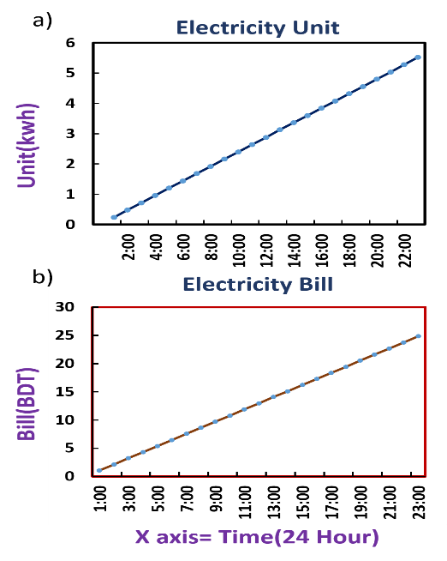
Fig. 6. (a) 24-hour observation of electricity units consumed, showing the continuous accumulation of energy usage over time, (b) 24-hour observation of electricity bill, demonstrating the proportional increase in costs based on hourly energy consumption.
Furthermore, the analysis highlights the system's robust functionality, reliability, and applicability in practical energy management scenarios. The system seamlessly integrates critical components, including the Arduino Mega microcontroller, voltage and current sensors, vibration sensor, relay driver, GSM module, and LCD display, to deliver accurate, real-time energy monitoring, control, and feedback. Fig. 6. showcases the energy consumption and billing data recorded by the system, stored on an SD card and analyzed in hourly intervals. The graphs provide a detailed representation of electricity units consumed Fig. 6(a) and the corresponding cost Fig. 6(b) over a 24-hour period. These results validate the system’s ability to collect and track energy data in real time. To ensure consistency during testing, a constant load was applied, enabling the system to measure and log data precisely. While minor inconsistencies arose due to partial sensor functionality during the testing phase, the overall data collection process demonstrated the system’s accuracy and reliability in capturing critical energy parameters. The electricity unit graph Fig. 6(a) illustrates the steady accumulation of consumed energy over time, reflecting the system’s ability to monitor energy usage continuously. The billing graph Fig. 6(b) shows a proportional increase in electricity costs based on hourly consumption, highlighting the system's capacity to dynamically calculate and present cost information. This feature provides users with actionable insight into their energy usage patterns, enabling informed decisions to optimize consumption and reduce costs. The system’s automation capabilities were further validated during testing. The relay driver dynamically managed connected loads based on real-time sensor inputs, ensuring energy efficiency and preventing damage caused by overcurrent or excessive vibrations. In critical situations, such as abnormal load behavior, the system immediately disconnected affected devices and triggered notifications via the GSM module, enabling timely user intervention. This dual-layered safety mechanism underscores the system’s reliability and adaptability for both residential and industrial energy applications integration further extended the system’s usability by enabling remote monitoring and control. The GSM module sent real-time alerts to users’ mobile devices, ensuring they remain informed of critical conditions such as power surges or equipment malfunctions, even when off-site. This capability enhances the system’s scalability, making it suitable for larger energy management networks requiring centralized oversight. The real-time data recorded and displayed on the LCD screen, combined with the hourly analysis shown in Fig. 7, demonstrates the system’s ability to function as a proactive energy management tool. It not only provides real-time feedback but also allows historical data analysis, empowering users to identify inefficiencies and optimize their energy usage. The combination of automated controls, IoT connectivity, and real-time monitoring ensures that the system meets the demands of modern energy management while enhancing safety and efficiency. This evaluation highlights the system’s robust performance, from accurately tracking energy consumption to dynamically calculating costs and providing safety measures. Its scalability, reliability, and user-friendly features position it as a practical solution for addressing key challenges in energy optimization and management, ensuring both operational efficiency and cost-effectiveness.
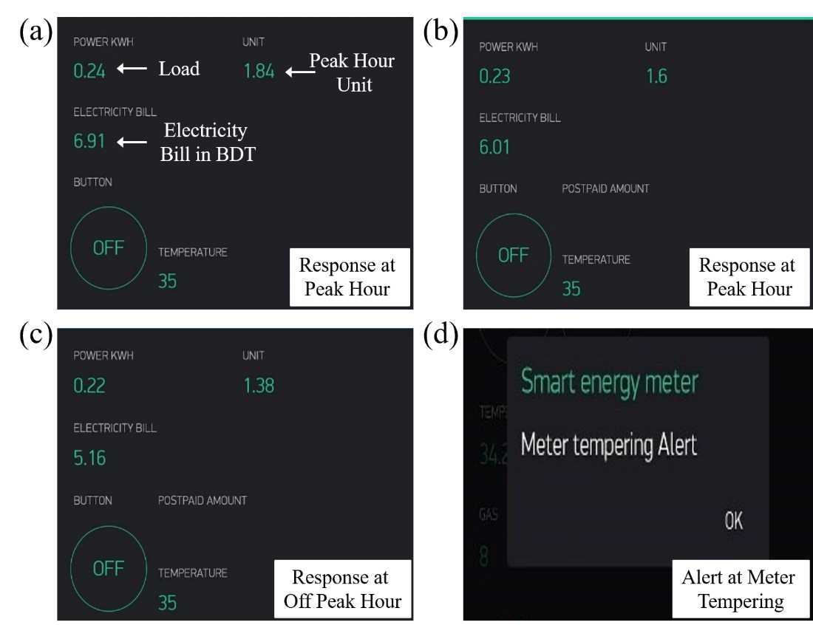
Fig. 7. (a) Real-time response during peak hours, showing load, energy units consumed, and corresponding electricity bill, (b) Consistent monitoring and billing data during peak hours, (c) System response during off-peak hours, highlighting reduced energy consumption and cost, (d) Alert notification for meter tampering, ensuring system security and integrity.
The figure demonstrates the operational responses of the Smart Energy Monitoring and Control System under varying conditions, highlighting its monitoring, calculation, and alert capabilities. In Fig.7 (a), the system records and displays real-time data during peak usage hours, including the load, total electricity units consumed, and the corresponding bill amount in local currency. This showcases the system's ability to provide users with accurate and timely insights into their energy consumption during high-demand periods, enabling them to manage their usage effectively. Similarly, Fig. 7(b), further reinforces this capability, presenting consistent monitoring and billing data for another instance of peak hour operation, emphasizing the system’s reliability in capturing and processing critical energy metrics. In Fig.7 (c), the system’s response during off-peak hours is illustrated. The load, energy units consumed, and electricity bill are notably lower than those observed during peak hours, reflecting reduced energy demand. This highlights the system's ability to differentiate between peak and off-peak usage, providing users with a clearer understanding of how shifting energy usage to off-peak hours can help reduce costs. This functionality promotes energy efficiency and encourages users to adopt more cost-effective consumption practices. In Fig. 7(d), showcases the system’s security feature, where an alert is generated in response to unauthorized tampering of the energy meter. The "Meter Tempering Alert" notification ensures the integrity of the monitoring system by detecting and reporting suspicious activities in real time. This feature is critical for safeguarding the system’s accuracy and reliability while preventing potential manipulation of energy data. The following fig 7 highlights the system’s comprehensive capabilities, including real-time energy monitoring, accurate billing calculation, and proactive security measures. By distinguishing between peak and off-peak hours and providing tampering alerts, the system ensures transparency, user accountability, and operational efficiency. These features make the system a robust and practical solution for energy management in both residential and industrial applications.

Fig. 8. showcases the operational dashboard of the Smart Energy Meter System, highlighting its advanced real-time monitoring and control capabilities for energy management and environmental safety. The interface provides users with detailed insights into key metrics such as power consumption, total units used, and dynamically calculated electricity bills, enabling effective tracking and management of energy usage. The dashboard also features a remote load control, with both Load 1 and Load 2 displayed in the "OFF" state. This functionality allows users to remotely manage their appliances, promoting energy efficiency and reducing unnecessary consumption. A notable feature of the system is the prepaid balance display, which provides users with a clear view of their remaining credit for electricity usage. This feature is particularly advantageous for prepaid energy systems, empowering users to monitor their expenditures and recharge balances as needed to avoid interruptions. Furthermore, the dashboard integrates environmental monitoring functionalities, displaying real-time temperature readings and gas levels. The gas detection feature enhances safety by continuously monitoring hazardous gas concentrations and alerting users if levels approach unsafe thresholds. The dashboard’s intuitive design combines real-time updates with actionable controls, offering a seamless and user-friendly experience. By providing a centralized platform for energy monitoring, load management, balance tracking, and safety alerts, the Smart Energy Meter System presents a robust and practical solution for residential and industrial energy management needs. Its ability to deliver accurate insights and enable proactive decision-making underscores its reliability and effectiveness in diverse applications.

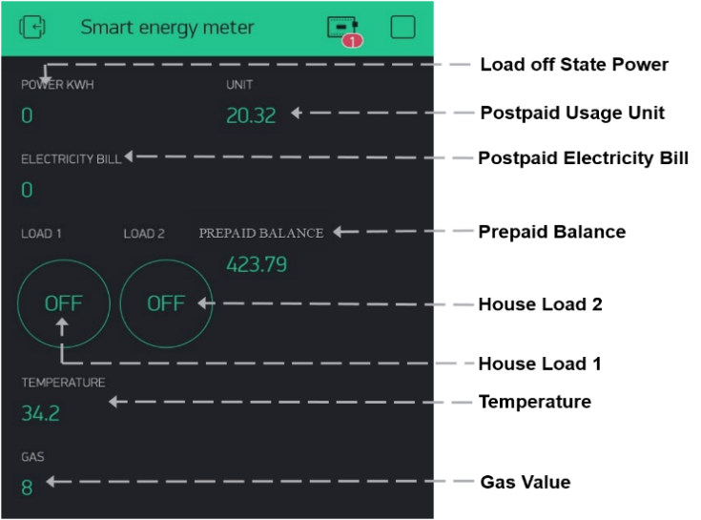
Fig. 8. Operational dashboard of the Smart Energy Meter system, showcasing real-time energy monitoring, load control, prepaid balance tracking, and environmental parameter updates for temperature and gas levels.
The application of the LPG Gas Leakage Detector System is demonstrated In Fig. 9. showcasing its capability to detect hazardous gas levels and respond effectively through automated actions and real-time alerts. The setup integrates a gas sensor, relay-controlled exhaust fan, and a mobile application for user notifications. The system is fully operational in the scenario depicted, actively monitoring gas concentrations. During the test, a lighter was used near the gas sensor to simulate a gas leakage scenario. As the gas concentration exceeded the predefined safety threshold of 100, the system immediately activated the exhaust fan via the relay module. This automated response ensured that the hazardous gas was ventilated out of the environment, reducing the risk of harm. The exhaust fan’s activation is indicated by the illuminated system LEDs, confirming the system's real-time responsiveness. Concurrently, a notification was sent to the connected mobile device, alerting the user with a message stating "Alert: GAS detected" to ensure timely awareness and action. This demonstration highlights the system's reliability in detecting gas leaks and initiating corrective measures without manual intervention. The integration of real-time monitoring, automated ventilation, and mobile alerts provides a comprehensive safety solution for residential and industrial applications. By proactively addressing gas leaks, the system minimizes risks to occupants and infrastructure, making it a robust and practical safety tool.
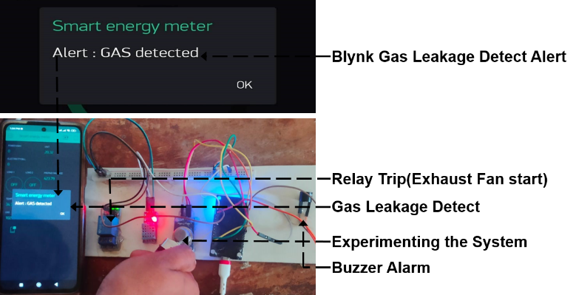
Fig. 9. Real-time operation of the LPG Gas Leakage Detector System, illustrating the detection of hazardous gas levels and automated activation of the exhaust fan with simultaneous user alerts via a connected mobile application.
Name of Component | Quantity Used | Our System with Integrated Sensors (in BDT) | Equivalent Sensors (India) (in BDT)
Arduino MCU [23] | 1.0 | 540 | 1321 (Arduino  Nano Every)
GSM Module | 1.0 | 600 | 1500 (Sim7600ei Module)
Current Sensor [24] | 1.0 | 220 | 1600 (ABB ES500)
Vibration Sensor | 1.0 | 200 | 750 (Banner QM30VT Series)
AC Voltage Sensor | 1.0 | 100 | 180 (ZMPT101B AC)
Time Sensor [25] | 1.0 | 250 | 750 (RTC DS1302 Real Time)
Total (in BDT) |  | 1910 | 6101
Table 1. The final cost for the project and analysis

7. PROJECT FINANCE
The primary objective of this project was to design and implement a cost-effective yet comprehensive Smart Plant Monitoring and Control System. A meticulous cost analysis was conducted to ensure financial feasibility and resource optimization showed in table 1. This analysis involved an extensive evaluation of the essential components required for the system, focusing on cost-effective procurement while maintaining high performance and reliability. The project’s cost estimation was carried out through exhaustive research, comparing the prices of components sourced from vendors in Bangladesh and India. This comparative approach allowed for a detailed understanding of the financial implications of resource acquisition and provided transparency in the decision-making process. Components such as the Arduino Nano, DHT-11 humidity sensor, ESP32 Camera module, and others were carefully evaluated to strike a balance between affordability and performance. The analysis not only included the cost of these components but also assessed their quality, functionality, and compatibility with the system’s requirements. The dual-market analysis enabled the identification of cost differences between local and regional suppliers, ensuring that the project leveraged the most cost-efficient options without compromising on quality. This approach ensured the system was developed within a reasonable budget while integrating high-quality components to meet functional and technical requirements. The final cost table reflects the outcomes of this detailed analysis, highlighting the project's commitment to cost optimization and transparency. This approach underscores the importance of balancing affordability with performance, making the system a practical and scalable solution for sustainable agricultural applications. By optimizing resource allocation, the project successfully demonstrated how advanced agricultural technologies can be developed within budget constraints while ensuring reliability and efficiency.
5. CONCLUSION
The Smart Billing Meter and LPG Gas Leakage Detection System represents an innovative and integrated solution that combines advanced energy monitoring with enhanced safety features. This system not only facilitates accurate electricity consumption tracking and dynamic billing but also incorporates remote load control, empowering users to optimize their energy usage effectively. With IoT integration, users benefit from real-time notifications and insights, ensuring transparency and promoting energy efficiency in both residential and industrial settings. The LPG gas leakage detection component enhances safety by promptly detecting hazardous gas levels and automatically activating preventive measures, such as triggering the exhaust fan to dissipate gas and sending immediate alerts to users. This proactive approach minimizes risks associated with gas leaks, ensuring the safety of both occupants and property. The system’s comprehensive testing and validation confirm its robustness, scalability, and adaptability to diverse environments. Its ability to integrate energy management and safety monitoring within a single platform makes it a versatile and practical solution. By leveraging IoT connectivity, automation, and real-time data processing, the system provides a reliable and efficient framework for modern smart homes and industrial setups. In this research highlights the potential of IoT-based solutions in improving energy efficiency, safety, and user convenience, offering a cost-effective and forward-thinking approach to resource management and risk mitigation. The major purpose is to provide an overall infrastructure for the energy meter that is now being used in the smart city concept. Energy meter readings, gas leakage detecting procedures, connection, and disconnection, as well as delivering pre-information to consumers, will all be done through Wi-Fi internet in the future.

Disclaimer (Artificial intelligence)
Author(s) hereby declare that NO generative AI technologies such as Large Language Models (ChatGPT, COPILOT, etc.) and text-to-image generators have been used during the writing or editing of this manuscript.
Acknowledgement
The authors express their heartfelt appreciation to the Department of Electrical and Electronic Engineering (EEE) at the American International University-Bangladesh (AIUB). Corresponding author: Shuvra Mondal, email: xxx@gmail.com.
References

- Díaz, Manuel, Cristian Martín, and Bartolomé Rubio. "State-of-the-art, challenges, and open issues in the integration of Internet of things and cloud computing." Journal of Network and Computer applications 67 (2016): 99-117.
- Grieco, Luigi Alfredo, Alessandro Rizzo, Simona Colucci, Sabrina Sicari, Giuseppe Piro, Donato Di Paola, and Gennaro Boggia. "IoT-aided robotics applications: Technological implications, target domains and open issues." Computer Communications 54 (2014): 32-47.
- Ahammed, Md Tanvir, and Imran Khan. "Ensuring power quality and demand-side management through IoT-based smart meters in a developing country." Energy 250 (2022): 123747.
- Sedhom, Bishoy E., Magdi M. El-Saadawi, M. S. El Moursi, Mohamed A. Hassan, and Abdelfattah A. Eladl. "IoT-based optimal demand side management and control scheme for smart microgrid." International Journal of Electrical Power & Energy Systems 127 (2021): 106674.
- Lobaccaro, Gabriele, Salvatore Carlucci, and Erica Löfström. "A review of systems and technologies for smart homes and smart grids." Energies 9, no. 5 (2016): 348.
- Abir, SM Abu Adnan, Adnan Anwar, Jinho Choi, and A. S. M. Kayes. "Iot-enabled smart energy grid: Applications and challenges." IEEE access 9 (2021): 50961-50981.
- Yadav, Vasudev, Akhilesh Shukla, Sofiya Bandra, Vipin Kumar, Ubais Ansari, and Suraj Khanna. "A review on microcontroller based LPG gas leakage detector." Journal of VLSI Design and Signal Processing 2, no. 3 (2016): 1-10.
- Kumar Pateriya, Pushpendra, Ali Azam Munna, Harichad Biswas, Aljami Ahammed, and Abishek Shah. "IoT-based LPG Gas Leakage Detection and Prevention System." In Proceedings of the International Conference on Innovative Computing & Communication (ICICC). 2021.
- Karuppusamy, P. "A sensor based IoT monitoring system for electrical devices using Blynk framework." Journal of Electronics and Informatics 2, no. 3 (2020): 182-187.
- Bedi, Guneet, Ganesh Kumar Venayagamoorthy, Rajendra Singh, Richard R. Brooks, and Kuang-Ching Wang. "Review of Internet of Things (IoT) in electric power and energy systems." IEEE Internet of Things Journal 5, no. 2 (2018): 847-870.
- Islam, Md Rakibul, Abdul Matin, Md Saifullah Siddiquee, Fahim Md Sifnatul Hasnain, Md Habibur Rahman, and Tonmoy Hasan. "A novel smart gas stove with gas leakage detection and multistage prevention system using IoT LoRa technology." In 2020 IEEE Electric Power and Energy Conference (EPEC), pp. 1-5. IEEE, 2020.
- Agyeman, Michael Opoku, Zainab Al-Waisi, and Igla Hoxha. "Design and implementation of an IoT-based energy monitoring system for managing smart homes." In 2019 Fourth International Conference on Fog and Mobile Edge Computing (FMEC), pp. 253-258. IEEE, 2019.
- Ahammed, Md Tanvir, and Imran Khan. "Ensuring power quality and demand-side management through IoT-based smart meters in a developing country." Energy 250 (2022): 123747.
- Jayaprakash, R., P. Poovizhi, D. Pavithra, Vijaya Kumar, R. Saranya, and S. Muthamilselvan. "RFID with IoT Integrated Smart Energy Meter Monitoring and Control System for Efficient Usage and Billing." In 2024 Second International Conference on Intelligent Cyber Physical Systems and Internet of Things (ICoICI), pp. 354-361. IEEE, 2024.
- Gomes, João BA, Joel JPC Rodrigues, Ricardo AL Rabêlo, Neeraj Kumar, and Sergey Kozlov. "IoT-enabled gas sensors: Technologies, applications, and opportunities." Journal of Sensor and Actuator Networks 8, no. 4 (2019): 57.
- Gavaskar, K., D. Malathi, G. Ravivarma, and A. Arulmurugan. "Development of LPG leakage detection alert and auto exhaust system using IoT." In 2021 7th International Conference on Electrical Energy Systems (ICEES), pp. 558-563. IEEE, 2021.
- Lloret, J., Tomas, J., Canovas, A. and Parra, L., 2016. An integrated IoT architecture for smart metering. IEEE Communications Magazine, 54(12), pp.50-57.
- Khalil, U., Malik, O. A., Uddin, M., & Chen, C. L. (2022). A comparative analysis on blockchain versus centralized authentication architectures for IoT-enabled smart devices in smart cities: a comprehensive review, recent advances, and future research directions. Sensors, 22(14), 5168.
- Hao, Yuqiuge, Petri Helo, and Angappa Gunasekaran. "Cloud platforms for remote monitoring system: a comparative case study." Production Planning & Control 31, no. 2-3 (2020): 186-202.
- Banerjee, Ananya. "A comparative study on IoT-aided smart grids using blockchain platform." In Artificial intelligence and machine learning for EDGE computing, pp. 443-467. Academic Press, 2022.
- Pitì, Alessandro, Giacomo Verticale, Cristina Rottondi, Antonio Capone, and Luca Lo Schiavo. "The role of smart meters in enabling real-time energy services for households: The Italian case." Energies 10, no. 2 (2017): 199.
- Hancke, Gerhard P., and Gerhard P. Hancke Jr. "The role of advanced sensing in smart cities." Sensors 13, no. 1 (2013): 393-425.
- Riyad, Tarifuzzaman, Md Asif Iqbal, Habib Un Nabi Polash, SM Oaliullah Sohrab, and Shuvra Mondal. "Low-Cost Wearable Hand Glove For Physiological Signal Monitoring." In 2024 3rd International Conference on Advancement in Electrical and Electronic Engineering (ICAEEE), pp. 1-6. IEEE, 2024.
- Xiao, Chucheng, Lingyin Zhao, Tadashi Asada, W. G. Odendaal, and J. D. Van Wyk. "An overview of integratable current sensor technologies." In 38th IAS Annual Meeting on Conference Record of the Industry Applications Conference, 2003., vol. 2, pp. 1251-1258. IEEE, 2003.
- Nayar, Shree K., Masahiro Watanabe, and Minori Noguchi. "Real-time focus range sensor." IEEE Transactions on Pattern Analysis and Machine Intelligence 18, no. 12 (1996): 1186-1198.

