Application of the Discrete Element Method for Modeling Lithium-Ion Batteries in Electric Vehicles

ABSTRACT
lithium-ion batteries have transformed the foundations of the world's infrastructure. From energy production to electricity distribution, the transportation of people and goods, and the operation of computing devices and even the internet. This scenario was analyzed during the aforementioned conference, where the latest innovations in the battery field—sodium, cobalt-free, and even solid-state batteries—were the main focus of the event. The purpose of this project is the application of the discrete element method (DEM) for the realization of a particle model based on the electrode material of the lithium-ion batteries in electric cars, trying to solve the main problems they present during charging and download since these directly affect the lifetime of the same
Key words. Electrode, batteries, electric vehicle, Discrete Element Method, Lithium-Ion

1. INTRODUCTION

One of the latest developments in the sector is lithium-ion batteries, designed to support electric vehicles. Regardless, the sector continues to advance, adapting to the needs of the automotive market and seeking to offer increasingly powerful batteries with greater range.
As battery and automotive researchers and manufacturers continue to work on innovations in battery development, there is a perception that the low cost and high density of lithium-ion batteries are beginning to change everything. This was evident during the Bay Area Battery Summit, held in Berkeley, California, this October. A conference that brings together technologists and entrepreneurs focused on short- and medium-term energy storage, particularly related to the automotive industry. Today, and without exaggeration, lithium-ion batteries have transformed the foundations of the world's infrastructure. From energy production to electricity distribution, the transportation of people and goods, and the operation of computing devices and even the internet. This scenario was analyzed during the aforementioned conference, where the latest innovations in the battery field—sodium, cobalt-free, and even solid-state batteries—were the main focus of the event. Furthermore, numerous researchers emphasized that lithium batteries are more successful, in terms of power and low cost, compared to other potential competitors today.
The reign of lithium is more than justified for several reasons. First, the development of lithium batteries continues to evolve, improving by 5 to 10% annually in terms of energy density. As if that weren't enough, lithium-ion batteries are increasingly more economically competitive compared to other options. These batteries are becoming increasingly cheaper to manufacture, and their applications are expanding, including stationary storage at any scale and their introduction into the aviation field. The potential in this area is very exciting, as it would allow for shorter flights (one or two hours) that are faster, quieter, and have a low environmental impact. Flights that would generate fewer CO2 emissions at a lower cost than the current one. As for long-haul flights, the conversion to electric mobility is anticipated in the long term.

2. methodology

Aitor Conde Velasco, an Industrial Technologies Engineer in 2018, presents his thesis for obtaining his degree entitled "Development and Validation of a Lithium-Ion Battery Model. Application to the Study of Aging Linked to the Type of Recharging." The thesis was carried out with the idea of ​​identifying those variables and recharging conditions that most influence the aging process of lithium-ion batteries intended to serve as power sources for electric vehicles. This was done in order to propose variation margins for key parameters and charging requirements that allow extending the useful life of these devices. A model was developed to simulate the use of batteries that allows systematic testing using a broad set of values ​​for each of the parameters identified as essential.

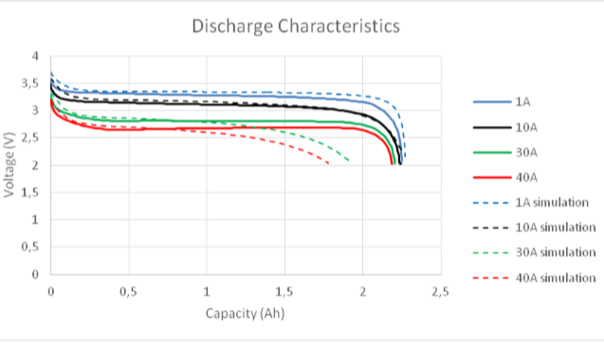
Figure 1 Discharge characteristics. LiFePo4 battery.

2.1 Importance of the discrete element method

Currently, the method is being disseminated by different centers and lines of research in different types of projects such as those already mentioned in the previous chapter, where work is recognized in different areas of study, including agriculture, structural mechanics, civil engineering, geomechanics, granular fluids, and the mining industry, among many others.

The method, although not well known, has great scope for the micromechanical study of different elements and materials. For example, we have the different types of fractures and crack propagation that can be represented and calculated correctly and illustratively with this method, something that would be difficult to visualize realistically with other types of computational solution strategies.
All this is thanks to the different parameters used for the real representation of a discrete medium where, depending on the area of ​​study, we can analyze a material or how it would behave under different types of external forces or reactions.

2.2 Breaking criterion

The contact model presents a microstructural failure criterion that characterizes the tensile or shear failure of the contacts between different elements. This aspect is delimited by a failure surface characterized by the maximum tensile strength (in terms of forces) and the maximum shear strength (in terms of forces).
Using the failure criterion, the contacts between particles can break (breaking of the cohesive contribution between particles) due to external loads of a certain magnitude. These contacts break when the interface forces in the normal or tangential directions are exceeded ($F_{n}>R_{T}$ o $\left|{|F}_{T}|\right|>R_{T}$). In the case of this contact constitutive model, the material's cohesion is considered to have been completely lost.

2.3 Cells used for analysis in software

Now that we have an idea of ​​how electric car batteries are constructed, we can begin a detailed analysis of each cell, which is mostly cylindrical or rectangular depending on the space they occupy. The images below show a specific type of 18650 cell, named for its 18 mm x 65 mm dimensions. This is a common nomenclature for battery manufacturing cells. We are also representing the differences between a physical model, drawing software, and software used to discretize said element, figure 2.
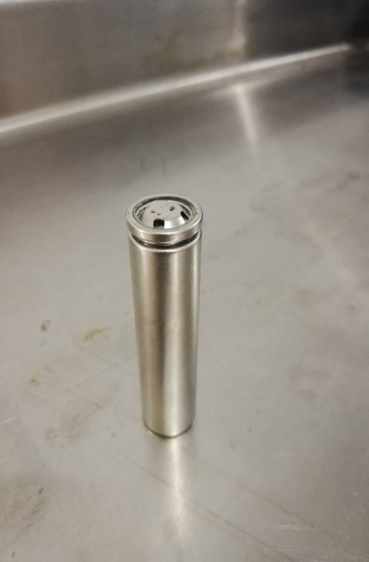
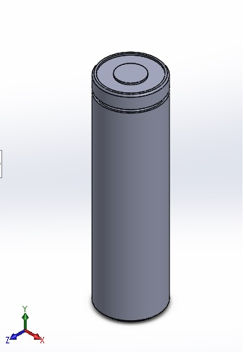

Figure 2 cell isometric view

The above is necessary to understand the nature of the project carried out, in order to clarify the pairs that make up the battery of an electric car from the general to the particular. The following images 3 and 4 show how a lithium-ion cell is constituted, which will be taken as a basis for the implementation of the method.

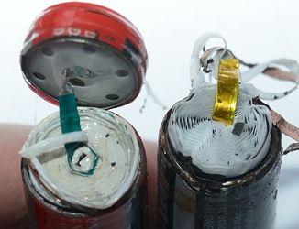
Figure 3 Cell open at the top

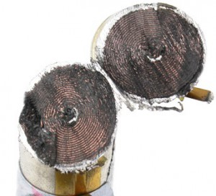

Figure 4 Cell with a cross section

Using the images above, we can render a drawing made in SolidWorks with the main parts to be analyzed: the anode, cathode, and electrolyte, which are enclosed in a perforated plastic film.
The figure 5 and 6 below shows this rendering, and we can see the small layers that make up the lithium cell.

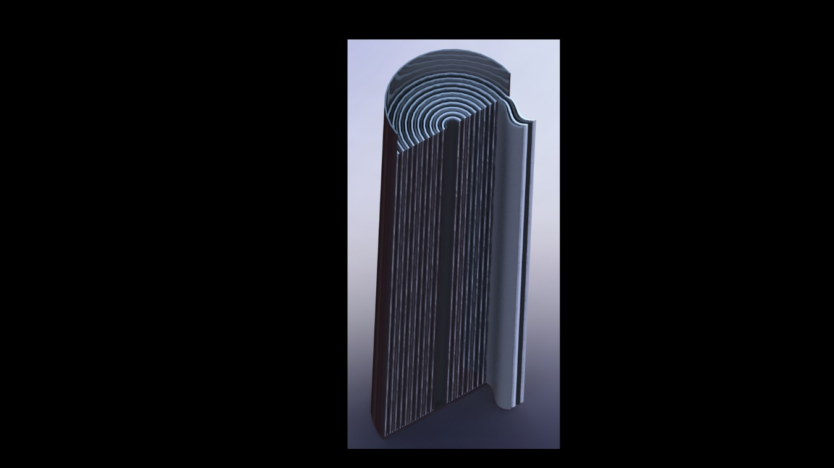
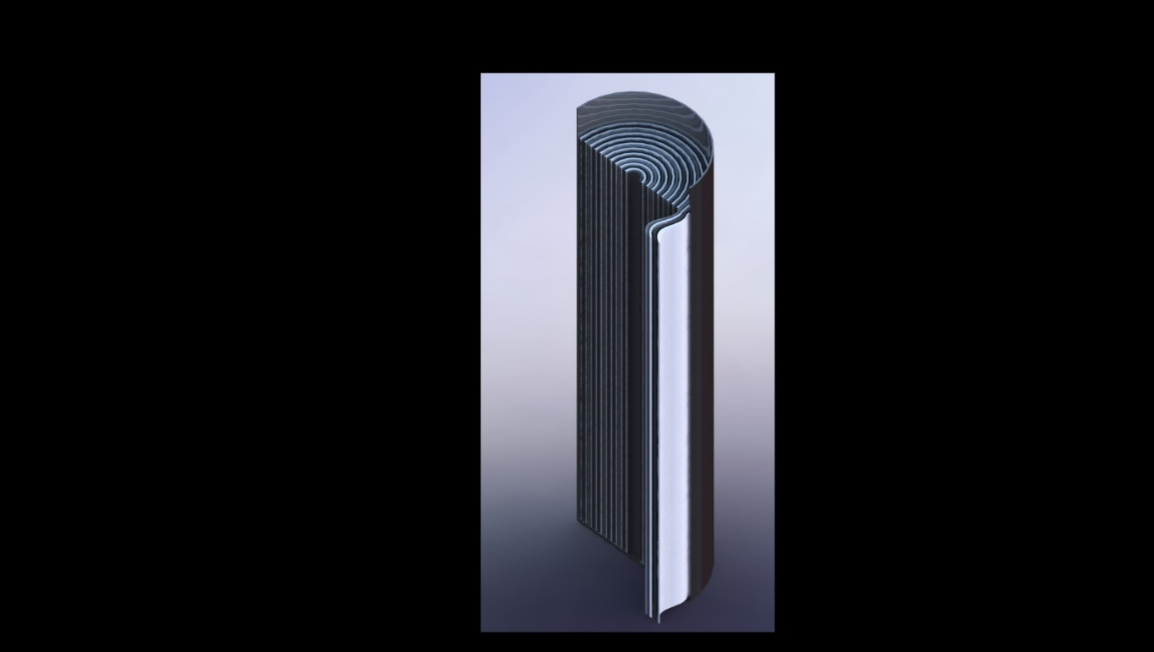
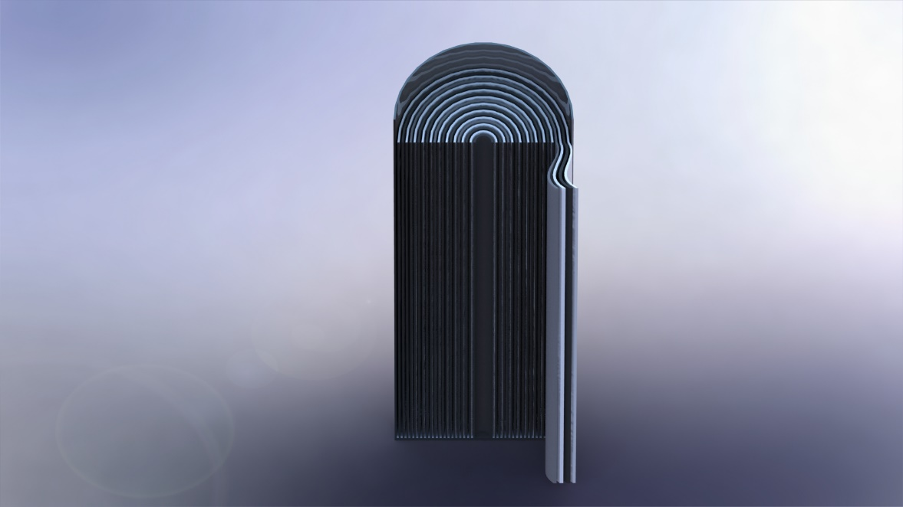
Figure 5 Longitudinal section of a lithium cell

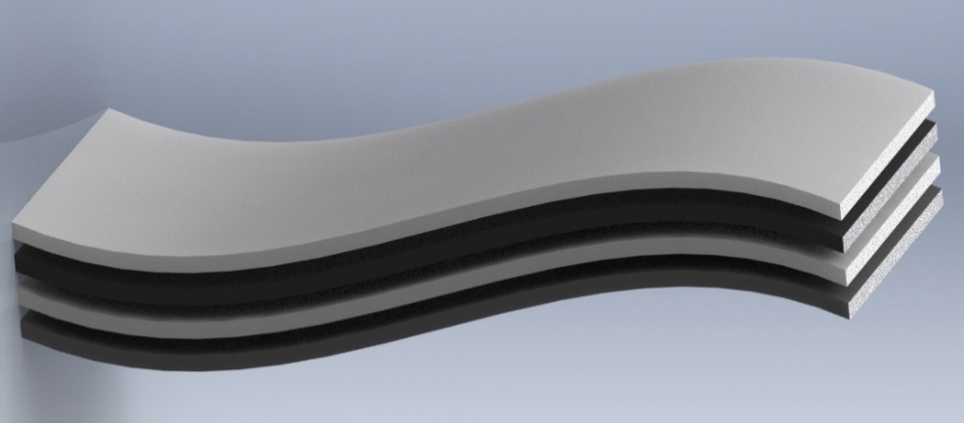

Figure 6 Layers of the cell interior

2.4 Lithium iron phosphate battery

Lithium iron phosphate batteries, also known as LFP batteries, are a type of rechargeable battery, specifically a lithium-ion battery which has a lithium iron phosphate cathode (${LiFePO}_{4}$).
The aforementioned material will be used for the simulation of this project.
The batteries ${LiFePO}_{4}$ they have a slightly lower energy density than common lithium cobalt oxide batteries (${LiCoO}_{2}$) frequently used in household appliances, but they offer greater durability, greater power and are much safer, making their use in electric vehicles optimal.

Lithium iron phosphate (${LiFePO}_{4}$), It is a natural mineral from the olivine family. Lithium iron phosphate (LFP) batteries are more stable, safer, and longer-lasting, but until now their use has been restricted by their lower energy capacity. Thanks to their greater reliability and the fact that they avoid the risk of combustion present in lithium cobalt oxide batteries, they are attractive for critical applications such as aeronautics, automotive, robotics, and medicine, where a failure can mean something much more serious than a missed call.

Several strategies have been tested to improve battery performance ${LiFePO}_{4}$, such as reducing the size of the compound particles to facilitate the transfer of ions, or coating them with a material with greater electrical conductivity to give an extra push to the lithium cations.
The batteries ${LiFePO}_{4}$ They have a very low internal resistance that allows them to deliver very high currents and they also have a fairly long lifespan, even when subjected to deep discharge cycles.

2.5 How and what factors affect the life of lithium batteries

Lifecycles of lithium batteries.

The useful life of a battery is deeply affected by how quickly it is charged and discharged. When these processes are carried out at high speed, the battery is subjected to considerable stress, causing faster wear and tear on its internal components and, as a result, a significant reduction in its total life span. Each rapid cycle involves additional stress that, over time, deteriorates its ability to store energy efficiently.

Conversely, when charging and discharging are carried out in a smoother, slower, and more controlled manner, the battery experiences much less aggressive treatment. This helps its internal materials degrade at a slower rate, allowing it to maintain its performance and capacity for a longer period of time. In simple terms, the more moderate the charging and discharging process, the longer the battery's life expectancy, as it promotes more stable and longer-lasting operation.

Swelling of lithium cells.

Swelling in lithium cells indicates that the cell has lost some of its battery properties. In addition, a swollen cell can be dangerous as there is a possibility of explosion.
Swelling occurs during battery charging or discharging (especially during charging) and can be caused by three factors:

1. Poor charger programming or use of an unsuitable charger.
This is easily detectable as all the cells in the pack or battery swell and their final voltage is above the maximum voltage per cell.

2.- A defective cell:
Only one cell is swollen, caused by a manufacturing defect or physical damage (e.g., impact or puncture). There is also the possibility that this cell has deteriorated more quickly than the rest.

3. In batteries that have undergone many charge and discharge cycles:
The cathode and anode are not in good condition and the cells swell during charging. This is not normally dangerous; these batteries continue to function but with greatly reduced performance.

How charging and discharging affect lithium batteries.

Depending on the architecture of a battery, the internal elements are stacked as follows:

Cathode-Separator-Anode-Separator-Cathode-Separator-Anode.

The electrolyte is housed between the different sheets that make up the internal architecture of a cell, acting as a conductive medium for the transport of ions between the electrodes. In the case of lithium-ion batteries, this electrolyte is usually in liquid form, which allows for efficient ionic mobility. On the other hand, in lithium polymer batteries, the electrolyte takes on a gel-like consistency, which is denser and more stable, performing the same function but with slightly different physical behavior, especially in terms of stability and thermal response.

When a lithium battery begins to discharge, the compounds it contains undergo oxidation reactions that release usable electrical energy. During this process, metallic lithium combines with oxygen to form lithium oxide. This resulting compound has a lower density than the original lithium, which means an increase in volume. The expansion that occurs inside the cell tends to exert pressure on the internal layers, slightly separating the laminar structures that make up the anode, cathode, and electrolyte itself. If this separation becomes too pronounced, it can cause a loss of contact between the sheets, hindering the ion exchange essential for battery operation. In this situation, the electrolyte may no longer be in adequate contact with both the anode and cathode, resulting in a loss of efficiency and even operational failures.

In addition, constant charging and discharging cycles not only cause chemical changes, but also physical variations such as expansion and contraction of internal materials. Over time, this repetitive process causes microcracks and microblockages to form on the surfaces of the anode and cathode. These microscopic imperfections progressively affect the battery's ability to conduct ions efficiently and uniformly. As a result, with each successive cycle, the battery loses properties and both its storage capacity and overall performance are reduced, making the natural deterioration associated with continuous use evident.

How temperature affects the life and performance of lithium batteries.

The internal resistance presents in batteries designed for high-power applications is usually kept at very low values, generally equal to or less than 10 mOhms. However, this value is not constant; it can vary significantly depending on multiple factors. Among the most important are operating temperature, physical cell size, external pressure or compression applied to the battery pack, and, in some cases, manufacturing tolerances that can cause variations even between identical cells of the same model. This internal resistance plays a crucial role in the electrical and thermal behavior of the battery, as it directly influences its efficiency and the amount of energy it can deliver under demanding conditions.

As with any electrical resistance, internal resistance generates heat when a current passes through it, a phenomenon known as the Joule effect. This effect causes electrical energy to be converted into thermal energy, increasing the internal temperature of the battery. Therefore, the higher the current intensity and the faster the discharges, the greater the heat production and, consequently, the higher the temperature the cell will reach. In situations of high energy demand, this heating can increase exponentially, directly affecting the battery's service life and stability.

The heat generated in a battery is not distributed completely evenly, even though it originates in most of the internal volume. Heat dissipation occurs mainly on the outer surface, which is in direct contact with the air or other cooling media. This causes the inside of the battery to reach significantly higher temperatures than those observed on the outside, creating hot spots that are difficult to detect with the naked eye. The difference between the internal and external temperatures can be considerable, especially under intense discharge cycles, and is one of the factors that causes the most thermal stress on the cell.

When the internal temperature of a lithium polymer battery exceeds a critical threshold—generally between 80 and 85 °C, although this range may vary depending on the chemical composition and manufacturing quality—the electrolyte begins to undergo a vaporization process. This vaporization generates small bubbles or pockets of gas that accumulate inside the cell. As the internal pressure increases, the flexible casing begins to swell, showing signs of severe deterioration. This swelling is not simply a cosmetic change: it is a clear sign that the cell is losing its structural integrity.

Internal bubbles completely disrupt the laminar architecture of the cell, separating the cathode, anode, and electrolyte layers. This separation drastically reduces the contact surface available for ion transfer, causing an almost total loss of the battery's electrochemical properties. Performance declines sharply, and the battery becomes unstable and dangerous. The few remaining contact points force the current to flow through very small areas, greatly increasing localized internal resistance. This can generate extremely high temperatures at specific points, increasing the risk of explosion or fire, especially during high-current charging or discharging.

Unlike sealed lead-acid batteries, whose water-based electrolyte can condense again when the temperature drops, the vaporization process in lithium polymer batteries is irreversible. Once the electrolyte turns into gas and alters the internal structure of the cell, it cannot regain its original properties. This makes the swelling permanent and irreversible, requiring the battery to be taken out of service.

It is important to note that even if the outside temperature of a battery pack never exceeds 60°C, this does not mean that the interior is operating safely. In many cases, current spikes generated during normal operation, or under extreme loads, can raise the internal temperature to over 80°C or more. These internal hot spots are directly responsible for the formation of bubbles and the onset of accelerated degradation. As contact between the internal plates and the electrolyte is lost, the battery's capacity progressively decreases, affecting both its performance and its service life.

Over time, this irreversible internal deterioration causes the battery to lose its ability to retain energy, reduces its efficiency, and makes it an increasingly unsafe component. In extreme cases, a battery in this state can fail catastrophically, underscoring the importance of monitoring its operating conditions and preventing overheating.

To complete the analysis of possible failures, reference can be made to the work carried out in 2017 by D. Ángel Iván Rodríguez Cea entitled “Model for the lithium-ion battery of an electric vehicle,” which provides us with the following information:

Electrochemical aging the main processes involved in the aging of a lithium-ion cell are those related to the chemical reaction that occurs in the cell. The physicochemical transformations that occur in the electrode, the electrolyte, and the interfaces between them are the subject of countless studies. Since providing a detailed description of the processes that occur is beyond the scope of this paper, only the most important aspects and their considerations for the automotive field will be detailed.

The main aging mechanisms associated with the chemical process are illustrated in the figure. These can be grouped into four categories:
1. Surface film formation, which includes the solid electrolyte interphase (SEI) and residual lithium coating.
2. Structural changes, including cationic disorders, phase transitions, and other similar phenomena.
3. Mechanical changes, such as particle cracking, electromechanical grinding, or gas formation.
4. Parasitic reactions, such as current collector corrosion and binder degradation.

Summary

This research was based mainly on gathering information about the problem to be solved, where we found advances regarding the failures and useful life of lithium-ion batteries, but none of them included a graphical representation to help understand the problem, which is what was done in the work presented.

The main cause of failure in these batteries is a change in the structure of the separator between the anode and cathode, creating direct contact between these two materials, which causes a short circuit that directly affects their useful life.

This project can be used as a basis for solving the problem of the useful life of electric car batteries in order to optimize their electrode composition and manufacture.

We can conclude that the model developed has reliable foundations that can be implemented and, in turn, improved to obtain more accurate results.

Conclusion

In the vast world of engineering, there have been great advances, but not as much as the impact lithium batteries have had today. These devices have transformed how we can store energy compactly, as they play a significant role in mobility, electronic devices, and energy storage.

Lithium-ion batteries are a type of rechargeable battery that uses lithium as a storage and energy generator.

These batteries work by transferring lithium ions between a cathode and an anode through an electrolyte, generating energy during discharge and storing lithium during charging. This process allows the battery to store and release electrical energy to power electronic and electrical equipment and devices.

The difference between lithium batteries and other energy sources is that they are not disposable. Lithium batteries are rechargeable, and therefore can last much longer, even if properly cared for, extending their lifespan until they need to be replaced with new ones.

Authors’ contributions
This work was carried out in collaboration between both authors. Both authors read and approved the
Final manuscript.

DISCLAIMER (ARTIFICIAL INTELLIGENCE)

Author(s) hereby declare that NO generative AI technologies such as Large Language Models (ChatGPT, COPILOT, etc.) and text-to-image generators have been used during the writing or editing of this manuscript.

COMPETING INTERESTS DISCLAIMER:
Authors have declared that they have no known competing financial interests OR non-financial interests OR personal relationships that could have appeared to influence the work reported in this paper.
References

Cabrera, S. (2012). Perspectives in Materials Processing - Electrodes for Lithium-Ion Batteries in Bolivia. Bolivian Journal of Chemistry, 24.

Cea, D. Á. (July 2017). Model for a Lithium-Ion Battery for an Electric Vehicle. Valladolid, Spain.

D'Ambra, R. B. (2008). Calculation of fractomechanical parameters via integral using the discrete element method. Computational Mechanics Vol. XXVII, 1277-1291.

Fonseca, L. J. (January 1, 2011). Lithium-ion cells, cells, and batteries: an alternative for…???. p. 8.

Garnica, A. G. (2015). Patenting, history, and characteristics of automotive batteries: the case of hybrid cars. Entreciencias DIALOGUE IN THE KNOWLEDGE SOCIETY, 17.

Materials Science Institute of Madrid. (1995). Lithium-ion battery Li4/3Ti5/3O41 LiC1O2/LiMn2O4. BULLETIN OF THE SPANISH SOCIETY OF Ceramics and Glass, 8.

ITURBE, J. L. (March 2007). Deposition and characterization of thin films of materials with application in cathodes for rechargeable lithium microbatteries. Toluca de Lerdo, State of Mexico, Mexico.

Mendoza, G. A. (April 9, 2014). Reliability analysis of a storage silo unloading model using the Discrete Element Method (DEM). Bogotá, Colombia.
Navarra, E. O. (2005). Fracture mechanics analysis. Advances in the development of discrete element and finite element methods for the analysis of fracture problems. Barcelona, ​​Spain.
Ordóñez, C. P. (May 2011). Study of batteries for electric vehicles. Madrid, Spain.
Quispe, M. M. (November 6, 2013). Finite element and discrete element formulation.
Graphene Batteries. (n.d.). Retrieved from Graphene Batteries: http://bateriasdegrafenopara.com/tipos-de-baterias/#Clases_de_baterias
Durán, R. S. (July 8, 2013). Design and implementation of a data acquisition system for lithium-ion battery charge and discharge testing. Santiago, Chile.
Unicrom Electronics. (n.d.). Retrieved from https://unicrom.com/historia-de-la-bateria-de-litio-ion/
ITURBE, J. L. (March 2007). Deposition and characterization of thin films of materials with application in cathodes for rechargeable lithium microbatteries. Toluca de Lerdo, State of Mexico, Mexico.
Iznaga, Á. L. (2014). Theoretical basis for simulating wear on working parts of agricultural implements using the Discrete Element Method (DEM). Journal of Agricultural Technical Sciences, 81-88.
Mendoza, G. A. (April 9, 2014). Reliability analysis of a storage silo unloading model using the Discrete Element Method (DEM). Bogotá, Colombia.
Navarra, E. O. (2005). Fracture mechanics analysis. Advances in the development of discrete element and finite element methods for the analysis of fracture problems. Barcelona, ​​Spain.
Ordóñez, C. P. (May 2011). Study of batteries for electric vehicles. Madrid, Spain.

Quispe, M. M. (November 6, 2013). Finite element and discrete element formulation.
Reyes, C. E. (November 2013). Parallelization of the Discrete Element Method for Damage Analysis After an Explosion. Guanajuato, Gto.

Velasco, A. C. (July 2018). Development and validation of a lithium-ion battery model. Application to the study of aging linked to the type of recharging.

