Original Research Article

A Longitudinal PLS-SEM Analysis of Regulatory Impact on Transaction Costs and Market Competitiveness in European Financial Markets

.
ABSTRACT

Aims: This study examines how the implementation of MiFID II and MiFIR has impacted transaction costs, infrastructure operations, and competitive dynamics within European financial market infrastructures. Grounded in Transaction Cost Economics (TCE), the research explores how institutional and operational changes affect cost structures and strategic positioning.
Study Design: A longitudinal multigroup Partial Least Squares Structural Equation Model (PLS-SEM) is applied to compare the relationships between infrastructure transactions, market economics, infrastructure operations and transaction costs in two distinct timeframes: pre- and post-MiFID II enforcement.
Place and Duration of Study: The study is based on anonymized data from European financial market operators and industry sources, covering the period from 2012 to 2023.
Methodology: Using SmartPLS 4.1.0.8, the model analyzes 120 observations across 31 financial and operational indicators. All variables were log-transformed – natural logarithm (LN) – to ensure statistical consistency. A 5,000-sample bootstrapping procedure and permutation-based multigroup analysis were used to evaluate the significance of structural paths and test for regulatory effects.
Results: Before MiFID II, transaction costs were primarily driven by trading volume, with infrastructure operations showing minimal influence. After MiFID II, the dominant driver shifted: infrastructure operations became the main factor influencing transaction costs, while the impact of trading activity weakened. The explanatory power of the model remained high across both periods (R² Transaction Costs: 0.960 → 0.990). Hypotheses H₁ and H₂ were statistically preliminary supported, while H₃, H₄, and H₅ showed no significance in the post-regulatory (MiFID II) period.
Conclusion: MiFID II significantly altered the cost dynamics of financial market infrastructures. Regulatory compliance and operational complexity now play a larger role in shaping transaction costs, suggesting a shift from volume-driven to structure-driven cost models. These findings contribute to Transaction Cost Economics and offer valuable implications for a better understanding of financial markets and contributes to the domain of science.

Keywords: MiFID II, Transaction Costs, Financial Market Infrastructure, Longitudinal Analysis, Market Competitiveness, PLS-SEM, Regulatory Impact, EU Capital Markets Union, Multigroup Analysis, Structural Equation Modeling

1. INTRODUCTION

In the aftermath of the global financial crisis, regulatory authorities worldwide introduced more stringent rules to enhance market stability, promote transparency, and protect investors. Within the European Union, the Markets in Financial Instruments Directive (MiFID I & II), along with the Markets in Financial Instruments Regulation (MiFIR), represent key regulatory pillars that have fundamentally reshaped the structure and operational dynamics of financial market infrastructures. These frameworks not only affect how stock exchange organizations operate but also alter the economic principles underpinning market activity – particularly in terms of transaction costs, infrastructure investments, and institutional competitiveness.

Operating in a multifaceted and highly regulated environment, stock exchanges face increasing pressure to manage transaction costs efficiently as a core driver of market leadership. Strategic transformation of infrastructure operations – such as the integration of cloud technologies and artificial intelligence – enables these organizations to reduce operational complexity, enhance agility, and strengthen their competitive position in an evolving European financial landscape. Regulatory compliance is no longer a constraint but a critical component of long-term strategic advantage.

This study examines the complex interrelations between infrastructure transactions, market economics, infrastructure operations, and transaction costs, with a specific focus on how these factors influence the competitive dynamics of stock exchange operators. Using a Partial Least Squares Structural Equation Modeling (PLS-SEM) approach, the analysis offers an evidence-based evaluation of the effects of MiFID II and MiFIR on cost structures and strategic positioning within the European financial market infrastructure ecosystem.

1.1 Research objects and subjects

This study provides an empirical examination of how the Markets in Financial Instruments Regulation (MiFIR) and the Markets in Financial Instruments Directive (MiFID II) have influenced transaction costs, market efficiency, and the competitive positioning of European financial market infrastructures. Through a systematic empirical approach, the research offers an independent and evidence-based evaluation of the extent to which these regulatory initiatives have achieved goals related to market competitiveness by improving cost efficiency within financial markets.

This study concentrates on stock exchange organizations that manage regulated trading platforms analyzing transaction costs within the European regulatory environment. By analyzing their operational and strategic frameworks, the research explores how financial market regulation shapes competitive positioning and market leadership within the wider ecosystem of financial market infrastructures. The empirical investigation explores how MiFIR and MiFID II influence the optimization of transaction costs and interact with key components such as infrastructure operations, trading activity, and broader market conditions. By examining these interrelationships, the study offers deeper insight into the ways in which regulatory measures reshape the financial market environment and impact the cost efficiency and strategic competitiveness of European financial markets.

1.2 Research hypotheses for the empirical tests

The strategic positioning and leadership of stock exchange organizations within the domain of financial market infrastructures are largely influenced by the dynamic interaction among infrastructure transactions, market-driven economic factors, operational structures, and associated transaction costs. The degree to which these elements are aligned directly impacts the organization's capacity to control costs, uphold market efficiency, and preserve a sustainable competitive edge in a tightly regulated financial landscape.

The hypotheses formulated in this study are grounded in the theoretical principles of Transaction Cost Economics (TCE) as established by Coase, Williamson, and expanded in the context of financial market infrastructures by Francioni et al.. These works emphasize the institutional and operational factors influencing cost structures and market coordination mechanisms, which are further shaped by regulatory interventions.
To empirically test the theoretical relationships, the conceptual model – Transaction Cost Economics in Financial Market Infrastructures (TCE-FMI) – draws on two longitudinal datasets that capture structural dynamics before and after a major regulatory event: the enforcement of MiFID II in 2018. The first dataset comprises five years of observations prior to MiFID II (2012–2017), while the second covers the five-year period following its implementation (2018–2023). This division enables a balanced and methodologically sound longitudinal comparison, allowing for a multi-group PLS-SEM analysis of structural shifts across key cost drivers and market behavior in response to regulatory change.
With the enforcement of MiFID II, the relationship between transaction costs, infrastructure operations, infrastructure transactions and market economics has changed significantly, leading to more competitive European financial market infrastructures. The specific empirically testable statements are defined as sub-hypotheses for the multi-group-analysis (MGA) related to pre- and post-MiFID II:

- H₁: Infrastructure transactions on transaction costs: MiFID II led to a significant reduction in transaction costs for market participants, with the aim of increasing competitive advantages, as measured by the revenues of stock exchange organizations in relation to trading volume and turnover, indicating the scalability of European financial market infrastructures.
- H₂: Infrastructure operations on transaction costs: the MiFID II regulation led to a positive impact of infrastructure operations on transaction costs, as the relationship between the infrastructure operations and the provision of infrastructure related services of stock exchange organization increased.
- H₃: Market economics on transaction costs: because of MiFID II, the optimization of transaction costs is directly influenced by the market economics, leading to more competitive regulated financial markets in Europe.
- H₄: Market economics on infrastructure operations: with the enforcement of MiFID II, an increase in market capitalization and listings will have a positive impact on infrastructure operations as more efforts and capacities are required to process new listings on stock exchange organizations operating financial market infrastructures.
- H₅: Infrastructure transactions on infrastructure operations: due to the enforcement of MiFID II, the impact of infrastructure transactions on infrastructure operations is reduced as regulators seek to increase the competitive advantages of European financial market infrastructures.
This research empirically examines the proposed hypotheses to shed light on the underlying structural drivers of transaction costs in European financial market infrastructures. The resulting insights aim to enhance the understanding of how MiFIR/MiFID II regulation has influenced cost structures and shaped the competitive positioning and operational efficiency of market participants within the European financial system.

2. METHoDOLOGY

For this empirical investigation, a structural equation model was developed using SmartPLS (Version 4.1.0.8), released on September 6, 2024. The model was designed to examine the relationships between key dimensions of financial market infrastructures: infrastructure transactions, market economics, infrastructure operations, and transaction costs. The analysis followed a systematic Partial Least Squares Structural Equation Modeling (PLS-SEM) approach to ensure methodological soundness and analytical precision.

To standardize the scale and distribution of variables, all input data were transformed using the natural logarithm (LN). The dataset comprised 120 observations, incorporating 31 indicators drawn from audited financial data, trading activity statistics, and regulatory disclosures.
The initial model estimation employed the PLS algorithm using the Path weighting scheme, with default settings for initial weights and standardized output enabled. Model reliability and parameter stability were assessed through a bootstrapping procedure using 5,000 subsamples and parallel computation. The analysis applied the bias-corrected and accelerated (BCa) bootstrap technique to construct confidence intervals and performed two-tailed significance testing at the 5% level, using a fixed random seed for reproducibility.
To evaluate the structural model, path coefficients and their associated T-values were examined to determine the significance of the hypothesized relationships. The measurement model was assessed using outer loadings, outer weights, and corresponding P-values, ensuring that indicator reliability met accepted thresholds. In addition, R² values were analyzed to gauge the explanatory power of the latent constructs.
An additional bootstrapping run was conducted to verify the stability of path estimates and model robustness. Together, these procedures provided a rigorous statistical framework to assess how regulatory developments – particularly the implementation of MiFID II and MiFIR – have influenced the operational cost structure and market behavior of European financial market infrastructures.

2.1 Research process

The research process followed a structured approach, starting with an extensive review of scholarly literature on transaction cost economics, financial market infrastructures, and stock exchange organizations. As part of a systematic literature review, 77 peer-reviewed studies published between 1998 and 2023 were identified and selected from an initial dataset of 52,180 records. In addition, the review examined the regulatory landscape, highlighting key policy initiatives that impact transaction costs across European financial market infrastructures.
Building upon this theoretical framework, a conceptual model – Transaction Cost Economics in Financial Market Infrastructures (TCE-FMI) – was developed to systematically explore the interplay between transaction costs, market structure, and regulatory intervention. Guided by this model, the study compiled a comprehensive dataset drawing from audited annual financial statements, historical and current trading statistics, and industry factbooks published by stock exchange organizations and relevant associations. The dataset encompasses archival materials such as secondary market fact sheets, historical corporate data, and archived listings of regulated markets, covering the period from 2012 to 2023. These secondary and archival sources form the empirical basis for the analysis.
To uphold research integrity, ensure generalizability, and adhere to academic ethical standards, all data were anonymized to eliminate potential conflicts of interest. The anonymization process involved several steps:
- Applying scaling and natural logarithmic (LN) transformations to maintain consistency in statistical modeling.
- Using anonymized financial ratios to protect sensitive corporate information.
- Employing data masking techniques and generating synthetic data through methods such as permutation and bootstrapping.
Following the empirical analysis, the findings were interpreted to generate both theoretical insights and practical implications, advancing the understanding of transaction cost optimization and competitive dynamics within European financial market infrastructures.

2.2 Conception of the empirical design

Grounded in the established theoretical framework, the empirical design is based on a range of secondary data sources, including audited financial statements, trading activity reports, industry factbooks, historical listing archives, and MiFID II-related transparency disclosures obtained from stock exchange organizations and industry bodies. These sources provide the empirical foundation for analyzing how financial market infrastructure influences transaction costs and shapes financial market competitiveness. The conceptual research model – Transaction Cost Economics in Financial Market Infrastructures (TCE-FMI) – is illustrated in Figure 1.
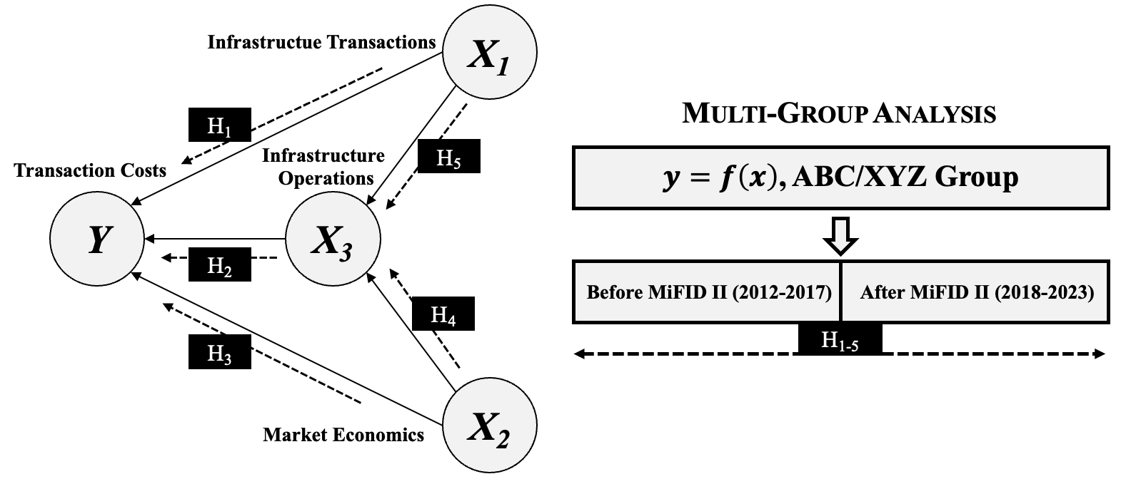

Fig. 1 The Theoretical Research – TCE-FMI-Model

The dependent variable in this study is Transaction Costs incurred by financial market participants, approximated through the revenue streams of stock exchange organizations that operate financial market infrastructures.
The independent variables are categorized into three main constructs:
- Infrastructure Transactions – This construct captures transactional activity within the infrastructure, including trade volumes and turnover from both electronic order book (EOB) and off-order book trading. It reflects the intensity and structure of trading within the regulated market environment.
- Market Economics – This variable reflects the broader economic context in which stock exchanges function. It includes metrics such as the number of listed financial instruments and overall market capitalization, indicating the extent to which regulated financial infrastructures are utilized by issuers and investors.
- Infrastructure Operations – This third construct represents the internal cost structures that influence transaction costs. It includes operational expense categories such as personnel costs (including headcount), other operating expenditures, depreciation, and amortization – capturing the efficiency and resource intensity of infrastructure provision.
Together, these variables enable a holistic analysis of the factors influencing transaction costs and provide insight into how they relate to the market positioning and competitive performance of stock exchange organizations.

3. results and discussion

3.1 Explanatory power

The interpretation of the structural model results from the Partial Least Squares Structural Equation Modeling (PLS-SEM) is guided by the model's explanatory power, the strength of inter-variable relationships, and the reliability of the measurement indicators.

Prior to the implementation of MiFID II, the R² value for the latent construct transaction costs is 0.960, indicating that 96.0% of its variance is accounted for by the predictors: infrastructure operations, infrastructure transactions, and market economics. This demonstrates an exceptionally high level of explanatory power, suggesting that the model comprehensively captures the key determinants influencing transaction costs within financial market infrastructures.
Similarly, the R² for infrastructure operations before MiFID II stands at 0.933, meaning that 93.3% of its variance is explained by the constructs of infrastructure transactions and market economics. This value represents a robust explanatory level, reflecting the significant role of these factors in shaping infrastructure-related cost structures.
Following the introduction of MiFID II, the explanatory power of the model remains strong. The R² value for transaction costs is 0.990, indicating that 99.0% of the variance is still explained by the same set of independent constructs, with an increased strength. For infrastructure operations, the R² reaches 0.778, meaning 77.8% of the variation can be attributed to infrastructure transactions and market economics after the regulatory shift.
Taken together, these results confirm the model’s ability to capture the core dynamics of transaction cost formation both before and after MiFID II. While the explanatory power for transaction costs increases post-MiFID II (from 0.960 to 0.990), the R² for infrastructure operations decreases slightly (from 0.933 to 0.778). This divergence may reflect evolving cost structures or shifts in reporting and operational focus within financial market infrastructures due to regulatory changes.

3.2 Relationship Between Variable Constructs (Pre-MiFID II)

The structural relationships between the latent variables are quantified through standardized path coefficients, which indicate both the strength and direction of influence among the constructs in the pre-MiFID II period.

A strong positive association is observed between infrastructure transactions and infrastructure operations, with a path coefficient of 0.792. This indicates that greater trading activity – captured by EOB and off-EOB transactions, trading days, and turnover – is associated with increased operational demands, such as higher personnel costs, other operating expenses, and depreciation.
In contrast, the relationship between infrastructure operations and transaction costs is negative but weak, as reflected in a path coefficient of -0.142. This suggests that, during the pre-regulatory period, higher operational expenses did not significantly translate into increased revenues from transaction-based services. The statistical insignificance of this path points to a possible decoupling between internal cost structures and transaction costs for market participants.
The path coefficient linking market economics to transaction costs is 0.084, indicating a very weak direct effect. This suggests that macro-level indicators such as market capitalization and the number of listed companies (domestic, foreign, and total) had limited direct influence on the cost burden faced by financial market participants.
A moderate positive relationship is identified between market economics and infrastructure operations, with a path coefficient of 0.267. This implies that more extensive listings and higher market capitalization were associated with increased operational complexity and cost, possibly due to broader service demands and infrastructure maintenance.
Notably, the relationship between infrastructure transactions and transaction costs is very strong, with a path coefficient of 1.065. This unusually high value suggests that increased trading activity strongly influenced revenue-generation tied to transaction services. It may also indicate that cost-per-transaction efficiencies (i.e., economies of scale) were not realized in this period, leading to higher total transaction costs alongside volume growth.
Collectively, these results highlight the differentiated roles of transaction volume, market structure, and internal operations in shaping cost dynamics. They also suggest that, prior to MiFID II, transaction activity was the primary driver of cost-related revenue, while infrastructure operations had a limited direct impact. These interrelationships are illustrated in Figure 2, representing the PLS-SEM multigroup model for the pre-MiFID II period.

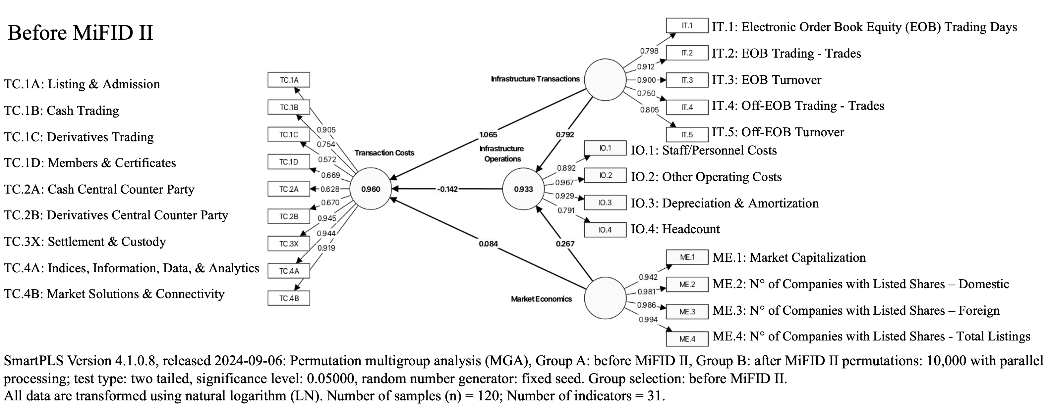
Fig. 2 Transaction Cost Analysis Before – Multi-Group-Analysis (Pre-MiFID II)

3.3 Relationship Between Variable Constructs (Post-MiFID II)

A strong and positive relationship remains between infrastructure transactions and infrastructure operations, reflected in a path coefficient of 0.654. This implies that increased trading activity – measured by trading days, turnover, and volumes across both EOB and off-EOB markets – continues to drive operational cost requirements, including staffing, operating expenses, and asset depreciation.
However, the relationship between infrastructure operations and transaction costs undergoes a marked change. The path coefficient of 0.850 signals a very strong and statistically significant direct effect, suggesting that rising operational expenses now translate more directly into revenue generating transaction costs. This shift reflects a tighter coupling between infrastructure cost structures and transaction costs for market participants, possibly due to enhanced transparency and cost allocation mandates.
Conversely, market economics – captured through market capitalization and the number of listed companies – exert virtually no direct effect on transaction costs, as indicated by a path coefficient of -0.001. This near-zero value confirms that broader economic indicators have minimal direct influence on transactional cost outcomes in the post-regulatory environment.
A moderate positive relationship is observed between market economics and infrastructure operations, with a path coefficient of 0.333. This suggests that expanding listings and increased market capitalization contribute to operational complexity and cost, possibly through increased demand for market infrastructure services.
Notably, the direct relationship between infrastructure transactions and transaction costs weakens considerably. The path coefficient of 0.168 indicates only a marginal effect, implying that rising trading volumes no longer drive transaction costs as significantly as before. This may point to the emergence of economies of scale or improved operational efficiencies introduced through post-MiFID II reforms.
Taken together, the results suggest a shift in cost dynamics after regulatory implementation: infrastructure operations have become the dominant determinant of transaction costs, while the influence of market activity has diminished. These revised interdependencies are illustrated in Figure 3, which depicts the multigroup PLS-SEM model for the post-MiFID II period.

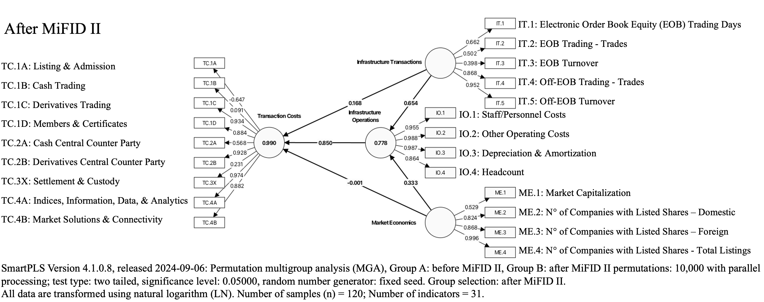
Fig. 3 Transaction Cost Analysis Before – Multi-Group-Analysis (Post-MiFID II)

3.4 Permutation Multi-Group-Analysis (MGA) Path Coefficients with Permutation P-Value with Summary of Sub Hypotheses-Test Conclusion

Table 1 summarizes the comparison between pre- and post-MiFID II phases.
Table 1 Permutation Multi-Group-Analysis Pre- vs. Post-MiFID II

When comparing the path coefficients between infrastructure transactions and transaction costs, the results led to a substantial decrease from 1.065 (before MiFID II) to 0.168 (after MiFID II) with a statistically significant permutation P-value of 0.000. Therefore, hypothesis H₁ is preliminary supported and confirmed that the introduction of MiFID II has ultimately led to a significant reduction in the transaction costs of the financial markets operated by stock exchange organizations for market participants, with the aim of increasing competitive advantages and scalability of the regulated European financial markets infrastructures.
There is also a large difference in the path coefficients between infrastructure operations and transaction costs before MiFID II came into force, -0.142 compared to 0.850 under MiFID II. In addition, the permutation P-value for this large difference is statistically significant < 0.05 with the value of 0.000. This means that the relationship between these variable constructs has increased significantly, suggesting that infrastructure operations have had a greater impact on transaction costs due to factors such as additional regulatory compliance, reporting requirements, and operational complexity. The results suggest that the impact of infrastructure operations on transaction costs will be much stronger after MiFID II comes into force. These empirical test results provide evidence and preliminary supports hypotheses H₂.
The influence of MiFID II on the direct relationship between market economics and transaction costs leads to a reduction in the path coefficient of 0.085 with a statistically insignificant permutation P-value of 0.239. In accordance with these empirical test results, the direct influence of market economics on the optimization of transaction costs according to hypothesis H₃ is not supported.
The impact of MiFID II enforcement between market economics relationship on infrastructure operation measures a relative similar path coefficient with an original difference of only 0.067 accompanied by a permutation P-value of 0.450 which is not statistically significant, hence hypothesis H₄ is not supported for this construct. This means that the increase of infrastructure operations due to higher market capitalization and more listings is confirmed but not statistically significant. Such results imply that the increase in infrastructure operations does not lead to more efforts and capacity requirements due to the higher market capitalization and more listings.
Finally, the path coefficient between the infrastructure transaction and its relationship to infrastructure operations measures an initial difference of 0.138 between the periods prior to MiFID II (0.792) and after MiFID II (0.654) came into force, indicating a decline with a slightly insignificant permutation P-value of 0.058. This means that the objective of MiFID II to in-crease the competitive advantages of European financial market infrastructures, measured against this empirical construct, does not support the H₅ hypothesis.
Table 2 provides a summary of hypotheses test conclusions.
Table 2 Summary of Hypotheses Test Conclusion

3.5 Limitations

One limitation of the study arises from the anonymization of data, which was essential to meet ethical requirements and protect confidentiality. However, replacing the names of actual institutions with coded identifiers may reduce the contextual richness of the analysis and limit the extent to which the results can be generalized to specific organizational settings.

4. Conclusion

From a theoretical perspective, this study extends the application of Transaction Cost Economics (TCE) to the field of financial market infrastructures by integrating institutional regulation – specifically MiFIR/MiFID II – as an exogenous factor influencing cost structures. The empirical findings demonstrate how regulatory reforms reshape the relationships between transaction costs, infrastructure operations, infrastructure transactions because of trading activity, and market economics over time, thereby offering a novel contribution to longitudinal PLS-SEM research in economics and finance. The study also refines the understanding of cost drivers in highly regulated, network-based financial market structures and offers a replicable model for future structural analyses.
In practical terms – exclusively within the academic domain – this research provides a validated empirical framework (TCE-FMI model) that scholars can apply, test, or adapt in comparative studies across jurisdictions, regulatory regimes, or market typologies. The study intentionally refrains from offering normative recommendations to regulators, financial institutions, or market operators, in order to maintain scientific neutrality and avoid potential conflicts of interest. Instead, its value lies in contributing to evidence-based academic discourse on how institutional rules shape economic behavior in complex financial market environments.
This study offers a comprehensive empirical assessment of how the implementation of MiFID II and MiFIR has reshaped the cost structures and strategic positioning of stock exchange organizations operating financial market infrastructures within Europe. By applying a Partial Least Squares Structural Equation Modeling (PLS-SEM) multigroup analysis, the research identifies key shifts in the relationships between infrastructure transactions, infrastructure operations, market economics, and transaction costs before and after the regulatory reforms.
The findings demonstrate that MiFID II has significantly altered the cost dynamics within financial market infrastructures. Most notably, infrastructure operations have emerged as the dominant driver of transaction costs post-regulation, suggesting a closer alignment between internal cost structures and financial market infrastructure services. Conversely, the previously strong link between trading activity and transaction costs has diminished considerably, indicating the onset of economies of scale and improved operational efficiency in the post-regulatory environment. The effect of macro-level market economics, such as listings and market capitalization, remains limited in directly shaping transaction costs, although it continues to influence operational complexity.
Through statistically significant permutation-based group comparisons, the study provides evidence that preliminary supports hypotheses H₁ and H₂, and does not support H₃, H₄ and H₅. These results highlight the differentiated impact of MiFID II on the structural relationships within European financial market infrastructures, particularly emphasizing how regulatory frameworks can influence both cost optimization and competitive positioning.
From a theoretical perspective, the study contributes to Transaction Cost Economics (TCE) by empirically validating how institutional and regulatory shifts affect cost structures and governance mechanisms in complex financial market ecosystems. The results support the view that regulation not only constrains but can also enable competitive advantage when financial market infrastructures respond with strategic operational alignment. The findings underscore the importance of aligning infrastructure investment, operational capabilities, and regulatory compliance to ensure cost efficiency and long-term competitiveness.
Future research could expand upon this study by integrating case-specific qualitative data to explore institutional differences in greater depth. Additionally, analyzing the impact of emerging technologies such as AI and cloud infrastructure in the context of evolving regulatory requirements may yield further insights into the transformation of financial market infrastructures across Europe.

disclaimer (data usage and research intent)

The author hereby declares that the research presented in this document is based exclusively on publicly available data, including audited financial reports, trading statistics, and industry association reports. The use of this data serves solely to contribute to the academic body of knowledge and does not aim to derive any business-related insights or conclusions.
The author assumes no responsibility for the accuracy or correctness of the data, as the research relies entirely on publicly accessible information. Furthermore, the study was conducted independently by the author, without external funding, third-party validation, or the application of the four-eyes principle.
disclaimer (financial instrument projections)

Any references to theoretical profits or financial developments in this document are based solely on historical data and past performance. It is important to acknowledge that past performance does not guarantee future results. Neither the author nor any referenced financial service providers assume responsibility for future developments in financial instruments or market conditions, as these are inherently subject to change and uncertainty.
disclaimer (Artificial Intelligence)

The author hereby declares that generative AI technologies were utilized in the writing and editing of this manuscript to enhance grammar, sentence structure, and overall clarity. Specifically, ChatGPT-4 (OpenAI) was employed for linguistic refinement, sentence restructuring, and improving coherence. AI-assisted revisions were guided by targeted prompts requesting rewriting, summarization, and clarity enhancements for specific sections.

References

Benston, G. J., & Smith, C. W. (1976). A Transactions Cost Approach to the Theory of Financial Intermediation. The Journal of Finance, 31(2), 215-231. https://doi.org/10.2307/2326596
Bitz, M. (2007). Banken und Börsen/Banking and Stock Markets - KE 3: „Wertpapierbörsen: Funktionen und institutionelle Rahmenbedingungen“ (Vol. 3). FernUniversität in Hagen - Lehrstuhl für Bank- und Finanzwirtschaft. https://d-nb.info/987173774
COMMISSION-DELEGATED-REGULATION-(EU)-2017/567. (2017). COMMISSION DELEGATED REGULATION (EU) 2017/567 of 18 May 2016 supplementing Regulation (EU) No 600/2014 of the European Parliament and of the Council with regard to definitions, transparency, portfolio compression and supervisory measures on product intervention and positions. THE EUROPEAN PARLIAMENT AND THE COUNCIL OF THE EUROPEAN UNION. Retrieved 21. September 2023 from https://eur-lex.europa.eu/legal-content/EN/TXT/PDF/?uri=CELEX:32017R0567
Commons, J. R. (1931). Institutional Economics. History of Economic Thought Articles, 21, 648-657. https://EconPapers.repec.org/RePEc:hay:hetart:commons1931
Dugger, W. M. (1983). The Transaction Cost Analysis of Oliver E. Williamson: A New Synthesis? Journal of Economic Issues, 17(1), 95-114. http://www.jstor.org.datubazes.lanet.lv/stable/4225277
Francioni, R. (2017). An Exchange and Its Value Chain. In R. Francioni & R. A. Schwartz (Eds.), Equity Markets in Transition: The Value Chain, Price Discovery, Regulation, and Beyond (pp. 15-69). Springer International Publishing. https://doi.org/10.1007/978-3-319-45848-9_2
Francioni, R., Freis, J. H., & Hachmeister, A. (2017). Financial Market Regulation. In R. Francioni & R. A. Schwartz (Eds.), Equity Markets in Transition: The Value Chain, Price Discovery, Regulation, and Beyond (pp. 239-286). Springer International Publishing. https://doi.org/10.1007/978-3-319-45848-9_9
Geranio, M. (2018). Evolution of the Exchange Industry - From Dealers’ Clubs to Multinational Companies. Springer Cham, Springer International Publishing Switzerland 2016. https://doi.org/https://doi-org.datubazes.lanet.lv/10.1007/978-3-319-21027-8
Ghosh, I., Chaudhuri, T. D., Alfaro-Cortés, E., Gámez, M., & García, N. (2022). A hybrid approach to forecasting futures prices with simultaneous consideration of optimality in ensemble feature selection and advanced artificial intelligence. Technological Forecasting and Social Change, 181, 121757. https://doi.org/https://doi.org/10.1016/j.techfore.2022.121757
Kun, E. (2024). Challenges in regulating cloud service providers in EU financial regulation: From operational to systemic risks, and examining challenges of the new oversight regime for critical cloud service providers under the Digital Operational Resilience Act. Computer Law & Security Review, 52, 105931. https://doi.org/https://doi.org/10.1016/j.clsr.2023.105931
Laudenbach, H. (2025a). Digital Transformation and Transaction Cost Drivers in European Financial Market Infrastructures: A Systematic Literature Review. Journal of Economics, Management and Trade, 31(9), 66–101. https://doi.org/https://doi.org/10.9734/jemt/2025/v31i91351
Laudenbach, H. (2025b). Transaction Cost Economics in European Financial Markets: A PLS-SEM Analysis
(2012–2023). Journal of Economics, Management and Trade, 31(10), 1-11. https://doi.org/https://doi.org/10.9734/jemt/2025/v31i101358.
Marjosola, H. (2019). The problem of regulatory arbitrage: A transaction cost economics perspective. Regulation & Governance, 15. https://doi.org/10.1111/rego.12287
North, D. C. (1992). Transaction costs, institutions, and economic performance. ICS Press San Francisco, CA. https://pdf.usaid.gov/pdf_docs/pnabm255.pdf
Schmidt, H. (1983). Marktorganisationsbestimmte Kosten und Transaktionskosten als börsenpolitische Kategorien — Grundsätzliche Überlegungen zur Weiterentwicklung des Anlegerschutzes aus ökonomischer Sicht. 16(2), 184-204. https://doi.org/10.3790/ccm.16.2.184 (Credit and Capital Markets – Kredit und Kapital)
Tchuente, D., Lonlac, J., & Kamsu-Foguem, B. (2024). A methodological and theoretical framework for implementing explainable artificial intelligence (XAI) in business applications [Article]. Computers in Industry, 155, Article 104044. https://doi.org/10.1016/j.compind.2023.104044
Williamson, O. E. (1979). Transaction-Cost Economics: The Governance of Contractual Relations. The Journal of Law & Economics, 22(2), 233-261. http://www.jstor.org.datubazes.lanet.lv/stable/725118
Williamson, O. E. (1981). The Modern Corporation: Origins, Evolution, Attributes. Journal of Economic Literature, 19(4), 1537-1568. http://www.jstor.org.datubazes.lanet.lv/stable/2724566
Williamson, O. E. (2010). Transaction Cost Economics: The Natural Progression. The American Economic Review, 100(3), 673-690. http://www.jstor.org.datubazes.lanet.lv/stable/27871227

Francioni, Freis and Hachmeister (2017), pp. 239-259
Francioni (2017), p. 11; Geranio (2018), pp. 15, 22-23, 27-28, 35-51
Kun (2024), pp. 14-15
Tchuente, Lonlac and Kamsu-Foguem (2024), p. 9; Ghosh, Chaudhuri, Alfaro-Cortés, Gámez and García (2022).
Bitz (2007), pp. 7-28; Williamson (1981), pp. 1537-1538; 1543-1551; Schmidt (1983), p. 187; Francioni (2017), pp. 15-70
COMMISSION-DELEGATED-REGULATION-(EU)-2017/567 (2017)
Williamson (1979), pp. 234-254, 259; Dugger (1983), pp. 96-99; Williamson (1981), pp. 1544-1548, 1562-1565; Francioni (2017), pp. 15-17
Commons (1931), pp. 648-657
Williamson (2010), pp. 673, 686; North (1992), pp. 7-8
Schmidt (1983), p. 187; Bitz (2007), pp. 2-4, 8-9
Laudenbach (2025b); Marjosola (2019)
Laudenbach (2025a)
Francioni (2017), p. 64; Benston and Smith (1976), pp. 228-229; Geranio (2018), p. 99
Laudenbach (2025b)
Authors own figure based on Laudenbach (2025b)
Authors own figure
Authors own figure
Authors own figure
Authors own figure

