Performance Evaluation of Developed Power Operated Groundnut Thresher

Abstract:
Groundnut is the major oilseed crop in India, and it plays a major role in bridging the Vegetable oil deficit in the country. Groundnuts in India are available throughout the year due to a two-crop cycle, harvested in March and October. This paper aims to perform an evaluation of the developed power-operated groundnut thresher. The prototype was conceived and fabricated through a collaborative effort between the S.V. College of Agricultural Engineering and Technology and Research Station, Indira Gandhi Krishi Vishwavidyalaya (IGKV). The design process involved detailed analysis of the mechanical requirements for effective threshing, material selection for major components and dimensional optimisation to achieve efficient separation with minimal grain loss or damage. The results show that cylinder speed had the most pronounced effect on threshing efficiency, followed by concave clearance and feed rate. At the lowest cylinder speed (23.5 m/s), the threshing efficiency ranged from 97.00% to 99.10%. An increase in cylinder speed to 27.5 m/s improved threshing efficiency to a range of 98.30% to 99.40%, while the highest cylinder speed of 31.5 m/s yielded the best performance, with efficiencies ranging from 98.80% to 99.70%. Overall, the maximum threshing efficiency (99.70%) was achieved at 31.5 m/s cylinder speed, 15 mm concave clearance, and 7800 kg/h feed rate. This combination provided the optimal balance between impact intensity, contact area, and material flow. Therefore, fine-tuning airflow and drum speed parameters is essential to achieve a balance between high cleaning efficiency and minimal pod loss, ensuring efficient and economical groundnut threshing performance.
Keywords: dimensional optimization, Groundnut Thresher, groundnut pods, groundnut cultivation

Introduction
India remains an agriculture-based country. Over the last 50 years, significant changes have transformed the agricultural sector, leading to the establishment of new agro-based industries and the discovery of new plant varieties and species. In our country, the majority of the population relies on the agricultural sector for their livelihood. In India, groundnut is a key product, often harvested in abundant quantities. However, the traditional method of separating groundnut pods is time-consuming, resulting in significant time waste. On average, separating one kilogram of groundnut pods using this old method requires approximately 1 to 2 hours (Khaerat et al., 2020). Groundnut is the major oil seed crop in India and it plays a major role in bridging the Vegetable oil deficit in the country. Groundnuts in India are available throughout the year due to a two-crop cycle harvested in March and October. Groundnuts are important protein crops in India grown mostly under rain-fed conditions (Rajasekar et al., 2017). India leads the world in production, second only to China, with an area of more than 70 lakh hectares and an output of 80 to 85 lakh million tons (Srinivasa et al., 2022).
Although mechanization has been introduced for groundnut planting and digging, threshing operations in India remain largely manual, requiring approximately 160–200 man-hours per hectare (Singh et al., 2009; Reddy et al., 2013; Dewangan et al., 2025). This manual process is recognized as highly labor-intensive and physically demanding (Naik et al., 2010). In regions such as Chhattisgarh, traditional emphasis on paddy cultivation has limited the adoption of groundnut farming; however, recent trends indicate a gradual increase in groundnut production across several districts. Despite this growth, small-scale farmers often face economic and operational challenges, as groundnut cultivation and post-harvest handling demand more time and resources than paddy (Dewangan et al., 2025).
Threshing is a crucial post-harvest operation that significantly influences both the quantity and quality of produce. The lack of affordable and efficient threshing machinery in rural areas contributes to high labor requirements and post-harvest losses, underscoring the need for power-operated groundnut threshers. Singh et al. (2009) evaluated the effects of three operational parameters-feed rate (600, 800 and 1,000 kg/h), cylinder peripheral speed (5.8, 6.4 and 7.1 m/s), and concave clearance (30, 36 and 42 mm) on the performance of a groundnut thresher but peripheral speed of threshing cylinder was taken up to 34 m/s (Spokar et al. 2008). Performance indicators such as threshing efficiency, cleaning efficiency, output capacity, and pod loss were measured using 30 second sample collections from all machine outlets. The study also characterized groundnut pod properties, reporting an average arithmetic mean diameter of 17.77 mm, a geometric mean diameter of 16.39 mm, sphericity of 0.58, bulk density of 246.45 kg/m³, true density of 438.79 kg/m³, and an angle of repose of 26.73°. Rupture forces were found to be 31.24 N (longitudinal) and 245.41 N (vertical). These engineering properties are essential for designing efficient post-harvest threshing systems aimed at minimizing losses and enhancing productivity (Dewangan et al., 2025). The groundnut legume is presented in Fig. 1.
Materials and Methods
To investigate the influence of various operational and design parameters on the performance of a groundnut thresher, an experimental setup and a full-scale prototype were designed, developed and evaluated under controlled laboratory conditions. The primary aim of this study was to analyze the combined effect of different threshing cylinder speeds, feed rates and concave clearances on the threshing efficiency, cleaning efficiency, pod breakage and blown pod percentage.
Design and Fabrication of the Prototype
The prototype thresher was formulated and fabricated through a mutual effort between the S.V. College of Agricultural Engineering and Technology and Research Station, Indira Gandhi Krishi Vishwavidyalaya (IGKV), Raipur and M/s Chandrakar Agrinext, Durg. The design process involved detailed analysis of the mechanical requirements for effective threshing, material selection for major components and dimensional optimization to achieve efficient separation with minimal grain loss or damage.
The developed machine comprised four major functional units: the threshing drum, concave unit, feeding unit, and cleaning unit.
Threshing Drum: This is the main component responsible for detaching pods from the groundnut vines. It was designed to operate at variable peripheral speeds, allowing for testing at different energy inputs and impact intensities.
Concave Unit: Positioned below the drum, the concave provides the surface against which the pods are threshed. The clearance between the drum and the concave is adjustable, enabling experimentation with three different gap settings (15 mm, 20 mm and 25 mm).
Feeding Unit: This system ensures uniform feeding of the harvested crop into the threshing cylinder. A consistent and controlled feed rate is critical to maintain steady performance and to prevent overloading or under-threshing.
Cleaning Unit: The cleaning mechanism was integrated to separate the threshed pods from lighter impurities such as husk, leaves, and dust. This ensured that the cleaning efficiency could be properly evaluated during testing.
The frame and supporting structures of the machine were fabricated to ensure mechanical stability, while moving parts were machined to precise tolerances. All rotating shafts were dynamically balanced to minimize vibration during operation. Fig. 2 is showing view of developed groundnut thresher.
Experimental Variables and Parameters
To analyze the machine’s performance, three independent variables were selected based on prior research and preliminary trials. These included:
Threshing cylinder peripheral speed: 23.5 m/s, 27.5 m/s and 31.5 m/s
Feed rate: 7700 kg/h, 7800 kg/h and 7900 kg/h
Concave clearance: 15 mm, 20 mm and 25 mm
The selection of these parameters was guided by their known influence on threshing behavior. Cylinder speed directly affects the impact force applied to the pods, which determines the degree of detachment as well as the risk of breakage. Feed rate influences the load on the cylinder and cleaning section, while concave clearance affects the interaction between pods and threshing elements. The dependent variables used to assess performance were: threshing efficiency (%), broken pod percentage (%), cleaning efficiency (%) and blown pod percentage (%). These output parameters collectively provide a comprehensive evaluation of threshing quality and overall machine effectiveness.
Results and Discussion
This preliminary investigation presented evaluation and performance of a high-performance groundnut thresher with various operational factors, concave clearance, material feed rate and the threshing cylinder peripheral speed are identified as the most significant parameters determining the machine’s overall performance. Field test of groundnut thresher is presented in Fig. 3 and by systematically experimenting with these variables, the best combination can be found, guaranteeing maximum threshing efficiency through efficient pod separation from vines, minimizing the percentage of broken pods, lowering blown losses, and improving the machine's overall energy efficiency.
Interactive Effect of Concave Clearance, Feed Rate and Cylinder Speed on Threshing Efficiency
The combined effect of concave clearance feed rate and cylinder speed on threshing efficiency of the groundnut thresher is presented in Table 1. The threshing efficiency of the machine varied significantly with changes in these operational parameters, as indicated by the interaction effect (CC×FR×CS), which was found to be statistically significant at a 5% probability level (C.D. = 0.129). Across all treatments, the threshing efficiency ranged between 97.00% and 99.70%, indicating that the developed thresher performed efficiently under the tested conditions. The results show that cylinder speed had the most pronounced effect on threshing efficiency, followed by concave clearance and feed rate. At the lowest cylinder speed (23.5 m/s), the threshing efficiency ranged from 97.00% to 99.10%. An increase in cylinder speed to 27.5 m/s improved threshing efficiency to a range of 98.30% to 99.40%, while the highest cylinder speed of 31.5 m/s yielded the best performance, with efficiencies ranging from 98.80% to 99.70%. The improvement in threshing efficiency with increasing cylinder speed may be attributed to the higher impact and rubbing action of the threshing elements, which resulted in more effective detachment of pods from the vines. Similar trends were reported by Singh et al. (2009) and Naik et al. (2010), who observed that increased peripheral speed enhances threshing action up to an optimal limit. The effect of concave clearance was also noticeable. The smallest concave clearance (15 mm) consistently produced higher threshing efficiency across all feed rates and cylinder speeds, ranging from 98.50% to 99.70%. This could be due to increased contact between the threshing drum and the pods, facilitating complete threshing. However, further reduction in concave clearance beyond this level could potentially increase pod breakage, which must be considered during optimization. The intermediate clearance (20 mm) resulted in slightly lower efficiency values (98.31%–99.50%), while the widest clearance (25 mm) produced the lowest efficiencies (97.00%–99.20%), possibly due to insufficient contact and ineffective separation. The feed rate had a comparatively minor but consistent influence on threshing efficiency. At all levels of concave clearance and cylinder speed, the efficiency was marginally higher at 7800 kg/h, followed by 7700 kg/h and 7900 kg/h. The slight reduction in efficiency at higher feed rates can be attributed to overloading of the threshing cylinder, which limits effective impact on all pods.
Overall, the maximum threshing efficiency (99.70%) was achieved at 31.5 m/s cylinder speed, 15 mm concave clearance, and 7800 kg/h feed rate. This combination provided the optimal balance between impact intensity, contact area, and material flow. The results clearly demonstrate that threshing efficiency improves with an increase in cylinder speed and a reduction in concave clearance up to the optimal threshold. These findings suggest that for efficient threshing performance with minimal loss, the groundnut thresher should ideally operate at a cylinder speed of 31.5 m/s, concave clearance of 15 mm, and feed rate of 7800 kg/h. Beyond these conditions, further increases in speed or feed rate may not yield significant gains and could adversely affect pod integrity.
Interactive effect of concave clearance, feed rate and cylinder speed on cleaning efficiency
The interactive effect of concave clearance, feed rate and cylinder speed on the cleaning efficiency of the groundnut thresher is presented in Table 2. Cleaning efficiency represents the effectiveness of the cleaning mechanism in separating pods from unwanted materials such as dust, husk and small stalk pieces.
The results reveal that cleaning efficiency was significantly influenced by variations in cylinder speed, concave clearance, and feed rate. The highest cleaning efficiency of 98.40% was observed at a cylinder speed of 31.5 m/s, concave clearance of 15 mm (CC1) and a feed rate of 7700 kg/h. This combination provided optimum airflow and adequate separation time, resulting in efficient removal of impurities. Conversely, the lowest cleaning efficiency of 95.40% was recorded at the lowest cylinder speed (23.5 m/s), the highest concave clearance (25 mm), and the highest feed rate (7900 kg/h).
An increase in cylinder speed from 23.5 m/s to 31.5 m/s led to a gradual rise in cleaning efficiency across all feed rates and concave clearances. This trend can be attributed to the enhanced centrifugal force and improved airflow generated at higher drum speeds, which promoted effective separation of pods from light chaff and debris. However, beyond the optimum speed, a marginal decline was noticed at higher feed rates, possibly due to overloading of the cleaning unit. Cleaning efficiency decreased slightly with increasing concave clearance and feed rate. Larger concave clearances reduced the impact and agitation required for effective separation, while higher feed rates increased the material load on the sieve and blower, reducing cleaning precision. These results indicate that maintaining a moderate feed rate (7700–7800 kg/h), narrow concave clearance (15–20 mm), and high cylinder speed (31.5 m/s) ensures superior cleaning efficiency. The results corroborate the findings of Pralhad (2007), Parmanand and Verma (2015), Humphred (2017), Aboegela et al. (2021) and Dewangan et al. (2025).
Interactive effect of concave clearance, feed rate and cylinder speed on broken pod
The interactive effects of concave clearance, feed rate, and cylinder speed on the broken pod percentage of the groundnut thresher are presented in Table 3. Broken pod percentage is a crucial performance indicator, as excessive breakage during threshing leads to post-harvest losses and reduced market value of the produce.
The results clearly show that the percentage of broken pods increased with an increase in cylinder speed and a decrease in concave clearance. The highest broken pod percentage of 2.60% was recorded at a cylinder speed of 31.5 m/s, feed rate of 7700 kg/h, and concave clearance of 15 mm (CC1). In contrast, the lowest broken pod percentage of 0.70% was obtained at the lowest cylinder speed (23.5 m/s), highest concave clearance (25 mm), and feed rate of 7900 kg/h. This trend indicates that higher cylinder speeds intensify the impact and rubbing action between the threshing elements and pods, resulting in more mechanical damage. Similarly, smaller concave clearances cause the pods to be compressed more tightly between the cylinder and concave, further increasing the likelihood of breakage. Conversely, at higher concave clearances (20–25 mm), the contact between the pods and threshing drum is more moderate, leading to reduced damage. Feed rate also exhibited a noticeable influence. As feed rate increased from 7700 kg/h to 7900 kg/h, the percentage of broken pods consistently decreased across all treatments. This may be attributed to the cushioning effect of additional material within the threshing unit, which minimizes the direct impact on individual pods and reduces mechanical stress. The interaction between the three factors (CC×FR×CS) was statistically significant, indicating that the combined variation in cylinder speed, feed rate, and concave clearance plays a critical role in determining pod damage levels.
Overall, the results suggest that to minimize pod breakage, the thresher should be operated at lower cylinder speeds (23.5–27.5 m/s), moderate feed rates (7800–7900 kg/h), and wider concave clearances (20–25 mm). Similar observations were reported by Singhal and Thierstein (1987), Asokan (1997), Sudjan et al. (2002), Dogra et al. (2014) and Patel et al. (2025), which found that excessive speed and reduced concave spacing increase mechanical injury to groundnut pods. Hence, proper adjustment of operational parameters is essential for achieving a balance between high threshing efficiency and minimal pod breakage, ensuring both productivity and product quality.
Interactive effect of concave clearance, feed rate and cylinder speed on blown pod
The interactive effects of concave clearance, feed rate, and cylinder speed on blown pod percentage are presented in Table 4. Blown pod percentage represents the proportion of threshed pods that are carried away with chaff and light impurities by the blower due to excessive airflow or inadequate separation control. Minimizing blown pods is vital for reducing threshing losses and improving overall machine efficiency.
The results indicate that the blown pod percentage increased with an increase in cylinder speed and a decrease in concave clearance. The highest blown pod percentage (2.05%) was observed at a cylinder speed of 31.5 m/s, concave clearance of 15 mm (CC1), and feed rate of 7700 kg/h. Conversely, the lowest blown pod percentage (0.06%) was recorded at the lowest cylinder speed (23.5 m/s), highest concave clearance (25 mm) and highest feed rate (7900 kg/h). At higher cylinder speeds, the threshing drum generates a stronger airflow and imparts greater kinetic energy to the pods, which often results in lighter pods being expelled along with the chaff. Similarly, a smaller concave clearance increases the rubbing action and turbulence inside the threshing unit, contributing to the unintentional blowing of pods during cleaning. Feed rate also exhibited a significant effect on blown pod losses. As the feed rate increased from 7700 kg/h to 7900 kg/h, a steady decrease in blown pod percentage was observed. This reduction may be attributed to the greater mass of material passing through the blower, which reduces the relative intensity of airflow per unit weight of pods, thus preventing excessive expulsion. The interaction among the three factors (CC×FR×CS) was found to be statistically significant, suggesting that the combined influence of operational parameters plays a key role in determining pod losses during cleaning. Overall, the results show that maintaining moderate cylinder speed (23.5–27.5 m/s), wider concave clearance (20–25 mm), and higher feed rates (7800–7900 kg/h) minimizes blown pod percentage while maintaining acceptable cleaning performance. Similar finding were also observed by Dhananchezhiyan et al. (2013), reported that excessive airflow and drum speed contribute to pod loss during threshing and cleaning operations. Therefore, fine-tuning airflow and drum speed parameters is essential to achieve a balance between high cleaning efficiency and minimal pod loss, ensuring efficient and economical groundnut threshing performance.
Conclusion
Threshing is a crucial post-harvest operation that significantly influences both the quantity and quality of produce. The lack of affordable and efficient threshing machinery in rural areas contributes to high labor requirements and post-harvest losses, underscoring the need for power-operated groundnut threshers. Fine-tuning airflow and drum speed parameters is essential to achieve a balance between high cleaning efficiency and minimal pod loss, ensuring efficient and economical groundnut threshing performance. The study aims to reduce the time consumption and reduce losses by the using of groundnut thresher and it is also increase the farm mechanization.

Disclaimer (Artificial intelligence)
Option 1:
Author(s) hereby declare that NO generative AI technologies such as Large Language Models (ChatGPT, COPILOT, etc.) and text-to-image generators have been used during the writing or editing of this manuscript.

Acknowledgements
The authors acknowledge the financial support of AICRP-FIM and thank the Department of Farm Machinery and Power Engineering at SV College and M/s Chandrakar Agrinext, Durg, for providing facilities for fabricating the high-capacity groundnut thresher.
Table 1: Interactive effect of concave clearance, feed rate and cylinder speed on threshing efficiency, %
Cylinder speed, (m/s) ⇓ | Threshing efficiency, %
Cylinder speed, (m/s) ⇓ | Concave clearance- 1 (15 mm) |  |  | Concave clearance - 2 (20 mm) |  |  | Concave clearance - 3 (25 mm)
Cylinder speed, (m/s) ⇓ | Feed rate, (kg/h)
Cylinder speed, (m/s) ⇓ | 7700 | 7800 | 7900 | 7700 | 7800 | 7900 | 7700 | 7800 |  |  |  | 7900
CS (23.5 m/s) | 98.70 | 99.10 | 98.50 | 98.31 | 99.01 | 98.50 | 97.60 | 98.70 |  |  |  | 97.00
CS (27.5 m/s) | 99.10 | 99.40 | 99.21 | 98.80 | 99.30 | 99.11 | 98.30 | 98.90 |  |  |  | 98.50
CS (31.5 m/s) | 99.50 | 99.70 | 99.60 | 99.31 | 99.50 | 99.40 | 98.80 | 99.20 |  |  |  | 99.00
Factor |  | C.D. |  | SE_{d} |  | SE_{m}
Factor (CC) |  | 0.043 |  | 0.021 |  | 0.015
Factor (FR) |  | 0.043 |  | 0.021 |  | 0.015
Factor (CS) |  | 0.043 |  | 0.021 |  | 0.015
Factor (CC × FR×CS) |  | 0.129 |  | 0.044 |  | 0.045
Note: CC₁ to CC₃= Concave clearance, mm, FR = Feed rate, kg/h, CC = Cylinder speed, m/s
Table 2: Interactive effect of concave clearance, feed rate and cylinder speed on cleaning efficiency, %
Cylinder speed ⇓ | Cleaning efficiency, %
Cylinder speed ⇓ | Concave clearance- 1  (15 mm) |  |  | Concave clearance – 2  (20 mm) |  |  | Concave clearance – 3  (25 mm)
Cylinder speed ⇓ | Feed rate, (kg/h)
Cylinder speed ⇓ | 7700 | 7800 | 7900 | 7700 | 7800 | 7900 | 7700 | 7800 |  |  |  | 7900
CS (23.5 m/s) | 98.21 | 97.82 | 97.50 | 97.50 | 97.10 | 97.00 | 96.90 | 96.10 |  |  |  | 95.40
CS (27.5 m/s) | 98.30 | 98.00 | 97.70 | 97.80 | 97.70 | 97.30 | 97.30 | 96.40 |  |  |  | 95.80
CS (31.5 m/s) | 98.40 | 98.20 | 98.00 | 98.20 | 98.01 | 97.70 | 97.60 | 96.70 |  |  |  | 96.30
Factor |  | C.D. |  | SE_{d} |  | SE_{m}
Factor (CC) |  | 0.013 |  | 0.007 |  | 0.005
Factor (FR) |  | 0.013 |  | 0.007 |  | 0.005
Factor (CS) |  | 0.013 |  | 0.007 |  | 0.005
Factor (CC × FR×CS) |  | 0.40 |  | 0.020 |  | 0.014
Note: CC₁ to CC₃= Concave clearance, mm, FR = Feed rate, kg/h, CS = Cylinder speed, m/s
Table 3: Interactive effect of concave clearance, feed rate and cylinder speed on broken pod percentage
Cylinder speed, ⇓ | Broken pod, %
Cylinder speed, ⇓ | Concave clearance- 1 (15 mm) |  |  | Concave clearance - 2 (20 mm) |  |  | Concave clearance - 3 (25 mm)
Cylinder speed, ⇓ | Feed rate, (kg/h)
Cylinder speed, ⇓ | 7700 | 7800 | 7900 | 7700 | 7800 | 7900 | 7700 | 7800 |  |  |  | 7900
CS (23.5 m/s) | 1.71 | 1.50 | `1.30 | 1.61 | 1.29 | 1.20 | 0.90 | 0.80 |  |  |  | 0.70
CS (27.5 m/s) | 2.31 | 1.90 | 1.70 | 1.90 | 1.50 | 1.20 | 1.20 | 1.11 |  |  |  | 1.00
CS (31.5 m/s) | 2.60 | 2.30 | 2.00 | 2.20 | 1.70 | 1.70 | 1.50 | 1.30 |  |  |  | 1.20
Factor |  | C.D. |  | SE_{d} |  | SE_{m}
Factor (CC) |  | 0.011 |  | 0.006 |  | 0.004
Factor (FR) |  | 0.011 |  | 0.006 |  | 0.004
Factor (CS) |  | 0.011 |  | 0.006 |  | 0.004
Factor (CC × FR×CS) |  | 0.034 |  | 0.017 |  | 0.012
Note: CC₁ to CC₃= Concave clearance, mm, FR= Feed rate, kg/h, CS = Cylinder speed, m/s

Table 4: Interactive effect of concave clearance, feed rate and cylinder speed on blown pod percentage
Cylinder speed, ⇓ | Blown pod percentage, %
Cylinder speed, ⇓ | Concave clearance- 1 (15 mm) |  |  | Concave clearance - 2 (20 mm) |  |  | Concave clearance - 3 (25 mm)
Cylinder speed, ⇓ | Feed rate, (kg/h)
Cylinder speed, ⇓ | 7700 | 7800 | 7900 | 7700 | 7800 | 7900 | 7700 | 7800 |  |  |  | 7900
CS (23.5 m/s) | 1.26 | 1.05 | 0.75 | 1.07 | 0.81 | 0.65 | 0.26 | 0.15 |  |  |  | 0.06
CS (27.5 m/s) | 1.65 | 1.45 | 1.15 | 1.35 | 0.95 | 0.76 | 0.45 | 0.36 |  |  |  | 0.35
CS (31.5 m/s) | 2.05 | 1.75 | 1.45 | 1.65 | 1.25 | 1.15 | 0.67 | 0.55 |  |  |  | 0.45
Factor |  | C.D. |  | SE_{d} |  | SE_{m}
Factor (CC) |  | 0.019 |  | 0.010 |  | 0.007
Factor (FR) |  | 0.019 |  | 0.010 |  | 0.007
Factor (CS) |  | 0.019 |  | 0.010 |  | 0.007
Factor (CC × FR×CS) |  | 0.058 |  | 0.029 |  | 0.020
Note: CC₁ to CC₃= Concave clearance, mm, FR= Feed rate, kg/h, CS = Cylinder speed, m/s
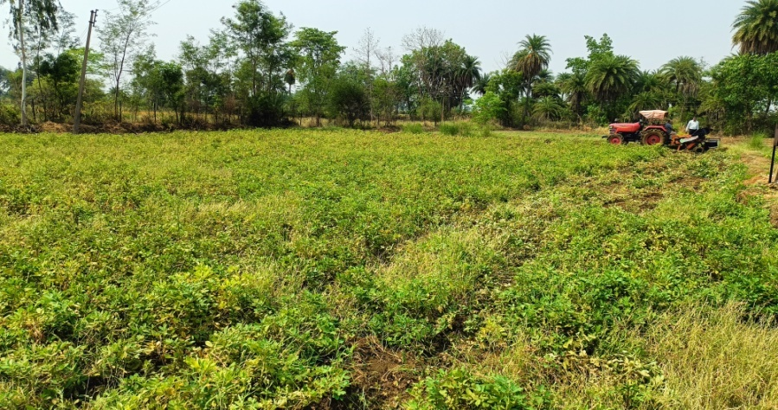 | 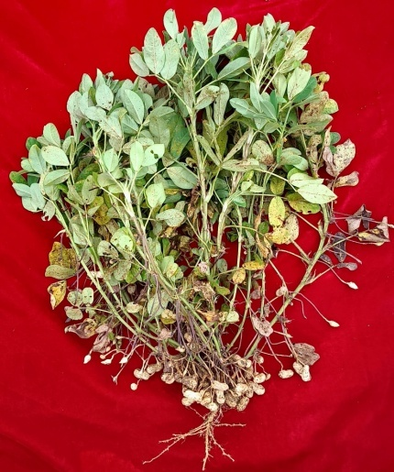
Fig. 1: Groundnut cultivation field and Groundnut legume

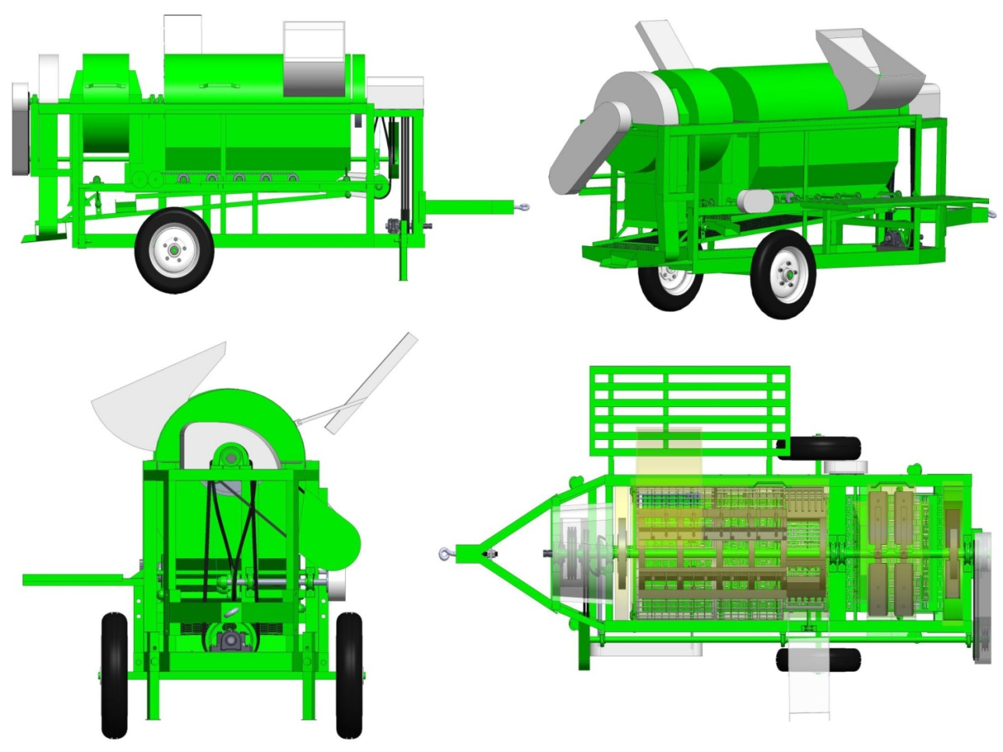
Fig. 2: 3D view of developed groundnut thresher

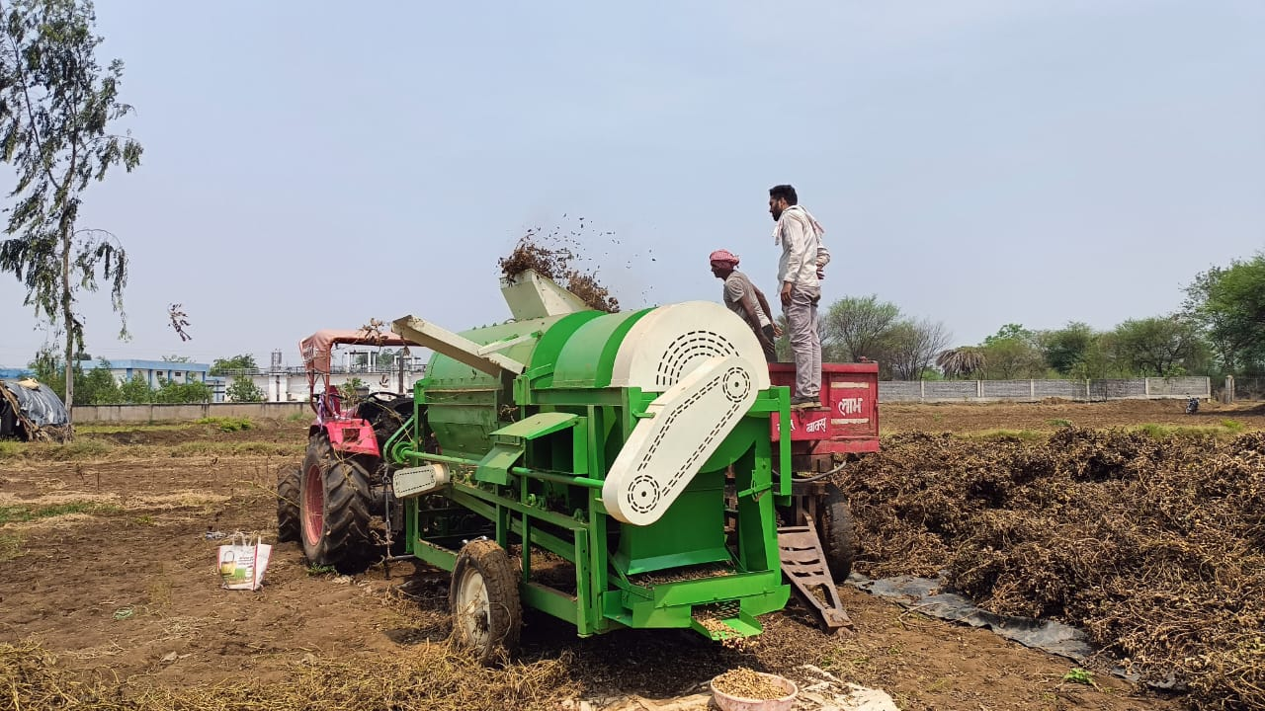
Fig. 3. Field test of groundnut thresher

References:
Aboegela, M. A. and Mourad, K. H. 2021. Development a locale thresher machine for separating peanut crop. Journal of Soil Sciences and Agricultural Engineering, 12(3): 131-135.
Asokan, D. 1997. Studies the effect of crop, machine and operational parameter relation to mechanical threshing of high moisture groundnut crop. PhD. Tamilnadu agricultural university, Coimbatore.
Dewangan, S. K., Naik, R. K., Patel, G., Lal, S. and Vaishanav, P. 2025. Physical and engineering properties of groundnut varieties commonly cultivated in Chhattisgarh. International Journal of Research in Agronomy, 8(8): 571-574.
Dewangan, S. K., Naik, R. K., Singh, G., Patel, G. and H. S., Tuteja. 2025. Effect of operating parameters on groundnut thresher performance. International Journal of Agriculture Extension and Social Development, 8(11): 296-303.
Dhananchezhiyan, P., Parveen, S. and Rangasamy, K. 2013. Development and performance evaluation of low cost portable paddy thresher for small farmers. International Journal of Research in Engineering and Technology, 2(7): 571-585.
Dogra, B., Dogra, R., Singh, S. and Manes, G. S. 2014. Performance of modified spike tooth thresher for pigeonpea (Cajanus cajan). Legume Research-An International Journal, 37(6): 628-634.
Humphred, M. N. 2017. Development and optimization of the threshing performance of a multi crop thresher. Ph. D. Department of Agricultural Engineering faculty of Engineering, Ahmadu Bello University, Ngeria, 1-270.
Khaerat, D. P., Bhoi, S., Khadse, M., Patil, B. and Narkhede, S. 2020. A review on manufacturing of groundnut separating machine. International Journal of Innovative Research in Science, Engineering and Technology, 9(4): 2320-6710.
Naik, R. K., Patel, S., Verma, A. K. and Shrivastava, A. K. 2010. Effect of crop and machine parameters on performance of paddy thresher. Agricultural Engineering Today, 34(1), 30-32.
Parmanand. and Verma, A. 2015. Development and testing of pedal operated thresher for finger millet. International Journal of Agricultural Science and Research: 5(3): 299-308.
Patel, K. K., Naik, R. K., Potdar, R. R. and Shukla, P. 2025. Optimizing axial flow finger millet (Eleusine coracana L.) thresher for efficient performance: A Taguchi Orthogonal Array Approach. Journal of Agricultural Engineering, 62(2): 279.
Pralhad, M. A. 2007. Developmemnt and performance evaluation of groundnut thresher. B. Tech. Marathwada Agricultural University, Parbhani : 13-15.
Rajasekar, M., Arunkumar, S., Divakar, S., and Santhosh Kumar, R. 2017. Design fabrication and performance analysis of groundnut thresher. International Research Journal of Engineering and Technology (IRJET), 4(2):1631-1637.
Singh, M., Manes, G. S. and Singh, S. 2009. Development and testing of axial-flow groundnut (Arachis hypogaea) thresher. The Indian Journal of Agricultural Sciences, 79 (9): 74-78.
Singhal, O. P. and Tbierstein, G. E. 1987. Development of an axial flow thresher with multi-crop potential. Agricultural Mechanization in Asia, Africa and Latin America, 18 (3), 57-65.
Spokas, L., Steponavicius, D. and Petkevicius, S. 2008. Impact of technological parameters of threshing apparatus on grain damage. Agronomy Research, 6(Special issue): 367-376.
Srinivasa, D., Dayananda, B. S. and Lokesh, A. C. 2022. A review on cultivation of groundnut and mechanization processes in India. IJIRT, 9 (4): 2349-6002.
Sudajan, S., Salokhe, V. M. and Triratanasirichai, K. 2002. PM—Power and machinery: effect of type of drum, drum speed and feed rate on sunflower threshing. Biosystems engineering, 83(4): 413-421.

