Effect of Sweet flag (Acorus calamus L.) Rhizome Seed Treatment on Seed Quality in Field bean (Lablab purpureus L.)

ABSTRACT
A field experiment was conducted to identify the best concentration of sweet flag (Acorus calamus) rhizome treatment for the enhancement of seed quality parameters in field bean (Lablab purpureus L.) at the Research Institute of Organic Farming, UAS Bangalore, GKVK, Karnataka. The experiment consisted of eight treatments including sweet flag rhizome powder at 5 g/kg (T₂), 10 g/kg (T₃) and 15 g/kg (T₄) and sweet flag rhizome oil at 2.5 ml/kg (T₅), 5 ml/kg (T₆) and 7.5 ml/kg (T₇), along with a chemical control using spinosad at 0.04 ml/kg (T₈) and an untreated control (T₁). All treatments were arranged in a randomized complete block design with three replications in field. After the field experiment and harvest, the seeds obtained from each treatment were subjected to laboratory evaluation in CRD design for seed quality parameters. Among the treatments, sweet flag rhizome powder at 15 g/kg (T₄) recorded the highest germination percentage (97.3 %), speed of germination (17.7), shoot length (29.4 cm), root length (25.6 cm), seedling length (55.0 cm), seedling dry weight (106.6 mg), seedling vigour index-I (5352) and II (10372), while recording the lowest electrical conductivity (121.3 µS/cm/g), indicating superior seed vigour and membrane stability. The enhanced seed performance in T₄ treatment may be attributed to the bioactive compounds of sweet flag rhizome, which promoted seed metabolism and reduced seed-borne infections.
Keywords: Sweet flag rhizome, quality parameters, field bean, seed treatment
- Introduction
Field bean is considered as one of the oldest vegetable legumes cultivated worldwide, particularly across tropical regions of India, Africa and Southeast Asia. It is an annual, herbaceous and warm-season crop believed to have originated in India (Sandeep et al., 2024). In addition to its use as a pulse and vegetable, it is grown for multiple other purposes, including green manure, hay, silage and as a cover crop for erosion control and weed suppression. The crop is mainly cultivated in the peninsular regions of India, where its adaptability to various agro-ecological conditions makes it a reliable choice for small and marginal farmers. It also contributes to soil improvement by enhancing nitrogen levels and breaking soil compaction.
India holds the distinction of being the largest pulse-producing country and it contributing significantly to global food security. The country accounts for approximately 25 % of global pulse production and nearly 32 % of the world's pulse-growing area. Karnataka is a major pulse-growing state in India and plays a crucial role in the country’s overall pulse output. It contributes nearly 90 % to both the total area under pulse cultivation and production at the national level. In India, Karnataka has major area under field bean cultivation accounting about 80 % of total country’s area. In Karnataka, field bean is grown in an area of 0.52 lakh ha and production of 0.28 lakh tonne of grain (Anon., 2023). It requires high temperatures to grow (18-30 °C). Prominent pulse-growing districts in Karnataka include Bangalore, Kolar, Mysore, Hassan, Dharwad, Belgaum and Bidar, where favourable agroclimatic conditions and traditional cropping practices support their cultivation.
Among the diverse range of pulses cultivated in India, field bean (Lablab purpureus L.) holds particular importance in Karnataka and other southern states due to its multipurpose utility. It belongs to the family Fabaceae and sub-family Faboideae. The crop is known by several regional and local names, such as hyacinth bean, dolichos bean, Indian bean, avare, bonavist bean and ‘val’ in Maharashtra. Field bean is primarily a self-pollinated legume and is cultivated both for its edible green pods, which are consumed as a vegetable and for its mature dry seeds, which serve as a protein-rich pulse (Bai et al., 2020). The crop is culturally and economically significant, especially in rainfed farming systems.
The nutritional composition of field bean makes it highly valuable in vegetarian diets. The green pods and dry grains are rich in essential nutrients, including carbohydrates (6.7 g), proteins (3.8 g), fats (0.7 g) and minerals (0.9 g). Moreover, they are abundant in magnesium (34.0 g), calcium (210 mg), phosphorus (68.0 mg), iron (1.7 mg), potassium (74.0 mg) and vitamins A and C. These nutritional qualities make it a wholesome food, particularly in rural households. The amino acid profile is well balanced with lysine content reaching up to 6.1 %. The total protein content ranges from 18.3 % to 31.6 %, making it a significant source of plant-based protein (Thamburaj and Narendra Singh, 2003). Its use is not limited to human consumption alone but also extends to animal feed and traditional medicine.
Among all inputs used in agriculture, seed is the most critical for ensuring good crop establishment and yield. High-quality seed leads to better germination, achieving maximum plant population, uniform stands and higher resilience to stress. However, seed quality can deteriorate rapidly due to poor storage conditions. In pulses, approximately 30–40 % of seed damage and viability loss occurs at post-harvest, primarily due to the infestation of storage pests like bruchids (Callosobruchus spp.) along with fungal contamination and nutrient imbalances (Paikaray et al., 2022). Therefore, developing effective low-cost and environmentally friendly seed storage techniques is essential to ensure seed viability and vigour until the next planting season, especially in rainfed areas where seed replacement rate is low.
One such promising and eco-friendly seed preservation method is the use of botanicals, especially the rhizome of sweet flag (Acorus calamus L.). Sweet flag is a semi-aquatic perennial monocotyledonous herb with thick, branched and aromatic rhizomes. These rhizomes have been traditionally used in Indian medicine systems such as Ayurveda, Unani and Siddha for their medicinal and aromatic properties. The rhizomes are rich in essential oils such as β-asarone, α-asarone, methyl eugenol, iso-methyl eugenol and camphor (Lokesh, 2004). These components are known for their diverse pharmacological properties including insecticidal, antifungal, antimicrobial, antioxidant, anti-inflammatory and repellent effects. Their presence offers great potential for sweet flag as a natural alternative to chemical pesticides and preservatives in seed treatment.
Traditionally, Acorus calamus has been widely used to treat a variety of ailments such as digestive disorders, bronchitis, skin diseases, colic pain, flatulence, rheumatism, fever and fatigue. The pharmacological activities of its essential oils, especially in repelling insects and protecting stored seeds, are being scientifically explored for agricultural applications. Its use in seed technology is a novel approach that bridges ancient herbal wisdom with modern agricultural science. Studies have shown that sweet flag can be used effectively as a seed protectant, helping to prolong seed longevity, preserve vigour and reduce pest-related losses in storage, especially for pulse crops that are highly vulnerable.
In adoption of integrating traditional botanical knowledge with modern scientific methodologies this research aims to develop a dependable, affordable and eco-safe seed enhancement technology for field bean growing farmers. The approach will be particularly beneficial to small and marginal land holders in rainfed and resource-constrained regions of South India, where access to synthetic chemicals is limited. The outcome of this research is expected to contribute meaningfully towards improving field bean productivity, seed quality in a sustainable manner. In Karnataka, where field bean is grown extensively as both an intercrop, a sole crop under rainfed and irrigated conditions, there is a critical need for sustainable and it can be considered as cost-effective method. The increasing interest in botanical-based seed treatments offers a new avenue for utilizing Acorus calamus rhizome for enhancing quality parameters.
- MATERIAL AND METHODS
Field bean seeds were subjected to six different conc. sweet flag rhizome-based and one spinosad seed treatments, along with one untreated control, to study their effect on seed quality parameters. The treatments were imposed prior to sowing and the experiment was laid out in Randomized Complete Block Design (RCBD) with three replications (Plate 1.). The treated seeds were sown under uniform agronomic conditions at the Research Institute of Organic Farming (RIOF), UAS, GKVK, Bengaluru. The details of seed treatments and treatment structure are presented in Plate 2. The details are as follows:
Treatment details:
T₁: Control
T₂: Sweet flag rhizome powder at 5 g/kg
T₃: Sweet flag rhizome powder at 10 g/kg
T₄: Sweet flag rhizome powder at 15 g/kg
T₅: Sweet flag rhizome oil at 2.5 ml/kg
T₆: Sweet flag rhizome oil at 5 ml/kg
T₇: Sweet flag rhizome oil at 7.5 ml/kg
T₈: Spinosad at 0.04 ml/kg
The field experiment was conducted during the rabi season, commencing in December 2024 and completed in April 2025. The experiment was laid out in a Randomized Complete Block Design (RCBD) with three replications. The land was well ploughed and brought to a fine tilth by two to three harrowing followed by levelling, after which well-decomposed farmyard manure was applied uniformly to all the beds. Each plot measured 3 m × 3 m as a gross plot, while a net plot size of 2.4 m × 1.8 m was considered for recording yield observations, excluding the two border rows on each side. Prior to sowing, seeds were subjected to seven different treatments and one untreated control. A common irrigation was provided to all treatments before sowing to ensure uniform seed germination and an optimum plant stand under field conditions.
Seed quality parameters:
Seed germination (%)
The germination test was conducted as per ISTA (2021) guidelines using the between-paper method in the Seed Testing Laboratory. From each treatment, 50 seeds were randomly selected in three replications and placed equidistantly on moist paper towels. The towels were rolled and kept in a germination chamber maintained at 25 ± 1°C temperature and 90% relative humidity. The first count and final count of normal seedlings were taken on the 4th and 10th day, respectively. The percentage of normal seedlings was calculated and expressed as germination percentage.
Speed of germination
Seeds were germinated on moist paper towels with four replications of 50 seeds each. Germinated seeds were counted daily until the final count was taken. The speed of germination was calculated using the formula suggested by Maguire (1962):
Speed of germination = G1/D1 + G2/D2 + ... + Gn/Dn.
Where,
G1, G2...Gn = number of seeds germinated on day D1, D2...Dn respectively.
Shoot length (cm)
From the standard germination test, ten normal seedlings were randomly selected from each treatment in three replications on the day of the final count. The shoot length was measured from the collar region to the tip of the shoot using a ruler. The average was calculated and expressed in centimeters (cm).
Root length (cm)
Ten normal seedlings were randomly selected from each treatment in three replications on the day of final count. Root length was measured from the collar region to the tip of the primary root. The average was computed and expressed in centimeters (cm).
Seedling length (cm)
On the 10th day of germination, ten normal seedlings were randomly selected from each replication. The length of each seedling was measured from the tip of the primary root to the tip of the apical shoot. The average seedling length was calculated and expressed in centimeters (cm).
Seedling dry weight (mg)
The same ten seedlings used for measuring shoot and root lengths were collected and wrapped in butter paper, then dried in a hot air oven at 80°C for 24 hours. After drying, they were cooled in a desiccator for 45 minutes and weighed using an electronic balance. The mean dry weight was calculated and expressed in milligrams (mg).
Seedling vigour index-I
Seedling vigour index-I was calculated using the formula proposed by Abdul-Baki and Anderson (1973) as follows:
Seedling vigour index-I = Germination (%) × Seedling length (cm)
The value was expressed as a whole number.
Seedling vigour index-II
Seedling vigour index-II was calculated by multiplying the germination percentage with the average seedling dry weight (mg) as follows:
Seedling vigour index-II = Germination (%) × Seedling dry weight (mg)
The value was expressed as a whole number.

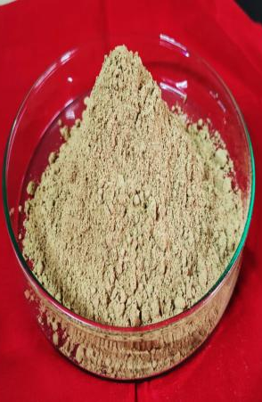 | 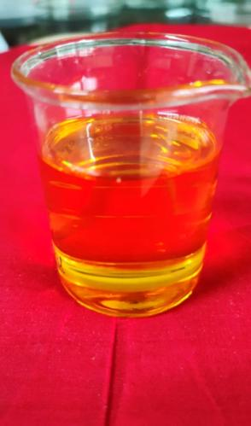
Sweet flag rhizome powder | Sweet flag rhizome oil
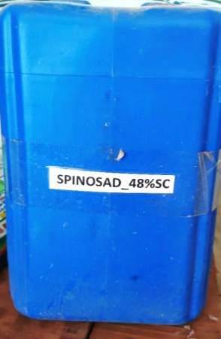 | 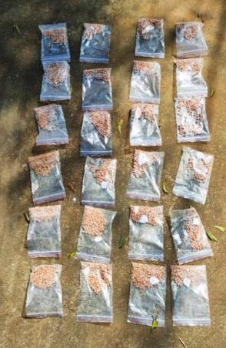
Spinosad | Treated seeds are ready for sowing
Plate 1: Images are showing the Field bean seed treatment using sweet flag rhizome powder, oil, and spinosad prior to sowing

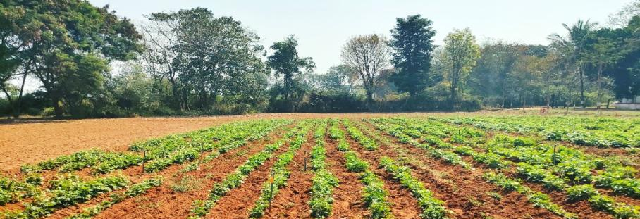
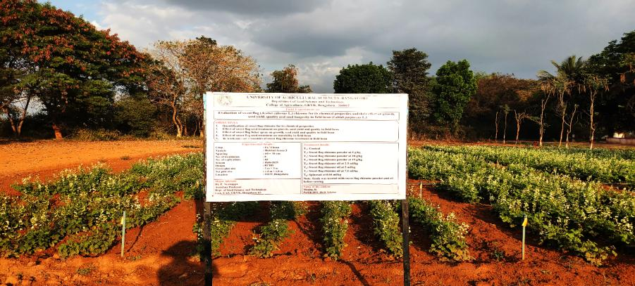
Plate 2: General view of experiment
Electrical conductivity (µS/cm/g)
The electrical conductivity test was performed as per ISTA rules. Fifty seeds from each treatment were weighed accurately in three replications and soaked in 75 ml of distilled water in plastic beakers for 24 hours at 25 ± 1°C. After soaking, the leachate was decanted and the electrical conductivity of the solution was measured using a calibrated conductivity meter. The results were expressed in micro Siemens per centimeter per gram of seed (µS/cm/g).
Statistical analysis and interpretation of data
In order evaluate comparative performance of various treatments, the data was analyzed by the technique of analysis of variance. The collected research data were analyzed statistically by the method of Panse and Sukhatme (1967) wherever the results were significant, the critical difference (CD) was calculated at 1 percent level of significance for lab observation.

- RESULTS AND DISCUSSION
Seed germination (%)
The data on seed germination as influenced by various sweet flag rhizome treatments along with a spinosad treatment under lab conditions are presented in table 1, fig. 1 and plate 3.
The seed germination showed non-significant variation across all sweet flag rhizome treatments with the highest germination recorded in sweet flag rhizome powder at 15 g/kg (T₄) (97.3 %) and it is followed by sweet flag rhizome powder at 10 g/kg (T₃) (96.9 %). The control (T₁) was recorded the lowest germination (91.9 %) indicating relatively poor seed viability under untreated conditions.
Speed of germination
The data on speed of germination as influenced by various sweet flag rhizome treatments along with a spinosad treatment under lab conditions are presented in table 1.
Among the all sweet flag rhizome treatments, speed of germination showed significant variation under lab conditions, with the highest germination speed recorded in sweet flag rhizome powder at 15 g/kg (T₄) (17.7) and it is followed by sweet flag rhizome powder at 10 g/kg (T₃) (16.9). The control (T₁) was recorded the lowest speed of germination (14.8) indicating relatively slower seedling emergence under untreated conditions.
The findings of the study highlighted that, seed germination percentage registered highest to treatment with sweet flag rhizome powder at 15 g/kg (T₄) was recorded the 5.9 per cent increase in seed germination and 19.6 per cent increase in speed of germination as compared to control indicating the beneficial role of bioactive compounds such as β-asarone, methyl isoeugenol (Z and E) and methyleugenol in promoting seed vigour. These substances are well-known for their antioxidant, antifungal, insecticidal and antibacterial qualities.
Table 1: Effect of sweet flag rhizome treatment on seed germination (%) and speed of germination in field bean
Treatments | Seed germination (%) | Speed of germination
T₁ | 91.9 | 14.8
T₂ | 94.8 | 15.4
T₃ | 96.9 | 16.9
T₄ | 97.3 | 17.7
T₅ | 93.7 | 15.7
T₆ | 95.1 | 16.5
T₇ | 95.6 | 15.8
T₈ | 94.9 | 16.3
Mean | 95.0 | 16.1
S.Em.± | 1.47 | 0.25
CD (P=0.01) | 4.40 | 1.03
CV (%) | 2.67 | 2.67
Significance | NS | S
Legend
T₁: Control
T₂: Sweet flag rhizome powder at 5 g/kg
T₃: Sweet flag rhizome powder at 10 g/kg
T₄: Sweet flag rhizome powder at 15 g/kg
T₅: Sweet flag rhizome oil at 2.5 ml/kg
T₆: Sweet flag rhizome oil at 5 ml/kg
T₇: Sweet flag rhizome oil at 7.5 ml/kg
T₈: Spinosad at 0.04 ml/kg

Fig. 1: Graph showing the effect of sweet flag rhizome treatment on seed germination (%) and electrical conductivity (µS/cm/g) in
field bean
Legend
T₁: Control T₅: Sweet flag rhizome oil at 2.5 ml/kg SG: Seed germination
T₂: Sweet flag rhizome powder at 5 g/kg T₆: Sweet flag rhizome oil at 5 ml/kg EC: Electrical conductivity
T₃: Sweet flag rhizome powder at 10 g/kg T₇: Sweet flag rhizome oil at 7.5 ml/kg
T₄: Sweet flag rhizome powder at 15 g/kg T₈: Spinosad at 0.04 ml/kg

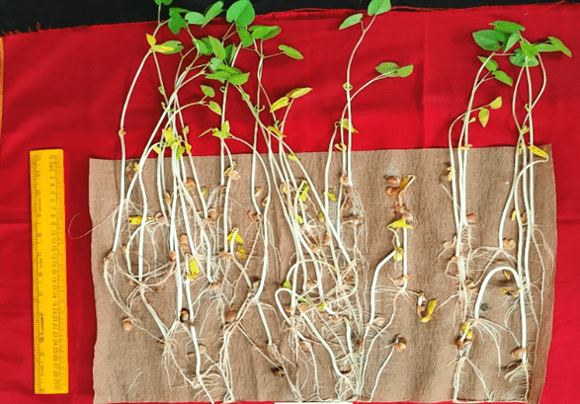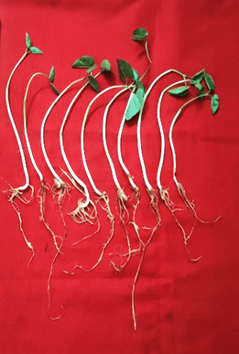
T₁: Control
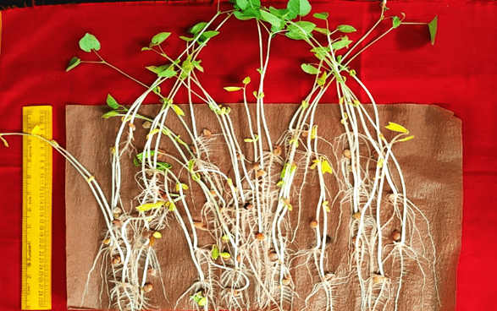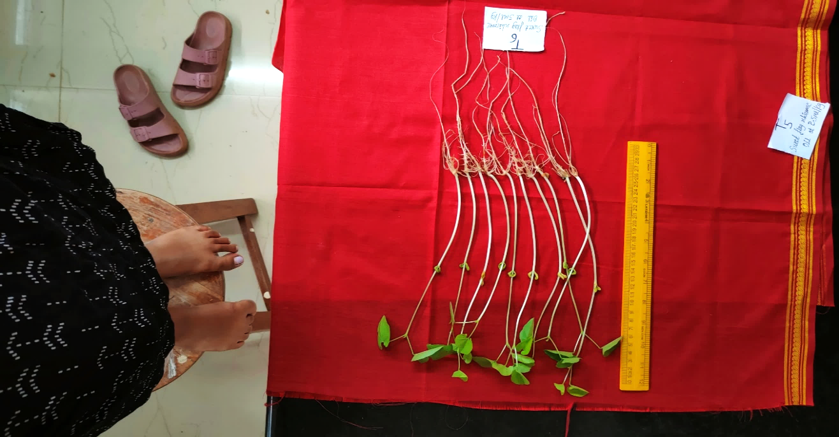
T₄: Sweet flag rhizome powder at 15 g/kg
Plate 3: Images showing the effect of sweet flag rhizome treatment on seed germination (%) and seedling length (cm) in field bean

Their antioxidant qualities reduce oxidative stress in seeds right after harvest, maintaining cellular function and accelerating germination, while their antifungal activity aids in suppressing seed-borne fungus and minimizing pathogen-induced damage at the crucial germination stage. By preventing microbial spoiling and insect damage, the antimicrobial and insecticidal qualities help create a healthy microenvironment around the seed, which in turn improves seed viability and vigour (Park et al., 2023; Ghosh et al., 2025).
Similar results were obtained in the studies of Basra et al. (2011) noticed that Moringa oleifera leaf extracts significantly improved seed germination percentage and seedling growth in maize due to phenolic compounds and flavonoids that enhance antioxidant activity and water uptake. Additionaly, these results are concurring with findings of Chandel and Kumar (2017) demonstrated that Allium sativum (garlic) seed treatments in pea improved germination efficiency and vigour through its potent antifungal and antimicrobial constituent allicin, which restricted pathogen proliferation on seeds. These findings affirm that treatments with bioactive-rich botanicals can enhance germination and speed of germination by providing multifaceted antifungal, antimicrobial, insecticidal and antioxidant protection.
By contrast, the control (untreated) seeds exhibited the lowest germination percentage and speed of germination, likely due to higher incidences of fungal infections, pest attacks and oxidative stress impairing seed vigour. These results are in consistent with the findings of Kumar et al. (2023) in untreated pea seeds where reduced germination speed and health were linked to fungal and pest incidence. Additionaly, these results are in conformity with the studies of Sandhi and Reddy (2020) reported that untreated pulse seeds, particularly under aphid infestations, showed poor vigour and emergence parameters.
Shoot length (cm)
The data on shoot length as influenced by various sweet flag rhizome treatments along with a spinosad treatment under lab conditions are presented in table 2.

Table 2: Effect of sweet flag rhizome treatment on shoot, root and seedling length (cm) in field bean
Treatments | Shoot length (cm) | Root length (cm) | Seedling length (cm)
T₁ | 21.4 | 15.2 | 36.6
T₂ | 24.9 | 18.9 | 43.8
T₃ | 27.5 | 23.9 | 51.4
T₄ | 29.4 | 25.6 | 55.0
T₅ | 23.6 | 16.8 | 40.4
T₆ | 25.2 | 20.2 | 45.4
T₇ | 25.6 | 22.3 | 47.9
T₈ | 26.2 | 23.2 | 49.4
Mean | 25.5 | 20.8 | 46.2
S.Em.± | 0.38 | 0.30 | 0.73
CD (P=0.01) | 1.57 | 1.24 | 3.02
CV (%) | 2.59 | 2.51 | 2.74
Significance | S | S | S
Legend
T₁: Control
T₂: Sweet flag rhizome powder at 5 g/kg
T₃: Sweet flag rhizome powder at 10 g/kg
T₄: Sweet flag rhizome powder at 15 g/kg
T₅: Sweet flag rhizome oil at 2.5 ml/kg
T₆: Sweet flag rhizome oil at 5 ml/kg
T₇: Sweet flag rhizome oil at 7.5 ml/kg
T₈: Spinosad at 0.04 ml/kg

Shoot length showed significant variation across all the sweet flag rhizome treatments with the highest shoot length recorded in sweet flag rhizome powder at 15 g/kg (T₄) (29.4 cm) and it is followed by sweet flag rhizome powder at 10 g/kg (T₃) (27.5 cm). The control (T₁) was recorded the lowest shoot length (21.4 cm) indicating relatively poor seedling growth under untreated conditions.
Root length (cm)
The data on root length as influenced by various sweet flag rhizome treatments along with a spinosad treatment under lab conditions are presented in table 2.
Significant differences in root length were registered across sweet flag rhizome treatments with the highest root length recorded in sweet flag rhizome powder at 15 g/kg (T₄) (25.6 cm) and it is followed by sweet flag rhizome powder at 10 g/kg (T₃) (23.9 cm). The control (T₁) was recorded the lowest root length (15.2 cm) indicating relatively poor root development under untreated conditions.
Seedling length (cm)
The data on seedling length as influenced by various sweet flag rhizome treatments along with a spinosad treatment under lab conditions are presented in table 2 and plate 3.
Seedling length showed significant variation across all the treatments with the highest seedling length recorded in sweet flag rhizome powder at 15 g/kg (T₄) (55.0 cm) and it is followed by sweet flag rhizome powder at 10 g/kg (T₃) (51.4 cm). The control (T₁) was recorded the lowest seedling length (36.6 cm) indicating relatively poor early seedling growth under untreated conditions.
The results of the experiment indicated that, the shoot length, root length and seedling length showed a positive response to treatment with sweet flag rhizome powder at 10 g/kg (T₃) was recorded the 28.5 per cent, 57.2 per cent and 40.4 per cent increase in shoot length, root length and seedling length, respectively, as compared to control indicating the beneficial role of bioactive compounds such as β-asarone, methyl isoeugenol (Z and E) and methyleugenol in promoting early seedling growth. β-Asarone, methyl isoeugenol and methyleugenol are known for their antifungal, insecticidal, antimicrobial and antioxidant properties, which can protect seedlings from biotic and oxidative stresses, enhancing shoot and root development (Dutt and kumar, 2025 and Prajapati et al., 2025)
Supporting results were obtained in the studies of Krishnasamy and Obbineni (2025) who reported that Moringa oleifera leaf extract applied as seed priming significantly improved seedling emergence, growth and vigour in black gram under laboratory conditions. Likewise, this study concurs with the findings of Ismil and Besar (2025) found that Allium sativum seed extracts enhanced shoot and root development by reducing microbial infection and insect damage in various crops immediately after treatment. These findings affirm that treatments with bioactive-rich botanicals can enhance early-stage seedling growth by providing protection through their multifaceted antimicrobial, insecticidal and antioxidant properties.
The control (untreated) seedlings exhibited the lowest shoot, root and seedling lengths, likely due to greater susceptibility to soil-borne fungi, pathogens and insect pests that adversely impact early seedling growth. These results are in conformity with the findings of Rajeshwaran et al. (2025) and El-Gammal et al. (2025) observed untreated pulse seedlings often show reduced growth and biomass due to pest and disease incidence.
Seedling dry weight (mg)
The data on seedling dry weight as influenced by various sweet flag rhizome treatments along with a spinosad treatment under lab conditions are presented in table 3.
Seedling dry weight showed significant variation across all treatments with the highest seedling dry weight recorded in sweet flag rhizome powder at 15 g/kg (T₄) (106.6 mg) and it is followed by sweet flag rhizome powder at 10 g/kg (T₃) (101.60 mg). The control (T₁) was recorded the lowest seedling dry weight (93.8 mg) indicating relatively poor early seedling vigour under untreated conditions.

Table 3: Effect of sweet flag rhizome treatment on seedling dry weight (mg),
seedling vigour index-I &II and electrical conductivity (µS/cm/g) in field bean
Treatments | Seedling dry weight (mg) | Seedling vigour index-I | Seedling vigour index-II | Electrical conductivity (µS/cm/g)
T₁ | 93.80 | 3364 | 8620 | 134.0
T₂ | 96.90 | 4152 | 9186 | 124.6
T₃ | 101.60 | 4981 | 9845 | 122.5
T₄ | 106.60 | 5352 | 10372 | 121.3
T₅ | 95.20 | 3785 | 8920 | 132.7
T₆ | 97.80 | 4318 | 9301 | 128.6
T₇ | 98.80 | 4579 | 9445 | 127.4
T₈ | 100.70 | 4688 | 9556 | 131.3
Mean | 98.93 | 4402 | 9406 | 127.8
S.Em.± | 1.03 | 44.21 | 97.65 | 1.38
CD (P=0.01) | 2.97 | 127.06 | 280.64 | 3.97
CV (%) | 3.85 | 3.70 | 3.82 | 3.98
Significance | S | S | S | S
Legend
T₁: Control
T₂: Sweet flag rhizome powder at 5 g/kg
T₃: Sweet flag rhizome powder at 10 g/kg
T₄: Sweet flag rhizome powder at 15 g/kg
T₅: Sweet flag rhizome oil at 2.5 ml/kg
T₆: Sweet flag rhizome oil at 5 ml/kg
T₇: Sweet flag rhizome oil at 7.5 ml/kg
T₈: Spinosad at 0.04 ml/kg

Seedling vigour index – I (SVI-I)
The data on seedling vigour index-I as influenced by various sweet flag rhizome treatments along with a spinosad treatment under lab conditions are presented in table 3.
Among the different sweet flag rhizome treatments, seedling vigour index-I showed significant variation, with the highest seedling vigour-I recorded in sweet flag rhizome powder at 15 g/kg (T₄) (5352) and it is followed by sweet flag rhizome powder at 10 g/kg (T₃) (4981). The control (T₁) was recorded the lowest vigour index (3364) indicating relatively poor early seedling growth and vigour under untreated conditions.
Seed vigour index-II (SVI-II)
The data on seedling vigour index-II as influenced by various sweet flag rhizome treatments along with a spinosad treatment under lab conditions are presented in table 3.
Seedling vigour index-II showed significant variation across all treatments with the highest seedling vigour-II recorded in sweet flag rhizome powder at 15 g/kg (T₄) (10372) and it is followed by sweet flag rhizome powder at 10 g/kg (T₃) (9845). The control (T₁) was recorded the lowest vigour index (8620) indicating relatively poor early seedling growth and vigour under untreated conditions.
In the current investigation, the seedling dry weight, SVI-I and SVI-II showed a highest to treatments with sweet flag rhizome powder at 10 g/kg (T₃) was recorded the 8.3 per cent, 48.1 per cent and 14.2 per cent increase in seedling dry weight, SVI-I and SVI-II, respectively, as compared to control indicating the beneficial role of bioactive compounds such as β-asarone, methyl isoeugenol (Z and E) and methyleugenol. These compounds are known for their antifungal, insecticidal, antimicrobial and antioxidant properties, which can protect seeds and emerging seedlings from biotic and abiotic stresses, enhancing early metabolic activity and vigour (Singh et al., 2025).
Similar results were obtained in the studies of Krishnasamy and Obbineni (2025) who reported that Moringa oleifera seed priming improved seedling vigour indices in black gram under laboratory conditions due to antioxidant-rich phenolics and flavonoids. Additionaly, this study is well supported by findings of Ismil and Besar (2025) found that Allium sativum seed treatments enhanced pea seedling vigour by suppressing seed-borne fungal pathogens through allicin and related organosulfur compounds, thereby improving early seedling health. These findings affirm that treatments with bioactive-rich botanicals can enhance seedling vigour by providing protection through their multifaceted antimicrobial, insecticidal and antioxidant properties.
On the other hand, the control (untreated) seeds exhibited the lowest seedling dry weight and vigour indices, likely due to greater vulnerability to pest infestation, fungal pathogens and abiotic stresses immediately post-harvest. These results are in conformity with the findings of Rajeshwaran et al. (2025) and Vatchev et al. (2025) observed untreated pulse seeds often show reduced vigour and growth due to disease incidence and pest damage.
Electrical conductivity (µS/cm/g)
The data on electrical conductivity as influenced by various sweet flag rhizome treatments along with a spinosad treatment under lab conditions are presented in table 3 and fig. 2.
Electrical conductivity showed significant variation across treatments with the lowest electrical conductivity recorded in sweet flag rhizome powder at 15 g/kg (T₄) (121.3 µS/cm/g) indicating better membrane integrity and seed quality and it is followed by sweet flag rhizome powder at 10 g/kg (T₃) (122.5 µS/cm/g) and the control (T₁) (134.0 µS/cm/g), which recorded the highest conductivity, suggesting relatively poor seed membrane stability under untreated conditions.
The current study showed that, the electrical conductivity showed a least to treatment with sweet flag rhizome powder at 10 g/kg (T₃) was recorded the 8.5 per cent decrease in electrical conductivity as compared to control indicating the beneficial role of bioactive compounds such as β-asarone and methyl isoeugenol (Z and E), along with methyleugenol in maintaining seed membrane stability. These compounds are known for their antifungal, insecticidal, antimicrobial and antioxidant properties, which can protect seeds from oxidative stress and microbial infections immediately after harvest, enhancing seed vigour and reducing electrolyte leakage (Aryal et al., 2023).
Consistent results were obtained in the studies of Nivethadevi and Swaminathan (2022) who reported that seed priming with Moringa oleifera on black gram seeds reduced electrical conductivity and improved seed vigour due to antioxidant phenolics and flavonoids that protect seed membranes from oxidative damage. Furthermore, these results are concurs with findings of Ismil and Besar (2025) found that treatment of wheat seeds with Allium sativum (garlic) extract lowered electrical conductivity values by protecting seeds from pathogen invasion immediately after harvest, thereby maintaining membrane integrity and enhancing seedling vigour. These findings support the role of bioactive-rich botanicals in preserving seed quality and vigour through multifaceted protective mechanisms.
The control (untreated) seeds exhibited the highest electrical conductivity, likely due to greater susceptibility to membrane deterioration caused by seed-borne pathogens, pests and abiotic stresses. These results are in line with the findings of Kumar et al. (2023) and Dalvi et al. (2020) observed that untreated chickpea and mung bean seeds showed increased electrolyte leakage and reduced seed vigour due to higher post-harvest biotic and abiotic stress.
- Conclusion
The study revealed that sweet flag (Acorus calamus) rhizome treatments significantly enhanced the seed quality parameters of field bean. Seeds were treated with different concentrations of sweet flag rhizome powder and oil before sowing and after harvest, the seeds obtained from each treatment were subjected to laboratory evaluation for seed quality parameters. Among the treatments, rhizome powder at 15 g/kg (T₄) proved most effective, followed by 10 g/kg (T₃), showing superior results in germination percentage, speed of germination, shoot length, root length, seedling length, seedling dry weight, seedling vigour index-I and II, and lower electrical conductivity. The improvement in seed quality may be attributed to the bioactive compounds present in the sweet flag rhizome, which enhanced seed metabolism, maintained membrane stability, and reduced seed-borne infection. Hence, sweet flag rhizome formulations can be recommended as sustainable and eco-friendly alternatives to chemical seed treatments for improving seed vigour and quality in field bean cultivation.

Disclaimer (Artificial intelligence):
Author(s) hereby declare that generative AI technologies such as Large Language Models, etc. have been used during the writing or editing of manuscripts. This explanation will include the name, version, model, and source of the generative AI technology and as well as all input prompts provided to the generative AI technology
Details of the AI usage are given below:
1. Chat gpt (for grammar corrections)

- REFERENCES
Abdul-Baki, A. A., & Anderson, J. D. (1973). Vigour determination by multiple criteria. Crop Science, 13(2), 630–637.
Anonymous. (2023). Ministry of Agriculture, India. Retrieved from http://www.agriwelfare.gov.in
Aryal, S., Poudel, A., Kafle, K., & Aryal, L. N. (2023). Insecticidal toxicity of essential oil of Nepalese Acorus calamus (Acorales: Acoraceae) against Sitophilus zeamais (Coleoptera: Curculionidae). Heliyon, 9(11).
Bai, S. K., Kulkarni, L. R., Keshavareddy, G., Nagaraj, K. H., & Ranganath, S. C. (2020). Impact assessment of frontline demonstrations on field bean grown under rainfed and irrigated condition in Karnataka. Mysore Journal of Agricultural Sciences, 54(1).
Basra, S. M. A., Iftikhar, M. N., & Afzal, I. (2011). Potential of moringa (Moringa oleifera) leaf extract as priming agent for hybrid maize seeds. International Journal of Agriculture and Biology, 13(6).
Chandel, S., & Kumar, V. (2017). Effect of plant extracts as pre-storage seed treatment on storage fungi, germination percentage and seedling vigour of pea (Pisum sativum). Indian Journal of Agricultural Sciences, 87(11), 1476–1481.
Dalvi, D. G., Kardile, P. B., & Pawar, Y. (2020). Effect of seed priming and foliar spray of bio-agents on quality seed production in chickpea (Cicer arietinum L.). Journal of Pharmacognosy and Phytochemistry, 4, 2–6.
Dutt, B., & Kumar, R. (2025). An ethnopharmacological review on the antibacterial, antifungal and therapeutic potentials of Acorus calamus Linn. European Journal of Medicinal Plants, 36(2), 98–105.
El-Gammal, Y. H., El-Blasy, S. A., Khalifa, N. A., Abu El-Maaty, S., & Awaly, S. B. (2025). Efficacy of biocontrol agents against damping-off and Sclerotinia stem rot diseases and their role in eliciting defense in chickpea plants. Egyptian Journal of Biological Pest Control, 35(1), 5.
Ghosh, A., Das, R., Mohanty, J. P., & Roy, S. (2025). An updated review on therapeutic and phytochemical profiling of Acorus calamus Linn. A natural remedy explored. Journal of Pharmacognosy and Phytochemistry, 14(3), 738–746.
Ismil, R., & Ali Besar, N. (2025). Therapeutic, cosmetic and agricultural applications of Allium sativum L. (garlic) and Allium cepa L. (onion): A review. Egyptian Journal of Botany, 65(1), 303–310.
Krishnasamy, R., & Obbineri, J. M. (2025). Phytopriming of Vigna mungo (L.) Hepper (black gram) seeds using aqueous extracts of Moringa oleifera Lam., Gliricidia sepium (Jacq.) Walp. and Pongamia pinnata (L.) Pierre improves seedling emergence, growth and yield. Indian Journal of Agricultural Research, 59(4), 545–552.
Kumar, R., Mor, V. S., Bhuker, A., Tanwar, H., & Singh, G. (2023). Exploring the relationship between organic seed treatments and storage period on seed quality of mung bean (Vigna radiata L.). Journal of Food Legumes, 36(1), 59–65.
Lokesh, G. B. (2004). Sweet flag (Acorus calamus)—Cultivation and economics aspects. Indian Journal of Natural Products Research, 3(1), 19–21.
Maguire, J. D. (1962). Speed of germination aid in selection and evaluation of seedling emergence and vigour. Crop Science, 2, 176–177.
Nivethadevi, P., Swaminathan, C., Kannan, P., & Tamilselvi, E. (2022). Seed fortification and foliar spraying with Moringa oleifera leaf extract enhances yield and yield attributes in black gram [Vigna mungo (L.) Hepper]. Legume Research, 45(3), 352–356.
Paikaray, S. S., Satapathy, S. N., & Sahoo, B. K. (2022). Estimation of yield loss due to pulse beetle, Callosobruchus chinensis (L.) on different mung bean cultivars. Journal of Pharmacognosy and Phytochemistry, 11(3), 924–927.
Panse, V. G., & Sukhatme, P. U. (1967). Statistical methods for agricultural workers. ICAR, New Delhi.
Park, C., Cha, H. J., Hwangbo, H., Bang, E., Hong, S. H., Song, K. S., Noh, J. S., Kim, D. H., Kim, G. Y., & Choi, Y. H. (2023). β-Asarone alleviates high-glucose-induced oxidative damage via inhibition of ROS generation and inactivation of the NF-κB/NLRP3 inflammasome pathway in human retinal pigment epithelial cells. Antioxidants, 12(7), 1410.
Prajapati, C., Rai, S. N., Singh, A. K., Rajak, N., Garg, N., & Singh, S. K. (2025). Untargeted metabolomics and bioactivities assessment of Xylaria ellisii, an endophytic fungus isolated from the leaf of the plant Acorus calamus Linn. Current Pharmaceutical Design, 31(22), 1781–1799.
Rajeshwaran, B., Faizal, M. H., Themuthi, M., & Anith, K. N. (2025). Harnessing endophytic allies: Defense priming in Vigna unguiculata (L.) Walp. against Spodoptera litura (Fabricius) by bacterial endophytes. Symbiosis, 95(1), 125–140.
Sandeep, V., Jayaramaiah, R., Navi, L., & Umashanker, N. (2024). Influence of planting geometry and nutrient levels on growth, yield, economics and nutrient uptake of field bean. Mysore Journal of Agricultural Sciences, 58(4).
Sandhi, R. K., & Reddy, G. V. (2020). Biology, ecology and management strategies for pea aphid (Hemiptera: Aphididae) in pulse crops. Journal of Integrated Pest Management, 11(1), 18.
Singh, W. R., Sagolshemcha, R., Devi, W. R., & Devi, A. I. (2025). Insecticidal and biological activities of Acorus calamus Linn.: A valuable medicinal and aromatic plant. Journal of Experimental Zoology India, 28(1).
Thamburaj, S., & Narendra Singh. (2003). Vegetables, tuber crops and spices (Vol. 2, No. 4, p. 214–216). Directorate of Information and Publication of Agriculture, ICAR.
Vatchev, T., Yanashkov, I. T., Marinova, P., & Benova, E. (2025). Pre-sowing seed treatments with cold atmospheric plasma for the control of seedling blights of winter wheat. Processes, 13, 632.

