the Utilization of Rythu Bharosa Kendra Services by Tribal Farmers in Andhra Pradesh Region, India

ABSTRACT

The study explored the extent of utilization of RBK services by tribal farmers in the districts of Visakhapatnam, Vizianagaram, and West godavari. This research involves 120 respondents from 12 villages namely Peddapuram, Doravalasa, Dolliguda, and Pedalabudu from Araku mandal of Visakhapatnam; Gochekka, Tonki, Adaru, and Budhuruvada from Parvathipuram Mandal of Vizianagaram; Sithapagudem, Tellamvarigudem, Doramamidi and K.R Puram from Buttaigudem of West Godavari were randomly selected for the study. Data were collected through structured interviews and analyzed using statistical methods like frequency, percentage, mean score. Services of RBKs are categorized into rendering input services, capacity-building services, marketing services, consultancy services and veterinary services to conduct reliable study. The study’s key findings reported that among the six RBK service categories, marketing services were the most used by farmers, with mean scores between 2.68 and 2.87. Capacity building and holistic services followed, scoring between 2.44–2.63 and 2.21–2.27, respectively. Input services showed moderate use (1.92–2.12), while consultancy (1.85–1.96) and veterinary services (1.27–1.53) were the least utilized.In overall, a significant majority of farmers, approximately 67.5%, exhibited a moderate level of utilization of Rythu Bharosa Kendras' services. This was followed by 17.5% of farmers who displayed a low level of service utilization, while the remaining 15% had a high extent of utilization.

Key words: Rythu Bharosa Kendras, Tribal farmers, Agriculture, marketing services

INTRODUCTION
“Andhra Pradesh, recognized as the "rice bowl" of India and a significant agricultural state, has acknowledged the necessity for a robust integrated platform at the village level to effectively address the unique needs of each farmer” (Anantha Damodara Reddy et al., 2022) ^{[10]}. “In response to this recognition, the government initiated the establishment of 10,641 Rythu Bharosa Kendras (RBKs) on May 30, 2020, across every village secretariat in the state. These RBKs play a crucial role as a resource hub for farmers, disseminating information on the latest agricultural production technologies and supplying quality inputs” (Reddy, 2020) ^{[9]}.
A study on "Awareness and usage of mobile phone services among farmers to access information for improving agricultural productivity revealed that approximately 38.33% of respondents had minimal utilization of mobile phone services”. (Giridhar, 2017) ^{[6]}. Research on "Utilization of e-Mitra services by rural youth" noted that around 65% of the surveyed individuals had limited usage of e-Mitra services. (Ameta, 2015) ^{[1]}. A study on "Perception and utilization of services offered by Rythu Bharosa Kendras among farmers in Guntur district, Andhra Pradesh inferred that a majority, specifically 87.5% of respondents, had a moderate level of utilization, followed by 10% with high utilization, and 2.5% with low utilization of Rythu Bharosa Kendra services”. (Pacha, 2022) ^{[8]}.
To oversee the functioning of these RBKs at the grassroots level, the Department of Agriculture has enlisted 6,758 village agriculture assistants (Babu et al., 2021) ^{[4]}. “Also known as Farmer Assurance Centres, these RBKs integrate agricultural input shops and knowledge centers” (Chowdary et al., 2022) ^{[5]}. “RBKs provide government-certified agricultural, animal husbandry and fisheries inputs to farmers and host workshops or knowledge centers offering scientific agricultural advisory services. Within RBKs, Community Hiring Centres (CHCs) provide machinery to groups of five to six village members with a 50% subsidy and access to a 40% bank loan, managed by local farmers and made available to marginalized and small farmers at affordable rates” (Krishna et al., 2022) ^{[7]}. “RBKs offer a spectrum of services, encompassing farmer training, soil testing, crop insurance, demonstrations, beneficiary identification for various schemes, market intelligence, and the issuance of animal health cards” (Reddy, 2020) ^{[9]}. “This comprehensive approach has significantly transformed the agricultural sector, addressing farmers' needs from seed to sale” (Anuhya et al., 2022) ^{[2]}.
“The international acclaim of Rythu Bharosa Kendras is evident as they have been nominated for United Nations Organization (UNO) awards, bringing pride to the nation” (Anuhya et al., 2022) ^{[2,3]}. “This system has successfully bridged the gap between the extension system and the farming community, enhancing transparency” (Reddy, 2020) ^{[9]}. Nevertheless, “despite global recognition, the initiative encountered implementation challenges from the outset. The program's success is contingent on farmers' awareness of RBKs” (Saifuddin et al., 2023) ^{[11,12]}. “Limited research has been conducted on farmers' knowledge of RBKs and the challenges they face” (Anuhya et al., 2022) ^{[3]}.

METHODOLOGY
Andhra Pradesh, one of the Indian states, primarily relies on agriculture and livestock for its economy. The selection of Andhra Pradesh for this study is deliberate, as the state government launched the RBKs (Rural Business Kendras) with an innovative approach to support farmers at the grassroots level.
Research design: An Ex post facto research design was selected because the utilization of Rythu Bharosa Kendra (RBK) services by tribal farmers have already occurred and the researcher has no control over the independent variables such as demographic characteristics, awareness levels, or accessibility of RBKs. The phenomenon has already transpired, making this design suitable.
According to 2001 Census the tribal population of Andhra Pradesh is 50.24 lakh with 33 tribes constitute about 6.6 percent of the total population of the state

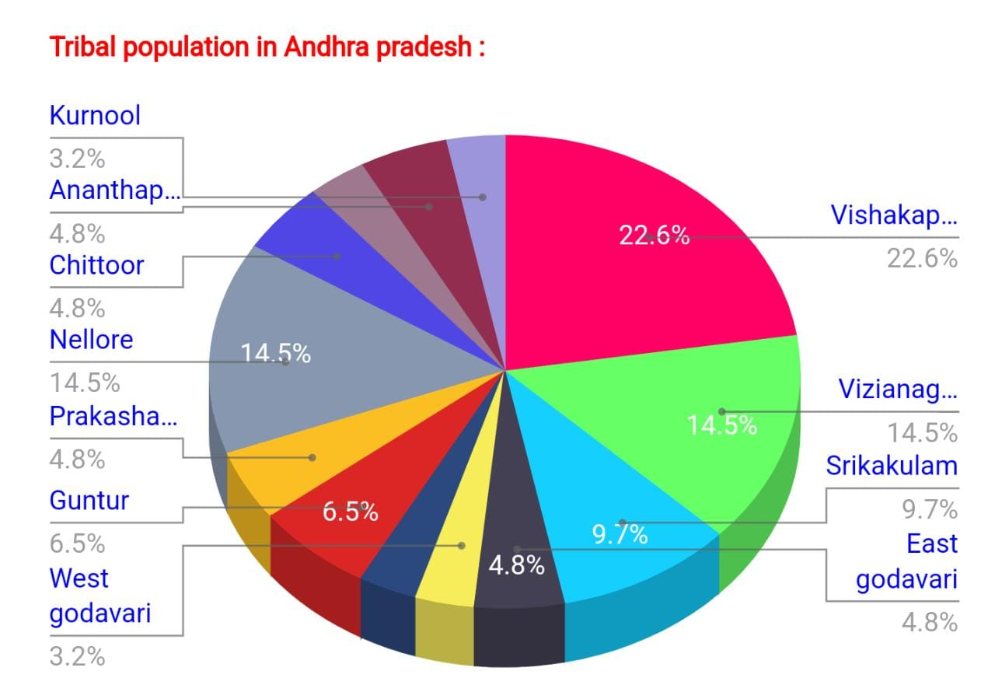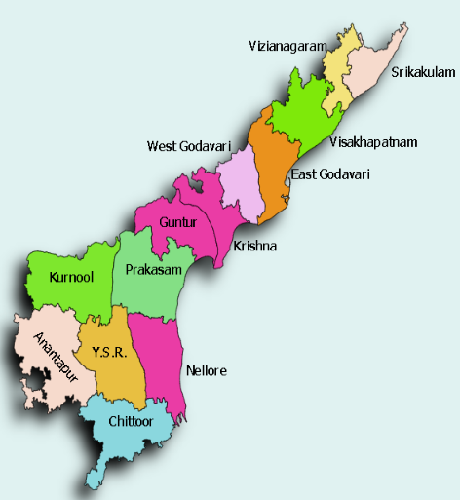

Fig.1. Distribution of tribal population in Andhra Pradesh | Fig.2. Selected districts of Andhra Pradesh for the research study.

As per Venkatanarayan M. (2013) ^{[13]}, “Visakhapatnam, Vizianagaram, and West Godavari districts were purposefully selected for their significant tribal population, as well as to enhance the geographical diversity in the sample. These three districts, namely Visakhapatnam, Vizianagaram and West Godavari, exhibit tribal populations of 13.4%, 10.05%, and 2.77%, respectively”. Araku Valley in Visakhapatnam, Parvathi Puram in Vizianagaram, and Buttaigudem in West godavari district were intentionally chosen as the tribal mandals for this study. Specifically, in the Araku Valley Mandal, out of its 172 villages, the study randomly selected Peddapuram, Doravalasa, Dolliguda, and Pedalabudu. Similarly, in the Parvathipuram Mandal with 49 villages, the study included Gochekka, Tonki, Adaru, and Budhuruvada as its random selections for research. In the Mandal of Buttaigudem there are 53 villages. Out of them four villages namely Sithapagudem, Tellamvarigudem, Doramamidi and K.R Puram were randomly selected for the study. The collected data were analyzed using appropriate statistical methods and tools, such as frequency, percentage, mean score and garrett ranking. Microsoft Excel is used for data interpretation, analysis of mean scores and descriptive statistics.
Operationalization and measurement of dependent variables

Extent of Utilization of RBK services: The measurement of the extent to which farmers utilized RBK services was defined as the degree to which they engaged with the various services offered by RBKs. RBK services are categorized into five sub factors as given below
Factor I: Rendering input services
Factor II: Capacity building services
Factor III: Marketing services
Factor IV: Veterinary services
Factor V: Holistic services
We utilized a schedule developed by Chowdary et al. (2022) with necessary adjustments. To categorize respondents, we employed mean and standard deviation calculations, ultimately grouping them into three categories based on their utilization levels.
List 1: Categorize respondents based on their utilization leve
S. No. | Category | Score
1. | Low extent of utilization | < Mean – S. D
2. | Medium extent of utilization | Mean ± S. D
3. | High extent of utilization | > Mean + S. D

Pre-testing: To assess the validity and reliability of the components within the interview schedule, preliminary is conducted. In areas where no sampling was involved, farmers were interviewed in person, and their responses were gathered for the items outlined in the schedule. Required adjustments were made based on the feedback and data collected.

Data collection: Farmers within the selected sample area were personally contacted and surveyed using a well-structured interview schedule. Subsequently, the gathered data underwent analysis employing various statistical tools, leading to the extraction of significant insights and conclusions.
Statistical tools: To derive meaningful insights from the data analysis, the study utilized the statistical tools like Arithmetic mean, Standard deviation, Frequency and percentage.
Mean scale value: It is the total sum of the scores desired by multiplying the frequency with the assigned scores to the category and dividing by total number of respondents. It has been used to convert the frequency of each preference to a comparative level. The mean scale value was calculated using following formula,
Mean scale value = | P1×3+P2×2+P3×1
Mean scale value = | N
whereas,

P1 = Frequency of respondent of 1st preference
P2 = Frequency of respondent of 2nd preference
P3 = Frequency of respondent of 3rd preference
N = Total number of respondents

RESULTS AND DISCUSSION

Factor: I Rendering input services
According to the data presented in Table 1, it can be deduced that among RBK's input services, the provision of various inputs, including fertilizers, pesticides, and seeds, at a lower cost compared to the local market, received the highest average rating of 2.12. This was closely followed by RBKs' commitment to delivering certified products at the right time and place, with a rating of 2.07. Other services included supplying quality seed materials through D-Krishi or mini kits (2.06), providing IPM kits like pheromone traps, sticky traps, and lures (2.04), offering bio-fertilizers and bio-fungicides (2.03), making organic inputs available and other natural farming products (2.02), providing farm equipment through custom hiring centers in RBKs (1.96), and maintaining digital kiosks for input bookings (1.92).

Table 1. Distribution of respondents according to rendering input services. (n=120)
S.  No | Statements | Most utilized | Utilized | Not utilized | Mean Score | Rank
S.  No | Statements | F (%) | F (%) | F (%) | Mean Score | Rank
1. | Supply of biofertilizers and | 11 | 102 | 7 | 2.03 | V
 | bio fungicides | (9.17) | (85.0) | (5.83)
2. | Providing IPM kits like pheromone traps, sticky traps and lures etc | 16  (13.33) | 93  (77.5) | 11  (9.17) | 2.04 | IV
3. | Provision of various inputs viz., fertilizers, seeds at a lower price compared to local market | 23  (19.17) | 88  (73.33) | 9  (7.50) | 2.12 | I
4. | Supply of quality seed material (green manure/ crop seeds /fodder seeds /concentrate feed) through D-Krishi | 13  (10.83) | 101  (84.17) | 6  (5.00) | 2.06 | III
5. | RBKs commitment to the delivery of certified products at right time and place | 19  (15.83) | 91  (77.14) | 10  (7.86) | 2.07 | II
6. | Farm equipment made available to farmers in village by maintaining custom hiring centers in RBKs | 18  (15) | 79  (65.83) | 23  (19.17) | 1.96 | VII
7. | Availability of organic inputs like neem cake, vermi-compost, neem oil, natural farming products etc. | 14  (11.67) | 95  (79.17) | 11  (9.17) | 2.02 | VI
8. | Maintaining digital kiosk for | 18 | 75 | 23 | 1.92 | VIII
 | Input bookings | (15.0) | (62.5) | (22.5)

Factor II: Capacity building services

According to the findings in Table 2, the top-rated capacity-building service offered by RBK was the organization of Polambadi, Thotabadi or Pasu vigyanbadi with a mean score of 2.63. This was closely followed by conducting advisory board meetings on a monthly basis, arranging training programs for farmers to update them on recent advancements in agriculture led by scientists, integrating with the ICC, the RBK channel for addressing farmer queries, and promoting interaction between farmers and scientists.

Table 2. Distribution of respondents according to capacity building services. (n=120)
S. No. | Statements | Most utilized | Utilized | Not utilized | Mean Score | Rank
S. No. | Statements | F (%) | F (%) | F (%) | Mean Score | Rank
1. | Arranging training programmes to farmers to update them on recent advances in agriculture led by scientist | 62  (51.67) | 53  (44.17) | 5  (4.17) | 2.47 | III
2. | Conducting advisory board meetings on a monthly basis | 67  (55.83) | 44  (36.67) | 9  (7.50) | 2.48 | II
3. | Organization of polambadi or thotabadi or pasuvigyanbadi | 81  (67.50) | 34  (28.33) | 5  (4.17) | 2.63 | I
4. | Integrating with the ICC, RBK channel for addressing farmers queries and promoting interaction between farmers and scientists. | 53  (44.17) | 58  (48.33) | 9  (7.50) | 2.36 | V
5. | Maintenance of a smart TV to facilitate interaction with scientists and other experts through audio and video conferences, along with the dissemination of technology. | 60  (50.00) | 53  (44.17) | 7  (5.83) | 2.44 | IV

Factor III: Marketing services

The findings in Table 3 indicate that RBK's marketing services have been assessed, and the following services were ranked based on their mean scores. Leading the list is RBK's facilitation of village produce marketing through procurement centers, receiving the highest mean score of 2.87. This is followed closely by the practice of purchasing surplus produce at minimum support prices (MSP) when market prices fall below MSP, which earned a mean score of 2.82. Other services include the provision of free crop insurance (mean score of 2.77), the availability of storage facilities in go-downs during times of produce surplus (mean score of 2.73), and the establishment of dedicated markets for organically produced goods and services (mean score of 2.68).

Table 3. Distribution of respondents according to marketing services. (n=120)

S.No. | Statements | Most utilized | Utilized | Not utilized | Mean score | Rank
S.No. | Statements | F (%) | F (%) | F (%) | Mean score | Rank
1. | Availability of storage facilities in go-downs during times of produce surplus | 91  (75.83) | 26  (21.67) | 3  (2.50) | 2.73 | IV
2. | Establishment of separate markets for organically produced goods and services | 89  (74.17) | 24  (20.0) | 7  (5.83) | 2.68 | V
3. | Facilitation of village produce marketing through procurement centers | 107  (89.17) | 11  (9.17) | 2  (1.67) | 2.87 | I
4. | Purchasing surplus produce at MSP whenever market prices fall below MSP | 101  (84.17) | 16  (13.33) | 3  (2.50) | 2.82 | II
5. | Provision of free crop insurance | 98  (81.67) | 17  (14.17) | 5  (4.17) | 2.77 | III

Factor IV: Consultancy services

The data from Table 4 reveals that, among the consultancy services offered by RBKs, the highest-rated service is the identification of beneficiaries for various government schemes, garnering the top mean score of 1.96. Following closely is the provision of guidance regarding the extent of loan eligibility, which received a mean score of 1.92. Additionally, RBKs excel in providing need-based information to farmers on crop health management, with a mean score of 1.90. Other valuable services include providing information on loans, weather conditions, and market prices through the CM APP (1.89) and maintaining a digital library with information materials aimed at enhancing farmers' knowledge (1.85).

Table 4. Distribution of respondents according to consultancy services. (n=120)

S.No. | Statements | Most utilized | Utilized | Not utilized | Mean Score | Rank
S.No. | Statements | F (%) | F (%) | F (%) | Mean Score | Rank
1. | Maintaining a digital library with information materials aimed at enhancing farmer's knowledge | 9  (7.5) | 84  (70.0) | 27  (22.5) | 1.85 | V
2. | Providing information on loans, weather conditions, and market prices through the CM APP | 11  (9.17) | 85  (70.83) | 24  (20) | 1.89 | IV
3. | Provision of guidance regarding the extent of loan eligibility | 15  (12.5) | 81  (67.5) | 24  (20.0) | 1.92 | II
4. | Identification of tribal beneficiary farmers for various government schemes | 19  (15.83) | 78  (65) | 23  (19.17) | 1.96 | I
5. | Providing the need-based information to farmers on management of crop health | 14  (11.67) | 80  (68.33) | 26  (21.67) | 1.90 | III

Factor V: Veterinary services

The data mentioned in Table 5 indicates that within the realm of veterinary services delivered by RBKs, providing free vaccination for animals stands out with the highest mean score of 1.53. Following closely in terms of mean scores are the provision of animal health cards (mean 1.51), offering first aid for animals and treatment after consulting with Veterinary Assistants and performing semen collection and Deworming procedures (mean 1.27), and offering free animal insurance (mean of 1.27).

Table 5. Distribution of respondents according to veterinary services. (n=120)
S.No. | Statements | Most utilized | Utilized | Not utilized | Mean score | Rank
S.No. | Statements | F (%) | F (%) | F (%) | Mean score | Rank
1 | First aid for animals and treatment consultations VAS, deworming and semen collection | 4  (3.33) | 29  (24.17) | 87  (72.50) | 1.30 | III
2 | Provision of free animal vaccination | 5  (4.17) | 54  (45.00) | 61  (50.83) | 1.53 | I
3 | Providing animal health cards | 5  (4.17) | 51  (42.50) | 64  (53.33) | 1.51 | II
4 | Free animal insurance | 4  (3.33) | 25  (20.83) | 91  (75.83) | 1.27 | IV

Factor VI: Holistic services

The insights derived from Table 6 indicate that among the comprehensive services offered by RBKs, the provision of Rythu Bharosa on an annual basis stands out as the most highly-rated service, garnering the highest mean score of 2.27.

Table 6. Distribution of respondents according to holistic services. (n=120)

S.No. | Statements | Most utilized | Utilized | Not utilized | Mean score | Rank
S.No. | Statements | F (%) | F (%) | F (%) | Mean score | Rank
1 | Provision of Rythu Bharosa on an annual basis | 39 | 75 | 6 | 2.27 | I
 | Provision of Rythu Bharosa on an annual basis | (32.50) | (62.50) | (5.00)
2 | Practices of organizing farmers into Farmer Producer Organizations (FPO), Farmer Interest Groups (FIG), and cooperative societies | 40  (33.33) | 69  (57.50) | 11  (9.17) | 2.24 | II
3 | RBKs offer soil and seed testing facilities | 37 | 71 | 12 | 2.21 | III
 | RBKs offer soil and seed testing facilities | (30.83) | (59.17) | (10.10)

Overall extent of utilization
Among the six distinct service categories offered by RBKs, marketing services were notably the most utilized by farmers, exhibiting mean score values ranging from 2.68 to 2.87. Following closely in terms of utilization were capacity building services and holistic services, with mean scores spanning from 2.44 to 2.63 and 2.21 to 2.27, respectively.
In contrast, rendering input services experienced moderate utilization with mean scores falling within the range of 1.92 to 2.12. Conversely, consultancy services and veterinary services witnessed lower levels of utilization, with mean scores ranging from 1.85 to 1.96 and 1.27 to 1.53, respectively
The primary reason behind the pronounced use of marketing services may be attributed to RBKs facilitating market linkages for locally grown crops, informing farmers about prevailing prices, and assisting them in selling their produce at profitable rates. This accessibility to markets resulted in a higher adoption of these services.
Concerning capacity building services, the significance lies in their location – RBKs provided these services in the village itself, tailored to the specific needs of the local farmers. Various training programs instilled enthusiasm for knowledge acquisition and helped farmers adapt to changing agricultural conditions.
Holistic services, such as Rythu Bharosa, provided financial support to farmers, significantly benefiting small and marginal farmers, tenant farmers, and agricultural laborers. These services also contributed to improving the economic conditions of farmers and promoting sustainable agriculture practices.
The moderate utilization of rendering input services may be attributed to the provision of agricultural inputs at subsidized rates by RBKs. However, delays in the supply of these inputs may have deterred some medium and large-scale farmers from fully embracing these services.
Conversely, low utilization of consultancy services may be due to traditional farmers' hesitance to seek advice or guidance from RBK staff. Trust and credibility issues may have played a role, and it may take time to build the necessary rapport.
Regarding the low utilization of veterinary services, this could be attributed to limited knowledge and awareness about the veterinary services available at RBKs. Farmers might also have well-established relationships with local veterinarians, making them more comfortable seeking assistance from them. The study's comprehensive findings on the overall extent of RBK service utilization are summarized in Table 7 and illustrated in Fig 3.

Table 7. Distribution of the respondents based on their overall extent of utilization of services of RBKs. (n=120)
S. No | Category | Frequency | Per cent
1. | Low extent of utilization (<57) | 21 | 17.5
2. | Medium extent of utilization (57-71) | 81 | 67.5
3. | High extent of utilization (>71) | 18 | 15.0
Total |  | 120 | 100
Mean = 63.12 Standard Deviation: 7.3

A significant majority of farmers, approximately 67.5%, exhibited a moderate level of utilization of RBK services. This was followed by 17.5% of farmers who displayed a low level of service utilization, while the remaining 15% had a high extent of utilization.

Fig.3 Distribution of respondents based on their overall extent of utilization
The primary rationale behind this notable trend of medium to high service utilization by the majority of farmers can be attributed to the grassroots establishment of RBKs. This local presence enables farmers to readily access the services they require. Moreover, the comprehensive array of services offered by RBKs, addressing farmers' needs from the initial stages of planting to the final sale of their produce, ensures accessibility to essential services without imposing a heavy financial burden on farmers.
These findings align with the observations made by Pacha (2022) and Anuhya (2021), who also reported a prevailing trend of medium to high service utilization among farmers.

CONCLUSION
The study clearly reveals that Rythu Bharosa Kendras (RBKs) have emerged as comprehensive one-stop centers supporting farmers through a wide range of agricultural services. Among the various service categories, marketing services were found to be the most utilized, primarily due to RBKs’ strong role in facilitating market linkages, procurement, and ensuring fair prices for farmers. This was followed by capacity-building and holistic services, which significantly contributed to enhancing farmers’ knowledge, skills, and financial stability. While input rendering services showed moderate utilization, mainly due to occasional delays in supply, consultancy and veterinary services exhibited relatively lower utilization, largely due to trust barriers, limited awareness, and farmers’ dependence on traditional service providers. Overall, the study concludes that a majority of farmers (67.5%) demonstrated a moderate level of utilization of RBK services, highlighting their growing importance in rural agricultural development. The establishment of RBKs at the village level has ensured greater accessibility and inclusivity, particularly benefiting small and marginal farmers. These findings reaffirm that RBKs play a vital role in empowering farmers, improving productivity, and promoting sustainable agricultural practices in the region.

AUTHOR CONTRIBUTION
All authors contributed significantly to the completion of this research paper titled, Analyzing the Utilization of Rythu Bharosa Kendra Services by Tribal Farmers in Andhra Pradesh Region. Dr. Bishnupriya Mishra guided in framing the conceptual framework of the study. R Kishorekumar involved in data collection, data analysis and interpretation of results. Pooja Mohanty involved in analysis and Divya Parimi involved in analysis and assisted in interpreting the findings. Each author approved the final version of the manuscript and agreed to be accountable for all aspects of the work.

Disclaimer (Artificial intelligence)
Option 1:
Author(s) hereby declare that NO generative AI technologies such as Large Language Models (ChatGPT, COPILOT, etc.) and text-to-image generators have been used during the writing or editing of this manuscript.
Option 2:
Author(s) hereby declare that generative AI technologies such as Large Language Models, etc. have been used during the writing or editing of manuscripts. This explanation will include the name, version, model, and source of the generative AI technology and as well as all input prompts provided to the generative AI technology
Details of the AI usage are given below:
1.
2.
3.

REFERENCES
- Ameta, P. 2015. "Utilization of e-Mitra services by rural youth." Unpub M.Sc. (Home Science) Thesis, Maharana Pratap University of Agriculture & Technology., Udaipur.
- Anuhya, Kisku U, and Khare N. 2022. "A study on correlates of profile characteristics and adoption behaviour of Rythu Bharosa Kendra (RBK) beneficiaries in Anantapur District, Andhra Pradesh." Current Journal of Applied Science and Technology 41 (24):39-45.
- Anuhya P, Kisku U, Khare N K, and Ramakrishna M. 2022. "A study on awareness, constraints and suggestions about Rythu Bharosa Kendra (RBK) services by the beneficiary farmers in Ananthapuram District of Andhra Pradesh." Multilogic in Science Journal 12.
- Babu, Nagendra N, Venkataramulu M, Venu Prasad H D, Sarma A S R, and Usha M. 2021. "Impact of Rythu Bharosa Kendra’s as Perceived by the Farmers." Asian Journal of Agricultural Extension, Economics and Sociology 41:606-616.
- Chowdary, Raghavendra K, Jyotsna M K, and Jyothi I. 2022. "A Study on Perception and Utilization of Services of Rythu Bharosa Kendra’s (RBKs) by the Farmers in Chittoor District of Andhra Pradesh, India." Current Journal of Applied Science and Technology 41 (27):40-47.
- Giridhar, KA. 2017. "Awareness and utilization of mobile phone services by farmers to access information for increasing agricultural productivity." Unpub. M.Sc. (Agri.) Thesis., University of Agricultural Sciences, Dharwad, Karnataka.
- Krishna T, Vamsi Y, Acharya S K, Biswas A, and Haque M. 2022. "Assessment of constraints and opportunities of technology adoption in agriculture during pandemic by participatory exercise." The Pharma innovation Journal 11 (2):1212-1215.
- Pacha, A. 2022. "Perception and utilization of services of Rythu Bharosa Kendras by the farmers in Guntur district of Andhra Pradesh " Unpub. M.Sc. (Agri.) Thesis, Palli Siksha Bhavana (Institute of Agriculture), Visva-Bharati, Srineketan, West Bengal.
- Reddy, Anilkumar D. 2020. "RBKs of Andhra Pradesh–one stop solution for the needs of farming community." Vigyan Varta 1 (3):22-24.
- Reddy U U. 2022. "A study on farmers perception towards Products and services offered at Rythu Bharosa Kendras (RBKs) in Kurnool district of Andhra Pradesh " Unpub M.B.A. (ABM) Thesis, Sri Venkateshwara Agricultural College, Acharya N.G Ranga Agricultural University, Tirupathi.
- Saifuddin Md. 2022. "Rythu Bharosa Kendras in service of farmers – An Exploratory Study." M.Sc. (Ag.) Thesis, Acharya N. G. Ranga Agricultural University, Bapatla, Andhra Pradesh.
- Saifuddin Md, Devy M R, Rao M S, and Suseela K. 2023. "Effectiveness of Rythu Bharosa Kendras (RBKs) Services as Perceived by Farmers in the East Godavari District of Andhra Pradesh, India." Asian Journal of Agricultural Extension, Economics & Sociology 41 (4):34-41.
- Venkatanarayan M. (2013). scheduled castes and Tribes in Andhra Pradesh: A situation Assessment Analysis. Munic Personal RePEc Archive. Page no:48186. https://mpra.ub.uni-muenchen.de/48186/

