Assessment of Carbon Sequestration in a Cocoa Field in the Lôh-Djiboua Region: The Case of Divo, Côte d’Ivoire

Abstract
This study was conducted in Divo Botanic reserve. The overall objective of the present research is to determine the various carbon sequestration potentials in cocoa-based agroforestry plantations. The biological material consists of trees recorded in Divo Botanic reserve. The sampling design includes 26 plots measuring 30 m x 50 m, randomly established and 61 plant species were recorded. The diameter was measured over bark at breast height (DBH) of 1.30m from the ground). The tool used to measure tree circumferences was a forestry tape. Biomass stocks were obtained using two methods: destructive and non-destructive. To determine carbon stock, aboveground biomass was converted according to established recommendations. The distribution of trees by height class showed a dominance of individuals in the medium height class. The height of most trees ranged from 10-15metres and 16-20metres, which alone stores an average of 42.03 tC/ha. The least carbon stock was recoreded was 27.94 tC/ha at the first Agroforestry system (SAF1), while the highest was 42.03 tC/ha, recorded the lowest carbon rate compared to the third Agroforestry system (SAF3), which alone stores an average of 42.03 tC/ha.The relationship between carbon stock and tree diameter showed a strong correlation, as the correlation coefficient was r = 0.98, close to 1, with a p-value less than 0.05.
Keywords : Carbon Sequestration, Tree circumferences, Aboveground biomass, Agroforestry system

Introduction
Ecosystems provide goods, ecological, and socio-economic services essential for the well-being and development of human populations (Ouattara et al., 2016). The approval of the Reducing Emissions from Deforestation and Forest Degradation (REDD) mechanism in Bali in 2007 led to a global mobilization to generate information on carbon stocks in potential existing carbon sinks, including land-use systems. Indeed, one of the many ecological services provided by ecosystems is the natural sequestration of carbon, which has become a major issue for climate stability today (Barré et al., 2020). However, with the degradation of natural ecosystems, it is evident that the carbon sequestration potential varies depending on the agroforestry practices applied.
Agroforestry has existed for several hundreds, even thousands of years, as a traditional land-use system practiced by many populations around the world (Touoyem, 2022), particularly in tropical countries (Ngono et al., 2015). Cocoa-based agroforestry systems are highly valued in Africa, especially in West and Central Africa (Koulibaly et al., 2010), as they help reduce deforestation commonly associated with cocoa cultivation in the tropics (Dixon et al., 2001). Indeed, cocoa trees are grown in association with many perennial, forest, and fruit species with multiple uses, providing farmers with various products for consumption or sale to increase their income. This also helps them mitigate risks related to the volatility of global cocoa prices (Sonwa et al., 2002). In Côte d’Ivoire, the cultivation of cocoa (Theobroma cacao L.) holds a significant place in the national economy (Vroh et al., 2019). Indeed, Côte d’Ivoire has remained the world's leading producer of cocoa beans since 1978 (Tano, 2012). However, the expansion of cocoa plantations has led to a significant reduction in forest areas (Goetze et al., 2010; World Bank, 2019). As averred by FAO (2005), Kassoum (2018) and IFFN (2021), the forest cover has drastically reduced from 16 million in 1960 to 2.97 million hectares. The current landscape of Côte d’Ivoire shows that more than 30% of the national territory is occupied by cocoa plantations (FAO, 2009; National REDD+ Strategy, 2018). These systems are also found in Mexico (Salgado-Mora et al., 2007) and Brazil (Ruf & Schroth, 1995). These agroforestry systems offer several ecosystem services, ranging from biodiversity conservation to carbon sequestration, including the preservation of soil diversity (Xavier et al., 2009).
The general objective of this study is to determine the different carbon sequestration potentials in cocoa-based agroforestry plantations. It aims to identify the various factors influencing these potentials, as well as the consequences for sustainable natural resource management and rural development in the Divo Botanic reserve, and to propose strategies to maximize carbon sequestration. Three specific objectives stem from this main aim. First, to conduct inventory of the diversity of plant species. Second, to quantify the above-ground biomass. Finally, to estimate the carbon stocks of the vegetation.

1. Material
1.1. Study area
Divo Botanic reserve is located in the Central-Western part of Côte d'Ivoire, in the Lôh-Djiboua Region, specifically in the Divo Department (Harvey-Brown, 2024). According to Ourega and Gbocho (2021), Divo, a colonial town founded in the Dida region from two villages (Bada and Boudoukou) gradually evolved into an administrative center thus: becoming a Sub-prefecture on January 30, 1961, a Prefecture in 1969, and a full-fledged Municipality in 1978 according to Law No. 78-07 of January 9, 1978. It became the regional capital of Lôh-Djiboua on January 15, 1997. Located in the south-western forest zone of Côte d'Ivoire, between 5°55' North latitude and 5°37' West longitude (Adou, 2021), the town of Divo lies 200 km from Abidjan, the economic capital of Côte d'Ivoire. The Divo Department borders Oumé to the North, Lakota to the West, Tiassalé to the East, and Fresco and Grand-Lahou to the South (Dihouegbeu, 2022).
Divo Botanic reserve is a large biosphere asset located 4 km from the Sub-prefecture headquarters, along the Divo-Tiassalé road (between the villages of Blé and Kpakossou-Carrefour) in the Lôh-Djiboua Region, Southern Côte d'Ivoire (Figure 1). The area designated and regulated as a botanical reserve forms a polygon with 29 numbered vertices. Vertex 1 (marker SF 3), defined by its geographic coordinates, is located at 5°17'28" West longitude and 5°50'22" North latitude, south of the N’Douci-Divo road.

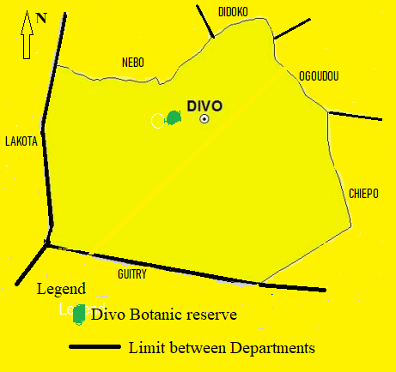
Figure 1: Presentation of the Study Area

1.2. Biological Material
The biological material consists of the trees inventoried in the Divo Botanic reserve.

1.3. Technical Material
For data collection on the trees, we used a measuring tape (Figure 2) to measure diameters, a smartphone equipped with the mobile data collection application "ODK Collect" to record inventory data in the field, forms were prepared in Excel and Word and a GARMIN 64 GPS device (Figure 3) to capture the geographic coordinates of each tree. All primary data collected were processed using software packages including Microsoft Office (Word, Excel), R/RStudio (Biomass, ggplot2, tidyverse), QGIS, and ARCGIS.
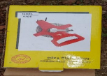
Figure 2: Measuring tape
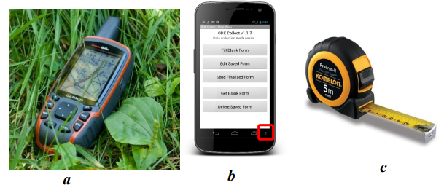 Figure 3: Equipment used for data collection

2. Methods
2.1. Installation of Sampling Plots
The sampling setup consists of 26 plots measuring 30 m x 50 m, installed randomly (Figure 4). At the start of setting up each plot, a reference point is identified to determine the azimuth. A baseline trail of 30 m in length is cleared using a compass and machetes. The 30 m x 50 m plot is then established using two tape measures. The geographic coordinates of each plot are recorded after installation.
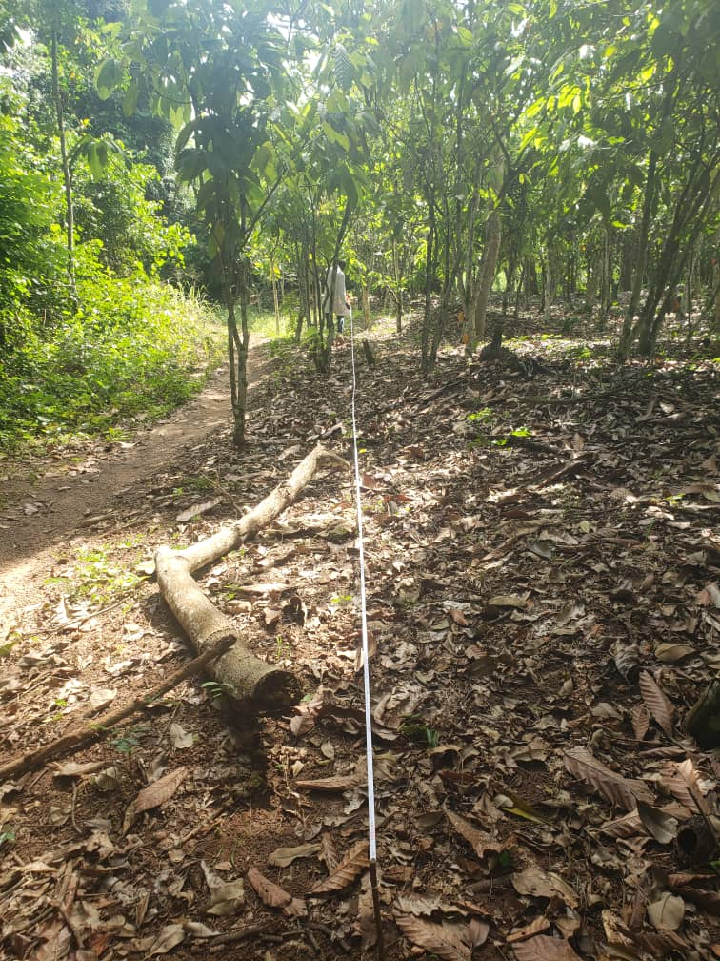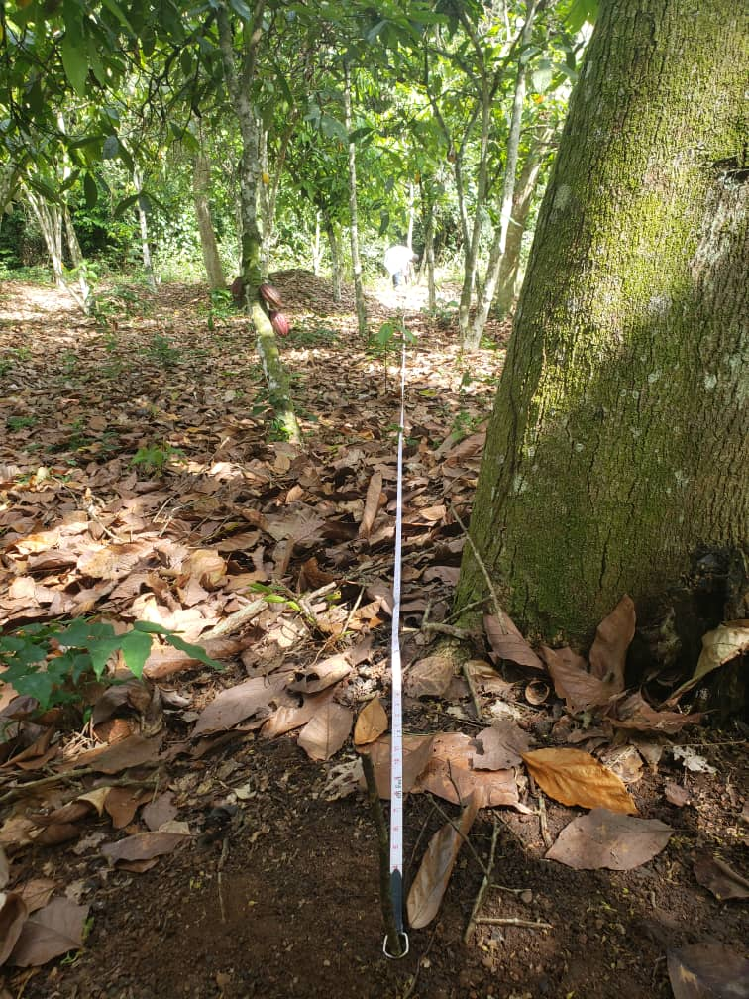
Figure 4: Installation of the sampling plots

2.2. Measurement of Tree Circumferences
In our study, we were able to measure only one predictor, namely the diameter of forest and fruit trees (Figure 5). The diameter was measured on the bark at breast height (DBH = 1.30 m above the ground). The tool used for measuring circumferences was the forestry tape.
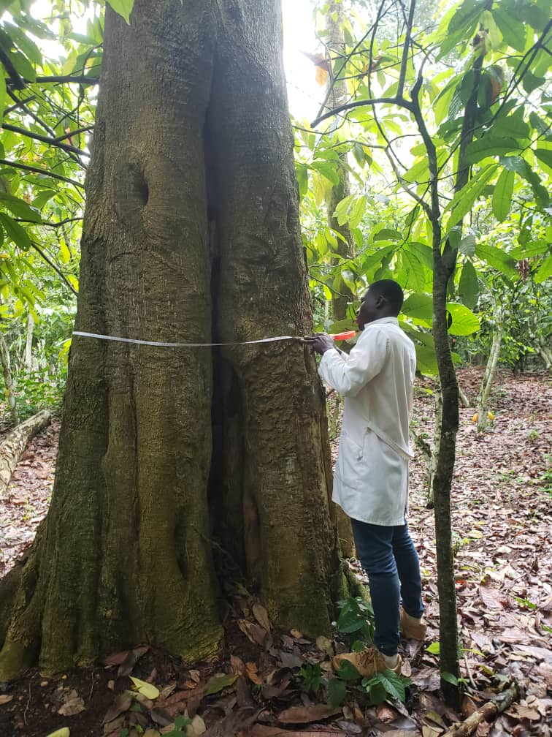
Figure 5: Measurement of tree circumference

2.3. Estimation of Carbon Stocks
To evaluate the amount of carbon sequestered in an ecosystem, it is recommended to estimate the biomass stocks present in the plots and multiply the result by a conversion factor (CF), which is 0.47 for this study (Zapfack et al., 2013). Biomass stocks are obtained using two methods: destructive and non-destructive. The non-destructive method involves applying allometric models to dendrometric measurements taken in the field. For this purpose, the allometric equations are used. On the other hand, the destructive method involved cutting all herbaceous plants. In the five subplots of 5 m x 5 m installed at the four corners and one at the center of the main 30 m x 30 m plot, all herbaceous plants present were cut at ground level, weighed, and then an aliquot (sub-sample) was taken if necessary, weighed, and finally dried in an oven at 105 °C for two to three days. The dry mass of each sample was determined using the following equation (Brown, 2005).

$$Y= \frac{Pht ×Ps}{Ph}$$

Where:
Ps = Dry weight of the sample after 3 days in the oven;
Ph = Fresh weight of the composite sample in the field;
Pht = Total fresh weight in the field.
To interpret and compare the results obtained with other studies, the biomass stocks measured at the plot level are extrapolated to one hectare using an expansion factor (EF) according to the following formula (Brown, 2005).

$$FE= \frac{ {10000 m}^{2}}{S}$$
Where:
S = Plot area in m²

2.4. Data analysis
2.4.1. Carbon Stock Estimation
2.4.1.1. Aboveground Biomass Calculation
In this study, the focus was on estimating aboveground biomass, and we had two methods available: the non-destructive method and the allometric equation method. Regarding the non-destructive method, our measurements were made only on forest species. This restriction is premised on autorisation by forestry administration before cutting down tees. Furthermore, we are constrained by limited financial resources. However, the literature provides data on the carbon stock contained in cocoa trees, which is 10 tC/ha according to the studies by Santhyami et al., (2018). The work of Réjou et al., (2017) led to the development of the "BIOMASS" package included in the R/RStudio software. This package allowed us to estimate the carbon stock of our different agroforestry systems. "BIOMASS" performs a number of standard tasks: (i) identification and correction of taxonomy, (ii) estimation of wood density based on tree species identity, (iii) construction of a local height-diameter (H-D) allometry using tree height data, and (iv) estimation of Aboveground Biomass (AGB) with associated errors. With this package, we have the option to estimate carbon stock using two approaches:
• If tree height data are available, AGB (aboveground biomass) is calculated using the following equation (Chave et al., 2014):

𝐆𝐁 = 𝟎. 𝟎𝟔𝟕𝟑 ∗ (𝛒 ∗ 𝐃𝐇𝐏 ∗ 𝐇) 𝟎.𝟗𝟕𝟔
If no tree height data are available, AGB is calculated using the site coordinates (Chave et al., 2014; Réjou-Méchain et al., 2017). In the following equation, an additional variable quantifies environmental stress, developed by Chave et al. (2014). The environmental stress factor E encompasses temperature seasonality, drought intensity, and precipitation seasonality, and ranges from -0.2 to 1 across tropical forests.

𝑮𝑩 = 𝒆𝒙𝒑 (-𝟐, 𝟎𝟐𝟒 - 𝟎, 𝟖𝟗𝟔 ∗ 𝑬 + 𝟎, 𝟗𝟐𝟎 ∗ 𝒍𝒐𝒈 (𝝆) + 𝟐, 𝟕𝟗𝟓 ∗𝒍𝒐(𝑫𝑯𝑷) - 𝟎, 𝟎𝟒𝟔𝟏 ∗ (𝒍𝒐𝒈 𝑫𝑯𝑷𝟐))

ρ = Species density
DBH = Diameter at breast height
H = Total height of a tree
E = Environmental factor related to the study area

2.4.1.2. Determination of the CO2 rate
To determine the carbon stock, we converted the aboveground biomass according to the recommendations of (Penman & IPCC, 2003). The carbon stock is equal to 50% of the calculated aboveground biomass (AGB) (Chenost et al., 2010). After estimating the total amount of carbon contained in a tree, the corresponding CO₂ rate was determined. The sequestered CO₂ is obtained by using the ratio of the molar masses of carbon and CO₂. The mass of CO₂ is calculated by the following formula:
m CO₂ = AGB × MCO₂ / MC, that is, m CO₂ = AGB * 44 / 12.

2.4.2. Carbon Sequestration Estimation
For the carbon sequestration potential, the Above ground biomass (AGB) of the different individuals was calculated using the allometric equation employed by Mbow et al. (2014) for the savanna forests of the Sudanian zone. For an individual (i), the Above ground biomass is calculated as follows:

d: diameter of the tree at 1.3 meters above the ground, in centimeters.
To obtain d, we use the basic formula for the circumference of a tree trunk, which is C = π × d. In this equation, C is the circumference of the tree. The constant π has a value approximately equal to 3.1416. The diameter of the tree trunk is d.

3. Results
3.1. Plant Species Richness in the Agroecosystems
The total number of species recorded in the various plantations from the floristic inventory conducted in this study revealed 61 species. These species are distributed across 52 genera belonging to 30 botanical families (Appendix 1).

3.2. Distribution by Families
The various plant species recorded in our study area are unevenly distributed among botanical families (Figure 6). The most represented family is Fabaceae, with 10 species. It is followed by Meliaceae (six species), Combretaceae, and Malvaceae, with four species each. Several families are less represented. This includes seventeen families such as Anacardiaceae, Annonaceae, Apocynaceae, etc., which each contain only one species. Similarly, seven families, including Araceae, Dichapetalaceae, and Flacourtiaceae, have two species each.

Figure 6: Distribution of Recorded Plant Species by Families

3.3. Distribution of Trees by Height Classes
The distribution of trees by height class (Figure 7) shows a monotonic pattern. This form reflects a dominance of individuals in the medium height classes. The majority of individuals fall within the height classes of (10–15 meters) and (15–20 meters).

Figure 7: Distribution of Trees by Height Classes

3.4. Carbon Stock of Woody Species
The first Agroforestry Systems (SAF1), which stores 27.94 tC/ha, represents the system with the lowest carbon stock compared to SAF3, which alone stores an average of 42.03 tC/ha. Thus, SAF3 has the highest carbon stock among the three systems. SAF2 ranks second with 28.65 tC/ha (Figure 8).
Farmers would like to plant certain species that have high food value and timber production potential but are currently scarce in their SAFs. However, several constraints hinder this introduction, such as the lack of seedlings, limited knowledge of silvicultural techniques, slow tree growth, and excessive shading.

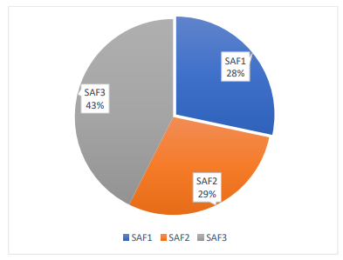
Figure 8: Estimation of Carbon Stock in the Agroforestry Systems (SAFs)

3.5. Relationship Between Carbon Stock and Tree Diameter
Figure 9 shows the relationship between a dendrometric parameter: DBH (Diameter at Breast Height) and carbon stock (tC.ha⁻¹). This graph indicates a strong correlation between tree diameter and carbon stock. Indeed, the correlation coefficient obtained by calculation is r = 0.98, close to 1 for a p-value of less than 0.05. Furthermore, the shape of the curve and the positions of the points on the graph are similar. There is, therefore, a strong positive correlation between carbon stock and tree diameter.
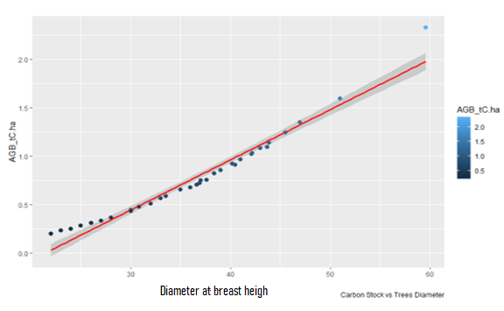

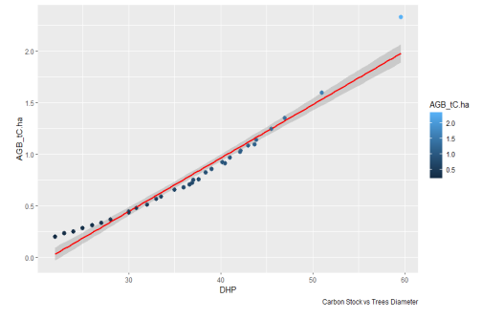
Figure 9: Relationship Between Carbon Stock and Tree Diameter

4. Discussion
4.1. Monitoring of Carbon Sequestration in Cocoa Farms
The results obtained from the monitoring of carbon sequestration in a cocoa field in the Divo region (Côte d’Ivoire) allowed the identification of 61 plant species belonging to 30 families.
The considered agroforestry systems (AFS) are relatively young compared to other cocoa plantations studied in Cameroon, where similar studies were conducted on 40-year-old plantations (Jagoret, 2011). The carbon stocks of AFS1 and AFS2, which are respectively 27.94 tC/ha and 28.65 tC/ha, remain lower than those reported by Temgoua et al. (2018). However, these results are higher than those reported by Santhyami et al. (2018).
AFS3, which stores 42.03 tC/ha, is the best-performing agroforestry system. This value is similar to that found by Oelbermann et al. (2006) but lower than that reported by Nolte et al. (2001) in a study on carbon stock estimation in agroforestry systems in Cameroon. These differences are probably due to the diversity of environments, tree densities, the different allometric equations used, and also the variation of species within the systems. Agroforestry promotes the sequestration of soil organic carbon (CO₂). According to Pan et al. (2025), agroforestry produces more diverse and abundant sources of carbon (litter, straw, and root biomass), which form the material basis for CO₂ accumulation. Furthermore, according to Ngaba et al. (2024) Meta-analysis unveils differential effects of agroforestry on soil quality indicators across climatic zones.
In the current context of climate change, forest loss could be offset by climate-smart agriculture that ensures carbon storage within cocoa-based agroforestry systems (Njomgang et al., 2011; Norgrove & Hauser, 2013; Atangana et al., 2014). This approach, which involves maintaining or integrating woody vegetation, would promote greater carbon sequestration and a high level of carbon storage for sustainable cocoa farming. The contribution of traditional cocoa agroforestry systems to carbon storage was assessed through the evaluation of carbon stocks in the associated woody vegetation and the cocoa stand, as well as through key structural parameters. In terms of carbon stock assessment, results show that the number of cocoa trees is higher than that of associated species, regardless of the study site. However, across all sites, both biomass and carbon stock are greater in the associated woody vegetation. The distribution of biomass and carbon stock across diameter and height classes shows that cocoa trees contain more biomass and carbon than associated woody species in the smallest diameter classes. This result highlights the importance of the cocoa variety's architecture (Jagoret, 2011). It may also be explained by the high density of cocoa trees and the fact that cocoa trees are shrubs. On the other hand, the highest biomass and carbon stock values of the associated vegetation are found in the classes with heights over 8 meters and diameters above 40 cm. The majority of the stored carbon is located in the biomass of large trees, which is similar to the results of Saj et al. (2013) obtained in the Ngomedzap area in central Cameroon. Although Kouamé (2013) reports that factors influencing carbon stock include species, diameter, height, planting density, and biodiversity, our results show that the diameter and total height of the tree are key parameters for managing cocoa agroforestry systems in the face of climate change. The taller and larger the diameter of the trees are the more carbon the cocoa agroforestry system stores. Contrary to our findings, Evans et al. (2016) showed that the correlation between tree crown size and carbon stock was moderately strong, while the correlation between diameter, height, and total tree carbon was generally weak.

4.2. Quantitative Evaluation of Cocoa Agroforestry Systems (AFS)
The floristic inventory across all AFS recorded a total of 61 species in addition to cocoa (Theobroma cacao). This value is roughly similar to the 51 and 45 species recorded respectively in cocoa plantations over 15 years old in Mbankomo by Nganwa (2001) and in AFS over 40 years old in Pendiki (Littoral) by Mbade (2012). However, it is higher than the 30 species found in AFS over 40 years old in the Centre region by Jagoret et al. (2011). The abundant species found in the AFS are characteristic of the severely degraded semi-deciduous forest facies (Letouzey, 1985). Other studies have shown that the species composition of AFS in the South and Southwest regions of Cameroon is quite distinct from that of natural forests (Zapfack et al., 2002; Bobo et al., 2006). The presence or absence of a woody species in an AFS depends on the farmer’s preferences, as they select trees to keep based on their useful properties. It was observed that the species left standing were useful either for traditional medicine, nutrition, soil fertilization, or because of the difficulty of cutting them down, or for providing shade in the case of most forest species. The absence or scarcity of certain species is linked to their being cut down for firewood or timber.

Conclusion
Cocoa agroforestry systems are types of vegetation formations that have undergone modifications through human activities such as agriculture. This work contributes, initially, to the characterisation of a peasant preservation strategy through a better understanding of the diversity of woody flora in cocoa agroforestry systems in the department of Divo. Secondly, this study highlights the contribution of traditional cocoa agroforestry systems to carbon storage. Overall, the carbon stock of the associated vegetation is significantly higher than that of the cocoa population in the study area. The parameters that most influence the carbon stock are mainly the diameter and height of the tree. The carbon stock stored by all the cocoa agroforestry systems studied in the Divo department is very substantial. To optimize the amount of carbon stored in trees within cocoa agroforestry systems, it would be important to provide more precise recommendations regarding the characteristics of species to maintain or introduce in plantations. This is the contribution of our study, which advises producers to preserve trees with large diameters and heights. The choice of species diversity according to the different study sites is made based on their contribution to carbon storage.

Disclaimer (Artificial intelligence)
Option 1:
Author(s) hereby declare that NO generative AI technologies such as Large Language Models (ChatGPT, COPILOT, etc.) and text-to-image generators have been used during the writing or editing of this manuscript.
Option 2:
Author(s) hereby declare that generative AI technologies such as Large Language Models, etc. have been used during the writing or editing of manuscripts. This explanation will include the name, version, model, and source of the generative AI technology and as well as all input prompts provided to the generative AI technology
Details of the AI usage are given below:
1.
2.
3.
Références
Adou, G. A. T. (2021). "Determinants of the establishment of basketry units in the city of Divo (Côte d'Ivoire)", Annals of the University of Bangui, Series A, 3(16): 137–152.
Atangana, A., Khasa D., Chang S., & Degrande A. (2014). Tropical Agroforestry. Department of Wood and Forest Sciences, Université Laval, 412 p.
Barré, P., Cécillon L., Chenu C., Martin M., Vidal-Beaudet L., & Eglin T. (2020). - Carbon sequestration in agricultural, forest and urban soils: inventory of assessment and quantification methods, Soil Study and Management, 27, 305–320.
Bobo, K.S., Waltert M., Sainge N.M., Njokagbor J., Fermon H., & Muehlenberg M. (2006). From forest to farmland: Species richness patterns of trees and understorey plants along a gradient of forest conversion in southwestern Cameroon. Biodivers. Conserv. 15: 4097–4117.
Brown, S. (2005). Guide to measuring and monitoring carbon in grassland forests and meadows. Report submitted to the United States Agency for International Development. Forestry Paper No. 134, Rome. 39 pp.
Dihouegbeu, D. P. (2022). Housing changes in the city of Divo (Côte d’Ivoire). African Journal of Social Sciences and Public Health, 4(1): 98–112.
Djakalia, O., Vroh, A. B. T., Kpangui, B. K., & N’guessan, K. E. (2013). Plant diversity and conservation value of the Agbaou Botanical Reserve under development, Central West, Côte d’Ivoire. Journal of Animal & Plant Sciences, 20(1), 3034–3047.
Evans, D., Winston, A., Emmanuel, A., & Paul, B. (2016). Shade tree diversity and aboveground carbon stocks in Theobroma cacao agroforestry systems: implications for REDD+ implementation in a West African cacao landscape. 28 p.
Harvey-Brown, Y. (2024). Restoration plan for Divo Botanic Reserve. BGCI, Richmond, UK, 27 p.
Jagoret, P., Michel-Dounias, I., & Malezieux, E. (2011). Long-term dynamics of cocoa agroforests: a case study in Central Cameroon. Agroforest Syst. 81: 267–278.
Jagoret, P. (2011). Analysis and evaluation of complex agroforestry systems over the long term: Application to cocoa-based cropping systems in Central Cameroon. Montpellier Sup Agro, 288 p.
Kouamé, A.P.S. (2013). Plant diversity and biomass estimation in the arboretum of the National Floristic Center (Abidjan, Côte d'Ivoire). Thesis submitted to the Department of Biosciences for the Advanced Studies Diploma in Tropical Ecology, Option: Plant Ecology, 78 p.
Letouzey, R. (1985). Notice of the 1:500,000 phytogeographic map of Cameroon. Inst. International Vegetation Map, Toulouse. 240 p.
Mbade, L.F. (2012). Biodiversity and vegetation dynamics in cocoa agroforests: the case of Pendiki village (Sanaga Maritime Department-Nyanon District). Master's thesis in Plant Biology, Faculty of Science, University of Yaoundé I, Cameroon, 60 p.
Nganwa, R.J. (2001). Carbon sequestration and woody species diversity in cocoa plantations: the case of Mbankomo and Mfou. Master's thesis in Plant Biology, Faculty of Science, University of Yaoundé I, Cameroon. 50 p.
Njomgang, R., Yemefack, M., Nounamo, L., Moukam, A. & Kotto, S.J. (2011). Dynamics of shifting agricultural systems and organic carbon sequestration in Southern Cameroon. Tropicultura, 29: 176–182.
Nolte, C., Kotto-Same, J., Moukam, A., Thenkabail, P. S., Weise, S. F., Woomer, P. L., & Zapfack, L. (2001). Land-Use Characterization and Estimation of Carbon Stocks in the Alternatives to Slash-and-Burn Benchmark Area in Cameroon. 49 p.
Norgrove, L., & Hauser S. (2013). Carbon stocks in cocoa (Theobroma cacao) plantations and adjacent secondary forests of the same age in Cameroon. Tropical Ecology, 54(1): 15-22.
Oelbermann, M., Voroney, R. P., Thevathasan, N. V., Gordon, A. M., Kass, D. C. L., & Schlönvoigt, A. M. (2006). Soil carbon dynamics and residue stabilization in a Costa Rican and southern Canadian alley cropping system. Agroforestry Systems, 68(1), pp. 27-36. https://doi.org/10.1007/s10457-005-5963-7
Ouattara, D., Kouamé, D., Tiébré M-S., Kouadio Y.J-C., & N’guessan, K.E. (2016). Plant biodiversity and use value in the Sudanian zone of Côte d’Ivoire. Int. J. Biol. Chem. Sci., 10(3): 1122-1138.
Ourega, D. D., & Gbocho, O. D., (2021). Resilience of households in the town of Divo (Southwest forest, Ivory Coast) in the face of increasing household waste, Revue espace Géographique et Société Marocaine, 54: 5–22.
Pan J., Shuotong C., Dejun H., Hao Z., Ke N., Ning M., Kaiyi L., Dongxi L., Wenhai M., Qicong W., Congzhi Z., Zhi D. (2025). Agroforestry increases soil carbon sequestration, especially in arid areas: A global meta-analysis. https://doi.org/10.1016/j.catena.2024.108667.
Touoyem, F. M. (2022). Contribution of cocoa-based agroforestry systems to the dynamics of periforest savannas at the Mbam-Sanaga confluence in Central Cameroon. Human and Social Sciences. University of Yaoundé I, 383 p.
Saj, S., Jagoret, P., & Ngogue, T.H. (2013). Carbon storage and density dynamics of associated trees in three contrasting Theobroma cacao agroforests of Central Cameroon. Agroforestry Systems, 87: 1309-1320.
Santhyami, S., Basukriadi, A., Patria, M. P., & Abdulhadi, R. (2018). The comparison of aboveground C-stock between cocoa-based agroforestry system and cocoa monoculture practice in West Sumatra, Indonesia. Biodiversitas Journal of Biological Diversity, 19(2), pp. 472 479. https://doi.org/10.13057/biodiv/d190214
Temgoua, L.F., Etchike, D.A.B., Solefack, M.M.C., Tumenta, P., Nkwelle, J. (2020). Woody species diversity conservation and carbon sequestration potential of coffee agroforestry systems in the Western Region of Cameroon. Journal of Horticulture and Forestry, 12(2): 35-48.
Temgoua, L. F., Dongmo, W., Nguimdo, V., & Nguena, C. (2018). Woody Diversity and Carbon Stock in Cocoa-Based Agroforestry Systems in Eastern Cameroon: The Case of the University of Dschang Teaching and Research Forest. Journal of Applied Biosciences, 122, pp. 12274-12286. https://doi.org/10.4314/jab.v122i1.7
Vroh, B.T.A., Abrou, N.E.J., Gone Bi, Z.B. & Adou Yao, C.Y. (2019). Cocoa Agroforestry Systems in Côte d’Ivoire: Existing Knowledge and Research Needs for Sustainable Production. Rev. Mar. Sci. Agron. Vet. 7 (1): 99-109.
Wood, G., & Lass, R. A. (1985). Cocoa. Tropical agriculture series, 4th Edition, Longman Scientific and Technical, New York. 620 p.
Zapfack, L., Engwald, S., Sonke, B., Achoundong, G. & Mandong, A B. (2002). The impact of land conversion on plant biodiversity in the forest zone of Cameroon. Biodiversity and Conservation 11:2047-2061
Zapfack, L., Noiha, N.V., Dziedjou, K.P.J., Zemagho, L. & Fomete, N.T. (2013). Deforestation and carbon stocks in the surroundings of Lobéké National Parc (Cameroon) in Congo Basin. Environment and Natural Resources Research 3 (2): 9 p.

Appendix 1 : List of recorded plant species
species | Families
Amorphophallus johnsonii N. E. Br. | Araceae
Lannea nigritana (Scott-Elliot) Keay | Anacardiaceae
Monanthotaxis whytei (Stapf) Verdc. | Annonaceae
Baissea zygodioides (K. Schum.) | Apocynaceae
Aptandra zenkeri Engl. | Aptandraceae
Culcasia liberica N. E. Br. | Araceae
Ehretia trachyphylla C. H. Wright | Boraginaceae
Euadenia eminens Hook. fil. | Capparaceae
Salacia columna N. Hallé | Celastraceae
Maranthes aubrevillei (Pellegr.) Prance ex F. White | Chrysobalanaceae
Garcinia kola Heckel | Clusiaceae
Strephonema pseudo-cola A. Chev. | Combretaceae
Terminalia ivorensis A. Chev. | Combretaceae
Combretum comosum G. Do | Combretaceae
Combretum tarquense Clark | Combretaceae
Neuropeltis prevosteoides Mangenot | Convolvulaceae
Cordia platythyrsa Baker | Cordiaceae
Dichapetalum albidum Chev. ex Pellegr. | Dichapetalaceae
Dichapetalum toxicarium (G. Don) Baill. | Dichapetalaceae
Diospyros vignei F. White | Ebenaceae
Afzelia bella Harms | Fabaceae
Albizia dinklagei (Harms) Harms | Fabaceae
Aubrevillea platycarpa Pellegr. | Fabaceae
Berlinia occidentalis Keay | Fabaceae
Berlinia tomentella Keay | Fabaceae
Dalbergia oblongifolia G. Don | Fabaceae
Daniellia thurifera Benn. | Fabaceae
Leptoderris miegei Aké Assi & Mangenot | Fabaceae
Millettia lane-poolei Dunn | Fabaceae
Platysepalum hirsutum (Dunn) Hepper | Fabaceae
Caloncoba brevipes (Stapf) | Flacourtiaceae
Caloncoba echinata (Oliv.) | Flacourtiaceae
Anthocleista nobilis G. Don | Gentianaceae
Cola caricifolia (G. Don.) K. Schum | Malvaceae
Nesogordonia papaverifera (A.Chev.) Capuron ex N. Hallé | Malvaceae
Pterygota macrocarpa K. Schum. | Malvaceae
Sterculia oblonga Mast. | Malvaceae
Tristemma coronatum Benth. | Melastomataceae
Entandrophragma angolense (Welw.) C. DC. | Meliaceae
Entandrophragma candollei Harms | Meliaceae
Entandrophragma utile (Dawe & Sprague) | Meliaceae
Khaya ivorensis A. Chev. | Meliaceae
Leplaea cedrata (A. Chev.) E. J. M. Koenen & J. J. de Wilde | Meliaceae
Turraea heterophylla Sm. | Meliaceae
Tiliacora dinklagei Engl. | Menispermaceae
Tiliacora leonensis (Scott Elliot) Diels | Menispermaceae
Milicia excelsa (Welw.) C. C. Berg | Moraceae
Milicia regia (A. Chev.) C. C. Berg | Moraceae
Eugenia leonensis Engl. & Brehmer | Myrtaceae
Rivina humilis L. | Phytolaccaceae
Rubus fellatae A. Chev. | Rosaceae
Chassalia kolly (Schumach.) | Rubiaceae
Pavetta akeassii J. B. Hall | Rubiaceae
Zanthoxylum gilletii (De Wild.) P. G. Waterman | Rutaceae
Zanthoxylum mezoneurispinosum (Aké Assi) W. D. Hawth. | Rutaceae
Inhambanella guereensis (Aubrév. & Pellegr.) T. D. Penn. | Sapotaceae
Tieghemella heckelii (A. Chev.) Pierre ex Dubard | Sapotaceae
Vitellaria paradoxa C. F. Gaertn. | Sapotaceae
Myrianthus libericus Rendle | Urticaceae
Scepocarpus oblongifolius (Benth.) T. Wells & A. K. Monro | Urticaceae

