Evaluation of Trichoderma Isolates for management of Soybean Anthracnose caused by Colletotrichum truncatum
ABSTRACT: Soybean anthracnose, caused by Colletotrichum truncatum, is a major constraint to soybean productivity worldwide. The present study evaluated the antagonistic potential of eight Trichoderma isolates against C. truncatum under both In-vitro and in-vivo conditions to identify effective biocontrol agents for sustainable disease management. In-vitro screening, conducted using the dual culture technique on Potato Dextrose Agar (PDA) in a Completely Randomized Design (CRD) with nine treatments (including one untreated control), revealed significant inhibition of pathogen growth by all isolates. Among them, T. reesei-1 exhibited the highest mycelial inhibition (55.56%), followed by T. harzianum-2 (54.70%), T. harzianum-1 (51.71%), and T. reesei-3 (49.57%). In-vivo evaluation under greenhouse conditions showed a marked reduction in anthracnose incidence, with T. reesei-1 recording the lowest disease incidence (6.25%) compared to 76.25% in the pathogen control. The strong antagonistic effect of these isolates may be attributed to the production of antifungal metabolites and efficient root colonization. Overall, the study highlights T. reesei-1 and T. harzianum-1 as promising bioagents for the eco-friendly and sustainable management of soybean anthracnose.
KEYWORDS: Soybean, Colletotrichum truncatum, Trichoderma, anthracnose, biocontrol
INTRODUCTION: Soybean (Glycine max L. Merr.) is one of the most important leguminous crops worldwide, valued for its high nutritional content and diverse uses in food, feed and industry (Kaul and Das, 1986). Despite its economic and nutritional importance, soybean production is greatly constrained by various diseases caused by fungi, bacteria and viruses. More than 100 pathogens have been reported to infect soybean, of which about 35 are economically important (Sinclair and Backman, 1989). Among these, anthracnose caused by Colletotrichum truncatum (Schwein.) Andrus & Moore has emerged as one of the most destructive diseases, infecting all aerial parts of the plant including stems, pods and seeds, leading to severe yield losses ranging from 10 to 30% (Sinclair, 1994). The pathogen exhibits high variability in its cultural and pathogenic characteristics, making its management difficult through conventional means such as resistant cultivars or chemical control. In recent years, biological control has gained prominence as an eco-friendly and sustainable approach to managing such pathogens. Among biological control agents, species of Trichoderma are well known for their antagonistic potential, rapid colonization and ability to suppress a wide range of plant pathogens through mechanisms such as mycoparasitism, antibiosis, competition for nutrients and space and the production of hydrolytic enzymes and secondary metabolites. Several In-vitro studies have demonstrated the effectiveness of different Trichoderma isolates in inhibiting the mycelial growth of pathogenic fungi, highlighting their potential as reliable biocontrol agents. Sharma and Kotasthane (2007) reported that T. harzianum and T. viride effectively inhibited the growth of C. truncatum through volatile and non-volatile metabolites, while Ramesh et al. (2018) found that T. asperellum showed strong antagonistic activity by overgrowing the pathogen colony and reducing its radial growth by more than 70%. The effectiveness of Trichoderma species has also been attributed to their production of lytic enzymes such as chitinases, β-1,3-glucanases and proteases that degrade the cell wall of pathogenic fungi (Vinale et al., 2008). Moreover, Kumar and Singh (2020) demonstrated that seed treatment with T. viride significantly reduced anthracnose incidence in soybean under field conditions. Considering the increasing importance of soybean anthracnose and the need for sustainable management strategies, the present investigation was undertaken to Evaluation of Trichoderma Isolates for management of Soybean Anthracnose caused by Colletotrichum truncatum.

METHODOLOGY

Experimental Overview: Both In-vitro and in-vivo experiments were conducted to evaluate the antagonistic potential of eight Trichoderma isolates against Colletotrichum truncatum, the causal agent of soybean anthracnose. All Trichoderma isolates were obtained from the Department of Plant Pathology, Jawaharlal Nehru Krishi Vishwa Vidyalaya (JNKVV), Jabalpur, Madhya Pradesh.

Cultural Variability of Trichoderma Isolates: The cultural variability of eight Trichoderma isolates was assessed on Potato Dextrose Agar (PDA) medium under aseptic conditions. Mycelial discs (5 mm diameter) from actively growing cultures were inoculated at the center of PDA plates and incubated at 27 ± 2 °C. Radial growth was recorded at 24, 48, 72, and 96 hours of incubation to assess colony expansion and growth rate. Observations on colony color, margin, and texture were also documented to characterize morphological diversity among isolates.

In-vitro Evaluation of Antagonistic Potential: The antagonistic efficacy of Trichoderma isolates against C. truncatum was assessed using the dual culture technique on PDA medium in a Completely Randomized Design (CRD) comprising nine treatments (eight Trichoderma isolates and one untreated control), each replicated three times.
The treatments were as follows:T₁ – T. asperellum, T₂ – T. reesei-1, T₃ – T. harzianum-1, T₄ – T. harzianum-2, T₅ – T. reesei-2, T₆ – T. reesei-3, T₇ – T. reesei-4, T₈ – T. reesei-5, and T₉ – control (pathogen only).
In each Petri plate, a 5 mm mycelial disc of C. truncatum and an equal-sized disc of the respective Trichoderma isolate were placed on opposite sides, equidistant from the center. Control plates received only the pathogen. All plates were incubated at 27 ± 2 °C in a BOD incubator, and daily observations were recorded to monitor mycelial interaction and overgrowth.
The radial growth of the pathogen was measured, and the percentage inhibition of mycelial growth (PI) was calculated using the formula proposed by Vincent (1947):
$$PI \left(\%\right)=\frac{C-T}{C}×100$$
where PI represents the percent inhibition of mycelial growth, C is the colony diameter in the control plate (mm) and T is the colony diameter in the treatment plate (mm).

In-vivo evaluation under pot conditions

Preparation of pathogen inoculum: The test pathogen C. truncatum was cultured on PDA plates and incubated at 25 ± 1 °C for seven days to obtain actively growing mycelium and abundant conidia. The plates were flooded with sterile distilled water, and the surface was gently scraped with a sterile glass rod to dislodge conidia. The resulting suspension was filtered through a double layer of muslin cloth to remove mycelial debris and adjusted to a concentration of approximately 1 × 10⁶ conidia ml⁻¹ using a haemocytometer. Surface-sterilized soybean seeds were soaked in the conidial suspension for 30 minutes under aseptic conditions and shade-dried for 2–3 hours prior to sowing. Seeds soaked in sterile distilled water served as healthy controls.

Preparation of Trichoderma inocula: For mass multiplication of Trichoderma isolates, 100 g of moistened wheat bran was filled into 250 ml Erlenmeyer flasks and sterilized by autoclaving at 121 °C for one hour on three consecutive days. After cooling, each flask was inoculated with a homogenized suspension containing spores and mycelial fragments from seven-day-old cultures. The flasks were incubated at 27 ± 2 °C for 14 days under fluorescent light with approximately 70% relative humidity to promote optimum sporulation. The fully colonized substrate was air-dried under sterile conditions, and inoculum density was adjusted to 10⁵–10⁷ CFU g⁻¹. A 10 g portion of inoculum was thoroughly mixed with 1 kg of sterilized soil before sowing.

Potting and experimental setup: A sterilized soil mixture (clay:peat moss, 1:1) was used for pot filling. The soil mixture was autoclaved at 121 °C for one hour on three consecutive days to eliminate contaminants. Soybean seeds inoculated with C. truncatum were sown directly into pots, and Trichoderma inocula were applied according to respective treatments. Untreated pathogen-inoculated pots served as infected controls, while uninfested, untreated pots served as healthy controls. The experiment was conducted under greenhouse conditions in a Completely Randomized Design (CRD) with four replications per treatment.
Chart 1: Disease assessment
Scale | % Disease Incidence | Symptom
0 | 0 | Healthy plants
1 | 10 | Few small leaf lesions on older leaves
2 | 25 | Yellowing and wilting of older leaves
3 | 50 | Wilting of some branches / stem lesions visible
4 | 75 | Wilting of all branches except apical shoot
5 | 100 | Complete wilting and plant death
Disease incidence was recorded weekly based on anthracnose symptoms using a 0–5 rating scale adapted from Chandra et al. (1983)

The percentage of infected plants was calculated using the following formula:
$$Percent infection=\frac{H-T}{H}X100$$
where
H​ = Number of healthy plants in healthy control and
T​ = Number of healthy plants in treatment.
Additionally, Disease Severity Index (DSI) was calculated using the formula:
$$DSI\left(\%\right)= \frac{\sum{(score)}}{(maximum score×total plants)}X100$$

Statistical analysis
All experimental data were analyzed using a Completely Randomized Design (CRD). Treatment means were compared using Duncan’s Multiple Range Test (DMRT) at a 5% level of significance to determine statistical differences among treatments.
RESULT AND DISCUSSION:
The present investigation demonstrated the strong antagonistic potential of eight Trichoderma isolates — T₁ (T. asperellum), T₂ (T. reesei-1), T₃ (T. harzianum-1), T₄ (T. harzianum-2), T₅ (T. reesei-2), T₆ (T. reesei-3), T₇ (T. reesei-4), and T₈ (T. reesei-5) — against Colletotrichum truncatum, the causal agent of soybean anthracnose, under both In-vitro and in-vivo conditions. The results confirmed the efficacy of these isolates as potential biocontrol agents, in agreement with earlier studies reporting antifungal activity of Trichoderma spp. under similar experimental systems (Admassiea et al., 2017; Ngo et al., 2021).
Significant variation was observed among the isolates in terms of radial growth at different incubation periods. T. reesei-1 (T₂) exhibited the fastest radial growth, followed by T. harzianum isolates (T₃ and T₄), whereas T. asperellum (T₁) showed the slowest growth rate. All isolates attained near-complete colony coverage within 96 hours. Similar cultural variability among Trichoderma species has been reported by Jambhulkar et al. (2024), Parihar et al. (2024), and Surma et al. (2025), who attributed such differences to genetic heterogeneity and environmental adaptation influencing colony morphology and growth behavior.
Under In-vitro conditions, all Trichoderma isolates significantly inhibited the mycelial growth of C. truncatum, though the magnitude of inhibition varied among isolates. The isolate T₂ (T. reesei-1) recorded the highest inhibition (55.56%), followed by T₄ (T. harzianum-2) (54.70%), T₃ (T. harzianum-1) (51.71%), and T₆ (T. reesei-3) (49.57%). This variation in antagonistic efficiency likely reflects differences in enzymatic activity and metabolic secretion among isolates, supporting earlier findings that link Trichoderma’s biocontrol potential to its ability to produce hydrolytic enzymes, secondary metabolites, and efficient rhizosphere colonization (Begum et al., 2008; Jagtap et al., 2012; Kumar et al., 2009, 2013, 2014a, 2014b; Jain et al., 2017; Parihar et al., 2025). The superior performance of T₂ and T₄ may be attributed to the production of antifungal compounds such as gliotoxin, viridin, and peptaibols, which disrupt the integrity of fungal cell membranes (Vinale et al., 2008). Conversely, T₁ (T. asperellum) exhibited the lowest inhibition (29.06%), highlighting inherent variability in bioefficacy among isolates. These findings are consistent with earlier reports documenting the In-vitro antagonistic efficacy of Trichoderma spp. against diverse phytopathogens (Kumar et al., 2016; Bansal et al., 2021; Dinkwar et al., 2023; Singh et al., 2023; Khare et al., 2025).
Under greenhouse conditions, a marked reduction in anthracnose incidence was recorded across all treatments containing Trichoderma isolates compared to the pathogen control. Two months post-inoculation, T₂ (T. reesei-1) exhibited the most pronounced disease suppression, with only 6.25% disease incidence, followed by T₃ (T. harzianum-1) and T₆ (T. reesei-3), recording 12.50% and 18.75% incidence, respectively. The pathogen control exhibited the highest incidence (76.25%), confirming the virulence of C. truncatum in the absence of antagonists. Healthy control and Trichoderma-treated plants without pathogen inoculation remained symptom-free, indicating the non-pathogenic and plant-beneficial nature of the tested isolates.
These observations corroborate previous reports on the effectiveness of Trichoderma spp. in suppressing Colletotrichum species across various crops (Padder & Sharma, 2011; Kumar & Sahu, 2014; Christmann et al., 2019; Ferreira et al., 2020; Mukhopadhyay et al., 2025). Overall, the study highlights T. reesei-1 (T₂) and T. harzianum-1 (T₃) as promising bioagents for the sustainable and eco-friendly management of soybean anthracnose, reinforcing their potential role in integrated disease management strategies across Colletotrichum-based pathosystems.
CONCLUSION: The present study demonstrated that Trichoderma spp. possess strong antagonistic activity against Colletotrichum truncatum, the causal agent of soybean anthracnose. Considerable cultural variability was observed among the Trichoderma isolates, reflecting inherent physiological and genetic differences influencing their growth behavior and biocontrol efficiency. Among the evaluated isolates, T. reesei (T₂) exhibited the highest In-vitro inhibition of the pathogen and achieved the greatest reduction in disease incidence under greenhouse conditions. These findings highlight the potential of T. reesei isolates as effective and environmentally sustainable biocontrol agents for managing soybean anthracnose. Further validation under field conditions is recommended to confirm their efficacy and integration into comprehensive disease management strategies.

DISCLAIMER (ARTIFICIAL INTELLIGENCE): Author(s) hereby declare that NO generative AI technologies such as Large Language Models (ChatGPT, COPILOT, etc) and text-to-image generators have been used during writing or editing of this manuscript.

REFERENCES
Admassiea, M., Handisob, S., & Alemua, T. (2017). In vitro and In vivo Evaluation of Antagonistic Microbes against Pepper Anthracnose (Colletotrichum capsici (syd.) Bisby and Bfutler. International Journal of Environmental Sciences, 6(3), 87-93.
Bansal, A., Biswas, S. K., Baboo, D., & Singh, V. (2021). Efficacy of different Trichoderma spp. and Fungicides against late blight of potato caused by Phytophthora infestans (Mont.) de-Bary. IJCS, 9(2), 666-670.
Begum, M. M., Sariah, M., Puteh, A. B., & Abidin, M. Z. (2008). Pathogenicity of Colletotrichum truncatum and its influence on soybean seed quality.
Boufleur, T. R., Ciampi‐Guillardi, M., Tikami, Í., Rogério, F., Thon, M. R., Sukno, S. A., ... & Baroncelli, R. (2021). Soybean anthracnose caused by Colletotrichum species: Current status and future prospects. Molecular Plant Pathology, 22(4), 393-409.
Chandra, S., Raisada, M. and Gaur, A. K. S. (1983). Pathological variability in Fusarium oxysporum and F. solani. Indian Phytopathology. 36 (1): 36-40.
Christmann, P. E. T. P., Dalla Pria, M., Hennipman, H. S., & Godoy, A. R. (2019). In vitro control of Colletotrichum lindemuthianum by Trichoderma spp. and in vivo with alternative products. Int. J. Adv. Eng. Res. Sci, 6, 74-80.
Chouhan, A., Kumar, A., Khare, A. K., Sharma, R., Dubey, A. K., Singh, S., ... & Laha, D. (2025). Evaluating the Efficacy of Fungicides against Macrophomina phaseolina, Causing Charcoal Rot of Soybean under In-vitro Conditions. Journal of Advances in Biology & Biotechnology, 28(10), 1962-1972.
Dinkwar GT, Yadav VK, Kumar A, Nema S and Mishra S. (2023). Compatibility of Fungicides with Potent Trichoderma Isolates. International Journal of Plant & Soil Science 35(18): 1934-1948.
Ferreira, F. V., Herrmann‐Andrade, A. M., Calabrese, C. D., Bello, F., Vázquez, D., & Musumeci, M. A. (2020). Effectiveness of Trichoderma strains isolated from the rhizosphere of citrus tree to control Alternaria alternata, Colletotrichum gloeosporioides and Penicillium digitatum A21 resistant to pyrimethanil in post‐harvest oranges (Citrus sinensis L.(Osbeck)). Journal of applied microbiology, 129(3), 712-727.
Jagtap, G. P., Gavate, D. S., & Dey, U. (2012). Control of Colletotrichum truncatum causing anthracnose/pod blight of soybean by aqueous leaf extracts, biocontrol agents and fungicides.
Jain, AK, Kumar A, Chouhan SS and Tripathi SK. (2017). Cultural characteristics and evaluation of Trichoderma isolates against Rhizoctonia solani Kühn causing banded leaf and sheath blight of Little Millet. Ann Plant Prot Sci 25(1): 140-143.
Jambhulkar, P. P., Singh, B., Raja, M., Ismaiel, A., Lakshman, D. K., Tomar, M., & Sharma, P. (2024). Genetic diversity and antagonistic properties of Trichoderma strains from the crop rhizospheres in southern Rajasthan, India. Scientific Reports, 14(1), 8610.
Kaul, A. K. and Das, M. L. (1986). Oilseeds in Bangladesh. Bangladesh Canada Agriculture Sector Team. Ministry of Agriculture, Govt. of the People’s Republic of Bangladesh, Dhaka. p.324
Khare, A. K., Kumar, A., Chouhan, A., Sharma, S., Ramakrishnan, R. S., Sharma, R., ... & Dubey, A. (2025). In-vitro efficacy of fungicides against Colletotrichum truncatum causing anthracnose of soybean. Journal of Advances in Biology & Biotechnology, 28(10), 1133-1141.
Khare, A. K., Kumar, A., Chouhan, A., Sharma, R., Namdeo, P., Dubey, R. K., ... & Laha, D. (2025). Morphological Characterization of Colletotrichum truncatum from Diverse Agro-climatic Zones of Madhya Pradesh, India. Journal of Scientific Research and Reports, 31(10), 733-744.
Kumar, A., & Sahu, T. K. (2014). Studies on substrate evaluation for mass multiplication of Trichoderma species and their plant growth promotion activity in tomato. International Journal of Plant Protection, 7(2), 382–388.
Kumar, A., Govil, M., Singh, S., Sharma, K. K., Tripathi, S. K., Tiwari, R. K., Tripathi, A. N., & Singh, S. (2015). Role of micro-organisms in bioremediation: A comprehensive model using Trichoderma spp. In Handbook of Research on Uncovering New Methods for Ecosystem Management through Bioremediation (pp. 29–50). IGI Global Scientific Publishing.
Kumar, A., Jain, A. K., Sahu, T. K., Singh, T. K., & Shivcharan, S. (2013). Exploration of potential biocontrol agent Trichoderma spp. from Madhya Pradesh against Fusarium oxysporum f. sp. ciceris causing wilt of chickpea. Environment and Ecology, 31(2B), 877–882.
Kumar, A., Jain, A. K., Singh, J., Tripathi, S. K., & Tiwari, R. K. (2016). In-vitro studies on cultural characterization of a repository of local isolates of Trichoderma spp. from Madhya Pradesh. Indian Phytopathology, 69(4S), 482–485.
Kumar, A., Kumar, S., Srivastava, R., & Sharma, A. K. (2009). Fungal biocontrol agents (BCAs) and their metabolites. In A. K. Sharma, S. Wahab, & R. Srivastava (Eds.), Agricultural Diversification: Problems and Prospects (pp. 44–56). I. K. International, New Delhi.
Kumar, A., Patel, A., Singh, S. N., & Tiwari, R. K. (2019). Effect of Trichoderma spp. in plant growth promotion in chilli. International Journal of Current Microbiology and Applied Sciences, 8(3), 1574–1581.
Kumar, A., Sahu, T. K., Bhalla, A., & Solanki, S. (2014a). Influence of Trichoderma spp. against Ustilaginoidea virens inciting false smut of rice. Environment and Ecology, 32(1), 163–168.
Kumar, A., Sahu, T. K., Bhalla, A., & Jain, A. K. (2014b). Morphological characterization of Trichoderma harzianum from Madhya Pradesh. Annals of Plant Protection Sciences, 22(1), 190–239.
Kumar, A., & Singh, S. (2020). Seed treatment with Trichoderma viride reduces anthracnose incidence in soybean under field conditions. International Journal of Current Microbiology and Applied Sciences, 9(5), 1234–1242.
Mukhopadhyay, A., Mukherjee, S., Dutta, S., Kanthal, S., & Mondal, G. (2025). Evaluating the bioactivity of Trichoderma asperellum against Colletotrichum siamense and its growth-promoting effects on Aloe vera (Aloe barbadensis Mill.). European Journal of Plant Pathology, 172(2), 275-289.
Ngo, M. T., Van Nguyen, M., Han, J. W., Park, M. S., Kim, H., & Choi, G. J. (2021). In vitro and in vivo antifungal activity of sorbicillinoids produced by Trichoderma longibrachiatum. Journal of Fungi, 7(6), 428.
Padder, B. A., & Sharma, P. N. (2011). In vitro and in vivo antagonism of biocontrol agents against Colletotrichum lindemuthianum causing bean anthracnose. Archives of Phytopathology and Plant Protection, 44(10), 961-969.
Parihar, S., Saxena, H. O., Kumar, A., & Singh, S. (2025). In-vitro antagonistic activity of Trichoderma spp. isolated from forest soils of central India against Macrophomina phaseolina for identification of potential strain. Vegetos, 38(4), 1643-1649.
Parihar, S., Saxena, H. O., Singh, S., Kumar, A., & Chauhan, P. S. (2024). Characterisation and antagonistic potential of Trichoderma species isolated from forest soils of central India against Rhizoctonia solani. Tropical Agriculture, 101(2), 167-177.
Ramesh, K., Singh, P., & Kumar, A. (2018). Antagonistic activity of Trichoderma asperellum against Colletotrichum truncatum by overgrowing pathogen colonies. Journal of Plant Pathology, 100(2), 345–352.
Sharma, S., & Kotasthane, A. S. (2007). Effect of Trichoderma harzianum and T. viride against Colletotrichum truncatum. Indian Phytopathology, 60(1), 102–106.
Sinclair, J. B. (1994). Reducing losses from plant diseases. World Soybean Research Conference V: Abstracts, 10.
Sinclair, J. B., & Backman, P. A. (1989). Compendium of soybean diseases (3rd ed., viii + 106 pp). The American Phytopathological Society.
Singh, Y., Bhatt, J., Yadav, V. K., Kumar, A., Kharte, S., & Malempati, S. S. S. (2023). In vitro management of Fusarium wilt of linseed using phytoextract, fungicides and bioagents. Environment Conservation Journal, 24(4), 96–105.
Surma, S., M, M., Dar, M. S., Padder, B. A., Khan, I., Mushtaq, K., ... & Shah, M. D. (2025). Morpho-cultural and molecular characterization of trichoderma species from the northwestern himalayan apple rhizosphere of India. Scientific Reports, 15(1), 26320.
Vinale, F., Sivasithamparam, K., Ghisalberti, E. L., Marra, R., Barbetti, M. J., Li, H., ... & Lorito, M. (2008). A novel role for Trichoderma secondary metabolites in the interactions with plants. Physiological and molecular plant pathology, 72(1-3), 80-86.
Vincent J.M (1947): Distortion of fungal hyphae in the presence of certain inhibitors. Nature. 150: 850-853.

Table 1: Per cent inhibition in growth of Colletotrichum truncatum using different isolates of Trichoderma under In-vitro conditions
Treatment  No. | Fungal Antagonist | Radial growth (mm) |  |  |  | Percent growth inhibition
Treatment  No. | Fungal Antagonist | 24 hrs | 48hrs | 72hrs | 96hrs | Percent growth inhibition
T₁ | Trichoderma asperellum | 8.50 | 15.50 | 21.17 | 27.67 | 29.06
T₂ | Trichoderma reesei-1 | 8.17 | 15.00 | 17.33 | 17.33 | 55.56
T₃ | Trichoderma harzianum-1 | 9.17 | 15.83 | 18.00 | 18.83 | 51.71
T₄ | Trichoderma harzianum-2 | 8.83 | 14.83 | 17.50 | 17.67 | 54.70
T₅ | Trichoderma reesei-2 | 9.33 | 15.67 | 19.33 | 21.17 | 45.73
T₆ | Trichoderma reesei-3 | 8.67 | 16.00 | 19.67 | 19.67 | 49.57
T₇ | Trichoderma reesei-4 | 8.00 | 16.00 | 22.50 | 23.67 | 39.32
T₈ | Trichoderma reesei-5 | 8.50 | 15.17 | 20.67 | 22.00 | 43.59
 | Control | 10.33 | 17.50 | 31.33 | 39.00 | -
 | C.D. (5%) | 1.22 | 1.27 | 1.60 | 1.56
 | SE(m)± | 0.41 | 0.42 | 0.54 | 0.52

Table 2. Effect of different Trichoderma isolates on anthracnose (% disease incidence) in soybean under greenhouse conditions
Treatment | % Disease incidence
Infested control (C. truncatum) | 76.25 a
C. truncatum + T. reesei-5 (T₈) | 63.75 ab
C. truncatum + T. reesei-4 (T₇) | 56.25 ab
C. truncatum + T. reesei-2 (T₅) | 43.75 ab
C. truncatum + T. asperellum (T₁) | 37.50 b
C. truncatum + T. reesei-3 (T₆) | 18.75 bc
C. truncatum + T. harzianum-2 (T₄) | 15.00 bc
C. truncatum + T. harzianum-1 (T₃) | 12.50 bc
C. truncatum + T. reesei-1 (T₂) | 6.25 c
Healthy control | 0.00 c
T. asperellum (T₁) | 0.00 c
T. reesei (T₂) | 0.00 c
T. harzianum (T₃) | 0.00 c
T. harzianum (T₄) | 0.00 c
T. reesei (T₅) | 0.00 c
T. reesei (T₆) | 0.00 c
T. reesei (T₇) | 0.00 c
T. reesei (T₈) | 0.00 c

Table 3: Cultural variability among different isolates of Trichoderma on PDA after different incubation period
Isolate code | Fungal Antagonist | Radial growth (mm)
Isolate code | Fungal Antagonist | 24 hrs | 48hrs | 72hrs | 96hrs
T₁ | Trichoderma asperellum (Ch.) | 11.67 | 28.00 | 52.00 | 81.33
T₂ | Trichoderma reesei-1 | 29.00 | 57.00 | 83.33 | 85.00
T₃ | Trichoderma harzianum-1 | 26.33 | 52.00 | 81.67 | 85.00
T₄ | Trichoderma harzianum-2 | 24.33 | 46.67 | 75.67 | 85.00
T₅ | Trichoderma reesei-2 | 14.00 | 29.67 | 58.00 | 84.00
T₆ | Trichoderma reesei-3 | 19.67 | 42.33 | 71.00 | 85.00
T₇ | Trichoderma reesei-4 | 15.67 | 32.00 | 62.00 | 85.00
T₈ | Trichoderma reesei-5 | 15.67 | 36.00 | 66.00 | 85.00
 | C.D. (5%) | 2.62 | 2.83 | 2.76 | 1.29
 | SE(m)± | 0.87 | 0.94 | 0.91 | 0.43

Figure 1: Antagonistic efficacy of eight isolates of Trichoderma against Colletotrichum truncatum measured as radial growth after 24, 48, 72 and 96 hours of incubation period

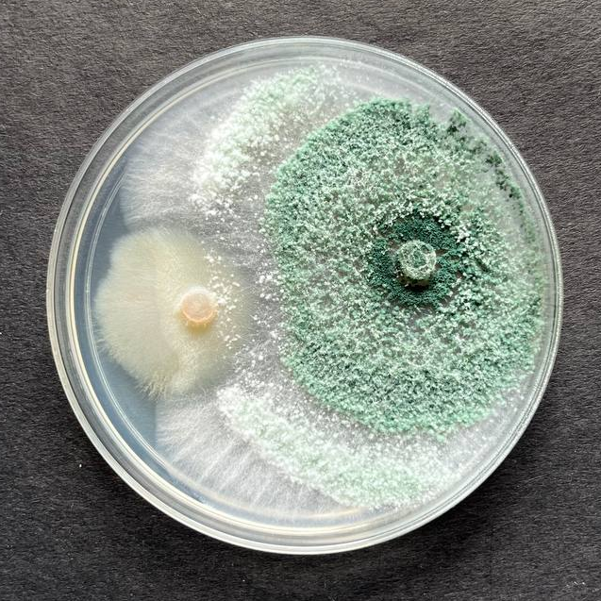  T1  T4  T2 | 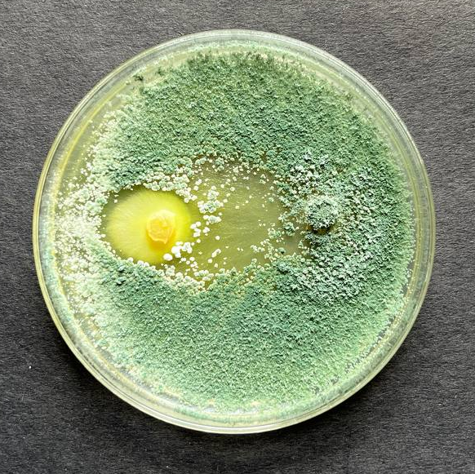 | 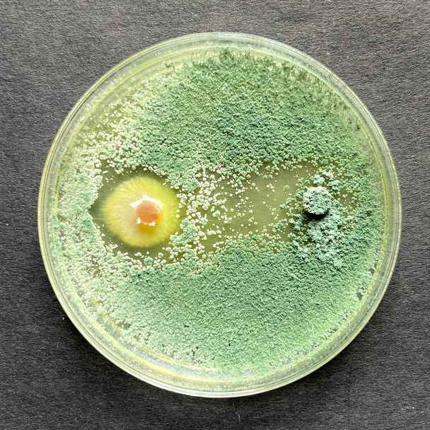  T6  T3
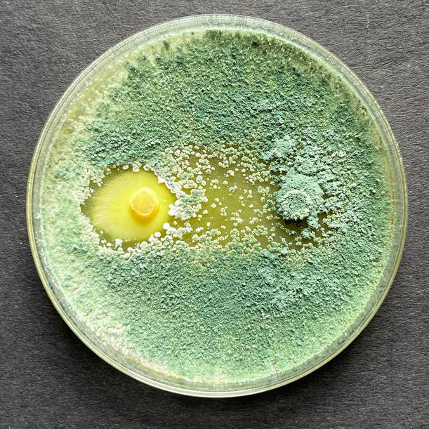 | 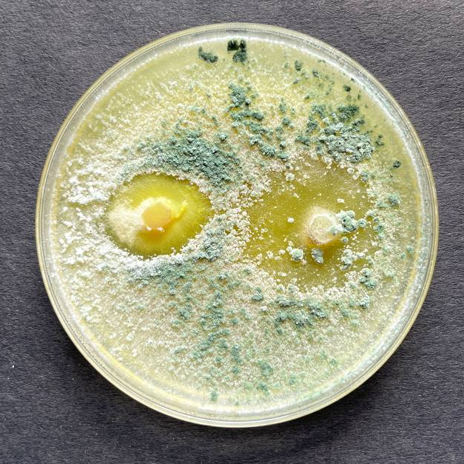  T8  T5 | 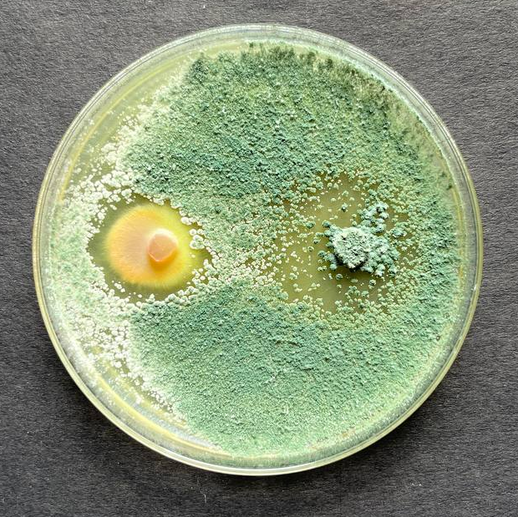  Control
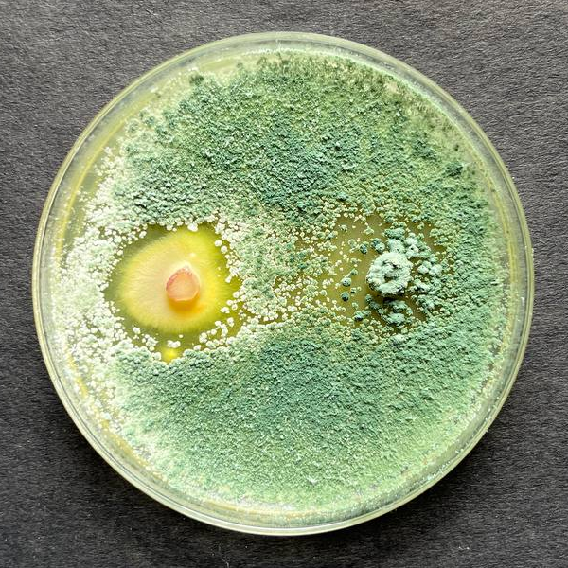  T7 | 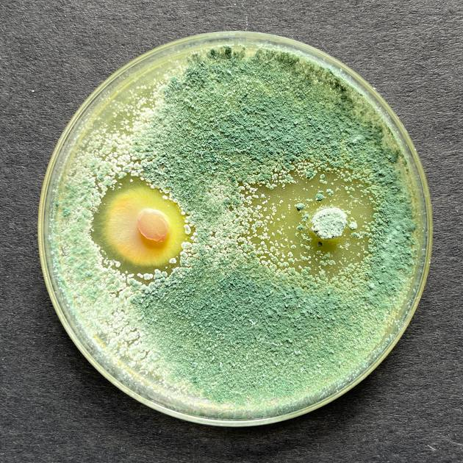 | 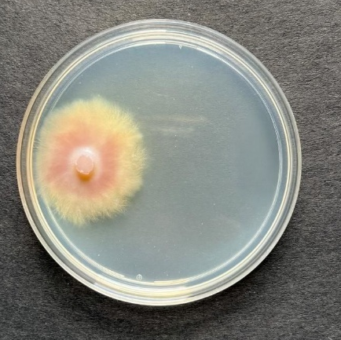
Plate 1: Dual culture assay of different species of Trichoderma with Colletotrichum truncatum

