Characterization of Swollen Shoot Disease and Evaluation of the Effectiveness of Rehabilitation Technology in Cocoa Farms in Gbazoa, Amaragui, and Liliyo (Côte d'Ivoire )
Original research article

Abstract
Objectives: The study carried out on swollen shoot disease in the Nawa region in Côte d’Ivoire aimed to monitor the early progression of this disease in cocoa plantations rehabilitated using three innovative technologies. The goal was to reduce the damage caused by swollen shoot disease in cocoa production systems.
Methodology and Results: Quarterly data collection in each plot, using Global Positioning System (GPS) and visual observations, were made to determine the prevalence, incidence, and severity of the cocoa swollen shoot disease within the rehabilitated plots. The rehabilitated plots were found in close proximity to plots already affected by the disease, and virus host plants were identified within the rehabilitated cocoa plots. Newly infected cocoa trees were found in the immediate vicinity of the disease foci. The number of newly infected cocoa trees was found to be proportional to the size of the disease focus. The highest prevalence and severity of the disease were recorded in Grafted trees on Old Cocoa farms (GOC), with 1.28 % and 1.55 %, respectively. The highest incidence of 1.26 % was observed among Replanting with Grafted Cocoa trees (RGC).
Conclusion and Application of Results: This study revealed the presence of the cocoa swollen shoot disease in the plots through its characteristic symptoms. The progression and severity of the symptoms were found to depend on the technology used. The presence of virus infected plants within and around the plots indicates either a lack of strict adherence to disease control methods or insufficient knowledge about these host plants during the establishment of the plots. These results will enable producers to better manage the disease, starting with the identification of cocoa swollen shoot virus (CSSV) host plants and the precautions to be taken when using maintenance and grafting tools between infected and non-infected cocoa trees. The implementation of early virus detection tools accessible to producers would be an asset in the fight control of the swollen shoot disease in cocoa.
Keywords: cocoa disease, rehabilitated plots, epidemiology, incidence, prevalence, severity

- Introduction​
The economy of Côte d’Ivoire is primarily based on agriculture. Cocoa cultivation constitutes a key pillar of the national economy, contributing about 15 % to the national Gross Domestic Product and accounting for nearly 30 % of export revenues (CIRAD, 2025). Côte d’Ivoire is the world’s leading producer and exporter of cocoa beans. The annual production was estimated at 2,300,000 tons during the 2022/2023 season (BCEAO, 2014; Isaac et al., 2025). Despite its high production levels, cocoa cultivation in Côte d’Ivoire remains constrained by several biotic stresses, notably the occurrence of insect pests as well as fungal, bacterial, and viral diseases. Among the viral pathogens, the Cocoa Swollen Shoot Virus Disease (CSSVD) stands out as the most devastating, affecting cocoa production in Côte d’Ivoire and other West African producing countries since its first report in the 1930s. The characteristic symptoms of swollen shoot disease include red streaks along the veins of young leaves, mosaic patterns on mature leaves, small rounded pods, and swelling of stems (Kouakou et al., 2011). The disease can cause significant yield losses and even the death of cocoa trees within five years after the first symptoms appear (Kébé, 2013). The recommended control method consists of cutting down infected trees and replanting in healthy environments using good agricultural practices (CNRA, 2016). However, the disease continues to spread through mealybugs and from harvesting and pruning activities, reaching new plantations and even rehabilitated plots (Aka et al., 2021). Understanding the epidemiological factors driving this spread is therefore crucial. The objective of this study is to characterize the study plots, assess the prevalence, severity, and incidence of swollen shoot disease, and determine its spatio-temporal evolution in rehabilitated cocoa farms.

- Materials and methods
  - Material
The materials used in this study consisted of plant material and technical equipment. The plant material consisted of cocoa trees of uniform age (six years old), originating from different rehabilitation technologies, namely: Grafting on Old Cocoa trees (GOC): this technique involved grafting performed on mature cocoa trees (top working) in the field using selected cocoa clones (C1, C9, C15, and C16), each representing a distinct genetic variety. The complete Replanting with Grafted Cocoa trees (RGC): this system was established using nursery-grafted cocoa seedlings produced with clones C1, C9, C15, and C16, each of which can be considered a separate cultivar. The Replanting with Hybrid Cocoa seedlings (RHC): this approach involved the use of young hybrid cocoa plants resulting from the controlled crossing of two pure-line parental varieties. The technical equipment comprised a Garmin GPS (Global Positioning System) device) for locating the sites and cocoa trees, as well as paint spray cans used for marking trees in the field.
  - Methods
    - Study area
The study was conducted during year 2022 May to December in the Nawa region, located in the south-western part of Côte d’Ivoire. The climate in Nawa is of the sub-equatorial type, characterized by a dry season (December–March) and two rainy seasons (April–June and September–November). Average temperatures range between 26 and 28 °C and can reach up to 30 °C during the dry season. The average annual rainfall is between 1,300 and 1,600 mm (Anonymous, 2024).
Activities were carried out specifically in 3 plots established in the localities of Gbazoa, Amaragui, and Diakitékro, which are situated respectively in the sub-prefectures of Grand-Zattry, Soubré, and Liliyo (Figure 1).

Figure 1: Study area

    - Characterization of the Study Plots and Disease Symptoms
The characterization of the study plots consisted of identifying the crops and trees associated with cocoa cultivation within the plots. The neighboring cocoa farms adjacent to the rehabilitated plots were also surveyed to verify their infection by the swollen shoot disease. Neighboring plots that were not cocoa farms were also recorded, specifying the crops present. Diseased cocoa trees were visually examined from the leaves down to the trunk to describe the characteristic symptoms of swollen shoot disease observed in the field.
    - Evaluation of the disease infection level within the rehabilitated plots
The infection level of swollen shoot disease in the rehabilitated plots was determined based on prevalence, incidence, and the severity index. Prevalence was defined as the proportion of diseased trees relative to the total number of trees in the plot:
(1)

$$P=\frac{nCi}{NC} x 100$$

where : nCi : Number of infected cocoa trees; NC : Total number of cocoa trees in the plot
Incidence represented the proportion of newly infected trees during a given period relative to the total number of trees in the plot:
I= $\frac{Ci\left(tx\right)-Ci(t0)}{NC}$ X 100

(2)

Where: Ci ( tx ) : Number of infected cocoa trees at tx ; Ci ( t0 ) : Number of infected cocoa trees at t ₀ ; NC : Total number of cocoa trees in the trial.
Severity assessed the intensity of the disease within the plot. It was evaluated using a symptom severity scale ranging from 0 to 6, as defined by Padi et al. (2013) and later modified:
0 = No symptom
1 = Red streaks on young leaves
2 = Reticulated mosaic
3 = Fern-like mosaic
4 = Stem swelling
5 = Die-back
6 = Death of the cocoa tree
The disease severity index (Is) in each experimental plot was calculated according to Kranz (1988):
(3)
Is = $\frac{∑(Xi.ni)}{N.Z}$ x 100

Where: Is : Disease severity index; x i : Severity i of the disease on the tree; n i : Number of trees of severity i ; N : Total number of trees observed; Z : Highest note on the scale, i.e. 6.
The geographical coordinates recorded in the field using GPS made it possible to produce distribution maps of swollen shoot disease within the rehabilitated plots.
    - Spatio-temporal distribution of the disease
Surveys were conducted within the plots to observe and geolocate cocoa trees showing the characteristic symptoms of swollen shoot disease. The first survey, called Trial 1, consisted of marking diseased cocoa trees with red paint and then geolocating them using a Garmin GPS device. Three months after Trial 1, the second survey, called Trial 2, took place. Trial 2 consisted of marking new diseased cocoa trees with paint and geolocating them. The geographical coordinates recorded in the field using GPS were used to produce maps showing the distribution of swollen shoot disease within the rehabilitated plots.
    - Data Analysis
The homogeneity of the data was checked using Levene’s test before performing one-way analysis of variance (ANOVA) using Excel and Statistica 7.1. The Newman-Keuls post hoc test was used to separed the means and identify statistically distinct groups. The geographic coordinates obtained made it possible to produce disease distribution maps using the geographic information system software QGIS 3.28.
- Results
  - Characterization of study plots
The study plots were located in areas already affected with swollen shoot disease. They bordered infected cocoa farms, and in most cases, there were no sanitary barriers such as buffer plants or safety distances separating them from infected neighboring plots. Within the plots, various associated crops and shade trees were present some of which were potential hosts of the Cocoa Swollen Shoot Virus (CSSV) (Table 1).
Table 1 : Characteristics of the study plots
Technologies | Locations | Trees in the plot | Types of Neighboring Plots
Grafting on Old Cocoa trees (GOC) | Amaragui 1 | Elaeis guineensis (Oil palm), Persea americana (Avocado tree) , Cola nitida (Kola tree), Citrus sinensis (orange tree) | Infected cocoa plantation
Replanting with Grafted Cocoa trees (RGC) | Grand- Zattry | Terminalia superba (Fraké) , Mangifera indica (mango tree) | Infected cocoa plantation, Hevea brasiliensis(Rubber tree)
Replanting with Hybrid Cocoa seedlings (RHC) | N' driagui | Tectona grandis (Teak tree), musa paradisiaca (Banana tree),  Elaeis guineensis (Oil palm) | Manihot esculenta (Cassava)

  - Characteristic symptoms of swollen shoot disease in different localities
In each observed plot, one dominant symptom of swollen shoot disease was identified. In Amaragui (Soubré) plots, the most common symptoms were reticulated and fern-like mosaics on mature leaves. In Diakité Camp (Liliyo), red veins on young leaves were predominant. In Grand-Zattry, reticulated mosaics and red veins on young leaves were most frequent, while in N’driagui and Petit Bondoukou, stem swelling was dominant (Figure 2).
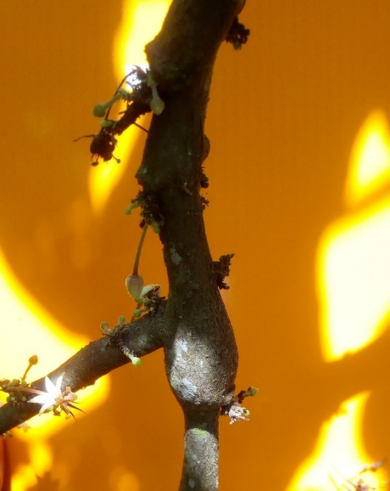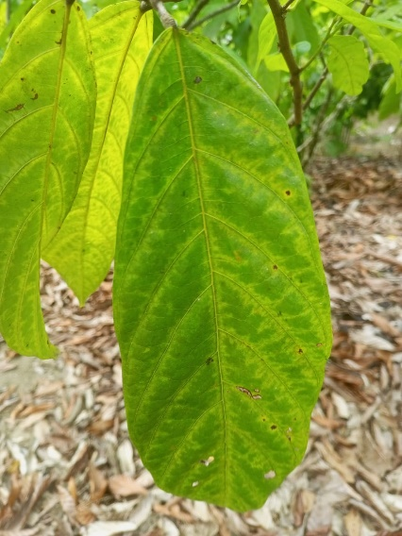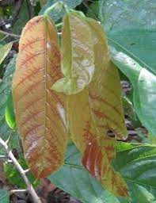
2 cm
2 cm
3 cm
c
b
a
Figure 2: Symptoms of swollen shoot disease (highlighted in red markups) in rehabilitated plots. a: Stem swelling; b: Fern mosaic; c: Red bands on young leaves

Level of Infection of Swollen Shoot Disease in Rehabilitated Plots
Figure 3 illustrates the prevalence, incidence and severity rate according to the three technologies adopted for replanting. The highest prevalence was recorded in GVV plots (1.28 %) and the lowest in RPH plots (0.50 %). The highest incidence occurred in RPG plots (1.26 %), followed by GVV, while RPH recorded the lowest incidence (0.20 %). ANOVA tests indicated that prevalence was not significantly affected by the technology (p ˃0.05; df=2; F=4.72 ), whereas incidence differences were significant (p < 0.05; df=2; F=51.31) Severity ranged from 0.18% to 1.55%, influenced significantly by the technology (p < 0.05; df=2; F=31.34). The severity index was highest in GVV and lowest in RPH plots.

Figure 3: Prevalence, incidence and severity of swollen shoot according to technologies.
GOC: Grafting on Old Cocoa trees; RGC: Replanting with Grafted Cocoa trees; RHC: Replanting with Hybrid Cocoa seedlings
The different letters above the histograms indicate the grouping classes according to the Newman–Keuls test at the 5% significance level. Classes topped with the same letters are not significantly different.
The error bars represent standard errors.
  - Spatial distribution of swollen shoot disease in rehabilitated Plots
Swollen disease was prevalent in the rehabilitated plots, regardless of the technology used. Observations revealed that the disease progressed in line with the number of infected cocoa trees in Trial 1. The higher the number of infected cocoa trees in Trial 1, the higher the number of newly infected cocoa trees in Trial 2. Similarly, the fewer infected trees there were in Trial 1, the fewer newly infected trees there were in Trial 2. Newly infected trees were identified in the immediate vicinity of the infection site (Figures 4-6).
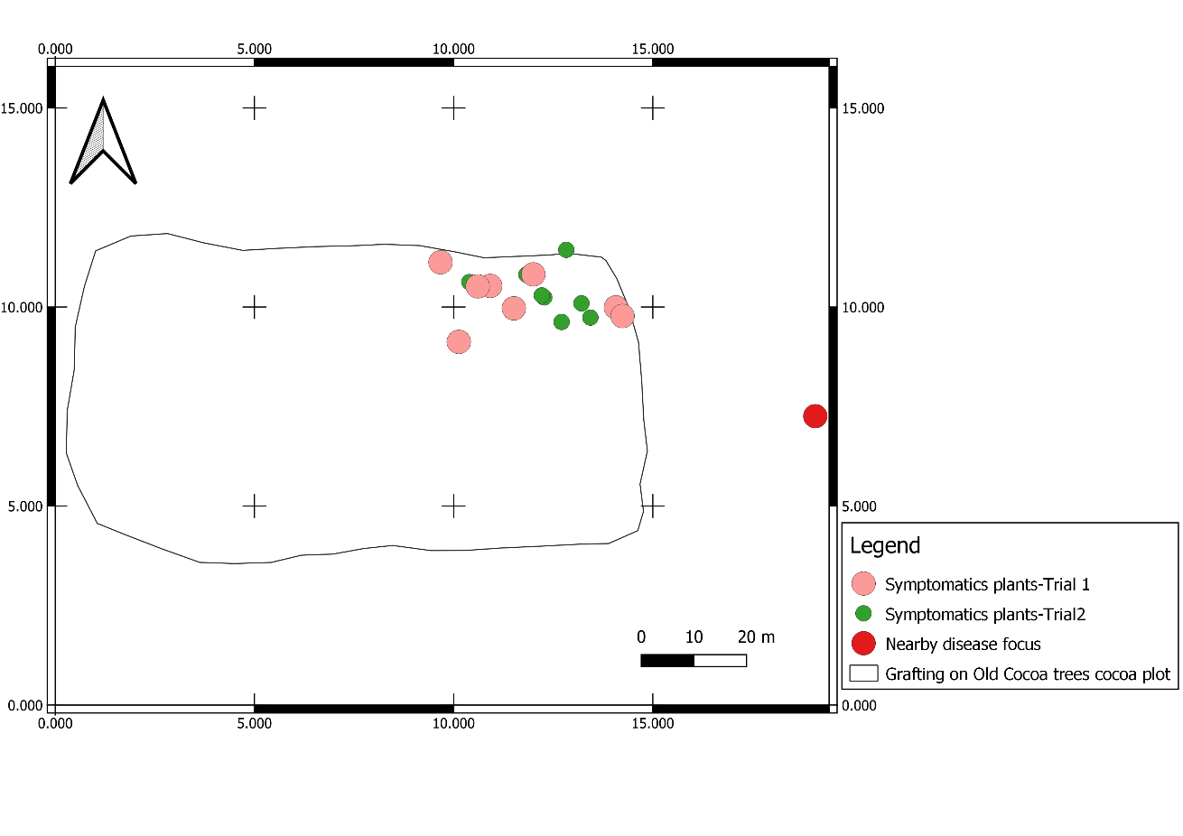
Figure 4. Geographic distribution map of cocoa trees with swollen shoot disease in top worked plots

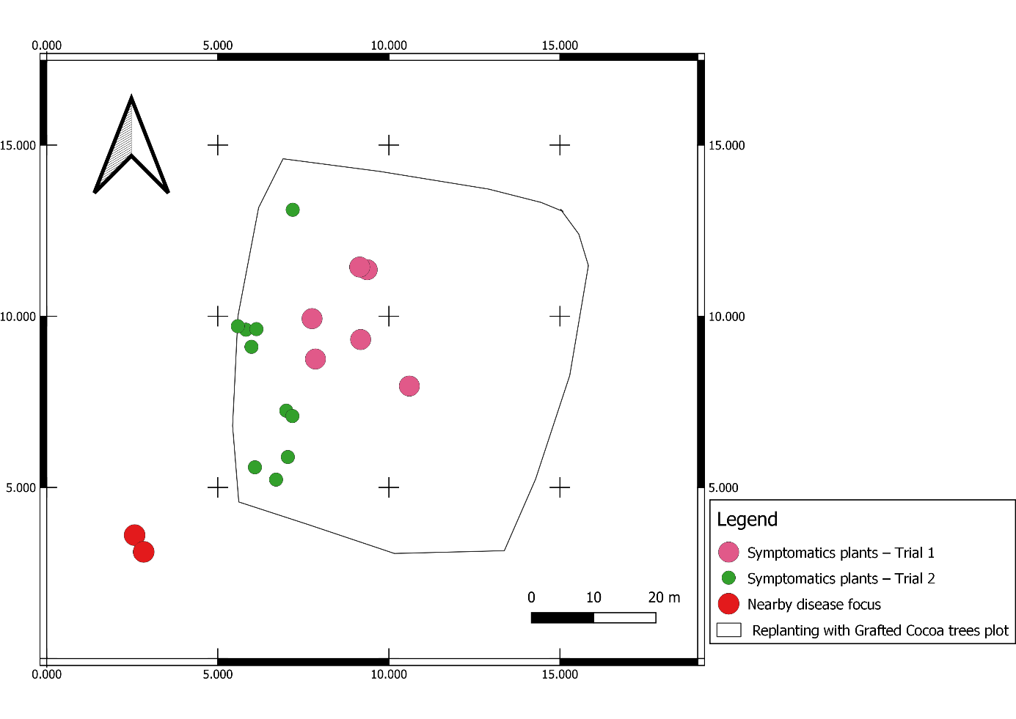
Figure 5: Geographic distribution map of cocoa trees with swollen shoot disease in plots replanted with grafted seedlings
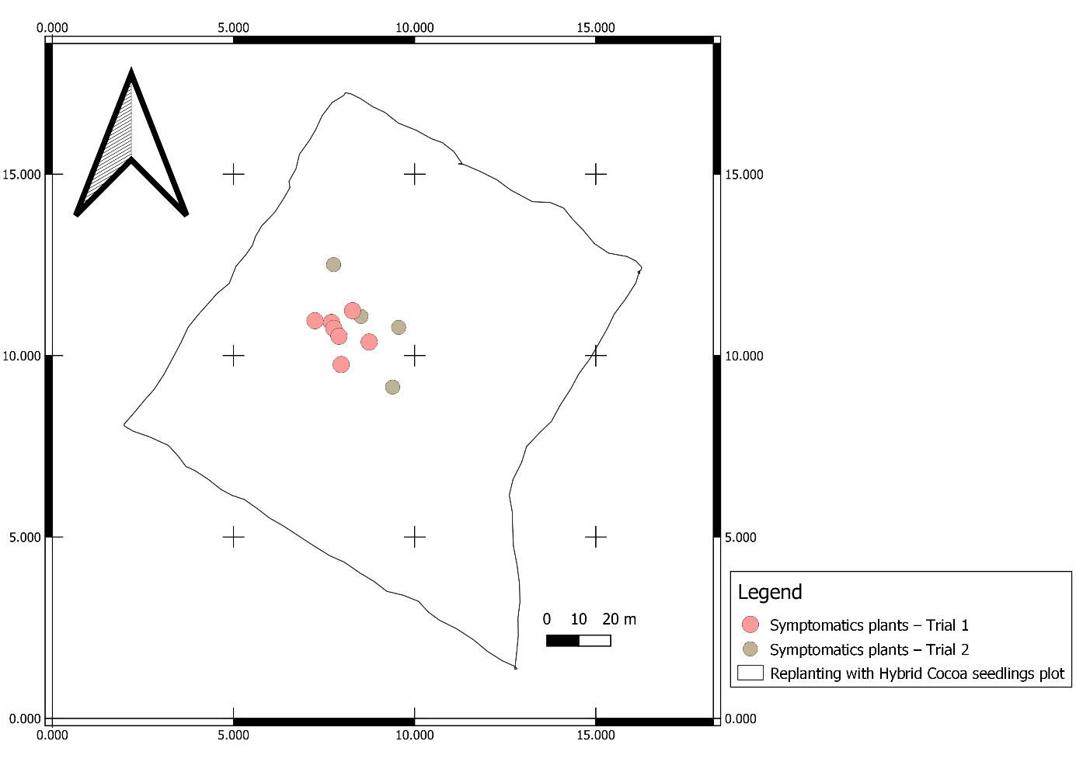
Figure 6: Geographic distribution map of cocoa trees with swollen shoot disease in plots replanted with hybrid seedlings
- Discussion
The results of the plots characterization revealed that most of the studied plots were located around infected cocoa farms. They were contiguous, with no barrier plants (Hevea brasiliensis, Coffea arabica) recommended for the required safety distance. This layout of the rehabilitated plots could explain their reinfection by CSSD. It is strongly recommended to use barrier crops at a distance of 10 to 15 meters around the new plot. This barrier line helps to slow down the spread of mealybugs, which are vectors of the virus. (Kebe et al., 2011). These barrier crops act as traps to keep mealybugs away from cocoa plantations and thus prevent disease outbreak (Kébé et al., 2016).
Furthermore, the presence of various crops and trees associated with cocoa trees was observed in the rehabilitated plots. Among these crops are natural hosts of the CSSV like Manihot esculenta, Cola nitida and Citrus sinensis. The presence of these plants both within and around the fields could therefore serve as new sources of reinfection for the plots. Several crop species and shade trees are known to naturally harbor the swollen shoot virus (Posnette et al., 1950; Kebe et al., 2011). Cola clamydantha is believed to be the original source of the CSSV outbreak in West Africa (Todd, 1951). Based on the studies of Aka (2013) on the alternative hosts of CSSV in Côte d’Ivoire, Manihot esculenta, Citrus sinensis, Cola nitida, and Carica papaya plants occuring near and within the plots act as potential alternative hosts of the virus. This could therefore partly explain the persistence of the swollen shoot disease in the rehabilitated cocoa plots.
The high levels of prevalence, incidence and severity observed in the RGC and GOC plots compared to the RHC plots can be explained at two levels: first, at the level of grafting, and second, at the level of the resistance of cocoa trees developed through different technologies. Indeed, during field grafting (GOC) and nursery grafting (RGC), some cocoa trees were likely already infected with the CSSV, and the tools used for grafting may have facilitated the transmission of the virus to healthy trees both in the field and in the nursery. Later, after a certain latency period, disease symptoms began to appear on the grafted cocoa trees. These findings confirm existing recommendations for managing the swollen shoot disease, which emphasize avoiding grafting operations in areas where the virus is already prevalent and refraining from using the same maintenance tools in infected cocoa plots. Kébé et al. (2011) based on previous studies conducted in Tafo, Ghana, suggested that the CSSV can be transmitted to cocoa trees during grafting, similar to other viral pathogens affecting fruit trees. During the grafting process, virus transmission may occur either from the scion to the rootstock or vice versa, or through contaminated grafting tools if they are not properly sanitized. This situation highlights the importance of early detection with PCR (polymerase chain reaction) of the CSSV before the appearance of visible disease symptoms, in order to prevent the contamination of grafted cocoa trees both in the field and in nurseries. Such preventive measures are essential to avoid the distribution of already infected cocoa plants to the famers.
Regarding tolerance, some cocoa trees are more tolerant to the viral disease than others, which could explain the observed differences between the prevalence and incidence rates of hybrids and grafted plants. The tolerance of cocoa trees to the swollen shoot disease has been confirmed by several authors, including Wegbe et al. (2012). These researchers initiated a breeding program in Togo aimed at developing CSSV-tolerant hybrids. Various combinations were tested by crossing different cocoa clones from the living collection. From these trials, six hybrids emerged as both high-yielding and tolerant to the swollen shoot disease. This varietal selection was based on prevalence and incidence criteria. The parent plants of these hybrids have been used to establish seed gardens, and since 2005, the seeds of these hybrids have been distributed for replanting and for increasing the density of old plantations in areas devastated by swollen shoot disease in Togo. Similarly, Padi et al. (2013) also demonstrated varying levels of tolerance to CSSV among different cocoa varieties, focusing primarily on the severity of the disease as the main evaluation criterion.
The results of this study revealed that the newly infected cocoa trees were located in the immediate vicinity of those that had been infected during the first observation period. The size of the trees infected during the second assessment was proportional to that of the trees infected during the first. The proximity of these newly infected cocoa trees to the initial infection focus could be explained by the mode of transmission of the swollen shoot disease. According to the study by Oro et al. (2012) on the epidemiology of swollen shoot disease in Togo, the virus spreads within plantations either radially or in leaps. This pattern of spread is likely due to the movement of mealybugs the vectors of the CSSV within the plots. The proportional relationship between previously infected cocoa trees and newly infected ones helps to explain the current control strategy against swollen shoot disease, which recommends cutting down both the visibly infected cocoa trees at the center of the infection and their asymptomatic neighbours, depending on the size of the infection focus. The larger the infection focus, the greater the number of asymptomatic trees that must also be removed (CNRA, 2016).

Conclusion

This study revealed the presence of the cocoa swollen shoot disease in the plots through its characteristic symptoms. The progression and severity of the symptoms were found to depend on the technology used. The presence of virus host plants within and around the plots indicates either a lack of strict compliance with disease control methods or insufficient knowledge about these host plants during the establishment of the plots. A detailed study should be conducted to understand the mechanism of virus transmission through plot maintenance tools and cocoa tree grafting equipment.

Acknowledgement
The authors gratefully acknowledge the World Agroforestry Center in Côte d'Ivoire for their support in conducting this study, and gratefully the Jean Lorougnon Guede University of Daloa.
Disclaimer (artificial intelligence)
Author(s) hereby declare that generative AI technologies such as Large Language Models, etc. have been used during the writing or editing of manuscripts. This explanation will include the name, version, model, and source of the generative AI technology and as well as all input prompts provided to the generative AI technology
Details of the AI usage are given below:
1. chat GTP and google translate: I used them to translate some sentences into English.

References
Aka A. R. 2013. Alternative hosts of cocoa swollen shoot virus. International Workshop on Cocoa Swollen Shoot Disease, November 26–28, 2013 – N’SA Hotel Grand Bassam, Ivory Coast. French
Anonymous, 2024. National report on the evaluation of climate action in Côte d'Ivoire. Report October 2024, 100p. French
BCEAO, 2014. Monographic Study on the Cocoa Sector in the UEMOA. Annual Report of the BCEAO - 2014. French
CNRA, 2016: Effectively combating cocoa swollen shoot disease in Ivory Coast. Cocoa Fact Sheet No. 4 CNRA, 4p. French
CIRAD, 2025. Côte d’Ivoire cirad.fr/ . French
Domfeh O, Ameyaw GA, Dzahini-Obiatey HK, Ollennu LAA, Osei-Bonsu K, Acheampong K., Aneani F., Owusu-Ansah F., 2016. Use of immune crops as a barrier in the management of cacao swollen shoot virus disease (CSSVD) – long-term assessment. Plant Dis. 100, 1889-1893.
Dufour, B.; Djiekpor, E. K.; Paulin, D. and Cilas, C., 1993. Screening method for resistance to swollen shoot virus: Improvement of transmission by mealybugs. In: Proceedings of the 11th International Conference on Cocoa Research. Yamoussoukro, Côte d’Ivoire, pp. 243-244. French
ICRAF, 2021. Annual report 2021, Côte d’Ivoire. 54p.
Isaac Y, Mariano J. B , Jeffrey DG, Joshua T, 2025 Cote d'Ivoire - Cocoa Sector Overview – 2025. United states departement of agriculture, foreign agricutural service. IV2025-0001. https://apps.fas.usda.gov/
Kouakou K, Kébé BI, Kouassi N, Anno AP, Aké S, Muller E. 2011. Impact of cocoa swollen shoot virus disease on cocoa production in a smallholder environment in Bazré (Côte d’Ivoire). Journal of Applied Biosciences, 43: pp. 2947–2957. French
Kouakou K, Kébé BI, Kouassi N, Aké S, Cilas C, Muller E. 2012. Geographical Distribution of Cacao Swollen Shoot Virus Molecular Variability in Côte d'Ivoire. Plant Disease, 96 (10): 1445-1450.
Kebe BI, N’guessan KF, Tahi GM, Assiri AA, Aka AR, N’guessan WP, Koko LKA, 2011 . Guide for the Control of Cocoa Swollen Shoot Disease in Cote d’Ivoire. French
Kébé, 2013. Cocoa Swollen Shoot Disease. International Workshop on Swollen Disease. 26 to 28 November 2013 – Grand-Bassam N'SA Hotel. 36 p., 2013 French.
Kranz, J. (1988). Measuring plant disease. In: Kranz, J., Rotem, J. (eds): Experimental techniques in plant disease epidemiology. Springer, Berlin, pp. 35-50
Obodji A, N’Guessan WP, N’Guessan KF, Seri KB P, Aboua LRN, Kébé I, Aka R, 2016. Inventory of the mealybug species associated with the cocoa tree (Theobroma cacao L.) in four producing areas infected with swollen shoot disease in Côte d’Ivoire. Journal of Entomology and Zoology Studies 2015; 3(4): 312-316
Oro Z, Franck, Muller E, Bonnot F, Dufour BP, Wegbe K, Cilas C, 2012. Spatio-temporal analysis of the progression of Cacao Swollen Shoot Virus at the scale of cocoa plots. In: 17th International Conference on Cocoa Research, Yaounde, Cameroon, October 15-20, 2012. French
Padi F.K., Domfeh O, Takrama J. & Opoku S.Y. (2013). An evaluation of gains in breeding for resistance to the cocoa swollen shoot virus disease in Ghana, Crop Protection (51):24-31
Posnette, A.F., N.F. Robertson, and J.M. Todd. 1950. Virus diseases of cocoa in West Africa. V. Alternative host plants. Annals of Applied Biology 37, pp: 229–240.
Wegbe K.1, Koudjega T.1, Ametefe K.E.1, Cilas C.2, and Dufour B., 2012. Selection of cocoa hybrids tolerant to swollen shoot for replanting diseased areas in Togo. 17th International Cocoa Research Conference (ICRC-COPAL) "Improving the profitability of small and medium-sized farms: the principal key to a global sustainable cocoa economy," 2012/10/15-20, Yaoundé, Cameroon. http://www.copal-cpa.org/icrc.ph

