Characterization of Swollen Shoot Disease and Evaluation of the Effectiveness of Rehabilitation Technology in Cocoa Farms in Gbazoa, Amaragui, and Liliyo (Côte d'Ivoire )
Original research article

Abstract
Objectives: The study carried out on swollen shoot disease in the Nawa region in Côte d’Ivoire aimed to monitor the early progression of this disease in cocoa plantations rehabilitated using three innovative technologies. The goal was to reduce the damage caused by swollen shoot disease in cocoa production systems.
Methodology and Results: Quarterly data collection in each plot, using GPS and visual observations, made it possible to determine the prevalence, incidence, and severity of the cocoa swollen shoot disease within the rehabilitated plots. The rehabilitated plots were found in close proximity to plots already contaminated by the disease, and virus host plants were identified within the rehabilitated cocoa plots. Newly infected cocoa trees were found in the immediate vicinity of the disease foci. The number of newly infected cocoa trees was found to be proportional to the size of the disease focus. The highest prevalence and severity of the disease were recorded in grafted trees on old cocoa farms (GVV), with 1.28 % and 1.55 %, respectively. The highest incidence was observed among young grafted cocoa trees (RPG), with 1.26 %.
Conclusion and Application of Results: This study revealed the presence of the cocoa swollen shoot disease in the plots through its characteristic symptoms. The progression and severity of the symptoms were found to depend on the technology used. The presence of virus host plants within and around the plots indicates either a lack of strict adherence to disease control methods or insufficient knowledge about these host plants during the establishment of the plots. These results will enable producers to better manage the disease, starting with the identification of CSSV host plants and the precautions to be taken when using maintenance and grafting tools between infected and non-infected cocoa trees. The implementation of early virus detection tools accessible to producers would be an asset in the fight control of the swollen shoot disease.
Keywords: swollen shoot, rehabilitated plots, epidemiology, incidence, prevalence, severity

- Introduction​
The economy of Côte d’Ivoire is primarily based on agriculture. Cocoa cultivation constitutes a key pillar of the national economy, contributing about 15 % to the national Gross Domestic Product and accounting for nearly 30 % of export revenues. Côte d’Ivoire is the world’s leading producer and exporter of cocoa beans. The annual production was estimated at 2,300,000 tons during the 2022/2023 season (BCEAO, 2014; Isaac and al., 2025). Despite its high production levels, cocoa cultivation in Côte d’Ivoire remains constrained by several biotic stresses, notably the occurrence of insect pests as well as fungal, bacterial, and viral diseases. Among the viral pathogens, the Cocoa Swollen Shoot Virus Disease (CSSVD) stands out as the most devastating, affecting cocoa production in Côte d’Ivoire and other West African producing countries since its first report in the 1930s. The characteristic symptoms of swollen shoot disease include red streaks along the veins of young leaves, mosaic patterns on mature leaves, small rounded pods, and swelling of stems (Kouakou and al., 2011). The disease can cause significant yield losses and even the death of cocoa trees within five years after the first symptoms appear (Kébé, 2013). The recommended control method consists of cutting down infected trees and replanting in healthy environments using good agricultural practices (CNRA, 2016). However, the disease continues to spread, reaching new production areas and even rehabilitated plots (Aka and al., 2021). Understanding the epidemiological factors driving this spread is therefore crucial. The objective of this study is to characterize the study plots, assess the prevalence, severity, and incidence of swollen shoot disease, and determine its spatio-temporal evolution in rehabilitated cocoa farms.

- Materials and methods
  - Material
The materials used in this study consisted of plant material and technical equipment. The plant material included grafted cocoa seedlings in open field, grafted seedlings in nurseries, and hybrid cocoa plants. The technical equipment comprised a Garmin GPS device for locating the sites and cocoa trees, as well as paint spray cans used for marking trees in the field.
  - Methods
    - Study area
The study was conducted in the Nawa region, located in the south-western part of Côte d’Ivoire. Activities were carried out specifically in plots established in the localities of Gbazoa, Amaragui, and Diakitékro, which are situated respectively in the sub-prefectures of Grand-Zattry, Soubré, and Liliyo (Figure 1).

Figure 1 : Study area

    - Characterization of the Study Plots and Disease Symptoms
The study plots consisted of three types of technologies. Grafting on old orchards (GVV) refers to grafting performed on old cocoa trees in the field. Replanting with grafted cocoa seedlings (RPG) corresponds to plots that were completely replanted with nursery-grafted cocoa trees using scions tolerant to the swollen shoot disease. Replanting with hybrid cocoa seedlings (RPH) refers to total replanting with young hybrid cocoa trees obtained from crosses between selected cocoa genotypes. Each plot was characterized by determining its area, the number of cocoa trees present, the type of crops in neighboring plots, and by recording associated crops and shade trees grown alongside cocoa. Diseased cocoa trees were examined from the leaves down to the trunk to describe the characteristic symptoms of swollen shoot disease observed in the field.
2.2.3. Assessment of infection level and disease distribution in rehabilitated plots
The infection level of swollen shoot disease in the rehabilitated plots was determined based on prevalence, incidence, and the severity index. Prevalence was defined as the proportion of diseased trees relative to the total number of trees in the plot:
(1)

$$P=\frac{nCi}{NC} x 100$$

where : nCi : Number of infected cocoa trees; NC : Total number of cocoa trees in the plot
Incidence represented the proportion of newly infected trees during a given period relative to the total number of trees in the plot:
I= $\frac{Ci\left(tx\right)-Ci(t0)}{NC}$ X 100

(2)

Where: Ci ( tx ) : Number of infected cocoa trees at tx ; Ci ( t0 ) : Number of infected cocoa trees at t ₀ ; NC : Total number of cocoa trees in the trial.
Severity assessed the intensity of the disease within the plot. It was evaluated using a symptom severity scale ranging from 0 to 6, as defined by Padi (2013) and later modified:
0 = No symptom
1 = Red streaks on young leaves
2 = Reticulated mosaic
3 = Fern-like mosaic
4 = Stem swelling
5 = Die-back
6 = Death of the cocoa tree
The disease severity index (Is) in each experimental plot was calculated according to Kranz (1988):
(3)
Is = $\frac{∑(Xi.ni)}{N.Z}$ x 100

Where: Is : Disease severity index; x i : Severity i of the disease on the tree; n i : Number of trees of severity i ; N : Total number of trees observed; Z : Highest note on the scale, i.e. 6.
The geographical coordinates recorded in the field using GPS made it possible to produce distribution maps of swollen shoot disease within the rehabilitated plots.
    - Data Analysis
The collected data were subjected to analysis of variance using Excel and Statistica 7.1. The geographic coordinates obtained made it possible to produce disease distribution maps using the geographic information system software QGIS 3.28.
- Results
  - Characterization of study plots
The study plots were located in areas already contaminated by swollen shoot disease. They bordered infected cocoa farms, and in most cases, there were no sanitary barriers such as buffer plants or safety distances separating them from infected neighboring plots. Within the plots, various associated crops and shade trees were present some of which were potential hosts of the Cocoa Swollen Shoot Virus (CSSV) (Table 1).
Table 1 : Characteristics of the study plots
Technologies | Locations | Trees in the plot | Types of Neighboring Plots
GVV | Amaragui 1 | Palm tree, avocado tree, kola tree | Infected cocoa plantation
RPG | Grand- Zattry | Fraké , mango tree | Infected cocoa plantation, rubber tree
RPH | N' driagui | Teak, banana tree, palm tree | Cassava

  - Characteristic symptoms of swollen shoot disease in different localities
In each observed plot, one dominant symptom of swollen shoot disease was identified. In Amaragui (Soubré) plots, the most common symptoms were reticulated and fern-like mosaics on mature leaves. In Diakité Camp (Liliyo), red veins on young leaves were predominant. In Grand-Zattry, reticulated mosaics and red veins on young leaves were most frequent, while in N’driagui and Petit Bondoukou, stem swelling was dominant (Figure 3).
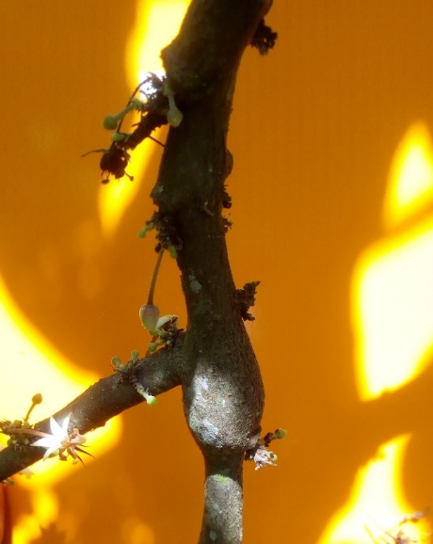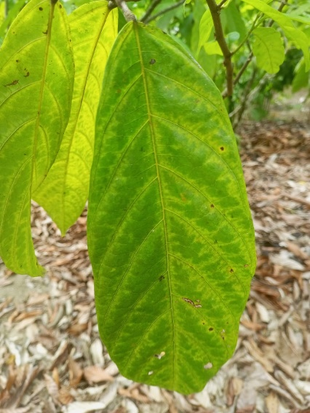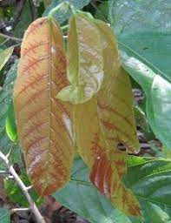
c
b
a
Figure 2: Symptoms of swollen shoot in rehabilitated plots A: Stem swelling; B: Fern mosaic; C: Red bands on young leaves

Level of Infection of Swollen Shoot Disease in Rehabilitated Plots
Figure 3 illustrates the prevalence, incidence and severity rate according to the 3 technologies adopted for replanting. The highest prevalence was recorded in GVV plots (1.28%) and the lowest in RPH plots (0.50%). The highest incidence occurred in RPG plots (1.26%), followed by GVV, while RPH recorded the lowest incidence (0.20%). ANOVA tests indicated that prevalence was not significantly affected by the technology (p = 0.058), whereas incidence differences were significant (p = 1.6 × 10⁻⁴). Severity ranged from 0.18% to 1.55%, influenced significantly by the technology (p < 0.05). The severity index was highest in GVV and lowest in RPH plots.

Figure 3: Prevalence, incidence and severity of swollen shoot according to technologies

  - Spatial distribution of swollen shoot disease in rehabilitated Plots
Swollen shoot disease was found to be widespread across all rehabilitated plots, regardless of the technology applied. Field observations indicated that the progression of the disease was closely associated with the number of infected cocoa trees recorded during the initial assessment. Plots with a higher number of infected trees at the first evaluation subsequently exhibited a greater number of new infections. Conversely, plots with fewer initial infections showed a lower rate of new cases during the second assessment (Figure 5).
Newly infected cocoa trees were predominantly located in the immediate vicinity of previously infected individuals, suggesting a localized spread pattern around primary infection foci. (Figures 4, 5, 6).
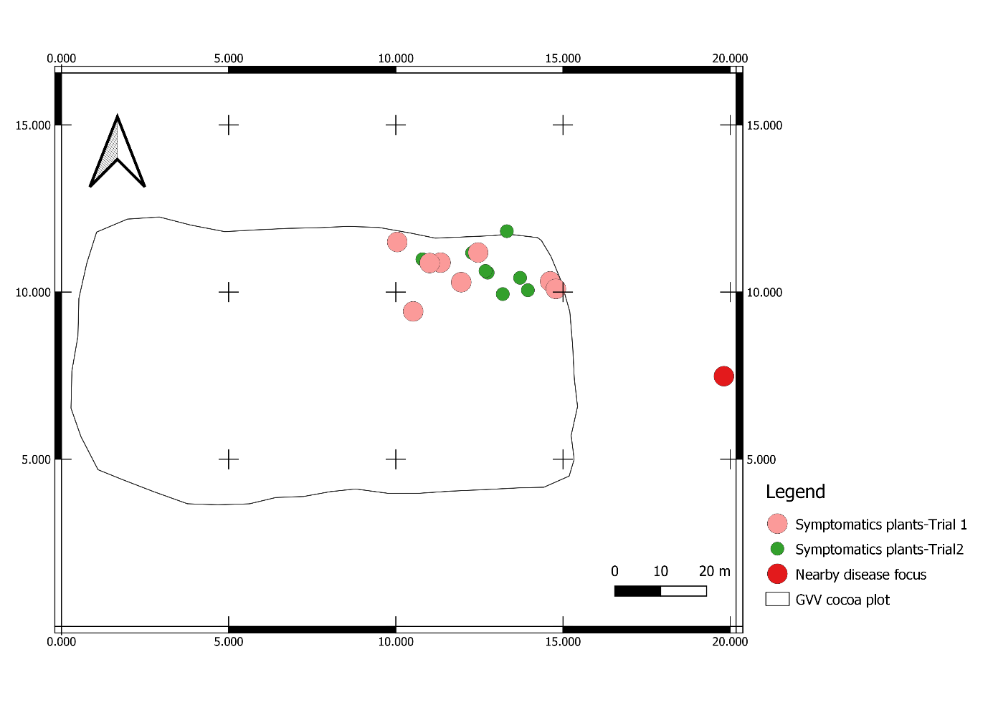
Figure 4: Geographic distribution map of swollen shoot in GVV plots

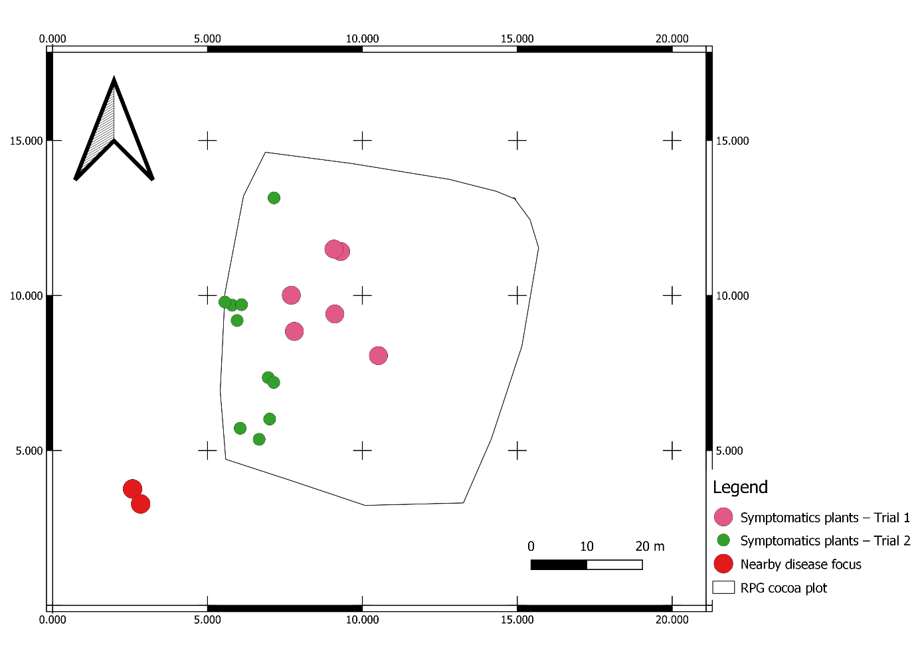
Figure 5: Geographic distribution map of swollen shoot in RPG plots
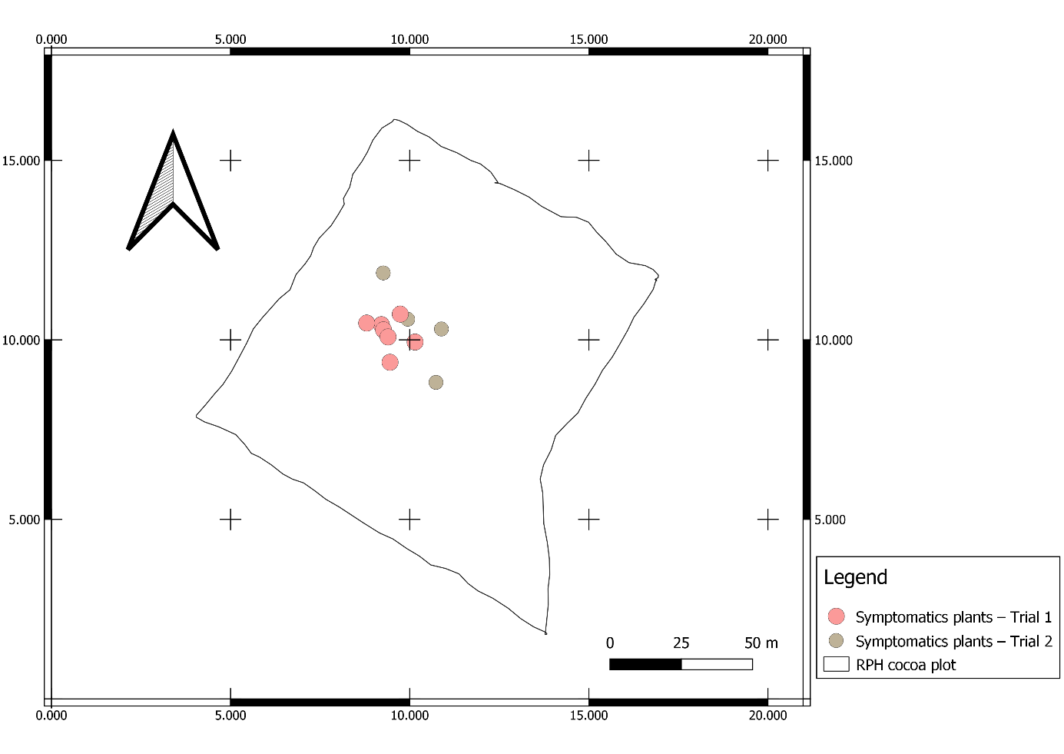
Figure 6: Geographic distribution map of swollen shoot in RPH plots
- Discussion
The results of the plots characterization revealed that most of the studied plots were located around infected cocoa farms. They were contiguous, with no barrier plants recommended for the required safety distance. This layout of the rehabilitated plots could explain their reinfection by CSSD. It was strongly recommended to use barrier crops at a distance of 10 to 15 meters around the new plot. This barrier line helps to slow down the spread of mealybugs, which are vectors of the virus. (Kebe and al., 2011). These barrier crops act as traps to keep mealybugs away from cocoa plantations and thus prevent contamination (Kébé and al., 2016).
Furthermore, the presence of various crops and trees associated with cocoa trees was observed in the rehabilitated plots. Among these crops are natural hosts of the Cocoa Swollen Shoot Virus (CSSV). The presence of these plants both within and around the fields could therefore serve as new sources of reinfection for the plots. Several crop species and shade trees are known to naturally harbor the swollen shoot virus (Posnette et al., 1950; Kebe and al., 2011). Cola clamydantha is believed to be the original source of the CSSV outbreak in West Africa (Todd, 1951). According to the studies of Aka (2013) on the alternative hosts of CSSV in Côte d’Ivoire, cassava, orange, kola, and papaya plants observed near and within the plots are considered potential alternative hosts of the virus. This could therefore partly explain the persistence of the swollen shoot disease in the rehabilitated cocoa plots.
The high levels of the parameters observed in the RPG and GVV plots compared to the RPH plots can be explained at two levels: first, at the level of grafting, and second, at the level of the resistance of cocoa trees developed through different technologies. Indeed, during field grafting (GVV) and nursery grafting (RPG), some cocoa trees were likely already infected with the Cocoa Swollen Shoot Virus (CSSV), and the tools used for grafting may have facilitated the transmission of the virus to healthy trees both in the field and in the nursery. Later, after a certain latency period, disease symptoms began to appear on the grafted cocoa trees. These findings confirm existing recommendations for managing the swollen shoot disease, which emphasize avoiding grafting operations in areas already contaminated by the virus and refraining from using the same maintenance tools in infected cocoa plots. Kébé and al. (2011) reported in their manuscript that previous studies conducted in Tafo, Ghana, and described in earlier research, also revealed that the virus can be transmitted to cocoa trees through grafting, similar to other viral pathogens affecting fruit trees. During the grafting process, virus transmission may occur either from the scion to the rootstock or vice versa, or through contaminated grafting tools if they are not properly sanitized. This situation highlights the importance of early detection of CSSV before the appearance of visible disease symptoms, in order to prevent the contamination of grafted cocoa trees both in the field and in nurseries.
Such preventive measures are essential to avoid the distribution of already infected cocoa plants to producers.
Regarding tolerance, some cocoa trees appear to be more tolerant to the disease than others, which could explain the observed differences between the prevalence and incidence rates of hybrids and grafted plants. The tolerance of cocoa trees to the swollen shoot disease has been confirmed by several authors, including Wegbe and al. (2012). These researchers initiated a breeding program in Togo aimed at developing CSSV-tolerant hybrids. Various combinations were tested by crossing different clones from the living collection.
From these trials, six hybrids emerged as both high-yielding and tolerant to the swollen shoot disease. This varietal selection was based on prevalence and incidence criteria. The parent plants of these hybrids have been used to establish seed gardens, and since 2005, the seeds of these hybrids have been distributed for replanting and for increasing the density of old plantations in areas devastated by swollen shoot in Togo. Similarly, Padi and al. (2013) also demonstrated varying levels of tolerance to CSSV among different cocoa varieties, focusing primarily on the severity of the disease as the main evaluation criterion.
The results of this study revealed that the newly infected cocoa trees were located in the immediate vicinity of those that had been infected during the first observation period. The size of the trees infected during the second assessment was proportional to that of the trees infected during the first. The proximity of these newly infected cocoa trees to the initial infection focus could be explained by the mode of transmission of the swollen shoot disease. According to the study by Oro and al. (2012) on the epidemiology of swollen shoot disease in Togo, the virus spreads within plantations either radially or in leaps. This pattern of propagation is likely due to the movement of mealybugs the vectors of the Cocoa Swollen Shoot Virus (CSSV)within the plots. Mealybugs can move from one cocoa tree to another or even from one plantation to another, facilitated by farming activities as well as by the action of wind and rain. The proportional relationship between previously infected cocoa trees and newly infected ones helps to explain the current control strategy against swollen shoot disease, which recommends cutting down both the visibly infected cocoa trees at the center of the infection and their asymptomatic neighbours, depending on the size of the infection focus. The larger the infection focus, the greater the number of asymptomatic trees that must also be removed (CNRA, 2016).

Conclusion

This study revealed the presence of the cocoa swollen shoot disease in the plots through its characteristic symptoms. The progression and severity of the symptoms were found to depend on the technology used. The presence of virus host plants within and around the plots indicates either a lack of strict compliance with disease control methods or insufficient knowledge about these host plants during the establishment of the plots.
Acknowledgement
The authors gratefully acknowledge the World Agroforestry Center in Côte d'Ivoire for their support in conducting this study, and gratefully the Jean Lorougnon Guede University of Daloa.
Disclaimer (artificial intelligence)
Author(s) hereby declare that generative AI technologies such as Large Language Models, etc. have been used during the writing or editing of manuscripts. This explanation will include the name, version, model, and source of the generative AI technology and as well as all input prompts provided to the generative AI technology
Details of the AI usage are given below:
1. chat GTP and google translate: I used them to translate some sentences into English.

References
Aka A. R. 2013. Alternative hosts of cocoa swollen shoot virus. International Workshop on Cocoa Swollen Shoot Disease, November 26–28, 2013 – N’SA Hotel Grand Bassam, Ivory Coast. French
BCEAO , 2014. Monographic Study on the Cocoa Sector in the UEMOA. French
CNRA, 2016: Effectively combating cocoa swollen shoot disease in Ivory Coast. Cocoa Fact Sheet No. 4 CNRA, 4p. French
Domfeh O, Ameyaw GA, Dzahini-Obiatey HK, Ollennu LAA, Osei-Bonsu K, Acheampong K., Aneani F., Owusu-Ansah F., 2016. Use of immune crops as a barrier in the management of cacao swollen shoot virus disease (CSSVD) – long-term assessment. Plant Dis. 100, 1889-1893.
Dufour, B.; Djiekpor, E. K.; Paulin, D. and Cilas, C., 1993. Screening method for resistance to swollen shoot virus: Improvement of transmission by mealybugs. In: Proceedings of the 11th International Conference on Cocoa Research. Yamoussoukro, Côte d’Ivoire, pp. 243-244. French
ICRAF, 2021. Annual report 2021, Côte d’Ivoire. 54p.
Isaac Y, Mariano J. B , Jeffrey DG, Joshua T, 2025 Cote d'Ivoire - Cocoa Sector Overview – 2025. United states departement of agriculture, foreign agricutural service. IV2025-0001. https://apps.fas.usda.gov/
Kouakou K, Kébé BI, Kouassi N, Anno AP, Aké S, Muller E. 2011. Impact of cocoa swollen shoot virus disease on cocoa production in a smallholder environment in Bazré (Côte d’Ivoire). Journal of Applied Biosciences, 43: pp. 2947–2957. French
Kouakou K, Kébé BI, Kouassi N, Aké S, Cilas C, Muller E. 2012. Geographical Distribution of Cacao Swollen Shoot Virus Molecular Variability in Côte d'Ivoire.
Kebe BI, N’guessan KF, Tahi GM, Assiri AA, Aka AR, N’guessan WP, Koko LKA, 2011 . Guide for the Control of Cocoa Swollen Shoot Disease in Cote d’Ivoire. French
Kébé, 2013. Cocoa Swollen Shoot Disease. International Workshop on Swollen Disease. French
Kranz, J. (1988). Measuring plant disease. In: Kranz, J., Rotem, J. (eds): Experimental techniques in plant disease epidemiology. Springer, Berlin, pp. 35-50
Obodji A, N’Guessan WP, N’Guessan KF, Seri KB P, Aboua LRN, Kébé I, Aka R, 2016. Inventory of the mealybug species associated with the cocoa tree (Theobroma cacao L.) in four producing areas infected with swollen shoot disease in Côte d’Ivoire. Oro Z, Franck, Muller E, Bonnot F, Dufour BP, Wegbe K, Cilas C, 2012. Spatio-temporal analysis of the progression of Cacao Swollen Shoot Virus at the scale of cocoa plots. In: 17th International Conference on Cocoa Research, Yaounde, Cameroon, October 15-20, 2012. French
Padi F.K., Domfeh O, Takrama J. & Opoku S.Y. (2013). An evaluation of gains in breeding for resistance to the cocoa swollen shoot virus disease in Ghana, Crop Protection (51):24-31
Posnette, A.F., N.F. Robertson, and J.M. Todd. 1950. Virus diseases of cocoa in West Africa. V. Alternative host plants. Annals of Applied Biology 37, pp: 229–240.
Wegbe K.1, Koudjega T.1, Ametefe K.E.1, Cilas C.2, and Dufour B., 2012. Selection of cocoa hybrids tolerant to swollen shoot for replanting diseased areas in Togo. 17th International Cocoa Research Conference (ICRC-COPAL) "Improving the profitability of small and medium-sized farms: the principal key to a global sustainable cocoa economy," 2012/10/15-20, Yaoundé, Cameroon. http://www.copal-cpa.org/icrc.ph

