Insecticidal Activity of Garlic and Onion Essential Oils against Pseudotheraptus devastans in Coconut

Abstract
Pseudotheraptus devastans (Heteroptera : Coreidae), commonly known as the coconut bug, is a major pest of coconut palms in Côte d'Ivoire. All larval stages and adults cause damage by their bites, resulting in either deformation of young nuts or their fall. As part of the search for a strategy to protect these nuts from attack, an evaluation of the effectiveness of essential oils from Allium sativum and Allium cepa was tested on out. The study was conducted at the coconut research station of the National Centre for Agricultural Research in Côte d'Ivoire. The essential oils extracted from the two aromatic plants were tested by contact using a hand sprayer at different concentrations on the eggs, larvae and adults of P. devastans at a temperature of 26.39 ± 1.50°C and a relative humidity of 87.85 ± 2.15%. These essential oils have insecticidal properties against P. devastans. The essential oil of A. sativum had LC ₍₅₀₎ and LC ₍₉₀₎ values of 0.27 ± 0.6% ; 11.24 ± 0.57% for larvae and 3.82 ± 0.07% ; 11.28 ± 0.17% for adults, whereas that of A. cepa had LC ₍₅₀₎ and LC ₍₉₀₎ values of 0.59 ± 0.51% ; 38.16 ± 0.93% for larvae and 4.84 ± 0.10% ; 20.05 ± 0.25% for adults. The essential oil of A. sativum was therefore the most toxic.
Keywords : Coconut bug, Essential oil, Garlic, Onion
1. Introduction
Pseudotheraptus devastans, an insect of the Coreidae family, is also known as the coconut bug. Its larvae and adults pierce immature nuts to feed. Their bites cause the premature fall of these nuts (Van der Vossen and Chipungahelo, 2007), or their deformation, thus reducing the copra content of the resulting mature nuts. These attacks can lead to a drop in production of around 50 to 80% (Allou et al., 2006). In addition to coconut palms, Manihot esculenta (cassava), Anacardium occidentale (cashew), Persea americano (avocado) and Theobroma cacao (cocoa) are also host plants of P. devastans. In response to the threat posed by P. devastans, various control methods have been proposed to reduce its harmfulness. These include chemical control using chemical insecticides and biological control using natural predators. However, these control methods have shown their limitations. To address the harmful consequences of synthetic chemicals and propose an effective and environmentally sound control method, entomologists have been focusing their activities for several years on finding alternatives to conventional chemical control. The well-known insecticidal and/or insect repellent action of certain aromatic plants is reported in the literature (Dabiré, 1992 ; Boeke et al., 2004, Anjarwalla et al., 2016, Tiendrebeogo et al., 2017, Biao et al., 2018, Kobenan et al., 2018, Doh et al., 2021). In addition, laboratory toxicity tests conducted with essential oils report varying levels of toxicity depending on the essential oils used, the pest species present, and, above all, the stage of development concerned by the tests (Seri-kouassi et al., 2004 ; Sanon et al., 2006, Kobenan et al., 2018). Such research is also in line with consumers' growing demand for organic products. This study will therefore compare the insecticidal activity of the essential oils of Allium sativum (garlic) and Allium cepa (onion), two plants of the Liliaceae family whose aqueous extracts have already proven effective against P. devastans.
2. Materials and methods
2.1 Experimental site
The study was conducted at the CNRA's Marc Delorme research station in Abidjan, specifically in the municipality of Port-Bouët, 12 km from the Bassam motorway (Côte d'Ivoire). Its geographical coordinates are 05° 14' and 05° 15' north latitude and 03° 54' and 03° 55' west longitude (Koffi et al., 2017). In general, average monthly temperatures vary little, with a monthly average of 26.7 °C. The average relative humidity recorded during the trial was 87.11% with an average monthly rainfall of 149.90 mm.
2.2 Essential oils
The study was conducted using essential oils extracted from the bulbs of two (02) local aromatic plants belonging to the Liliaceae family. These were Allium sativum L. and Allium cepa L. (Figure 1), obtained from the local market. These essential oils were supplied by the Industrial Research Unit on Biopesticides at Felix Houphouët Boigny University (Côte d'Ivoire).
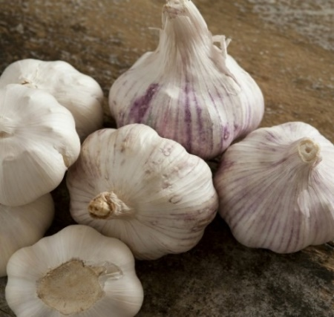
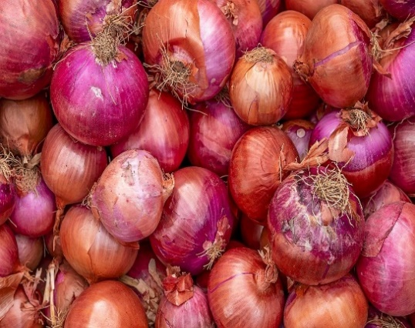

Allium sativum
Allium cepa
Figure1 : Bulbs of plants used for essential oil extraction
2.3 Extraction and analysis of essential oils
The essential oils of A. sativum and A. cepa were obtained from fresh bulbs by saturated steam distillation using a Clevenger-type device for 2 hours. This method consists of conventional distillation in which the leaves are not in direct contact with the water. The leaves are placed on a grid and a stream of steam is passed through them. As the steam passes through, the leaf cells burst and release the essential oil, which is carried into the essential oil collector via the condenser. Separation is achieved by decantation.
2.4 Mass cultivation
Intensive breeding of P. devastans was carried out on coconut trees in plot 060, in cages covered with mosquito nets, at an average temperature of 26.39 ± 1.50 °C and an average relative humidity of 87.85 ± 2.15%. Pairs of Pseudotheraptus devastans were formed and placed in cages containing clusters of immature coconuts from coconut trees in order to produce a sufficient number of eggs, larvae and adults for the various tests.
2.5 Preparation of concentrations
The essential oils of garlic and onion were diluted with distilled water and an emulsifier. Thus, for each of the essential oils, the extract diluted to 1/5 with solvent (5% solution) was used to prepare the different concentrations tested : 0.01, 0.05, 0.1, 0.5 and 1% on eggs and larvae, then 1, 2 and 5% on adults. Callifan Super 40 EC (40 g of active ingredient at a rate of 20 g of acetamiprid and 20 g of bifenthrin) was used as a positive control, with 10.4 ml diluted in 1000 ml of distilled water according to the recommended dose (125 ml for 12 L of water).
2.6 Conducting the tests
During the tests, the essential oils were applied to the eggs, larvae and adults of P. devastans using a hand sprayer (Figure 2). For the various tests, as the incubation period for the eggs was 6 to 8 days, two types of eggs were treated. These were young eggs aged 2 days and slightly older eggs aged 5 days. Batches of 10 eggs were formed for each age (2 days and 5 days). Each concentration of essential oil from A. sativum and A. cepa bulbs was then applied to the eggs using a hand sprayer, with 3 repetitions. A batch of 30 eggs per age served as a control (reference control and blank control). After the eggs hatched, the number of stage 1 larvae obtained was recorded, and the hatch rate (HR) of the eggs was calculated.

$$HR \left(\%\right)=\frac{Number of eggs hatched}{Total number of eggs processed} ×100$$

Stage 3 (L3) larvae from the above-mentioned breeding programme were used for the different treatments. Ten (10) larvae were placed in different cages containing immature walnut diets as food. These larvae were also treated with each concentration of essential oils. A batch of 10 stage 3 larvae was used for each control (reference control and blank control). Three replicates were performed per concentration. As for the adults, the imagoes from the mass rearing of P. devastans were counted. Ten (10) adults were placed in different cages for each concentration of essential oil. A batch of 10 adults served as a control (reference control and blank control) for each treatment.
2.7 Determination of mortality rates
Mortality in the different batches was observed 24 hours, 48 hours and 72 hours after application of the essential oils. When dead or moribund insects were observed among the controls, mortality rates were corrected using Abbott's formula (1925).
$$MC (\%)=\frac{Mt-M0}{100-M0}×100$$
Mc : Corrected mortality rate ; Mt : Mortality observed at the concentration considered ; Mo : Mortality observed in the blank control batch
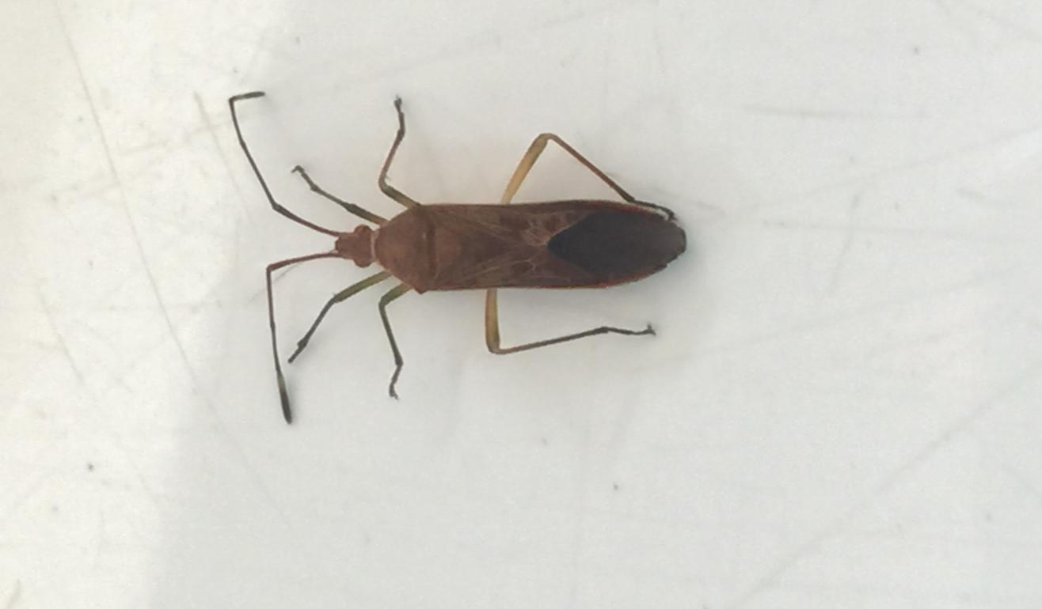
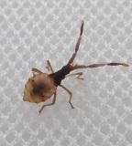
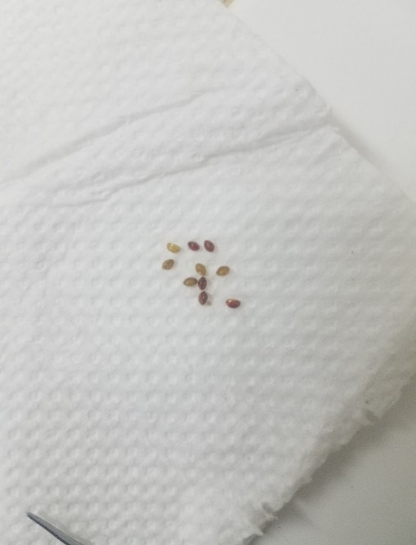
Adult P. devastans
P. devastans larva stage 3
P. devastans eggs

Figure2 : Different stages of development of P. devastans
2.8 Data analysis
An analysis of variance (ANOVA) was performed using R (4.4.1) software on the corrected mortality rate of insects according to treatment (essential oils and concentrations). In cases of significant differences between treatments, means were compared using the Newman Keuls test at a 5% significance level.
Using WinDL 32.0 software (CIRAD, Montpellier, 1998 version), the lethal concentrations causing the death of 50% (LC50) and 90% (LC90) of the test populations were determined for each of the essential oils, two days (48 hours) after exposure of the bugs
3. Results
3.1 Effects of essential oils on the survival of Pseudotheraptus devastans
3.1.1 Effect of essential oils on the hatching of P. devastans eggs
Depending on the concentration, A. sativum essential oil resulted in hatching rates ranging from 0% to 66.67 ± 5.77% for eggs aged 2 days. For 5-day-old eggs, hatching rates ranged from 20.00 ± 10.00% to 70 ± 26.45% (Table 1). A. cepa essential oil resulted in hatching rates ranging from 0 to 70.00 ± 20.00% at different concentrations. For eggs aged 5 days, hatching rates ranged from 20.00 ± 0.00 to 83.33 ± 5.77% (Table 2). Analysis of variance for interaction effects showed a significant difference between concentrations and egg age (P < 0.001).
Table 1 : Hatching rates of P. devastans eggs as a function of A. sativum essential oil concentration
Essential oil concentrations (%) | Hatching rate (%) according to egg age (days)
Essential oil concentrations (%) | 2 | 5
0.01 | 66.67 ± 5.77 b | 70.00 ± 26.46 b
0.05 | 53.33 ± 15.27 b | 56.67 ± 5.77 bc
0.1 | 26.67 ± 20.82 c | 43.33 ± 5.77 cd
0.5 | 10.00 ± 10.00 cd | 30.00 ± 10.00 d
1 | 0.00 ± 0.00 d | 20.00 ± 10.00 de
Califan | 0.00 ± 0.00 d | 0.00 ± 0.00 e
Water | 100.00 ± 0.00 a | 100.00 ± 0.00 a
Significance (p) | 0.00 | 0.00

Within the same column, means marked with the same letter do not differ statistically at the 5% level (Newman Keuls Student's test).

Table 2 : Hatching rate of P. devastans eggs as a function of the concentration of A. cepa essential oil
Essential oil concentrations (%) | Hatching rate (%) according to egg age (days)
Essential oil concentrations (%) | 2 | 5
0.01 | 70.00 ± 20.00 b | 83.33 ± 5.77 b
0.05 | 60.00 ± 17.32 b | 53.33 ± 15.27 c
0.1 | 33.33 ± 15.28 c | 46.67 ± 11.55 c
0.5 | 16.67 ± 11.55 cd | 33.33 ± 15.27 cd
1 | 0.00 ± 0.00 d | 20.00 ± 0.00 d
Califan | 0.00 ± 0.00 d | 0.00 ± 0.00 e
Water | 100.00 ± 0.00 a | 100.00 ± 0.00 a
Significance (p) | 0.00 | 0.00

Within the same column, means marked with the same letter do not differ statistically at the 5% level (Newman Keuls Student's test).
3.1.2 Effect of essential oils on stage 3 larvae of P. devastans
The results of tests on the insecticidal activity of essential oil from A. sativum indicate that at concentrations of 0.01 to 1%, the mortality rate of larvae varies from 10.00 ± 10.00% to 66.67 ± 15.27% in 24 hours, from 16.67 ± 11.55 to 70.00 ± 20.00% in 48 hours and from 16.67 ± 11.55 to 73.33 ± 25.17% in 72 hours (Table 3). As for A. cepa essential oil at concentrations of 0.01 to 1%, larval mortality rates ranged from 10.00 ± 10.00% to 53.33 ± 20.82% in 24 hours, from 13.33 ± 5.77% to 60.00 ± 10.00% in 48 hours and from 16.67 ± 11.55% to 66.67 ± 11.55% in 72 hours (Table 4). In contrast, the chemical control group had a mortality rate of 100% for the observation periods and 0% for the water control group. Statistical analysis revealed a significant difference between the concentrations and mortality rates of P. devastans larvae.
Table3 : Chronological evolution of the average mortality of P. devastans larvae as a function of the concentration of A. sativum essential oil
Essential oil concentrations (%) | Average mortality (%)
Essential oil concentrations (%) | 24 h | 48 h | 72 h
0.01 | 10.00 ± 10.00 | 16.67 ± 11.55 | 16.67 ± 11.55 of
0.05 | 16.67 ± 5.77 of | 20.00 ± 10.00 of | 20.00 ± 10.00 of
0.1 | 33.33 ± 20.82 cd | 36.67 ± 15.27 cd | 36.67 ± 15.27 cd
0.5 | 50.00 ± 20.00 bc | 56.67 ± 11.55 bc | 56.67 ± 11.55 bc
1 | 66.67 ± 15.27 b | 70.00 ± 20.00 b | 73.33 ± 25.17 b
Control + | 100.00 ± 0.00 a | 100.00 ± 0.00 a | 100.00 ± 0.00 a
Control - | 0.00 ± 0.00 e | 0.00 ± 0.00 e | 0.00 ± 0.00 e
Significance (p) | 0.00 | 0.00 | 0.00
Within the same column, means marked with the same letter do not differ statistically at the 5% level (Newman Keuls Student's test).
Table4 : Chronological evolution of average mortality of P. devastans larvae as a function of A. cepa essential oil concentration
Essential oil concentrations (%) | Average mortality (%)
Essential oil concentrations (%) | 24 h | 48 h | 72 h
0.01 | 10.00 ± 0.00 d | 13.33 ± 5.77 d | 16.67 ± 11.55 de
0.05 | 16.67 ± 15.27 cd | 20.00 ± 10.00 d | 20.00 ± 10.00 d
0.1 | 23.33 ± 5.77 cd | 26.67 ± 5.77 d | 30.00 ± 10.00 d
0.5 | 40.00 ± 20.00 bc | 46.67 ± 11.55 c | 50.00 ± 10.00 c
1 | 53.33 ± 20.82 b | 60.00 ± 10.00 b | 66.67 ± 11.55 b
Control + | 100.00 ± 0.00 a | 100.00 ± 0.00 a | 100.00 ± 0.00 a
Witness - | 0.00 ± 0.00 d | 0.00 ± 0.00 e | 0.00 ± 0.00 e
Significance (p) | 0.00 | 0.00 | 0.00
Within the same column, means marked with the same letter do not differ statistically at the 5% level (Newman Keuls Student's test).
3.1.3 Effect of essential oils on adult P. devastans
Mortality rates caused by A. sativum essential oil at concentrations of 1 to 5% ranged from 6.67 ± 5.77% to 56.67 ± 20.82% in 24 hours, from 13.33 ± 5.77% to 63.33 ± 15.27% in 48 hours and from 16.67 ± 5.77% to 63.33 ± 15.27% in 72 hours (Table 5). As for A. cepa essential oil at concentrations of 1 to 5%, adult mortality rates ranged from 6.67 ± 5.77% to 50.00 ± 20.00% in 24 hours, from 10.00 ± 0.00% to 53.33 ± 15.27% in 48 hours and from 10.00 ± 0.00% to 56.67 ± 11.55% in 72 hours (Table 6). In contrast, the chemical control had a mortality rate of 100% for the observation periods and 0% for the water control. Statistical analysis revealed a significant relationship between concentrations and mortality rates of P. devastans larvae.
Table5 : Chronological evolution of average mortality of P. devastans adults as a function of A. sativum essential oil concentration
Essential oil concentrations (%) | Average mortality (%)
Essential oil concentrations (%) | 24 h | 48 h | 72
1 | 6.67 ± 5.77 c | 13.33 ± 5.77 c | 16.67 ± 5.77 c
2 | 13.33 ± 5.77 c | 20.00 ± 0.00 c | 23.33 ± 5.77 c
5 | 56.67 ± 20.82 b | 63.33 ± 15.27 b | 63.33 ± 15.27 b
Control + | 100.00 ± 0.00 a | 100.00 ± 0.00 a | 100.00 ± 0.00 a
Control - | 0.00 ± 0.00 d | 0.00 ± 0.00 d | 0.00 ± 0.00 c
Significance (p) | 0.00 | 0.00 | 0.00
Within the same column, means marked with the same letter do not differ statistically at the 5% level (Newman Keuls Student's test).
Table6 : Chronological evolution of the average mortality of P. devastans adults as a function of the concentration of A. cepa essential oil
Essential oil concentrations (%) | Average mortality (%)
Essential oil concentrations (%) | 24 h | 48 h | 72
1 | 6.67 ± 5.77 c | 10.00 ± 0.00 cd | 10.00 ± 0.00 cd
2 | 10.00 ± 0.00 c | 16.67 ± 5.77 c | 16.67 ± 5.77 c
5 | 50.00 ± 20.00 b | 53.33 ± 15.27 b | 56.67 ± 11.55 b
Control + | 100.00 ± 0.00 a | 100.00 ± 0.00 a | 100.00 ± 0.00 a
Control - | 0.00 ± 0.00 c | 0.00 ± 0.00 d | 0.00 ± 0.00 c
Significance (p) | 0.00 | 0.00 | 0.00
Within the same column, means marked with the same letter do not differ statistically at the 5% level (Student's Newman Keuls test).
3.2 Comparison of the toxicity of Allium sativum and Allium cepa essential oils
The lethal concentrations (LC₅₀ and LC₉₀ in %) of the essential oils of A. sativum and A. cepa 48 hours after application to Pseudotheraptus devastans larvae and adults were determined. The essential oil of A. sativum had the lowest LC₅₀ and LC₉₀ values, which were (0.27 ± 0.6% and 11.24 ± 0.57% for larvae; 3.82 ± 0.07% and 11.28 ± 0.17% for adults). In contrast, A. cepa had the highest LC₅₀ and LC₉₀ values (0.59 ± 0.51% and 38.16 ± 0.93% for larvae ; 4.84 ± 0.10% and 20.05 ± 0.25% for adults) (Table 7).
Table7 : Lethal concentrations (LC50 and LC90 in %) of Allium sativum and Allium cepa essential oils 48 hours after application to Pseudotheraptus devastans larvae and adults.
Aromatic plant | Insect development stage | N | ddl | Slope | LC₅₀ (%) | LC₉₀ (%)
A. sativum | Larvae | 150 | 3 | 0.44 | 0.27 ± 0.6 | 11.24 ± 0.57
A. cepa | Larvae | 150 | 3 | 0.16 | 0.59 ± 0.51 | 38.16 ± 0.93
A. sativum | Adults | 90 | 1 | -1.42 | 3.82 ± 0.07 | 11.28 ± 0.17
A. cepa | Adults | 90 | 1 | -1.42 | 4.84 ± 0.10 | 20.05 ± 0.25
LC₅₀ : Lethal concentration killing 50% of the population ; LC₉₀ : Lethal concentration killing 90% of the population ; Insect stage : Insect development stage ; N : Number of individuals tested ; df : degrees of freedom

4. Discussion
The effectiveness of A. sativum and A. cepa essential oils varied according to their concentrations and the different stages of development (egg, larva and adult) of P. devastans. On 2-day-old eggs, A. sativum essential oil resulted in hatching rates ranging from 0% to 66.67%, depending on the concentration. As for A. cepa essential oil, it resulted in hatching rates ranging from 0% to 70.00% at different concentrations. As the hatching rates of untreated eggs were 100%, the low hatching rates obtained could be attributed to the ovicidal effect that these plant extracts may have. According, Ketoh et al. (2005) and Gotyal et al. (2014), depends on the dose and is thought to be due to the easy penetration of the active substances in the extracts through the delicate vitelline coating and chorion membrane. This would inhibit embryogenesis and, as a result, cause the death of the embryo, reducing hatching rates. Five-day-old eggs were much less sensitive than two-day-old eggs. This could explain the high hatching rate of older eggs due to the hardening of the chorion, which loses its permeability with age, thus reducing the penetration and action of the active substances in essential oils. This work is consistent with that of Doh et al. (2021). These authors showed that 2-day-old eggs of P. devastans were more sensitive than 5-day-old eggs to aqueous extracts of Ricinus communis and Zingiber officinale. In contrast, Tano et al. (2012) found that older eggs of Coelaenomenodera lameensis were more sensitive than younger eggs. The age of the eggs could therefore influence the ovicidal effect of plant extracts.
The essential oils of both aromatic plants had a larvicidal effect. After application to the larvae, they caused the death of some of the individuals tested, depending on the concentrations used. This larval mortality could be due to the penetration of the bioactive components of the essential oils into the larva's body either orally or through the body wall (Singh et al., 2016). The bioactive components damage the epithelial alignment of the gut (Abdel-Shafy et al., 2009). Thus, the penetration of these components inhibits the production of ecdysone, leading to the death of the larvae, as reported by Islam et al. (2007).
The essential oils also exhibited adulticidal activity at various times after treatment. The highest mortality rates were achieved with the highest concentrations after 72 hours. The test results reveal that there is a variation in insect mortality rates depending on the dose of essential oils used and the duration of exposure. These results corroborate those of Kim et al. (2003), who showed that the toxic effects of essential oils depend on the pest, the oil tested and the duration of exposure. A. savtivum essential oil caused the highest mortality rates compared to A. cepa essential oil. A comparison of their lethal concentrations reveals that A. sativum essential oil is more toxic than A. cepa essential oil at all stages of P. devastans development. These results corroborate those of Doh (2018), who showed that aqueous extracts of A. sativum were more toxic than those of A. cepa at all stages of P. devastans development. The effectiveness of A. sativum essential oil is mainly due to its sulphur compounds, whose anti-appetitive, repellent, insecticidal, and egg-laying and larval development disruptive properties have been demonstrated by several studies on various insect orders (Trematerra and Lanzotti, 1999 ; Auger et al., 1993).
Conclusion
This study revealed that essential oils extracted from the bulbs of A. sativum and A. cepa have insecticidal properties against P. devastans. They are also ovicidal and larvicidal. The essential oil of A. sativum was the most toxic. However, given the low oil yield of A. sativum and A. cepa bulbs, application in the field would be costly.
Disclaimer (Artificial intelligence)
Author(s) hereby declare that NO generative AI technologies such as Large Language Models (ChatGPT, COPILOT, etc.) and text-to-image generators have been used during the writing or editing of this manuscript.

References
Abbott WS: (1925). A method for computing the effectiveness of an insecticide. J. Econ. Entomol. 18: 265-267.
Abdel-Shafy S, El-Khateeb RM, Soliman MM. and Abdel-Aziz MM: 2009. The efficacy of some wild medicinal plant extracts on the survival and development of third instar larvae of Chrysomyia albiceps (Wied) (Diptera: Calliphoridae). Tropical Animal Health and Production 41: 1741-1753.
Allou K., Doumbia M., Atta D. H: 2006. Influence of three factors on the population of oecophylles in the biological control of coconut bugs in the lower Côte d'Ivoire. African Agronomy, 18(1): 1-18.
Anjarwalla P, Belmain S., Sola P, Jamnadass R. &amp; Stevenson PC: 2016. Guide to pesticidal plants. World Agroforestry Centre (ICRAF), Nairobi, Kenya, 74 p
Auger, J., Lecomte, C., & Thibout, E. (1993). Les composés soufrés des Allium: leurs activités biologiques chez les insectes et leur production. [Sulfur compounds of Allium: their biological activities in insects and their production] Acta Botanica Gallica, 140(2), 157-168
Biao, F., Afouda, L., & Koné, D. (2018). Effet des extraits aqueux à base d’ail (Allium sativum), de neem (Azadirachta indica), d’hyptis (Hyptis spp.) et d’huile d’arachide sur les pucerons, vecteurs du virus de la panachure du piment vert (Capsicum chinense) au Nord-Bénin. Journal of Animal & Plant Sciences, 38(3), 6336-6348.
Boeke SJ, Baumgart IR, Van Loon JJA, Van Huis A, Dicke M, & Kossou DK: 2004. Toxicity and repellency of African plants traditionally used for the protection of stored cowpea against Collosobruchus maculatus. Journal of Stored Products Research 40 (2004) 423-438
Dabiré, L. C. (1992). Les méthodes traditionnelles de protection des stocks de niébé au Burkina Faso.[ Traditional methods of protecting cowpea stocks in Burkina Faso] Sahel PV-Info, 42, 7-13.
Doh F: 2018.- Methods of controlling the bug Pseudotheraptus devastans Distant (Heteroptera: Coreidae), a pest of coconut palms in Côte d'Ivoire: case of varietal tolerance and use of aqueous extracts from five local plants. Doctoral thesis, University of Abobo-Adjamé, Côte d'Ivoire, 113p.
Doh F, Beugre IN, Kadio EAAB: (2021). Bio-insecticidal effects of aqueous extracts of Zingiber officinale rhizomes and Ricinus communis seed capsules on Pseudotheraptus devastans. Journal of Animal & Plant Sciences 49 (3): 8878-8889.
Dwivedi SC. and Garg S: 2003. Toxicity evaluation of flower extract of Lantana camara on the life cycle of Corcyra cephalonica. Indian Journal of Entomology 65 (3): 330–334.
Gotyal BS, Srivastava C. and Walia S: 2014. Toxicity of Lantana camara Leaf Extracts against Almond Moth, Cadra cautella (Walker). The Proceedings of the National Academy of Sciences, India, Section B Biological Sciences 86: 199.
Islam MD, Latif MA, Begum R, Razzaque MA. and Akhtar-Akhy A: 2007. Effect of neem oil on food consumption growth and development of jute hairy caterpillar Spilarctia oblique (Alker) International Journal of Sustainable Agricultural Technology 3 (4): 1-5.
Ketoh GK, Koumaglo HK. and Glitho IA: 2005. Inhibition of Callosobruchus maculates (F.) (Coleoptera: Bruchidae) development with essential oil extracted from Cymbopogon schoenanthus L. Spreng. (Poaceae), and the wasp Dinarmus basalis Rondani (Hymenoptera: Pteromalidae). Journal of Stored Products Research 41: 363-371.
Kim S, Roh JY, KIM DH, Lee HS, Ahn Y J: 2003. Insecticidal activities of aromatic plant extracts and essential oils against Sitophilus oryzea and Callosobruchus chinensi. Journal of Stored Products, Vol. 39, pp. 293-303.
Kobenan KC, Tia VE, Ochou GEC, Kouakou M, Bini KKN, Dagnogo M, Dick AE & Ochou OG: 2018.- Comparison of the insecticidal potential of essential oils from Ocimum gratissimum L. and Ocimum canum Sims on Pectinophora gossypiella Saunders (Lepidoptera : Gelechiidae), a cotton pest in Côte d'Ivoire. European Scientific Journal, 14 (21):286-301.
Koffi EBZ, Yao SDM, Doh F, Koffi Y, Sié RS, Konan KJ L: 2017. Evaluation of the tolerance of hybrid coconut (Cocos nucifera L.) NJM x GVT offspring to attacks by the bug Pseudotheraptus devastans Distant (Heteroptera: Coreidae) in Côte d'Ivoire. Afrique Science, 13(3): 364–376.
Sanon A, Ilboudo Z, Dabire BLC, Nebie CHR, Dicko OI & Monge JP: 2006. Effects of Hyptis spicigera Lam. (Labiatae) on the behaviour and development of Callosobruchus maculatus F. (Coleaptera: Bruchidae), a Pest of Stored Cowpeas, International Journal of Pest Management, 52(2): 117–123
Seri-kouassi BP, Kanko K, Aboua LRN, Bekon KA, Glitho AI, Koukoua G & N’Guessan YT: 2004. Action of essential oils from two aromatic plants from Côte d’Ivoire on Collosobruchus maculatus F., 2004. Comptes Rendus Chimie, 7, 1043-1046
Singh A. and Kaur J: 2016. Toxicity of Leaf Extracts of Ricinus communis L. (Euphorbiaceace) Against the Third Instar Larvae of Musca domestica L. (Diptera: Muscidae). American Journal of BioScience. Special Issue: Recent Trends in Experimental Toxicology 4 (3-1): 5-10.
Tano DKC, Aboua LRN, Seri-Kouassi BP. and Koua KH: 2012. Evaluation of the insecticidal activity of aqueous extracts of five plants on Coelaenomenodera lameensis Berti and Mariau (Coleoptera: Chrysomelidae) pest of oil palm (Elaeis guineensis Jacq.). International Journal of AgriScience 2: 120-135.
Tiendrebeogo A, Ouedraogo I, Bonzi S & Kassankogno AI: 2016. Study of the antifungal activity of extracts of Cymbopogon citratus (DC.) Stap, Eclipta alba L., Lippia multiflora M. and Agave sisalana P. International Journal of Biological and Chemical Sciences, 11 (3): 1202-1211
Trematerra P, Lanzotti V: 1999. The activity of some compounds extracted from Allium on stored-product insects Oryzaephilus surinamensis (L.), Sitophilus oryzae (L.) and Tribolium castaneum (Herbst). Journal of Pest Science 72: 122-125.
Van Der Vossen HAM, Chipungahelo GSE: 2007. Cocos nucifera L. In Vegetable oils/Oilseeds [CD-ROM], Van Der Vossen HAM, Mkamilo GS (eds). PROTA 14: Wageningen, Netherlands.

