Case report

Silent Obstruction: A rare case of nasolabial
schwannoma

.
ABSTRACT

Schwannomas are benign peripheral nerve sheath tumors most frequently found in the head and neck region. Their occurrence in the nasolabial area, however, is exceedingly rare. We reported this case, a 27-year-old man presenting with a gradually enlarging right-sided nasal swelling causing progressive obstruction. Clinical examination revealed a firm, non-tender mass at the anterior nasal floor. The lesion was excised via a sub-labial approach, and histopathological analysis confirmed the diagnosis of schwannoma. Given the rarity of nasolabial schwannomas, they should be considered among differential diagnoses of nasal masses. Complete surgical excision through a sub-labial approach remains the preferred management, offering both diagnostic confirmation and curative treatment. Post operatively patient experiencing improvement in nasal blockage and recovered well with complete excision of mass with no sign of recurrence seen on follow up.

Keywords: schwannoma, nasolabial, nasolabial schwannoma, nasal mass

1. INTRODUCTION

Schwannomas are benign neoplasms arising from Schwann cells of peripheral nerve sheaths. They are histologically composed of Schwann cells, axons, fibroblasts, macrophages, T cells, and extracellular matrix components [1]. Schwannomas may occur sporadically or be associated with neurofibromatosis type 2 (NF2) [2]. Most schwannomas are solitary and slow-growing, frequently found in the head, neck, and flexor surfaces of extremities, where it is rare at the nose [3]. Associated symptoms of sensory abnormalities such as anosmia is a very rare [3]. However, preoperative identification of extracranial schwannomas remains challenging due to their nonspecific clinical presentation.

2. CASE PRESENTATION

A 27-year-old male presented with a two-year history of a progressively enlarging swelling over the right nostril. Over the past year, he developed nasal obstruction on the same side but denied rhinorrhea, sneezing, or epistaxis. On examination, there was a firm, smooth, non-tender 1 × 1 cm mass over the anterior right nasal floor with intact overlying mucosa and no punctum. Sub-labial palpation confirmed a well-circumscribed swelling. Nasoendoscopy findings were unremarkable. The lesion was excised completely via a sub-labial approach under general anesthesia (Figure 1, Figure 2). The tumor measured 10 × 9 × 6 mm and was encapsulated. Histopathological examination demonstrated spindle-shaped cells arranged in hypercellular Antoni A and hypocellular Antoni B areas with Verocay bodies (Image 1, Image 2), consistent with schwannoma. Postoperative recovery was uneventful, and no recurrence was observed during follow-up.
3. discussion

Schwannomas is a tumors of the Schwann cells that are benign and slow-growing tumors. This tumors are rare with 25-45% occurrence in the head and neck region, and it arising from the nasal cavity and paranasal sinuses in about 4% [4][5]. Nasal cavity schwannomas are reported to be coming from nasal septum and rarely nasal sidewall [6].Both genders are equally affected, and their most common site of origin is the vestibulocochlear nerve [7]. For swelling at the nasolabial region, nasolabial cyst is the most common [8]. In this case, this tumor develop at nasolabial area which is rare and the second reported case in Malaysia.

Schwannomas in the facial region, are uncommon especially at the upper lip as of this case [9]. These tumors characterize as solitary, movable and elastic-soft subcutaneous masses. Despite usually presented with solitary in nature, Schwannoma can also associated with others central neurological tumor including meningioma, neurofibromatosis type 2 or appear as multiple lesions such as schwannomatosis [10]. Nasolabial cysts is considered as a differential diagnoses because of the clinical presentation may mimic as same [11]. Masses in the nose able to cause nasal obstruction where it decrease the air passage in the nose and may also causing deviation of the nasal septum [12]. Computed tomography and magnetic resonance imaging able to aid in diagnosis showing sinonasal Schwannoma characterized as well-defined soft-tissue mass, frequently occur in the nasal cavity with adjacent bony wall remodelling [13] In this case, an initial diagnosis of nasolabial cyst was made due to the similar presentation with schwanoma until histophathological result proven it as schwannoma.

Histological examination of schwannomas includes different subtypes, such as common, epithelioid, cellular, plexiform, and ancient [2]. In this case, the histopathological findings shows spindle cells arranged in compact hypercellular Antoni A areas and myxoid hypocellular Antoni B areas with presence of verocay bodies which is features of schwannoma, differentiated it from neurofibroma. Schwannomas in the nose can also be differentiated from other diseases including inflammatory polyps or inverted papilloma with immunostaining for S-100 protein [5]. Differentiating schwannoma from neurofibroma is crucial as solitary neurofibromas may be linked to neurofibromatosis, that 5-16% of cases has the probability of malignant transformation. [14].

The mainstay of treatment for schwannomas is surgical excision and it can be done endoscopically or via external approaches [15]. Schwannomas have tendency to cause pressure remodeling and erosion of nearby bone, surgery is the only curative treatment [16]. In this instance, the tumor size and location allowed for excision to be done through a sub-labial approach under general anesthesia. The mass was carefully dissected and removed along with its capsule. Other than plexiform tumors, benign nerve sheath tumours including Schwannomas exposed less risk of injury to the nerve when surgically removed [17]. Recurrence of schwannoma rare, and the patient remained well and asymptomatic post surgery and during follow-up.

4. Conclusion

Nasolabial schwannoma is an uncommon benign tumor that can mimic other nasal or sub-labial lesions such as nasolabial cysts. Histopathological confirmation is essential for accurate diagnosis. Complete excision through a sub-labial approach provides both diagnostic and therapeutic benefits with excellent functional and cosmetic outcomes. Clinicians should maintain a high index of suspicion for schwannoma in cases of atypical nasal masses.
Consent (where ever applicable)

All authors declare that written informed consent was obtained from the patient and patient agreed for publication of this case report and accompanying images. A copy of the written consent is available for review by the Editorial office/Chief Editor/Editorial Board members of this journal whenever needed.

Disclaimer (Artificial intelligence)
Author(s) hereby declare that generativ AI technologies such as ChatGPT have been used during the writing or editing of manuscripts.
Details of the AI usage are given below:
1.OpenAI. (2025). ChatGPT (GPT-5) [Large language model]. OpenAI. https://chat.openai.com/

References

- Helbing, D. L., Schulz, A., & Morrison, H. (2020). Pathomechanisms in schwannoma development and progression. Oncogene, 39(32), 5421-5429.
- Hilton, D. A., & Hanemann, C. O. (2014). Schwannomas and their pathogenesis. Brain pathology, 24(3), 205-220.
- Yoon, S. H., Kim, C. S., Oh, J. W., & Lee, K. C. (2020). Schwannoma on the nasal dorsum and tip with sensory changes. Archives of Craniofacial Surgery, 21(6), 380.
- Suh, J. D., Ramakrishnan, V. R., Zhang, P. J., Wu, A. W., Wang, M. B., Palmer, J. N., & Chiu, A. G. (2011). Diagnosis and endoscopic management of sinonasal schwannomas. Orl, 73(6), 308-312.
- Liao, J. Y., Lee, H. S., & Kang, B. H. (2024). Nasal cavity schwannoma—a case report and review of the literature. Ear, Nose & Throat Journal, 103(1), 19-24.
- Barati, B., Mohseni, M., Asadi, M., & Mangeli, F. (2022). Schwannoma of the lateral nasal wall: A case report. Clinical Case Reports, 10(2), e05451.
- Khodaei, I., & Davies, E. (2008). Schwannoma of the inferior turbinate: case report and review of literature. Radiologia Brasileira, 41, 205-206.
- Abdelaziz, A. A., Abdelhak, B. H., Abdelmoneim, R. A., & Talaat, M. (2023). Nasolabial swellings as a rare challenging diagnosis. Minia Journal of Medical Research, 34(4), 12-17.
- Yang, S. W., & Lin, C. Y. (2003). Schwannoma of the upper lip: case report and literature review. American journal of otolaryngology, 24(5), 351-354.
- Kondo, R. N., Pontello, R., & Taguti, P. D. S. (2017). Cutaneous schwannoma: an atypical presentation. Anais brasileiros de dermatologia, 92(3), 441-442.
- Iida, S., Aikawa, T., Kishino, M., Sakai, T., Nakano, Y., Okura, M., & Kogo, M. (2006). Spheric mass beneath the alar base: MR images of nasolabial cyst and schwannoma. American journal of neuroradiology, 27(9), 1826-1829.
- Kumar, M., Rao, M., Elhence, P., Kaushal, D., & Yadav, T. (2020). Schwannoma of head-and-neck region: A clinical chameleon–Report of two cases occurring at rare sites with unusual clinical manifestations. Journal of Oral and Maxillofacial Pathology, 24(1), 164-167.
- Kim, Y. S., Kim, H. J., Kim, C. H., & Kim, J. (2013). CT and MR imaging findings of sinonasal schwannoma: a review of 12 cases. American Journal of Neuroradiology, 34(3), 628-633.
- Wright, B. A., & Jackson, D. (1980). Neural tumors of the oral cavity: a review of the spectrum of benign and malignant oral tumors of the oral cavity and jaws. Oral Surgery, Oral Medicine, Oral Pathology, 49(6), 509-522.
- Agarwal, A., Kumar, P., Gupta, N., & Sharma, N. (2023). A rare case of schwannoma of the nasal vestibule. The Egyptian Journal of Otolaryngology, 39(1), 9.
- Corvino, S., de Divitiis, O., Corazzelli, G., Berardinelli, J., Iuliano, A., Di Domenico, C., ... & Mariniello, G. (2025). Naso-Ethmoidal Schwannoma: From Pathology to Surgical Strategies. Cancers, 17(7), 1068.
- Artico, M., Cervoni, L., Wierzbicki, V., D'Andrea, V., & Nucci, F. (1997). Benign neural sheath tumours of major nerves: characteristics in 119 surgical cases. Acta neurochirurgica, 139(12), 1108-1116.

APPENDIX

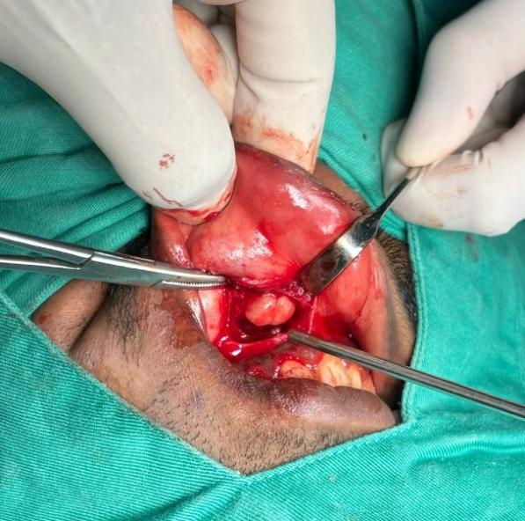  Figure 1 : Intraoperative right nasolabial mass | 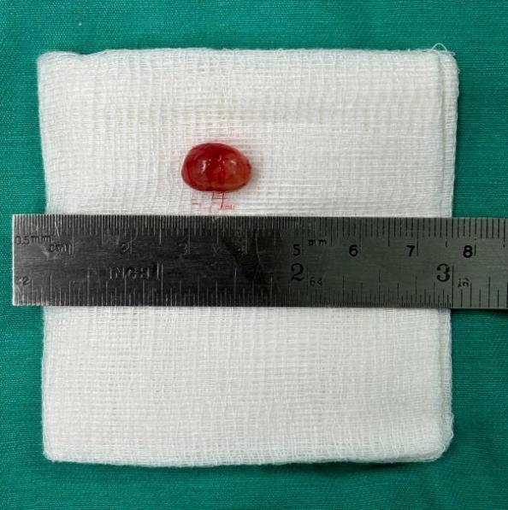  Figure 2: Right Nasolabial Mass

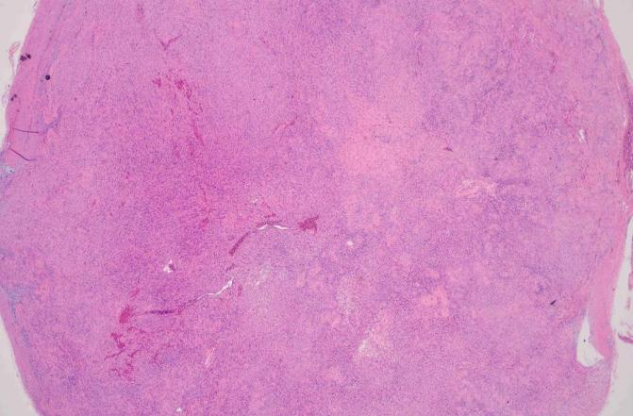  Image 1: Low power image showing a well circumscribed tumor with hypercellular (Antoni A) and hypercellular (Antoni B) areas. | 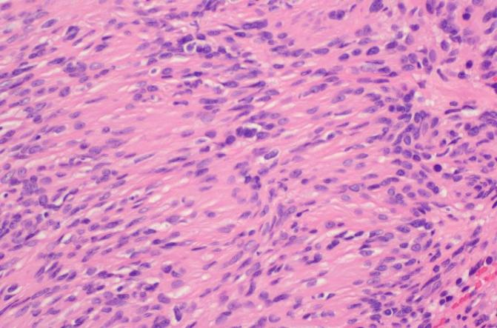  Image 2: hypercellular areas with presence of nuclear pallisading around fibrillary process (Verocay bodies)

