THE REGISTRATION OF MEDICAL DEVICE IN FDA, EU AND CDSCO: OVERVIEW
ABSTRACT:
This comprehensive summary provides a detailed look into the regulatory processes for registering medical devices in three major jurisdictions: the US Food and Drug Administration (FDA), the European Union (EU), and India's Central Drugs Standard Control Organization (CDSCO). Each regulatory agency plays a crucial role in ensuring the safety, effectiveness, and quality standards of medical devices in their respective markets.
The FDA, as the regulatory authority in the United States, has a stringent registration system in place to evaluate and approve medical devices before they can be marketed and sold. Manufacturers must adhere to specific procedures and programs to comply with FDA regulations, which are designed to safeguard patient health and promote innovation in the medical device industry.In the European Union, medical device registration is regulated by the EU's Medicinal Products for Human Use Directive, which sets forth stringent requirements for safety and quality standards. Manufacturers must undergo a thorough review process and obtain a CE Mark certification before their devices can be introduced to the European market. The EU's regulatory framework aims to harmonize standards across member states and ensure consistency in device registration procedures.In India, the CDSCO oversees the registration of medical devices and plays a key role in evaluating the safety and efficacy of products before they can be launched in the Indian market. Manufacturers must comply with CDSCO regulations and submit detailed documentation to demonstrate the safety and performance of their devices.

KEYWORDS: USFDA, EU, CDSCO, Medical device, Regulatory framework

INTRODUCTION
Registration is an important step in ensuring that a product meets strict standards of safety, effectiveness and quality before it is sold and made available to patients and doctors. This summary discusses the three main regulatory agencies that develop these systems: the US FDA (Food and Drug Administration), the European Union (EU) Medical Device Regulatory Authority (MDR), and the Central Drugs Standards Control Organization (CDSCO). India. These regulatory bodies play an important role in protecting public health by evaluating and certifying medical devices according to established standards and scientific evidence. Understanding the intricacies of various management systems is essential for manufacturers, practitioners, and management professionals trying to navigate the complexities of global business. [31-33]
The United States Food and Drug Administration (USFDA) is a government agency responsible for regulating and monitoring the safety of food, tobacco products, foodstuffs, drugs (especially sales), vaccines, biopharmaceuticals, blood transfusions, medical devices, and Erectile Dysfunction Devices (ERED). veterinary devices and cosmetics. It's in the Department of Health and Human Services. Its goals include ensuring the safety, security and performance of these products; To protect and promote health and knowledge. Conducts research, disseminates information to the public and practitioners, develops and maintains safety and security standards for food, drugs, and cosmetics, and works to protect dangerous and illegal products from leaving the American economy.
The European Union (EU) plays a key role in regulating and monitoring the development, approval and market access of medicines in its member states. The EU’s role in the pharmaceutical industry is described below:Regulatory Framework: The EU operates within the regulatory framework for medicines, which aims to ensure that medicines sold in the EU meet quality, safety and performance standards. . The European Commission oversees the regulatory process in collaboration with the European Medicines Agency (EMA) and national authorities. This process allows pharmaceutical companies to submit a marketing authorisation to the EMA, which is valid in all EU member states, facilitating access to new medicines across the EU. In addition to the centralised system, the EU also has an integration and recognition system. These allow marketing authorisations granted in one Member State to be recognised in other Member States, thus promoting access to quality medicines while monitoring the regulatory process. effect. . The Pharmacovigilance Risk Assessment Committee (PRAC) evaluates safety signals and implements the controls necessary to protect public health. . This facilitates access to medicines for patients in member states and encourages competition between pharmaceutical companies. This includes harmonized standards for clinical trials, manufacturing and labeling. This includes agreement on recognition and participation in international governance.
The Central Drugs Control Organization (CDSCO) is the national regulatory body for drugs and medical devices in India. Here is the profile of CDSCO:Mission and Mission: CDSCO manages the import, manufacturing, distribution, sales and marketing of pharmaceuticals and medical devices in India. It ensures that these products comply with the effectiveness, safety and performance standards set out in the Drugs and Cosmetics Act 1940 and the Act 1945. Ministry of Health and Family Welfare, Govt. It is headquartered in New Delhi and has many regional offices and sub-regional offices across the country. Certificate. It has also been approved for clinical trials in India. Respond to and implement regulatory measures, such as market recalls or withdrawals, to protect public health. Organization: CDSCO is supported by a panel of experts and advocates who provide scientific advice and recommendations regarding all aspects of controlled substances and safety. and the Cosmetics Act. It classifies medical devices according to risk and oversees their marketing, production and sales in India. Ensuring regulatory approval and access to affordable medicines. He introduced reforms to simplify the administrative process and increase transparency and accountability. It strives to ensure that medical products meet stringent standards and help maintain the quality and safety of healthcare services provided to the Indian community.

MEDICAL DEVICE CLASSIFICATION AS PER USFDA:
Utilizing a methodology based on risk that takes into account the planned usage as well as the intended reason for use, the US FDA classifies therapeutic devices. Three classifications are distinguished between them: I, II, and III. Medical equipment fall into three categories: Class I, the least dangerous; Class II, the risky class; and Class III, the most dangerous class. Medical equipment that is classified as Class II or Class III (high-risk) has the potential to inflict serious or catastrophic harm, whereas generally secure medical technology glitches or expires without putting a patient at risk. The amount of phases in the procedure for clearance varies based on the type of device. In order to maintain security, category I medical equipment is normally prohibited. Only a few of the particular regulations that pertain to Class II are those that deal with requirements for labelling, post-market surveillance, and advertising effectiveness. Class III medical devices cannot be premarket cleared until their effectiveness and safety have been demonstrated. The reason modern technologies are considered such is that they don't require a great deal of contact among patients and don't significantly affect the user's sense of trending topics or fitness. Individuals usually keep their central nervous system, hearts, and other vital organs apart within the Class I system. These devices are subject to the fewest limitations that are practical.

Figure.1 “An Overview of Food and Drug Administration Medical Device Legislation and Interplay with Current Medical Practices” Cureus by Schlauderaff A, Boyer KC 2019 May 9;
CLASS I MEDICAL DEVICE EXAMPLES
Class I medical supplies include things like tongue depressors, bandages, hospital beds, reusable surgical scalpels, electric toothbrushes, oxygen masks, and wheelchairs. Because they pose the least risk to patients and are not usually required for life-sustaining treatment, Class I devices may be the most quickly and easily brought to the market. The majority of Class I devices are exempt from 510(k) and premarket approval (PMA) requirements, per FDA guidelines. The U.S. Food and Drug Administration's (FDA) Fundamental Controls, a set of guidelines that still apply to Class II and III equipment, are difficult for scientific equipment classified as Class I to follow. Recordkeeping, adulteration, and intended manufacturing procedures are all part of the Fundamental Control standards. Manufacturers of classification I clinical devices, irrespective of how they are configured, need to maintain excellent management systems and comply with all legal requirements in order to guarantee excellence in their goods. The higher complexity and increased potential for direct patient contact make Class II medical equipment more risky than Class I equipment. Diagnostic equipment and instruments that come into contact with a patient's internal or circulatory systems fall under this category.
CLASS II MEDICAL DEVICE EXAMPLES:
- Catheters
- Blood stress cuffs
- Pregnancy check kits
- Syringes
- Blood transfusion kits
- Contact lenses
- Surgical gloves
Resorbable stitches the subsequent items may also be included in regulates, contingent on the particular application:
- Device overall performance
- Post-marketplace surveillance
- Patient registries
- Special labelling necessities
- Premarket facts requirements Guidelines
The class II devices are also subject to extra restrictions in relation to the originally indicated revisions to the foundational rules. a variety of factors including the technology, these limitations might also involve person-to-person registry systems, precise branding requirements, and universally applicable criteria for performance. A premarket notification approach known as 510(K) is used to bring Class II items into the market. The FDA requires a complicated software installation called a 510(K) in order to verify a device's efficacy and sustainability. This program shows how similar a gadget is to every other product currently on the market at the moment. FDA regulations state that a piece of equipment that is already on retail shelves cannot be used in the not too distant future unless it shows considerable equivalency. In essence, even if the technology isn't meant to be identical replicas, there should be many similarities between them in terms of usage, construction, and items in order packing, specifications, and other elements. Beginning in 2018, the FDA released a list of waivers that removed almost 800 distinct categories of technology from the 510(k) process. Use our guidelines to determine if a standard Class II investigation device that contains technological gadgets is prohibited from submitting a 510(k) application.
CLASS III MEDICAL DEVICE EXAMPLES
  - Breast implants
  - Pacemakers
  - Defibrillators
  - High-frequency ventilators
  - Cochlear implants
  - Fetal blood sampling video display units
  - Implanted prosthetics
All class III products must follow the other basic rules and regulations governing the Food and Drug Administration's Premarket Approval (PMA) procedure. The FDA states that traditional overall unique methods by themselves are insufficient to guarantee the efficacy and safety of category III devices. The PMA is the most comprehensive type of tool commercialization filing that the FDA accepts. A number of FDA classified as class III devices for medical use may be eligible for the 510(K) approach, as demonstrated by the option we selected above, provided a relevant predicate that was commercialized prior to the 1976 modifications to the Medicine and Healthcare Devices Regulations can be found.Still, if the FDA continues to oppose the use of over-ten-year-old drugs, this tactic could become less and less popular over time. For an extended approach, the PMA is your best bet regarding a category III instrument. In an attempt to consistently monitor safety and efficacy, you should thoroughly examine your class III healthcare devices for the PMA processes and premarket an evaluation if a benefit/hazard profile based on facts is provided. For the PMA approach to yield enough data, clinical studies frequently demand a large time and cost investment. You can even request at this stage that the FDA conduct a thorough assessment of your efficient system.
CLASSIFICATION OF MEDICAL DEVICES AS PER EMA
Medical devices are divided into just four categories in Europe, depending on the technology's intended function and any potential risks. Three categories—aggressive, continuing, and non-disruptive—are created by twenty-two regulations (Annex VIII). The Class I categorization is often not applicable to low-risk and non-invasive technologies. Measurement or sterilizing equipment is categorized under a different heading than Class I. Technologies for electrical system control or unexpected backup, medical equipment for proactive tracking and assessment, and technology that is deemed disruptive for brief intervals or therapeutically detrimental for brief intervals are all included in Class IIa. Not included within Class IIb are devices that provide energy (ionizing radiation) or distribute medicinal capsules. Instead, they comprise nearly all therapeutically traumatic devices that are implanted for a lengthy period of time. Active gadgets are likewise protected in this manner. Devices consisting of materials meant for intervention into the human body and those containing constituents that, when combined, may be interpreted as therapeutic products are categorized as Class III devices. Included are also devices designed to control the overall performance of dynamic implants and technologies with a diagnostic element for dynamic restorations.
CLASSIFICATION OF MEDICAL DEVICES AS PER CDSCO
Healthcare equipment are categorized according to their purported biological utility, technological innovation, and manufacturing quality. Administrative bodies, however, have categorized scientific apparatus according to its efficacy, safety, and unique qualities that can be disseminated globally. In addition to efficacy, chance, and impacted frame tool, fantastic needs are used to assess additional local and systemic consequences. Medical instrument warning; 2. Ignored clinical system Notifications have been sent out about the equipment in Classes A, B, C, D, and the Class A medical equipment. These devices are thought to present little risk even if their controls are difficult to operate. The initially formed group is governed by suggestions. Unauthorized devices are typically included in this subcategory along with alternative options, best manufacturing practices, refunds, restorations, and notifications. The purpose of excellence technologies is not to protect you against diseases that might be detrimental to your health. Premarket notice is often straightforward to find. Generally speaking, such pieces use a simpler strategy than the rest. Elastic bandages, toothbrushes, medical supplies, and examination gloves are a few examples. CLASS B: This elegance's key elements are the targeted controls and the intended manage. It wants stronger regulatory control than Class 1. We refer to these gadgets as minimal to medium-risk. Certification from the informed body is required for this. When instructions are followed, the affected person is not affected.
REGULATORY FRAMEWORK FOR MEDICAL DEVICE IN US
510(K) PATHWAY
A 510(K) premarket notification from the FDA attesting to the tool's highest degree of safety and efficacy is required before it may be sold. For the great majority of Class II and certain Class I devices, premarket review is an essential step. It's almost precisely like an almost legal predicate instrument. For the most part, new scientific equipment are brought to market through the 510(K) procedure. A review of the newly created technologies utilizing at least one legally available, similarly marketed instrument is one of the materials that submitters must provide in order to demonstrate their claims of substantial equivalency under the 510(K). Technologies that were lawfully advertised include those that were reclassified from the third category to Category II or I, those that were lawfully claimed in the US before May 28, 1976 (preamendments equipment), and those that the FDA determined to be significantly comparable through the application of the 510(K) strategy. PMAs are not necessary for Class III devices. Furthermore, a predicate cannot contravene the FDandC Act in order to be marketed legitimately. When a tool performs the same purpose as the predicate and has comparable technical tendencies, it is said to be usually interchangeable in a comparative study assessment.
PMA PROCESS
Considered legally advertised devices are those that were reorganized from Class III to Class II or I, those that the FDA determined to be substantially comparable through the application of the 510(K) technique, and those that were duly implemented in the United States before the 28th of May 1976 (preamendments technology). A PMA is not necessary for these devices. As a predicate, something must not be in violation of the FD&C Act in order to be legitimately sold. When two instruments perform comparable tasks and show comparable technological advancements, they are deemed practically identical in a comparable examination. Assessing generally recognized human experimentation, suitably documented case series, single-arm research, and trial designs that are randomized, in addition to other kinds of valid scientific data, can provide a reasonable assurance of both effectiveness and safety. No longer is clinical proof acceptable in the type of opinions derived from far removed research initiatives, perceptions without backing, opinions that are random, or views without sufficient information to make a meaningful judgment.
DE NOVO REQUESTS
No matter how dangerous a device may be, it is automatically classified as Class III under FD&C Act paragraph 513(f)(1). In the past, the FDA only categorized devices according to how dangerous they were. This justification stems from the description's inability to classify a newly produced item within a category that was previously classified as Class I or Class II or that was released into the market before the 1976 Biomedical Technology Modifications. Congress created a new channel for the marketing of novel, low-risk device categories that typically fit under Class III after the FDA A reorganization Act of 1997. A comparable adjustment was made to this process, commonly referred to as "de novo elegance," following the FDA health and security and Technology Act violation in 2012. As long as new device instructions fulfill threshold requirements and don't pose an unreasonable risk, the FDA will evaluate them when they are submitted de novo. Primarily, the gadget under consideration is not included in the group of gadgets that were formerly divided into categories according to degree of danger. In order to be classified as the first category or Class II, the recently introduced instrument may also satisfy phase 513(a)(1) requirements and should carry little to no risk.
INVESTIGATIONAL DEVICE EXEMPTION
Clinical trials using novel technologies with significant potential need submission of an IDE application in the United States. Clinical data may be gathered through the IDE to better guide any upcoming marketing and advertising programs. Moreover, it waives some regulatory limitations and allows the lawful transfer of a scientific instrument for investigation to organizations for medical examinations. The major objective of an IDE is to guarantee the welfare and safety of human research subjects. Internal IDE security requirements include susceptibility investigation, informed consent, clinical practice, and investigational labeling. FDA and institutional review board (IRB) approval are required for high-risk devices, however IRB approval is sufficient for low-risk devices to be utilized in experiments. When a scientific instrument is meant to be used primarily to provide diagnosis, therapy, mitigation measures, or cure of disease, or in any other circumstance the fact that prohibits deterioration of the human condition or compromises the individual who participated health, protection, or welfare, or when it is made clear or implied that its primary significance serves to preserve or protecting the existence of humanity however jeopardizing the wellness, assurance, or welfare of the state of affairs, then it is considered a major threat.
HUMANITARIAN DEVICE EXEMPTION (HDE)
Humanitarian organizational technological advances are not included (HDE). HDEs, or information technology device analogies, are commodities that resemble PMAs but don't satisfy the effectiveness standards. An approved HDE must provide their authorization before a device intended for humanitarian use may be marketed. A humanitarian use device is designed to assist health care providers in diagnosing and treating diseases that affect fewer than 4,000 Americans each year. The producer notifies the FDA's Department of Orphan Products Development (OOPD) before submitting an HDE utility that it would desire to be classified as a tool for humanitarian in nature use. The following items are part of the request: the producer's name and address; (2) a statement that a unique situation or condition is being evaluated for a humanitarian use device designation; 21 CFR § 814.102(a) requires that the instrument's intended application for a specific illness or condition be condensed, its instrument evidence furnished, and supporting documentation utilized in conjunction with the previously mentioned resources to demonstrate that the instrument is intended for the diagnosis or treatment of an illness or disease which impacts a smaller amount than 4,000 individuals annually in the United States.
REGULATORY FRAMEWORK FOR MEDICAL DEVICE IN EUROPE
There are substantial differences between the US and EU legal systems. In the 1990s, the current accepted approach was put into place with the goal of supporting European enterprises and encouraging innovations. Which gadgets are allowed is decided by the "notified bodies"—profit-making corporations. The authorized organizations that were informed by the official entities have been verified by the European Union to be in active operation. Via partnerships with gadget makers, these profit-driven businesses haggle for tool validation. The device is eventually approved for sale inside the European Union by them with the Conformité Européenne (CE) permission. In every EU member state, postmarket safety surveillance is modified by government-affiliated corporations or national governments. The CE certification on healthcare equipment provides confirmation that it complies with applicable EU criminal laws. If scientific technology bearing the CE mark conforms to all relevant national legislation, including those concerning authentication and transformation, it can be actively created inside the European Union. The CE mark must be applied to these devices before they may be sold, according EU medical equipment regulations. Releasing a systematic tool to the general population for the first time—as a patient, healthcare provider, or distributor, for example—is known as commercialization. Whether the device is given away for free, completely refurbished, or brand-new, this holds true.

REGULATORY FRAMEWORK FOR MEDICAL DEVICE IN INDIA
﻿ India has grown to be one of the largest markets for medicinal products worldwide. India's healthcare sector is now impartial because of the country's expanding personal healthcare infrastructure, the emergence of rural marketplaces, and the integration of a more varied current generation. Healthcare has the capacity to generate income, and this potential is growing at the same time as the scientific equipment industry is expanding. The Drugs and Cosmetics Act (DandC, Act) was developed in 1940 by India to control the import, manufacture, supply, and retail of medicines and cosmetics. As of right now, the Indian government has not enacted any special laws or guidelines that limit the import, manufacture, distribution, or rental of medical equipment inside its boundaries. In 1940, the Drugs and Cosmetics Act (DandC) was enacted.
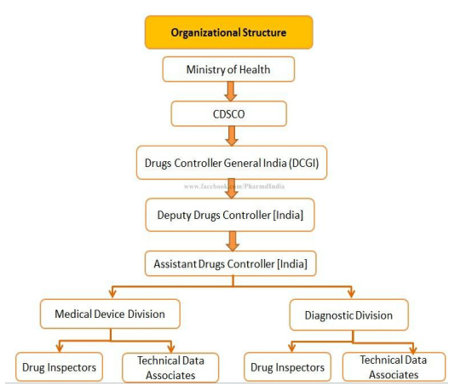

Fig.2 A Review on: Indian Pharma Regulatory System and List of New Drugs Approved By Central Drugs Standard Control Organization in the Year 2021 Till Date by Poonam Yadav

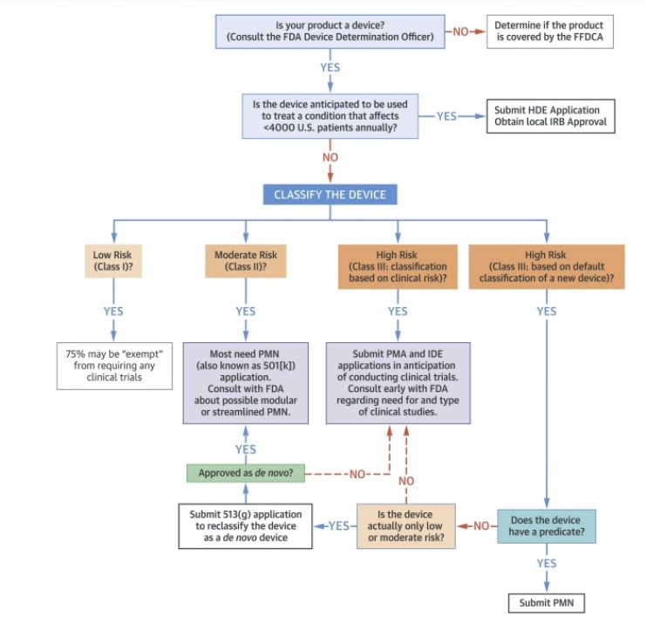
REGULATORY APPROVAL PROCESS FOR MEDICAL DEVICE IN US

Figure.3 Drugs, Devices, and the FDA: Part 2: An Overview of Approval Processes: FDA Approval of Medical Devices by Gail A. Van Norman MD

REGULATORY APPROVAL PROCESS FOR MEDICAL DEVICE IN EUROPE

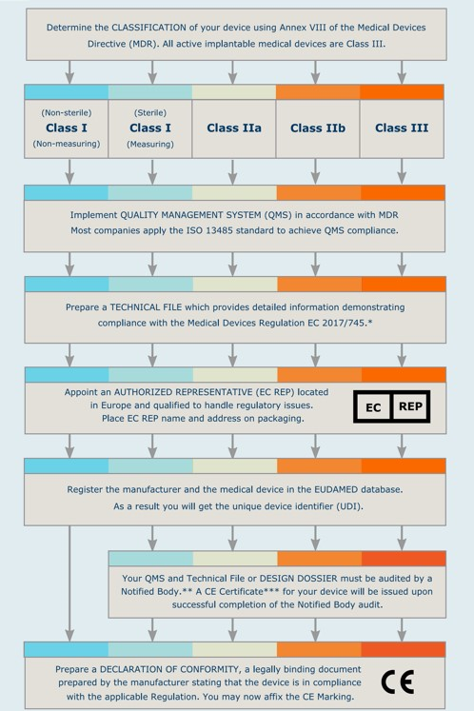

Figure.4 GUIDELINES OF IMPORTING MEDICAL DEVICES INTO THE EUROPEAN UNION

REGULATORY APPROVAL PROCESS FOR MEDICAL DEVICE IN INDIA
The Central Drugs Standard Control Organization (CDSCO), a division of the Indian government's Ministry of Health and Family Welfare, facilitates the oversight of the approval procedure for healthcare equipment regulations in a more convenient manner. In the process of approving equipment used for research, the sentence that follows steps are frequently included:
Classification of the Medical Device:
- Arrange the medical supplies based on the degree of danger involved in their use. Through the CDSCO, gratuities are used to cover the cost of the entire class.
- Writing guidelines for technical documentation
- Create a thorough technical requirement file that details the general scientific average performance, testing, manufacturing, and design of the clinical equipment.
- Send the necessary paperwork to the CDSCO in order to submit your application for the position and receive formal approval. Together with the filled-out Form MD-1, the technical documentation is included.
- The CDSCO conducts a preliminary program evaluation to ensure that all required paperwork is included.
- Visual evaluation To ensure that production facilities follow proper manufacturing practices (GMP), a walk-through observation may be conducted as part of an effort to provide appropriate education about gadgets.
- The Subject Expert Committee (SEC) evaluated the subsequent items:
- Following a review of the technical material, the SEC may request more information or clarification.
- If the SEC's recommendations and the review's full results are met, the CDSCO has the authority to approve or disapprove the clinical device's entrance into the Indian market.
- It will be challenging to conduct post-marketing surveillance on the clinical gadget once it has been cleared in order to show consumers its effectiveness and safety.
- Extending Permission: The validity of medical device approvals is frequently limited.
Manufacturers are required to confirm their approval by providing up-to-date data and meeting renewal requirements. It is important to remember that regulations and particular requirements might change at any time. Manufacturers can get up-to-date and precise data by referring to the guidelines and recommendations made accessible by the CDSCO. Consulting with professionals who have previously worked with the relevant issue or gaining regulatory experience may also be beneficial in order to effectively navigate the approval processes.

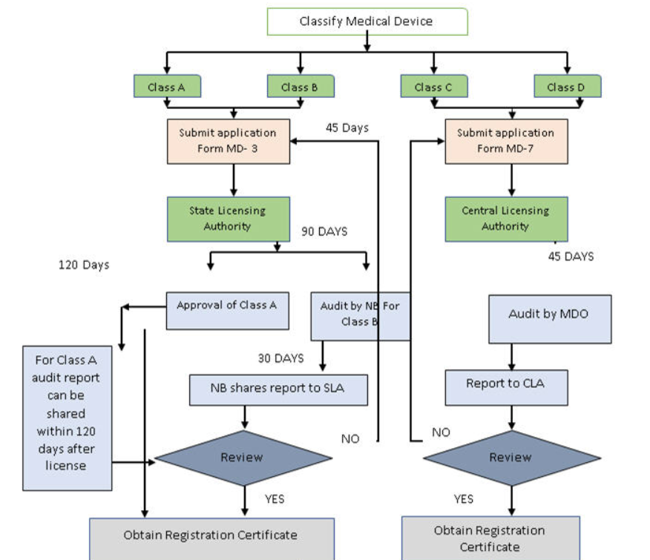
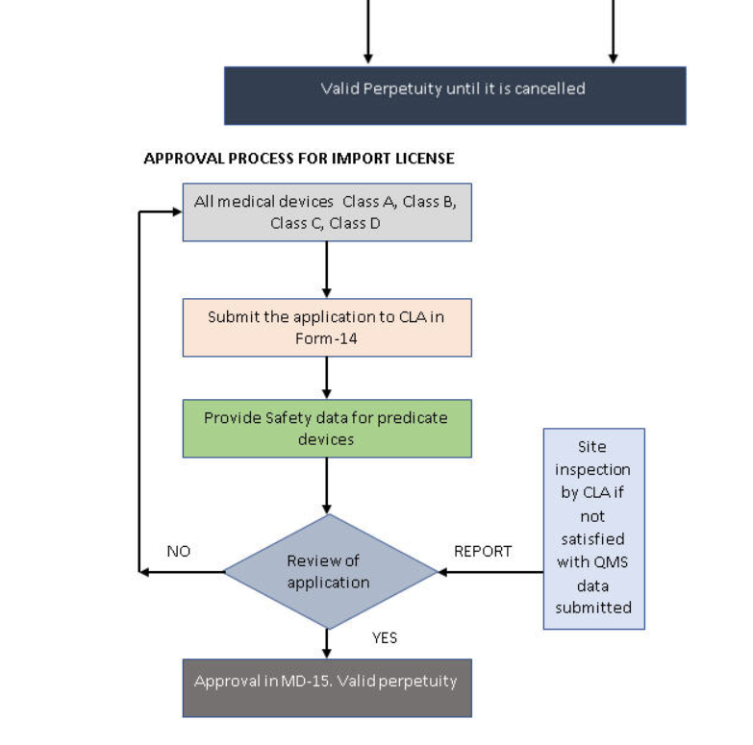

Figure.5 Medical Devices Regulatory Priorities in India By Harish Reddy Arkala, Freyr

CONCLUSION:
To be established with governmental organizations like the Food and Drug Administration ( FDA ) in the US, the EU (European Union), and an organization called the CDSCO (Central Drugs Standard Control Organization) in India, any healthcare tool must be able to prove its outstanding effectiveness, guarantee, and the effectiveness. This is a difficult yet necessary procedure. For the manufacturers, completing this registration process successfully marks a critical turning point since it enables them to sell and distribute their medical products in those crucial nations legally. When everything is taken into account, the technological device's ability to be legitimately registered with the FDA, EU, and CDSCO techniques attests to its compliance with strict regulatory standards and its importance for preserving public health. This accomplishment demonstrates the company's commitment to maintaining the highest standards of quality and safety in the design and production of scientific apparatus. These organizations' regulatory permission allows the company to grow both its patient base and its market share. Because it meets all security and efficacy criteria, the device fosters confidence among patients, healthcare professionals, and other stakeholders. Manufacturers are expected to keep an eye on, investigate, and resolve any possible post-market monitoring needs during the length of a product's lifetime. Maintaining regulatory bodies and the health care system overall may be facilitated by a persistent commitment to regulatory compliance and continual improvement, which also serves to preserve patients' interests and innovate healthcare.

Disclaimer (Artificial intelligence)
Option 1:
Author(s) hereby declare that NO generative AI technologies such as Large Language Models (ChatGPT, COPILOT, etc) and text-to-image generators have been used during writing or editing of manuscripts.
Option 2:
Author(s) hereby declare that generative AI technologies such as Large Language Models, etc have been used during writing or editing of manuscripts. This explanation will include the name, version, model, and source of the generative AI technology and as well as all input prompts provided to the generative AI technology
Details of the AI usage are given below:
1.
2.
3.
REFERENCE:
- Center for Devices and Radiological Health. Classify Your Medical Device [Internet]. U.S. Food and Drug Administration. 2020.
- Lamph S. Regulation of medical devices outside the European Union. J R Soc Med. 2012 Apr; 105 Suppl 1(Suppl 1):S12-21.
- Schlauderaff A, Boyer KC. An Overview of Food and Drug Administration Medical Device Legislation and Interplay with Current Medical Practices. Cureus. 2019 May 9;
- The Difference between Approval Processes for Medicinal Products and Medical Devices in Europe Subject Area: Ophthalmology ,John Marshall ,Kristine Morrill; Marine Gobbe; Lauren Blanchard ,Ophthalmologica (2021) 244 (5): 368–378.
- REGULATORY APPROVAL PROCESS FOR MEDICAL DEVICES IN INDIA, USA & EUROPEAN UNION Pushpa Bindu Nannepamu*, Tavva Naga Panindra Kumar, Pagadala Sai Ram, M. V. Nagabhushanam, G. Ramakrishna, Brahmaiah Bonthagarala, Y. Ratna Sindhu, Santosh Kumar Ch Volume 11, Issue 5, 2008-2017, Revised on 11 April 2022, Accepted on 01 May 2022
- The U.S. Approval Process for Medical Devices: Legislative Issues and Comparison with the Drug Model March 23, 2005 Michele Schoonmaker Specialist in Genetics Domestic Social Policy Division
- A Comparative Study of Medical Device Regulations:: US, Europe, Canada, and Taiwan ,Yi-Jung Chen, MSc, Chi-Ming Chiou, PhD, and Chia-Hung Chien, PhD View all authors and affiliations July 7, 2017.
- Review of U.S. Medical Device Regulation Jan B. Pietzsch, Lauren M. Aquino, Paul G. Yock, M. Elisabeth Paté-Cornell, John H. Linehan October 19, 2007
- Medical Device Regulation: A Comparison of the United States and the European Union Maak, Travis G. MD; Wylie, James D. MD, MHS august 2016.
- Medical Device Regulation in the European Union,Linda R. Horton,Food and Drug Law Journal,Vol. 50, No. 3 (1995), pp. 461-476 (16 pages),Published By: Food and Drug Law Institute (FDLI).
- On the new regulation of medical devices in Europe,Antonio Migliore, 24 Nov 2017
- Regulatory guidelines for medical devices in India: An overview Article Sidebar,Published: Aug 23, 2014 ,Nadimpalli Radhadevi ,Veeranna Balamuralidhara ,Teggina Math Pramod Kumar ,Valluru Ravi.
- Comparison of approval procedures for medical devices in Europe and the USA ,Marcel Vila Wagner and Thomas Schanze,From the journal Current Directions in Biomedical Engineering.
- Overview of the US FDA Medical Device Approval Process,New Therapies for Cardiovascular Disease (KW Mahaffey, Section Editor),Published: 01 June 2014 ,volume 16, Article number: 494 (2014)
- A review on approval process and regulation of medical devices as per US FDA and CDSCO,Pawar Kaustubh Navnath, Gore Rohit Tukaram, Palekar Samiksha Rohidas,SCES’s Indira College of Pharmacy, Tathawade, Pune, Maharashtra,Online published on 18 April, 2023.
- Regulation and Clinical Investigation of Medical Device in the European Union Manita; Deep, Aakash; Vikram; Rana, Avtar C.; Sharma, Prabodh C.Source: Applied Clinical Research, Clinical Trials and Regulatory Affairs, Volume 6, Number 3, 2019, pp. 163-181(19)
- Advancements in Regulatory Framework For Medical Device Regulations In India.Source: International Journal of Pharmaceutical Research (09752366) . 2020 Supplement1, p745-754. 10p. Author(s): N., VENUGOPAL; M., SELLA SENTHIL; GOWTHAMARAJAN, K.; R., ARUN
- A review of medical device regulations in India, comparison with European Union and way-ahead Manas Manu and Gaurav Anand 2021 Jul 12
- A comparative study of medical device regulations in India: Before and after the implementation of medical device rules 2017 Gomez Ann Lydia, Venkatesh D. Nagasamy*, Neelakandan Niveditha
- FDA Regulation and Approval of Medical Devices: 1976-2020Jonathan J. Darrow, SJD, LLM, JD, MBA¹; Jerry Avorn, MD¹; Aaron S. Kesselheim, MD, JD, MPH¹.
- A review on approval process and regulation of medical devices as per US FDA and CDSCO Pawar Kaustubh Navnath, Gore Rohit Tukaram, Palekar Samiksha Rohidas 18 April, 2023.
- Medical device regulations: a current perspective,SK Gupta - Journal of Young Pharmacists, 2016.
- Medical Devices and Combination Products: General Regulatory Framework Ray Bakhtiar Teva Branded Pharmaceutical Products R & D, USA Received: February 4, 2017; Accepted: March 22, 2017; Published: April 5, 2017.
- A review on approval process and regulation of medical devices as per US FDA and CDSCO,Pawar Kaustubh Navnath, Gore Rohit Tukaram, Palekar Samiksha Rohidas International Journal Of Drug Regulatory Affairs,Year : 2023, Volume : 11, Issue.
- Regulatory requirements for Medical Device Registration in Kingdom of Saudi Arabia, US and European UnionBhaskar Rajveer¹, Ola Monika², Saharan Subhash Singh³, Nikam Vishal.
- US Perspectives on the EU Medical Device Approval System, and Lessons Learned from the United States,Published online by Cambridge University Press: 20 January 2017, Christa Altenstetter.
- comparison of medical device approval process in regulated countries, associates of regulated countries and emerging countries konuri dinesh chandra* a. elphin prabhahar, brahma srinivasa rao desu, rama rao nadendla
- The FDA and the Medical Device Approval Process By Ghislaine Guez, MD, MBA, Arun Garg, DMD, Volume 23, Number 5 May 2012.
- 14 New Medical Device Approval Process in the United States,M Sherman - New Drug Approval Process, 2016.
- Improving FDA's Product Approval Process for Medical Devices,EM Basile - Food Drug Cosm. LJ, 1986.
- Motupalli, V., Bose, S. C., Venkatesh, M. P., Tiwari, V. and Ramya, G. (2021) “Overview on Regulatory Requirements for Medical Devices in Srilanka - National Medicines Regulatory Authority/NMRA”, Journal of Pharmaceutical Research International, 33(46B), pp. 567–576. doi: 10.9734/jpri/2021/v33i46B32978.
- Eidenberger R. Medical device registration, agreements on mutual recognition—a step forward to global harmonization?. Radiation Physics and Chemistry. 2000 Mar 1;57(3-6):539-42.
- Aronson JK, Heneghan C, Ferner RE. Medical devices: definition, classification, and regulatory implications. Drug safety. 2020 Feb;43(2):83-93.

