Psoriasis Vulgaris in Libyan Patients: Demographic Characteristics, Disease Severity, and Body Mass Index

Abstract:
Background: Psoriasis is a common chronic inflammatory skin disorder mainly driven by T-lymphocyte activity. It is characterized by sharply demarcated, scaly, and indurated erythematous plaques, commonly affecting the extensor surfaces, scalp, nails, genital area, and lumbosacral region.
Aim of the Study:
- To analyze the demographic characteristics of psoriasis patients in Ajdabia, Libya.
- To evaluate disease severity using the Psoriasis Area and Severity Index (PASI) and to assess patients’ Body Mass Index (BMI).
Materials and Methods: This prospective cross-sectional study included 64 patients clinically diagnosed with psoriasis vulgaris who attended the dermatology outpatient clinic at Ejdabia Hospital. Written informed consent was obtained from all participants. Detailed medical histories were recorded, including disease onset, symptoms, affected sites, family history, and triggering or aggravating factors. Each patient underwent a thorough dermatological examination. Disease severity was assessed using the Psoriasis Area and Severity Index (PASI). Body Mass Index (BMI) was calculated using standard formulae.
Statistical Analysis: Data were analyzed using the Statistical Package for the Social Sciences (SPSS) version 18. Descriptive statistics, including mean and standard deviation, were reported. The Chi-square test was used to compare categorical variables, with a p-value < 0.05 considered statistically significant.
Results: Patients’ ages ranged from 7 to 71 years, with a mean age of 36.7 years. The most represented age group was 21–40 years (32.8%), followed by 41–60 years (28.1%). Females were more common in the under-20 age group, while males predominated in those over 60. Overall, males slightly outnumbered females (53.6%). Plaque-type psoriasis was the most common clinical presentation (68.7%), followed by scalp involvement (14%). In 54% of cases, disease duration ranged from 1 to 5 years. A positive family history was noted in 53.1% of patients. PASI scores indicated moderate disease severity (score 6–10) in 67.1% of patients, while 12.3% had severe psoriasis. Most patients had a normal BMI, whereas 29% were classified as overweight.
Conclusion: The mean age of patients was 36.7 years, and more than half had a positive family history of psoriasis. Moderate disease severity was most commonly observed. PASI remains the standard tool for assessing psoriasis severity, particularly in clinical trials. Monitoring BMI is essential, as obesity is an independent risk factor that may influence disease progression and treatment outcomes.
Keywords: Psoriasis; Demography; Psoriasis Area Severity Index; Body Mass Index; Libya
Keywords: Psoriasis, PASI score, Life quality, Body Mass Index (BMI).

Introduction:
Psoriasis is a common, chronic, immune-mediated inflammatory skin disease primarily driven by T-lymphocyte dysfunction. Clinically, it is characterized by scaly, well-demarcated, indurated erythematous plaques typically located on extensor surfaces, scalp, nails, genitalia, and the lumbosacral region (1, 2). It is a multifactorial disorder influenced by both intrinsic and extrinsic factors. Genetic susceptibility plays a significant role, especially in early-onset cases (under 40 years), where a family history is frequently observed (3, 4). Psoriasis is widely recognized as a systemic disease with polygenic inheritance and is often triggered or exacerbated by various environmental and behavioral factors (5).
Globally, psoriasis affects approximately 125 million people (6, 7). In about 30% of cases, joint involvement occurs, leading to psoriatic arthritis—a potentially disabling manifestation of the disease (8). Psoriasis affects both children and adults, with no definitive sex predilection, although females and individuals with a family history may experience earlier onset (9, 10). The disease demonstrates a bimodal age distribution: 30–39 and 60–69 years in men, with onset occurring approximately a decade earlier in women (11).
Recent global epidemiological analyses, including large multicenter studies, have confirmed the substantial worldwide burden of psoriasis across all age groups, including young adults (12, 13). Regional studies have also demonstrated significant variability in disease patterns. For example, Egyptian studies have reported notable functional disabilities among psoriasis patients and distinct clinicodemographic features in the local population (14, 15).
While psoriasis can develop at any age, it is more prevalent in adults. A global systematic review reported a prevalence ranging from 0.5% to 11.4% in adults and 0% to 1.4% in children (16). Overall, it is estimated that around 60 million people worldwide are affected, with higher prevalence in high-income and aging populations (6, 11). Interestingly, prevalence also correlates with geographic location. Populations living closer to the equator (e.g., Egypt, Tanzania, Sri Lanka, and Taiwan) have lower prevalence compared to those in more distant regions such as Europe and Australia (4, 9, 17).
Evaluating the severity of psoriasis relies on both patient-reported outcomes and objective clinical tools. Among these, the Psoriasis Area and Severity Index (PASI) remains the gold standard. PASI scores quantify lesion severity and body surface area involvement, with treatment goals often targeting PASI 75, PASI 90, or PASI 100 responses (18). Additional research has refined PASI evaluation methods, including flow-cytometry-based objectivization of lymphocyte subsets (19) and evidence demonstrating that PASI assessment of a single body region may reliably reflect overall PASI 75/90 therapeutic responses (20). Furthermore, psoriasis affecting special areas (e.g., scalp, nails, genital regions, intertriginous sites) has gained increasing clinical attention due to its unique burden and management challenges (21).
Body Mass Index (BMI) is among the most widely used indicators for assessing body weight relative to height. Evidence supports a strong association between psoriasis and obesity-related comorbidities, including type 2 diabetes mellitus, hypertension, ischemic heart disease, and hyperlipidemia (22). Adipose tissue in obese individuals secretes proinflammatory cytokines and adipokines such as TNF-α, IL-6, leptin, and chemokines, which contribute to chronic systemic and cutaneous inflammation (22, 23). Leptin enhances T-cell activation and TNF-α production, thereby amplifying psoriatic inflammation (23). Another adipokine, resistin, produced by visceral fat macrophages, is associated with insulin resistance and has been linked to increased psoriasis severity (22).
Given these associations, obesity is increasingly recognized as an independent risk factor for the onset, persistence, and severity of psoriasis (24, 25). Recent studies further confirm that elevated BMI is strongly associated with severe psoriasis phenotypes (26) and demonstrate significant correlations between BMI, blood pressure, and psoriasis severity (27).

Aim of the Study:

General Objective

To comprehensively assess the demographic characteristics and clinical severity of psoriasis among patients attending the dermatology outpatient clinic in Ajdabia, Libya.

Specific Objectives
- To determine the demographic profile of psoriasis patients (including age, sex, and disease duration) attending the dermatology clinic in Ajdabia, Libya.
- To evaluate psoriasis severity using the Psoriasis Area and Severity Index (PASI) score in the study population.
- To measure Body Mass Index (BMI) among the included patients and explore its distribution within the cohort.
Materials and Methods:
This prospective cross-sectional study included 64 patients clinically diagnosed with psoriasis vulgaris. All patients attended the dermatology outpatient clinic at Ejdabia Hospital. Informed written consent was obtained from all participants. Each patient underwent a detailed history-taking, including disease onset, symptoms, affected sites, family history, and known precipitating or aggravating factors, and underwent a thorough dermatological examination. Disease severity was assessed using the Psoriasis Area and Severity Index (PASI), and BMI was calculated from patients’ weight and height recorded on a standardized form.
Inclusion Criteria:
- Clinically diagnosed psoriasis (any type, e.g., plaque, guttate, or scalp).
- Patients of all ages and both sexes.
- Willingness to participate and provide informed consent.

Exclusion Criteria:
- Patients with chronic liver, kidney, or gastrointestinal disorders.
- Pregnant or lactating women.
Data were analyzed using SPSS version 18 for Windows. Descriptive statistics, including mean, standard deviation, median, and mode, were calculated as appropriate. The Chi-square test was used to compare variables between genders, and a p-value < 0.05 was considered statistically significant.
Results:
The study included 64 patients aged between 7 and 71 years, with a mean age of 36.7 years. The most represented age group was 21–40 years (32.8%), followed by 41–60 years (28.1%) (Figure 1). Females were more prevalent in the under-20 age group, whereas males were more common in those over 60. Overall, males slightly outnumbered females (53.6%) (Figure 2).
Clinically, plaque-type psoriasis was the most common presentation (68%), followed by scalp psoriasis (14%) (Table 1). In terms of disease duration, 54% of patients had psoriasis for 1–5 years (Table 2). A positive family history was noted in 53.1% of cases.
PASI score analysis revealed that 67.1% of patients had moderate psoriasis (PASI 6–10), while 12.3% had severe disease (Figure 3). BMI measurements showed that the majority had normal BMI, although 29% were categorized as overweight (Figure 4). (Figure 5) displays a case of severe psoriasis vulgaris, while (Figure 6) illustrates palmoplantar psoriasis.

Figure 1: Age group distribution of patients.

Figure 2: Gender distribution of patients.

Table 1: Distribution of patients according to the clinical type of Psoriasis.
Psoriasis type | Plaque Psoriasis | Gutatte  Psoriasis | Scalp  Psoriasis | Palmoplantar  Psoriasis
No. | 44 ( 68.7% ) | 6 (9.3% ) | 9 (14 % ) | 5 (7.8% )

Table 2: Distribution of patients according to duration.
Duration | < 1 year | 1-5 years | 6-10 years | 11-15 years
No. (%) | 8 ( 12.5% ) | 35 (54.6% ) | 12 (18.7% ) | 9 (14% )

Figure 3: Distribution of patients according to the severity of psoriasis.

Figure 4: Distribution of the patients according to BMI.
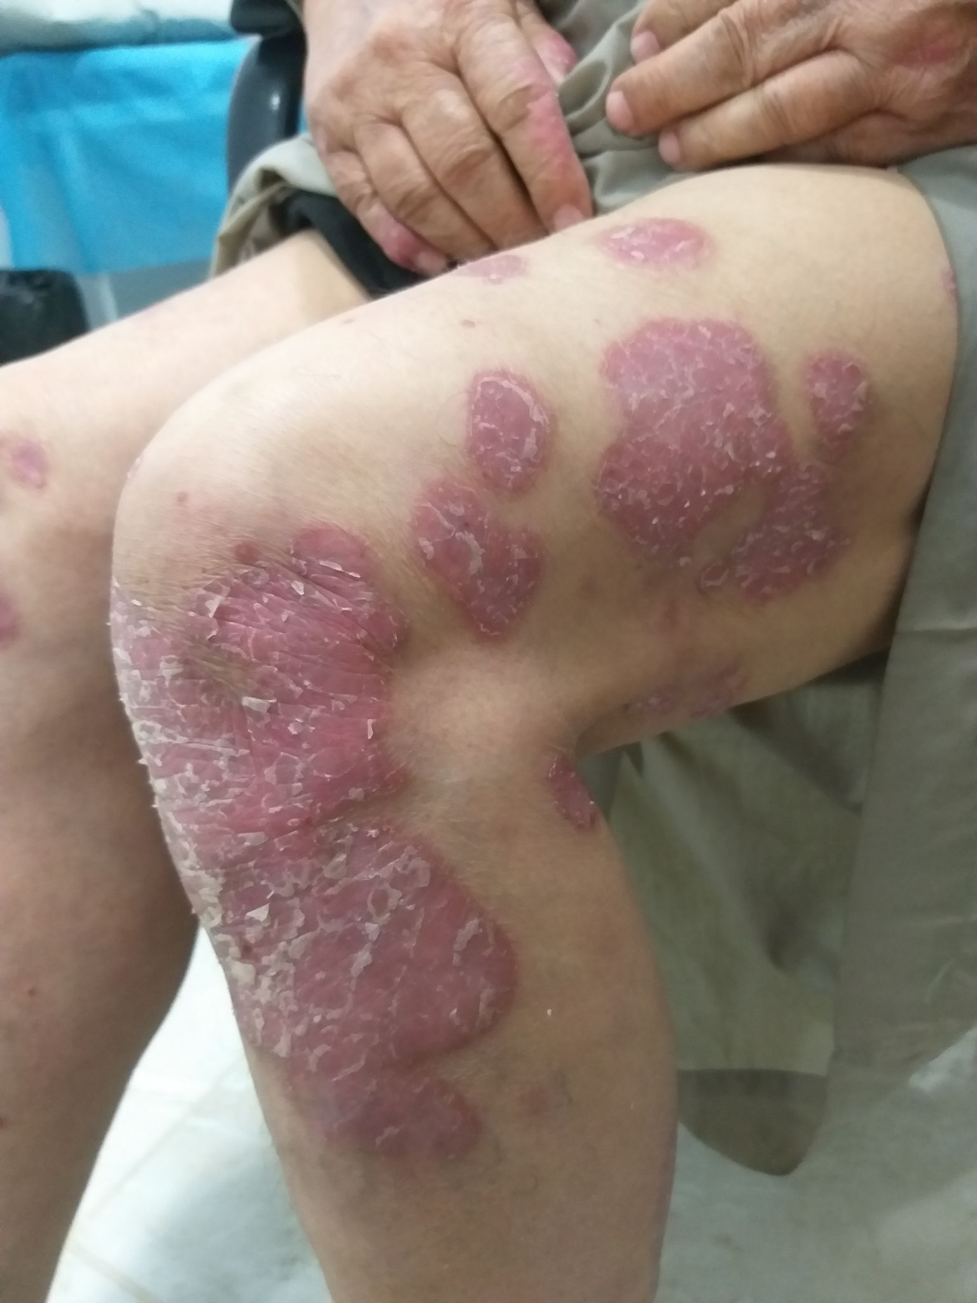
Figure. 5: Extensive ( Severe ) plaque psoriasis involving lower extremities.

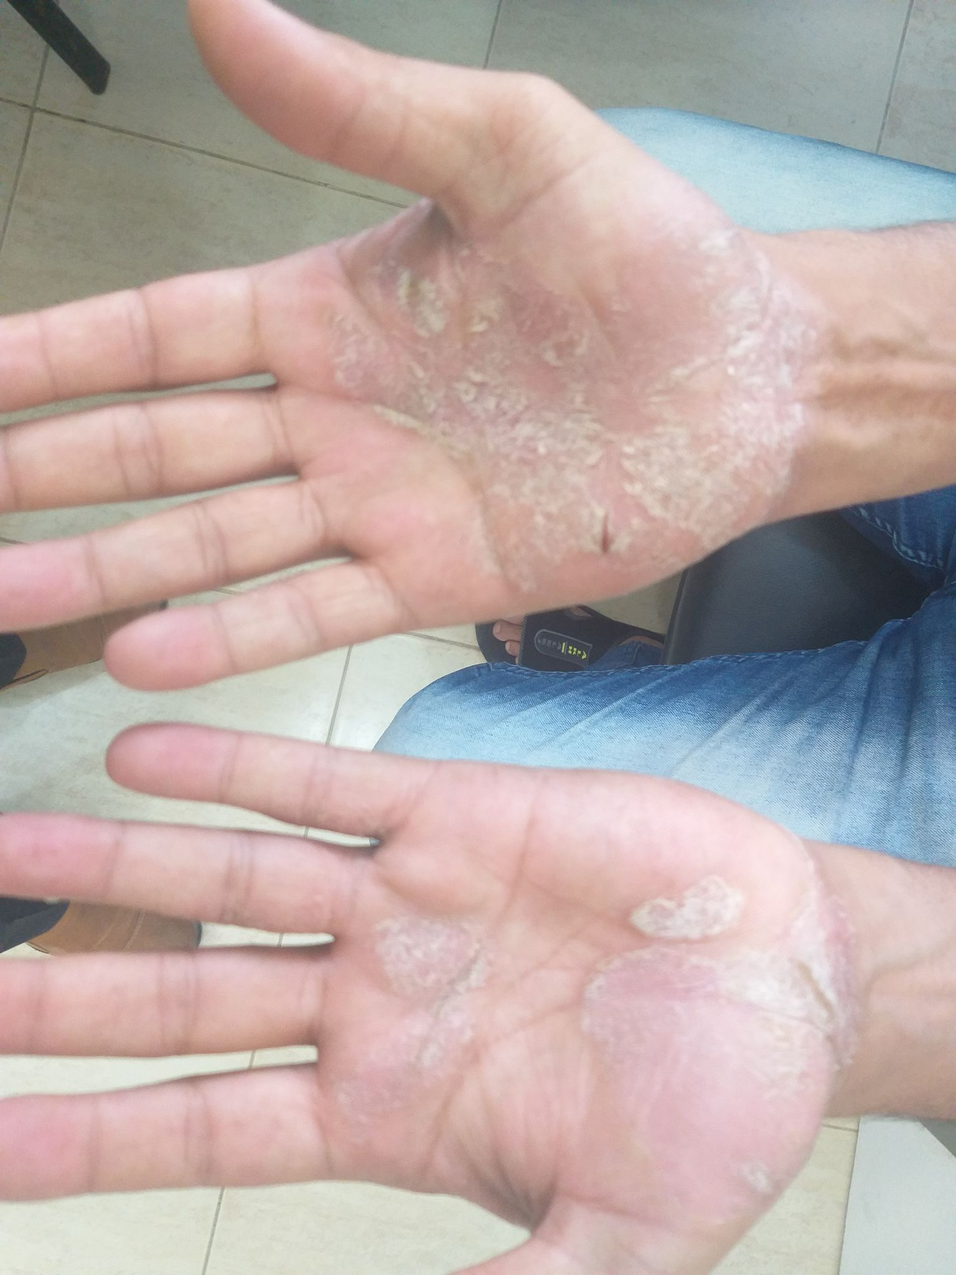
Figure 6: Palmoplantar psoriasis.
Discussion:
Psoriasis is a chronic, non-infectious, immune-mediated systemic condition influenced by both polygenic inheritance and environmental triggers (1,3). Its pathogenesis involves increased antigen presentation by antigen-presenting cells (APCs), which activate T lymphocytes. This activation stimulates the release of pro-inflammatory cytokines such as interferon-γ, interleukin-2 (IL-2), and tumor necrosis factor-alpha (TNF-α), particularly from Th1 cells. These cytokines drive the inflammatory cascade in the epidermis, leading to the formation of thickened, scaly plaques (1, 3).
Globally, the prevalence of psoriasis is estimated to range from 1% to 4%, with regional variation in occurrence. In the United States, approximately 2% of the population is affected (1, 3). Despite being a worldwide condition, the incidence of psoriasis differs across regions. For example, epidemiological data indicate an incidence as low as 31.4 per 100,000 person-years in Eastern Europe (Russia) and as high as 521.1 per 100,000 person-years in Western Europe (Germany) (27, 28). Additionally, a study by Kubanova et al. documented a slight decline in psoriasis incidence in Russia, from 69.8 to 65.0 per 100,000 person-years between 2010 and 2016 (27).
Only two long-term studies one from Italy (7 years) and one from the United States (30 years) have examined the incidence of psoriasis in pediatric populations (29, 30). In contrast, psoriasis remains relatively rare in Africa, particularly in West Africa. Prevalence rates range from 1.9% to 3.5% in East African nations such as Kenya, Uganda, and Tanzania but are significantly lower in West African countries, including Nigeria, Ghana, Mali, and Angola, where reported rates range from 0.025% to 0.9% (31, 32, 33).
In Australia, psoriasis prevalence varies between 0.3% and 2.5% (34). Interestingly, the disease appears to be absent or extremely rare among full-blooded Australian Aborigines. A large survey of approximately 3,000 individuals across central, northern, and southern Australia did not document a single case of psoriasis (35).
Plaque psoriasis is the most prevalent clinical variant globally. For example, studies report its occurrence in 62.9% of cases in Ethiopia (36), 84.1% in Egypt (37), 88.1% in Nigeria (31), 89% in Australia (38), 89.5% in Russia (39), 97.4% in Japan (40), and 97.06% in China (41). Furthermore, research has shown that all-cause mortality among psoriasis patients is approximately 20% higher than in individuals without the disease. In our prospective cross-sectional study conducted in Ejdabia, Libya, the mean patient age was 37.2 years. The most commonly affected age groups were 21–40 years and 41–60 years, with fewer patients above the age of 60. These findings align with international literature, which indicates that psoriasis can develop at any age, including infancy and advanced age (1). Epidemiological studies also suggest a bimodal age of onset, typically peaking at 20–30 and 50–69 years (42, 43), while some data indicate peaks at 30–39 and 60–69 years (44). Although psoriasis affects both sexes equally, it is reportedly more common among non-Hispanic white populations (42, 43).
Variations in the prevalence of psoriasis between males and females have been reported across different studies. Some research indicates a nearly equal distribution between the sexes (1, 31), with one study noting a prevalence of 0.12% in men and 0.11% in women (10). Conversely, other studies have identified a higher prevalence in men; for example, one report suggested that psoriasis is twice as common in males compared to females (1, 2).
In our study, psoriasis was slightly more prevalent in males (53.6%) than in females, aligning with findings from previous studies conducted in countries such as China and India. Notably, females were more frequently affected in the under-20 age group, whereas males were more represented in the over-60 age group.
Psoriasis vulgaris is the most common clinical form, accounting for approximately 80% to 90% of all psoriasis cases (9). Research has shown that the heritability of psoriasis is significantly elevated in first-degree relatives, with a prevalence of 4.6% approximately 22 times higher than in the general population (0.21%) (1, 2 ,3).
A 2012 study found that 28% of individuals with psoriasis had a positive family history, representing nearly 13 times the population average (22, 31). Another report indicated that 29.4% of psoriasis vulgaris patients had affected family members, and those with psoriatic parents often experienced an earlier onset than those with unaffected parents. Heritability rates were estimated at 71% for first-degree relatives and 37% for second-degree relatives (28). In the present study, a positive family history was noted in 53.1% of patients higher than rates documented in previous studies.
The Psoriasis Area and Severity Index (PASI) remains the gold standard for assessing psoriasis severity in clinical trials and practice. It combines the assessment of lesion severity (erythema, induration, and desquamation) with the percentage of affected body surface area across four regions: head, trunk, upper limbs, and lower limbs. The total score ranges from 0 to 72, with higher scores indicating more severe disease (14, 17, 25, 26).
Standard thresholds typically classify psoriasis as:
- Mild: PASI < 6
- Moderate: PASI 6–10
- Severe: PASI > 10
PASI 75, PASI 90, and PASI 100 are widely used treatment response benchmarks, referring to 75%, 90%, and 100% improvement from baseline, respectively.
In our study, PASI scores revealed that 67.1% of patients had moderate psoriasis (score 6–10), while 12.3% had severe disease (18, 19, 45).
Obesity has been consistently linked to psoriasis in numerous large-scale studies conducted across Europe and the United States. Even after adjusting for confounding variables such as age, sex, and race, individuals with psoriasis have been found to exhibit significantly higher body mass index (BMI) values compared to those without the condition. This elevated BMI is also associated with an increased risk of cardiovascular comorbidities in psoriatic patients (21, 22). An observational study involving 147 adults with plaque psoriasis reported that 39.46% of participants were overweight and 37.41% were obese, highlighting a strong predisposition among psoriatic individuals toward abnormal body weight. Furthermore, 77% of patients with psoriatic arthritis in the same study were either overweight or obese. Correlation analysis revealed that increased BMI significantly influenced psoriasis severity, as evidenced by a positive association with PASI scores (R = 0.23, p = 0.016) and body surface area (BSA) involvement (R = 0.21, p = 0.023), particularly when compared to individuals with normal BMI (21, 22, 46). In the current study cohort, the majority of patients had a normal BMI, while 29% were classified as overweight.

Conclusion:

The Psoriasis Area and Severity Index (PASI) remains the gold standard for evaluating disease severity and is commonly used as a key efficacy endpoint in clinical trials for moderate-to-severe psoriasis.
Additionally, dermatologists should place greater importance on monitoring BMI as part of managing psoriasis, recognising obesity as an independent risk factor that can influence disease progression and treatment outcomes.

CONSENT
The authors confirm that informed consent was obtained from all patients involved in the study.

ETHICAL APPROVAL
The authors declare that ethical approval was secured prior to conducting the research.

DISCLAIMER (ARTIFICIAL INTELLIGENCE)
The authors certify that no generative AI tools, including large language models (e.g., ChatGPT, Copilot) or text-to-image generators, were used in the writing or editing of this manuscript.

COMPETING INTERESTS
The authors declare that there are no competing interests.

References:
- Bologna JL, Schaffer JV, Cerroni L. Dermatology. China: Elsevier; 2018:138–139.
- Tokuyama M, Mabuchi T. New treatments targeting the pathogenesis of psoriasis. International Journal of Molecular Sciences. 2020;21:7488.
- Cheng L, Wang S, Peng C, et al. Human umbilical cord mesenchymal stem cells for psoriasis: a phase 1/2a single-arm study. Signal Transduction and Targeted Therapy. 2022;7:263.
- Dand N, Mahil SK, Capon F, et al. Psoriasis and genetics. Acta Dermato-Venereologica. 2020;100.
- O’Rielly DD, Jani M, Rahman P, et al. The genetics of psoriasis and psoriatic arthritis. Journal of Rheumatology. 2019;95(Suppl):46–50.
- Hepat A, Chakole S, Rannaware A. Psychological well-being of adult psoriasis patients: a narrative review. Cureus. 2023;15(4):e37702.
- National Psoriasis Foundation. Psoriasis statistics. Accessed Dec 21, 2023.
- Alinaghi F, Calov M, Kristensen LE, et al. Prevalence of psoriatic arthritis in patients with psoriasis: a systematic review and meta-analysis. Journal of the American Academy of Dermatology. 2019;80(1):251–265.e19.
- Parisi R, Symmons DPM, Griffiths CEM, Ashcroft DM. Global epidemiology of psoriasis: a systematic review of incidence and prevalence. Journal of Investigative Dermatology. 2013;133:377–385.
- Rachakonda TD, Schupp CW, Armstrong AW. Psoriasis prevalence among adults in the United States. Journal of the American Academy of Dermatology. 2014;70:512–516.
- Parisi R, Iskandar IYK, Kontopantelis E, et al. National, regional, and worldwide epidemiology of psoriasis: systematic analysis and modelling study. BMJ. 2020;369:m1590.
- Skayem C, Taieb C, Halioua B, Baissac C, Saint Aroman M, et al. Epidemiology of psoriasis: a worldwide global study. Acta Dermato-Venereologica. 2025;105:42945. doi:10.2340/actadv.v105.42945.
- Zhang Y, Dong S, Ma Y, Mou Y. Burden of psoriasis in young adults worldwide from the global burden of disease study 2019. Frontiers in Endocrinology. 2024;15:1308822. doi:10.3389/fendo.2024.1308822. PMID:38414821.
- Ibrahim Abd El Kader A, Ahmed Ibrahim F, Awad Abd El Magied Salime R, et al. Psoriasis severity and functional disabilities among patients with psoriasis. Egyptian Journal of Health Care. 2024;15(1):1358–1370. doi:10.21608/ejhc.2024.346001.
- Aboeldahab S, El Hamd MA, Bakla RM, Nada EA, et al. Clinicodemographic and laboratory features of 200 Egyptian psoriatic patients. Egyptian Journal of Dermatology and Venereology. 2023;43(1):15–23. doi:10.4103/ejdv.ejdv_9_22.
- Michalek IM, Loring B, John SM. A systematic review of worldwide epidemiology of psoriasis. Journal of the European Academy of Dermatology and Venereology. 2017;31:205–212.
- Butacu AI, Toma C, Negulet IE, Manole I, Banica AN, Plesea A, et al. Updates on psoriasis in special areas. Journal of Clinical Medicine. 2024;13(24):7549. doi:10.3390/jcm13247549. PMID:39768472.
- Alizadeh N, Azimi SZ, Hoseinzadeh S. Body mass index and severity of psoriasis: a cross-sectional study. Iranian Journal of Dermatology. 2021;24(1).
- Zecevic Pasic L, Dzananovic N, Gojak R, Tihic Kapidzic S, Hasanefendic B, Begovic E, et al. Psoriasis Area and Severity Index (PASI) objectivisation by flow cytometry analysis of major lymphocyte subsets. Acta Informatica Medica. 2023;31(3):206–210. doi:10.5455/aim.2023.31.206210. PMID:37781498.
- Okun MM, Gu Y, Huang X, Sun Y, Karunaratne P, Valdecantos WC, et al. Psoriasis Area and Severity Index (PASI) assessment of a single body region to represent achievement of PASI 75 and 90 responses with adalimumab. Journal of the American Academy of Dermatology. 2017;76(6):AB208.
- Correia B, Torres T. Obesity: a key component of psoriasis. Acta Biomedica. 2015;86(2):121–129.
- Paller AS, Mercy K, Kwasny MJ, et al. Association of pediatric psoriasis severity with excess and central adiposity. JAMA Dermatology. 2013;149(2):166–176.
- Takeshita J, Grewal S, Langan SM, et al. Psoriasis and comorbid diseases: epidemiology. Journal of the American Academy of Dermatology. 2017;76(3):377–390.
- Fleming P, Kraft J, Gulliver WP, Lynde CW. The relationship of obesity with the severity of psoriasis: a systematic review. Journal of Cutaneous Medicine and Surgery. 2015;19(5):450–456.
- Wang H, Hou S, Kang X, Yu C, Yang B, Shi Y, et al. BMI matters: understanding the link between weight and severe psoriasis. Scientific Reports. 2025;15:11158. doi:10.1038/s41598-025-94505-0. PMID:40169742.
- Prakasita KA, Prakoeswa CRS, Alinda MD, Setyaningrum T, Astari L, Utomo B, et al. Correlation between body mass index and blood pressure with severity of psoriasis vulgaris. Journal of the Pakistan Association of Dermatology. 2025;35(1):67–72
- Jacob C, Meier F, Neidhardt K, et al. Epidemiology and costs of psoriasis in Germany: a retrospective claims data analysis. Value Health. 2016;19:A.
- Kubanova A, Kubanov A, Melekhina L, et al. Assessment of the incidence of skin disorders in the Russian Federation from 2003 to 2016. Vestn Dermatol Venerol. 2017;93:22–33.
- Egeberg A, Skov L, Gislason GH, et al. Incidence and prevalence of psoriasis in Denmark. Acta Derm Venereol. 2017;97:808–812.
- Cantarutti A, Donà D, Visentin F, et al. Epidemiology of common skin diseases in Italian children from 2006 to 2012: a retrospective, population-based study. Pediatr Dermatol. 2015;32:668–678.
- Yahya H. Psoriasis in Kaduna, North-West Nigeria: a twenty-year experience. Niger Postgrad Med J. 2022;29(2):155–160.
- Parisi R, Symmons DPM, Griffiths CEM, Ashcroft DM. Global epidemiology of psoriasis: a systematic review of incidence and prevalence. J Invest Dermatol. 2013;133(2):377–385.
- Chandran V, Raychaudhuri SP. Geoepidemiology and environmental factors of psoriasis and psoriatic arthritis. J Autoimmun. 2010;34(3):J314–J321.
- Plunkett A, Marks R. A review of the epidemiology of psoriasis vulgaris in the community. Aust J Dermatol. 1998;39(4):225–232.
- Green AC. Australian Aborigines and psoriasis. Australas J Dermatol. 1984;25(1):18–24.
- Morrone A, Dell’Anna ML, Cristaudo A, et al. Psoriasis in Tigray, Ethiopia: focusing on available treatments. Dermatol Ther. 2022;35(3):e14718.
- El-Komy MHM, Mashaly H, Sayed KS, et al. Clinical and epidemiologic features of psoriasis patients in an Egyptian medical center. JAAD Int. 2020;1(2):81–90.
- Dickison P, Swain G, Peek JJ. Itching for answers: prevalence and severity of pruritus in psoriasis. Australas J Dermatol. 2018;59(3):206–209.
- Kubanov AA, Bogdanova EV. Epidemiology of psoriasis in the Russian Federation based on patient registry data. Vestn Dermatol Venerol. 2022;98(2):33–41.
- Kubota K, Kamijima Y, Sato T, et al. Epidemiology of psoriasis and palmoplantar pustulosis: a nationwide study using Japan’s national claims database. BMJ Open. 2015;5(1):e006450.
- Ding X, Wang T, Shen Y, et al. Prevalence of psoriasis in China: a population-based study in six cities. Eur J Dermatol. 2012;22(5):663–667.
- Armstrong AW. Psoriasis. JAMA Dermatol. 2017;153(9):956.
- Raharja A, Mahil SK, Barker JN. Psoriasis: a brief overview. Clin Med (Lond). 2021;21(3):170–173.
- Iskandar IYK, Parisi R, Griffiths CEM, et al. Global Psoriasis Atlas: a systematic review of changes over time in psoriasis incidence and prevalence by age and gender. Br J Dermatol. 2021;184(2):243–258.
- Feldman SR, Fleischer AB, Reboussin DM, et al. The self-administered psoriasis area and severity index is valid and reliable. J Invest Dermatol. 1996;106:183–186.
- Czarnecka A, Zabłotna M, Purzycka-Bohdan D, et al. An observational study of 147 psoriasis patients: overweightness and obesity as significant clinical factors correlated with psoriasis. Medicina (Kaunas). 2023 Nov 15;59(11):2006.

