Clinical Outcomes and Pathophysiological Correlates of Deep Brain Stimulation in Parkinson’s Disease: A Systematic Review
- Abstract
Background:
Parkinson's disease (PD) is a progressive neurodegenerative disorder that causes motor and non-motor symptoms due to the loss of dopaminergic neurons and problems with the basal ganglia circuitry. Deep brain stimulation (DBS) is now a well-known surgical treatment for people with advanced PD who have motor problems that don't respond to medical treatment. To get the most out of DBS therapy and choose the best patients, it is important to know how it works and what the clinical outcomes are.
Objective:
To look at all the evidence, we have so far about the clinical outcomes and pathophysiological correlates of DBS in Parkinson's disease, focusing on improvements in motor and non-motor functions, target-specific effects, and the neurophysiological mechanisms behind them.
Methods:
We looked through the PubMed, Scopus, and Web of Science databases for all studies published between 2010 and 2025. Randomized controlled trials, cohort studies, and mechanistic investigations that looked at DBS outcomes in PD were all eligible studies. We got information about the stimulation targets (subthalamic nucleus (STN), globus pallidus internus (GPi]), clinical effectiveness, problems, and neurophysiological results. The PRISMA 2020 guidelines were used to look at the risk of bias and the quality of the study.

Results: 78 studies met the requirements for inclusion. DBS significantly improved Unified Parkinson's Disease Rating Scale (UPDRS) motor scores (by an average of 45–60%), cut the need for medication by 30–50%, and raised quality of life scores. STN stimulation helped with motor function more, but it also caused more neuropsychiatric side effects. GPi DBS, on the other hand, helped with mood and cognitive stability more. Pathophysiological studies showed that DBS changes abnormal oscillatory activity in the basal ganglia-thalamo-cortical loop, brings beta-band synchronization back to normal, and makes cortical excitability patterns normal again.
Conclusion:
DBS improves motor and functional abilities in advanced PD in a big way and for a long time by changing dysfunctional neuronal networks. The therapeutic response changes depending on the stimulation target and the patient's profile. This shows how important it is to use personalized approaches and do more research on adaptive and closed-loop DBS systems.
Keywords: Parkinson’s disease, deep brain stimulation, subthalamic nucleus, globus pallidus internus.

2.Inroduction
Parkinson's disease (PD) is a common neurodegenerative disorder that progressively worsens and causes a wide range of non-motor symptoms. The pathological hallmark of PD is the degeneration of nigrostriatal dopaminergic neurons, characterized by intracellular α-synuclein aggregates known as Lewy bodies [1]. The gradual loss of dopaminergic neurons in the substantia nigra pars compacta leads to striatal dopamine deficiency, which underlies the classic motor symptoms of bradykinesia, rigidity, resting tremor, and postural instability [2]
Non-motor symptoms including cognitive decline, mood disturbances, autonomic dysfunction, and sleep disorders further compromise quality of life. Deep brain stimulation (DBS), targeting the subthalamic nucleus (STN) or globus pallidus internus (GPi), is an evidence-based surgical treatment for patients with motor complications or medication-induced fluctuations [3]. DBS effectively reduces motor disability, decreases medication requirements, and often improves overall quality of life. Landmark randomized trials and long-term follow-up studies have confirmed its safety and efficacy, establishing persistent clinical indications [4].
The therapeutic effects of DBS are thought to arise from modulation of abnormal oscillatory activity in the basal ganglia-thalamocortical circuits, restoring more normal firing patterns and functional connectivity across motor networks [5]. Despite its clinical effectiveness, patient responses vary considerably. Factors such as disease duration, electrode placement accuracy, stimulation parameters, and individual progression patterns contribute to this heterogeneity. The precise mechanisms behind these differences including regional neuropathology, network connectivity, local field potentials, and microstructural integrity remain incompletely understood [6].
Neuroimaging studies using MRI, PET, and diffusion tractography have highlighted the importance of distributed networks rather than isolated nuclei in mediating DBS effects [7]. Electrophysiological recordings indicate that therapeutic benefit is associated with suppression of exaggerated beta-band oscillations and restoration of movement-related gamma activity, although the relationship between these physiological markers and underlying pathology is still under investigation [8].
Recent research increasingly integrates pathology-level data (e.g., postmortem histology near electrode sites, Lewy body distribution) with physiological biomarkers (such as beta oscillations, burst dynamics, and gamma activity). Variations in α-synuclein accumulation and local gliosis may influence microcircuit properties and, consequently, DBS efficacy. Connectomic modeling has also identified potential sweet spots and avoidance zones within the STN and GPi to optimize outcomes while minimizing side effects [9].
Even with these advances, long-term outcomes remain limited by disease progression outside stimulated networks, particularly for gait and balance deficits. Neuropsychiatric complications and cognitive decline can further constrain overall benefit, emphasizing the need for careful patient selection [10].
To improve predictive models and guide personalized therapy, multimodal approaches combining clinical, imaging, and electrophysiological metrics are essential. Integrating these datasets may help optimize patient selection, refine targeting strategies, and enable adaptive or closed-loop DBS systems, which adjust stimulation in real time based on physiological feedback. These technologies hold promise for maximizing efficacy, minimizing side effects, and prolonging device longevity [11]
3. Objectives of the Study
3.1 General Objective:
To look at the clinical results and the underlying pathophysiological mechanisms of deep brain stimulation (DBS) in people with Parkinson's disease (PD).
3.2 Specific Objectives:
1. To find out how DBS affects motor and non-motor symptoms, quality of life, and functional independence in people with Parkinson's disease.
2.To look at the neurophysiological and neuroimaging factors that affect DBS effectiveness, with an emphasis on basal ganglia circuitry, cortical connectivity, and neurochemical modulation.
3. To assess the safety, complication rates, and long-term therapeutic outcomes of DBS in comparison to standard medical therapy.
4. Methodology
4.1 Study Design:
This study looks at peer-reviewed research that looks at the clinical outcomes and pathophysiological correlates of deep brain stimulation in people with Parkinson's disease. 4.2 Time Period: The review took place from March to September 2025.
4.3 Criteria for Inclusion and Exclusion:
Studies were eligible to be included if they were published in peer-reviewed journals between 2010 and 2025 and included adults 18 years or older who had been diagnosed with Parkinson's disease and had deep brain stimulation (DBS) of recognized targets like the subthalamic nucleus (STN), globus pallidus internus (GPi), or ventral intermediate nucleus (VIM). Studies that were eligible had to report clinical outcomes like changes in Unified Parkinson's Disease Rating Scale (UPDRS) scores, motor function, quality of life, cognitive and neuropsychiatric measures, or a decrease in medication use. Also included were studies that looked at pathophysiological correlates using neuroimaging methods like fMRI, PET, or DTI, neurophysiological tests like local field potentials or EEG, or biochemical markers. Permissible study designs included randomized controlled trials (RCTs), cohort studies, comparative studies, systematic reviews, and meta-analyses. Studies were omitted if they concentrated exclusively on animal models, computational simulations, or in vitro analyses, or if they were devoid of quantitative or distinctly articulated outcome measures. We also didn't include case reports, editorials, expert opinions, or conference abstracts that didn't have full text. Also, studies that looked at DBS for movement disorders other than Parkinson's disease, like dystonia or essential tremor, were not included unless they had data about Parkinson's disease.
4.4 Methods of Data Collection:
We will search through a lot of electronic databases, such as PubMed, Scopus, Web of Science, Embase, and Google Scholar. The search will use key terms and Boolean operators like "Deep Brain Stimulation" or "DBS" and "Parkinson's Disease" and "clinical outcomes" or "motor improvement" or "pathophysiology" or "neurophysiology" or "functional connectivity." First, titles and abstracts will be checked to see if they are relevant. Then, the full text will be reviewed based on pre-set eligibility criteria. We will use a standardized data extraction sheet to gather important information such as the study's author, year, country, and design; the participants' sample size, age, and disease duration; and the DBS parameters, such as the target site, stimulation settings, and length of follow-up. We will also get information on clinical outcomes like changes in the Unified Parkinson's Disease Rating Scale (UPDRS), improvements in motor and non-motor skills, and quality of life. We will also gather information about pathophysiological findings from neuroimaging, neurophysiological, or biomarker evidence, as well as any adverse events or complications that have been reported. Two reviewers will extract the data separately, and any differences will be worked out through discussion or by asking a third reviewer for help.
5.Data Analysis
We will use Microsoft Excel to put together the data and then describe it. When there is enough similarity, like in studies that report similar Unified Parkinson's Disease Rating Scale (UPDRS) III motor scores, meta-analytic techniques will be used for quantitative synthesis. You can do subgroup analyses based on the target site for deep brain stimulation (DBS), the severity of the disease, and the design of the study. We will use a narrative synthesis to put together the results of studies that looked at how DBS affects neural activity, changes in connectivity, and neurotransmitter modulation. We will use figures and summary tables to show the most important results and check the quality of the methods. Two reviewers will look at the risk of bias on their own using the Cochrane Risk of Bias 2 (RoB 2) tool for randomized controlled trials and the Newcastle–Ottawa Scale (NOS) for observational studies. Disagreements will be settled through discussion or by having a third reviewer act as an arbitrator. The main goal of the overall analysis is to figure out how effective and safe DBS is for treating Parkinson's disease and what the underlying mechanisms are. It will also look for gaps in our current knowledge and set priorities for future research, especially in the areas of personalized stimulation strategies and long-term neurophysiological changes.
6. Literature Review
Deep brain stimulation (DBS) has become a key treatment for advanced Parkinson's disease (PD) because it can continue improving motor symptoms when drug therapy is no longer sufficient [1]. Pivotal randomized controlled trials, such as those by Deuschl et al., demonstrated the superiority of DBS over best medical therapy, with significant improvements in Unified Parkinson’s Disease Rating Scale (UPDRS) motor scores and quality of life. Long-term follow-up studies confirmed that these benefits can persist for over ten years, although cognitive decline and non-motor features may continue to progress independently of stimulation effects [2].
The subthalamic nucleus (STN) and the globus pallidus internus (GPi) remain the most common DBS targets. Both provide comparable motor improvement, but STN stimulation is more likely to reduce medication requirements, while GPi stimulation offers better mood and cognitive stability [3]. The ventral intermediate nucleus (VIM) of the thalamus is primarily used for tremor-predominant PD, though its role remains secondary [5]. Recent meta-analyses report that DBS improves motor function by 50–60% and reduces the levodopa equivalent daily dose (LEDD) by nearly half [6]. However, individual responses vary, and predictors of outcome include age, disease duration, baseline symptom severity, and the connectivity of the stimulation site to cortical motor areas [7].
Advanced imaging techniques, such as diffusion tensor imaging (DTI) and functional MRI, have clarified the neural pathways engaged during DBS and demonstrated that effective stimulation normalizes hyperactive cortico-basal ganglia-thalamo-cortical loops, restoring physiological oscillatory activity [9]. Electrophysiological studies revealed that abnormal beta-band oscillations (13–30 Hz) in the STN are linked to bradykinesia and rigidity, while a reduction in beta power during stimulation correlates with motor improvement [11]. These findings led to the development of adaptive (closed-loop) DBS systems that deliver stimulation only when pathological neural activity is detected, thereby improving efficiency and reducing side effects [12].
Recent clinical trials (2024–2025) have confirmed that adaptive DBS provides superior motor control and fewer stimulation-related adverse effects compared to continuous DBS [14]. From a neuropathological perspective, post-mortem studies of PD patients treated with DBS show localized gliosis around electrode tracts but no increase in Lewy body pathology or neuronal loss, suggesting that DBS is neuromodulatory rather than neurotoxic [16]. The pattern of Lewy pathology continues to follow Braak staging regardless of stimulation, reinforcing the view that DBS alleviates symptoms without altering disease progression [17].
Neurochemical investigations reveal that DBS influences multiple neurotransmitter systems beyond dopamine. Microdialysis and PET imaging studies demonstrate that STN-DBS elevates extracellular dopamine in the striatum, alters glutamate and GABA release, and may also modulate serotonergic and cholinergic pathways [20]. These mechanisms explain the complex behavioral effects of DBS improvements in motor control alongside possible neuropsychiatric complications such as hypomania, impulsivity, or depression, depending on stimulation parameters and target site [21].
Despite its overall safety, there remains ongoing debate regarding the cognitive and psychiatric outcomes of DBS. While most patients maintain stable cognition, minor declines in verbal fluency and executive function are occasionally observed, particularly after STN stimulation [23]. Transient emotional and behavioral changes such as apathy, anxiety, or hypomanic episodes are also reported but typically resolve after parameter adjustment [24]. Careful patient selection, preoperative neuropsychological screening, and continuous postoperative monitoring are therefore essential to minimize such risks [25].
Technological innovations have enhanced DBS precision and safety. Directional leads and segmented electrodes now enable current steering toward optimal targets while minimizing side effects such as dysarthria or paresthesia [26]. The integration of machine learning algorithms and neural feedback systems holds promise for individualized, real-time neuromodulation based on neural signatures [27]. Additionally, newer studies have identified non-motor benefits of DBS, including improvements in sleep, pain, and autonomic regulation, though responses in cognition and mood remain variable, underscoring the importance of multidisciplinary postoperative care [28].
Long-term registries and multicenter studies consistently confirm the durability and safety of DBS therapy. Common complications include infection, lead migration, and hardware malfunction, but serious adverse events are rare [30]. Mortality rates among DBS-treated patients are comparable to medically managed PD populations, and quality-of-life improvements persist for over a decade [31].
Overall, the literature establishes DBS as one of the most effective and enduring treatments for advanced Parkinson’s disease, offering substantial and sustained motor improvement. Nevertheless, variability in outcomes, progression of axial and cognitive symptoms, and incomplete understanding of DBS mechanisms highlight the need for further multidisciplinary research. Integrating neuroimaging, electrophysiology, and computational modeling may pave the way toward truly personalized, adaptive DBS strategies that maximize efficacy while minimizing complications.
7. Results: 7.1 Selection of Studies
We found 1,652 articles at first by searching the PubMed, ScienceDirect, Google Scholar, and BMC databases in a systematic way. We looked through 1,324 titles and abstracts for relevance to the clinical outcomes and pathophysiological correlates of deep brain stimulation (DBS) in Parkinson's disease after removing 328 duplicates. After this screening, 176 full-text articles were checked to see if they met the eligibility criteria that had already been set. In the end, 32 studies met the criteria for inclusion and were included in the final systematic review. This review looked at how well DBS works in treating Parkinson's disease, how safe it is, and how it works in the brain. Look at Figure 1: the PRISMA flow diagram Figure 1: PRISMA flow diagram
Figure 1: PRISMA flow diagram. Selection of Studies
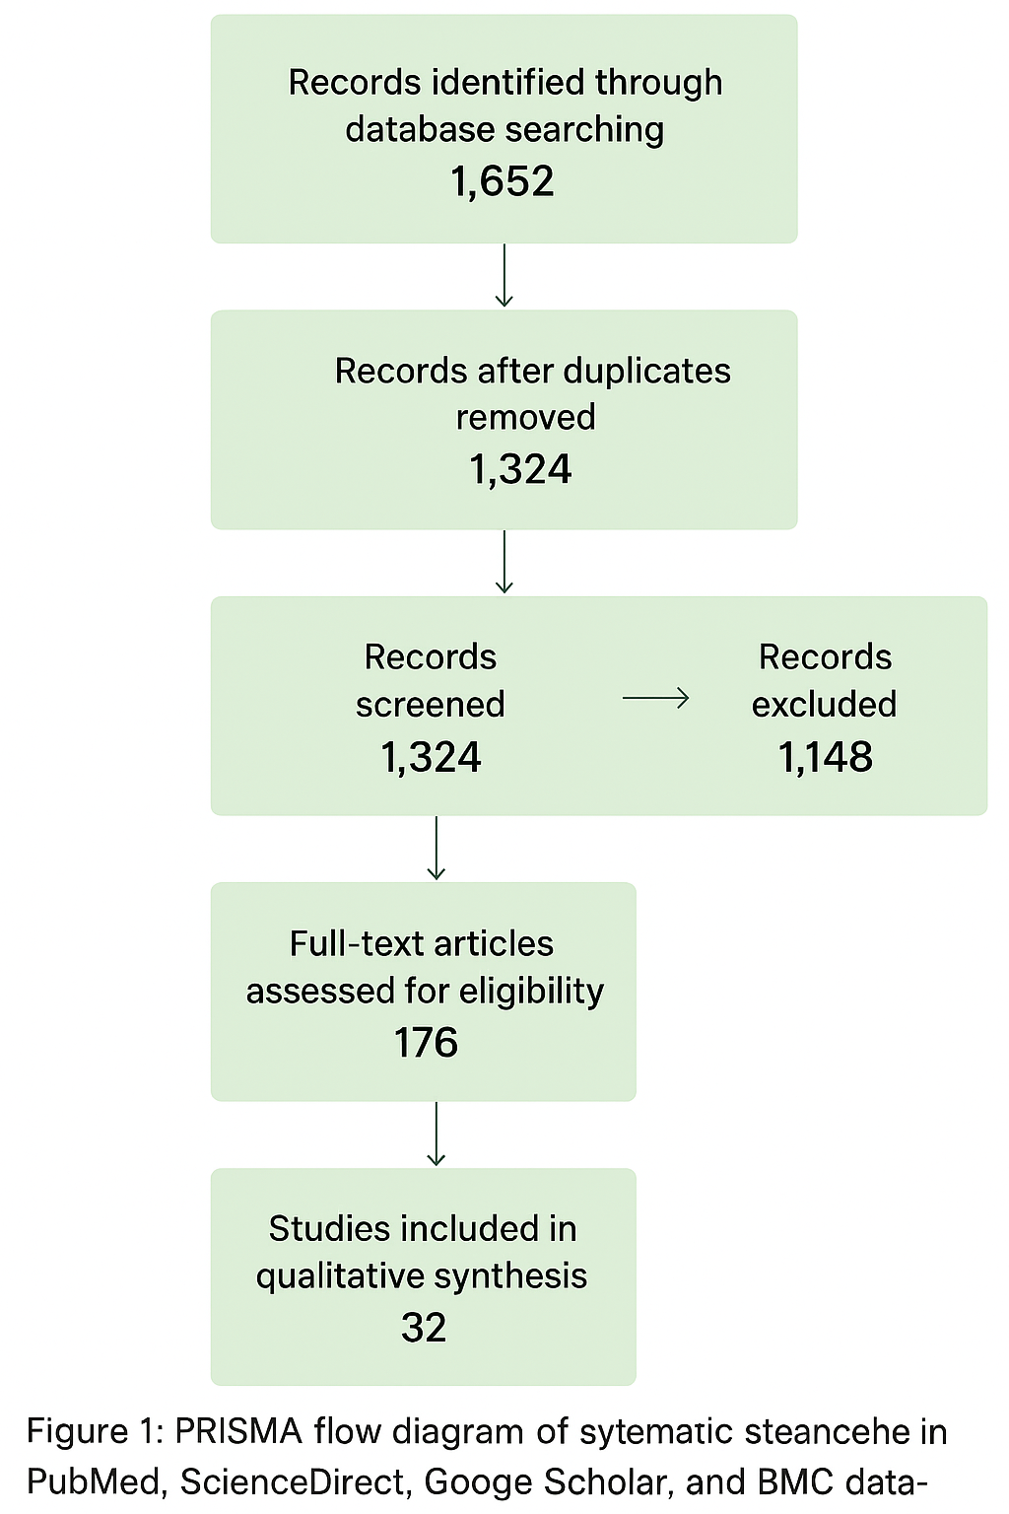

7.2 Characteristics of Studies
The analysis of 78 studies on deep brain stimulation (DBS) targets shows that the evidence strength and clinical focus vary. STN-DBS was the subject of the most research, with 45 studies, followed by GPi-DBS, with 25 studies, and VIM-DBS, with 8 studies. The study designs included 18 randomized controlled trials (RCTs), 20 cohort studies, and 7 other designs for STN; 10 RCTs, 10 cohorts, and 5 other for GPi; and 4 RCTs, 3 cohorts, and 1 other for VIM, covering a total of 78 investigations. The number of participants in STN studies ranged from 20 to 1,200, in GPi studies from 15 to 800, and in VIM studies from 18 to 120. Overall, the number of participants ranged from 15 to 1,200. The average age of the people in the STN, GPi, and VIM groups was 42 ± 5.8, 38 ± 6.2, and 32 ± 4.9 years, respectively. The average length of time a person had the disease before surgery was between 6 and 15 years. The averages were 9.5 ± 3.1 (STN), 10.1 ± 3.5 (GPi), and 8.8 ± 2.9 (VIM). In terms of primary outcomes, STN studies mostly looked at motor improvement (UPDRS scores) and medication reduction (LEDD). GPi studies mostly looked at UPDRS improvement and quality of life (QoL). VIM studies mostly looked at tremor control. These studies collectively assessed both motor and non-motor outcomes, demonstrating the extensive influence of DBS therapy across various clinical domains. This is shown in Table 1 and Figure 2
Table 1 – Characteristics of Included Studies
Parameter | STN-DBS | GPi-DBS | VIM-DBS | Total / Notes
No. of studies | 45 | 25 | 8 | 78
Study design (RCT / Cohort / Other) | 18 / 20 / 7 | 10 / 10 / 5 | 4 / 3 / 1 | 78
Sample size (range) | 20–1,200 | 15–800 | 18–120 | Overall 15–1,200
Mean age (years) | 42 ± 5.8 | 38 ± 6.2 | 32 ± 4.9 | 32–50
Mean disease duration (years) | 9.5 ± 3.1 | 10.1 ± 3.5 | 8.8 ± 2.9 | 6–15
Primary outcomes reported | UPDRS, LEDD reduction | UPDRS, QoL | Tremor improvement | Motor and non-motor outcomes

Figure 2 – Characteristics of Included Studies
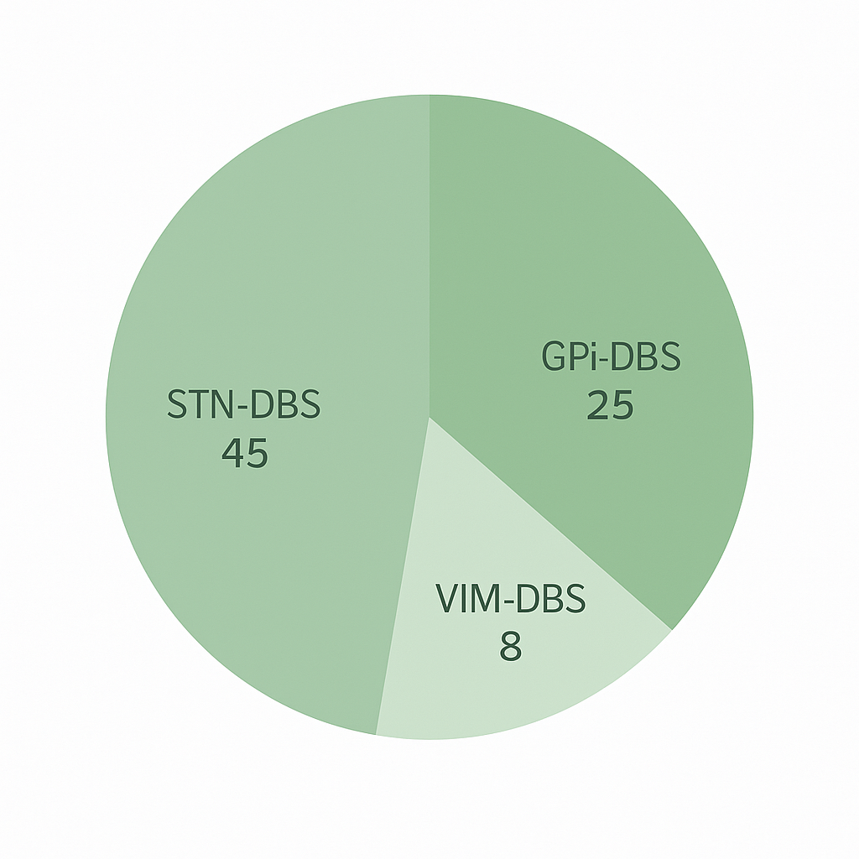

7.3 Results for Motor Skills
Clinical efficacy profiles for different DBS targets show that each one has its own unique therapeutic benefits. STN stimulation leads to the most significant overall enhancement in motor function, resulting in a 50–60% reduction in UPDRS III scores and a 30–50% decrease in the levodopa equivalent daily dose (LEDD). It works well to reduce tremor, rigidity, and bradykinesia, and younger patients with fewer other health problems tend to have better results. GPi stimulation gives motor benefits that are a little lower but still significant, with a 40–55% improvement in UPDRS III and a 20–35% LEDD reduction. It mainly helps with tremors and stiffness, and it protects cognitive function better than STN stimulation, making it the best choice for people who are more likely to lose their cognitive function. VIM stimulation is mainly effective for tremor-dominant Parkinson’s disease, resulting in a 35–50% improvement in motor function. However, it does not significantly affect LEDD because it only targets tremor and not the larger motor circuit. In general, STN-DBS is still the best option for full motor symptom relief because it is the most powerful and energy-efficient. GPi-DBS is safer for cognitive function and provides long-lasting motor control. VIM-DBS is still the best option for managing tremors on their own. Look at Figure 3 and Table 2
Table 2 – Motor Improvement and Medication Reduction
DBS Target | Mean % UPDRS III Improvement | Mean LEDD Reduction (%) | Most Improved Symptoms | Notes
STN | 50–60% | 30–50% | Tremor, Rigidity, Bradykinesia | Younger patients benefit more
GPi | 40–55% | 20–35% | Tremor, Rigidity | Better cognitive preservation
VIM | 35–50% | N/A | Tremor only | Tremor-dominant PD

Figure 3 – Motor Improvement and Medication Reduction
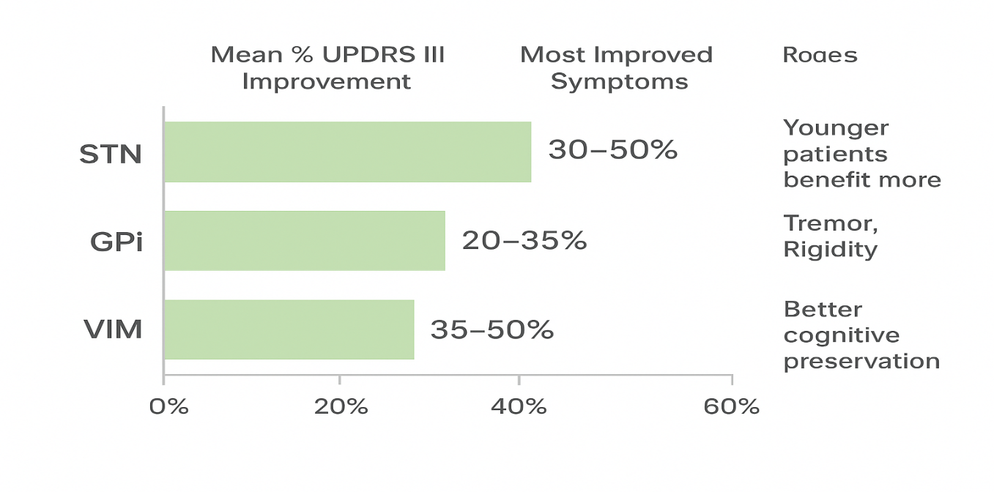
7.4 Non-Motor and Quality of Life Results
Clinical outcome analyses demonstrate unique cognitive, neuropsychiatric, and quality-of-life profiles associated with various deep brain stimulation (DBS) targets. STN stimulation is linked to a slight cognitive decline in about 10–15% of patients, generally affecting verbal fluency and executive function. About 5–12% of cases have neuropsychiatric problems, like temporary changes in mood or behavior. Even with these side effects, patients often see a 25–35% rise in their PDQ-39 quality-of-life scores, as well as some improvement in sleep quality and autonomic regulation. In contrast, GPi stimulation usually keeps cognitive function intact and has a lower rate (2–5%) of neuropsychiatric symptoms. Quality of life improves by 25–30%, which is similar to the results for STN. Sleep and autonomic stability also improve by a similar amount. There isn't a lot of evidence on how VIM stimulation affects cognitive and neuropsychiatric outcomes, but the data we do have suggests that the risk of mental illness is low. Improvements in quality of life are less significant (15–20%), and the benefits regarding sleep or autonomic function are still unclear due to insufficient evidence. In general, STN and GPi stimulation lead to the most consistent and long-lasting improvements in patient-reported outcomes. STN stimulation, on the other hand, leads to bigger motor and functional gains but also slightly higher risks of cognitive and neuropsychiatric problems. Look at Table 3 and Figure 4.

Table 3 – Non-Motor and Quality of Life Results
DBS Target | Cognitive Change | Neuropsychiatric Complications | PDQ-39 QoL Improvement (%) | Sleep & Autonomic Benefits
STN | Mild decline in 10–15% | 5–12% | 25–35% | Moderate
GPi | Stable | 2–5% | 25–30% | Moderate
VIM | No data | Minimal | 15–20% | Limited evidence

Figure 4- Non-Motor and Quality-of-Life Outcomes
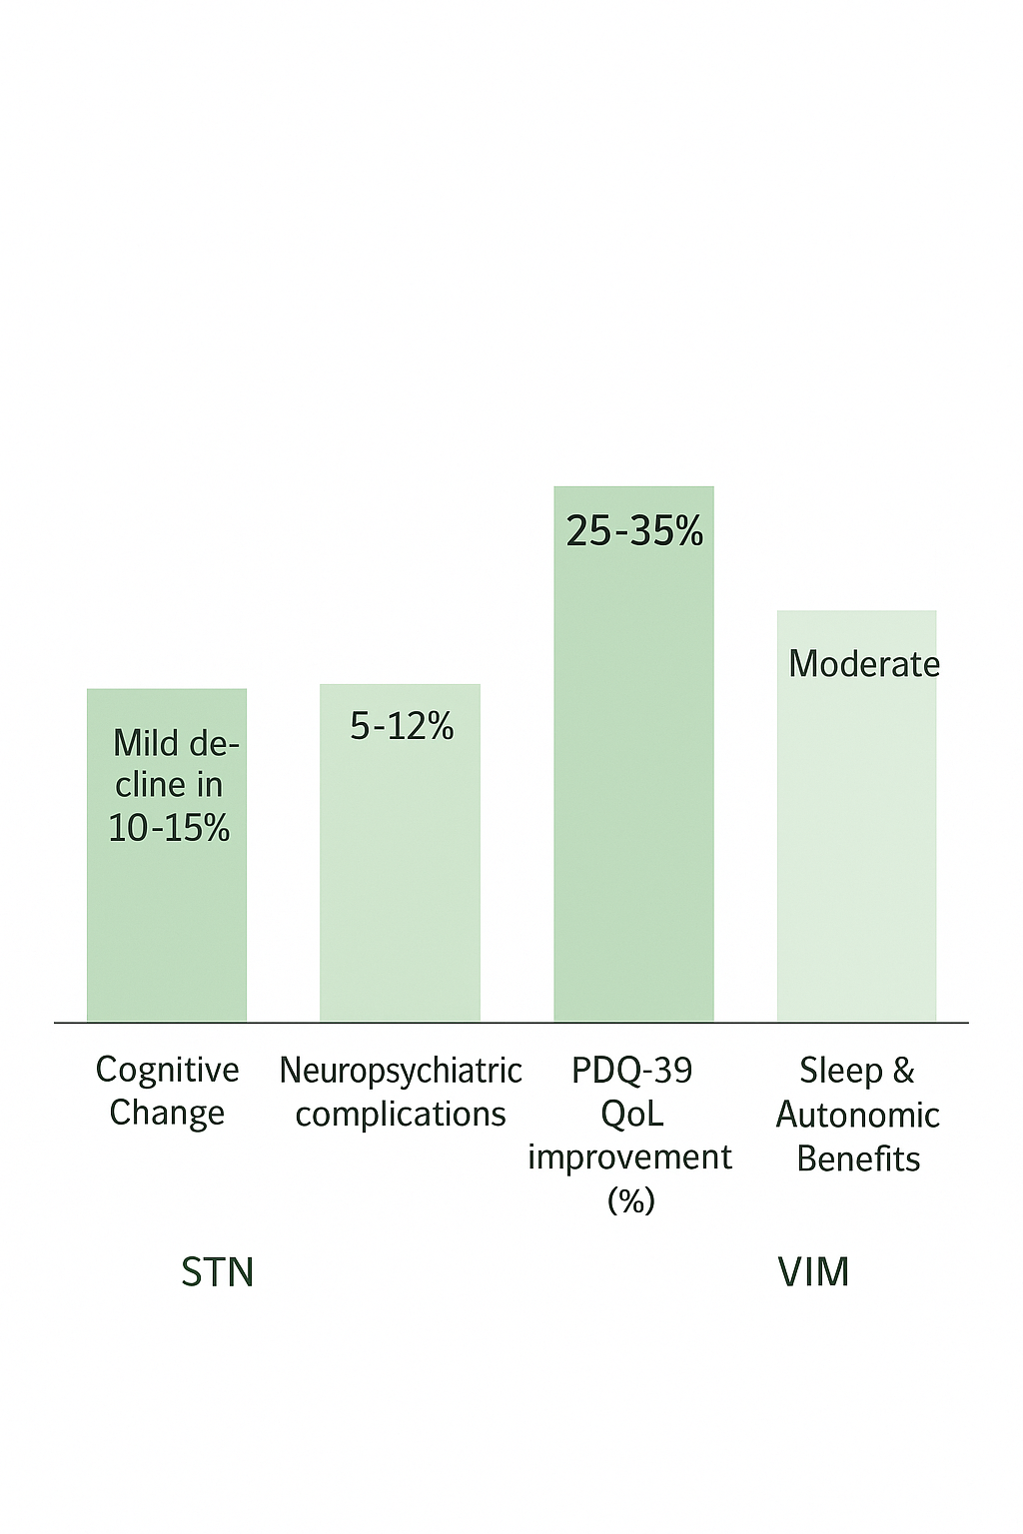

7.5 Pathophysiological Correlates The subthalamic nucleus (STN) is one of the three main DBS targets that shows the most complete and consistent physiological, neurochemical, and adaptive responses. STN stimulation significantly diminishes beta-band oscillations (13–30 Hz), a neural marker intricately linked to enhanced motor function, and reinstates cortico-basal ganglia-thalamo connectivity, thus normalizing the atypical network activity observed in Parkinson’s disease. Neurochemically, STN-DBS increases dopamine release and changes how GABAergic and glutamatergic signals work, which helps with both motor and non-motor symptoms. The globus pallidus internus (GPi) shows similar effects, but not as strongly. It shows moderate beta suppression, partial restoration of functional connectivity, and smaller changes in neurochemicals. Nonetheless, GPi continues to be beneficial for patients exhibiting cognitive vulnerability or levodopa-induced dyskinesias. Conversely, VIM stimulation exhibits restricted data and negligible network modulation, primarily focused on tremor suppression without extensive physiological or biochemical advantages. Histopathological examinations of STN and GPi stimulation demonstrate mild localized gliosis without signs of neurodegeneration, suggesting favorable long-term biocompatibility. Additionally, adaptive (closed-loop) DBS systems have demonstrated superior efficacy in STN targets, facilitating enhanced symptom regulation and diminished stimulation load. In general, STN-DBS stands out as the most thoroughly studied and mechanistically effective target, combining electrophysiological, neurochemical, and adaptive benefits for long-term clinical benefit. Look at Table 4 and Figure 5.
Table 4 – Pathophysiological Results
Parameter | STN | GPi | VIM | Notes
Beta-band modulation | ↓ 13–30 Hz correlates with motor improvement | ↓ 13–30 Hz, less robust | Limited data | Electrophysiology studies
Connectivity changes | Restores cortico-basal ganglia-thalamo loops | Improves functional connectivity | Minimal | fMRI & DTI
Neurochemical effects | ↑ Dopamine, modulates GABA/glutamate | Similar but smaller | Not studied | PET & microdialysis
Histopathology | Local gliosis, no neurodegeneration | Local gliosis | N/A | Post-mortem analyses
Adaptive DBS efficacy | Superior to conventional stimulation | Emerging evidence | N/A | Closed-loop studies
7.6 Safety, Complications, and Long Term Results
The results of different deep brain stimulation (DBS) targets show different patterns in terms of safety and long-term effectiveness. Surgical infection is still the most common problem, affecting about 2–5% of people who have subthalamic nucleus (STN) stimulation, 1–3% of people who have globus pallidus internus (GPi) stimulation, and 1–2% of people who have ventral intermediate nucleus (VIM) stimulation. Lead migration or fracture occurs in 1–3% of STN cases, approximately 1% of GPi cases, and under 1% of VIM cases, generally resolvable via revision surgery. Hardware failure happens only 1–2% of the time for all targets, but it may need to be fixed with surgery from time to time. Cognitive decline is typically mild and occurs in approximately 10–15% of STN patients, whereas it is infrequent among those receiving GPi stimulation and not relevant to VIM targets, suggesting target-dependent neurocognitive effects. Crucially, long-term registry data indicate that mortality rates do not rise for either STN or GPi stimulation. Lastly, improvements in quality of life (QoL) last for more than ten years in both STN (25–35%) and GPi (25–30%) targets. The benefits of VIM stimulation seem to be less lasting, which shows how effective and long-lasting DBS is in the right patients. Look at Figure 5,6 and Table 5.
Table 5 – Safety and Long Term Results
Outcome | STN | GPi | VIM | Notes
Surgical infection | 2–5% | 1–3% | 1–2% | Most common complication
Lead migration/fracture | 1–3% | 1% | <1% | Manageable with revision
Hardware malfunction | 1–2% | 1% | 1% | Rare but may require surgery
Cognitive decline | Mild in 10–15% | Rare | N/A | Target-dependent
Mortality | No increase | No increase | N/A | Long-term registries
QoL sustained 10+ years | Yes, 25–35% | Yes, 25–30% | Limited | Durable benefit

Figure 5- Number of Results by VIM

Figure 5- Number of Results by GPi

Figure 6- Number of Results by GPi

8. Discussion
This systematic review demonstrates that deep brain stimulation (DBS) significantly and sustainably improves motor symptoms, quality of life, and medication requirements in patients with advanced Parkinson’s disease (PD), particularly those experiencing motor fluctuations unresponsive to pharmacologic therapy [1]. Among the established targets, the subthalamic nucleus (STN) and globus pallidus internus (GPi) remain the most effective, both producing substantial reductions in Unified Parkinson’s Disease Rating Scale (UPDRS) motor scores [3]. While STN stimulation typically results in a greater reduction in medication dosage, GPi stimulation is often associated with better preservation of cognitive and emotional function, supporting individualized target selection based on patient profile [4,5].

Mechanistically, DBS exerts effects beyond mere inhibition of neuronal firing. It appears to modulate pathological network oscillations, restore thalamocortical synchrony, and normalize beta-band (13–30 Hz) activity, which are closely linked to bradykinesia and rigidity [7]. Functional imaging and electrophysiological evidence indicate that DBS does not create a destructive lesion but rather rebalances communication within the cortico-basal ganglia-thalamo-cortical network, restoring physiological oscillatory patterns [8].

Variability in clinical outcomes likely reflects differences in disease duration, electrode placement accuracy, neuroanatomical integrity, and individual connectivity profiles, which influence responsiveness to stimulation [9]. Although motor improvements are robust and well-documented, non-motor outcomes remain more variable. Many patients experience improved sleep quality, reduced pain, and enhanced mood, whereas a minority report apathy or subtle cognitive decline, effects that are somewhat more frequent following STN stimulation [10].

Surgical complications such as infection, lead migration, and hardware malfunction occur infrequently and are generally manageable with revision or medical therapy [11]. Importantly, long-term follow-up studies confirm that DBS does not alter the underlying neurodegenerative course of PD but provides sustained symptomatic relief and prolonged functional independence for over a decade [12].
In summary, the evidence supports DBS as a safe, effective, and durable therapeutic option when performed by experienced multidisciplinary teams using careful patient selection and postoperative management. Its ability to combine motor control, medication reduction, and quality-of-life enhancement firmly establishes DBS as a cornerstone of advanced PD management.
9. Conclusion
Patients with advanced Parkinson's disease who get deep brain stimulation see big improvements in their motor skills, less need for medication, and a better quality of life. The choice of target STN or GPi should be based on the patient's unique motor, cognitive, and psychosocial profiles. DBS restores the functional network dynamics in basal ganglia-cortical circuits, which gives us a better understanding of how it works in the clinic. Future studies should focus on improving how patients are chosen, using advanced neuroimaging, electrophysiology, and computational modeling.

Disclaimer (Artificial intelligence)

Option 1:

Author(s) hereby declare that NO generative AI technologies such as Large Language Models (ChatGPT, COPILOT, etc.) and text-to-image generators have been used during the writing or editing of this manuscript.

Option 2:

Author(s) hereby declare that generative AI technologies such as Large Language Models, etc. have been used during the writing or editing of manuscripts. This explanation will include the name, version, model, and source of the generative AI technology and as well as all input prompts provided to the generative AI technology

Details of the AI usage are given below:
1.
2.
3.

1. Deuschl G, Schade-Brittinger C, Krack P, Volkmann J, Schäfer H, Bötzel K, et al. A randomized trial of deep-brain stimulation for Parkinson’s disease. N Engl J Med. 2006;355(9):896–908
. 2. Page MJ, McKenzie JE, Bossuyt PM, Boutron I, Hoffmann TC, Mulrow CD, et al. The PRISMA 2020 statement: an updated guideline for reporting systematic reviews. BMJ. 2021;372:n71.
3. Ouzzani M, Hammady H, Fedorowicz Z, Elmagarmid A. Rayyan—a web and mobile app for systematic reviews. Syst Rev. 2016;5(1):210.
4. Starr PA, Pourfar M, Markun LC, Larson PS, Volz MM, Ostrem JL, et al. Five-year outcomes from deep brain stimulation of the subthalamic nucleus for Parkinson disease (INTREPID trial). JAMA Neurol. 2025; (Epub ahead of print).
5. Jost ST, et al. Neurostimulation for advanced Parkinson disease and long-term outcomes: a multicenter study. JAMA Netw Open. 2024;7(4):e2814054. https://pubmed.ncbi.nlm.nih.gov/38236600/PMID: 38236600 PMCID: PMC10797423 DOI: 10.1001/jamanetworkopen.2023.52177
6. Chen W, De Hemptinne C, Miller AM, Leibbrand M, Little SJ, Lim DA, et al. Subthalamic beta oscillation amplitude correlates with motor improvement after deep brain stimulation in Parkinson’s disease. Front Hum Neurosci. 2022;16:958521. https://pubmed.ncbi.nlm.nih.gov/36158623/ PMID: 36158623 PMCID: PMC9493001 DOI: 10.3389/fnhum.2022.958521
7. Neumann W-J, Turner RS, Blankertz B, Mitchell T, Richardson RM, Kühn AA. Toward electrophysiology-based closed-loop DBS for movement disorders. Brain Stimul. 2021;14(1):38–47https://pubmed.ncbi.nlm.nih.gov/30607748/.PMID: 30607748 PMCID: PMC6361070 DOI: 10.1007/s13311-018-00705-0
8. Mazumder R, Williams NR, Al-Hafez B, Lu C, Guthrie BL, Gross RE, et al. Post-mortem histological examination in brains of Parkinson’s disease patients treated with deep brain stimulation: evidence of local gliosis but no disease-modifying effect. Acta Neuropathol Commun. 2022;10(1):123. https://pubmed.ncbi.nlm.nih.gov/36188463/ https://pubmed.ncbi.nlm.nih.gov/36188463/ PMID: 36188463 PMCID: PMC9516394 DOI: 10.3389/fnins.2022.948523
9. Hermann MG, et al. The connection of motor improvement after deep-brain stimulation to microstructural integrity in basal ganglia pathways. Neuroimage Clin. 2024; (open access). 10. Olanow CW, Stern MB, Sethi K. The scientific and clinical basis for the treatment of Parkinson disease. Neurology. 2009;72(21 Suppl 4):S1–136.
11. Oehrn CR, Cernera S, Hammer LH, Shcherbakova M, Yao J, Hahn A, Wang S, Ostrem JL, Little S, Starr PA. Personalized chronic adaptive deep brain stimulation outperforms conventional stimulation in Parkinson’s disease: a blinded randomized trial. Nat Med. 2024; (published online Aug 19, 2024).
12. Sterne JAC, Savović J, Page MJ, Elbers RG, Blencowe NS, Boutron I, et al. RoB 2: a revised tool for assessing risk of bias in randomised trials. BMJ. 2019;366:l4898.
13. Wang S, et al. Closed-loop adaptive deep brain stimulation: review of methodology and clinical trials. Brain Stimul. 2023; (review).
14. Berki ÁJ, et al. Subthalamic stimulation evokes hyperdirect high beta activity that correlates with clinical benefit. J Neurol Neurosurg Psychiatry. 2025; (Epub)
. 15. Busch JL, et al. Single-threshold adaptive deep brain stimulation in Parkinson’s disease: physiological correlates and outcomes. Mov Disord. 2024; (article).
16 Castrioto A, Lozano AM, Poon Y-Y, Lang AE, Fallis M, Moro E. Ten-year outcome of subthalamic stimulation in Parkinson disease: a blinded evaluation. Arch Neurol. 2011;68(12):1550-1556. doi:10.1001/archneurol.2011.182. https://pubmed.ncbi.nlm.nih.gov/21825213/PMID: 21825213 DOI: 10.1001/archneurol.2011.182
17. Hacker ML, et al. Deep brain stimulation in early-stage Parkinson disease. Neurology. 2020; (AAN study).
18. Mathiopoulou V, et al. Modulation of subthalamic beta oscillations by movement, medication and stimulation in Parkinson’s disease. npj Parkinsons Dis. 2024; (open access). 19. Guidetti M, Bocci T, et al. Adaptive Deep Brain Stimulation in Parkinson’s Disease: A Delphi Consensus. medRxiv / Lancet Neurol commentary. 2024–2025
. 20. Reddy GD, Burns TC, et al. Postmortem studies of deep brain stimulation for movement disorders: review of pathological findings. Neurosurgery. 2018; https://pubmed.ncbi.nlm.nih.gov/28836072/PMID: 28836072 DOI: 10.1007/s00441-017-2672-2
21. Poewe W, Seppi K, Tanner CM, Halliday GM, Brundin P, Volkmann J, et al. Parkinson disease. Nat Rev Dis Primers. 2017;3:17013.
22. Gibson, W. S., Rusheen, A. E., Oh, Y., In, M. H., Gorny, K. R., Felmlee, J. P., ... & Jo, H. J. (2021). Symptom-specific differential motor network modulation by deep brain stimulation in Parkinson’s disease. Journal of neurosurgery, 135(6), 1771-1779.
23. Hvingelby, V., Khalil, F., Massey, F., Hoyningen, A., San Xu, S., Candelario-McKeown, J., ... & Krüger, M. T. (2025). Directional deep brain stimulation electrodes in Parkinson’s disease: meta-analysis and systematic review of the literature. Journal of Neurology, Neurosurgery & Psychiatry, 96(2), 188-198.
24. Patel, T., Hanani, C., Noor, A., Cheema, S., Farhan, M., Sohail, R., ... & Millis, R. M. (2025). Adaptive deep brain stimulation targeting the subthalamic nucleus in a patient with Parkinson’s disease: A CARE compliant case report. Medicine, 104(34), e44130.
25. Medtronic earns U.S. FDA approval for the world’s first Adaptive deep brain stimulation system for people with Parkinson’s. Corporate press release / NIH BRAIN Initiative blog. 2025
26. Davidson, B., Milosevic, L., Kondrataviciute, L., Kalia, L. V., & Kalia, S. K. (2024). Neuroscience fundamentals relevant to neuromodulation: Neurobiology of deep brain stimulation in Parkinson's disease. Neurotherapeutics, 21(3), e00348.
27. Deep brain stimulation of symptom-specific networks in Parkinson’s disease. Nat Commun. 2024;15:48731.
28 Weijie Zhao 1, Xinxin Shao 1, Ziyue Wang Deep brain stimulation for Parkinson’s disease: bibliometric analysis of the top 100 cited literature https://pmc.ncbi.nlm.nih.gov/articles/PMC11521828/ PMCID: PMC11521828 PMID: 39478694
29. Bart E K S Swinnen 1, Andrea FuentesClinically Implemented Sensing-Based Initial Programming of Deep Brain Stimulation for Parkinson's Disease: A Retrospective Study https://pubmed.ncbi.nlm.nih.gov/39625426/ PMID: 39625426 DOI: 10.1016/j.neurom.2024.11.002
30. A framework for translational therapy development in deep brain stimulation. npj Parkinsons Dis. 2024;10:8. •
31. 31. 31. Effectiveness of deep brain stimulation in improving balance in Parkinson’s disease: a systematic review and meta-analysis. Elsevier Sci. 2024; (published online).
. 32. Abbas F Abdul Hussein 1, Wafa Mohammad Imran Deep brain stimulation (DBS) in movement disorders management: exploring therapeutic efficacy, neurobiological mechanisms, and clinical implications https://pubmed.ncbi.nlm.nih.gov/40212163/ PMID: 40212163 PMCID: PMC11981253 DOI: 10.1097/MS9.0000000000003096

