Review Article

Vital pulp therapy in irreversible pulpitis: a case report on literature guidelines

.
ABSTRACT

Aims: Vital pulp therapies aim to preserve the integrity of the dental element, avoiding complete removal of pulp tissue by pulpectomy. The aim of this literature review and clinical case report was to scientifically indicate a guideline, demonstrating the specificity of the different types of vital pulp therapies and when they can be indicated, as well as to emphasize the importance of diagnosis and biomaterial choice.
Methodology: The PubMed, Scopus, Cochrane Library, and Grey Literature (Google Scholar) databases were accessed using the following keywords: “vital pulp therapy”; “indirect pulp capping”; “direct pulp capping”; “pulpotomy”; “partial pulpotomy”; “total pulpotomy”; “capping materials”; “biomaterials”; “MTA”; “Biodentine”; “TheraCal.” Articles were screened by reading titles and abstracts, selecting those describing, indicating or contraindicating vital pulp therapies, as well as those comparing commonly used biomaterials as capping agents. A clinical case of pulpotomy was described, using TheraCal as the capping material.
Results: The study highlights the scientific relevance favoring therapies that preserve endodontic tissues, consequently preserving the tooth. It also allows the understanding of the required mechanisms of action of capping biomaterials and differences among them. The clinical case demonstrated the importance of diagnosis and the step-by-step procedure.
Conclusion: It is concluded that when properly selected, pulpotomy can preserve root pulp tissue and that TheraCal proved to be a better material due to its ease of application compared to globally referenced materials.

Keywords: vital pulp therapy; pulpotomy; endodontics; MTA; Biodentine; TheraCal.

1. INTRODUCTION

Endodontics currently aims to broaden its study perspective to highlight techniques and materials that focus on the preservation of the dental element (Duncan et al., 2022). The radical procedure of pulpectomy has been successful in treating teeth with exposed pulp; however, the total removal of the pulp tissue restricts dental functions such as proprioception and nociception, which are characteristics linked to the pulp and periodontium that allow the maintenance of
teeth in the alveolus, protecting them from harmful agents (Kojima et al., 2004; Ng et al., 2008; Randow et al., 1986). Studies point to the success of vital pulp therapy (VPT) which aims to maintain the total or partial pulp tissue (Cushley et al., 2021). Moreover, the evolution of tissue engineering has brought biomaterials with extreme bioactivity that expand the horizons of clinical success of VPT (Lin et al., 2021; Rajasekar et al., 2025).

Pulpal compromise is associated with trauma, prosthetic preparations, carious lesions, and iatrogenic factors (ESE, 2019; Duncan et al., 2022). Conservative therapies that can be associated with pulp preservation include indirect or direct pulp capping, partial or total pulpotomy (Asgary et al., 2016), and regenerative therapies such as revitalization or revascularization, which aim to stimulate the formation of pulp-like tissue, reproducing its essential functions including sensorial ones (Duncan et al., 2022; Siddiqui et al., 2021). Despite extensive literature and scientific evidence (Cushley et al., 2021), inflammatory processes resulting from deep caries, trauma, or other factors that compromise pulp health cause spontaneous pain and discomfort to the patient, leading to the onset of an inflammatory process and resulting in a diagnosis of irreversible pulpitis, characterized by the presence of microabscesses in specific areas of the pulp (Ricucci et al., 2014).

There is discussion about treatment choice in cases of pulpitis, where the first choice is typically pulpectomy, i.e., total pulp removal through biomechanical preparation followed by hermetic filling of the root canals with filling materials (Glickman et al., 2009; Boutsiouki et al., 2021). However, for irreversible pulpitis cases, one of the conservative therapies gaining prominence is pulpotomy which, due to extensive scientific development and consequent improvement of materials and techniques, has become a treatment option increasingly chosen worldwide (Aguilar et al., 2011).
A systematic review conducted by Cushley et al. (2019) showed success rates >90% in mature permanent teeth with irreversible pulpitis, with one-year follow-up. However, it is important to emphasize that pulpotomy can be indicated when there is the presence of coronal remnants, observation of clinical signs of bright red bleeding, and a pulp that appears consistent (Duncan, 2022; Ather et al., 2022). Another important factor to consider is the type of biomaterial chosen to be in contact with the remaining root pulp (Ather et al., 2022). Materials used for this type of procedure must have bioinductive capacity, stimulating the formation of soft and hard tissue, preserving dental integrity, which is a characteristic of pulp tissue (Cushley et al., 2019).
A material of choice, due to its biological and physicomechanical properties, is Mineral Trioxide Aggregate (MTA) (Camilleri et al., 2006; Torabinejad et al., 2017), which interacts fluidly with pulp tissue, inducing dentin formation and possessing antimicrobial properties (Parirokh et al., 2010; Komabayashi et al., 2016; Le Fournis et al., 2019; Taha et al., 2020). However, it is difficult to handle and previously it was associated with tooth discoloration due to bismuth oxide as a radiopacifier (Haapasalo et al., 2015).
In the search for materials with easier handling that offer clinician and patient comfort while inducing tissue formation, TheraCal was developed. It is an alkaline double-cured resin-modified calcium silicate cement, allowing an ideal seal of the area, reducing risks of saliva and microorganism penetration (Hassanpour et al., 2023). It’s a biocompatible and a calcium releaser cement indicated for use in the vital pulp therapy; In addition, it possesses physical properties to reinforce teeth, which reduces the need for total coverage. Thus, the use of a long-lasting dicalcium or tricalcium silicate-modified hydrophilic resin enables the performance of more conservative restorations (Cannon, 2019; Quiñonez-Ruvalcaba et al., 2023).
Thus, this literature review and case report aim to describe the stages of a pulpotomy procedure in a tooth diagnosed with irreversible pulpitis, using TheraCal as the biomaterial of choice for contact with the remaining pulp tissue. Along with the case report, this content aims to provide information supported by scientific literature to sustain a guideline for vital pulp therapy (VPT) and indicate ideal materials that can be used.

2. methodology

The PubMed, Scopus, Cochrane Library, and Grey Literature (Google Scholar) databases were accessed using the following keywords: “vital pulp therapy”; “indirect pulp capping”; “direct pulp capping”; “pulpotomy”; “partial pulpotomy”; “total pulpotomy”; “capping materials”; “biomaterials”; “MTA”; “Biodentine”; “TheraCal.” Articles were screened by reading titles and abstracts, selecting those describing, indicating or contraindicating vital pulp therapies, as well as those comparing commonly used biomaterials as capping agents.

3. Review

3.1 Therapeutic procedure guide for vital pulps

Therapeutic guides for selecting conservative pulp therapies and biomaterials to be used in vital pulp treatments are essential (Estrela et al., 2011; Esse et al., 2019; Duncan et al., 2022).

Table 1. Conservative Vital Therapies.
Vital pulp therapies | Indications | Materials indicated
Indirect pulp capping | Deep caries without pulp exposure, vital pulp, no signs of inflammation. | HydroC®, Dycal®
Direct pulp capping | Minimal pulp exposure in healthy or slightly inflamed pulp. | MTA, Biodentine®, TheraCal®, Calcium Hydroxide.
Partial pulpotomy | Recent trauma with limited pulp exposure, vital pulp, especially in youth. | MTA, Biodentine
Total Pulpotomy | Coronary inflammation with controlled bleeding, healthy root pulp. | MTA, Biodentine®, TheraCal®, Hemostatics/anti-inflammatory (Otosporin®).
Pulp Revascularization | Immature teeth with pulp necrosis and incomplete root formation. | MTA, calcium hydroxide, Biodentine®,

Table 2. Indications for Performing Pulpotomy.
Criterias | Descritption
Pulp vitality | Pulp still vital, without necrosis.
Controllable Bleeding | Hemostasis achieved within 10 minutes after removal of coronal pulp.
Pulp Appearance | Pulp is resistant and structured, without liquefied characteristics.
No Systemic Symptoms | No fever, malaise, lymphadenopathy, or signs of spread.
No Periapical Lesions | Radiographically no periapical rarefactions or root resorption,
No Fistulas or Abscesses | Absence of clinical signs of active infection.
Patient Age | Preferably young patients, but possible in adults.
Favorable Pulp Test Response | Thermal or electric test with response compatible with vital pulp.
Normal Periodontal Condition | No dental mobility or significant bone loss.
Sufficient Structural Integrity | Tooth allows for proper definitive restoration after procedure.

Table 3. Biomaterials Recommended by Literature for Conservative Vital Therapies.
Biomaterials | Clinical indications | Features/Benefits
Biodentine | Direct capping, pulpotomy, perforations, apexogenesis. | Bioactive, similar to MTA, faster setting (~12 min), excellent sealing and handling.
MTA (Mineral Trioxide Aggregate) | Direct pulp capping, pulpotomy, apexogenesis. | High biocompatibility, excellent sealing, stimulates reparative dentin formation, antimicrobial.
TheraCal LC | Direct capping and cavity base. | Resin with calcium release, light-curable, good composite adhesion, easy handling.
Bioceramics (Bio-C-Pulpo, EndoSequence BC). | Capping, pulpotomy, apical seal. | High calcium ion release, bioactivity, excellent sealing and biocompatibility.
Calcium Hydroxide | Direct/indirect capping, intracanal dressing. | Inductor reparative dentin, antimicrobial, soluble, inferior sealing.
Glass Ionomer | Indirect capping, protective base. | Fluoride release, adheres to dentin, biocompatible, not suitable for direct pulp contact.

3.2 Dental pulp biology and inflammation

The dental pulp is a highly vascularized and innervated connective tissue responsible for a variety of functions, including the formation of secondary dentin and defense against external aggressions. When exposed to irritating factors, such as deep caries or trauma, an inflammatory process occurs. Initially, this inflammation may be reversible, allowing for indirect treatments that preserve pulp vitality. Studies indicate that if treatment is performed early, the pulp’s regenerative capacity can be maintained, avoiding more invasive procedures.

3.3 Vital pulp therapy: indications and approaches

Vital pulp therapy encompasses procedures that preserve the healthy portion of the pulp even in the presence of inflammatory processes. The main indications for this approach include:
• Cases of reversible pulp inflammation;
• Patients with spontaneous pain without signs of irreversible involvement;
• Developing teeth, where vitality preservation is crucial for continued root formation.
3.4 Pulpotomy: concept, technique, and materials

Pulpotomy consists of the partial or total removal of the coronal pulp, keeping the radicular pulp intact. This procedure is one of the most frequently used techniques in vital pulp therapy and is indicated when inflammation is localized only in the coronal pulp, without compromising the radicular remnant. Historically, calcium hydroxide was the material of choice for covering exposed pulp tissue due to its ability to stimulate reparative dentin formation. However, its limitations, such as solubility and irregular reparative dentin formation, have led to the search for alternatives (Kaya et al. 2022). Currently, calcium silicate–based materials, such as mineral trioxide aggregate (MTA) (Camilleri et al. 2006; Torabinejad et al. 2017) and Biodentine, have gained prominence for their bioactivity (Mythraiye et al. 2019). Another material gaining ground, especially in Europe, is TheraCal (used in this study), a resin-modified calcium silicate cement that exhibits high biocompatibility, good calcium release, and strong adhesion due to its light-curing properties, providing efficient mechanical performance (Rahman et al. 2021).
3.5 Scientific evidence and clinical studies

Current literature presents several studies evaluating the success of pulpotomy in permanent teeth with reversible pulp inflammation. These studies show that, when properly performed, the procedure demonstrates high success rates, with preservation of pulp vitality and significant pain reduction (Cushley et al. 2021).

3.6 Considerations for clinical practice

Treatment selection should consider the patient’s clinical condition, the extent of inflammation, and the characteristics of available materials. An accurate diagnosis, along with proper operative technique, is essential for pulpotomy success. The literature emphasizes the importance of postoperative follow-up to assess pulp tissue response and ensure long-term treatment success.
4. presentation of CASE

4.1 Patient data

A 27-year-old female patient attended the dental clinic at FOA/UNESP in February 2025 complaining of spontaneous pain in tooth 16.
4.2 Clinical and tomographic examination

The patient presented no systemic comorbidities, was normoglycemic, normotensive, and had a body temperature of 36.6º C. Facial appearance was normal, without edema. Intraoral examination showed no mucosal lesions. Regarding tooth 16, a positive response to pulp vitality tests (cold test) was observed, with intense pain that ceased after an atypical period. Vertical and lateral percussion tests were negative.
4.3 Tomographic examination

Tomographic images showed an extensive resin restoration in intimate contact with the mesial pulp horn.
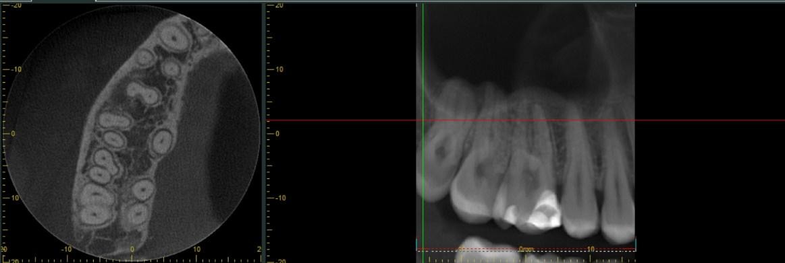
C

Fig. 1. Initial tomography of the affected tooth

4.4 Procedure performed

Pulpotomy was chosen as a more conservative procedure. The procedure followed these steps:
- Preparation of the operatory field.
- Local anesthesia and absolute isolation of the operative field.
- Exposure of the coronal pulp.
- Bleeding control with otosporin.
- Application of biocompatible material theracal pt.
- Final restoration of the tooth with glass ionomer cement (ionoseal).

Materials and instruments used:
- Anesthetic
- Clinical kit (explorer probe, mirror, forceps)
- Carpule syringe
- Medium needle
- Rubber dam
- Rubber dam punch
- Ostby arch
- Clamp 0
- Clamp holder
- Dental floss
- Top dam (gingival barrier)
- Spherical bur (diamond tip)
- Endo z bur
- Curette
- Disposable syringe (5ml)
- Saline solution
- Cotton pellets
- Otosporin
- Theracal

And sterile instruments in perfect condition.

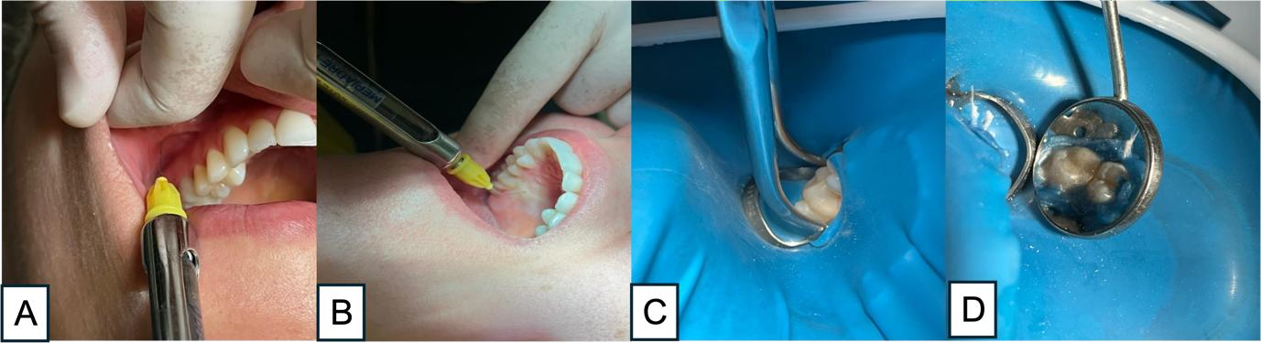
Fig. 2. Clinical sequence. A and B – local anesthesia and isolation; C and D – absolute isolation of the operative field).

An inferior posterior superior alveolar nerve block was performed, followed by palatal nerve block and some infiltrative terminals around tooth 16 (2 cartridges of mepivacaine anesthetic were used). After anesthesia, absolute isolation was performed using clamp 0 placed on tooth 16, and sealed with Top Dam (gingival barrier).

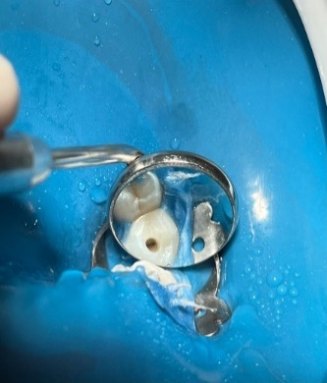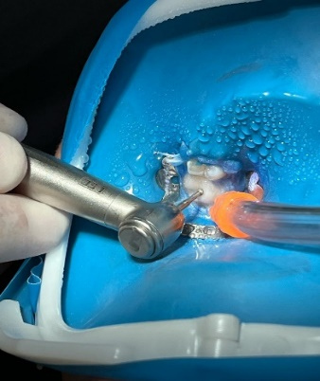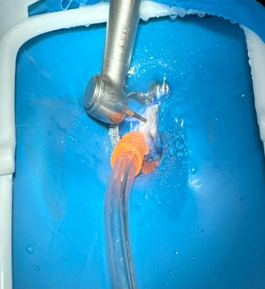
C
B
A
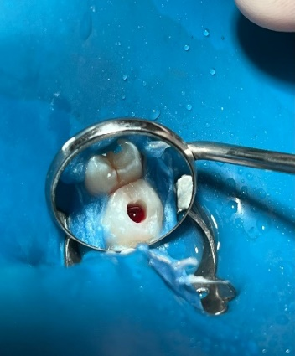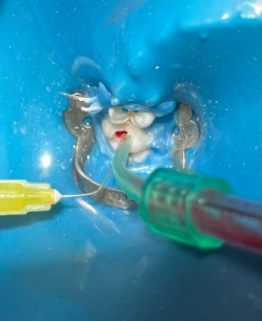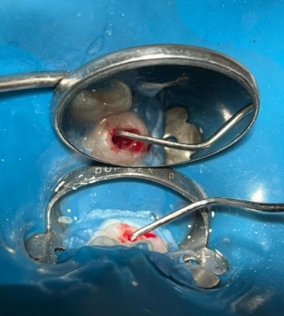
F/
E
D
Fig. 3. Coronal opening. A, B and C – pulp exposure plus shape and contour; D – pulp chamber (bright red blood); E – irrigation with cold 0.9% saline solution; F – pulp tissue).

With dental element isolated and using a spherical bur, access to the pulp chamber was carefully made to avoid excessive mechanical trauma, until the ‘drop into the void’ sensation was felt. The chamber shape and contour were finished with an inactive Endo Z bur. After removing the chamber roof, bleeding confirmed pulp vitality. The region was irrigated with cooled saline solution. Figure F shows the density of pulp tissue (a good sign of live pulp), and the coronal pulp was cut from the radicular pulp with a curette.
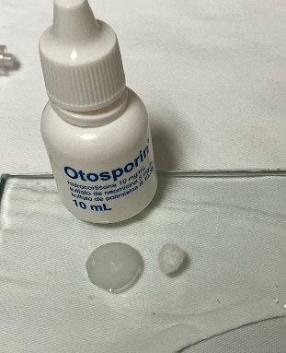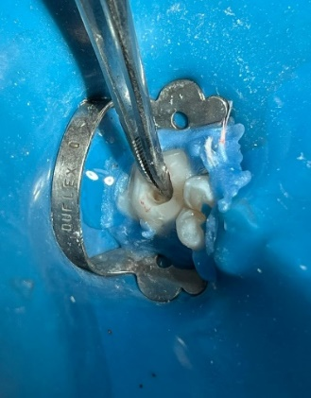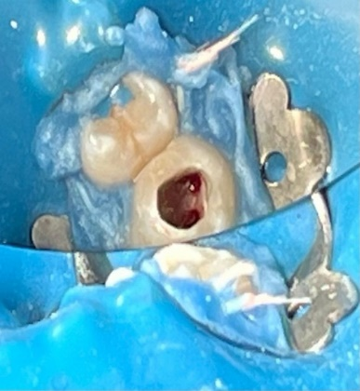
C
B
A
Fig. 4. Hemostasis. A – Otosporin®; B – bleeding control; C – root canal orifices and clean pulp chamber).

After removing the coronal pulp, hemostasis was performed with a cotton pellet soaked in saline solution. With bleeding controlled, the immediate technique (one session) was executed by leaving a cotton pellet soaked with Otosporin® for 5 minutes.
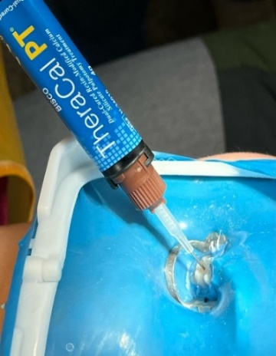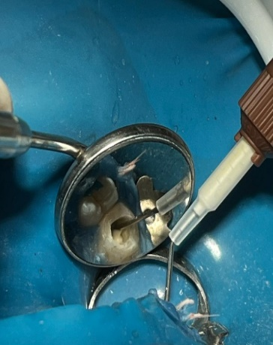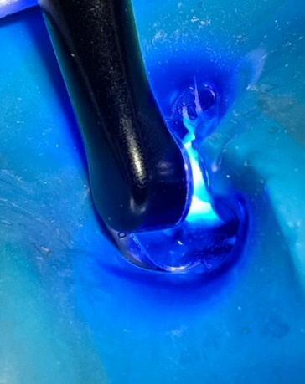
C
B
A
Fig. 5. Finalization. A and B – application of capping material TheraCal; C – photopolymerization).

After 5 minutes with Otosporin®, the pulp chamber was filled with TheraCal, a resin-based capping material capable of releasing calcium ions promoting remineralization. The material allows for single-layer application followed by at least 10 seconds of photopolymerization.
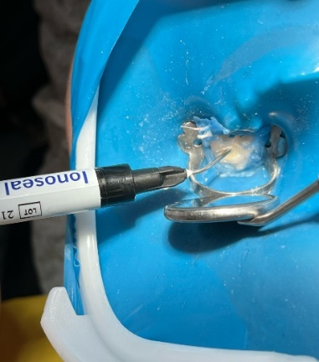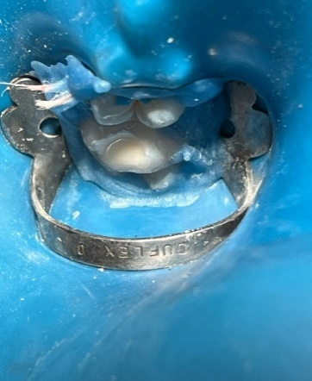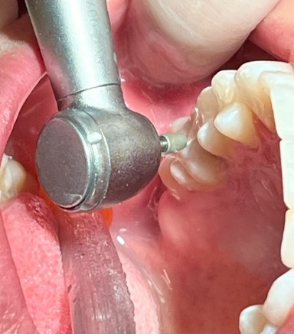
C
B
A
Fig. 6. Finishing. A – restoration with glass ionomer cement; B – final restoration; C – occlusal adjustment).

Finally, restoration with glass ionomer cement (Ionoseal) was performed for provisional sealing of the capping material (TheraCal). After removing the absolute isolation, occlusal adjustment and finishing were done.

5. DISCUSSION

Pulpotomy has been established as a viable alternative to radical therapies, especially in cases of pulp inflammation clinically diagnosed as irreversible, but where the root pulp maintains vitality and repair potential (Duncan et al., 2022). Traditionally, teeth with spontaneous pain were treated exclusively by pulpectomy (Glickman et al., 2009; Boutsiouki et al., 2021). However, recent evidence suggests that partial preservation of pulp tissue can result in satisfactory medium and long-term prognoses (Cushley et al., 2019; Duncan, 2022). This research theme presents scientific content reaffirming the choice of conservative pulp therapies, including pulpotomy, indicating the types of treatment, materials shown as bioinductive that can be recommended, and reports a clinical case describing the pulpotomy technique and the use of TheraCal LC.

In the present clinical case, after clinical and imaging exams, the diagnosis was reversible pulpitis, with the patient presenting intermittent, provoked pain and reporting painful symptoms after a restorative procedure that did not invade the pulp area. Due to this condition and the association of systemic health and dental structure, pulpotomy was suggested and accepted. The conservative choice based on confirmed pulp vitality, controllable bleeding, structural integrity of the pulp tissue, and absence of root necrosis signs—criteria widely recognized as determinants of pulpotomy success (ESE, 2019; Ather et al., 2022).
Furthermore, the patient presented good systemic condition and favorable elements for immediate restoration, factors that minimize microleakage and preserve pulp integrity (Taha et al., 2020, 2023).

The literature indicates that pulp presenting microabscesses should not be maintained and preserved, requiring total removal by pulpectomy; otherwise, necrosis will take over the whole pulp tissue (Ricucci et al., 2019). Histologic signs are impossible to collect in clinical routine, not favoring visualization of pathological phenomena. Therefore, the professional must rely on clinical pulp characteristics when exposed (Ricucci et al., 2019; Cushley et al., 2021).

A novelty discussed in this study is the type of biomaterial used, TheraCal LC, a resin-modified calcium silicate cement light-cured after application, combining bioactivity with ease of handling, insertion, and good adhesion to remaining dental structures. This offers comfort to both professional and patient, especially by reducing clinical time (Rahman et al., 2021; Hassanpour et al., 2023). Moreover, those characteristics facilitate treatment, reducing steps and patient chair time and clinic visits. Another characteristic is the calcium ion release and stimulation of progenitor cells for dentin matrix formation, positioning TheraCal as competitive versus established materials like MTA (Camilleri et al., 2006; Torabinejad et al., 2017) and Biodentine, especially in cases requiring rapid clinical finalization (Komabayashi et al., 2016; Mythraiye et al., 2019). Comparative studies show calcium silicate materials, including TheraCal, maintain high clinical and radiographic success when paired with strict diagnosis and contamination control protocols (Parirokh et al., 2010; Cushley et al., 2021; Uesrichai et al., 2019). However, differently from MTA and Biodentine, the presence of resin in TheraCal implies greater dependence on adhesive technique, which may impact long-term performance if sealing is inadequate (Haapasalo et al., 2015).

In the case described, the whole remaining dentin was filled followed by provisional restoration, ensuring adhesion control and protecting against infiltrations that could compromise the root pulp. Considering every step, the case aligns with literature showing lack of immediate complications and functional recovery of the dental element. Nevertheless, it is consensus that pulpotomy success requires medium- and long-term clinical and radiographic follow-up (Cushley et al., 2019; Duncan, 2023). Periodic evaluations verify pulp vitality maintenance, absence of periapical lesions, and restoration integrity, consolidating treatment effectiveness (ESE, 2019). This scientific writing reports a guideline for vital pulp therapies, pulp conditions that should be analyzed and the different biomaterials that can be indicated. In addition, pulpotomy was described as the procedure indicated for the case selected, using a new resin light-cured biomaterial, evaluating immediate responses.

Thus, integration among precise diagnosis, careful biomaterial selection, and proper technical execution is determinant for vital pulp therapy success, especially when targeting spontaneous pain cases. TheraCal LC usage showed promise, offering biological, operational, and patient comfort benefits. However, the importance of longer clinical studies to confirm durability and efficacy compared to established bioceramics is reinforced.

6. CONCLUSION

The case report combined with the literature review allows to conclude that vital pulp procedures, such as pulpotomy, can be indicated after rigorous diagnosis aiming to preserve the integrity of the dental element. Furthermore, the appropriate use of biomaterial can induce the formation of dentin matrix and, in this case, with the selection of TheraCal, improved comfort during treatment was observed for both the clinician and the patient.

DISCLAIMER (ARTIFICIAL INTELLIGENCE)

Author(s) hereby declares that no generative ai technologies such as large language models (chatgpt, copilot, etc) and text-to-image generators have been used during writing or editing of this manuscript.

Competing interests

Authors have declared that they have no known competing financial interests or non-financial interests or personal relationships that could have appeared to influence the work reported in this paper.

Consent

As per international standards or university standards, patient(s) written consent has been collected and preserved by the author(s).

References

Aguilar, P., & Linsuwanont, P. (2011). Vital pulp therapy in vital permanent teeth with cariously exposed pulp: a systematic review. Journal of endodontics, 37(5), 581–587.
Asgary, S., & Shirvai, A. (2016). Pulpotomy With Calcium Hydroxide May be an Effective Alternative to Root Canal Therapy in Vital Teeth. The journal of evidence-based dental practice, 16(1), 64–66.
Ather, A., Patel, B., Gelfond, J. A. L., & Ruparel, N. B. (2022). Outcome of pulpotomy in permanent teeth with irreversible pulpitis: a systematic review and meta-analysis. Scientific reports, 12(1), 19664.
Boutsiouki, C., Frankenberger, R., & Krämer, N. (2021). Clinical and radiographic success of (partial) pulpotomy and pulpectomy in primary teeth: A systematic review. European journal of paediatric dentistry, 22(4), 273–285.
Camilleri, J., & Pitt Ford, T. R. (2006). Mineral trioxide aggregate: a review of the constituents and biological properties of the material. International endodontic journal, 39(10), 747–754.
Cannon, M.L. Pulp therapy in the difficult child patient. Compend. Contin. Educ. Dent. 2019, 40, 20–23.
Cushley, S., Duncan, H. F., Lappin, M. J., Chua, P., Elamin, A. D., Clarke, M., & El-Karim, I. A. (2021). Efficacy of direct pulp capping for management of cariously exposed pulps in permanent teeth: a systematic review and meta-analysis. International endodontic journal, 54(4), 556–571.
Cushley, S., Duncan, H. F., Lappin, M. J., Tomson, P. L., Lundy, F. T., Cooper, P., Clarke, M., & El Karim, I. A. (2019). Pulpotomy for mature carious teeth with symptoms of irreversible pulpitis: A systematic review. Journal of dentistry, 88, 103158.
Duncan H. F. (2022). Present status and future directions-Vital pulp treatment and pulp preservation strategies. International endodontic journal, 55 Suppl 3(Suppl 3), 497–511.
Esse, R., Barroso, M., Tavares de Almeida, I., & Castro, R. (2019). The Contribution of Homocysteine Metabolism Disruption to Endothelial Dysfunction: State-of-the-Art. International journal of molecular sciences, 20(4), 867.
Estrela, C., Alencar, A. H., Kitten, G. T., Vencio, E. F., & Gava, E. (2011). Mesenchymal stem cells in the dental tissues: perspectives for tissue regeneration. Brazilian dental journal, 22(2), 91–98.
European Society of Endodontology (ESE) developed by: Duncan, H. F., Galler, K. M., Tomson, P. L., Simon, S., El-Karim, I., Kundzina, R., Krastl, G., Dammaschke, T., Fransson, H., Markvart, M., Zehnder, M., & Bjørndal, L. (2019). European Society of Endodontology position statement: Management of deep caries and the exposed pulp. International endodontic journal, 52(7), 923–934.
Glickman G. N. (2009). AAE Consensus Conference on Diagnostic Terminology: background and perspectives. Journal of endodontics, 35(12), 1619–1620.
Haapasalo, M., Parhar, M., Huang, X., Wei, X., Lin, J., & Shen, Y. (2015). Clinical use of bioceramic materials. Endodontic Topics, 32(1), 97–117.
Hassanpour, S., Aminabadi, N. A., Rahbar, M., & Erfanparast, L. (2023). Comparison between the Radiographic and Clinical Rates of Success for TheraCal and MTA in Primary Tooth Pulpotomy within a 12-Month Follow-Up: A Split-Mouth Clinical Trial. BioMed research international, 2023, 8735145.
Kaya, C., Elbay, Ü. Ş., Elbay, M., & Uçar, G. (2022). The comparison of calcium hydroxide + biostimulation, calcium hydroxide, formocresol, and MTA pulpotomies without biostimulation in primary teeth: 12-months clinical and radiographic follow-up. Lasers in medical science, 37(5), 2545–2554.
Kojima, K., Inamoto, K., Nagamatsu, K., Hara, A., Nakata, K., Morita, I., Nakagaki, H., & Nakamura, H. (2004). Success rate of endodontic treatment of teeth with vital and nonvital pulps. A meta-analysis. Oral surgery, oral medicine, oral pathology, oral radiology, and endodontics, 97(1), 95–99.
Komabayashi, T., Zhu, Q., Eberhart, R., & Imai, Y. (2016). Current status of direct pulp-capping materials for permanent teeth. Dental materials journal, 35(1), 1–12.
Le Fournis, C., Hadjichristou, C., Jeanneau, C., & About, I. (2019). Human Pulp Fibroblast Implication in Phagocytosis via Complement Activation. Journal of endodontics, 45(5), 584–590.
Lin, X. et al. (2021). Fascinating MXene nanomaterials: emerging opportunities in the biomedical field. Biomaterias Science, 9, 5437-5471.
Mythraiye, R., Rao, V. V., Minor Babu, M. S., Satyam, M., R, P., & Paravada, C. (2019). Evaluation of the Clinical and Radiological Outcomes of Pulpotomized Primary Molars Treated with Three Different Materials: Mineral Trioxide Aggregate, Biodentine, and Pulpotec. An In-vivo Study. Cureus, 11(6), e4803.
Ng, Y. L., Mann, V., Rahbaran, S., Lewsey, J., & Gulabivala, K. (2008). Outcome of primary root canal treatment: systematic review of the literature -- Part 2. Influence of clinical factors. International endodontic journal, 41(1), 6–31.
Quiñonez-Ruvalcaba F, Bermúdez-Jiménez C, Aguilera-Galavíz LA, Villanueva-Sánchez FG, García-Cruz S, Gaitán-Fonseca C. Histopathological Biocompatibility Evaluation of TheraCal PT, NeoMTA, and MTA Angelus in a Murine Model. Journal of Functional Biomaterial. 2023;14(4):202. Published 2023 Apr 6. doi:10.3390/jfb14040202
Parirokh, M., & Torabinejad, M. (2010). Mineral trioxide aggregate: a comprehensive literature review--Part I: chemical, physical, and antibacterial properties. Journal of endodontics, 36(1), 16–27.
Rahman, B., & Goswami, M. (2021). Comparative Evaluation of Indirect Pulp Therapy in Young Permanent Teeth using Biodentine and Theracal: A Randomized Clinical Trial. The Journal of clinical pediatric dentistry, 45(3), 158–164.
Rajasekar, V., Abdalla, M. M., Huang, M., Neelakantan, P., & Yiu, C. K. Y. (2025). Next-Generation Biomaterials for Vital Pulp Therapy: Exploring Biological Properties and Dentin Regeneration Mechanisms. Bioengineering (Basel, Switzerland), 12(3), 248.
Randow, K., & Glantz, P. O. (1986). On cantilever loading of vital and non-vital teeth. An experimental clinical study. Acta odontologica Scandinavica, 44(5), 271–277.
Ricucci, D., Loghin, S., & Siqueira, J. F., Jr (2014). Correlation between clinical and histologic pulp diagnoses. Journal of endodontics, 40(12), 1932–1939.
Ricucci, D., Siqueira, J. F., Jr, Li, Y., & Tay, F. R. (2019). Vital pulp therapy: histopathology and histobacteriology-based guidelines to treat teeth with deep caries and pulp exposure. Journal of dentistry, 86, 41–52.
Siddiqui, Z., Sarkar, B., Kim, K. K., Kadincesme, N., Paul, R., Kumar, A., Kobayashi, Y., Roy, A., Choudhury, M., Yang, J., Shimizu, E., & Kumar, V. A. (2021). Angiogenic hydrogels for dental pulp revascularization. Acta biomaterialia, 126, 109–118.
Taha, N. A., About, I., Sedgley, C. M., & Messer, H. H. (2020). Conservative Management of Mature Permanent Teeth with Carious Pulp Exposure. Journal of endodontics, 46(9S), S33–S41.
Torabinejad, M., Nosrat, A., Verma, P., & Udochukwu, O. (2017). Regenerative Endodontic Treatment or Mineral Trioxide Aggregate Apical Plug in Teeth with Necrotic Pulps and Open Apices: A Systematic Review and Meta-analysis. Journal of endodontics, 43(11), 1806–1820.
Uesrichai, N., Nirunsittirat, A., Chuveera, P., Srisuwan, T., Sastraruji, T., & Chompu-Inwai, P. (2019). Partial pulpotomy with two bioactive cements in permanent teeth of 6- to 18-year-old patients with signs and symptoms indicative of irreversible pulpitis: a noninferiority randomized controlled trial. International endodontic journal, 52(6), 749–759.

