Asynchronous Teledentistry for Oral Lesion Screening: A Retrospective Study from TeleEstomato-MG

ABSTRACT

Aims: To describe the use of TeleEstomato-MG, an asynchronous teledentistry platform, for the screening and management of oral lesions in primary care.
Study design: Retrospective observational study of asynchronous teleconsultations conducted at the Federal University of Alfenas, Brazil, from November 2022 to September 2024.
Methodology: Data from 263 teleconsultations were extracted from the TeleEstomato-MG platform and analyzed descriptively by lesion site and diagnostic category.
Results: Most patients were male (52.1%), with a mean age of 53 years. The tongue (27.4%) and lips (17.8%) were the most affected sites. Diagnostic hypotheses included benign lesions (75.6%), potentially malignant disorders (13.7%), and malignant lesions (10.7%). Early detection of malignant cases supported timely referral for specialized care. The analysis was constrained by missing data on risk factors and variable image quality.
Conclusion: TeleEstomato-MG proved feasible for triaging oral lesions and accelerating referrals, highlighting the role of asynchronous teledentistry in expanding access to specialized oral health services in primary care.

Keywords: Teledentistry. Oral lesions. Telehealth. Remote diagnosis.

.
1. INTRODUCTION

The COVID-19 pandemic created an unexpected scenario of isolation, imposing significant barriers to healthcare systems worldwide. In this context, the impossibility of direct contact between dentists and patients highlighted the need for solutions to ensure continuity of care (Ghai, 2020; Kochhar et al., 2020). Teledentistry, a subset of telehealth, emerged as a response to this demand, using digital technologies for remote consultations, which can be classified as synchronous (via videoconference) or asynchronous (through photographic records) (Flores et al., 2020; Minervini et al., 2022; Uhrin et al., 2023). During this period, this approach was fundamental in providing continuous basic care, especially to residents of rural areas and oncology patients (Cardozo, 2022; Firincioglulari & Orhan, 2021; Flores-Hidalgo et al., 2023).
Telehealth has been widely investigated in studies focused on improving disease surveillance and offering remote multidisciplinary consultations to patients with limited access, standing out as a low-cost and effective alternative (Dailah, 2022; Paixão et al., 2022). In leading oncology healthcare centers in the United States, this practice is promoted as a valuable tool for initial screening and early cancer diagnosis (Brenner & Hearing, 2008; Dailah, 2022; Nguyen et al., 2023).
Oral pathology can benefit significantly from telehealth, as this tool can provide accurate diagnoses, reducing the time between diagnosis and treatment (Ilhan et al., 2022). This directly impacts the early detection of oral lesions such as oral cancer and expands access to specialized dental care (Flores-Hidalgo et al., 2023; Nguyen et al., 2023). Diagnosing oral lesions can be challenging due to their variable clinical presentation and the similarities between potentially malignant and benign lesions, which complicate differential diagnosis (Nguyen et al., 2023; Uhrin et al., 2023). Early detection and monitoring of potentially malignant oral lesions can prevent their progression to oral cancer (Firincioglulari & Orhan, 2021; Uhrin et al., 2023). In this sense, teledentistry is essential for the early diagnosis of malignant lesions, enabling faster interventions and increasing the effectiveness of oral cancer treatment (Flores et al., 2020).
Based on the presented scientific literature and the scarcity of studies reporting the experience of using teledentistry linked to primary care, the aim of this article is to describe the asynchronous use of the TeleEstomato-MG application between November 2022 and August 2024, as well as to assess, identify, and manage oral lesions through this technology.

2. MATERIAL AND METHODS
This study was a retrospective observational study that included cases submitted between November 2022 and September 2024 through the TeleEstomato-MG asynchronous teledentistry platform, covering 24 municipalities in the southern macro-region of Minas Gerais, Brazil. The platform was developed to support the assessment of oral lesions and to guide therapeutic management, thereby contributing to timely referral and continuity of care. Cases with missing basic demographic data (age or sex) or without at least one clinical image of sufficient quality (adequate focus, lighting, and framing) were excluded.
Before submitting a teleconsultation request, professionals registered in the platform completed a form that included information such as full name, age, sex, city, profession, specialty, and level of care. For each case submission, professionals conducted a clinical examination and provided the patient’s initials, age, sex, lesion site and description, as well as symptoms, medical history, medication use, harmful habits, and photographs or radiographs of the affected area (Figure 1A and Figure 1B). When information on risk factors or other fields was missing, these variables were coded as “unknown” and retained in the dataset rather than excluded.

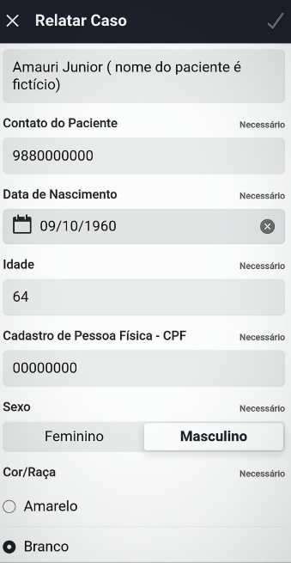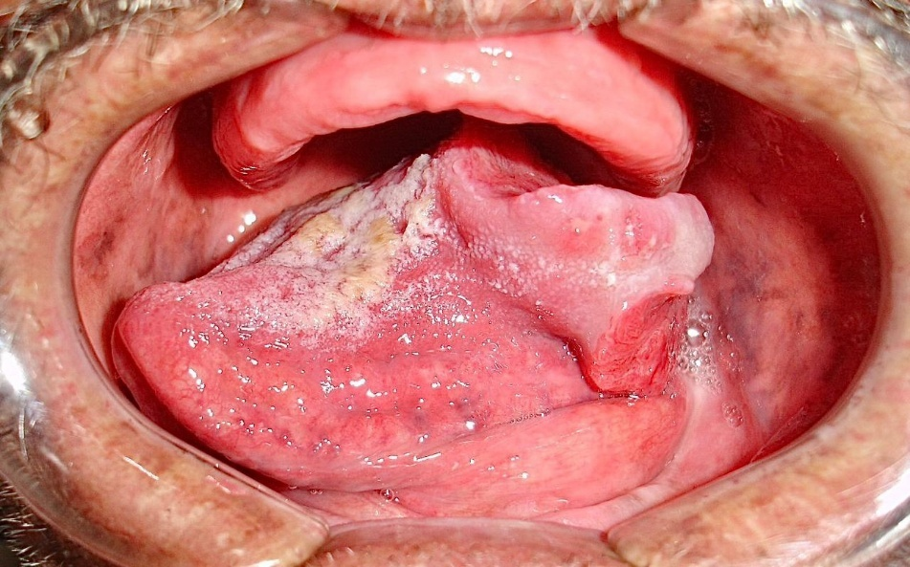
Figure 1: A: Submission of a case report through the TeleEstomato-MG application. B: Photograph of the case submitted by the teleconsultation requester via the TeleEstomato-MG application, with a diagnostic hypothesis of squamous cell carcinoma.

The variables collected included demographic data, habits, lesion site, diagnostic hypotheses proposed both by the requesting professionals and by the teleconsultants, and the final diagnostic category. Descriptive analyses were performed using absolute and relative frequencies for categorical variables, and means with standard deviations for continuous variables. Ninety-five percent confidence intervals (CIs) were calculated for key proportions, such as lesion categories and anatomical sites. Potential sources of bias included selection bias due to voluntary case submission across municipalities and information bias inherent to asynchronous image review with variable image quality. The study protocol was approved by the institutional ethics committee. Because this was a retrospective study using anonymized data, a waiver of informed consent was granted.
3. RESULTS AND DISCUSSION
This study analyzed the experience of a remote diagnostic support service in asynchronous teledentistry using the TeleEstomato-MG platform between November 2022 and September 2024. A total of 263 teleconsultations were recorded, demonstrating the feasibility of this model in oral health, particularly in contexts where access to specialists was limited (Cardozo, 2022; Ilhan et al., 2022). Previous research has shown that nearly 85% of dentists face challenges in detecting and managing oral lesions, suggesting that digital platforms can help bridge this gap (Almubarak, 2022). The high utilization of TeleEstomato-MG reflected its potential to strengthen primary care and support referral pathways.
A cross-sectional study conducted by Quites et al. (2023) in Minas Gerais municipalities reported that telehealth improved access, problem-solving capacity, and the scope of primary health care (PHC). In this study, TeleEstomato-MG facilitated asynchronous teleconsultations that included images and demographic data, providing essential information for consultant decision-making (Czerninski, Mordekovich & Basile, 2022; Gurgel-Juarez et al., 2022; Lin et al., 2021).
The demographic profile of the sample showed a predominance of male patients (52.1%, n = 137), while 47.9% (n = 126) were female, with a mean age of 53 years. These findings are consistent with prior studies reporting higher prevalence of oral lesions among middle-aged men (Bajracharya et al., 2017). Regarding self-reported race, 70% (n = 184) of participants identified as White, consistent with Brazilian studies that highlighted sociodemographic influences on lesion distribution (Cunha et al., 2023; Daroit et al., 2023). Figure 2 illustrates these distributions.
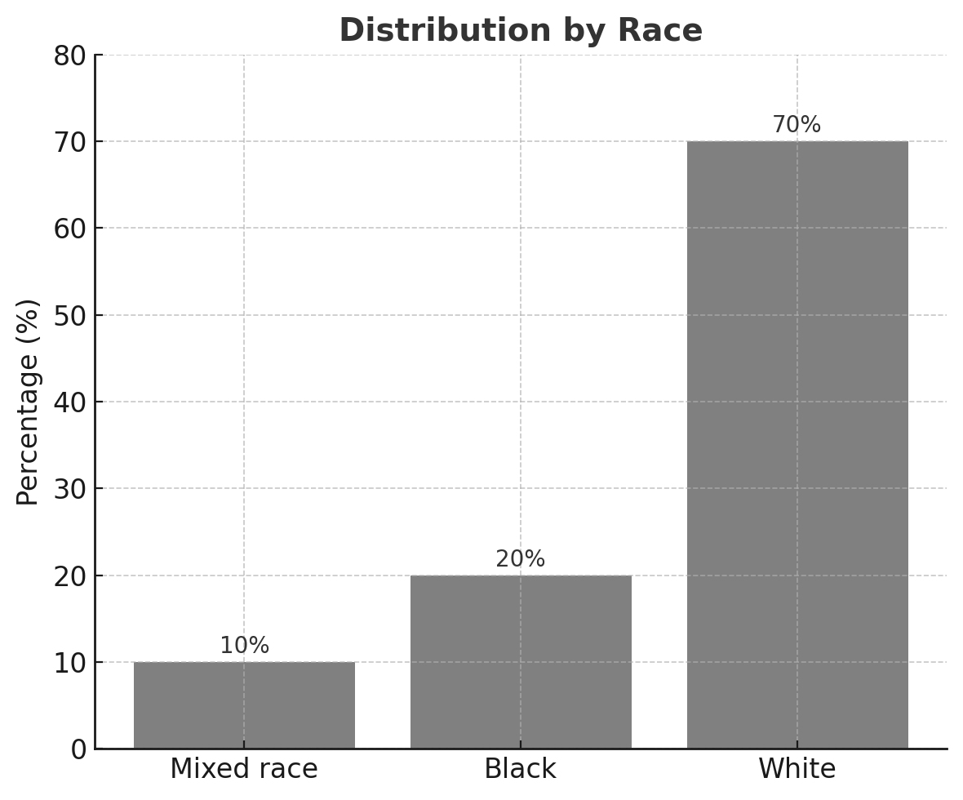
Figure 2. Distribution of patients by race.
Tobacco use was reported in 16.3% (n = 43) of cases, and the combination of tobacco and alcohol use in 5% (n = 13). These findings reinforce established evidence linking such habits with higher risk for malignant oral lesions (Collins et al., 2021; Mehrotra et al., 2010). Other reported habits included former smokers (6%, n = 16), former smokers who also consumed alcohol (0.38%, n = 1), alcohol users (6%, n = 16), former alcohol users (2.3%, n = 6), and illicit drug use (0.38%, n = 1). However, information on habits was missing in 63.7% (n = 167) of cases, which limited a more detailed analysis (Figure 3).
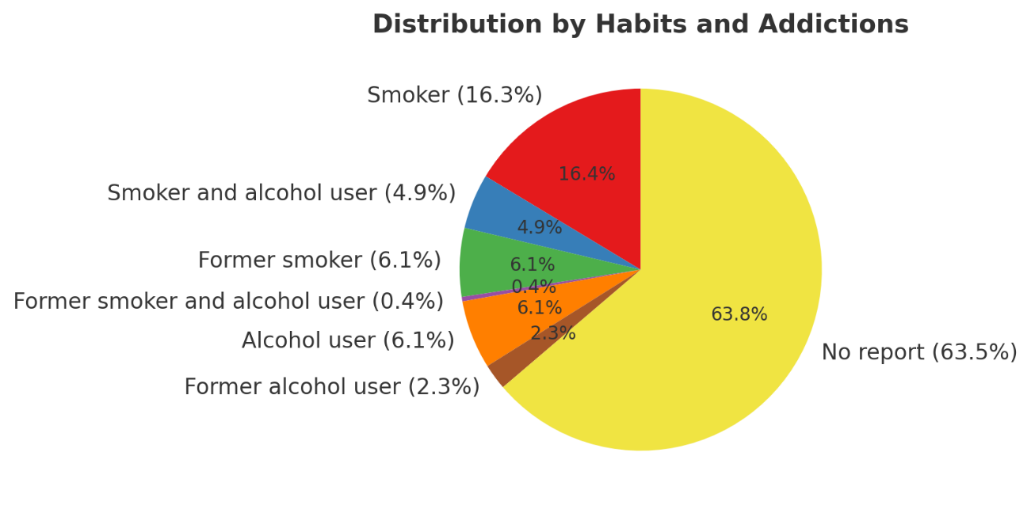

Figure 3. Chart of distributions by habits and addictions. It is noteworthy that most requesters did not provide this information.
The anatomical distribution of lesions revealed that the tongue (27.4%, n = 72), lips (17.8%, n = 47), buccal mucosa (14.5%, n = 38), and palate (12.6%, n = 33) were the most frequently affected sites. Lesions on the alveolar ridge accounted for 5.7% (n = 15), while gingiva and floor of mouth lesions were less common (3.4%, n = 9 each). Intraosseous lesions were rare (0.38%, n = 1). The predominance of lesions in visible regions underscored the potential of asynchronous teleconsultations to support early recognition and referral (Gupta et al., 2023) (Figure 4).

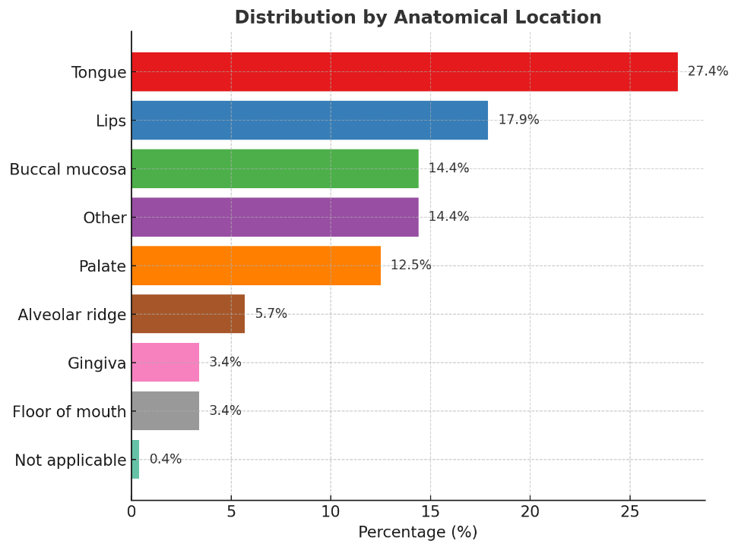
Figure 4. Distribution of lesions by anatomical location. The tongue was the most frequently affected site, followed by the lips, buccal mucosa, and palate.
Diagnostic hypotheses reported by requesting dentists included other types of lesions (75.6%, n = 199), potentially malignant disorders (13.7%, n = 36), and malignant neoplasms (9.5%, n = 25). These proportions are in line with a multicenter study by Cunha et al. (2023), which found that reactive lesions were the most frequent, followed by malignant neoplasms, predominantly squamous cell carcinoma (Figure 5).
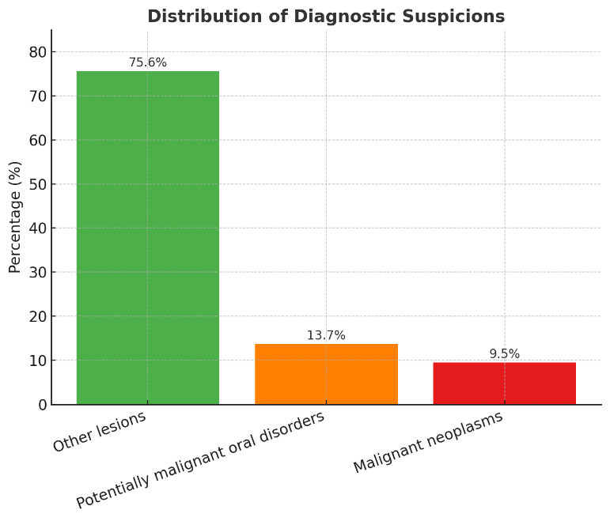

Figure 5. Distribution of diagnostic suspicions. The majority of cases were classified as other lesions, while a smaller proportion corresponded to potentially malignant disorders and malignant neoplasms.
Although some studies have indicated that specialist teleconsultations may achieve diagnostic agreement levels comparable to in-person evaluations (Da Silva et al., 2021; Dailah, 2022; Nguyen et al., 2023), our findings should be interpreted cautiously. The primary aim of TeleEstomato-MG was not to establish definitive diagnoses but to support primary care teams in patient assessment and referral. Nonetheless, missing information—such as lesion duration and medication history—represented common barriers, emphasizing the importance of complete clinical records for more effective consultations (Cardozo, 2022).

4. CONCLUSION
The participation of specialized professionals remains essential for the screening of oral lesions, as it provides strategies that enable dentists to manage cases more effectively and to initiate timely referrals when needed. The TeleEstomato-MG asynchronous teledentistry platform appears feasible for outlining the demographic profile of the assisted population, mapping the distribution of lesions, and documenting patients’ harmful habits. These descriptive findings suggest that asynchronous teledentistry can contribute to expanding access to specialized oral health services in primary care and to supporting referral pathways. While further research is needed to evaluate long-term outcomes, this model represents a promising approach for strengthening oral health care delivery in real-world settings.
Ethical Approval
This study was conducted in accordance with the ethical principles governing research involving human subjects. All data were anonymized, with no possibility of identifying patients or professionals. The project was approved by the Research Ethics Committee of the Federal University of Alfenas (UNIFAL-MG), under approval number 5.641.950. This framework ensures the confidentiality and integrity of the data, in compliance with applicable ethical and legal guidelines, including the Brazilian General Data Protection Law (Law No. 13.709/2018).

Consent for Publication
All authors declare that written informed consent was obtained from the patient (or their legal representative) for the publication of this case report and accompanying images.

Competing Interests
The authors declare that they have no competing interests.

Funding Statement
This study was supported by the Fundação de Amparo à Pesquisa do Estado de Minas Gerais (FAPEMIG), under grants APQ-03280-22 and APQ-03579-23.

Acknowledgments
The authors thank the professors and researchers of the Graduate Program in Dental Sciences at the Federal University of Alfenas for their valuable contributions. The authors also acknowledge the Federal University of Alfenas (UNIFAL-MG) for institutional support and FAPEMIG for funding and encouragement of this project.

Author’s Contributions

Caroline Miranda Pernambuco, Ana Luisa Alves, and Davi Figueiredo Valadares contributed to data collection, case description, and the first draft of the manuscript. Livian Isabel de Medeiros Carvalho, João Adolfo Costa Hanemann, and Edson Hilan Gomes de Lucena contributed to the analysis and interpretation of the results. Paulo Rogério Ferreti Bonan and Lívia Maris Ribeiro Paranaíba Dias contributed to the critical review of the manuscript and to the refinement of the discussion. Leonardo Amaral dos Reis conceived and designed the study, supervised data collection and analysis, and finalized the manuscript. All authors read and approved the final version of the manuscript.

REFERENCES

Almubarak, H. (2022). The Potential Role of Telemedicine in Early Detection of Oral Cancer. Journal of Pharmacy and Bioallied Sciences, 14(1), 19–23. DOI 10.4103/jpbs.jpbs_641_21

Bajracharya, D., Gupta, S., Ojha, B., & Baral, R. (2017)Prevalência de lesões da mucosa oral em um hospital odontológico de atendimento terciário de Kathmandu. J Nepal Med Assoc , 56(207), 362–366. DOI 10.1590/S1413-81232010000800028

Brenner, M., & Hearing, V. J. (2008). The protective role of melanin against UV damage in human skin. Photochemistry and Photobiology, 84(3), 539-549. DOI 10.1111/j.1751-1097.2007.00226.x

Cardozo, I., da Silva, V. C., Perdoncini, N., & Torres-Pereira, C. C. (2022). Telehealth in Oral Medicine: of an experience from public health care in a southern Brazilian state. Original Research Stomatology, 36, 0031. DOI 10.1590/1807-3107bor-2022.vol36.0031

Collins, J. R., Brache, M., Ogando, G., Veras, K., & Rivera, H. (2021) . Prevalence of oral mucosal lesions in an adult population from eight communities in Santo Domingo, Dominican Republic. Acta Odontol. Latinoam, 34(3), 249–256. DOI 10.54589/aol.34/3/249

Cunha, J. L. S., Cavalcante, I. L., Rodrigues, A. B. R., de Sousa-Catão, N. E., Cruz, V. M. S., & Turatti, E., et al. (2023). A retrospective multicenter study of oral and maxillofacial lesions in older people. Brazilian Oral Research, 37, e098. DOI 10.1590/1807-3107BOR-2023.VOL37.0098

Czerninski, R., Mordekovich, N., & Basile, J. (2022). Factors important in the correct evaluation of oral high-risk lesions during the telehealth era. Journal of Oral Pathology and Medicine, 51(8), 747–754. DOI 10.1111/jop.13343
Da Silva, H. E. C., Santos, G. N. M., Leite, A. F., Mesquita, C. R. M., de Souza-Figueiredo, P. T., & dos Reis, P. E. D., et al. (2021). The role of teledentistry in oral cancer patients during the COVID-19 pandemic: an integrative literature review. Supportive Care in Cancer Springer Science and Business Media Deutschland GmbH. 29(12), 7209-7223. DOI 10.1007/s00520-021-06398-0

Dailah, H. G.(2022). Mobile Health (mHealth) Technology in Early Detection and Diagnosis of Oral Cancer-A Scoping Review of the Current Scenario and Feasibility. Journal of Healthcare EngineeringHindawi Limited. 2022. DOI 10.1155/2022/4383303

Daroit, N. B., Martins, L. N., Garcia, A. B.,Haas, A. N., Maito, F. L. D. M., & Rados, P. V. (2023). Oral cancer over six decades: a multivariable analysis of a clinicopathologic retrospective study. Brazilian Dental Journal, 34(5), 115–124. DOI 10.1590/0103-6440202305264

Dos Santos, R. T. N., Faria, C. A. B., Martins, N. F., de Sousa, D. J. L. G., Azevêdo, A. B. F., & da Silva, W. R., et al. (2024). Use of digital strategies in the diagnosis of oral squamous cell carcinoma: a scoping review. PeerJ, 12(5). DOI 10.7717/peerj.17329

Firincioglulari, M., Orhan, K. (2021). Teledentistry as a Supportive Tool for Dentists in Diagnosing MRONJ in Northern Cyprus. BioMed Research International, 2021. DOI 10.1155/2021/5657152

Flores, A. P. C., Lazaro, S. A., Molina-Bastos, C. G., Guattini, V. L. de O., Umpierre, R. N., & Gonçalves, M. R. et al. (2020). Teledentistry in the diagnosis of oral lesions: A systematic review of the literature. Journal of the American Medical Informatics Association. Oxford University Press, 27(7), 1166-1172. DOI 10.1093/jamia/ocaa069

Flores-Hidalgo, A., Collie, J., King, S., Grant, F. T., Beasley, N. E., & Beasley, N. E., et al. (2023).The use of teledentistry in clinical oral and maxillofacial pathology practice: an institutional experience. Frontiers in Oral Health, 4, 1063973. DOI 10.3389/froh.2023.1063973

Ghai, S. (2020). Teledentistry during COVID-19 pandemic. Diabetes and Metabolic Syndrome: Clinical Research and Reviews, 14(5), 933–935. DOI 10.1016/j.dsx.2020.06.029
Gupta, A., Shrestha, P., Poudyal, S., Kumar, S., Lamichhane, R. S., & Acharya, S. K. et al. (2023). Prevalence and Distribution of Oral Mucosal Lesions and Normal Variants among Nepalese Population. BioMed Research International, 2023. DOI 10.1155/2023/9375084

Gurgel-Juarez, N., Torres-Pereira, C., Haddad, A. E., Sheehy, L., Finestone, H., & Mallet, K. et al. (2022). Accuracy and effectiveness of teledentistry: a systematic review of systematic reviews. Evidence-Based DentistrySpringer Nature. DOI 10.1038/s41432-022-0257-8

Ilhan, B., Bayrakdar, I. S., Baydar, O., & Guneri, P. (2022). Is It Time to Consider Implementation of Telemedicine in Current Oral Health Care Services? Disaster Medicine and Public Health Preparedness, 16(2), 423–424. DOI 10.1017/dmp.2020.503

Khoury, Z. H., & Sultan, A. S. (2020). Tele-Oral Oncology: Reinvigorating Telemedicine in Oral Cancer Care. Journal of Cancer & Allied Specialties, 6(1). DOI 10.37029/jcas.v6i1.335

Kochhar, A. S., Bhasin, R., Kochhar, G. K., & Dadlani, H. (2020). Provision of continuous dental care for oral oncology patients during & after COVID-19 pandemic. Oral OncologyElsevier Ltd, 106. DOI 10.1016/j.oraloncology.2020.104785

Lin, I., Datta, M., Laronde, D. M., Rosin, M. P., & Chan, B. (2021). Intraoral Photography Recommendations for Remote Risk Assessment and Monitoring of Oral Mucosal Lesions. International Dental JournalElsevier Inc, 71(5), 384-389. DOI 10.1016/j.identj.2020.12.020

Mehrotra, R., Thomas, S., Nair, P., Pandya, S., Singh, M., & Nigam, N. S. et al. (2010). Prevalence of oral soft tissue lesions in Vidisha. BMC Research Notes, 3(23). DOI 10.1186/1756-0500-3-23

Minervini, G., Russo, D., Herford, A. S., Gorassini, F., Meto, A., & D'Amico, C. et al. (2022). Teledentistry in the Management of Patients with Dental and Temporomandibular Disorders. BioMed Research International Hindawi Limited. DOI 10.1155/2022/7091153

Nguyen, J., Yang, S., Melnikova, A., Abouakl, M., Lin, K., & Takesh, T. et al. (2023). Novel Approach to Improving Specialist Access in Underserved Populations with Suspicious Oral Lesions. Current Oncology, 30(1), 1046–1053. DOI 10.3390/curroncol30010080

Paixão, L. C., Ferreira, E. F., Ribeiro-Sobrinho, A. P., & Martins, R. C. (2022). National analysis of dental teleconsulting of the Brazilian Telehealth Program. Brazilian oral research, 36, e110. DOI 10.1590/1807-3107bor-2022.vol36.0110

Quittes, H. F. O., Silva, T. C., Viegas, S. M. F., Gontijo, T. L., Oliveira, V. C., Guimarães, E. A. A. (2023). Estratégias de enfrentamento na Atenção Primária à Saúde na pandemia de Covid-19 em Minas Gerais, Brasil. Saúde em Debate, 47(139), 818–829. DOI 10.1590/0103-1104202313907

Uhrin, E., Domokos, Z., Czumbel, L M., Kói, T., Hegyi, P., & Hermann, P. et al. (2023). Teledentistry: A Future Solution in the Diagnosis of Oral Lesions: Diagnostic Meta-Analysis and Systematic Review. Telemedicine and e-Health Mary Ann Liebert Inc, 29(11), 1591-1600. DOI 10.1089/tmj.2022.0426

