Original Research Article

A Novel Deep Learning Approach for High-Fidelity Vectorization of Arabic Calligraphy

.
ABSTRACT

Arabic calligraphy, a centuries-old art with deep cultural and spiritual meaning, requires accurate digital representation to preserve its historical and artistic importance. Arabic calligraphy relies on precise stroke continuity, curvature harmony, and proportional balance. However, when calligraphic works are digitized, standard auto-vectorization tools often fail to preserve these qualities, producing vectors with either too many or too few anchor points. This leads to curves that appear fragmented or oversimplified, requiring extensive manual correction. Unlike traditional raster-to-vector tools that rely on fixed heuristics, the proposed method predicts optimal tracing parameters directly from the input image, enabling significantly smoother curvature and more coherent stroke continuity.
This study proposes a deep learning–based approach that treats calligraphic vectorization as a parameter prediction task rather than direct curve generation. For each input image, multiple vectorizations are first generated using Potrace under varied parameter settings, and the best configuration is selected relative to a high-quality Vector Magic (VM) raster rendering used only as a scoring reference, using a composite evaluation that combines image similarity metrics (IoU, Dice, SSIM, Chamfer) with structural efficiency (path and segment counts). A neural model is then trained to predict these optimal parameters directly from the raster image, enabling high-quality vector output at inference time.
The method was evaluated on 2,418 samples from Naskh, Reqaa, and Dewani styles. It achieved IoU = 0.9953, Dice = 0.9976, SSIM = 0.9787, and a mean Chamfer distance of 0.159 px, while reducing the average vector structure to 1.38 paths and 28.84 segments. The resulting vectors exhibit smoother curvature and more coherent stroke flow compared to standard auto-tracing. These results demonstrate the approach as a promising proof of concept, indicating that learning-based parameter prediction can approximate manual refinement and may achieve even greater accuracy with larger and more stylistically diverse datasets, as well as with more advanced vector refinement methods.

Arabic Calligraphy, Deep Learning, Vectorization, Computer Vision, Art

1. INTRODUCTION

Arabic calligraphy holds a profound position in Arabic and Islamic culture, where the written word is elevated to an artistic expression that conveys spiritual, intellectual, and aesthetic values (Blair, 2006). Over centuries, master calligraphers developed distinct styles—such as Naskh, Thuluth, Dewani, and Reqaa—each governed by rules of proportion, curvature, spatial balance, and rhythm (Naji, 2002; Safadi, 1978). Figure 1 presents examples of various Arabic calligraphy styles, each representing unique artistic traditions and philosophies rather than just visual differences. Maintaining accurate forms is crucial, as even minor changes to strokes, curves, or spacing between letters can disrupt both the artwork’s aesthetic balance and its cultural significance (al-Kurdi, 1939).

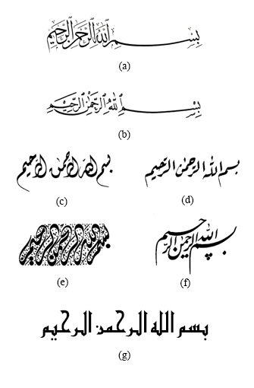
Figure 1: Different Artistic Arabic Calligraphy Types samples. (a) Thuluth,
(b) Naskh, (c) Dewani, (d) Reqa’a, (e) Jali Dewani (f) Farsi (g) Kufi

As Arabic calligraphy becomes increasingly integrated into digital environments for preservation, education, and contemporary design, the need for reliable digital representation has grown (Alsalamah & King, n.d.). High-quality vector forms are particularly important because they scale and adapt without degrading visual integrity (Hori & Tanigawa, 2002). Yet the structural characteristics of Arabic calligraphy—cursive connectivity, ligatures, and stylistic diversity across scripts—pose challenges for general-purpose vectorization tools, which often fail to capture visual rhythm and curvature accurately (Elarian et al., 2015; Khorsheed & Clocksin, 2013). Recent handwriting and manuscript datasets have advanced Arabic script analysis, but they predominantly target recognition rather than the preservation of calligraphic aesthetics, indicating a need for approaches focused on artistic fidelity (Alyafeai et al., 2021; Mahmoud et al., 2012). Moreover, recent systematic analyses of Arabic calligraphy generation highlight a persistent shortage of large, standardized, and stylistically rich datasets, noting that most available resources are either small, private, or oriented toward handwriting rather than artistic calligraphy (Sumayli & Alkaoud, 2025). Recent analyses of Arabic-script manuscripts further demonstrate that curved, overlapping, and multidirectional text lines remain challenging for recognition pipelines, reflecting the intrinsic structural complexity of Arabic calligraphy (D. Chen et al., 2024). Similarly, recent deep transfer-learning models have achieved strong performance in handwriting classification tasks, yet remain oriented toward recognition rather than the preservation of stylistic or aesthetic structure (Almisreb et al., 2022). Similar recent explorations in generative modeling further confirm that conventional digital tools remain insufficient for capturing the stylistic richness of Arabic calligraphy, underscoring the need for aesthetic-aware computational approaches (Sobhan et al., 2024). Figure 2 illustrates an Arabic calligraphy sample in both raster and vector forms.

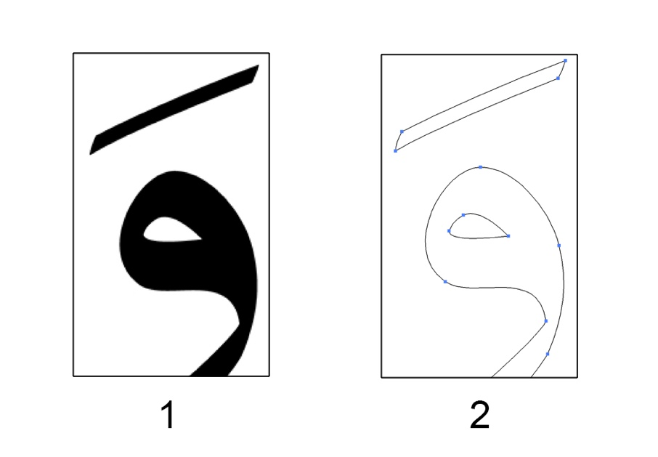
Figure 2: an Arabic calligraphy sample in (1) raster form (2) vector form

Most existing digital vectorization tools are optimized for generic graphics or printed text, not for the continuous, expressive stroke structure characteristic of Arabic calligraphy. When applied to calligraphic forms, they frequently produce dense and uneven anchor distributions, fragment single gestural strokes into multiple disconnected paths, and distort curvature and internal rhythm. These defects become more pronounced when artworks are scaled or edited, leading to noticeable losses in expressive quality (Khorsheed & Clocksin, 2013). Figure 3 illustrates Arabic calligraphy letter حـ in Thulth type in raster form and vector form using automatic and manual vectorization.

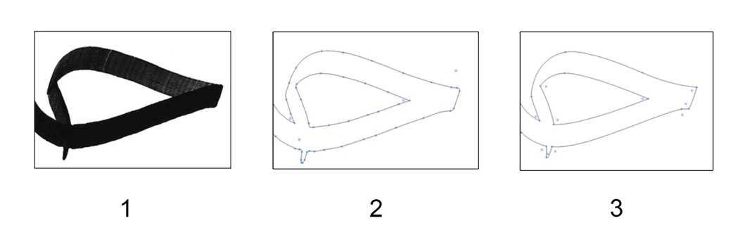
Figure 3: A sample of Arabic calligraphy image in (1) raster form and vector form after (2) Automatic and (3) Manual vectorization.

Recent advances in deep learning for vector graphics illustrate a fundamental constraint: current models primarily focus on optimizing pixel-space reconstruction over aesthetic fidelity. While these approaches minimise visual error, they do not necessarily ensure the preservation of aspects such as gesture, stroke balance, or continuity of curvature (Egiazarian et al., 2020). Even sequence-based formulations continue to struggle with Bézier parameter stability, exhibiting corner flattening and curve overshooting, particularly where the script’s flow changes direction or tension (Tian & Günther, 2022). Similarly, recent work on neural parametric curve reconstruction shows that deep models still face difficulties in reliably recovering smooth Bézier-like curve structures from raster inputs, especially in regions with complex curvature transitions (J. Tang et al., 2022). Recent studies further note that standard shape-only vectorization frameworks fail to capture texture-dependent or visually irregular regions, reinforcing the need for representations that integrate both geometric and textural cues (Y. Chen et al., 2023). Traditional RGB-based segmentation pipelines also remain limited, as they typically vectorize only pre-filtered portions of the raster image and cannot robustly preserve complex visual structure across the whole artwork (Svatý et al., 2023). Recent multimodal approaches further demonstrate that effective SVG generation requires semantic understanding rather than curve-only vectorization, as shown by StarVector’s use of visually informed SVG primitives (Rodriguez & others, 2025). Recent work has also shown that vector graphics represented through stroke-level tokens can capture semantic structure far more effectively than grid-based raster encodings, enabling more coherent and compact vector synthesis (Z. Tang & others, 2024). Furthermore, low-resource studies show that deep models struggle even more when dealing with rare or underrepresented calligraphic styles, largely due to extreme data scarcity and high intra-class variability (Ogundairo et al., 2025).
Accordingly, the challenge is not merely to vectorize Arabic calligraphy, but to do so while preserving artistic fidelity, stroke rhythm, and stylistic identity. Generic vectorizers and current deep-learning pipelines do not inherently model these properties, which is why professional workflows still depend on manual tracing or labor-intensive refinement of auto-traced vectors. This process demands significant time, expertise, and repetition across artworks and style variants(Blair, 2017; Liu et al., 2022; Xie et al., 2017).
To address this problem, we introduce a vector refinement methodology that simulates the corrective decisions made by calligraphers: reducing unnecessary anchors, restoring continuous stroke flow, and aligning Bézier curvature with the intended calligraphic gesture. Rather than generating curves directly (Tian & Günther, 2022), the method reframes vectorization as parameter prediction and optimization. For each raster input, we first produce multiple candidate vectorizations with Potrace (Selinger, 2003) under systematically varied configurations. A composite evaluation then selects the best-performing configuration per image by combining image-space similarity Intersection-over-Union (IoU) (Zheng et al., 2019), Dice coefficient (Dice) (Zhang & Guindon, 2017), Structural Similarity Index (SSIM) (Wang et al., 2004), and Chamfer distance (Wu et al., 2021) with structural efficiency (anchor/segment compactness and path continuity). These evaluations are performed relative to a high-quality Vector Magic (VM) raster rendering used strictly as a scoring reference, not as ground truth. The resulting configuration labels are then used to train a model that predicts optimal Potrace parameters directly from the normalized 128×128 grayscale input, eliminating the need for search at inference.
In practice, the trained system generates SVG outputs that preserve stroke shape and proportional relationships while maintaining a reduced and well-organized anchor structure. As shown in the Results, the approach yields consistently high image-space correspondence (IoU, Dice, SSIM) with low Chamfer distance when evaluated against the Vector Magic (VM) reference, and produces vectors with fewer paths and segments than standard auto-tracing, reflecting smoother curvature and more coherent stroke continuity. Qualitative comparisons further show that the refined vectors avoid the local flattening, overshooting, and fragmentation, thereby reducing the manual correction burden in professional digitization workflows. As demonstrated in Figure 4, standard auto-vectorization tools tend to introduce excessive anchor points and local discontinuities in stroke flow, while the proposed parameter-prediction approach produces structurally compact vectors that maintain smoother curvature transitions and stylistic coherence.

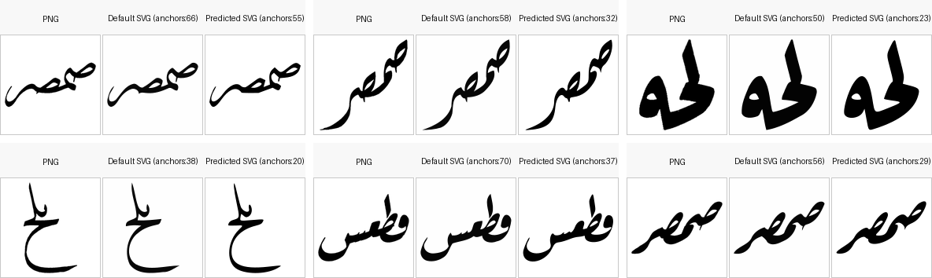

Figure 4: Visual and Structural Comparison Between Standard Auto-Vectorization and the Proposed Parameter-Prediction Method, Including Anchor-Point Counts

This study contributes a practical vector refinement workflow tailored specifically to the characteristics of Arabic calligraphy, together with a reformulation of the vectorization task as a parameter prediction problem that supports stroke continuity, curvature smoothness, and proportional balance. It further provides both quantitative and qualitative evidence—evaluated relative to a Vector Magic (VM) raster reference used exclusively for scoring—showing that the proposed method produces more coherent, stylistically consistent vector forms while substantially reducing the manual correction typically required in professional digitization workflows. The scope of the work is limited to the three calligraphic styles: Naskh, Reqaa, and Dewani, focusing on parameter optimization, prediction of effective tracing configurations, and the resulting improvements in vector smoothness and structural efficiency. Broader stylistic generalization, curve-level refinement beyond the representational limits of Potrace, and perceptual evaluation in collaboration with expert calligraphers are identified as key directions for future development. In addition, incorporating annotated calligraphic stroke structure and curvature guidance—whether through expert labeling or semi-automated stroke decomposition—has the potential to further enhance the model’s ability to preserve stylistic nuance and improve overall vector fidelity.

The following section describes the parameter search procedure, learning framework, and evaluation protocol employed in this study.

2. methodology

2.1 Overview of the Proposed Pipeline

The proposed pipeline performs raster-to-vector conversion through a guided parameter optimization and prediction strategy, illustrated in Figure 5. Given an input raster image I, the system first produces multiple vectorization candidates $V_{θ_{i}}$ by executing Potrace across a controlled set of parameter configurations $Θ=\{θ_{1},θ_{2},…,θ_{n}\}$. Potrace, in this context, operates as a contour-following vectorization backend, in which the raster image is binarized, connected foreground regions are identified, and their boundaries are approximated by sequences of cubic Bézier curves.

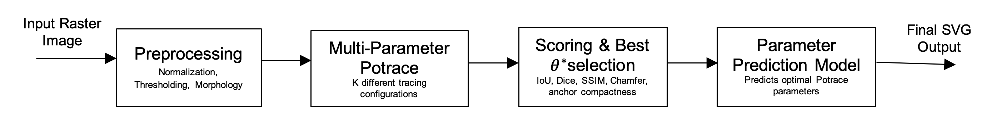

Figure 5: Overview of the proposed vectorization pipeline

The tracing behavior is governed by two groups of settings: preprocessing operations and Potrace runtime parameters. Rather than fixing these settings, the pipeline jointly explores both groups during the search stage, enabling the system to adapt to differences in stroke clarity, contour continuity, and curvature transitions across calligraphic samples. The preprocessing operations (smoothing, thresholding, and morphological filtering) are summarized in Table 1, while the Potrace parameters (alphamax, opttolerance, and turdsize) are detailed in Table 2.

Table 1. Pre-processing Operations Enumerated in the Parameter Search

Step | Options Used | Effect on Input Bitmap
Smoothing | none; Gaussian (k = 3, 5) | Reduces local noise and stabilizes contour flow
Thresholding | Otsu; global (105, 120, 135, 145) | Defines foreground ink regions for tracing
Morphology | none; opening (k = 1); closing (k = 1) | Removes speckles or repairs stroke continuity

Table 2. Potrace Parameters Enumerated in the Parameter Search

Parameter | Values Used | Influence on Vectorization Behavior
alphamax | {0.8, 1.0, 1.2, 1.4} | Regulates Bézier curve fitting tightness
opttolerance | {1.0, 1.2} | Controls post-fit path simplification and anchor reduction
turdsize | {0, 2} | Removes connected components below a size threshold

Each configuration $θ_{i}$ produces a distinct vector output $V_{θ_{i}}$. These outputs are evaluated using a composite scoring function $S$ that integrates image-space similarity relative to a rasterized Vector Magic (VM) reference used strictly as a scoring comparator rather than as a ground truth) and structural compactness:

$θ^{*}=\arg{\max_{θ_{i}∈Θ}{S\left(R\left(V_{\text{VM}}\right), R\left(V_{θ_{i}}\right)\right)}}$ (1)

The resulting supervision pairs $\left(I,θ^{*}\right)$ provide the foundation for training a prediction model $f_{ϕ}$, which learns to infer suitable tracing parameters directly from the input raster representation:

$\hat{θ}=f_{ϕ}\left(I\right)$ (2)

At inference time, the model outputs $\hat{θ}$ in a single forward pass, and Potrace is invoked only once to generate the final vector $V_{\hat{θ}}$. This produces vector outputs with smooth curvature transitions, coherent stroke flow, and reduced anchor-point density—effectively approximating the manual refinement typically required in professional digitization workflows.

2.2 Pre-Processing and Normalization

All calligraphy samples used in this work are provided as binary, cropped, and centered images, prepared during a prior dataset construction process (Figure 6). Therefore, no geometric alignment or background removal is required at this stage. However, the preprocessing operations applied before vectorization—smoothing, thresholding, and morphological filtering—are included in the parameter search space because they influence contour clarity and stroke boundary shape. These operations are selected from a predefined set of alternative configurations listed in Table 1 and are evaluated jointly with the Potrace parameters during candidate generation. Since the preprocessing configuration is predicted dynamically during inference, the pipeline can also adapt to inputs containing background texture or grayscale variation, rather than relying solely on pre-segmented binary inputs.

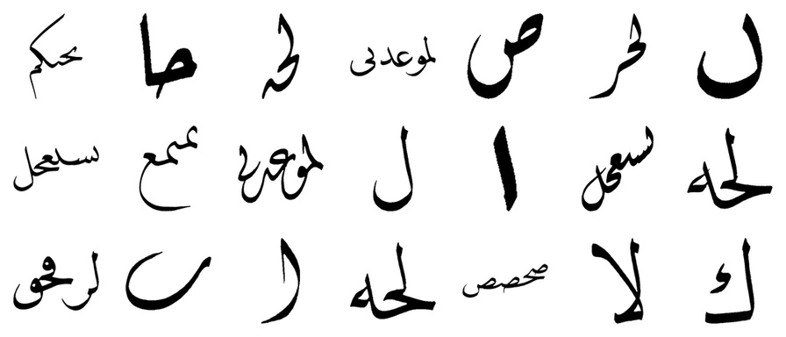

Figure 6: Random samples of calligraphy images used in this work

After preprocessing, the resulting binary mask is placed on a square canvas and rescaled to a standard resolution of $128 ×128$, which ensures a uniform spatial scale across all samples for both parameter prediction and vectorization:

$I_{\text{norm}}=\text{Resize}\left(\text{Preprocess}\left(I\right), 128×128\right)$ (3)

This normalization step preserves the dataset’s original centered stroke composition while enabling the parameter search procedure to explore variations in fine-scale contour handling,rather than applying a single fixed preprocessing configuration across all images.

2.3 Two-Stage Parameter Optimization for Potrace Vectorization

The vectorization stage generates multiple candidate vector outputs from the normalized raster input by evaluating both preprocessing settings and Potrace configurations. For each image, the pipeline iterates over a combined parameter space in which smoothing, thresholding, and morphological operations (Table 1) are paired with Potrace runtime parameters (Table 2). This produces a controlled range of contour interpretations, allowing the system to capture variations in curvature sensitivity, stroke continuity, and noise handling.

Formally, let P denote the set of preprocessing configurations (smoothing, thresholding, morphology), and let A, O, and T denote the Potrace parameters:

$$A: alphamax\left(-a\right) = \text{curve-fitting tolerance}$$
$$O: opttolerance\left(-O\right) = \text{path simplification pressure}$$
$$T: turdsize\left(-turdsize\right) = \text{small component suppression}$$

The full configuration grid is:

$Θ= P ×A ×O ×T$ (4)

Each configuration $θ_{i}∈Θ$ produces a distinct vectorization candidate:

$V_{θ_{i}}=\text{Potrace}\left(I_{\text{norm}}, θ_{i}\right)$ (5)

In practice, the search is performed in two stages. First, a coarse grid search enumerates all configurations in $Θ$ to identify a high-performing region of the parameter space. Then, a local refinement search evaluates small perturbations around the best-scoring configuration, allowing the system to fine-tune curve-fitting and path simplification without requiring a prohibitively dense global grid. This two-stage strategy reduces computation while avoiding suboptimal selections caused by coarse parameter discretization.
Because Arabic calligraphy is continuous and gesture-based, no single tracing configuration is universally optimal. Enumerating and refining $Θ$ preserves multiple plausible curvature interpretations before selecting the most appropriate one for the input shape. Each candidate is scored against a rasterized Vector Magic (VM) reference used strictly as a scoring comparator rather than as a ground truth, ensuring that selection reflects visual correspondence and structural coherence without adopting VM’s geometry as the target representation.

2.4 Scoring and Selection of the Optimal Vectorization

Once the set of vectorization candidates $\{V_{θ_{i}}\}$ is generated, each candidate is evaluated to determine how well it preserves the structural and visual characteristics of the original calligraphy. The evaluation considers two complementary aspects: image-space similarity and vector structural efficiency.
The image-space component compares the raster rendering of each candidate vector to a rasterized Vector Magic (VM) reference used strictly as a scoring comparator, capturing stroke placement, curvature behavior, and overall stylistic balance. The structural component quantifies the geometric organization of the vector representation, measuring path continuity and anchor-point compactness to discourage over-segmentation and unnecessary curvature breaks.

The scoring function is defined as:

$S\left(θ_{i}\right)=λ_{1} M\text{sim}\left(R\left(V\text{VM}\right), R\left(V_{θ_{i}}\right)\right)+λ_{2} M\text{struct}\left(Vθ_{i}\right)$ (6)

where:

$M\text{sim}$ measures similarity between the rasterized VM reference and the raster rendering $R\left(Vθ_{i}\right)$ of the vector candidate (e.g., IoU, Dice, SSIM, Chamfer distance),
$M_{\text{struct}}$ quantifies vector compactness based on path count and anchor-point distribution,
$λ_{1},λ_{2}$ control the balance between visual fidelity and structural efficiency.

The optimal tracing configuration is selected as:

$θ^{*}=\arg{\max_{θ_{i}∈Θ}{S}}\left(θ_{i}\right)$ (7)

This selection procedure ensures preservation of stroke geometry and proportional relationships, while avoiding curvature flattening or excessive anchor density.

2.5 Training the Parameter Prediction Model

The supervision pairs $\left(I_{\text{norm}},θ^{*}\right)$ obtained from the parameter search stage form the training data for the parameter prediction model $f_{ϕ}.$ The goal of the model is to learn how to replicate the selection behavior of the search procedure. Instead of generating and scoring multiple vectorizations, the model learns to approximate the selection behavior of the search procedure directly:

$f_{ϕ}: I_{\text{norm}}→\hat{θ}$ (8)

The parameter vector $θ$ is structured, containing both categorical (preprocessing and discrete Potrace settings) and continuous (curve-fitting and simplification) components:

- Categorical: smoothing mode, thresholding type, and morphological operation
- Continuous: alphamax (a), opttolerance (O), and threshold value when applicable

Thus, the model performs joint classification and regression. A convolutional encoder extracts a latent feature representation from the input, and separate prediction heads estimate each component of $θ.$

The training objective is a weighted multi-task loss:

$L\left(ϕ\right)=\sum_{c∈C}{CE\left(\hat{c},c\right)} + λ_{a} ||\hat{a}-a||1 + λ_{O} ||\hat{O}-O||1 + λ_{\text{thr}} ||\hat{v}\text{thr}-{v_{\text{thr}} ||}_{1}⋅1\left[\text{threshold-kind}=\text{global}\right]$ (9)

The indicator term ensures that threshold regression is only performed when global thresholding is selected, maintaining semantic consistency in the parameter space.
Training uses mini-batch gradient descent with a validation split. Importantly, validation monitors the quality of the resulting vector output rather than pixel-level loss alone, ensuring that optimization aligns with final SVG behavior.
Because all inputs are normalized to a centered $128×128$ layout, the model learns shape-level cues such as curvature tension, stroke mass distribution, and proportional balance, enabling parameter predictions that maintain coherent stroke flow without manual adjustment.
Figure 7 illustrates this supervision and prediction process, showing how the optimal configuration selected during parameter search is used to train the model to infer parameters directly at inference time.

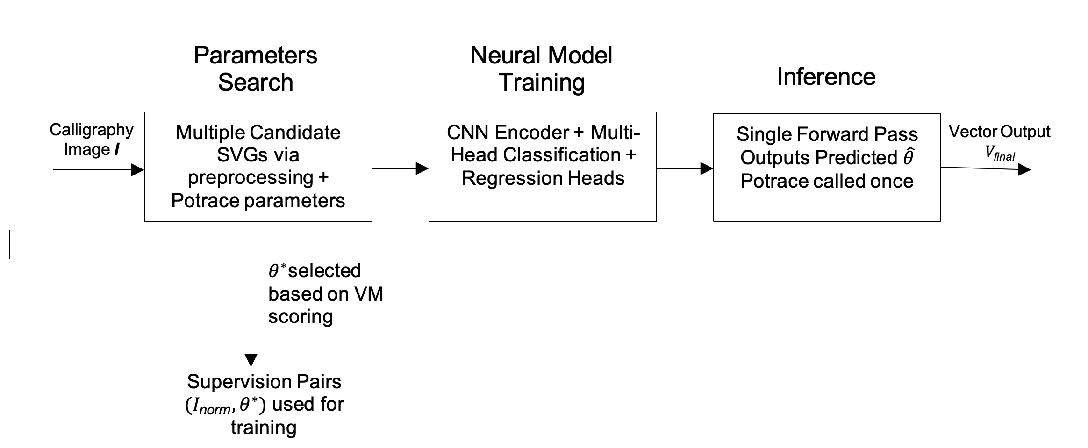

Figure 7. Overview of the parameter prediction framework.

2.6 Inference and Final Vector Output

At inference time, the multi-configuration tracing stage is no longer required. Given a new input image, the preprocessing and normalization described previously are applied to produce $I_{\text{norm}}$, and the trained prediction model $f_{ϕ}$ generates a parameter estimate $\hat{θ}$ in a single forward pass:

$\hat{θ}=f_{ϕ}\left(I_{\text{norm}}\right)$ (9)

The predicted parameter set $\hat{θ}$ includes both the preprocessing operations (e.g., smoothing, thresholding, morphology) and the Potrace tracing parameters. Accordingly, the input is first preprocessed using the predicted preprocessing settings, after which Potrace is executed once using the predicted tracing parameters to obtain the final vector:

$V_{\text{final}}=\text{Potrace}\left(\text{Preprocess}\hat{θ}\left(I\text{norm}\right), \hat{θ}\right)$ (10)

This eliminates the need for iterative parameter tuning or manual curve refinement. The resulting vector forms preserve curvature continuity, stroke proportions, and overall visual balance characteristic of the original calligraphy, while avoiding excessive anchor density and segmentation. In practice, this produces vector outputs that are more structurally coherent and require significantly less post-editing compared to standard auto-vectorization.

This completes the proposed pipeline. The following section evaluates its performance and examines the qualitative and quantitative impact of parameter prediction on the resulting vector representations.

3. results and discussion

3.1 Quantitative Evaluation

The proposed method was quantitatively assessed on a dataset of 2,418 calligraphic samples using both image-space correspondence metrics and structural vector complexity measures. Image-space fidelity was evaluated using Intersection-over-Union (IoU), Dice coefficient (Dice), Structural Similarity Index (SSIM), and Chamfer distance, which jointly assess global shape overlap, perceptual similarity, and contour alignment. To evaluate the geometric efficiency of the vector outputs, we further measured the number of paths and anchors in the final SVG representations. These metrics reflect the smoothness, structural coherence, and editability of the resulting vector forms.

The results, summarized in Table 3, indicate that the method consistently preserves the overall letterform structure with very high image-space similarity while producing compact and well-organized vector topologies. The mean IoU and Dice scores demonstrate near-perfect overlap with the original raster shapes, while SSIM and Chamfer distance confirm close alignment in stroke curvature and boundary detail. At the same time, the reduced number of paths and curve segments shows that the model avoids redundant anchor placement and unnecessary segmentation, yielding vectors that are aesthetically stable and easier to modify in downstream design workflows.

Table 3. Image-space correspondence metrics

Metric | Mean
IoU | 0.9953
Dice | 0.9976
SSIM | 0.9787
Chamfer Distance (px) | 0.159

At the same time, the structural metrics in Table 4 reveal a clearer picture of how the proposed method positions itself between the behaviors of Vector Magic and standard Potrace. Vector Magic achieves the lowest anchor count (27.08) but does so while generating a comparatively large number of paths (3.08), indicating that its smoothness is achieved partly through segmenting strokes into multiple subpaths—a structurally costly outcome in calligraphic contexts. In contrast, default Potrace favors single continuous paths (1.38 on average) but at the expense of producing an inflated number of anchors (36.07), which introduces unnecessary geometric redundancy and complicates downstream editing.

The proposed method attains a more desirable compromise: it preserves Potrace’s path compactness (1.38 paths, matching the baseline exactly) while substantially reducing the excessive anchor density (down to 28.84, approaching the VM profile). In other words, it avoids VM’s tendency to fragment strokes across several paths and simultaneously prevents Potrace’s tendency to overfit the contour with dense anchor placement. This combination—low path count with moderated anchor usage—results in vector outputs that are structurally coherent, stylistically stable, and significantly easier to refine or integrate into design workflows requiring precise control over curve geometry.

Table 4. Structural vector complexity metrics

Measure | Mean
Measure | Vector Magic | Standard Potrace | Our work  (DL + Potrace)
Number of paths | 3.08 | 1.38 | 1.38
Number of anchors | 27.08 | 36.07 | 28.84

The distribution profiles of IoU, Dice, SSIM, and Chamfer distance are shown in Figure 8, illustrating that performance is consistently stable across the dataset, with no significant long-tail degradations. These results collectively demonstrate that the proposed method achieves high-fidelity reconstruction of calligraphic structure while producing structurally efficient and stylistically coherent vector outputs.

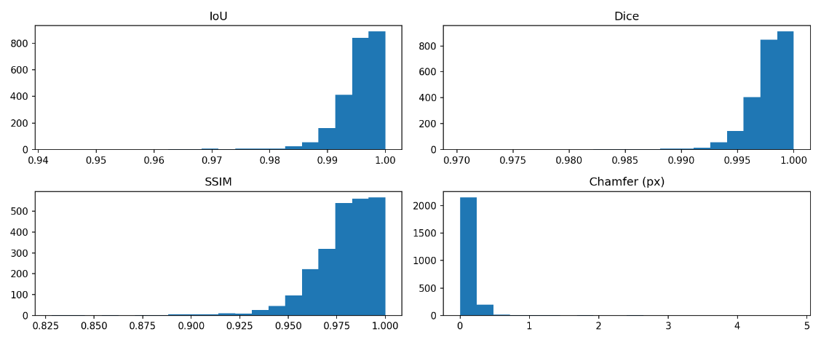
Figure 8. Histograms of IoU, Dice, SSIM, and Chamfer distance across the dataset

3.2 Visual Results and Comparison

To illustrate the qualitative differences between the proposed method and standard auto-vectorization, representative samples were compared across four views: (A) input raster, (B) Potrace default output, (C) proposed refined vector output, and (D) vector edge/anchor representation. Figure 9 illustrates that baseline auto-tracing often results in subtle flattening or segmentation within areas exhibiting gradual curvature transitions. In contrast, the proposed method delivers smoother curvature profiles and maintains a more consistent directional flow, supported by an appropriate number of anchors and improved positioning.

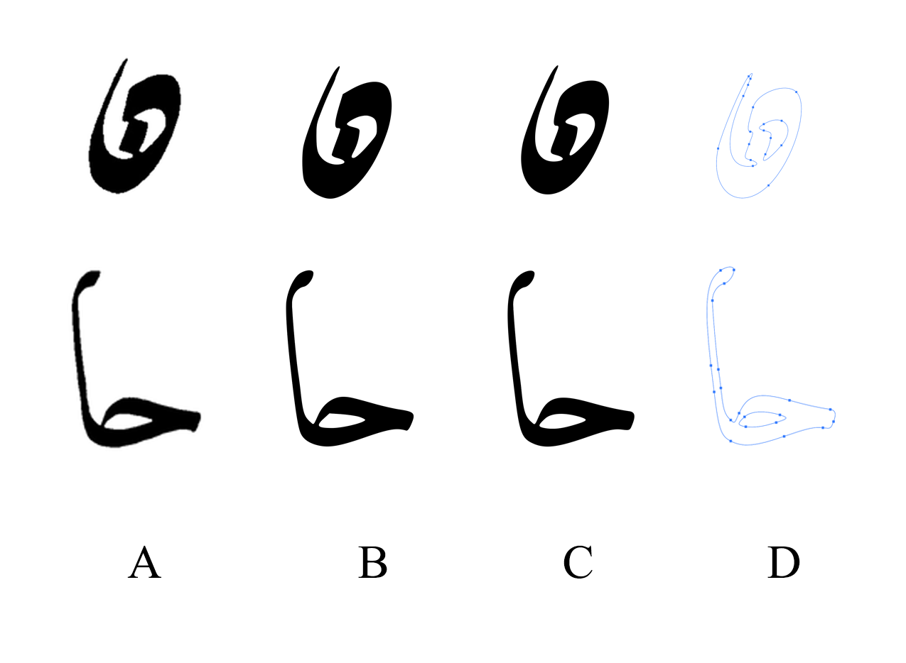

Figure 9. Qualitative comparison (A) Input raster, (B) Potrace default, (C) Proposed output, (D) Vector edges and anchor structure.

3.3 Interpretation

The results suggest that parameter optimization can serve as a practical substitute for manual refinement in calligraphic vectorization workflows. By selecting tracing parameters that adapt to the curvature characteristics of individual samples, the method preserves stroke continuity and proportional balance—qualities that are foundational to the visual identity of Arabic calligraphy. This reduces the need for extensive manual correction and supports efficient incorporation into digital design and archival processes.

3.4 Limitations

This method has been evaluated on only three calligraphic styles, and its behavior across a broader spectrum of historical and contemporary scripts remains to be assessed. Its refinement capability is also constrained by Potrace’s representational model, which does not permit direct manipulation of anchor placement or curve segmentation beyond the predefined tracing parameters. Moreover, the evaluation relies on image-space and structural metrics computed against a rasterized Vector Magic (VM) reference, which is used exclusively as a scoring anchor rather than as a ground-truth artistic standard. Importantly, the absence of a professionally annotated ground-truth vector dataset limits the model’s ability to learn calligraphically ideal stroke structures. A curated dataset produced by expert calligraphers—where vectors are traced manually according to established rules of proportion, curvature, and stroke dynamics—would provide a far more authoritative supervisory signal and could substantially enhance the model’s ability to reproduce stylistically accurate and artistically faithful vector forms.

4. Conclusion

This study presented a parameter prediction–based vectorization approach aimed at preserving the stylistic and structural characteristics of Arabic calligraphy in digital vector form. By identifying and learning optimal tracing configurations, the method generates vector outputs with smoother curvature behavior, coherent stroke continuity, and reduced anchor complexity compared to standard auto-tracing. The results indicate that refinement practices typically performed manually in calligraphy digitization workflows can be approximated within a learning-based pipeline, enabling efficient and reliable vector reproduction. Evaluation was conducted using a rasterized Vector Magic (VM) reference strictly as a scoring comparator, demonstrating high image-space fidelity and structural efficiency across the dataset.
Future work will extend the evaluation to a broader range of calligraphic styles and compositions and investigate models capable of directly manipulating Bézier control points to support curve-level refinement beyond the constraints of Potrace. Incorporating perceptual and style-aware evaluation criteria informed by expert calligraphers remains a key direction for aligning computational output more closely with artistic intent.

Disclaimer

Author hereby declares that NO generative Al technologies such as Large Language Models (ChatGPT, COPILOT, etc) and text-to-image generators have been used during the writing or editing of this manuscript.

References

al-Kurdi, M. T. (1939). Tarikh al-khatt al-ʻArabi wa Adabihi. Maktabat al-Hilal.

Almisreb, A. A., Tahir, N. M., Turaev, S., Saleh, M. A., & Al Junid, S. A. M. (2022). Arabic Handwriting Classification using Deep Transfer Learning Techniques. Pertanika Journal of Science & Technology, 30(1), 641–654.

Alsalamah, S., & King, R. (n.d.). Towards the Machine Reading of Arabic Calligraphy: A Letters Dataset and Corresponding Corpus of Text. https://imagej.net/ImageJ.

Alyafeai, Z., Al-Shaibani, M., Ghaleb, M., & Al-Wajih, Y. A. (2021). Calliar: an online handwritten dataset for Arabic calligraphy. Neural Computing and Applications, 34, 20701–20713. https://doi.org/10.1007/s00521-022-07537-2

Blair, S. S. (2006). Islamic calligraphy. American University in Cairo Press. https://aucpress.com/9789774160394

Blair, S. S. (2017). Islamic Calligraphy. Oxford Research Encyclopedia of Religion. https://doi.org/10.1093/acrefore/9780199340378.013.950

Chen, D., Murel, J., Shahid, T., Zhang, X., Allen, J. P., Berg-Kirkpatrick, T., & Smith, D. A. (2024). MONSTERMASH: Multidirectional, Overlapping, Nested, Spiral Text Extraction for Recognition Models of Arabic-Script Handwriting. Proceedings of the International Workshop on Computational Processing, 1–14. /mnt/data/chen-monstermash-iwcp-2024.pdf

Chen, Y., Ni, B., Liu, J., Huang, X., & Chen, X. (2023). Towards High-fidelity Artistic Image Vectorization via Texture-Encapsulated Shape Parameterization. Proceedings of the IEEE/CVF Conference on Computer Vision and Pattern Recognition, 15877–15886.

Egiazarian, V., Voynov, O., Artemov, A., Volkhonskiy, D., Safin, A., Taktasheva, M., Zorin, D., & Burnaev, E. (2020). Deep Vectorization of Technical Drawings. ArXiv Preprint ArXiv:2003.05471. https://arxiv.org/abs/2003.05471

Elarian, Y., Ahmad, I., Awaida, S., Al-Khatib, W., & Zidouri, A. (2015). Arabic ligatures: Analysis and application in text recognition. Proceedings of the International Conference on Document Analysis and Recognition, ICDAR, 2015-November, 896–900. https://doi.org/10.1109/ICDAR.2015.7333891

Hori, O., & Tanigawa, S. (2002). Raster-to-vector conversion by line fitting based on contours and skeletons. 353–358. https://doi.org/10.1109/ICDAR.1993.395716

Khorsheed, M. S., & Clocksin, W. F. (2013). Structural Features of Cursive Arabic Script. 42.1-42.10. https://doi.org/10.5244/c.13.42

Liu, H., Li, C., Liu, X., & Wong, T.-T. (2022). End-to-End Line Drawing Vectorization. Proceedings of the AAAI Conference on Artificial Intelligence, 36(2), 4559–4567. https://ojs.aaai.org/index.php/AAAI/article/view/20379

Mahmoud, S. A., Ahmad, I., Alshayeb, M., Al-Khatib, W. G., Parvez, M. T., Fink, G. A., Märgner, V., & El Abed, H. (2012). KHATT: Arabic offline Handwritten Text Database. Proceedings - International Workshop on Frontiers in Handwriting Recognition, IWFHR, 449–454. https://doi.org/10.1109/ICFHR.2012.224

Naji, H. (2002). Mawsuʻat Turath al-Khatt al-ʻArabi. al-Dar al-Dawliyya lil-Istithmarat al-Thaqafiyya.

Ogundairo, O., Khalil, H., Alghamdi, K., & Mehdi, L. (2025). Low-Resource Deep Learning Strategies for Rare Arabic Calligraphic Styles in Digitized Archives. Unpublished Manuscript / Digital Archive Study.

Rodriguez, J. A., & others. (2025). StarVector: Generating Scalable Vector Graphics Code from Images and Text. Proceedings of the AAAI Conference on Artificial Intelligence, 39(28), 35369. https://doi.org/10.1609/aaai.v39i28.35369

Safadi, Y. H. (1978). Islamic Calligraphy. Thames and Hudson.

Selinger, P. (2003). Potrace: A Polygon-Based Tracing Algorithm. https://potrace.sourceforge.net/potrace.pdf

Sobhan, A., Pasquier, P., & Tindale, A. (2024). Unveiling New Artistic Dimensions in Calligraphic Arabic Script with Generative Adversarial Networks. Proceedings of the ACM on Computer Graphics and Interactive Techniques, 7(4), 1–12. https://doi.org/10.1145/3664210

Sumayli, A., & Alkaoud, M. (2025). Handwritten Arabic Calligraphy Generation: A Systematic Literature Review. International Journal of Advanced Computer Science and Applications, 16(3), 822–830. /mnt/data/out.pdf

Svatý, V., Vrtal, V., Kouhout, J., & Nouzovský, A. (2023). Automated Detection and Vectorization of Road Elements in Orthophotos. Proceedings of GIS Ostrava 2023, 1–10.

Tang, J., Wang, Y., & Mitra, N. (2022). Neural Parametric Curve Reconstruction. ACM Transactions on Graphics, 41(6), 1–16. https://doi.org/10.1145/3550454.3555484

Tang, Z., & others. (2024). StrokeNUWA: Tokenizing Strokes for Vector Graphic Synthesis. ArXiv Preprint ArXiv:2401.17093. https://arxiv.org/abs/2401.17093

Tian, X., & Günther, T. (2022). A Survey of Smooth Vector Graphics: Recent Advances in Representation, Creation, Rasterization, and Image Vectorization. IEEE Transactions on Visualization and Computer Graphics, 30(3), 1652–1671. https://doi.org/10.1109/TVCG.2022.3220575

Wang, Z., Bovik, A. C., Sheikh, H. R., & Simoncelli, E. P. (2004). Image Quality Assessment: From Error Visibility to Structural Similarity. IEEE Transactions on Image Processing, 13(4), 600–612. https://doi.org/10.1109/TIP.2003.819861

Wu, T., Pan, L., Zhang, J., Wang, T., Liu, Z., & Lin, D. (2021). Density-aware Chamfer Distance as a Comprehensive Metric for Point Cloud Completion. ArXiv Preprint ArXiv:2111.12702. https://arxiv.org/abs/2111.12702

Xie, J., Winnemöller, H., Li, W., & Schiller, S. (2017). Interactive Vectorization. Proceedings of the 2017 CHI Conference on Human Factors in Computing Systems (CHI ’17), 6695–6705. https://doi.org/10.1145/3025453.3025872

Zhang, Y., & Guindon, B. (2017). Application of the Dice Coefficient to Accuracy Assessment of Object-Based Image Classification. Canadian Journal of Remote Sensing, 43(1), 18–33. https://doi.org/10.1080/07038992.2017.1259557

Zheng, Z., Wang, P., Liu, W., Li, J., Ye, R., & Ren, D. (2019). Distance-IoU Loss: Faster and Better Learning for Bounding Box Regression. ArXiv Preprint ArXiv:1911.08287. https://arxiv.org/abs/1911.08287

