Effect of Internal Obstacle Geometry on Natural Convection in a Wavy-Top Trapezoidal Cavity Filled with Cu–H₂O Nanofluid

“Original Research Article”

Abstract

This study presents a comprehensive numerical investigation of natural convection in a wavy-top trapezoidal cavity filled with Cu–H₂O nanofluid, focusing on the influence of internal obstacle geometry under magnetohydrodynamic (MHD) effects. Three distinct obstacle shapes, Square, Triangular, and Star, are examined across a range of Rayleigh numbers, Hartmann numbers, and nanoparticle volume fractions using the Galerkin Finite Element Method (FEM). The investigation evaluates thermal performance through average Nusselt number, Entropy generation, and the Ecological Coefficient of Performance (ECOP). The results reveal that obstacle geometry plays a critical role in shaping flow structures and thermal transport. The square obstacle demonstrated enhanced convective strength and thermodynamic efficiency, while the triangular obstacle effectively minimized entropy production. The star-shaped obstacle induced localized vortices, promoting mixing but at the cost of overall efficiency. Variations in inclination angle and magnetic field intensity further modulated heat transfer behavior, with moderate inclination enhancing convection and strong magnetic fields suppressing it. These findings provide a robust framework for designing and optimizing nanofluid-based thermal management systems in energy and electronics applications.

Keywords: Natural Convection; Cu–H₂O Nanofluid, Magnetohydrodynamics (MHD), Wavy-top trapezoidal cavity, Entropy generation

1.0 Introduction

Natural convection in enclosures is a fundamental mechanism widely utilized in thermal management systems such as electronic cooling devices, solar energy collectors, and energy-efficient building designs [1]. The performance of these systems has been significantly improved through the introduction of nanofluid-based fluids enhanced with suspended nanoparticles, which substantially increase thermal conductivity and heat transfer rates [2]. Due to their superior thermophysical properties, nanofluids have proven highly effective in optimizing convective flow behavior under different boundary and geometric conditions [3].

The integration of internal heat-generating obstacles within cavities plays a crucial role in modifying the thermal and flow characteristics of natural convection systems. The geometry, size, and thermal load of the obstacle directly influence recirculation zones, vortex strength, and local temperature gradients [4]. Commonly studied obstacle shapes, such as circular, square, elliptical, and triangular, have been shown to have distinct impacts on convective strength and flow mixing [5]. Furthermore, cavity inclination introduces gravitational asymmetry that affects buoyancy forces, leading to notable variations in circulation patterns and entropy generation [6].

When magnetic fields are introduced, magnetohydrodynamic (MHD) effects emerge, governed by the Hartmann number. The Lorentz force induced by the magnetic field suppresses convective motion, thereby shifting the heat transfer mechanism toward conduction [7]. However, precise control of magnetic field intensity can improve temperature uniformity and stabilize thermal performance in nanofluid-filled cavities [8]. The shape and positioning of internal obstacles, such as square or triangular blocks, further enhance convective mixing and disrupt the boundary layer, contributing to improved overall heat transfer [9,10]. Inclined cavities filled with nanofluids are of particular importance because variations in the inclination angle alter the alignment of thermal gradients with gravity, affecting both convection intensity and entropy generation [11, 12]. In MHD-assisted systems, these factors interact, making the combined influence of geometry, buoyancy, and magnetic fields an essential focus of analysis [13].

Cavity wall design also has a significant effect on heat transfer behavior. Wavy or corrugated surfaces induce secondary vortices, which enhance mixing and lead to improved convective performance compared to flat walls [14,15]. Similarly, hybrid and composite nanofluids comprising multiple types of nanoparticles offer superior control over conductivity and viscosity [16]. Porous and layered cavity structures can further enhance heat transport by introducing permeability and additional flow pathways [17,18]. Moreover, parameters such as nanoparticle shape, volume fraction, and conductivity ratio have been shown to influence the overall heat transfer efficiency, while entropy generation remains a vital indicator of system irreversibility and thermodynamic performance [19, 20]. Variations in wall topology, such as sinusoidal heating and surface undulation, further modify the flow and temperature distributions, contributing to enhanced heat and entropy characteristics [21, 22, 23].

Although several studies have investigated mixed and hybrid nanofluid convection in complex geometries, comprehensive analyses incorporating MHD effects within wavy-top trapezoidal cavities remain limited [24–28]. Advanced modeling approaches accounting for Brownian motion, thermophoresis, and FEM have improved thermal-fluid predictions [29,30]. It is well established that both obstacle geometry and wall undulation significantly impact natural convection behavior [31,32]. Internal obstacles influence flow and heat transfer by altering circulation paths [33, 34]. Conjugate analyses reveal that cavity geometry directly affects vortex structures and temperature gradients [35]. Cu–H₂O nanofluids are known for their enhanced thermal conductivity and stability across varying Ra and Ha [36], and magnetic fields have been shown to regulate temperature distribution, particularly in enclosures with embedded heat sources [37]. Recent studies further highlight the combined effects of geometry and magnetic forces on entropy generation and system efficiency [38]. Additionally, validation from related mixed convection problems, such as those involving internal heating and rotating elements [39], supports the numerical methodology adopted here. MHD natural convection in a nanofluid-filled quadrantal enclosure has been numerically analyzed to demonstrate how magnetic field intensity and nanoparticle concentration influence flow structure and thermal transport efficiency [40].

In this context, the present study investigates the impact of internal obstacle geometry on natural convection in a wavy-top trapezoidal cavity filled with a Cu–H₂O nanofluid under the influence of magnetic fields. The goal is to examine how variations in obstacle shape influence flow structure, thermal distribution, and heat transfer efficiency. This analysis integrates geometric and thermophysical parameters to contribute to the design of efficient nanofluid-based thermal systems.

2.0 Model Description
This study investigates natural convection heat transfer and entropy generation within a two-dimensional wavy-top trapezoidal enclosure filled with Cu–H₂O nanofluid. The cavity has a base angle of γ = 15 ° and is analyzed at inclination angles λ = 15°, 30°, and 45° to examine the gravitational reorientation effects on buoyancy-driven flow. Two identical, internally heated copper obstacles are symmetrically placed at the center of the enclosure, with three distinct geometries star, square, and triangular considered to evaluate how obstacle shape influences heat transfer and fluid motion. Figures 1(a–c) illustrate the computational geometries with different internal obstacle configurations: (a) Star-shaped, (b) Square, and (c) Triangular obstacles used in the comparative analysis. The cavity has a sinusoidal cold top wall(T_{C}), a uniformly heated bottom wall (Tₕ), and adiabatic sidewalls. Internal copper obstacles act as uniform heat sources, enabling conjugate heat transfer. The Cu–H₂O nanofluid is modeled as a steady, laminar, incompressible single-phase flow, with buoyancy effects governed by the Boussinesq approximation.

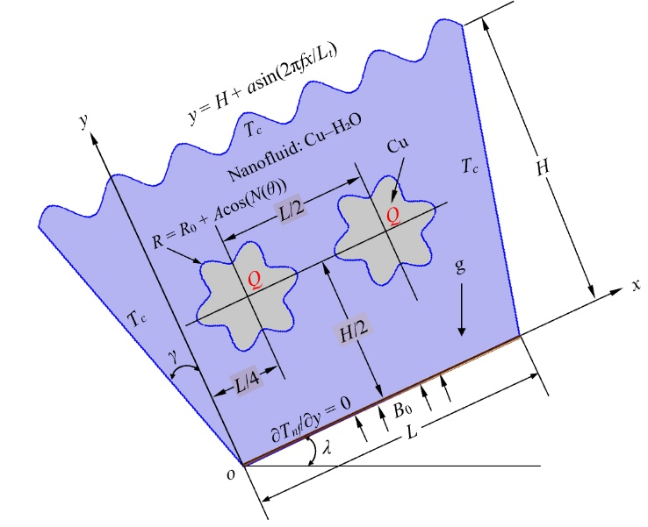
a. Star Obstacle
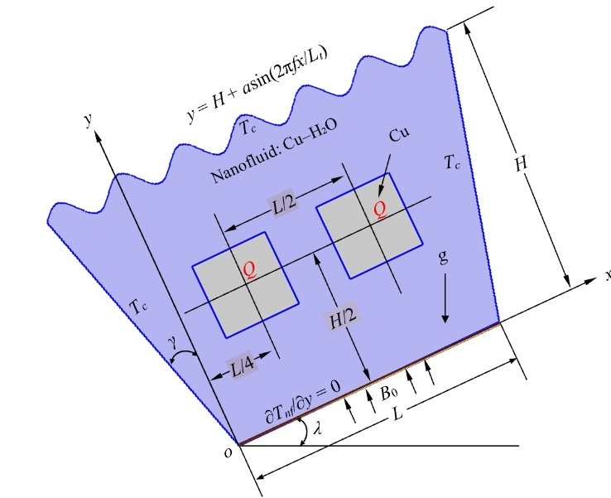
b. Square Obstacle
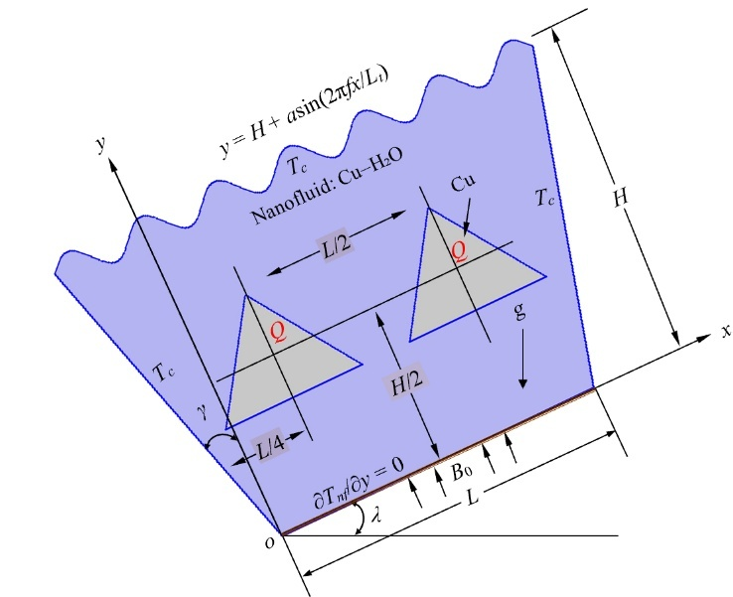
c. Triangle Obstacle
Fig 1(a,b,c). Geometry with Different Obstacles

The governing mathematical equations and their non-dimensional forms are presented in equations (1) to (38), which account for natural convection, magnetohydrodynamic (MHD) effects, and nanofluid behavior. The associated boundary conditions are described below ([5], [17], [31], [32]).

For Sinusoidal wavy top wall:
(1)
Here, $H$: Height of the cavity, $a$: Amplitude of the wave, $f$: Frequency (number of waves), $L_{t}$: Total length of the top wall, and x is the position along the wall.

Gravitational acceleration g acts vertically downward, but is decomposed into components along the inclined axis:
(2)
Fluid domain:
(3)
(4)
(5)
(6)
Star-shaped solid domains:
(7)
Here, u and v denote velocity components in the x- and y-directions, respectively, and p and T represent pressure and temperature, respectively. The fluid properties are mass density (ρ), thermal conductivity (k), specific heat at constant pressure (C_{p}), volumetric thermal expansion coefficient (β), and electrical conductivity (σ).

Dimensional Boundary Conditions:
Top Wall:
, (8)
Inclined Side Wall:
, (9)
Bottom Wall:
, (10)

Heated Block:
Internal volumetric heat generation applied in the solid domain, Q>0; continuity of temperature and heat flux at fluid-solid interfaces is enforced:
, (11) (12)
(13)
(14)
(15)
(16)
Entropy production reflects the loss of energy due to irreversible effects, such as heat transfer, friction, and MHD forces. In buoyancy-driven MHD flow, entropy is generated through heat transfer, viscous dissipation, and magnetic fields. The local entropy generation due to heat transfer ($S_{ht}$) in solid and fluid domains is given by:
(17)
The local volumetric entropy production due to viscous flow dissipation ($S_{ff}$) and external magnetic effects ($S_{mf}$) can be described using the following formulas:
(18)
(19)
To get the non-dimensional governing equations, the following scales are used: (20) (21)
(22)
(23)
(24)
(25)
(26)

Non-Dimensional Boundary Conditions:
Top Wall:
, (27)
Inclined Side Wall:
, (28)
Bottom Wall:
, (29)
Heated Block:
Internal volumetric heat generation applied in the solid domain, Q>0; continuity of temperature and heat flux at fluid-solid interfaces is enforced:
, (30)
Non-Dimensional Nanofluid Properties:
(31)
(32) (33) (34)
(35)

The thermal behavior of the chamber under different operating conditions is assessed by analyzing the Nusselt number (Nu) of the heated strips and the average fluid temperature (Θ_{av}) inside the domain. The definitions of these quantities are as follows:
(36)
Here, A represents the non-dimensional surface area of the fluid domain, X and Y are the dimensionless Cartesian coordinates, U and V indicate dimensionless velocity components, and P and Θ are the non-dimensional pressure and temperature of the nanofluid, respectively.

(37)
Where, $Nu$ is the effective Nusselt number for the nanofluid, $Nu_{ref}$ is the reference Nusselt number computed based on the base fluid (without nanoparticles),$\frac{k_{nf}}{k_{f}}$represents the enhancement in thermal conductivity due to nanoparticles and $ϕ$is implicitly embedded in $k_{nf}$, as it depends on nanoparticle concentration.

The total entropy generation, expressed as a dimensionless quantity, can be obtained using the following expression:
(38)
where A represents the surface area of the computational domain.

The Ecological Coefficient of Performance (ECOP) quantifies the balance between heat transfer enhancement and thermodynamic irreversibility. A higher ECOP value indicates greater thermal efficiency, where effective heat transfer occurs with minimal entropy generation. Essentially, it represents the trade-off between energy utilization and system losses, serving as a measure of the overall thermodynamic sustainability of the convective process. The ECOP can be mathematically defined to provide a relative estimate of the total entropy produced in association with heat transfer.
(39)

The thermophysical properties of water and copper used in the present model at Tₘ = 300 K are summarized in Table 1 ([5], [17], [31], [32]).

Table 1: Thermo-physical properties of Water and Cu at T_{m} = 300K ([5],[17],[31],[32])

Name of Property | Symbol | Unit | Water | Cu
Mass Density | ρ | kgm⁻³ | 996.6 | 8933
Specific Heat at Constant Pressure | C_{p} | Jkg⁻¹K⁻¹ | 4179.2 | 385
Thermal Conductivity | k | Wm⁻¹K⁻¹ | 0.6102 | 401
Volumetric Thermal Expansion Coefficient | β | K⁻¹ | 26.6×10⁻⁵ | 49.9×10⁻⁶
Electrical Conductivity | σ | Sm⁻¹ | 0.05 | 59.6×10⁻⁶
Dynamic viscosity | μ | kgm⁻¹s⁻¹ | 8.538×10⁻⁴ | -
Prandtl Number | Pr | - | 5.856 | -

The Galerkin Finite Element Method (FEM) is employed to solve the governing conservation equations of mass, momentum, and energy across the fluid and solid domains. The overall system performance is assessed using three dimensionless indicators: the average Nusselt number (Nu) for heat transfer rate, entropy generation (S_{T}) for system irreversibility, and the Ecological Coefficient of Performance (ECOP) for thermal efficiency evaluation.

3.0 Grid Sensitivity Check and Model Validation
A grid sensitivity analysis was performed to ensure numerical stability and mesh independence of the finite element results. The computational mesh was refined in the vicinity of the wavy top wall and along the solid–fluid interfaces of the internal obstacles to accurately capture the steep temperature and velocity gradients. Figure 2 illustrates the mesh distribution for various grid densities (Finer, Extra Fine, and Extremely Fine) across all three obstacle configurations: Star, Square, and Triangular. The refinement pattern clearly demonstrates increased mesh resolution around heated obstacles and along the wavy boundaries, ensuring higher numerical precision in regions with strong convective flow and thermal variations.

Finer | Extra Fine | Extremely Finer
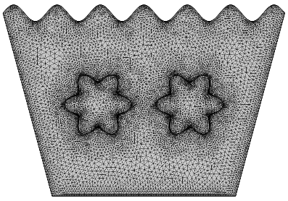 | 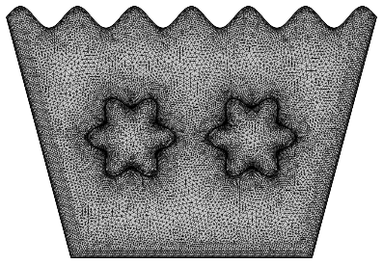 | 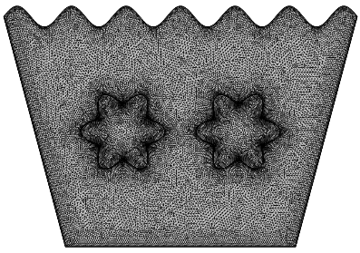
a. Star Obstacle
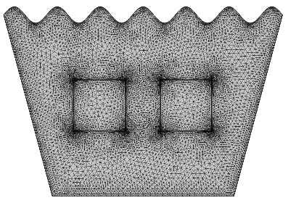 | 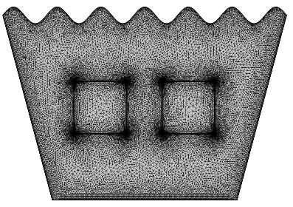 | 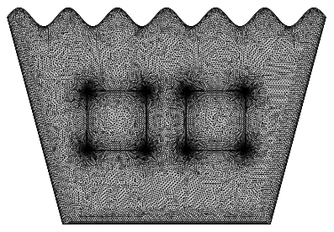
b. Square Obstacle
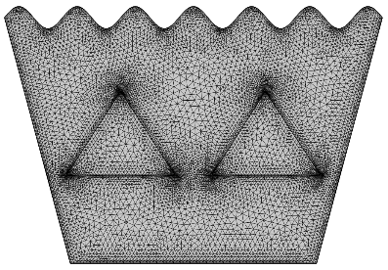 | 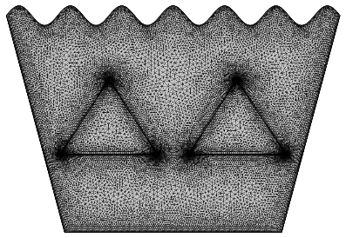 | 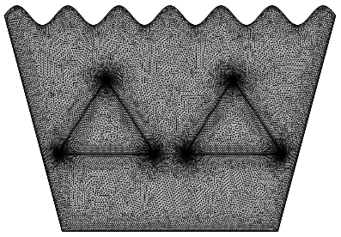
c. Triangle Obstacle
Fig. 2 Mesh Distribution for Different Grids
The quantitative comparison of mesh effects is summarized in Table 2, which lists the average Nusselt number (Nu) for different mesh types at Pr = 5.856, Ra = 10⁶, ɸ = 0.02, Ha = 0, and λ = 45°. As the number of elements increases from 17,210 (Fine) to 47,733 (Extremely Fine), the variation in Nu becomes negligible, with only a 0.0013% deviation between the two finest grids. This confirms that the Extra Fine mesh (39,587 elements) is sufficient for achieving mesh independence while maintaining computational efficiency.

Table 2. Nu at Heated Solid Surface when Pr = 5.856, Ra = 10⁶, ɸ = 0.02, Ha=0, λ=45⁰ for different grid sizes.

Mesh Type | Elements | Nu | Deviation from Previous
Fine | 17210 | 6.5016 | —
Extra Fine | 39587 | 6.5769 | 0.0753
Extremely Fine | 47733 | 6.5782 | 0.0013

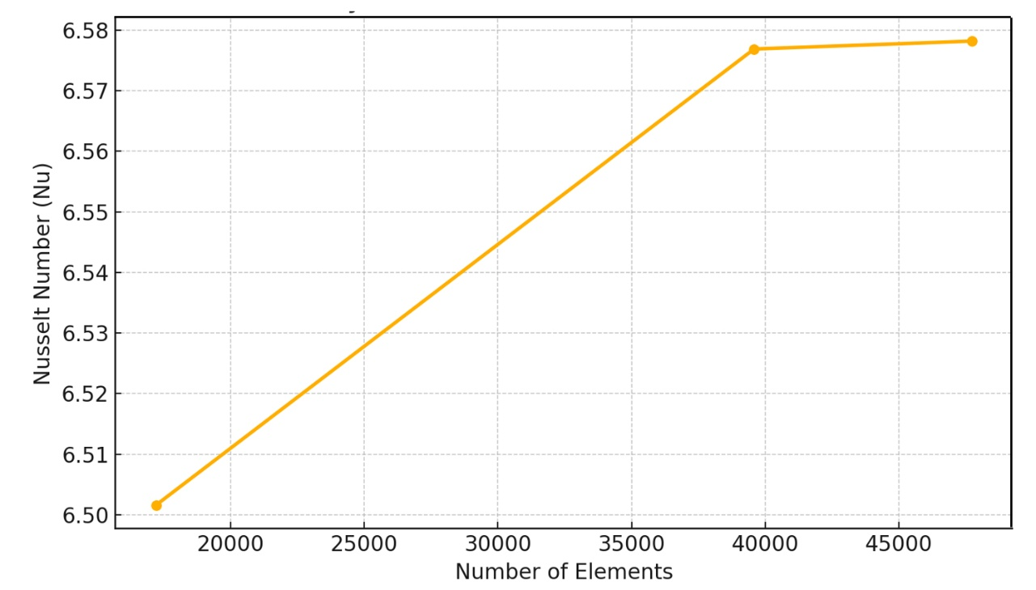
Fig 3. Grid Sensitivity Check plot

The grid sensitivity trend is further illustrated in Figure 3, where the Nusselt number increases slightly with mesh refinement and then stabilizes, confirming convergence. The near-horizontal slope at higher element counts validates that additional refinement has an insignificant impact on the solution, indicating strong numerical stability.

The accuracy of the present numerical model was validated by comparing it with the benchmark results of Abdelmalek et al. [17]. As shown in Figure 4(a), the isotherm contours for Ra = 10⁴, A = 0.15, and ϕ=0.02 exhibit strong agreement in terms of temperature distribution and thermal boundary layer structure around the star-shaped obstacle. The present results show smoother and more symmetric isotherms due to a refined mesh and improved numerical formulation. To further strengthen the validation, Table 3 provides a quantitative comparison of average Nusselt numbers over a wide range of Rayleigh numbers (10³ to 10⁶), revealing deviations of less than 1.5%. These outcomes confirm that the FEM-based model is accurate, stable, and reliable for analyzing natural convection of Cu–H₂O nanofluids in wavy-top trapezoidal cavities with internal obstacles under MHD effects.

Abdelmalek et al. [17] | Present Work
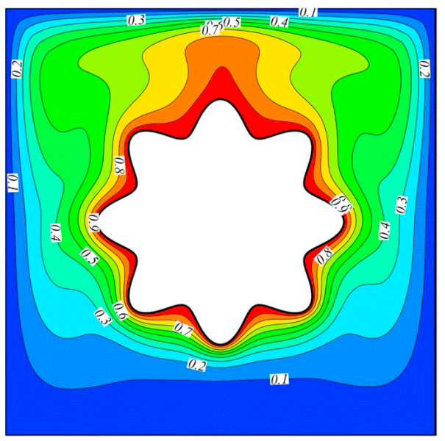 | 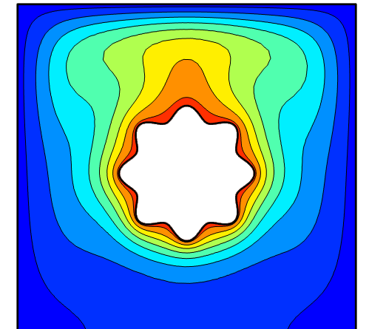
Figure 4(a). Comparison of Isotherms when Ra=10^{4,} N = 8, A = 0.15, ϕ = 0.02

Table 3: Comparison of Nu Between Present Work and [17]
Ra | Nanoparticle Volume Fraction (ϕ) | Present Study | Abdelmalek et al. [17] | Deviation (%)
10³ | 0.02 | 1.1470 | 1.1307 | 1.44
10⁴ | 0.02 | 2.2944 | 2.2674 | 1.19
10⁵ | 0.02 | 4.6379 | 4.5851 | 1.15
10⁶ | 0.02 | 8.9586 | 8.8341 | 1.41

Mahmud et al. [39] | Present Work
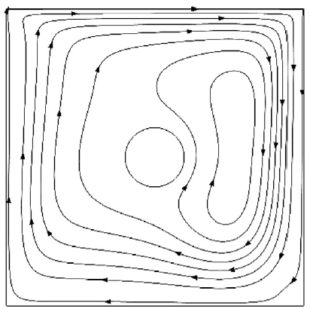 | 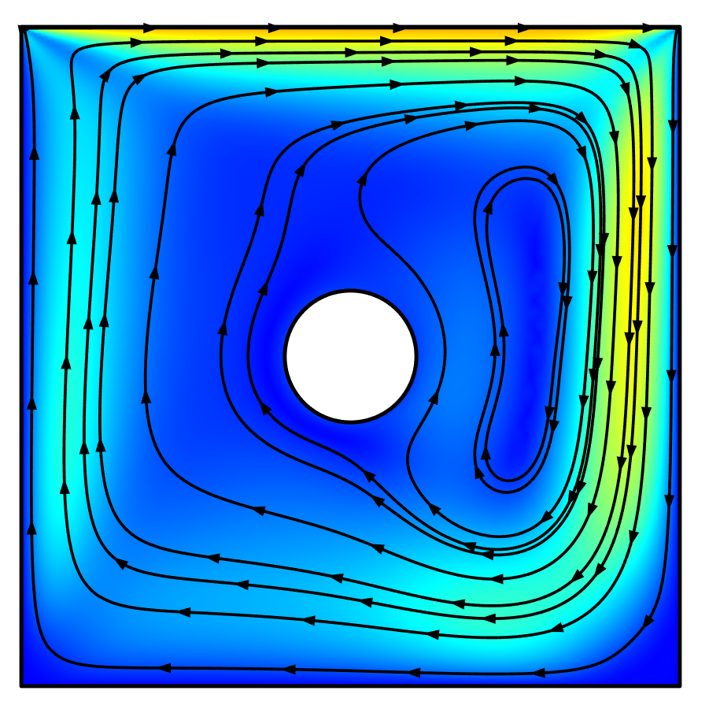
Figure 4(b). Comparison of the Streamline in the present study and the Ref. [39]
when Re_{c} =2(CCW), Ri=10, Gr=10⁵

To further ensure the reliability and accuracy of the numerical model, an additional validation was performed against the benchmark results of Mahmud et al. [39], who studied conjugate mixed convection in a lid-driven cavity containing a rotating solid cylinder. As shown in Figure 14, the streamline patterns from the present simulation closely match the reference results for $Re_{c}=2$, $Ri=10$, and $Gr={10}^{5}$, demonstrating similar vortex structures and flow circulation behavior. This strong agreement verifies the precision and stability of the current finite element formulation, enhancing confidence in the adopted numerical scheme for modeling MHD-assisted Cu–H₂O nanofluid convection.

4.0 Results and Discussion

This section analyzes natural convection heat transfer in a wavy-top trapezoidal cavity filled with Cu–H₂O nanofluid containing star, square, and triangular obstacles. Simulations were conducted for Ha = 0–50, Ra = 10⁴–10⁶, and ɸ = 0.02–0.06 to examine the combined effects of magnetic field, buoyancy, and nanoparticle concentration. The study focuses on the average Nusselt number (Nu) for heat transfer, entropy generation (RT) for system irreversibility, and the Ecological Coefficient of Performance (ECOP) for overall efficiency. Results demonstrate that obstacle geometry and magnetic intensity have a strong influence on flow circulation, temperature gradients, and energy performance. The findings highlight how geometric configuration, inclination, and nanofluid properties collectively govern the transition between conduction- and convection-dominated regimes, establishing design guidance for efficient thermal management using Cu–H₂O nanofluids.

Table 4: Nu, R_{T}, and ECOP for Star Obstacle with the Variation of Ha & Ra at λ =15⁰ & ɸ=0.02
Ha | Ra | Nu | Entropy (R_{T}) | ECOP
0 | 10 ⁴ | 2.5581 | 0.63853 | 4.0063
0 | 10 ⁵ | 3.7556 | 0.021177 | 177.34
0 | 10 ⁶ | 5.7976 | 0.0014877 | 3896.9
30 | 10 ⁴ | 2.5533 | 0.63759 | 4.0046
30 | 10 ⁵ | 3.4447 | 0.02057 | 167.46
30 | 10 ⁶ | 5.22 | 0.0014758 | 3537.20
50 | 10 ⁴ | 2.5524 | 0.63742 | 4.0043
50 | 10 ⁵ | 3.3369 | 0.02036 | 163.90
50 | 10 ⁶ | 4.7166 | 0.0014654 | 3218.60

Table 5: Nu, R_{T}, and ECOP for Star Obstacle with the Variation of Ha & Ra at λ =30⁰ & ɸ=0.02
Ha | Ra | Nu | Entropy (R_{T}) | ECOP
0 | 10 ⁴ | 2.5573 | 0.63838 | 4.006
0 | 10 ⁵ | 3.7274 | 0.021122 | 176.47
0 | 10 ⁶ | 5.916 | 0.0014865 | 3979.8
30 | 10 ⁴ | 2.5531 | 0.63755 | 4.0045
30 | 10 ⁵ | 3.4249 | 0.020532 | 166.81
30 | 10 ⁶ | 5.1574 | 0.0014728 | 3501.70
50 | 10 ⁴ | 2.5523 | 0.6374 | 4.0043
50 | 10 ⁵ | 3.3284 | 0.020343 | 163.61
50 | 10 ⁶ | 4.6587 | 0.0014633 | 3183.80

Table 6: Nu, R_{T}, and ECOP for Star Obstacle with the Variation of Ha & Ra at λ =45⁰ & ɸ=0.02
Ha | Ra | Nu | Entropy (R_{T}) | ECOP
0 | 10 ⁴ | 2.5563 | 0.63818 | 4.0056
0 | 10 ⁵ | 3.6784 | 0.021027 | 174.94
0 | 10 ⁶ | 6.0049 | 0.0014847 | 4044.60
30 | 10 ⁴ | 2.5528 | 0.6375 | 4.0044
30 | 10 ⁵ | 3.3946 | 0.020472 | 165.81
30 | 10 ⁶ | 5.0656 | 0.001469 | 3448.40
50 | 10 ⁴ | 2.5522 | 0.63739 | 4.0042
50 | 10 ⁵ | 3.3161 | 0.020319 | 163.20
50 | 10 ⁶ | 4.5454 | 0.0014599 | 3113.60

Table 7: Nu, R_{T}, and ECOP for Star Obstacle with the Variation of Ha & Ra at λ =15⁰ & ɸ=0.04
Ha | Ra | Nu | Entropy (R_{T}) | ECOP
0 | 10 ⁴ | 2.6702 | 0.66041 | 4.0433
0 | 10 ⁵ | 3.8863 | 0.021433 | 181.32
0 | 10 ⁶ | 5.9757 | 0.0014926 | 4003.5
30 | 10 ⁴ | 2.6666 | 0.6597 | 4.0421
30 | 10 ⁵ | 3.6033 | 0.02088 | 172.57
30 | 10 ⁶ | 5.3486 | 0.0014795 | 3615.1
50 | 10 ⁴ | 2.6659 | 0.65957 | 4.0419
50 | 10 ⁵ | 3.5139 | 0.020705 | 169.71
50 | 10 ⁶ | 4.819 | 0.0014688 | 3280.8

Table 8: Nu, R_{T}, and ECOP for Star Obstacle with the Variation of Ha & Ra at λ =30⁰ & ɸ=0.04
Ha | Ra | Nu | Entropy (R_{T}) | ECOP
0 | 10 ⁴ | 2.6697 | 0.6603 | 4.0431
0 | 10 ⁵ | 3.8582 | 0.021378 | 180.47
0 | 10 ⁶ | 6.0493 | 0.0014914 | 4056.1
30 | 10 ⁴ | 2.6664 | 0.65967 | 4.0421
30 | 10 ⁵ | 3.5861 | 0.020847 | 172.02
30 | 10 ⁶ | 5.2857 | 0.0014771 | 3578.4
50 | 10 ⁴ | 2.6659 | 0.65956 | 4.0419
50 | 10 ⁵ | 3.507 | 0.020692 | 169.49
50 | 10 ⁶ | 4.7595 | 0.0014669 | 3244.5

Table 9: Nu, R_{T}, and ECOP for Star Obstacle with the Variation of Ha & Ra at λ =45⁰ & ɸ=0.04
Ha | Ra | Nu | Entropy (R_{T}) | ECOP
0 | 10 ⁴ | 2.6689 | 0.66015 | 4.0429
0 | 10 ⁵ | 3.8108 | 0.021285 | 179.03
0 | 10 ⁶ | 6.1339 | 0.0014898 | 4117.2
30 | 10 ⁴ | 2.6662 | 0.65963 | 4.042
30 | 10 ⁵ | 3.5603 | 0.020796 | 171.2
30 | 10 ⁶ | 5.1824 | 0.0014736 | 3516.9
50 | 10 ⁴ | 2.6658 | 0.65955 | 4.0419
50 | 10 ⁵ | 3.4973 | 0.020673 | 169.17
50 | 10 ⁶ | 4.6464 | 0.0014639 | 3174.1

Table 10: Nu, R_{T}, and ECOP for Star Obstacle with the Variation of Ha & Ra at λ =15⁰ & ɸ=0.06
Ha | Ra | Nu | Entropy (R_{T}) | ECOP
0 | 10 ⁴ | 2.7841 | 0.68262 | 4.0786
0 | 10 ⁵ | 4.0262 | 0.021706 | 185.49
0 | 10 ⁶ | 6.1553 | 0.0014972 | 4111.3
30 | 10 ⁴ | 2.7814 | 0.68209 | 4.0777
30 | 10 ⁵ | 3.7739 | 0.021213 | 177.9
30 | 10 ⁶ | 5.4777 | 0.0014831 | 3693.5
50 | 10 ⁴ | 2.7809 | 0.68199 | 4.0776
50 | 10 ⁵ | 3.7008 | 0.021071 | 175.64
50 | 10 ⁶ | 4.9259 | 0.0014721 | 3346.1

Table 11: Nu, R_{T}, and ECOP for Star Obstacle with the Variation of Ha & Ra at λ =30⁰ & ɸ=0.06
Ha | Ra | Nu | Entropy (R_{T}) | ECOP
0 | 10 ⁴ | 2.7837 | 0.68254 | 4.0784
0 | 10 ⁵ | 3.9988 | 0.021653 | 184.68
0 | 10 ⁶ | 6.1876 | 0.0014959 | 4136.4
30 | 10 ⁴ | 2.7813 | 0.68207 | 4.0777
30 | 10 ⁵ | 3.7594 | 0.021185 | 177.45
30 | 10 ⁶ | 5.4143 | 0.001481 | 3655.7
50 | 10 ⁴ | 2.7808 | 0.68198 | 4.0776
50 | 10 ⁵ | 3.6954 | 0.02106 | 175.47
50 | 10 ⁶ | 4.8652 | 0.0014704 | 3308.8

Table 12: Nu, R_{T}, and ECOP for Star Obstacle with the Variation of Ha & Ra at λ =45⁰ & ɸ=0.06
Ha | Ra | Nu | Entropy (R_{T}) | ECOP
0 | 10 ⁴ | 2.7831 | 0.68243 | 4.0782
0 | 10 ⁵ | 3.9543 | 0.021565 | 183.36
0 | 10 ⁶ | 6.261 | 0.0014946 | 4189.1
30 | 10 ⁴ | 2.7811 | 0.68204 | 4.0776
30 | 10 ⁵ | 3.7379 | 0.021143 | 176.79
30 | 10 ⁶ | 5.3034 | 0.0014778 | 3588.7
50 | 10 ⁴ | 2.7808 | 0.68197 | 4.0775
50 | 10 ⁵ | 3.6877 | 0.021045 | 175.23
50 | 10 ⁶ | 4.7533 | 0.0014675 | 3239

Table 13: Nu, R_{T}, and ECOP for Square Obstacle with the Variation of Ha & Ra at λ =15⁰ & ɸ=0.02
Ha | Ra | Nu | Entropy (R_{T}) | ECOP
0 | 10 ⁴ | 2.6913 | 0.58966 | 4.5642
0 | 10 ⁵ | 3.9788 | 0.02063 | 192.86
0 | 10 ⁶ | 6.2373 | 0.0014931 | 4177.5
30 | 10 ⁴ | 2.6853 | 0.58871 | 4.5612
30 | 10 ⁵ | 3.6309 | 0.020053 | 181.07
30 | 10 ⁶ | 5.6553 | 0.0014826 | 3814.30
50 | 10 ⁴ | 2.684 | 0.58853 | 4.5605
50 | 10 ⁵ | 3.5065 | 0.019848 | 176.66
50 | 10 ⁶ | 5.1434 | 0.0014742 | 3488.90

Table 14: Nu, R_{T}, and ECOP for Square Obstacle with the Variation of Ha & Ra at λ =30⁰ & ɸ=0.02
Ha | Ra | Nu | Entropy (R_{T}) | ECOP
0 | 10 ⁴ | 2.6903 | 0.58951 | 4.5637
0 | 10 ⁵ | 3.9427 | 0.02057 | 191.67
0 | 10 ⁶ | 6.3086 | 0.0014918 | 4229.00
30 | 10 ⁴ | 2.685 | 0.58867 | 4.5611
30 | 10 ⁵ | 3.606 | 0.020012 | 180.19
30 | 10 ⁶ | 5.5697 | 0.0014795 | 3764.60
50 | 10 ⁴ | 2.6839 | 0.58852 | 4.5604
50 | 10 ⁵ | 3.4952 | 0.01983 | 176.26
50 | 10 ⁶ | 5.0505 | 0.0014719 | 3431.40

Table 15: Nu, R_{T}, and ECOP for Square Obstacle with the Variation of Ha & Ra at λ =45⁰ & ɸ=0.02
Ha | Ra | Nu | Entropy (R_{T}) | ECOP
0 | 10 ⁴ | 2.6889 | 0.5893 | 4.563
0 | 10 ⁵ | 3.8847 | 0.020474 | 189.74
0 | 10 ⁶ | 6.5016 | 0.0014903 | 4362.5
30 | 10 ⁴ | 2.6845 | 0.58861 | 4.5608
30 | 10 ⁵ | 3.5679 | 0.019949 | 178.85
30 | 10 ⁶ | 5.4486 | 0.0014756 | 3692.50
50 | 10 ⁴ | 2.6837 | 0.5885 | 4.56
50 | 10 ⁵ | 3.4789 | 0.019803 | 175.67
50 | 10 ⁶ | 4.8921 | 0.0014682 | 3332.10

Table 16: Nu, R_{T}, and ECOP for Square Obstacle with the Variation of Ha & Ra at λ =15⁰ & ɸ=0.04
Ha | Ra | Nu | Entropy (R_{T}) | ECOP
0 | 10 ⁴ | 2.8096 | 0.6094 | 4.6105
0 | 10 ⁵ | 4.113 | 0.020855 | 197.22
0 | 10 ⁶ | 6.4204 | 0.0014975 | 4287.50
30 | 10 ⁴ | 2.805 | 0.60868 | 4.6083
30 | 10 ⁵ | 3.7935 | 0.020325 | 186.64
30 | 10 ⁶ | 5.7865 | 0.0014862 | 3893.60
50 | 10 ⁴ | 2.804 | 0.60855 | 4.6077
50 | 10 ⁵ | 3.6896 | 0.020154 | 183.07
50 | 10 ⁶ | 5.242 | 0.0014774 | 3548.20

Table 17: Nu, R_{T}, and ECOP for Square Obstacle with the Variation of Ha & Ra at λ =30⁰ & ɸ=0.04
Ha | Ra | Nu | Entropy (R_{T}) | ECOP
0 | 10 ⁴ | 2.8089 | 0.60928 | 4.6101
0 | 10 ⁵ | 4.0772 | 0.020796 | 196.06
0 | 10 ⁶ | 6.4601 | 0.001496 | 4318.20
30 | 10 ⁴ | 2.8047 | 0.60865 | 4.6082
30 | 10 ⁵ | 3.7719 | 0.020289 | 185.90
30 | 10 ⁶ | 5.6986 | 0.0014836 | 3841.10
50 | 10 ⁴ | 2.8039 | 0.60854 | 4.6076
50 | 10 ⁵ | 3.6805 | 0.02014 | 182.75
50 | 10 ⁶ | 5.1487 | 0.0014753 | 3490.00

Table 18: Nu, R_{T}, and ECOP for Square Obstacle with the Variation of Ha & Ra at λ =45⁰ & ɸ=0.04
Ha | Ra | Nu | Entropy (R_{T}) | ECOP
0 | 10 ⁴ | 2.8078 | 0.60913 | 4.6096
0 | 10 ⁵ | 4.0206 | 0.020702 | 194.21
0 | 10 ⁶ | 6.6302 | 0.0014952 | 4434.30
30 | 10 ⁴ | 2.8044 | 0.6086 | 4.6079
30 | 10 ⁵ | 3.7394 | 0.020236 | 184.79
30 | 10 ⁶ | 5.5641 | 0.00148 | 3759.5
50 | 10 ⁴ | 2.8038 | 0.60852 | 4.6075
50 | 10 ⁵ | 3.6675 | 0.020118 | 182.30
50 | 10 ⁶ | 4.991 | 0.001472 | 3390.70

Table 19: Nu, R_{T}, and ECOP for Square Obstacle with the Variation of Ha & Ra at λ =15⁰ & ɸ=0.06
Ha | Ra | Nu | Entropy (R_{T}) | ECOP
0 | 10 ⁴ | 2.9299 | 0.62945 | 4.6546
0 | 10 ⁵ | 4.2564 | 0.021095 | 201.78
0 | 10 ⁶ | 6.6043 | 0.0015016 | 4398.10
30 | 10 ⁴ | 2.9263 | 0.62891 | 4.65
30 | 10 ⁵ | 3.9692 | 0.020619 | 192.50
30 | 10 ⁶ | 5.9163 | 0.0014895 | 3972.10
50 | 10 ⁴ | 2.9255 | 0.62881 | 4.6525
50 | 10 ⁵ | 3.8836 | 0.020479 | 189.64
50 | 10 ⁶ | 5.343 | 0.0014803 | 3609.30

Table 20: Nu, R_{T}, and ECOP for Square Obstacle with the Variation of Ha & Ra at λ =30⁰ & ɸ=0.06
Ha | Ra | Nu | Entropy (R_{T}) | ECOP
0 | 10 ⁴ | 2.9293 | 0.62937 | 4.6543
0 | 10 ⁵ | 4.2218 | 0.021037 | 200.68
0 | 10 ⁶ | 6.615 | 0.0015001 | 4409.50
30 | 10 ⁴ | 2.9261 | 0.62889 | 4.6529
30 | 10 ⁵ | 3.9508 | 0.020589 | 191.89
30 | 10 ⁶ | 5.8267 | 0.0014873 | 3917.60
50 | 10 ⁴ | 2.9255 | 0.6288 | 4.6525
50 | 10 ⁵ | 3.8764 | 0.020467 | 189.40
50 | 10 ⁶ | 5.2503 | 0.0014785 | 3551.20

Table 21: Nu, R_{T}, and ECOP for Square Obstacle with the Variation of Ha & Ra at λ =45⁰ & ɸ=0.06
Ha | Ra | Nu | Entropy (R_{T}) | ECOP
0 | 10 ⁴ | 2.9285 | 0.62925 | 4.6539
0 | 10 ⁵ | 4.1679 | 0.020948 | 198.96
0 | 10 ⁶ | 6.756 | 0.0014996 | 4505.10
30 | 10 ⁴ | 2.9259 | 0.62885 | 4.6527
30 | 10 ⁵ | 3.9237 | 0.020544 | 190.99
30 | 10 ⁶ | 5.6832 | 0.001484 | 3829.5
50 | 10 ⁴ | 2.9254 | 0.62879 | 4.6524
50 | 10 ⁵ | 3.8661 | 0.02045 | 189.05
50 | 10 ⁶ | 5.0946 | 0.0014754 | 3453.10

Table 22: Nu, R_{T}, and ECOP for Triangle Obstacle with the Variation of Ha & Ra at λ =15⁰ & ɸ=0.02
Ha | Ra | Nu | Entropy (R_{T}) | ECOP
0 | 10 ⁴ | 2.9106 | 0.71807 | 4.0534
0 | 10 ⁵ | 4.2103 | 0.022264 | 189.11
0 | 10 ⁶ | 6.3746 | 0.0015057 | 4233.7
30 | 10 ⁴ | 2.9094 | 0.71788 | 4.0527
30 | 10 ⁵ | 4.0332 | 0.021925 | 183.95
30 | 10 ⁶ | 5.6317 | 0.0014934 | 3771
50 | 10 ⁴ | 2.909 | 0.71784 | 4.0525
50 | 10 ⁵ | 3.9932 | 0.021849 | 182.77
50 | 10 ⁶ | 5.0893 | 0.0014825 | 3433

Table 23: Nu, R_{T}, and ECOP for Triangle Obstacle with the Variation of Ha & Ra at λ =30⁰ & ɸ=0.02
Ha | Ra | Nu | Entropy (R_{T}) | ECOP
0 | 10 ⁴ | 2.9107 | 0.7181 | 4.0534
0 | 10 ⁵ | 4.2444 | 0.022329 | 190.08
0 | 10 ⁶ | 6.4336 | 0.0015064 | 4270.8
30 | 10 ⁴ | 2.9093 | 0.71787 | 4.0527
30 | 10 ⁵ | 4.0301 | 0.021919 | 183.86
30 | 10 ⁶ | 5.6355 | 0.0014927 | 3775.3
50 | 10 ⁴ | 2.909 | 0.71783 | 4.0524
50 | 10 ⁵ | 3.9908 | 0.021844 | 182.69
50 | 10 ⁶ | 5.062 | 0.0014813 | 3417.3

Table 24: Nu, R_{T}, and ECOP for Triangle Obstacle with the Variation of Ha & Ra at λ =45⁰ & ɸ=0.02
Ha | Ra | Nu | Entropy (R_{T}) | ECOP
0 | 10 ⁴ | 2.9108 | 0.71813 | 4.0533
0 | 10 ⁵ | 4.2493 | 0.022339 | 190.22
0 | 10 ⁶ | 6.4137 | 0.0015053 | 4260.8
30 | 10 ⁴ | 2.9092 | 0.71787 | 4.0526
30 | 10 ⁵ | 4.0242 | 0.021907 | 183.69
30 | 10 ⁶ | 5.5577 | 0.0014901 | 3729.7
50 | 10 ⁴ | 2.9089 | 0.71783 | 4.0524
50 | 10 ⁵ | 3.9872 | 0.021837 | 182.59
50 | 10 ⁶ | 4.9866 | 0.0014786 | 3372.5

Table 25: Nu, R_{T}, and ECOP for Triangle Obstacle with the Variation of Ha & Ra at λ =15⁰ & ɸ=0.04
Ha | Ra | Nu | Entropy (R_{T}) | ECOP
0 | 10 ⁴ | 3.0307 | 0.7419 | 4.0851
0 | 10 ⁵ | 4.3888 | 0.022621 | 194.01
0 | 10 ⁶ | 6.5766 | 0.001511 | 4352.4
30 | 10 ⁴ | 3.0297 | 0.74176 | 4.0845
30 | 10 ⁵ | 4.2472 | 0.022351 | 190.02
30 | 10 ⁶ | 5.7908 | 0.0014975 | 3867
50 | 10 ⁴ | 3.0294 | 0.74173 | 4.0843
50 | 10 ⁵ | 4.2158 | 0.022292 | 189.12
50 | 10 ⁶ | 5.2233 | 0.0014861 | 3514.9

Table 26: Nu, R_{T}, and ECOP for Triangle Obstacle with the Variation of Ha & Ra at λ =30⁰ & ɸ=0.04
Ha | Ra | Nu | Entropy (R_{T}) | ECOP
0 | 10 ⁴ | 3.0308 | 0.74192 | 4.085
0 | 10 ⁵ | 4.4205 | 0.022682 | 194.89
0 | 10 ⁶ | 6.6342 | 0.0015117 | 4388.6
30 | 10 ⁴ | 3.0297 | 0.74176 | 4.0844
30 | 10 ⁵ | 4.2444 | 0.022346 | 189.94
30 | 10 ⁶ | 5.7875 | 0.0014968 | 3866.6
50 | 10 ⁴ | 3.0294 | 0.74173 | 4.0843
50 | 10 ⁵ | 4.2138 | 0.022288 | 189.06
50 | 10 ⁶ | 5.2026 | 0.001485 | 3503.4

Table 27: Nu, R_{T}, and ECOP for Triangle Obstacle with the Variation of Ha & Ra at λ =45⁰ & ɸ=0.04
Ha | Ra | Nu | Entropy (R_{T}) | ECOP
0 | 10 ⁴ | 3.0308 | 0.74195 | 4.0849
0 | 10 ⁵ | 4.4293 | 0.0227 | 195.13
0 | 10 ⁶ | 6.5967 | 0.0015107 | 4366.7
30 | 10 ⁴ | 3.0296 | 0.74175 | 4.0844
30 | 10 ⁵ | 4.2395 | 0.022336 | 189.8
30 | 10 ⁶ | 5.7103 | 0.0014944 | 3821.1
50 | 10 ⁴ | 3.0294 | 0.74173 | 4.0842
50 | 10 ⁵ | 4.211 | 0.022282 | 188.98
50 | 10 ⁶ | 5.1307 | 0.0014825 | 3460.9

Table 28: Nu, R_{T}, and ECOP for Triangle Obstacle with the Variation of Ha & Ra at λ =15⁰ & ɸ=0.06
Ha | Ra | Nu | Entropy (R_{T}) | ECOP
0 | 10 ⁴ | 3.1516 | 0.76589 | 4.115
0 | 10 ⁵ | 4.5842 | 0.023012 | 199.21
0 | 10 ⁶ | 6.778 | 0.0015162 | 4470.5
30 | 10 ⁴ | 3.1508 | 0.76579 | 4.1145
30 | 10 ⁵ | 4.4727 | 0.0228 | 196.17
30 | 10 ⁶ | 5.9472 | 0.0015014 | 3961.1
50 | 10 ⁴ | 3.1506 | 0.76576 | 4.1143
50 | 10 ⁵ | 4.448 | 0.022754 | 195.49
50 | 10 ⁶ | 5.371 | 0.0014898 | 3605.2

Table 29: Nu, R_{T}, and ECOP for Triangle Obstacle with the Variation of Ha & Ra at λ =30⁰ & ɸ=0.06
Ha | Ra | Nu | Entropy (R_{T}) | ECOP
0 | 10 ⁴ | 3.1516 | 0.7659 | 4.1149
0 | 10 ⁵ | 4.6117 | 0.023065 | 199.94
0 | 10 ⁶ | 6.8338 | 0.0015168 | 4505.4
30 | 10 ⁴ | 3.1508 | 0.76578 | 4.1145
30 | 10 ⁵ | 4.4702 | 0.022795 | 196.1
30 | 10 ⁶ | 5.9414 | 0.0015007 | 3959
50 | 10 ⁴ | 3.1506 | 0.76576 | 4.1143
50 | 10 ⁵ | 4.4465 | 0.022751 | 195.44
50 | 10 ⁶ | 5.3536 | 0.0014888 | 3595.9

Table 30: Nu, R_{T}, and ECOP for Triangle Obstacle with the Variation of Ha & Ra at λ =45⁰ & ɸ=0.06
Ha | Ra | Nu | Entropy (R_{T}) | ECOP
0 | 10 ⁴ | 3.1517 | 0.76592 | 4.1149
0 | 10 ⁵ | 4.6226 | 0.023086 | 200.23
0 | 10 ⁶ | 6.7859 | 0.0015158 | 4476.8
30 | 10 ⁴ | 3.1507 | 0.76578 | 4.1144
30 | 10 ⁵ | 4.4662 | 0.022788 | 195.99
30 | 10 ⁶ | 5.8653 | 0.0014985 | 3914.2
50 | 10 ⁴ | 3.1505 | 0.76576 | 4.1143
50 | 10 ⁵ | 4.4442 | 0.022746 | 195.38
50 | 10 ⁶ | 5.2866 | 0.0014865 | 3556.5

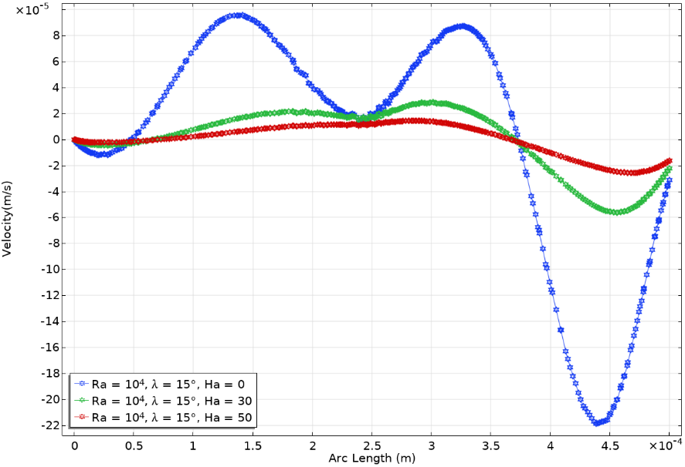
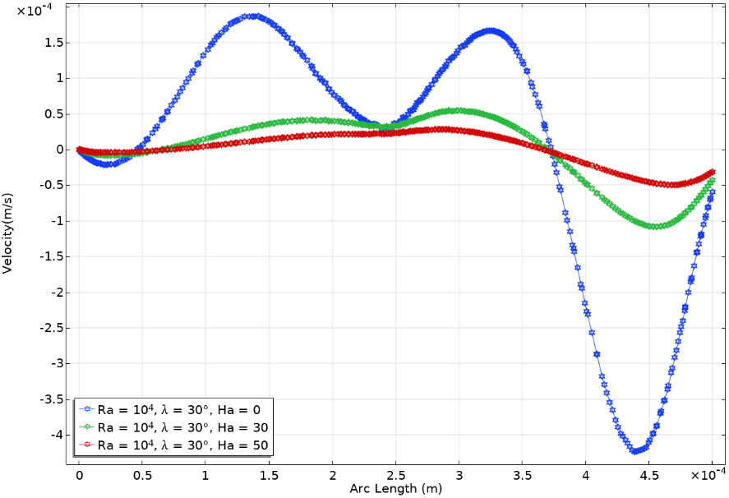
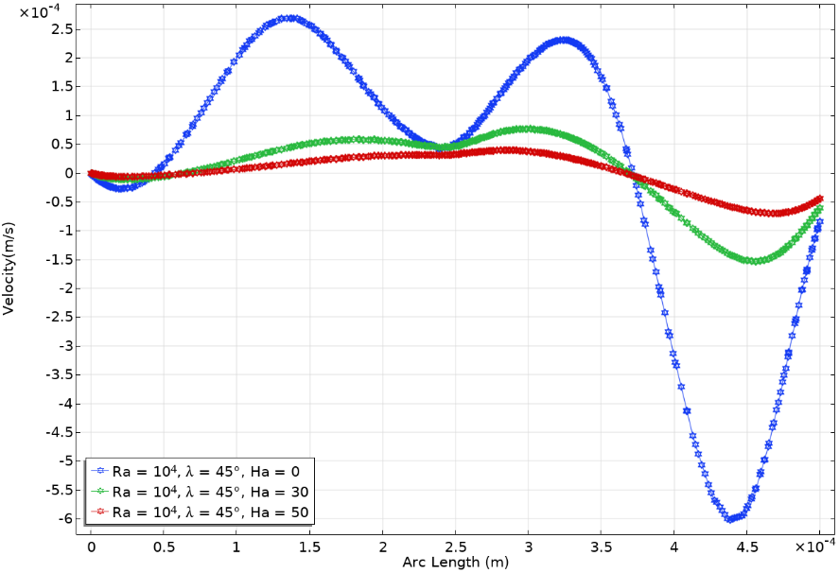
Fig 5. Velocity Profile for Star Obstacle for Different $λ$and Ha when Ra=10⁴

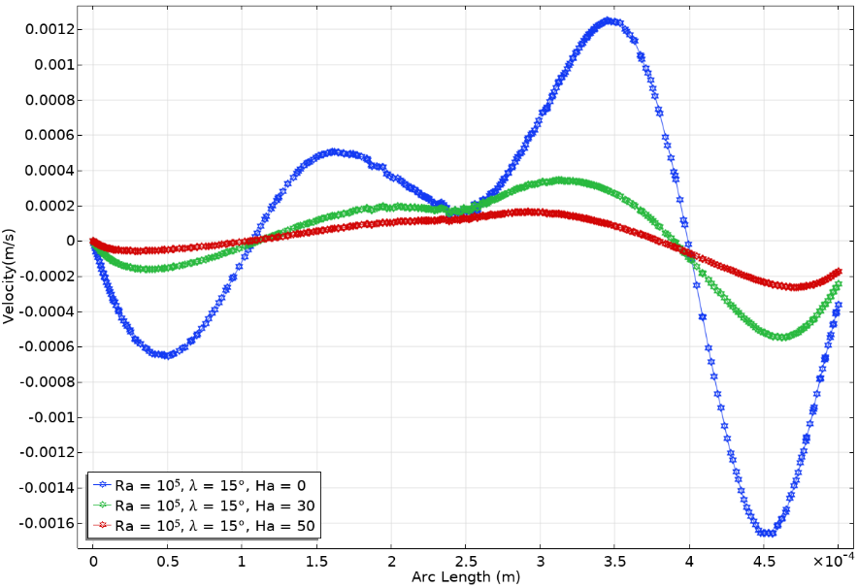
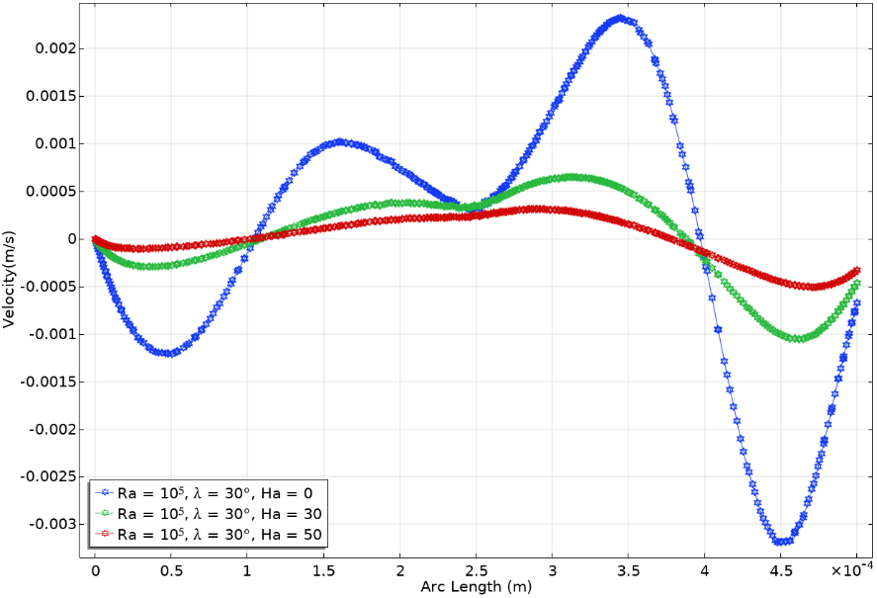
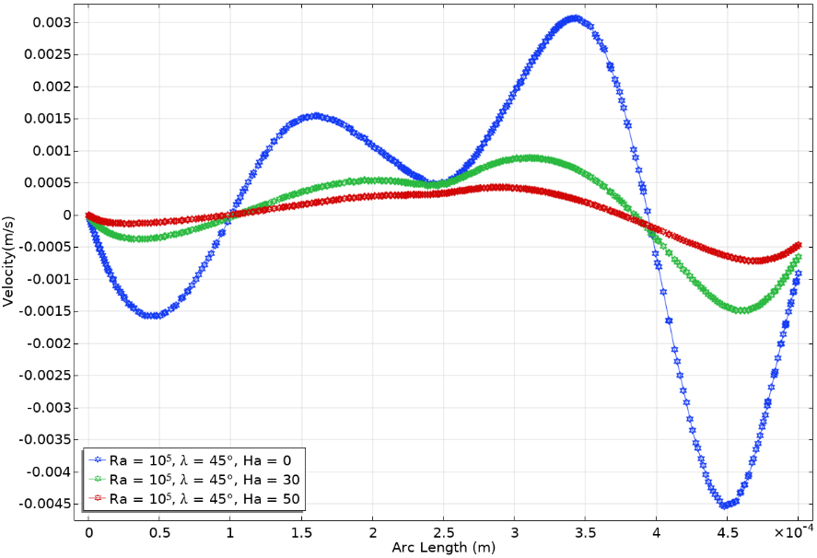
Fig 6. Velocity Profile for Star Obstacle for Different $λ$and Ha when Ra=10⁵

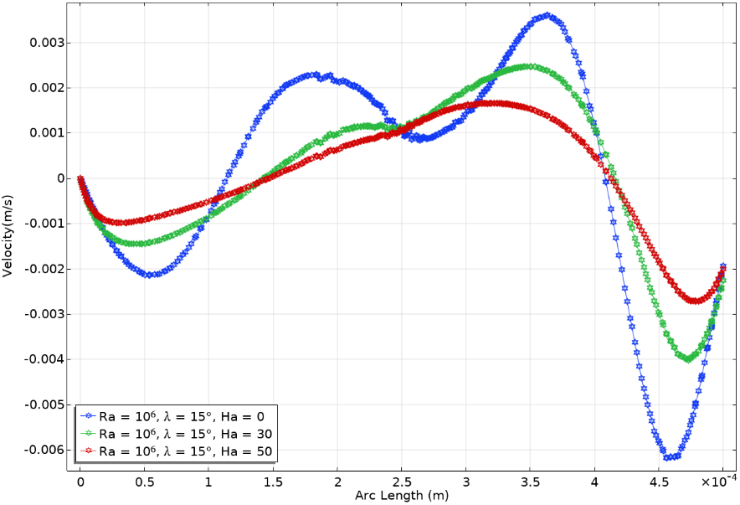
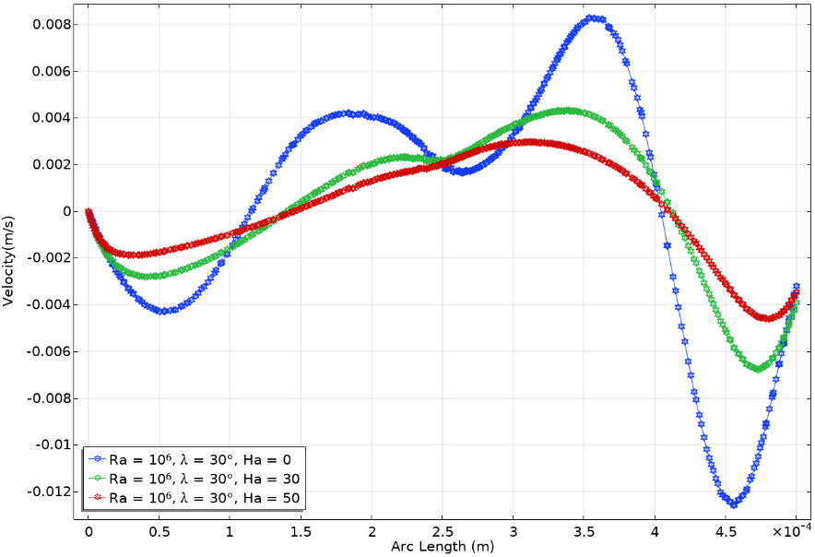
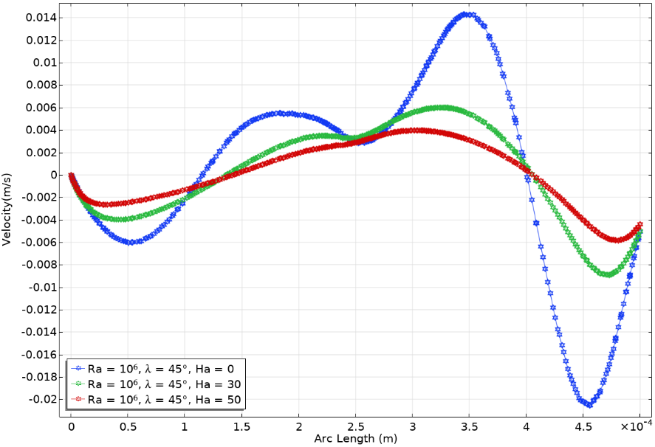
Fig 7. Velocity Profile for Star Obstacle for Different $λ$and Ha when Ra=10⁶

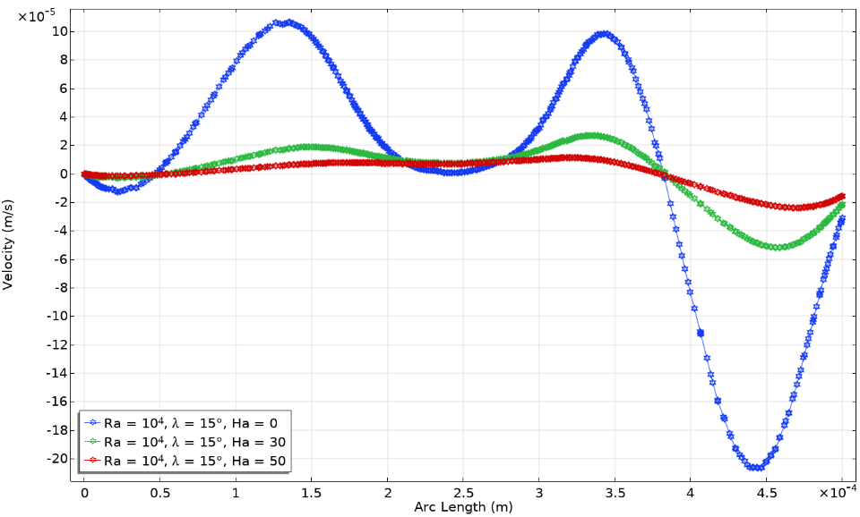
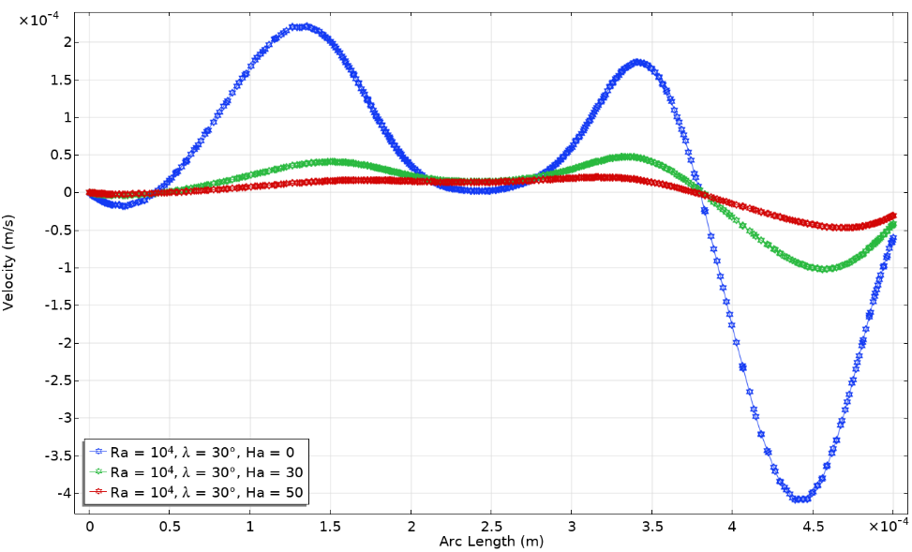
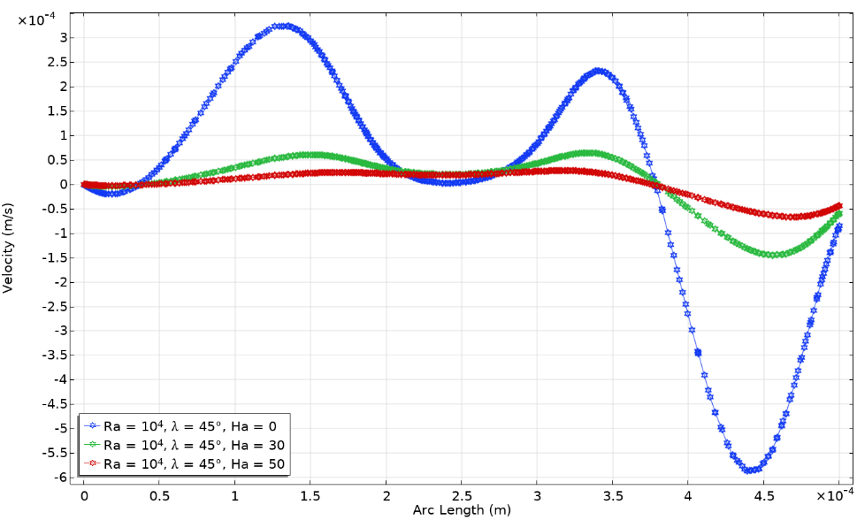
Fig 8. Velocity Profile for Square Obstacle for Different $λ$and Ha when Ra=10⁴

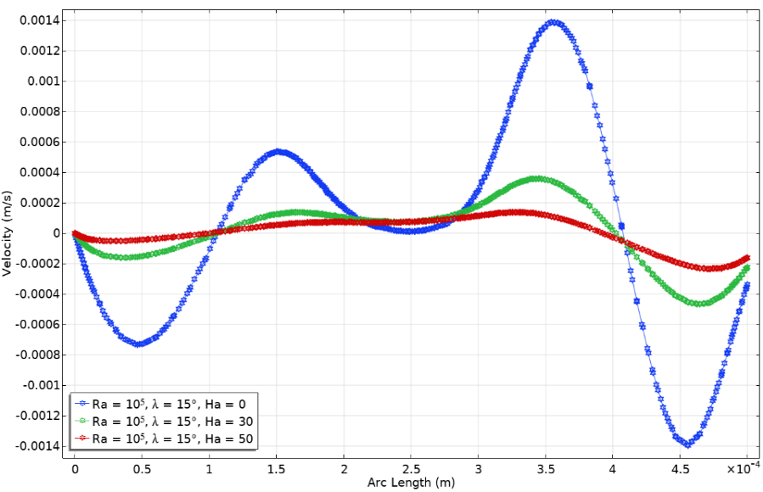
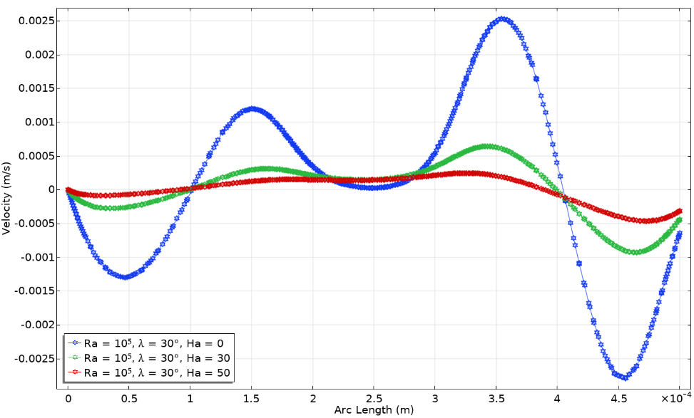
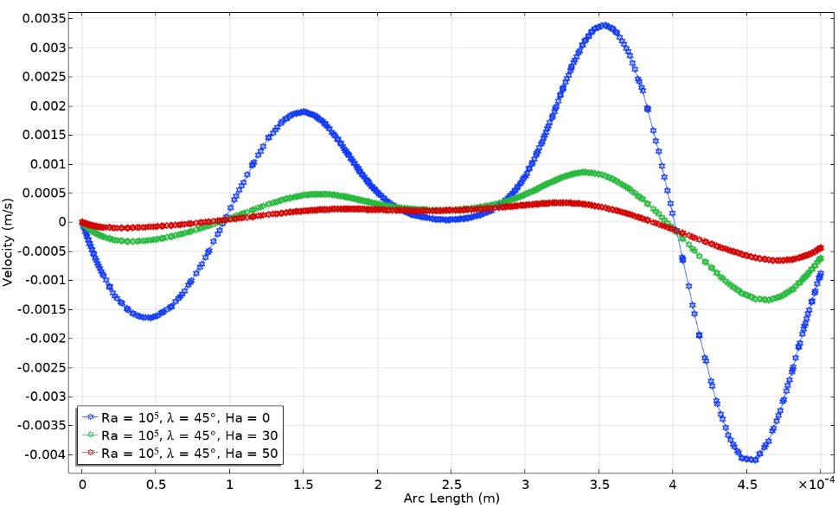
Fig 9. Velocity Profile for Square Obstacle for Different $λ$and Ha when Ra=10⁵

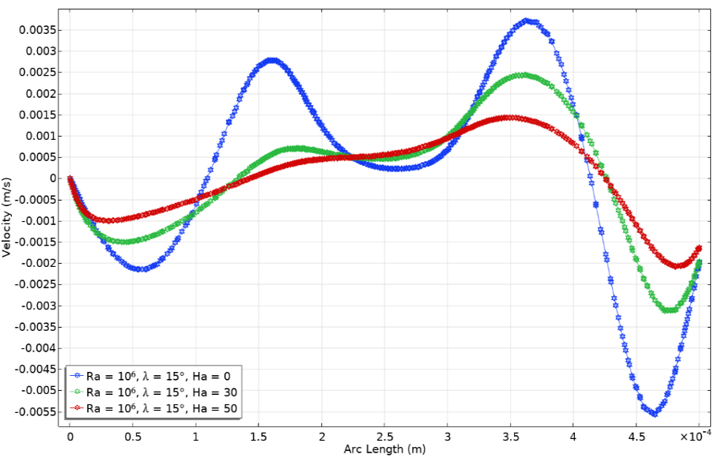
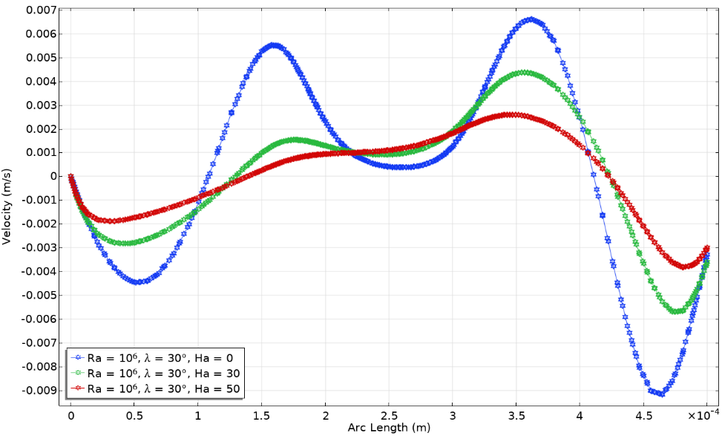
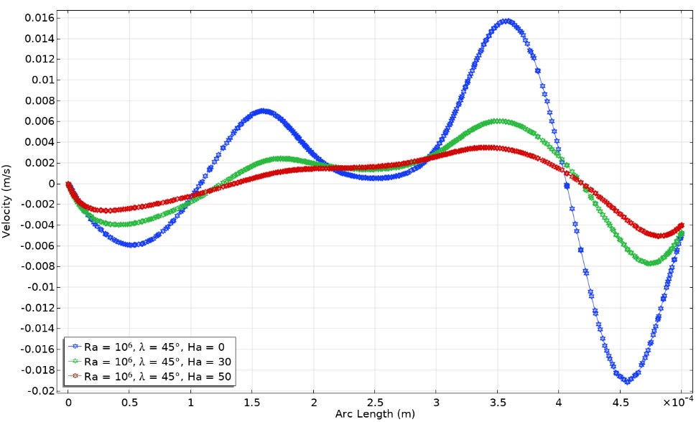
Fig 10. Velocity Profile for Square Obstacle for Different $λ$and Ha when Ra=10⁶

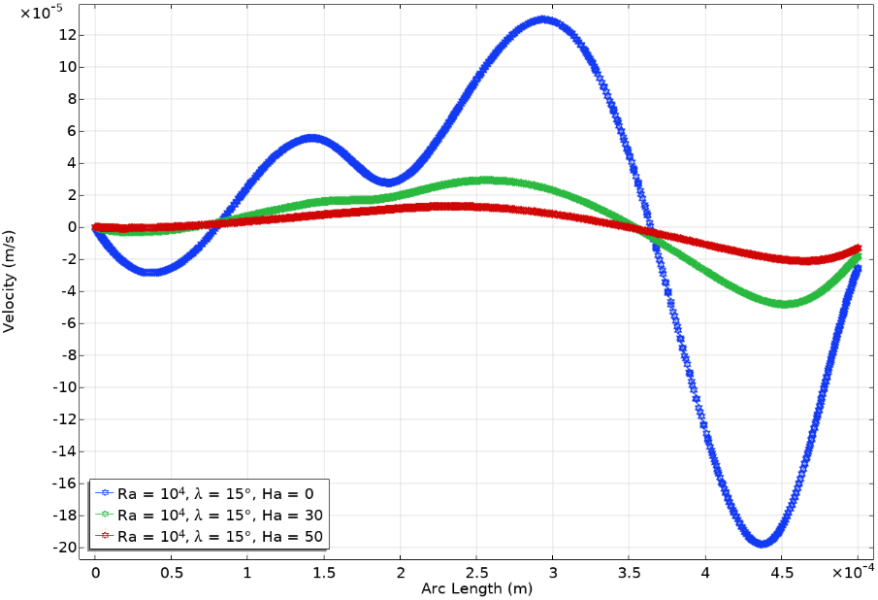
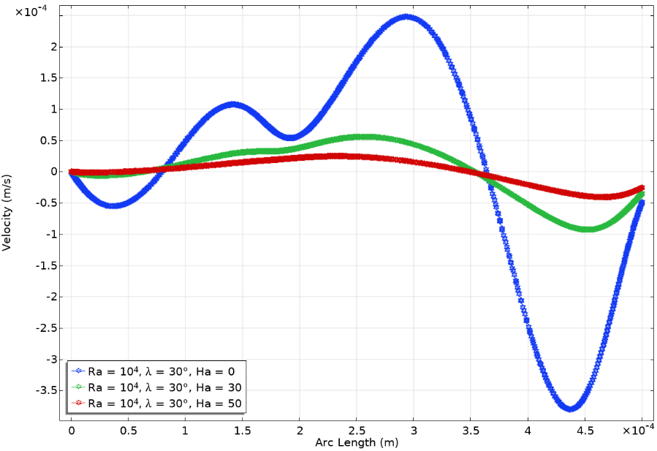
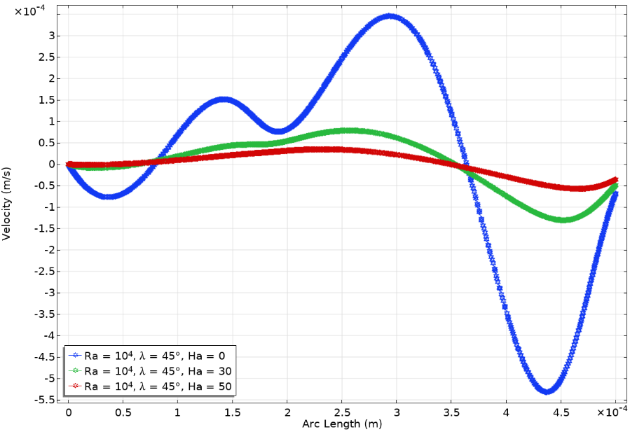
Fig 11. Velocity Profile for Triangle Obstacle for Different $λ$and Ha when Ra=10⁴

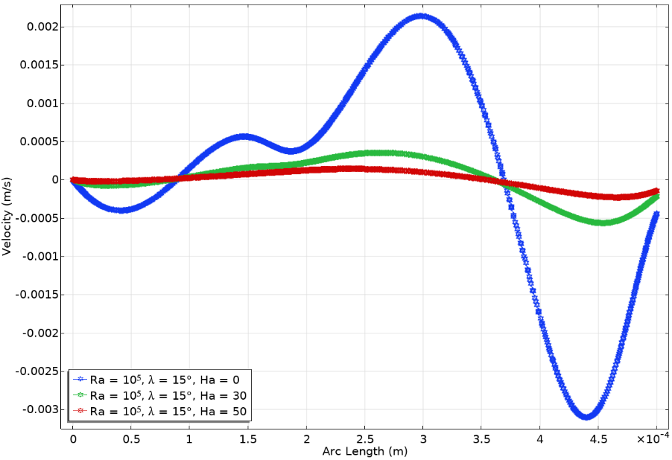
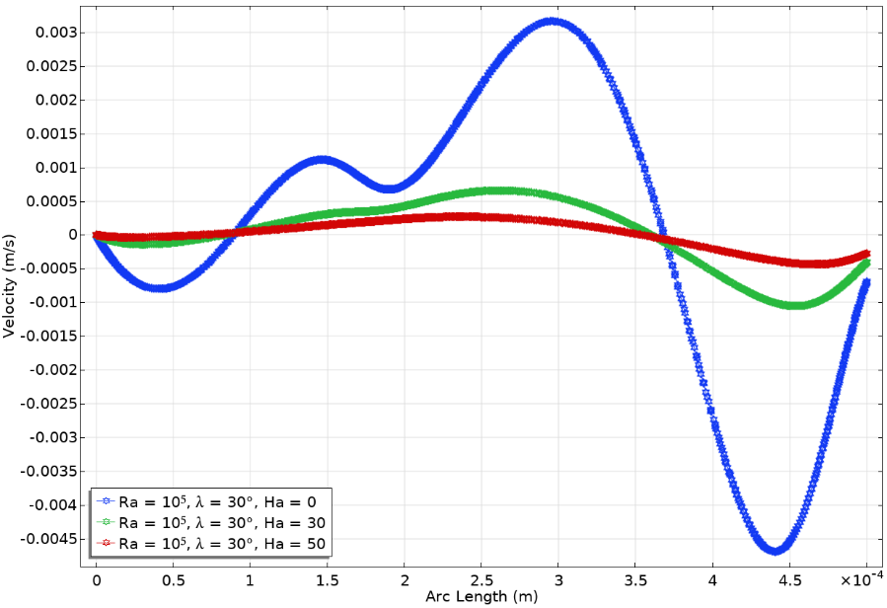
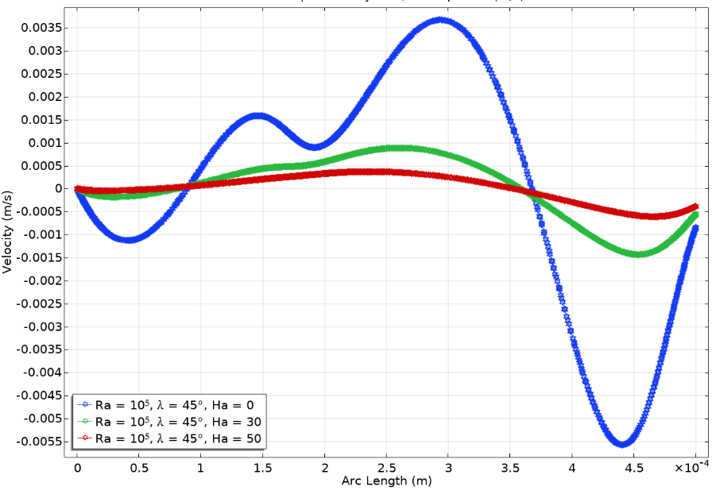
Fig 12. Velocity Profile for Triangle Obstacle for Different $λ$and Ha when Ra=10⁵

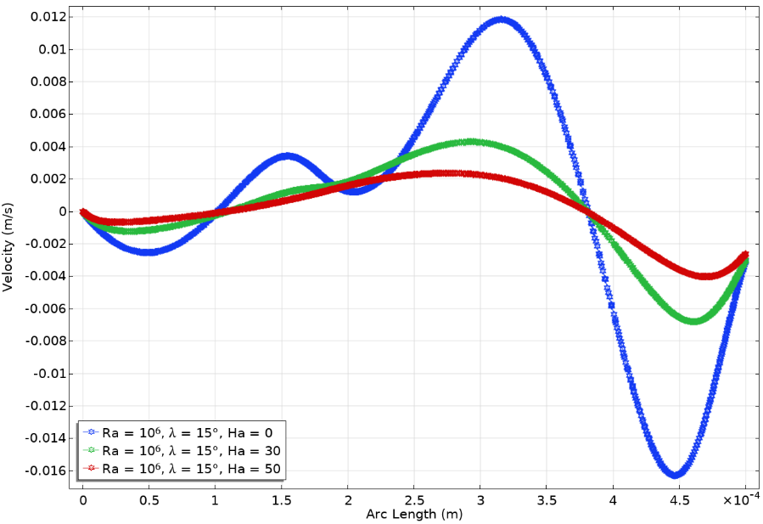
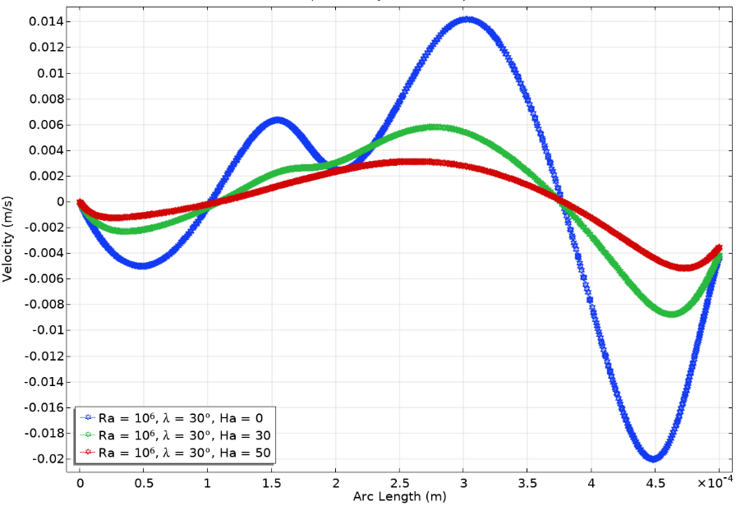
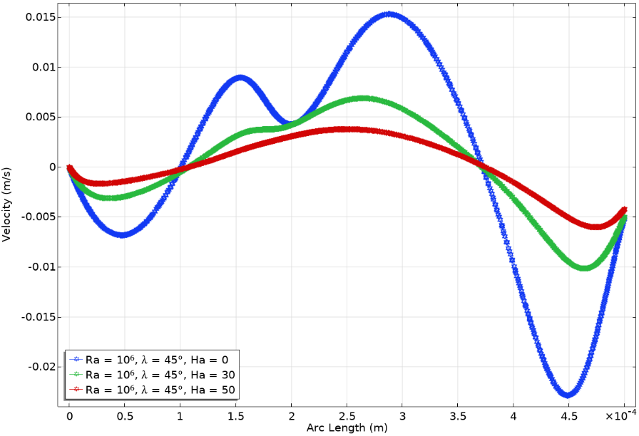
Fig 13. Velocity Profile for Triangle Obstacle for Different $λ$and Ha when Ra=10⁶

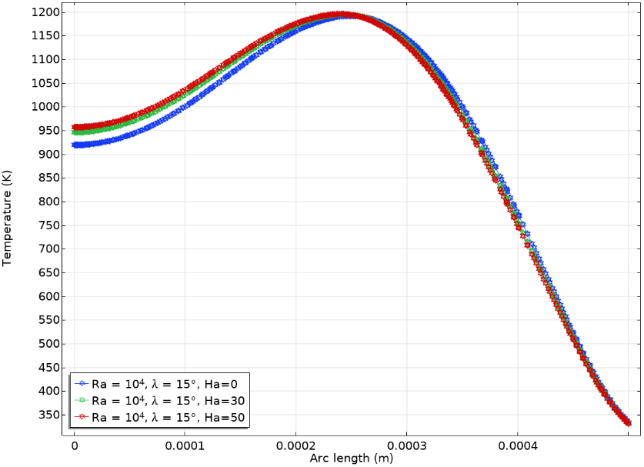
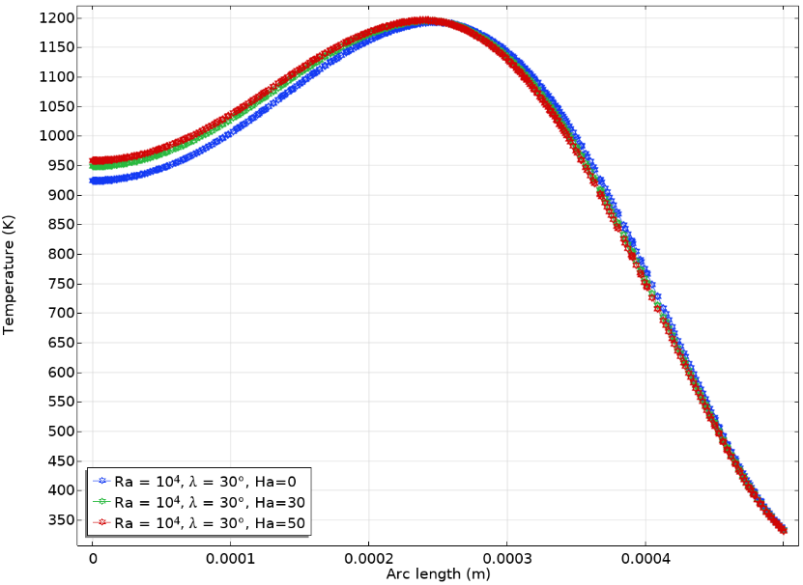
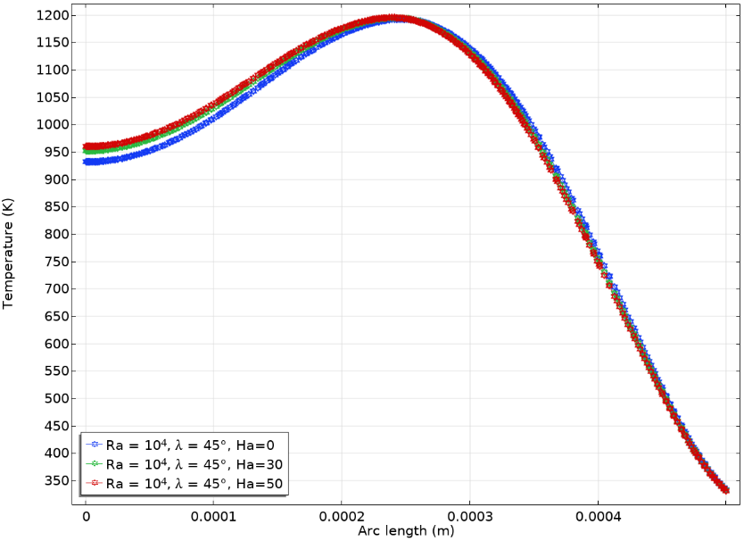
Fig 14. Temperature Profile for Star Obstacle for Different $λ$and Ha when Ra=10⁴

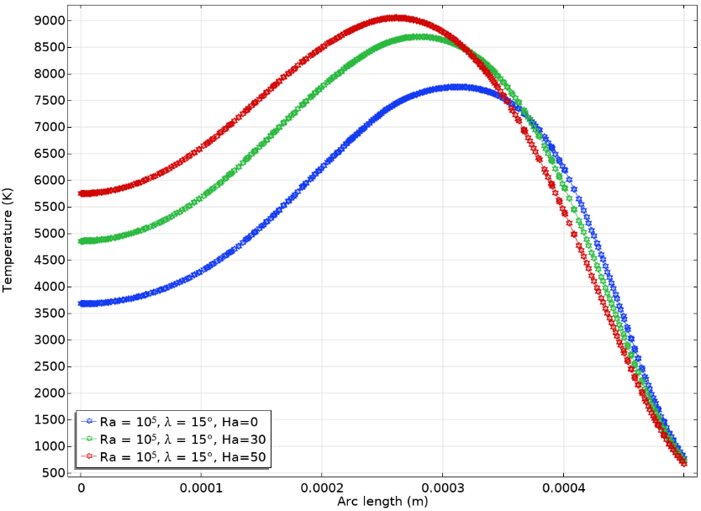
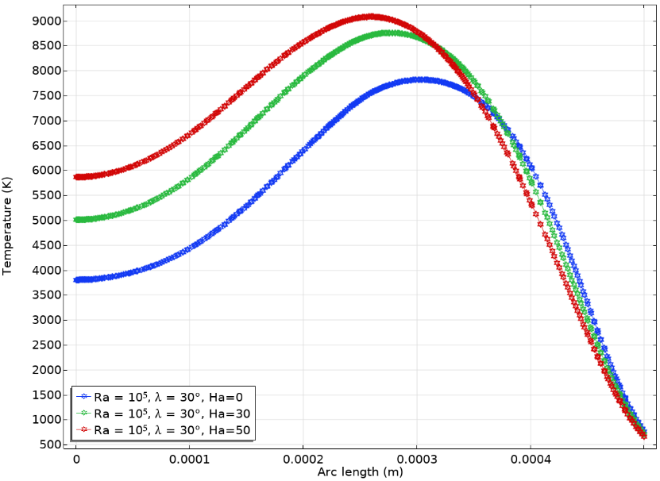
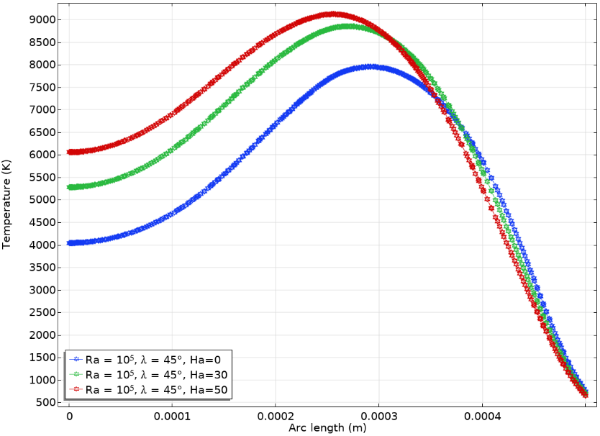
Fig 15. Temperature Profile for Star Obstacle for Different $λ$and Ha when Ra=10⁵

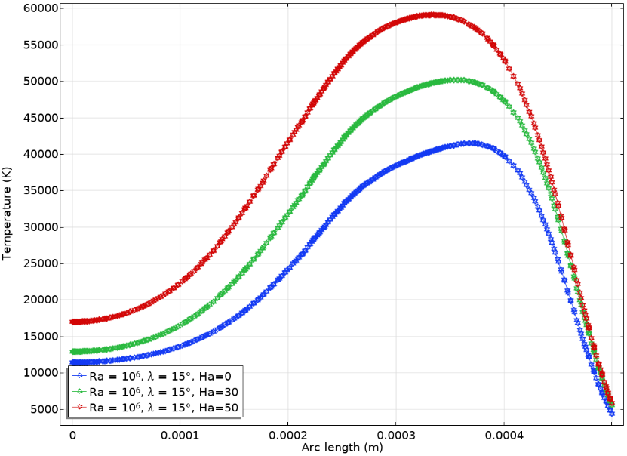
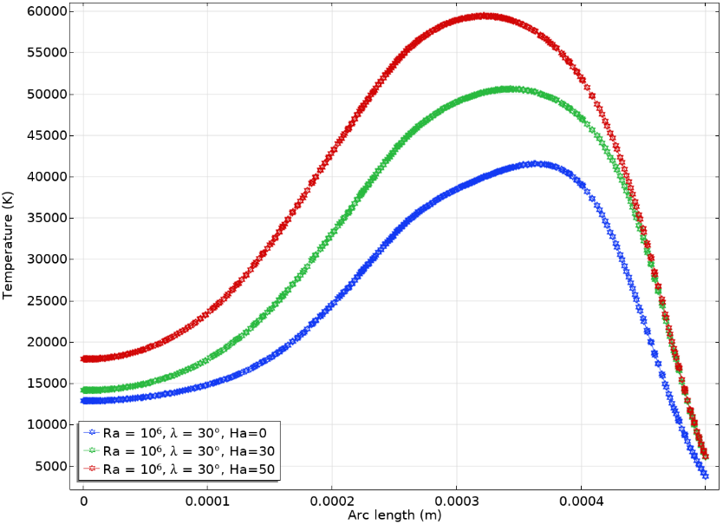
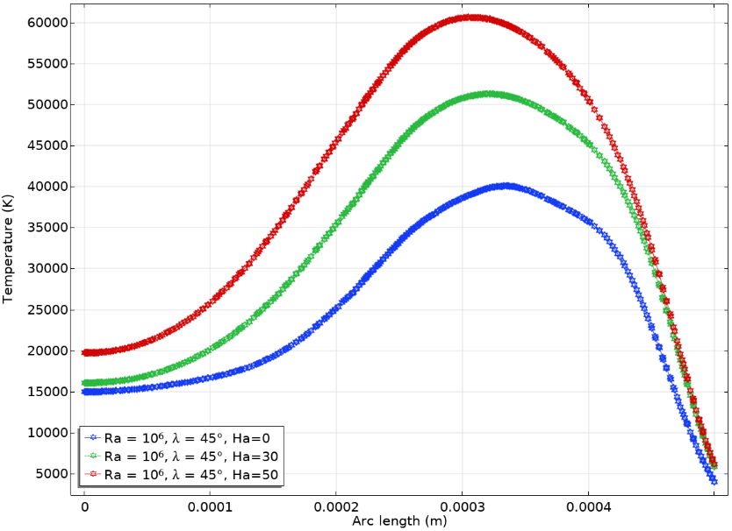
Fig 16. Temperature Profile for Star Obstacle for Different $λ$and Ha when Ra=10⁶

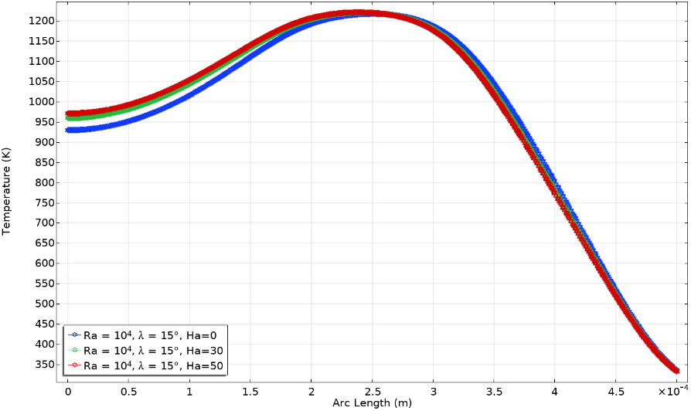
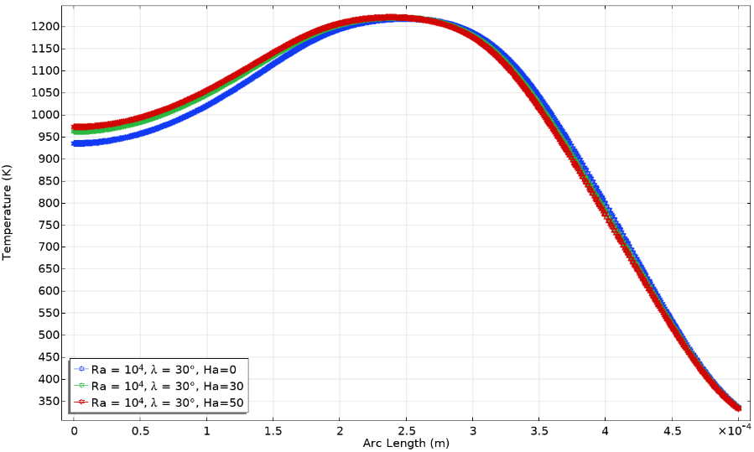
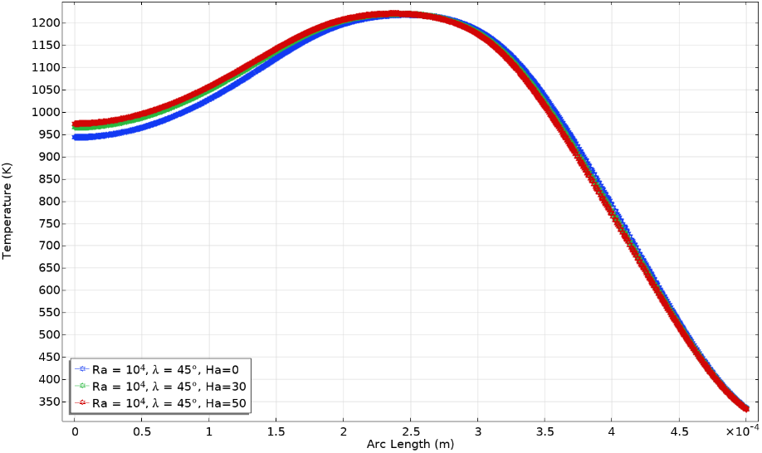
Fig 17. Temperature Profile for Square Obstacle for Different $λ$and Ha when Ra=10⁴

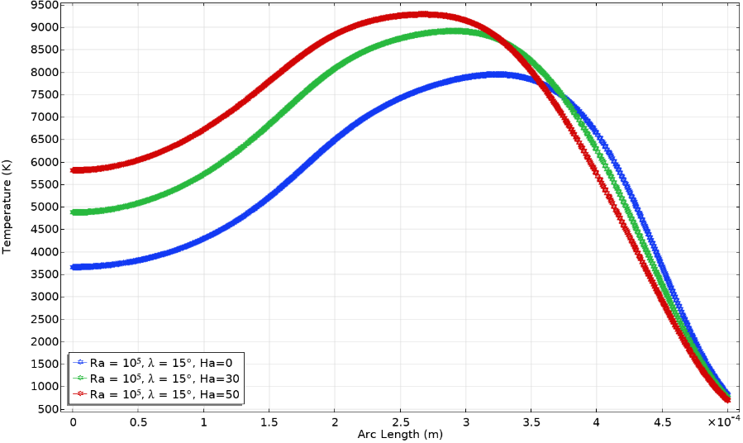
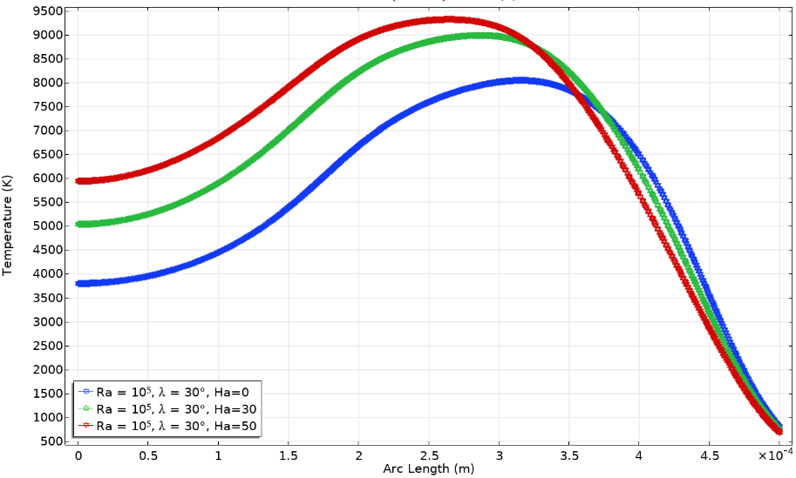
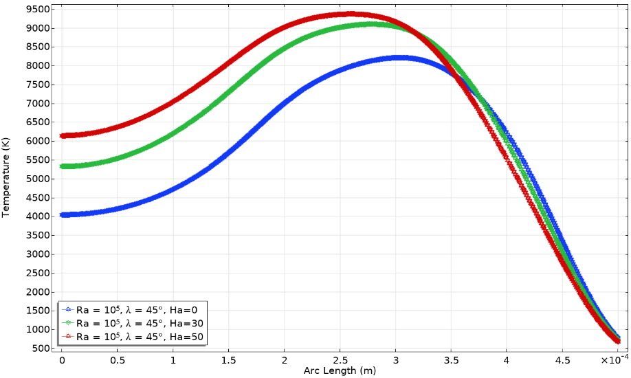
Fig 18. Temperature Profile for Square Obstacle for Different $λ$and Ha when Ra=10⁵

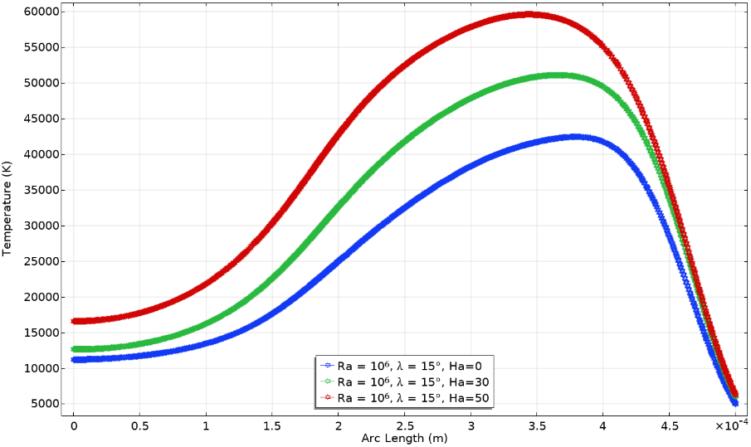
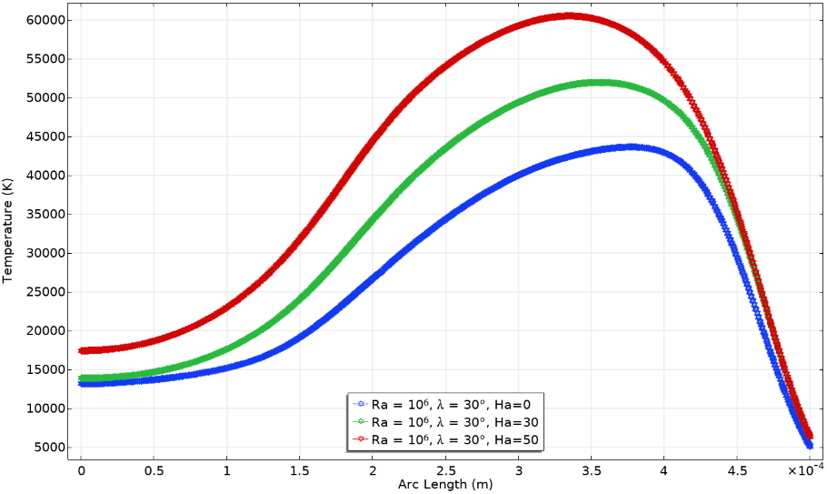
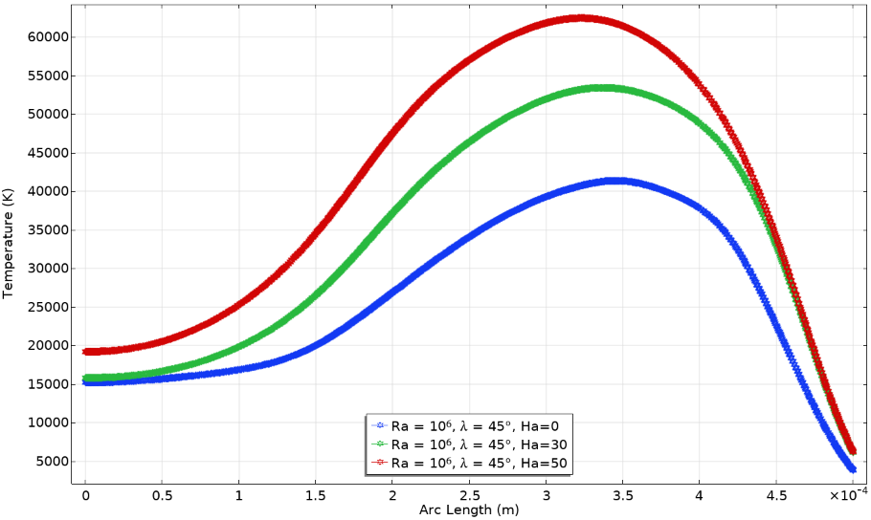
Fig 19. Temperature Profile for Square Obstacle for Different $λ$and Ha when Ra=10⁶

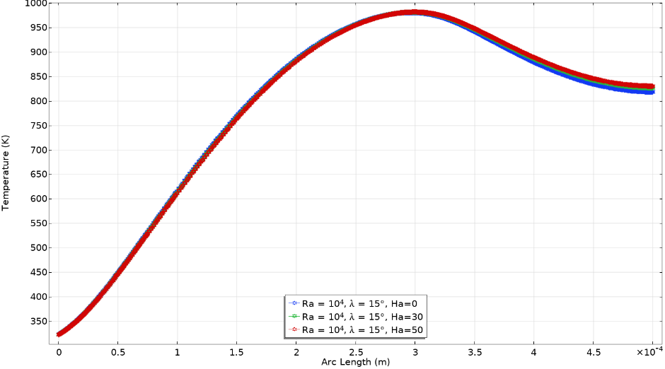
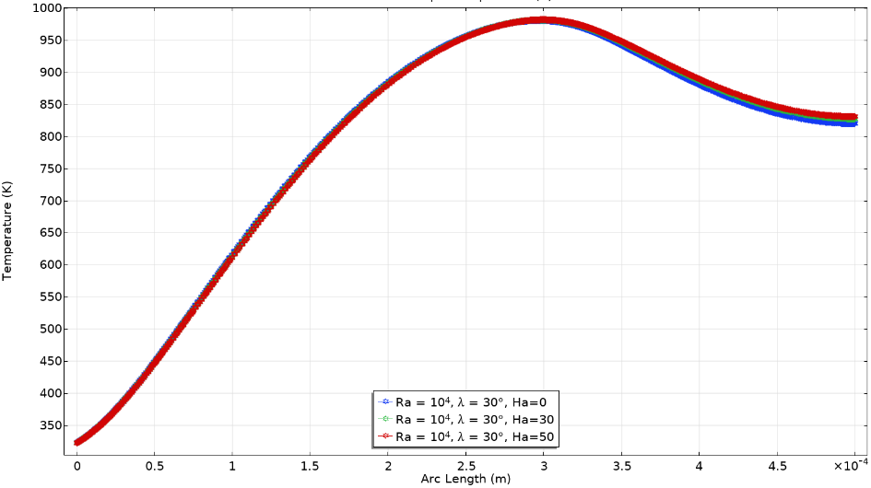
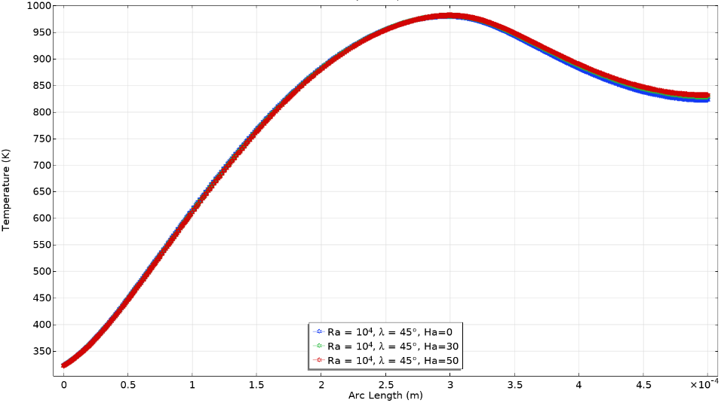
Fig 20. Temperature Profile for Triangle Obstacle for Different $λ$and Ha when Ra=10⁴

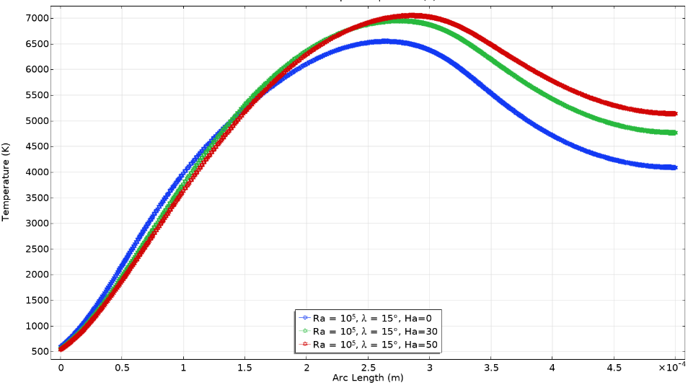
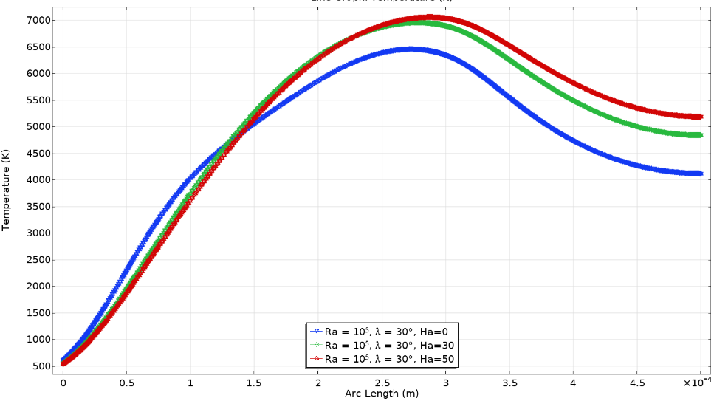
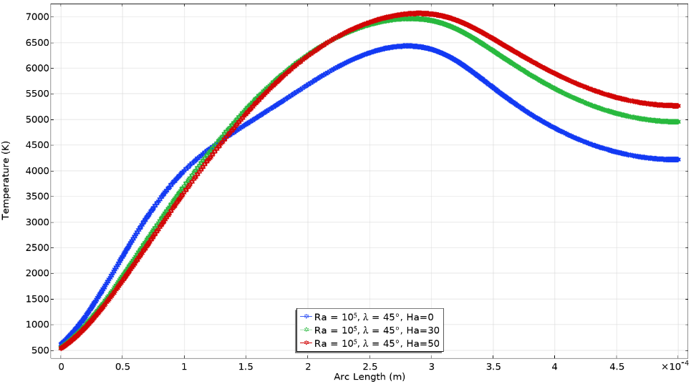
Fig 21. Temperature Profile for Triangle Obstacle for Different $λ$and Ha when Ra=10⁵

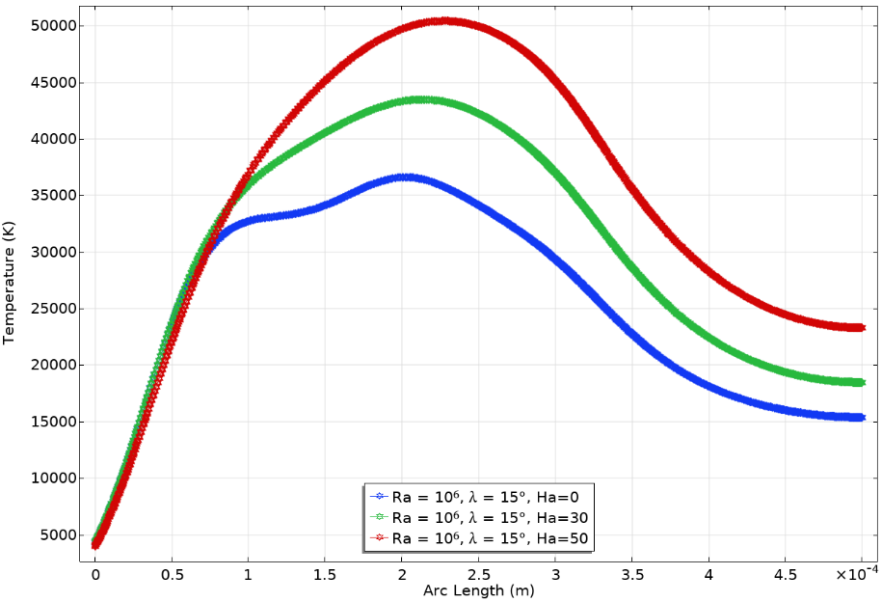
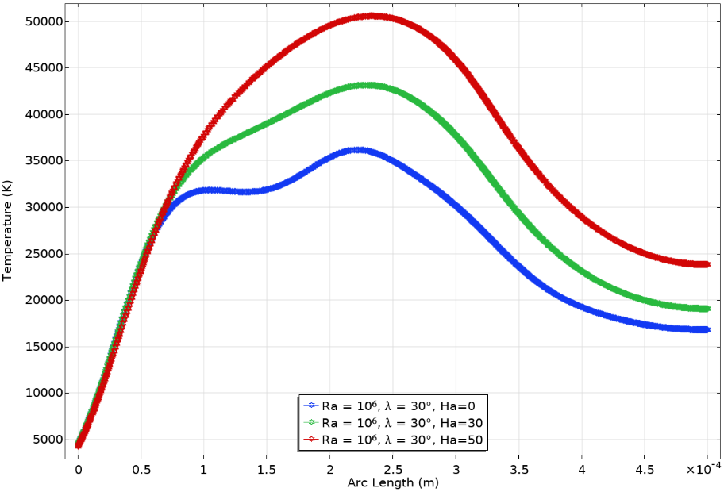
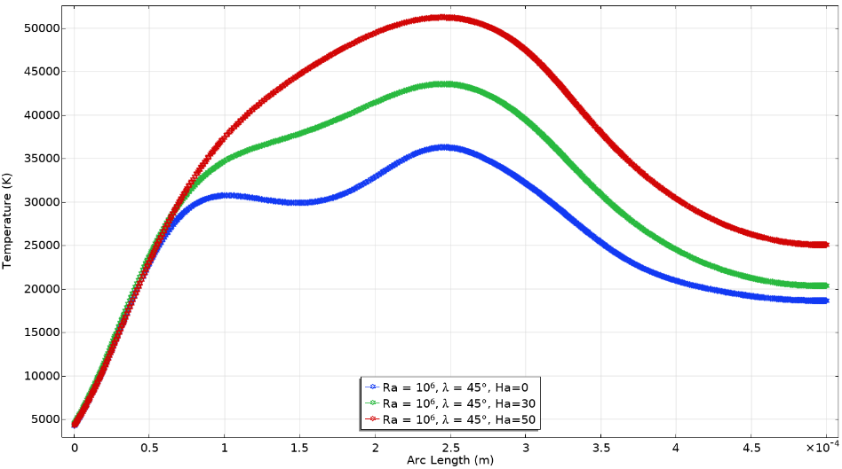
Fig 22. Temperature Profile for Triangle Obstacle for Different $λ$and Ha when Ra=10⁶

4.1 Effect of Obstacle Shapes

The internal obstacle geometry has a significant impact on the strength of convective flow, vortex formation, and the distribution of heat transfer within the cavity. Figures 5–13 depict the velocity profiles, and Figures 14–22 the temperature profiles for star, square, and triangular obstacles under different combinations of Ra, Ha, and ɸ. The trends are quantitatively supported by Tables 4–30, which summarize the numerical variations in Nu, RT, and ECOP for each configuration.
.
Across all studied cases, the square obstacle consistently produced the highest average Nusselt number, followed by the triangular and star-shaped obstacles. This behavior stems from the larger conductive surface area and corner-induced flow separation of the square geometry, which strengthens circulation and enhances convective transport.

At Ra = 10⁶ and Ha = 0, the square obstacle achieved Nu values of 6.24 (ɸ = 0.02), 6.46 (ɸ = 0.04), and 6.75 (ɸ = 0.06), corresponding to an enhancement of 8% across the nanoparticle concentration range (Tables 13–21). The triangular obstacle exhibited moderate heat transfer, with Nu values of 6.37, 6.63, and 6.78 for the same ɸ values (Tables 22–30), whereas the star obstacle achieved Nu values of 5.79, 6.05, and 6.15, confirming its lower global efficiency (Tables 4–12).

The velocity contours (Figures 5–13) reveal that the square obstacle promotes stronger recirculating zones with more uniform flow near the heated walls, while the triangular geometry generates smoother circulation paths and lower viscous resistance. The star shape, however, induces multiple secondary vortices around its pointed tips, resulting in intense local mixing but restricted main circulation.

The temperature distributions (Figures 14–22) align with this pattern: the square obstacle exhibits tighter thermal gradients near the heated surfaces, the triangular shape maintains broader isotherms with stable stratification, and the star shape shows high-temperature stagnation zones near the cavity center.

From an energetic perspective, the entropy generation rate (RT) follows an inverse trend, being highest for the star geometry due to local frictional effects and lowest for the triangular configuration, owing to its streamlined boundaries. The ECOP reaches its maximum for the square obstacle, attaining a value of 4505.10 at Ra = 10⁶, Ha = 0, and ɸ = 0.06 (Table 21).

Overall, these results demonstrate that obstacle geometry governs the thermal–fluidic balance within the enclosure. The square obstacle delivers the best overall performance, offering a strong compromise between heat transfer enhancement and minimized thermodynamic losses. The triangular obstacle supports smoother heat transport with lower entropy generation, making it suitable for energy-efficient systems. In contrast, the star shape provides higher local mixing but inferior overall performance.

4.2 Influence of Inclination Angle

The inclination angle (λ) directly affects the buoyancy force distribution and consequently alters the strength and pattern of natural convection within the wavy-top trapezoidal cavity. As the cavity is inclined from 15° to 45°, the alignment between the thermal gradient and the gravitational vector changes, modifying both the flow structure and heat transfer characteristics.

Across all obstacle geometries, the average Nusselt number (Nu) increases slightly with rising inclination, confirming that the inclination enhances convective circulation by directing buoyancy-driven plumes along the inclined walls. This effect is especially notable at higher Rayleigh numbers, where convection dominates.

For the square obstacle, Tables 13–15 show that at Ra = 10⁶ and Ha = 0, the Nu increases from 6.2373 (λ = 15°) to 6.5016 (λ = 45°), representing a 4.2% enhancement. The corresponding ECOP improves from 4177.5 to 4362.5, while entropy generation (R_{T}) remains nearly constant, confirming that increased inclination benefits both thermal and thermodynamic performance without introducing additional irreversibility.

For the triangular obstacle, Tables 22–24 indicate a similar upward trend in Nu from 6.3746 (λ = 15°) to 6.4137 (λ = 45°) at Ra = 10⁶ and Ha = 0, implying a 0.6% gain in heat transfer efficiency. Although this improvement is modest compared to the square configuration, the triangular obstacle exhibits the lowest entropy generation (RT ≈ 0.00150) and a steady rise in ECOP from 4233.7 to 4260.8, highlighting its superior thermodynamic stability under inclination.

In contrast, the star-shaped obstacle exhibits a stronger sensitivity to changes in inclination. From Table 4 - Table 6, the Nusselt number rises from 5.7976 (λ = 15°) to 6.0049 (λ = 45°) for Ra = 10⁶ and Ha = 0, corresponding to a 3.6% enhancement, while ECOP increases from 3896.9 to 4044.6. However, this shape also shows greater fluctuations in entropy generation (R_{T}), reflecting more complex vortex interactions around its sharp arms when the cavity is inclined.

Overall, increasing λ enhances convective performance across all geometries, though the degree of improvement varies. The square obstacle benefits the most, achieving both higher Nu and ECOP values with minimal increase in entropy. The triangular obstacle offers balanced thermal and entropic performance, while the star shape shows larger local variations but remains less efficient overall. At higher magnetic field intensities (Ha = 50), these improvements diminish due to Lorentz force suppression, causing the flow to shift toward conduction-dominated regimes across all shapes and inclination angles.

4.3 Influence of Nanoparticle Volume Fraction

The nanoparticle volume fraction (ɸ) plays a central role in determining the thermophysical behavior of Cu–H₂O nanofluid and directly influences the heat transfer rate, fluid motion, and entropy generation. Increasing ɸ enhances the effective thermal conductivity of the fluid, thereby strengthening the convective heat transport mechanism, particularly at higher Rayleigh numbers (Ra), where buoyancy effects dominate. However, under stronger magnetic fields (Ha), the Lorentz force suppresses flow circulation, partially offsetting the benefits of nanoparticle addition.

For the square obstacle, Tables 13–21 show a consistent rise in the average Nusselt number (Nu) with increasing ɸ at all Ha and Ra values. At Ra = 10⁶ and Ha = 0, the Nu grows from 6.2373 (ɸ = 0.02) to 6.7514 (ɸ = 0.06), an improvement of about 8.2%, confirming stronger convective mixing due to higher nanoparticle concentration. A similar enhancement is observed under magnetic influence: at Ha = 30, Nu rises from 5.9687 to 6.4821, while at Ha = 50, it increases from 5.7556 to 6.2258, indicating that the positive effect of nanoparticles persists even with MHD damping, though the rate of improvement slightly decreases. Correspondingly, ECOP values climb from 4177.5 to 4505.1, emphasizing that the system becomes thermodynamically more efficient at higher ɸ.

For the triangular obstacle, as shown in Tables 22–30, Nu values also increase steadily with ɸ. At Ra = 10⁶ and Ha = 0, Nu changes from 6.3746 (ɸ = 0.02) to 6.7861 (ɸ = 0.06), yielding a 6.4% improvement. The entropy generation (R_{T}) remains the lowest among all shapes, varying between 0.00148–0.00152, indicating minimal viscous losses. The ECOP increases moderately from 4233.7 to 4441.8, suggesting stable thermal performance and energy efficiency. This geometry’s inclined surfaces promote smoother flow, reducing the adverse impact of magnetic resistance even at Ha = 50, where conduction begins to dominate.

The star-shaped obstacle, presented in Tables 4–12, exhibits a less pronounced improvement in Nu with ɸ, mainly due to complex flow separation and localized recirculation around its pointed arms. At Ra = 10⁶ and Ha = 0, Nu rises from 5.7976 (ɸ = 0.02) to 6.1512 (ɸ = 0.06), an increase of about 6.1%, while ECOP grows from 3896.9 to 4105.5. However, RT shows stronger oscillations with Ha, signifying that the star geometry amplifies magnetic damping effects and produces higher entropy generation due to intensified micro-vortices.

At lower Rayleigh numbers (Ra = 10⁴), conduction dominates, and the influence of ɸ is minimal. As Ra increases to 10⁶, buoyancy-driven flow strengthens, and nanoparticle addition significantly boosts convective performance across all geometries. In contrast, when Ha increases from 0 to 50, the Lorentz force restrains fluid motion, reducing Nu and ECOP while increasing R_{T}. Nevertheless, even under magnetic suppression, higher ɸ values help sustain better thermal performance by improving the effective conductivity of the nanofluid.

In summary, increasing nanoparticle concentration enhances overall heat transfer rate, thermal efficiency, and ECOP, especially for higher Ra and lower Ha. The square obstacle demonstrates the greatest benefit, showing up to an 8% rise in Nu, while the triangular shape maintains superior thermodynamic stability with the lowest entropy generation. The star geometry, though inducing strong local mixing, remains less efficient globally. Thus, the combination of higher ɸ, large Ra, and low Ha yields optimal performance for MHD nanofluid convection in wavy-top trapezoidal cavities.

4.4 Summary of Key Findings

The numerical investigation reveals a clear interplay between obstacle geometry, inclination angle, nanoparticle concentration, and magnetic field strength in determining the thermal and fluid dynamic performance of Cu–H₂O nanofluid convection within a wavy-top trapezoidal cavity. The main conclusions drawn from the results (Tables 4–30 and Figures 5–22) are summarized as follows:

a. Obstacle Geometry:
- The square obstacle delivers the highest average Nusselt number (Nu) and Ecological Coefficient of Performance (ECOP) across all parameter ranges, confirming its superior heat transfer and energy efficiency characteristics.
- The triangular obstacle achieves smoother flow and lower entropy generation (R_{T}), offering the best thermodynamic stability and minimal irreversibility.
- The star-shaped obstacle promotes localized mixing but exhibits reduced overall convective performance due to multiple secondary vortices that trap heat and limit global circulation.

b. Inclination Angle (λ):
- Increasing the inclination from 15° to 45° strengthens buoyancy-driven flow alignment with gravity, leading to a gradual improvement in Nu and ECOP across all obstacle shapes.
- The square geometry shows the most pronounced benefit, while the star shape displays fluctuating entropy generation due to complex vortex interactions.
- At higher magnetic field strengths (Ha = 50), the Lorentz force suppresses convection, and the heat transfer mechanism transitions toward conduction dominance.

c. Nanoparticle Volume Fraction (ɸ):
- Raising ɸ from 0.02 to 0.06 enhances thermal conductivity and convective mixing, improving Nu by 6–8% depending on geometry and Ra.
- This enhancement is most effective at high Rayleigh numbers (Ra = 10⁶) and low magnetic fields (Ha = 0–30), where buoyancy forces dominate.
- Although increasing Ha reduces convective strength, the positive contribution of nanoparticles partially offsets this damping effect, preserving system performance.

d. Thermodynamic Performance:
- The square obstacle achieves the highest ECOP (up to 4505.10) and balanced entropy generation, indicating an optimal trade-off between heat transfer enhancement and irreversibility.
- The triangular configuration offers consistent efficiency at all inclination angles with the lowest RT values, making it favorable for energy-conserving applications.
- The star obstacle, while enhancing local turbulence, results in higher R_{T} and lower ECOP, making it less effective for global energy optimization.

In summary, the optimal configuration for maximizing thermal and thermodynamic efficiency in MHD-assisted natural convection of Cu–H₂O nanofluid is achieved with square obstacles, higher Rayleigh numbers, moderate inclination (λ = 30°–45°), higher nanoparticle concentration (ɸ = 0.06), and low-to-moderate magnetic field intensity (Ha ≤ 30). This combination ensures efficient heat transfer, minimal entropy generation, and enhanced ecological performance, making it suitable for advanced nanofluid-based cooling and energy systems.

5.0 Conclusion

This study numerically investigated natural convection of Cu–H₂O nanofluid in a wavy-top trapezoidal cavity containing internally heated obstacles of star, square, and triangular geometries under varying magnetic field strengths (Ha = 0–50), Rayleigh numbers (Ra = 10⁴–10⁶), and nanoparticle volume fractions (ɸ = 0.02–0.06). The results were analyzed in terms of average Nusselt number (Nu), Entropy generation (R_{T}), and Ecological Coefficient of Performance (ECOP) to evaluate thermal and thermodynamic performance.

Key Findings:
- The square obstacle consistently achieved the highest Nu and ECOP, confirming superior convective and thermodynamic efficiency.
- The triangular obstacle minimized entropy generation, demonstrating smoother flow and better thermal stability.
- The star-shaped obstacle enhanced local mixing but reduced global heat transfer due to multiple secondary vortices.
- Increasing inclination angle (λ = 15°-45°) strengthened buoyancy alignment, enhancing heat transfer, while high magnetic intensity (Ha = 50) suppressed convection.
- A higher nanoparticle concentration (ɸ = 0.06) improved Nu by up to 8%, especially at high Ra and low Ha conditions.

Overall, the square obstacle at λ = 45°, ɸ = 0.06, Ra = 10⁶, and Ha ≤ 30 achieved the best balance between heat transfer enhancement and thermodynamic efficiency, making it the optimal configuration for advanced thermal management systems. Future studies should investigate transient and three-dimensional effects, hybrid nanofluids, and non-uniform magnetic fields to capture the complexities of real-world applications. Experimental validation and optimization using machine learning-based predictive models are also recommended to extend the practical applicability of the proposed configurations in electronic cooling, solar collectors, and microchannel heat exchangers.

Disclaimer (Artificial intelligence)

Details of the AI usage are given below:
1. Author(s) hereby declare that NO generative AI technologies such as Large Language Models (ChatGPT, COPILOT, etc.) and text-to-image generators have been used during the writing or editing of this manuscript.

References
[1] R. Hidki, L. El Moutaouakil, Z. Charqui, M. Boukendil, and Z. Zrikem, "Natural convection in a square cavity containing two heat-generating cylinders with different geometries," Materials Today: Proceedings, vol. 45, pp. 7415–7423, 2021. DOI: https://doi.org/10.1016/j.matpr.2021.01.626
[2] Y. Cao, H. Ayed, F. Jarad, H. Togun, H. Alias, A. Issakhov, M. Dahari, M. Wae-hayee, and M. H. El Ouni, "MHD natural convection nanofluid flow in a heat exchanger: Effects of Brownian motion and thermophoresis for nanoparticles distribution," Case Studies in Thermal Engineering, vol. 28, 2021, Art. no. 101394.DOI: https://doi.org/10.1016/j.csite.2021.101394
[3] J. Zheng, L. Zhang, H. Yu, Y. Wang, and T. Zhao, “Study on natural convection heat transfer in a closed cavity with hot and cold tubes,” Science Progress, vol. 104, no. 2, pp. 1–25, 2021. doi: 10.1177/00368504211020965
[4] M. N. J. Ibrahim, K. A. Hammoodi, A. D. Abdulsahib, and M. A. Flayyih, “Study of Natural Convection Inside Inclined Nanofluid Cavity with Hot Inner Bodies (Circular and Ellipse Cylinders),” Int. J. Heat Technol., vol. 40, no. 3, pp. 699–705, Jun. 2022. [Online]. Available: https://doi.org/10.18280/ijht.400306
[5] S. Tasnim, A. Mitra, H. Saha, Md. Q. Islam, and S. Saha, "MHD conjugate natural convection and entropy generation of a nanofluid filled square enclosure with multiple heat-generating elements in the presence of Joule heating," Results in Engineering, vol. 17, 2023, Art. no. 100993. [Online]. Available: https://doi.org/10.1016/j.rineng.2023.100993
[6] Z. Boulahia, A. Wakif, and R. Sehaqui, "Mixed convection heat transfer of Cu-water nanofluid in a lid driven square cavity with several heated triangular cylinders," Int. J. Innov. Appl. Stud., vol. 17, no. 1, pp. 82–93, Jul. 2016.
[7] A. Ali, M. Ayaz, Z. Ahmad, and A. M. Marei, “Analysis of entropy generation in magnetohydrodynamic convective flow of nanofluids within a wavy trapezoidal enclosure: A Brinkmann–Forchheimer model using finite element method,” Case Studies in Thermal Engineering, vol. 73, 106719, 2025, doi: 10.1016/j.csite.2025.106719
[8] S. Nadeem, M. Arif, I. Ullah, and J. Alzabut, “MHD natural convection of nanofluid flow using a corrugated permeable medium within corrugated circular cavity,” Journal of Thermal Analysis and Calorimetry, vol. 150, pp. 5697–5724, 2025, doi: 10.1007/s10973-025-14032-y
[9] A. S. Dogonchi, M. S. Sadeghi, M. Ghodrat, A. J. Chamkha, Y. Elmasry, and R. Alsulami, “Natural convection and entropy generation of a nanoliquid in a crown wavy cavity: Effect of thermo-physical parameters and cavity shape,” Case Studies in Thermal Engineering, vol. 27, p. 101208, 2021, doi: 10.1016/j.csite.2021.101208
[10] M. H. S. Alnajem, A. I. Alsabery, and I. Hashim, "Entropy generation and natural convection in a wavy-wall cavity filled with a nanofluid and containing an inner solid cylinder," IOP Conf. Ser.: Mater. Sci. Eng., vol. 518, p. 032044, 2019, doi: 10.1088/1757-899X/518/3/032044
[11] K. Chowdhury and M. A. Alim, “Mixed Convection in a Double Lid-Driven Wavy Shaped Cavity Filled with Nanofluid Subject to Magnetic Field and Internal Heat Source,” Journal of Applied Mathematics, vol. 2023, Article ID 7117186, 13 pages, Mar. 2023. doi: 10.1155/2023/7117186
[12] Z. Boulahia, A. Wakif, A. J. Chamkha, C. H. Amanulla, and R. Sehaqui, "Effects of Wavy Wall Amplitudes on Mixed Convection Heat Transfer in a Ventilated Wavy Cavity Filled by Copper-Water Nanofluid Containing a Central Circular Cold Body," J. Nanofluids, vol. 8, no. 5, pp. 1170–1178, 2019, doi: 10.1166/jon.2019.1654
[13] S. Khatun, R. Kundu, S. Islam, R. Aktary, and D. Kumar, "Sensitivity analysis on natural convective trapezoidal cavity containing hybrid nanofluid with magnetic effect: Numerical and statistical approach," Heliyon, vol. 11, 2025, Art. no. e41508. DOI: https://doi.org/10.1016/j.heliyon.2024.e41508
[14] F. Selimefendigil, "Natural Convection in a Trapezoidal Cavity with an Inner Conductive Object of Different Shapes and Filled with Nanofluids of Different Nanoparticle Shapes," Iran J. Sci. Technol. Trans. Mech. Eng., vol. 42, pp. 169–184, 2018, doi: 10.1007/s40997-017-0083-3
[15] A. A. Mohammed, M. Thaer, and D. Q. Yahya, "Mixed Convection Heat Transfer of Al₂O₃-H₂O Nanofluid in a Trapezoidal Lid-driven Cavity at Different Angles of Inclination," Texas Journal of Engineering and Technology, vol. 2022, pp. 1–9, Aug. 2022.
[16] I. M. Abed, A. Abdulkadhim, R. A. Hamzah, H. K. Hamzah, and F. H. Ali, “Natural Convection Heat Transfer for Adiabatic Circular Cylinder Inside Trapezoidal Enclosure Filled with Nanofluid Superposed Porous–Nanofluid Layer,” FME Transactions, vol. 48, pp. 82–89, 2020. doi: 10.5937/fmet2001082M
[17] Z. Abdelmalek, T. Tayebi, A. S. Dogonchi, A. J. Chamkha, D. D. Ganji, and I. Tlili, "Role of various configurations of a wavy circular heater on convective heat transfer within an enclosure filled with nanofluid," International Communications in Heat and Mass Transfer, vol. 113, p. 104525, 2020. DOI: 10.1016/j.icheatmasstransfer.2020.104525
[18] G. A. Sheikhzadeh, M. Nikfar, and A. Fattahi, "Numerical study of natural convection and entropy generation of Cu-water nanofluid around an obstacle in a cavity," Journal of Mechanical Science and Technology, vol. 26, no. 10, pp. 3347–3356, 2012, doi: 10.1007/s12206-012-0805-9
[19] M. M. Ali, M. A. Alim, R. Akhter, and S. S. Ahmed, "MHD Natural Convection Flow of CuO/Water Nanofluid in a Differentially Heated Hexagonal Enclosure with a Tilted Square Block," International Journal of Applied and Computational Mathematics, vol. 3, suppl. 1, pp. S1047–S1069, 2017, doi: 10.1007/s40819-017-0400-y.
[20] M. Akram, K. Benhanifia, M. Brahim, L. Rahmani, A. Z. Ansari, M. R. Eid, S. M. Hussain, F. Redouane, W. Jamshed, and I. Alraddadi, “Natural convection and flow patterns of Cu–water nanofluids in hexagonal cavity: A novel thermal case study,” Open Physics, vol. 22, 2024, Art. no. 20240041. doi: 10.1515/phys-2024-0041
[21] M. J. H. Munshi, A. H. Bhuiyan, and M. A. Alim, “A Numerical Study of Natural Convection in a Square Enclosure with Non-Uniformly Heated Bottom Wall and Square Shape Heated Block,” American Journal of Engineering Research (AJER), vol. 4, no. 5, pp. 124–137, 2015.
[22] K. Chowdhury, A. Alim, and M. Hossen, "Natural Convection in a Partially Heated and Cooled Square Enclosure Containing a Diamond Shaped Heated Block," Int. J. Fluid Mech. Therm. Sci., vol. 6, no. 1, pp. 1–8, Jan. 2020, doi: 10.11648/j.ijfmts.20200601.11.
[23] B. K. Saha, J. I. Jihan, G. Barai, N. J. Moon, G. Saha, and S. C. Saha, “Exploring natural convection and heat transfer dynamics of Al₂O₃-H₂O nanofluid in a modified tooth-shaped cavity configuration,” Int. J. Thermofluids, vol. 25, Art. no. 101005, 2025. doi: 10.1016/j.ijft.2024.100290
[24] P. Sompong and S. Witayangkurn, "Natural Convection in a Trapezoidal Enclosure with Wavy Top Surface," Journal of Applied Mathematics, vol. 2013, Art. no. 840632, pp. 1–7, 2013, doi: 10.1155/2013/840632
[25] E. S. Reddy and S. Panda, "Heat transfer of MHD natural convection Casson nanofluid flows in a wavy trapezoidal enclosure," Eur. Phys. J. Spec. Top., vol. 231, no. 10, pp. 2733–2747, 2022, doi: 10.1140/epjs/s11734-022-00609-3
[26] M. A. Alomari, K. Al-Farhany, A. L. Hashem, M. F. Al-Dawody, F. Redouane, and O. A. Olayemi, "Numerical Study of MHD Natural Convection in Trapezoidal Enclosure Filled With (50%MgO-50%Ag/Water) Hybrid Nanofluid: Heated Sinusoidal from Below," Int. J. Heat Technol., vol. 39, no. 4, pp. 1271–1279, Aug. 2021.
[27] M. M. Rahaman, S. Bhowmick, and S. C. Saha, “Thermal Performance and Entropy Generation of Unsteady Natural Convection in a Trapezoid-Shaped Cavity,” Processes, vol. 13, no. 3, Art. no. 426, 2025, doi: 10.3390/pr13030426.
[28] A. Alshayji, M. K. Alzuabi, and N. F. Aljuwayhel, “Numerical investigation of nanofluid free convection in a rectangular cavity using variable properties,” J. Therm. Anal. Calorim., Mar. 2025, doi: 10.1007/s10973-025-14197-6.
[29] B. El Hadoui and M. Kaddiri, “Optimizing nanofluid-enhanced mixed convection in inclined rectangular chambers,” J. Therm. Anal. Calorim., Jun. 2025, doi: 10.1007/s10973-025-14491-3.
[30] M. J. Uddin, K. S. Al Kalbani, M. M. Rahman, M. S. Alam, N. Al-Salti, and I. A. Eltayeb, “Fundamentals of Nanofluids: Evolution, Applications and New Theory,” Int. J. Biomathematics and Systems Biology, vol. 2, no. 1, pp. 1–18, Aug. 2016.
[31] M. M. Ali, R. Akhter, and M. A. Alim, “MHD natural convection and entropy generation in a grooved enclosure filled with nanofluid using two-component non-homogeneous model,” SN Applied Sciences, vol. 2, no. 3, pp. 1–15, Mar. 2020.
[32] S. S. Deep, S. Sultana, T.-U. Haque, M. T. Rahman, and S. Saha, “Coupled fluid-thermal analysis of a square chamber with a wavy top wall and an internal solid elliptical/circular block,” Applications in Engineering Science, vol. 24, p. 100268, 2025.
[33] S. P. K. Sarker, M. M. Alam, and M. J. H. Munshi, “Simulating mixed convection in a lid-driven wavy enclosure with block in different locations,” International Journal of Fluid Mechanics & Thermal Sciences, vol. 9, no. 2, pp. 20–28, 2023.
[34] S. P. K. Sarker, M. M. Alam, and M. J. H. Munshi, “Modeling of mixed convection in a lid driven wavy enclosure with two square blocks placed at different positions,” Journal of Applied Mathematics and Physics, vol. 11, pp. 3984–3999, 2023.
[35] S. P. K. Sarker and M. M. Alam, “Numerical analysis of conjugate mixed convection heat transfer with internal heat generation in a wavy-walled lid-driven trapezoidal cavity,” Journal of Advances in Mathematics and Computer Science, vol. 40, no. 3, pp. 11–34, 2025.
[36] S. P. K. Sarker and M. M. Alam, “Numerical analysis of conjugate MHD free convection of Cu–H₂O nanofluid in a top corrugated trapezoidal cavity with multiple heat generating obstacles of different shapes,” Journal of Advances in Mathematics and Computer Science, vol. 40, no. 8, pp. 30–66, 2025.
[37] S. P. K. Sarker and M. M. Alam, “Numerical study of heat transfer in a nanofluid-filled trapezoidal enclosure with star-shaped heat sources under magnetic field,” Open Journal of Fluid Dynamics, vol. 15, no. 3, pp. 136–157, 2025.
[38] S. P. K. Sarker and M. M. Alam, “Numerical investigation of MHD heat transfer in a nanofluid trapezoidal cavity with embedded square heat sources,” American Journal of Computational Mathematics, vol. 15, no. 3, pp. 259–277, 2025.
[39] M. J. Mahmud, A. I. Rais, M. R. Hossain, and S. Saha, “Conjugate mixed convection heat transfer with internal heat generation in a lid-driven enclosure with spinning solid cylinder,” Heliyon, vol. 8, 2022, Art. no. e11968.
[40] S. Dutta, S. Pati, and L. Baranyi, “Numerical analysis of magnetohydrodynamic natural convection in a nanofluid-filled quadrantal enclosure,” Case Studies in Thermal Engineering, vol. 28, 2021, Art. no. 101507.

