Effect of Mathematics Anxiety on Mathematics Performance among Ghanaian SHS Students
Abstract
Math anxiety (MA) a significant non-cognitive barrier that hinders participation in STEM fields and academic performance is recognized on a global scale. Tension and anxiety are common psychological phenomena that cause working memory to be depleted which leads to quantifiable performance impairments in mathematical performance. This quantitative cross-sectional study investigated the relationship and expected effects of mathematics anxiety (MA) on mathematics performance (SA) among Senior High School (SHS) students in Ghana. A structured survey design was used to collect information from a sample of 300 SHS students. The methodological approach employed reliability analysis $(MA α=0. 869; SA α=0. 954)$, descriptive statistics, Pearson product-moment correlation and simple linear regression to develop the predictive model. The instruments displayed excellent internal consistency and students reported moderate MA levels $(Mean=2. 52)$ in contrast to relatively high SA levels $(Mean = 3. 22).$ $r(298)=-0.276,p<.001$ indicated a significant negative correlation between MA and SA. Regression analysis showed that MA was a statistically significant predictor of SA $(F(1, 298) = 24.558, p < .001)$ and explained $7. 6\% (R^{2}=0. 076)$ of the variation. $A 0. 318 unit drop$ $(β= -0. 276)$ in mathematical performance is anticipated for each unit increase in MA according to the results which demonstrate a significant negative impact. In the Ghanaian SHS context MA is a reliable and statistically significant negative predictor of mathematical performance thereby providing empirical support for the working memory interference theory. The results have significant policy implications requiring the adoption of necessary customized therapies focused on cognitive reappraisal and emotional regulation in addition to pedagogical adjustments meant to lessen anxiety-inducing teaching strategies.
Keywords: Mathematics Anxiety, Mathematics Performance, Predictive Influence, Working Memory Interference, Ghana.

1.1 Background of the Study
Math anxiety (MA) defined as a feeling of apprehension, tension or panic experienced when working with numbers or mathematical concepts is a significant global obstacle to academic success and future career pathways (Ashcraft and Moore 2009). This psychological barrier is particularly important for educational institutions that want to build a strong pipeline for STEM (science, technology, engineering and mathematics) fields which are crucial for economic competitiveness in emerging economies (OECD 2022).
In Ghana Mathematics Anxiety has been reported to be an issue. Studies show that many Senior High School (SHS) students have Mathematics Anxiety, which has significant effects on academic performance (Bornaa, Rahaman and Iddrisu, 2023). A vicious cycle of avoidance and poor performance is eventually fueled by high levels of Mathematics Anxiety, which often lead to cognitive interference which reduces the amount of working memory available for problem-solving (Caviola et al., 2022). Another study carried out in the Sagnarigu Municipality revealed a significant negative correlation between math anxiety and SHS student’s mathematical performance (Bornaa, Rahaman and Iddrisu, 2023). These empirical findings demonstrate that anxiety affects academic performance in measurable ways and is not only common in Ghana.
Math-related anxiety is increasingly recognized as one of the main obstacles to academic success in the world. Math-related assignments may be avoided, test scores may suffer or students may lose confidence as a result of experiencing anxiety, worry or uncertainty (Sammallahti, Finell Jonsson and Korhonen, 2023). Meta-analyses show that emotion control and cognitive support-focused therapies can improve academic performance and reduce arithmetic anxiety (Sammallahti et al., 2023). It is therefore necessary to comprehend the precise nature and scope of the relationship between Mathematics Anxiety and performance in order to design effective local interventions.
1.2 Problem Statement
The primary problem is that despite the fact that numerous international studies show a broad negative relationship between mathematics anxiety (MA) and academic performance globally (Caviola et al. 2022), the exact quantifiable predictive effect is still unclear in the Ghanaian Senior High School (SHS) setting. Local research indicates that mathematics anxiety is very common among SHS students and is linked to poor performance in mathematics (Bornaa, Rahaman and Iddrisu 2023). A critical gap in the current local research is the need for strong statistical modeling such as robust regression analysis to determine the predictive value and the degree of impairment that MA imposes on mathematical ability in this population. Without such thorough quantitative evidence, therapies cannot effectively target the precise degree of performance impairment caused by anxiety which is necessary for effective resource allocation and successful intervention design (Sammallahti et al., 2023).
1.3 Purpose and Objectives of the Study
The primary objective of this study is to examine the relationship between math performance (SA) and mathematics anxiety (MA) in senior high school students in Ghana.
These are the specific objectives.
- To determine the reliability or internal consistency of the instruments used to measure Mathematics Anxiety and Mathematics Performance.
- To assess the Mathematics anxiety and mathematics performance levels of Ghanaian SHS students using descriptive statistics.
- To examine the Mathematics anxiety and mathematics performance associations strength and direction.
- To determine the predictive influence of Mathematics anxiety on mathematics performance using simple linear regression analysis.
1.4 Significance of the Study
The study’s findings offer empirical data that can be measured and used to guide Ghanaian educational policy. By calculating the predictive relationship (R-squared value) and the predictive effect (Beta coefficient) of Mathematics anxiety on mathematics performance, the study provides a strong basis of evidence. This enables educators and policymakers to support the need for counseling services and socio-emotional learning (SEL) programs in SHS and again develop targeted classroom interventions (like anxiety-reduction techniques and non-timed assessments) that try to mitigate the negative effects of Mathematics anxiety and lastly contribute to the body of psychological literature by proving the cross-cultural applicability of the working memory interference hypothesis in the Ghanaian educational context.
2. Literature Review
2.1 Theoretical Frameworks
2.1.1 Cognitive Load Theory (CLT)
Based on the Cognitive Load Theory (CLT) one can comprehend how mathematics anxiety and performance are related (Sweller et al., 2019). According to CLT the capacity of human working memory is limited. Students with mathematics anxiety spend a portion of their working memory resources on intrusive thoughts (fear of failure concern). This so-called irrelevant cognitive load instantly reduces the capacity available for processing new mathematical information or performing complex operations (Caviola et al., 2022). Based on empirical findings mathematics anxiety most negatively impacts higher-order thinking activities due to this working memory depletion.
2.1.2 Krashen's Affective Filter Hypothesis
This theory states that emotional factors such as high levels of anxiety can act as a filter that impedes or stops academic information from being fully processed and understood (Krashen, 1982). A strong affective filter which is exacerbated by mathematic anxiety explains how students with the requisite skills perform poorly their emotional state actively obstructs learning and the application of knowledge.
2.2 Empirical Evidence on mathematics anxiety and Performance
Numerous studies conducted globally have shown a strong negative correlation between mathematics anxiety and student mathematics performance.
2.2.1 Meta-Analytic Consistency
According to Bornaa, Rahaman and Iddrisu, 2023, analytic data indicate a small-to-moderate negative relationship between mathematics anxiety and mathematics performance. The effect of mathematics anxiety is considered significant even though it does not account for the majority of performance variance because it is a powerful negative predictor that operates independently of many other academic characteristics. Namkung et al, (2019) provided additional evidence for this correlation highlighting how consistent it is across a variety of age groups and mathematical tasks.
2.2.2 Causal Mechanisms.
According to recent experimental research, cognitive interference can be explained. For example, experimental setups demonstrated that MA specifically reduces working memory and inhibitory control which lowers a student’s ability to successfully finish challenging math problems. (Demedts, F. et al., 2022). These findings support the basic notion that anxiety is an active inhibitor rather than just an indication of poor performance.
2.2.3 Local Contextual Studies
Preliminary findings indicate that Ghana supports this global trend. Bornaa, Rahaman and Iddrisu (2023) found a negative correlation in the Sagnarigu Municipality indicating that mathematics anxiety is a significant barrier even in local Municipality. To measure the predictive effect in a larger more widely applicable sample, a comprehensive examination of the current study is necessary as supported by these local results.
3. Methodology
3.1 Research Paradigm and Approach
The basis for this analysis is the positivist research paradigm which stresses the objective measurement of phenomena and the use of quantifiable data to test theories (Creswell and Creswell 2017). Positivism is appropriate because the goal of this study is to demonstrate a statistically verifiable relationship between two objectively measured constructs (mathematics anxiety and student mathematics performance).
A quantitative research approach was chosen which focuses on the measurement and statistical analysis of numerical data in order to test theories and identify connections (Salkind, 2010). Because the study involves the analysis of survey responses this approach is necessary.
3.2 Research Design
This study employed a quantitative non-experimental approach called a cross-sectional survey design. In order to examine the relationship and predictive power between the quantifiable components of math anxiety this approach involved collecting data from a sample of participants at a specific time.
3.3 Population and Sampling
3.3.1 Population
The population for this study was students in a Senior High school located in Sekyere South Municipal District, Ashanti, Ghana. The school has a population of 3200 students who offer core mathematics from the various departments, selected for the research, since these individuals exhibit common characteristics which is relevant to this study (Ghana Education Service, 2023).
3.3.2 Sample Size and Sampling Technique
Using Yamane’s (1967) computation for a finite population $N = 3200$ at a 95% confidence level and margin of error $e=0.05$, the required sample size for the study was $n≈356$ students.
$$n= \frac{N}{1+Ne^{2}}=\frac{3,200}{1+3,200 . {\left(0.05\right)}^{2}}= \frac{3,200}{9}≈355.56$$
The estimated sample size was therefore 356 students. Due to practical considerations such as time accessibility and anticipated nonresponse the final sample size was lowered to 300 students. This final sample size still provides adequate statistical power and representativeness for quantitative analysis of the observed dynamics (Israel G. A., 1992).
Sampling Technique: Using proportional stratified random sampling the participants were selected. The population was separated into SHS 1, SHS 2 and SHS 3 grade levels to ensure that each grade was fairly represented. Random selection across all strata improved estimate precision and reduced sample bias across these heterogeneous groups (Johnson and Christensen 2024).
3.4 Data Collection Technique and Instruments
Structured questionnaires were used to collect data during scheduled class sessions after informed consent was obtained. Stronger performance or greater concern are usually indicated by higher scores. Recoded from validated scales were the items for Mathematics Performance (SA) and Mathematics Anxiety (MA).
3.5 Data Analysis Techniques
Utilizing SPSS Version 27 the Statistical Package for the Social Sciences, the quantitative data was assessed. Three stages were used to organize the analysis.
- Reliability analysis: Cronbach’s alpha (α) to assess the student mathematics performance and mathematics anxiety scales internal consistency.
- Descriptive statistics use means and standard deviations to characterize the distribution and central tendency of mathematics performance and mathematics anxiety scores.
- For inferential analysis, the linear relationship is examined using Pearson product-moment correlation and then the predictive ability of mathematics anxiety on Student mathematics performance is assessed using simple linear regression.
4. Results
4.1 Reliability Analysis of the Research Instruments
Table 1: Summary of the Reliability Analysis
Scale | Cronbach's Alpha (α) | Internal Consistency
Mathematics Anxiety (MA) | 0.869 | Good
Mathematics Performance (SA) | 0.954 | Exceptional

The reliability of the items used to measure Mathematics Performance (SA) and Mathematics Anxiety (MA) was checked using Cronbach’s alpha coefficient. Cronbach’s alpha is a widely used internal consistency metric that shows how well a group of items captures a single construct. According to Taber (2018) a Cronbach’s alpha value larger than 0. 70 is generally considered suitable for social science and educational research. According to the results the Mathematics Anxiety scale had a Cronbach’s alpha of point 0.869 indicating a fair level of internal consistency. Similarly, the Cronbach’s alpha for the Mathematics Performance scale was 0. 954 indicating exceptional internal consistency. The findings suggest that both assessments are highly reliable and can be used with assurance to determine students’ levels of anxiety and mathematical ability.
Even though extremely high alpha values (above 0. 95) may occasionally suggest possible redundancy among items the results for the Mathematics Performance scale are still acceptable because performance-related items are often strongly correlated (Taber 2018).
4.2 Descriptive Statistics
Table 2: Descriptive Statistics of Mathematics Anxiety and Mathematics Performance
Variable | N | Mean(M) | Std.Deviation(SD) | Minimum | Maximum
MA(Anxiety) | 300 | 2.52 | 0.96 | 1.00 | 4.75
SA(Performance) | 300 | 3.22 | 1.11 | 1.00 | 5.00
Using descriptive statistics, a broad picture of students reported levels of mathematics performance (SA) and mathematics anxiety (MA) was obtained. Table 3 displays the results. In general students had low to moderate levels of math anxiety as indicated by their mean score of 2. 52 (SD = 0. 96). Conversely the mean score of 3. 22 (SD = 1. 11) for mathematics performance indicates that students generally reported medium to relatively high levels of mathematical performance. The range of scores further illustrates how different students are. The range of MA scores which ranged from 1. 00 to 4. 75 showed that some students had relatively low anxiety levels and others were quite high. With scores ranging from 1. 00 to 5. 00 SA’s performance levels ranged widely from extremely low to very high-performance indicators.
Despite the fact that many children do not suffer from math anxiety to the most extreme degree these descriptive findings suggest that math anxiety is a serious issue with potential consequences for performance. The results Suárez-Pellicioni et al., (2016), this trend is supported by researchers like who showed that anxiety can coexist with relatively good performance but may ultimately impede performance. Additionally, Caviola et al. (2022) emphasize that even mild cases of math anxiety can negatively impact student’s capacity to successfully complete mathematical tasks.
4.3 Graphical Analysis of Scores and Relationship
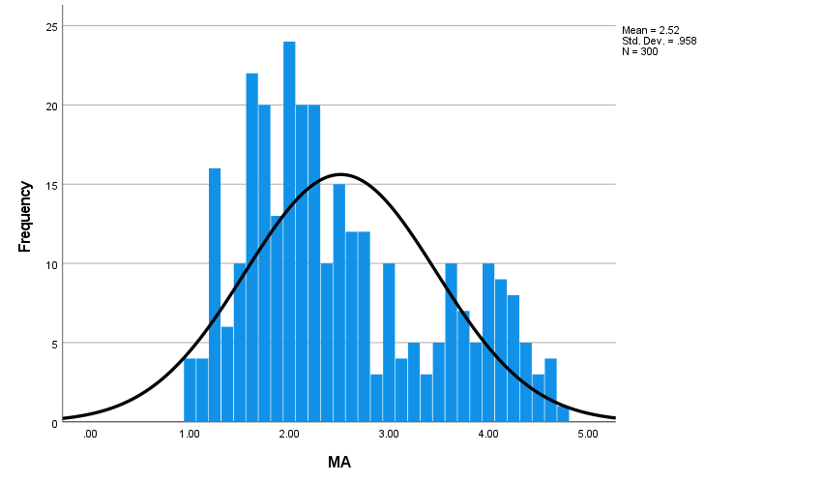
Figure 1: Frequency Distribution of Mathematics Anxiety (MA) Scores Among Participating Students $(N = 300).$
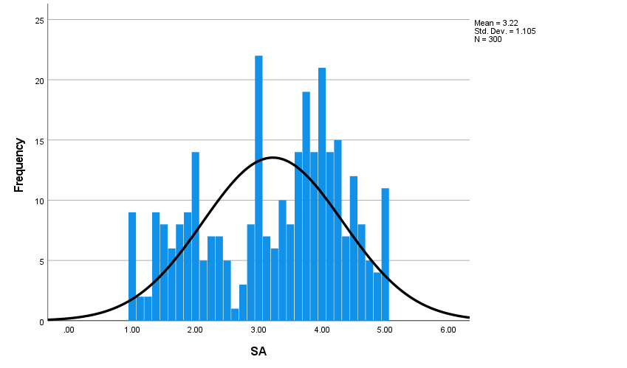
Figure 2: Frequency Distribution of Student Achievement (SA) Scores Among Participating $Students (N = 300).$

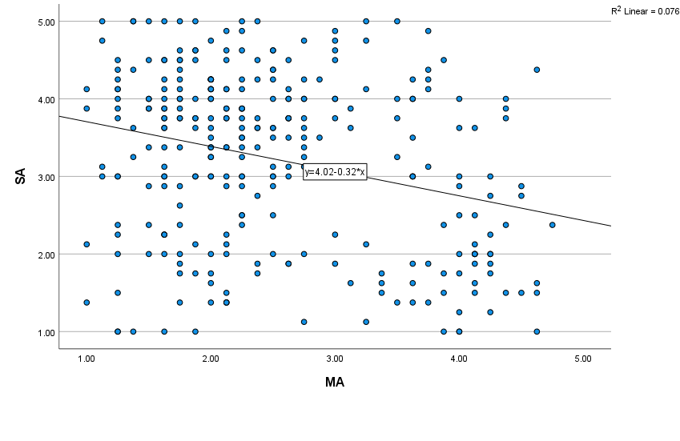Figure 3: Scatter Plot Illustrating the Negative Linear Relationship between Mathematics Anxiety (MA) and Student Achievement (SA).

4.3.1 Distribution of Key Variables
Histograms were utilized to visualize the central tendency and variability of the primary variables by analyzing the distribution of Student Performance (SA) and Mathematics Anxiety (MA) scores (Figures 1 and 2).
Figure 1 shows the distribution of the MA scores for the 300 participants. The distribution of the MA scores despite the presence of anxiety is generally grouped towards the lower-middle end of the scale (Mean = 2. 52) suggesting that the scores are tilted slightly in the direction of lower anxiety levels. This is significant because it demonstrates that performance impairments can occur even at very low average anxiety levels.
The distribution of Student Performance (SA) scores is displayed in Figure 2. There is a noticeable clustering around the center (Mean = 3. 22) despite the wide dispersion of the SA scores suggesting a wide range of academic competence throughout the sample. The higher standard deviation (SD = 1. 105) in comparison to the MA scores (SD = 0. 958) indicates that students performance varies more than their declared anxiety levels.
4.3.2 Visualizing the Predictive Relationship
The relationship between Mathematics Anxiety (MA) and Student Performance (SA) was examined visually using a scatter plot with a fitted linear regression line (Figure 3).
Figure 3 clearly shows the two variables negative correlation. The quantitative conclusion that student performance (SA Y-axis) tends to decrease as mathematics anxiety (MA X-axis) levels rise is graphically supported by the regression lines downward slope $(y = 4. 02 - 0. 32x).$ The data points corroborate the negative predictive association shown in the regression and correlation tables (Table 3) despite being widely distributed. The scatter plots visual representation bolsters the argument that MA seriously hinders Sekyere South Municipal District students ability to perform at their highest level.
4.4 Correlation Analysis
A Pearson product-moment correlation analysis was used to examine the relationship between mathematics anxiety and mathematical performance in senior high school students. The results indicated a significant negative correlation between the two variables $r (298) = -. 276, p<.0 01.$ This suggests that children with higher levels of math anxiety tended to report lower math accomplishment scores. This finding is in line with several recent studies that despite the moderate effect size have consistently demonstrated a negative relationship between performance and math anxiety. For example, Barroso et al. (2021) found that anxiety significantly reduces student’s ability to think mathematically and solve problems as well as Namkung, J.M. (2019). Likewise, Caviola et al. (2022) demonstrated how anxiety reduces working memory and cognitive processing efficiency which in turn reduces mathematical task performance accuracy.

4.5 Regression Analysis.
Utilizing a simple linear regression analysis, the effect of mathematics anxiety (MA) on the mathematics performance (SA) of 300 senior high school students was examined.

Table 3: Model summary

Model | R | R Square | Adjusted R Square | Std. Error of the Estimate
1 | 0.276 | 0.076 | 0.073 | 1.06391

According to the model summary (Table 4), the correlation coefficient $(R)$ is 0. 276.
0. 076 is the $R^{2}$ value indicating that 7. 6 percent of the variance in mathematical performance can be attributed to mathematics anxiety. This suggests a statistically significant effect size in performance prediction that is small to moderate. The standard error of the estimate (1. 06391) shows that there is a significant degree of discrepancy between the expected and actual performance scores.

Table 4: ANOVA table

Model | Sum of Squares | df | Mean Square | F | Sig.
Regression | 27.798 | 1 | 27.798 | 24.558 | 0.000
Residual | 337.310 | 298 | 1.132
Total | 365.108 | 299
Based on the ANOVA results, the total regression model was statistically significant F (1, 298) = 24.558, p < .001. This implies that a child’s math anxiety is a reliable indicator of their mathematical performance.

4.6 Coefficients
Table 5: Coefficients Table
Model | Unstandardized Coefficients (B) | Std. Error | Standardized Coefficients (Beta) | t | Sig. | 95% Confidence Interval for B (Lower, Upper)
(Constant) | 4.023 | 0.173 | — | 23.280 | 0.000 | [3.683, 4.364]
MA | -0.318 | 0.064 | -0.276 | -4.956 | 0.000 | [-0.445, -0.192]

Coefficients table (Table 5), (B = –0.318, t = –4.956, p < .001). demonstrates that mathematics anxiety has a significant and negative impact on mathematical performance. For every unit increase in Mathematics Anxiety the expected Mathematical Performance score decreases by approximately 0. 32 units according to the Unstandardized Coefficient $(B).$ The Constant $(B = 4. 023)$ represents the expected performance score when MA is zero. The negative standardized coefficient which provides more evidence for the negative correlation $(β = -0. 276)$ validates the relationships robustness.
5 Discussion
The findings demonstrated that in this sample, Mathematics Anxiety (MA) statistically significantly predicts Mathematical Performance (SA) (r = –0.276, R² = 0.076). Since MA accounts for about 7.6% of the variance in Mathematical Performance scores it follows that for every unit increase in MA the expected Mathematical Performance score $(B = -0. 318)$ falls. Mathematics anxiety has substantial educational ramifications despite its small-to-moderate effect size because in contrast to other contextual factors it is a psychological barrier that can be altered and consistently impedes learning.
This conclusion is consistent with broader meta-analytic findings in the field. For instance, according to a comprehensive meta-analysis there was an average small-to-moderate relationship between performance and mathematics anxiety (Barroso C. Ganley, et al, 2021). Meanwhile research on the connection between math anxiety and student performance found that both trait and state math anxiety impair performance with the effects being more noticeable on more challenging tasks (Demedts F. Depaepe et al. 2022).
The outcome could theoretically be explained by the working memory interference hypothesis which maintains that anxiety lowers cognitive resources such as working memory which in turn lowers the number of resources available for problem-solving (Finell, Sammallahti and Korhonen 2022). In summary students who experience severe math anxiety may find it difficult to concentrate or manipulate mathematical knowledge because anxiety depletes some of their cognitive resources. This cognitive strain helps to explain why the regression had a negative predictive connection. Furthermore, this finding is in line with empirical research carried out locally in Ghana such as the Sagnarigu Municipality study by Bornaa, Rahaman and Iddrisu (2023) which verified that anxiety is a hindrance in Ghanaian classrooms.
6 Conclusion
This study provides compelling empirical evidence that mathematics anxiety is a reliable and significant predictor of mathematics performance among senior high school students in Ghana. The results show a moderate negative relationship $(r=-0. 276)$ and continuously show that performance declines with every unit increase in anxiety. The best theory to explain this phenomenon is working memory interference.
7 Recommendations
Recommendations for Teachers
Teachers are encouraged to modify their regular classroom practices and pedagogical approaches in order to directly reduce the effects of mathematics anxiety (MA). Teachers should receive proactive anxiety-reduction training such as how to lessen their reliance on competitive timed high-stakes tests which have been shown to exacerbate working memory interference. Additionally, teachers should prioritize fostering a growth mindset and establishing a positive learning environment in the classroom where errors are reframed as teaching opportunities rather than as reasons for criticism. These simple low-cost adjustments to classroom culture allow students to engage with mathematics in a more secure cognitive setting.
Recommendations for Curriculum and Policy Developers
Systemic necessary changes that ensure long-term effectiveness are given priority by curriculum and policy developers. Using strategies that have been demonstrated to release working memory resources, Senior High School (SHS) administrators are advised to implement structured term-long intervention programs. These targeted interventions should emphasize cognitive reappraisal and emotional control in order to directly address mathematics anxiety at a structural level. Policy must also ensure that Socio-Emotional Learning (SEL) modules are formally included in the SHS curriculum particularly for incoming students in order to prevent MA from developing.
8 Limitations and Future Research
- Future research should include variables like motivation, prior knowledge, instructor quality and socioeconomic position as the explained variation suggests that anxiety is just one of several factors.
- The cross-sectional design limits causal inference longitudinal or experimental designs would provide stronger evidence.
- Measurement issues: as some meta-analyses suggest distinctions between state and trait anxiety or the development of task-specific tests may reveal distinct effects.

Ethical Considerations
While closely following ethical guidelines, the study prioritized participant and institutional rights. Formal institutional authorization and clearance were initially granted by the headmaster of the senior high school that was involved. The written approval of headmaster and other designated staff who act in loco parentis was recognized as the main authority for access to the student body. Crucially, before data collection began each participant express consent was acquired demonstrating their understanding and willingness to take part. All information gathered was kept completely anonymous and confidential ensuring that no personally identifying information was shared or recorded.

Disclaimer (Artificial intelligence)
Authors hereby declare that NO generative technologies such as Large Models and text-to-image generators have been used during the writing or editing of this manuscript.

References
- Bornaa, C. S., Rahaman, H. A., & Iddrisu, A. B. (2023). Mathematics anxiety and academic performance of Senior High School students in Sagnarigu Municipality, Ghana. East African Journal of Education Studies, 6(2), 347–366. https://doi.org/10.37284/eajes.6.2.1358
- Ashcraft, M. H., & Moore, A. M. (2009). Mathematics anxiety and the affective drop in performance. Journal of Psychoeducational Assessment, 27(3), 197–205. https://doi.org/10.1177/0734282908330580
- Barroso, C., Ganley, C. M., McGraw, A. L., Geer, E. A., Hart, S. A., & Daucourt, M. C. (2021).
A meta-analysis of the relation between math anxiety and math achievement. Psychological Bulletin, 147(2), 134–168. https://doi.org/10.1037/bul0000307
- Bornaa, C. S., Rahaman, H. A., & Iddrisu, A. B. (2023). Mathematics anxiety and academic performance of Senior High School students in Sagnarigu Municipality, Ghana. East African Journal of Education Studies, 6(2), 347–366. https://doi.org/10.37284/eajes.6.2.1358
- Caviola, S., Toffalini, E., Giofrè, D., Mercader Ruiz, J., Szűcs, D., & Mammarella, I. C. (2022).
Math performance and academic anxiety forms, from sociodemographic to cognitive aspects: A meta-analysis on 906,311 participants. Educational Psychology Review. https://doi.org/10.1007/s10648-021-09618-5
- Creswell, J. W., & Creswell, J. D. (2017). Research design: Qualitative, quantitative, and mixed methods approaches (5th ed.). Sage publications.
- Demedts, F., Depaepe, F., Sasanguie, D., Reynaert, B., & Reynvoet, B. (2022). Unraveling the role of math anxiety in students’ math performance: The importance of state vs. trait anxiety and task complexity. Frontiers in Psychology, 13, Article 979113. https://doi.org/10.3389/fpsyg.2022.979113 (title properly not match)
- Finell, J., Sammallahti, E., Korhonen, J., Eklöf, H., & Jonsson, B. (2022).Working memory and its mediating role on the relationship of math anxiety and math performance: A meta-analysis. Frontiers in Psychology, 12, Article 798090. https://doi.org/10.3389/fpsyg.2021.798090
- Ghana Education Service. (2023). EMIS annual report 2023 (district tables). Ministry of Education, Ghana.
- Israel, G. D. (1992). Determining sample size. University of Florida Cooperative Extension Service, Institute of Food and Agriculture Sciences, EDIS.
- Johnson, B., & Christensen, L. (2024). Educational research: Quantitative, qualitative, and mixed approaches (8th ed.). Sage publications.
- Krashen, S. D. (1982). Principles and practice in second language acquisition. Pergamon Press.
- Suárez-Pellicioni, M., Núñez-Peña, M. I., & Colomé, À. (2016). Math anxiety: A review of its cognitive consequences, psychophysiological correlates and brain bases. Cognitive, Affective, & Behavioral Neuroscience, 16, 3–22. https://doi.org/10.3758/s13415-015-0370-7
- Namkung, J. M. (2019). The relation between mathematics anxiety and mathematics performance among school-aged students: A meta-analysis. Review of Educational Research, 89(3), 459–496. https://doi.org/10.3102/0034654319843494
- OECD. (2022). PISA 2022 results: Learning in the digital age. OECD Publishing.
- Salkind, N. J. (Ed.). (2010). Encyclopedia of research design. Sage publications.
- Sammallahti, M. L., Finell, A., Jonsson, J., & Korhonen, J. (2023). A meta-analysis of math anxiety interventions. Journal of Numerical Cognition, 9(2), 346–362. https://doi.org/10.5964/jnc.8401
- Sweller, J., Ayres, P., & Kalyuga, S. (2019). Cognitive load theory. Springer.
- Taber, K. S. (2018). The use of Cronbach’s alpha when developing and reporting research instruments in science education. Research in Science Education, 48(6), 1273–1296. https://doi.org/10.1007/s11165-016-9602-2
- Yamane, T. (1967). Statistics: An introductory analysis (2nd ed.). Harper and Row.

