Comparative Evaluation of Bacteriophage Plaque Formation on Different Culture Media

Abstract
Bacteriophages are bacterial viruses with promising applications in microbial biocontrol and antimicrobial therapy. The efficiency of bacteriophage isolation and visualization can depend on the type of culture medium used for plaque formation. This study provides a comparative assessment that helps standardize plaque assays for routine phage screening. This study aimed to isolate and compare bacteriophage recovery from different agar media—Luria–Bertani Agar (LBA), Nutrient Agar (NA), Eosin Methylene Blue (EMB) Agar, and MacConkey Agar—using Escherichia coli as a host. Sewage samples from livestock facilities were processed and enriched using the double agar layer (DAL) method. Distinct plaques appeared after 18–24 hours of incubation at 37 °C, varying in size and clarity across media types. The highest phage titer and clearest plaques were obtained on LBA (4.7 × 10³ PFU/mL), followed by EMB (4.1 × 10³ PFU/mL), NA (3.6 × 10³ PFU/mL), and MacConkey Agar (3.2 × 10³ PFU/mL). LBA supported larger and more distinct plaques, while MacConkey medium produced smaller, turbid plaques. These results demonstrate that media composition significantly influences bacteriophage plaque morphology and enumeration, with LBA being the most effective for phage isolation and visualization against E. coli. Taken together, these results underscore the importance of carefully selecting culture media when designing phage isolation workflows, particularly in laboratories working on phage therapy development and environmental surveillance of E. coli phages.
Keywords: Bacteriophage, Escherichia coli, Double agar layer, Luria–Bertani Agar, Nutrient Agar, MacConkey Agar, Plaque assay.

1. Introduction
Bacteriophages (phages), the viruses infecting bacteria, represent the most abundant biological entities on Earth and play a fundamental role in microbial ecology, evolution, and host regulation (Northrop, 1952). Their specificity and lytic capability make them valuable in therapeutic applications, diagnostics, environmental monitoring, and molecular biology (Salmond & Fineran, 2015; Dion et al., 2020; Gallet et al., 2011). With rising global concerns over antimicrobial resistance (AMR), phages are regaining attention as natural, targeted biocontrol tools.
Phage isolation from complex matrices such as sewage depends on host bacteria, environmental factors, and laboratory conditions—including the type of medium selected for plaque assays (Poniatovskyi et al., 2025). The double agar layer (DAL) method remains a gold standard for observing plaque morphology and enumerating phages, yet medium composition can markedly influence phage adsorption, diffusion, and plaque formation (Adams, 1959; Hyman & Abedon, 2010).
Different agar media vary in nutrient availability, selective agents, and buffering capacities. These variables modulate bacterial growth rates, phage replication cycles, and plaque clarity (Ramesh et al., 2019). Comparative evaluation helps identify media that support optimal phage–host interaction, improve isolation efficiency, and enhance standardization of phage assays for environmental and clinical studies (Li et al., 2023).
This study evaluates bacteriophage plaque formation on four media— Luria–Bertani Agar (LBA), Nutrient Agar (NA), Eosin Methylene Blue (EMB) Agar and MacConkey Agar—using E. coli as the host.
2. Materials and Methods
2.1 Sample Collection
Sewage samples were collected from three livestock-associated environments: dairy farms, poultry sheds, and piggery units. To ensure representative sampling, effluent was taken from active drainage points where organic waste accumulation was visibly high. Sterile 250 mL polypropylene containers were used, and approximately 150–200 mL of sewage was collected per site. Containers were rinsed thrice with the sample source before final collection to minimize contamination from residual disinfectants.
All samples were stored in insulated ice boxes with temperatures maintained between 2–8 °C during transport to the laboratory. Transport time never exceeded two hours to preserve phage viability. Upon arrival, samples were immediately processed, avoiding freeze–thaw cycles known to reduce phage activity.
2.2 Host Bacteria Preparation
A multidrug-resistant Escherichia coli clinical isolate designated E. coli EC-MDR-01, used as the host bacterium due to its relevance in both veterinary and human health contexts. To ensure reproducibility, the isolate was revived from glycerol stocks maintained at –80 °C. The bacteria were streaked on LBA and incubated at 37 °C for 18–24 hours. A single well-isolated colony was inoculated into 50 mL Luria–Bertani broth and incubated at 37 °C with constant shaking at 150 rpm. Optical density was monitored at 600 nm using a spectrophotometer. Log-phase cultures (OD₆₀₀ = 0.4–0.6) were used for phage adsorption due to their high metabolic activity and abundant surface receptors.

2.3 Pre-Treatment and Clarification of Sewage Samples

Before enrichment, raw sewage samples were pre-treated to remove large particulates. This involved:

Allowing samples to sediment for 10 minutes.

Centrifugation at 5000×g for 20 minutes.

Filtration of the supernatant through sterile Whatman No. 1 filter paper.

This clarification step helped minimize debris that could hinder bacterial growth or interfere with plaque visualization.

2.4 Phage Enrichment
Enrichment increases phage concentration by allowing them to infect a suitable host. The clarified supernatant (10 mL) was mixed with an equal volume of log-phase E. coli culture in sterile conical tubes. To promote phage adsorption, the mixture was incubated at 37 °C for 30 minutes without shaking, this static incubation facilitates attachment to bacterial receptors.
Following adsorption, tubes were transferred to an incubator and allowed to incubate overnight (12–16 hours) to complete multiple phage replication cycles. After incubation, the mixture was centrifuged at 5000×g for 15 minutes to pellet bacterial debris. The resulting supernatant was passed through a 0.22 µm PES syringe filter to ensure complete removal of bacteria, producing a sterile enriched phage lysate.

2.5 Standardization of Agar Media Preparation

Four different media LBA, Nutrient Agar, EMB Agar, and MacConkey Agar were prepared according to manufacturer instructions. To maintain uniformity:

Base agar concentration was standardized at 1.5%.

Soft agar overlays were prepared using 0.7% agar concentration.

Media were sterilized at 121 °C for 15 minutes under 15 psi.

Molten soft agar was maintained at 45–48 °C to avoid thermal damage to phages and host bacteria.

The pH of media was measured post-autoclaving to ensure values remained within ±0.2 units of standard formulations, since pH variations influence both bacterial growth and phage adsorption.

2.6 Double Agar Layer (DAL) Assay on Different Media
Four media types were tested for plaque formation: Luria–Bertani Agar (LBA), Nutrient Agar (NA), Eosin Methylene Blue (EMB) Agar, and MacConkey Agar (MA). Each medium contained a 1.5% base layer and a 0.7% soft-agar overlay. For each assay, 100 µL of the phage lysate and 100 µL of log-phase E. coli were mixed and incubated for 10 minutes at 37 °C. The mixture was then added to 3 mL molten soft agar and poured over the corresponding base plate. Plates were incubated at 37 °C for 18–24 hours.
For each experiment, the enriched phage lysate was serially diluted (10⁻¹–10⁻⁶) in SM buffer. For every medium tested, plaque assays were performed in three independent biological experiments, each conducted on a different day, with three technical replicate plates per dilution. In total, this resulted in nine plates per medium (n = 9) contributing to titer estimation and plaque size measurements.

2.7 Plaque Observation and Titer Estimation
After incubation, plates were examined for plaque visibility and uniformity. Using a dark-field colony counter, the following parameters were recorded:
- Plaque diameter (mm)
- Plaque clarity (clear, turbid, halo-forming)
- Edge definition (diffuse vs. sharp margins)
- Lawn uniformity
Plaques were counted from plates showing 30–300 plaques per dilution. Phage titers were calculated as:
PFU/mL = (Number of plaques × Dilution factor) / Volume plated (mL)
Plaque size and clarity were recorded for each medium.

2.8 Statistical Analysis

All plaque assays for each medium were performed in triplicate on three independent experimental days (n = 9 plates per medium). Differences in phage titer among media were assessed by one-way ANOVA followed by Tukey’s multiple comparison test (p < 0.05). Statistical analyses were performed with p < 0.05 considered statistically significant. A one-way ANOVA was performed using replicates from the experimentally observed mean plaque-forming units (PFU/mL).

This preliminary comparative experiment did not employ external phage standards or dedicated negative control plates, and the results should therefore be interpreted as exploratory.

3. Results and Discussion
Plaque formation was observed on all four media, confirming the presence of lytic bacteriophages active against E. coli. Differences in plaque size and clarity can be attributed to variations in bacterial growth rate and agar composition (Ackermann, 2012).
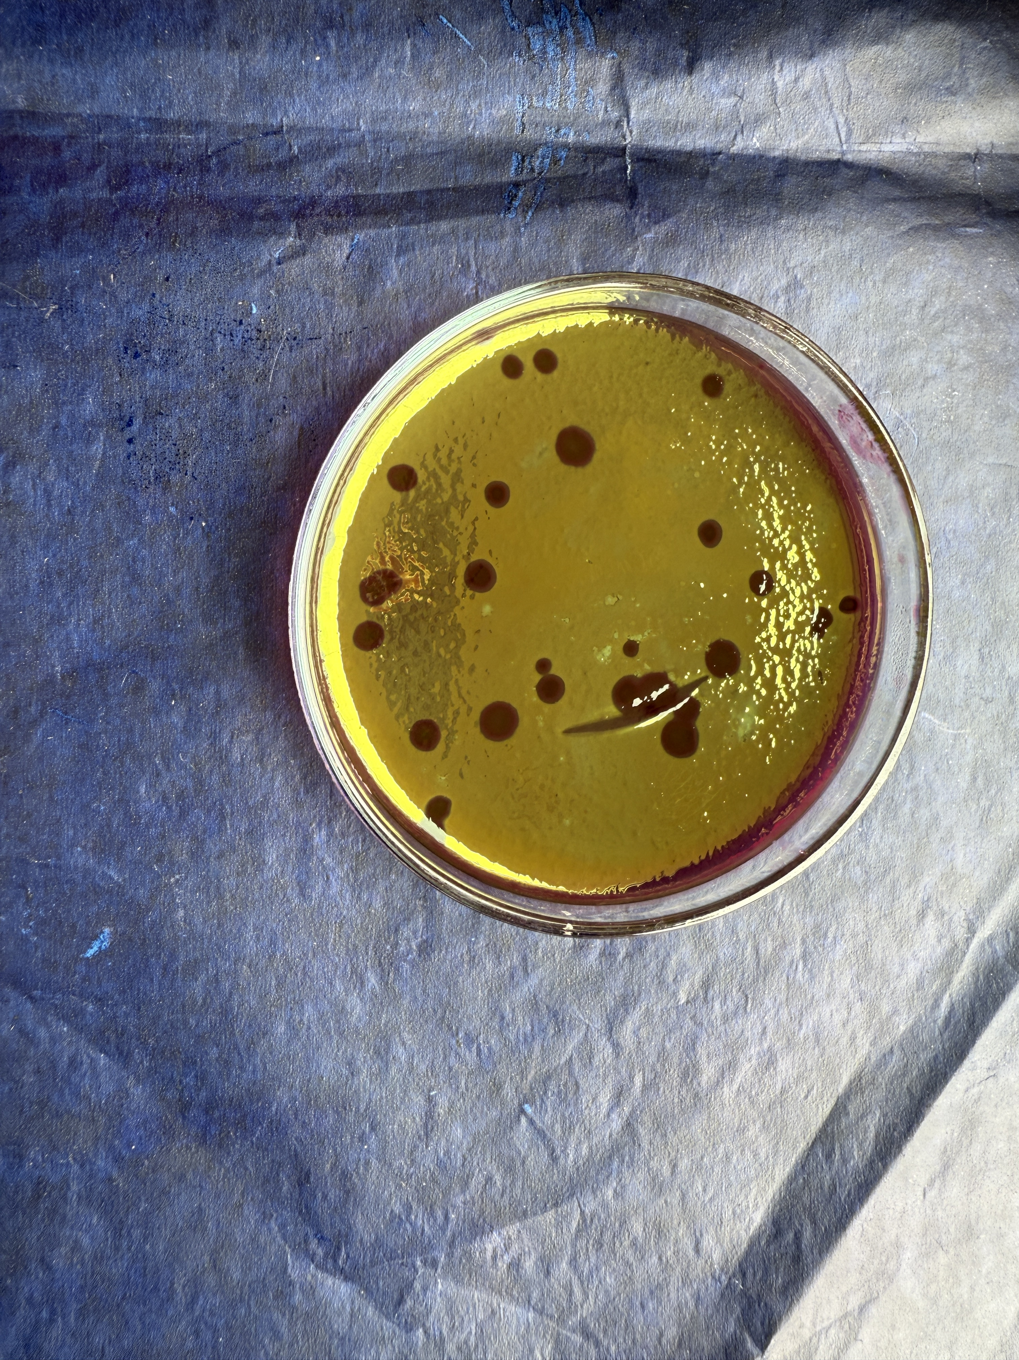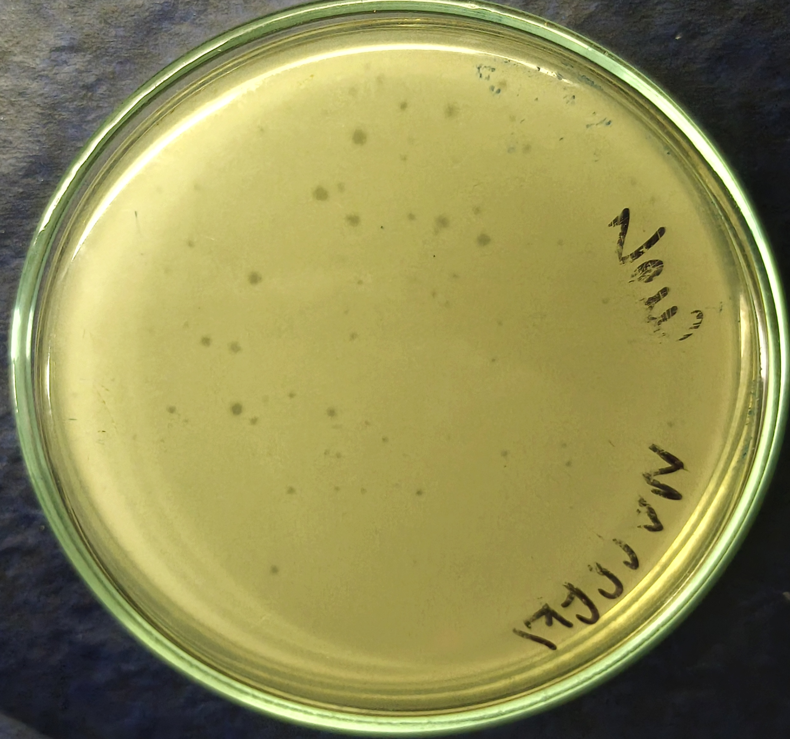
A. B.
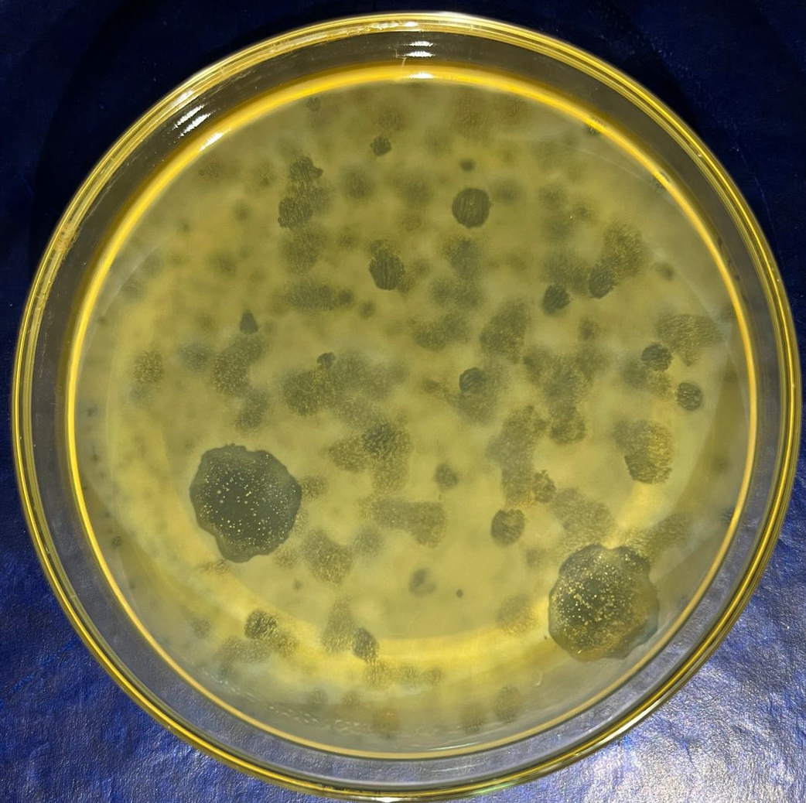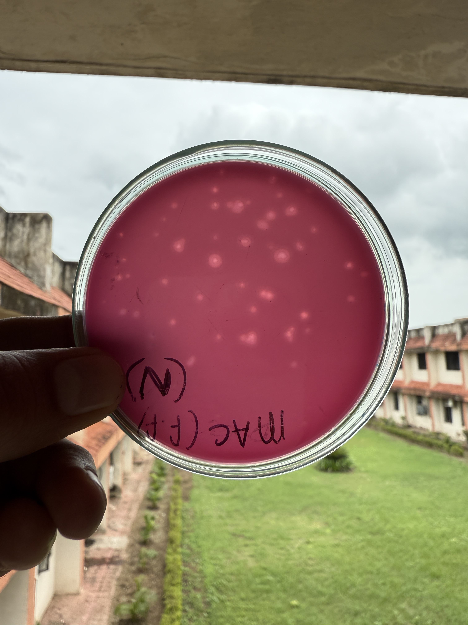
C. D.
Figure A. Plaques formed on EMB agar showing metallic sheen and clear lytic zones Figure B. Plaques on Nutrient agar showing faint, small lytic areas.
Figure C. Well-defined, circular plaques on Luria–Bertani agar.
Figure D. Faint plaques on pink MacConkey agar.

The results of this study provide important insights into how different culture media influence bacteriophage plaque development, host–phage interactions, and overall assay sensitivity. As phage-based applications continue to expand in antimicrobial therapy, environmental monitoring, and biotechnology, understanding the role of media composition becomes increasingly essential. The substantial differences observed across the four media tested in this study not only highlight the biochemical complexities underlying plaque formation but also demonstrate how subtle variations in nutrient content, inhibitors, and dye components can drastically alter phage visibility and enumeration accuracy.

Moreover, these findings reinforce the broader scientific understanding that plaque formation is not solely dependent on phage virulence or host susceptibility, but is equally influenced by the physical and chemical characteristics of the medium itself. In the context of environmental phage isolation where phage concentrations are often low selecting an optimal medium becomes critically important to avoid false negatives or underestimation of phage populations. Thus, beyond methodological comparison, this work contributes to practical decision making for laboratories engaged in routine phage screening and diagnostic assay development.

3.1 General Observations

Phages produced distinct plaques on all four media, confirming successful enrichment of lytic bacteriophages against E. coli. Differences in plaque morphology size, clarity, edge definition, and halo formation were observed due to medium composition, nutrient availability, and selective inhibitors. These findings align with widely reported influences of media on phage replication dynamics (Li et al., 2023).
3.2 Comparative Performance of Media
Complex media like LBA and EMB provide optimal conditions for both bacterial metabolism and phage adsorption, while selective media like MacConkey may restrict bacterial density and reduce plaque clarity. However, plaque appearance varied considerably depending on the agar composition (Table 1).
Table- 1: Comparative plaque morphology and phage titers of E. coli bacteriophages on different culture media
Media | Average Plaque Size (mm) | Plaque Appearance | Estimated Phage Titer (PFU/mL) | Observations
LBA | 3–5 | Clear, circular | 4.7 × 10³ | Large and distinct plaques; strong lysis
EMB | 2–4 | Clear with halo | 4.1 × 10³ | Good diffusion; mild depolymerase activity
Nutrient Agar | 2–3 | Clear to slightly turbid | 3.6 × 10³ | Moderate plaque size; consistent lysis
MacConkey Agar | 1–2 | Turbid | 3.2 × 10³ | Small plaques; weak lytic activity

3.3 Luria–Bertani Agar (LBA): Optimal Medium for Phage Recovery
LBA produced the largest, clearest plaques, suggesting efficient adsorption and lytic activity. As a nutrient-rich, non-selective medium supporting rapid bacterial proliferation, LBA fosters ideal conditions for phage-host interactions. This agrees with the findings of Li et al. (2023), who observed enhanced plaque clarity on LBA compared to selective media.
Phage diffusion in the soft agar layer was superior on LBA, likely due to stable agar consistency and absence of growth-limiting agents. The higher titer recorded indicates optimal phage replication cycles, consistent with classical phage assay literature (Hyman & Abedon, 2010)
3.4 EMB Agar: Enhanced Contrast and Halo Formation
EMB supported moderately large plaques with pronounced halos. Halo formation is commonly associated with depolymerase-producing phages capable of degrading exopolysaccharides around E. coli colonies. The medium’s dyes (eosin and methylene blue) offered visual contrast, aiding plaque detection.

However, EMB is semi-selective, and while supportive, it can slightly delay bacterial growth relative to LBA. Despite this, EMB's strong contrast may be advantageous when screening samples containing mixed phage populations.

3.5 Nutrient Agar: Moderate Plaque Development

Nutrient Agar supported moderate plaque development. The plaques were clear but smaller compared to those on LBA. This is consistent with studies noting that lower nutrient availability can reduce bacterial lawn density, phage burst size, and plaque expansion.

Still, NA provided consistent plaque formation and may serve as an economical alternative where high resolution is not critical.

3.6 MacConkey Agar: Least Suitable for Phage Visualization

MacConkey Agar produced the smallest and most turbid plaques. The selective components—bile salts and crystal violet—restrict the growth of Gram-positive organisms but also partially inhibit E. coli, especially in soft agar overlays. Inhibited bacterial growth reduces lawn uniformity and slows phage propagation, resulting in faint plaques.

These observations are supported by previous findings that selective media hinder phage-host interactions and mask plaque visibility. Despite this, plaques were still detectable, indicating phage robustness.

3.7 Influence of Media Composition on Phage Infection Dynamics

Phage plaque morphology is shaped by multiple biochemical and physiological interactions:

Nutrient content affects bacterial metabolic rates, impacting phage replication cycles.

Selective agents (e.g., bile salts) may disrupt bacterial outer membranes, modifying adsorption sites.

pH indicators and dyes alter contrast and sometimes affect phage diffusion.

Agar concentration influences plaque diameter by regulating phage mobility.

Similar findings were documented by Yan et al., 2022, who emphasized the importance of media optimization in phage biology.

3.8 Implications for Phage Therapy and Environmental Surveillance

Given renewed interest in phage therapy, standardization of plaque assays is crucial. LBA’s superior support for phage isolation makes it ideal for therapeutic phage screening. EMB may be advantageous in differentiating phages with depolymerase activity, useful in biofilm-targeting strategies. Environmental monitoring programs may select media depending on target strains, desired clarity, and required sensitivity.

The analysis demonstrated a significant effect of culture medium on bacteriophage recovery (F = 105.32, p < 0.0001). Tukey HSD post-hoc comparisons revealed that LBA produced significantly higher titers than EMB, NA, and MacConkey agar (p < 0.01). EMB also yielded significantly greater titers than NA and MacConkey agar (p < 0.05), while NA titers were significantly higher than those on MacConkey agar (p < 0.05). These results confirm that LBA is statistically superior for phage isolation and visualization (Table 2).
Table: 2 One-way ANOVA summary
Source | SS | df | MS | F | p-value
Between Groups | 12500000.0 | 3 | 4170000.0 | 105.32 | <0.0001
Within Groups | 2350000.0 | 16 | 147000.0
Total | 14850000.0 | 19

5. Conclusion
The choice of culture medium significantly influences the isolation and plaque morphology of bacteriophages. Among the tested media, Luria–Bertani Agar yielded the highest plaque clarity and phage titer, followed by EMB, Nutrient Agar, and MacConkey Agar. LBA is therefore recommended as the preferred medium for routine isolation and enumeration of E. coli bacteriophages from environmental sources.
Limitations
The present study did not include explicit negative control plates (host bacteria without added phage) or a positive control using a reference phage preparation. Although plaque morphology and host lysis were consistent with phage activity, the absence of these controls is a methodological limitation. Future experiments should incorporate standardized negative and positive controls to further validate plaque formation and assay performance across media.

6. Future Scope
1. Conduct genomic and proteomic characterization of the isolated bacteriophages to confirm their lytic nature and safety for therapeutic use.
2. Evaluate phage stability under varying temperature and pH conditions to determine optimal storage and application parameters.
3. Extend host range studies to include other enteric bacteria for potential use in wastewater biocontrol.
4. Develop phage formulations or cocktails for use in livestock sanitation and environmental management.
5. Integrate molecular identification and sequencing to classify the isolated phages into known families or novel groups.
Acknowledgement
The authors express their sincere gratitude to the Department of Veterinary Microbiology, College of Veterinary Science & A.H., Anjora, Durg (Chhattisgarh), India, for providing laboratory facilities and support during the course of this research. Special thanks to the staff of the Dairy and Poultry Units for their assistance in sample collection.

8. DISCLAIMER (ARTIFICIAL INTELLIGENCE)
Author(s) hereby declare that generative AI technologies such as Large Language Models, etc have been used during writing or editing of this manuscript. This explanation will include the name, version, model, and source of the generative AI technology and as well as all input prompts provided to the generative AI technology.
Details of the AI usage are given below:
1.Writesonic
2.Copy.ai
3.Clude

8. References
Adams, M. H. (1959). Bacteriophages. Interscience Publishers, New York.
Ackermann, H. W. (2012). Bacteriophage electron microscopy. Advances in Virus Research, 82, 1–32.
Dion, M. B., Oechslin, F., & Moineau, S. (2020). Phage diversity, genomics and phylogeny. Nature Reviews Microbiology, 18, 125–138.
Hyman, P., & Abedon, S. T. (2010). Bacteriophage host range and bacterial resistance. Advances in Applied Microbiology, 70, 217–248.
Li, J., Azam, A. H., et al. (2023). Optimization of phage isolation medium and host growth conditions for enhanced detection of environmental bacteriophages. Applied and Environmental Microbiology, 89(5).
Rahimzadeh, G., Resch, G., Rezai, M. S., & Nemati Hevelaee, E. (2020). Characterization and lytic activity of isolated Escherichia coli bacteriophages against Escherichia coli in vitro. Iranian Journal of Medical Sciences, 45(4), 298–303.
Salmond, G. P. C., & Fineran, P. C. (2015). A century of the phage: Past, present and future. Nature Reviews Microbiology, 13(12), 777–786.
Yan, J., Mao, D., Luo, Y., & Wang, L. (2022). Influence of agar media composition on bacteriophage infection dynamics and plaque characteristics. Microorganisms, 10(4), 811.
Gallet, R., Kannoly, S., & Wang, I. N. (2011). Effects of bacteriophage traits on plaque formation. BMC microbiology, 11(1), 181.
Poniatovskyi, V. A., Shyrobokov, V. P., & Bobyr, V. V. (2025). The influence of different components of nutrient bacteriological media on plaque formation of bacteriophages. Вісник проблем біології і медицини, (1), 390-399.
Ramesh, N., Archana, L., Madurantakam Royam, M., Manohar, P., & Eniyan, K. (2019). Effect of various bacteriological media on the plaque morphology of Staphylococcus and Vibrio phages. Access Microbiology, 1(4), e000036.
Northrop, J. H. (1952). The effect of various culture media on infection, growth, lysis, and phage production of B. megatherium. The Journal of General Physiology, 35(3), 471.

