Cloning and Expression of ORF 2 Protein of PCV2 in Pichia Pastoris

ABSTRACT
Porcine circovirus type 2 (PCV2) is a major pathogen responsible for post-weaning multisystemic wasting syndrome in pigs, causing significant economic losses in the swine industry. The ORF2 gene of PCV2 encodes the capsid (Cap) protein, the primary immunogenic component and a key target for vaccine development and serological diagnostics. In this study, the ORF2 gene was cloned and expressed in Pichia pastoris X-33 to establish a eukaryotic expression system for the recombinant Cap protein. Codon optimization was employed to enhance expression efficiency in the yeast host. Successful cloning was confirmed by restriction analysis and PCR, while expression of recombinant Cap protein was verified by SDS-PAGE and western blotting. These results highlight P. pastoris as a robust platform for the large-scale production of PCV2 Cap protein, providing a foundation for future subunit vaccine development and improved diagnostic strategies against PCV2 infection.
Key words: Porcine Circovirus 2, ORF2, Cloning and expression, Pichia pastoris
- INTRODUCTION
The pig rearing and pork industry in India is a steadily expanding sector that plays a crucial role in ensuring food security and improving the livelihoods of economically weaker communities. Rearing pigs provides a reliable source of income and contributes to poverty reduction and employment generation, particularly in rural and tribal regions.
Porcine circovirus diseases (PCVD) refer comprise a group of clinical and subclinical syndromes associated with circovirus infections in pigs. Among the various syndromes post-weaning multisystemic wasting syndrome (PMWS) plays a significant role. Other diseases associated are reproductive disorders (PRDC) (Sanchez et al., 2001; Mateusen et al. 2007), enteritis (Kim et al., 2004; Opriessnig et al., 2007), respiratory disease (Kim et al., 2003; Wellenberg et al., 2010) and porcine dermatitis and nephropathy syndrome (PDNS) (Allan et al., 2000). “Porcine circovirus (PCV), belongs to the genus Circovirus and family Circoviridae are small, non-enveloped, icosahedral viruses containing single-stranded circular DNA genome organized in a typical ambisense pattern of about 1.76 kb” (Tischer et al., 1974). The PCV2 genome has been proposed to contain approximately 11 potential open reading frames (ORFs), which are predicted to encode proteins with molecular masses ranging from 36 to 2 kDa (Hamel et al., 1998). ORF2 encodes the major capsid (Cap) protein molecular mass of 30 kDa. (Nawagitgul et al., 2000). Capsid proteins encoded by open reading frame 2 (ORF2) have been shown to be immunogenic, making them promising candidates for vaccine development (Blanchard et al., 2003). Expression of ORF2 protein in Pichia pastoris expression system with prioritizing P. pastoris possesses the necessary machinery for proper protein folding post-translational modifications (Muzaffar et al., 2025), including glycosylation, use of a strong promoter derived from the alcohol oxidase I (AOX1) gene achieving high cell density (Creg et al., 2009), considered safe for producing recombinant proteins and avoids endotoxin contamination unlike in E.coli with only drawback of codon bias (Hu et al., 2011; Karbalaei et al., 2020).
The aim of this study was to achieve efficient expression of the PCV2 capsid (Cap) protein in the Pichia pastoris X-33 host system by employing a codon-optimized ORF2 gene. This approach was designed to enhance translation efficiency and protein yield, facilitating the production of recombinant ORF2 protein for potential applications in vaccine development and immunological studies.
- MATERIALS AND METHODS
  - Codon optimization of ORF2 gene
The ORF2 gene was codon-optimized based on the sequence of the PCV2 isolate deposited in GenBank (Accession No. OP455998.1). The GC content percentage of the opti-Cap gene was adjusted to 49.6 %. One stop codon was added at the C terminus to form a termination signal after His-tag sequence for easier protein purification. The optimized ORF2 gene fragment was ligated into the pPICZalphaA vector between EcoRI and NotI restriction sites. The optimized ORF2 gene was synthesized and provided by GenScript (USA).The recombinant plasmids pPICZalphaA with optimized ORF2 gene were transformed in to DH5α cells.
  - Confirmation of E.coli DH5α transformants
    - Restriction analysis and Polymerase chain reaction:
The transformed colonies were confirmed by restriction digestion analysis and PCR. The colonies were inoculated in LB broth with Zeocin (25 ug/mL) and incubated at 37°C overnight. The Plasmid DNA was extracted by using miniprep kit Smart prime Plasmid extraction kit. The primers used for confirmation of transformants are; AOX1 F – 5’ GACTGGTTCCAATTGACAAGC 3’, AOX1 R–– 5’ GCAAATGGCATTCTGACATCC (Invitrogen) and also subjected with restriction digestion analysis by using restriction enzymes EcoRI and NotI. The double digested products were separated in 1% agarose gel, visualized and gel documented.
  - Chromosomal insertion of recombinant shuttle vector pPICZαA into expression host Pichia pastoris strain X-33
    - Linearization of cloned plasmid\
The cloned pPICZαA plasmid was extracted from the E. coli DH5α recombinants. Recombinant cloned plasmid was linearized using the SacI restriction enzyme for chromosomal insertion of recombinant shuttle vector pPICZαA to get plasmid concentration of 10μg for efficient transformation by electroporation.
    - Competent cell preparation of Pichia pastoris X-33
P. pastoris X-33, 750μl culture in Yeast Extract Peptone Dextrose (YPD)' broth was inoculated to a 50 ml of YPD broth. It was incubated at 28°C at 210 rpm till the OD reaches 1.0. When the OD reached to 1.0, the culture was taken for competent cell preparation. The 50 ml of P. pastoris X-33 culture was centrifuged at 10,000 rpm for 10 minutes at 4°C. The supernatant was discarded and cells were resuspended in equal volume of ice-cold sterile (distilled & autoclaved) water and this step was repeated twice. To the pellet equal volume of ice-cold sterile 1M sorbitol was added and this step was also repeated one more time. Finally with the pellet 1 ml of ice-cold sterile 1M sorbitol was added and mixed gently by keeping over ice and used for transformation.
2.3.3. Electroporation
Purified linearized plasmid (20 μL) was electroporated into competent pastoris strain X-33 cells (100 μL) through Gene Pulser X cellTM Electroporation System (BioRad Laboratories Inc., USA). The electroporation was accomplished at 2mm Gene Pulser cuvette in exponential decay pulse type at a voltage of 1500V, capacitance of 50 uF (micro farad) and a resistance of 250 Ω (ohm). Immediately, 1ml of sorbitol was added in to the Gene Pulser cuvette.
    - Selection of high copy recombinant in YPD+ zeocin agar plate
After electroporation was over, the electroporated P. pastoris strain X-33 cells were plated in YPD + zeocin (100 ug/ml) and YPD + zeocin (500 ug/ml) agar plates. The host P. pastoris strain X-33 without insert (uncloned host/ empty host) was plated as control. Plates were incubated at 28°C. Selection of high copy P. pastoris X33 recombinants was done in YPD + zeocin (500 ug/ml) agar plate.
    - Screening of recombinant Pichia pastoris strain X-33 clones
The recombinant P. pastoris strain X-33 clones were screened through of extraction of genomic DNA or the chromosomal DNA of suspected colonies after inoculation and growth in YPD + zeocin broth (1ug/ml).
    - Confirmation of clones by PCR

      - Optimized PCV2 PCR: The recombinant clones were screened through PCR by extracting yeast chromosomal DNA using the primers Opti-PCV 2 F and Opti-PCV 2-R. Full length optimized gene sequence of ORF 2 size was 705 bp. Out of that 299 bp was selected partially for primer designing to confirm the insert in the yeast chromosomal DNA using Primer3 plus software.
      - Another PCR was carried out using the primers AOX1-F and Opti-PCV 2-R.
  - Yeast expression studies
The protein was expressed from selected Mutt recombinants in Buffered methanol-complex (BMMY) medium under the control of methanol inducible AOXl promoter. The composition of BMMY medium includes, 8 ml of YP broth, 1 ml of 10X sterile phosphate buffer (1x final concentration), 1 ml of filter sterilized 10x yeast nitrogen base (YNB) (1x final concentration), 20 ul of 500x biotin solution (1x final concentration) and 0.5% of final concentration of absolute methanol. The culture in BMMY medium was induced with methanol of appropriate concentration. Culture was induced with methanol (0.5%) for 24hrs and 1% afterwards. The induction was continued up to 120 hrs and collection of induced culture aliquots (500 μL) on every 24 hours interval.
    - SDS-PAGE and Western blot assay:
The supernatant of the original samples were concentrated 20% trichloroacetic acid and cell pellet was added with Phosphate buffer saline (PBS) and equal volume of glass beads were added and vortexed with intermittent cooling. The supernatant of samples and cell pellet lysed supernatant was boiled at 95◦C for 7 mins in SDS-loading buffer and then separated on 12.5 % SDS-PAGE gel and were electrotransferred onto a nitrocellulose membrane using a TransBlotTM Semi-Dry Transfer Cell (Bio-Rad, USA). The nitrocellulose membrane was blocked overnight with 1% Bovine serum albumin at 4 °C, incubated overnight at 4 °C with a 1:1000 dilution of PCV2 capsid monoclonal antibody (GeneTex). After washing with PBST, the membrane was incubated with HRP-conjugated antimouse IgG antibody (Thermoscientific) for 2 hrs. After further washing, the signal was detected using the 3,3′-diaminobenzidine substrate with metal enhancer (Sigma) as directed by the manufacturer.
- RESULT AND DISCUSSION
  - Codon optimization of ORF 2 gene
For achieving higher heterologous expression in Pichia pastoris, the codons of the PCV2 were systematically optimized to conform to the preferred codon usage bias of the host genome, without altering the primary amino acid sequence. During the optimization process, critical parameters including codon usage bias, GC content, Restriction sites that could hinder cloning and RNA instability motifs were composition were rigorously assessed for codon optimization.
The optimized ORF2 gene exhibited a Codon Adaptation Index (CAI) of 0.95 (Puigbo et al., 2008), indicating an optimal codon usage for efficient expression in the selected host system, whereas the native sequence showed a comparatively lower CAI value of 0.6. (Fig.1)
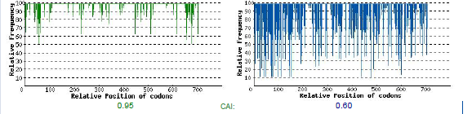
Fig. 1 Codon adaptation index of native sequence from 0.6 to optimized sequence of 0.95
  - Confirmation of E. coli DH5α transformants
Recombinant white colonies containing the optimized ORF2 gene transformants were observed on LB plates supplemented with Zeocin after 18- 24hrs at 37°C overnight incubation
The transformants were confirmed by PCR using AOX1 sequencing primers, amplified a product size of corresponding to the size of AOX1 gene plus the inserted ORF2 gene (705 bp+588 bp=1293 bp). For the control (pPICZαA), band amplified from the native AOX1 gene in pPICZαA (588 bp), and the AOX1 gene in the chromosome of P. pastoris were observed (Fig. 2).
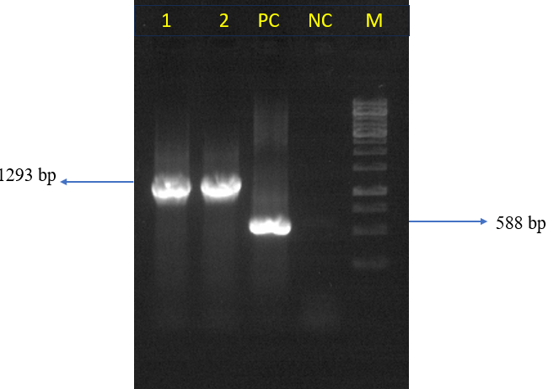
Fig.2 PCR reaction showing confirmed transformants containing AOX1gene with ORF2 insert. Lane 1 and 2 AOX1 gene with insert ORF2 gene (705 bp+588 bp=1293 bp). PC-Positive control- native AOX1 gene in pPICZαA without insert, NC-Negative control, M- 1kb DNA ladder
Enzymatic digestion of the ORF2/pPICZαA vector with EcoRI and Not I released a 705 bp fragment, confirming the successful cloning of the codon-optimized full-length PCV2 Cap gene (ORF2) into pPICZαA (Fig. 3).
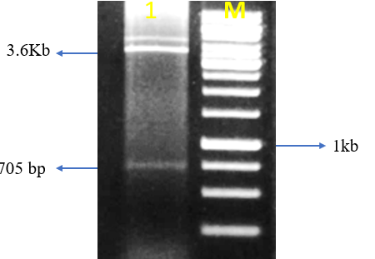
Fig. 3 Enzymatic digestion of the PCV2 /pPICZαA transformants in E.coli DH5α. Lane 1. The reaction resulted in the release of the ORF2 gene with 705 bp from 3.6kb vector. Lane M: 1Kb DNA ladder.
  - Analysis of recombinant yeasts and the detection of ORF2 protein
After linearisation of E. coli DH5α (Fig. 4) and successful electroporation, after 3-5 days of incubation, white colonies indicative of Pichia pastoris transformants were observed after transformation with the PCV2/pPICZαA both in 100 ug/ml and 500 ug/ml zeocin resistance plates (Fig 5 & 6).

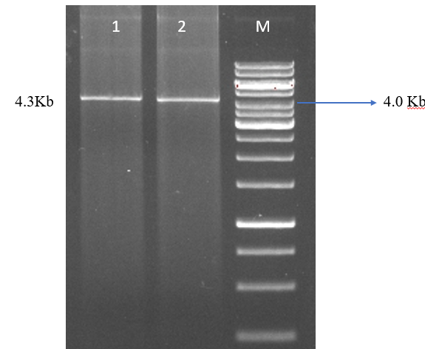
Fig. 4. Linearised pPICZαA/PCV2 for chromosomal insertion in to eukaryotic expression host P. pastoris X-33. Lane 1 and 2 Linearised Plasmid pPICZαA/PCV2 and M- 1kb DNA ladder
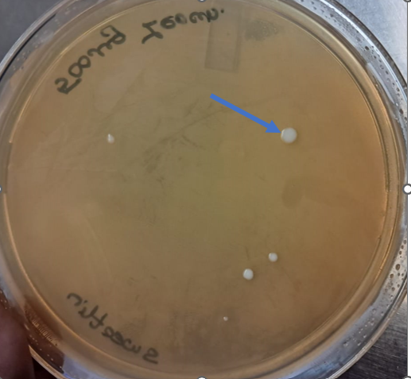  Fig.5. Recombinant P. pastoris clones on yeast peptone dextrose (YPD) agar after 3 days of incubation. | 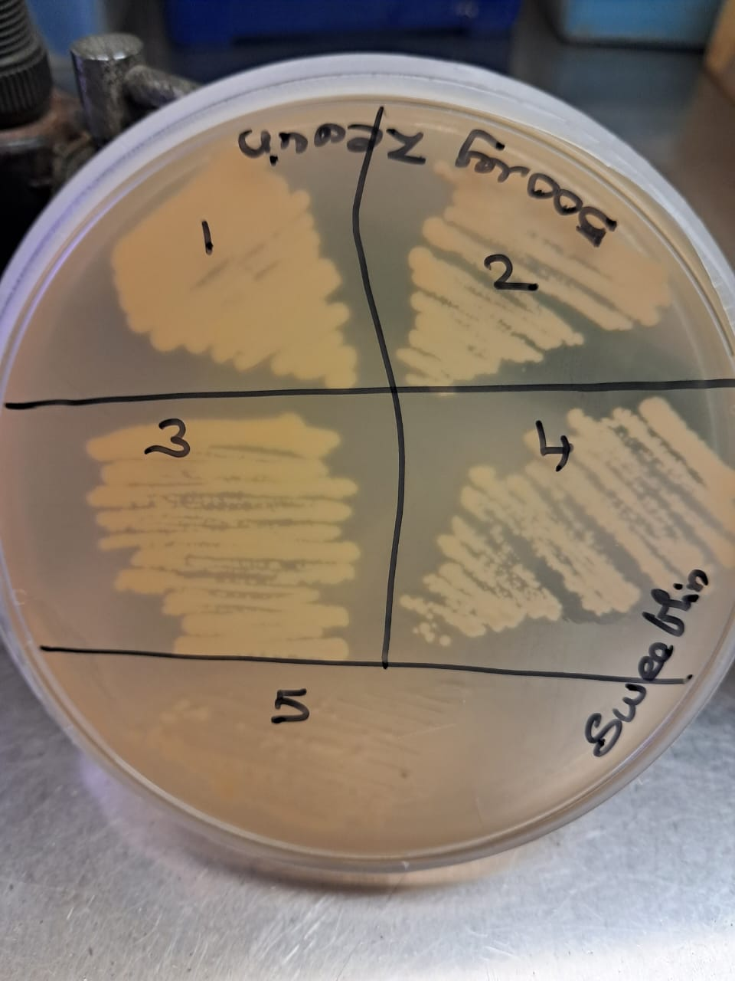  Fig. 6. Screening of High copy number zeocin resistant P. pastoris X-33 transformants on YPD plate with zeocin concentration of 500 µg/ml zeocin
Confirmation of transformants in P. pastoris by PCR. One set of PCR verification of the recombinants was performed using 5’and 3’ optimized partial gene sequence primers amplified a product size of 299 bp (Fig. 7.) and another set PCR confirmation done with AOX1 forward primer and Opti-PCV 2-Reverse amplified product size of 887 bp (299+588 bp=887 bp) (Fig 8).
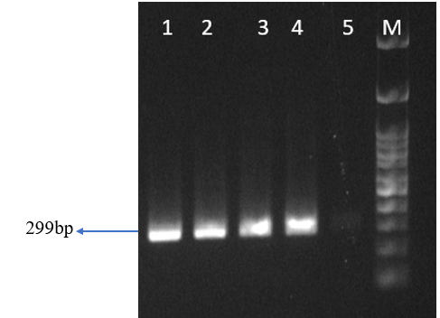
Fig.7 PCR reaction showing positive tranformants in P. pastoris from different clones. Lane 1 to 5. Partial ORF2 gene clones, M- 500bp DNA ladder. 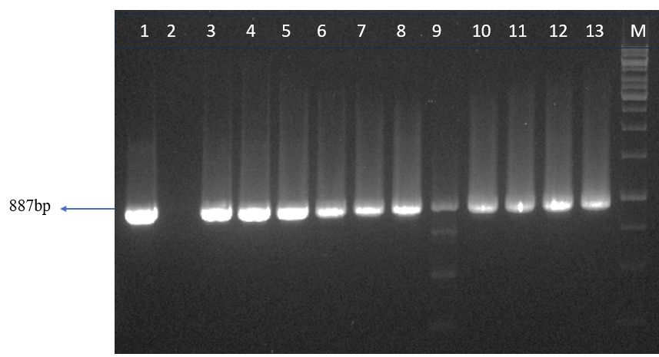
Fig.8 PCR reaction showing positive transformants in P. pastoris from different clones. Lane 1 to 13- amplified product size of 887 bp (299+588 bp=887 bp), M- 1kb DNA ladder.
All induced sample supernatant from PCR positive transformants in SDS-PAGE showed no bands on the expected size. While the recombinant proteins expressed intracellularly could be identified on SDS-PAGE on expected size from 38-41kDa (Fig. 9A) and on Westernblot using PCV2 capsid monoclonal antibody, whereas no reaction was observed in the negative control (P. pastoris cells -33 uninduced with methanol) (Fig.9B).

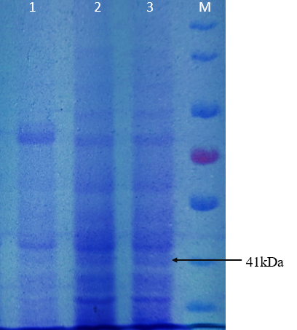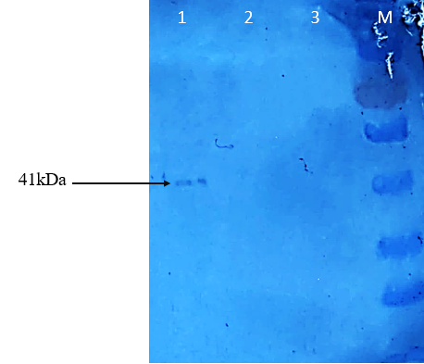
(A) (B)
Fig 9: SDS-PAGE (A) and Western blot (B) analysis of optimized ORF 2 positive transformants expression.
A). Lane M molecular weight marker (Thermoscientific), lanes 1- P. pastoris X-33 uninduced with methanol (Negative control), Lane 2,3 P. pastoris X-33 positive transformant induction at 48 hrs and 72 hrs.
B) Lane M molecular weight marker (Thermoscientific), Lane 1 P. pastoris X-33 positive transformant, Lane 2- P. pastoris X-33 uninduced with methanol, Lane – 3 empty pPICZαA.

In the present study, the porcine circovirus type 2 (PCV2) ORF2 gene encoding the capsid (Cap) protein was successfully cloned and expressed in Pichia pastoris X-33, demonstrating the yeast system’s efficiency as a eukaryotic host for recombinant protein production. The Cap protein, being the major immunogenic component of PCV2, plays a crucial role in viral assembly and helps in eliciting protective immune responses in pigs (Fort et al., 2007). Therefore, its heterologous expression in a cost-effective and scalable system such as P. pastoris offers substantial advantages over traditional baculovirus or mammalian cell expression systems.
Codon optimization of the ORF2 sequence significantly enhanced expression efficiency in P. pastoris. The optimized gene showed improved codon adaptation to the yeast host, leading to higher protein yield compared to the wild-type construct. Similar observations have been reported in the expression of viral structural proteins, where optimization improved translational efficiency and protein accumulation (Tu et al., 2013).
The recombinant PCV2 optimized ORF2 sequence exhibited an approximately the size of 41kDa which is slightly higher than the expected molecular weight of native 30kDa. The protein secreted in the cell pellet probably containing the α-mating factor signal peptide through consideration of the intracellular expression which is not removed. This is consistent with previous findings by Tu et al. (2013) and the presence of glycosylation sites in the cap protein (Hamel et al., 1998) and variation in protein mobility (Bucarey et al., 2009)
“The nuclear localization signal (NLS) present in the N- terminal region of PCV2-Cap play a critical role in gene expression and they are responsible for mediating nuclear accumulation of the protein” (Zhou et al., 2005; Liu et al., 2001). “NLS is an important domain for the formation of the inner surface of thevirion” (Lekcharoensuk et al., 2004; Wu et al., 2012). This could be the reason the protein failed to export to the secretory medium and results was opined with Tu et al. (2013).
Further, present data underscore the potential of P. pastoris for producing recombinant capsid protein of PCV2 for diagnostics and good target for vaccine candidate as a subunit vaccine with scaling up with large scale production.
- CONCLUSION
Pichia pastoris is an ideal heterologous system for expression for recombinant of protein was confirmed from this work. In future, this optimized cap gene could be ideal subunit vaccine candidate, to have a better control over disease.

Details of the AI usage are given below:
Artificial intelligence (AI) tools, including ChatGPT (OpenAI, GPT-5 model), were used to assist in language editing, grammar refinement, and stylistic improvement of the English version of the revised discussion and conclusion of this manuscript.
REFERENCES
Sanchez, R. E., Nauwynck, H. J., McNeilly, F., Allan, G. M and Pensaert, M.B.(2001). Porcine circovirus 2 infection in swine foetuses inoculated at different stages of gestation. Vet. Microbiol. 83, 169–176.
Mateusen, B., Maes, D.G., Van Soom, A., Lefebvre, D., Nauwynck, H.J. (2007) .Effect of a porcine circovirus type 2 infection on embryos during early pregnancy. Theriogenology, 68:896–901.
Kim, J and Chae, C. (2004). Expression of monocyte chemoattractant protein-1 and macrophage inflammatory protein-1 in porcine circovirus 2- induced granulomatous inflammation. J Comp Pathol 131:121–126.
Opriessnig, T., Meng, X. J., and Halbur, P. G. (2007). Porcine circovirus type 2 associated disease: Update on current terminology, clinical manifestations, pathogenesis, diagnosis, and intervention strategies. Journal of veterinary diagnostic investigation: official publication of the American Association of Veterinary Laboratory Diagnosticians, Inc, 19(6), 591–615.
Kim, J., Chung, H. K., and Chae, C. (2003) Association of porcine circovirus 2 with porcine respiratory disease complex. Vet. J. 166, 251–256.
Wellenberg, G. J., Bouwkamp. F.T., Wolf, P.J., Swart, W.A., Mombarg, M.J., et al., (2010) A study on the severity and relevance of porcine circovirus type 2 infections in Dutch fattening pigs with respiratory diseases. Vet Microbiol 142:217–224.
Allan, G. M., McNeilly, E., S., Kennedy, B., Meehan, D., Moffett, F., Malone, J., Ellis, et al., (2000). PCV-2-associated PDNS in Northern Ireland in 1990. Porcine dermatitis and nephropathy syndrome. Vet. Rec. 146,711–712.
Tischer, I., Rasch, R., and. Tochtermann, G. Characterization of papovavirus-and picornavirus-like particles in permanent pig kidney cell lines,” ZBL.BAKT.REIHE A, vol. 226, no. 2, pp. 153–167, 1974.
Hamel, A.L., Lin, L.L., and Nayar, G.P.S. (1998). Nucleotide sequence of porcine circoviruses associated with postweaning multisystemic wasting syndrome in pigs. J Virol 72:5262–5267.
Nawagitgul, P., Morozov, I., Bolin, S.R., Harms, P.A., Sorden, S.D., Paul, P.S. (2000). Open reading frame 2 of porcine circovirus type 2 encodes a major capsid protein. J.Gen. Virol. 81, 2281–2287
Blanchard, P., Mahe D, Cariolet R, Keranflec’h A, Baudouard MA, Cordioli P, Albina E, Jestin A (2003) Protection of swine against post-weaning multisystemic wasting syndrome (PMWS) by porcine circovirus type 2 (PCV2) proteins. Vaccine 21:4565–4575.
Muzaffar, N., Raziq, A., Khan, M.W., Khan, N.M., Shahid, N., Gul, A., and Ullah, H. (2025). Recent Developments in Heterologous Expression of Cellulases Using the Pichia pastoris Expression System: A Comprehensive Literature Review. Appl. Microbiol., 5(1), 22.
Cregg, J.M., Tolstorukov, I., Kusari, A., Sunga, J., Madden, K., Chappell, T. (2009) Expression in the yeast Pichia pastoris. Methods Enzymol 463:169–189
Hu, F., Li, X., Mao, P.H., Jin, X., Rao, B., Zheng, P., Zhou, Y.L., Sheng, Y.L., Ke, T., Ma,L.X. (2011). A visual method for direct selection of high-producing Pichia pastoris clones. BMC Biotechnol. 11, 23.
Karbalaei, M., Rezaee, S.A., and Farsiani, H (2020). Pichia pastoris: A highly successful expression system for optimal synthesis of heterologous proteins. J Cell Physiol, 235(9):5867–5881.
Puigbo, P., Bravo, I. G., and Garcia-Vallve, S. (2008). CAIcal: A combined set of tools to assess codon usage adaptation. Bioinformatics, 24(5), 608-609.
Fort, M., Olvera, A., Sibila, M., Segales, J., Mateu, E., (2007) Detection of neutralizing antibodies in postweaning multisystemic wasting syndrome (PMWS)-affected and non-PMWS-affected pigs. Vet Microbiol 125:244–255.
Tu, Y., Wang, Y., Wang, G., Wu, J., Liu, Y., Wang, S., et al.,(2013). High-level expression and immunogenicity of a porcine circovirus type 2 capsid protein through codon optimization in Pichia pastoris. Appl Microbiol Biotechnol, 97:2867–2875
Bucarey, S.A., Noriega, J., Reyes, P., Tapia, C., Sáenz, L., Zu˜niga, A., Tobar, J.A., 2009.The optimized capsid gene of porcine circovirus type 2 expressed in yeast formsvirus-like particles and elicits antibody responses in mice fed with recombinant yeast extracts. Vaccine 27, 5781–5790
Zhou, J.Y., Shang, S.B., Gong, H., Chen, Q.X., Wu. J.X., Shen, et al., (2005) In vitro expression, monoclonal antibody and bioactivity for capsid protein of porcine circovirus type II without nuclear localization signal. J Biotechnol 118:201–211.
Liu, Q, Tikoo, S.K., and Babiuk, L.A .(2001). Nuclear localization of the ORF2 protein encoded by porcine circovirus type 2. Virology 285:91–99
Lekcharoensuk, P., Morozov, I., Paul, P.S., Thangthumniyom, N., Wajjawalku, W.,Meng, X.J. (2004). Epitope mapping of the major capsid protein of type 2porcine circovirus (PCV2) by using chimeric PCV1 and PCV2. J. Virol. 78,8135–8145.
Wu, P.-C., Lin, W-L., Wu, C.M., Chi, J.N., Chien, M.S., Huang, C. (2012). Characterization of porcine circovirus type 2 (PCV2) capsid particle assembly and its applica-tion to virus-like particle vaccine development. Appl. Microbiol. Biotechnol. 95,1501–1507.

