Does fire exclusion impact insect communities? An insight with ants in three habitat types from Lamto Scientific Reserve, Côte d'Ivoire, West Africa

.
ABSTRACT

Vegetation fires remain one of the primary causes of habitat degradation and biodiversity loss in tropical forest-savanna mosaic ecosystems. However, their impact on certain components of biodiversity is often understudied, especially when fire is excluded from a given ecosystem for extended periods. This study aims to evaluate the effect of long-term fire exclusion on ant communities across three distinct habitat types within the Lamto Scientific Reserve, Côte d’Ivoire. Ants were sampled from January to May 2022 using standardized methods of Ant of Leaf Litter (ALL) protocol, soil monoliths and tuna lures. The study yielded 82 ant species belonging to 32 genera and 7 subfamilies including Amblyoponinae, Dolichoderinae, Dorylinae, Formicinae, Myrmicinae, Ponerinae and Proceratiinae. Results showed a strong variation in ant species between the three habitat types (X² = 28.57, df = 8, P= 0.001). The ant species richness was higher in annually Burned Savanna (47 species) than Gallery Forest (40 species) and Unburned Savanna (29 species). A dissimilarity in ant species composition was observed between three habitat types (ANOSIM: R = 0.56, df = 2, P= 0.014). However, Gallery Forest and Unburned Savanna were more similar (ANOSIM: R = 0.07, df = 1, P= 0.40) than annually Burned Savanna. This study provides a baseline dataset on ant community of an understudied habitat.. It demonstrated that ant communities of this savanna excluded from fire tend to be similar to ant communities of Gallery Forest. Although this study provides valuable information on the effect of long-term fire exclusion on ant communities, it is necessary to conduct further studies integrating other insect taxa to have a better understanding and reinforce knowledge on the effect of long-term fire exclusion on insects and biodiversity.

Keywords: Fire ecology, forest-savanna mosaic, insects, Formicidae

1. INTRODUCTION

Protected areas play a vital role for biodiversity conservation (Tomadon et al., 2019). This key role not only serves as refuge for biodiversity but, they contribute to poverty reduction by providing naturals resources and ecosystems services to surrounding habitats and local people (Li et al., 2024). However, these areas are prone to multiple pressures associated to human activities like urbanization, mining and agriculture expansion (Kalischek et al., 2023). The disturbances caused by human activities are jeopardizing ecological balances and threatening the livelihoods of local communities (Li et al., 2024). This degradation is exacerbated by climate change, which disrupts flora and soil macrofauna, which play an important role in maintaining the health of terrestrial ecosystems (Weiskopf et al., 2020).
Vegetation fires are among the main drivers of habitat degradation and threats to biodiversity (Afelu et al., 2016, Konko et al., 2021). In fact, fires contribute to greenhouse gas emissions (Ribeiro-Kumara et al., 2020; Singh, 2022) and changes in precipitation patterns and increasing temperatures (Dastour et al., 2024), thus, affecting biodiversity and accelerating the invasion by exotic species. For example, the increasing frequency of fires disrupts the growth and development cycle of certain species (Soro et al., 2021). For instance, the germination of fire-resistant seeds can be disrupted by the increasingly short intervals between fires and their growing intensity (Afelu et al., 2025). Fire also disrupts the natural habitat of many animal and plant species. This can lead to the loss of certain species, particularly those that are already endangered or have small populations. (Alba et al., 2015, Lee et al., 2024).
Among fauna, invertebrates are pointed out as a key component influencing the functioning and dynamics of savanna ecosystems (Walker et al., 2024; Madikana et al., 2025). Intensity and frequency of fires in savannas greatly affect the invertebrate communities. Among invertebrates, ants are a key component of savanna biodiversity. These insects are implied in many ecological functions such as seed dispersal, nutrient cycling and scavengers, directly influencing resilience and productivity (Kaplan & Eubanks 2005, Ouattara et al., 2023; Walker et al., 2024). Ants are also sensitive to environmental changes, and therefore, are commonly used as biological indicators for invertebrates and included in monitoring programs dealing on the pressure of human activities on biodiversity and ecosystems (Kone et al., 2018, Azcárate, et al., 2021, Walker et al., 2024).
In Lamto savanna, studies on fire had been implemented since the creation of reserve in 1961 in order to maintain the structure of vegetation i.e the coexistence of shrubs and trees (Dauget & Menault 1992, Dembélé 2008). Likewise, several studies were conducted on arthropods including ants, dealing with the effect of fire regimes (Kone et al., 2018), nutrient cycling (Ouattara et al., 2023) and their distribution above and below ground in forest-savanna mosaic areas (Yeo 2006). Despite these efforts, some habitats in Lamto reserve savanna remain unexplored and understudied. This is the case for “Unburned Savanna”, a plot of 50 hectares preserved from bushfire since more than 60-year-old. To address the limited data, understanding the “Unburned Savanna” ant assemblage will be useful in determining the effect of 60 years of fire exclusion on ants and by congruence on insects in Lamto Scientific Reserve habitat types.
In this study, we aim to address two objectives: (1) to provide baseline data for ant communities in “Unburned Savanna”; and (2) to evaluate differences in ant community considering surrounding annually burned savanna and gallery forest. This is a pioneer study that will help provide a preliminary understanding of long-term savanna fire exclusion on insects, like ants, and on global biodiversity.

2. material and methods

2.1 Study area
The study was conducted at Lamto Scientific Reserve (6°25′–6°13′N, 5°01′–4°97′W) located in Central Côte d'Ivoire, West Africa (Figure 1). The locality is under an intertropical climate. Over 4 seasons, there is an average temperature of 28.21˚C and an annual rainfall average of 1257 mm. Rainy seasons span from April to July and September to November (Yeo et al., 2017). Dry seasons occur in August and December to March (Yeo et al., 2017). The vegetation type is a forest-savannah mosaic with three main habitat types: the forest islands, the gallery forest and humid grassy savannah (Yeo et al., 2017). For this study, we sampled three different habitats (Figure 2): the “Unburned Savanna” (SaPr) and the “Gallery Forest” (FoGa) located on the border of Bandama River and the “Burned Savanna” (SaBr) submitted to annual vegetation fires (Menaut & Abbadie, 2006).
The Unburned Savanna (SaPr) is a plot of 50 hectares preserved from vegetation fires since 1961. This habitat reverted to forest after more than 60 years of fire exclusion. It is now dominated by trees species Ceiba pentandra (L.) Gaertn., Cola cordifolia (Cav.) R. Br., Milicia excelsa Welw., Carapa procera and Elaeis guineensis (Jacq.). In this habitat, decaying stumps of savanna palm tree, Borassus aethiopum (Mart.) Warb., are still present, indicating a past savanna ecosystem (Gautier, 1990).
The Gallery Forest (FoGa) is located at the border of the Bandama river. It is characterized by a well-closed canopy and a very sparse understory with a significant amount of litter. It has a homogeneous physical structure and is made up of woody forest species. The tree species are dominated by Croton scarciesii Sc. Elliot. and Cynometra megalophylla Harms. (Gueulou et al., 2018).
The annually Burned Savanna (SaBr) is a tropical grassland with herbaceous carpet, 0-2 m high. It consists mainly of Poaceae (75 to 99% of total biomass) and small Cyperaceae (Lamotte, 1967). On well-drained soils, the dominant species are Andropogon schirensis Hochst. ex A.Rich., Hyparrhenia diplandra Stapf., H. smithiana Stapf., and Imperata cylindrica, all belonging to the family Andropogoneae (Menaut & Abbadie 2006). This habitat is dominated by Borassus aethiopum Mart. palm trees (Gautier, 1990) and Crossopteryx febrifuga Benth., (Rubiaceae), Piliostigma thonningii (Schumach.) Milne-Redh., Bridelia ferruginea Benth., and Annona senegalensis Pers., (Menaut & Abbadie, 2006).

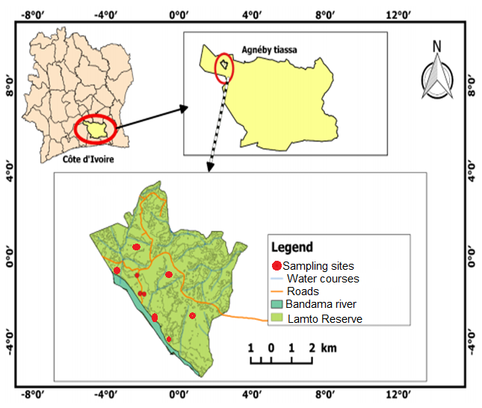

Figure 1. Map of the study sites

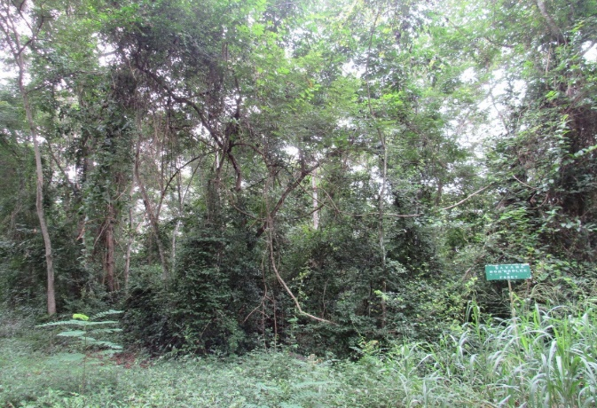
A

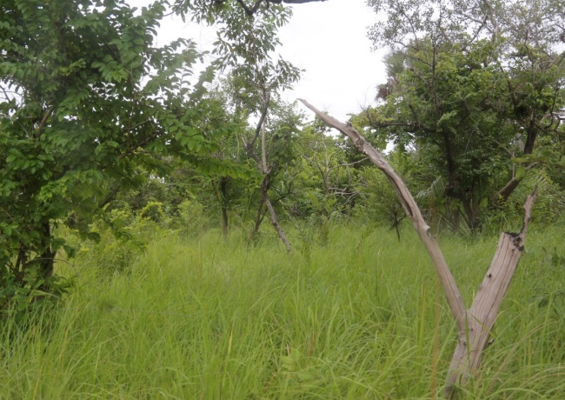
B

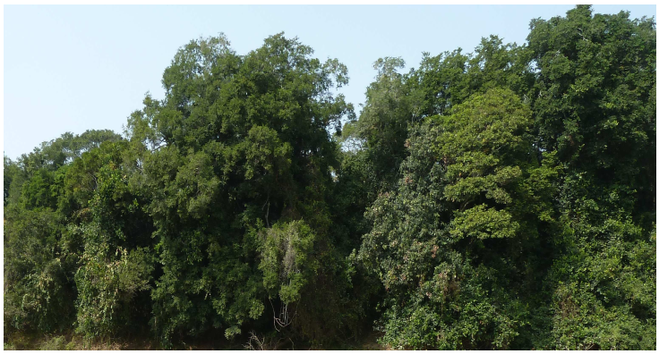
C

Figure 2. Sampled habitats during the study. (A): Unburned Savanna, (B): Burned Savanna and (C): Gallery Forest

2.2 Sampling and identification
Sampling was carried out from March to July 2022 in three habitats of the Lamto scientific reserve as described above. The sampling design consists of three transects per habitat type, each one being 200 meters long. The methods used are the ALL protocol, the monolith method, and bait using tuna lures (Bestelmeyer et al, 2000, Agosti et al., 2000; Yeo 2006, Devi et al., 2025).
Ant identification was made with an OLYMPUS SZ8 microscope. Ant workers were first sorted and separated on the basis of the morphological traits (Bolton 1994). Then, they were pinned and primarily identified at the genus level using Fisher and Bolton (2016). The species level identification was made using keys of Bolton (1980, 1982, and 1987) and from the personal ant reference collection from Yeo (2006) located in Lamto Ecological Station. Online resources like AntWeb (www.antweb.org) and Ant Catalogue (www.Antcat.org) were used for correct and up-to-date taxonomy and species names. All identified pinned specimens, as well as specimens in ethanol (90%), are deposited at Lamto Ecological Research Station, Côte d’Ivoire.

2.3 Data analysis
Statistical analyses pooled data of all sampling methods to ensure an accurate measurement of ant communities across all habitats. Relative abundance was first calculated by dividing the species' occurrence in a given habitat by the total occurrence of all species throughout the study. Our estimate of relative abundance was based on the occurrence of individual workers (absence/presence) rather than the total number of individuals (Yeo et al., 2011). This measure was preferred to the abundance of individuals because of the patchy distribution of ants ascribed to their social life, (Longino 2000) and due to great differences in colony size (Andersen 1991) Thus, we defined abundant species as all species whose occurrence is at least equal to 1% in the combined data. The sampling completeness was estimated using sample coverage calculated as the ratio of observed and estimated species richness using non-parametric estimator Chao 2 included in EstimateS 9.1 (Colwell et al., 2013). Alpha-diversity was estimated using species richness, Shannon’s index (H’), Simpson dominance index, Evenness and the number of unique species (rare species) in each habitat. Levene’s test for homogeneity of variance was used to test the normality of our data before comparing ant community between study sites. The Friedman test was then used for comparison between the three habitat types. Beta-diversity was estimated using Bray Curtis index to quantify the similarity of species composition between green spaces of the study sites. We then plotted a two-dimensional map with non-metric multidimensional scaling (NMDS) to examine the variation in ant species composition among land use type of both agroecological zones. An analysis of similarities (ANOSIM) by 10,000 permutations was conducted to test significant differences in species composition between land use types. A Venn diagram was also performed to show the common species between each habitat type. All these statistical analyses were made using Past Software v3.09 and R Software v4.4.3. The value of P ≤0.05 was taken as an indicator of statistical significance.

3. results and discussion

3.1 Results
3.1.1 Sampling efficiency
Understanding how insect communities respond to fire exclusion is important for biodiversity conservation. Our study provides a baseline across three different vegetation types. The evaluation of sampling efficiency using sampling coverage (more than 80%) and species accumulation curves revealed that overall, the effectiveness of our sampling is acceptable. Considering each habitat type, the sampling coverage ranked between 51% and 93% (Table 1). The species accumulation curves, which provide sampling completeness and habitat quality, showed an asymptotic trend with a consistent increase in species with each additional trap for all habitats combined (Figure 3A). The same trend was observed for Burned Savanna and Unburned Savanna (Figure 3B & 3D). However, for Gallery Forest, we found an important gap of 38 species between the observed and Chao 2 estimated species richness, showing a low sampling coverage in this habitat.

Table 1. Metrics of sampling effort in the three habitat types. Gallery Forest = FoGa; Burned Savanna= SaBr; and Unburned Savanna = SaPr

Habitats | Number of samples | Observed Species | Estimated species (Chao 2) | Sampling Coverage (%)
FoGa | 60 | 40 | 78 | 51.3
SaPr | 60 | 29 | 31 | 93.5
SaBr | 60 | 47 | 62 | 75.8
All Habitats | 180 | 82 | 102 | 80.4

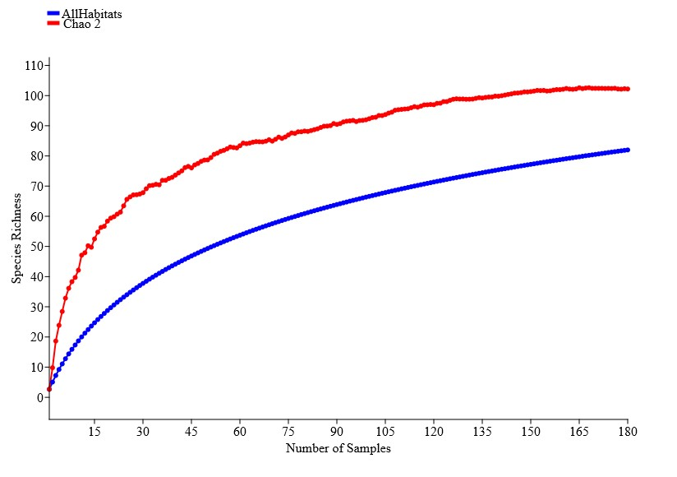
A

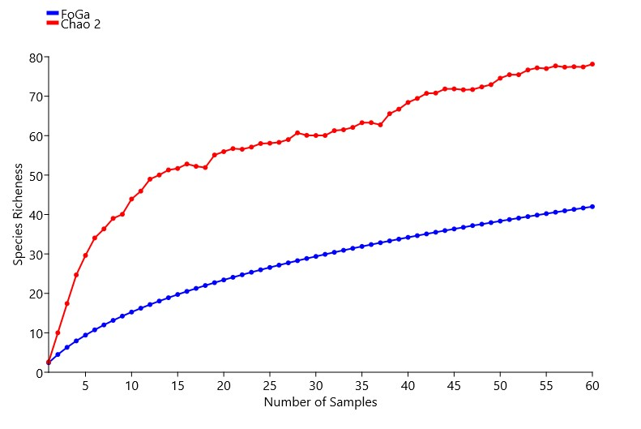
B

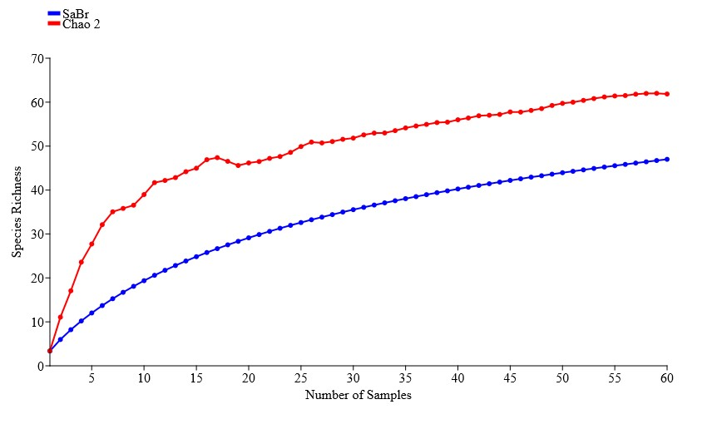
C

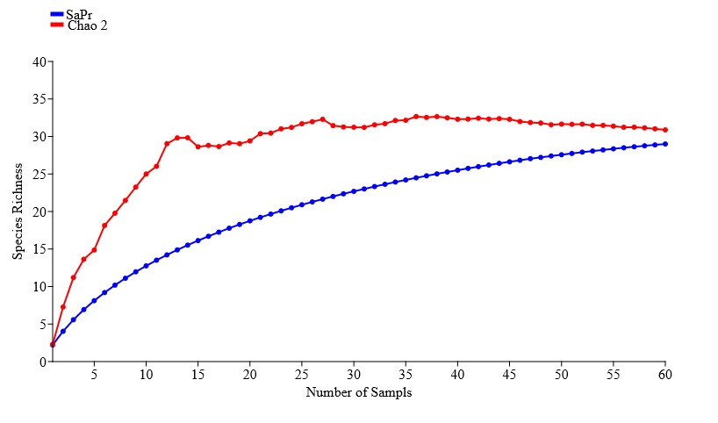
D

Fig. 3. Sample-based curves of Chao2 estimated species richness and rarefied species richnes of ant communities from sampled habitats: (A) All habitats combined, (B). Gallery Forest = FoGa; (C) Burned Savanna= SaBr; and (D) Unburned Savanna = SaPr

3.1.2 Taxonomical composition of ant community
This study recorded 82 species belonging to 32 genera and 7 subfamilies (Table 2). The ant community was dominated by three subfamilies: the Myrmicinae, which recorded more than one half of the total species of the whole study (43 species), followed by Formicinae (18 species), and Ponerinae (12 species). The other subfamilies were poor in species richness with Dorylinae (4 species) followed by Amblyoponinae (2 species), Dolichoderinae (2 species) and Proceratiinae (1 species). The 32 genera recorded include the genus Tetramorium (12 specimens) followed by Camponotus (8 specimens), Pheidole (7 specimens), Crematogaster and Carebara (6 specimens, respectively). The remaining generarecorded less than five specimens and the genus Probolomyrmex (1 specimen).

Table 2. Checklist of ant species collected and their relative abundance in the study

Subfamily /Species | Burned Savanna  (SaBr) | Unburned Savanna  (SaPr) | Gallery Forest (FoGa) | Total
AMBLYOPONINAE
Xymmer muticus | 0.75 | 0 | 0.41 | 1.16
Xymmer phungi | 0 | 0 | 0.52 | 0.52
DOLICHODERINAE
Tapinoma lugubre | 0.64 | 0.17 | 0.7 | 1.51
Tapinoma sp.2 | 0.06 | 0 | 0 | 0.06
DORYLINAE
Aenictus sp.7 | 0.06 | 0 | 0 | 0.06
Dorylus nigricans | 0 | 2.51 | 0 | 2.51
Dorylus sp.3 | 0.64 | 0 | 0 | 0.64
Parasyscia nitidulus | 0 | 0 | 0.06 | 0.06
FORMICINAE
Acropyga sp.1 | 0.06 | 0 | 0 | 0.06
Camponotus acvapimensis | 17.75 | 0 | 0 | 17.75
Camponotus compressiscapus | 0.3 | 0 | 0 | 0.3
Camponotus maculatus | 0.23 | 1.7 | 0.3 | 2.23
camponotus puberulus | 0.64 | 0 | 0 | 0.64
Camponotus schoutedeni | 0.12 | 0 | 0 | 0.12
Camponotus sp.1 | 0.06 | 0 | 0 | 0.06
Camponotus sp.2 | 0.46 | 0 | 0 | 0.46
Camponotus sp.3 | 0.06 | 0 | 0 | 0.06
Lepisiota sp.1 | 0.12 | 0 | 0.87 | 0.99
Lepisiota sp.3 | 1.74 | 0 | 0 | 1.74
Lepisiota sp.6 | 0.06 | 0 | 0 | 0.06
Nylanderia boltoni | 1.11 | 0 | 0 | 1.11
Nylanderia scintilla | 0.17 | 0 | 0 | 0.17
Oecophylla longinoda | 0 | 0.12 | 0.12 | 0.24
Plagiolepis sp.1 | 0 | 0.17 | 0 | 0.17
Plagiolepis alluaudi | 0.46 | 0 | 0 | 0.46
Polyrhachis sp.1 | 0.06 | 0 | 0 | 0.06
MYRMICINAE
Baracidris meketra | 0 | 0 | 0.06 | 0.06
Calyptomyrmex sp.01 | 0 | 0 | 0.12 | 0.12
Cardiocondyla neferka | 0 | 0 | 0.06 | 0.06
Carebara distincta | 0.64 | 1.7 | 0 | 2.34
Carebara thoracica | 0.35 | 0 | 0.76 | 1.11
Carebara lilith | 0 | 0.35 | 0.06 | 0.41
Carebara perpusilla | 0 | 0.93 | 0 | 0.93
Carebara sp.4 | 0 | 0 | 0.06 | 0.06
Carebara thoracica | 0 | 0.64 | 0 | 0.64
Cataulacus erinaceus | 0.06 | 0 | 0 | 0.06
Cataulacus sp.1 | 0.06 | 0 | 0 | 0.06
Crematogaster sp.1 | 0.7 | 1.45 | 0.99 | 3.14
Crematogaster sp.2 | 0.7 | 0.12 | 0.99 | 1.81
Crematogaster sp.3 | 0.17 | 0 | 0 | 0.17
Crematogaster sp.4 | 0 | 0.06 | 0 | 0.06
Crematogaster sp.6 | 0.02 | 0 | 0 | 0.02
Crematogaster sp.7 | 0.02 | 0 | 0.06 | 0.08
Crematogaster striatula | 0 | 0 | 1.45 | 1.45
Monomorium invidium | 0 | 0 | 0.06 | 0.06
Monomorium sp.2 | 0 | 0 | 0.76 | 0.76
Pheidole sp.1 | 0 | 0 | 0.058 | 0.058
Pheidole sp.2 | 0.99 | 0.41 | 0 | 1.4
Pheidole sp.3 | 0 | 3.38 | 1.75 | 5.13
Pheidole sp.4 | 0 | 0.12 | 0 | 0.12
Pheidole sp.6 | 0 | 4.25 | 4.02 | 8.27
Pheidole megacephala | 2.97 | 0 | 0 | 2.97
Pheidole sp.8 | 0.81 | 0.12 | 0.76 | 1.69
Strumigenys petiolata | 0 | 0 | 0.06 | 0.06
Strumigenys sp.1 | 0 | 0 | 0.17 | 0.17
Strumigenys rufobrunea | 0 | 3.5 | 0.12 | 3.62
Strumigenys sp.4 | 0 | 3.5 | 0 | 3.5
Tetramorium distinctum | 0 | 0 | 0.17 | 0.17
Tetramorium minimum | 0 | 0 | 0.12 | 0.12
Tetramorium rhetidum | 0.06 | 0.99 | 0 | 1.05
Tetramorium sericeiventre | 1.51 | 0 | 0 | 1.51
Tetramorium sp.1 | 0.81 | 0.41 | 0.12 | 1.34
Tetramorium sp.2 | 0.06 | 2.91 | 0.06 | 3.03
Tetramorium sp.3 | 0 | 0.06 | 0 | 0.06
Tetramorium sp.5 | 0.12 | 0 | 0.06 | 0.18
Tetramorium sp.6 | 0 | 0 | 0.23 | 0.23
Tetramorium sp.7 | 0.17 | 0 | 0 | 0.17
Tetramorium uelense | 0.23 | 0 | 0 | 0.23
Tetramorium zambezium | 0 | 2.91 | 0 | 2.91
PONERINAE
Anochetus sp.2 | 0.12 | 0 | 0 | 0.12
Asphintopone sylvestrii | 0.06 | 0 | 0.12 | 0.18
Euponera brunoï | 0.01 | 1.05 | 0 | 1.06
Hypoponera sp.1 | 0.4 | 0 | 0.93 | 1.33
Hypoponera sp.2 | 0.12 | 0 | 0.7 | 0.82
Hypoponera sp.3 | 0.35 | 0.06 | 0.7 | 1.11
Hypoponera inaudax | 0 | 0 | 4.6 | 4.60
Leptogenys sp.1 | 0 | 0 | 0.76 | 0.76
Mesoponera caffraria | 0 | 0.52 | 2.85 | 3.37
Odontomachus troglodytes | 0 | 0 | 1.57 | 1.57
Paltothyreus tarsatus | 0.17 | 3.38 | 0.64 | 4.19
Psallidomyrmex foveolatus | 0 | 0.12 | 0 | 0.12
PROCERATIINAE
Probolomyrmex sp.1 | 0 | 0 | 0.12 | 0.12
Total number of species | 47 | 27 | 40 | 82

3.1.3 Ant species richness, diversity and abundance across habitat types
Our study revealed a significant variation in ant species richness (Friedman test: X² = 28.57, df = 8, P= 0.01) across three habitat types. Out of 82 species yielded (Table 2), annually Burned Savanna recorded a higher number of species (47 species) than Gallery Forest (40 species) and Unburned Savanna (27 species). Results showed that Shannon diversity index does not change significantly between the three habitat types (ANOVA: F = 0.68, df = 2, P= 0.56) contrasting with the number of unique species, which decreases from Gallery Forest to annually Burned Savanna to Unburned Savanna (Table 3). Simpson dominance index decreases from Burned Savanna to Unburned Savanna to Gallery Forest. Evenness showed a contrasted trend and decreases from Burned Savanna to Gallery Forest to Unburned Savanna (Table 3).

Table 3: Metric of diversity index and number of unique species detected in different sampled habitat types. Gallery Forest = FoGa; Burned Savanna= SaBr; and Unburned Savanna = SaPr

Habitats | Shannon  diversity index | Simpson  Dominance | Evenness | Number  of Unique
FoGa | 3.7 | 0.05 | 0.57 | 21
SaPr | 3.4 | 0.08 | 0.58 | 7
SaBr | 3.9 | 0.20 | 0.30 | 17

3.1.4 Species composition and abundance
Ant species composition differed significantly between the three habitat types in Lamto Scientific Reserve (ANOSIM: R = 0.56, df = 2, P= 0.01). Two distinct communities were identified based on the species composition. One community accounting for the ant species found in the Gallery Forest and in the Unburned Savanna (ANOSIM: R = 0.07, df = 1, P = 0.40) and a second ant community represented by species from annually Burned Savanna (Figure 3). Out of 82 species, only nine ant species are shared between the three habitat types (Figure 4). These species include Paltothyreus tarsatus, Camponotus maculatus, Crematogaster sp.1, Crematogaster sp.2, Hypoponera sp.3, Pheidole sp.8, Tapinoma lugubre, Tetramorium sp.1 and Tetramorium sp.2. The Gallery Forest shared fifteen species with Unburned and sixteen species with Burned Savanna, while thirteen species were shared between Unburned and Burned Savanna (Figure 4).
Results showed a significant variation in ant abundance between habitats types (Friedman test:X² = 30.38, df = 8, P= 0.01). Relative abundance was higher in Burned Savanna than Gallery Forest and Unburned Savanna (Figure 5). In contrast, we did not observe a difference of ant abundance between Unburned Savanna and Gallery Forest. The Burned Savanna is dominated by five ant species with Camponotus acvapimensis being the most abundant (17.75% of total abundance). In Unburned Savanna, twelve species dominated the ant community with Pheidole sp. 6 (4.25% of total abundance) as the most abundant species. The community of Gallery Forest was dominated by six species with, also, Pheidole sp. 6 (4.02%) as most abundant ant species.

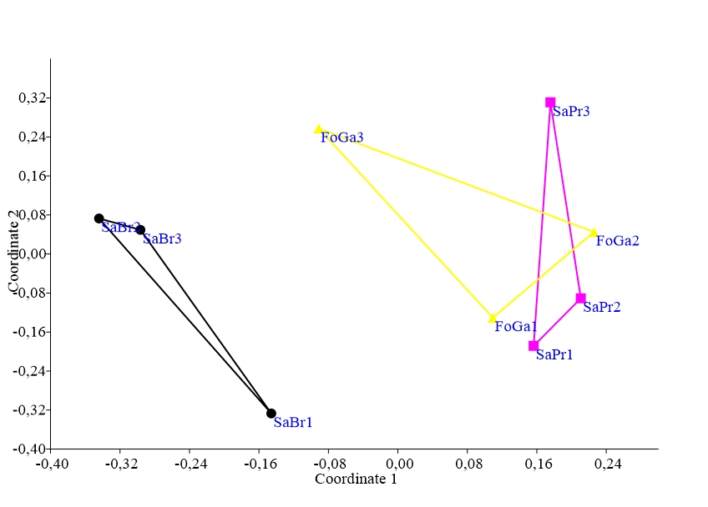

Figure 4. Non-metric multidimensional scaling (NMDS) showing spatial distribution of ant species composition based on Bray-Curtis similarity index. Stress = 0.1146, Axis 1= 0.367, Axis 2 = 0.19
Gallery Forest = FoGa; Burned Savanna= SaBr; and Unburned Savanna = SaPr,

9
40
29
47
16
13
FoGa
SaPr
SaBr
15

Figure 5. Venn diagram showing the number of shared species between the different habitat types. Gallery Forest = FoGa; Burned Savanna= SaBr; and Unburned Savanna = SaPr

Figure 6. Relative abundance of ant species in three habitats type. Chart with the same letter showed habitats without significant variation in ant abundance.
Gallery Forest = FoGa; Burned Savanna= SaBr; and Unburned Savanna = SaPr

3.2 Discussion

Understanding how insect communities respond to fire exclusion is important for biodiversity conservation. Although our study is a pioneering work it has provided a baseline data for three distinct vegetation types. This work has recorded a sampling coverage of more than 80% and species accumulation curves revealed that overall, the effectiveness of our sampling is acceptable. The different values of sampling coverage ranked from 51% to 93% for different habitat types. The Gallery Forest recorded the lower value of sampling coverage, approximately 51%. This observation may suggest that the sampling missed a significant portion of species richness, greater sampling effort is required to achieve an accurate estimation of species richness in this vegetation type. This conclusion corroborates the work of Kone et al. (2018), who have demonstrated that the increase of sample coverage across habitats does not imply all species were detected. This pattern was also observed in Gotelli et al. (2011) who supported that achieving complete invertebrate sampling is difficult, especially for ants, where new species are often discovered after decades of continuous collection.
The study showed a taxonomic rich ant community for three different vegetation types with 82 species yielded. These species belong to 32 genera and 7 subfamilies with the Myrmicinae subfamily showing high richness (43 species), followed by Formicinae (18 species) and Ponerinae (12 species). The number of species in Myrmicinae subfamily represents half of the species yielded in the whole study. This trend has also been pointed out by Hölldobler & Wilson (1990) and Bolton (1994), who supported that Myrmicinae are the most numerical dominant ant subfamily within the world of ant fauna. These authors ascribed the high dominance of Myrmicinae subfamily because many ant species in this group belonged to Generalized Myrmicinae. The species of this functional group are less sensitive to environmental disturbances and highly competitive for resources (Ruiz et al., 2009). Our findings align with Yeo et al. (2011), who also identified Myrmicinae, Ponerinae, and Formicinae as the three subfamilies contributing the highest species richness. However, in our study these three subfamilies seem to be correlated to the vegetation complexity. Myrmicinae and Formicinae dominate fire-prone, open savannas which provide full ground cover whereas Ponerinae prefer stable vegetation like Gallery Forest and Unburned Savanna (Table 2.). These finding are consistents with Kuate et al. (2015) who reported that specialized predator ants, (Ponerinae ant in our case study), appear more sensitive to disturbance than Generalist species which have generalized diet and are able to recolonize an area after disturbances.

The comparison of three habitat types revealed a significant variation of ant species richness. Surprisingly, the annually Burned Savanna (SaBr) was richer in ant species than Gallery Forest (FoGa) and Unburned Savanna. This finding has demonstrated that fire exclusion in a habitat does not inevitably assure high species richness of ant communities and contradict the general pattern that species richness correlates with habitat complexity and the level of disturbances (Vasconcelos and Vilhena 2006, Stein et al., 2014). In fact, with the fire exclusion in Gallery Forest and Unburned Savanna, we had expected that ant communities in these habitats to be more species rich than in annually Burned Savanna since fire could negatively impact habitat complexity due to the loss of plant and animal species (Alba et al., 2015, Lee et al., 2024). The trend observed contradict the observations of Yeo et al. (2017) who found no significant difference comparing ant species richness between Gallery Forest, Forest Island and Savanna. They ascribed this pattern to an underestimation of the heterogeneity of sampled savanna which seem more complex habitat with mainly subtypes correlated to tree density and soil (Menaut and Cesar 1979). Unlike in this study, we provided evidence Savannas promote broad species exploitation, increasing diversity; forests, however, allow dominant species to limit ant richness. The findings of this study were also inconsistent with the Yodé et al. (2023) who reported that arboreal ant species richness was greater in Forest Islands and Gallery Forest than in the Savanna. These authors found a greater species richness with 43 and 42 ant species in Forest Island and Gallery Forest, respectively and a lower species richness in Savanna with 27 ant species. They explained this pattern by the availability of nesting sites, heterogenous structure of vegetation and food resources quality and quantity due to plant community in forest and savanna habitats (Pierce, 2019; Unni et al., 2021).

We found that the Shannon diversity index did not reflect the pattern on species richness. Nevertheless, the number of unique species decrease from Gallery Forest (FoGa) to annually Burned Savanna (SaBr) to Unburned Savanna. This finding may suggest that Gallery Forest and annually Burned Savanna could host a community with high species diversity than Unburned Savanna (SaPr). A possible explanation could be due to the change in vegetation structure and plants species which promote herbivorous insects rather than specialized insect fauna (de Freitaset al., 2023). Thus, this change could prone some functional group like specialist predators (Ponerinae ants) rather than surbbordinate opportunists or Generalized Myrmicinae and subordinate campotini. Additionally, Simpson dominance index decreased from Gallery Forest (FoGa) toward Unburned Savanna ( SaPr) and Burned Savanna (SaBr) while an opposite trend was observed with Evenness in the same habitats. A non-exclusive explanation could be the disturbance caused by annual fire in Burned Savanna as reported in previous studies (Maravalhas and Vasconcelos 2014, Veldman et al. 2015). Indeed, fire may control ant abundance and interspecific competition to allow several species to exploit resources (Lessard 2019, Thabethe et al., 2025).Thus, High Simpson diversity and low evenness reveal a community heavily dominated by a portion of species. For instance, Gallery Forest and Unburned Savanna are more stable habitats and which promote a high dominance of some ant species (Parr et al. 2005, Yodé et al., 2023).

Consistent with the previous idea, our species composition and abundance reinforce the finding on ant species richness and diversity. Results showed a forested ant community consisting of Gallery Forest (FoGa) and Unburned Savanna (SaPr) habitat and another community represented by annually Burned Savanna, that share few common ant species (Figure 4). Our observations corroborate the idea on the distinctness of savanna ant assemblages in savanna-forest mosaic habitats in Brazilian cerrado (Vasconcelos and Vilhena 2006) and in Australia (Andersen et al. 2007). Although we have not measured the vegetation features in our study, an explanation of distinctiveness between annually Burned Savanna and forested habitats (FoGa and SaPr) could be microhabitat features like reported in Yeo et al. (2019). For instance, forested habitats are characterized by a well-closed canopy, specific microclimate conditions, resources and a very sparse understory with abundant litter while savannas are sunny open habitats with less or a lack of litter which greatly influence the composition of ant community.The comparison of relative abundance between three habitat types reinforces findings on Simpson dominance and Evenness (Table 3), and demonstrated that each ant community is dominated by exclusives species. The Unburned Savanna recorded the highest number of dominant species, thus witnessing of the stability of this habitat due to the exclusion from fire. The dominant ant species were Pheidole sp. 6, Paltothyreus tarsatus, Dorylus nigricans, Tetramorium sp. 2, Tetramorium Zambezium, Euponera brunoï, Crematogaster sp 1, Carebara distincta, Carebara perpusilla, Strumigenys rufobrunea, Strumigenys sp.4 and Tetramorium rhetidum. The annually Burned savanna was dominated by Camponotus acvapimensis, Pheidole megacephala, Lepisiota sp.3, Tetramorium sericeiventre, and Nylanderia boltoni. The most domint ant species in Gallery Forest were Pheidole sp 6, Hypoponera sp. 4, Mesoponera caffraria, Pheidole sp 3, Crematogaster striatula and Odontomachus troglodytes Our findings align with Yeo et al. (2019), who identified most of the listed species as significant indicator ants specific to particular savanna soil habitats and strata.

4. Conclusion

Our work provides an important ecological insight and evaluates how long-term fire exclusion has structured ant communities across three distinct habitats in Lamto. It demonstrated that ant community of Gallery Forest, annually Burned Savanna and understudied habitat like Unburned Savanna., host a rich taxonomic ant community. We demonstrated that frequency of fires in savannas greatly affect the invertebrate communities. the annually Burned savanna recorded a higher species richness, abundance and distinguished itself in terms of ant community composition from Gallery Forest and Unburned excluded from fire for 60 years. Forest-savanna mosaics are globally distributed biodiversity hotspots and are increasingly threatened by changes in fire frequency, climate, and land use. The patterns observed here regarding fire's impact on insect communities can serve as a predictive framework for managing fire-dependent ecosystems across West Africa and other similar biomes worldwide. By understanding the intricate balance between fire and insect life in Lamto, we gain crucial knowledge to inform global conservation strategies for these vulnerable transition zones.

Disclaimer (Artificial intelligence)
Option 1:
Author(s) hereby declare that NO generative AI technologies such as Large Language Models (ChatGPT, COPILOT, etc.) and text-to-image generators have been used during the writing or editing of this manuscript.
Option 2:
Author(s) hereby declare that generative AI technologies such as Large Language Models, etc. have been used during the writing or editing of manuscripts. This explanation will include the name, version, model, and source of the generative AI technology and as well as all input prompts provided to the generative AI technology
Details of the AI usage are given below:
1.
2.
3.

References

Afelu, B., Bimare, K., Soro, T. D., Pilabina, S., Edou, K., Dourma, M., & Kokou, K. (2025). Geostrategy and ecological considerations for wildfire management in West Africa. VertigO - the electronic journal in environmental sciences. https://doi.org/10.4000/1431p
Afelu, B., Djongon, K. A., & Kokou, K. (2016). Spatiotemporal dynamics of wildfires in Togo (West Africa). European Scientific Journal, 12, 14-23.
Agosti, D., Majer, J. D., Alonso, L. E., & Schultz, T. R. (2000). Standard methods for measuring and monitoring biodiversity. Smithsonian Institution, Washington, DC, 9, 204-6.
Alba, C., Skálová, H., McGregor, K. F., D’Antonio, C., & Pyšek, P. (2015). Native and exotic plant species respond differently to wildfire and prescribed fire as revealed by meta‐analysis. Journal of Vegetation Science, 26, 102-113.
Andersen, A. N. (1991). Sampling communities of ground‐foraging ants: pitfall catches compared with quadrat counts in an Australian tropical savanna. Australian Journal of Ecology, 16(3), 273-279. doi.org/10.1111/j.1442-9993.1991.tb01054.x
Andersen, A. N., van Ingen, L. T., Campos, R. I. (2007). Contrasting rainforest and savanna ant faunas in monsoonal northern a rainforest patch in a tropical savanna landscape. Australian Journal of Zoology, 55, 363–369
Azcárate, F. M., Alameda-Martín, A., Escudero, A., and Sánchez, A. M. (2021). Ant communities resist even in small and isolated gypsum habitat remnants in a Mediterranean agroecosystem. Frontiers in Ecology and Evolution, 9, 619215.
Bestelmeyer, B. T., Agosti, D., Alonso, L. E., Brandão, C. R. F., Brown, W. L., Delabie, J. H., & Silvestre, R. (2000). Field techniques for the study of ground-dwelling ant: an overview, description, and evaluation. In: Agosti, D., Majer, J. D., Alonso, L. E., Schultz,146 T. R. (eds), Ants: Standard methods for measuring and monitoring biodiversity.Washington and London, Smithsonian Institution Press, 122-144.
Bolton B. (1994). Identification Guide to the Ant Genera of the World. Harvard University Press. Cambridge, Mass. 225pp
Bolton, B. (1980). The ant tribe Tetramoriini (Hymenoptera: Formicidae). The genus Tetramorium Mayr in the Ethiopian zoogeographical region. Bulletin of the British Museum (Natural History) Entomology, 40,193-384
Bolton, B. (1982). Afrotopical species of the myrmicine Cardiocondyla, Leptothorax, Melissotarsus, Messor and Cataulacus (Formicidae) in the Ethiopian region. Bulletin of the British Museum (Natural History) Entomology, 45, 307-370
Bolton, B. (1987). A review of the Solenopsis genusgroup and revision of Afrotropical Monomorium Mayr (Hymenoptera: Formicidae). Bulletin of the British Museum (Natural History) Entomology, 54, 263-452.
Colwell, R. K. (2013). Estimates: Statistical Estimation of Species Richness and Shared Species from Samples. Version 9. User’s Guide and Application. http://purl.oclc.org/estimates.
Dastour, H., Ahmed, M. R., & Hassan, Q. K. (2024). Analysis of forest fire patterns and their relationship with climate variables in Alberta's natural subregions. Ecological Informatics, 80, 102531.
Dauget, J. M. & Menaut, J. C. (1992). Evolution over 20 years of a wooded savanna plot not protected from fire in the Lamto reserve (Côte d’Ivoire). Candollea, 47, 621–630.
Devi, R., Tholkudiyil, S. R., Naduvalloor, T., Krishnan, J. U., & Sajeev, T. V. (2025). Evaluating insect assemblages in the tropical forest ecosystem of the Southern Western Ghats: a comparative analysis of standardised sampling strategies employing field-tested protocols. Biologia, 1-13.
de Freitas, E. V. D., Maracahipes, L., & de Araujo, W. S. (2023). Plant richness and vegetation structure drive the topology of plant-herbivore networks in Neotropical savannas. Acta Oecologica, 121, 103961.
Dembélé, A. (2008). Spatial distribution and dynamics of a tree stand in a humid savanna subject to annual fire (Lamto, Ivory Coast). Master's thesis, University of Abobo-Adjamé, Ivory Coast. 34 pp.
Fisher, B. L., & Bolton, B. (2016). Ants of Africa and Madagascar: A guide to the genera. University of California Press.
Gautier, L. (1990). Map of tree cover in the Lamto reserve. Conservatory and Botanical Gardens.
Gotelli, N. J., Ellison, A. M., Dunn, R. R., & Sanders, N. J. (2011). Counting ants (Hymenoptera: Formicidae): biodiversity sampling and statistical analysis for myrmecologists. Myrmecological News, 15, 13-19
Gueulou, N., Ouattara, D., Konan, D., Eric, G., Missa, K., & Bakayoko, A. (2018). Floristic and structural diversity of the Bandama gallery forest in the Lamto Scientific Reserve in Côte d’Ivoire. Afrique Science, 14, 439–452.
Hölldobler, B., Wilson, O. E. (1990). The Ants. Cambridge: Belknap, 733 pp.
Kalischek, N., Lang, N., Renier, C., Daudt, R. C., Addoah, T., Thompson, W., et al. (2023). Cocoa plantations are associated with deforestation in Côte d’Ivoire and Ghana. Nature Food, 4, 384–393.
Kaplan, I., & Eubanks, M. D. (2005). Aphids alter the community‐wide impact of fire ants. Ecology, 86(6), 1640-1649.
Kone, M., Dosso, K., Yode, C. D., Kouakou, A. E., N'dri, A. B., Kone, N. G. A., N’Dri, J. K., W. Dekoninck & Barot, S. (2018). Short-term changes in the structure of ant assemblages in a Guinean savanna under differing fire regimes at Lamto Scientific Reserve, Côte d'Ivoire. Journal of Tropical Ecology, 34, 326-335.
Konko, Y., Afelu, B., & Kokou, K. (2021). Potential of Sentinel-2 satellite data for mapping the impact of vegetation fires in tropical Africa: application to Togo. Bois et Forêts des Tropiques, 347, 59-73.
Fotso Kuate, A., Hanna, R., Tindo, M., Nanga, S., & Nagel, P. (2015). Ant diversity in dominant vegetation types of southern Cameroon. Biotropica, 47(1), 94-100.
Lee, S., Klinger, R., Brooks, M. L., & Ferrenberg, S. (2024). Homogenization of soil seed bank communities by fire and invasive species in the Mojave Desert. Frontiers in Ecology and Evolution, 12, 1271824. Li, B. V., Wu, S., Pimm, S. L., & Cui, J. (2024). The synergy between protected area effectiveness and economic growth. Current Biology, 34, 2907-2920
Lessard, J. P. (2019). Ant community response to disturbance: a global synthesis. Journal of Animal Ecology, 88(3), 346-349.
Madikana, A., Manyevere, A., Mashamaite, C. V., Araya, T., Tshivhandekano, P. G., & Nxele, T. (2025). Investigation of the responses of soil invertebrate communities to four decades of prescribed fire frequency levels in semi-arid savanna rangelands. Forest Ecology and Management, 580, 122521.
Maravalhas, J., & Vasconcelos, H. L. (2014). Revisiting the pyrodiversity–biodiversity hypothesis: long‐term fire regimes and the structure of ant communities in a N eotropical savanna hotspot. Journal of Applied Ecology, 51, 1661-1668.
Menaut, J. C., & Cesar, J. (1979). Structure and primary productivty of Lamto savannas, Ivory Coast. Ecology, 60(6), 1197-1210.
Menaut, J.-C., & Abbadie, L. (2006). Vegetation. In L. Abbadie, J. Gignoux, X. Le Roux, & M. Lepage (Eds.), Lamto (pp. 63–74). Springer. https:// doi.org/10.1007/0-387-33857-8_5
Ouattara, K., Yeo, K., Kouakou, L. M., & Dekoninck, W. (2023). Ant nests effect on organic matter, carbon, and nitrogen flux in the soil under grasses tufts in Lamto savannah (Côte d'Ivoire). Agrosystems, Geosciences & Environ.ment, 6, e20374.
Parr, C. L., Sinclair, B. J., Andersen, A. N., Gaston, K. J., & Chown, S. L. (2005). Constraint and competition in assemblages: a cross-continental and modeling approach for ants. The American Naturalist, 165(4), 481-494.
Pierce, M. P. (2019). The ecological and evolutionary importance of nectar-secreting galls. Ecosphere, 10, e02670.
Ribeiro-Kumara, C., Köster, E., Aaltonen, H., & Köster, K. (2020). How do forest fires affect soil greenhouse gas emissions in upland boreal forests? A review. Environmental Research, 184, 109328.
Ruiz, P., Meneses, G., Santana, Z. (2009). Composition and functional groups of epiedaphic ants (Hymenoptera: Formicidae) in irrigated agroecosystem and in nonagricultural areas. Pesquisa Agropecuária Brasileira, 44, 904-910
Singh, S. (2022). Forest fire emissions: A contribution to global climate change. Frontiers in Forests and Global Change, 5, 925480.
Soro T.D., Koné, M., N'Dri, A.B. & N'Datchoh E.T. (2021). Identified main fire hotspots and seasons in Cote d'lvoire (West Africa) using MODIS fire data, South african journal of science,117,1-13.
Stein, A., Gerstner, K., & Kreft, H. (2014). Environmental heterogeneity as a universal driver of species richness across taxa, biomes and spatial scales. Ecology letters, 17, 866-880.
Tomadon, L. D. S., Dettke, G. A., Caxambu, M. G., Ferreira, I. J. M., & Couto, E. V. D. (2019). Significance of forest fragments for conservation of endangered vascular plant species in southern Brazil hotspots. Écoscience, 26, 221-235.
Thabethe, N. F., Foord, S. H., & Munyai, T. C. (2025). Mechanisms facilitating ant species coexistence in the burnt and unburnt grassland. Acta Oecologica, 128, 104107.
Unni, A. P., Mir, S. H., Rajesh, T. P., Ballullaya, U. P., Jose, T., & Sinu, P. A. (2021). Native and invasive ants affect floral visits of pollinating honey bees in pumpkin flowers (Cucurbita maxima). Scientific Reports, 11, 1–7.
Vasconcelos, H. L., & Vilhena, J. M. (2006). Species turnover and vertical partitioning of ant assemblages in the Brazilian Amazon: A comparison of forests and Savannas 1. Biotropica: The Journal of Biology and Conservation, 38, 100-106.
Veldman, J. W., Buisson, E., Durigan, G., Fernandes, G. W., Le Stradic, S., Mahy, G., ... & Bond, W. J. (2015). Toward an old‐growth concept for grasslands, savannas, and woodlands. Frontiers in Ecology and the Environment, 13(3), 154-162.
Walker, A. E., Robertson, M. P., Eggleton, P., Fisher, A. M., & Parr, C. L. (2024). Functional compensation in a savanna scavenger community. Journal of Animal Ecology, 93, 812-822.
Weiskopf, S. R., Rubenstein, M. A., Crozier, L. G., Gaichas, S., Griffis, R., Halofsky, J. E., et al. (2020). Climate change effects on biodiversity, ecosystems, ecosystem services, and natural resource management in the United States. Science of the Total Environment, 733, 137782.Yeo, K., (2006). Dynamique spatiale et diversité des fourmis de la litière et du sol dans une mosaïque foret-savane en cote d’ivoire. Thèse de Doctorat en cotutelle. Université Pierre Marie Curie et Université d’Abobo Adjamé. 212 p.
Yeo, K., Delsinne, T., Konate, S., Alonso, LL., Aïdara, D., & Peeters, C. (2017). Diversity and distribution of ant assemblages above and below ground in a West African forest–savannah mosaic (Lamto, Côte d’Ivoire). Insectes Sociaux, 64, 155-168.
Yeo, K., Konate, S., Tiho, S., et Camara, SK. (2011). Impacts of land use types on ant communities in a tropical forest margin (Oumé–Côte d’Ivoire). African Journal of Agricultural. Research, 6, 260-274.
Yode, D. C., Kouakou, L. M. M., Dosso, K., Dekoninck, W., Yeo, K., Konate, S., & Kouassi, P. K. (2023). Diversity and assembly composition of arboreal ants in a west African humid forest-savannah mosaic. African Journal of Ecology, 00, 1–8. https://doi.org/10.1111/aje.13189.

