Comparison of Coral Growth Rates Between Species, Growth Forms and Habitats on Unguja Island, Zanzibar, Tanzania

.
ABSTRACT

Recovery of degraded reefs depends on how quickly juvenile corals grow and how well they survive, both of which vary among growth forms. In Tanzania, species and habitat-specific performance information remains limited, constraining evidence-based restoration. We quantified juvenile growth and survival across coral species and growth forms: Echinopora lamellosa (foliose), Isopora palifera (sub-massive), Acropora tenuis (corymbose), Echinopora hirsutissima (encrusting), and Porites lutea (massive) on Chumbe Reef (Unguja, Zanzibar), and identified habitat locations and species that best support short-term coral growth and long-term reef survival. Fifty-nine colonies representing five species and five growth forms were monitored at ~6-month intervals from October 2010 to May 2012, across three reef habitats (reef flat, reef crest, and reef slope). We measured Planar tissue area to estimate growth (cm² per 6 months); survival was recorded at each interval. We summarized growth and survival by species, growth form, and habitat; compared performance among habitats; and described inter-individual variability. Mean planar growth ranged from 8.1 cm²·6 mo⁻¹ (P. lutea) to 155.7 cm²·6 mo⁻¹ (E. lamellosa). Overall survival was 68%, with peak mortality in the first interval (Oct 2010-Apr 2011). Explicit growth survival trade-offs emerged in which foliose and corymbose taxa (E. lamellosa, A. tenuis) grew rapidly but survived poorly, whereas submassive, encrusting, and massive taxa grew more slowly yet survived at higher rates. Inter-individual variability in growth was high for E. lamellosa and low for P. lutea. Both growth and survival were highest on the reef slope compared with the crest and flat. Collectively, the results suggest that restoration designs should prioritize slope habitats for nurseries. A mixed taxa strategy can balance goals by deploying fast-growing foliose and corymbose corals to accelerate short-term cover, while integrating submassive, encrusting, and massive forms to secure steadier, long-term recovery.

Keywords: Growth rates, sclearactinian corals, Zanzibar, species, variability in growth

- INTRODUCTION

Growth is a core ecological parameter that tracks how systems change over time (Miller and Hay, 1998). For coral reefs, understanding colony and species growth helps estimate regenerative capacity and hence recovery after natural or human-driven disturbances (Richmond, 1997). Coral growth is closely tied to biogenic calcification, the formation of aragonite (CaCO₃), which increases colony size through skeletal accretion and thickening (Gattuso et al., 1999, Esplandiu et al., 2024). Colony shape and skeletal development are strongly influenced by environmental conditions, including sedimentation that affects light and polyp energy balance (Larcombe et al., 1995; Muzuka et al., 2010; Tuttle and Donahue, 2022), depth (Barnes, 1973), light attenuation that shapes symbiont photophysiology (Macintyre and Graus, 1982; Rogers, 1990; Kramer et al., 2025), and exposure to waves and currents that affects particle settlement and mechanical stress (Muko et al., 2013; Fan et al., 2024). In practice, coral growth is measured with complementary metrics that capture different aspects of structure: (i) linear extension (skeletal growth along the main axis), (ii) skeletal density and annual density bands (time-marked records of calcification), and (iii) horizontal expansion of canopy/planform cover (Davies, 1989; Linge et al., 2022; Cardoso et al., 2025). Together, these measurements allow estimation of colony-level calcification, assessment of morphological plasticity, and attribution of growth variation to environmental drivers across space and time (Ross et al., 2022; Bravo and Schoepf, 2024; Kwiatkowski et al., 2025).
Reef habitats vary widely in the stresses imposed on corals because exposure to physical and biological processes differs among zones. Reef crests and flats are high-energy environments compared with reef slopes (Boodoo and Villarroel-Lamb, 2025), and are therefore more vulnerable to sediment effects generated by wave breaking, including polyp clogging (Rogers, 1990; Rogers and Ramos-Scharrón, 2022). Sediment also increases the vulnerability of juvenile corals to predation, competition, and bleaching (Rogers et al., 1984). By contrast, reef slopes experience stronger horizontal tidal currents that inhibit sediment deposition on colonies (Larcombe et al., 1995; Victor et al., 2006; Schlaefer et al., 2021). Morphologically, there is an inverse relationship between the density and thickness of coral plates (Hughes,1987). Foliose and encrusting forms tend to have higher skeletal density and thinner plates than massive and bushy corals. Early work suggested a negative relationship between skeletal density and growth rate (Vaughan, 1915), a view later questioned by Highsmith (1981).
Multiple factors govern coral growth because corals tolerate environmental stress within a relatively narrow physiological range (Pastorok and Bilyard, 1985). Among the most influential are climate-related changes in seawater temperature (Hughes et al., 2003; Manzello, 2010), ocean acidification (Kleypas and Langdon, 2006; Atkinson and Cuet, 2008; Cohen and Holcomb, 2009; Kleypas and Yates, 2009), and sedimentation (Rogers, 1990). Ecological interactions such as predation, herbivory, and disease also modulate growth outcomes (Ward, 1995; Jompa and McCook, 2002; Burkepile and Hay, 2010; van der Steeg et al., 2025).
Thermally, corals occur across broad geographic gradients, with a lower lethal limit near 18 °C (Jokiel and Coles, 1977), and optimal performance reported around 26-27 °C (Coles, 1988; Marshall and Clode, 2004). Ocean acidification lowers seawater pH (Dickson, 1984; Sabine et al., 2004) and reduces carbonate saturation states, shifting the balance from CaCO₃ precipitation toward dissolution (Atkinson and Cuet, 2008; Feely et al., 2009). Its impacts are generally less pronounced on tropical reefs than on subtropical reefs (ISRS, 2008).
Sedimentation becomes stressful to growth and survival when fluxes exceed ~10 mg cm⁻² day⁻¹ (Rogers, 1990). Elevated loads can clog feeding structures (Yap and Gomez, 1985), forcing colonies to divert energy to sediment rejection rather than growth and reproduction (Rogers, 1990). Suspended particulates also reduce light penetration, depressing photosynthesis and calcification.
Biotic stressors such as excessive predation, herbivory imbalance, and disease further depress growth (Sutherland et al., 2004; Box and Mumby, 2007). These pressures reduce live tissue cover (Rotjan et al., 2006), increasing the energetic costs of regeneration. Small, young colonies are especially susceptible because they have limited energetic reserves for competition and repair (Raymundo and Maypa, 2004). Conversely, optimal herbivory can enhance coral growth by reducing algal competition (Mumby et al., 2007; Burkepile and Hay, 2010).
Responses to climate and ecological drivers vary among regions, species, and growth forms. Subtropical reefs are often more limited by low carbonate saturation states than tropical reefs (Kleypas et al., 1999). Massive corals tend to be less sensitive to thermal extremes (Marshall and Baird, 2000) and to acidification (Fabricius et al., 2011) than branching taxa.
Given this variability, local-scale understanding of growth is essential for reef management and restoration. Such knowledge guides the selection of suitable species and growth forms, appropriate colony sizes for transplantation, and optimal habitat placement. These data remain limited for Zanzibar reefs. To address this gap, the present study quantified the growth of juvenile colonies from five species representing five growth forms, Echinopora lamellosa (foliose), Isopora palifera (submassive), Acropora tenuis (corymbose), Echinopora hirsutissima (encrusting), and Porites lutea (massive), at Chumbe Reef, Zanzibar.

- methodology

2.1 Study site and sampling design
This study was conducted at Chumbe Reef, located on the Western side of Unguja Island, Zanzibar (Fig.1), selected because it is protected from local fishing and thus provides an ideal setting for monitoring juvenile corals. Chumbe reef habitats span from less than 1m to more than 12m depth at low tide. Two fixed plots (50 m × 75 m), located about 300m apart, were established for growth monitoring, each of which covered all available reef habitats (reef flat, reef slope, and reef crest). The replicate plots were intended to provide an authentic replication for within-site replicates, ensuring that site means and confidence intervals were not based on a single location. Six-2m x 2m permanent quadrats were established on each plot; two quadrats in each habitat. The quadrats within the reef habitats were established in areas where the targeted juvenile coral colonies were located in open spaces to ensure the absence of spatial competition that could restrict normal growth rates. Plot 1 contained 30 colonies and Plot 2 contained 29, for a total of 59 colonies. By habitat, 20 colonies occurred on the reef slope, 17 on the reef crest, and 22 on the reef flat. The monitoring plots were situated at ~1.5-2m on the reef crest, 2-3 m on the reef flat, and more than 5m on the reef slope. Initial measurements were made in October 2010 and repeated in April 2011, November 2011, and May 2012.

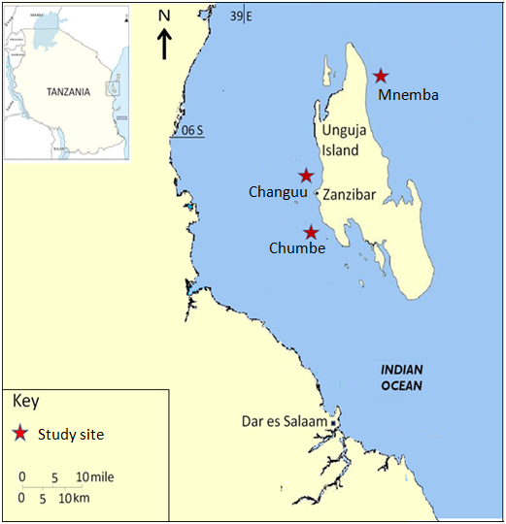

Figure 1: Map of Unguja Island, Zanzibar, showing the location of Chumbe reef ( 06° 16′ 38.57″ S, 39° 10′ 31.06″ E).

2.2 Species and growth forms
Monitored juveniles represented five species and five growth forms (Plate1(a-e)): Echinopora lamellosa (foliose, n = 10), Isopora palifera (submassive, n = 12), Acropora tenuis (corymbose, n = 13), Echinopora hirsutissima (encrusting, n = 15), and Porites lutea (massive, n = 9).
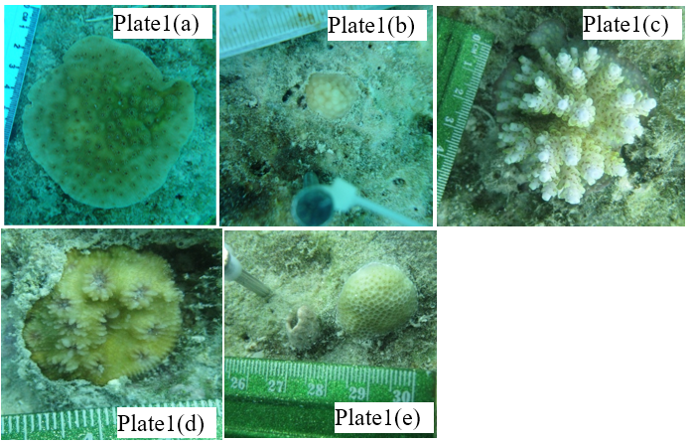

Plate 1: Monitored juveniles of the hard coral species. (a) = Echinopora lamellose, (b) = Isopora palifera, (c) = Acropora tenuis, (d) = Echinopora hirsutissima, and (e) = Porites lutea.

2.3 Area measurements
For each juvenile colony, the maximum diameter (Dm) and the maximum perpendicular diameter (Dp) were measured to the nearest centimetres using callipers. Measurements were taken in the colony’s horizontal plane (plan view) to capture the footprint of living tissue; protruding branches or vertical relief were not included.Colony planar surface area (A) was estimated by assuming a flat circular outline with an effective diameter equal to the geometric mean of Dm and Dp (Obura, 1995):
$A = π{(\frac{\sqrt{Dm⋅Dp}}{2})}^{2}$ (1)Where $π=3.14159265358979$, $Dm$is the maximum diameter, and $Dp$ is the maximum perpendicular diameter.

2.4 Growth and survival computations
Colony growth rate (g) between surveys was expressed as the change in area per unit time as:
$g =\text{ (}\frac{A_{2}-A_{1}}{t})*180$ (2)Where $A_{1}$and $A_{2}$are consecutive area estimates and $t$is the elapsed time in days. Values were reported as cm² per 6-month interval for comparability across surveys.
Survival for each species at each interval was calculated as:
$\text{Survival (\%) }= \frac{N_{t}}{N_{t-1}}×100,$ (3)Where $N_{t-1}$is the number of colonies present in the previous survey and $N_{t}$is the number that remained alive in the subsequent survey.

2.5 Data analysis
One-way GLMs (ANOVA) was used to test differences in survival rates mong habitats as the nature of survival data were proportions with denominators. We evaluated growth rate differences using separate one-way ANOVA for each factor: species, habitat, and the three-time intervals. This was because of the nature of the growth rate data being continuous with similar variances across groups. Homogeneity of variances was assessed with Bartlett’s test. When assumptions were not met, data were log- or square-root transformed to meet parametric requirements. Post hoc pairwise comparisons were conducted with the Student Newman-Keuls (SNK) test to identify which means differed.

3. results

3.1 Survival rates
Across 59 juvenile colonies, overall survival was 68%; two of every three colonies lived to the end of monitoring. Survival differed by species; the foliose Echinopora lamellosa had the lowest survival (30%), whereas submassive Isopora palifera (83%), encrusting E. hirsutissima (80%), and massive Porites lutea (78%) survived at higher rates; corymbose Acropora tenuis was intermediate at 62% (Fig. 2). Most deaths occurred early (October 2010–April 2011), with additional losses confined to Acropora between April and November 2011, while other species showed no further mortality thereafter. When species were pooled by genus, survival was higher in Isopora (83%), Porites (78%), and Acropora (62%) than in Echinopora (55%) (Table 1). Survival also differed among habitats (one-way ANOVA, F = 3.8898, df = 2, p = 0.04), indicating a real effect of site conditions beyond random variation, with the highest survival on the reef slope. Smaller colonies tended to die earlier across species and habitats, whereas survival did not differ between the Northeast and Southeast monsoon periods for any species.
Table 1: Total survival rate from October 2010 to May 2012 of five observed coral species. N.B: S = start, E = end and SR = survival rate.
Species | Reef Slope |  |  | Reef crest |  |  | Reef flat |  |  | SSR (%) | Genus | SR (%)
Species | S | E | SR (%) | S | E | SR (%) | S | E | SR (%) | SSR (%) | Genus | SR (%)
I. palifera | 3 | 3 | 100 | 3 | 3 | 100 | 6 | 4 | 67 | 83 | Isopora | 83
A. tenius | 4 | 4 | 100 | 5 | 2 | 40 | 4 | 2 | 50 | 62 | Acropora | 62
E. hirsutissima | 6 | 6 | 100 | 4 | 3 | 75 | 5 | 3 | 60 | 80 | Echinopora | 55
E. lamellosa | 4 | 3 | 75 | 3 | 0 | 0 | 3 | 0 | 0 | 30 | Echinopora | 55
P. lutea | 3 | 3 | 100 | 2 | 1 | 50 | 4 | 3 | 75 | 78 | Porites | 78
Average |  |  | 95 |  |  | 53 |  |  | 55 | 68

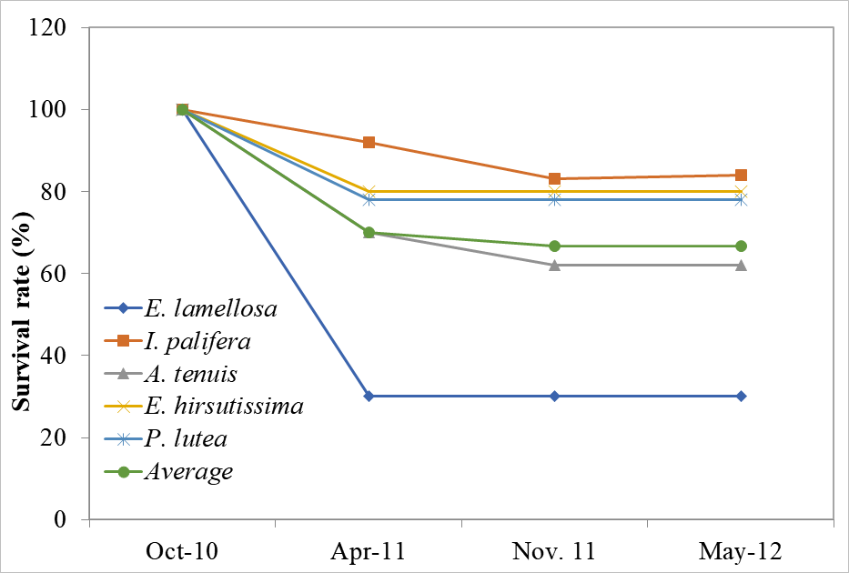
Figure 2: Survival schedules of individual species (E.lamellosa = Echinopora lamellosa (n = 10), I. palifera = Isopora palifera (n = 12), A. tenius = Acropora tenius (n = 13), E. hirsutissima = Echinopora hirsutissima (n = 15), and P. lutea = Porites lutea (n = 9); April-Nov = SEM and Nov-May = NEM).

3.2 Growth
Mean growth rates varied significantly among species (one-way ANOVA: F = 12.5183, df = 4, p < 0.001). The fastest growth occurred in E. lamellosa (155.7 cm² 6-month⁻¹), followed by A. tenuis (72.7 cm² 6-month⁻¹) and E. hirsutissima (61.7 cm² 6-month⁻¹); I. palifera (10.8 cm² 6-month⁻¹) and P. lutea (8.1 cm² 6-month⁻¹) were the slowest. Post hoc comparisons indicated no difference between E. hirsutissima and A. tenuis, nor between P. lutea and I. palifera. Growth increased with colony size across species (Fig. 3). Seasonal fluctuations in growth were not significant. Overall growth differed among habitats (one-way ANOVA: F = 7.6276, df = 2, p = 0.001), with higher rates on the reef slope than on the reef flat or crest. Cumulative trajectories showed a consistent ranking across intervals: E. lamellosa grew most rapidly, followed by A. tenuis and E. hirsutissima, whereas I. palifera and P. lutea were slowest (Fig. 4). Temporal variability within species was pronounced for E. lamellosa, A. tenuis, and E. hirsutissima, but minimal for I. palifera and P. lutea (Fig. 3).

Figure 3: Average growth rates of monitored coral species in three-time intervals (October 2010, April 2011, November 2011 and May 2012). Eerror bars indicate standard error of the mean.
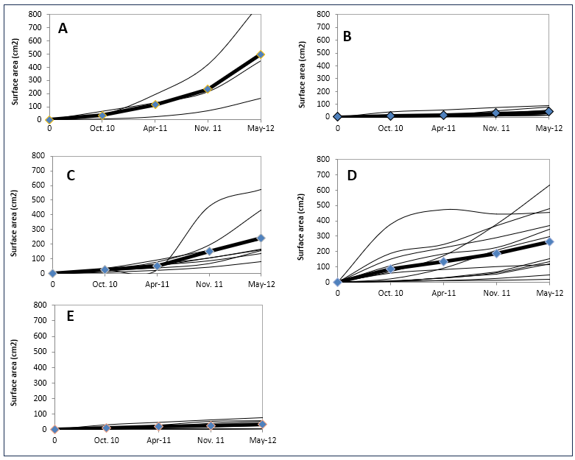
Figure 4: Cumulative growth of monitored coral species in planar surface area (cm²); (A) Echinopora lamellosa, (B) Isopora palifera, (C) Acropora tenuis (D) Echinopora hirsutissima and (E) Porites lutea (Thin lines show growth in single colony, the bold line shows the overall cumulative growth of a species).

4. discussion

Survival of monitored juveniles varied with genus/species, growth form, colony size, and habitat. The observed survival patterns in this study are consistent with established links among coral life history, morphology, and environment. Higher survival of Porites (78%) and Acropora (74%) relative to Echinopora (55%) (Table 3.1) mirrors the dominance of Porites and Acropora in the local adult assemblage (Ussi, 2024). The findings also reflect contrasting life-history strategies, in which competitive, fast-growing taxa (e.g.,Acropora, Echinopora) trade rapid extension and space capture for reduced stress tolerance, whereas stress-tolerant massive taxa (e.g., Porites) prioritize survival over growth (Darling et al., 2012). Pronounced growth‐form effects further explain the patterns (Table 1). Foliose and corymbose colonies exhibited greater mortality than encrusting, submassive, and massive forms because their large, lever-like architectures confer high size-dependent mechanical vulnerability and dislodgement risk under hydrodynamic forcing, particularly for small or recently handled colonies (Madin et al., 2014). These morphologies are also more susceptible to bleaching and post-stress mortality than massive and encrusting forms, with Porites generally ranking among the more heat-tolerant genera and acroporids among the most sensitive (McCowan et al., 2012, Ussi et al, 2019). Mortality peaked during the first interval (October 2010 - April 2011), likely reflecting handling and sediment disturbance associated with study establishment (Ward, 1995), underscoring the need to minimize physical contact during setup and transplantation.

Habitat differences were equally clear. Shallow, high-energy zones (reef flats, crests) exhibited higher mortality than the reef slope (Table1). Mechanically, wave-driven resuspension is known to promote polyp clogging (Rogers, 1990), while spring low tides can intensify thermal stress. Greater irradiance in shallow zones fosters algal overgrowth and intensifies space competition and grazing (Lilliesköld Sjöö et al., 2011), diverting energy from growth to maintenance and defense. Foliose and corymbose species their surfaces could have traped sediments more readily, increasing the risk of smothering and hypoxia in depositional microhabitats, whereas larger, low-profile massive and encrusting colonies were less affected by sediment loading (Jones et al., 2019). These mechanisms are consistent with the higher live coral cover observed on the slope relative to reef crests and reef flats and with prior reports of greater survivorship in deeper, less sediment-prone habitats (Babcock and Mundy, 1996).Collectively, the mechanisms of life-history trade-offs, morphology-driven mechanical fragility, thermal sensitivity, and sediment interactions could provide a coherent explanation for variation in juvenile survival across genera, growth forms, colony sizes, and habitats observed in this study.
Overall survival (68%) compares favorably with studies from Puerto Rico (54.8%; Irizarry-Soto and Weil, 2009) and the Philippines (67.5%; Villanueva et al., 2012), exceeds the 11% reported by Villanueva et al. (2005), and is lower than the 100% observed by Bongiorni et al. (2003). Such differences likely reflect environmental context (eutrophication at Bolinao) and initial colony size. Consistent with the general trend of decreasing mortality with increasing juvenile size (Smith, 1992), our starting sizes (2.7–7.1 cm;) were closer to Irizarry-Soto and Weil (2009) than to very small one-month-old recruits (Villanueva et al., 2005) or larger fragments (Bongiorni et al., 2003).
Species-level growth rates ranked Echinopora lamellosa (foliose) > Acropora tenuis (corymbose) ≈ Echinopora hirsutissima (encrusting) >> Isopora palifera (submassive) ≈ Porites lutea (massive) (Fig.4). This hierarchy matches established links between morphology, skeletal architecture, and growth: thin-plated foliose and corymbose forms typically accrete area rapidly, whereas massive forms trade speed for robustness (Highsmith, 1981; Hughes, 1987; Connell, 1973; Tamelander, 2002). Notably, the fastest-growing morphologies also showed higher temporal variability and mortality, particularly in shallow and high-energy habitats, suggesting a trade-off between rapid planar expansion and resilience.
This study estimated the surface areas of monitored juvenile coral colonies using a two-dimensional approach. A methodological caveat is that using planar (2D) area can underestimate growth in branching corals because the approach did not fully capture the inter-branch live tissues in a top-down projection. This limitation is well recognized: errors tend to increase with structural complexity, and 3D metrics (surface area/volume) better reflect branching morphology (House et al., 2018). However, the 2D area often matches well with the 3D size and can serve as a reasonable estimate for small or simple-shaped colonies. In our study, the colonies were small juveniles with little branching during the study period, so any underestimation is likely small and consistent; comparisons between species remain meaningful. Studies have shown a strong relationship between flat (planar) area and 3D size across different coral shapes, including branching types. However, they recommend using 3D methods (like photogrammetry or CT scans) when colonies are highly complex. In contrast, measuring planar area works well for estimating size when colony shapes are simple or moderately complex (House et al., 2018), and therefore, the results from this study remain valid.

5. Conclusion
The results indicated a short- vs. long-term recovery complementarity. Foliose and corymbose taxa can drive rapid early gains in cover following disturbance, whereas encrusting, submassive, and massive corals contribute to structural stability and persistence over longer horizons. For interventions, we recommend (i) prioritizing slope habitats for nurseries and early outplanting where survival and growth are highest; (ii) pairing fast-growing foliose and corymbose species to jump-start cover with more resilient encrusting, submassive and massive species to secure long-term structure; (iii) minimizing handling and sediment disturbance during setup; and (iv) selecting larger juvenile fragments where feasible to improve early survival.

Disclaimer (Artificial intelligence)
Author(s) hereby declare that NO generative AI technologies such as Large Language Models (ChatGPT, COPILOT, etc.) and text-to-image generators have been used during the writing or editing of this manuscript.

References
Atkinson, M. J., & Cuet, P. (2008). Possible effects of ocean acidification on coral reef biogeochemistry: topics for research. Marine Ecology Progress Series, 373: 249-256. https://doi.org/10.3354/meps07867.
Babcock, R., & Mundy, C. (1996). Coral recruitment: consequences of settlement choice for early growth and survivorship in two scleractinians. Journal of Experimental Marine Biology and Ecology, 206:179–201. https://doi.org/10.1016/S0022-0981(96)02622-6.
Barnes. D. J. (1973). Growth in colonial scleractinians. Bulletin of Marine Science, 23: 280-298.
Bongiorni, L., Shafir, S., Angel, D., & Rinkevich, B. (2003). Survival, growth and gonad development of two hermatypic corals subjected to in situ fish-farm nutrient enrichment. Marine Ecology Progress Series, 253: 137-144. https://doi.org/10.3354/meps253137.
Boodoo, A., & Villarroel-Lamb, D. (2025). Numerical modelling of the impact of coral reef degradation and sea level rise on coastal protection at The Buccoo Reef, Tobago: implications for reef restoration and management strategies. Frontiers in Marine Science, 12, 1525438. https://doi.org/10.3389/fmars.2025.1525438.
Box, J. B., & Mumby, P. J. (2007). Effect of macroalgal competition on growth and survival of juvenile Caribbean corals. Marine Ecology Progress Series, 342: 139–149. https://doi.org/10.3354/meps342139.
Bravo, M., & Schoepf, V. (2024). Growth rates of five coral species across a strong environmental gradient in the Colombian Caribbean. Marine Biology, 171(9), 187. https://doi.org/10.1007/s00227-024-04511-5.
Burkepile, D. E., & Hay, M. E. (2010). Impact of herbivore identity on algal succession and coral growth on a Caribbean reef. PLoS One, 5(1): 8963. https://doi.org/10.1371/journal.pone.0008963.
Cardoso, G. O., Kersting, D. K., Brachert, T. C., Heiss, G. A., Leinfelder, R., Maréchal, J. P., & D’Olivo, J. P. (2025). Emerging skeletal growth responses of Siderastrea siderea corals to multidecadal anthropogenic impacts in Martinique, Caribbean Sea. Scientific Reports, 15(1), 23127. https://doi.org/10.1038/s41598-025-08709-5.
Cohen, A. L., & Holcomb, M. (2009). Why corals care about ocean acidification: Uncovering the mechanism. Oceanography, 22(4):118–127. https://www.jstor.org/stable/24861029.
Coles, S.L. (1988). Limitations on reef coral development in the Arabian Gulf: Temperature or algal competition? Proceedings of the 6th International Coral Reef Symposium, 3: 211-216.
Connell, J. H. (1973). Population ecology of reef building corals. In: Jones, O.A. and Endean, R. (eds). Biology and Geology of Coral Reefs, Vol II, Biology 1. Academic Press, New York, 2: pp.205-245.
Darling, E. S., Alvarez‐Filip, L., Oliver, T. A., McClanahan, T. R., & Côté, I. M. (2012). Evaluating life‐history strategies of reef corals from species traits. Ecology Letters, 15(12), 1378-1386. https://doi.org/10.1111/j.14610248.2012.01861.x
Davies, P. S. (1989). Short-term growth measurements of corals using an accurate buoyant weighing technique. Marine Biology, 101(3): 389-395. https://doi.org/10.1007/BF00428135.
Deng, W., Kenyon, T., Eigeland, K., Callaghan, D. P., & Baldock, T. E. (2025). Structural and hydrodynamic modelling of the probability of breakage of branching and plate coral colonies. Coastal Engineering, 195, 104647. https://doi.org/10.1016/j.coastaleng.2024.104647.
Dickson, A. G. (1984). pH scales and proton-transfer reactions in salinc media such as sea water. Geochimica et Cosmochimica Acta, 48: 2299-2308. https://doi.org/10.1016/0016-7037(84)90225-4.
Esplandiu, E., Morris, J., Enochs, I., Besemer, N., & Lirman, D. (2024). Enhancing reef carbonate budgets through coral restoration. Scientific reports, 14(1), 27599. doi: 10.1038/s41598-024-76799-8.
Fabricius, K. E., Langdon, C., Uthicke, S., Humphrey, C., Noonan, S., De’ath, G., Okazaki, R., Muehllehner,N., Glas, M., & Lough, J. M. (2011). Losers and winners in coral reefs acclimatized to elevated carbon dioxide concentrations. Nature Climate Change, 1(3), 165-169. DOI:10.1038/NCLIMATE1122
Fan, R., Wei, H., Mai, Y., Zhang, L., Yu, J., & Wang, D. (2024). Observations of waves and currents on the fore-reef and reef flat of a coral reef atoll in the South China Sea. Frontiers in Marine Science, 11, 1460450. https://doi.org/10.3389/fmars.2024.1460450.
Feely, R. A., Doney, S. C., & Cooley, S. R. (2009). Ocean acidification: present conditions and future changes in a high-CO2 world. Oceanography, 22(4): 36-47. https://www.jstor.org/stable/24861022.
Gattuso, J.-P., D. Allemand, & M. Frankignoulle (1999), Photosynthesis and calcification at cellular, organismal and community levels in coral reefs: A review on interactions and control by carbonate chemistry, American Zoologist., 39: 160–183. https://doi.org/10.1093/icb/39.1.160.
Highsmith, R. C. (1981). Passive colonisation and asexual colony manipulation in the massive coral Porites lutea at Milne Edwards and Haime. Journal of Experimental Marine Biology and Ecology, 47: 55-67. https://doi.org/10.1016/0022-0981(80)90137-9.
House, J. E., Brambilla, V., Bidaut, L. M., Christie, A. P., Pizarro, O., Madin, J. S., & Dornelas, M. (2018). Moving to 3D: relationships between coral planar area, surface area and volume. PeerJ, 6, e4280.https://doi.org/10.7717/peerj.4280.Hughes, T. P. (1987). Skeletal density and growth form of corals. Marine Ecology Progress Series, 35, 259-266.
Hughes, T. P., Baird, A. H., Bellwood, D. R., Card, M., Connolly, S. R., Folke, C., Grosberg, R., Hoegh-Guldberg, O, Jackson, J. B. C, Kleypas, J., Lough, J. M., Marshall, P., Nystro¨m, M., Palumbi, S. R, Pandolfi, J. M, Rosen, B., & Roughgarden, J. (2003). Climate change, human impacts, and the resilience of coral reefs. Science, 301(5635): 929-933. DOI: 10.1126/science.1085046.
Irizarry-Soto, E., & Weil, E. (2009). Spatial and temporal variability in juvenile coral densities, survivorship and recruitment in La Parguera, southwestern Puerto Rico. Caribbean Journal of Science, 45(2-3): 269-281. https://doi.org/10.18475/cjos.v45i2.a14.
ISRS (International Society for Reef Studies), (2008). Coral Reefs and Ocean Acidification. Briefing Paper 5, International Society for Reef Studies, 9 pp.
Jokiel, P. L., & Coles, S. L. (1977). Effects of temperature on the mortality and growth of Hawaiian reef corals. Marine Biology, 43: 201-208. https://doi.org/10.1007/BF00402312.
Jompa, J., & McCook, L. J. (2002). Effects of competition and herbivory on interactions between a hard coral and a brown alga. Journal of Experimental Marine Biology and Ecology, 271(1): 25-39. https://doi.org/10.1016/S0022-0981(02)00040-0.
Jones, R., Fisher, R., & Bessell-Browne, P. (2019). Sediment deposition and coral smothering. PLoS ONE 14(6): e0216248. https://doi.org/10.1371/journal.pone.0216248.
Kleypas, J. A., & Langdon, C. (2006). Coral reefs and changing seawater carbonate chemistry. Coastal and Estuarine Studies, 61: 73-110. https://doi.org/10.1029/61CE06.
Kleypas, J. A., & Yate, K. K. (2009). Coral reefs and ocean acidification. Oceanography, 22(4): 108–117. https://www.jstor.org/stable/24861028.
Kleypas, J. A., Buddemeier, R. W., Archer, D., Gattuso, J., Langdon, C., & Opdyke, B. N. (1999). Geochemical consequences of increased atmospheric carbon dioxide on coral reefs. Science, 284: 118–120. https://doi.org/10.1126/science.284.5411.118.
Kramer, N., Galindo-Martínez, C. T., Jacques, S. L., Tresguerres, M., Loya, Y., & Wangpraseurt, D. (2025). Depth-dependent microskeletal features modify light harvesting in Turbinaria reniformis corals. Iscience, 28(8). doi: 10.1016/j.isci.2025.113137.
Kwiatkowski, L., Planchat, A., Pyolle, M., Torres, O., Bouttes, N., Comte, A., & Bopp, L. (2025). Declining coral calcification to enhance twenty-first-century ocean carbon uptake by gigatonnes. Proceedings of the National Academy of Sciences, 122(23), e2501562122. doi: 10.1073/pnas.2501562122.
Lange, I. D., Molina-Hernández, A., Medellín-Maldonado, F., Perry, C. T., & Álvarez-Filip, L. (2022). Structure-from-motion photogrammetry demonstrates variability in coral growth within colonies and across habitats. PLoS One, 17(11), e0277546.https://doi.org/10.1371/journal.pone.0277546.
Larcombe, P., Ridd, V. P., Prytz, A., & Wilson, B. (1995). Factors controlling suspended sediments on inner-shelf coral reef. Coral reef, 14: 163-171. https://doi.org/10.1007/BF00367235.
Lilliesköld Sjöö, G., Mörk, E., Andersson, S., & Melander, I. (2011). Differences in top-down and bottom-up regulation of macroalgal communities between a reef crest and back reef habitat in Zanzibar. Estuarine, Coastal and Shelf Science, 91(4): 511-518. https://doi.org/10.1016/j.ecss.2010.12.003.
Macintyre, I. G., & Graus, R. R., (1982). Variation in growth forms of the reef coral Montastrea annularis (Ellis and Solander): a quantitative evaluation of growth response to light distribution using computer simulation. The Atlantic Barrier Reef ecosystem at Carrie Bow Cay, Belize, 1, Structure and communities. Smithsonian Contributions to the Marine Sciences, 12: 441-464.https://doi.org/10.5479/si.01960768.12.441.
Madin, J. S., Baird, A. H., Dornelas, M., & Connolly, S. R. (2014). Mechanical vulnerability explains size-dependent mortality of reef corals. Ecol Lett. 17(8):1008-15. doi: 10.1111/ele.12306.
Manzello, D. P. (2010). Coral growth with thermal stress and ocean acidification: lessons from the eastern tropical Pacific. Coral Reefs, 29(3): 749-758. https://doi.org/10.1007/s00338-010-0623-4.
Marshall, A. T., & Clode, P. L. (2004). Calcification rate and the effect of temperature in a zooxanthellate and an azooxanthellate scleractinian reef coral. Coral Reefs, 23:218 -224. https://doi.org/10.1007/s00338-004-0369-y.
Marshall, P. A., & Baird, A. H. (2000) Bleaching of corals on the Great Barrier Reef: differential susceptibilities among taxa. Coral Reefs, 19(2):155–163. https://doi.org/10.1007/s003380000086.
McCowan, D. M., Pratchett, M. S., & Baird, A. H. (2012). Bleaching susceptibility and mortality among corals with differing growth forms.Proceedings of the 12th International Coral Reef Symposium, Cairns, Australia, 9-13 July 2012 9A – Coral bleaching and climate change.
Miller, M. W., Hay, M. E., Miller, S. L., Malone, D., Sotka, E. E., & Szmant, A. M. (1999). Effects of nutrients versus herbivores on reef algae: a new method for manipulating nutrients on coral reefs. Limnology and Oceanography, 44(8): 1847-1861. https://doi.org/10.4319/lo.1999.44.8.1847.
Muko, S., Arakaki, S., Nagao, M., & Sakai, K. (2013). Growth form-dependent response to physical disturbance and thermal stress in Acropora corals. Coral reefs, 32(1): 269-280. https://doi.org/10.1007/s00338-012-0967-z.
Mumby, P. J., Harborne, A. R., Williams, J., Kappel, C. V., Brumbaugh, D. R., Micheli, F., Holmes, K. E., Dahlgren, C. P., Paris, C. B., & Blackwell, P. G. (2007). Trophic cascade facilitates coral recruitment in a marine reserve. Proceedings of the National Academy of Sciences, 104: 8362-8367. https://doi.org/10.1073/pnas.0702602104.
Muzuka, A. N., Dubi, A. M., Muhando, C. A., & Shaghude, Y. W. (2010). Impact of hydrographic parameters and seasonal variation in sediment fluxes on coral status at Chumbe and Bawe reefs, Zanzibar, Tanzania. Estuarine, Coastal and Shelf Science, 30: 1-8. https://doi.org/10.1016/j.ecss.2010.05.007.
Obura, D. (1995). Environmental Stress and Life History Strategies, A Case Study of Corals and River Sediment from Malindi, Kenya. PhD Dissertation, University of Miami.
Pastorok, R. A., & Bilyard, G. R. (1985). Effects of sewage pollution and coral reefs communities. Marine Ecology Progress Series, 21: 175-189.
Raymundo, L. J., & Maypa, A. P. (2004). Getting bigger faster: mediation of size-specific mortality via fusion in juvenile coral transplants. Ecological Applications, 14(1): 281-295. https://doi.org/10.1890/02-5373.
Richmond, M. D. (ed.). (1997). A guide to the seashores of Eastern Africa and the western Indian Ocean islands. Sida-SAREC, Stockholm. 448 pp.
Rogers, C. S. (1990). Responses of coral reefs and reefs organisms to sedimentation. Marine Ecology Progress Series, 62:105-202.
Rogers, C. S., Fitz III, H. C., Gilnack, M., Beets, J., & Hardin, J. (1984). Scleractinian coral recruitment patterns at Salt River Submarine Canyon, St. Croix, US Virgin Islands. Coral Reefs, 3(2): 69-76. https://doi.org/10.1007/BF00263756.
Ross, C. L., Warnes, A., Comeau, S., Cornwall, C. E., Cuttler, M. V., Naugle, M., ... & Schoepf, V. (2022). Coral calcification mechanisms in a warming ocean and the interactive effects of temperature and light. Communications Earth and Environment, 3(1), 72. https://doi.org/10.1038/s43247-022-00396-8.
Rotjan, R. D., Dimond, J. L., Thornhill, D. J., Leichter, J. J., Helmuth, B., Kemp, D. W., & Lewis, S. M. (2006). Chronic parrotfish grazing impedes coral recovery after bleaching. Coral Reefs, 25(3), 361-368. https://doi.org/10.1007/s00338-006-0120-y.
Sabine, C. L., Feely, R. A., Gruber, N., Key, R. M., Lee, K., Bullister, J. L., Wanninkhof, R., & Rios, A. F. (2004). The oceanic sink for anthropogenic CO2. Science, 305(5682): 367-371. https://doi.org/10.1126/science.1097403.
Schlaefer, J. A., Tebbett, S. B., & Bellwood, D. R. (2021). The study of sediments on coral reefs: a hydrodynamic perspective. Marine Pollution Bulletin, 169, 112580. https://doi.org/10.1016/j.marpolbul.2021.112580.
Smith, S. R. (1992). Patterns of coral recruitment and post-settlement mortality on Bermuda's reefs: comparisons to Caribbean and Pacific reefs. American Zoologist, 32(6): 663-673. https://doi.org/10.1093/icb/32.6.663.
Sutherland, W.J., Pullin, A.S., Dolman, P.M., & Knight, T.M. (2004) The need for evidence-based conservation. Trends in Ecology and Evolution, 19, 305–308. https://doi.org/10.1016/j.tree.2004.03.018.
Tamelander, J. (2002). Coral recruitment following mass mortality event. Ambio, 3(7-8): 551-557. https://doi.org/10.1579/0044-7447-31.7.551.
Tuttle, L. J., & Donahue, M. J. (2022). Effects of sediment exposure on corals: a systematic review of experimental studies. Environmental Evidence, 11(1), 4. doi: 10.1186/s13750-022-00256-0.
van der Steeg, E., Humanes, A., Bythell, J. C., Craggs, J. R., Edwards, A. J., Golbuu, Y., ... & Guest, J. R. (2025). Grazing deterrents improve survival of outplanted juvenile corals. Coral Reefs, 1-13. https://doi.org/10.1007/s00338-025-02703-z.
Ussi, A. M., Mohammed, M., Muhando, C. A., & Yahya, S. A. S. (2019). Ecological impact of thermal stress in reefs of Zanzibar following the 2016 elevated higher sea surface temperatures. In Climate Change and Coastal Resources in Tanzania: Studies on Socio-Ecological Systems' Vulnerability, Resilience and Governance (pp. 93–115). Cham: Springer International Publishing. https://doi.org/10.1007/978-3-030-04897-6_6
Vaughan, T. W. (1915). The geological significance of the growth rate of the Floridian and Bahamian shoal-water corals. Journal of the Washington Academy of Sciences, 5: 591-600. https://www.jstor.org/stable/24520846.
Victor, S., Neth, L., Golbuu, Y., Wolanski, E., & Richmond, R.H. (2006). Sedimentation on mangroves and coral reefs in a wet tropical island, Pohnpei, Micronesia. Estuarine and Shelf Science, 66: 409-416. https://doi.org/10.1016/j.ecss.2005.07.025.
Villanueva, R. D. , Baria, M. B., & Cruz, D. W. (2012). Growth and survivorship of juvenile corals out planted to degraded reef areas in Bolinao-Anda Reef Complex, Philippines. Marine Biology Research, 8(9): 877-884. https://doi.org/10.1080/17451000.2012.682582.
Villanueva, R. D., Yap, H. T., & Montaño, M. N. E. (2005). Survivorship of coral juveniles in a fish farm environment. Marine Pollution Bulletin, 51(5): 580-589. https://doi.org/10.1016/j.marpolbul.2005.04.033.
Ward, S. (1995). The effect of damage on the growth, reproduction and storage of lipids in the scleractinian coral Pocillopora damicornis (Linnaeus). Journal of Experimental Marine Biology and Ecology, 187(2): 193-206. https://doi.org/10.1016/0022-0981(94)00180-L
Yap, H. T., & Gomez, E. D. (1985). Growth of Acropora palchra: III Preliminary observations on the effect of transplantation and sedimentation on the growth and survival of transplants. Marine Biology, 87: 203-209. https://doi.org/10.1007/BF00539430.

