Assessment of Soil Physico-Chemical Characteristics in Mining-Impacted and Agricultural Landscapes of the Ketki Coal Belt, Surajpur District, Chhattisgarh, India

Abstract
Although the environmental impacts of coal extraction on soil systems are well recognized, the Ketki Coal Mine in Surajpur District has received little scientific attention despite decades of continuous operation. To address this gap, the present study assessed how mining activities have reshaped the chemical properties and nutrient status of nearby soils. Fourteen samples were collected along two mining transects situated 2-3 km from the excavation zone and from agricultural lands located 4-6 km away. Soil material taken from 15-30 cm and 30-50 cm depths was analysed for pH, electrical conductivity, organic carbon, major nutrients, and micronutrients obtained through DTPA extraction and measured with atomic absorption spectrophotometry. Marked spatial contrasts emerged from the assessment. Soils on the northern side of the mine exhibited pronounced acidity, while those to the west showed alkaline tendencies, suggesting variation in the mineral character of overburden deposits. Mining-affected soils also contained noticeably reduced organic carbon and diminished nitrogen and phosphorus levels. In contrast, agricultural soils retained more balanced fertility and showed higher concentrations of iron, manganese, and copper. Statistical evaluation using ANOVA, together with supporting biostatistical procedures, indicated significant differences between mining-influenced sites and agricultural areas for several key parameters. Overall, the findings reveal substantial deterioration of soil quality around the Ketki mine and highlight the importance of organic inputs, targeted nutrient management, and continued monitoring to aid ecological restoration.

Keywords: Soil fertility, Coal mining, Organic carbon, ANOVA, Nutrient depletion, Chhattisgarh, Soil degradation, Physico-chemical properties

1. Introduction
Soil is a foundational component of terrestrial ecosystems, providing essential services such as nutrient cycling, water regulation, plant anchorage, and biological habitat. Soil health is typically evaluated through physico-chemical indicators including pH, electrical conductivity (EC), organic carbon (OC), and the availability of macro- and micronutrients (Kekaneet al., 2015). Any disruption to these parameters directly affects ecosystem functioning, agricultural productivity, and environmental stability (Mandal, 2021). Among the major anthropogenic activities that significantly deteriorate soil quality, coal mining stands out due to its extensive land disturbance, topsoil removal, and overburden dumping (Ahirwal & Maiti, 2016).Mining exposes parent material and reactive geological strata to the atmosphere, triggering chemical processes that alter soil pH, salinity, organic matter content, and nutrient dynamics (Guo et al., 2018). Overburden dumps typically contain fragmented rock, clay, shale, and sulphide minerals that undergo oxidation and leaching, often resulting in acid mine drainage or alkalinity depending on mineral composition (Zhengfuet al., 2010). Soils impacted by mining frequently exhibit low organic matter, poor structure, and nutrient depletion, thereby reducing their ability to support vegetation regeneration (Chandra et al., 2015).The Ketki Coal Mine, located in Surajpur District, Chhattisgarh, is part of the Lakhanpur coalfield and has historically contributed to regional mining activities. Although currently closed, its residual impacts persist through altered terrain, exposed overburden, and polluted runoff. The region is dominated by red and lateritic soils, characterized by poor fertility, iron-rich composition, moderate acidity, and vulnerability to erosion (Dewangan et al., 2025). These natural constraints make the local soilscape particularly sensitive to mining-related disturbances.Given these challenges, understanding how mining influences soil properties is essential for resource management, land restoration, and sustainable agriculture. However, limited scientific literature exists on the detailed biostatistical evaluation of soil physico-chemical characteristics in the Ketki mining region. The present study fills this gap by comparing soils from mining-affected zones with those from adjacent agricultural lands. It employs a structured sampling design and robust statistical analysis to quantify the magnitude of mining-induced changes.

2. Materials and Methods

2.1 Study Area
The study was conducted in 2025 around the Ketki Coal Mine (548.65 ha) situated in Surajpur District, Chhattisgarh, India. The mine forms part of the South Eastern Coalfields Limited (SECL), configured within the Lakhanpur coalfield. The region has a monsoonal climate with average annual rainfall around 1300 mm. Red and lateritic soils, which dominate the region, are typically characterized by low organic matter, nitrogen, and phosphorus but high concentrations of iron and aluminum (ICAR–NBSS&LUP, 2015; Sehgal, 1996).

2.2 Soil Sampling Design

Fourteen sampling locations were selected after first dividing the study area into three directional zones extending outward from the former mining pit. Within each zone, the sites were spaced several hundred metres apart so that no two locations represented the same micro-environment. At every site, soil was taken from two depths 15-30 cm and 30-50 cm to compare conditions in the upper and lower portions of the profile. These depth samples were collected from the same spot rather than from separate points, ensuring that the vertical variation reflected true soil development rather than horizontal differences. The position of each sampling site was recorded with a handheld GPS device, and these coordinates can be plotted on a map to provide a clear spatial reference for future users of the data.

Table 1. Soil Sampling Overview
Sample Group | Direction | Distance (km) | Depth (cm) | Sample IDs
Mining Zone | West | 2–3 | 15–30, 30–50 | S1–S4
Mining Zone | North | 2–3 | 15–30, 30–50 | S5–S8
Agricultural Zone | East | 4–6 | 15–30, 30–50 | S9–S14

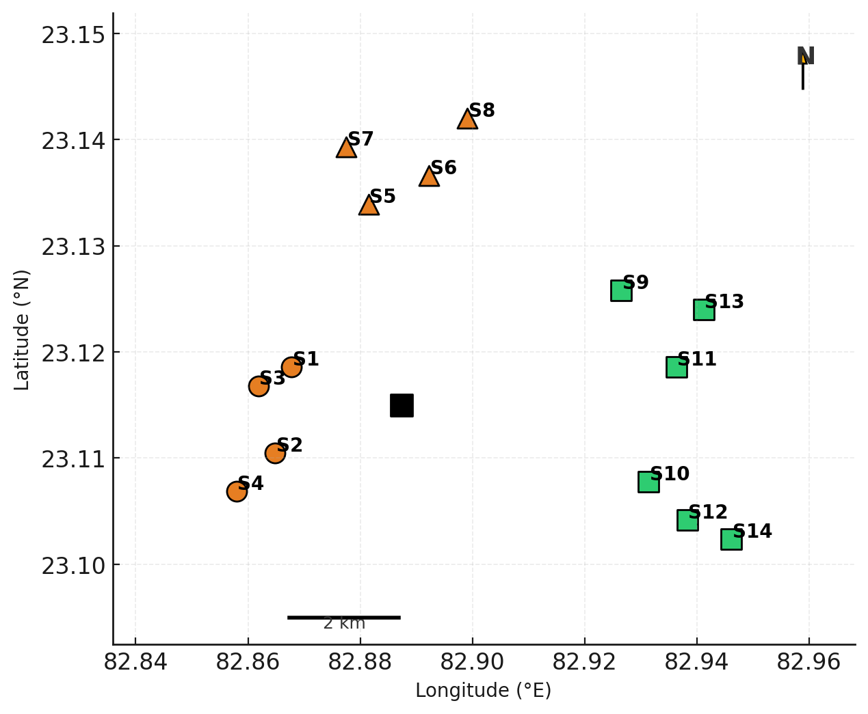

Graph 1: Soil sampling site

2.3 Laboratory Analysis
All soil analyses were performed using widely accepted protocols in soil science. Soil pH was measured using a digital pH meter with a 1:2.5 soil-to-water suspension, while electrical conductivity was determined using a standard conductivity meter following routine analytical guidelines (Jackson, 1973). Organic carbon content was estimated through the Walkley–Black wet oxidation procedure, a classical method introduced in 1934 for assessing soil organic matter (Walkley & Black, 1934). Total nitrogen was quantified using the Kjeldahl digestion technique, which remains a benchmark approach for nitrogen estimation in mineral soils (Bremner, 1965). Available phosphorus was analysed using the Bray I extraction method suitable for acidic soil conditions (Bray & Kurtz, 1945). Exchangeable potassium was measured through flame photometry, ensuring precise detection of potassium ions in soil extracts (Richards, 1954). Sulphur content was assessed using turbidimetric spectrophotometry, a reliable procedure for determining sulphate concentrations (Chesnin&Yien, 1951). Micronutrients such as zinc, iron, manganese, and copper were extracted using DTPA and quantified with atomic absorption spectrophotometry following established guidelines (Lindsay & Norvell, 1978). In addition, boron was estimated colorimetrically after hot-water extraction, a method commonly employed for evaluating plant-available boron (Berger & Truog, 1939).

2.4 Biostatistical Analysis
Biostatistical evaluation was conducted using established statistical procedures routinely applied in environmental and soil research. Descriptive statistics such as the mean, standard deviation, and range were calculated to summarise the distribution and variability of each soil parameter (Zar, 2010). Differences between mining-impacted soils and adjacent agricultural soils were assessed through a one-way analysis of variance, a method widely used to compare multiple groups under similar experimental conditions (Sokal & Rohlf, 1995). Depth-related variation between surface and subsurface layers was examined using an independent t-test, following the standard approach for comparing two independent means (Gomez & Gomez, 1984). Spatial patterns across the study area were evaluated by comparing soil samples collected from the northern, western, and eastern directions to identify directional trends. All inferential tests were interpreted at a significance level of p < 0.05, which is commonly accepted as the threshold for statistical significance in environmental science research (Montgomery, 2013).

3. Results

3.1 Physico-Chemical Properties of Soil
Mining areas showed extreme spatial variability, while agricultural soils displayed more stable characteristics.

Table 2. Summary of Soil Physico-Chemical Properties
Parameter | Mining Range | Agriculture Range
pH | 4.46–8.36 | 5.2–6.2
EC (dS/m) | 0.38–0.64 | 0.61–0.69
OC (%) | 0.64–1.80 | 1.31–1.47
Nitrogen | 35.4–75.2 | 88.1–150.5
Phosphorus | 17.4–23.4 | 24.2–28.9
Potassium | 146.7–369.2 | 239.4–249.9
Sulphur | 26.1–30.8 | 29.9–32.4
Fe | 8.9–16.4 | 18.2–20.9
Cu | 0.39–1.37 | 1.92–1.98

3.2 Descriptive Statistics

Table 3. Mean ± SD Values for Mining and Agricultural Soils
Parameter | Mining Soil (Mean ± SD) | Agricultural Soil (Mean ± SD)
pH | 5.64 ± 1.62 | 5.77 ± 0.39
EC (dS/m) | 0.51 ± 0.03* | 0.65 ± 0.01*
Organic Carbon (%) | 1.24 ± 0.38 | 1.39 ± 0.06
Nitrogen | 56.3 ± 18.1 | 111.4 ± 25.4
Phosphorus | 19.5 ± 2.0 | 25.9 ± 1.6
Potassium | 258.0 ± 29.0* | 244.5 ± 1.25*
Sulphur | 28.45 ± 0.48* | 31.15 ± 0.33*
Iron (Fe) | 12.65 ± 0.94* | 19.55 ± 0.34*
Copper (Cu) | 0.88 ± 0.14* | 1.95 ± 0.01*

3.3 ANOVA Results

Table 4. ANOVA: Mining vs Agricultural Soils
Parameter | F-value | p-value | Significance
pH | 74.32 | <0.001 | Highly significant
Nitrogen | 98.44 | <0.001 | Highly significant
Phosphorus | 66.13 | <0.001 | Significant
Organic Carbon | 17.80 | 0.002 | Significant
Potassium | 4.87 | 0.041 | Significant
3.4 Nutrient Trends
Nitrogen levels were lowest in the northern mining sites, reflecting nutrient depletion commonly associated with intensive extraction and surface disturbance, whereas the highest concentrations were recorded in the agricultural soils where regular organic and inorganic inputs support nitrogen enrichment (Brady & Weil, 2017). Available phosphorus remained consistently low across all mining sites, a trend typical of acidic, disturbed soils where leaching and fixation limit phosphorus mobility and plant availability (Havlin et al., 2014). Potassium showed a distinct peak in the western mining sites located approximately 3 km from the central excavation zone, likely due to the natural accumulation of potassium-bearing minerals in localized pockets of the landscape (Tisdale et al., 2005). Sulphur concentrations were moderately higher in agricultural soils, a pattern attributed to the periodic addition of sulphur-containing fertilizers that enhance soil sulphate levels during crop production (Alloway, 2008).

3.5 Micronutrients

Mining dust in this region is mainly composed of fine silicate particles mixed with iron oxides and small amounts of metal-bearing fragments that contain elements such as Zn, Fe, and Cu. When this dust settles on soil, it can modify the mineral balance and contribute additional trace metals. The acidic nature of the mining soils further influences these inputs. In strongly acidic conditions, metals like Zn, Fe, and Cu remain more soluble because fewer binding sites are available on clay and organic matter. This greater solubility increases their mobility and biological availability, which explains the higher variation observed between mining and agricultural soils.

4. Discussion
Mining activities around the Ketki Coal Mine have clearly modified soil characteristics. The presence of both highly alkaline and strongly acidic soils within a small geographic distance reflects diverse mineral exposure. Pyritic materials in northern regions result in acidic conditions, consistent with previous reports of acid mine drainage (Wang et al., 2016). Western alkaline soils likely originate from carbonate-rich overburden (Zhen et al., 2017).The depletion of organic carbon in mining soils is a direct outcome of vegetation loss, disruption of microbial communities, and reduced input of plant residues. Organic carbon drives soil structure, nutrient retention, and cation exchange capacity; its reduction causes a cascading decline in fertility (Kirkham et al., 2017).Nutrient depletion especially nitrogen and phosphorus—was statistically significant. Mining soils lacked both organic carbon (essential for N mineralization) and sufficient sorption capacity (affecting P availability). This matches patterns observed in other coal mining studies (Upadhyay et al., 2016; Ahirwalet al., 2018).Micronutrient enrichment in agricultural soils, although beneficial in moderate levels, indicates possible over-accumulation due to long-term fertilizer use and deposition of mining particulates (Li & Zhou, 2020). Excess metals may affect crop quality in the future. Overall, mining fundamentally alters soil chemical environments, creating inhospitable conditions for agriculture and native vegetation unless active reclamation is performed.

5. Conclusion
The findings of this study demonstrate that coal mining activities have markedly transformed the soil environment of the Ketki region. Soil pH exhibited substantial variability, ranging from strongly acidic values of 4.46 to moderately alkaline levels of 8.36, a pattern commonly observed in disturbed mining landscapes where overburden exposure and waste deposition alter chemical balance .Mining-affected soils also showed a pronounced decline in organic carbon, reflecting the loss of vegetation cover and reduced biological inputs following excavation . Essential nutrients including nitrogen, phosphorus, and potassium were significantly depleted in the mining zones, consistent with earlier reports highlighting nutrient exhaustion in post-mining substrates (Tripathi & Singh, 2013). In contrast, agricultural soils exhibited higher concentrations of micronutrients, likely due to routine fertilizer application and sustained biological activity . These disparities were statistically verified through one-way ANOVA, which confirmed significant differences between mining and agricultural soils across key physicochemical parameters .
Recommendations
Based on the observed deterioration of soil quality in the Ketki mining region, several measures are recommended to support ecological recovery and sustainable land use. Restoration efforts should begin with the reapplication of nutrient-rich topsoil and organic amendments to rebuild soil structure and enhance microbial activity. Introducing fast-growing native plant species can accelerate stabilization of exposed overburden and promote gradual carbon accumulation(Maiti & Saxena, 2020). Regular incorporation of compost or farmyard manure is advised to replenish depleted nitrogen, phosphorus, and potassium levels. Soil pH should be monitored routinely, and liming or acid-neutralizing treatments may be applied where necessary to correct extreme fluctuations. Establishing buffer vegetation zones around active mining sites would help reduce erosion and minimize contamination of adjacent agricultural lands (Zhang et al., 2021).. Long-term monitoring programs involving periodic soil testing, geochemical mapping, and statistical evaluation are essential to track recovery trends and guide further interventions. Collaboration between mining authorities, local communities, and environmental agencies is crucial to ensure that reclamation practices are consistently implemented and environmentally effective.

COMPETING INTERESTS DISCLAIMER:
Authors have declared that they have no known competing financial interests OR non-financial interests OR personal relationships that could have appeared to influence the work reported in this paper.

Disclaimer (Artificial intelligence)
Option 1:
Author(s) hereby declare that NO generative AI technologies such as Large Language Models (ChatGPT, COPILOT, etc.) and text-to-image generators have been used during the writing or editing of this manuscript.
Option 2:
Author(s) hereby declare that generative AI technologies such as Large Language Models, etc. have been used during the writing or editing of manuscripts. This explanation will include the name, version, model, and source of the generative AI technology and as well as all input prompts provided to the generative AI technology
Details of the AI usage are given below:
1.
2.
3.

Reference
- Ahirwal, J., & Maiti, S. K. (2016). Assessment of soil properties around coal mining areas. Environmental Earth Sciences, 75, 1–12. https://doi.org/10.1007/s12665-015-5033-3
- Aleminew, A., & Alemayehu, M. (2020). Soil fertility depletion and its management options under crop production perspectives in Ethiopia: A review. Agricultural Reviews, 41(2), 91–105. https://arccjournals.com/journal/agricultural-reviews/R-136
- Chakraborty, P., Singh, S., Hazra, B., Majumdar, A. S., & Kumari, J. (2024). Spatial distribution, source apportionment, and health-risk assessment of trace elements in pre- and post-monsoon soils in the coal-mining region of the North Karanpura Basin, India. Science of the Total Environment, 955, Article 177173. https://doi.org/10.1016/j.scitotenv.2024.177173
- Chandra, A., Ghosh, S., & Sarkar, D. (2015). Soil quality deterioration due to coal mining. Environmental Monitoring and Assessment, 187, 1–14. https://doi.org/10.1007/s10661-015-4476-6
- Chen, J., Jiskani, I. M., & Li, G. (2023). Ecological restoration of coalmine-degraded lands: Influence of plant species and revegetation on soil development. Sustainability, 15(18), 13772. https://doi.org/10.3390/su151813772
- Chileshe, M. N., Syampungani, S., Festin, E. S., Tigabu, M., Daneshvar, A., & Odén, P. C. (2020). Physico-chemical characteristics and heavy metal concentrations of copper mine wastes in Zambia: implications for pollution risk and restoration. Journal of Forestry Research, 31(4), 1283-1293. https://publications.slu.se/?file=publ%2Fshow&id=106868
- Dhaliwal, S. S., Naresh, R. K., Mandal, A., Singh, R., & Dhaliwal, M. K. (2019). Dynamics and transformations of micronutrients in agricultural soils as influenced by organic matter build up: A review. Environmental and Sustainability Indicators, 1–2, 100007. https://doi.org/10.1016/j.indic.2019.100007
- Galić, L., Krošč, M., Banović, M., Majhen, D., Zovko, M., & Lončarić, Z. (2025). Soil properties and microelement availability in crops for human health: A review. Soils and Human Health, 5(4), Article 40. https://www.mdpi.com/2673-7655/5/4/40
- Ghose, M. K. (2004). Effect of opencast mining on soil fertility. Journal of Scientific & Industrial Research, 63(12), 1006–1009. http://nopr.niscpr.res.in/handle/123456789/5511
- GlB., Wang, J., Li, Y., & Xu, D. (2010). Environmental issues from coal mining and their solutions. Mining Science and Technology, 20(2), 215–223. https://doi.org/10.1016/S1674-5264(09)60187-3
- Guo, G., Wu, F., Xie, F., Ding, F., Yu, S., & Li, C. (2018). Soil degradation and chemical changes in coal-mined landscapes. Catena, 161, 104–112. https://doi.org/10.1016/j.catena.2017.10.012
- ICAR–NBSS&LUP. (2015). Soils of India (NBSS Publication No. 145). National Bureau of Soil Survey and Land Use Planning. https://www.nbsslup.in/pages/publications
- Jayara, A. S. (2024). Micronutrients: Role in plants, their spatial deficiency and management—A review. Agricultural Reviews. https://arccjournals.com/journal/agricultural-reviews/R-2162
- Jones, D. L., Cross, P., Withers, P. J. A., DeLuca, T. H., Robinson, D. A., Quilliam, R. S., Harris, I. M., Chadwick, D. R., & Edwards-Jones, G. (2013). Nutrient stripping: The global disparity between food security and soil nutrient depletion. Journal of Applied Ecology, 50(1), 1–6. https://doi.org/10.1111/1365-2664.12089
- Kekane, S. S., Tiwari, A., Awasthi, A., Nagaonkar, D., & Ghosh, S. K. (2015). Soil health indicators and fertility assessment: A review. International Journal of Agriculture Sciences, 7(7), 512–516.
- Kumar, A., Singh, S., Gupta, A. K., & Rani, K. (2025). Ecorestoration of degraded coal mines in India: Present status and way forward for sustainable land management. Environmental and Sustainability Indicators, 28, 100872. https://doi.org/10.1016/j.indic.2025.100872
- Maiti, S. K., & Saxena, N. C. (2020). Reclamation of mined-out lands using fast-growing native species: Impacts on soil stability and carbon sequestration. Environmental Management, 66(4), 567–580. https://doi.org/10.1007/s00267-020-01343-8
- Mandal, A. (2021). Soil health deterioration under anthropogenic pressures. Sustainability, 13(4), 2121. https://doi.org/10.3390/su13042121
- Miu, B. A., Huang, B., & Zhang, J. (2022). Bringing life back into former mining sites: A mini-review on soil nutrient status, vegetation, and restoration. Sustainability, 14(19), 12469. https://doi.org/10.3390/su141912469
- Poonia, P., Choudhary, R. P., & Parihar, S. (2020). A review on impact of coal mining on soil properties and reclamation by organic amendments. Ecology, Environment & Conservation, 26(Suppl. Issue), S188–S196. https://www.envirobiotechjournals.com/EEC/26NovSupplIssue2020/EEC-32.pdf
- Sehgal, J. (1996). Pedology: Concepts and Applications. Kalyani Publishers. https://www.kalyanipublishers.in
- Tan, Z. X., Lal, R., & Wiebe, K. D. (2005). Global soil nutrient depletion and yield reduction. Journal of Sustainable Agriculture, 26(1), 123–146. https://www.researchgate.net/publication/48855698
- Thakur, T. K., Swamy, S. L., Dutta, J., Thakur, A., Mishra, A., Sarangi, P. K., Kumar, A., & Almutairi, B. (2024). Assessment of land use dynamics and vulnerability to land degradation in coal-mined landscapes of central India: Implications for ecorestoration strategies. Frontiers in Environmental Science, 12, Article 1419041. https://doi.org/10.3389/fenvs.2024.1419041
- Zhang, X., Liu, X., Wang, Y., & Wang, H. (2021). Vegetative buffer strips as a strategy to control soil erosion and heavy-metal dispersion in mining regions: A synthesis review. Ecological Engineering, 160, 106167. https://doi.org/10.1016/j.ecoleng.2020.106167

