ASSESSMENT OF MARKET SURVEY ANALYSIS ON FISH FOR MGOMBEZI COMMUNITY AQUAPONICS PROJECT

Abstract

The market survey analysis aimed to collect information on the demand, supply, pricing trends, and consumer preferences for fish among the communities living in the area and its environs. This information would support the Mgombezi community’s initiative to implement fish farming using aquaponics technology, to address malnutrition, kwashakor and food insecurity and at the same time empowering community members through experiential learning to discover and solve their own problems. An observational and survey method of study was employed. Primary and secondary data collection strategies were used. It involved planning for the survey where use of face-to-face interviews, questionnaires, phone calls and observations at markets were adopted. Questionnaires were used to collect information. The questions that sought to know fish types that had high turnover; fish types in high demand; price trends in each market and season; and sources of fish sold. Other data collected included the type of market, open or enclosed in a building or space; source of fish in terms of whether locally or externally sourced; buying/selling price; perishability, whether high or low; mode of transport, either motorbike or vehicle; market capacity; demand/supply; government interventions, among others. During the survey, 27 different types of fresh fish were sold in these markets. Almost 99% of these fresh fish were salt water fish obtained from the nearby Ocean. Few fresh water fish either from Lake Victoria or from China found their way into these markets. Most Coastal communities preferred salt water fish rather than fresh water fish. The quantities of dried fish sold were also pocket friendly and therefore either sold in kilograms or in tins. These dried fish formed the major source of fish protein for most communities living in the hinterlands away from the sea. The study revealed that fish marketing is a viable business and offers significant growth opportunities since the demand for fish cannot be satisfied as evidenced by the high prices. However, there is need to address the observed challenges especially on provision of cold storage facilities and processing equipment since fish is a highly perishable commodity.

Keywords: food insecurity, Coastal communities, malnutrition, Mgombezi

1.0 Introduction
Mgombezi community has a membership of 1000 members. It is based in Lunga Lunga Sub-County, a semi-arid area in Kwale County that borders river Umba (Kwale County profile, 2020; Mwanga, 2019; Kwale County Integrated Development Plan, 2020). This community was earmarked to benefit from an Aquaponics project to be producing fish. The project aimed at empowering the community to address the rampant malnutrition and food insecurity in the region while at the same time generating income (Aich et al., 2020). However, as a rule of thumb, before any fish production can be undertaken, it is a requirement that a market survey has to be done to identify and establish market dynamics involved, where the products would be sold, while at the same time identifying threats and opportunities. It is in this respect that this market survey was undertaken.

1.1 Description of Mgombezi area and its environs
The Mgombezi area is located South of Kwale and borders Tanzania on the extreme southern end (Mwanga, 2019. The area is served by two seasonal rivers namely river Umba and Ramisi. These rivers, although seasonal, are the major sources of water for domestic, livestock and irrigation activities for most part of the year. These rivers will be an important source of water for the Mgombezi project before a borehole can be drilled. River Umba flows through Lunga Lunga town, before emptying into the Indian Ocean near Vanga (Lerise, 2005). Vanga town is an important fish landing site and receives fish from both Kenyan and Tanzanian fishermen.
Lunga Lunga Municipality mainly relies on road transportation which has boosted its trade potential. It is served by matatus, buses, motorcycles, and bicycles which links it to major commercial hubs and fish markets such as Diani, Kinango, Mwangulu among others (Kemfsed, 2020). The dueling of the Malindi-Mombasa-Lunga Lunga-Bagamoyo road and tarmacking of other feeder roads, promise a bright future and further development potential for upscaling Mgombezi project.

1.5 Statement of the Problem
Mgombezi community intends to start fish farming project using aquaponics technology to empower its members to address the wide spread malnutrition and food insecurity (Sustainable development goals (SDGs) 1 and 2). However, there exists limited market information regarding the types fish preferred and consumed by the various communities in the area, as well as the potential demand, supply, and pricing trends for these products.

1.6 Objectives of the market survey
The market survey aimed at collecting information on the demand, supply, pricing trends, and consumer preferences for fish among the communities living in the area and its environs. This information would support the Mgombezi community’s initiative to implement fish farming using aquaponics technology, to address malnutrition, kwashakor and food insecurity and at the same time empowering community members through experiential learning to discover and solve their own problems.

1.6.1 Specific objectives of the market survey

These were to:
- To determine and understand consumer preferences for the various fish consumed in Lunga Lunga and neighboring Sub-Counties.
- To determine demand and supply for the various fish sold in the various markets in Lunga Lunga and neighboring Sub-Counties.
- To identify the various pricing trends for the various fish sold in the different markets in Lunga Lunga and neighboring Sub-Counties
- To analyze likely competition between Mgombezi produced fish, and those from different markets in Lunga Lunga and neighboring Sub-Counties
- To determine the effects of seasonality on demand, supply and pricing for the various fish sold in the various markets in Lunga Lunga and neighboring Sub-Counties.

1.7 Justification
The information generated from the market survey will facilitate determination of various types of fish that could be produced at the proposed Mgombezi Aquaponics Project for purposes of selling to the local markets. It will also gauge the amounts of fish that will be required for the different markets in the different seasons and the effects of seasonality on demand, supply and pricing for the various fish types.

2.0 Methodology

2.1 Study area
The study area for the market survey included all major and local markets in Lunga Lunga Sub-County and neighboring Sub-Counties, namely Msambweni and Kinango. Lunga Lunga Sub-County is bordered by Kinango Sub-County to the southwest, Msambweni Sub-County to the north and Tanzania to the south (Figure 1).
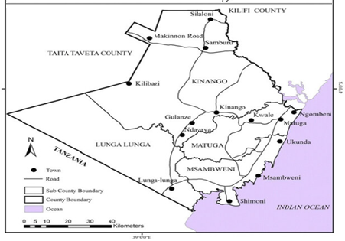
Figure 1: Map of Kwale County and its administrative boundaries showing various Sub-Counties.

2.2 Study design
An observational and survey method of study was employed. Primary and secondary data collection strategies were used. It involved planning for the survey where use of face-to-face interviews, questionnaires, phone calls and observations at markets were adopted. The target population for the survey included fish mongers, wholesalers, retailers and some key informants. During planning, Wards in the three Sub-Counties of Lunga Lunga, Kinango and Msambweni were listed from where sampling was done. Before commencement of the survey, one of the key members of Mgombezi Community paid a visit to all important administration offices to seek permission for conducting the survey. These administrative offices included Chiefs, Sub-chiefs, Village elders, Sub-County Commanders and Heads of Police Stations. Key informants from the focal area were involved in identification and selection of markets for the survey and also gave information on market days. Purposive sampling was done to select at least three Sub-Counties and three Wards per Sub-County for the survey (Kemfsed, 2020).. Of the over 100 local market centers in all the Wards in the three Sub-Counties, only 10 markets were selected for data collection. Criteria used for selection of the markets included, logistical issues especially the distances involved, impassable roads and also presence or absence of a market or market day. The visit to the markets for data collection was aligned to the market days to obtain hands-on information.

2.3 Data collection
Questionnaires were used to collect information. The questions that sought to know fish types that had high turnover; fish types in high demand; price trends in each market and season; and sources of fish sold. Other data collected included the type of market, open or enclosed in a building or space; source of fish in terms of whether locally or externally sourced; buying/selling price; perishability, whether high or low; mode of transport, either motorbike or vehicle; market capacity; demand/supply; government interventions, among others. In each market, vendor competition was assessed by observing their pricing strategies, mode of packaging, and branding, and presence or absence of any promotional efforts. Market and price trends were assessed by looking at seasonal variations in fish demand and prices and also identifying trends in locally sourced and exotic types of fish. Two groups of enumerators (each group composed of two enumerators) were involved in interviewing the traders, two handling fresh and two handling dried fish. Before starting the interview, the total number of fishmongers were identified and 30% of them were randomly selected for interview. Also, in the specific markets, sampling of fish traders for interviews was done by identifying those selling locally sourced fish while the other group of enumerators sampled traders with externally sourced fish. The same was applied for fish mongers where one group interviewed those selling fresh fish while the other interviewed those selling dried fish.

2.4 Data analysis
Descriptive data analysis using excel, pie charts, bar charts and tables was used to identify patterns of demand and supply, price fluctuations and fish preferences in the individual markets and by Sub-Counties.

3.0 Results and discussions

Fish market survey findings
The fish market survey was conducted along the sea shore markets and in the hinterland markets extending all the way to Kinango, some 50-60kms away from Lunga Lunga.

3.1 Categories of fish sold
There were two categories of fish i.e. those sold fresh and those sold dried. The fresh fish consisted of local (those straight from the ocean) and imported (cold stored) from China and Japan. The dried fish had been harvested and processed into dry form for longer shelf life and convenience during transportation. The imported fish initially sold at 150 per kg but the prices increased to 400 after introduction of import duty in 2023.

3.2 Types of fish

3.2.1 Fresh fish
During the survey, 27 different types of fresh fish were sold in these markets (Table 1). Almost 99% of these fresh fish were salt water fish obtained from the nearby Ocean. Few fresh water fish either from Lake Victoria or from China found their way into these markets. Most Coastal communities preferred salt water fish rather than fresh water fish. The fresh water fish were mainly preferred by hinterland consumers and a few up-country communities. Most of the fish mongers who sold fresh fish preserved their merchandise using refrigerators or cooler boxes filled with ice. These fish were either sold in kilograms or in pieces or bundles (Plate 1). Fresh salt-water fish was the major source of protein for communities living along the coastal strip.
Table 1: Fresh fish types found in fish markets in the study area.
S/No | Fish type | English name | Scientific name
1 | Kolekole | Jack Crevalle or Jackfish or trevally | Seriola rivoliana
2 | Mizira | barracuda | Sphyraena sphyraena
3 | Mkundaji | Goatfish or Red Mullet | Mullus spp
4 | Mkupi | Yellow fish | Labeobarbus aeneus
5 | Tilapia | cichlid fish | Oreochromis spp
6 | Tsengo | Narrow-barred Spanish mackerel | Scomberomorus commerson
7 | Una | mackerel
8 | Kidau | large-scaled, round, floating fish | Hyporhamphus dussumieri
9 | Msuse/msusa | Black-barred half beak | Hemiramphus far
10 | Ngisi | squid | Decapodiformes spp
11 | Ngurangura | - | -
12 | Mizira | Barracuda | Sphyraena sphyraena
13 | Chaa | Common silver-biddy | Gerres oyena
14 | Fute | - | -
15 | Kanga macho | - | -
16 | Parawe | False Trevally or Trevally, or Malabar Jack or Malabar King Fish. | Lactarius lactarius
17 | Prawns | prawns | Macrobrachium rosenbergii
18 | Pweza | octopus | Octopus vulgaris
19 | Red snapper | Red snapper | Lutjanus campechanus
20 | Tembo | - | -
21 | Kibembere | - | -
22 | Kipepeo | Butterfly fish | Chaetodon capistratus
23 | Simsim | - | -
24 | Sulisuli | - | -
25 | Tafi | rabbit fish | Siganus sutor
26 | Tangu | Athi elephant-snout fish | Mormyrus tenuirostris
27 | Mabeshe | - | -

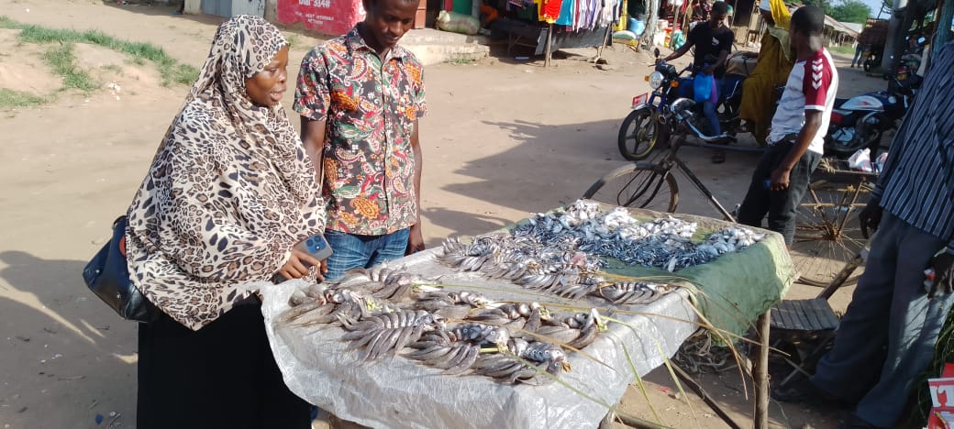
Plate 1: Perani fish market during a market day. The fish were being sold in 3-5pieces per bundle.
High perishability of the fresh fish determined the quantities a family could buy since most of them had no refrigerators. This factor explained why few types of fresh salt water fish were sold in the hinterland markets while the dried fish dominated these markets. This suggests that if the Mgombezi project was to sell fresh fish, it has to provide for cold storage, freezers and cooler boxes for transportation and delivery to distant markets.

3.2.2 Dried fish
Ten types of dried fish were identified in the sampled markets (Table 2 and Plate 2a, b). Most of these fish were mainly derived from the sea. Few dried fish types were derived from fresh water sources, namely Omena and Tilapia (Kamongo) both from Lake Victoria. Some fresh water fish derived from fresh water ponds were also noted. These included Mabeshe and Mtonzi (Mud fish) (Table 2).
Table 2: Dried fish types found in fish markets in the study area
s/no | Fish type | English name | Scientific name |  | Fish type | English name | Scientific name
1 | Kata shingo | Fried sardines | Sardinella longiceps | 6 | **Kamongo | marbled lungfish | Protopterus aethiopicus
2 | Simsim | Fresh Sardines | Sardinella tawilis | 7 | **Mtonzi | eel catfish | Plotosus lineatus
3 | Papa | Shark | Carcharhinus spp | 8 | **Omena | silver cyprinid or Lake Victoria sardine, | Rastrineobola argentea
4 | Kipungu | Silver Cyprinid | Rastrineobola argentea | 9 | Kimala wari
5 | Kamba | Prawns | Penaeus spp | 10 | **Mabeshe
**Denotes fresh water fish, either from Lake Victoria, Taveta or fresh water ponds, and are important candidates for Mgombezi project since they are locally acceptable especially in the hinterlands.

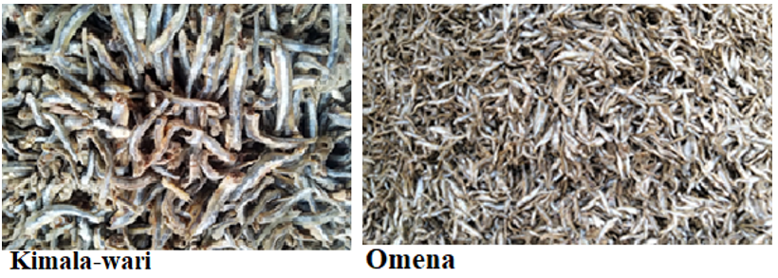
Plate 2a: Types of dried fish sold in Kinango market during a market day.
These dried fish were preferred for their different tastes and qualities, and especially their long shelf life since they were of low perishability and could keep for longer period until the next market day (Plates 2a and 2b).
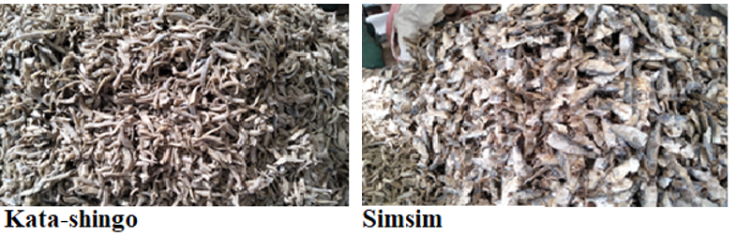

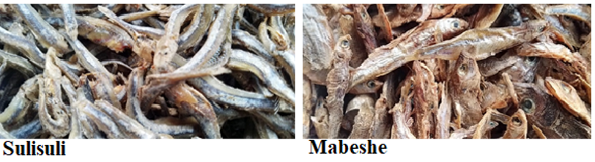
Plate 2b: Types of dried fish sold in Kinango market on a market day.
The quantities of dried fish sold were also pocket friendly and therefore either sold in kilograms or in tins. These dried fish formed the major source of fish protein for most communities living in the hinterlands away from the sea. It should be noted that most of the fresh salt water fish sold in the sea shore markets also found their way into hinterlands, being sold as dried fish since they could keep for long periods after processing (Table 2). The fresh water fish were likely to dominate fish farming activities at Mgombezi aquaponics project. Therefore, conducting trials on identification of suitable species of fresh water fish to adapt to re-circulatory system will occupy the initial stages of the project period (Table 2 and Plates 7-10). The possibility of using sea water for fish farming should also be given a trial as research has shown that some fish can thrive under brine or brackish water especially from boreholes.

3.3 Sources of fish in the markets
It should be noted that of all the fish types, only Omena, Mabeshe, Mtonzi and Tilapia were from fresh water sources, while the rest were from the ocean (Table 2 and Plates 7-10). The major sources of fresh water fish included Lake Victoria, Taveta, local rivers, swamps and ponds. Vanga was the major source of salt water fish with well-developed fish landing bay and market fitted with refrigeration facilities (Plate 3).
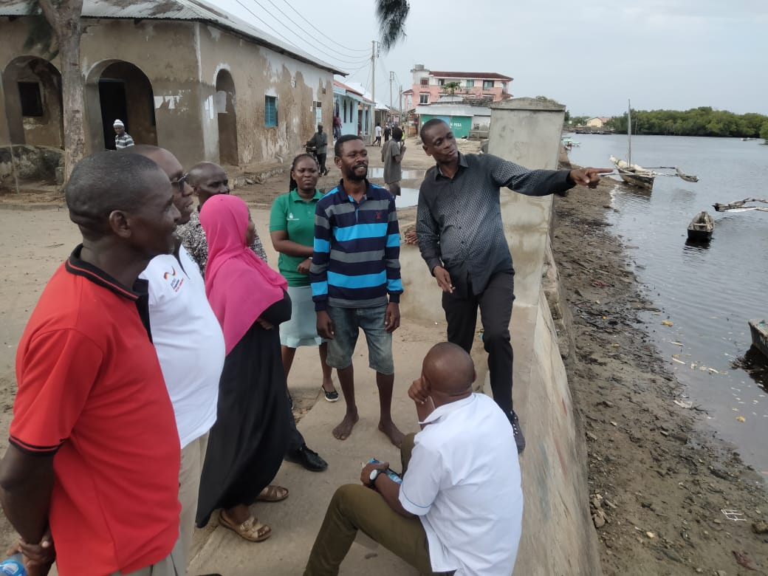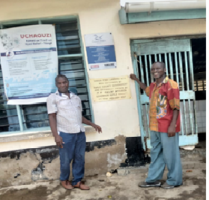
Plate 3: Vanga fresh fish landing bay and market.
Significant amounts of fish catches come from Tanzania ocean waters, courtesy of the strength of the Kenyan currency. Other fish sources included Shimoni, Gasi, Msambweni, Likoni and Kibuyuni

3.4 Fish selling units
Both fresh and dried fish were sold in kilograms, bunches and per piece (Table 3 and Plate 4). For both types of fish, prices per kilogram ranged from Ksh. 300-500, while per bunch ranged from Ksh. 50-200 and per piece ranged from Ksh. 100-200 (Table 3). These prices were dependent on size, fish type, market, buying price, and season which in turn affected the supply. For papa and kipungu fish types, the prices were Ksh. 700 per kilogram and Ksh. 20 shillings per piece.

Table 3: Average fish prices at the markets (in Ksh).
 | Type of fish | Unit | Price, normal season | Price, off-season
 | Fresh/Dried | kg | 300-400 | 400-600
 | Fresh/Dried | piece | 100 | 200-300
 | Fresh/Dried | bunch | 50-100 | 70-150

Factors that determined fish prices included: fish type, size, buying price, season.
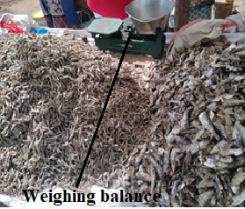
Plate 4: Weighing balances used for weighing dried fish in Kinango market.

3.5 Packaging
Fresh fish were mainly packaged in nylon, newspaper and raffia strings while the dried fish were packaged in nylon, newspapers and nets.

3.6 Storage and preservation
Due to the high perishability of fresh fish most fishmongers stored their merchandise in cooler boxes filled with ice blocks and in refrigerators. In situations where spoilage of fresh fish would occur, the fish especially the small sizes ones were preserved by boiling, salting and drying while the big sized fish were preserved after removal of offals, by salting and drying (Plate 5). Dried fish were stored in cool dry place for future sales (Plates 2a, b).
To facilitate its operations, the Mgombezi project will have to consider installing refrigeration facilities to preserve their catches, but also consider selling a given proportion of their fish as fresh, processed or dried for future sales. Since the major market for fresh water fish was in the hinterlands, most of the Mgombezi project’s fish will have to be sold in the hinterland markets where the communities are used to them and also have little choices, unless the fish are processed such that they can compete with the salt water sea fish.

3.7 Processing and value addition
Fresh fish were sold as a whole or processed by removal of offals and scales. Some of the small sized fish such as Kata-shingo, Simsim and Kimala-wari were processed into dried fish by boiling, salting and drying (Plates 2, 4, 5 and 6).
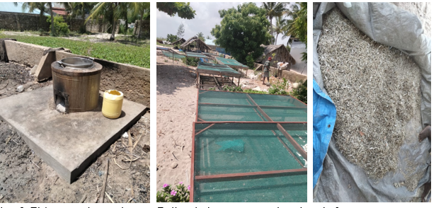
Plate 5: Fish processing equipment. Boiler, drying screens, and sorting platforms.

Value addition of fresh fish was done by deep frying (Plate 6). The Mgombezi communities will need to be trained on various methods of fish processing and value addition techniques.
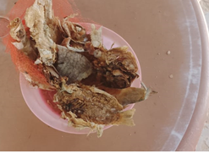
Plate 6: Value added fish by deep frying in cooking oil.

3.8 Mode of transportation
Most fresh fish were transported to markets using bicycles for nearby shopping centers, motorbikes for moderately distant markets, and refrigerated vans for far markets such as Mombasa Town and Kinango. The Mgombezi project will have to explore the use of motorbikes at initial stages when the produced quantities are small but escalate to use of refrigerated vans once the production has picked up.

3.9 Demand and supply
The demand for fish ran throughout the year while the supply was seasonal for both fresh and dried fish. Along the seashore markets, demand for fresh salt water fish was much higher than for dried fresh water fish. However, demand for fresh water dried fish was highest in the hinterland markets. The high preference for dried fish in the hinterland markets was attributed to their long shelf life with minimal demand for storage equipment (Plates 2a and 2b). This is where much of fish from Mgombezi project should be targeted to go. Use of motorbikes fitted with cooler boxes will be quite handy for transporting fresh and dried fish to the various markets.

3.10 Market days
Along the seashore markets, fresh salt water fish availability and marketing was not strongly tied to market days (Table 4). Thus, in these markets fish selling was a daily activity.
Table 4: Fish market days in the study area
s/no | Market/Days | Mon | Tues | Wed | Thur | Fri | Sat | Sun
1 | Mwangulu | X
2 | Kinango |  |  | X | X
3 | Ukunda | X | X | X | X | X | X | X
4 | Msambweni |  |  |  |  |  |  | X
5 | Shimoni | X | X | X | X | X | X | X
6 | Mrima |  |  |  | X
7 | Perani |  |  |  |  |  |  | X
8 | Menzamwenye |  |  |  | X
9 | Lunga Lunga |  |  |  |  | X
10 | Vanga | X | X | X | X | X | X | X
However, in the hinterland markets availability and marketing of large volumes of fresh and dried fish was strongly dependent on market days. Therefore, once Mgombezi fish production picks up there will be need to explore the possibility of sustaining a continuous supply of their fish in these markets so that communities get accustomed to them.

3.11 Proposed types of fresh water fish for farming in Mgombezi project
From the analysis of the findings of the market survey, it is evident that Mgombezi can only venture in fresh water fish farming since it has no sea front for farming salt water fish. While majority of fish found in the markets especially along the Coastal strip markets were salt water fish, they were highly preferred along the Coast than fresh water fish. However, fresh water fish were more preferred and dominated the hinterland markets of Kinango and Mwangulu among other markets. Table 5 shows a list of fish that were being sold in the local markets and could be farmed locally in fresh water ponds in Mgombezi.
Table 5: Types of fish that can be farmed in freshwater ponds in Mgombezi project.
 | Fish type |  | Fish type
1 | Mtonzi (Mud-fish) | 4 | Cat fish
2 | Tilapia | 5 | Common carp
3 | Mabeshe

3.11.1 Pictures of fresh water fish proposed for Mgombezi
Tilapia (Oreochromis niloticus)
Tilapia is the most farmed fish and a popular choice for most fish farming communities in Kenya due to its adaptability and rapid growth.
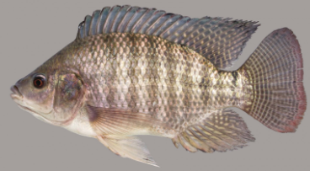
Plate 7: Tilapia fish
Thus, it is quite prolific and multiplies very fast leading to overpopulation. It thrives and adapts well in different environmental conditions and has a high demand in the market.
African Catfish (Clarias gariepinus).
Catfish is the most common type of freshwater fish farmed in ponds in Kenya.
It is known for its resilience and tolerance to low oxygen levels.
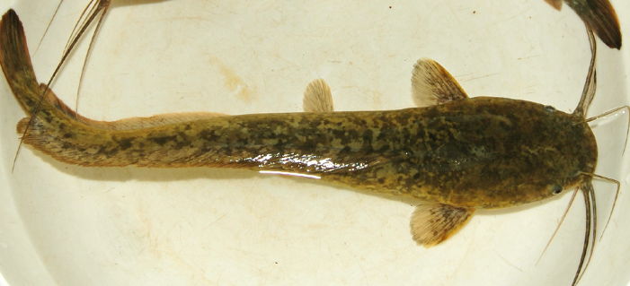
Plate 8: Cat fish
It can be farmed in areas with limited access to clean water because it can tolerate poor water quality. It grows quickly and is favored for its high protein content. The catfish can easily be distinguished from other fish types because it lacks scales.
Common carp (Cyprinus carpio)
This is one of popular types of fish farmed in ponds.
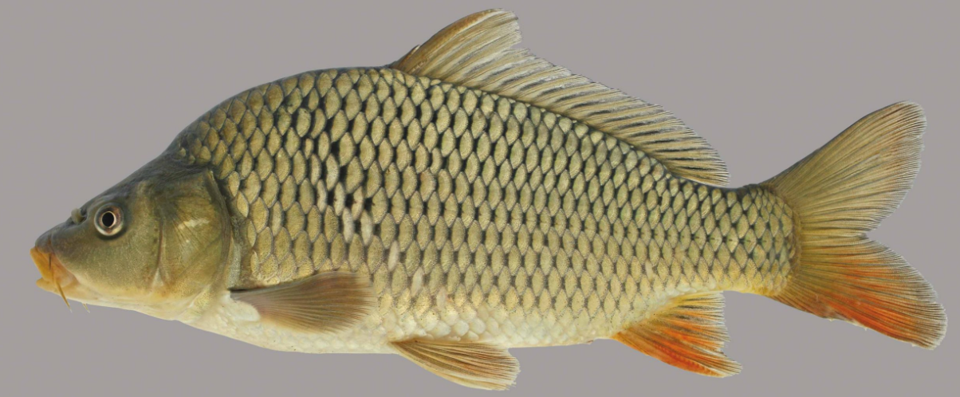
Plate 9: Common carp fish
It is valued for its fast growth rate and ability to adapt to various conditions including hot and cold areas. The species can survive prolonged periods of low oxygen.
Mud fish
Mud fish, is locally known as Kamongo. It can easily be farmed in fishponds or swampy areas. They remain buried in the mud during the dry season to avoid dehydration. 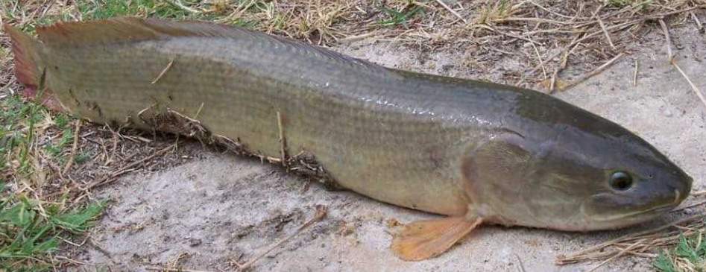
Plate 10: Mud fish

3.12 Challenges facing fish marketing
Fish marketing in the study area was influenced by a number of challenges that affected efficiency of markets operations. These included:
i) Poor handling and transportation of harvested fish especially from the sea or landing sites to destined markets. In most cases the fresh fish were stashed into gunny bags and carried at the back of bicycles, motor bikes or loaded at the back of matatus to destination points. Others used crates for fish transportation.
ii) Inadequate storage facilities in the market centers: Most fish mongers literally “walked” with their fish merchandise from one market to the next after a market day. In most cases there was no organized storage for their merchandise. Often they had to hire premises to store their remaining merchandise after a market day. Unlike vegetables, dried fish had longer shelf life. However, fresh fish was highly perishable and required fulltime refrigeration.
iii) Transportation and delivery delays also affected freshness and quality of fresh fish since the distances involved were large.
iv) Harsh climatic and weather conditions: Most fish mongers especially those operating in the open air markets complained of substantial loses of their fish merchandise during rainy seasons which resulted in mold or danger of aflatoxin. The rain also affected the flow of customers and this affected daily sales and turnover since few customers turned up.
v) Lack of power and cold storage facilities: Since most markets were in the rural areas, lack of power supply made it difficult to install cold storage rooms or facilities leading to high rates of spoilage of fresh fish when power failed, leading to huge loses since fish are highly perishable.

3.13 Opportunities in fish marketing
During the survey, a number of opportunities were evident: -
a) Preferences for fresh salt water fish. The communities along the coastal strip had more preference for fresh salt water fish for their daily meals than dried fish. However, dried fish was more preferred in the hinterlands than in coastal strip. This worked well in favor of Mgombezi project in that the project should maximize on production of dried fish since it had a wider market in the hinterlands and low requirement for cold storage refrigeration facilities during transportation.
b) Value-addition of fish: There is a wide scope for processing and value addition of harvested fish. Diversification of these processed and value added fish products would offer a wider price and income range, and time for selling the products since these processes enhance their appearance and shelf life.
c) Technology integration: A large number of fish mongers were using mobile apps for obtaining orders and making payments directly to their suppliers and buyers. This improved efficiency of the marketing processes and reduced time wastage in traveling to look for merchandise or orders.
d) There were limited cooperatives dealing with fish selling and marketing. Establishment of more cooperative societies would enhance efficiency in fish marketing in the region.

3.14 Conclusion on fish marketing
The study revealed that fish marketing is a viable business and offers significant growth opportunities since the demand for fish cannot be satisfied as evidenced by the high prices. However, there is need to address the observed challenges especially on provision of cold storage facilities and processing equipment since fish is a highly perishable commodity.

4.0 General Conclusions and Recommendations

4.1 Conclusions
The market survey has assisted in gathering information on demand, supply, price trends and their seasonality and consumer preferences for fish sold in the study area markets. This information has been used to make a case for production of fish for Mgombezi project and sale of the same to markets in the study area at a profit. It has also helped to establish the likely competition relationship between the fish supplies and Mgombezi community products. It has assisted in determining the types and quantities of fish to be produced by Mgombezi community.

4.2 Recommendations
i) For vendors: There is need for vendors to invest in cold storage facilities to enhance fish freshness quality and reduce post-harvest losses. However, this will require support from authorities in electrification of most markets and production areas. Equally Mgombezi will have to invest in installation of cold storage facilities.
ii) Mgombezi will need to diversify on different types and sources of fish that will grow faster at minimal costs to meet demand and eliminate seasonality in supply and stabilize prices especially during off-seasons.
iv) Once production at Mgombezi has established and stabilized, there will be need to establish collection and marketing centers and fish selling outlets. The project should eventually be scaled up to all Mgombezi community members so that they can experience individual benefits of practicing fish farming.
v) There will also be need to bring fish farmers together and initiate formation of cooperatives societies to access better marketing and transportation services.
vi) There will also be need to introduce subscription models for weekly deliveries to the various fish markets and consumers.

4.3 Way forward: Some important issues to be addressed or considered
The following will need to be addressed.
1. What will be the source of water before a borehole is drilled.
2. If Mgombezi project has to sell fresh fish, it has to provide for cold storage facilities such as freezers and cooler boxes for storage, transportation and delivery to distant markets.
3. Fresh water fish, from fresh water ponds, will be important candidates for Mgombezi project since they are the most locally acceptable especially in the hinterlands. Such are Kamongo, Mtonzi, Omena, Kimala-wari, and Mabeshe.
4. At initial stages there will be need to set up trials to determine the suitable fish during the aquaponics testing phase. Thus, initial stages of the project period (phase 1) will involve conducting trials on identification of suitable species of fresh water fish to adapt to re-circulatory system.
5. The possibility of using sea water for fish farming should also be given a trial as research has shown that some fish can thrive under brine or brackish water especially from boreholes.
6. To facilitate its operations, the Mgombezi project will have to consider installing refrigeration facilities to preserve their catches, but also consider selling a given proportion of their fish as fresh, processed or dried for future sales.
7. Since the major market for fresh water fish is in the hinterlands, most of the project’s fish will have to be sold in the hinterland markets where the communities are used to them and also have little choices, unless the fish are processed such that they can compete with the salt water sea fish.
8. Value addition of fresh fish was done by deep frying. The Mgombezi communities will need to be trained on these processing and value addition techniques.
9. The Mgombezi project will have to explore the use of motorbikes at initial stages when the produced quantities are small but escalate to use of refrigerated vans once the production has picked up.
10) There will be need to introduce subscription models for weekly deliveries to the various fish markets and consumers in the markets.
11. There will be need to do sensitization of community members about the project, their role and project’s role and also address their expectation.
13. Some expected important challenges will need to be addressed. i) Source of water for the project and farmers, ii) identification of land for the project iii) identification of equipment needed, iv) stray livestock, v) and fencing will be a priority.
14. There will be need to consider establishing project steering committee and later formation of cooperatives.
15. There will be need to determine sources of fingerlings and water for hydroponics system.

Disclaimer (Artificial intelligence)
Option 1:
Author(s) hereby declare that NO generative AI technologies such as Large Language Models (ChatGPT, COPILOT, etc.) and text-to-image generators have been used during the writing or editing of this manuscript.
Option 2:
Author(s) hereby declare that generative AI technologies such as Large Language Models, etc. have been used during the writing or editing of manuscripts. This explanation will include the name, version, model, and source of the generative AI technology and as well as all input prompts provided to the generative AI technology
Details of the AI usage are given below:
1.
2.
3.

REFERENCES
Aich, N., Nama, S., Biswal, A., & Paul, T. (2020). A review on recirculating aquaculture
systems: Challenges and opportunities for sustainable aquaculture. Innovative Farming, 5(1), 17-24.
KEMFSED, (2020). Kenya Marine Fisheries and Socio-Economic Development Project.
Enhancing Livelihoods. https://kemfsed.org.
Lerise, F. S. (2005). Facilitating Cross-Border Dialogue: The Case of Umba River Ecosystem in
Kenya and Tanzania. Topics of Integration Watershed Management, 3, 69-88.
Lunga Lunga Municipality development plan, (2020). Https://Lunga Lunga.Municipality.co.ke/#
Mwanga, S. S. (2019). Water dynamics in the Umba river sub-catchment of Tanzania: water
resource allocation for livelihoods (Doctoral dissertation).
Fadlan M, Nurhayati A, Maulina I, Rizal A. Analysis of Consumer Preferences
in Selecting Processed Fish Products (Case Study in Bendungan Hilir Market, Central Jakarta, Indonesia). Asian J. Fish. Aqu. Res. [Internet]. 2022 Jan. 29 [cited 2025 Jul. 12];16(2):8-15. Available from: https://journalajfar.com/index.php/AJFAR/article/view/342

Osman YA, Samy‐Kamal M. Diversity and characteristics of commercial Red Sea fish species based on
fish market survey: informing management to reduce the risk of overfishing. Journal of Fish Biology. 2023 Apr;102(4):936-51.

Appendix 1: The Data Collection Team at Mgombezi
.