Original Research Article
Analysis of Genetic variability, Heritability and Genetic Advance among 61 genotypes of Groundnut (Arachis hypogaea L.)
ABSTRACT
The present investigation was conducted to quantify genetic variability, heritability, and genetic advance among 61 diverse groundnut (Arachis hypogaea L.) genotypes along with five check varieties during Kharif 2024 at the Agricultural Research Farm of Lovely Professional University, Punjab. The material was evaluated in an augmented design with each genotype planted in 3 m rows at 45 cm × 10 cm spacing. Eleven agro-morphological and yield-related traits plant height, 100-pod weight, 100-kernel weight, shelling percentage, days to maturity, days to 50% flowering, pod yield per plant, biological yield, sound mature kernel percentage, harvest index, and kernel yield per plant were recorded. ANOVA revealed highly significant differences (p < 0.01) among the genotypes for all traits, indicating the presence of sufficient genetic variability for selection. Several characters such as pod yield per plant, kernel yield per plant, 100-pod weight, and days to 50% flowering showed strong discrimination among test genotypes and checks, confirming wide diversity and superior performance of certain accessions. Variability parameters showed that PCV values were only marginally higher than corresponding GCV values, reflecting limited environmental influence and the predominance of genetic factors. Moderate GCV was observed for plant height (15.62%) and days to 50% flowering (13.40%), whereas most other traits exhibited low GCV. Heritability estimates were notably high for plant height (95.98%), shelling percentage (95.96%), days to 50% flowering (95.28%), days to maturity (93.15%) and kernel yield per plant (91.57%), demonstrating strong genetic control and reliability of direct selection. High genetic advance as percent of mean (GAM) recorded for plant height (31.58%) and days to 50% flowering (26.99%) further indicated the predominance of additive gene action for these traits. Moderate GAM values for 100-pod weight (13.02%), 100-kernel weight (12.82%), shelling percentage (16.38%), pod yield (11.36%) and kernel yield (10.97%) revealed good prospects of improvement through selection. Collectively, traits expressing high heritability coupled with moderate to high GAM particularly plant height, days to 50% flowering and shelling percentage emerge as reliable selection indices for groundnut improvement. Overall, the study confirms ample exploitable variability within the evaluated germplasm and identifies key yield-related traits with strong genetic determinism. The results provide a robust genetic foundation for developing high-yielding, early-maturing and quality-enhanced groundnut cultivars suitable for diverse agro-ecological conditions.
Keywords: Heritability; Genetic advance; Yield components; Genotypic coefficient of variation (GCV); Phenotypic coefficient of variation (PCV)
- INTRODUCTION
Groundnut (Arachis hypogaea L.), commonly known as peanut, is a vital oilseed and leguminous crop cultivated extensively in tropical and subtropical regions across the globe. Recognized as “the king of oilseeds,” groundnut is India’s predominant oilseed crop. It is an autotetraploid, self-pollinated species (2n = 4x = 40) belonging to the Fabaceae family, valued for its rich nutritional composition. Groundnut kernels contain 47–54% edible oil, 22–30% high-quality protein, 6–24% carbohydrates, along with cellulose, minerals, and caloric energy. In addition to these macronutrients, the crop is also a significant source of polyphenols, flavonoids, isoflavones, vitamins, antioxidants, and several important minerals such as Na, K, Mn, Ca, Zn, and Fe, as documented by Bhawar et al. (2020). Furthermore, Adjei et al. (2022) highlighted groundnut as a rich source of arginine, phytosterols, and resveratrol, underscoring its nutraceutical value.
India ranks as the world’s second-largest producer of groundnut, contributing substantially to global production. The country recorded a productivity of 1831 kg ha⁻¹ with an output of 102 lakh tonnes, and according to Statista (2023), production reached 10.14 million metric tonnes in 2022, projected to rise to 10.6 million metric tonnes in 2023. During Kharif 2021–22, groundnut production was estimated at 82.54 lakh tonnes from 49.14 lakh hectares (ANGARU Crop Outlook Report, 2021). Globally, groundnut cultivation covered 31.57 million hectares with a production of 53.64 million tonnes in 2019–2020, where India accounted for 15.30% of the total cultivated area, followed by China (14.57%) and Nigeria (12.89%) (Prajapati et al., 2022). In India, major groundnut-growing states include Gujarat, Karnataka, Andhra Pradesh, Tamil Nadu, and Maharashtra, with additional cultivation extending to Madhya Pradesh, Rajasthan, Uttar Pradesh, and Punjab (ICAR-DGR, Annual Report, 2020).
Groundnut seeds are consumed in multiple forms such as raw, roasted, or boiled, and the extracted oil serves both culinary and industrial purposes. The haulm is widely used as green manure and livestock feed, while the nitrogen-fixing ability of its root system enriches the soil with 100–152 kg ha⁻¹ of nitrogen. Given its agronomic and nutritional significance, enhancing groundnut productivity remains a priority. Understanding trait expression and the influence of environmental factors forms the foundation of effective crop improvement. Since yield is a complex trait governed by numerous component characters, evaluating these components provides clearer insights into yield structure. The study, therefore, emphasizes character associations and genotypic correlations to help identify traits contributing most effectively to yield enhancement. The present study is designed with objectives to estimate the genetic variability and heritability with genetic advance in groundnut.

- MATERIALS AND METHODS
2.1 Experimental site
The present investigation was conducted at the Agriculture Research Farm, Department of Genetics and Plant Breeding, School of Agriculture, Lovely Professional University, Phagwara, Punjab during the Kharif 2024. Geographically, the experimental site is located at 31°13'28" North latitude and 75°46'25" East longitude, with an altitude of 245 meters above mean sea level.
2.2 Experimental material
The experimental material for the present study consisted of 61 diverse groundnut (Arachis hypogaea L.) genotypes, along with 5 check varieties, obtained from the ICAR-Directorate of Groundnut Research (ICAR-DGR). The material was evaluated in an augmented design with each genotype planted in 3 m rows at 45 cm × 10 cm spacing. These genotypes were selected to represent a wide range of genetic diversity in terms of yield and related agronomic traits. Each genotype was assigned a unique code and NRCG number for identification and reference. The material was chosen based on its relevance to breeding programs aimed at improving yield potential, adaptability, and other economically important traits in groundnut tabulated in Table 1.
Table 1: List of genotypes used in the present study
Sr. No. | Code | NRCG | Sr. No. | Code | NRCG
1 | 146 | 16480 | 34 | 269 | 1399
2 | 150 | 9874 | 35 | 275 | 10099
3 | 156 | 15070 | 36 | 276 | 10447
4 | 158 | 15720 | 37 | 277 | 16736
5 | 164 | 10892 | 38 | 278 | 9123
6 | 165 | 14367 | 39 | 279 | 12682
7` | 174 | 11511 | 40 | 280 | 12855
8 | 176 | 8240 | 41 | 281 | 11056
9 | 178 | 11863 | 42 | 282 | 12854
10 | 179 | 12852 | 43 | 285 | 12666
11 | 182 | 11991 | 44 | 288 | 12668
12 | 193 | 14366 | 45 | 291 | 12686
13 | 197 | 11033 | 46 | 294 | 11494
14 | 205 | 12304 | 47 | 295 | 12688
15 | 206 | 10628 | 48 | 297 | 12690
16 | 225 | 1428 | 49 | 298 | 12691
17 | 233 | 14611 | 50 | 299 | 12685
18 | 236 | 15040 | 51 | 301 | 12674
19 | 238 | 14388 | 52 | 302 | 12675
20 | 239 | 1580 | 53 | 304 | 12677
21 | 241 | 14617 | 54 | 305 | 12673
22 | 242 | 16404 | 55 | 306 | 12678
23 | 244 | 9145 | 56 | 308 | 12681
24 | 246 | 15064 | 57 | 309 | 12970
25 | 247 | 5346 | 58 | 310 | 12682
26 | 249 | 10729 | 59 | 313 | 10654
27 | 250 | 9139 | 60 | 314 | 14966
28 | 251 | 10372 | 61 | 315 | Tag 24
29 | 259 | 2258 | Check 1 | 311 | JL24
30 | 261 | 8465 | Check 2 | 318 | GG 20
31 | 264 | 8494 | Check 3 | 263 | TG 37A
32 | 265 | 16415 | Check 4 | 260 | ICGV91114
33 | 266 | 16420 | Check 5 | 267 | K6

2.3 Observation recorded
In the present study, a comprehensive set of morphological and yield-contributing traits were recorded to evaluate variability among the groundnut genotypes viz., plant height, 100 pod weight, 100 kernel weight, shelling percentage, days to maturity (days), days to 50% flowering (days), pod yield per plant (g), biological yield per plant (g), sound mature kernel (%), harvest index (%), kernel yield per plant (g).
2.4 Statistical analysis
To evaluate inter-relationships among the yield and yield-contributing traits and path analysis of 61 groundnut genotypes, statistical analyses were employed using R software tools:
Analysis of Variance (ANOVA): The ANOVA was performed as per the method suggested by Panse and Sukhatme (1967) to determine the presence of significant differences among the genotypes for all the studied traits. This helps in identifying whether the observed variation is statistically meaningful.
Estimation of Genetic Parameters: Genetic parameters including Genotypic Coefficient of Variation (GCV), Phenotypic Coefficient of Variation (PCV), Heritability (broad sense), and Genetic Advance as percent of Mean were calculated using the method given by Hanson et al. (1956) and Johnson et al. (1955). These parameters help assess the extent of genetic variability and the potential for improvement through selection.
Formula for GCV, PCV

Where,
PCV = Phenotypic Coefficient of variation, GCV = Genotypic Coefficient of variation
σ²g = Genotypic variance = (Mean sum of squares due to genotypes – Error mean sum of squares) ÷ Replications
σ²p= Phenotypic variance = σ²g + σ²e
x̅ = General mean
Less than 10% | = | Low
10-20% | = | Moderate
More than 20 % | = | High
Heritability
$$h2b=\frac{σ2g}{σ2p}X100$$
0-30% | = | Low
31-60% | = | Medium
61% and above | = | High

Genetic advance
$$GA = K × σp× h2 (b)$$
Where,
K = Selection differential at 5 per cent selection intensity value 2.06
σp= Phenotypic standard deviation
Less than 10% | = | Low
10-20% | = | Moderate
More than 20 % | = | High

3. RESULTS AND DISCUSSION
3.1 ANALYSIS OF VARIANCE
The analysis of variance (ANOVA) presented in Table 2 revealed highly significant differences among the 61 groundnut genotypes for all the studied traits, indicating the presence of substantial genetic variability under study. The treatment, excluding blocks, shows highly significant differences for most traits, such as pod yield per plant, 100-pod weight, and kernel yield per plant, suggesting substantial genetic variation among the 61 genotypes. These results indicate that the genotypes respond differently to genetic factors, particularly in yield-related traits.
Check comparison also highlights significant differences for several traits, such as days to 50% flowering and pod yield per plant, emphasizing the contrast between the test genotypes and the control varieties. The treatment: test vs. check analysis shows that the test genotypes differ significantly from the controls, with a particularly high mean square for pod yield per plant, suggesting that the test genotypes may outperform the checks in certain traits. The low residuals in the ANOVA further suggest that the experimental design was effective, and the variability in the data was mostly accounted for by the treatments and blocks. The results suggest that there is significant potential for genetic improvement in groundnut traits like yield and maturity. This indicates that the genotypes were genetically variable and exhibits a wide range of variability among each other to measure traits similar findings were reported by Ahmed et al., (2022), Madhuri et al., (2022), Kalyani Kumari and Sasidharan, (2020), Mitra et al., (2019) and Adjei et al., (2022).

Table 2: Analysis of Variance (ANOVA) for Different Agronomic and Yield-Related Traits in Groundnut
Character | Treatment (ignoring Blocks) | Treatment: Check | Treatment: Test | Treatment: Test vs. Check | Block (eliminating Treatments) | Residuals
Plant Height | 52.55** | 64.75** | 50.80** | 109.22** | 1.50 | 2.04
100 Pod Weight | 90.76** | 134.00** | 86.86** | 151.81** | 4.05 | 14.69
100 Kernel Weight | 54.06** | 93.62** | 48.51** | 228.92** | 3.46 | 12.33
Shelling Percentage | 83.23** | 5.51* | 46.70** | 2586.34** | 0.90 | 1.89
Days to Maturity (days) | 94.11** | 313.47** | 80.99** | 3.72 | 8.11 | 5.55
Days to 50% Flowering | 33.53** | 57.87** | 29.79** | 160.57** | 1.47 | 1.41
Pod Yield per Plant (g) | 5.15** | 13.81** | 3.97** | 41.59** | 0.83 | 1.02
Biological Yield (g) | 61.93** | 198.40** | 47.90** | 358.35** | 78.25** | 12.79
Sound Mature Kernel (%) | 19.73** | 3.71 | 18.82* | 138.54** | 3.27 | 7.59
Harvest Index (%) | 5.51** | 11.41** | 2.82** | 143.58** | 0.87 | 0.98
Kernel Yield per Plant | 16.93** | 32.48** | 15.95** | 13.74** | 0.28 | 1.35
Significance levels: * Significant at 5%, ** Highly significant at 1%, ns = Non-significant

2.2 VARIABILITY PARAMETERS
The genetic variability analysis of various traits is presented in terms of their mean, phenotypic variance (PV), genotypic variance (GV), environmental variance (EV), and other variability parameters like GCV (genotypic coefficient of variation), PCV (phenotypic coefficient of variation), ECV (environmental coefficient of variation), broad-sense heritability (hBS), genetic advance (GA), and genetic advance as a percentage of the mean (GAM). The analysis provides insight into the heritable variation in each trait and helps assess the potential for genetic improvement.
2.2.1 Genotypic and Phenotypic Coefficients of Variation (GCV & PCV)
The analysis of variability among the traits revealed differences between their genotypic and phenotypic expressions (Table 2, Fig. 1). Plant height exhibited moderate variability, with a GCV of 15.62% and a slightly higher PCV of 15.95%, indicating minimal environmental influence. Days to 50% flowering also showed moderate variability (GCV = 13.40%, PCV = 13.73%), suggesting that genetic factors predominantly govern this trait. In contrast, several traits such as 100-pod weight (GCV = 6.92%, PCV = 7.59%), 100-kernel weight (GCV = 7.19%, PCV = 8.33%), shelling percentage (GCV = 8.10%, PCV = 8.27%), and days to maturity (GCV = 7.81%, PCV = 8.09%) displayed low variability, implying limited scope for selection based solely on variability. Very low variability was noted for sound mature kernel percentage (GCV = 4.62%, PCV = 5.98%), indicating strong environmental masking effects. Yield traits such as pod yield per plant (GCV = 6.39%, PCV = 7.41%), biological yield per plant (GCV = 5.53%, PCV = 6.46%), harvest index (GCV = 7.95%, PCV = 9.83%), and kernel yield per plant (GCV = 5.55%, PCV = 5.80%) revealed low genetic variability, demonstrating that these traits are relatively stable but exhibit minor environmental influence. Present results are in accordance with the findings of Kalyani Kumari and Sasidharan, (2020), Mitra et al., (2019), Amolic et al., (2019) and Adjei et al., (2022).

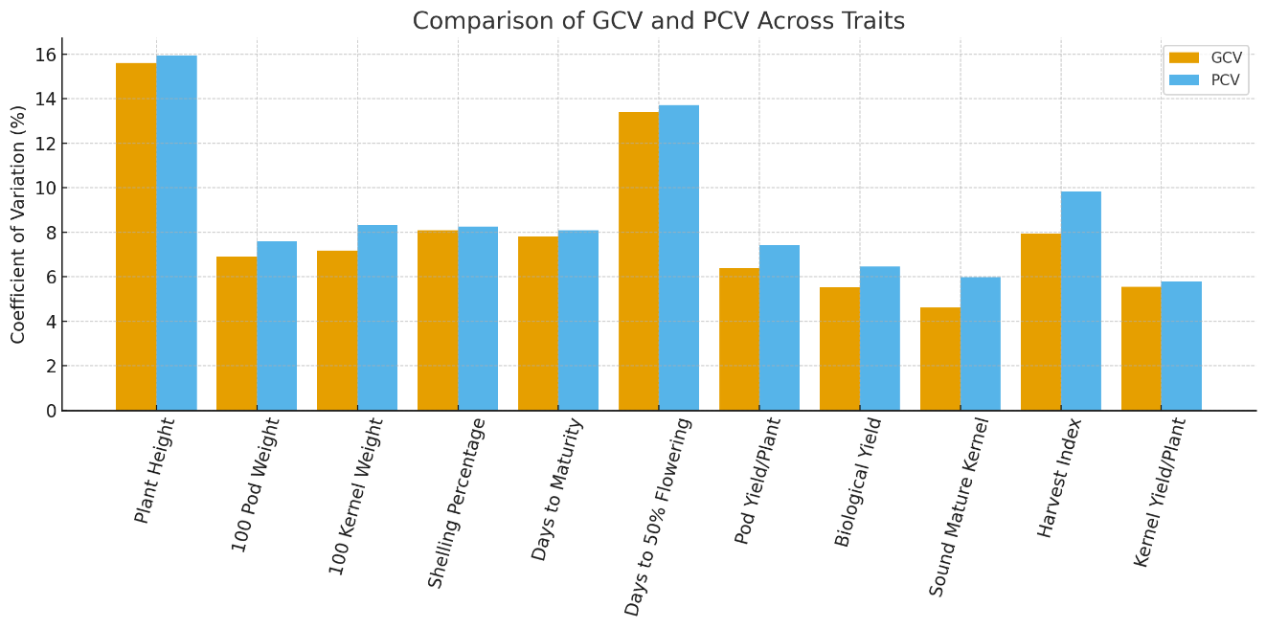
Fig. 1: Comparison of Genotypic and Phenotypic Coefficients of Variation Across Groundnut Traits

2.2.2 Heritability
Heritability estimates revealed the extent of genetic control over the examined traits (Table 3, Fig. 2). Plant height exhibited very high heritability (95.98%), indicating strong genetic determination. Similarly, shelling percentage (95.96%), days to 50% flowering (95.28%), kernel yield per plant (91.57%), and days to maturity (93.15%) also exhibited high heritability, suggesting that these traits can be reliably improved through direct selection. Moderate to high heritability was recorded for 100-pod weight (83.09%), 100-kernel weight (74.58%), pod yield per plant (74.30%), and biological yield per plant (73.30%), indicating a considerable genetic contribution despite low variability. Harvest index demonstrated moderate heritability (65.38%), and sound mature kernel percentage showed the lowest heritability (59.65%), signifying greater environmental influence on these traits and suggesting the need for multi-environment testing.

2.2.3 Genetic Advance as Percent of Mean (GAM)
Genetic advance values further supported the heritability estimates, indicating the expected response to selection. Plant height exhibited high GAM (31.58%), and days to 50% flowering also showed a high GAM (26.99%), suggesting effective improvement through selection. Medium genetic advance was observed for traits such as 100-pod weight (13.02%), 100-kernel weight (12.82%), shelling percentage (16.38%), days to maturity (15.56%), pod yield per plant (11.36%), harvest index (13.26%), and kernel yield per plant (10.97%), indicating moderate selection gains. Biological yield per plant recorded low GAM (9.77%), while sound mature kernel percentage showed the lowest GAM (7.36%), reflecting limited selection efficiency due to environmental influence and low variability. These results collectively indicate that traits showing high heritability coupled with high to medium GAM such as plant height, days to 50% flowering, shelling percentage, and kernel yield can be considered reliable selection criteria for groundnut improvement. Present results are in accordance with the findings of Ahmed et al., (2022), El-Rahman et al., (2022), Dama & Desu. (2022), Kalyani Kumari and Sasidharan, (2020) and Mitra et al., (2019).

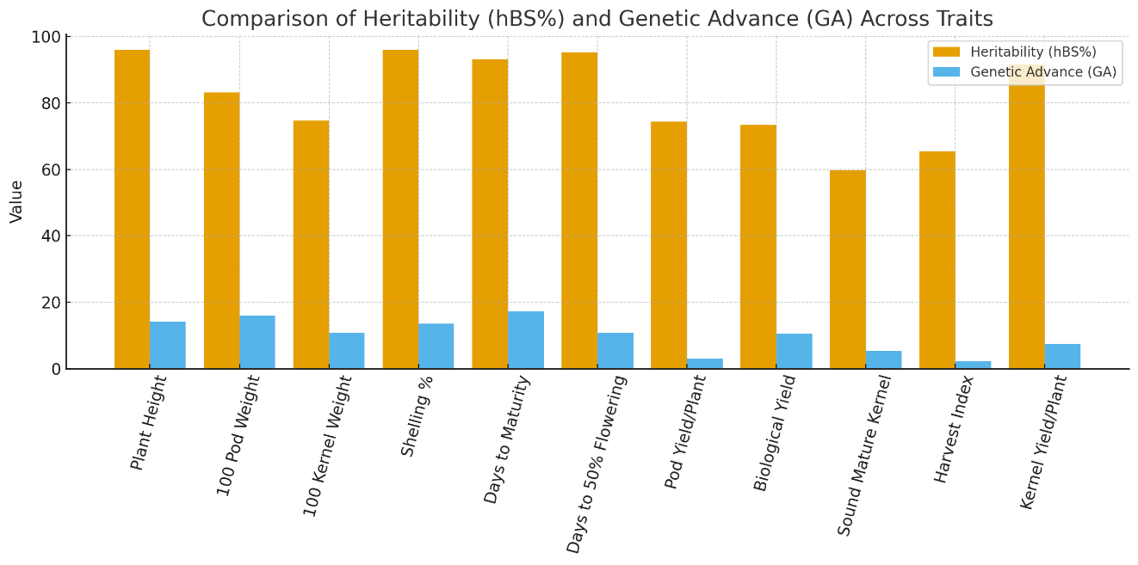
Fig. 2: Heritability vs Genetic Advance Across Traits

Table 3: Estimates of Variability Parameters for Different Agronomic and Yield Traits in Groundnut
Trait | Mean | PV | GV | EV | GCV | GCV Category | PCV | PCV Category | ECV | hBS (%) | hBS Category | GA | GAM (%) | GAM Category
Plant  Height | 44.69 | 50.80 | 48.76 | 2.04 | 15.62 | Medium | 15.95 | Medium | 3.20 | 95.98 | High | 14.11 | 31.58 | High
100 Pod  Weight | 122.72 | 86.86 | 72.17 | 14.69 | 6.92 | Low | 7.59 | Low | 3.12 | 83.09 | High | 15.98 | 13.02 | Medium
100 Kernel Weight | 83.60 | 48.51 | 36.18 | 12.33 | 7.19 | Low | 8.33 | Low | 4.20 | 74.58 | High | 10.72 | 12.82 | Medium
Shelling Percentage | 82.61 | 46.70 | 44.81 | 1.89 | 8.10 | Low | 8.27 | Low | 1.66 | 95.96 | High | 13.53 | 16.38 | Medium
Days to Maturity (days) | 111.18 | 80.99 | 75.45 | 5.55 | 7.81 | Low | 8.09 | Low | 2.12 | 93.15 | High | 17.29 | 15.56 | Medium
Days to 50% Flowering | 39.75 | 29.79 | 28.38 | 1.41 | 13.40 | Medium | 13.73 | Medium | 2.98 | 95.28 | High | 10.73 | 26.99 | High
Pod Yield per Plant (g) | 26.88 | 3.97 | 2.95 | 1.02 | 6.39 | Low | 7.41 | Low | 3.76 | 74.30 | High | 3.05 | 11.36 | Medium
Biological Yield per Plant | 107.10 | 47.90 | 35.11 | 12.79 | 5.53 | Low | 6.46 | Low | 3.34 | 73.30 | High | 10.47 | 9.77 | Low
Sound Mature Kernel (%) | 72.49 | 18.82 | 11.22 | 7.59 | 4.62 | Low | 5.98 | Low | 3.80 | 59.65 | Medium | 5.34 | 7.36 | Low
Harvest Index (%) | 17.09 | 2.82 | 1.84 | 0.98 | 7.95 | Low | 9.83 | Low | 5.78 | 65.38 | High | 2.27 | 13.26 | Medium
Kernel Yield per Plant (g) | 68.80 | 15.95 | 14.61 | 1.35 | 5.55 | Low | 5.80 | Low | 1.69 | 91.57 | High | 7.54 | 10.97 | Medium

- CONCLUSION
The study demonstrated substantial genetic variability among 61 groundnut genotypes for all morphological and yield-related traits, confirming ample scope for genetic enhancement. High heritability coupled with moderate to high genetic advance observed in key traits such as plant height, shelling percentage, days to 50% flowering, kernel yield, and days to maturity indicates strong additive gene action, making these traits effective targets for selection in early breeding generations. Yield traits, though exhibiting low to moderate variability, showed considerable heritability, suggesting that consistent multi-location testing may further refine their selection efficiency. Overall, the identified promising genotypes provide a valuable resource base for enhancing productivity, adaptability, and quality in groundnut breeding programs. Looking ahead, integrating these findings with advanced breeding tools such as molecular markers, genomic selection, and trait-specific marker-assisted breeding can accelerate cultivar development. Future studies should explore genotype × environment interactions to identify stable and climate-resilient genotypes under varying moisture and temperature regimes. Incorporating physiological traits and stress-resilience parameters will further strengthen selection efficiency. Additionally, expanding the genetic base by utilizing wild Arachis species can introduce novel alleles for yield, disease resistance, and abiotic stress tolerance. Such integrative approaches will facilitate the development of high-yielding, climate-smart, and nutritionally enriched groundnut cultivars to meet future food and nutritional security challenges.
DISCLAIMER (ARTIFICIAL INTELLIGENCE)
Author(s) hereby declare that no generative AI technologies such as Large Language Models (ChatGPT, COPILOT, etc.) and text-to-image generators have been used during the writing or editing of this manuscript.

REFERENCES
Adjei, R. R., Amadu, B., Boateng, A. S., & Donkor, E. F. (2022). Genetic variability, heritability and association among yield components and proximate composition of neglected and underutilized Bambara groundnut (Vigna subterranea (L) Verdc) accessions for varietal development in Ghana. Heliyon, 8(6). https://doi.org/10.1016/j.heliyon.2022.e09691
Ahmed, A. A., Attia, M., & Noman, H. M. (2022). Genetic variation, correlation coefficient and pathway analysis for yield and its components in peanut (Arachis hypogaea L.). SVU-International Journal of Agricultural Sciences, 4(3), 178–186. https://doi.org/10.21608/svuijas.2022.165588.1236
Al Mamun, M., Jusoh, M., Khaliqi, A., Khan, M. M. H., Oladosu, Y., Rafii, M. Y., Ramlee, S. I. (2022). Unveiling Genetic Diversity, Characterization, and Selection of Bambara Groundnut (Vigna subterranea L. Verdc) Genotypes Reflecting Yield and Yield Components in Tropical Malaysia. BioMed Research International: 1–23. https://doi.org/10.1155/2022/6794475
Amolic, V.L., More, S.R., Pawar, S.V., Nimbalkar, C.A., Shinde, G.C., & Shinde, H.N. (2019). Genetic variability and association study for different traits in F5 progenies of groundnut. Journal of Pharmacognosy and Phytochemistry, 8(5), 1497-1500.
ANGARU Crop Outlook Report, Dec. 2021. Accessed on: 10 April, 2023.
Bhawar, P. C., Tiwari, S., Tripathi, M. K., Tomar, R. S., & Sikarwar, R. S. (2020). Screening of Groundnut Germplasm for Foliar Fungal Diseases and Population Structure Analysis Using Gene Based SSR Markers. Current Journal of Applied Science and Technology, 39(2), 75–84. https://doi.org/10.9734/CJAST/2020/v39i230500
El-Rahman, A., Naguib, A., Nemat, A., & Rehab, H.A. (2022). Variability and genetic parameters in yield and its attributes among some groundnut (Arachis hypogaea L.) lines. (2022). Egyptian Journal of Applied Science, 37(7), 1–16.
Hanson, C. H., Robinson, H. F., & Comstock, R. E. (1956). Biometrical studies of yield in segregating populations of Korean lespedeza 1. Agronomy journal, 48(6), 268-272.
ICAR-DGR, Annual Report, 2020. Accessed on: 10 April, 2023.
Johnson, H. W., Robinson, H. F., & Comstock, R. E. (1955). Genotypic and phenotypic correlations in soybeans and their implications in selection. Agron. J., 47, 477-483.
Kalyani Kumari and Sasidharan, N. (2020). Studies on Genetic Variability, Correlation and Path Coefficient Analysis for Morphological and Yield Traits in Different Arachis spp. Int.J.Curr.Microbiol.App.Sci. 9(11), 1030-1039.
Lothe, G.R., & More, S.R. (2022). Assessment of physiological indices for growth and yield of groundnut (Arachis hypogaea L.). The Pharma Innovation Journal, 11(5), 1393-1398.
Madhuri, T., Reddy, V. R., Kumar, C. V., Rani, C. V. D., & Sravanti, K. (2022). Genetic Variability Parameters and Character Associations among Yield Attributing Traits in Advanced Backcross Lines of Groundnut. International Journal of Environment and Climate Change, 12(12), 1109-1118.
Miller, P. A., Williams Jr, J. C., Robinson, H. F., & Comstock, R. E. (1958). Estimates of genotypic and environmental variances and covariances in upland cotton and their implications in selection 1. Agronomy journal, 50(3), 126-131.
Mitra, M., Gantait, S., & Kundu, R. (2021). Genetic variability, character association and genetic divergence in groundnut (Arachis hypogaea L.) accessions. Legume Research-An International Journal, 44(2), 164-169.
Panse, V.G. and Sukhatme, P.V.1967. Statistical methods for agricultural workers. 2nd edition pp 152-157.
Prajapati, M. R., and Ramoliya, R. K. (2022). A Study on Level of Input and Economics of Production of Groundnut in Gujarat. Current Journal of Applied Science and Technology, 41(37), 30-41.
Sridevi, S., Meenakumari, B., Manivannan, N., & Ravichandran, V. (2022). Assessment of genetic variability, character association and path analysis of kernel yield and yield components in groundnut (Arachis hypogaea L.). Electronic Journal of Plant Breeding, 13(2), 476-481.
Statista. (2023). India: groundnut production volume 2023. Accessed on: 12 April, 2023.

