Quantitative Assessment of Heritability and Genetic Advance for Yield Attributes Using Line × Tester Derived Generations in Pea (Pisum sativum L.)

ABSTRACT
The present study, “Quantitative Assessment of Heritability and Genetic Advance for Yield Attributes Using Line × Tester Derived Generations in Pea (Pisum sativum L,),” was conducted at the Oil Seed Farm, Chandra Shekhar Azad University of Agriculture and Technology, Kanpur, during rabi seasons of 2022–23, 2023–24, and 2024–25. Sixteen lines and four testers were crossed using a line × tester mating design to evaluate genetic parameters in F₁ and F₂ generations. Heritability estimates varied widely, with high heritability in F₁ observed for 100-seed weight and seed yield per plant, while the remaining traits showed moderate to low heritability. In F₂, seed yield per plant again exhibited the highest heritability, whereas most traits showed low estimates, indicating strong environmental influence. Genetic advance as percent of mean (GA%) revealed high values for number of pod clusters per plant, number of pods per plant, biological yield per plant, harvest index, and seed yield per plant in both generations, indicating additive gene action. Low heritability with low GA% for days to maturity, shelling percentage, and protein content indicated minimal response to direct selection. The findings emphasize that yield and major yield components can be effectively improved by selection in later generations, while traits strongly influenced by the environment require alternative breeding strategies.
Keywords: Heritability, genetic advance, line × tester, additive gene action, F₁ and F₂ populations.
INTRODUCTION
“Pea (Pisum sativum L.) is a globally important cool-season grain legume grown for food, feed, and soil enrichment. It contributes significantly to human nutrition due to its high protein content (20–30%), balanced amino acid profile, vitamins, minerals, and antioxidant compounds that support health in pulse-based diets” (Devi et al., 2015; Lamichaney et al., 2021). “As plant-based protein demand increases worldwide, pea has gained further importance because of its role in sustainable diets and its functional uses in processed foods such as protein isolates, flour blends, and plant-based meat alternatives” (Boye et al., 2010; Parihar et al., 2021). “In India, pea forms an integral component of rabi cropping systems and plays a major role in enhancing food security and rural livelihoods” (Parihar et al., 2022).
“Agronomically, pea is valued for its nitrogen-fixing ability through symbiotic association with Rhizobium leguminosarum, which helps improve soil fertility, enhance system productivity, and reduce the dependency on synthetic fertilizers, contributing to low-input sustainable agriculture” (Jensen et al., 2012; Peoples et al., 2009). “However, despite these benefits, pea productivity remains constrained by narrow genetic diversity, environmental fluctuations, poor pod set under temperature extremes, and susceptibility to major diseases including powdery mildew, rust, and root rots” (Shrestha et al., 2023; Ali et al., 2021).
“Yield in pea, as in other legumes, is a quantitative trait governed by multiple genes and is strongly influenced by environmental interactions. Component traits such as pods per plant, seeds per pod, 100-seed weight, biological yield, and harvest index show wide variation across genotypes and environments, making it essential to assess inheritance patterns for effective improvement” (Cvejić et al., 2022; Azam et al., 2024). “Because early-generation selection for yield is often unreliable due to environmental noise, breeders rely on genetic parameters—particularly heritability and genetic advance—to assess the extent of genetic control and predict selection response” (Bari et al., 2021; Pratap et al., 2021).
“Heritability is a fundamental quantitative genetic measure that indicates the proportion of phenotypic variation attributable to genetic factors. High heritability enables effective selection, whereas low heritability suggests strong environmental influence” (Burton and De Vane, 1953). “However, heritability alone cannot accurately predict genetic improvement; therefore, it is evaluated alongside genetic advance (GA), which estimates expected progress under selection” (Johnson et al., 1955). High heritability coupled with high genetic advance indicates predominant additive gene action, while low heritability with low GA suggests dominant or epistatic interactions and high environmental influence (Panse, 1957; Singh and Chaudhary, 1985). “Studies in pea have consistently shown that traits such as pods per plant, 100-seed weight, and biological yield often exhibit higher heritability, while shelling percentage, flowering time, and protein content demonstrate lower heritability” (Sinjushin et al., 2023; Rahman et al., 2021).
Given the urgent need to enhance pea productivity under changing environmental conditions, the present investigation was conducted to assess the inheritance of yield and its contributing traits using F₁ and F₂ generations derived from line × tester crosses. The study aims to quantify heritability, estimate genetic advance, and identify traits that can be improved effectively through early or late-generation selection, thereby contributing to the development of high-yielding and genetically diverse pea cultivars.

MATERIALS AND METHODS
The study was conducted at the Oil Seed Farm of CSAUAT, Kanpur, during the rabi seasons of 2022–23, 2023–24, and 2024–25. Sixteen genetically diverse lines namely, RILHF 2, VL MATAR 47, Pant P 243, Pant P 200, Pant P 347, IPFD 18-14, IPFD 18-26, IPF 2014-13, IPF 2014-16, RFP 2009-2, KPMR 910, HFP 1802, KPMR 916, KPMR 890, KPMR 940, and KPMR 947 and four testers KPMR 913 KPMR 522 KPMR 400 Sapna were crossed using a line × tester mating design to produce F₁ seeds. These F₁s were selfed to generate F₂ populations. Both F₁ and F₂ generations were evaluated in a Randomized Block Design (RBD) with recommended agronomic practices. Observations were recorded on sixteen important traits, including days to 50% flowering, days to maturity, plant height, number of primary branches per plant, number of pod clusters per plant, number of pods per plant, pod length, number of seeds per pod, pod weight, pod grain weight, shelling percentage, 100-seed weight, biological yield, seed yield per plant, harvest index and protein percentage.
Heritability Estimation:
1. Narrow-sense heritability (h²ₙ) in F₁ and F₂ was calculated according to Kempthorne & Curnow (1961):
h²ₙ = [2σ²g / (2σ²g + 2σ²s + 2σ²e)] × 100
Classification of heritability (Robinson et al., 1966):
High: >30% ; Moderate: 10–30% ; Low: <10%
Genetic Advance:
Calculated using Robinson et al. (1949):
GA = k × h² × σph
GA(%) = (GA / x̄) × 100
Where k = 2.06 at 5% selection intensity.
Classification:
High: >20% ; Moderate: 10–20% ; Low: <10%

RESULTS AND DISCUSSION
The heritability estimates recorded in the present study displayed wide variation among the sixteen traits in both F₁ and F₂ generations, reflecting differences in the genetic and environmental contributions to phenotypic expression. In F₁, high heritability (>30%) was observed for only 100-seed weight (39.98%) and seed yield per plant (36.86%), suggesting strong additive genetic control and a high probability of genetic gain through selection. These results agree with earlier findings in pea reported by Kaur et al. (2023) and Sharma et al. (2022), who also noted high heritability for seed yield and seed size traits. Most other traits in F₁ exhibited moderate heritability (10–30%), including days to maturity, plant height, number of pod clusters per plant, number of pods per plant, pod length, number of seeds per pod, protein content, and biological yield per plant. Such moderate heritability suggests that both additive and non-additive gene actions influence these traits, consistent with the reports of Tampha et al. (2023) who observed similar inheritance patterns in field pea populations. Traits such as days to 50% flowering, number of primary branches per plant, pod weight, pod grain weight, shelling percentage, and harvest index recorded low heritability (<10%) in F₁, indicating a strong environmental effect and reduced response to early selection. These findings align with results from Ali et al. (2021), who highlighted that environmental fluctuations greatly impact reproductive and physiological traits in pea.
In the F₂ generation, high heritability was recorded only for seed yield per plant (39.58%), which revealed even stronger genetic control in the segregating generation. Traits such as days to 50% flowering, number of pods per plant, pod length, 100-seed weight, biological yield per plant and harvest index showed moderate heritability, whereas the remaining traits showed low heritability values. “The reduced heritability in F₂ could be attributed to increased segregation, recombination, and environmental influence”, a trend previously described by Singh et al. (2022). These results suggest that early segregating generations are heavily influenced by environmental factors and that effective selection should be practised in later generations. Genetic advance as percent of mean further supported the heritability patterns.
In F₁, GA% ranged from 6.57% to 44.82%, with high GA% observed for the number of pod clusters per plant, the number of pods per plant, the biological yield per plant, harvest index and seed yield per plant. The high GA% indicates the predominance of additive gene effects and is comparable to earlier findings by Robinson et al. (1949). “In F₂, GA% ranged from 6.60% to 43.44%, with high values again for number of primary branches per plant, number of pod clusters per plant, number of pods per plant, pod length, biological yield per plant, and seed yield per plant. This further confirms that these traits are primarily controlled by additive gene action and can be improved through phenotypic selection in advanced generations” (Falconer & Mackay, 1996). “Moderate genetic advance was observed for days to 50% flowering, plant height, number of primary branches per plant, number of seeds per pod, pod weight, pod grain weight, and 100-seed weight, implying a mixture of additive and non-additive genetic control. Conversely, traits such as days to maturity, shelling percentage, and protein content exhibited low GA% despite low heritability, indicating strong environmental influence and limited scope for direct selection”—similar to the conclusions drawn by Sanwal et al. (2024). Overall, the combined results emphasize that yield and its major components exhibit substantial additive variance and are ideal targets for selection, whereas traits strongly influenced by environment require alternative breeding approaches such as heterosis breeding or recurrent selection.

CONCLUSION
Traits such as seed yield per plant, number of pods per plant, number of pod clusters per plant, pod length, biological yield per plant and 100-seed weight showed moderate to high heritability and genetic advance, indicating strong additive gene action. These traits are ideal targets for selection in advanced generations. Traits like days to maturity, shelling percentage, and protein content displayed low heritability and low genetic advance, reflecting strong environmental influence and limited genetic control. Thus, selection for these traits should be avoided in early generations, and alternative breeding strategies may be needed.
Disclaimer (Artificial intelligence)
Author(s) hereby declare that NO generative AI technologies such as Large Language Models (ChatGPT, COPILOT, etc.) and text-to-image generators have been used during the writing or editing of this manuscript.

REFERENCES

Ali, B., Kumar, S., & Ahmed, W. (2021). Genetic variability, heritability and correlation coefficient in production traits of pea (*Pisum sativum* L.) genotypes. *International Journal of Genetics and Genomics*, 9(4), 78-88.
Azam, M. G., Iqbal, M. S., Hossain, M. A., & Hossain, M. F. (2024). Phenotypic diversity in qualitative and quantitative traits for selection of high yield potential field pea genotypes. *Scientific Reports*, 14, 18323.
Bari, M. A. A., Zheng, P., Viera, I., Worral, H., Szwiec, S., Ma, Y., Main, D., Coyne, C. J., McGee, R. J., & Bandillo, N. (2021). Harnessing genetic diversity in the USDA pea germplasm collection through genomic prediction. *Frontiers in Genetics*, 12, 707754.
Boye, J., Zare, F., & Pletch, A. (2010). Pulse proteins: Processing, characterization, functional properties and applications in food and feed. *Food Research International*, 43(2), 414-431.
Burton, G. W., & De Vane, E. H. (1953). Estimating heritability in tall fescue (*Festuca arundinacea*) from replicated clonal material. *Agronomy Journal*, 45(10), 478-481.
Cvejić, S., Mladenović Drinić, S., Prijović, M., Ćeran, M., Kondić Špika, A., Aćin, V., Jocković, B., Jocić, S., & Balalić, I. (2022). Phenotypic and genotypic characterization and correlation analysis of pea (*Pisum sativum* L.) diversity panel. *Plants*, 11(10), 1321.
Devi, J., Singh, I., Devi, A., & Singh, N. B. (2015). Genetic variability and character association in fieldpea (*Pisum sativum* L.). *Legume Research*, 38(2), 149-156.
Falconer, D. S., & Mackay, T. F. C. (1996). *Introduction to Quantitative Genetics* (4th ed.). Longman, Harlow, UK.
Jensen, E. S., Peoples, M. B., & Hauggaard-Nielsen, H. (2012). Faba bean in cropping systems. *Field Crops Research*, 115(3), 203-216.
Johnson, H. W., Robinson, H. F., & Comstock, R. E. (1955). Estimates of genetic and environmental variability in soybeans. *Agronomy Journal*, 47(7), 314-318.
Kaur, H., Sharma, N., Sharma, A., & Gupta, M. (2023). Utilizing genetic variability parameters of garden pea (*Pisum sativum* L.) germplasm for yield and quality traits. *Genetika*, 55(3), 869-882.
Kempthorne, O., & Curnow, R. N. (1961). The partial diallel cross. *Biometrics*, 17(2), 229-250.
Lamichaney, A., Parihar, A. K., Hazra, K. K., Dixit, G. P., Katiyar, P. K., Singh, D., Singh, A. K., Kumar, N., & Singh, N. P. (2021). Untangling the influence of heat stress on crop phenology, seed set, seed weight, and germination in field pea (*Pisum sativum* L.). *Frontiers in Plant Science*, 12, 635868.
Panse, V. G. (1957). Genetics of quantitative characters in relation to plant breeding. *Indian Journal of Genetics and Plant Breeding*, 17, 318-328.
Parihar, A. K., Dixit, G. P., Bohra, A., Gupta, D. S., Kumar, N., & Singh, A. K. (2021). Potential of field pea as a nutritionally rich food legume crop. In D. S. Gupta, A. K. Singh, N. P. Singh, & R. K. Bhardwaj (Eds.), *Breeding for Enhanced Nutrition and Bio-Active Compounds in Food Legumes* (pp. 47-82). Springer International Publishing.
Parihar, A. K., Rajesh Yadav, Amrit Lamichaney, R. K. Mishra, Anup Chandra, D. S. Gupta, Kuldeep Tripathi, K. K. Hazra, & G. P. Dixit. (2022). Field pea breeding. In *Fundamentals of Field Crop Breeding* (pp. 1237-1321). Springer Nature Singapore.
Peoples, M. B., Brockwell, J., Herridge, D. F., Rochester, I. J., Alves, B. J. R., Urquiaga, S., Boddey, R. M., Dakora, F. D., Bhattarai, S., Maskey, S. L., Sampet, C., Rerkasem, B., Khan, D. F., Hauggaard-Nielsen, H., & Jensen, E. S. (2009). The contributions of nitrogen-fixing crop legumes to the productivity of agricultural systems. *Symbiosis*, 48(1-3), 1-17.
Pratap, V., Sharma, V., Kamaluddin, & Shukla, G. (2021). Assessment of genetic variability and relationship between different quantitative traits in field pea (*Pisum sativum* var. *arvense*) germplasm. *Legume Research*, 43, 6.
Rahman, A., Singh, P. M., Nanda, H. C., & Yadav, S. K. (2021). Studies on genetic parameters, correlation and path coefficient analysis in ER2 introgressed garden pea genotypes. *Legume Research*, 44, 621-626.
Robinson, H. F., Comstock, R. E., & Harvey, P. H. (1949). Estimates of heritability and the degree of dominance in corn. *Agronomy Journal*, 41(8), 353-359.
Robinson, H. F., Comstock, R. E., & Harvey, P. H. (1966). Genetic variances in open-pollinated corn varieties. *Genetics*, 40(1), 45-60.
Sanwal, S. K., Kesh, H., Devi, J., & Singh, B. (2024). Analysis of trait association and genetic diversity in garden pea (*Pisum sativum* L.) genotypes under Middle Gangetic Plain Region of India. *Legume Research*, 47(3), 385-390.
Sharma, A., Sharma, S., Kumar, N., Rana, R. S., Sharma, P., Kumar, P., Sharma, V., Kumar, R., Chand, S., Rana, J. C., & Chahota, R. K. (2022). Morpho-molecular genetic diversity and population structure analysis in garden pea (*Pisum sativum* L.) genotypes using simple sequence repeat markers. *PLoS ONE*, 17(9), e0273499.
Shrestha, D. S., Chaudhary, J. N., Ghimire, K. H., Shrestha, J., & Bhattarai, M. (2023). Agro morphological characterization and diversity assessment of pea (*Pisum sativum* L.) genotype conserved in genebank of Nepal. *IJRPR.com*, 4, 422-435.
Sinjushin, A., Ash, O., & Khartina, G. (2023). Ovule number and flower size in pea (*Pisum sativum* L.): Variation, heritability, and correlation with some components of productivity. *Horticulturae*, 9(3), 371.
Singh, A., Kumar, J., & Kumar, P. (2022). Genetic variability, heritability and genetic advance in field pea (*Pisum sativum* L.). *International Journal of Plant, Animal and Environmental Sciences*, 4(2), 549-553.
Singh, R. K., & Chaudhary, B. D. (1985). *Biometrical Methods in Quantitative Genetic Analysis*. Kalyani Publishers, New Delhi.
Tampha, S., Sharma, V., Sharma, R., Dhiman, V., Thakur, S., & Sharma, A. (2023). Assessment of gene action and identification of heterotic hybrids for enhancing yield in field pea. *Horticulturae*, 9(9), 997.

Characters | Grand mean |  | Heritability in percent (h²) |  | GA |  | GA in per cent over mean
Characters | F₁ | F₂ | F₁ | F₂ | F₁ | F₂ | F₁ | F₂
Days to 50% flowering | 67.45 | 66.19 | 6.92 | 26.59 | 9.92 | 9.82 | 14.71 | 14.83
Days to maturity | 115.77 | 115.16 | 23.34 | 1.37 | 7.60 | 7.60 | 6.57 | 6.60
Plant height | 63.97 | 62.94 | 13.59 | 8.19 | 10.61 | 10.39 | 16.59 | 16.51
Number of primary branches per plant | 3.39 | 3.39 | 5.78 | 4.13 | 0.67 | 0.71 | 19.86 | 20.91
Number of pod clusters per plant | 7.73 | 7.70 | 12.64 | 8.24 | 1.61 | 1.81 | 20.84 | 23.50
Number of pods per plant | 15.41 | 15.07 | 15.56 | 11.20 | 4.36 | 3.98 | 28.32 | 26.40
Pod length | 6.52 | 6.51 | 13.90 | 17.98 | 1.18 | 1.31 | 18.07 | 20.07
Number of seeds per pod | 6.08 | 5.98 | 11.38 | 9.88 | 1.13 | 1.10 | 18.54 | 18.41
Pod weight | 11.13 | 11.11 | 8.79 | 8.92 | 1.33 | 1.37 | 11.97 | 12.37
Pod grain weight | 6.25 | 6.23 | 9.77 | 8.55 | 0.77 | 0.83 | 12.35 | 13.34
Shelling percentage | 56.33 | 56.15 | 1.63 | 0.68 | 4.07 | 4.30 | 7.22 | 7.65
100 seed weight | 22.28 | 22.26 | 39.98 | 14.08 | 4.09 | 3.78 | 18.34 | 16.98
Biological yield per plant | 39.14 | 37.41 | 20.02 | 29.90 | 14.83 | 13.40 | 37.90 | 35.82
Seed yield per plant | 18.55 | 17.82 | 36.86 | 39.58 | 8.32 | 7.74 | 44.82 | 43.44
Harvest index | 47.44 | 47.56 | 3.36 | 10.89 | 10.17 | 9.18 | 21.43 | 19.31
Protein content | 23.98 | 23.97 | 17.78 | 8.96 | 2.02 | 2.16 | 8.44 | 9.01
Table1 : Heritability (narrow sense) and genetic advance % over mean in sixteen characters of pea (Pisum sativum L.)

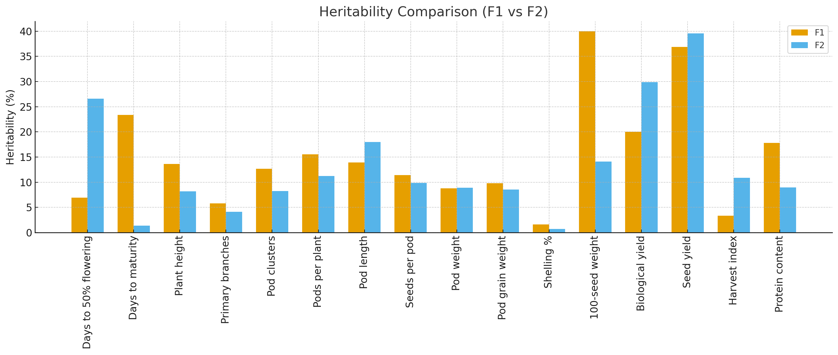

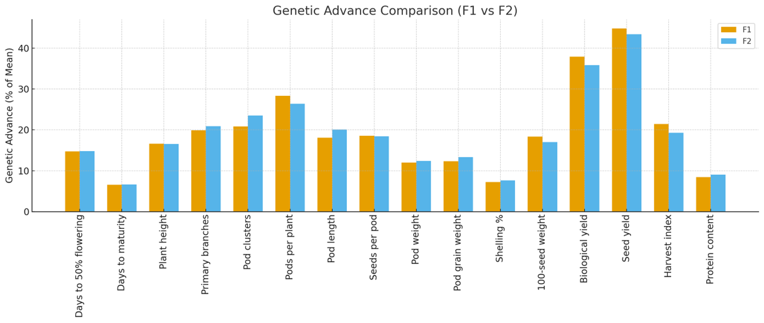

Graph : Heritability and genetic advance in per cent of mean for 16 characters in F₁ and F₂ generation

