Assessment of post-harvest pathogens of Khasi mandarin
Original Research Article
- (Citrus reticulata, Blanco) from Meghalaya and evaluation of most

potent artificial inoculation method to initiate Penicillium rot
4

- .

ABSTRACT
13
Khasi mandarin is a unique germplasm of North East India owing to its exceptional juice quality, taste and aroma. But the shelf life of the fruit is decreasing due to the post-harvest decay pathogens. The present investigation was carried out in 2023-2024 and 2024-2025 The aim of the study was to investigate post-harvest storage pathogens associated with Khasi mandarin in Meghalaya and to evaluate the most effective method of inoculation to get the highest infection. Penicillium spp., Fusarium spp., Aspergillus spp., Geotrichum, and Mucor species were isolated as post -harvest associated pathogens with a maximum frequency of 71.42% against Penicillium spp. followed by Fusarium spp. (57.15%). Isolated pathogens were characterized morphologically and culturally. Penicillium italicum, being the most dominant post-harvest pathogen of Khasi mandarin, as proved by the pathogenicity test, was artificially inoculated by four different methods in the fully ripened mandarins. The most efficient inoculation method for disease development was evaluated by calculating disease severity index (DSI) which was found to be highest (83.33%) in the disc inoculation method, followed by injection (58.33%) and immersion (41.66%). Percent seed infection was also calculated by blotter test and found to be highest in disc inoculation method (96%) and lowest in spraying (76%) on 10th day of inoculation. The present investigation evaluates the post- harvest associated mycoflora of Khasi mandarin in Meghalaya and the most potent artificial inoculation method responsible for Penicillium rot.
Keywords: Blotter test, disc inoculation, disease severity index, Penicillium italicum
14

1.INTRODUCTION
- Khasi mandarin or soh-niamtra (citrus reticulata, blanco) is a dominant cultivated
- citrus species of north east india, along with other citrus species like citrus jumbhiri, citrus
- indica, citrus latipase etc. it is mainly cultivated in Meghalaya, Arunachal
- Pradesh, Sikkim, Nagaland, Tripura, Manipur and Assam (kumar et al., 2024). high juice
- content of 43.33ml to 46.82ml (borah et al., 2023) with unique taste and aroma makes the
- fruit a potent exporter from north east india. it is well established that the state of meghalaya
- is the origin or primary gene center of khasi mandarin (citrus reticulata family: rutaceae),
- cultivating mainly in east and West Khasi Hills, Ri-Bhoi, Haro hills and Jaintia Hills
- the fruit, Khasi mandarin was granted for geographical indication (GI) tag in 2014 under the geographical indication of good, registration and protection act, 1988 of
- the government of India (doki et al., 2019) as the climatic condition for Meghalaya is found to
- be more suitable for production of khasi mandarin as compared to contributing states. but, it
- deteriorates rapidly after harvest due to microbial infection. enormous nutrients with higher
- water content (80-89%) makes the fruit more vulnerable to many post-harvest pathogens.
- the prevailing high humidity is also an added advantage for post-harvest pathogen attack.
- due to which off-season availability is very less. However, like other citrus fruits, Khasi lime is highly perishable and vulnerable to a range of post-harvest pathogens that significantly reduce marketability and shelf life. Fungal pathogens such as Penicillium digitatum (green mold), Penicillium italicum (blue mold), Aspergillus niger, Alternaria alternata, and Geotrichum candidum frequently infect fruits during handling, transportation, and storage. These pathogens enter through natural openings or wounds created during harvesting operations, leading to rapid decay, water loss, and loss of fruit firmness. Poor post-harvest hygiene, high humidity, and inadequate storage conditions further exacerbate disease severity. Limited work has been carried out on evaluating post-harvest pathogens associated with Khasi mandarin in North East India that

are responsible for short shelf life of the fruit. to diagnose the most potent post-harvest
- pathogens associated with Khasi mandarin and to evaluate the most efficient artificial
- inoculation methods, that leads to Penicllium rot, the present investigation was carried out in
- 2023-2024 and 2024-2025 at college of post graduate studies in agricultural sciences,
- Umiam, Meghalaya, India
38

39 2.METHODOLOGY
40

41 2.1 COLLECTION OF SAMPLES
42
- Infected Khasi mandarin fruits were collected from the local market of Ri Bhoi district
- of Meghalaya which is one of the dominating areas for Khasi mandarin production in
- Meghalaya. All total of 50 samples were collected in clean polypropylene bags with the
- dimensions of 10’’×8’’ and were brought to the Plant Pathology Laboratory at CPGS-AS,
- Umiam, Meghalaya for further processing.
48

49 2.2 ISOLATION AND PURIFICATION OF PUTATIVE PATHOGENS
50
- The collected samples were double-washed with clean running tap water. Tissue
- segments (3-5 mm) containing both infected and diseased tissues were cut with a sterile
- flamed blade, and cut portions were surface sterilized with 1% NaOCl followed by three
- successive changes of sterile distilled water, and air dried the sample. Dried segments were
- placed equidistantly in previously prepared sterilized PDA plates and incubated at 25±1 ºC
- for 5 days under 12 hour photoperiod. Developed fungal colonies were purified by hyphal tip
- culture. The isolated putative pathogens were identified up to the generic level based on
- morphological and cultural characterization. The purified culture was maintained in PDA
- slants for further studies.
- Purified fungal colonies were first identified by observing colony morphology,
- pigmentation, shape and structure of mycelium, branching pattern, presence of
- conidiophores, sclerotia, shape of conidia and were culturally characterized with Royal
- Horticultural Society Colour chart. Identification up to the generic level was made by
- consulting relevant literature (Pitt and Hocking, 1997; Samson et al., 2004). The
65

66 2.3 PATHOGENICITY TEST
67
- Koch's postulates were carried out to find the most dominant species amongst the
- isolated post-harvest pathogens. Khasi mandarin fruits free from infection with equal size,
- texture and colour were selected for in vitro pathogenicity test and were carried out
- according to the Koch’s postulates. The most dominant post-harvest fungal pathogen proved
- by in vitro pathogenicity test was further molecularly characterized and identified.

- 2.4 MOLECULAR IDENTIFICATION
- Out of the four isolated Penicillium spp., the most dominant Penicillium species was found by in vitro pathogenicity test based on the appearance of disease symptoms. The isolate was further pure cultured on PDA media for molecular identification and was out sourced from GCC Biotech Ltd, Kolkata. The DNA sequence has been deposited in NCBI.

- 2.4 INOCULATION OF P. ITALICUM WITH FOUR DIFFERENT
- INOCULATION METHODS
76
- The most dominant Penicillium species confirmed from the pathogenicity test was
- inoculated with four different inoculation methods viz., spraying, immersion injection and disc
- inoculation method. Spore concentration of 2.65X10⁶ CFU/mL was used for spraying,
- immersion as well as injection method. Freshly prepared spore suspension was sprayed on
- the fully ripened equal size fruits with the help of hand held atomizer with the pore size of 0.8
- mm till the run off condition and the fruits were kept in pre sterilized tray. For immersion
- method of inoculation, fruits were dipped in 250 ml conidial suspension with the above
- mentioned spore concentration for a period of 1 minutes and air dried the inoculated sample

- and kept in sterilized tray. For injection method of inoculation, spore suspension were
- directly inserted into the skin with 5 mL hypodermic syringe on the sterilized fruits in four equidistant position and injected with spore suspension till run off condition. Inoculated mandarins were kept in pre sterilized tray. For discinoculation, 6 mm disc from freshly prepared culture plates were inoculated with the help of a sterile cork borer in four equidistant positions of Khasi mandarin fruits. The inoculated fruit were kept in a pre-sterilized plastic tray and all the trays were covered with a perforated transparent polythene sheet and incubated at room temperature (28±1ºC). The fruits were observed each day for the appearance of visible symptoms.
93

2.5 ESTIMATION OF DISEASE SEVERITY INDEX (DSI)
95 Disease severity index (DSI) was calculated on 10^{h} day of inoculation in each of the
- inoculation methods with the following formula

𝛴((𝑁𝑜. 𝑜𝑓 𝑑𝑖𝑠𝑒𝑎𝑠𝑒𝑑 𝑓𝑟𝑢𝑖𝑡 𝑖𝑛 𝑒𝑎𝑐ℎ 𝑟𝑎𝑡𝑖𝑛𝑔 𝑐𝑎𝑡𝑒𝑔𝑜𝑟𝑦 𝑋 𝑆𝑒𝑣𝑒𝑟𝑖𝑡𝑦 𝑟𝑎𝑡𝑖𝑛𝑔)

101
102
𝐷𝑆𝐼(%) =
𝑇𝑜𝑡𝑎𝑙 𝑁𝑜. 𝑜𝑓 𝑓𝑟𝑢𝑖𝑡 𝑎𝑠𝑠𝑒𝑠𝑠𝑒𝑑 𝑋 𝐻𝑖𝑔ℎ𝑒𝑠𝑡 𝑆𝑐𝑎𝑙𝑒
𝑋100

- The inoculated mandarins were also observed for pulp and seed infection, if any to
- investigate whether the infection was moved to the pulp and seed. Each of the segments
- from the inoculated mandarins was observed for Penicillium infection by removing the outer
- peel and evaluating the condition of each segment of the fruit by observing its compactness,
- colour and texture.
108

109 2.6 ESTIMATION OF PERCENT SEED INFECTION (%)
110
- To evaluate the seed infection, the standard blotter test method was followed as per
- the ISTA (International Seed Testing Association) guidelines. Twenty-five numbers of Khasi
- mandarin seeds extracted from the inoculated fruits were plated in sterilized 9 cm petri
- plates with three layers of moistened filter papers soaked in sterile water and incubated the
- plates for 7 days. Control plates were maintained by seeds collected from the uninoculated
- mandarins. The incubated seeds were observed with magnification for the association of
- pathogens, if any. Four replications for each of the treatments were maintained. The percent
- seed infection was calculated by the following formula.
(𝑁𝑢𝑚𝑏𝑒𝑟 𝑜𝑓 𝑖𝑛𝑓𝑒𝑐𝑡𝑒𝑑 𝑠𝑒𝑒𝑑)

119
𝑃𝑒𝑟𝑐𝑒𝑛𝑡 𝑠𝑒𝑒𝑑 𝑖𝑛𝑓𝑒𝑐𝑡𝑖𝑜𝑛 (%) = (
𝑇𝑜𝑡𝑎𝑙 𝑛𝑢𝑚𝑏𝑒𝑟 𝑜𝑓 𝑠𝑒𝑒𝑑 𝑝𝑒𝑟 𝑝𝑙𝑎𝑡𝑒
) × 100

- The fruits were weighed before inoculation and after inoculation of the pathogen.
- The findings were estimated as the percentage of weight loss with the following formula [8a].
𝑊𝑖 − 𝑊𝑠)

122
123
124
𝑊𝑒𝑖𝑔ℎ𝑡 𝑙𝑜𝑠𝑠(%) = (
Where,
Wi= Initial fruit weight
𝑊𝑖
) × 100

125
126
Ws= Fruit weight at sampling date

127 | 3. RESULTS AND DISCUSSION
128
129 | Ten (10) different fungal species belonging to five genera were found to be
130 | associated with the post-harvest deterioration of the Khasi mandarin. The symptoms on
131 | each fruit were recorded (Plate 1: a-h) before further processing. The isolated pathogens
132 | were identified based on morphological and cultural characteristics. Table 1, Plate 3(a-l)
133 | represents the cultural, morphological as well as microscopical characteristics of the isolated
134 | pathogen from the Khasi mandarin and these characteristics were recorded as per the Royal
135 | Horticultural Society Colour Chart (Table 3) (Plate 2a-f). While evaluating the frequency of
136 | occurrence (Table 2) of post-harvest pathogen, Penicillium spp. being the most frequently
137 | occurring pathogen (71.42%) followed by Fusarium spp. (57.14), Aspergillus niger (42.85%)
138 | and Mucor spp (42.85%) (Fig.1). The most dominant post-harvest pathogen of Khasi
139 | mandarin was identified with molecular characterization and found 100% similarity with
140 | Penicillium italicum PV931913).  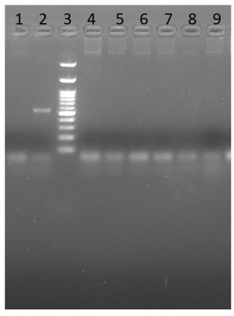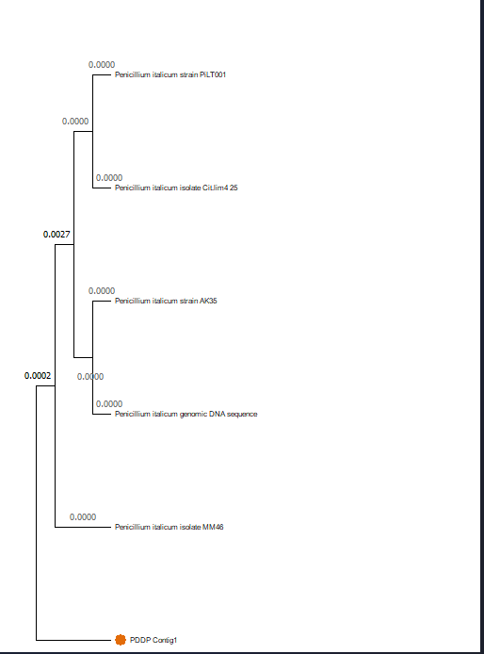
142
143

141

Table 1: Cultural, morphological, and microscopical characters of the isolated pathogens
from Khasi mandarin

Pathogen  isolated | Cultural characters | Microscopic characters
Aspergillus flavus | Initially whitish mycelia, later yellowish green, periphery irregular, fluffy, zonate in Potato Dextrose Agar (PDA) media. | Conidia are olive green in colour in (PDA)
Aspergillus niger | Initially, the colour of the mycelia is  white, later turns black quickly in PDA | Aerial conidia are developed,  margin irregular, conidia always in chains
Mucor spp. | Brownish grey colonies in PDA, floccose, growing repeatedly in PDA | Mycelium coenocytic, globular sporangia
Geotrichum  spp. | Whitish mycelia, equally spreading, fast growing in PDA | Hyphae are fragmented into single cells, smooth arthroconidia
Fusarium spp. 1 | Moderate growing in PDA, initially white, later on dark pinkish, reverse  reddish in colour. | Aerial mycelium, producing macroconidia
Fusarium spp. 2 | Moderate growing in PDA, initially white, later on light pinkish, reverse light pinkish in colour. | Aerial mycelium, microconidia are produced.
Penicillium spp. 1 | Yellowish green flat colonies with irregular periphery, center green. Periphery white in Czapex Dox Agar (CDA) medium, reverse dark  brownish green. | Conidia are oval, mycelium is septate
Penicillium spp. 2 | Conies are scattered, with a whitish margin, dark green colour, and  reverse whitish-yellow colour. | Conidia are oval, mycelium is septate
Penicillium spp.  3 | Dark green colonies, reverse brown, slow growth | Conidia are spherical
Penicillium spp. 4 | Dark small green scattered colonies with regular margins, reverse yellowish brown | Conidia are spherical, hyaline
145

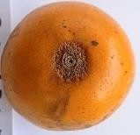 | 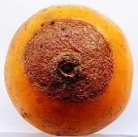 | 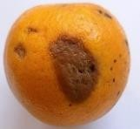
1 (a) Brown dry rot near stem end, initially starting from the stalk end and later spreading on the skin. Shrinkage of the discoloured skin. |  | (b) Brown soft rot in oval-shaped manner.
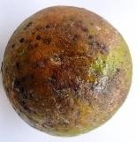 | 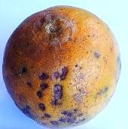 | 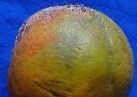
©Multiple dot spot coalaces, spots are black in colour, sooty mold like growth observed. | (d) Blackish brown irregular spot deepseated, coalacing, average spot diameter is  0.26 cm. | (e ) Brownish discolouration and white mycellial growth.
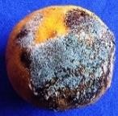 | 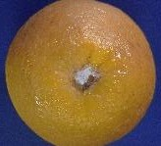 | 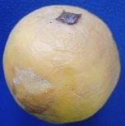
(f) Blueish green mycellial growth with blackish discolouration. | (g) White mycellial growth near stalk end, softing of tissue near stalk end rot. | (h) White irregular mycellial growth with brownish discolouration.
Plate 1(a-h): Symptoms observed from the sample collected for isolation of post-harvest associated pathogen.
146
147
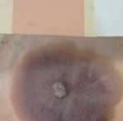 |  | 
2(a)Fusariu m spp. | 2(b)Pestalotio psis spp. | 2(c)Penicilli um spp.
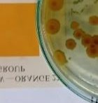 | 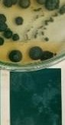 | 
2(d)Penicilli um spp. | 2(e)Penicillium spp. | 2(f)Penicilli um spp.
148
- Plate. 2 (a-f) Culturally characterized isolated spp. with Royal Horticultural Society Colour
- Chart
151
152
153
154
155

Fig 1. Frequency of occurrence of the Postharvest pathogen of Khasi mandarin
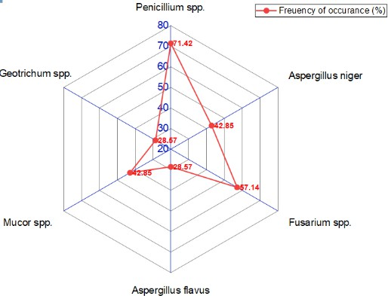
159
160
161
162
163
164
165
166
167
156
157
158

- Table 2 : Frequency of occurrence of
- different post-harvest pathogens in Khasi
- mandarin of Meghalaya
171

Pathogen | Frequency of occurrence
Penicillium spp. | 71.42 (
Aspergillus niger | 42.85
Fusarium spp. | 57.14
A. flavus | 28.57
Mucor spp. | 42.85
Geotrichum spp. | 28.57
172
173
174
Plate 3 (a-l): microscopical
Front, reverse and
observation of
isolated
pathogens from the Khasi mandarin fruits
175
176
177
178
179
180
181
182
183
184
185
186
187
188
189
190
191
192
193
194
Front view | Reverse view | Microscopical characters
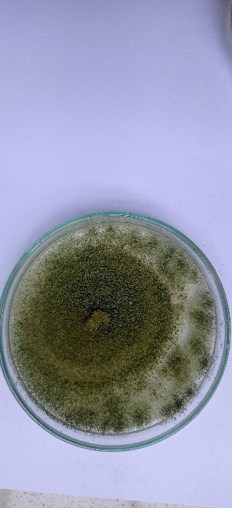 | 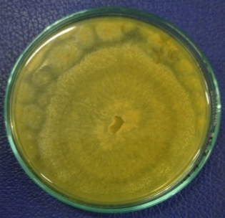 | 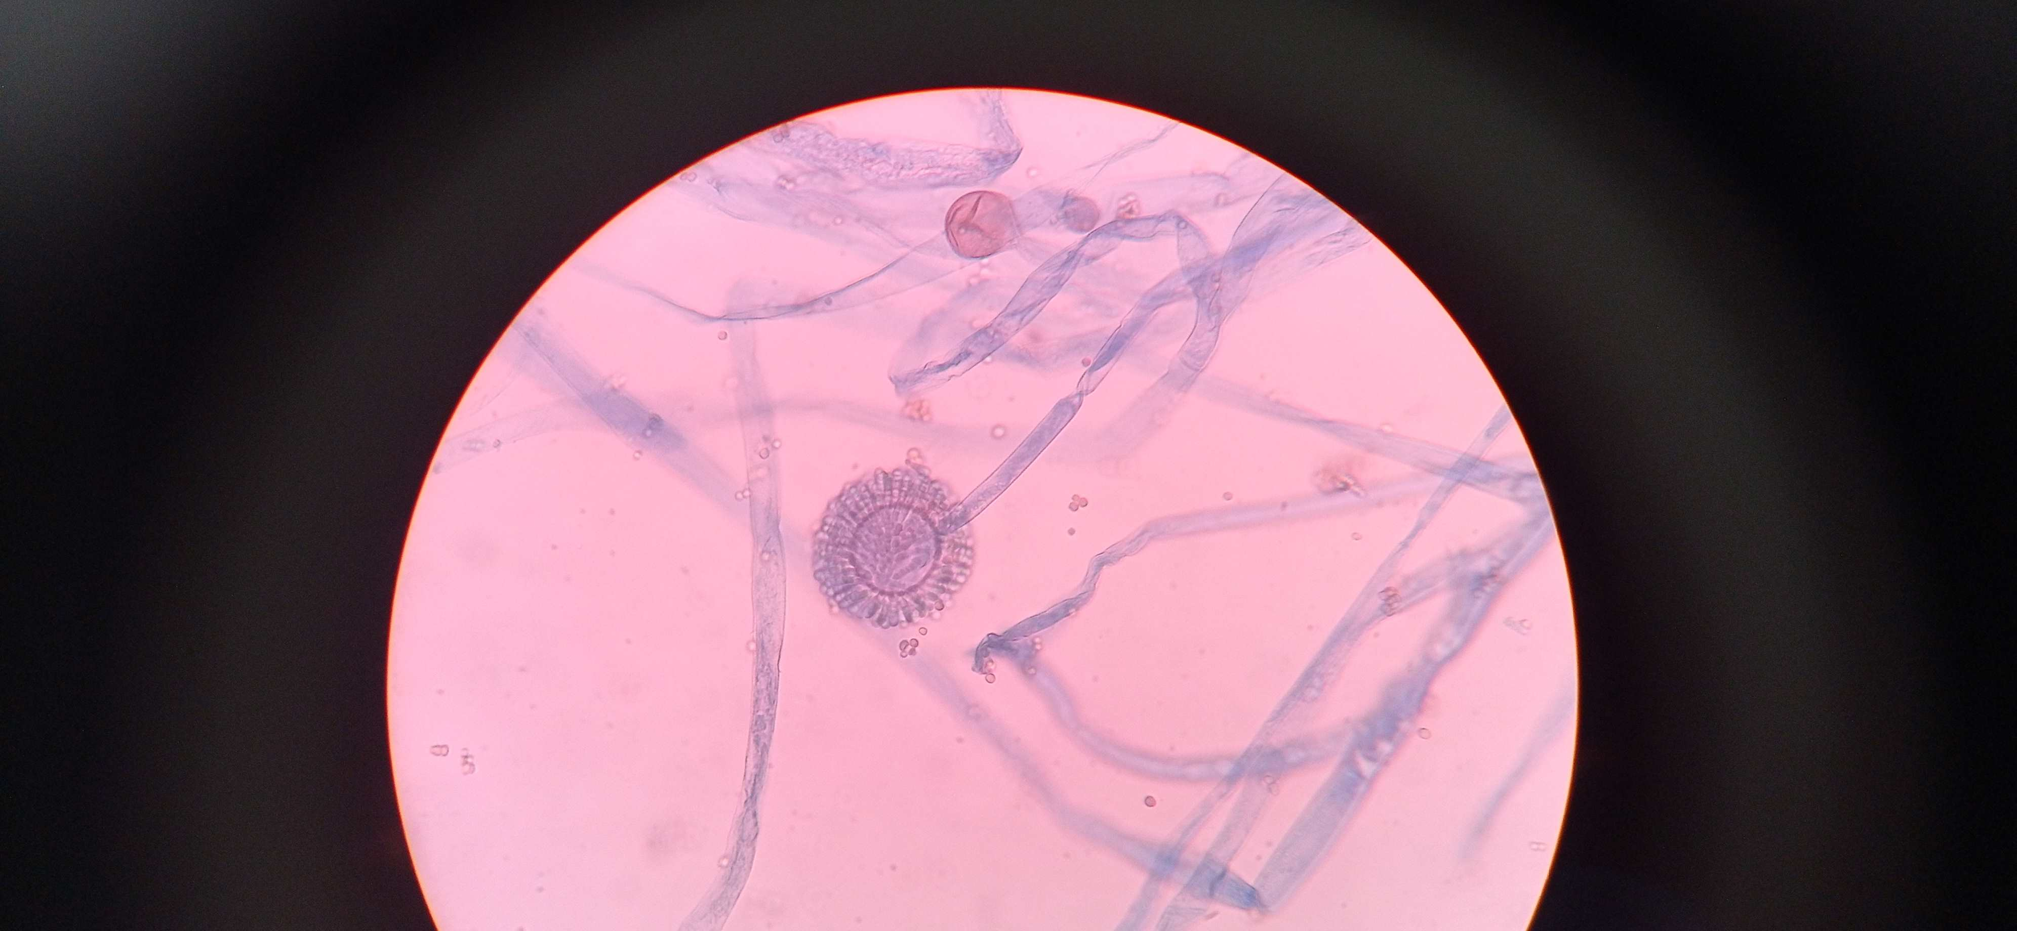
Aspergillus spp. | Aspergillus spp. | Conidia and conidiophores (40X)
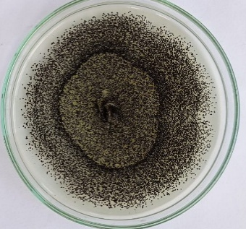 | 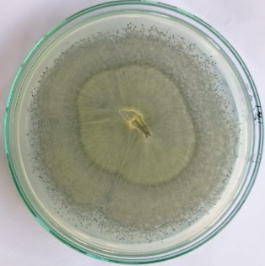 | 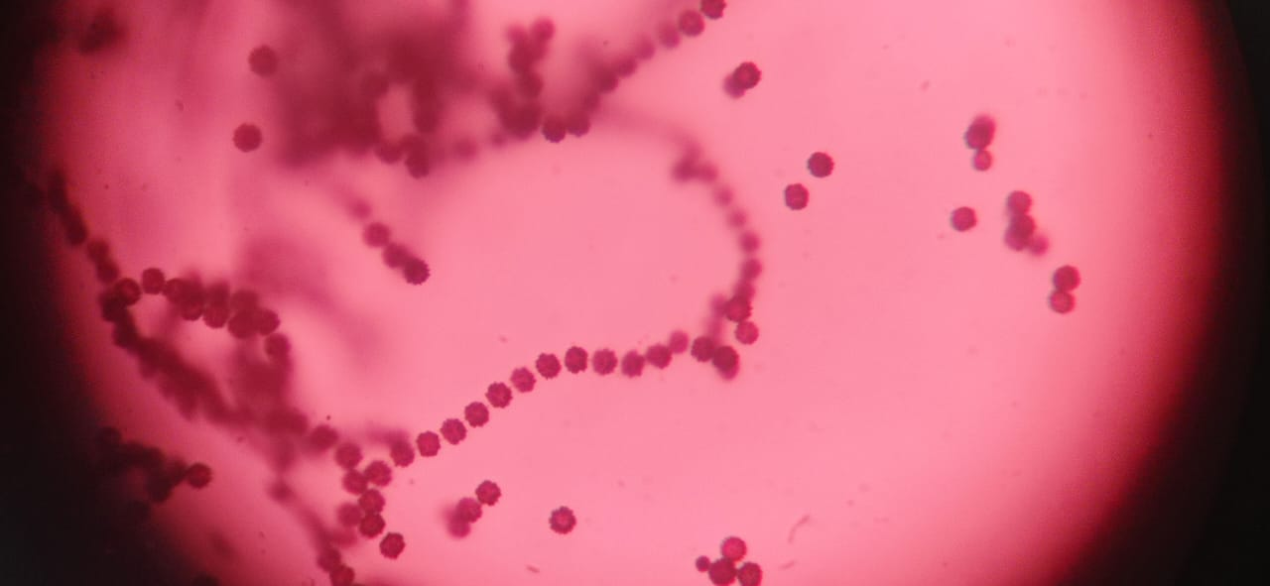
Aspergillus spp. | Aspergillus spp. | Sporangiospore (40X)
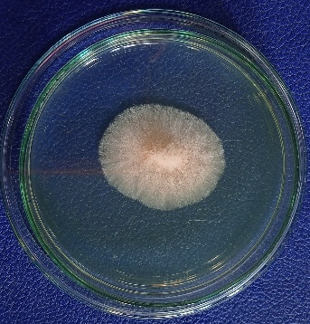 | 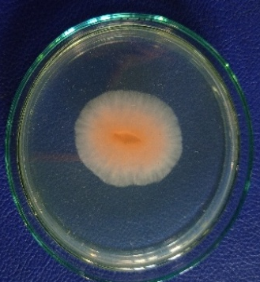 | 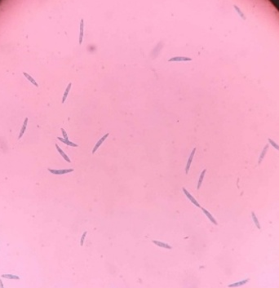
Fusarium spp. | Fusarium spp. | Macroconidia (40X)
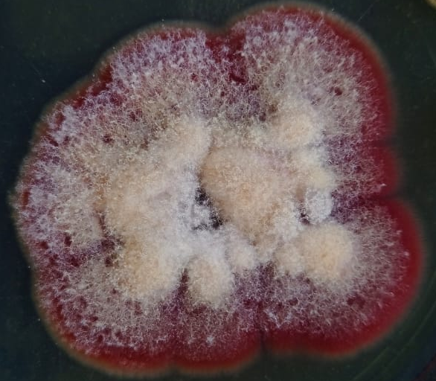 | 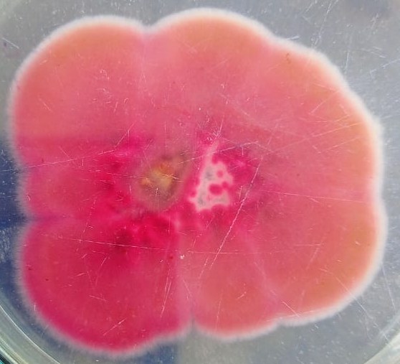 | 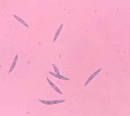
Fusarium spp. | Fusarium spp. | Macroconidia (40X)
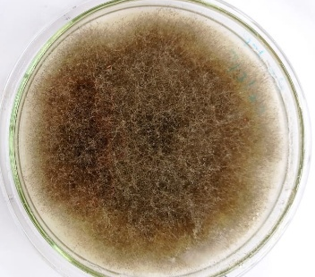 | 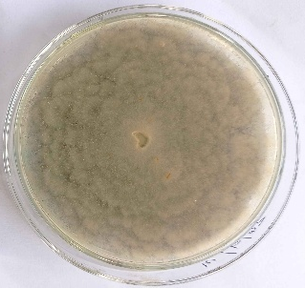 | 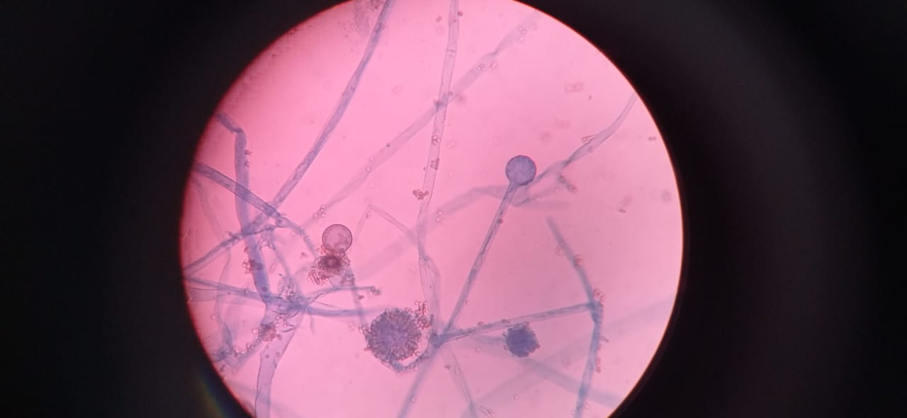
Mucor spp. | Mucor spp. | Sporangium (40X)
Fig. 36 (a): Front and reverse view of PDA plates and microscopical view of the pathogens isolated from the Khasi mandarin fruits.
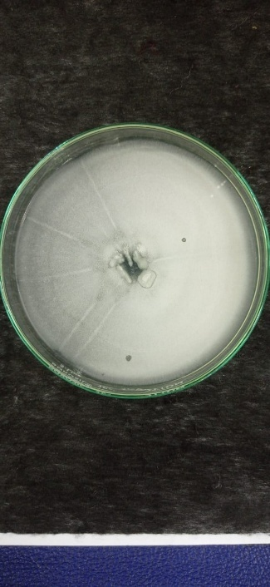 |  | 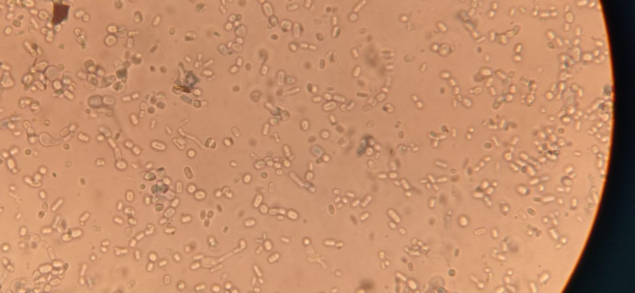
Geotrichum spp. |  | Arthospores (40X)
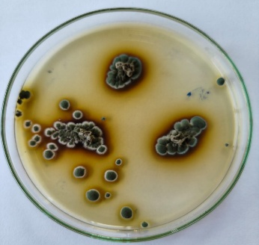 | 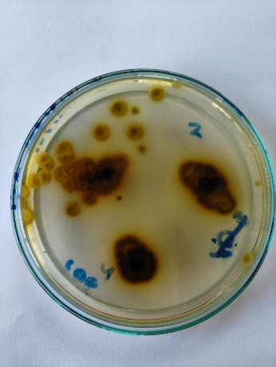 | 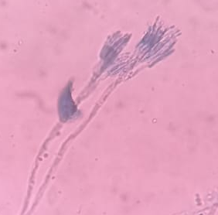
Penicillium sp.1 | Penicillium sp. 1 | Conidia and conidiophores (40X)
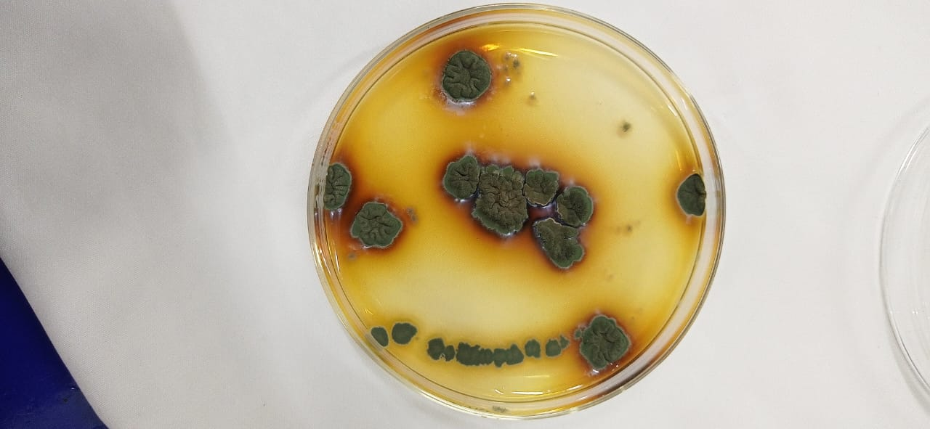 | 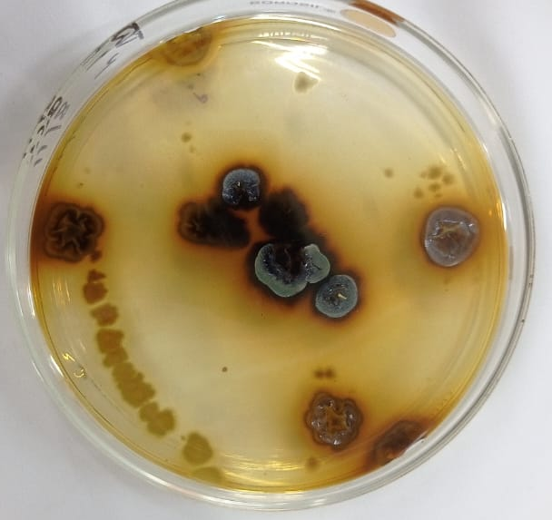 | 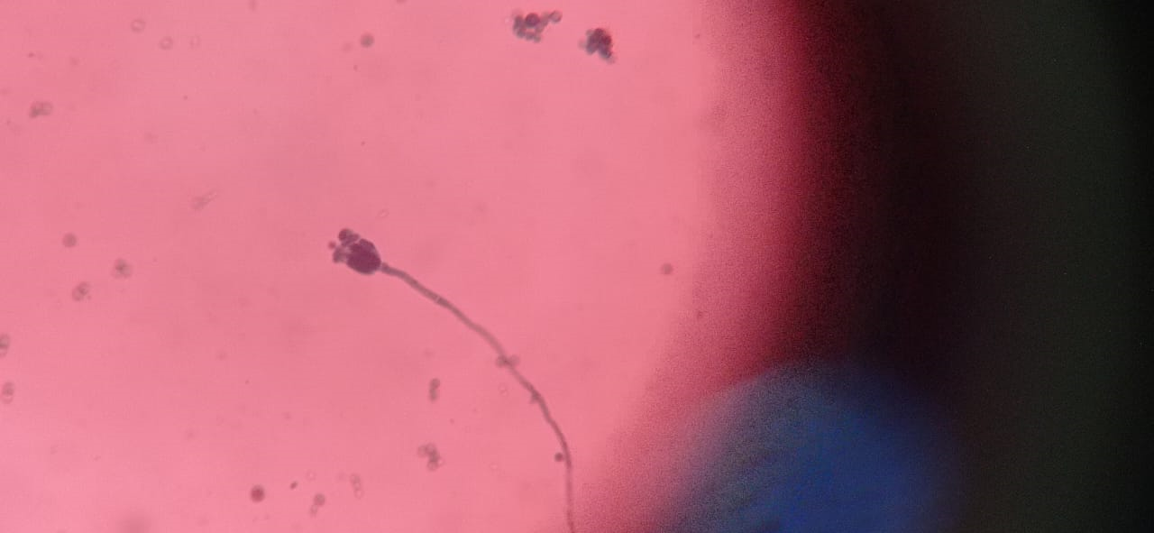
Penicillium sp.2 | Penicillium sp.2 | Conidia and conidiophores (40X)
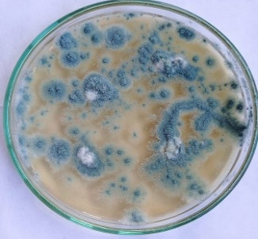 | 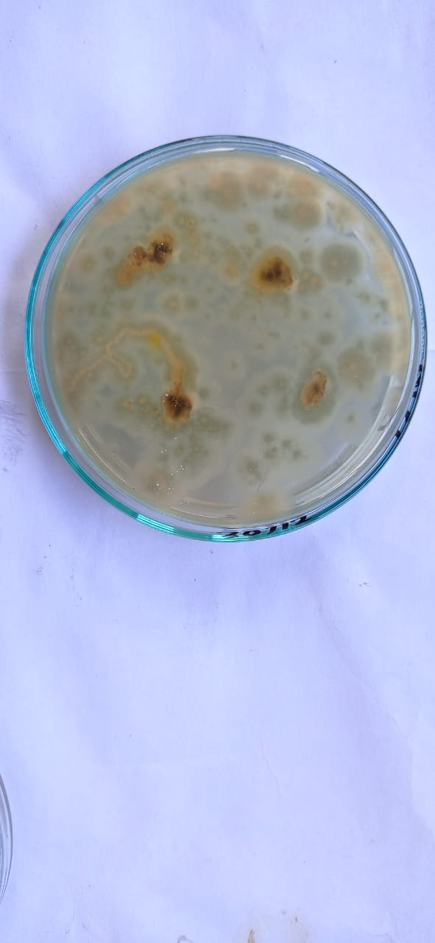 | 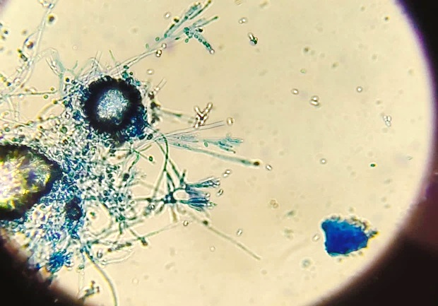
Penicillium sp. 3 | Penicillium sp. 3 | Conidia and conidiophores (40X)
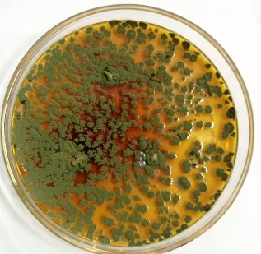 | 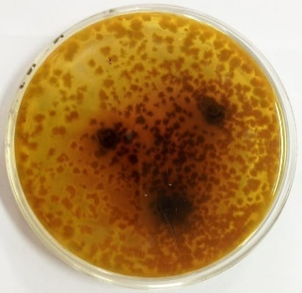 | 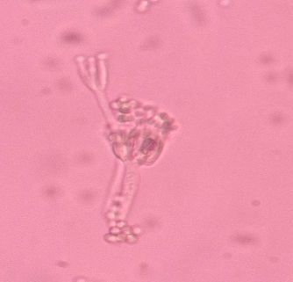
Penicillium sp. 4 | Penicillium sp. 4. | Conidia and conidiophores (40X)

- Table 3: Table of Cross-reference of cultural characterization of isolated post-harvest
- pathogens by the Royal Horticultural Society colour chart

197
198

Pathogen | Front view | Actual colour | Reverse view | Actual colour
Penicillium spp. 1 | Green group 131 A | Winchester green cc 106 | Yellow orange 22 A | Yellow ochre HCC 07
Penicillium spp. 2 | Yellow green 147 A | Wood peeker green CC 244 | Greyed orange 163 A | Bronge yellow CC 66
Penicillium spp. 3 | Green group 137 A | - | Greyed orange 163 A | Bronge yellow CC 66
Penicillium spp. 4 | Green group 139 A | Arras green CC 250 | Greyed orange 170 C | -
Fusarium spp. 1 | Red group 49 B | Venetian Pink HCC 420 | Red group 49 B | Dawn Pink BCC 15
Diplodia spp. | Black group 202 A | Jet Black BCC 220 | Black group 202 A | Jet Black CC 324
Fusarium spp. 2 | Greyed Red group 181 A | - | Greyed Red group 181 A
Geotrichum spp. | White Group B 155 | - | Greyed yellow 160 D | -
Pestalotiopsis spp. | White Group 155 D | - | Greyed orange 163 C | -
199
200

3.1 COMPARISON OF DISEASE SEVERITY INDEX AMONG THE FOUR
- DIFFERENT INOCULATION METHODS
The DSI was calculated with the following timeline
- The per cent disease severity index was calculated with the following disease rating
- scale
Grade | Range of infection
0 | No infection
1 | 1-25% of the surface area of the fruit showing disease symptom
2 | 26-50% of the surface area of the fruit showing disease symptom
3 | 51-75% of the surface area of the fruit showing disease symptoms.
4 | >75% of the surface area of the fruit showing disease symptoms.

203
- The first visible disease symptom was observed on the 3rd day of inoculation by disc
- inoculation method as water-soaked areas and within a few days the infected area enlarged
- with abundant sporulation zone surrounding a band of white mycelium. The infected area
- goes on increasing and ultimately the whole fruit is covered by the spores of the pathogen.
- Whereas, in the injection method, the first visible symptom was observed on the 5th day

after inoculation as minute white dots in the injected areas, which progressed gradually and the area covered by sporulation of the inoculated pathogen. In the rest two inoculation methods, viz., immersion and spraying, visible symptoms was observed on 6th and 8th day after inoculation. Disease severity was measured on 12th day after inoculation. Highest disease severity (Fig. 2) (83.33%) was recorded on the disc inoculation method (M4) followed
Fig. 2 Disease severity index (DSI)% of
inoculated mandarins with different inoculation technique
25
83.33
41.66
58.33
M1 M2 M3 M4
209
210
211
212
213
214
215
216
217
218
219
220
  - by the injection method (M3) and the
  - lowest was observed on spraying (M1) (25%). So, the method of spore application has a
  - significant impact on the incidence of disease symptoms.
224
225
226
Table 4: Observation on physical parameters of the inoculated fruit with four different inoculation methods

Day | M1 | M2 | M3 | M4
  wise progress of  diseases | M1 | M2 | M3 | M4
  Day 1 | - | - | - | -
  Day 2 | - | - | - | -
  Day 3 | - | - | - | +
  Day 4 | - | - | - | ++
  Day 5 | - | - | + | ++
  Day 6 | - | + | + | ++
  Day 7 | - | ++ | + | ++
  Day 8 | + | ++ | ++ | +++
  Day 9 | + | ++ | ++ | +++
  Day 10 | + | ++ | ++ | +++
  Day 11 | ++ | ++ | ++ | 233  +++
  Day 12 | ++ | ++ | +++ | +++

No disease= “-“ , Mild diseases= “+”, Moderate Disease= “++”, Severe Disease=”+++” (Barbedo et al., 2020)
M1: Spraying, M2: Immersion, M3: Injection, M4: Disc inoculation
236
227
228
229
230
231
232
234
235
237

238

Days of  observation | Physical  parameters | M1: Spraying | M2: Immersion | M3:  Injection | M4:Disc  inoculation
1st day | Lustre | good | good | good | good
1st day | Colour | orange | orange | orange | orange
1st day | Shrinkage | No | No | No | No
2nd day | Lustre | good | good | good | good
2nd day | Colour | orange | orange | orange | orange
2nd day | Shrinkage | No | No | No | No
3rd day | Lustre | good | good | good | slight soft
3rd day | Colour | orange | orange | orange | pale yellow
3rd day | Shrinkage | No | No | No | slight
4th day | Lustre | good | good | good | soft
4th day | Colour | orange | orange | orange | pale yellow
4th day | Shrinkage | No | No | No | slight
5th day | Lustre | good | good | Soft | soft
5th day | Colour | orange | orange | Pale Yellow | pale yellow
5th day | Shrinkage | No | No | Yes | Yes

6th day | Lustre | good | Soft | Soft | soft
6th day | Colour | orange | Pale Yellow | Pale Yellow | pale yellow
6th day | Shrinkage | No | Yes | Yes | Yes
7th day | Lustre | good | Soft | Soft | soft
7th day | Colour | orange | Pale Yellow | Pale Yellow | pale yellow
7th day | Shrinkage | No | Yes | Yes | Yes
8th day | Lustre | Soft | Soft | Soft | very soft
8th day | Colour | Pale Yellow | Pale Yellow | Pale Yellow | pale yellow
8th day | Shrinkage | Yes | Yes | Yes | Yes
9th day | Lustre | Soft | Soft | Soft | very soft
9th day | Colour | Pale Yellow | Pale Yellow | Pale Yellow | pale yellow
9th day | Shrinkage | Yes | Yes | Yes | Yes
10th day | Lustre | Soft | Soft | Soft | very soft
10th day | Colour | Pale Yellow | Pale Yellow | Pale Yellow | pale yellow
10th day | Shrinkage | Yes | Yes | Yes | Yes
11th day | Lustre | Soft | Soft | Soft | very soft
11th day | Colour | Pale Yellow | Pale Yellow | Pale Yellow | pale yellow
11th day | Shrinkage | Yes | Yes | Yes | Yes
12th day | Lustre | Soft | Soft | Soft | very soft
12th day | Colour | Pale Yellow | Pale Yellow | Pale Yellow | Pale yellow
12th day | Shrinkage | Yes | Yes | Yes | Yes
239
- Table 5: Day wise progress of the disease in four different inoculation methods
- Visual observation of physical parameters:
242
- Inoculated and uninoculated fruits were observed for three physical parameters like
- lustre, colour and shrinkages developed on different methods of inoculation from first day of
- inoculation till 12th day. It was observed that the tissues surrounding the inoculated disc were
- soften in the disc inoculation method from the third day onwards. Skin become pale
- coloured as well as shrinkages in the skin near the inoculated point was observed. On the
- other hand, in the injection and immersion method of inoculation, softening and pale yellow
- discoloration were noticed from the 5th day and 6th day onwards (Table 4 and 5). In the
- spraying method of inoculation, no symptom was observed until 7 days of inoculation. So,
- disc inoculation method is the fastest method for producing symptom while spraying method
- is the slowest method for producing disease symptoms on artificial inoculation.
253

3.2 PERCENT SEED INFECTION AMONGST FOUR DIFFERENT INOCULATION
- METHODS
256
- Seed health is an important aspect. Though the orange seeds are usually thrown off,
- they are a rich source of calcium, potassium, phosphorus, oil, and antioxidants (Adubofuor et
- al., 2021). Seeds are also used as propagating materials. In the current study, seed
- discolouration was observed in the inoculated mandarins. Percent seed infection was
- evaluated by the blotter test method (Plate 4 a-d) with four replications and found to be
- maximum in the disc inoculation method with a highest of 96%, followed by injection (88%)

- and the lowest was recorded in the spraying method (76%) at 7 days after incubation (Fig 3).
- The discolouration and infection on the seed initially started from one side of the seed and
- gradually covered the entire area of the seed (Plate 5). Presterilized seeds with O.5% NaOCl
- isolated from Penicillium inoculated fruits by disc inoculation method, while plated on an agar
- plate, growth of profuse green to dark green mycelia from tip of the seed (Plate 6 a-b) or
- radicle was observed, which is the store house of nutrients and water required for
- translocation during seed germination.
270
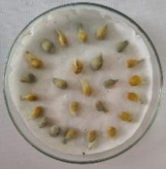 | 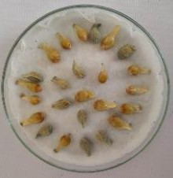 | 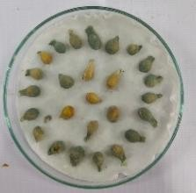 | 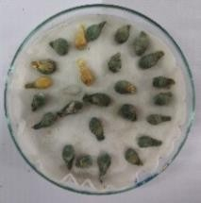 | 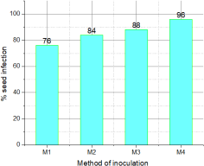
Plate 4 (a-d) Blotter test: M1: Spraying, M2: Immersion, M3: Injection, M4: Disc inoculation method respectively. |  |  |  | Fig 3. Percent seed infection in blotter test
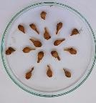 | 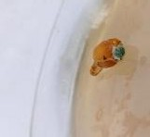 | 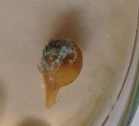
Plate 5:  Discoloured seed | Plate 6 (a-b) Growth of pathogenic mycelia from the seed of inoculated mandarins

3.3 PULP INFECTION
- Inoculated fruits were carefully peeled off after 12 days of incubation and each of
- the segments was observed for Penicillium infection. Growth and sporulation of Penicillium
- species in flavedo and albedo of inoculated fruits were also observed in the disc method of
- inoculation. Individual fruit segments were found to be more or less covered with greenish
- fungal mycelium (Plate 7 a-c ). Almost all the inoculated fruits by different inoculation
- methods lose their turgidity and compactness as compared to the uninoculated control.

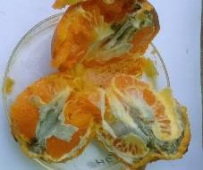 | 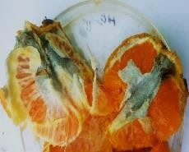 | 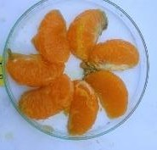 | 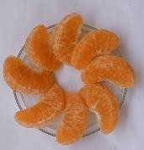
Plate 7a: Pulp infection in the inoculated mandarins |  | 7(b-c): Loose and intact pulp in inoculated (b) and uninoculated mandarins (c)

278
279 4. DISCUSSION
280
- Post-harvest losses are the biggest concern in developing countries like India.
- Combined harvest and post-harvest losses of oranges range up to 25-30% (Doki et al.,
- 2019). Fungal infection of the fruit may occur during the growing season, ripening,
- harvesting, processing, handling, and storage. High sugar and water content along with low
- pH make the fruit suitable for fungal attack (Singh and Sharma, 2007). Five different fungal
- genera were isolated from the Khasi mandarin fruit as associated pathogens for post-harvest
- decay and were identified as Penicillium spp., Aspergillus spp., Mucor spp., Geotrichum spp.
Fusarium spp. and Penicillium spp. were widely occurring amongst the collected fruit

- samples, followed by Fusarium , Aspergillus and Mucor spp. These findings are in line of
- Oviasogie et al., 2015 who reported many post-harvest pathogens associated with Citrus
- sinensis of Benin city, Edo state, Nigeria. Tariang et al., (2019) also reported Penicillium rot
- as a major constraint in Khasi mandarin production and storage from North East India.
- Penicillium ear rot of Maize kernels is one of the serious post-harvest diseases in the maize
- industry, where blue-green growth occurs on the cob surface. Similarly, Medic Pap et al.,
- (2022) also reported 3-13.3% Penicillium infection on storage onion seeds. The growth of
- the Penicillium mycelium was observed from one side of the maize seed (Erasto et al.,
- 2023), similar findings are also recorded in the present study. Application of sporulating
- mycelial disc to the injured mandarins can quickly develop lesions as compared to spraying
- of spore load to an uninjured one. The present investigation confirms that the Penicillium is a
- wound loving fungus. Which is in line of the work conducted by Kavanagh and wood (1967)
- they proved the role of wounded fruit on symptom development as compared to un injured
- one. The coloured flavedo of oranges is full of oil glands. While wounding, these oil glands
- release essential oils which kill the flavedo cells and colonization of dead flavedo cells helps
- to entry of the pathogens through the thin parenchymatous cell and reach the albedo, and
- sporulation starts in the fruit surface. Lesions on the skin develops on successful penetration
- of the albedo cells. The injury in the albedo layer, which is more spongy as well as having
- more intercellular spaces than the flavedo layer of the mandarin, makes it more susceptible
- to producing symptoms (Kavanagh and wood 1967). In the disc inoculation method, mycelial
- discs are in direct contact with the albedo, making the easier for proliferation of the pathogen
- and thereby more quickly symptom develop than the rest of the inoculation method.
- Moreover, on Penicillium inoculation, production of pectinases, cellulases, and
- polygalacturanases degrade the fruit cell wall, resulting shrinkages of the skin which was
- observed in the inoculated fruits (Papoutsis et al., 2019). The infected epicarp or flavedo and
- whitish mesocarp or albedo undergo plasmolysis, resulting development of soft watery spots
- in the infection site (Han et al., 2013) followed by gradual development of whitish mycelia
- and greenish sporulation, ultimately fruit is rotten. Overall, the study highlights Penicillium as the predominant post-harvest pathogen causing rapid decay in Khasi mandarin, especially through wound-mediated infections. These findings emphasize the need for improved handling and storage practices to minimize fruit injury and reduce post-harvest losses.
317
318 5. CONCLUSION
319
- The present research emphasises the need for improved storage practices of Khasi
- mandarin (Citrus reticulata) which is a unique germplasm of North East India having the
- highest export potential. To conserve this germplasm and to increase its storability, the
- present research focused on the pathogen that are associated with the short shelf life of
- Khasi mandarin and also gives insights into the different methods of inoculation of
- pathogens into the fruit and the impact of inoculated Penicillium in the fruit as well as seed
- and pulp texture. Khasi mandarin, the king of oranges (Singh et al., 2022) is rich in
- biochemical composition, physicochemical properties, mainly its bright orange colour, thin
- peel, more sweeter juice content make it a unique germplasm of North East India. Currently,
- India is in the third position in the production of oranges. To raise the position or to keep in
- the same, the productivity and yield of the crop should be enhanced. Awareness
- programme must be created in the mandarin growers of North East India, specialty the Khasi
- tribe, to enhance its productivity as well as increase its storage life. Future research should
- be focused on increasing the storability either by use of bioagents like Bacillus subtilis
- (Tariang et al., 2019) or antimicrobial nanomaterials (Singh et al., 2022) as a coating
- material with an eco-friendly approach that can effectively enhance the shelf life of Khasi
- mandarin.
337
339

357
358
364

365 ETHICAL DECLARATION
366
- The submitted work is original and has not been published elsewhere in any form or in
- language. The collection of the plant parts used in the present study complied with local
- guidelines.
370
371 CONFLICTS OF INTEREST The authors declare there is no conflicts of interest.
372

DATA AVAILABILITY
- The data supporting this study's findings are not openly available due to reasons of
- sensitivity and are available from the corresponding author upon reasonable request. Data
- are located in controlled access data storage at CPGS-AS, Umiam, Central Agricultural
- Institute (Imphal).
378
Disclaimer (Artificial intelligence)
Option 1:
Author(s) hereby declare that NO generative AI technologies such as Large Language Models (ChatGPT, COPILOT, etc.) and text-to-image generators have been used during the writing or editing of this manuscript.
Option 2:
Author(s) hereby declare that generative AI technologies such as Large Language Models, etc. have been used during the writing or editing of manuscripts. This explanation will include the name, version, model, and source of the generative AI technology and as well as all input prompts provided to the generative AI technology
Details of the AI usage are given below:
1.
2.
3.

379 References:
380
- Adubofuor, J., Akyereko, Y.G., Batsa, V, Apeku, O.D., Amoah, I. and Diako, C.. (2021).
- Nutrient composition and physical properties of two orange seed varieties.
- International Journal of Food Science. 11: 6415620.
- https://doi.org/10.1155/2021/6415620
- Annonymous (2014) Khasi Mandarin-GI application No. 465. Geographical Indications
- Journal No 63. Government Of India, 24-34. www.search.ipindia.gov.in/GIRPublic/Application/Details/465
- Bock, C.H., Barbedo, J.G.A., Del, Ponte., E.M., Bohnenkamp, D. & Mahlein, A.K. (2020).
- From visual estimates to fully automated sensor-based measurements of plant

- disease severity: status and challenges for improving accuracy. Phytopathology
- Research 2: 9. https://doi.org/10.1186/s42483-020-00049-8.
- Doki, N., Eya, C. & Tughgba M. (2019). Determinants of post-harvest losses of orange in
- selected local government areas of Benue state. International Journal of New
- Economics and Social Sciences https://doi.org/10.5604/01.3001.0013.8106.
- Erasto, R., Kilasi, N. & Madege, R.R. (2023). Prevalence and Management of
- Phytopathogenic Seed-Borne Fungi of Maize. Seeds, 2, 30-42.
- https://doi.org/10.3390/seeds2010003
- Han, QZhao H., Cheng, Y., Yao, J., Huang, L. & Kang, Z. (2013). A cytological study on
- infection of citrus fruits by Penicillium digitatum. Mycosystema. 32:967–977. (In
- Chinese)
- Jkavanagh, J.A. &Wood, R.K.S. (1967). The role of wounds in the infection of oranges by
- Penicillium digitatum Sacc. Annals of Applied Biology, 60(3), 375–383.
- https://doi.org/10.1111/j.1744-7348.1967.tb04490.x
- Kumar, N., Khan, A. A., Pyngrope, D., Alanzi, A.M., Upadhyay, A. & Shukla, S. (2024)
- Development and characterization of novel starch (mango kernel and litchi seed)
- based active edible coatings and films using ultrasonication Effects on postharvest
- shelf life of Khasi mandarins. Sustainable Chemistry and Pharmacy
- https://doi.org/10.1016/j.scp.2024.101610
- Medic-Pap, S., Tančić Živanov, Sonja, D. D., Ignjatov, M. & Ilić, A. G., Svetlana,
- Gvozdanović-Varga, Jelica. (2022). Seedborne fungi on stored onion seeds.
- Zbornik Matice srpske za prirodne nauke.
- https://doi.org/10.2298/ZMSPN2243039M
- Oviasogie, F.E., Ogofure, A.G., Beshiru, A., Ode, J.N. & Omeje, F.I. (2015). Assessment of
- fungal pathogens associated with orange spoilage. African Journal of Microbiology
- Research. 9 (29)1758-1763 DOI: 10.5897/AJMR2014.7246
- Papoutsis, K., Mathioudakis, M. M., Hasperué, J.H. & Ziogas, V. (2019). Non chemical
- treatments for preventing the postharvest fungal rotting of citrus caused by
- Penicillium digitatum (green mold) and Penicillium italicum (blue mold). Trends in
- Food Science and Technology. 86, 479–491.
- http://dx.doi.org/10.1016/j.tifs.2019.02.053
- Pitt, J.I. & Hocking, A.D. (1997). Fungi and food spoilage. Blackie Academic and
- Professional, an imprint of Chapman and Hall, Second Edition p.593.
- Royal Horticultural Society Colour Chart, British Colour Council Dictionary of colour
- standards
- Singh, Y. D., Das, D., Das, S., Swain, K. D., Pradhan, S. & Babu, P. J. (2022)
- Pharmacological activities of limonin from Khasi Mandarin as therapeutic
- applications, Pharmacological Research - Modern Chinese Medicine, 5,100181,
- ISSN 2667-1425, https://doi.org/10.1016/j.prmcm.2022.100181.
- Tariang, J., Majumder, D. & Firake, D. M. (2019). Biocontrol Management of Postharvest
- Penicillium Rot Disease of Khasi Mandarin (Citrus reticulata Blanco) Oranges
- Using Native B. subtilis in Meghalaya, India International Journal of Pure and
- Applied Bioscience. 7 (2): 292-302 (2019) http://dx.doi.org/10.18782/2320-
- 7051.7186
438
439
440

