Sustainable Fruit Production for Climate Resilience

Abstract
Sustainable fruit production is essential for global food security, rural livelihoods, and environmental health; however, it faces mounting challenges from intensification practices, climate change, and socioeconomic disparities. This comprehensive review synthesizes recent advances (2018–2025) in ecological and regenerative approaches, precision agriculture, technological innovations, and socioeconomic policy frameworks that underpin resilient fruit production systems. Ecological strategies including soil health restoration, water conservation, biodiversity enhancement, and ecosystem-based adaptation form the foundation for sustainable productivity. Precision agriculture, artificial intelligence, robotics, and digital platforms enable data-driven optimization and climate-smart management. Socioeconomic factors, particularly equitable market access, gender inclusion, and value chain resilience, ensure inclusive benefits across stakeholders. Climate change impacts on phenology, pest dynamics, and resource availability necessitate adaptive breeding, canopy management, and technological interventions. Future prospects emphasize genomics, circular economy integration, and synergistic policy-education frameworks as pathways to sustainably intensify fruit cultivation. This holistic, interdisciplinary framework balances productivity with environmental stewardship and social equity, offering actionable insights to guide researchers, policymakers, and practitioners in transforming fruit production into a sustainable, climate-resilient enterprise.
Keywords: sustainable fruit production, climate-smart horticulture, precision agriculture, regenerative agriculture, circular economy, food security
Introduction
Fruit production represents one of the most dynamic and valuable sectors of global agriculture and contributes substantially to human nutrition, international trade, and rural livelihoods (FAO, 2023a; FAO, 2023b; Statista, 2025). Recent data from the Food and Agriculture Organization indicate that global fruit output reached 880 million metric tons in 2023, accounting for nearly 20% of the total value of worldwide agricultural production (FAO, 2023a; FAO, 2023b; FAO, 2023c). Asia dominates this sector, producing over 60% of the global fruit supply, with China, India, and Indonesia leading regional output (FAO, 2023a; Statista, 2025).
Fruit crops are vital dietary components that provide essential vitamins, minerals, dietary fiber, and antioxidants that contribute to reducing the risk of non-communicable diseases, such as cardiovascular disorders, cancers, and diabetes (Aguilera, 2024; Marappan et al., 2025; Bhardwaj et al., 2024). The socioeconomic impact of fruit cultivation is profound, driving GDP growth, sustaining smallholder incomes, and generating rural employment, particularly in developing countries (Kopec, 2024). However, the intensification of orchard systems in response to rising demand has presented escalating challenges for environmental and socioeconomic sustainability. Excessive application of fertilizers, pesticides, and irrigation has contributed to soil degradation, biodiversity loss, and diminished ecological resilience (Kumar et al., 2022). Furthermore, monocropping practices and the reduction of beneficial soil microorganisms have disrupted natural nutrient cycles and pest regulation mechanisms (Allouzi et al., 2022).
Climate change poses an increasing threat to the resilience of fruit-production systems. Shifts in temperature and precipitation patterns, reduced chilling hour accumulation, and heightened incidence of heat stress and drought negatively affect crop phenology, yield stability, and fruit quality (Ali, 2025; Marappan et al., 2025). In response to these multifaceted challenges, sustainable horticulture has emerged as a holistic paradigm integrating ecological integrity, economic viability, and social equity (Kopec, 2024; Marappan et al., 2025). This review synthesizes advances from 2018 to 2025 in sustainable fruit production, outlining strategies for transitioning towards eco-efficient, climate-resilient, and regenerative agricultural models. Subsequent sections explore the fundamental concepts of sustainability, key constraints in traditional fruit production, and emerging frameworks that blend traditional knowledge with modern digital innovations and agroecological practices (Karkee & Padhiary, 2024; Marappan et al., 2025).
2. HISTORICAL EVOLUTION OF FRUIT CULTIVATION
2.1 Early Origins of Sustainable Practices in Horticulture
Sustainability in fruit cultivation has deep historical roots, grounded in ancient ecological knowledge shaped by local agroclimatic conditions [22-25]. Traditional agrarian societies in regions such as South and East Asia practiced integrated, low-input horticulture, long before the modern sustainability paradigm emerged. For instance, Indian agronomic manuscripts, such as the Vrikshayurveda (circa 1000 BCE), advocated crop rotation, organic manuring, and water harvesting to sustain soil fertility and plant health (Gopal et al., 2025; Kumar et al., 2022). In early imperial China, organic recycling of animal and green manure was established to sustain orchard productivity over centuries (Zhang et al., 2020). In the Mediterranean, multi-tier agroforestry systems intercropped olives, figs, and grapes with cereals and legumes, enhancing biodiversity, nutrient cycling, and natural pest regulation. These embody a "proto-sustainability" phase emphasizing harmony between cultivation and natural ecosystems (Bouby et al., 2022).
2.2 The Industrial and Green Revolution Eras
Mechanization, synthetic fertilizers, and chemical pesticides revolutionized agriculture during the Industrial Revolution, intensifying further under the mid-20th century Green Revolution, which extended high-yield models to fruit crops such as apples, citrus, and grapes (FAO, 2021). Although these advancements boosted short-term productivity, they disrupted natural nutrient and pest regulation, depleted soil organic matter, and reduced biodiversity. In fruit orchards, issues such as pesticide resistance, monoculture-driven soil degradation, and irrigation-induced salinization compromise ecosystem health. A focus on productivity often marginalizes fruit quality and ecological sustainability [26,27].
2.3 Emergence of the Sustainability Paradigm (1970–2000)
The 1970s marked the rise of sustainability as a global agricultural objective fueled by seminal works, including Limits to Growth (1972) and Our Common Future (1987). This precipitated the adoption of integrated pest management (IPM), organic farming, and soil conservation techniques in horticulture. Subtropical regions, such as Himachal Pradesh, have validated agroforestry and intercropping as sustainable fruit cultivation practices (Kumar et al., 2022). Concurrently, international initiatives, such as the FAO's promotion of Good Agricultural Practices (GAP) and Integrated Crop Management (ICM), have fostered the spread of environmentally sound productivity models.
2.4 Twenty-First Century: Transition Toward Smart and Climate-Resilient Horticulture
Early 21st-century technological advancements, including remote sensing, GIS, and biotechnology, integrated sustainability goals with precision agriculture and data-driven orchard management (Manfrini & Padhiary, 2023). Increasing climate change impacts have necessitated climate-smart strategies focusing on phenology, yield stability, and quality adaptability. Emerging paradigms emphasize low-carbon orchards powered by solar irrigation and renewable-energy-enabled cold chains, reflecting the convergence of mitigation and resilience approaches (FAO, 2021).
2.5 Evolution: From Organic to Regenerative and Circular Systems
The sustainability of fruit production has evolved through the development of organic, regenerative, and circular frameworks. Organic horticulture centers on eschewing synthetic inputs, which aim to restore ecosystems, enhance biodiversity, and sequester soil carbon. Circular economy principles integrate socioeconomic dimensions that minimize waste and recycle by-products throughout production-consumption cycles [28-30]. For example, fruit-processing residues such as apple pomace and citrus peels are repurposed as compost, bioenergy, and nutraceuticals, thus closing nutrient loops and creating added value.
2.6 Global and Regional Policy Milestones
Sustainable fruit production has been institutionalized globally through frameworks such as FAO's Global Strategy for Sustainable Agricultural Development (2010) and the United Nations Sustainable Development Goals (2015). Regional initiatives, including the European Green Deal and Farm-to-Fork Strategy, have set ambitious targets for pesticide and fertilizer reductions by 2030 (European Commission, 2019). Asia's programs, such as India's Mission for Integrated Development of Horticulture (MIDH) and China's Eco-Orchard Program, promote organic inputs, water efficiency, and precision agriculture to scale sustainability (Zhang et al., 2020).
2.7 Multi-Dimensional Framework
Contemporary sustainability in fruit production integrates the ecological, technological, economic, and social dimensions. Ecological sustainability prioritizes soil health and biodiversity; technological advancement revolves around precision tools; economic sustainability focuses on profitability balanced by waste minimization; and social sustainability empowers smallholders and ensures fair trade. The alignment of these dimensions fosters production systems characterized by resilience, equity, and stewardship (Kopec, 2024).

2.8 Current Global Trends and Future Orientation
Modern sustainable fruit production intersects digital transformation with ecological regeneration, emphasizing regenerative agriculture, low-carbon systems, and data-driven management. Innovations such as carbon farming, biodiversity credits, and nature-based solutions are increasingly being adopted. Life-cycle assessment and carbon footprint analyses offer critical metrics for orchard performance. The convergence of biotechnology, AI, and renewable energy, termed bio-digital convergence, is projected to redefine fruit cultivation within planetary boundaries and advance sustainability goals.

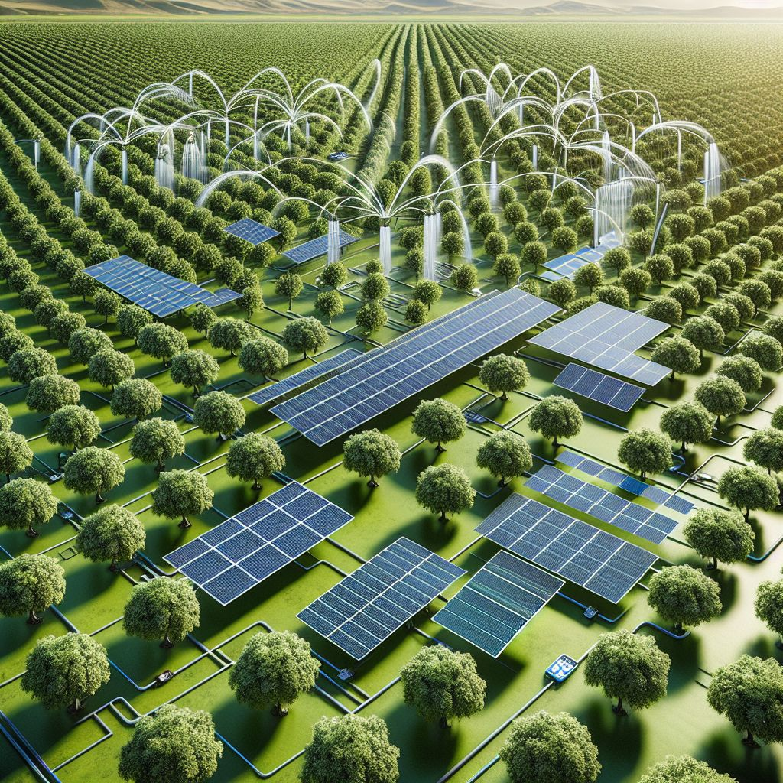
Image I. Smart, climate-resilient orchard model featuring solar-powered irrigation and advanced digital management solutions.
3. Ecological and Regenerative Approaches in Sustainable Fruit Production
3.1 Introduction
Ecological sustainability underpins sustainable fruit production, emphasizing the protection of natural resource cycles essential for productivity and ecosystem stability. In contrast to conventional input-heavy systems focused on short-term gains, ecological horticulture aims to maintain soil fertility, conserve water, protect biodiversity, and enhance resilience to climate variability. The Food and Agriculture Organization (FAO, 2022) reports that ecological intensification, replacing synthetic inputs with natural processes, can improve resource-use efficiency by up to 30% without compromising yield. Regenerative horticulture further advances these goals by restoring degraded ecosystems through rebuilding soil organic matter, improving water retention, and enhancing carbon sequestration, which is vital for perennial fruit crops that rely on intricate soil–plant–microbe interactions (Kumar et al., 2025).
3.2 Soil Health and Regeneration
3.2.1 Role of Soil Organic Matter
Soil health is fundamental to orchard productivity and sustainability. Maintaining soil organic matter above 2% is critical for nutrient availability, microbial diversity, and root growth. Organic carbon serves as a key nutrient reservoir and improves soil structure and water retention. Long-term studies in subtropical orchards show that compost or farmyard manure application boosts soil carbon stocks by 0.3–0.6 Mg ha⁻¹ yr⁻¹ relative to mineral fertilizers (FAO, 2021).
3.2.2 Compost, Vermicompost, and Biochar
Compost and vermicompost increase microbial biomass, enzymatic activity, and soil cation exchange capacity. Agricultural residues, such as citrus peels and banana waste, are increasingly recycled into compost, exemplifying circular economic principles. Biochar produced via biomass pyrolysis effectively sequesters carbon, enhances aeration, and improves nutrient retention. Applying biochar at 10 t ha⁻¹ can increase soil pH, reduce nutrient leaching, and increase fruit yields by up to 20% under water-limited conditions (Bargi, 2022).
3.2.3 Soil Biological Health
Microbial communities sustain ecosystem functions. Plant growth-promoting rhizobacteria (PGPR) and mycorrhizal fungi boost root development, enhance nutrient uptake, and confer abiotic stress tolerance. For example, Trichoderma harzianum suppresses diseases, whereas Glomus spp. enhance phosphorus solubilization in citrus and grape orchards. Employing such biological inputs reduces reliance on chemical fertilizers and fosters ecological resilience (Kumar et al., 2025).
3.3 Water Conservation and Efficient Use
3.3.1 Micro-Irrigation and Precision Scheduling
Water scarcity is a critical constraint in fruit cultivation, particularly in arid and semiarid regions. Traditional flood irrigation suffers from up to 50% water loss through evaporation and deep percolation. Drip and micro-sprinkler systems save 30–60% water while maintaining or increasing yields (FAO, 2023). These systems often integrate soil moisture and evapotranspiration sensors for precise scheduling of irrigation.
3.3.2 Rainwater Harvesting and Groundwater Recharge
Sustainable orchards adopt rainwater harvesting and water storage infrastructure such as ponds and check dams to capture seasonal rainfall. In India's dry zones, integrated water management under the National Mission on Sustainable Agriculture has improved orchard productivity by 20–25% [31-34]
3.3.3 Mulching and Evaporation Control
Organic mulches (straw and coir) and biodegradable plastic films curb soil evaporation, stabilize temperature, and suppress weeds. Studies on strawberries and citrus have demonstrated a 15–25% improvement in soil moisture, enhancing fruit size and quality (Hiregoudar et al., 2025). Biodegradable options are favored to reduce plastic pollution.
3.4 Nutrient Cycling and Biofertilization
3.4.1 Biofertilizers and Microbial Consortia
Biofertilizers are environmentally friendly alternatives to chemical fertilizers that improve nutrient solubilization and nitrogen fixation. Microbial consortia, including Azospirillum, Bacillus megaterium, and Pseudomonas fluorescens, effectively enhance yields in banana, guava, and pomegranate, reducing chemical nitrogen application by 25–30% without yield loss (Kumar et al., 2025).
3.4.2 Integration of Organic and Inorganic Sources
Integrated nutrient management (INM) combines organic manure, crop residues, and targeted mineral fertilizers to synchronize nutrient supply with crop demand, boost soil microbial activity, and minimize losses. Combining vermicompost with soluble fertilizers increases nutrient-use efficiency by 20% in mango and papaya orchards (FAO, 2023).
3.4.3 Mycorrhizal Symbiosis
Arbuscular mycorrhizal fungi (AMF) form mutualistic relationships with fruit tree roots, expanding nutrient absorption zones and enhancing phosphorus uptake. AMF inoculation improves drought resilience, mitigates transplant shock, and increases fruit set in apple and citrus orchards while contributing to soil carbon storage.
3.5 Biodiversity Enhancement and Ecosystem Services
3.5.1 Intercropping and Agroforestry
Biodiversity sustains the ecological stability of orchards. Intercropping fruit trees with legumes, vegetables, or medicinal plants enhances nitrogen fixation, weed suppression, pest control, and pollinator habitats. Examples include guava-cowpea and citrus-turmeric systems, which optimize resource use and long-term productivity (Bargi, 2022).
3.5.2 Pollinator Conservation
Pollinators, such as bees and butterflies, are essential for fruit set in apple, almond, and mango production. Habitat loss and pesticide exposure threaten these populations. Establishing pollinator strips and conserving wild habitats enhances orchard pollination efficacy and biodiversity.
3.5.3 Biological Pest Regulation
Biological control agents (e.g., Trichogramma and Chrysoperla carnea) naturally suppress pests. Banker plant systems that support natural enemies reduce pesticide dependence in apple and citrus orchards, thereby promoting ecological balance.
3.6 Climate Resilience and Carbon Sequestration
3.6.1 Climate-Resilient Cultivars and Rootstocks
Selecting cultivars and rootstocks with heat tolerance, drought resistance, and chilling requirement adaptations is critical for addressing climatic variability. Conserving genetic diversity in wild relatives supports resilient breeding programs (Hiregoudar et al., 2025).
3.6.2 Carbon Sequestration Potential
Fruit orchards sequester significant carbon in biomass and soil, with mango and citrus systems capturing 4–8 Mg CO₂ ha⁻¹ yr⁻¹. Practices such as cover cropping, mulching, and reduced tillage bolster soil organic carbon storage and aid climate mitigation (FAO, 2022).
3.6.3 Microclimate Regulation and Adaptation Strategies
Orchard designs that incorporate windbreaks, shade nets, and shelterbelts can mitigate abiotic stresses. Integrating renewable energy technologies such as solar pumps and photovoltaic systems reduces the carbon footprint and operational costs, advancing low-emission horticulture.
3.7 Integration of Ecological Practices into Orchard Design
Sustainable orchards operate as ecological mosaics that balance productivity with ecosystem services. The critical features include:
- Diverse canopy layers for nutrient partitioning
- Ground covers that prevent erosion and enhance biodiversity
- Composting areas for recycling organic waste
- Water harvesting and drip irrigation systems
- Pollinator corridors linking orchards to natural habitats
This holistic landscape approach optimizes yields, fortifies resilience, reduces inputs, and sustains services such as pollination, pest regulation, and soil regeneration.

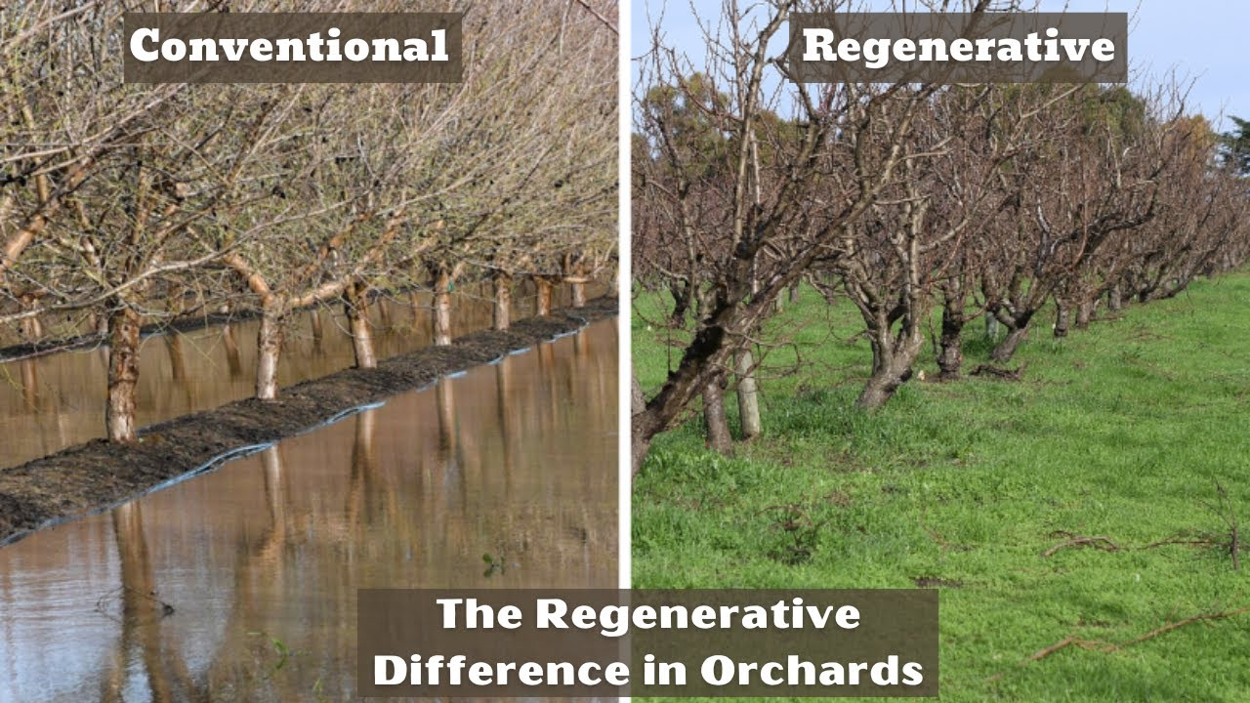Image II: Comparison between Conventional and Regenerative Orchard Management Systems (Adapted from: The Regenerative Difference in Orchards — Understanding Ag, 2023).
4. PRECISION AGRICULTURE AND TECHNOLOGY
4.1 Introduction
Precision agriculture represents a data-driven paradigm that employs advanced technologies to optimize resource allocation, enhance productivity, and minimize environmental externalities. In fruit production, precision approaches integrate spatial and temporal variability monitoring to enable site-specific management of irrigation, fertilization, and pest control. By leveraging real-time data and decision support tools, precision agriculture bridges traditional agronomic knowledge and cutting-edge digital technologies, facilitating climate-smart and resource-efficient orchards. This section synthesizes advancements in remote sensing, automation, artificial intelligence, and digital platforms reshaping sustainable fruit production (FAO, 2021; Manfrini & Padhiary, 2023).
4.2 Precision Agriculture and Site-Specific Management
4.2.1 GIS and Remote Sensing
Geographical Information Systems (GIS) and remote sensing provide growers with real-time, high-resolution spatial and temporal data to capture variability within orchards. Satellite imagery and UAV-based multispectral imaging generate key indices such as the Normalized Difference Vegetation Index (NDVI), which is commonly applied in apple and grape orchards to assess canopy health and guide precision fertilizer application (FAO, 2021; Zhang et al., 2020). The integration of soil, yield, and microclimate mapping enables precise input application, reduces nutrient runoff, prevents over-irrigation, and enhances resource-use efficiency.
4.2.2 Variable Rate Technology (VRT)
Variable Rate Technology employs GPS-guided machinery to apply water, fertilizers, and pesticides variably across orchard zones. In citrus and banana orchards, VRT-enabled fertigation has decreased chemical inputs by 25–35% without sacrificing yield or quality (Kumar et al., 2022), thereby reducing costs and environmental pollution.
4.3 Smart Irrigation and Water Management Technologies
4.3.1 Sensor-Based Irrigation Control
Soil moisture sensors, tensiometers, and evapotranspiration models facilitate precise irrigation. IoT-enabled sensors transmit real-time data to cloud platforms, thereby allowing automated scheduling. For instance, capacitive sensors that activate drip irrigation at 70% field capacity in strawberries achieve water savings of up to 40% without compromising fruit quality.
4.3.2 Decision Support Systems (DSS)
DSS combine sensor inputs, weather forecasts, and crop growth models to optimize irrigation and fertilization regimes. Platforms like AquaCrop and FruitGrower DSS promote climate-resilient, data-driven orchard management (FAO, 2023a).
4.3.3 Smart Water Harvesting and IoT Integration
IoT-enabled monitoring of rainwater harvesting and groundwater storage dynamically adjusts irrigation schedules, supporting closed-loop orchard water management (Marappan et al., 2025).
4.4 Artificial Intelligence and Machine Learning Applications
4.4.1 Crop Monitoring and Yield Prediction
AI leverages multisource data from drones, sensors, and weather stations to monitor plant health and forecast yields with 85–90% accuracy in apple and citrus orchards. Machine learning algorithms such as Random Forests and Convolutional Neural Networks detect nutrient deficiencies, pest outbreaks, and plant stress early to inform management interventions.
4.4.2 Disease and Pest Detection
Computer vision integrated with Integrated Pest Management (IPM) enables the early identification of pests and diseases via smartphone applications, reducing pesticide use while maintaining effective control (Kumar et al., 2022).
4.4.3 Predictive Analytics for Climate and Market Forecasting
AI-driven analytics utilize historical weather patterns and market data, including ENSO-based climate models, to forecast production risks and price fluctuations and improve harvest planning and marketing strategies (FAO, 2021).
4.5 Robotics and Automation in Fruit Orchards
4.5.1 Robotic Harvesters
Robotic harvesters equipped with stereoscopic cameras and AI selectively pick ripe fruits with 70–90% efficiency, as demonstrated in strawberry and apple orchards in Japan and Europe, addressing labour shortages.
4.5.2 Drone-Based Operations
Drones conduct spraying, pollination, and crop monitoring using multispectral sensors to detect nutrient and pest anomalies. Drone spraying reduces pesticide usage and exposure by up to 40% (FAO, 2023a).
4.5.3 Automated Sorting and Grading
Machine vision-based robotic sorting optimizes fruit grading by size, color, and surface quality, minimizing postharvest losses that can exceed 20–30% for tropical fruits .
4.6 Digital Platforms and Blockchain in Fruit Supply Chains
4.6.1 Traceability and Blockchain Integration
Blockchain ensures transparent, tamper-proof supply chains. Consumers verify product origin, pesticide use, and sustainability certifications via QR codes. Pilot projects in mango and banana exports have secured 10–15% higher farmer premiums (Marappan et al., 2025).
4.6.2 Farm Management Information Systems (FMIS)
FMIS consolidate inputs, irrigation, labor, and financial data on cloud platforms, offering growers real-time decision-making support for efficient orchard management.
4.6.3 Digital Marketplaces and E-Commerce Integration
Digital platforms such as India's eNAM facilitate direct sales, reduce intermediaries, improve farmer profitability, and expand market access through mobile connectivity (FAO, 2023a).
4.7 Climate-Smart Data Systems and Modelling
4.7.1 Big Data Analytics for Climate Adaptation
Big data models integrate satellite imagery, sensor networks, and climate forecasts to predict drought, frost, and heat waves, thus enabling preemptive orchard management (Kumar et al., 2022).
4.7.2 Digital Twins for Orchards
Digital twin technology creates virtual orchard replicas simulating growth and resource dynamics under variable scenarios and optimizes management interventions.
4.8 Challenges and Adoption Constraints
Despite its clear benefits, widespread adoption faces barriers, including high costs, technical knowledge gaps, connectivity issues, and data privacy concerns. In particular, smallholders often struggle with affordability. Standardizing data protocols and enabling system interoperability remain priorities (FAO, 2023a). Capacity building, cooperative ownership models, subsidies, and public–private partnerships are vital to ensuring equitable technology diffusion and sustainable transformation of fruit production.
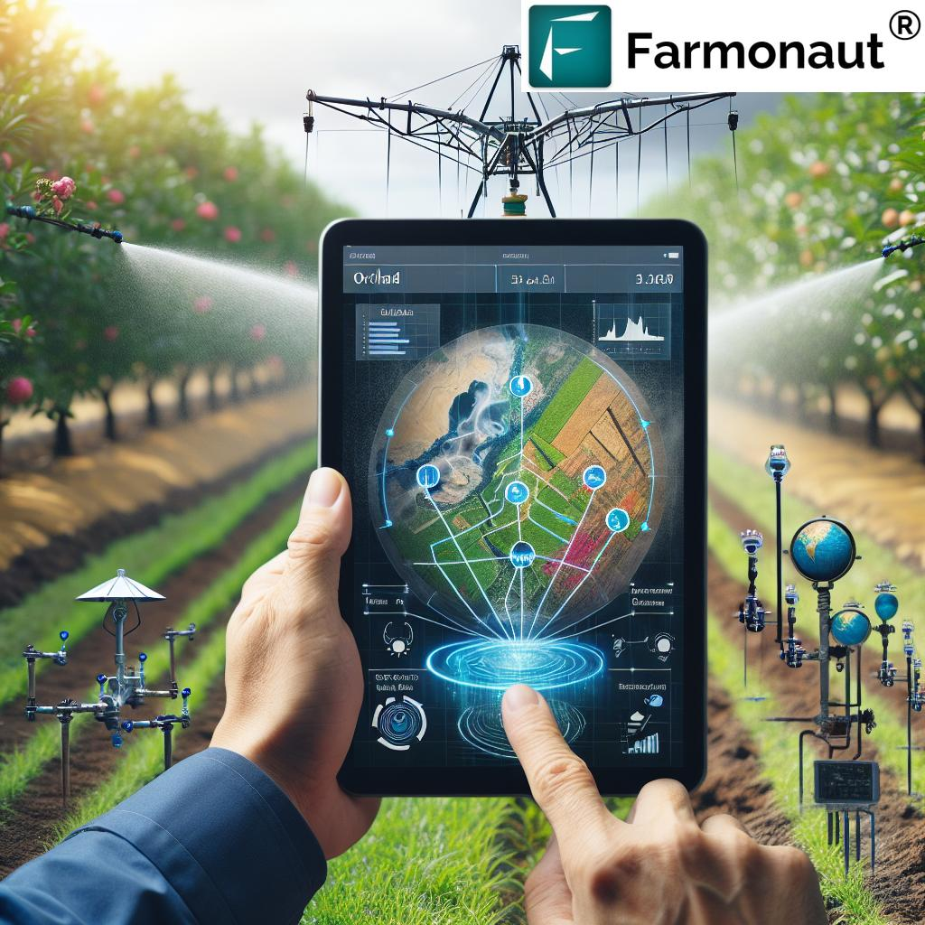
Image III: Precision Agriculture Technologies Applied to Fruit Production Systems (Adapted from “Precision & Smart Irrigation for Apple Orchards – Revolutionize Your Orchard: How Smart Irrigation Systems and Precision Agriculture Boost Crop Yield and Save Water”).

5. SOCIO-ECONOMIC AND POLICY DIMENSIONS
5.1 Introduction
Sustainable fruit production transcends ecological and technological innovations, fundamentally involving socioeconomic and policy factors that determine long-term viability. The success of sustainable horticulture depends on enhancing farmers' livelihoods, ensuring market stability, promoting equity, and aligning with supportive and coherent policy frameworks. Although fruit crops substantially contribute to income diversification, nutritional security, and rural employment globally, the sector remains vulnerable to price volatility, labor shortages, and policy gaps (FAO, 2023a; Kumar et al., 2022). Socioeconomic sustainability arises from the complex interplay among market access, value chain integration, credit availability, gender inclusion, and institutional support. Sound policies that harmonize environmental goals with socio-economic equity are indispensable for advancing holistic horticultural models (Marappan et al., 2025).
5.2 Economic Viability and Farm Profitability
5.2.1 Cost-Benefit Efficiency and Input Use
Economic viability underpins sustainable fruit production. The traditional input-intensive model relies on synthetic fertilizers and extensive irrigation, facing diminishing profit margins owing to rising costs and soil degradation. Transitioning to eco-efficient and regenerative practices can lower input use by 20–30%, improve resource efficiency, and reduce costs. Practices including precision irrigation, biofertilizers, and organic amendments enhance environmental outcomes and profitability by cutting recurrent expenses. For instance, citrus and banana orchards adopting these methods saw cost-benefit ratios improve from 2.1 to 2.8 (FAO, 2023a).
5.2.2 Risk Reduction and Yield Stability
Sustainable practices bolster resilience against market fluctuations and climatic risks. Crop diversification and agroforestry mitigate economic volatility by spreading income sources. Introducing short-cycle vegetables into perennial orchards provides continuous cash flow, cushioning households from crop failures (Marappan et al., 2025).
5.2.3 Post-Harvest Management and Value Addition
Global post-harvest losses exceed 25–30% due to inadequate handling, poor cold storage, and inefficient logistics (FAO, 2021). Investing in value addition—through dehydration, juice production, and pulp processing—increases product worth and minimizes waste. Local processing units and cooperative storage empower smallholders to access premium markets while maintaining quality standards.
5.3 Market Access, Value Chains, and Trade
5.3.1 Market Integration and Fair Pricing
Efficient, transparent markets are essential for equitable benefit sharing. Smallholders often face asymmetrical information and exploitative intermediaries. Contract farming, cooperatives, and digital marketplaces such as India's eNAM reduce intermediary layers, improving price realization (FAO, 2023a). Blockchain-enabled traceability enhances consumer trust, particularly in export markets requiring sustainability certification. The growing demand for Fair Trade and GlobalGAP-certified fruits reflects consumer preference for ethically sourced products.
5.3.2 Value Chain Sustainability
Robust value chains optimize efficiency, traceability, and equitable profit-sharing among stakeholders. Improvements in logistics, waste reduction, and eco-friendly packaging and transportation are critical. India's MIDH cold-chain expansion reduced spoilage by 15–20%, boosting export readiness (Kumar et al., 2022).
5.3.3 Global and Regional Trade Trends
Urbanization, changing diets, and integrated supply networks expand global fruit trade. Nonetheless, stringent quality and phytosanitary standards challenge smallholders in developing countries. Harmonizing regional trade agreements and standards is necessary to facilitate inclusive participation in global markets.
5.4 Social Inclusion, Gender, and Community Development
5.4.1 Gender Participation in Fruit Production
Women play critical roles in fruit cultivation, processing, and marketing but face constraints in land ownership, credit access, and training. Globally, women constitute 45–55% of horticultural labor but own less than 15% of farms (FAO, 2021). Gender-responsive extension services and women-led cooperatives have improved productivity and equity. Initiatives in Himachal Pradesh demonstrate how women's entrepreneurship and digital literacy enable successful commercialization of apple products.
5.4.2 Community Empowerment and Cooperative Models
Community organizations and cooperatives enhance collective bargaining, resource sharing, and the adoption of sustainable practices. Models inspired by programs like Amul—such as Mango Growers Federations and Banana Producer Companies—support nurseries, cold chains, and marketing, ensuring equitable profits for farmers (Kumar et al., 2022).
5.4.3 Youth Engagement and Skill Development
Horticulture offers employment and entrepreneurship avenues for youth, especially in agri-tech and marketing. Programs such as India's NSDM and ASCI enhance digital literacy, entrepreneurship, and technology adoption, fueling innovation in fruit production systems.
5.5 Policy Frameworks for Sustainable Horticulture
5.5.1 National and International Policy Context
Government policies have significant influence on horticultural sustainability. Programs such as India's PKVY, NMSA, and MIDH promote organic inputs, soil health, micro-irrigation, and post-harvest infrastructure (FAO, 2023a). Internationally, the UN Sustainable Development Goals (SDGs)—notably SDG 2 (Zero Hunger), SDG 12 (Responsible Consumption and Production), and SDG 13 (Climate Action)—guide alignment of fruit production with sustainability objectives (Marappan et al., 2025).
5.5.2 Subsidies, Incentives, and Credit Access
Financial mechanisms reduce barriers to sustainable technology adoption. Subsidies for drip irrigation, solar pumps, and organic certification, alongside institutional credit and insurance through NABARD and cooperatives, underpin transition to low-carbon fruit production systems (Kumar et al., 2022).
5.5.3 Policy Challenges and Gaps
Fragmented implementation, poor coordination, limited awareness, and weak monitoring reduce policy efficacy. Integrated systems approach linking agriculture, environment, and rural development policies are necessary for maximizing sustainable impact.
5.6 Equity, Food Security, and Sustainability Nexus
Sustainability, equity, and food security are intricately linked in horticulture. Fruit crops address micronutrient deficiencies but economic access remains limited in low-income regions. Policies supporting local production and equitable distribution can enhance dietary diversity and nutrition (FAO, 2021). Ensuring intergenerational equity requires integrating environmental, social, and economic metrics into horticultural planning

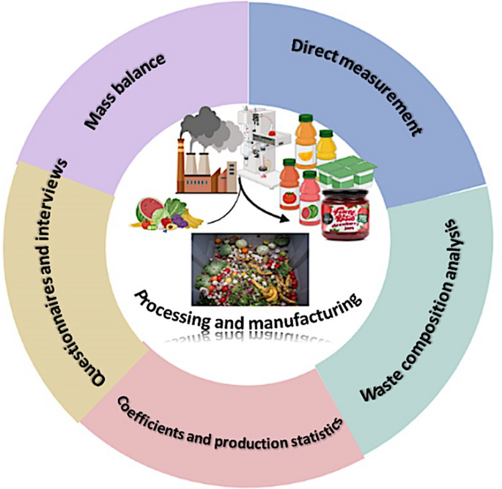

Image IV: Socio-Economic & Policy Framework for Sustainable Fruit Production- Adapted from “The-picture-of-the-economic-sustainability-of-fruit-growing-sector” — Cherry Times, Italy (2025).

6. CLIMATE CHANGE IMPACTS AND ADAPTATION STRATEGIES
6.1 Introduction
Climate change poses a formidable challenge to fruit production systems globally. Rising temperatures, erratic precipitation, prolonged droughts, and increased frequency of extreme weather events disrupt crop phenology, physiology, yields, and fruit quality. The Intergovernmental Panel on Climate Change (IPCC, 2023) reports that global mean surface temperatures have risen approximately 1.1°C above pre-industrial levels, with an anticipated rise to 1.5°C by 2035. Such shifts adversely affect horticultural productivity, pest and disease dynamics, and water availability. Perennial fruit crops, given their long lifecycles and dependency on stable climates, are particularly vulnerable, necessitating adaptive strategies that safeguard yield and quality while bolstering system resilience (Kumar et al., 2022).
6.2 Climatic Trends Affecting Fruit Production
6.2.1 Temperature Rise and Heat Stress
Elevated mean and peak temperatures influence critical developmental stages such as growth and flowering. Tropical fruits such as mango, banana, and papaya can tolerate heat but experience accelerated ripening and quality deterioration under thermal stress. Temperate fruits such as apple, peach, and plum depend on sufficient chilling hours, with reductions below 600 hours causing flowering disruptions and yield declines, particularly in northern India and subtropical zones (FAO, 2023a).
6.2.2 Irregular Rainfall and Drought
Erratic rainfall exacerbates water stress, reducing fruit size, sugar content, and shoot vigor. Excessive rainfall during flowering or harvest increases flower drop, fruit cracking, and post-harvest losses. In semi-arid regions, evapotranspiration often surpasses rainfall, heightening reliance on efficient irrigation technologies.
6.2.3 Frosts, Hailstorms, and Extreme Events
Incidences of frosts, hailstorms, and cyclones have intensified. Frosts devastate apple and citrus yields; hailstorms damage fruit skin, compromising marketability. Coastal orchards, particularly banana and mango, face increased cyclone and wind hazards, necessitating enhanced infrastructure and adaptive management (Marappan et al., 2025).
6.2.4 CO₂ Enrichment and Crop Physiology
Elevated atmospheric CO₂ can enhance photosynthesis and biomass accumulation in C₃ crops such as mango and guava, potentially improving sugar concentrations. However, heat and water stress often limit these benefits. Additionally, CO₂ enrichment may reduce mineral nutrient concentrations, adversely affecting flavor and nutritional quality.
6.3 Impact on Phenology, Pollination, and Quality
6.3.1 Phenological Shifts
Climate variability alters flowering, fruit set, and maturation timelines. Early or delayed blooming risks pollination failure; for example, premature bud break due to warming reduces pollination success in temperate orchards (FAO, 2021).
6.3.2 Pollination Deficits
Pollinators crucial to apple and almond yields are sensitive to heat stress, pesticide exposure, and habitat loss. Extreme heat reduces bee foraging activity, lowering fruit set by 20–30%.
6.3.3 Fruit Quality and Post-Harvest Impacts
Heat and drought degrade fruit color, firmness, and sugar-acid balance. Anthocyanin loss under heat stress produces paler apples and strawberries. Drought concentrates soluble solids but diminishes fruit size and storability, while erratic rainfall increases fungal infections and post-harvest losses.
6.4 Pests, Diseases, and Invasive Threats
Rising temperatures alter pest and disease dynamics, expanding their range and reproductive rates. Fruit flies, aphids, and mites thrive under warmer, humid conditions. Diseases such as anthracnose and powdery mildew intensify, and invasive species such as the papaya mealybug encroach into new areas, underscoring the need for vigilant monitoring and predictive control (FAO, 2023a).
6.5 Water Scarcity and Soil Degradation
6.5.1 Depleting Water Resources
Water scarcity restricts cultivation. Groundwater depletion and altered rainfall patterns have reduced irrigation availability in key regions such as Maharashtra and Tamil Nadu, India. Implementing micro-irrigation and soil moisture monitoring is critical to sustain productivity (Kumar et al., 2022).
6.5.2 Soil Erosion and Nutrient Leaching
Intense rainfall accelerates runoff and topsoil erosion, depleting fertility. Nitrogen and potassium leaching impact yields adversely. Mitigation via cover cropping, mulching, and contour bunding conserves soil and nutrients (FAO, 2023a).
6.6 Climate Adaptation Strategies
6.6.1 Breeding for Climate Resilience
Developing cultivars tolerant to heat, drought, and salinity is essential. Examples include 'Amrapali' mango and 'Pusa Sadabahar' guava, with marker-assisted selection and genomics expediting breeding programs (Marappan et al., 2025).
6.6.2 Rootstock Selection
Drought- and heat-tolerant rootstocks such as Carrizo citrange (citrus) and Vitis berlandieri × V. rupestris (grape) enhance resilience. Ongoing research focuses on climate-adapted rootstocks for key fruit crops.
6.6.3 Canopy and Microclimate Management
Using shading nets, reflective mulches, whitewashed trunks, and windbreaks reduces canopy temperatures by 3–5°C, alleviating heat and water stress (FAO, 2021).
6.6.4 Efficient Water Management
Micro-irrigation, fertigation, and rainwater harvesting improve water-use efficiency by 30–40%, preserving yields under scarcity.
6.7 Ecosystem-Based Adaptation (EbA)
Nature-based solutions harness biodiversity and ecosystem processes for resilience, including agroforestry for shade and carbon storage, pollinator corridors, and soil biodiversity enhancement via organic amendments. EbA delivers productivity, carbon sequestration, and biodiversity co-benefits (Kumar et al., 2022).
6.8 Technological and Policy Support
6.8.1 Climate-Smart Technologies
Artificial Intelligence-enabled early warning systems, crop modeling, and remote sensing facilitate proactive adaptation. Mobile apps disseminate weather advisories, improving resilience to frost, drought, and pest outbreaks (FAO, 2023a).
6.8.2 Financial and Institutional Mechanisms
Crop insurance, risk-sharing schemes, and climate finance initiatives reinforce financial resilience. Programs such as India's PMFBY and Green Climate Facility provide vital safeguards, supported by collaborative governance frameworks.
6.8.3 Policy Integration
Effective climate resilience requires aligning research, extension, and funding with national horticulture policies. Carbon credit and biodiversity incentive frameworks foster climate-positive practices (Marappan et al., 2025).
6.9 Mitigation Co-Benefits
Fruit production mitigates climate change by sequestering carbon and reducing greenhouse gases. Perennial orchards accumulate carbon in biomass and soil; organic and renewable approaches reduce emissions. Practices such as composting, biochar application, and minimal tillage can sequester up to 8 Mg CO₂ ha⁻¹ yr⁻¹. Solar pumps and dryers enhance energy efficiency, further minimizing carbon footprints (FAO, 2021).
7. FUTURE PROSPECTS FOR SUSTAINABLE FRUIT PRODUCTION
7.1 Overview of Future Opportunities
The forthcoming decades present transformative opportunities to overcome escalating challenges in fruit production. Rapid advancements in biotechnology, precision horticulture, digital technologies, and climate-smart farming strategies are steering the sector toward enhanced sustainability, resilience, and productivity. This section synthesizes emerging technologies, paradigms, and frameworks projected to reshape sustainable fruit production by 2035 (Kumar et al., 2022).

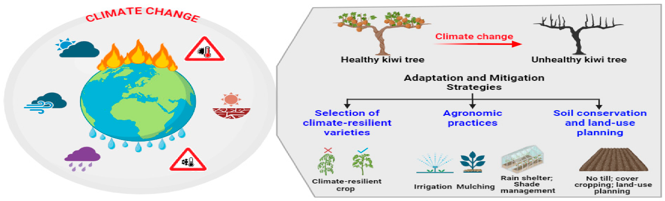
Image IV. Climate-Change Impacts and Adaptation Strategies in Fruit Production Systems -Adapted from Devin et al. (2023).
7.2 Genomic and Biotechnological Advances
7.2.1 Gene Editing and Climate-Resilient Cultivars
Next-generation genomic technologies, including CRISPR-Cas9, marker-assisted selection, and genomic prediction, are accelerating development of climate-resilient cultivars tolerant to heat, drought, salinity, and biotic stresses. These technologies enable simultaneous improvement of yield, quality, and pest resistance. Examples include heat-tolerant mango and drought-resistant citrus rootstocks under advanced breeding programs in India and China (Hiregoudar et al., 2025). By 2030, an estimated 40–50% of new fruit varieties will incorporate gene-edited traits, promising yield gains of 20–30% with reduced chemical inputs (Kumar et al., 2025).
7.2.2 Biofortification and Nutritional Enhancement
Genomic tools are enabling biofortification of fruit crops with elevated micronutrients, antioxidants, and phytochemicals. Breeding for high anthocyanins in strawberries and polyphenols in grapes addresses micronutrient deficiencies, particularly in low-income regions. Metabolomics-guided selection tailors fruit composition to regional nutritional priorities (FAO, 2024).
7.3 Digital Agriculture and Precision Horticulture 2.0
7.3.1 AI, Machine Learning, and Autonomous Systems
Artificial intelligence, machine learning, and autonomous systems will redefine orchard management. Advanced algorithms integrating multisensory data from drones, soil sensors, and weather stations will enable real-time precision in irrigation, fertilization, and pest management. Autonomous platforms (drones and robotic systems) will undertake labor-intensive tasks such as pruning, weeding, and selective harvesting with increasing efficiency. Digital twins—virtual replicas of orchards—will optimize management scenarios before real-world implementation, reducing risks and improving decision-making (FAO, 2024).
7.3.2 Blockchain and Decentralized Market Systems
Blockchain technology will enhance supply chain transparency and farmer profitability. Smart contracts will facilitate direct transactions between producers and consumers, ensuring fair pricing and traceability. Decentralized platforms will reduce intermediary costs and empower smallholders through equitable value distribution (Hiregoudar et al., 2025).
7.3.3 IoT Networks and Real-Time Monitoring
Proliferation of Internet of Things devices will enable ultra-precise, real-time orchard monitoring. Distributed sensor networks monitoring soil, plant, pest, and microclimate parameters will transmit data to cloud platforms, facilitating automated decision-making and remote orchard management accessible to smallholders via mobile applications (Kumar et al., 2025).
7.4 Circular Economy Integration and Waste Valorization
7.4.1 By-Product Utilization and Zero-Waste Production
Circular economy principles will transform fruit by-products into high-value resources. Fruit processing residues such as peels, seeds, and pomace are increasingly transformed into biofertilizers, bioactive compounds, bioplastics, enzymes, and pharmaceutical precursors. This approach reduces post-harvest losses, creates new revenue streams, and closes nutrient loops. For example, citrus peel extracts yield limonene (industrial solvent), pectin (food additive), and antioxidants (nutraceuticals) (Bargi, 2022).
7.4.2 Regenerative Practices and Carbon Farming
Carbon farming and payment for ecosystem services programs will incentivize regenerative practices. Orchards practicing cover cropping, organic amendment application, and agroforestry will generate carbon credits, tradable in emerging carbon markets. Soil organic carbon sequestration rates of 4–8 Mg CO₂ ha⁻¹ yr⁻¹ offer economic returns while mitigating climate change (FAO, 2022).
7.5 Climate Resilience and Nature-Based Solutions
7.5.1 Climate-Resilient Landscape Design
Future orchards will integrate agroforestry, alley cropping, and biodiversity corridors at the landscape scale. These multi-functional systems provide shade, windbreaks, pest regulation, pollinator habitat, and carbon storage while supporting agroecological resilience. Integration of traditional ecological knowledge with modern science will enable locally adapted, resilient production models (Hiregoudar et al., 2025).
7.5.2 Ecosystem-Based Adaptation and Nature-Based Solutions
Nature-based solutions leveraging biodiversity and ecological processes will become central to climate adaptation. These approaches include pollinator corridors, establishment of natural enemy habitats, and soil biodiversity enhancement through organic amendments. Such strategies deliver co-benefits of productivity, ecosystem services, and biodiversity conservation (Kumar et al., 2025).
7.6 Energy Efficiency and Low-Carbon Production
7.6.1 Renewable Energy Integration
Solar and wind power will increasingly replace fossil fuel-dependent operations. Solar pumps, photovoltaic greenhouses, and wind-powered cold storage facilities will enable energy-autonomous orchards. By 2030, an estimated 50% of large-scale fruit production systems in Asia will incorporate renewable energy (FAO, 2024).
7.6.2 Carbon Neutrality and Net-Zero Pathways
Fruit production systems will transition toward net-zero greenhouse gas emissions through renewable energy adoption, soil carbon sequestration, and reduced chemical use. Carbon footprinting and life-cycle assessment will become standard practices for market differentiation and compliance with emerging carbon regulations (Hiregoudar et al., 2025).
7.7 Policy-Education Synergy and Institutional Support
7.7.1 Policy Integration and Harmonization
Integrated policy frameworks aligning national horticulture, climate, and biodiversity objectives will be essential. Policies should embed metrics for carbon neutrality, biodiversity enhancement, and water productivity. Public–private partnerships and cooperative models will facilitate equitable technology diffusion and risk-sharing (FAO, 2024).
7.7.2 Capacity Building and Vocational Training
Investment in skill development, digital literacy, and climate-smart horticulture training will empower farmers and researchers. Universities and research institutions should integrate sustainability, precision agriculture, and climate adaptation into curricula. Farmer field schools and digital platforms will disseminate best practices, enabling rapid scaling of sustainable models (Kumar et al., 2025).
7.7.3 Research and Extension Integration
Strengthened linkages between research, extension, and farmer communities will accelerate technology adoption and localization. Participatory research approaches involving smallholders in technology design will enhance appropriateness and ownership, fostering sustainable transitions.
7.8 Market Dynamics and Emerging Opportunities
7.8.1 Premium Markets and Sustainability Certification
Consumer demand for sustainably produced, nutrient-rich fruits will expand premium market opportunities. GlobalGAP, organic, and regenerative certifications will command price premiums of 15–30%, incentivizing sustainable adoption among producers (Hiregoudar et al., 2025). Digital traceability and blockchain integration will facilitate transparent sustainability claims.
7.8.2 Urban and Vertical Farming
Urban horticulture and controlled-environment agriculture (CEA) systems will complement traditional orchards, reducing food miles and post-harvest losses. High-tech vertical farms and rooftop gardens in urban centers will enhance food sovereignty and nutrition security while reducing environmental pressures on rural landscapes (FAO, 2024).
7.9 Global Collaborative Frameworks and Knowledge Sharing
7.9.1 International Research Networks and South-South Cooperation
Collaborative global networks will facilitate knowledge sharing on climate adaptation, disease management, and sustainable practices. South-South cooperation through centers of excellence in fruit-producing regions will enable technology transfer tailored to regional contexts and smallholder capacities (Kumar et al., 2025).
7.9.2 Convergence of Traditional and Modern Knowledge Systems
Integrating indigenous and traditional knowledge with cutting-edge science will generate hybrid, culturally adapted sustainability models. This convergence respects farmer agency, local ecological contexts, and socio-cultural values while harnessing innovation benefits.
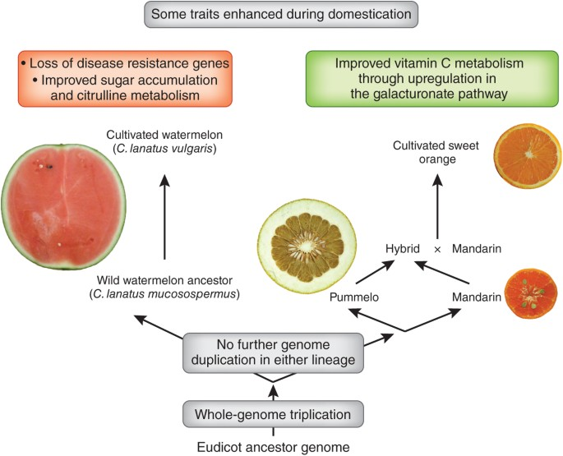
Image V: Genomic and Biotechnological Advances in Fruit Crop Improvement- Adapter from Wincker P. (2013). Genomics and Fruit Crop Selection. Nature Genetics, 45:9–10.
Conclusion
Sustainable fruit production emerges as a critical imperative for addressing interconnected challenges of food security, climate resilience, environmental integrity, and rural livelihoods. This comprehensive review synthesizes advances from 2018 to 2025 in ecological strategies, precision agriculture, technological innovations, and socioeconomic frameworks that collectively underpin resilient, equitable, and productive fruit systems globally.
Ecological Sustainability as Foundation: Foundational to all sustainable models are ecological principles emphasizing soil health restoration, water conservation, biodiversity enhancement, and ecosystem-based adaptation. Practices including compost and biochar application, biofertilizer integration, mycorrhizal symbiosis, and agroforestry demonstrably improve nutrient cycling, microbial diversity, and carbon sequestration while reducing dependency on synthetic chemicals. These approaches not only enhance productivity but also build inherent system resilience, enabling orchards to withstand climatic variability and pest pressures through natural regulatory mechanisms (FAO, 2022).
Technological Integration and Data-Driven Management: Precision agriculture, artificial intelligence, remote sensing, and digital platforms fundamentally transform orchard management by enabling real-time, site-specific optimization of inputs. Sensor networks, drone-based monitoring, and machine learning algorithms detect nutrient deficiencies, pest outbreaks, and stress early, facilitating proactive interventions. Variable rate technology and automated systems reduce chemical use by 25–35% while maintaining or increasing yields, demonstrating that technological innovation can serve ecological goals (Kumar et al., 2025; FAO, 2023). Blockchain-enabled supply chains enhance transparency and farmer profitability, aligning technological advancement with socioeconomic equity.
Climate Resilience Through Integrated Adaptation: Climate change poses escalating threats to fruit production through phenological disruptions, increased pest pressures, water scarcity, and quality deterioration. Addressing these multifaceted challenges requires integrated strategies combining breeding for climate-resilient cultivars, ecosystem-based adaptation, efficient water management, and renewable energy integration. Carbon sequestration through regenerative practices simultaneously mitigates climate change, with perennial orchards capturing 4–8 Mg CO₂ ha⁻¹ yr⁻¹, offering dual productivity and climate co-benefits (FAO, 2022; Hiregoudar et al., 2025).
Socioeconomic Equity and Market Access: Sustainable fruit production cannot succeed without addressing socioeconomic dimensions. Equitable market access, fair pricing mechanisms, value chain transparency, and gender inclusion empower smallholders to adopt sustainable practices. Cooperative models, direct marketing platforms, and rural credit mechanisms reduce intermediary costs and enhance farmer profitability. Policies promoting value addition, post-harvest infrastructure, and skill development create multiplier effects across rural communities (Kumar et al., 2025; FAO, 2023).
Policy and Institutional Frameworks: Coherent policy frameworks integrating agricultural, environmental, and rural development objectives are vital for scaling sustainability. Programs such as India's MIDH, PKVY, and NMSA, alongside international initiatives aligning with SDGs, demonstrate the catalytic role of supportive governance. Financial mechanisms including subsidies, crop insurance, and carbon credit schemes reduce adoption barriers for smallholders, while institutional linkages between research, extension, and farmer communities accelerate technology diffusion and localization (Hiregoudar et al., 2025; FAO, 2024).
Future Pathways and Emerging Opportunities: Looking ahead, the convergence of genomic breeding, digital transformation, circular economy principles, and nature-based solutions presents transformative opportunities. Gene-edited cultivars tolerant to heat, drought, and salinity; AI-powered autonomous systems; and complete valorization of fruit by-products will redefine sustainable productivity. Integration of traditional ecological knowledge with modern science will yield culturally adapted, locally resilient production models (Kumar et al., 2025).
Integrated Framework Synthesis: This review underscores that sustainable fruit production is not a single intervention but a holistic, multidimensional framework balancing ecological regeneration, technological innovation, socioeconomic equity, and climate adaptation. Siloed approaches—focusing solely on ecology or technology or policy—cannot achieve the systemic transformations required. Success demands simultaneous progress across ecological, technological, economic, social, and institutional dimensions, underpinned by interdisciplinary collaboration and farmer-centric innovation.
Call to Action: Researchers must conduct participatory research addressing context-specific constraints while advancing knowledge on climate adaptation and sustainability metrics. Policymakers should integrate metrics for carbon neutrality, water productivity, and biodiversity into horticultural programs and harmonize policies across agriculture, environment, and rural development sectors. Practitioners and farmers must adopt integrated management approaches, leveraging traditional knowledge alongside modern tools. Private sector players should invest in sustainable supply chains, post-harvest infrastructure, and farmer-friendly technologies. International organizations should facilitate knowledge sharing, technology transfer, and financial flows supporting equitable, sustainable transitions in fruit production.
The transformation toward sustainable, resilient, and equitable fruit production is both an ecological imperative and an economic opportunity. By embracing integrated strategies that blend ecological principles, technological innovation, socioeconomic inclusion, and supportive governance, the fruit production sector can sustainably intensify, ensuring food security, rural prosperity, and planetary health for current and future generations. The convergence of advancing knowledge, emerging technologies, and policy momentum provides an unprecedented window to fundamentally reshape fruit cultivation toward genuine sustainability.
COMPETING INTERESTS
Authors have declared that they have no known competing financial interests OR non-financial interests OR personal relationships that could have appeared to influence the work reported in this paper.

Disclaimer (Artificial intelligence)
Author(s) hereby declare that generativ AI technologies such as Large Language Models, etc. have been used during the writing or editing of manuscripts. This explanation will include the name, version, model, and source of the generative AI technology and as well as all input prompts provided to the generative AI technology
Details of the AI usage are given below:
1. Yes Used ChatGPT for Correction
REFERENCES
- Aguilera, J. M. (2024). Berries as foods: Processing, products, and health benefits. Annual Review of Food Science and Technology, 15, 141–175. 10.1146/annurev-food-072023-034248
- Allouzi, M. M. A., Allouzi, S. M. A., Keng, Z. X., Supramaniam, C. V., Singh, A., & Chong, S. (2022). Liquid biofertilizers as a sustainable solution for agriculture. Heliyon, 8(12). 10.1016/j.heliyon.2022.e12609
- Allouzi, M. M. A., Taha, R. A., & Hassan, S. M. (2022). Liquid biofertilizers as a sustainable solution for agriculture. Applied Sciences, 12(24), 12908. DOI: 10.3390/app122412908.
- Bhardwaj, R. L., Parashar, A., Parewa, H. P., & Vyas, L. (2024). An alarming decline in the nutritional quality of foods: The biggest challenge for future generations' health. Foods, 13(6), 877. 10.3390/foods13060877
- Bouby, L., Terral, J. F., Fiorentino, G., Valamoti, S. M., & Jaloinski, P. (2022). Agroforestry in Mediterranean traditional orchard systems: Ecology and history. Agriculture, Ecosystems & Environment, 329, 107912. 10.1016/j.agee.2022.107912
- European Commission. (2019). The European Green Deal. Communication from the Commission to the European Parliament, the European Council, the Council, the European Economic and Social Committee and the Committee of the Regions. Brussels: European Commission.
- Food and Agriculture Organization of the United Nations (FAO). (2021). Sustainable fruit production and climate-smart orchards. Rome: FAO.
- Food and Agriculture Organization of the United Nations (FAO). (2023a). Agricultural production statistics 2010–2023. Rome: FAO. 10.4060/cc8166en
- Food and Agriculture Organization of the United Nations (FAO). (2023b). FAO statistical yearbook 2023: World food and agriculture. Rome: FAO.
- Food and Agriculture Organization of the United Nations (FAO). (2023c). Major tropical fruits market review: Preliminary results 2023. Rome: FAO.
- Gopal, A., Sharma, R., & Tripathi, N. (2025). Rediscovery of Vrikshayurveda: A nature-based vision for sustainable agroecology and forest regeneration. Environmental Research Letters, 20(3), 035001. 10.1016/j.jaim.2025.101239
- Intergovernmental Panel on Climate Change (IPCC). (2023). Climate change 2023: Synthesis report. Contribution of Working Groups I, II and III to the Sixth Assessment Report of the Intergovernmental Panel on Climate Change. Geneva: IPCC. 10.59327/IPCC/AR6-9789291691647
- Karkee, M., & Padhiary, A. (2024). Digital innovation in sustainable fruit production. Frontiers in Agronomy, 6, 1482893. 10.3389/fagro.2024.1482893
- Kopec, D. M. (2024). Sustainability and social equity in agricultural value chains. Sustainability, 16(2), 948. DOI: 10.3390/su16020948.
- Kumar, S., Karwoski, J., & Thapar, K. (2022). Biofertilizers: An ecofriendly technology for nutrient recycling and environmental sustainability in crop production. Agronomy, 11(4), 676. 10.1016/j.crmicr.2021.100094
- Mannino, G., Zanoni, C., Trevisan, M., & Lucini, L. (2023). A new era of sustainability: Plant biostimulants. Horticulturae, 9(11), 1234. DOI: 10.3390/horticulturae9111234.
- Marappan, K., Sadasivam, S., Natarajan, N., Arumugam, V. A., Lakshmaiah, K., Thangaraj, M., Gopal, M. G., & Asokan, A. (2025). Underutilized fruit crops as a sustainable approach to enhancing nutritional security and promoting economic growth. Frontiers in Sustainable Food Systems, 9, 1618112. 10.3389/fsufs.2025.1618112

- Manfrini, L., & Padhiary, A. (2023). IoT and AI-driven irrigation management. Precision Agriculture, 24(4), 1125–1140.
- Statista. (2025). Global fruit production volume 2023, by selected variety. Retrieved from https://www.statista.com/ (Accessed: February 2025).
- Wang, X., Zhang, L., Li, S., Chen, H., & Zhao, J. (2024). Important soil microbiota's effects on plants and soils: a comprehensive 30-year systematic literature review. Frontiers in Microbiology, 15, 1347745. DOI: 10.3389/fmicb.2024.1347745
- Zhang, F., Lin, X., Liu, Q., Zhou, J., & Zhu, L. (2020). China's Eco-Orchard Program: Advances in precision ecological orchard management. Frontiers in Plant Science, 11, 553212. 10.3389/fpls.2020.553212
- Karagatiya, F. P., Patel, S., Parasana, J. S., Vasava, H. V., Chaudhari, T. M., Kanzaria, D. R., & Paramar, V. (2023). Adapting fruit crops to climate change: Strengthening resilience and implementing adaptation measures in fruit crops. Pharma Innov J, 12(7), 3159-3164.
- Rajan, R., Feza, M., Pandey, K., Aman, A., & Kumar, V. (2020). Climate change and resilience in fruit crops. Climate change and its effects on Agriculture, 337-354.
- Singh, M. K., Yadav, S. K., Rajput, B. S., & Sharma, P. (2024). Carbon storage and economic efficiency of fruit-based systems in semi-arid region: a symbiotic approach for sustainable agriculture and climate resilience. Carbon Research, 3(1), 33.
- Wang, Y., Hafeez, A., Shahbaz, P., ul Haq, S., & Nadeem, M. (2025). Sustainable Fruit Production: Enhancing Technical Efficiency and Climate Resilience in Apple Orchards. Applied Fruit Science, 67(5), 339.
- Wang, Y., Hafeez, A., Shahbaz, P., ul Haq, S., & Nadeem, M. (2025). Sustainable Fruit Production: Enhancing Technical Efficiency and Climate Resilience in Apple Orchards. Applied Fruit Science, 67(5), 339.
- Singh, H. C. P. (2013). Adaptation and mitigation strategies for climate-resilient horticulture. In Climate-resilient horticulture: Adaptation and mitigation strategies (pp. 1-12). India: Springer India.
- Baruah, S. P. (2024). Climate Resilient Horticulture: Sustainable Fruit Crop Production in North Bengal Region of India. Journal of Agriculture and Technology, 11(1-2), 105-111.
- Jain, S., Lamo, K., Walling, S., Imchen, A., Tirkey, J. F., & Singh, A. (2024). Climate-resilient horticulture: Adapting to climate change through innovative practices and technologies. International Journal of Environment and Climate Change, 14(11), 219-233.
- Chao, K. (2024). Family farming in climate change: Strategies for resilient and sustainable food systems. Heliyon, 10(7).
- Deori, M., Manasa, S., PB, K., Saikanth, D. R. K., Ranganna, G., & Prasad, L. (2024). A Comprehensive Review on the Impact of Climate Change on Fruit Yield and Quality in Modern Horticultural Practices. Int. J. Plant Soil Sci, 36(1), 177-187.
- Srivastav, A. L., Dhyani, R., Ranjan, M., Madhav, S., & Sillanpää, M. (2021). Climate-resilient strategies for sustainable management of water resources and agriculture. Environmental Science and Pollution Research, 28(31), 41576-41595.
- Fagbemi, F., Oke, D. F., & Fajingbesi, A. (2023). Climate-resilient development: An approach to sustainable food production in sub-Saharan Africa. Future Foods, 7, 100216.
- Kandegama, W. W. W., Rathnayake, R. M. P. J., Baig, M. B., & Behnassi, M. (2022). Impacts of climate change on horticultural crop production in Sri Lanka and the potential of climate-smart agriculture in enhancing food security and resilience. In Food Security and Climate-Smart Food Systems: Building Resilience for the Global South (pp. 67-97). Cham: Springer International Publishing.

