Original Research Article
Induce sperm motility and catfish eggs fertilization (Clarias gariepinus) by use different artificial solutions

ABSTRACT

The aim of this study is to increase the motility and ability of catfish sperm to fertilize the eggs of the Mutiara catfish using an artificial fertilization solution containing NaCl, CaCl₂ and KCl electrolytes. Mutiara catfish strain was created from a hybrid cross between four strains (paiton, sangkuriang, dumbo and mesir) as a genetic improvement for the catfish reproductive success in Indonesia. The research design used Completely Randomized Design with six artificial fertilization solutions used as test treatments including solution A (2.5 mmol/L NaCl, 5 mmol/L CaCl₂, 0.25 mmol/L KCl), solution B (4 mmol/L NaCl, 7.5 mmol/L CaCl₂, 0.50 mmol/L KCl), solution C (5.50 mmol/L NaCl, 10 mmol/L CaCl₂, 0.75 mmol/L KCl), solution D ((7 mmol/L NaCl, 12.5 mmol/L CaCl₂, 1 mmol/L KCl), solution E (8.5 mmol/L NaCl, 15 mmol/L CaCl₂, 1.25 mmol/L KCl) and solution F (aquabidest as control). Replication as much four times (n = 4). The research parameters used were motility tests, motility duration, degree of fertilization and hatching of mutiara catfish eggs. The results of the study showed that a solution with a composition of 7 mmol/L NaCl, 12.5 mmol/L CaCl₂, and 1 mmol/L KCl (treatment D) induced sperm motility of 83% with a duration of 180 seconds (3 minutes), a fertilization rate of 78.25% and egg hatching of 75%. Furthermore, the results of this study can be used to improve artificial reproduction, especially optimizing the degree of fertilization and hatching of catfish eggs for mass production of larvae to support food security programs.

Keywords: Mutiara catfish, sodium; calcium; potassium; sperm motility; eggs fertility

- INTRODUCTION

Motility is the most commonly used parameter to evaluate sperm quality in fish. Most studies refer to duration of motility and percentage of motile spermatozoa which is a prerequisite factor that determine semen quality and fertilizing capacity. Sperm motility is influenced by several factors, such as pH, cations, osmolality and dilution ratio in either aqueous environment or diluent. Determination of sperm quality parameters such as seminal plasma composition and sperm motility traits could help to develop and improve artificial reproduction in fish farms. Sperm quality is a measure of the ability of sperm to successfully fertilize an egg. Any quantifiable parameter that directly correlates with fertilization capacity could be potentially used as a measure of sperm quality. The dilution of the spermatozoa media in the sperm duct into the natural spawning media causes an osmotic pressure change in the fluid or catfish spermatozoa media when freshwater fish broodstock, including catfish, spawn in natural waters [1]. This shift in osmotic pressure is a common sign of inhibiting sperm motility in the seminal plasma (sperm duct) and is undoubtedly present in the spermatozoa cell fluid of freshwater fish. In contrast, in marine fish spermatozoa, osmotic pressure tends to decrease. Freshwater fish sperm cells become more active by the hypotonicity of freshwater because the dilution of electrolyte fluid in the seminal plasma causes the release of sperm motility inhibition and stimulates sperm movement, but sperm motility tends to decrease when the male parent spermiates during spawning activity [2]. Fertilisation of fish eggs, which is generally external, causes a reduction in the motility of the sperm and the activation of the fertilisation eggs by differences in the ionic composition of the external and internal fluids in the sperm duct or oviduct of the fish. These differences cause short sperm motility and reduced sperm ability to fertilise eggs, resulting in low egg-fertilisation rates [3, 4]. The concentration of Na⁺, Ca²⁺ and K⁺ ions in the artificial insemination solution affect motility of the spermatozoa, which has implications for the degree of egg fertilization. Variations in the ionic composition of the seminal fluid in the seminal duct and the external water environment cause variations in the osmotic pressure required to induce the motility of freshwater fish sperm during spawning activity [4, 5]. The degree of egg fertilization is closely related to the duration of motility of the spermatozoa and may be maintained in an artificial fertilization solution which is hypotonic or isotonic to the fluid present in the fish sperm or the fish egg [6]. The composition of the carp egg sac fluid contains Na⁺ ranging from 2.46-3.14 mmol/L NaCl, Ca²⁺ between 10.2-10.8 mmol/L CaCl₂ and K⁺ between 0.2-0.68 mmol/L KCl. Meanwhile, the carp sperm sac fluid contains sodium (Na⁺) of 12.8 mmol/L NaCl, calcium (Ca²⁺) of 2.85 mmol/L CaCl₂, potassium (K⁺) of 1.7 mmol/L KCl [7] and the sperm motility of African catfish was maintained at 15 mmol/L NaCl, 10 mmol/L CaCl₂ and 5 mmol/L KCl [8]. To enhance the degree of fertilization, hatching, and production of mutiara catfish larvae, an artificial fertilization solution containing a mixture of ionic liquids NaCl, CaCl₂, and KCl is required to support the artificial spawning activities of broodstock. This study identifies the optimal ionic composition for improving sperm motility and fertilization in Clarias gariepinus, contributing to more efficient artificial breeding and sustainable aquaculture practices. Regulating the ionic composition of the artificial fertiliser fluid is important for increasing egg and larval production in the production of Mutiara catfish.

- MATERIAL AND METHODS

Research was carried out at the hatchery of the Faculty of Fisheries and Marine Sciences, Padjadjaran University (July-September 2025) to prepare the larvae and artificial spawning of brood of Mutiara catfish. Stripping, measuring of sperm motility and artificial insemination of eggs with sperm were carried out at the Fisheries Biotechnology Laboratory of Fisheries and Marine Science, Padjadjaran University.

  - Preparation for research

The materials used include test fish, namely adult Mutiara catfish (C. gariepinus) broodstock with mature gonads (12 months old, average weight 500 ± 42.50 g) as many as 10 pairs (kept in a fiberglass tank with a diameter of 1.4 m, a tank height of 1.05 m and a water volume of 1384 L), artificial fertilization solution (a mixture of NaCl, CaCl₂, KCl) according to the test treatment. Aquabidest (pure water) is used as a control solution (does not contain ionic salts) to test the importance of the treatment fertilization solution. During 1.5 months of gonad maturation, the brood fish were given mixed feed (commercial feed Hiprovite 128, 40% protein content and snail flour, Achatina fulica) at a rate of 2% of biomass weight and fed twice daily (8:00 AM and 5:00 PM). Total water changes were performed weekly, water temperature was maintained at a constant level (27 ± 1 ºC), and an aeration system was used to requirement dissolved oxygen requirements during maintenance. Selection of mature gonad broodstock ready for artificial spawning is carried out based on observations of the pink urogenital papillae organs of the female and male broodstock and indications that the dorsal fins of both broodstock stand up when touched along the surface of the skin in the dorsal area [9]. Ovulation and spermiation induction of mature broodstock using Ovaprim hormone (dose 0.5 ml/kg for female broodstock and 0.3 ml/kg for male broodstock).

2.2 Stripping the broodstock

After 10-12 hours of Ovaprim injection into the male and female broodstock, the female fish were stripped to release eggs. Before stripping the female, the male's sperm was first removed by caesarean section. After the testes were obtained, the tips of the testes were cut and stripped to release the sperm fluid. These were then collected in 10 mL beakers containing 7 mL of each treatment's fertilization solution.

2.3 Measurement of sperm motility

A Neubaurer-type haemacytometer (GrayMed, Victoria, Australia) was used to test the motility of fish sperm prior to egg fertilization. A micropipette was used to transfer 1 μL of fish semen, diluted with 200 μL of 0.9% NaCl solution, into the hemocytometer counting chamber under a microscope [10]. For three minutes, sperm motility was manually measured in a tiny counting chamber. Because estimating sperm motility is a subjective process [11], sperm were only considered motile if they moved forward steadily and forcefully [12]. The formula used is as follows:
Motility (%) = number of motile sperm in 3 minutes / initial sperm count x 100%.

2.4 Egg fertilization

Simultaneously with the release of the sperm, the female parent is removed to allow the egg to be released and collected in a petri dish. Add 1 ml of aquabidest for the calculation of the egg quantity per ml. A total of 20 petri dishes were filled with 1 mL of the collected eggs, then mixed with each 10 mL glass containing 7 mL of the treatment solution and mixed together with sterile chicken feathers for 5 minutes. The eggs were then incubated in a 31 x 18 x 24 x 40 cm aquarium with 12 L of water, a constant water temperature of 27 ± 1°C (using a water heater), and an aeration system with a dissolved oxygen content of 3 ± 0.5 ppm. The following formula is used to determine the degree of egg fertilization: FR (%) = number of fertilized eggs / number of sample eggs x 100%, FR = degree of fertilization.

2.5 Hatching rate of eggs

The fertilized eggs continue to develop in the aquarium for 18 to 20 hours before hatching. The formula for calculating the number of eggs that hatch is HR (%) = number of eggs hatched / number of eggs fertilized x 100%, HR = hatching rate.

2.6 Statistic Analysis

Statistical tests using one-way ANOVA with a confidence level of 95% were conducted to detect the effect of differences in the composition of artificial fertilization solutions on the duration of sperm motility, degree of fertilization, and hatching of Mutiara catfish eggs. If there is a significant difference between treatments, it will be continued with the Duncan Multiple Range Test.

3 RESULT AND DISCUSSION

3.1 Motility of sperm after three minutes

Sperm motility duration is typically used as a metric to assess the quality of sperm in relation to their capacity to fertilize eggs. Up to a concentration of 7 mmol/L NaCl, 12.5 mmol/L CaCl₂, and 1 mmol/L KCl (treatment D), the average sperm motility of Mutiara catfish preserved with fertilization solution treatment increased in proportion to the increase in NaCl, CaCl₂, and KCl. However, sperm motility tended to decline when the NaCl and CaCl₂ concentrations were raised above 7, 12.5 and 1 mmol/L (treatment E), respectively (Fig. 1). Treatments A and B showed no difference in average sperm motility after 3 minutes, indicating that the concentrations of both artificial fertilization solutions had relatively similar effects on sperm motility. Conversely, treatments C and D showed significant differences in fish sperm motility compared to treatments A and B, indicating that the ionic liquid concentrations in treatments C and D are suitable for inducing mutiara catfish sperm motility. The ionic composition of the fertilisation solution that increases the motility and ability of the sperm to fertilise the eggs of Salmo trutta caspius fish must contain of a minimum of Na⁺ ions of 11.7 mmol/L of NaCl and Ca²⁺ ions of 8 mmol/L g of CaCl₂ [13]. Meanwhile, the ionic concentration of K⁺ ions is relatively low (ranging from 0.7-1 mmol/L KCl) or a solution that is isotonic for eggs and sperm is needed to increase sperm motility and the degree of egg fertilization [6]. Based on this explanation, treatment D shows the criteria for an isotonic solution and produces a higher level of Mutiara catfish sperm motility than other treatments. The reduction of K⁺ ion concentration in the natural aquatic environment during fish spawning is a triggering factor for carp (Cyprinus carpio) sperm motility, which experiences a dilution in concentration from 1.7 mmol/L (in the seminal plasma of the testes) after contact with external water media to 0.7-1 mmol/L. In contrast, the concentration of K+ ions in carp ovarian fluid is 0.68 mmol per L [7]. Overall, the immersion of Mutiara catfish spermatozoa in the treatment fertilization solution was higher than the control solution (aquabidest).

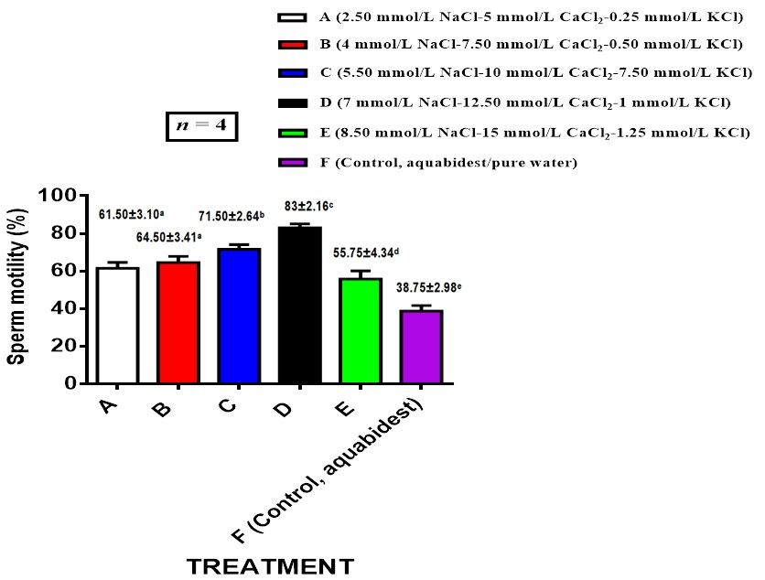

Fig. 1. Sperm motility of mutiara catfish in fertilization solution after 3 minutes
Mean ± SD values followed by different letters indicate significance (p < 0.05).
Solution A (2.50 mmol/L NaCl, 5 mmol/L CaCl₂, 0.25 mmol/L KCl); B (4 mmol/L NaCl, 7.50 mmol/L CaCl₂, 0.50 mmol/L KCl); C (5.50 mmol/L NaCl, 10 mmol/L CaCl₂, 0.75 mmol/L KCl); D (7 mmol/L NaCl, 12.50 mmol/L CaCl₂, 1 mmol/L KCl); E (8.5 mmol/L NaCl, 15 mmol/L CaCl₂, 1.25 mmol/L KCl); F (control, aquabidest); 1 mmol/L = 46 mg/L

Sperm motility increased when the concentration of Na+ and Ca²⁺ ions was increased up to the limit of 7 mmol/L NaCl and 12.5 mmol/L CaCl₂ (treatment D), but it tended to decrease when the concentration was increased to 8.50 mmol/L NaCl and 15 mmol/L CaCl₂ (Fig. 1). This result is comparable to the conditions during the broodfish spawning season, when the concentration of Na⁺, Cl⁻, and Ca²⁺ ions rose to a point where fish sperm motility could be induced in the seminal plasma of the testis due to hydration (the entry of external environmental water into the seminal plasma of the testis), which decreased K⁺ ions and osmotic pressure [14]. This is necessary physiologically because fish spermatozoa stay immobile in the lumen of seminiferous tubules or sperm ducts during the non-breeding season because the high concentration of K⁺ ions in these ducts inhibits fish sperm motility [6, 15]. The physiological mechanism to regulate the ionic balance of the seminal fluid of the testis and the fluid of the spermatozoa is a basic function of gonadotropins and steroid hormones, which affect the secretion of the fluid produced by the spermatozoa and cause increased hydrostatic pressure in the tubule and the tubus [16].

3.2 Sperm motile rate per 50 seconds

The average motile sperm showed a decrease after 50, 100 and 150 seconds in sperm preservation solutions (solutions A, B, C, D, E and F) as shown in Figure 2. However, solution D showed a higher level of sperm motility (85.50%) after 150 seconds than other treatments, with motility of 90.50% (first 50 seconds), 87.25% (100 seconds) and 85.50% (150 seconds). The lowest motility was found in solution E, with motility of 62.25% (first 50 seconds), 61% (100 seconds) and 58.50% (150 seconds). Between solution A and B are relatively the same with motility of 80.75% (first 50 seconds), 74.25% (100 seconds) and 66.75% (150 seconds) in A and 81.50% (first 50 seconds), 75% (100 seconds) and 67.75% in B. Solution C is higher than A and B, but lower than D, with motility of 85.25% (first 50 seconds), 77.25% (100 seconds) and 72.25% (150 seconds). These findings suggest that the artificial fertilization solution in solution D has an ionic balance and is isotonic, which can sustain high motility for up to 150 seconds. The higher ratio of Na⁺ to K⁺ ions in the solution is assumed to be the cause of this increase in sperm motility, as is the fact that the K⁺ ions do not reach levels that impede motility. Prior to the spawning season, the K⁺ ion concentration was lowered to 7.97 mmol/L in order to stimulate sperm motility in the sperm duct [17]. Research on Atlantic salmon seminal plasma was 13.82 mmol/L K⁺. Salmo gairdneri and S. trutta sperm motility was still initiated by K⁺ ions at concentrations of ± 1 mmol/L KCl, but sperm motility was not induced at concentrations greater than 1 mmol/L KCl, in the contrary a concentration of 1.25 mmol/L KCl in African catfish still induced [7, 8, 18]. According to the study's findings, solution D's effect demonstrated that the motility level remained high after 150 and 180 seconds (3 minutes), indicating that solution D's ionic balance is isotonic to the mutiara catfish sperm fluid (as shown in Fig. 1 and 2). The sperm duct naturally controls the electrolyte fluid balance of sperm with external fluids to stimulate sperm motility prior to broodfish spawning.

Fig. 2. Sperm motility after 50, 100 and 150 seconds in fertilization solution
Mean ± SD values followed by different letters indicate significance (p < 0.05).
Solution A (2.50 mmol/L NaCl, 5 mmol/L CaCl₂, 0.25 mmol/L KCl); B (4 mmol/L NaCl, 7.50 mmol/L CaCl₂, 0.50 mmol/L KCl); C (5.50 mmol/L NaCl, 10 mmol/L CaCl₂, 0.75 mmol/L KCl); D (7 mmol/L NaCl, 12.50 mmol/L CaCl₂, 1 mmol/L KCl); E (8.5 mmol/L NaCl, 15 mmol/L CaCl₂, 1.25 mmol/L KCl); F (control, aquabidest/pure water); 1 mmol/L = 46 mg/L

  - Fertilization rate (FR)

Spermatozoa's capacity to fertilize eggs is a crucial metric for evaluating the quality of fish sperm. This indication is taken into account in fish sperm preservation and artificial fertilization methods. The artificial fertilization solution is determined by comparing the ionic concentrations of the seminal fluids from the testicles and the ovaries. In order to induce and sustain sperm motility that can fertilize eggs, this solution must be appropriate. The average fish sperm fertilization ability increased in proportion to the increase in Mutiara catfish sperm motility sustained after 180 seconds (3 minutes) (Fig. 3). Based on the results of Mutiara catfish sperm motility (Figures 1 and 2), it shows that solution D is able to maintain sperm motile activity for up to 3 minutes compared to other treatments, explaining that the concentration of Na⁺, Ca²⁺ and K⁺ ions in solution D optimally induces sperm motility providing a duration of sperm motility for 3 minutes reaching more than 80%, and ultimately increasing the fertilization rate by 78% (Figure 3). Treatment D remain showed a higher degree of fertilization of mutiara catfish eggs than other treatments, which was a consequence of increased sperm motility after preservation with solution D and conversely tended to decrease in treatment E. This increase in fertilization degree was closely related to high sperm motility, when the concentration of NaCl, CaCl₂ and KCl reached 7 mmol/L, 0.125 mmol/L and 1 mmol/L KCl respectively, indicating that the fertilization solution of treatment D was isotonic to sperm motility and increased the ability to fertilize eggs optimally. An artificial fertilization solution that allows sperm to activate eggs and sperm motility of freshwater fish under isotonic conditions must contain a relatively low concentration of K⁺ ions [16, 19, 20]. Reduction of K+ ion concentration is necessary to extend the duration of freshwater fish sperm motility and maintain the degree of egg fertilization for up to several minutes [21]. Increasing the concentration of the K+ concentration was increased by more than 1 mmol/L (treatment E, Figure 3) it showed a decrease in Mutiara catfish sperm motility (means of 58%) at 150 seconds, giving an effect on decreasing the fertilization rate (means of 40%). This result was also shown in the increase in K+ ions by 5 mmol/L KCl in the African catfish (C. gariepinus) sperm preservative solution causing a decrease in sperm motility (45.7%) [8], confirming that the effectiveness of potassium concentration as a fertilization solution for Mutiara catfish eggs is optimal at the limit of 1 mmol/L. Calcium (Ca2+) concentration of 8 mmol/L (isotonic solution) in C. macrocephalus sperm can prevent the inhibitory action of potassium (K+) and induce fish sperm motility (22, Tan-Fermin et al., 1999). Based on this explanation, in Mutiara catfish sperm, sperm motility activity was inhibited when the calcium concentration was increased to 15 mmol/L (treatment E), sperm motility decreased by an average of 58% for 150 seconds and to 55% for 180 seconds (Figures 1 and 2). Optimal sperm motility was obtained at a concentration of 12.5 mmol/L (average 83%, treatment D), this difference indicates that Mutiara catfish sperm motility was still optimally induced, and decreased when increased to 15 mmol/L (to 55%).

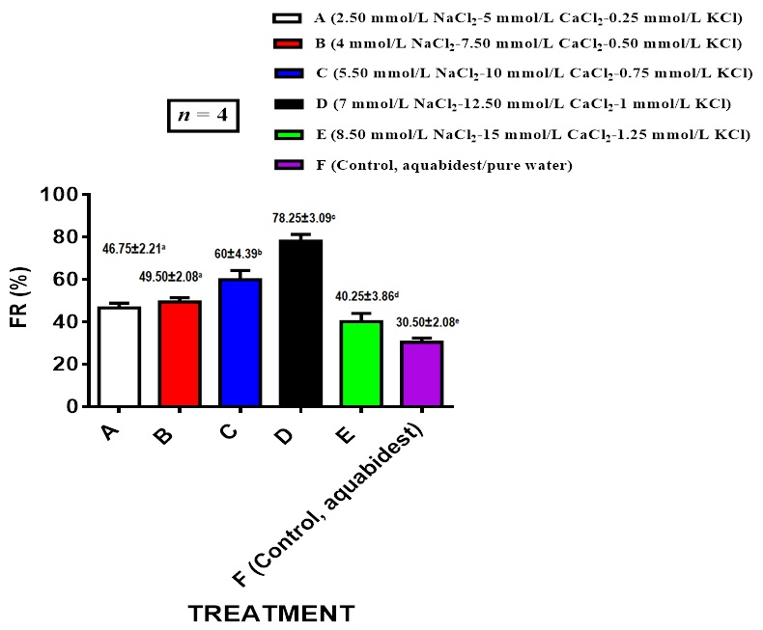

Fig. 3. Degree of fertilization (FR) with sperm preserved in fertilization solution treatment
Mean ± SD values followed by different letters indicate significance (p < 0.05).
Solution A (2.50 mmol/L NaCl, 5 mmol/L CaCl₂, 0.25 mmol/L KCl); B (4 mmol/L NaCl, 7.50 mmol/L CaCl₂, 0.50 mmol/L KCl); C (5.50 mmol/L NaCl, 10 mmol/L CaCl₂, 0.75 mmol/L KCl); D (7 mmol/L NaCl, 12.50 mmol/L CaCl₂, 1 mmol/L KCl); E (8.5 mmol/L NaCl, 15 mmol/L CaCl₂, 1.25 mmol/L KCl); F (control, aquabidest); 1 mmol/L = 46 mg/L

The concentration of Na⁺ and Ca²⁺ ions which were gradually increased to the limit of 7 mmol/L and 12.50 mmol/L in the isotonic solution of treatment D played an important role in increasing the degree of fertilization of mutiara catfish eggs, especially to maintain the opening of the egg micropyle which allows sperm penetration into the egg [23]. The Na⁺ ions plays a role in holding the closure of the egg micropyle for several minutes which allows increased fertilization of eggs in a solution of 7.3 mmol/L NaCl [24]. While Ca²⁺ in the fertilization solution contains at least 12.70 mmol/L CaCl₂ to suppress the process of egg yolk precipitation, so that it does not clog the egg micropyle when the box is with external fluid and optimizes egg fertilization by sperm [25]. Generally, freshwater fish sperm motility ranges from 2-3 minutes, and the duration of carp egg micropyle opening is only around 45-60 seconds, this is the basis for making artificial fertilization solutions to increase sperm motility and egg micropyle opening and increase egg fertilization. This representation has been shown in treatment D (Fig. 1, 2 and 3) which indicates that the ideal electrolyte balance of the fertilization solution approaches isotonic conditions that are similar in sperm fluid and egg fluid.

  - Hatching rate (HR)

The average egg hatching rate varied between treatments, with treatments A (68.50%), B (69.25%), and C (70.75%) showing no significant differences, indicating that the egg hatching rate was no longer affected by the electrolyte composition of the sperm preservation solution (Fig. 4). However, treatment D (75%) showed a significant difference compared to the other treatments, possibly due to the higher egg fertilization rate (78.25%) previously obtained compared to treatments A, B, C, and E (46.75%, 49.50%, 60%, and 40.25%, respectively). Meanwhile, treatments E and F did not significant differences, indicating that the hatching rate was not affected by the artificial fertilization solution, and the results were relatively similar to the control treatment (F, aquabidest).
Fig. 4. Hatching rate of mutiara catfish eggs
Mean ± SD values followed by different letters indicate significance (p < 0.05).
Solution A (2.50 mmol/L NaCl, 5 mmol/L CaCl₂, 0.25 mmol/L KCl); B (4 mmol/L NaCl, 7.5 mmol/L CaCl₂, 0.50 mmol/L KCl); C (5.50 mmol/L NaCl, 10 mmol/L CaCl₂, 0.75 mmol/L KCl); D (7 mmol/L NaCl, 12.5 mmol/L CaCl₂, 1 mmol/L KCl); E (8.5 mmol/L NaCl, 15 mmol/L CaCl₂, 1.25 mmol/L KCl); F (control, aquabidest); 1 mmol/L = 46 mg/L

The decrease in HR on treatment E (50%), is thought to be due to an increase in Na⁺ ion concentration to a limit of 8.5 mmol/L reducing sperm motility by 55% (Figure 1) and FR by 40% which causes low HR (Figure 4). The HR value depends on FR, which shows that the high and low degree of egg hatching is proportional to the value of the degree of hatching, which is shown by each treatment (Figures 3 and 4).
The egg hatching rate obtained by treatments C (70.75%) and D (75%) is quite high for fish spawning activities with artificial fertilization, considering that generally the natural hatching rate of catfish eggs is 60-70% which is categorized as good for supporting mass larval production [26, 27].

- CONCLUSIONS

Induction of mutiara catfish sperm motility up to above 80% was achieved with a solution composition of 7 mmol/L NaCl, 12.5 mmol/L CaCl₂, and 1 mmol/L KCl. An increase in mutiara catfish egg fertilization of up to 78.25% was achieved with a fertilization solution containing 12.5 mmol/L CaCl₂. The concentration of K+ ions in the artificial fertilization solution that produces a sperm motility duration of 3 minutes and a fertilization rate of 60-80% must contain 0.75-1.00 mmol/L KCl.

DISCLAIMER (ARTIFICIAL INTELLIGENCE).

Author(s) hereby declare that NO generative AI technologies such as Large Language Models (ChatGPT, COPILOT, etc) and text-to-image generators have been used during writing or editing of manuscripts.

REFERENCES

- Bellard, R. Artificial insemination and gamete management in fish. Marine & Freshwater Behaviour & Phy. 1988; 14(1): 3-21.
- Yang, H., & Tiersch, T. R. Sperm motility initiation and duration in a euryhaline fish, medaka (Oryzias latipes). Theriogenology. 2009; 72(3): 386-392.
- Gallego, V., & Asturiano, J. F. Fish sperm motility assessment as a tool for aquaculture research: a historical approach. Reviews in Aquaculture. 2019; 11(3): 697-724.
- Alavi, H., S. M., Jorfi, E., Hatef, A., & Saheb Mortezavi, S. A. Sperm motility and seminal plasma characteristics in Barbus sharpeyi (Günther, 1874). Aquaculture research. 2010; 41(10): 688-694.
- Cosson, J., Groison, A. L., Suquet, M., Fauvel, C., Dreanno, C., & Billard, R. Studying sperm motility in marine fish: an overview on the state of the art. Journal of Applied Ichthyology. 2008; 24(4): 460-486.
- Cosson, J. The ionic and osmotic factors controlling motility of fish spermatozoa. Aquaculture International. 2004; 12(1): 69-85.
- Scott, A. P., & Baynes, S. M. A review of the biology, handling and storage of salmonid spermatozoa. Journal of Fish Biology. 1980; 17(6): 707-73.
- Mansour, N., Lahnsteiner, F., & Patzner, R. A. Seminal vesicle secretion of African catfish, its composition, its behaviour in water and saline solutions and its influence on gamete fertilizability. Journal of Experimental Zoology Part A: Comparative Experimental Biology. 2004; 301(9): 745-755.
- Buwono, I. D., Grandiosa, R., Mulyani, Y., & Pratiwy, F. M. GnRHr, LHr, and Vg gene expression levels and ovarian development of G5 transgenic mutiara female catfish (Clarias gariepinus) after exposure photoperiod induction. Discover Applied Sciences. 2024; 6(2), 63.
- Buwono, I. D. (2024). Effect of different temperatures on GH-transgenesis, testosterone levels and spermatozoa density of G5 transgenic mutiara catfish (Clarias gariepinus). Fisheries and Aquatic Sciences. 2024; 27(10): 677-686.
- Tiersch, T. R., Yang, H., Jenkins, J. A., & Dong, Q. Sperm cryopreservation in fish and shellfish. Society of Reproduction and Fertility supplement. 2007; 65, 493.
- Rurangwa, E., Kime, D. E., Ollevier, F., & Nash, J. P. The measurement of sperm motility and factors affecting sperm quality in cultured fish. Aquaculture. 2004; 234(1-4): 1-28.
- Hajirezaee, S., Amiri, B. M., Mirvaghefi, A., & Sheikh Ahmadi, A. Evaluation of semen quality of endangered Caspian brown trout (Salmo trutta caspius) in different times of spermiation during the spawning season. Czech Journal of Animal Science. 2010; 55(10): 445-455.
- Piironen, J., & Hyvärinen, H. Composition of the milt of some teleost fishes. Journal of Fish Biology. 1983; 22(3): 351-361.
- Morita, M., Fujinoki, M., & Okuno, M. K+-independent initiation of motility in chum salmon sperm treated with an organic alcohol, glycerol. Journal of experimental biology. 2005; 208(23): 4549-4556.
- Islam, M. S., & Akhter, T. Tale of fish sperm and factors affecting sperm motility: a review. Advances in Life Sciences. 2011; 1(1): 11-19.
- Billard, R., Cosson, J., & Crim, L. W. Motility of fresh and aged halibut sperm. Aquatic Living Resources. 1993; 6(1): 67-75.
- Alavi,H. S. M., Jorfi, E., Hatef, A., & Saheb Mortezavi, S. A. Sperm motility and seminal plasma characteristics in Barbus sharpeyi (Günther, 1874). Aquaculture research. 2010; 41(10): e688-e694.
- Erdahl, A. W., & Graham, E. F. Fertility of teleost semen as affected by dilution and storage in a seminal plasma-mimicking medium. Aquaculture. 1987; 60(3-4): 311-321.
- Krasznai, Z., Morisawa, M., Morisawa, S., Krasznai, Z. T., Trón, L., Gáspár, R., & Márián, T. Role of ion channels and membrane potential in the initiation of carp sperm motility. Aquatic Living Resources. 2003; 16(5): 445-449.
- Dziewulska, K., & Pilarska, M. Inhibitory effect of K+ ions and influence of other ions and osmolality on the spermatozoa motility of European burbot (Lota lota L.). PLoS One. 2018; 13(5): e0196415.

- Tan-Fermin, J. D., Miura, T., Adachi, S., & Yamauchi, K. Seminal plasma composition, sperm motility, and milt dilution in the Asian catfish Clarias macrocephalus (Gunther). Aquaculture. 1999; 171(3-4): 323-338.

- Yasui, G. S., Fujimoto, T., Arias-Rodriguez, L., Takagi, Y., & Arai, K. The effect of ions and cryoprotectants upon sperm motility and fertilization success in the loach Misgurnus anguillicaudatus. Aquaculture. 2012; 344: 147-152..
- Bondarenko, O., Dzyuba, B., Cosson, J., Rodina, M., & Linhart, O. The role of Ca2+ and Na+ membrane transport in brook trout (Salvelinus fontinalis) spermatozoa motility. Fish physiology and biochemistry. 2014; 40(5): 1417-1421.
- Pérez, L., Vílchez, M. C., Gallego, V., Morini, M., Peñaranda, D. S., & Asturiano, J. F. Role of calcium on the initiation of sperm motility in the European eel. Comparative Biochemistry and Physiology Part A: Molecular & Integrative Physiology. 2016; 191: 98-106.
- Macharia, S. K., Ngugi, C. C., & Rasowo, J. Comparative study of hatching rates of African catfish (Clarias gariepinus Burchell 1822) eggs on different substrates. 2005.
- Browne, R. K., Kaurova, S. A., Uteshev, V. K., Shishova, N. V., McGinnity, D., Figiel, C. R., & Cosson, J. Sperm motility of externally fertilizing fish and amphibians. Theriogenology. 2015; 83(1): 1-13.

