Genetic Insights into Growth, Yield potential and Quality attributes of Sweet Potato (Ipomoea batatas L.) for Perpetual crop Improvement

Abstract
The present study was undertaken during the Rabi season of 2024–25 at the AICRP on Tuber Crops, (RHREC), Dharwad, under the UHS, Bagalkot, Karnataka. Twenty-seven elite genotypes were evaluated for interrelationships among traits governing growth and yield potential performance. Analysis of trait variation demonstrated highly significant (p < 0.01) differences amid the evaluated genotypes across all 22 quantitative characters, thus affirming the manifestation of broad genetic divergence within the population. Elevated heritability aligned by a appreciable genetic advance was observed for vine length, number of branches vine⁻¹, leaf area, tuber diameter attributes and yield vine⁻¹, thereby indicating the dominance of additive gene effects and the scope for effective improvement through direct effectiveness of phenotypic selection. Among the evaluated genotypes, TSp 23-11, TSp 16-7 and TSp 23-10 exhibited superior yield potential, while TSp 22-1 and the check variety BS recorded higher harvest indices, indicating efficient assimilate partitioning. Quality traits such as β-carotene, anthocyanin and total sugar content also registered high heritability alongside substantial genetic advance, highlighting opportunities for biofortification breeding. The study underscores the presence of wide genetic variability among elite genotypes and provides a valuable foundation for developing high-yielding and nutritionally enriched sweet potato cultivars suited to heterogeneous ecological zones.
Keywords: Sweet potato; Genetic variability; Heritability
INTRODUCTION
Sweet potato (Ipomoea batatas (L.) Lam.) is a nutrient-rich, starchy root crop cultivated extensively under tropical, subtropical and even temperate environmental conditions across the globe. It belongs to the Convolvulaceae family and exhibits the growth habit of a perennial, soft-stemmed, creeping vine, though it is predominantly managed as an annual crop in agricultural systems. The crop is thought to have originated in Central America, a region recognized for maintaining a wide spectrum of genetic diversity. From a cytogenetic standpoint, sweet potato is a naturally cross-pollinated hexaploid species (2n = 6x = 90) (Jones et al., 1986), characterized by high heterozygosity and genetic plasticity. In India, it is popularly known as “Sakarkand” and is gaining prominence as a food, feed and industrial crop due to its high productivity, nutritional richness and adaptability to marginal environments. Globally, sweet potato ranks as the seventh prime alimentary important crop after rice, wheat, maize, potato, yam and cassava (Loebenstein, 2009). It is cultivated on about 8.4 million hectares with an annual production of approximately 110 million tonnes and an average yield of 12.2 t ha⁻¹ (FAOSTAT, 2021). Its diverse uses ranging from human consumption to animal feed, industrial starch and bioethanol production make it a key crop in achieving nutritional and economic security, particularly in developing regions. The crop’s high degree of cross-pollination and heterozygosity has resulted in remarkable genetic diversity, which embodies a resource of eminent relevance for breeding and The genetic fortification of any crop relies on a thorough understanding of the range of genetic variation, heritability levels and the expected genetic progress for key morphological, agronomic and quality-related traits. Such knowledge is essential for pinpointing superior genotypes and designing effective breeding and selection strategies. The evaluation of genetic metrics coefficients of variation (GCV and PCV), appraisals of heritability and predicted genetic advance enables breeders to differentiate the contribution of hereditary factors from environmental effects in trait expression, thus facilitating precise and efficient selection in crop improvement programs. (Burton and Devane, 1953; Johnson et al., 1955). Moreover, Yield in sweet potato is a multifaceted quantitative trait governed by traits like vine growth, leaf area, tuber size and total number of tubers vine⁻¹ Correlation coefficient and path analyses aid in identifying the key contributing traits. Since yield-related traits are often influenced by environmental variation, distinguishing heritable variation from non-heritable components becomes critical for ensuring genetic gain and stability across environments. In this context, With an emphasis on improving breeding efficiency, this investigation sought to assess genetic variability, heritability and genetic advance for key growth, yield and quality traits in a diverse panel of sweet potato genotypes, thereby recognizing traits chiefly controlled by additive gene effects for precise selection. that can be efficiently improved through direct selection, thereby providing a genetic foundation for the development of high-yielding and nutritionally enriched sweet potato cultivars suited to varying agro-ecological conditions.
MATERIALS AND METHODS
To accomplish the objectives of the study, the experimental evaluation was implemented in Rabi season of 2024. Executed in AICRP on Tuber Crops, located at the (RHREC), Dharwad, under UHS, Bagalkot, Karnataka, India. The experimental site is situated within the ecologically significant Western Ghats region and falls under the Northern Transition Zone (Agro-Climatic Zone–VIII) of Karnataka. Geographically, the location lies between 15°15′–15°35′ N latitude and 75°00′ 75°20′ E longitude, at an elevation of approximately 768 meters above mean sea level. Twenty-seven meticulously executed employing elite sweet potato (Ipomoea batatas (L.) Lam.) genotypes, arranged in a Randomized Complete Block Design (RCBD) with three replications to ensure statistical reliability and minimize experimental error. Each genotype was established at an inter-row and intra-row spacing of 60 × 20 cm within plots of 3.0 × 2.4 m, thereby facilitating optimal plant stand, equitable resource allocation and robust comparative evaluation among treatments.
All measured traits were recorded and processed for statistical elucidation the mean performance of the genotypes was subjected to (ANOVA) as per the classical procedure of Panse and Sukhatme (1957) to determine the extent and significance of genotypic differentiation across traits. The Genotypic and Phenotypic Coefficient of Variation were computed in accordance with Burton and Devane (1953) and subsequently delineated following the classification scheme of Sivasubramanian and Madhavamenon (1973). The broad-sense heritability (h²) as postulated by Weber and Moorthy (1952) and interpreted following the evaluative criteria described by Robinson et al. (1949). Additionally, Genetic Advance (GA) and Mean of Genetic Advance (GAM) were reported Johnson et al. (1955) to appraise the expected efficacy of selection, wherein GAM values were stratified into low (<10%), moderate (10–20%) and high (>20%) categories, also based on Johnson et al. (1955). All statistical evaluations were rigorously applied using standardized biometrical protocols, enabling a precise quantification of genetic variability, estimation of heritability and evaluation of the potential response to selection among the genotypes under investigation.
RESULT AND DISCUSSION
The variance (ANOVA) elucidated profoundly significant (p < 0.01) differences within the twenty-seven sweet potato genotypes across all twenty-two quantitative characters, unequivocally affirming the existence of pronounced and exploitable

Table 1. Assessment of Genetic variability in Growth, Yield, and Quality Parameters of Sweet Potato
 | Source of variance/ characters | Treatment | Replication | Error | SEm± | CD (5%) | CD (1%)
S. No | Degree of freedom | 26 | 2 | 52 | SEm± | CD (5%) | CD (1%)
1 | Vine length (cm) | 20536.61 | 136.54 | 265.43 | 9.41 | 26.69 | 35.57
2 | internodal length (cm) | 5.84 | 0.30 | 0.15 | 0.22 | 0.64 | 0.85
3 | Number of branches vine⁻¹ | 15.01 | 2.01 | 0.80 | 0.40 | 1.13 | 1.51
4 | Leaf area (cm²) | 5729911.21 | 213748.60 | 121592.30 | 201.32 | 571.32 | 761.25
5 | Leaf area index | 3.98 | 0.15 | 0.08 | 0.17 | 0.48 | 0.63
6 | Tuber length (cm) | 27.24 | 6.03 | 3.45 | 1.07 | 3.05 | 4.06
7 | Tuber diameter (cm) | 2.31 | 0.48 | 0.20 | 0.26 | 0.73 | 0.97
8 | Number of tubers vine⁻¹ | 1.27 | 0.42 | 0.14 | 0.22 | 0.62 | 0.82
9 | Average weight of tuber vine⁻¹ | 914.38 | 312.88 | 124.60 | 6.44 | 18.29 | 24.37
10 | Tuber yield vine⁻¹ | 19456.12 | 3777.96 | 1364.82 | 21.33 | 60.53 | 80.65
11 | Tuber yield plot⁻¹ (kg/plot) | 50.61 | 9.83 | 3.55 | 1.09 | 3.09 | 4.11
12 | Tuber yield (t/ha) | 97.64 | 18.96 | 6.85 | 1.51 | 4.29 | 5.71
13 | Harvest index (%) | 238.92 | 14.99 | 17.42 | 2.41 | 6.84 | 9.11
14 | Pest incidence (%) | 0.28 | 0.19 | 0.08 | 0.16 | 0.45 | 0.6
15 | Reducing sugar (%) | 2.62 | 0.03 | 0.07 | 0.15 | 0.43 | 0.57
16 | Non-reducing sugar (%) | 14.79 | 0.84 | 0.80 | 0.52 | 1.46 | 1.95
17 | Starch content (%) | 22.86 | 0.96 | 1.59 | 0.73 | 2.07 | 2.75
18 | Total sugar (%) | 5.98 | 0.01 | 0.02 | 0.08 | 0.23 | 0.31
19 | β-carotene content (mg 100g ⁻¹FW) | 40.95 | 0.14 | 0.16 | 0.23 | 0.65 | 0.87
20 | Anthocyanin content (mg 100g ⁻¹ FW) | 2804.17 | 2.20 | 0.97 | 0.57 | 1.61 | 2.15
21 | Dry matter content (%) | 36.50 | 5.87 | 2.24 | 0.86 | 2.45 | 3.27

Table 2. Estimation of genetic parameters for growth characters of sweet potato

S No | Characters | Range | SE(m) | GV | PV | GCV (%) | PCV  (%) | h²  (%) | GAM (%)
1 | Vine length (cm) | 72.73-388.80 | 9.41 | 6767.06 | 7022.49 | 44.31 | 45.17 | 96.22 | 89.54
2 | Internodal length (cm) | 1.57-7.70 | 0.26 | 1.88 | 2.08 | 33.55 | 35.28 | 90.43 | 65.72
3 | Number of branches vine⁻¹ | 2.53-9.90 | 0.40 | 4.84 | 5.30 | 38.56 | 40.43 | 90.99 | 75.77
4 | Leaf area (cm²) | 875.19-5593.67 | 201.32 | 1869439.64 | 1991031.94 | 44.01 | 45.42 | 93.89 | 87.86
5 | Leaf area index | 0.73-4.66 | 0.17 | 1.30 | 1.38 | 44.00 | 45.41 | 93.91 | 87.84

GV - Genotypic variance PV – Phenotypic variance
GCV - Genotypic coefficient of variation PCV - Phenotypic coefficient of variation
h² – Broad sense heritability GA - Genetic advance

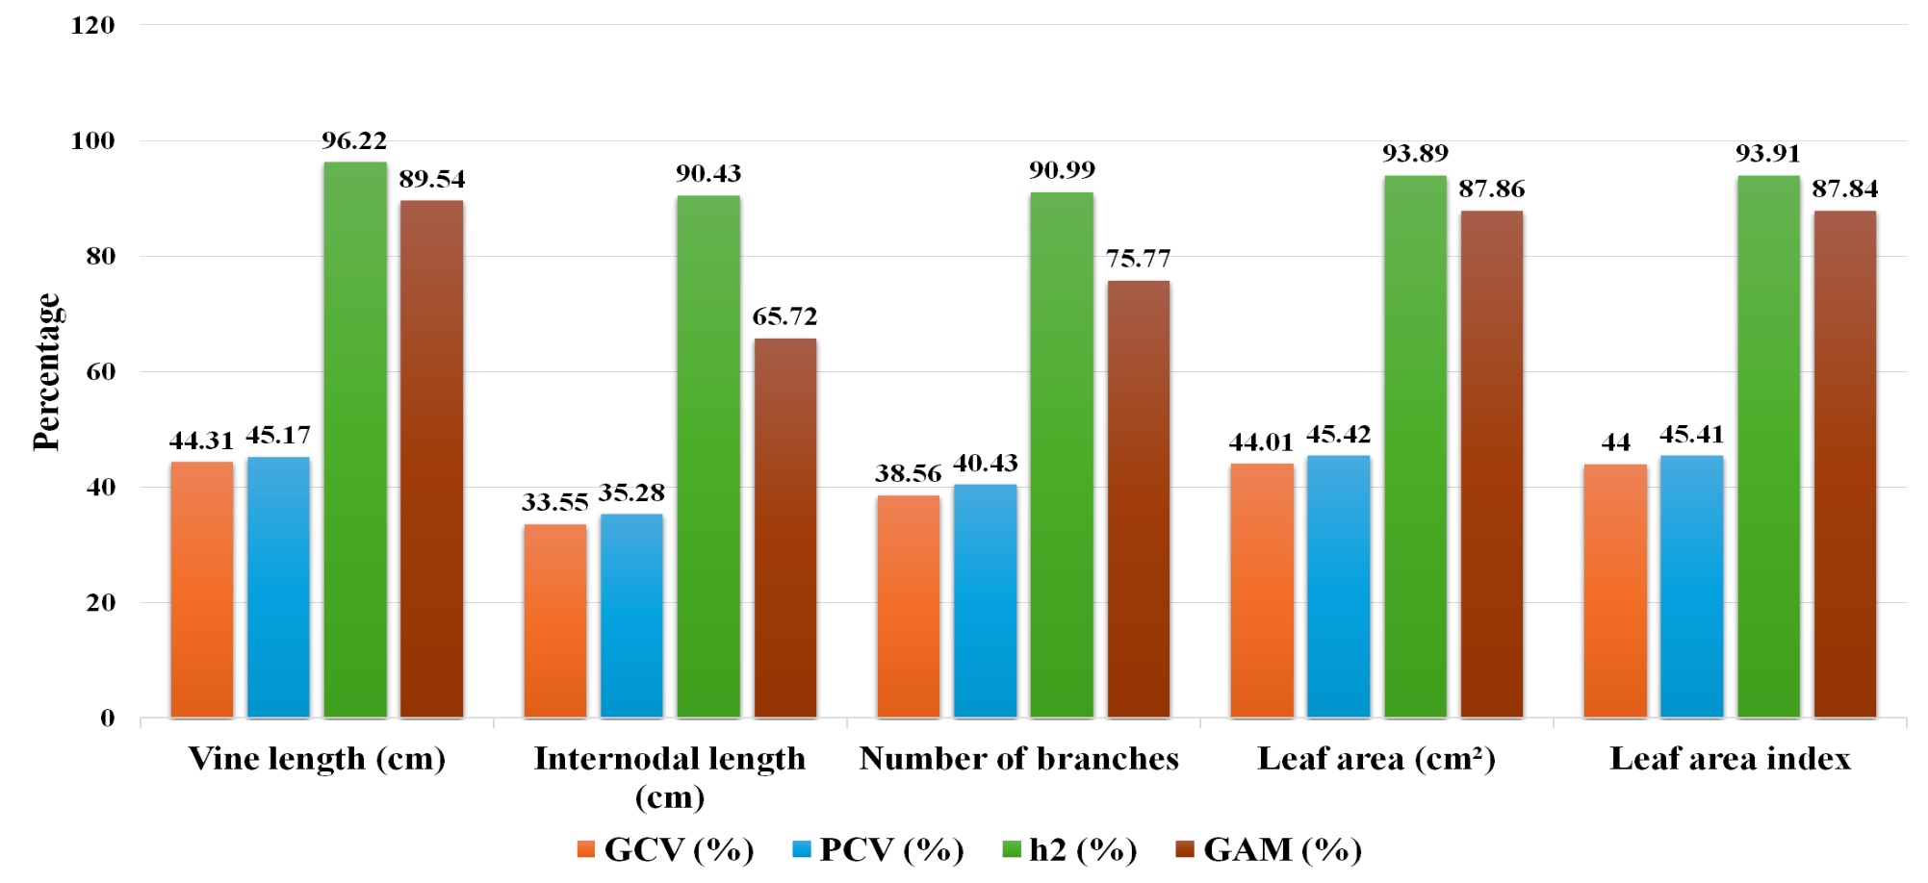
Fig 1. Mean performance of GCV, PCV, h² and genetic advance in per cent of growth parameters

genetic variability within the experimental material. within the evaluated germplasm (Table 1). The traits studied included growth and canopy parameters, yield and its components, pest incidence and several quality attributes. The wide range of variation observed among genotypes indicates a rich genetic base, offering considerable potential for selection and improvement. Consistent results have been noted by Sharavathi et al. (2018), Hejjegar et al. (2023) and Vinod et al. (2024).
Substantially elevated (GCV and PCV > 20%) were observed for major vegetative traits, including vine length, internodal length, number of branches vine⁻¹, leaf area and leaf area index (Table 2). The narrow divergence between The genetic and phenotypic dispersion indices for these traits indicates negligible environmental modulation, thereby suggesting that direct phenotypic selection would be efficient in achieving genetic advancement. Similar documented by earlier researchers Badu et al. (2017), Mekonnen et al. (2021) and Wu et al. (2025).
Yield-contributing traits such as tuber (length and diameter), average weight of tuber vine⁻¹, vine⁻¹, yield plot⁻¹ and per hectare exhibited high GCV and PCV values (Table 3). This reflects the presence of a wide genetic foundation and offers considerable potential for progressive enhancement through judicious selection. These observations corroborate the conclusions of Prarthana et al. (2015), Tripathi et al. (2016) and Vinod et al. (2024), who likewise reported pronounced genetic variability and substantial heritability for yield-contributing traits in sweet potato, thereby reinforcing the reliability and applicability of selective breeding strategies in this crop.
Moderate estimates of both GCV and PCV were noted for total number of tubers vine⁻¹ and harvest index, indicating a reasonable yet utilizable reservoir of genetic variability amenable to improvement through selection (Table 3). Concordant observations have been documented by earlier researchers, further substantiating the potential of these traits as viable targets in breeding programs for yield enhancement. Darshan et al. (2017), Sharavathi et al. (2018) and Hejjegar et al. (2023). In contrast, non-reducing sugar content illustrated low GCV and PCV values, indicating limited genetic variability and restricted improvement potential through conventional breeding. Results were noted by Haque et al. (2023) in molecular studies where starch and sugar-related traits exhibited complex inheritance patterns influenced by polyploid gene dosage effects.

Table 3. Estimation of genetic parameters for yield characters of sweet potato
S No | Characters | Range | SE(m) | GV | PV | GCV (%) | PCV (%) | h² (%) | GAM (%)
1 | Tuber length (cm) | 7.27-18.87 | 1.07 | 7.93 | 11.38 | 21.54 | 25.81 | 69.65 | 37.04
2 | Tuber diameter (cm) | 2.01-5.22 | 0.26 | 0.71 | 0.90 | 23.69 | 26.79 | 78.20 | 43.15
3 | Number of tubers vine ⁻¹ | 3.20-5.43 | 0.22 | 0.38 | 0.52 | 14.68 | 17.23 | 72.60 | 25.77
4 | Average weight of tuber vine ⁻¹ (g) | 34.09-98.75 | 6.45 | 263.26 | 387.86 | 27.67 | 33.59 | 67.90 | 46.96
5 | Tuber yield vine ⁻¹ (g) | 115.88-400.13 | 21.33 | 6030.44 | 7395.25 | 31.29 | 34.65 | 81.50 | 58.20
6 | Tuber yield per plot (kg/plot) | 5.91-25.45 | 1.09 | 15.69 | 19.24 | 31.29 | 34.65 | 81.50 | 58.20
7 | Tuber yield (t/ha) | 8.21-28.34 | 1.51 | 30.26 | 37.11 | 31.29 | 34.65 | 81.50 | 58.20
8 | Harvest index (%) | 49.23-83.44 | 2.41 | 73.83 | 91.25 | 12.98 | 14.43 | 80.91 | 24.05
9 | Pest incidence (%) | 0.93-1.85 | 0.16 | 0.07 | 0.14 | 16.73 | 24.45 | 46.81 | 23.58

GV - Genotypic variance PV – Phenotypic variance
GCV - Genotypic coefficient of variation PCV - Phenotypic coefficient of variation
h² – Broad sense heritability GA - Genetic advance

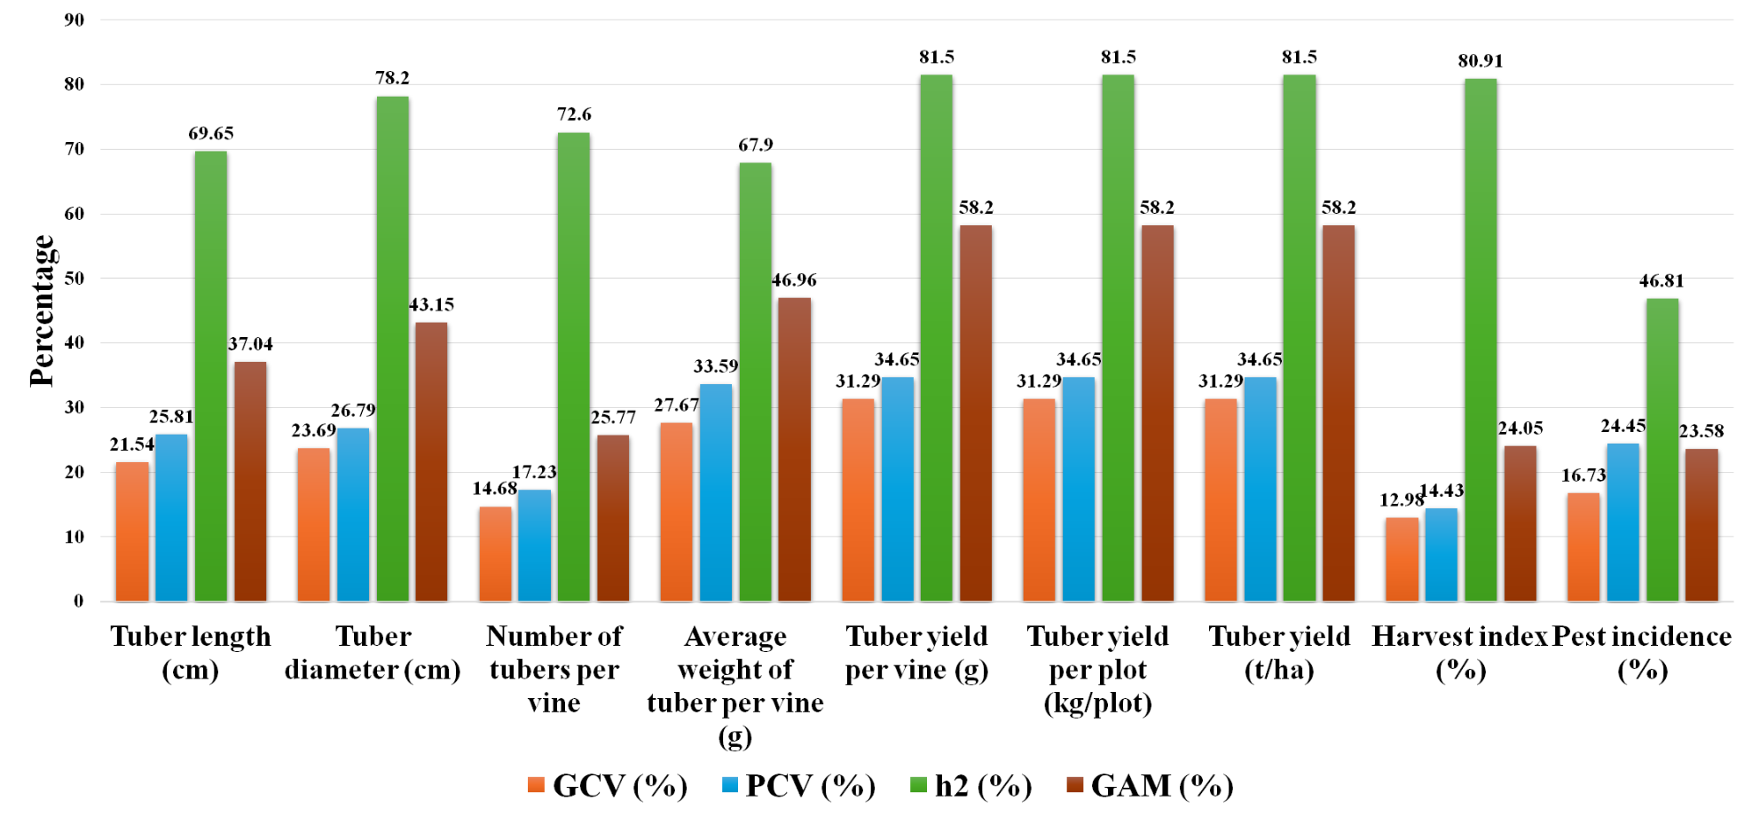
Fig 2: Mean performance of GCV, PCV, h² and genetic advance in per cent of yield parameters

High heritability (>60%) High heritability and mean of genetic advance (>20%) for growth traits (Table 2) indicates additive gene control, making direct phenotypic selection effective for their improvement. indicating that selection on phenotypic efficacy would be effective. These results noted before Prarthana et al. (2015), Wani (2021) and Hejjegar et al. (2023).
Among the yield attributes, high (heritability and mean of genetic advance) for tuber length and diameter), number of tubers vine⁻¹, average weight of tuber vine⁻¹ and total yield (Table 3), largely determined by additive gene action. Similar observations were made by Gehan (2019), Prajapati et al. (2020) and Seid et al. (2020). Recent studies by Vinod et al. (2024) and Wu et al. (2025) also confirm that both morphological and molecular analyses consistently reveal significant heritable variation in yield and related attributes for these genotypes.
Quality parameters such as reducing sugars, total sugars, starch, β-carotene, anthocyanin and dry matter content exhibited elevated heritability accompanied by appreciable genetic advance (Table 4), thereby underscoring the preeminence of additive genetic influence in governing these traits. mainly by additive gene effects. The exceptionally high heritability for β-carotene and anthocyanin content for improving nutritional quality through direct selection. Resulted by Badu et al. (2017), Mekonnen et al. (2021), Hejjegar et al. (2023) and Zhang and Zhao (2024), who emphasized the importance of utilizing genetically diverse germplasm to enhance the nutritional attributes of sweet potato.
Overall, the findings highlight high heritability and genetic advance particularly vine length, leaf area, tuber yield, β-carotene and anthocyanin content—can be effectively improved through phenotypic selection. On the other hand, traits showing limited variability, such as non-reducing sugar content, may require genetic broadening through hybridization or molecular breeding. The unification of phenotypic and molecular approaches, as demonstrated by Haque et al. (2023) and Wu et al. (2025), expedite the recognition and selection of elite genotypes that simultaneously manifest elevated yield potential, resilience to biotic and abiotic stresses, and superior nutritional composition. Among the evaluated entries, TSp 23-11, TSp 16-7, and TSp 23-10 exhibited remarkable yield proficiency, whereas TSp 22-1 and the check cultivar BS recorded notably higher harvest indices, thereby signifying efficient assimilate allocation toward economically important storage roots. Collectively, these findings establish a robust empirical foundation for breeding endeavors directed toward the development of high-yielding, nutrient-dense, and climate-adaptive sweet potato cultivars, aligned with the goals of sustainable and resilient agricultural production systems.
Table 4: Estimation of genetic parameters for quality characters of sweet potato

S No | Characters | Range | SE(m) | GV | PV | GCV (%) | PCV (%) | h² (%) | GAM (%)
1 | Reducing sugar (%) | 3.19-6.81 | 0.15 | 0.85 | 0.92 | 18.34 | 19.07 | 92.50 | 36.33
2 | Non-reducing sugar (%) | 20.22-28.42 | 0.52 | 4.67 | 5.46 | 8.62 | 9.33 | 85.40 | 16.42
3 | Starch content (%) | 18.56-29.39 | 0.73 | 7.09 | 8.68 | 10.93 | 12.09 | 81.70 | 20.34
4 | Total sugar (%) | 3.20-7.80 | 0.08 | 1.99 | 2.01 | 25.30 | 25.42 | 99.02 | 51.85
5 | β-carotene content (mg 100g⁻¹ FW) | 0.13-9.60 | 0.23 | 13.60 | 13.76 | 94.46 | 95.02 | 98.80 | 193.46
6 | Anthocyanin content (mg 100g⁻¹ FW) | 2.16-137.11 | 0.57 | 934.40 | 935.37 | 169.59 | 169.68 | 99.90 | 349.18
7 | Dry matter content (%) | 17.41-32.02 | 0.86 | 11.42 | 13.66 | 12.48 | 13.65 | 83.60 | 23.51

GV - Genotypic variance PV – Phenotypic variance
GCV - Genotypic coefficient of variation PCV - Phenotypic coefficient of variation
h² – Broad sense heritability GA - Genetic advance

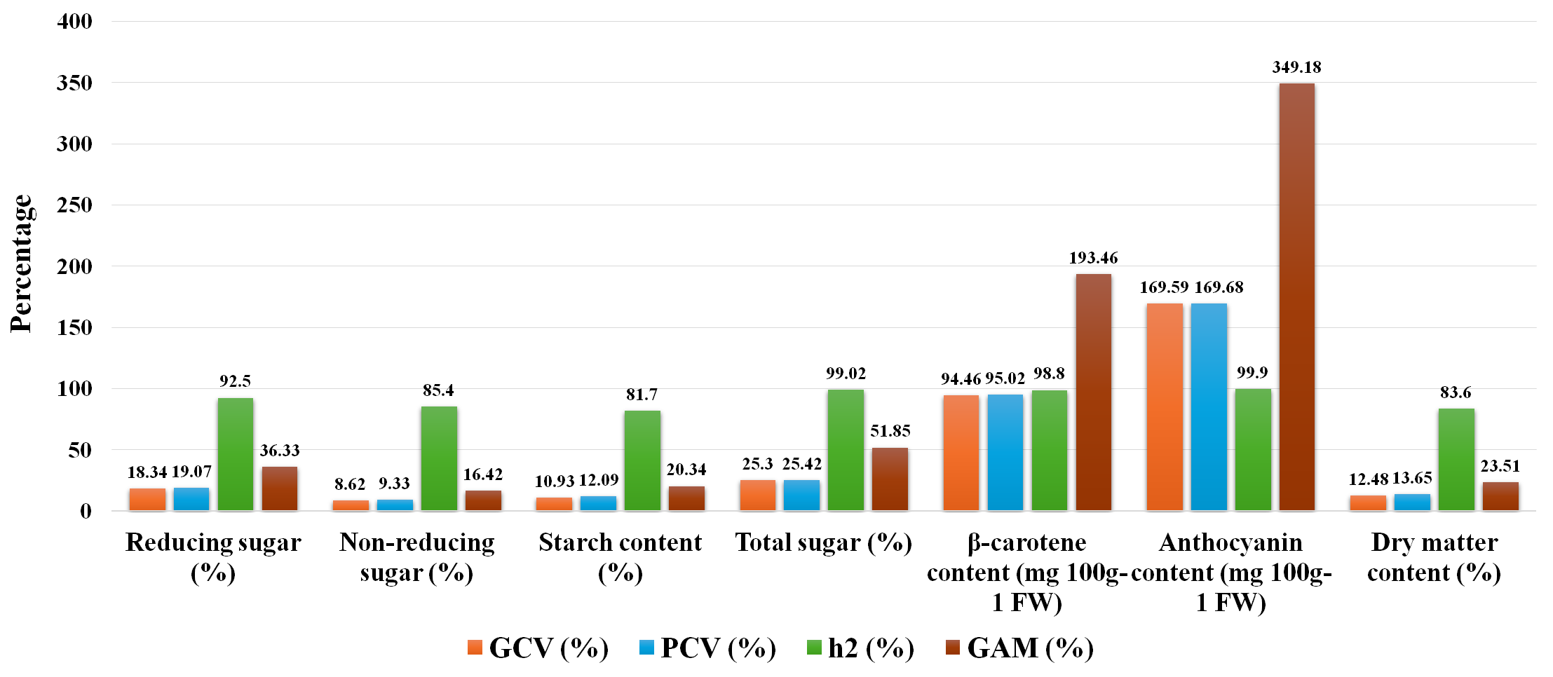
Fig 3. Mean performance of GCV, PCV, h² and genetic advance in per cent of quality parameters

CONCLUSION
The investigation evidenced substantial genetic differentiation among the evaluated elite sweet potato genotypes (Ipomoea batatas L.) genotypes, as demonstrated distinctly elevated (GCV and PCV) across several key traits. Characteristics including vine length, internodal length, number of branches vine⁻¹, leaf area, leaf area index, tuber size attributes, yield components, total yield, total sugars, β-carotene and anthocyanin content exhibited high heritability in conjunction with substantial genetic advance as mean in per cent. This alignment unmistakably denotes the predominance of additive genetic control, thereby making direct phenotypic selection both efficacious and genetically advantageous for the improvement of these traits, making them highly amenable to improvement through direct phenotypic selection. The results emphasize simultaneous improvement in both yield and nutritional quality Such genetic enhancement is well within the scope of the current germplasm repository. The superior genotypes identified herein exhibit considerable potential as elite parental lines for progressive breeding pipelines directed toward the development of high-yielding, nutritionally fortified, and climate-resilient sweet potato cultivars, well aligned with the objectives of sustainable production systems and targeted biofortification initiatives.

Disclaimer (Artificial intelligence)
Option 2:
Author(s) hereby declare that generativ AI technologies such as Large Language Models, etc. have been used during the writing or editing of manuscripts. This explanation will include the name, version, model, and source of the generative AI technology and as well as all input prompts provided to the generative AI technology
Details of the AI usage are given below:
1.Chat gpt
2.
3.

References
Allard, R. W. (1960). Principles of Plant Breeding. John Wiley and Sons, New York. p. 485.
Badu, M., Ashok, P., Kiran Patro, T. S. K. K. and Sasikala, K. (2017). Studies on genetic variability, heritability and genetic advance for growth, yield and quality parameters among orange-fleshed sweet potato [Ipomoea batatas (L.) Lam.] genotypes. International Journal of Current Microbiology and Applied Sciences, 6(9), 1804–1903.
Bajrang, B. (2021). Studies on genetic variability of sweet potato [Ipomoea batatas (L.)] genotypes for tuber yield and yield components. Ph.D. Thesis, Indira Gandhi Krishi Vishwavidyalaya, Raipur.
Burton, G. W. and De Vane, D. E. (1953). Estimating heritability in tall fescue (Festuca arundinacea) from replicated clonal material. Agronomy Journal, 45, 478–481.
Darshan, S., Byregowda, M., Gowda, M. V. C. and Ramachandra, R. K. (2017). Genetic variability and heritability studies in sweet potato (Ipomoea batatas (L.) Lam.). International Journal of Pure and Applied Bioscience, 5(4), 680–686.
FAOSTAT. (2021). Food and Agriculture Organization of the United Nations. http://faostat.fao.org.
Gehan, A. (2019). Assessment of variability, correlation and response to selection in four cultivars of sweet potato. Asian Journal of Agricultural Sciences, 64(1), 21–31.
Gin, D. E., Laurie, S. M. and Faber, M. (2008). Sensory acceptability of sweet potato varieties by rural consumers in South Africa. African Journal of Food, Agriculture, Nutrition and Development, 8(4), 372–388.
Haque, M. E., Saito, T. and Yoshida, T. (2023). Polyploid GWAS reveals the basis of molecular marker development for complex breeding traits including starch content in the storage roots of sweet potato. Frontiers in Plant Science, 14, 1181909.
Hejjegar, I. S. M., Hiremath, S. M., Naik, K. R. and Kolur, S. M. (2023). Genetic variability, heritability and genetic advance in sweet potato (Ipomoea batatas (L.) Lam.) genotypes. International Journal of Environment, 13(9), 2791–2798.
Johnson, H. W., Robinson, H. F. and Comstock, R. E. (1955). Estimates of genetic and environmental variability in soybeans. Agronomy Journal, 47(7), 314–318.
Jones, A., Dukes, P. D. and Schalk, J. M. (1986). Sweet potato breeding. In M. J. Bassett (Ed.), Breeding Vegetable Crops. AVI Publishing Company, Westport, Connecticut. pp. 1–35.
Loebenstein, G. (2009). The taxonomy, evolution and genetic diversity of sweet potatoes and related wild species. In P. Gregory (Ed.), Exploration, Maintenance and Utilization of Sweet Potato Genetic Resources. CIP, Lima, Peru. pp. 27–60.
Madawal, S. I., Alloli, A., Madarakhandi, T. B. S. and Anand Narasannavar, A. N. (2015). Genetic variability study in sweet potato (Ipomoea batatas L.) genotypes. International Journal of Tropical Agriculture, 33(2), 279–282.
Mekonnen, B., Gedebo, A. and Gurmu, F. (2021). Genetic variability for yield and yield-related traits in orange-fleshed sweet potato genotypes evaluated at Hawassa, Ethiopia. Agricultural Technology, 10(1), 28–35.
Narasimhamurthy, P. N., Patel, N. B., Patel, A. I. and Koteswara Rao, G. (2018). Genetic variability, heritability and genetic advance for growth, yield and quality parameters among sweet potato [Ipomoea batatas (L.) Lam.] genotypes. International Journal of Chemical Studies, 6(4), 2410–2413.
Nasiruddin, M., Haydar, F. M. A., Islam, A. K. M. R. and Hossain, M. M. (2014). Study of genetic variability and correlation of potato (Solanum tuberosum L.) genotypes grown in Bangladesh. Plant Environment and Development, 3(2), 9–13.
Panse, V. G. and Sukhatme, P. V. (1957). Statistical Methods for Agricultural Workers. Indian Council of Agricultural Research, New Delhi.
Prajapati, D. R., Patel, R. N. and Gami, R. A. (2020). Study of genetic variability of tuber yield and storage-related traits in potato (Solanum tuberosum L.). International Journal of Chemical Studies, 8(3), 188–192.
Prarthana, M., Ashok, P., Rout, M. K. and Dash, R. K. (2015). Genetic variability for yield and yield attributing characters in sweet potato (Ipomoea batatas (L.) Lam.). Bioscience Trends, 8(9), 2426–2429.
Ramachandra, M. K. and Srinivasa, V. (2017). Variability, heritability and genetic advance for quantitative and qualitative traits in potato genotypes under hill zone of Karnataka. Green Farming, 8(6), 1250–1253.
Robinson, H. F., Comstock, R. E. and Harvey, P. H. (1949). Estimates of heritability and the degree of dominance in corn. Agronomy Journal, 41(8), 353–359.
Seid, E., Mohammed, W. and Abebe, T. (2020). Genetic variability, heritability and genetic advance in potato (Solanum tuberosum L.) for processing quality, yield and yield related traits. International Journal of Plant Breeding and Crop Science, 7(3), 928–936.
Sharavathi, M. B., Naik, K. R., Devaraju, K., Kolakar, S. S., Kanthraj, Y. and Srinivasa, V. (2018). Evaluation of sweet potato (Ipomoea batatas L.) genotypes under hill zone of Karnataka. International Journal of Chemical Studies, 6(5), 882–886.
Sharavathi, M. B., Srinivasa, V., Anusha, R. B. and Shubha, A. S. (2018). Genetic variability studies in sweet potato (Ipomoea batatas (L.) Lam) genotypes under hill zone of Karnataka, India. International Journal of Current Microbiology and Applied Sciences, 7(9), 850–858.
Sivasubramanian, J. and Madhavamenon, P. (1973). Genotypic and phenotypic variability in rice. Madras Agricultural Journal, 60(9–12), 15–16.
Tripathi, V., Deo, C., Ravi, S. and Singh, R. S. (2016). Genetic variability and association studies in sweet potato [Ipomoea batatas (L.) Lam.]. International Quarterly Journal of Life Sciences, 11(4), 3203–3206.
Vinod, P., Ashok, R. and Devi, L. S. (2024). Estimation of genetic variability and heritability for yield and its related components of orange-fleshed sweet potato (Ipomoea batatas L.) genotypes. Biochemical Journal, 8(12S), 3313–3322.
Wani, P. (2021). Evaluation of orange-fleshed sweet potato (Ipomoea batatas L.) genotypes. Ph.D. Thesis, University of Horticultural Sciences, Bagalkot, Karnataka.
Weber, C. R. and Moorthy, H. R. (1952). Heritable and non-heritable relationship and variability of oil content and agronomic characters in the F₂ generation of soybean crosses. Agronomy Journal, 44, 202–209.
Wu, X., Zhang, Y. and Li, T. (2025). Genetic diversity evaluation and selection methods of sweet potato hybrid F₁ population based on SSR markers and phenotypic detection. BMC Plant Biology, 25, 6166.
Zhang, L. and Zhao, Q. (2024). Genetic diversity in sweet potato: A review of global germplasm. Plant Genetic Resources and Breeding, 6(2), 45–57.

