Wild Edible Mushrooms of Chhattisgarh, India: A Review on Diversity, Nutrition, and Ecosystem Services as NTFPs

Abstract
In India, edible fungi, particularly wild mushrooms, have received little attention and remain underutilized. The exact diversity of edible species is still uncertain, and their significant contributions to human nutrition as well as the vital ecosystem services they offer are often overlooked and insufficiently recognized.Chhattisgarh, which encompasses the country’s largest semi-evergreen Sal (Shorearobusta) forest, is home to a diverse range of mushrooms associated with various tree species. Mushrooms are composed of about 90% water and 10% dry matter, of which 40–70% consists of carbohydrates and 10–40% of proteins, with only a small proportion of fats (less than 1–6%). Their unique physicochemical makeup makes them nutritionally valuable. They are rich in essential nutrients, including trace elements like copper, zinc, iron, molybdenum, and cadmium, along with major minerals such as potassium, phosphorus, sodium, calcium, and magnesium.Ecologically, fungi play a vital role in ecosystem services, from primary production (nutrient creation and enhancement) to secondary production (food provision and species interactions), as well as in regulating populations and communities. Mushrooms also support human well-being by offering nutritional, medicinal, and economic benefits. They are recognized for their antioxidant, cardioprotective, cholesterol-lowering, antibacterial, hepatoprotective, and anticancer properties. Beyond health benefits, mushrooms serve as an important source of income for rural communities, providing sustainable livelihood opportunities through collection and sale.
Keywords: - Biodiversity, ecosystem, marketing, nutrients, wild mushroom.
Introduction
Wild edible mushrooms are important non-timber forest products valued by communities worldwide (Boa, 2004; Degreef et al., 2016; Dejene et al., 2017a; Degreef et al., 2020; Ngom et al., 2022). People have harvested and consumed these fungi for thousands of years, but in recent decades their global use has gained renewed attention (FAO, 2004). They are regarded as highly nutritious, with mineral concentrations often exceeding those found in meat, fish, and many vegetables (Chan, 1981). To date, over 2,000 fungal species have been identified as producers of edible sporocarps worldwide, with around 1,069 species recognized for human consumption (Boa, 2004). In India, 283 edible mushroom species have been recorded, some of which have also been brought under cultivation (Purkayastha& Chandra, 1985; Adhikari, 2000). Wild mushrooms have been collected and consumed since ancient times, serving as an important source of food in natural environments. Once primarily gathered from the wild, they are now increasingly incorporated into modern diets owing to their exceptional nutritional and medicinal value (Bano, 1976).Non-wood forest products (NTFPs) have gained attention for their potential to generate rural income and enhance markets, their role in preserving traditional knowledge, their contribution to sustainable forest management and conservation, and their impact on improving dietary diversity and providing nourishment, particularly for communities living near forests (Bargahet al., 2024; Dixit, 2022).Across cultures, mushrooms have historically held symbolic and practical importance-Greeks associated them with strength for warriors, Romans honored them as the “Food of the Gods,” while in China they were esteemed as the “Elixir of Life” (Chang & Miles, 1982). Nutritionally, edible mushrooms are valued for their abundance of polysaccharides, dietary fiber, proteo-glucans, and essential vitamins such as riboflavin and thiamine (Balan et al., 2018; Cardwell et al., 2018; Ślusarczyk et al., 2021).Plantation of the forest tree species has emerged as a crucial initiative in the forestry sector to meet the increasing demand for timber, non-timber forest produce (NTFP), fodder, fuelwood, etc., both from natural forests and plantation forestry (Bargahet al.,2025). Beyond these bioactives, their macronutrient balance offers distinct dietary benefits, particularly in combating lifestyle-related disorders. They also contain a wide range of health-promoting compounds, including antioxidants (Taskınet al., 2021), terpenoids (Dasgupta& Acharya, 2019), lectins (El-Maradny, 2021), phenolic and polyphenolic compounds (Acar et al., 2021; Verma et al., 2024), polysaccharides (Cateniet al., 2021), and ergosterols (Nowak et al., 2022). In India, research has focused on documenting the country’s mushroomdiversity across various biogeographical regions, with notable surveys conducted in South India, the North-Western Himalayas, and eastern areas. However, northern and central parts of India, including regions like Central India, have remained comparatively underexplored (Thakur et al., 2005).
Wild Edible Fungi
Fungi form a unique group of organisms, among which many species produce large, visible fruiting bodies known as macrofungi. The most recognizable examples are mushrooms, typically consisting of a cap and stalk, and commonly found in forests and open fields. While the majority are inedible, several species are edible, and only a very small fraction is dangerously poisonous. The most widely consumed mushrooms are cultivated varieties, available fresh or canned in markets (Boa, 2004).
Wild mushrooms, however, constitute an important category of Non-Timber Forest Products (NTFPs) and have been an essential food source since ancient times (Devkota, 2008). In India, various edible fungal species are traditionally consumed by local communities without reported cases of toxicity or fatalities. These wild edible mushrooms are valued not only for their nutritional richness but also for their medicinal significance (Thakur, 2018; Shukla et al., 2017).
Groups of Wild Edible Fungi
Edible fungi can be classified into three trophic groups based on their nutritional strategies: mycorrhizal, termitophilic, and saprobic mushrooms. This categorization is crucial as it indicates whether a species can be cultivated on artificial media and provides insights into their ecological roles and habitat preferences. Mycorrhizal mushrooms are typically associated with forests and woodlands, while termitophilic mushrooms grow on termite mounds (termitaria) in grasslands, woodlands, or cultivated fields, with their occurrence entirely dependent on the presence of specific termite hosts (Koné et al., 2011; 2018). Among consumers, mycorrhizal and termitophilic mushrooms are generally more popular than saprobic species (Degreef et al., 2016).
Fungi as a whole obtain nutrients from both living and dead matter through three primary modes: saprobic, by decomposing organic material; symbiotic, by forming mutually beneficial associations with other organisms; and parasitic or pathogenic, by exploiting and harming a host (Boa, 2004).

List 1 :Ecological Groups of Mushrooms: Characteristics, Habitats, and Ecological Roles

Groups | Description | Habitat | Benefits and Examples
Mycorrhizal species | This group of mushrooms represents the fruiting bodies of fungi that establish obligatory symbiotic relationships with higher plants (Hall et al., 2011). | Mycorrhizal mushrooms show strong habitat specificity, typically associating with host plants in woodlands, rainforests, or desert ecosystems. These host plants are often the dominant tree species in forests and woodlands (Meidl et al., 2021; Tedersoo&Brundrett, 2017). | Mycorrhizal fungi shape plant communities through their mutualistic associations (Martin et al., 2016) and play an important role in driving ecological succession within forest plantations (Termoshuizen, 1991). Examples include Boletus edulis, Russulavirescens, and Cantharelluscibarius.
Termitophilic species | Termitophilic mushrooms exist in a mandatory symbiotic relationship with fungus-growing termites of the subfamily Macrotermitinae. These fungi decompose cellulose and lignin, converting them into nutrient-rich compost that becomes a food source for the termites (Vesala et al., 2022). | The partially decomposed plant matter provides a substrate for fungal growth, allowing the mycelium of Termitomyces to spread during the monsoon season and later produce fruiting bodies, leading to the emergence of basidiocarps on termitaria (Atri et al., 2012). | Termitophilic fungi can influence vegetation through their association with termites, which alter soil characteristics and enhance substrate diversity (Bonachelaet al., 2021; Sileshi et al., 2010).  Examples-  Termitomycesheimii, Termitomycesalbuminosa, Termitomycesmicrocarpus
Saprobic or parasitic species | Saprobic and parasitic fungi do not rely on living hosts; they either thrive on decomposing organic matter or act as pathogens of plants.  (Sileshiet al.2023). | Fungi that grow on decaying organic matter can be easily cultivated on artificial substrates like straw, sawdust, or logs. They occur in a wide range of habitats such as agricultural lands, pastures, woodlands, and forests, where they colonize different types of decomposing materials. Moreover, certain saprobic mushrooms also possess pathogenic potential. | Saprobic mushrooms are essential for nutrient recycling in ecosystems (Martin et al., 2016).  Examples-  Astraeushygrometricus, Pleurotusspecies,Gynoderma species
Ecosystem Services
Ecosystem services are generally divided into four categories, provisioning, regulating, cultural, and supporting services and all of them rely on biodiversity, which directly sustains human well-being. Fungi contribute to each of these services, playing roles in primary production (nutrient creation and enhancement), secondary production (as food sources and through interactions with animals), and the regulation of populations and communities. As heterotrophic organisms, fungi form associations with nearly all known life forms for example, in mutualistic partnerships with cyanobacteria and algae in lichens and thrive even in extreme habitats. They provide numerous ecosystem benefits, particularly regulating services. Moreover, as key components of soil biodiversity, fungi are essential for nutrient cycling, carbon processing, and biological regulation at a global scale.
The Common International Classification of Ecosystem Services (CICES), formulated by the European Environment Agency (Haines-Young &Potschin, 2017), categorizes ecosystem services into specific groups. Based on this framework, the ecosystem services provided by mushrooms are classified into three main categories (Sileshi et al., 2023).
- Provisioning services – These include all nutritional, non-nutritional, and energy-related outputs such as food, medicine, feed, and fuel. Mushrooms are recognized as a valuable food source, being low in fat (average: 3.2%), high in dietary fibre (around 11.6% of dry weight), and rich in digestible proteins and essential minerals. Furthermore, mushrooms yield nutraceuticals—a class of bioactive compounds used as dietary supplements or for therapeutic purposes (Shiuan, 2004; Wandatiet al., 2013; Assemie& Abaya, 2022).

Nutrient Profile and Medicinal Properties of Mushrooms –
For thousands of years, medicinal mushrooms have been valued not only for their taste and delicate texture but also for their healing properties. Typically, mushrooms consist of about 90% water and 10% dry matter, with a physicochemical composition that plays a significant role in human nutrition (Román et al., 2006).
The nutritional importance of edible mushrooms lies in their high levels of protein, fiber, vitamins, and minerals, combined with their low fat content (Barros et al., 2008). They are considered nutrient-dense, low-calorie foods rich in essential nutrients, making them especially valuable in vegetarian diets since they provide all the essential amino acids required by adults and generally have higher protein content than most vegetables. In addition, edible mushrooms are a source of numerous bioactive compounds that contribute to various health benefits (Gruen et al., 1982). It is worth noting that their nutritional composition can be influenced by growth conditions, developmental stage, and postharvest handling (Valverde et al., 2015).
Mushrooms are also capable of accumulating heavy metals such as lead, nickel, chromium, mercury, and others, with mineral content varying according to species, age, and the characteristics of the fruiting body. While they contain trace elements like copper, zinc, iron, molybdenum, and cadmium, they are also rich in essential minerals including potassium, phosphorus, sodium, calcium, and magnesium. The chemical composition of mushrooms is further shaped by the type of cultivation substrate used. Interestingly, the nutrient profile of wild edible mushrooms is often superior to that of cultivated varieties.
Dry Matter, Proximate Composition , and Energy Value
Mushrooms are characterized by a low dry matter content, typically ranging from 60 to 140 g/kg (Kalač, 2009). This aligns with findings by Bano and Rajarathnam (1988), who reported that edible mushrooms contain a high moisture level of 81.8–94.8%. The moisture content varies depending on species as well as factors related to cultivation, harvesting, and storage. Due to this high water content, fresh mushrooms have a relatively short shelf life (Guillamónet al., 2010). On a dry-weight basis, mushrooms generally comprise about 63% carbohydrates, 25% protein, 4% fat, and 8% minerals represented as ash (Rajarathnam&Sashirekha, 2003).
General nutritional data (expressed on a dry-weight basis) for selected wild edible mushrooms, compiled from different sources.
Table :1 Nutritional content of Mushroom
Wild edible mushroom species | Carbohydrate (%) | Protein (%) | Fat (%) | Reference
Volvariellavolvacea | 2.99 | 4 | 0.19 | (Paisey and Abbas 2015)
Termitomyces sp. | 2.81-69.13 | 15.1- 19.2 | 2.5 – 5.4 | (Niranjanet al.2012)
Heimioporus sp. | 49 | - | - | (Feng et al.2022)
Pleurotus sp. | 3.37- 3.33 | 1.74- 3.4 | - | (Das et al.2021)
Auricularia sp. | 66.1 | 12.5 | 1.7 | (Irina et al. 2015)
Agaricus sp. | 62.97-83.65 | 8.56-23.8 | 3.4 | (Jacinto-Azevedoet al 2021)
Fungi have long been recognized for their medicinal benefits. Traditional Oriental medicine, dating back to ancient times, emphasizes the idea that food and medicine share the same origins. Several fungal species are commonly used for their therapeutic properties, including Clavicepspurpurea, Cordycepssinensis, Ganodermalucidum, Laricifomesofficinalis, Lentinulaedodes, and Trametes versicolor (Molitoris, 2002). Fungi are a source of easily absorbed proteins and contain fiber in the form of chitin, which may contribute to lowering cholesterol levels (Sadler, 2003). Additionally, the consumption of fungi has been linked to cancer prevention. Ikekawa (2001) reviewed studies conducted at Japan’s National Cancer Research Institute since 1966, focusing on the anti-tumor properties of fungi. Several anti-tumor polysaccharides have been identified, among which lentinan a β-1, 3-glucan extracted from Lentinulaedodes (shiitake) is considered the most notable and is utilized clinically in Japan.
Okigbo and Nwatu (2015) reported six macrofungal species traditionally used for medicinal purposes by the people of Anambra State, Nigeria. Daldiniaconcentrica is applied to relieve stomach ailments, while Auricularia auricular-judae and Lentinussquarrosulus are used to address infertility and anemia. Trichobatrachusrobustus is employed in the treatment of anemia and high blood pressure, and species of Termitomyces are used to combat anemia, weakness, and hypertension. Furthermore, Volvariellavolvacea is specifically utilized for treating anemia (Debnath et al., 2019).
Table: 2 Medicinal Mushroom in Chhattisgarh

Mushroom species | Medicinal uses | Reference
Auriculariaauricula-judae | Anti-tumor, anticoagulant, hypocholesterolemic | Das(2010)
Ganodermalucidum | Anti-viral, antibacterial, antifungal, anticanc | Das (2010)
Schizophyllum commune | Anti-cancer(drug Schizophyllan) | Das (2010)
Russulavirescens | Antioxidant, Cholesterol-lowering | Das (2010)
Astraeushygrometricus | Immunoanhancing activity | Chakrabortyet al. (2004)
Termitomycesheimii | Wound healing, fever, coughs, and fungal infections | Chakrabortyet al. (2004)
Termitomycesmicrocarpus | Wound healing | Chakrabortyet al. (2004)
Calocybeindica | Diabetes | Sun (2014)
Source: Dixit (2023)

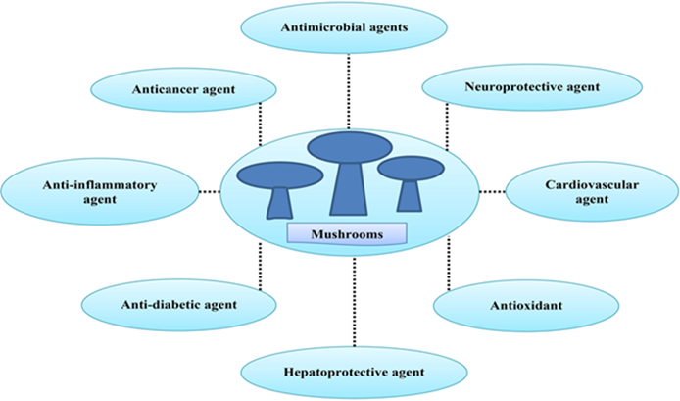
Fig 1: The Medicinal properties of edible fungi

- Regulation and Maintenance Services –
Regulation and maintenance services encompass the ways in which organisms influence the physical, chemical, and biological conditions that impact human health, safety, and comfort. Fungi play a crucial role in supporting plant health, aiding tree regeneration, and maintaining the structure and functioning of forest ecosystems (Meidl et al., 2021; Pérez-Moreno et al., 2021). For instance, mycorrhizal fungi contribute to tree growth, forest sustainability, and biodiversity, while also helping mitigate greenhouse gas emissions by sustaining forest biomass. These fungi provide such benefits by enhancing nutrient and water uptake via underground mycelial networks that link trees and other plants, increasing nutrient availability, and producing metabolites that protect against pathogens and environmental stressors (Pérez-Moreno et al., 2021). In nutrient-poor soils, mycorrhizal fungi assist trees in accessing scarce nutrients and water beyond the reach of their roots. Since the levels of bioavailable nutrients in forest soils are often insufficient for optimal plant growth, many tree species depend on symbiotic relationships with mycorrhizal fungi to establish and thrive (Martin et al., 2016).
- Cultural Services –
Cultural services refer to the non-material, non-consumptive benefits that influence people’s physical and mental well-being through spiritual enrichment, cognitive development, reflection, recreation, and aesthetic experiences. Mushrooms contribute significantly to various cultural practices. For instance, Termitomycesmicrocarpa (formerly Podabrellamicrocarpa) holds cultural importance in traditional ceremonies in Rakai District, Uganda (Engolaet al., 2006). Additionally, some species are incorporated into rituals: Lentinus (Pleurotus) tuber-regium is used as a love charm, while certain Termitomyces species are employed in Cameroon to ward off evil spirits (Onguene&Kuyper, 2019).

Biodiversity of Edible Wild Macrofungi in Chhattisgarh
Chhattisgarh, located in the central-eastern part of India between 17–23.70° N latitude and 80.40–83.38° E longitude, covers a total geographical area of 136,030 sq. km. The region receives an average annual rainfall of approximately 1400 mm, with atmospheric humidity exceeding 90% during the monsoon and gradually decreasing from October to reach 15–20% in peak summer. The state is endowed with extensive forest resources, covering 44% of its total area, which include diverse ecosystems and a rich but largely unexplored diversity of macrofungal species. The vegetation is dominated by sal trees, which account for 46% of the forested area, followed by teak, with additional stretches of sarai, bamboo, tendu, and eucalyptus across various regions. Much of the forest flora and fauna, including mushroom species, remains unstudied (Singh et al., 2020).
Many mycorrhizal mushrooms in the state are traditionally collected from the wild for food. Unlike mushrooms that grow exclusively on soil or wood, these species form mutualistic associations with the roots of host plants (Lakhanpal, 1995). In Chhattisgarh, such mushrooms represent the fruiting bodies of ectomycorrhizal fungi associated with the roots of sal trees and bamboo trunks. Among them, Astraeushygrometricus and Termitomycesheimii showed the highest frequency of occurrence at 83.33%, followed by Boletus edulis at 82%, Russulavirescens at 81.21%, and Russularosea at 78.54%. Other species exhibited frequency values ranging from 49% to 80.72%. Regarding density, Termitomycesheimii and Astraeushygrometricus recorded the highest at 126.67%, with Boletus edulis at 120% and Russulavirescens at 93.33%, while the remaining species ranged between 30.33% and 56.67% (Dixit, 2024).
Diversity of Wild Edible Mushrooms in Chhattisgarh
Mushrooms in Chhattisgarh occur in a variety of habitats, including soil, dead wood logs, tree trunks, and organic matter. The most frequently encountered species include Russula, Termitomyces, and Astraeushygrometricus. Ganodermalucidum, belonging to the family Polyporaceae and order Polyporales, is the most commonly used medicinal mushroom, typically found on dead tree logs, and is known for its immune-stimulating, anti-inflammatory, and anti-allergic properties.Among the local population, Astraeushygrometricus, commonly called “Puttu,” is a widely consumed ectomycorrhizal mushroom. In central India, it grows in nutrient-poor lateritic soils in association with Shorearobusta and is found in scattered groups; the immature fruiting bodies are collected for consumption. Across various habitats—such as litter, soil, termite mounds, wood logs, live plants, and decaying leaves—a total of 83 genera of mushrooms and fungi have been documented, encompassing edible, non-edible, medicinal, poisonous, and mycorrhizal types (Singh et al., 2020).These samples were collected from dense forests in regions such as Bastar, Amarkantak, Jagdalpur, and Ambikapur, as well as from multiple marketplaces throughout the state. A survey conducted during the monsoon seasons of 2005 and 2006 recorded 75 mushroom species from the Chhattisgarh Plain and Bastar Plateau (Thakur et al., 2017).Much of the forest’s flora and fauna, including its mushroom species, remains largely unexplored and unmanaged. The northern hilly regions, such as Manpat in Surguja district at higher altitudes, host unique mushroom flora that requires conservation and sustainable utilization. Similarly, the Bastar Plateau, characterized by dense forest cover, remains mostly unattended and unexplored. Although sporadic efforts have been made in Chhattisgarh to collect, conserve, identify, and maintain the local mushroom diversity, these initiatives were primarily conducted under the All India Coordinated Mushroom Improvement Project of ICAR, based at Indira Gandhi Agricultural University, Raipur, since 1988.( Thakur et al 2017.)
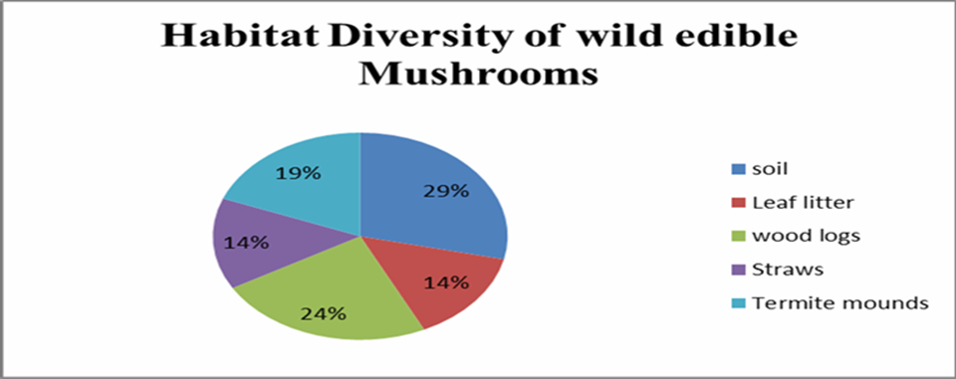
Fig 2:habitat diversity of fungiSource -DixitandEkka (2021)
Table: 3 Diversity of Wild Edible Fungi in Chhattisgarh
SN | ScientificName | CommonName | Period ofCollection | Habitat
1. | Russulaemitica | Paanfutu  (Redcolour) | July-August | Leaflitter
2. | Russuladelica | Paanfutu  (whitecolour) | July-August | soil/Leaflitter
3. | Russulafoetens | Paanfutu  (yellowcolour) | July-August | Soil/Leaflitter
4. | Russulanigricans | Paanfutu  (Blackcolour) | July-August | Leaflitter
5. | Russulaatro  Purpurea | Paanfutu  (Purplecolour) | August-  October | Leaflitter
6. | Termitomyces  Heimii | Dengurfutu | July-August | Termite  Mounds
7. | Volvariellavolvacea | Pairafutu | August-  September | Paddystraw  Heap
8. | Termitomyces  Albuminosa | Manaifutu | July-August | Termite/soil
9. | Termitomycesspp.  (Bigsize) | Dashahrafutu | August-  September | Leaflitter  /soil
10. | Syzygiumjambolana | Jamunfutu | July-August | Leaflitter
11. | Cantharellusspp. | Bansfutu | June-August | OnBamboo  Trunk
12. | Amanitabisporigera | Manjur  Dhundha | July-August | Soil
13. | Pesilocybecubensis | Gobarfutu | July-August | Cowdung
14. | Astraeusodoratus | Jathaboda,ChharkeniPutu | July-August | Leaflitter/  Soil
15. | Astraeus  Hygromtrious | Rakhdiboda, Sarai Putu, Gohiya | July-August | Leaflitter/  Soil
16. | Termitomyces  Microcarpus | Kankifutu | July-August | Termite  Mounds
17. | Agrocybeerebia | - | July –August | Soil
18. | Armillariamellea | - | July – August | Decaying woods
19. | Auricularia spp. | - | July – August | Wood logs
20. | Boletus edulis | - | July – August | Soil

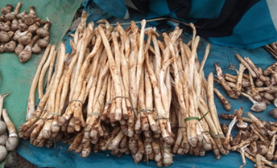  Termitomycesheimii | 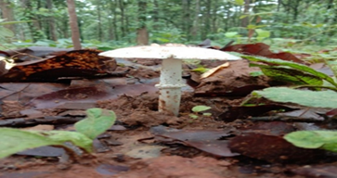  Russuladelica | 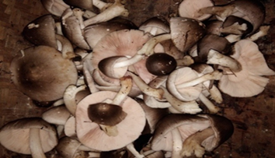  Volvariellavolvacea
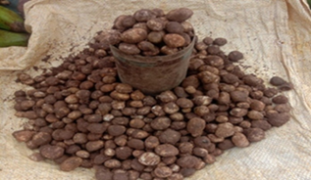  Astraeushygromtrious | 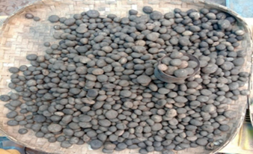  Astraeusodorathus | 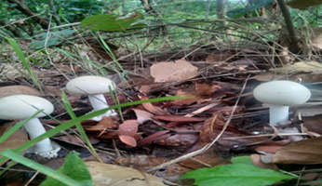  Amanitabisporigera
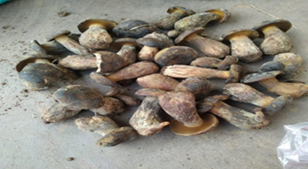  Syzygiumjambolana | 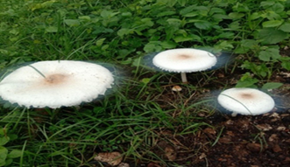  Pesilocybecubensis | 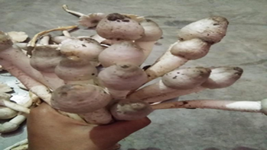  Termitomycesspp.(bigsize)
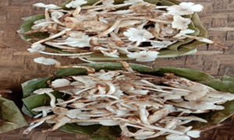  Termitomycesmicrocarpus | 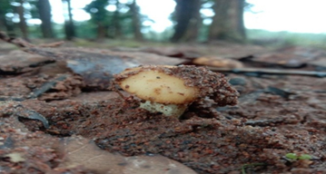  Russulafoetens | 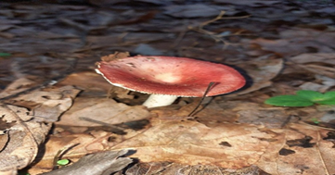  Russulaemetic
Fig: 3 Different species of Mushrooms Source: Kumar and Netam (2022)

Livelihood Support and Income
Wild edible fungi are used in two main ways: for personal or subsistence consumption, and for commercial harvesting. Although detailed information on personal use is limited, it is widely practiced globally, and increasing evidence highlights the significance of wild edible mushrooms for rural communities in countries like India. Many more species are consumed locally than are collected for commercial purposes. The tradition of harvesting and consuming wild edible fungi is particularly strong in tribal-dominated and heavily forested states. A similar trend has been observed in Malawi, where income earned by local collectors is modest but meaningful, and the local market for wild edible fungi continues to grow (Boa et al., 2000).
Local traditional healers (also known as "Vaidyas") determined the method of preparation and dose of administration. Furthermore, all of the traditional healers were men, as they feel that women would not be capable of mushroom harvesting in deep forest locations. During the rainy season, tribal women collect mushrooms for their livelihood which becomes their additional source of income. Mushrooms are a very important part of tribal people as it adds value to their life. . Out of 6 types of mushroom species available in the Bilaspur Forest Division, Termitomycesmicrocarpus yield is maximum. Due to their superior flavor and texture, genera including Astraeus, Agaricus, Pleurotus, andTermitomyces have higher ratings. Termitomycesspecies have a high economic value due to their good flavor, according to various reports, and they contribute significantly to the income of many tribal households. The data reveals that the tribes should sell their mushrooms in a large market in order to earn maximum income.
The distance between collection sites and potential markets plays a critical role in the sale of wild edible fungi. In the Bastar region, roadside markets are located close to the forests where mushrooms are harvested, facilitating easier access for collectors. However, increasing demand and competition have forced collectors to travel longer distances to gather fungi (Lowore& Boa, 2001). The market structure in Bastar is typically small-scale and local. Sales depend on the flow of buyers, and on some days, few customers arrive. Some traders purchase unsold mushrooms at the end of the day and transport them quickly to central markets in larger cities, often offering low prices. Alternatives for collectors include drying the mushrooms or discarding them.
A similar pattern is observed in local markets in Madhya Pradesh, India, which are small-scale and operate mostly within towns rather than along roadsides (Harsh et al., 1999). In Bastar, mushroom harvesting at the onset of monsoon rains is a traditional practice among various communities. Mushrooms contribute directly to livelihoods through their economic, nutritional, and medicinal value. Despite this, mushroom collection and cultivation often face challenges, and multiple studies in India have highlighted issues related to rural livelihood and sustainable harvesting. In Jagdalpur, the market price for mushrooms ranges between 500–600 INR per kilogram.
Future Prospects
The growing recognition of mushrooms as nutraceuticals has been described as a “Non-Green Revolution” (Thakur &Lakhanpal, 2015). Wild edible mushrooms play a significant role in alleviating poverty, enhancing human health, and mitigating environmental degradation. They have the potential to contribute to equitable economic growth and social well-being. This chapter also emphasizes the need to explore strategies for the conservation and sustainable use of wild edible mushrooms, along with the preservation of indigenous knowledge associated with them, as these fungi can generate substantial socio-economic benefits.
It is essential to develop systems and policies for training local communities to utilize ethnomycological knowledge for the responsible and sustainable exploitation of wild edible fungi (Christensen & Larsen, 2005). Educating people about both edible and poisonous mushroom species is crucial to reduce the risk of accidental poisoning. Furthermore, the bioactive compounds found in medicinally important wild mushrooms have received considerable attention for their role in enhancing biological functions and promoting overall health and fitness.

Conclusion:
The conclusion of the study on underutilized wild edible fungi and their undervalued ecosystem services highlights the critical need to recognize and promote the importance of these fungi. Wild edible fungi, often overlooked, offer a wide range of ecosystem services that are crucial to biodiversity, soil health, and sustainable food systems. They play essential roles in nutrient cycling, enhancing soil fertility, supporting plant growth, and maintaining ecosystem balance, these are the essential reasons for conservation. Wild fungi provide significant economic opportunities for rural and indigenous communities through foraging, trade, and culinary uses. However, their potential remains largely untapped due to a lack of awareness, scientific research, and sustainable management practices. To fully harness the benefits of wild edible fungi, it is necessary to Raise Awareness, support Research and Conservation, Integrate Fungi into Food Security Strategies.

Disclaimer (Artificial intelligence)
Option 1:
Author(s) hereby declare that NO generative AI technologies such as Large Language Models (ChatGPT, COPILOT, etc.) and text-to-image generators have been used during the writing or editing of this manuscript.

Reference:-

- Acar, ˙ I.; Blando, F.; Gul, B.; Greco, A.; Mukemre, M.; Uzun, Y.; Dalar, A. The Phenolic Profile and Biological Activities of the Wild-Edible Mushrooms Helvellaleucopus and Morchella pulchella. Food Meas. 2021, 15, 555–566.
- Ambhore, J. P., Adhao, V. S., Rafique, S. S., Telgote, A. A., Dhoran, R. S., &Shende, B. A. (2024). A concise review: edible mushroom and their medicinal significance. Exploration of Foods and Foodomics, 2, 183-194.
- Arora, B., Kamal, S., Sethi, S., Joshi, A., & Sharma, V. P. (2018). Mushrooms: Reservoir of vital nutrients and bioactives. Mushroom Research, 27(1).
- Assemie, A., & Abaya, G. (2022). The effect of edible mushroom on health and their biochemistry. International journal of microbiology, 2022(1), 8744788.
- Badhai, P. K., Jangde, C., Singh, A., Shukla, C. S., Lakpale, N., & Singh, H. K. (2020). Biological insights of forest mushrooms of Chhattisgarh with special reference to Termitomyces-termitarium-corpus. Mushroom Research, 29(2).
- Bao, E.R; Meke, G.M and Munthali, C. (2000). First Regional Workshop on Sustainable use of Forest Products Miombo Wild Edible Fungi. Zomba,Malawi, Forest research institute of Malawi and CABI Bioscience. 61 pp.
- Bargah, A. S., Kumar, R., Khandekar, H., &Vaishnaw, A. K. (2024). A Status of Different Non Wood Forest Products in Chhattisgarh, India. International Journal of Plant & Soil Science, 36(11), 23-40.
- Bargah, A. S., Sharma, D., Kumar, R., Nag, R., & Pradhan, R. (2025). Enhancing Germination of Forest Tree Seeds in Chhattisgarh through PGR-Based Treatments: A Review. Journal of Advances in Biology & Biotechnology, 28(7), 851-863.
- Barros, L., Cruz, T., Baptista, P., Estevinho, L. M., & Ferreira, I. C. (2008). Wild and commercial mushrooms as source of nutrients and nutraceuticals. Food and Chemical Toxicology, 46(8), 2742-2747.
- Boa, E. (2012). From Chipho to Msika: An introduction to mushrooms, trees and forests. In Mushrooms in forests and woodlands (pp. 1-19). Routledge.
- Boa, E. R. (2004). Wild edible fungi: a global overview of their use and importance to people.
- Bourdeaux, Q., Buyck, B., Malaisse, F., Matera, J., Marlier, M., Wathelet, B., &Lognay, G. (2003). Wild edible mushrooms from a Zambezian woodland area (Copperbelt Province, Zambia).
- Cardwell, G.; Bornman, J.; James, A.; Black, L. A Review of Mushrooms as a Potential Source of Dietary Vitamin D. Nutrients 2018, 10, 1498.
- Cateni,F.; Gargano, M.L.; Procida, G.; Venturella, G.; Cirlincione, F.; Ferraro, V. Mycochemicals in Wild and Cultivated Mushrooms: Nutrition and Health. Phytochem. Rev. 2021, 1–45.
- Chakraborty I, Mondal S, Pramanik M, Rout D, Islam SS. (2004). Structural investigation of a watersoluble glucan from an edible mushroom, Astraeushygrometricus. Carbohydrate Res. 339, 2249- 2254.
- Christensen, M. and Larsen, H.O. (2005). How can collection of wild edible fungi contribute to livelihoods in rural areas of Nepal. Journal of Forest and Livelihood, 4(2): 50-55.
- Das K. (2010). Diversity and conservation of wild mushrooms in Sikkim with special reference to Barsey Rhododendron Sanctuary. NeBIO 1(2), 1-13.
- Das, S. K., Masuda, M., Sakurai, A., &Sakakibara, M. (2010). Medicinal uses of the mushroom Cordycepsmilitaris: current state and prospects. Fitoterapia, 81(8), 961-968.
- Dasgupta, A.; Acharya, K. Mushrooms: An Emerging Resource for Therapeutic Terpenoids. 3 Biotech 2019, 9, 369
- Debnath, S., Debnath, B., Das, P., &Saha, A. K. (2019). Review on an ethnomedicinal practices of wild mushrooms by the local tribes of India. Journal of Applied Pharmaceutical Science, 9(8), 144-156.
- Degreef, J., Demuynck, L., Mukandera, A., Nyirandayambaje, G., Nzigidahera, B., & De Kesel, A. (2016). Wild edible mushrooms, a valuable resource for food security and rural development in Burundi and Rwanda. Base.
- Dejene, T., Oria-de-Rueda, J. A., & Martín-Pinto, P. (2017). Edible wild mushrooms of Ethiopia: Neglected non-timber forest products. RevistaFitotecnia Mexicana, 40(4), 391-397.
- deRomán, M., Boa, E., & Woodward, S. (2006). Wild-gathered fungi for health and rural livelihoods. Proceedings of the Nutrition Society, 65(2), 190-197.
- Dixit, B. (2022). Community based natural resource management of edible mushroom and its significance for the livelihood of tribal women of Bilaspur, Chhattisgarh. Ecosystem services with sustainable development, 109.
- Dixit, B., &Ekka, R. (2021). Habitat diversity of edible wild mushrooms in semarsot wildlife sanctuary, Chhattisgarh, India.
- El-Maradny, Y.A.; El-Fakharany, E.M.; Abu-Serie, M.M.; Hashish, M.H.; Selim, H.S. Lectins Purified from Medicinal and Edible Mushrooms: Insights into Their Antiviral Activity against Pathogenic Viruses. Int. J. Biol. Macromol. 2021, 179, 239–258.
- Fang, W., Devkota, S., Arunachalam, K., Phyo, K. M. M., &Shakya, B. (2023). Systematic review of fungi, their diversity and role in ecosystem services from the Far Eastern Himalayan Landscape (FHL). Heliyon, 9(1).
- Gruen, F.H. and Wong, M.W. (1982). Distribution of cellular amino acids, protein and total nitrogen during fruit body development in Flammulingvelutips. Canadian Journal of Botany, 160: 1339-1341.
- Haines-Young, R., &Potschin, M. (2017). 2.4. Categorisation systems: The classification challenge. Mapping Ecosystem Services, 42.
- Harsh, N.S.K.; Rai, B.K. and Soni, V.K. (1999). Some ethnomycological studies from Madhya Pradesh, India. In J. Singh & K.R. Aneja, eds From ethnomycology to fungal biotechnology, pp. 19-31.
- Ho, L. H., Zulkifli, N. A., & Tan, T. C. (2020). Edible mushroom: nutritional properties, potential nutraceutical values, and its utilisation in food product development. An introduction to mushroom, 10.
- Ikekawa T (2001). Beneficial effects of edible and medicinal mushrooms on health care. International Journal of Medicinal Mushrooms 3, 291–298.
- Khastini, R. O., Maryani, N., & Lestari, I. D. (2022, December). Wild Edible Mushroom, a Potential and Valuable Source for Food Security. In 2nd International Conference for Smart Agriculture, Food, and Environment (ICSAFE 2021) (pp. 160-168). Atlantis Press.
- Kumar, S., &Netam, B. (2022). Study of wild edible mushrooms for improving human health and livelihoods support in Bastar Plateau India. Plant Archives (09725210), 22(1).
- Liu, S., Liu, H., Li, J., & Wang, Y. (2022). Research progress on elements of wild edible mushrooms. Journal of Fungi, 8(9), 964.
- Lowore, J. and Boa, E. (2001). Local practices and indigenous knowledge of wild edible fungi: Bowa markets in Malawi. Prepared for the Miombo Edible Fungi Project, DFID.
- Masamba, K. G., &Kazombo-Mwale, R. (2010). Determination and comparison of nutrient and mineral. African Journal of Food Science, 4(4), 176-179.
- Meidl, P., Furneaux, B., Tchan, K. I., Kluting, K., Ryberg, M., Guissou, M. L. ...&Rosling, A. (2021). Soil fungal communities of ectomycorrhizal dominated woodlands across West Africa. MycoKeys, 81, 45.
- Molitoris HP (2002) Pilze in Medizin, Folklore und Religion (Mushrooms in medicine, folklore and religion). FeddesRepertorium 113, 165–182.
- Munyanziza, E. (1994). Miombo trees and mycorrhizae: ecological strategies, a basis for afforestation. Wageningen University and Research.
- Ngom, K., Nakabonge, G., Ssekandi, J., Akowedaho, B. D., Baldé, I., &Noba, K. (2022). Diversity of BasidiomycetousMacrofungi from Mpanga Forest in Mpigi District, Central Uganda. Annual Research & Review in Biology, 37(10), 24-56.
- Obodai, M., Ferreira, I. C., Fernandes, Â., Barros, L., Mensah, D. L. N., Dzomeku, M., ... &Takli, R. K. (2014). Evaluation of the chemical and antioxidant properties of wild and cultivated mushrooms of Ghana. Molecules, 19(12), 19532-19548.
- Pérez‐Moreno, J., Guerin‐Laguette, A., Rinaldi, A. C., Yu, F., Verbeken, A., Hernández‐Santiago, F., & Martínez‐Reyes, M. (2021). Edible mycorrhizal fungi of the world: What is their role in forest sustainability, food security, biocultural conservation and climate change? Plants, People, Planet, 3(5), 471-490.
- Purkayastha, R. P., & Chandra, A. (1985). Manual of Indian edible mushrooms (pp. 41-48). New Delhi: Today and Tomorrow's Printers and Publishers.
- Sadler M (2003) Nutritional properties of edible fungi. Nutrition Bulletin 28, 305–308.
- Sahu, R., Sahu, K., Chanda, R., Chaturvedi, K., Sahu, B., &Chaursia, H. (2023). Nutritional and Pharmacological Potential of Edible Mushroom. Acta Scientific Pharmaceutical Sciences (ISSN: 2581-5423), 7(4).
- Sileshi, G. W., Nyeko, P., Nkunika, P. O., Sekematte, B. M., Akinnifesi, F. K., &Ajayi, O. C. (2009). Integrating ethno-ecological and scientific knowledge of termites for sustainable termite management and human welfare in Africa. Ecology and Society, 14(1).
- Sileshi, G. W., Tibuhwa, D. D., &Mlambo, A. (2023). Underutilized wild edible fungi and their undervalued ecosystem services in Africa. CABI Agriculture and Bioscience, 4(1), 1-20.
- Singh, H. K., Thakur, M. P., Kerketta, A., & Nag, U. K. (2020). Biodiversity of Edible, Medicinal, Mychorhizal, Poisonous and Wild Macrofungi in Chhattisgarh. Mushroom Research, 29(1).
- Singh, N. (2010). Edible Potential of Wild Mushroom Astraeushygromatricus(Pers.) Morg. Nature, Environment and Pollution Technology, 9(3), 597-600.
- Sun S. 2014. One kind of traditional Chinese medicine composition for treating diabetes. China patent application CN103550660A.
- Ta¸ skın, H.; Süfer, Ö.; Attar, ¸ S.H.; Bozok, F.; Baktemur, G.; Büyükalaca, S.; Kafkas, N.E. Total Phenolics, Antioxidant Activities and Fatty Acid Profiles of Six Morchella Species. J. Food Sci. Technol. 2021, 58, 692–700
- Thakur, M. (2018). Wild Macro-Fungi from Northwest Himalayas: Future Prospects and Challenges. Biology of Macrofungi, 379-394.
- Thakur, M. P., Shukla, C. S., &Jha, D. (2017). Occurrence of mushroom diversity in Chhattisgarh plains, northern hilly regions and Bastar plateau of Chhattisgarh state. International Journal of Researches in Biosciences, Agriculture & Technology, 5(2), 1-5.
- Titilawo, M. A., Oluduro, A. O., &Odeyemi, O. (2020). Proximate and chemical properties of some underutilized Nigerian wild mushrooms. Journal of microbiology, biotechnology and food sciences, 10(3), 390-397.
- TIWARI, M., Shukla, K., Shukla, R. V., & TRIPATHI, A. M. (2009). Prevalence of tribal mushrooms in Sal forests of Chhattisgarh. proteins, 1, 12.
- Valverde, M. E., Hernández-Pérez, T., & Paredes-López, O. (2015). Edible mushrooms: improving human health and promoting quality life. International journal of microbiology, 2015(1), 376387.
- Vesala, R., Räsänen, M., Leitner, S., Mulat, D. G., Mwangala, L., Rikkinen, J., &Arppe, L. (2023). Mound architecture and season affect concentrations of CO2, CH4 and N2O in nests of African fungus growing termites. Ecological Entomology, 48(6), 725-737.
- Vinayaka, K. S., Mahendru, N., Lal, S., Mishra, S., & Kumar, S. (2024). Rugda (Astraeus hygrometricus): a livelihood of Tribal community. Edible & Medicinal Mushrooms of India, 10947246, 10.
- Wandati, T. W., Kenji, G. M., &Onguso, J. M. (2013). Phytochemicals in edible wild mushrooms from selected areas in Kenya. Journal of Food Research, 2(3), 137-144.
- Dixit, B. (2022). Community based natural resource management of edible mushroom and its significance for the livelihood of tribal women of Bilaspur, Chhattisgarh. Ecosystem services with sustainable development, 109.
- Verma, S., Tirkey, S., & Shukla, K. (2024). A review on therapeutic potential of wild mushrooms with their relative status in Chhattisgarh, Central India. Advances in Traditional Medicine, 24(3), 685-702.
- Shukla, K., Giri, B., & Shukla, R. V. (2017). Occurrence and distribution of mushrooms in semi-evergreen Sal (Shorea robusta) forest Chhattisgarh, Central India. In Developments in Fungal Biology and Applied Mycology (pp. 501-523). Singapore: Springer Singapore.

