Influence of Physical Crop Parameters of the Sorghum Crop (Sorghum bicolor L.) on the Design of the Sorghum Harvester

Abstract: Sorghum (Sorghum bicolor L.), popularly known as “Jowar”, is a cereal grain found in tropical and subtropical climates. The physical properties of the sorghum crop help in various machine and operational parameters like design of cutting unit, conveying unit, design of cutting blade, blade velocity, design of row divider and power requirement of sorghum harvester. Therefore, this study aimed to study the influence of physical crop parameters of the sorghum crop on the design of the sorghum harvester. In the experiment, seven varieties, namely Hytech-3201, Varada-14, Sriram-5001, Jockey, M 35-1, Mahindra and Teja sorghum crop varieties were selected. The crop parameters considered for the present study included plant height, stalk diameter, crop density, and moisture content of the crop at the time of harvesting. The crop parameters under both farmers’ field conditions and the research plots of the University of Agricultural Sciences (UAS) were carefully determined following standard agronomic procedures. A one square meter frame was placed at five places chosen randomly in the plot to determine the crop density. The height of the plants was measured at five different locations selected randomly for sorghum. The diameter of the sorghum plant stalk was measured at the cutting height of the stalk of the sorghum from five randomly selected plants. A Stanley steel tape with 0.1 cm divisions was used for measuring the length of the ear head of sorghum. Plant-to-plant spacing was measured by measuring the distance between one plant to another plant. The results revealed that the heights of the sorghum crop of different selected varieties ranged from 1450 mm to 1890 mm. It was observed that the average diameters of selected sorghum varieties' stalks ranged from 12-33 mm, and the ear head length of the sorghum crop ranged from 170-350 mm. The average crop stand densities of the sorghum crop were from 10-27 plants per m². The row spacing and plant spacing were 35-40 cm and 14-18 cm, respectively. Designing the harvester based on the optimised physical properties ensures efficient operation, reduced crop loss, and improved field performance under varying crop and field conditions.

Keywords: Cutting energy, Engineering properties, Physical crop parameter, Sorghum harvester, Stalk diameter
Introduction
Sorghum (Sorghum bicolor L.), popularly known as Jowar, is a major cereal grain widely cultivated in tropical and subtropical regions. It ranks as the fifth most important cereal crop in the world after wheat, maize, rice, and barley (Kazungu et al., 2023). In India, sorghum holds the position of the third major cereal crop after rice and wheat (Kumar Charyulu, 2011). Nutritionally, sorghum is superior to rice due to its higher mineral and fibre content. The grain primarily consists of starch (60–75%), followed by proteins (7–15%), non-starch polysaccharides (2–7%), and fat (1.5–6%). The average calorific value of whole sorghum grain flour is approximately 356 kcal per 100 g (Dicko et al., 2006).
Sorghum is typically cultivated in hot and dry regions with relatively long summers. The crop generally matures in 90–120 days, passing through the boot stage (50–60 days) and flowering stage (60–70 days) before reaching full grain maturity at around 120 days (Khalifa & Eltahir, 2023). It is an annual or short-term perennial crop, with culms that can grow up to 4 meters or more in height, often possessing a sweet stem in non-grain types. The panicle length ranges from 8–40 cm, and the sessile spikelet measures 4–6 mm in length. At the end of the growth period, the grain moisture content typically varies between 18% and 22% (Anon., 2003).
In terms of area under cultivation, Maharashtra ranks first in India with 3.94 million hectares (37.86%) of sorghum cultivation during 2019–20, followed by Karnataka (20.66%), Tamil Nadu (10.89%), and Rajasthan (6.82%) (Anon., 2019). During 2019–20 and 2020–21, Maharashtra also recorded the highest sorghum production with 2.68 million tonnes (34.40%), followed by Karnataka (24.11%). Other contributing states include Tamil Nadu (12.64%), Andhra Pradesh (7.33%), Uttar Pradesh (4.73%), Madhya Pradesh (3.45%), Telangana (1.18%), and Gujarat (2.10%) (INDIASTAT, 2020). In Karnataka, sorghum is grown over an area of 0.94 million hectares with a production of 0.98 million tonnes and an average productivity of 945 kg/ha (INDIASTAT, 2020).
The major sorghum-growing districts in Karnataka include Kalaburgi, Raichur, Koppal, Belagavi, Ballari, and Vijayapur. In the Hyderabad–Karnataka region, also known as Kalyana Karnataka (comprising Bidar, Kalaburgi, Yadgir, Koppal, Raichur, Ballari, and Vijayanagara), the crop is cultivated over an area of 0.37 million hectares, producing 0.42 million tonnes with a productivity of 1194 kg/ha during 2018–19 (Anon., 2018). Proper sorghum harvesting is critical for maximising yield, preserving grain quality, and ensuring profitability for farmers. The correct timing and technique directly influence the crop's nutritional value, storability, and marketability (Kankal et al., 2025).
Understanding the crop parameters of sorghum is essential for the design and operation of agricultural equipment, particularly harvesting machinery. According to Sahay (2010), crop parameters are vital for determining the operational efficiency and functional adaptability of farm implements. Research revealed that sorghum stems and leaves easily appear and the ears overlap, which increases the difficulty of harvesting sorghum, increases the harvest loss of cutting table, and even causes cutting table blockage in serious cases (He et al., 2023). Similarly, Sawant (2010) emphasised that the development of a crop harvester requires a detailed understanding of the physical, mechanical, and frictional properties of the crop, along with crop density.
In this context, the present study focuses on the measurement and analysis of physical crop parameters of selected sorghum varieties. These parameters serve as fundamental design inputs for developing a sorghum harvester optimised for local field and crop conditions.

Material and methods
The crop parameters considered for the present study included plant height, stalk diameter, crop density, and moisture content of the crop at the time of harvesting (Mantesh, 2006). These parameters are crucial as they significantly influence the harvesting efficiency, cutting performance, and overall field capacity of the harvesting equipment. Accurate measurement of these parameters helps in assessing the crop’s physical characteristics and their interaction with the harvesting mechanism. The crop parameters of different sorghum varieties cultivated under both farmers’ field conditions and the research plots of the University of Agricultural Sciences (UAS) were carefully determined following standard agronomic procedures.

Physical crop parameters of sorghum

In order to design of sorghum harvester, the knowledge of various crop parameters, such as physical, mechanical and frictional properties of the crop and crop density (Sawant, 2010) is required. Hence, it is important to determine the following parameters are explained in the following subheadings.
Crop height
The height of the sorghum plant above the ground surface is an important factor in relation to the design of the cutting and conveyor unit of the sorghum harvester. The height of the plants above the ground surface was measured at five different locations selected at random for sorghum using a 10 m metal tape; the mean value was recorded as shown in Fig.1 and used for investigation. A Stanley steel tape with 0.1 cm divisions was used in measuring the height of the plant and height of cut (Yiljep and Mohammed, 2005).
Stalk diameter
The stalk diameter of the sorghum plant is an important factor in relation to the energy requirement for cutting. The diameter of the sorghum plant stalk was measured at the cutting height of the stalk of the sorghum from five randomly selected plants is as shown in Fig.2. A stainless steel digital vernier calliper with LCD display screen with a least count of 0.01 mm was used to measure the diameter of the stem (Yiljep and Mohammed, 2005).

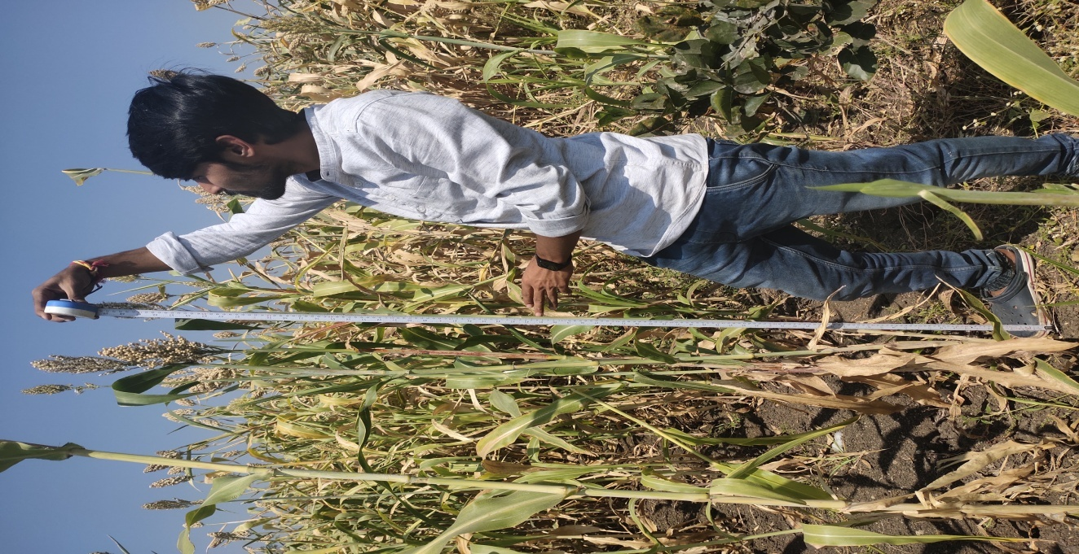
Fig.1 Measuring the height of a sorghum plant
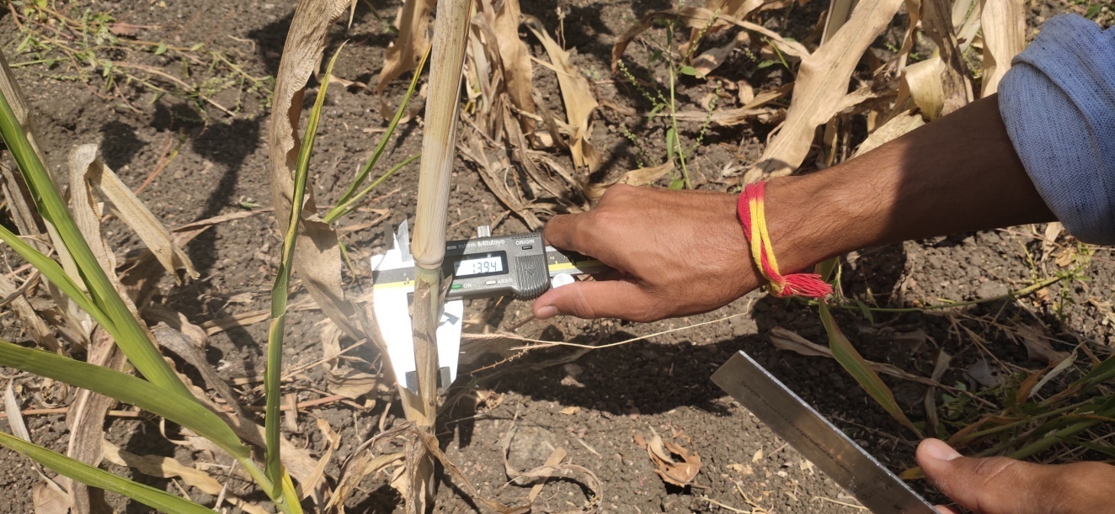
Fig. 2 Measuring the stalk diameter of a sorghum plant

Crop density
Crop density is defined as the plant population per unit square area. The plant population is a variable used in determining the quantity of the crop handled by the machine per unit time for different speeds. A one square meter frame was placed at five places chosen randomly in the plot to determine the crop density (Ashok Kumar et al., 2017).
Length of the ear head
The length of the ear head is an important crop parameter in relation to the design of the conveying unit. The length of the ear head was measured and recorded from five randomly selected ear heads in each plant using a 30-meter steel tape. It was measured from the bottom of the ear head to the tip of the ear head, and their average value was recorded as shown in Fig.3. A Stanley steel tape with 0.1 cm divisions was used for measuring the length of the ear head of sorghum.
Row spacing and plant spacing
Row spacing was considered as very important parameter which facilitates easy movement of the machine and row dividers in standing crop without any damage to the plants. The row-to-row spacing and plant-to-plant spacing were measured and recorded in five randomly selected positions using tape. Row to row spacing was measured by measuring the distance between each row is as shown in Fig.4. Plant to plant spacing was measured by measuring the distance between one plant to another plant, as shown in Fig.5. (Rabnawaz et al., 2018).
Results and discussion

The average values of these parameters, representing the growth and maturity status of the crop at harvest, are compiled and presented in Table 1. This data forms the basis for evaluating the field performance of the harvester under varying crop and field conditions.
Crop height (mm)
The plant height of the sorghum crop among the different selected varieties ranged from 1120 mm to 1890 mm, indicating a considerable variation in growth characteristics across genotypes. The mean plant heights of the respective varieties — Hytech-3201, Varada-14, Sriram-5001, Jockey, M 35-1, Mahindra, and Teja — were 1692 mm, 1626 mm, 1660 mm, 1629 mm, 1628 mm, 1258 mm, and 1506 mm, respectively, as presented in Table 1.
The observed variation in plant height may be attributed to genetic differences among varieties, soil fertility status, and environmental conditions prevailing during the crop growth period. Taller varieties such as Hytech-3201 and Sriram-5001 exhibited more vigorous vegetative growth, which could influence the cutting efficiency and lodging tendency during harvesting. Conversely, relatively shorter varieties like Mahindra and Teja are expected to offer better stability and ease of harvesting due to their compact stature. Hence, understanding these height variations is essential for evaluating the performance and adaptability of the harvester under diverse field conditions
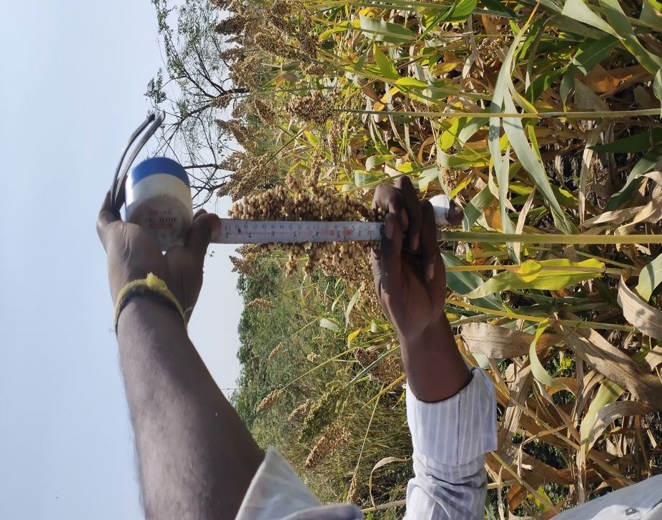
Fig. 3. Measuring the length of the ear head of a sorghum plant

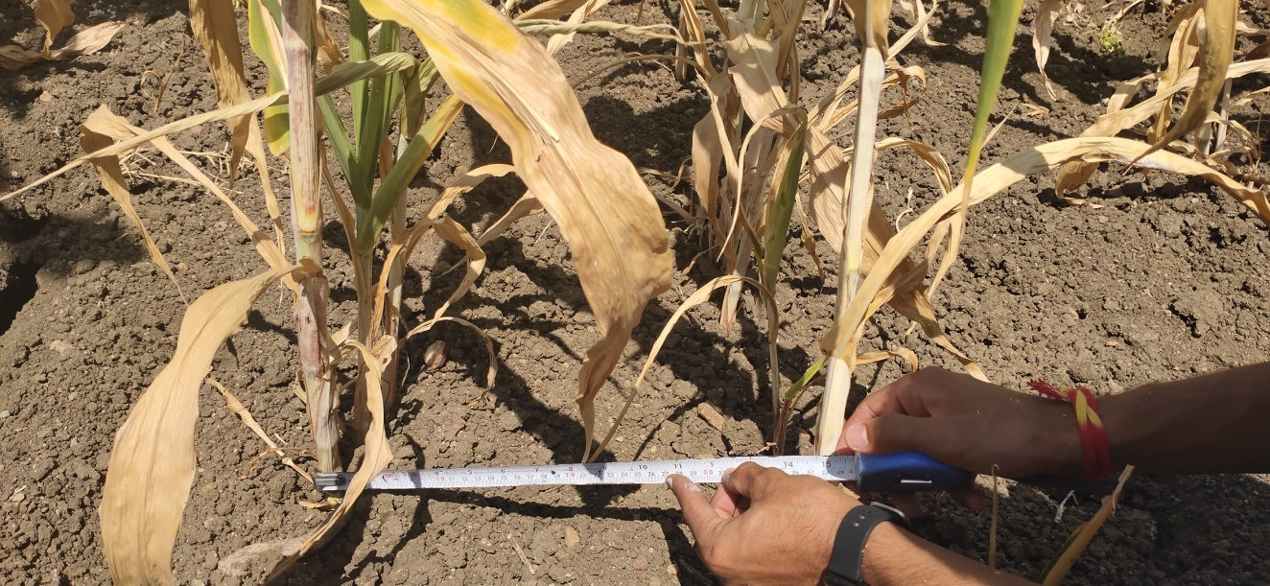
Fig.4. Measuring row spacing of the sorghum crop

Fig. 5 Average height of selected sorghum varieties
Stalk diameter
The average stalk diameter of the selected sorghum varieties ranged from 6 mm to 33 mm, indicating a wide variation in stem thickness among the genotypes. The mean stalk diameters of Hytech-3201, Varada-14, Sriram-5001, Jockey, M 35-1, Mahindra, and Teja were 22.00 mm, 28.00 mm, 11.00 mm, 15.70 mm, 13.20 mm, 11.00 mm, and 21.20 mm, respectively, as presented in Table 1. The standard deviations of the stalk diameters for the respective varieties were 6.04, 4.47, 3.16, 3.27, 2.39, 3.16, and 3.11, as illustrated in Figure 6, indicating moderate variability within each variety. The variation in stalk diameter can be attributed to genetic makeup, plant age, and growth conditions, which influence the stem rigidity and structural strength of the crop.
Thicker stalks, as observed in Varada-14 and Hytech-3201, generally require higher cutting force and energy input during harvesting, whereas thinner stalks, such as those of Sriram-5001 and Mahindra, can be cut more easily but may be more prone to lodging. Thus, assessing stalk diameter is essential for optimising cutter bar design and evaluating the mechanical performance of the harvesting unit under field conditions.

Fig. 6. Average stalk diameter of selected sorghum varieties
Earhead length
The ear head length of the sorghum crop among the selected varieties ranged from 170 mm to 350 mm, showing notable variation in panicle size across genotypes. The mean ear head lengths of Hytech-3201, Varada-14, Sriram-5001, Jockey, M 35-1, Mahindra, and Teja were 312 mm, 296 mm, 172 mm, 264 mm, 196 mm, 172 mm, and 272 mm, respectively. The corresponding standard deviations were 31.14, 29.66, 25.88, 30.50, 23.02, 25.88, and 19.23, respectively, as presented in Figure 7. The variation in ear head length among the sorghum varieties can be attributed to genetic differences, environmental factors, and management practices influencing panicle development and grain filling. Longer ear heads, as observed in Hytech-3201 and Varada-14, generally indicate better grain-bearing capacity and higher potential yield, whereas shorter ear heads, as in Sriram-5001 and Mahindra, may reflect short-duration growth or limited nutrient availability during the reproductive stage. Understanding ear head length is crucial as it directly affects harvestable yield, header losses, and crop handling efficiency during mechanical harvesting operations.
Crop density
The average crop stand density of the sorghum crop varied from 10 to 27 plants per square meter, reflecting differences in germination, plant vigour, and planting pattern among the selected varieties. The mean crop stand densities for Hytech-3201, Varada-14, Sriram-5001, Jockey, M 35-1, Mahindra, and Teja were 25.00, 22.40, 18.60, 12.40, 22.40, 16.20, and 20.80 plants/m², respectively. The corresponding standard deviations were 1.58, 1.64, 1.14, 0.89, 1.52, 1.14, and 2.17, as shown in Figure 8. The variation in crop stand density among the varieties can be attributed to differences in seed size, germination percentage, and plant establishment. A higher plant population, as observed in Hytech-3201 and Varada-14, tends to produce denser crop stands, influencing the material flow and feeding rate during harvesting. Conversely, lower plant densities, such as in Jockey and Mahindra, result in reduced crop bulk, allowing smoother material handling. The crop stand density plays a crucial role in designing the conveyor system of the harvesting machine. A higher density requires the conveyor to handle greater crop volume per unit time, necessitating adjustments in belt width, speed, and conveying capacity to ensure continuous and uniform flow without blockage or spillage. Therefore, accurate determination of crop stand density is essential for optimising the conveyor design parameters, such as feed rate, conveying velocity, and power requirement, ensuring efficient crop transfer from the cutter bar to the collection unit.

Table 1. Physical crop parameters of selected sorghum varieties
SI. No. | Crop Parameters | Variety | Hytech 3201 | Varada-14 | Sriram 5001 | Jockey | M-35-1 | Mahindra | Teja
1 | Plant height, mm | Maximum | 1850.00 | 1830.00 | 1890.00 | 1670.00 | 1800.00 | 1500.00 | 1550.00
1 | Plant height, mm | Minimum | 1490.00 | 1500.00 | 1560.00 | 1590.00 | 1500.00 | 1120.00 | 1450.00
1 | Plant height, mm | Mean | 1692.00 | 1626.00 | 1660.00 | 1629.00 | 1628.00 | 1258.00 | 1506.00
1 | Plant height, mm | SD | 155.95 | 146.05 | 131.34 | 31.70 | 133.30 | 145.33 | 40.37
1 | Plant height, mm | CV (%) | 9.22 | 8.98 | 7.91 | 1.95 | 8.19 | 11.55 | 2.68
2 | Plant stalk diameter, mm | Maximum | 30.00 | 33.00 | 14.00 | 20.00 | 16.00 | 14.00 | 25.00
2 | Plant stalk diameter, mm | Minimum | 15.00 | 22.00 | 6.00 | 12.00 | 10.00 | 6.00 | 18.00
2 | Plant stalk diameter, mm | Mean | 22.00 | 28.00 | 11.00 | 15.70 | 13.20 | 11.00 | 21.20
2 | Plant stalk diameter, mm | SD | 6.04 | 4.47 | 3.16 | 3.27 | 2.39 | 3.16 | 3.11
2 | Plant stalk diameter, mm | CV (%) | 27.46 | 15.97 | 28.75 | 20.83 | 18.09 | 28.75 | 14.69
3 | Ear head length, mm | Maximum | 350.00 | 330.00 | 200.00 | 300.00 | 230.00 | 200.00 | 300.00
3 | Ear head length, mm | Minimum | 280.00 | 250.00 | 140.00 | 220.00 | 170.00 | 140.00 | 250.00
3 | Ear head length, mm | Mean | 312.00 | 296.00 | 172.00 | 264.00 | 196.00 | 172.00 | 272.00
3 | Ear head length, mm | SD | 31.14 | 29.66 | 25.88 | 30.50 | 23.02 | 25.88 | 19.23
3 | Ear head length, mm | CV (%) | 9.98 | 10.02 | 15.05 | 11.55 | 11.75 | 15.05 | 7.07
4 | Crop stand density, No of plants/m² | Maximum | 27.00 | 22.00 | 24.00 | 20.00 | 14.00 | 24.00 | 19.00
4 | Crop stand density, No of plants/m² | Minimum | 23.00 | 18.00 | 21.00 | 18.00 | 10.000 | 21.00 | 14.00
4 | Crop stand density, No of plants/m² | Mean | 25.00 | 19.80 | 22.40 | 18.60 | 12.40 | 22.40 | 16.20
4 | Crop stand density, No of plants/m² | SD | 1.58 | 1.64 | 1.14 | 0.89 | 1.52 | 1.14 | 2.17
4 | Crop stand density, No of plants/m² | CV (%) | 6.32 | 8.30 | 5.09 | 4.81 | 12.23 | 5.09 | 13.38

Fig. 7. Average ear head length of selected sorghum varieties

Fig 8. Average crop density (No./m²) of selected sorghum varieties
Row spacing and Plant spacing
The row spacing of the sorghum crop in the experimental fields ranged from 35 to 40 cm, while the intra-row (plant-to-plant) spacing varied between 14 and 18 cm. Such spacing ensured adequate plant population and uniform crop establishment across the field. The selected spacing also facilitated optimal aeration, sunlight interception, and nutrient utilization, contributing to uniform crop growth and development.
Row and plant spacing are important agronomic factors influencing crop stand density, biomass distribution, and ultimately the design and operation of harvesting mechanisms. In particular, they directly affect the width and alignment of the crop inlet and conveyor system in the harvester. Proper consideration of these parameters ensures efficient crop gathering, conveying, and cutting performance during mechanical harvesting operations.
Conclusion

The physical crop parameters of the selected sorghum varieties are essential for the design and development of a sorghum harvester, as they directly influence the functional performance of the machine. Hence, the key physical parameters of the selected sorghum varieties were measured and analysed in the present study.
The average plant height of the selected varieties ranged from 1120 mm to 1890 mm, while the average stalk diameter varied between 6 mm and 33 mm. The crop stand density ranged from 10 to 27 plants per square meter, and the ear head length varied from 170 mm to 350 mm among the different varieties. The row spacing of the sorghum crop was observed to be in the range of 35–40 cm, and the plant spacing varied between 14–18 cm.
These measured parameters were used as the basis for designing the critical components of the sorghum harvester, such as the cutting unit, conveying mechanism, and crop handling system. Designing the harvester based on the optimised physical properties ensures efficient operation, reduced crop loss, and improved field performance under varying crop and field conditions.

Disclaimer (Artificial intelligence)
Option 1:
Author(s) hereby declare that NO generative AI technologies such as Large Language Models (ChatGPT, COPILOT, etc.) and text-to-image generators have been used during the writing or editing of this manuscript.
Option 2:
Author(s) hereby declare that generativ AI technologies such as Large Language Models, etc. have been used during the writing or editing of manuscripts. This explanation will include the name, version, model, and source of the generative AI technology and as well as all input prompts provided to the generative AI technology
Details of the AI usage are given below:
1.
2.
3.

REFERENCES
Anon. (2003). Sorghum: Crop description and growth characteristics. Food and Agriculture Organization (FAO).
Anon. (2018). Agricultural statistics at a glance 2018–19. Directorate of Economics and Statistics, Ministry of Agriculture and Farmers Welfare, Government of India.
Anon. (2019). Agricultural statistics at a glance 2019–20. Directorate of Economics and Statistics, Ministry of Agriculture and Farmers Welfare, Government of India.
Dicko, M. H., Gruppen, H., Traoré, A. S., Voragen, A. G. J., & van Berkel, W. J. H. (2006). Sorghum grain as human food in Africa: Relevance of content of starch and amylase activities. African Journal of Biotechnology, 5(5), 384–395.
INDIASTAT. (2020). Agricultural production statistics: Sorghum area, production and productivity in India (2019–2021). Retrieved from https://www.indiastat.com
Kumar Charyulu, D. (2011). Sorghum research and production trends in India. National Institute of Agricultural Extension Management (MANAGE), Hyderabad, India.
Mantesh. (2006). Performance evaluation of different crop harvesters (Master’s thesis). University of Agricultural Sciences, Raichur, India.
Sahay, J. (2010). Elements of agricultural engineering (5th ed.). Standard Publishers Distributors.
Sawant B P; Munde P A; 2010. Effect of moisture content on selected physical properties of pulses. Int. J. Agric. Engg., 2(2), 270-272.
USDA. 2020. https://www.fas.usda.gov/data/search ?reeports%
Yiljep Y D; Mohammed U S; 2005. Effect of knife velocity on cutting energy and efficiency during impact cutting of sorghum stalk. Ag. Engg. Int. The CIGR e- J., (7), 1-10.
He, Q., Wang, Q., Geng, D., Li, D., Niu, L., Ma, J., Zhang, C., Ming, J., & Ni, L. (2023). Design and Experiment of Grain Lifter for Sorghum Harvester. Applied Sciences, 13(24), 13168.
Kankal, U. S., Thakare, S. H., Gajakos, A. V., Kamble, A. K., Karale, D. S., & Walke, R. D. (2025). Economic feasibility analysis of sorghum harvester. Journal of Agriculture and Ecology Research International, 26(5), 97–106.
Khalifa, M., & Eltahir, E. A. (2023). Assessment of global sorghum production, tolerance, and climate risk. Frontiers in Sustainable Food Systems, 7, 1184373.
Kazungu, F. K., Muindi, E. M., Mulinge, J. M., Wamukota, A. W., Muchomba, M. K., Okello, N., Wekesa, G., & Ahmed, H. (2023). Sorghum growth and yield as influenced by farmyard manure and inorganic fertilizer in post mined soils. International Journal of Plant & Soil Science, 35(16), 331–341.

