Original Research Article
Impact of High-Density Planting on Seasonal Incidence of Sucking Pests and Pink Bollworm, Pectinophora gossypiella in Cotton

Abstract
The present investigation on the dynamics of insect pests of cotton under the High-Density Planting System (HDPS) was conducted during Kharif 2024 at the All India Coordinated Research Project (AICRP) on Cotton, Haradanahalli Farm, Chamarajanagar. The study aimed to elucidate the seasonal incidence of major pests and their association with weather parameters. Results revealed distinct interactions between pest incidence, crop growth stages, and prevailing climatic conditions. Among the sucking pests, aphids and leafhoppers appeared during the early crop stages, with populations increasing as the crop advanced. Although overall pest incidence was comparable among the four cotton genotypes evaluated, the non-Bt hybrid ‘Suraj’ exhibited higher susceptibility to sucking pests. Peak infestations of aphids (41.60 per 3 leaves) and whiteflies (3.46 per 3 leaves) occurred during the 35th standard meteorological week (SMW), while leafhoppers (2.42 per 3 leaves) and thrips (6.43 per 3 leaves) reached maxima in the 43rd SMW. Correlation analyses indicated that aphids and whiteflies were positively associated with maximum temperature (r = 0.509–0.741) and negatively correlated with relative humidity and rainfall. Leafhoppers showed positive correlations with maximum temperature (r = 0.244–0.375) and morning relative humidity (r = 0.521–0.739), but negative relationships with minimum temperature and rainfall. Thrips exhibited weak positive associations with temperature and morning humidity, but strong negative relationships with minimum temperature and rainfall. The pink bollworm larval population was strongly negatively correlated with minimum temperature (r = –0.801 to –0.862). Overall, weather factors together accounted for 55–57% of the variation in pest incidence, emphasizing the significant role of temperature, humidity, and rainfall in influencing pest population dynamics under HDPS cotton.
Keywords: High-Density Planting System (HDPS), Sucking pests, Pink bollworm, Pectinophora gossypiella, Weather parameters, Temperature

1. Introduction
Cotton (Gossypium spp.), belonging to the family Malvaceae, is one of the most important fibre-yielding crops cultivated in India and in more than seventy cotton-growing countries worldwide. Due to its immense contribution to industrial and economic development, as well as its vital role in foreign exchange earnings, cotton is often regarded as “White Gold.” India earns approximately 12–14 billion US dollars annually through the export of cotton yarn, thread, fabric, and garments. The crop provides livelihood to millions of people engaged in its production, processing, marketing, and trade, contributing around 13.5 million bales (170 kg each) to the nation’s total output. The combined domestic and international trade value of Indian cotton has been estimated at Rs. 15,000 crores (30 billion US dollars) per annum (Anonymous, 2024b).
In India, nearly 160 insect pest species have been reported to infest cotton from seedling to harvest stages (Agrawal, 1978), causing 20–80% yield losses under favourable conditions (Thakare et al., 1983). Among these, a few have attained major pest status due to their frequent and widespread occurrence. The predominant sucking pests associated with Bt cotton include aphids (Aphis gossypii Glover), leafhoppers (Amrasca biguttula biguttula Ishida), thrips (Thrips tabaci Lindeman), and whiteflies (Bemisia tabaci Gennadius).
In recent years, cotton productivity has been severely affected by the resurgence and resistance development of the pink bollworm (Pectinophora gossypiella) against first- and second-generation Bt cotton hybrids. This pest alone has been reported to cause 2.8–61.90 % reduction in seed cotton yield, 2.10–47.10% loss in oil content, and 10–55% damage to green bolls (Anonymous, 2024a).
Environmental and weather parameters exert a profound influence on the abundance, survival, and activity of insect pests and their natural enemies, either directly or indirectly (Arif et al., 2007). Developing weather-based pest forecasting models requires a comprehensive understanding of the relationships between pest population fluctuations and prevailing climatic factors such as temperature, relative humidity, and rainfall. These meteorological variables not only govern pest incidence but also influence crop growth and phenology. Therefore, understanding the interactions among crop growth stages, pest dynamics, and weather parameters is essential for developing effective and reliable pest forecasting and management systems. (Divya et al., 2020)
Temperature plays a critical role in cotton planting decisions, influencing seed germination, plant growth, and overall yield potential. Warm conditions promote vigorous growth, whereas cooler weather slows development, increases susceptibility to chilling injury, and elevates biotic stress risks. Excessively high temperatures impair seedling emergence and vigour, emphasizing the importance of identifying optimal temperature ranges that ensure healthy crop establishment. Soil temperature, being closely linked to air temperature, directly affects seed placement and early development by shaping the thermal environment of the seed zone. Climate variability further complicates this relationship by introducing inconsistent weather patterns. Identifying optimal planting windows allows farmers to avoid cold spells while ensuring sufficient heat accumulation for crop establishment. Temperature-based indices, such as heat units, are valuable tools in determining suitable conditions for key developmental stages (Soni et al., 2025).
The incidence and development of insect pests are largely dependent on prevailing environmental conditions and crop canopy structure. Both sucking pests and bollworms continue to pose major threats to cotton production under normal planting systems. Changes in plant density significantly modify the crop microclimate, which in turn may influence pest and disease incidence (Venugopalan et al., 2014). Concerns have been raised that the altered microclimate under high-density planting systems (HDPS) could aggravate pest infestations and disease severity. However, studies on the influence of HDPS and varying nutrient levels on insect pest incidence across different agro-ecological zones remain limited.
Considering these aspects, the present investigation was undertaken to explore the impact of closer spacing on sucking pests and pink bollworm infestation in cotton. The study aimed to evaluate pest incidence under different planting geometries and nutrient levels to achieve sustained higher yields in cotton cultivated under the High-Density Planting System (HDPS).
2. Materials and Methods
2.1 Experimental Details
The present investigation was carried out during the kharif season of 2024 at the All India Coordinated Research Project (AICRP) on Cotton, Haradanahalli Farm, Chamarajanagar, to study the population dynamics of sucking pests and pink bollworm in relation to prevailing meteorological parameters. The experiment was conducted on four popular cotton hybrids, viz., DCH-32 (Bt), Bahubali (BG-II), KCH-9292 (BG-II), and Suraj (non-Bt).
The seeds of each hybrid were sown during the first week of August, 2024, in field plots of 500 m² area per hybrid, maintaining a row-to-row spacing of 90 cm and plant-to-plant spacing of 60 cm. All recommended agronomic practices were followed uniformly across treatments throughout the crop growth period under unprotected field conditions.
2.2 Observation Recorded
The seasonal incidence of major sucking pests, namely Aphis gossypii (aphid), Amrasca biguttula biguttula (leafhopper), Bemisia tabaci (whitefly), and Thrips tabaci (thrips), was recorded at weekly intervals, starting from 45 days after sowing (DAS). Observations were taken on three leaves per plant (top, middle, and bottom canopy levels) from ten randomly selected plants in each plot. The incidence of pink bollworm (Pectinophora gossypiella Saunders) was assessed using the destructive sampling method. Observations were made at weekly intervals, starting from 60 DAS until harvest. For each hybrid, 20 randomly collected green bolls were examined, and the number of larvae per boll was recorded to estimate infestation levels.
2.3 Meteorological Data Collection
To establish the relationship between pest incidence and environmental conditions, data on meteorological parameters—including maximum and minimum temperature, relative humidity (morning and evening), number of rainy days, and total rainfall were obtained from the Agrometeorological Observatory Unit, AICRP on Cotton, Chamarajanagar. For analytical consistency, fortnightly mean values of these parameters were computed and used for statistical correlation and regression analyses.
2.4 Statistical Analysis
The relationships between pest incidence and meteorological factors were examined through Pearson’s correlation analysis to determine the degree and direction of association between pest populations and weather variables. Further, the combined influence of these parameters on pest dynamics was analyzed using Multiple Linear Regression (MLR) following the procedure described by Panse and Sukhatme (1967). All statistical computations were performed using SAS – Syntax Reference Guide, Version 16 (SPSS, 2016; South Wacker Drive, Chicago, IL).
3. Results
3.1 Influence of meteorological variables on the population of aphids, Aphis gossypii (Glover) [Aphididae: Hemiptera]
The population dynamics of aphids were monitored weekly on four cotton hybrids, viz., DCH-32 (BG-II), Bahubali (BG-II), KCH-9292 (BG-II), and the non-Bt hybrid Suraj, starting from 45 days after sowing (DAS) and continuing until harvest (Table 2; Fig. 1). Aphid infestation persisted throughout the cropping period, exhibiting two to three distinct population peaks corresponding to favourable weather conditions.
The first major peak occurred during the 35th Standard Meteorological Week (SMW) (last week of August), with mean densities of 43.50, 42.70, 42.79, and 37.42 aphids per three leaves on DCH-32, Bahubali, Suraj, and KCH-9292, respectively. This outbreak coincided with warm (32.2 °C) and dry conditions (0 mm rainfall), accompanied by low afternoon relative humidity (42%). A second peak was recorded during the 40th SMW (early October), when Bahubali (28.13) and Suraj (32.50) supported higher populations, followed by KCH-9292 (24.72) and DCH-32 (10.50) aphids per three leaves. This increase was associated with moderate rainfall (17 mm), maximum temperatures around 30.5 °C, and afternoon relative humidity of 52%. A minor resurgence was also observed during the 43rd SMW (late October) under renewed warm and dry conditions.
Correlation analysis revealed a positive association between maximum temperature and aphid incidence across all hybrids—DCH-32 (r = 0.515), Bahubali (r = 0.714), Suraj (r = 0.509), and KCH-9292 (r = 0.626)—indicating that higher temperatures favoured aphid proliferation. In contrast, rainfall exhibited a negative correlation with aphid populations, ranging from –0.482 (DCH-32) to –0.348 (KCH-9292), suggesting that increased rainfall suppressed population build-up. Minimum temperature, morning relative humidity, and evening relative humidity also showed weak to moderate negative correlations with aphid abundance (Table 1).
The coefficient of determination (R²) values indicated that weather parameters collectively explained 65.81% of the variation in aphid populations on DCH-32, followed by Suraj (38.12%), Bahubali (37.59%), and KCH-9292 (32.13%). These findings demonstrate that environmental factors had a stronger influence on aphid dynamics in DCH-32 compared to the other hybrids.
Table 1: Correlation between aphids incidence on cotton hybrids and meteorological variables during Kharif- 2024
Hybrid/ Variety | Rain fall  (mm) | Temp max  (°C) | Temp min  (°C) | RH max  (%) | RH min  (%) | R²  Value
DCH-32 | -0.482 | 0.514* | -0.326 | 0.422 | -0.482 | 0.658
Bahubali | -0.450 | 0.714* | -0.347 | 0.353 | -0.293 | 0.375
Suraj | -0.442 | 0.508* | -0.327 | 0.371 | -0.310 | 0.381
KCH-9292 | -0.448 | 0.626* | -0.319 | 0.372 | -0.218 | 0.321
N=18; * Significant at p ≤ 0.05
Temp: Temperature RH: Relative humidity, max: Maximum, min: Minimum
The positive influence of maximum temperature on aphid incidence may be attributed to its role in shortening developmental duration and increasing reproductive rates. Elevated temperatures, coupled with mild water stress, can increase the concentration of soluble nutrients in the phloem, enhancing host plant suitability for aphids. In contrast, high rainfall and humidity likely reduce aphid abundance through direct mechanical dislodgment, unfavorable leaf-surface microclimates, and enhanced activity of natural enemies.
Table 2: Seasonal incidence of aphids on cotton hybrids in relation to abiotic factors during Kharif-2024
SMW | Weather parameters |  |  |  |  | Aphids/3 leaves
SMW | Rain fall  (mm) | Temp max  (°C) | Temp min  (°C) | RH max  (%) | RH min  (%) | DCH-32 | Bahubali | Suraj | KCH- 9292
30 | 10 | 30.1 | 24.5 | 99 | 62 | 17.31 | 25.68 | 25.6 | 23.98
31 | 74 | 28.96 | 21.97 | 98 | 60 | 15.21 | 8.94 | 8.94 | 17.62
32 | 16 | 26.85 | 22.35 | 93 | 51 | 3.61 | 4.92 | 4.95 | 4.49
33 | 17.5 | 33.7 | 24.63 | 97 | 50 | 4.91 | 5.25 | 5.98 | 6.77
34 | 1 | 30.95 | 20.71 | 98 | 48 | 28.4 | 7.810 | 7.81 | 15.56
35 | 0 | 32.2 | 19.2 | 99 | 42 | 43.5 | 42.70 | 42.79 | 37.42
36 | 27.5 | 27.46 | 20.77 | 98 | 49 | 9.62 | 10.11 | 10.22 | 11.43
37 | 60.5 | 34.52 | 21.1 | 96 | 63 | 5.53 | 11.98 | 11.97 | 13.47
38 | 102 | 30.5 | 20.5 | 94 | 78 | 4.98 | 6.28 | 7.16 | 10.25
39 | 27 | 30.5 | 21.5 | 99 | 57 | 2.35 | 4.72 | 4.30 | 2.71
40 | 17 | 30.5 | 19 | 97 | 52 | 10.50 | 28.13 | 32.50 | 24.72
41 | 10 | 30.8 | 20.3 | 99 | 48 | 12.80 | 23.56 | 26.72 | 21.22
42 | 19 | 30.5 | 18.73 | 97 | 62 | 9.80 | 18.69 | 15.23 | 18.98
43 | 0 | 30.2 | 17.71 | 99 | 53 | 24.30 | 28.30 | 25.9 | 24.36
44 | 53 | 27.5 | 18.97 | 94 | 50 | 9.63 | 10.20 | 8.20 | 9.30
45 | 11 | 31.5 | 19.75 | 92 | 52 | 15.39 | 15.38 | 14.56 | 16.14
46 | 0 | 27.63 | 17.01 | 99 | 47 | 14.36 | 13.23 | 16.18 | 15.38
47 | 0 | 30.8 | 18.7 | 98 | 45 | 20.68 | 15.23 | 14.36 | 13.65
SMW: Standard meteorological weeks Temp: Temperature RH: Relative humidity max: Maximum min: Minimum

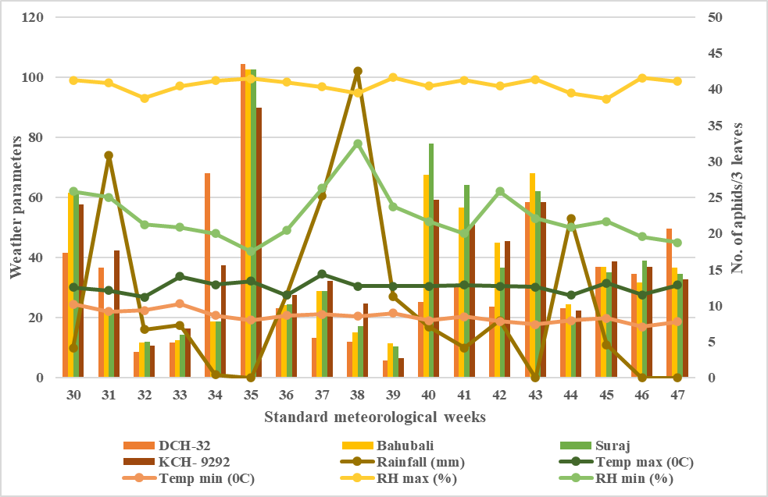
Fig. 1: Influence of meteorological variables on the incidence of aphid, Aphis gossypii, Kharif, 2024
3.2 Influence of meteorological parameters on the population dynamics of Amrasca biguttula biguttula (Ishida) [Cicadellidae: Hemiptera]
Observations recorded during the Kharif-2024 season indicated that leafhopper infestation commenced from the 30th Standard Meteorological Week (SMW) across all evaluated cotton hybrids. The population exhibited temporal fluctuations in response to prevailing weather patterns, with marked peaks during the later growth stages of the crop (Table 4 & Figure 2).
In DCH-32, infestation levels varied between 0.73 and 2.63 leafhoppers per three leaves, with the highest density (2.63 leafhoppers per 3 leaves) documented during the 43rd SMW when morning relative humidity reached 99 % and no precipitation was recorded. In Bahubali (BG-II) a peak population of 2.35 individuals per three leaves during the 46th SMW, coinciding with saturated morning humidity (99%) and prolonged dry conditions. In Suraj (non-Bt), the maximum population (2.93 leafhoppers per 3 leaves) noticed in the 47th SMW under relatively elevated maximum temperatures (30.8 °C) and absence of rainfall. Similarly, KCH-9292 (BG-II) recorded highest incidence (2.48 leafhoppers per 3 leaves) in the same week under comparable meteorological conditions.
Table 3: Correlation between leafhoppers incidence on cotton hybrids and meteorological variables during Kharif-2024
Hybrid/  variety | Rain fall  (mm) | Temp max  (°C) | Temp min  (°C) | RH max  (%) | RH min  (%) | R² value
DCH-32 | -0.617 | 0.374 | -0.351 | 0.695* | -0.529 | 0.484
Bahubali | -0.722 | 0.243 | -0.509 | 0.624* | -0.587 | 0.686
Suraj | -0.524 | 0.247 | -0.338 | 0.520* | -0.276 | 0.547
KCH-9292 | -0.568 | 0.269 | -0.385 | 0.739* | -0.286 | 0.595
N=18; * Significant at p ≤ 0.05
Temp: Temperature RH: Relative humidity max: Maximum min: Minimum

Table 4: Seasonal incidence of leafhoppers on cotton hybrids in relation to abiotic factors during Kharif-2024
SMW | Weather parameters |  |  |  |  | Leafhoppers / 3 leaves
SMW | Rain fall  (mm) | Temp max  (°C) | Temp min  (°C) | RH max  (%) | RH min  (%) | DCH-32 | Bahubali | Suraj | KCH-9292
30 | 10 | 30.1 | 24.5 | 99 | 62 | 1.13 | 1.20 | 1.54 | 1.60
31 | 74 | 28.96 | 21.97 | 98 | 60 | 0.87 | 1.00 | 0.93 | 1.13
32 | 16 | 26.85 | 22.35 | 93 | 51 | 1.13 | 1.10 | 0.87 | 0.87
33 | 17.5 | 33.7 | 24.63 | 97 | 50 | 1.33 | 1.50 | 1.00 | 1.07
34 | 1 | 30.95 | 20.71 | 98 | 48 | 1.92 | 1.80 | 1.92 | 1.68
35 | 0 | 32.2 | 19.2 | 99 | 42 | 2.60 | 2.30 | 1.98 | 1.62
36 | 27.5 | 27.46 | 20.77 | 98 | 49 | 1.27 | 1.17 | 0.73 | 0.93
37 | 60.5 | 34.52 | 21.1 | 96 | 63 | 1.40 | 1.27 | 1.00 | 1.33
38 | 102 | 30.5 | 20.5 | 94 | 78 | 0.73 | 0.93 | 0.93 | 0.87
39 | 27 | 30.5 | 21.5 | 99 | 57 | 1.07 | 1.07 | 1.73 | 1.27
40 | 17 | 30.5 | 19 | 97 | 52 | 1.40 | 1.53 | 1.47 | 1.27
41 | 10 | 30.8 | 20.3 | 99 | 48 | 1.35 | 1.67 | 1.32 | 1.13
42 | 19 | 30.5 | 18.73 | 97 | 62 | 1.20 | 1.30 | 1.73 | 1.41
43 | 0 | 30.2 | 17.71 | 99 | 53 | 2.63 | 2.20 | 2.50 | 2.44
44 | 53 | 27.5 | 18.97 | 94 | 50 | 0.87 | 0.68 | 0.87 | 0.80
45 | 11 | 31.5 | 19.75 | 92 | 52 | 1.80 | 1.87 | 0.93 | 1.53
46 | 0 | 27.63 | 17.01 | 99 | 47 | 1.00 | 2.35 | 1.00 | 1.45
47 | 0 | 30.8 | 18.7 | 98 | 45 | 2.30 | 2.20 | 2.93 | 2.48
SMW: Standard meteorological weeks Temp: Temperature RH: Relative humidity max: Maximum min: Minimum
Fig. 2: Influence of meteorological variables on the incidence of leafhopper, Amrasca biguttula biguttula during, Kharif, 2024
The correlation analysis (Table 3) revealed that in DCH-32, leafhopper abundance had a negative association with rainfall (r = –0.617) and minimum temperature (r = –0.351), while maximum temperature (r = 0.375) showed a weak positive association. Morning relative humidity (r =0.695) was positively correlated, whereas evening relative humidity (r = –0.529) was negatively related. The coefficient of determination (R² = 0.485) indicated that the analyzed weather variables collectively accounted for 48.5% of the variation in pest incidence.
A similar trend was observed in Bahubali (BG-II), where negative correlations were observed with rainfall (r = –0.722), minimum temperature (r = –0.510) and evening RH (r = –0.587), whereas maximum temperature (r = 0.244) and morning RH (r = 0.624) were positively associated with pest density. The relatively high R² value (0.686) suggested that nearly 69% of the variability in population dynamics was attributable to meteorological influences. For Suraj (non-Bt), rainfall (r = –0.524), minimum temperature (r = –0.339) and evening RH (r = –0.277) exhibited negative associations, while maximum temperature (r = 0.248) and morning RH (r = 0.521) were positively correlated. The R² value (0.548) indicated a moderate degree of weather influence on pest incidence.
In KCH-9292 (BG-II), rainfall (r = –0.568), minimum temperature (r = –0.386) and evening RH (r = –0.287) maintained negative associations, whereas maximum temperature (r = 0.269) and morning RH (r = 0.739) displayed positive relationships. The R² value (0.595) showed that approximately 60% of the variation in leafhopper population could be explained by weather factors. In general, morning relative humidity consistently exhibited a favourable association with A. biguttula biguttula incidence across hybrids, whereas higher rainfall and increased evening humidity tended to suppress pest build-up.
3.3 Influence of meteorological variables on the population of Bemisia tabaci [Aleurodidae: Hemiptera]
The seasonal incidence of whitefly adults on four cotton hybrids, namely DCH-32, Bahubali (BG-II), Suraj (non-Bt) and KCH-9292 (BG-II), is presented in Table 6 & Figure 3. The pest was first appeared during the 30th SMW with populations ranging between 2.25 and 2.62 adults/3 leaves. Numbers fluctuated in subsequent weeks, showing a gradual increase until a distinct peak during the 35th SMW, where DCH-32, Bahubali, Suraj, and KCH-9292 recorded 3.89, 2.98, 3.26, and 2.98 Whiteflies/3 leaves, respectively.
Following this peak, a sharp decline was observed between the 36th and 39th SMW, with the lowest incidence in the 38th SMW, where all hybrids recorded less than 0.53 Whiteflies /3 leaves. A secondary, moderate rise occurred in the 40th SMW, after which the population remained low until crop maturity. In all hybrids, the seasonal trend indicated that population build-up was favored by warmer and drier conditions, while heavy rainfall and high evening humidity coincided with population suppression.
Correlation analysis (Table 5) demonstrated distinct associations between meteorological variables and the seasonal population of Bemisia tabaci across the cotton hybrids evaluated. In DCH-32, the whitefly population exhibited a strong positive correlation with maximum temperature (r = 0.547) and a moderate positive association with morning relative humidity (r = 0.427). However, these correlations were not statistically significant. In contrast, rainfall (r = –0.731) and evening relative humidity (r = –0.658) showed strong and negative correlations, suggesting that heavy precipitation and increased evening moisture considerably suppressed whitefly proliferation. Minimum temperature (r = –0.068) maintained a weak negative correlation, indicating negligible influence on pest build-up. In Bahubali (BG-II), whitefly population exhibited a strong positive correlation with maximum temperature (r = 0.741) and morning relative humidity (r = 0.213) exhibited a weak positive relationship with whitefly abundance. Conversely, rainfall (r = –0.6587), evening relative humidity (r = –0.608), and minimum temperature (r = –0.007) were negatively correlated, although the effect of minimum temperature appeared marginal.
Table 5: Correlation between whiteflies incidence on cotton hybrids and meteorological variables during Kharif-2024
Hybrid/  variety | Rain fall  (mm) | Temp max  (°C) | Temp min  (°C) | RH max  (%) | RH min  (%) | R² value
DCH-32 | -0.731 | 0.546* | -0.068 | 0.427 | -0.658 | 0.441
Bahubali | -0.658 | 0.740* | -0.007 | 0.213 | -0.608 | 0.496
Suraj | -0.678 | 0.588* | -0.048 | 0.262 | -0.663 | 0.535
KCH-9292 | -0.653 | 0.727* | -0.003 | 0.216 | -0.619 | 0.499
N=18; * Significant at p ≤ 0.05
Temp: Temperature RH: Relative humidity max: Maximum min: Minimum
In Suraj (non-Bt), whitefly population exhibited a strong positive correlation with maximum temperature (r = 0.589) and morning relative humidity (r = 0.262) showed positive but weak correlations with population build-up. Rainfall (r = –0.678) and evening relative humidity (r= –0.6639) again displayed strong negative correlations, suggesting that moisture-related factors predominantly constrained whitefly survival and reproduction. Minimum temperature (r = –0.0487) maintained a weakly negative relationship. In KCH-9292 (BG-II), the population showed a similar trend, with strong positive associations for maximum temperature (r = 0.72) and weak positive associations for morning relative humidity (r = 0.216). Rainfall (r = –0.653), evening relative humidity (r = –0.619), and minimum temperature (r = –0.003) were negatively associated, indicating an overall suppressive role of these variables.
Across hybrids, maximum temperature demonstrated a tendency to favor whitefly population build-up, although morning relative humidity correlations remained weak to moderate in magnitude. Conversely, rainfall and evening relative humidity were consistently antagonistic to whitefly multiplication, with correlation coefficients often approaching strong negative values, implying significant suppression of pest incidence under conditions of frequent precipitation and moist evening microclimates.
Table 6: Seasonal incidence of whitefly on cotton hybrids in relation to abiotic factors during Kharif-2024
SMW | Weather parameters |  |  |  |  | Whiteflies/3 leaves
SMW | Rain fall  (mm) | Temp max  (°C) | Temp min  (°C) | RH max  (%) | RH min  (%) | DCH-32 | Bahubali | Suraj | KCH- 9292
30 | 10 | 30.1 | 24.5 | 99 | 62 | 2.50 | 2.62 | 2.25 | 2.25
31 | 74 | 28..96 | 21.97 | 98 | 60 | 1.21 | 1.50 | 1.23 | 1.50
32 | 16 | 26.85 | 22.35 | 93 | 51 | 2.34 | 2.68 | 2.45 | 2.68
33 | 17.5 | 33.7 | 24.63 | 97 | 50 | 2.89 | 2.59 | 2.52 | 2.59
34 | 1 | 30.95 | 20.71 | 98 | 48 | 3.45 | 3.42 | 3.23 | 3.42
35 | 0 | 32.2 | 19.2 | 99 | 42 | 3.89 | 2.98 | 3.26 | 2.98
36 | 27.5 | 27.46 | 20.77 | 98 | 49 | 0.98 | 0.81 | 1.50 | 0.81
37 | 60.5 | 34.52 | 21.1 | 96 | 63 | 1.20 | 1.32 | 1.32 | 1.32
38 | 102 | 30.5 | 20.5 | 94 | 78 | 0.29 | 0.23 | 0.53 | 0.23
39 | 27 | 30.5 | 21.5 | 99 | 57 | 0.89 | 0.53 | 0.93 | 0.93
40 | 17 | 30.5 | 19 | 97 | 52 | 2.50 | 3.26 | 3.26 | 3.26
41 | 10 | 30.8 | 20.3 | 99 | 48 | 1.80 | 1.82 | 1.82 | 1.82
42 | 19 | 30.5 | 18.73 | 97 | 62 | 1.60 | 1.52 | 1.52 | 1.52
43 | 0 | 30.2 | 17.71 | 99 | 53 | 1.90 | 1.63 | 1.63 | 1.63
44 | 53 | 27.5 | 18.97 | 94 | 50 | 1.20 | 1.54 | 1.54 | 1.54
45 | 11 | 31.5 | 19.75 | 92 | 52 | 1.00 | 1.50 | 1.50 | 1.50
46 | 0 | 27.63 | 17.01 | 99 | 47 | 2.94 | 2.60 | 2.60 | 2.60
47 | 0 | 30.8 | 18.7 | 98 | 45 | 3.45 | 2.82 | 2.10 | 2.10
SMW: Standard meteorological weeks Temp: Temperature RH: Relative humidity max: Maximum min: Minimum
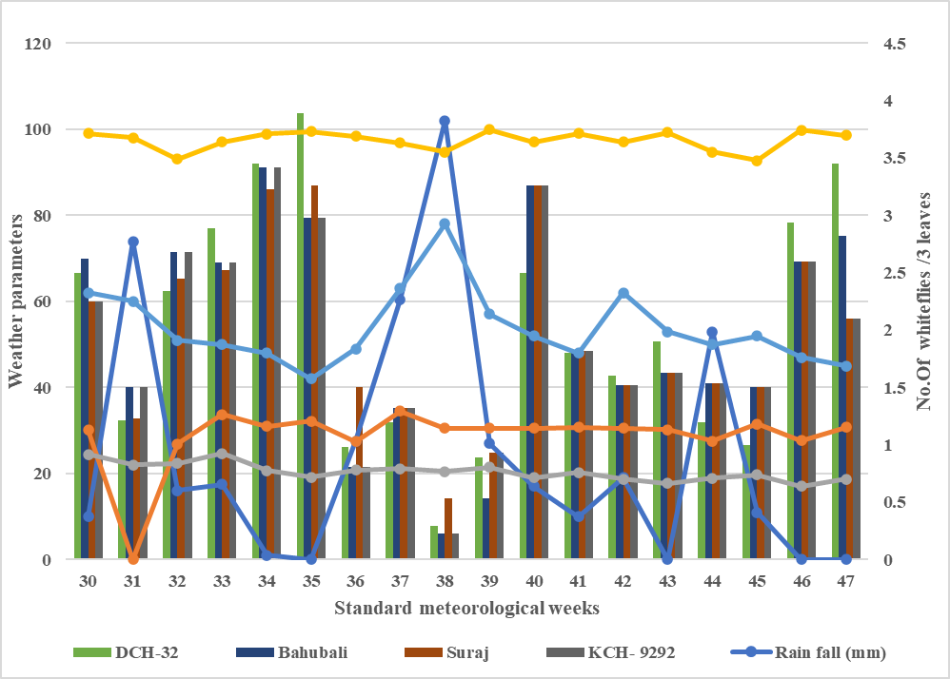
Fig. 3: Influence of meteorological variables on the incidence of Bemisia tabaci during Kharif, 2024
3.4 Influence of meteorological variables on the population of Thrips Tabaci (Thripidae: Hemiptera)
The seasonal abundance of T. tabaci on four cotton hybrids DCH-32, Bahubali (BG-II), Suraj (non-Bt), and KCH-9292 (BG-II) is summarised in Table 8 & Figure 4. Thrips incidence was first observed on the 30th (SMW) and persisted throughout the crop growth period. However, the population remained at relatively low levels until the 38th SMW. A distinct increase in infestation was recorded during the 35th SMW, with populations ranging from 4.23 to 4.81 thrips per three leaves across the hybrids. This phase of build-up was followed by a temporary decline during the 36th–38th SMW, which coincided with heavy rainfall events (up to 102 mm) coupled with high relative humidity, suggesting the suppressive role of precipitation on thrips survival.
The highest population densities occurred during the 42nd–43rd SMW with peak infestations of 6.34 thrips/3 leaves in DCH-32, 6.33 in Bahubali, 6.65 in Suraj, and 6.32 in KCH-9292. This late-season surge was most likely facilitated by declining rainfall and the prevalence of moderately dry yet humid morning conditions, which favored nymphal development and adult activity. Towards the end of the season (46th–47th SMW), a moderate resurgence was recorded, particularly in KCH-9292 (4.98–4.99 thrips/3 leaves), possibly reflecting overlapping generations under favorable microclimatic conditions.
The correlation analysis (Table 7) revealed differential responses of thrips populations to abiotic variables across the cotton hybrids in DCH-32 Thrips incidence was weakly and positively correlated with maximum temperature (r = 0.221) and morning relative humidity (r = 0.408). In contrast, rainfall (r = –0.566), minimum temperature (r = –0.485), and evening relative humidity (r = –0.304) were negatively associated, with rainfall exerting the most pronounced suppressive effect. In Bahubali (BG-II) a weak positive influence of maximum temperature (r = 0.068) and morning relative humidity (r = 0.418) was observed. Negative associations were found with rainfall (r = –0.602), minimum temperature (r = –0.630) and evening relative humidity (r = –0.393), with minimum temperature showing the strongest negative impact.
Table 7: Correlation between thrips incidence on cotton hybrids and meteorological variables during Kharif-2024
Hybrid/  variety | Rain fall  (mm) | Temp max  (°C) | Temp min  (°C) | RH max  (%) | RH min  (%) | R² value
DCH-32 | -0.566 | 0.221 | -0.485 | 0.408* | -0.304 | 0.475
Bahubali | -0.602 | 0.068 | -0.629 | 0.418* | -0.393 | 0.573
Suraj | -0.578 | 0.137 | -0.580 | 0.403* | -0.378 | 0.516
KCH-9292 | -0.614 | 0.002 | -0.662 | 0.431* | -0.418 | 0.641
N=18; * Significant at p ≤ 0.05
Temp: Temperature RH: Relative humidity max: Maximum min: Minimum
In Suraj (non-Bt) Maximum temperature (r = 0.137) and morning relative humidity (r = 0.403) maintained weakly positive correlations. Conversely, rainfall (r = –0.578), minimum temperature (r = –0.5802), and evening relative humidity (r = –0.378) displayed moderate negative correlations highlighting the suppressive role of precipitation and cooler nights. In KCH-9292 (BG-II) Morning relative humidity (r = 0.431) exhibited the strongest positive association with thrips abundance among the hybrids, whereas maximum temperature (r = 0.002) showed virtually no effect. Rainfall (r = –0.614), minimum temperature (r = –0.662), and evening relative humidity (r = –0.418) were negatively correlated, with minimum temperature being the most influential limiting factor.
Such variation may be exhibited from differences in hybrid susceptibility, planting season, local agro-climatic conditions, and microhabitat effects. The late-season peaks in thrips incidence in the present study coincided with periods of reduced rainfall, moderate night temperatures, and favorable morning humidity levels, conditions that collectively support multiple overlapping generations. These results highlight the ecological sensitivity of T. tabaci to both moisture and thermal regimes, underscoring the importance of integrating weather-based pest forecasting into cotton thrips management programs.
Table 8: Seasonal incidence of thrips on cotton hybrids in relation to abiotic factors during Kharif-2024
SMW | Weather parameters |  |  |  |  | Thrips/3 leaves
SMW | Rain fall  (mm) | Temp max  (°C) | Temp min  (°C) | RH max  (%) | RH min  (%) | DCH-32 | Bahubali | Suraj | KCH-9292
30 | 10 | 30.1 | 24.5 | 99 | 62 | 2.82 | 2.53 | 2.68 | 2.69
31 | 74 | 28.96 | 21.97 | 98 | 60 | 1.56 | 1.23 | 1.82 | 1.89
32 | 16 | 26.85 | 22.35 | 93 | 51 | 1.28 | 1.5 | 1.53 | 1.84
33 | 17.5 | 33.7 | 24.63 | 97 | 50 | 2.1 | 1.98 | 2.3 | 1.99
34 | 1 | 30.95 | 20.71 | 98 | 48 | 3.23 | 3.56 | 3.25 | 3.98
35 | 0 | 32.2 | 19.2 | 99 | 42 | 4.32 | 4.23 | 4.81 | 4.42
36 | 27.5 | 27.46 | 20.77 | 98 | 49 | 1.2 | 1.05 | 1.1 | 1.22
37 | 60.5 | 34.52 | 21.1 | 96 | 63 | 1.98 | 1.62 | 1.99 | 1.82
38 | 102 | 30.5 | 20.5 | 94 | 78 | 0.9 | 0.86 | 0.92 | 0.98
39 | 27 | 30.5 | 21.5 | 99 | 57 | 2.2 | 2.12 | 2.9 | 2.62
40 | 17 | 30.5 | 19 | 97 | 52 | 3.29 | 3.36 | 3.36 | 3.69
41 | 10 | 30.8 | 20.3 | 99 | 48 | 5.23 | 5.23 | 5.55 | 5.42
42 | 19 | 30.5 | 18.73 | 97 | 62 | 6.1 | 6.2 | 6.16 | 6.12
43 | 0 | 30.2 | 17.71 | 99 | 53 | 6.34 | 6.33 | 6.65 | 6.32
44 | 53 | 27.5 | 18.97 | 94 | 50 | 2.32 | 3.62 | 3.52 | 3.68
45 | 11 | 31.5 | 19.75 | 92 | 52 | 2.36 | 2.75 | 2.82 | 2.62
46 | 0 | 27.63 | 17.01 | 99 | 47 | 2.34 | 3.89 | 3.56 | 4.98
47 | 0 | 30.8 | 18.7 | 98 | 45 | 5.23 | 5.18 | 5.24 | 4.99
SMW: Standard meteorological weeks Temp: Temperature RH: Relative humidity max: Maximum min: Minimum
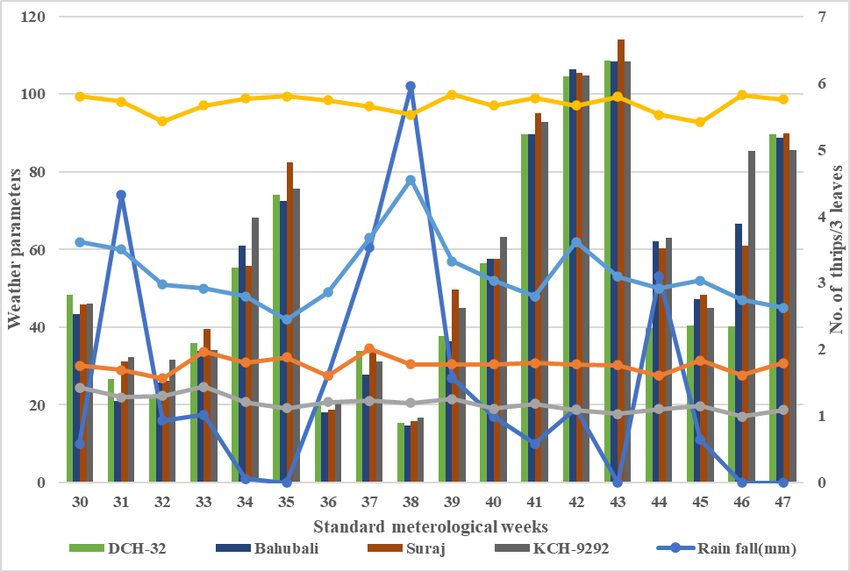
Fig. 4: Influence of meteorological variables on the incidence of Thrips tabaci, during Kharif,2024
3.5 Influence of meteorological variables on population of Pectinophora gossypiella (Gelechiidae: Lepidoptera)
The incidence pattern of pink bollworm (Pectinophora gossypiella) larvae on green bolls during Kharif -2024 was recorded on four cotton hybrids DCH-32, Bahubali (BG-II), Suraj (non-Bt), and KCH-9292 (BG-II) and is presented in (Table 10 & Figure 5). The pest was absent during the early crop stages (30th–34th SMW). Initial larval infestation was noticed during the 35th SMW with 10.20, 11.40, 12.50, and 10.40 larvae/20 green bolls on DCH-32, Bahubali, Suraj, and KCH-9292, respectively. From this point onward, larval numbers showed a gradual and consistent increase, reaching their peak during the 46th SMW (second fortnight of November) when maximum larval populations were recorded at 19.96 larvae/20 bolls in DCH-32, 19.82 in Bahubali, 19.50 in Suraj, and 19.96 in KCH-9292. Thereafter the larval population remained relatively high until the 47th SMW, coinciding with the late boll development stage.
Table 9: Correlation between pink bollworm incidence on cotton hybrids and meteorological variables during Kharif-2024
Hybrid/  Variety | Rain fall  (mm) | Temp max  (°C) | Temp min  (°C) | RH max  (%) | RH min  (%) | R² Value
DCH-32 | -0.115 | -0.025 | -0.821* | 0.0175 | -0.106 | 0.566
Bahubali | -0.108 | -0.026 | -0.801* | 0.0134 | -0.114 | 0.567
Suraj | -0.106 | -0.024 | -0.862* | 0.0184 | -0.130 | 0.547
KCH-9292 | -0.119 | -0.024 | -0.831* | 0.0195 | -0.106 | 0.570
N=18; * Significant at p ≤ 0.05
Temp: Temperature RH: Relative humidity max: Maximum min: Minimum

Table 10: Seasonal incidence of pink bollworm larvae on cotton hybrids in relation to abiotic factors during Kharif-2024
SMW | Weather parameters |  |  |  |  | Pink bollworm larvae/20 green bolls
SMW | Rain fall  (mm) | Temp max  (°C) | Temp min  (°C) | RH max  (%) | RH min  (%) | DCH-32 | Bahubali | Suraj | KCH-9292
30 | 10 | 30.1 | 24.5 | 99 | 62 | 0 | 0 | 0 | 0
31 | 74 | 28.96 | 21.97 | 98 | 60 | 0 | 0 | 0 | 0
32 | 16 | 26.85 | 22.35 | 93 | 51 | 0 | 0 | 0 | 0
33 | 17.5 | 33.7 | 24.63 | 97 | 50 | 0 | 0 | 0 | 0
34 | 1 | 30.95 | 20.71 | 98 | 48 | 0 | 0 | 0 | 0
35 | 0 | 32.2 | 19.2 | 99 | 42 | 10.20 | 11.40 | 12.50 | 10.40
36 | 27.5 | 27.46 | 20.77 | 98 | 49 | 10.90 | 11.80 | 11.80 | 10.90
37 | 60.5 | 34.52 | 21.1 | 96 | 63 | 12.50 | 12.50 | 12.38 | 12.40
38 | 102 | 30.5 | 20.5 | 94 | 78 | 12.30 | 12.90 | 12.99 | 12.20
39 | 27 | 30.5 | 21.5 | 99 | 57 | 15.30 | 15.80 | 16.80 | 15.30
40 | 17 | 30.5 | 19 | 97 | 52 | 14.30 | 16.30 | 16.70 | 14.30
41 | 10 | 30.8 | 20.3 | 99 | 48 | 16.80 | 16.90 | 16.98 | 16.80
42 | 19 | 30.5 | 18.73 | 97 | 62 | 16.98 | 16.80 | 16.40 | 17.89
43 | 0 | 30.2 | 17.71 | 99 | 53 | 17.86 | 17.83 | 17.53 | 17.50
44 | 53 | 27.5 | 18.97 | 94 | 90 | 16.98 | 17.60 | 18.50 | 16.98
45 | 11 | 31.5 | 19.75 | 92 | 52 | 18.62 | 18.90 | 18.90 | 18.50
46 | 0 | 27.63 | 17.01 | 99 | 47 | 19.96 | 19.82 | 19.50 | 19.96
47 | 0 | 30.8 | 18.7 | 98 | 45 | 19.25 | 19.30 | 19.89 | 19.50
SMW: Standard meteorological weeks Temp: Temperature RH: Relative humidity max: Maximum min: Minimum
Fig. 5: Influence of meteorological variables on the incidence of pink bollworm larval Pectinophora gossypiella. during Kharif, 2024
Correlation analysis (Table 9) revealed that in all hybrids, the PBW larval population exhibited a strong and significant negative association with minimum temperature (r = −0.821 for DCH-32, −0.801 for Bahubali, −0.862 for Suraj, and −0.831 for KCH-9292). Similarly, evening (minimum) relative humidity also showed a consistent negative relationship (ranging from −0.106 to −0.130), although the correlation was not statistically significant in all cases. Maximum temperature showed a weak, non-significant negative correlation across hybrids (r between −0.025 and −0.027), indicating that higher daytime temperatures did not directly favor larval abundance. Morning (maximum) relative humidity also had negligible correlation values (r = 0.013–0.019), suggesting minimal influence on infestation dynamics. Rainfall displayed a weak, non-significant negative relationship with larval numbers in all hybrids, implying that precipitation events did not substantially suppress larval populations. The coefficient of determination (R²) indicated that meteorological variables collectively explained 54.73–57.00 % of the variation in larval abundance, with KCH-9292 recording the highest R² (0.570) followed closely by Bahubali (0.567) and DCH-32 (0.566).
4. Discussion
These results are in close agreement with the findings of Chauhan et al. (2017) who reported that, “peak incidence of aphids was recorded in the month of September”. Similarly, the present findings are also in agreement with Nemade et al. (2018) who observed that “the population of aphids showed a non-significant negative correlation with morning and evening relative humidity and a significant positive correlation with maximum temperature”. The results on the influence of meteorological variables on leafhopper population are in close agreement with the findings of Kataria et al. (2017), who reported “peak incidence of leafhoppers was observed during the second fortnight of July and their population showed non-significant positive correlation with temperature, relative humidity and a negative correlation with rainfall”. A correlation relationship between pest population dynamics and weather variables and similar observations were recorded by Soni and Dhakad. However, the study conducted by Kadam et al. also similar with our findings with respect to maximum temperature, but results differed in relative humidity and rainfall. Our study again differs from Hussain et al. findings in terms of maximum temperature, rainfall and relative humidity temperature while it was in line with one parameter i.e. minimum temperature and significantly positively. The finding of Laxman et al. does not support our findings as their study showed a negative correlation with rainfall. Similarly, the present findings are more or less related to the findings of Janu et al. (2017) and Navi et al. (2021) who indicated that “minimum temperature and morning relative humidity had a high impact on the population of thrips”.
The observed negative relationship with minimum temperature suggests that cooler night conditions during the late crop season favoured PBW larval development and survival, in agreement with the findings of Vora et al. (2024), who reported that PBW infestation typically peaks during cooler post-monsoon periods. Similarly, the inverse association with evening relative humidity may be linked to reduced fungal pathogen activity under drier night conditions, allowing higher larval survival rates (Chaudhari and Sisodiya 2024), a weak relationship with rainfall, indicating that PBW activity is largely independent of precipitation once bolls are available. The results of the present findings are in close agreement with Rawal et al. (2017), who reported that “the population of bollworm were positively correlated with morning relative humidity. Minimum and maximum temperature, rainfall and evening relative humidity were negatively correlated”. Similarly, Laxman et al. (2014) indicated that “both American and pink bollworm showed a positive correlation with morning relative humidity. Minimum and maximum temperature, rainfall and evening relative humidity were negatively correlated to the incidence of pink bollworm both on Bt and non-Bt cotton”.
5. Conclusion
The present investigation on cotton grown under the High-Density Planting System (HDPS) provided valuable insights into the seasonal dynamics of major insect pests and their association with weather parameters. The crop was initially infested by aphids and leafhoppers, which established during the early vegetative stages and increased as the crop matured. Thrips and whiteflies appeared early but attained their peak densities during the later growth phases, indicating a delayed buildup. Pink bollworm incidence was confined mainly to the reproductive stage, reflecting its dependence on developing fruiting bodies. Among the genotypes studied, the non-Bt hybrid Suraj recorded higher susceptibility to sucking pests, while BG-II hybrids exhibited comparatively lower pest loads, suggesting varietal influence on pest incidence.
Correlation analyses revealed that maximum temperature positively influenced aphid, whitefly, and leafhopper populations, whereas minimum temperature, relative humidity, and rainfall exerted a suppressive effect. Pink bollworm larval incidence showed a strong negative association with minimum temperature, while other weather variables had relatively minor impacts. Collectively, climatic factors explained 55–57% of the variation in pest incidence across hybrids, underscoring the dominant role of environmental conditions in shaping pest population dynamics.
The study emphasizes the need to understand seasonal occurrence, peak activity periods, and weather–pest interactions for devising timely and effective Integrated Pest Management (IPM) strategies. Such insights are crucial for optimizing pest control operations, minimizing yield losses, and ensuring sustainable cotton production under HDPS. The generated information also serves as a scientific basis for forecasting pest outbreaks and developing location- and genotype-specific management strategies to enhance the resilience and productivity of cotton cropping systems.
Disclaimer (Artificial intelligence)
Authors hereby declare that NO generative AI technologies such as Large Language Models (ChatGPT, COPILOT, etc.) and text-to-image generators have been used during the writing or editing of this manuscript.
References

Agrawal, R. A. (1978). Cotton insect pests and their control. Richer Harvest, 1, 22–29.
Anonymous. (2024a). Cotton Corporation of India. Accessed 4 September, 2025.
Anonymous. (2024b). Annual report of All India Coordinated Research Project on Cotton (pp. 2–4) Accessed 4 September, 2025.
Arif, M. J., Abbas, G., & Saeed, S. (2007). Cotton in danger. Dawn, The Internet Edition.
Chaudhari, V. K., & Sisodiya, D. B. (2024). Population dynamics of pink bollworm in Bt cotton at middle Gujarat. International Journal of Advanced Biochemical Research, 8(8S), 515–519.
Chauhan, R. P., Vekaria, M. V., Chaudhary, H. K., & Chaudhary, N. J. (2017). Seasonal incidence of sucking pests and their natural enemies in Bt cotton. Journal of Entomology, 5(5), 1274–1282.
Divya, B., Navi, S., Sugeetha, G., Shashi Kumar, C., Somu, G., & Patel, V. N. (2020). Studies on seasonal incidence of sucking pests and pink bollworm, Pectinophora gossypiella (Saunders), in cotton (Gossypium spp.). International Journal of Chemical Studies, 8(1), 228–230.
Hussain, M., Akram, M., Abbas, Q., Ahmad, S., Babar, T. K., & Karar, H. (2014). Impact of environmental factors on the population dynamics of leaf hopper Amrasca biguttula biguttula Ishida (Homoptera: Jassidae) on various transgenic cotton genotypes in Multan. Academic Journal of Entomology, 7(1), 27–31.
Janu, A., Dahiya, K. K., & Jakhar, P. (2017). Population dynamics of thrips, Thrips tabaci Lindeman in American cotton (Gossypium hirsutum). International Journal of Current Microbiology and Applied Sciences, 6(7), 203–209.
Kadam, D. B., Kadam, D. R., & Umate, S. M. (2015). Effects of weather parameters on incidence of sucking pests on Bt cotton. International Journal of Plant Protection, 8(1), 211–213.
Kamal, P. A., Navi, S., Vijaykumar, L., Shashi Kumar, C., & Somu, G. (2025). Influence of dates of sowing on incidence of pink bollworm, Pectinophora gossypiella (Saunders) (Lepidoptera: Gelechiidae) in cotton (Gossypium hirsutum L.). International Journal of Advanced Biochemical Research, 9(7), 522–528.
Kataria, S. K., Singh, P., Bhawana, & Kaur, J. (2017). Population dynamics of whitefly, Bemisia tabaci Gennadius and leaf hopper, Amrasca biguttula biguttula Ishida in cotton and their relationship with climatic factors. Journal of Entomology and Zoology Studies, 25(4), 976–983.
Laxman, P., Samatha, C., & Sammaiah, C. (2013). Sucking pest on Bt and non-Bt cotton. Indian Journal of Entomology, 75(2), 167–169.
Laxman, P., Samatha, C., Thirupathi, U., & Sammaiah, C. (2014). Study on infestation of bollworms on Bt and non-Bt cotton fields of Warangal. International Journal of Pharmaceutical Research and Bio-Analysis, 3(1), 7–13.
Naik, V. C. B., Narode, M. K., Kumbhare, S., Ghongade, D. S., Madhu, T. N., Murthy, J. S. V., ... & Prasad, Y. G. (2023). Efficacy of novel insecticides and their combinations against pink bollworm, Pectinophora gossypiella (Saunders)(Lepidoptera: Gelechiidae) in cotton. International Journal of Tropical Insect Science, 43(2), 397-407.
Navi, S., Shashi Kumar, C., Somu, G., Meena, N., Krishna Kishore, R., & Rajendra, B. (2021). Population dynamics of insect pests of cotton in Southern dry zone of Karnataka. Journal of Entomology and Zoology Studies, 9(1), 1402–1405.
Nemade, P. W., Budhvat, K. P., & Wadaskar, P. S. (2018). Population dynamics of sucking pests with relation to weather parameters in Bt cotton in Buldana district, Maharashtra, India. International Journal of Current Microbiology and Applied Sciences, 7(1), 620–626.
Panse, V. G., & Sukhatme, P. V. (1967). Statistical methods for agricultural workers (pp. 359). ICAR, New Delhi.
Patil, S. B., Udikeri, S. S., & Kambrekar, D. N. (2018). Impact of planting geometry on pink bollworm incidence in cotton. Journal of Entomology and Zoology Studies, 6(5), 1372–1376.
Pearson, K. (1948). Early statistical papers. Cambridge University Press.
Rawal, R., Dahiya, K. K., Kumar, A., & Saini, V. (2017). Effect of abiotic factor on bollworm infestation in Bt and non-Bt cotton genotypes. Journal of Entomology and Zoology Studies, 5(5), 902–905.
Soni, M., Sheshukov, A. Y., & Aguilar, J. (2025). The critical role of temperature in determining optimal planting schedule for cotton: A review. Agricultural and Forest Meteorology, 373, 110741.
Soni, R., & Dhakad, N. K. (2016). Seasonal incidence of cotton leaf hopper, Amrasca biguttula biguttula (Ishida) on transgenic Bt cotton and their correlation with weather parameters. International Journal of Agriculture Innovations and Research, 4(6), 2319–1473.
Thakare, K. R., Borle, M. N., Ajri, D. S., Gawande, R. B., & Satpute, U. S. (1983). Twenty-five years of research on cotton. Pest Management in Maharashtra, Directorate of Research, MPKV, Rahuri, India, 1–15.
Venugopalan, M. V., Kranthi, K. R., Blaise, D., Lakde, S., & Sankaranarayana, K. (2014). High density planting system in cotton – The Brazil experience and Indian initiatives. Cotton Research Journal, 5(2), 172–185.
Vora, K. M., Ghelani, Y. H., Kachhadiya, N. M., Patoliya, B. V., & Ghelani, M. K. (2024). Influence of abiotic factors on incidence of pink bollworm, Pectinophora gossypiella (Saunders) on Bt cotton. International Journal of Advanced Biochemical Research, 8(2S), 244–249.

