Evaluation of Antiviral and Immunomodulatory Effects of Resveratrol in Porcine Reproductive and Respiratory Syndrome by Network Pharmacology and Molecular Docking
ABSTRACT
Aims: To elucidate the therapeutic mechanisms of resveratrol against Porcine Reproductive and Respiratory Syndrome Virus (PRRSV) through an integrated network pharmacology and molecular docking approach, focusing on its potential immunomodulatory and antiviral targets in host cells.
Study Design: Computational systems pharmacology study integrating network pharmacology, protein–protein interaction analysis, pathway enrichment, and molecular docking.
Methodology: Resveratrol-associated targets were retrieved from SwissTargetPrediction, BindingDB, ChEMBL, TCMSP, and STITCH databases, while PRRS-associated host targets were obtained from the Host–Pathogen Interaction Database (HPIDB). Intersecting targets were used to construct a protein–protein interaction (PPI) network using STRING and visualized in Cytoscape to identify hub genes. Gene Ontology (GO) and KEGG pathway enrichment analyses were performed using ShinyGO to determine biological processes and signaling pathways. Five key hub genes that are ISG15, STAT1, TLR3, IL6, and DDX58 were selected for molecular docking using AutoDock to evaluate resveratrol’s binding affinity with these targets.
Results: The integrated analysis identified five major hub genes associated with resveratrol’s potential antiviral effects. Docking results showed favorable binding affinities with the following energies: ISG15: −7.53 kcal/mol, DDX58: −7.31 kcal/mol, TLR3: −6.63 kcal/mol, STAT1: −5.45 kcal/mol, IL6: −5.10 kcal/mol, and pathway enrichment revealed significant associations with Toll-like receptor signaling, C-type lectin receptor signaling, and viral infection–related pathways, suggesting resveratrol’s ability to modulate innate immune responses and antiviral signaling cascades.
Conclusion: This study demonstrates that resveratrol may exert antiviral and immunomodulatory effects against PRRSV by targeting key immune genes and regulating innate antiviral pathways. These findings provide mechanistic insights into resveratrol’s therapeutic potential as a host-directed antiviral agent for controlling PRRS in swine.
Keywords: Protein-Protein Interaction, Functional enrichment, Hub genes, Molecular Docking

- INTRODUCTION
Porcine Reproductive and Respiratory Syndrome (PRRS) is among the most economically significant diseases affecting the global swine industry, characterized by reproductive failure in sows and respiratory distress in piglets (Fiers et al., 2024). The causative agent, Porcine Reproductive and Respiratory Syndrome Virus (PRRSV), is an enveloped, positive-sense RNA virus belonging to the Arteriviridae family (Chen et al., 2023). Moreover, the virus’s biology and epidemiology contribute to its persistence and difficulty in control: PRRSV displays high genetic diversity, frequent recombination and mutation events, which facilitate immune evasion, poor vaccine efficacy and endemic circulation in swine herds (He et al., 2025). PRRSV continues to challenge global swine production due to its rapid genetic evolution and immune evasion capabilities (Amona et al., 2024). Recent reviews have highlighted the broad-spectrum antiviral activity of resveratrol against various RNA and DNA viruses, achieved through modulation of innate immune signaling and oxidative stress pathways (Di Nardo et al., 2024).
Despite the availability of commercial modified-live vaccines, PRRS control remains difficult due to viral genetic variability, immune evasion, and persistence (Chae, 2021). During infection, PRRSV targets macrophages and dendritic cells, leading to impaired interferon responses and immunosuppression, which promote viral persistence and secondary infections (Crisci et al., 2022). These limitations necessitate novel host-directed therapeutics that enhance antiviral responses.
Resveratrol, a naturally occurring stilbene polyphenol found in grapes and berries, exhibits antioxidant, anti-inflammatory, and antiviral activities (Kaur et al., 2022). It has been shown to inhibit replication of several RNA and DNA viruses, including influenza, herpes simplex virus, and SARS-CoV-2 (Chen et al., 2022). Resveratrol modulates multiple cellular pathways such as NF-κB, JAK/STAT, and TLR signaling, which are central to antiviral and inflammatory responses. In PRRSV infection, host pattern-recognition receptors such as Toll-like receptor 3 (TLR3) and the RNA helicase DDX58 (RIG-I) recognize viral RNA and trigger interferon responses, while downstream effectors such as ISG15, STAT1, and IL6 orchestrate antiviral signaling and cytokine regulation. These sensors, including TLR3 and RIG-I (DDX58), play critical roles in antiviral RNA recognition and interferon induction (Yoneyama et al., 2024), while ISG15 amplifies antiviral signaling by post-translational ISGylation of key proteins (Sarkar et al., 2023). However, PRRSV interferes with these mechanisms to evade immunity. Computational modeling and in silico docking have become indispensable tools for drug discovery, particularly in identifying host-pathogen interactions and predicting bioactive compound mechanisms (Mahapatra et al., 2025). This study applies an integrative network pharmacology and molecular docking approach to predict how resveratrol interacts with key host immune targets involved in PRRS, revealing its therapeutic potential.

- Materials and Methods
  - Collection of Data and Preparation
Initially, potential targets of resveratrol for Porcine Reproductive and Respiratory Syndrome (PRRS) were predicted using the Host-Pathogen Interaction Database (HPIDB), Gene Expression Omnibus (GEO), and literature mining. The potential targets of resveratrol were primarily derived from SwissTargetPrediction, BindingDB, ChEMBL, TCMSP, and STITCH.
2.2 Protein-Protein Interaction (PPI) Network Construction
To explore the interactions among the core targets, the STRING database (https://string-db.org/) was used to construct the protein-protein interaction network. PPI networks are valuable for understanding protein functions and their interrelationships (Athanasios et al., 2017). The "Multiple proteins" option was selected, and Sus scrofa was chosen as the organism. High confidence (score ≥ 0.700) was used as the threshold to ensure reliable interaction data.
The PPI network was imported into Cytoscape v3.8.0 for hub gene identification. Cytoscape (v3.8.0) was employed to create a visual PPI network and identify the hub genes (Shannon et al., 2003). Ranking algorithm in the CytoHubba plug-in Node Connect Degree (Degree) was employed to select the top 5 hub genes.
2.3 Gene Ontology (GO) and KEGG Pathway Enrichment Analysis
Functional annotation and pathway analysis were conducted using ShinyGO 0.85 (http://bioinformatics.sdstate.edu/go/). Gene Ontology (GO) enrichment analysis categorized the core targets into biological processes (BP) and molecular functions (MF), which were visualized as column charts. KEGG pathway enrichment analysis was performed to determine key signaling pathways associated with PRRS and resveratrol action. Results were visualized using bubble plots and histograms. Statistical significance was considered at p < 0.05.
2.4 Molecular Docking
Molecular docking studies were performed using AutoDock 1.5.7 to evaluate the binding of resveratrol to the key PRRS-associated targets. Molecular docking is a well-established computational approach for predicting ligand–receptor interactions and evaluating potential binding affinities, widely used in modern drug discovery (Agu et al., 2023; Al-Warhi et al., 2023). The 3D structures of the five hub proteins including ISG15 (PDB_ID: 7S6P), STAT1 (PDB_ID: 1YVL), TLR3 (PDB_ID: 7C76), IL6 (PDB_ID: 4NI7), and DDX58 (PDB_ID: 2QFB) were obtained from the RCSB PDB database (https://www.rcsb.org/). The chemical structure of resveratrol was retrieved from PubChem (https://pubchem.ncbi.nlm.nih.gov/). Before docking, water molecules and ligands were removed from protein structures. Hydrogens were added, Gasteiger charges were calculated, and structures were saved in PDBQT format. The docking results were visualized in both 2D and 3D using BIOVIA Discovery Studio Visualizer and UCSF ChimeraX, respectively. A binding energy threshold of ≤ -5.0 kJ·mol⁻¹ was used to assess favorable interactions. Similar computational docking and ADMET-based evaluations have been successfully employed in structure–activity studies of small molecules (Kumar et al., 2023).
- Results and Discussion
3.1 Identification of Core Targets and Network Analysis
The intersection of resveratrol- and PRRS-related targets revealed five hub genes: ISG15, STAT1, TLR3, IL6, and DDX58 (Fig. 1). These genes were identified as core targets through network pharmacology analysis and CytoHubba ranking, highlighting their pivotal roles in antiviral defense, interferon signaling, and immune modulation. The protein–protein interaction (PPI) network constructed using these genes demonstrated strong interconnections, suggesting their cooperative involvement in regulating innate immune responses during viral infection. Degree centrality analysis further confirmed the robustness and centrality of these hub targets within the network, indicating that modulation of these proteins could have significant effects on antiviral immunity.
3.2 Functional Enrichment Analysis
Gene Ontology (GO) enrichment analysis revealed significant enrichment in immune-related biological processes, including interferon signaling, cytokine activity, and viral RNA recognition (Fig. 2). KEGG pathway enrichment further identified critical pathways such as the Toll-like receptor signaling pathway, C-type lectin receptor signaling pathway, and multiple viral infection-related pathways including Influenza A, Hepatitis B, Herpes simplex virus 1 infection, and Coronavirus disease (COVID-19). These findings suggest that resveratrol may exert antiviral effects by modulating innate immune pathways that are commonly targeted during viral infection, thereby enhancing host antiviral defenses and mitigating PRRSV-induced immune suppression.
3.3 KEGG Pathway Enrichment Analysis
KEGG pathway enrichment revealed that the identified targets are involved in multiple pathways related to viral infection and immune regulation. The top pathways included Toll-like receptor signaling pathway, C-type lectin receptor signaling pathway, Influenza A, Hepatitis B, Herpes simplex virus 1 infection, Coronavirus disease COVID-19, Kaposi sarcoma-associated herpesvirus infection, Epstein-Barr virus infection, and Human papillomavirus infection (Fig. 2). These results suggest that resveratrol may modulate multiple host pathways to enhance antiviral defense and mitigate PRRS-induced immune suppression. The negative binding energies indicate stable interactions, suggesting that resveratrol may directly interact with these proteins to enhance antiviral signaling, particularly RIG-I-mediated interferon responses and pro-inflammatory cytokine regulation.
3.4 Molecular Docking Analysis
To validate the molecular interactions, molecular docking was performed between resveratrol and the five hub target proteins. The binding affinities were as follows: ISG15 (−7.53 kcal/mol), DDX58 (−7.31 kcal/mol), TLR3 (−6.63 kcal/mol), STAT1 (−5.45 kcal/mol), and IL6 (−5.10 kcal/mol) (Table 1; Fig. 3). The negative binding energies indicate thermodynamically stable interactions, suggesting that resveratrol can directly associate with these proteins. Notably, resveratrol exhibited the strongest binding with ISG15 and DDX58 (RIG-I), both of which are crucial components of the host antiviral machinery. These interactions involved multiple hydrogen bonds and hydrophobic contacts, supporting stable ligand-protein complex formation. Comparable docking-based correlation of antioxidant and antimicrobial activity has been reported by Kumar et al. (2023), supporting the present findings.
The strong interaction between resveratrol and DDX58 (RIG-I) implies its potential to enhance RIG-I-mediated antiviral signaling. RIG-I functions as a cytosolic receptor recognizing viral double-stranded RNA, subsequently activating downstream MAVS–IRF3/7 pathways to induce type I interferons (IFN-α/β). The observed interaction between resveratrol and ISG15 further supports this mechanism, as ISG15 is an interferon-stimulated ubiquitin-like protein that amplifies antiviral defenses through ISGylation, the conjugation of ISG15 to viral or host proteins involved in replication and immune signaling (Perng and Lenschow, 2018). By stabilizing and activating these molecules, resveratrol may potentiate interferon production and enhance host antiviral immunity against PRRS.

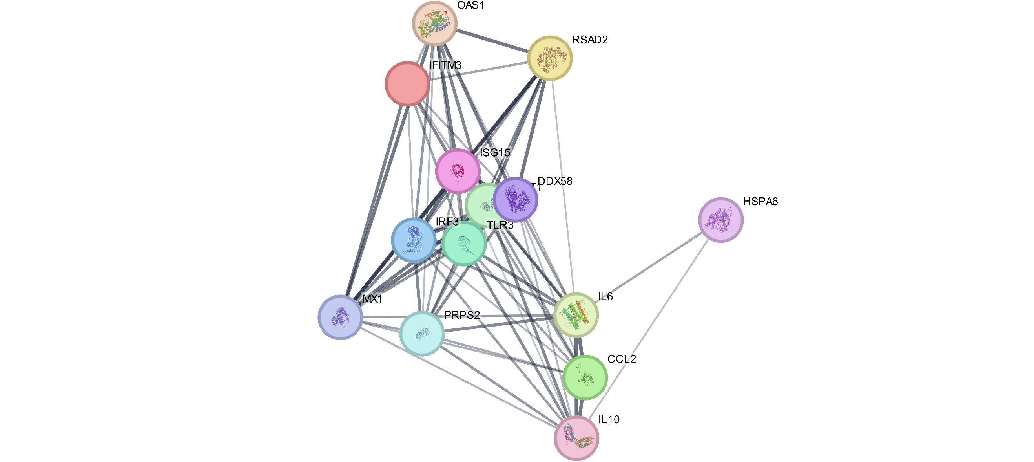
a

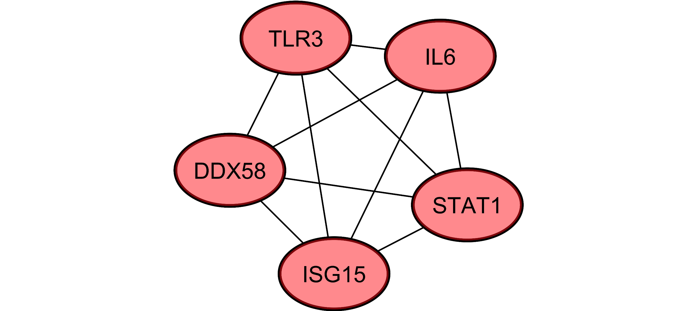
b

Figure 1: (a) PPI network map (b) Identification of 5 core targets.

a
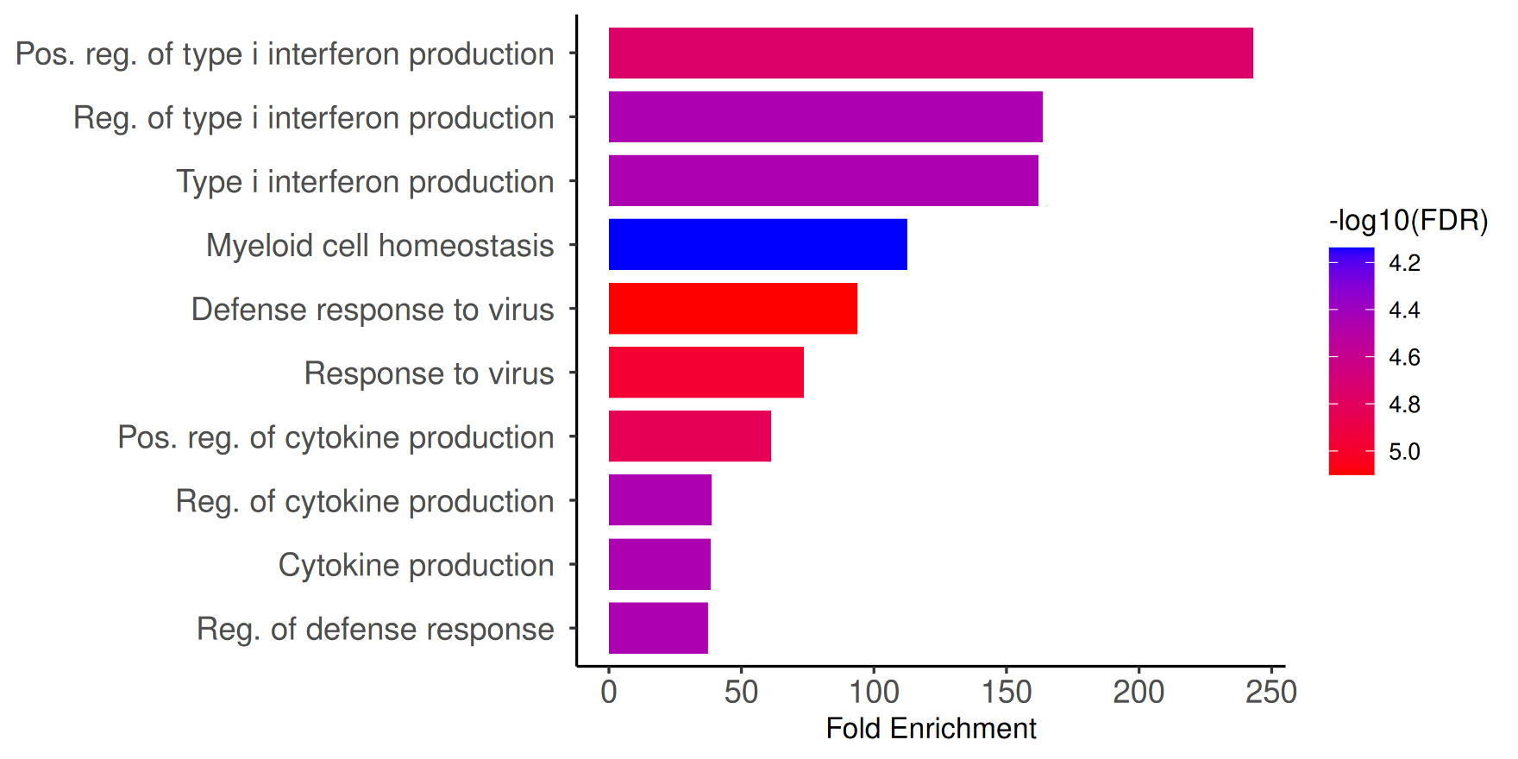

b
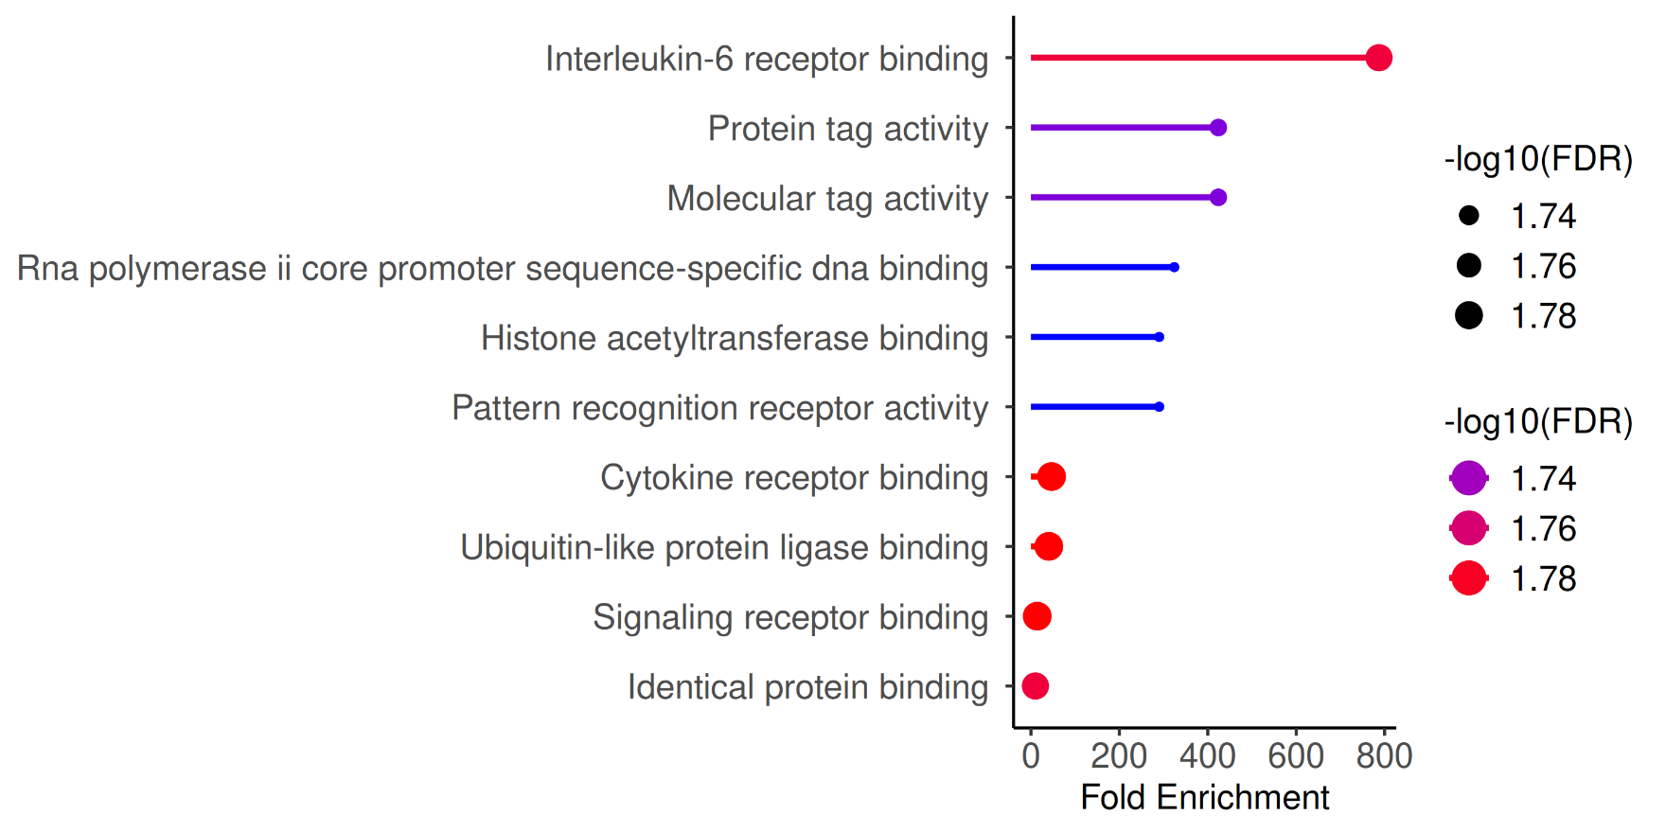

c
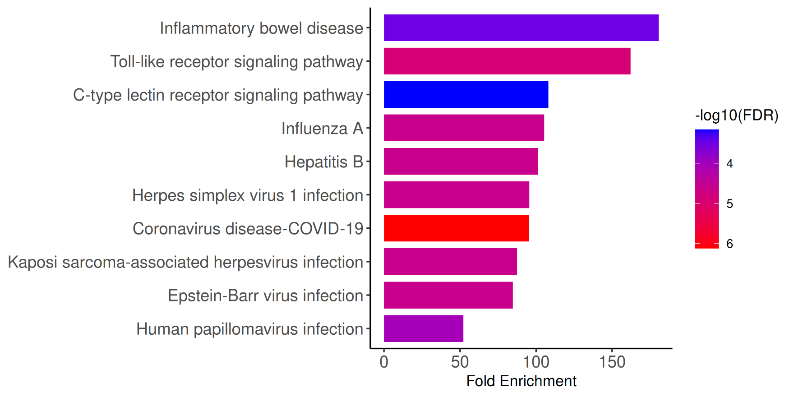

Figure 2: GO functional enrichment analysis and KEGG enrichment analysis.
Additionally, the moderate binding affinities of resveratrol with STAT1 and IL6 (−5.45 and −5.10 kcal/mol, respectively) suggest that it may also modulate cytokine-mediated inflammatory signaling. PRRSV infection is known to cause cytokine dysregulation, with excessive IL-6, TNF-α, and IL-1β production leading to pathological inflammation and reduced antiviral signaling (Ma et al., 2021; Gao and Wen, 2025). Previous studies have demonstrated that resveratrol suppresses IL-6 and TNF-α expression, restoring immune balance in inflammatory lung models (Chen et al., 2022). Therefore, the interaction of resveratrol with IL6 and STAT1 observed here supports its potential to attenuate hyperinflammation while promoting interferon-driven antiviral responses.
Enrichment of the Toll-like receptor (TLR) and C-type lectin receptor (CLR) signaling pathways aligns with the observed docking interactions. TLR3, in particular, plays a critical role in recognizing viral RNA and initiating type I interferon synthesis. The strong binding affinity of resveratrol to TLR3 (−6.63 kcal/mol) indicates its possible role in stabilizing TLR3–ligand interactions, thereby enhancing antiviral signaling (Ma et al., 2021). These effects collectively suggest that resveratrol may act through multiple innate immune pathways, particularly RIG-I and TLR3 dependent mechanisms to restore antiviral competence in PRRSV-infected macrophages.
Beyond PRRSV, resveratrol has exhibited broad-spectrum antiviral activity against several RNA and DNA viruses, including pseudorabies virus, respiratory syncytial virus, herpes simplex virus type 1, and hepatitis B virus (Zhao et al., 2017; Rossi et al., 2021; Xiong et al., 2024). Similar antiviral effects have been documented in recent studies where resveratrol inhibited respiratory syncytial virus and other respiratory pathogens by targeting viral entry and host signaling cascades (Xiong et al., 2024). The compound’s antiviral efficacy is attributed not only to its direct modulation of host immune signaling but also to its antioxidant properties via activation of the SIRT1–Nrf2 axis (Yu et al., 2024; Fernandes et al., 2025). These pathways enhance the expression of cellular antioxidant enzymes and mitigate virus-induced oxidative stress, which is a contributing factor in PRRSV pathogenesis. Such findings are consistent with computational analyses linking resveratrol’s polyphenolic structure to its antioxidant and immunomodulatory potential (Mathew et al., 2025).
Moreover, KEGG analysis in the present study revealed overlap between PRRS-related pathways and those of other viral infections (Influenza A, Hepatitis B, Epstein-Barr virus, and Kaposi sarcoma-associated herpesvirus). This suggests that resveratrol may act on conserved host-defense mechanisms shared across viral infections (Lim et al., 2020; Malla et al., 2025).
Given its multi-target pharmacological profile, resveratrol emerges as a promising adjunctive therapeutic candidate for PRRS management. Its ability to simultaneously enhance interferon production, modulate inflammatory cytokines, and reduce oxidative stress addresses multiple aspects of PRRSV-induced pathogenesis. Furthermore, as a natural compound with a favorable safety profile, resveratrol represents a sustainable and resistance-free alternative or supplement to conventional antiviral therapies.
Table 1: Molecular docking results of resveratrol and 5 core targets
Sr No. | Protein | Target structure | Binding Energy (kJ·mol⁻¹)
1 | ISG15 | 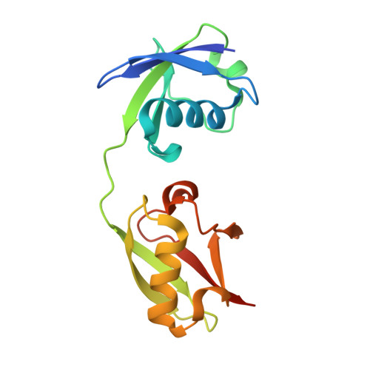 | -7.53
2 | STAT1 | 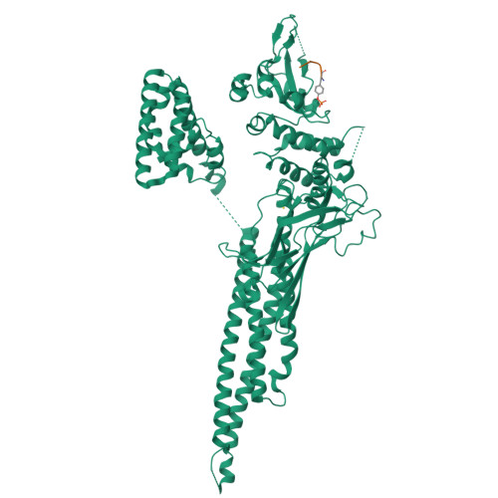 | -5.45
3 | TLR3 | 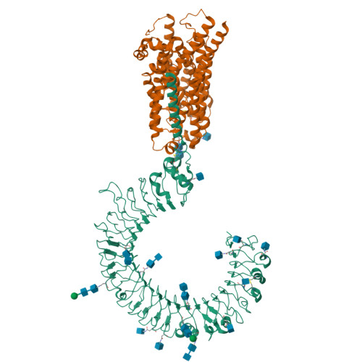 | -6.63
4 | IL6 | 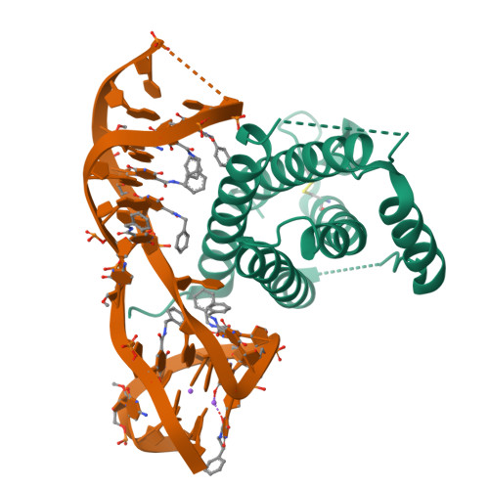 | -5.10
5 | DDX58 | 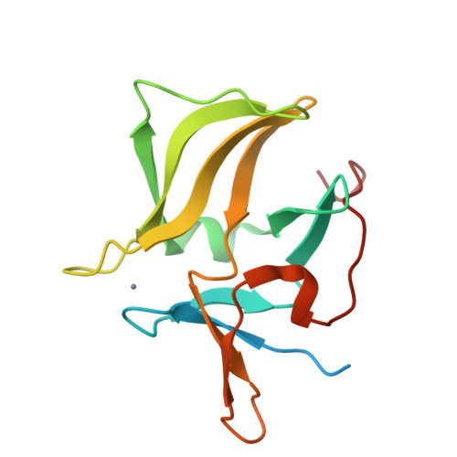 | -7.31
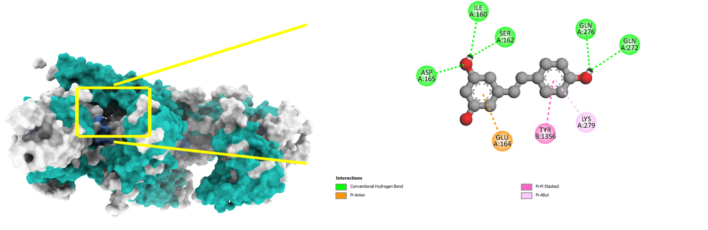
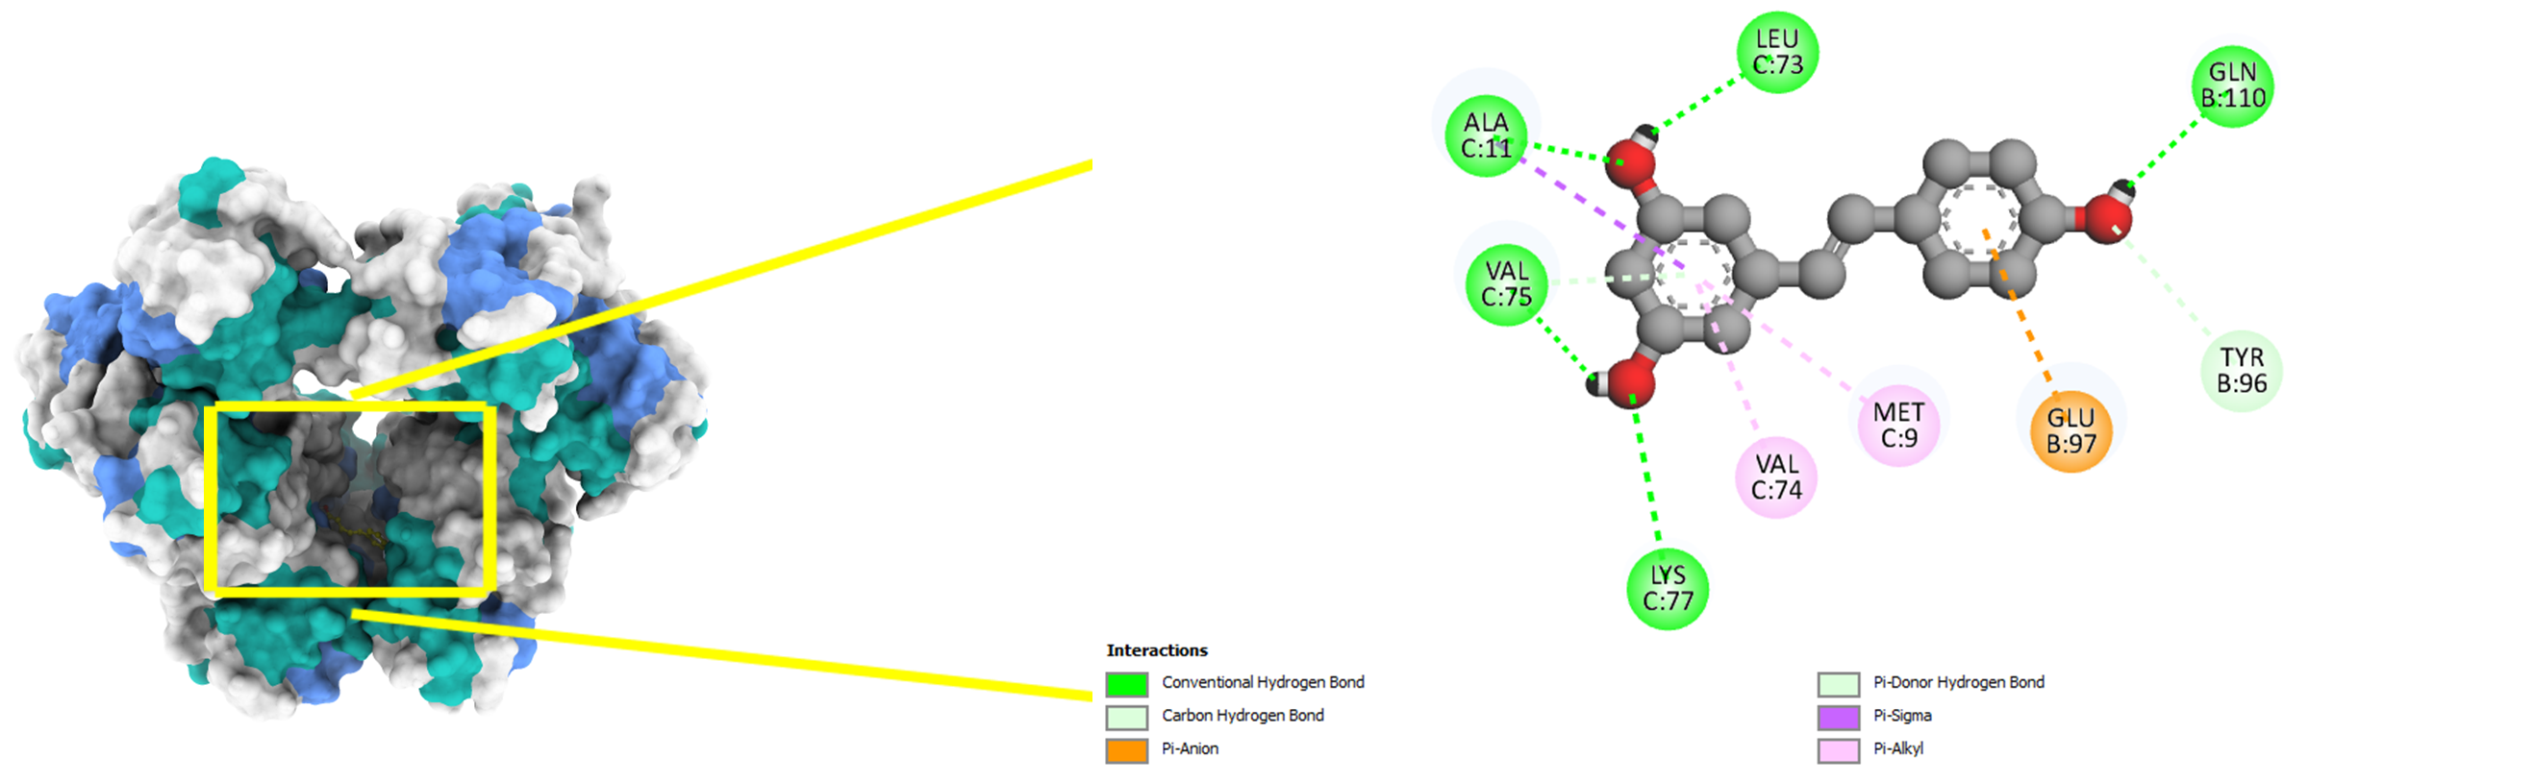
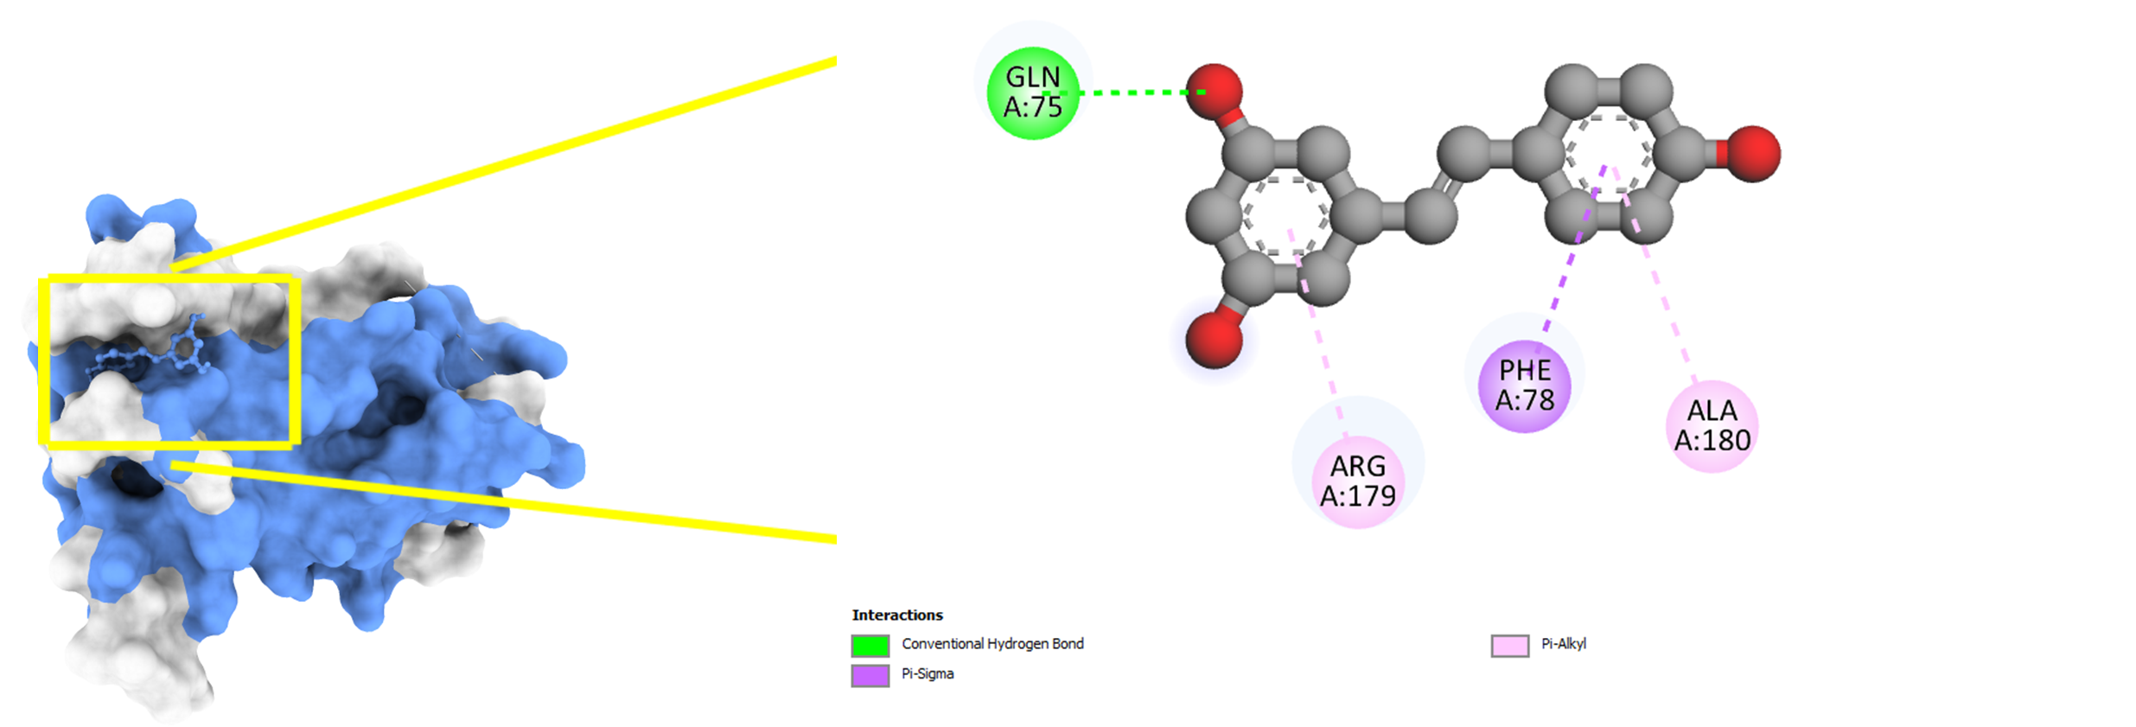
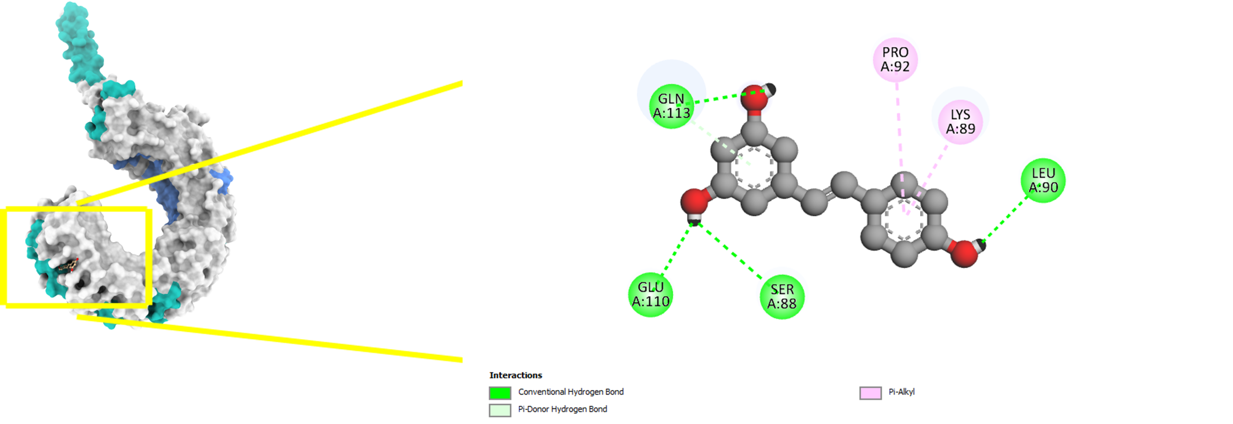
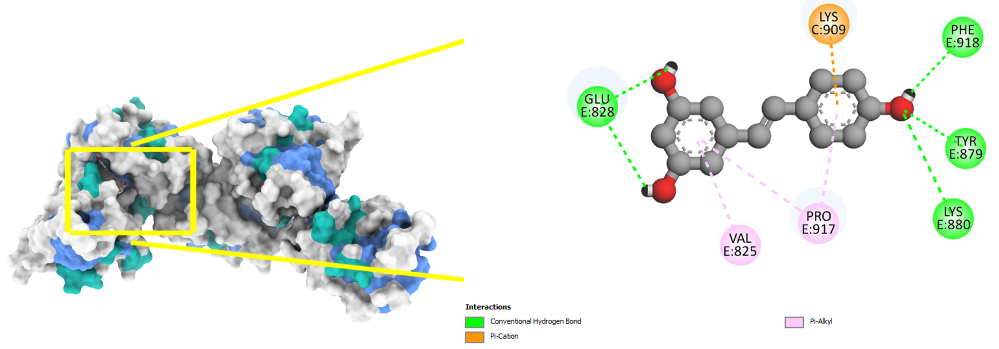
e
d
c
b
a

Figure 3: Molecular docking of resveratrol and 5 core targets. (a) DDX58, (b) IL6, (c) ISG15, (d) TLR3, (e) STAT1.
4. CONCLUSION
Resveratrol exhibits a multifaceted mechanism of action against PRRSV by targeting key antiviral proteins (ISG15, STAT1, TLR3, IL6, and DDX58) and modulating pathways central to innate immune activation, including Toll-like receptor and C-type lectin receptor signaling. Its broad-spectrum antiviral potential, antioxidant capacity, and immunomodulatory properties underscore its promise as a candidate compound for PRRS therapy. These findings align with a growing body of evidence supporting resveratrol’s role in enhancing host defense mechanisms against diverse viral infections. These computational findings suggest that resveratrol may serve as a natural immunomodulatory agent in mitigating PRRS-associated inflammation and viral persistence.
DISCLAIMER (ARTIFICIAL INTELLIGENCE)
Author(s) hereby declare that NO generative AI technologies such as Large Language Models (ChatGPT, COPILOT, etc.) and text-to-image generators have been used during the writing or editing of this manuscript.
ACKNOWLEDGEMENTS
The authors gratefully acknowledge the developers of the open-access bioinformatics resources and databases used in this research.

COMPETING INTERESTS DISCLAIMER
Authors have declared that they have no known competing financial interests OR non-financial interests OR personal relationships that could have appeared to influence the work reported in this paper.

REFERENCES
- Agu, P. C., Afiukwa, C. A., Orji, O. U., Ezeh, E. M., Ofoke, I. H., Ogbu, C. O., ... & Aja, P. M. (2023). Molecular docking as a tool for the discovery of molecular targets of nutraceuticals in disease management. Scientific Reports, 13(1), 13398.
- Al-Warhi, T., Al-Karmalawy, A. A., Elmaaty, A. A., Alshubramy, M. A., Abdel-Motaal, M., Majrashi, T. A., ... & Sharaky, M. (2023). Biological evaluation, docking studies, and in silico ADME prediction of some pyrimidine and pyridine derivatives as potential EGFRWT and EGFRT790M inhibitors. Journal of Enzyme Inhibition and Medicinal Chemistry, 38(1), 176–191.
- Amona, F. M., Pang, Y., Gong, X., Wang, Y., Fang, X., Zhang, C., & Chen, X. (2024). Mechanism of PRRSV infection and antiviral role of polyphenols. Virulence, 15(1), 2417707.
- Athanasios, A., Charalampos, V., Vasileios, T., & Md Ashraf, G. (2017). Protein-protein interaction (PPI) network: recent advances in drug discovery. Current Drug Metabolism, 18(1), 5–10.
- Chae, C. (2021). Commercial PRRS modified-live virus vaccines. Vaccines, 9(2), 185.
- Chen, X. X., Qiao, S., Li, R., Wang, J., Li, X., & Zhang, G. (2023). Evasion strategies of porcine reproductive and respiratory syndrome virus. Frontiers in Microbiology, 14, 1140449.
- Chen, X., Song, X., Zhao, X., Zhang, Y., Wang, Y., Jia, R., ... & Yin, Z. (2022). Insights into the anti‐inflammatory and antiviral mechanisms of resveratrol. Mediators of Inflammation, 2022(1), 7138756.
- Crisci, E., Fraile, L., & Montoya, M. (2019). Cellular innate immunity against PRRSV and swine influenza viruses. Veterinary Sciences, 6(1), 26.
- Di Nardo, G., Del Giudice, M. M., Drago, L., Daglia, M., Gori, A., Varricchio, A., ... & Indolfi, C. (2024). A review of clinical and preclinical data supporting a role for resveratrol in the treatment of common respiratory tract pathogens. NFS Journal, 37, 100194.
- Fernandes, I. G., Oliveira, L. D. M., Andrade, M. M. D. S., Alberca, R. W., Lima, J. C., de Sousa, E. S. A., ... & Sato, M. N. (2025). Resveratrol upregulates antioxidant factors expression and downmodulates interferon-inducible antiviral factors in aging. International Journal of Molecular Sciences, 26(5), 2345.
- Fiers, J., Cay, A. B., Maes, D., & Tignon, M. (2024). A comprehensive review on porcine reproductive and respiratory syndrome virus with emphasis on immunity. Vaccines, 12(8), 942.
- Gao, F., & Wen, G. (2025). Strategies and scheming: the war between PRRSV and host cells. Virology Journal, 22(1), 191.
- He, Z., Li, F., Liu, M., Liao, J., & Guo, C. (2025). Porcine Reproductive and Respiratory Syndrome Virus: Challenges and Advances in Vaccine Development. Vaccines, 13(3), 260.
- Kaur, A., Tiwari, R., Tiwari, G., & Ramachandran, V. (2022). Resveratrol: A vital therapeutic agent with multiple health benefits. Drug Research, 72(1), 5–17.
- Kumar, A., Sharma, R., & Singh, S. (2023). Synthesis, in silico ADMET, docking, antioxidant, antibacterial and antifungal evaluations of some pyrimidine derivatives. Journal of Molecular Structure, 1289, 135792.
- Lim, B., Kim, S., Lim, K. S., Jeong, C. G., Kim, S. C., Lee, S. M., ... & Kim, J. M. (2020). Integrated time-serial transcriptome networks reveal common innate and tissue-specific adaptive immune responses to PRRSV infection. Veterinary Research, 51(1), 128.
- Ma, J., Ma, L., Yang, M., Wu, W., Feng, W., & Chen, Z. (2021). The function of the PRRSV–host interactions and their effects on viral replication and propagation in antiviral strategies. Vaccines, 9(4), 364.
- Mahapatra, A. D., Paul, I., Dasgupta, S., Roy, O., Sarkar, S., Ghosh, T., ... & Chattopadhyay, D. (2025). Antiviral potential and in silico insights of polyphenols as sustainable phytopharmaceuticals: A comprehensive review. Chemistry & Biodiversity, 22(4), e202401913.
- Malla, S., Shahreen, N., & Saha, R. (2025). Immunometabolism at the crossroads of infection: Mechanistic and systems-level perspectives from host and pathogen. arXiv preprint, arXiv:2506.02236.
- Perng, Y. C., & Lenschow, D. J. (2018). ISG15 in antiviral immunity and beyond. Nature Reviews Microbiology, 16(7), 423–439.
- Rossi, G. A., Sacco, O., Capizzi, A., & Mastromarino, P. (2021). Can resveratrol-inhaled formulations be considered potential adjunct treatments for COVID-19? Frontiers in Immunology, 12, 670955.
- Sarkar, L., Liu, G., & Gack, M. U. (2023). ISG15: Its roles in SARS-CoV-2 and other viral infections. Trends in Microbiology, 31(12), 1262–1275.
- Shannon, P., Markiel, A., Ozier, O., Baliga, N. S., Wang, J. T., Ramage, D., ... & Ideker, T. (2003). Cytoscape: a software environment for integrated models of biomolecular interaction networks. Genome Research, 13, 2498–2504.
- Xiong, Y., Tao, K., Li, T., Ou, W., Zhou, Y., Zhang, W., ... & Ji, J. (2024). Resveratrol inhibits respiratory syncytial virus replication by targeting heparan sulfate proteoglycans. Food & Function, 15(4), 1948–1962.
- Yoneyama, M., Kato, H., & Fujita, T. (2024). Physiological functions of RIG-I-like receptors. Immunity, 57(4), 731–751.
- Yu, X., Chen, M., Wu, J., & Song, R. (2024). Research progress of SIRTs activator resveratrol and its derivatives in autoimmune diseases. Frontiers in Immunology, 15, 1390907.
- Zhao, X., Cui, Q., Fu, Q., Song, X., Jia, R., Yang, Y., ... & Yin, Z. (2017). Antiviral properties of resveratrol against pseudorabies virus are associated with the inhibition of IκB kinase activation. Antiviral Research, 147, 34–45.

