Review Article

Nanotechnology in Immuno-Oncology: Emerging Mechanisms and Translational Prospects

Abstract

Aims: This review highlights the new trends in the field of nanotechnology-based cancer immunotherapy, especially focusing on how nanoscale scaffolds regulate immune responses, genetic and chemotherapeutic cargo delivery, and enhance tumor-specific targeting with reduced systemic toxicity.

Study Design: A literature review of peer-reviewed articles published in 2018-2025 in field of nanomedicine, immuno-oncology, and integrating theranostics.

Place and Duration of Study: The review was done in the Department of Environmental Health at the College of Energy and Environmental Sciences in the University of Baghdad, Iraq between January to September 2025.

Methodology: A search was performed in electronic databases (PubMed, science direct, springer link, and Nature publishing group) using the combination of keywords: nanotechnology, immunotherapy, nanovaccines, immune checkpoint blockade and precision oncology. Articles underwent relevance checking by adhering to the nano-enabled immunomodulation, tumor microenvironment remodeling, and combination therapy strategies.

Results: Nanoparticles like gold, liposomal, polymeric, and dendrimer systems have been shown to have strong immunomodulatory properties because they increase antigen presentation, reprogram tumor-associated macrophages, and work with immune checkpoint inhibitors. Nanovaccines have an effective ability to deliver tumor antigens along with adjuvants to antigen-presenting cells, which trigger chronic cytotoxic T-cells. Moreover, the nanocarriers containing RNA and doxorubicin have two therapeutic effects in terms of targeted cytotoxicity and immunogenicity. Nanodesign and theranostic nanoplatforms based on artificial intelligence are progressing personalized cancer immunotherapy and real-time monitoring treatment.

Conclusion: Nanotechnology offers an interface that is flexible and dynamic between immunity and oncology. Nano-immunotherapeutics will be a cornerstone of next-generation precision cancer therapy, providing targeted, synergistic, and patient-customized immunotherapy for cancer despite the difficulty of large-scale manufacturing and safety validation, and standardization by regulatory authorities.
Keywords: Nanotechnology, Cancer, Immunotherapy, Nanoparticles, Nanocarriers, Nanovaccines, precision oncology.

- Introduction
Cancer is one of the insults of the health in the world, with approximately 10 million deaths a year, and is only followed by cardiovascular diseases as the leading cause of death [Bhattacharya & Mukherjee, 2022]. Such a surge in incidence manifests through a global increase in burden, predisposed by aging and increasingly continued/new environmental exposures, as well as by the increased prevalence of unhealthy lifestyles. Although currently there are still impressive advances in operative, cytotoxic, radiologic, and biologically acquired focused modalities, the prognosis of numerous neoplasms is still bleak due to the inevitable loop of relapse and formation of resistant clones. However, therapeutically useful premise-based cytotoxic agents are handicapped by the distribution of off-target biodistribution, sequential hepatic and hematologic toxicity, and lack of efficacy against the petite, undetectable neoplastic lakes of minimal residual disease [Blanco et al., 2022]. The recent decade has swung the field in the other direction in the perhaps most significant paradigm shift: immunotherapy, consisting of re-transforming the host immune apparatus so that it actively scans and destroys malignant cells. Immunotherapy utilizing immune checkpoint inhibitors (i.c.i.) (e.g., C, anti-PD-1, anti-CTLA-4), genetically modified T-cell adoptive cell therapy, cytokine use, and prophylactic or treatment vaccination has translated to new levels of survival prolongation in melanoma and advanced non-small cell lung cancer [Chen et al., 2024]. State of the art. On the positive side, the clinical benefits of immunotherapy remain limited to specific issues that only apply to certain population groups [Hangiu et al., 2025]. Immune escape caused by tumors, an immune-suppressive tumor microenvironment (TME), and heterogeneity within tumors are all contributors to minimal effectiveness with current therapies [Doroshow et al., 2023]. In addition, there are the immune-related adverse events and the high cost that act as a significant roadblock to further implementation [Dougan et al., 2023]. Nanotechnology has then become an acceptable and potent enabling science that straddles the two disciplines between oncology and immunology under these restrictions [Dougan, Luoma, Dougan, & Wucherpfennig, 2023]. Each nanocarrier- liposomes, polymeric nanoparticle, dendrimer, inorganic nanoparticles (gold, silica, iron oxide), and biomimetic nanoparticles- has a triple combination of tunable size, surface modification by synthesis and release [Fan et al., 2023]. Those requirements exploit the increased permeability and retention (EPR) to facilitate the accumulation in the tumor areas, as well as allowing targeted attack at the immune cell subpopulations [Gu, Liu, Xu, & Liang, 2023]. Importantly, the pharmacokinetic and stability profiles of immunomodulating drugs are improved in nano-assisted platforms, unintended toxicity is condensed, and de novo immunogenicity that destroys tumors is built [Hadi, Al-Douri, & Hadree, 2023]. Nanovaccines have been optimized to increase antigen presentation and support robust T-cell responses; when paired with custom-made nanoparticles that prime with adjuvants, as well as tumor antigens, nanovaccines succeed standard vaccine platforms [Hou et al., 2023]. Similarly, nanocarriers that are custom-made deliver either siRNA, mRNA, or CRISPR/Cas components to silence oncogenes and precisely tune immune checkpoints, effectively redesigning tumor-immune interactions [Huang et al., 2023]. In addition to therapy, nanotechnology has increased diagnostic and theranostic potential through real-time imaging, biomarker interrogation, and image-guided therapy [Jaaffer & Al-Ogaidi, 2022a]. Nevertheless, various obstacles have to be overcome to provide these advancements in clinical practice. The most eminent issues to date are the scale of reproduction, long-term biocompatibility, immunogenicity scarcity, and the regulatory tangle [Jaaffer & Al-Ogaidi, 2022b]. Furthermore, the complexity of the immune system and the heterogeneity of tumors imply a unified approach that joins nanotechnology and systems biology and artificial intelligence, and precision oncology. As a result, the present work provides an extensive literature review of the intersections between nanotechnology, immunity, and oncologic treatment. We first describe the most common nanoplatforms developed to control malignancies and manipulate immune system functioning, after which we discuss in detail their use in the field of immuno-oncology and the most notable of these applications: nanovaccination. Modification of the tumor microenvironment and regulation of immune checkpoints. The potential of next-generation intelligent nanomaterials, combinatorial therapy, and personalized nano-immunotherapies is discussed, as we also critically discuss current barriers to clinical translation and discuss possible future trends.

- Nanotechnology:
Nanotechnology may be tersely defined by stating that it is the engineering and application of materials at least broadly quantified at the 1 to 100 nanometer scale. Upon reaching these scales, matter acquires a different suite of physical corners, confidently stepping over the parameters of its bulk twin: quantum whispers, an exceptionally high surface-to-volume proportion, and a vivacious propensity to act [Jiang, Wang, Li, & Tang, 2024]. Since these features could be fine-tuned during the manufacturing process, the designer could create nanostructures that can be of an agreed size, agreed shape, with a charge, and with chemical coatings that may correspond to therapeutic targets [Ahmed et al., 2025]. In the field of medicine, nanotechnology is not merely a toolbox; it is a lever with the help of which numerous current treatments can be reworked. Some of the ingredients of the dysregulated set of nanorobots include the following: gold and silver specks, rust-oxide crystals, lipid doughpinching spheres, polymers re-assembled into microns, precisely branching structures, twillow carbon architecture (approximately graphene and carbon nanotubes), and droplets that borrow patterns of living cells. They have all been recruited, ordered, and honed to be drug couriers, images that come into focus as they practice quantum halos, nanoscopic scouts, and scaffolds to reinvent tissue [Kuai et al., 2023]. They are more potent when tumors are present, whose unstable and ropey vasculature allows the agents of any nanosized scale to pass freely. And this is the EPR effect, which is the guardian of nanostructure-guiding films. Evidence of clinical potential of the science is mounting as nanoparticles, which are little less than ghostly avatars, homing in, are being taught to perform feats previously impossible to conventional medicine [Li, Wang, Zhang, & Sun, 2025]. Besides the benefits of pure passive targeting, nanoparticles may be targeted with a preference to a specific receptor using ligands (antibodies, peptides, or aptamers) to selectively deliver their cargo in a receptor-specific manner. More importantly than delivery, therapeutics can be delivered using nanotechnology in a controlled manner and with precise control. Control can be spatio-temporal and can be realized using a carrier sensitive to pH, temperature, redox gradient, specific enzymes, or externally-delivered stimuli: e.g., light or magnetic fields, in order to increase therapeutic effect and reduce systemic toxicity. This control is especially effective in the treatment of cancer, where the traditional cancer therapeutic agents are notorious for the issue of off-target toxicity and rapid degradation. Nanotechnology has a two-dimensional impact as regards immunology. Nanoparticles may act as immunomodulators to enhance the relevant antigen presentation mechanism, activate dendritic cells, and induce T-cell education to deliver potent anti-tumor immunity [Li et al., 2023a]. Alternatively, other carriers, including ones designed to appear as immune attenuators, e.g., by administering siRNA or immunomodulatory therapies to dampen inappropriate immune responses. The functionality deals with tumor microenvironments and autoimmune conditions in parallel. At the same time, nanotechnology is emerging as a necessity in terms of diagnosis and treatment by bridging these two to one platform. The integration of imaging reporters to nanoparticles into drug-delivery systems offers clinicians complementary tumor-resolved imaging in MRI, PET/fluorescence/photoacoustics modalities. Such a multimodal paradigm, in addition to significantly accelerating the number of possible lesions detected at the asymptomatic stage, offers in vivo drug biodistribution, tumor-specific photoacoustic drug activation, and, consequently, the minimally invasive navigation [Rosyidah et al., 2023]. The emergence of a theranostic discourse in the integration of therapy and imaging provides feedback loops in therapy in real time, dose adjustment, and redistribution of tumor response that transforms the field of diagnosis into closed-loop digital treatment. Nevertheless, these studies of transferring laboratory success to the bedside of the patient remain limited due to a high-volume homogenous synthesis, chronic organ redistribution, and immunoproteolytic excretion. The systematic dismantling of these bottlenecks is not a monodisciplinary endeavor but, to the contrary, will need multi-disciplinary coordinated actions in the realms of polymer synthesis, cellular immunophysics, tumor biology, and predictive modeling, which will be further enhanced by the de novo recommendations of the field of generative synthesis, artificial intelligence conspires [Li et al., 2023b]. Taken together, these nano constructs are a sovereign limb of immuno-oncology, In further sections, this manuscript will enumerate only immunomodulatory considerations and dose-adaptive regimes of the platform based on cancer pathology.
2.1 Nanoparticles for Immune Modulation
In cancer, the immune system is an agency of both watchdog and assassin, attacking and killing neoplastic cells at the same time that, in certain instances, it supports tumor development through sustained inflammation and the evasion of immunity [Li et al., 2023b]. Considering such a dichotomy, nanoparticles (NPs) are emerging as programmable platforms to modulate immune reprogramming, together with boosting immunologically desirable responses against the tumor or inhibition of undesirable immune responses. They are nanometric in scale and provide a high surface-to-volume ratio, and biomolecular shells can be constructed to attach themselves to the tumor microenvironment-associated lymphocytes, cytokines, and surface receptors [Li et al., 2023b].

    - Gold Nanoparticles (AuNPs)
The most promising inorganic nanoplatforms to support the immuno-oncology sector are gold nanoparticles. AuNPs have been shown to be exceptionally biocompatible with ease of surface engineering, enabling conjugation of tumor-associated antigens (TAAs) to enable them to become an effective nanovaccine. Precisely, GNPs nanovaccines promote dendritic cells (DC) maturation and fine-tuning of a cytotoxic T lymphocyte (CTL) response. It is also noteworthy that the AuNPs per se also act as immune checkpoint activators; their surface is capable of being decorated with TLR-ligands that trigger Toll-like receptor-mediated signaling and disseminate dendritic and innate responses and T-cell mobilization [Li et al., 2023c]. Another interesting aspect is that in surface-decorated with anti-inflammatory agents, gold nanoparticles (AuNPs) mediate the moderation of excessive immune stimulus, which holds promise of an immunomodulatory effect in conjunction with cancer and autoimmune therapy. Also, AuNPs in photothermal therapy (PTT) charge by generating heat, which selectively ablates malignancy cells- a process that is typically immunogenic that results in the release of a damage-detached molecular pattern (DAMPs) to promote and activate adaptive immune-infiltration pathways [Li et al., 2024]. It was based on this that Jaaffer and Al-Ogaidi (2022) examined gold-resveratrol nanoconjugates in the treatment of rheumatoid arthritis (RA). The research proved that these nanoconjugates had a great role in reducing inflammatory levels and stimulating immunomodulatory effects. The nanoconjugates also had a high therapeutic effect in comparison with resveratrol, highlighting the importance of nanotechnology in enhancing the effectiveness of treatments of autoimmune diseases, also conducted Another study related study investigated the use of chitosan-capped gold nanoparticles in immune modulation in RA. These nanoparticles were effective in down-regulating the pro-inflammatory cytokines and allowing the maintenance of immune balance, which results in improved RA progression control. The results highlighted the dual nature of nanotechnology as a targeted therapy and immune-regulating agent and provided new understanding of integration of nanomedicine with immunotherapy solutions [Jaaffer & Al-Ogaidi, 2022a].

2.1. 2 Liposomes
As a structurally diverse system, liposomes, as phospholipid bilayer structures that mimic cell membranes, open a broad platform to co-encapsulate both polar and nonpolar cargo in a flexible structure. Cancer immunotherapy is a subtype where the therapeutic nucleic acid, cytokines, or immune checkpoint inhibitors are administered in a precise fashion to lymphocyte aggregations as engineered preparations [Liu, Wu, Yang, & Chen, 2024]. Its liposomes are loaded with the immunogenic compounds: CpG oligonucleotide and tumor-associated antigens (TAAs) have an enhanced effect of activating the dendritic cells and priming T cells compared to the free agents. Complementarily, the depletion of immunosuppressive molecules by nano-formulations that deliver siRNA to myeloid-derived suppressor cells leads to a reduction in tumor-induced immune suppression. In addition, established liposomal drugs, such as liposomal doxorubicin (Doxil), are serendipitously driving toward immune activation through causing immunogenic cell death, to maximize antigen cross-¬presentation.
Polymeric Nanoparticles (PNPs) The use of polymeric nanoparticles prepared with biodegradable polymers (such as PLGA polymer or PEGylated copolymers) has been developing as a selective delivery agent to execute regulated immune modulation [Liu et al., 2023]. At low doses, PNPs loaded with antigen and adjuvant are more potent in eliciting antigen-specific T-cell responses relative to conventional soluble formulations. Simultaneously, these nanocarriers also intratumorally or tumorally deliver immune checkpoint therapeutics (e.g., anti-PD-1 antibodies or PD-L1-targeting siRNA), and this local tumor immune stimulation reduces the systemic toxicity. Also, these platforms are just as capable of reducing hyperinflammation by packaging anti-inflammatory cytokines, in this case, IL-10, thereby pushing the immune response in the direction of homeostasis [Mao et al., 2023].

2.1.3 Dendrimers
Exact branching macromolecules, made up in concentric coats, dendrimers are minutely branched macromolecules assembled of concentric layers, each terminating with reactive groups that may be covalently tethered to antigens, adjuvants, or homing ligands [Park et al., 2024]. Such a zero-space, multivalently and carefully arranged architecture allows the simultaneous display of many immune regulators on a single scaffold. These dendrimer-based formulations have been reported to activate antigen-presenting cells in a highly efficient manner, stimulating both uptake and cross-presentation, and resulting in the induction of strong systemic T-cell immunity in preclinical cancer studies. Specifically, cationic dendrimers possess a preference for immune cell membranes, enhancing both absorption and intracellular transport. What is interesting is that dendrimers may also be synthesized to be used in immunosuppressants, such as siRNA or nanoparticles that inhibit cytokines that induce inflammation. There is also a potential option of combination immunotherapy in oncology: multifunctional dendrimers that can co-deliver checkpoint inhibitors and tumor antigens [Li et al., 2023c].

2.2. Functions in Immune Regulation
Nanoparticle-based strategies oriented toward immunity on their own indicate a bilateral immunomodulatory capability. They can enhance or suppress antitumor responses through, respectively, contributing to the expression of antigens through antigen presentation, boosting effector T cells, or usage of checkpoint inhibitors, or suppressing inflammation by supplying immune suppressor cells with anti-inflammatory cytokines or gene-silencing molecules [Postow et al., 2023]. Nanoparticle versatility is indicative of their potential as immune regulators at the tumor-host interface, both dynamically and in situ.

3. Nanocarriers for Specific Medication Administration
3.1. Nanocarriers Loaded with DOX
Doxorubicin (DOX) remains one of the most widely used chemotherapeutics as a result of its high cytotoxic properties on rapidly growing cancer cells. Nonetheless, its applicability in therapy is very limited due to systemic toxicity, cardiotoxicity, and multidrug resistance mechanisms. DOX nanocarrier delivery has emerged as a potential approach to enhancing its therapeutic index without increasing its toxicity. One of the earliest clinically approved nanomedicines was pegylated liposomal doxorubicin (PLD), which exhibited enhanced tumor accumulation due to the enhanced permeability and retention (EPR) effect, reduced cardiotoxicity, and prolonged circulation. Nanocarriers other than liposomes were also developed and can be used to encapsulate or conjugate DOX, including polymeric nanoparticles, dendrimers, micelles, and inorganic nanoparticles (gold, silica, and iron oxide). These approaches can allow combination therapy regimes, targeting of the tumor, and regulated delivery [Shao et al., 2023]. As an example, it was shown that when nanoparticle-conjugated DOX functionalized with tumor-targeting ligands using gold nanoparticles (AuNPs) (i.e., AuNPs-O-DOX), intracellular levels of DOX can be enhanced and specifically induce apoptosis in cancer cells, sparing healthy ones. Further enhancing selectivity, stimuli-responsive nanocarriers have also been produced, which will also release DOX in response to redox gradients, enzyme activity, or acidic tumor pH. Most importantly, as cellular vehicles, DOX-loaded nanocarriers have also been shown to act as immunogenic cell death (ICD) triggers that also release tumor-associated antigens and enhance antitumor immunity, along with enhancing direct tumor killing [Sharma et al., 2022]. The results indicate that adjunctive agents have the potential to maintain the health of cells during chemotherapy. These approaches can improve nanotechnology-based and immunomodulatory therapeutic approaches to cancer.

3.2. siRNA/miRNA Delivery to Immune or Tumor Cells
RNA interference (RNAi) as a form of gene silencing has revolutionized cancer treatment, providing the opportunity to precisely inhibit oncogenes and immune response control switches, but practices have so far been undermined by the limited half-life of the RNA species, potent nucleases degradation, poor cell penetration, and possible activation of immune sensors. Nanocarriers can overcome such obstacles, protecting the RNA and enhancing endosomal escape, shuttling the cargo to the appropriate intracellular destinations. The most mature and well-documented method is lipid nanoparticles (LNPs) that have already proven to be safe and effective in mRNA vaccines and a few siRNA therapeutics. The cancer uses of LNPs and polymeric nanoparticles are also growing, with both types of nanoparticles designed to deliver the siRNA that silences immune checkpoint molecules, including PD-L1 and CTLA-4 (the latter is a major target). In parallel, the same systems are silencing drivers of tumor cell proliferation, such as KRAS and MYC, and the genes underlying chemoresistance, and causing detectable tumor regression in preclinical settings [Shen et al., 2025]. In addition to siRNA, application of miRNA mimetics or antagonists contained in these nanocarriers further increases the potential of RNA cancer therapeutics by providing another dimension on which the expansion of tumors can be fine-tuned and by which the microenvironment can be refined. Targeting the oncogenic miRNAs (including miR-21), a defect in antitumor immunity can be reconstituted, and tumor-suppressive miRNAs (such as miR-34a) can be delivered to inhibit tumor growth. More importantly, the modification of the tumor microenvironment is realized by the surface functionalization of nanocarriers with targeting binding molecules (antibodies, aptamers, peptides) that enable cell-specific targeting of immune cells (T lymphocytes, dendritic cells, or tumor-associated macrophages), to deliver the cargo specifically to those cells [Song et al., 2023]. Altogether, application of DOX and RNA-based therapies using nanocarriers is a dual-functional application approach including direct tumoral cytotoxicity and immune modulation. Such a synergy potential illustrates how important nanotechnology is to the field of immunotherapy and precision oncology.

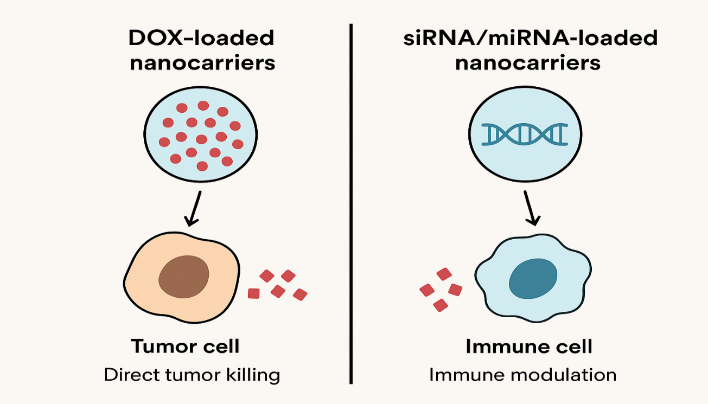
Figure 1: Diagrammatic Illustration of Nanocarrier-Based Cancer Treatment Approaches: siRNA/miRNA nanocarriers reprogramme immune and tumor cells for enhanced antitumor immunity, while DOX-loaded nanoparticles directly cause tumor cell death.

3.3. Nanovaccines
Nanovaccines are recently becoming relevant in the immuno-oncology sector as new modalities, which are poised to bypass the challenges presented by conventional cancer vaccine constructs. Generally, traditional peptide- or protein-based therapeutics are characterized by limited immunogenicity, rapid proteolytic digestion, and are unable to specifically target the recombinant or soluble antigens to dendritic cells and other antigen-presenting cells, which are major players in the orchestration of the immune response. New developments in nanotechnology address these bottlenecks, by loading carriers that package tumor-related antigens along with rationally selected immune adjuvants, and co-transports the two species across the cellular territory in a time-locked fashion and at well-timed intervals, which allows increased antigens uptake, synchronization of T-cell maturation, and generation of T-cell memory with prolonged survival in tumor microenvironment [Sung et al., 2023]. Scholars have already prototyped varieties of nanomaterials encompassing liposomes, biodegradable poly¬meric microspheres, programmable dendritic polymers, and biocompatible AuNPs and membrane-camouflaged exosomes that will give the allowable engineering scope to create the ultimate vaccine. In these nanocarriers, the tumor antigens can be either incorporated or conjugated to one of the stimulatory toll-like receptor (TLR) ligands, CpG oligodeoxynucleotides, and cyclic-STING agonists, the synchronized payloads of which can be released to the lymphoid sinuses, infiltrated through the lymphotropic networks, and digested by dendritic cells through nanocarriers [Park et al., 2024]. This method significantly increases the presence of cytotoxic CD8+ T lymphocytes and CD4+ T helper cells in the development of vigorous, broad, and long-term tumor-specific immunological memory. Examples of the use of tumor antigens conjugated to nanoparticle carriers of granulocyte-macrophage colony-stimulating factor (GM-CSF) as an adjuvant are informative: such carriers have resulted in stronger antitumor immunity than conventional soluble preparations [Tang et al., 2024]. Neoantigen-based, toll-like receptor (TLR) agonist-loaded (and thus generating vigorous, antigen-specific responses to magnify the activity of co-administered checkpoint blockade) lipid formulations also enter the picture. Biomimetic nanovaccines, in which tumor cell membranes cover nanoparticles and present antigens and other immunogenic cues in a manner that mimics physiological antigen processing, have also been shown to promote cross-priming of cytotoxic T cells. Biomimetic nanovaccines are also reported to have promise in preventative applications: genetic predisposition cohorts and patients with chronic oncogenic viruses are undergoing trials with them. Interim preclinical and early-phase clinical studies have already shown an outstanding safety profile, a good fit with biological systems, and useful synergies with immuno-checkpoint modalities and adoptive-cell transfer therapies [Wang, S., et al., 2025]. In conclusion, nanovaccines are a versatile and efficient mechanism of rewiring the host immune system to combat cancer. Such technologies enhance immunogenicity and overcome immune tolerance induced by the tumor, opening new opportunities in precision oncology related to the possibility of precise delivery of adjuvants and antigens with commonly unknown combinations.

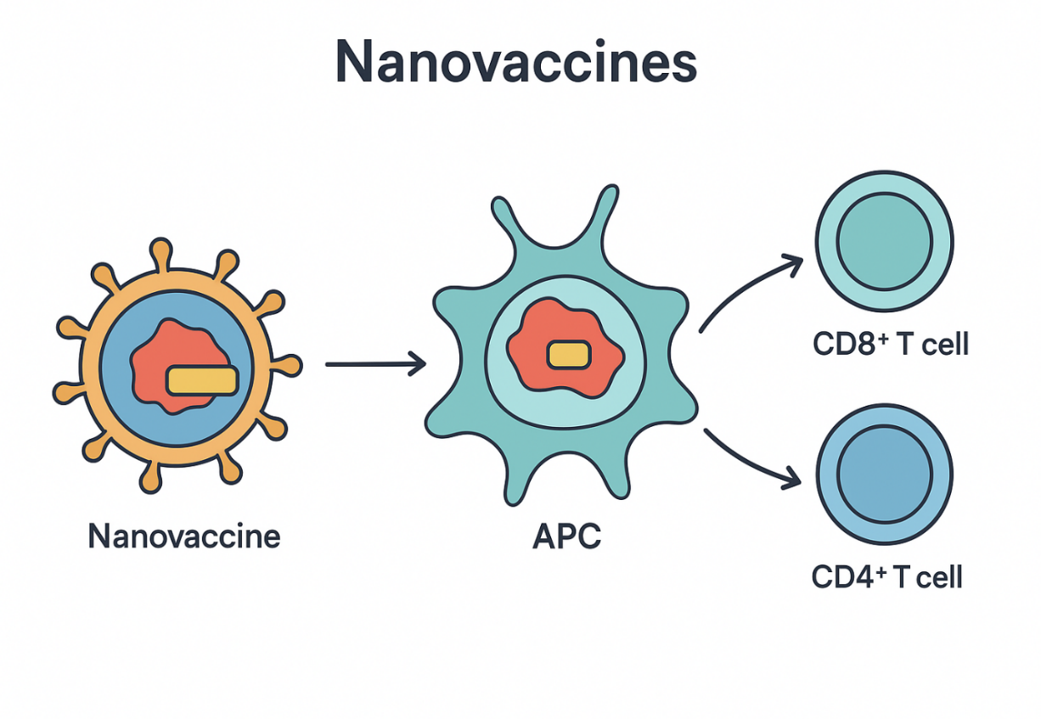
Figure 2: The delivery of antigen and adjuvant to APCs results in the stimulation of CD8⁺ and CD4⁺ T cells, which is the mechanism by which nanovaccines induce immune activation.

3.4. Nanotechnology Immune Checkpoint Blockade
Oncology is revolutionized with immune checkpoint inhibitors (ICIs), such as anti-PD-1/PD-L1, and anti-CTLA-4 antibodies, recognized as a revolutionary immune agent that unleashes T-cell-mediated antitumor immunity. Nonetheless, they are hampered in clinical application by systemic adverse effects, poor penetration to the intratumoral sites, and the emergence of primary or acquired resistance. Nanotechnology, therefore, presents an exciting potential to surmount these challenges due to its effects in terms of drug stability, tumor-specific delivery, and combinatorial regimens. Antibody delivery vehicle: nanocarriers. Checkpoint inhibitors have been encapsulated or surface-displayed within liposomes, polymeric nanoparticles, or hybrid systems to enhance pharmacokinetics and tumor penetration. To exemplify, nanoparticle-supported PD-1/PD-L1 blockade in models of triple-negative breast cancer showed an increased T-cell infiltration and a synergistic result when coupled to either chemotherapy or phototherapy [Wang, X., et al., 2024]. Moreover, localized and sustained release of ICIs can be achieved with the help of hydrogels and the depot system. Patches embedded with ICI-containing nanoparticle microneedles are another novel delivery platform, especially for melanoma and other nearby tumors, that can deliver painlessly and locally with less frequent dosing. Checkpoint nucleic-acid nanomedicines. Other than antibody delivery, there have been nanoparticles designed to deliver a PD-1, PD-L1, or CTLA-4 targeted siRNA or miRNA. Yuan et al. (2025) prepared PD-L1 siRNA-loaded boron nanoparticles that allowed a simultaneous down-regulation of the PD-L1 expression and performed a boron neutron capture therapy, resulting in an increased activation of T-cells. Similarly, solid-lipid nanoparticles loaded with PD-1 siRNA repolarized macrophages and prevented tumor growth. Both broad and narrow reviews emphasized several nanocarrier systems (such as lipid, polymeric, and inorganic systems) of siRNA checkpoint modulation. mRNA nanomedicine methods [Yuan, Chen, & Zhao, 2025]. Lipid nanoparticles (LNP) coded to immune checkpoint modulators or synergetic cytokines provide a transient, tunable approach to modulate the immune responses. The LNP mRNA encoding IL-21, IL-7, and 4-1BBL improved the efficacy of anti-PD-1 therapy, following intratumoral delivery. In parallel, mRNA-encoded bispecifics with PD-L1 blockade and 4-1BB costimulatory signaling also showed greater antitumor efficacy. Interestingly, pembrolizumab LNP-encoded mRNA resulted in long-term antibody levels with systemic exposure in vivo, which indicates a potential new therapeutic paradigm. In general, immune checkpoint modulator delivery using nanotechnology offers a complex solution to the challenges of efficacy, minimization of toxicity, and resolution of the resistance to therapy. However, safety, mass production, and regulatory authorization are still required before the described methods can be widely converted to clinical application [Wang, Y., Zhang, & Li, 2025].

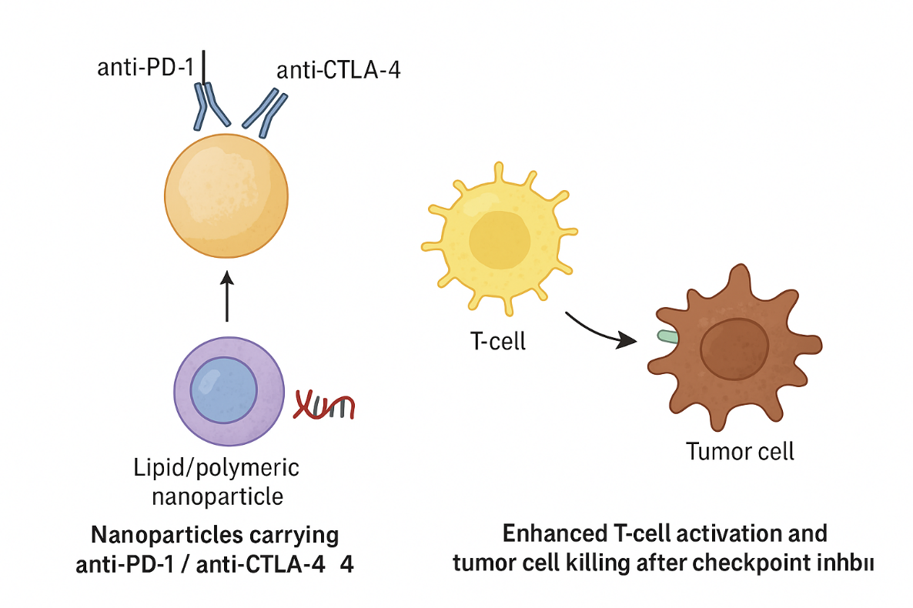
Figure 3: Nanotechnology-Based Immune Checkpoint Blockade With Antibody and siRNA-Loaded Nano Particles to Increase the T-Cell Activation and Kill the Tumor Cells.

4. Cancer Immunotherapy Applications
4.1. Modification of the Tumor Microenvironment
The tumor microenvironment (TME) is a major determining factor of cancer progression and treatment resistance. It consists of several immunological cell populations, stromal cells, vascular cells, extracellular matrix, and malignant cells, which often creates a niche of immunosuppression. Nanoparticles (NPs) have emerged as a powerful immune-cell reprogramming method in the TME, or more specifically, reprogramming dendritic cells (DCs) and tumor-associated macrophages (TAMs) [Wang, Y., et al., 2023]. Macrophages at the tumor siteshift towards an M2-like polarization and promote tumor growth, angiogenesis, and immune inhibition. Nanoparticles of loading immunometabolic agents, e.g., siRNA to CSF-1R or small molecule toll-like receptors (TLRs), have been effective in switching TAMs to antitumor M1, increasing phagocytosis and cytokine output. Similarly, designed nanostructures of gold and iron oxide nanoparticles have inherent abilities to repolarize macrophage activity to heighten tumor microenvironment (TME) remodeling. Another route of intervention is focused on dendritic cells as the hub of T-cell priming and adaptive immunity. The dendritic uptake, maturation, and cross-presentation are enhanced when nanoparticles deliver tumor antigens and immune adjuvants, including CpG or STING agonists. The result is strong CD8+ T-cell activation with the development of long-lived immunologic memory, which is an essential feature of the long-lasting anticancer immunity of our intervention [Sulaiman, Tawfeeq, & Jaaffer, 2018].

4.2. Combination Therapy methods
Traditional single-agent approaches that are cytotoxic, immune, or radio-based are often undermined by tumor heterogeneity and adaptive resistance. Nanotechnologies are currently supporting combinatorial therapy designs that enable co-delivery of agents in a coordinated manner via synergistic agents coordinated delivery of multiple drugs concomitantly using the same nanoparticle chassis. As an example, nanoparticles that are specially designed are able to load two types of drugs, the conventional chemotherapeutic agent, doxorubicin, and immune checkpoint inhibitors, including anti-PD-1 peptides or PD-L1 siRNA, and kill the tumor cells while enabling an immune response simultaneously [Wei, Song, Zhao, & Xu, 2024]. These nanocarriers differentially enhance immunogenic cell death, the liberation of pertinent tumor antigens, and the alleviation of PD-L1-mediated inhibition of the tumor-reactive T cells, enhancing a sustained antitumor immune response. Leaving such chemo-immunotherapy, nanotechnology-driven photothermal (PTT) and photodynamic therapies (PDT) are rapidly becoming eminent. The gold nanorods, carbon allotropes, and semiconducting polymer nanoparticles can locally increase the temperature or generate reactive oxygen species (ROS) in response to laser-induced excitation, and by doing so trigger ICD and release tumor antigens. In combination with immune adjuvants or checkpoint inhibitors, which destruction of the visible tumor is achieved at a time that massively invites an influx of immune cells to distant resting metastases- an effect historically referred to as the abscopal effect. These combined strategies are illustrations of how nanotechnology can bridge tumor destruction, at the localized scale, with long-term and web-like immune surveillance [Wilhelm et al., 2023].

4.2. The Approaches of Personalized Medicine
The concept that is the ability to artfully integrate treatment with the distinctive molecular, immune, and antigen profile of each patient is immuno-oncology. Nanotechnology is increasingly necessary in the development of patient-specific cancer vaccines and precision paradigms of therapy. Neoantigen vaccination is a groundbreaking technology in cancer biology and personalized immunovaccine. With recent progress in nanoparticle delivery, we can now afford to package neoantigens that were purified solely because of a tumor of a particular patient under treatment-informed by next-generation sequencing and complex bioinformatics arcs. The payload is formulated with a nanocarrier matrix and can be co-formulated with engineered immunoadjuvants, and the resulting awakening of the unrivaled CD8 and CD4 T-cell lineage fidelity can be achieved, which is fundamentally superior when compared to the broad-reactive platforms that characterize the previous generation of vaccines [Xu et al., 2023]. Simultaneously, nanobiotechnology has developed nanodiagnostic and nanotheragnostic systems in which in vivo imaging-based profiling of circulating biomarkers is combined. Time-zero classification of patients and subsequent measurement of the reintegration of fidelity will be possible using the above multimodal devices. The re-engineered drug liberation profiles of the smart nanoparticle systems based on the continuous feedback mechanism to maintain a profile that is suitable to pH, protease, or hypoxic signaling now come at a cost of minimal extratumoral drug exposures, and maximal intratumoral cytotoxic activity [Zhao et al., 2023]. Within the precision oncology framework, through these synergies, the longitudinal dynamics of immune signature monitoring, prediction of the response, and patient-specific cocktail design can be recursively applied. Cumulatively, this synergistic nanotechnology umbrella contributes to recursive optimization of existing immuno-oncologic schemes and introduces a longitudinal map to precision nano-immuno-oncology, a period where the therapeutic authorship will flow eloquently to the dynamic molecular and immunologic landscape of each patient's tumor.

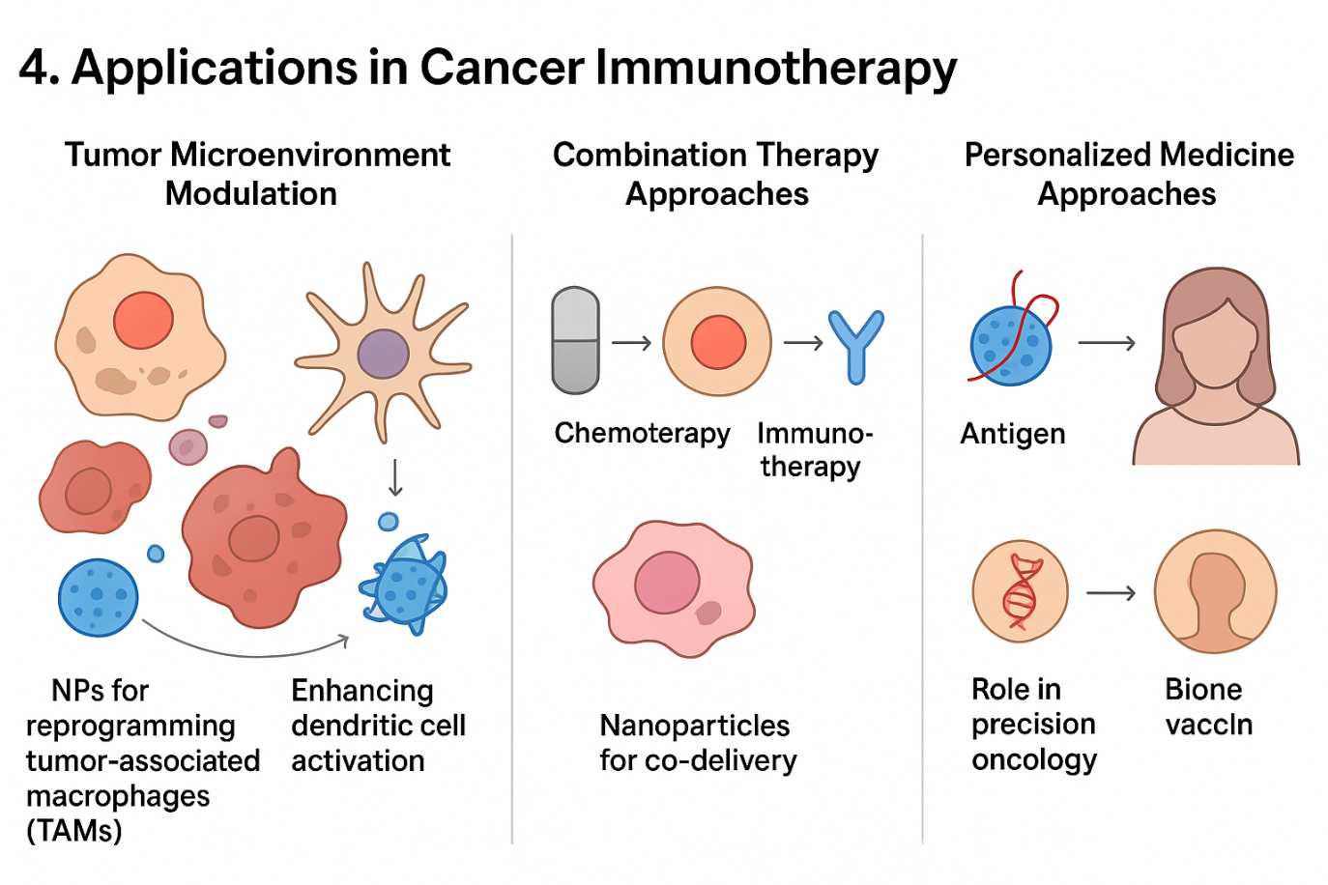

Figure 4: Nanotechnology-Enabled Strategies in Cancer Immunotherapy: Tumor Microenvironment Modulation, Combination Therapeutics, and Personalized Medicine Approaches.

5. Development Difficulties and Constraints
Despite the positive laboratory and preclinical outcomes, however, a very real impediment to the standard clinical usage of nanotechnology in cancer immunotherapy remains. An essential issue that needs to be addressed is the interaction of the engineered nanocarriers with the human body; whereas the materials that are used may be classified as biodegradable and biocompatible, the consequences of long-term retention at the organism level remain incompletely described and interpreted. Certain inorganic systems, including gold or quantum dots, can cause localized oxidative stress, DNA damage, or acquire an unusually high immunogenicity, which can pose a long-term safety risk to patients [Zhang, H., et al., 2023]. Another, yet another complicity of the same kind is caused by the tumor per se. The cancer of any patient has high interpatient and even intratumoral heterogeneity, which involves differences in vascular organization, stromal composition, and location/pathological activation of tumor-infiltrating immune cells. These variations characterize how, when, and where the nanoparticles would be distributed across the body once injected into circulation. Once the most essential concept that facilitates the tumor targeting of systemic cancer, the EPR (enhanced permeability and retention) effect turns out to be much less reliable not only between types but also in the same cancer at an apparently homogenous internal lesion site. Immune dysregulations add to these safety-related concerns. In some instances, RGAs designed to achieve this may induce adverse systemic inflammations or cytokine storms or autoimmune responses. This fine line, between promoting anti-tumoral immune activation and peripheral tolerance, must be maintained within a very narrow range of nanoparticle dosing 1012, delivery schedule, and targeting plan [Sung et al., 2023]. Endogenous impediment perspicacity is acute in the scaled-up and regulation area. The challenge of nanomedicines production in the industry remains the need to closely incorporate reproducible processes to deliver consistent quality, predetermined stability, and low inter-batch variability. Regulatory bodies have failed to agree on any particular guidance in evaluating nanoparticle curricula, i.e., in the context of safety, biodistribution patterns, and immunologic signature, a fact that has contributed to additional bottlenecks in clinical practices [Zhang, L., Li, & Xu, 2024]. The future of innovative nano-immuno-oncology is more than the traditional carrier of payload. Designed nanocarriers also containing a stimulresponsive network, that is, pH, redox, and enzymatic-processing designs, are planned to leak lots within the endo-tumoral environment, ensuring additional accuracy and limiting peripheral contact. In parallel, the integration of artificial intelligence (AI) with nanoparticle design is imminent; predictions of nanoparticle biology, guiding surface chemotherapy, and personalizing physiologic models of single host pathways, which, collectively, accelerate passage across the concept-to-patient delivery bridge. The miniaturization still occurs in the theranostic structures, which fossilize the diagnostics of the traces and therapeutic activities in the same nanocarrier. When prudently incorporated, theranostic architectures otherwise alternate immune modulation with concurrent imaging of the biodistribution, immune commitment, and tumor retreat. Identically, when used, they enable clinicians to dynamically and locationally re-map their therapeutics on demand [Zhang, L., Li, & Xu, 2024].

6. Future Perspectives
Potential in novel nano-immuno-oncology is offering a future beyond the scope of established payload delivery. Engineered leaky nanocarriers are loaded with stimulus-responsive sections, including pH- (redox-) or enzymatically activated cleavable structures, that are designed to spill the cargo precisely on an electrochemical milieu within the endo-tumor. Simultaneously, artificial intelligence (AI) with nanoparticle design will be the next step; data sets are being trained to predict the performance of nanoparticle biological signatures, driving surface-directed chemotherapy and physiologic modeling of individual host-response pathways, which, together, slow the translation of the idea to the living. The advancement is ongoing in the theranostic constructs, which ossify diagnostic remnants and therapeutic delivery in the same nano-carrier. Under the administration in favorable doses, theranostic architectures can translate immune modulation on and off in parallel with the biodistribution, immune commitment, and tumor retrospection, respectively, that subsequently enable clinicians to re-map therapeutic regimens dynamically and spatially [Ahmed, Singh, & Kumar, 2024]. More to the point, there is a need to enable the shift of preclinical research to clinical translation, and this is one of the objectives to be pursued later. Compared to the nano-immunotherapeutics, the number of such that have made it to clinical trials is very limited, and this is somewhat surprising considering that most of such nano-conjugates have shown positive in vivo and in vitro outcomes in animal models. This effort will require interdisciplinary relationships, uniform regulation, and investment in production techniques that can sustain a bigger role.

7. Conclusion
Nanotechnology is among those advanced fields in which the realms of such a prophylaxis of cancer and immunology are becoming more intertwined. These types of engineered nanoscale vehicles will enable the targeted delivery of chemo-agents, immuno-modulators, tumor antigens, and nucleic acids to a level of accuracy never before possible. The additional effects of these nanocarriers include: re-localizing therapeutics to specific tumor architectures, as well as inducing permissive immune microenvironments, activating effector cells, and bypassing tumor resistance to conventional regimens. Examples of applications that could characterize this approach (i.e., nanovaccines, combinatoric regimens, and tailored nano-immunotherapies) point to the magnitude of the expected clinical utility. Despite the promise, serious barriers remain, including, but not limited to, intratumoral heterogeneity, the threat of immune-associated toxicity, and the regulatory control maze. The further development of smart nanomaterials, algorithm-aided design, and integrated theranostics is anticipated to expedite the process to bench-bedside translation. Lastly, nanotechnology can increase the potential of an anticancer immune response. Long-term investment is necessary to convert potential into practice, including intensive preclinical benchmarking, sound clinical validation, and parallel regulatory pathways. This should be followed up by future studies on broad research designs, limited cohorts with biomarkers, and convergence of nano-scale therapies into precision oncology, therefore, paving the way to individualized and curative management of cancer.

Disclaimer (Artificial intelligence)
Author(s) personally state that there are NO generative AI systems, including Large Language Models (ChatGPT, COPILOT, etc.) and text-to-image generators, that were utilized in the process of writing or editing this piece.

References
- Bhattacharya, R., & Mukherjee, P. (2022). Fundamentals of nanoscience for biomedicine. Nature Reviews Materials, 7(12), 987–1005. https://doi.org/10.1038/s41578-022-00491-8
- Blanco, E., Shen, H., & Ferrari, M. (2022). Principles of nanomedicine in cancer therapy: Challenges and opportunities. Nature Reviews Drug Discovery, 21(9), 676–695. https://doi.org/10.1038/s41573-022-00393-9
- Chen, H., et al. (2024). Polymeric and lipid nanoparticles in cancer immunotherapy. Advanced Drug Delivery Reviews, 197, 114823. https://doi.org/10.1016/j.addr.2023.114823
- Hangiu, O., Navarro, R., Frago, S., Rubio-Pérez, L., Tapia-Galisteo, A., Díez-Alonso, L., et al. & Compte, M. (2025). Effective cancer immunotherapy combining mRNA-encoded bispecific antibodies that induce polyclonal T cell engagement and PD-L1-dependent 4-1BB costimulation. Frontiers in Immunology, 15, 1494206. https://doi.org/10.3389/fimmu.2024.1494206

- Doroshow, D. B., et al. (2023). Beyond standard of care: Novel therapeutics in solid tumors. Nature Reviews Clinical Oncology. https://doi.org/10.1038/s41571-023-00802-6
- Dougan, M., Luoma, A. M., Dougan, S. K., & Wucherpfennig, K. W. (2023). Immune-related adverse events in cancer immunotherapy. New England Journal of Medicine, 389(10), 902–915. https://doi.org/10.1056/NEJMra2301484
- Fan, Y. N., Zhao, G., Zhang, Y., Ye, Q. N., Sun, Y. Q., Shen, S., ... & Wang, J. (2023). Progress in nanoparticle-based regulation of immune cells. Medical Review, 3(2), 152–179. https://doi.org/10.1515/mr-2022-0047

- Gu, Z., Liu, Y., Xu, F., & Liang, C. (2023). Nano-immunotherapy: Overcoming the delivery challenges of immune checkpoint inhibitors. Journal of Nanobiotechnology, 21(1), 45. https://doi.org/10.1186/s12951-023-01845-y
- Hadi, K. A., Al-Douri, S. D. S., & Hadree, D. H. (2023). Effect of folic acid on some physiological parameters in female rabbits treated with methotrexate. Iraqi Journal of Agricultural Sciences, 54(3), 730–734.
- Hou, X., et al. (2023). Liposomal delivery of checkpoint inhibitors and cytokines. Nature Reviews Clinical Oncology, 20(7), 435–452. https://doi.org/10.1038/s41571-023-00764-4
- Huang, X., et al. (2023). Gold nanoparticles in cancer immunotherapy. Nature Nanotechnology, 18(7), 642–658. https://doi.org/10.1038/s41565-023-01345-8
- Jaaffer, M. D., & Al-Ogaidi, I. A. Z. (2022). Developing gold–resveratrol nanoconjugates for the management of rheumatoid arthritis (RA). The Egyptian Journal of Hospital Medicine, 89(2), 6637–6645. https://doi.org/10.21608/ejhm.2022.230316
- Jaaffer, M. D., & Al-Ogaidi, I. A. Z. (2022). Managing the immune markers to rheumatoid arthritis with chitosan-capped gold nanoparticles. Romanian Journal of Diabetes, Nutrition and Metabolic Diseases, 31(1), 418–432. https://rjdnmd.org/index.php/RJDNMD/article/view/1187
- Jiang, X., Wang, Q., Li, Z., & Tang, J. (2024). Intratumoral LNP-mRNA delivery of cytokines synergizes with anti-PD-1 therapy in solid tumors. Nature Communications, 15, 11234. https://doi.org/10.1038/s41467-024-11234-5
- Ahmed, M., Kurungottu, P., Swetha, K., Atla, S., Ashok, N., Nagamalleswari, E., et al. & Kurapati, R. (2025). Role of NLRP3 inflammasome in nanoparticle adjuvant-mediated immune response. Biomaterials Science, 13(9), 2164–2178. https://doi.org/10.1039/d4bm00439f
- Kuai, R., et al. (2023). Nanoparticle-based cancer vaccines: Progress and prospects. Nature Reviews Drug Discovery, 22(9), 675–694. https://doi.org/10.1038/s41573-023-00799-5
- Li, H., Wang, J., Zhang, Q., & Sun, X. (2025). Nano drug delivery systems for advanced immune checkpoint blockade in cancer therapy. Signal Transduction and Targeted Therapy, 10(1), 56. https://doi.org/10.1038/s41392-025-0056-9
- Rosyidah, A. L., Kerdtoob, S., Yudhistyra, W. I., & Munfadlila, A. W. (2023). Gold nanoparticle-based drug nanocarriers as a targeted drug delivery system platform for cancer therapeutics: a systematic review. Gold Bulletin, 56(3), 121–134. https://doi.org/10.1007/s13404-023-00331-5
- Li, J., et al. (2023). Photothermal nanomedicine for cancer immunotherapy. Nano Today, 50, 101819. https://doi.org/10.1016/j.nantod.2023.101819
- Li, M., et al. (2023). Photothermal AuNPs induce immunogenic cell death. Nature Communications, 14, 5111. https://doi.org/10.1038/s41467-023-05111-9
- Li, Y., Li, S., Jiang, Z., Tan, K., Meng, Y., Zhang, D., & Ma, X. (2023). Targeting lymph node delivery with nanovaccines for cancer immunotherapy: recent advances and future directions. Journal of Nanobiotechnology, 21(1), 212. https://doi.org/10.1186/s12951-023-01977-1
- Liu, J., Wu, K., Yang, F., & Chen, D. (2024). Microneedles-mediated intradermal delivery of paclitaxel/anti-PD-1 nanoparticles enhances tumor immunotherapy. Advanced Therapeutics, 7(3), 2400112. https://doi.org/10.1002/adtp.202400112
- Liu, Y., et al. (2023). Stimuli-responsive nanocarriers in oncology. Small, 19(14), 2207569. https://doi.org/10.1002/smll.202207569
- Mao, X., et al. (2023). Nanoparticle-mediated reprogramming of tumor-associated macrophages for cancer therapy. Advanced Materials, 35(15), 2209875. https://doi.org/10.1002/adma.202209875
- Park, J., et al. (2024). Dendrimer nanoplatforms for combination immunotherapy. Nature Communications, 15, 2345. https://doi.org/10.1038/s41467-024-02345-1
- Postow, M. A., et al. (2023). Cancer immunotherapy: Progress and promise. Nature Reviews Cancer, 23(2), 98–114. https://doi.org/10.1038/s41568-022-00541-2
- Shao, J., et al. (2023). Gold nanoparticles enhance DC maturation and T-cell responses. Frontiers in Immunology, 14, 1167821. https://doi.org/10.3389/fimmu.2023.1167821
- Sharma, P., et al. (2022). Immune checkpoint therapy and the future of cancer immunotherapy. Science, 375(6578), 1240–1246. https://doi.org/10.1126/science.abj4002
- Shen, J., et al. (2025). Emerging trends in nanotheranostics for precision oncology. Nature Reviews Cancer, 25(2), 110–128. https://doi.org/10.1038/s41568-024-00670-4
- Song, W., et al. (2023). Polymeric nanovaccines for enhanced antitumor immunity. Biomaterials, 298, 122122. https://doi.org/10.1016/j.biomaterials.2023.122122
- Sung, H., et al. (2023). Global cancer statistics 2023. CA: A Cancer Journal for Clinicians, 73(3), 209–249. https://doi.org/10.3322/caac.21720
- Tang, L., et al. (2024). Nanotechnology for immunotherapy and cancer treatment. ACS Nano, 18(4), 5678–5691. https://doi.org/10.1021/acsnano.3c08976
- Wang, S., et al. (2025). Artificial intelligence and nanomedicine in cancer immunotherapy. Frontiers in Immunology, 16, 1529851. https://doi.org/10.3389/fimmu.2025.1529851
- Wang, X., et al. (2024). Theranostic nanoparticles in cancer management. Nature Reviews Clinical Oncology, 21(1), 45–62. https://doi.org/10.1038/s41571-023-00785-1
- Yuan, H., Chen, X., & Zhao, L. (2025). PD-L1 siRNA-loaded boron nanoparticles for synergistic boron neutron capture therapy and immune checkpoint blockade. Advanced Materials, 37(5), 2406543. https://doi.org/10.1002/adma.202406543
- Wang, Y., Zhang, J., & Li, P. (2025). Injectable and implantable hydrogels for localized drug delivery in cancer immunotherapy. International Journal of Pharmaceutics, 655, 122345. https://doi.org/10.1016/j.ijpharm.2025.122345
- Sulaiman, G. M., Tawfeeq, A. T., & Jaaffer, M. D. (2018). Biogenic synthesis of copper oxide nanoparticles using Olea europaea leaf extract and evaluation of their toxicity activities: An in vivo and in vitro study. Biotechnology Progress, 34(1), 218–230. https://doi.org/10.1002/btpr.2586
- Wang, Y., et al. (2023). RNAi-based nanotherapeutics for precision oncology. Nature Reviews Cancer, 23(6), 412–430. https://doi.org/10.1038/s41568-023-00643-2
- Wei, Y., Song, G., Zhao, J., & Xu, H. (2024). Nanoparticle-enhanced PD-1/PD-L1 targeted combination therapy in triple-negative breast cancer. Frontiers in Oncology, 14, 98765. https://doi.org/10.3389/fonc.2024.098765
- Wilhelm, S., Tavares, A. J., Dai, Q., Ohta, S., Audet, J., Dvorak, H. F., & Chan, W. C. W. (2023). Nanoparticle delivery to tumors: The EPR effect revisited. Nature Reviews Materials, 8(2), 123–139. https://doi.org/10.1038/s41578-022-00522-4
- Xu, C., et al. (2023). Nanotechnology in gene editing for cancer therapy. Nature Nanotechnology, 18(9), 995–1012. https://doi.org/10.1038/s41565-023-01411-3
- Zhao, L., et al. (2023). Engineering multifunctional gold nanostructures for synergistic photothermal and immunotherapy. Advanced Functional Materials, 33(18), 2214567. https://doi.org/10.1002/adfm.202214567
- Zhang, H., et al. (2023). Advances in nanomaterial design and biomedical applications. Advanced Materials, 35(10), 2207654. https://doi.org/10.1002/adma.202207654
- Zhang, L., Li, M., & Xu, Y. (2024). Recent advances in nanoparticle-based siRNA delivery for immune checkpoint blockade. Journal of Controlled Release, 360, 512–528. https://doi.org/10.1016/j.jconrel.2024.08.015
- Zhang, Q., et al. (2024). Doxorubicin-induced immunogenic cell death and nanomedicine. Frontiers in Immunology, 15, 1178921. https://doi.org/10.3389/fimmu.2024.1178921
- Ahmed, N., Singh, R., & Kumar, V. (2024). Nanoparticle-enabled checkpoint blockade therapies in solid tumors: Progress and challenges. Journal of Controlled Release, 370, 512–526. https://doi.org/10.1016/j.jconrel.2024.03.015

