Original Research Article
Correlation and Path Coefficient Studies for Grain Yield and Yield Component traits in browntop millet

Abstract
Browntop millet (Brachiaria ramosa (L.) Stapf. or Urochloa ramosa (L.)) belongs to Poaceae, and exists as var. ramosa and var. pubescens. Grown mainly in parts of southern and North-Central India, it is used for both food and fodder, though often considered a weed. Despite its potential, cultivation remains limited, warranting greater research and promotion. This study aimed to conduct correlation and path coefficient studies for grain yield and yield component traits in browntop millet. Evaluation of 30 browntop millet genotypes was done during Rabi, 2024-25, at the Agricultural Research Station, Perumalapalle, Andhra Pradesh, India, to correlate and perform path analysis of yield and yield component traits. Data were collected on nine yield and yield component traits. The WINDOSTAT program was used for statistical analysis. Correlation analysis revealed strong positive and significant genotypic and phenotypic correlations between grain yield and traits such as plant height, panicle length, and harvest index. This implies that indirect selection for these traits could enhance grain yield. Path coefficient analysis further confirmed that harvest index had the highest positive direct effect on grain yield, making it a crucial trait for selection. Plant height and panicle length, though showing moderate direct effects, contributed significantly to grain yield through positive indirect effects. Days to 50% flowering and days to maturity exhibited negative correlations and direct effects on grain yield, suggesting that earlier maturity is advantageous for yield enhancement.
Keywords: Browntop millet, Grain Yield, Correlation, Coefficient,
Introduction
Millets are the major food source in arid and semi-arid parts of the world. Although India is the topmost producer of millets, observed a steady decline in its production and utilisation. Millets can be used for food, feed and fodder, and they can be used as raw material for industries. Millets are a staple food of Asia and African countries (Ashoka & Sunitha, 2020). Browntop millet (Brachiaria ramosa (L.) Stapf. or Urochloa ramosa (L.)) is a drought-tolerant minor millet native to Southeast Asia, first domesticated in southern India. It belongs to Poaceae, and exists as var. ramosa and var. pubescens. It has 8 haploid chromosomes and exists as a tetraploid (4x=32). Its vernacular names include “Andukora or Pedda saama” in Telugu; “Kula samai or Palapul” in Tamil; “Korale” in Kannada, and “Hari kanganee or Makara” in Hindi. Grown mainly in parts of southern and North-Central India, it is used for both food and fodder, though often considered a weed. Rich in protein (11.5g), dietary fibre (12.5g), and minerals (4.2g) per 100g, it supports nutrition, combats lifestyle diseases, and offers climate resilience. The growing curiosity of health-conscious people towards the usage of millet in their daily diet is due to its rich composition of protein, dietary fibre, vitamins and minerals. By incorporating millets into the cereal matrix, food manufacturers can produce naturally gluten-free ingredients appropriate for people with gluten sensitivity (Srivastav & Chauhan, 2024; Reddy & Patel, 2023). Despite its potential, cultivation remains limited, warranting greater research and promotion.
The correlation coefficient measures the degree of association and also the genetic or non-genetic relationship between two or more characters, which forms the basis for selection. Path analysis simply splits the correlation coefficient into the measures of direct and indirect effect of a set of independent variables on the dependent variables (Kamle et al., 2022; Azarinasrabad et al., 2025). A combination of correlation and path analysis gives good insights into the cause-and-effect relationship of different pairs of characters that determine the selection of plants for breeding. It will be an additional advantage to have information about the association of characters, and also the direct and indirect effects of each character on yield. The degree of association between yield and its components can easily be established and understood by correlation and path analysis. This helps the breeder to design different strategies to get better grain yield.
The path coefficient analysis can be split into direct and indirect effects of different traits concerning the dependent variable, as proposed by Wright (1921) and described by Dewey and Lu (1959). This helps in evaluating the cause–and–effect relationship and selection of hybrids. This can be utilised in the selection of genotypes for yield enhancement. This study aimed to conduct correlation and path coefficient studies for grain yield and yield component traits in browntop millet.
Material and Methods
The present investigation was carried out to assess character associations in brown top millet using correlation and path analysis. The study was conducted during Rabi, 2024-25 at the Agricultural Research Station (ARS), Perumallapalle, Tirupati rural, Andhra Pradesh, India.
In this study, two replications were taken in a randomised block design. 30 different genotypes from across the country were taken. Gross plot size was 2rows of 2m length, while spacing between row to rows was set to 45cm, and the same between plants was 15cm. Recommended dose of fertiliser was used – 40kg/ha N; 20kg/ha P₂O_{5.} K₂O was not used. 5 plants were randomly selected in each replication from each plot to find out character associations. The observations were recorded on a plot basis for days to 50% flowering and days to grain maturity.
Data were collected on nine yield and yield component traits viz., plant height (cm), number of productive tillers per plant, days 50% flowering, panicle length (cm), days to maturity, test weight (g), straw yield per plant (g), grain yield per plant (g) and harvest index (%). Grain yield per plant was calculated after harvest. The WINDOSTAT program was used for statistical analysis. Correlation among the selected nine characters was arrived at by using the method given by Singh and Chaudhary (1977). Assessment of direct and indirect effects of these characters was done as described by Dewey and Lu (1959).
RESULTS AND DISCUSSIONS
Correlation studies
Expression of the character grain yield depends upon various constituent characters. To improve the efficiency of selection for the production of improved varieties, knowledge of the association between a character and its component traits is very helpful. For achieving genetic enhancement of yield, the correlation coefficient can be relied upon. This measures the relationship among different plant characters. Also, it determines the component characters which affect genetic improvement. Generally, a positive correlation occurs during the coupling phase and a negative correlation during the repulsion phase of linked genes controlling different traits.
The present study reveals that phenotypic correlations were lower than the corresponding genotypic correlations. This may be due to masking or environmental impact on the genetic association among characters. Whereas, a significant negative correlation was observed with grain yield per plant by days to 50% flowering and days to maturity. Similarly, a positive association of grain yield per plant with harvest index was revealed by Arya et al. (2017) in barnyard millet, Nagar et al. (2020) in little millet and Anuradha et al. (2020) in browntop millet; Smita et al. (2016) in foxtail millet for panicle length and Ashok et al. (2016b) and Kumar et al. (2017) in little millet for plant height. Negative significant results were reported by Kavitha (2018) in foxtail millet for days to50 % flowering.; Ashok et al. (2016a) and Jyothsna et al. (2016) in foxtail millet and Anuradha et al. (2017) in little millet for days to maturity.
The present study showed a significant positive association between panicle length and grain yield per plant (r_{g}=0.427*). Similar results were obtained by Vardhan et al. (2025) in foxtail millet, Jadhav et al. (2015) in finger millet and Anuradha et al. (2020) in browntop millet. A significantly positive association was observed between days to 50% flowering and days to maturity (r_{g}=0.993** and r_{p}= 0.893**) by Vardhan et al. (2025) in foxtail millet, Dasaliya et al. (2023) in kodo millet and Bahera et al. (2024) in finger millet. reported likewise results and between panicle length and harvest index (r_{g}=0.376*). Bahera et al. (2024) and Patel et al. (2024) in finger millet for harvest index reported similar results. Significantly negative associations were observed between plant height and number of productive tillers per plant (r_{p}= -0.280*), plant height and days to maturity (r_{p}= -0.291*) at the phenotypic level by Behera et al. (2024) in little millet for panicle length. Shingane et al. (2016) reported similar findings for the number of productive tillers in finger millet, and Selvi et al. (2014) in little millet reported likewise results for days to maturity, Days to 50% flowering and harvest index (r_{g}= -0.457* and r_{p}= 0.373**). Dalsaniya et al. (2023) reported similar negative association, panicle length and test weight (r_{g}= -0.429*) similar results were reported by Bahera et al. (2024) in finger millet, days to maturity and harvest index (r_{g}= -0.606** and r_{p}= -0.438**) reported by Naidu et al. (2021) and Venkataratnam et al. (2019) in little millet for harvest indexand fodder yield per plant and harvest index (r_{g}= -0.401* and r_{p}= -0.389**)Venkataratnam et al. (2019) in little millet and Arya et al. (2019) in barnyard millet.
Plant height showed a significant positive association with panicle length at the genotypic level, indicating that genetically taller plants are likely to develop longer panicles, which in turn increase grain yield per plant. The selection of early-flowering genotypes would be helpful in reducing the duration of the crop by achieving early maturity. There is a positive and significant genetic association between panicle length and harvest index. This means that plants with longer panicles are more likely to have a higher harvest index, making them more efficient in converting biomass into yield. days to maturity had a significant negative association with harvest index at both genotypic and phenotypic levels, indicating that longer maturity periods are linked to a reduction in harvest index. This suggests that the selection of early maturing genotypes might help in improving harvest efficiency. An increase in fodder yield per plant would be a decrease in harvest index.
Path coefficient analysis is a good tool that helps in identifying the affective components of a given character, and its direct as well as indirect effects. It helps in getting information about the actual contribution of each component to the yield. The cause-and-effect relationship of selected variables is taken into account in path analysis. The association between variables is divided into direct and indirect effects through other independent variables, in this analysis. Also, path analysis, together with correlation studies, provides the required information about the nature and association between any two traits selected for study. This helps plant breeders to select the best possible variety.
Harvest index (G= 1.2060 and P= 1.0666) and fodder yield per plant (G= 0.5610 and P= 0.4478) recorded very high and high positive direct effects on grain yield per plant at both genotypic and phenotypic levels. These results are in agreement with reports of Jhansi Rani et al. (2021) and Pallavi et al. (2020) in foxtail millet for fodder yield and Venkataratnam et al. (2019) in little millet and Arya et al. (2019) in barnyard millet for harvest index.
Path coefficient analysis of browntop millet genotypes revealed that harvest index, fodder yield per plant, plant height, and panicle length are the most important contributors to grain yield, exerting significant direct and indirect effects. Among these, harvest index and fodder yield per plant showed the strongest direct positive impact on grain yield at both genotypic and phenotypic levels, establishing them as key traits for selection. Although plant height and panicle length had smaller direct effects, they contributed substantially to grain yield through positive indirect effects via other yield components. Conversely, days to 50% flowering and days to maturity exhibited significant negative associations with grain yield, suggesting that early flowering and maturity favour higher yields. The analysis indicated that 90.18% of the variation in grain yield per plant was explained by the studied component traits, underscoring the importance of focusing on these traits in breeding programs. Therefore, selection efforts could prioritise harvest index, fodder yield per plant, plant height and panicle length to effectively isolate superior lines with high genetic potential for grain yield improvement.
Conclusion
The character association studies among the nine yield and yield-component traits revealed that exercising selection based on plant height, panicle length and harvest index would be considered for improvement in grain yield as they had exhibited significant and positive association with grain yield per plant. The genotypic correlations were higher than the phenotypic correlation coefficient in general, indicating that although the characters studied have an intrinsic relationship, the environment and its interaction with the genotype played a major role in determining these relationships. Path coefficient analysis further confirmed that harvest index had the highest positive direct effect on grain yield, making it a crucial trait for selection. Plant height and panicle length, though showing moderate direct effects, contributed significantly to grain yield through positive indirect effects. Days to 50% flowering and days to maturity exhibited negative correlations and direct effects on grain yield, suggesting that earlier maturity is advantageous for yield enhancement.

Table 1. Genotypic and phenotypic correlations among yield and yield component traits in browntop millet

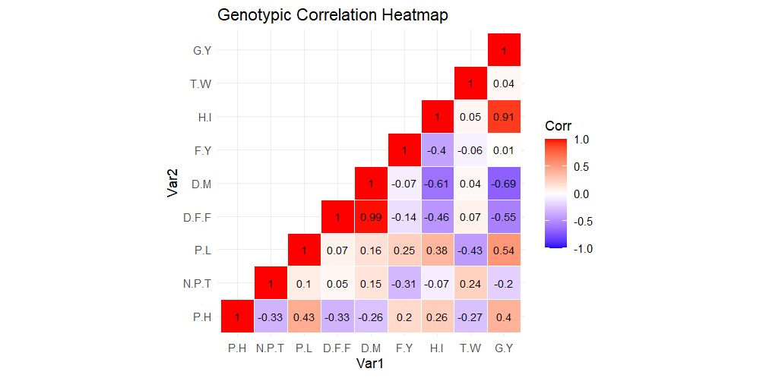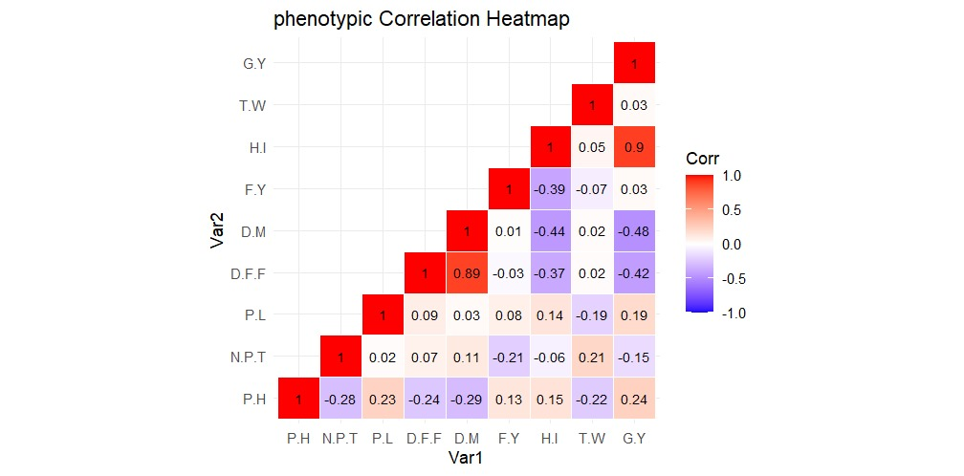

PH- Plant height (cm), NPT- No. of productive tillers per plant, DFF- Days to 50% flowering, PL- Panicle length (cm), DM- Days to maturity, TW- Test weight (g), FY- Fodder yield per plant (g), GY- Grain yield per plant (g), HI-Harvest Index (%).
Fig. 1 Depiction of genotypic and phenotypic correlations among yield and yield-component traits through a shaded correlation matrix

Table 2. Genotypic and phenotypic direct and indirect effects of yield component traits on grain yield per plant in browntop millet genotypes
 |  | PH | NPT | DFF | PL | DM | TW | FY | HI | Correlation  with GY
PH | G | 0.0999 | -0.0387 | -0.0596 | -0.0544 | 0.0174 | 0.0129 | 0.1101 | 0.3094 | 0.3970**
PH | P | 0.0234 | -0.0039 | -0.0060 | 0.0016 | 0.0099 | -0.0035 | 0.0574 | 0.1582 | 0.2372
NPT | G | -0.0332 | 0.1164 | 0.0095 | -0.0128 | -0.0103 | -0.0117 | -0.1737 | -0.0843 | -0.2001
NPT | P | -0.0066 | 0.0139 | 0.0017 | 0.0002 | -0.0039 | 0.0033 | -0.0953 | -0.0646 | -0.1513
DFF | G | -0.3304 | 0.0061 | 0.1805 | -0.0087 | -0.0669 | -0.0033 | -0.0773 | -0.5516 | -0.5542**
DFF | P | -0.0056 | 0.001 | 0.025 | 0.0007 | -0.0304 | 0.0004 | -0.0114 | -0.3982 | -0.4187**
PL | G | 0.0426 | 0.0117 | 0.0122 | -0.1276 | -0.0111 | 0.0209 | 0.1382 | 0.4536 | 0.5406**
PL | P | 0.0053 | 0.0003 | 0.0023 | 0.0073 | -0.0012 | -0.0031 | 0.0373 | 0.1458 | 0.1940
DM | G | -0.0258 | 0.0177 | 0.1791 | -0.0210 | -0.0674 | -0.0021 | -0.0419 | -0.7306 | -0.6919**
DM | P | -0.0068 | 0.0016 | 0.0223 | 0.0003 | -0.0341 | 0.0004 | 0.0024 | -0.4677 | -0.4816**
TW | G | -0.0265 | 0.0281 | 0.0124 | 0.0548 | -0.0029 | -0.0486 | -0.0328 | 0.0552 | 0.0397
TW | P | -0.0051 | 0.0029 | 0.0006 | -0.0014 | -0.0008 | 0.0160 | -0.0313 | 0.0493 | 0.0302
FY | G | 0.0196 | -0.0360 | -0.0249 | -0.0315 | 0.0050 | 0.0028 | 0.5610 | -0.4831 | 0.0131
FY | P | 0.0030 | -0.0030 | -0.0006 | 0.0006 | -0.0002 | -0.0011 | 0.4478 | -0.4145 | 0.0320
HI | G | 0.0256 | -0.0081 | -0.0825 | -0.048 | 0.0408 | -0.0022 | -0.2247 | 1.206 | 0.9068**
HI | P | 0.0035 | -0.0008 | -0.0093 | 0.0010 | 0.0149 | 0.0007 | -0.1740 | 1.0666 | 0.9025**
Phenotypic residual effect: 0.108, Genotypic residual effect: 0.084
PH- Plant height (cm), NPT- No. of productive tillers per plant, DFF- Days to 50% flowering, PL- Panicle length (cm), DM- Days to maturity, TW- Test weight (g), FY- Fodder yield per plant (g), GY- Grain yield per plant (g), HI- Harvest index (%).
G: Genotypic direct or indirect effect, P: Phenotypic direct or indirect
*Significance at 5% level ,**Significance at 1% level

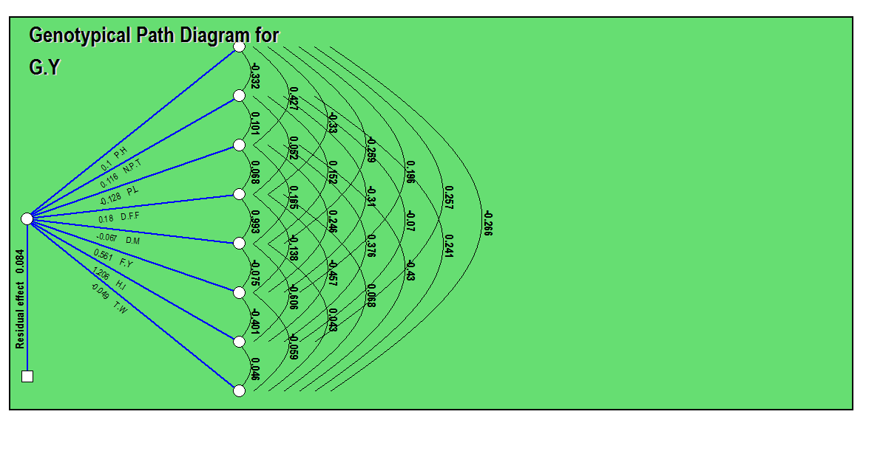
Fig. 2. Genotypic path diagram showing direct and indirect effects of yield component traits on grain yield per plant in browntop millet
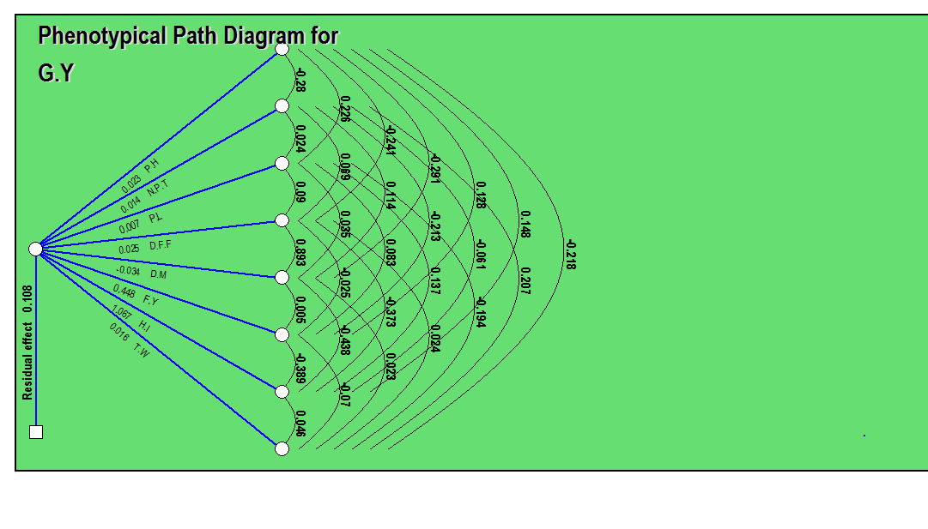

Fig. 3 Phenotypic path diagram showing direct and indirect effects of yield component traits on grain yield per plant in browntop millet

Disclaimer (Artificial intelligence)
Option 1:
Author(s) hereby declare that NO generative AI technologies such as Large Language Models (ChatGPT, COPILOT, etc.) and text-to-image generators have been used during the writing or editing of this manuscript.
Option 2:
Author(s) hereby declare that generative AI technologies such as Large Language Models, etc. have been used during the writing or editing of manuscripts. This explanation will include the name, version, model, and source of the generative AI technology and as well as all input prompts provided to the generative AI technology
Details of the AI usage are given below:
1.
2.
3.

References
Anuradha, N., Patro, T.S.S.K., Divya, M., Rani, S.Y and Triveni, U. 2017. Genetic variability, heritability and correlation of quantitative traits in little millet genotypes. Journal of Pharmacognosy and Phytochemistry. 6(6): 489-492.
Anuradha, N., Patro, T.S.S.K., Triveni, U., Rao, P.J and Rajkumar, S. 2020. Trait association and genetic variability in browntop millet. Journal of Pharmacognosy and Phytochemistry. 9(1): 1950-1953.
Arya, R., Bhatt, A and Kumar, V. 2018. Study of genetic divergence in barnyard millet (Echinochloa frumentacea (Roxb.) Link) germplasm. International Journal of Bio-resource and Stress Management. 9(2):192-196.
Ashok, S., Patro, T.S.S.K., Jyothsna, S and Divya, M. 2016a. Studies on genetic parameters, correlation and path analysis for grain yield and its components in foxtail millet (Setaria italica). Progessive Research. 11(3): 300-303.
Ashok, S., Patro, T.S.S.K., Jyothsna, S and Divya, M. 2016b. Study of genetic parameters, character association and path analysis for grain yield and its components in little millet (Panicum sumatrense). Progessive Research. 11(4): 314-317.
Behera, R., Singamsetti, A., Rout, S., Nanda, S. and Sharma, S.S., 2024. Genetic variability and character associations for grain yield and other secondary traits in little millet (Panicum sumatrense L.) at Eastern Ghats Zone of Odisha. Electronic Journal of Plant Breeding, 15(1): 239-245.
Dewey, D.R and Lu, K.H. 1959. A correlation and path coefficient analysis of components of crested wheat grass seed production. Agronomy Journal. 51(9): 515-518.
Jadhav, R., Babu, D.R., Ahmed, M.L and Rao, V.S. 2015. Character association and path coefficient analysis for grain yield and yield components in finger millet (Eleusine coracana (L.) Gaertn.). Electronic Journal of Plant Breeding. 6(2): 535-539.
Kavitha, S. 2018. Genetic studies on yield and quality attributes in grain sorghum (Sorghum bicolor L.). M.Sc. Thesis. Agricultural college, Bapatla, AcharyaN.G. Ranga Agricultural University, Guntur, Andhra Pradesh.
Kumar, A., Jain, A.K., Kumar, A and Sharma, R.L. 2017. Agro-morphological characters of little millet (Panicum sumatrense) associated with grain smut incidence. Journal of Entomology and Zoology Studies. 5(5): 356-359.
Nagar, J., Kumar, B., Sahu, B., Kumar, S and Joshi, R.P. 2020. Studies on character association and path coefficient analysis for grain yield and its influencing traits in little millet (Panicum sumatrense). Journal of Pharmacognosy and Phytochemistry. 9(3): 1899-1900.
Patel, U., Patil, H., Parekh, V., Vadodaria, G. and Shrivastava, A., 2024. Genetic variability, heritability and genetic advance in finger millet (Eleusine coracana L.) genotypes. Electronic Journal of Plant Breeding, 15(2): 471-477.
Selvi, M.V., Nirmalakumari, A and Subramanian, A. 2014. Genetics and interrelationships of yield traits for enhancing productivity of little millet. Electronic Journal of Plant Breeding. 5(1): 82-86.
Shingane, S., Gomashe, S., Ganapathy, K.N and Patil, J.V. 2016. Genetic variability and association analysis for grain yield and nutritional quality in foxtail millet. International Journal of Bio-resource and Stress Management. 7(6): 1239-1243.
Smita, S., Patil, J.V., Sunil, G and Ganapathy, K.N. 2016. Genetic variability and association analysis for grain yield and nutritional quality in foxtail millet. International Journal of Bio-Resource and Stress Management. 7 (6): 1239- 1243.
Vardhan, B.H., Ragimekula, N., Priya, M.S. and Sekhar, A.C., 2025. Association analysis for morpho-physiological and yield-attributing traits in foxtail millet (Setaria Italica L. Beauv.). Annals of Arid Zone, 64(1): 129-134.
Venkataratnam, T., Latha, L.M., Sekhar, M.R and Nirmal, A.R.K. 2019. Genetic divergence studies in Little Millet (Panicum sumatrense). Agricultural Science Digest. 39(3): 210-214.
Wright, S. 1921. Correlation and causation. Journal of Agricultural Research. 20: 557- 585.
Ashoka, P., & Sunitha, N. H. (2020). Review on browntop millet – A forgotten crop. Journal of Experimental Agriculture International, 42(7), 54–60.
Srivastav, S., & Chauhan, E. S. (2024). Formulation and sensory evaluation of browntop (Brachiaria ramosa L.) millet-based breakfast cereal enriched with foxnut (Euryale ferox L.) flour. Asian Food Science Journal, 23(12), 92–98.
Kamble, P. S., Barhate, K. K., & Andhale, G. R. (2022). Correlation and path analysis for Zinc, Iron and yield contributing characters in pearl millet [Pennisetum glaucum (L.) R. Br.] Genotypes. The Pharma Innovation Journal, 5(06), 596-600.
Azarinasrabad, A., Mousavi Nik, S. M., Galavi, M., Sirousmehr, A., & Beheshti, S. A. (2025). Correlation and path analysis in yield and its components in grain sorghum genotypes (Sorghum bicolor L.) under water stress conditions. Crop Science Research in Arid Regions, 6(4), 295-310.
Reddy, R., & Patel, D. (2023). A study on consumers’ awareness and preference towards millets and its products in Vizianagaram District, Andhra Pradesh, India. Asian Journal of Agricultural Extension, Economics & Sociology, 41(6), 9-16.

