Original Research Article
Genetic Variability Studies in a Biparental RIL Population for Blast Disease in Pearl Millet

ABSTRACT
Aim: This study aimed to estimate genetic parameters within a pearl millet population comprising 288 recombinant inbred lines (RILs) of the F₇ generation along with two parental lines. The investigation focused on exploring the relationships among 13 quantitative traits and Blast disease score across two environments (ENV-I, ENV-II) as well as in pooled environments.
Study Design: Alpha Lattice Design
Place and Duration of Study: Patancheru, Telangana and Vizianagaram, Andhra Pradesh during Kharif, 2023.
Methodology: The RILs used for this current study developed through the single seed descent method at ICRISAT, Patancheru. The genotypes were assessed at ICRISAT, Patancheru, Hyderabad (ENV-I), and Agricultural Research Station, Vizianagaram, Andhra Pradesh (ENV-II). Combined Analysis of Variance, Heritability, Phenotypic Coefficient of Variation (PCV), Genotypic Coefficient of Variation (GCV), Genetic Advance as percent of Mean (GAM), and Correlation studies were performed in R 4.4.0.
Results: The analysis identified significant variation in both the quantitative traits and Blast disease scores among the RILs, highlighting the potential for genetic improvement and selection. High heritability coupled with substantial genetic advance was observed for traits such as Plant Height, Number of Tillers, Panicle Length, Thousand Seed Weight, Seed Yield, Harvest Index, and Blast Score across ENV-I, ENV-II and Pooled environments. PCV and GCV were notably high for the Number of Tillers, Number of Productive Tillers, Thousand Seed Weight, Seed Yield, and Blast Score across ENV-I, ENV-II, and Pooled Environments. Seed Yield showed positive and significant correlations with the Number of Productive Tillers, Harvest Index, Plant Height, and Number of Tillers in all environments. Conversely, Blast Score exhibited negative associations with all studied traits across the environments.
Conclusion: High heritability coupled with high GAM, along with medium to high PCV and GCV for traits such as plant height, panicle length, seed yield, harvest index, and thousand seed weight, indicates that these traits are predominantly genetically controlled and can be improved significantly through selection, making them valuable for breeding. Blast disease was negatively correlated with seed yield, thousand seed weight, days to maturity, harvest index, number of leaves, number of productive tillers, plant height, and number of tillers, suggesting that increased susceptibility to blast disease negatively affects key agronomic traits. This implies that genotypes with higher blast disease scores tend to exhibit lower productivity, delayed maturity, and reduced overall plant vigor, making resistance to blast disease a critical factor for achieving optimal crop performance and yield stability.
Keywords: Heritability, PCV, GCV, Correlation, Blast Disease Resistance
1. INTRODUCTION
Pearl millet (Pennisetum glaucum (L.) R. Br.) serves as a vital source of nutrition for millions residing in the semi-arid regions of tropical and subtropical countries. It's a nutrient-dense staple food grain that's also utilized as a feed, fodder, construction material and even a biofuel source (Singh and Chhabra, 2018). Recognized for its hardiness, pearl millet thrives in challenging conditions like drought, salinity, low rainfall, and nutrient-deficient soils (Kumawat et al., 2019). It exhibits remarkable traits, including high biomass production, rapid regeneration, prolific tillering, extensive leaf area, and substantial green fodder yield, along with tolerance to pests and diseases.
In the 2023-24, pearl millet was cultivated on 7.36 million hectares in India, yielding an average production of 10.67 million tons with a productivity of 1,449 kg/ha (Department of Agriculture and Farmers Welfare). Nutritionally, pearl millet is a rich source of proteins (6-15%), fats (5-6%), fiber (1-1.8%), and essential minerals like iron, calcium, and zinc, as well as vital amino acids, making it superior to other cereals in terms of nutrient content (Fleck, 1981). As a C₄ plant, pearl millet is highly efficient in utilizing sunlight and water, making it a cornerstone of dryland agriculture and a crucial crop for ensuring food and nutritional security in the face of climate change.
The primary objective of plant breeding programs is to enhance productivity, typically measured as yield per unit area. A significant challenge in pearl millet production is the threat posed by blast disease, caused by the fungal pathogen Pyricularia grisea (Cooke) Sacc., with its teleomorph Magnaporthe grisea. This disease is a major constraint, leading to substantial yield losses. Developing resistance to blast disease is crucial for the sustainable cultivation of pearl millet. Understanding the genetic mechanisms behind blast resistance and identifying resistant lines are key strategies in mitigating the disease's impact.
Genetic variability forms the foundation of crop improvement, providing a broader scope for selection. The success of selection depends on the nature, extent, and magnitude of genetic variability within the material, as well as the heritability of this variability. A thorough assessment of variability using truly diverse germplasm offers an accurate picture of the extent of variation, which is essential for evaluating genetic variability and identifying the factors that have limited progress in pearl millet breeding. Identifying genotypes with high variability is critical for improving yield.
Genetic variability among traits is crucial in selecting desirable types, with parameters such as the genotypic coefficient of variation (GCV) and phenotypic coefficient of variation (PCV) serving as valuable tools for detecting the variability present in the germplasm. Heritability, particularly when paired with high genetic advance, is a powerful indicator for predicting the outcomes of selecting the best genotypes for yield and related traits. The progress of any crop improvement program relies on accurate assessments of genetic variability, heritability, and genetic advance in the base material, as these are essential for identifying traits that are responsive to selection. Additionally, correlation studies are vital in designing effective breeding strategies for specific environments, as they help clarify the relationships between various traits. Consequently, this investigation focused on estimating variability, heritability, expected genetic advance and correlation for various quantitative characters and blast disease scores.
2. MATERIALS AND METHODS
The recombinant inbred lines (RIL) used for this current study on blast resistance (Pyricularia grisea (Cooke) Sacc., teleomorph: Magnaporthe grisea) is composed of 288 F₇ lines. This population involves two parents: ICMR 100844 as the resistant parent and ICMB 95444 as the susceptible parent. These parents, having diverse parentages for blast resistance, were crossed to develop the F₇ generation through the single seed descent method at ICRISAT, Patancheru.
For phenotypic evaluation, the study involved 288 (RILs), including the two parental lines. The genotypes were assessed at ICRISAT, Patancheru, Hyderabad (ENV-I), and Agricultural Research Station, Vizianagaram, Andhra Pradesh (ENV-II), during the kharif season of 2023. The experimental design employed was an Alpha Lattice Design with two replications, and each RIL was planted with a spacing of 60 × 10 cm in two rows, each 2 meters in length. Standard management practices were followed to ensure healthy crop growth. Observations were recorded on five plants per plot for various traits including Days to 50% Flowering (DFF), Days to Maturity (DM), Plant Stand (PS), Plant Height (PH), Number of Tillers (NT), Number of Productive Tillers (NPT), Number of Leaves (NL), Panicle Length (PL), Panicle Diameter (PD), Stem Girth (SG), Thousand Seed Weight (TSW), Seed Yield per plant (SY), Harvest Index (HI), and Blast Score (BS).
Combined Analysis of Variance (ANOVA) was performed by using ASReml-R Package v4 (Butler et al., 2009) to test the significance of the main and interaction effects. Best Linear Unbiased Predictors (BLUPs) were estimated for all the traits from individual and pooled environments. Broad sense heritability, Phenotypic and genotypic coefficient of variation and Genetic advance as percentage mean were estimated using META- R v6.0.4. The Pearson’s correlation coefficients was performed in R 4.4.0 with "corr" function. Data analysis included calculations of analysis of variance and summary statistics according to Panse and Sukhatme (1967). Phenotypic and genotypic coefficients of variation (PCV and GCV) were computed following Burton and Devane (1953). Heritability in the broad sense was estimated based on Allard (1960). Genotypic and phenotypic correlations were calculated according to Falconer (1981), and heritability and genetic advancement were categorized into low, medium, and high as per Johnson et al. (1955). PCV and GCV (Robinson et al., 1949) and GA and GAM (Johnson et al., 1955) were divided into three categories: low (0-10%), moderate (10.1-20%), and high (>20%). Heritability was divided into three categories: low (0-30%), moderate (30.1-60%), and high (>60%) (Robinson et al., 1949).
3. RESULTS AND DISCUSSION
3.1. ANOVA
The ANOVA conducted on the RIL population including parents across two locations showed highly significant differences (P< .001) for most traits (Table 1). These results indicate substantial genetic variability within the RIL population for traits under study, which is crucial for selection and improvement in breeding programs. Significant variations were also observed between two environments for all the traits except NT and NPT indicating the role of environment in the expression of a phenotype.
Table 1. Combined ANOVA for agronomic traits and blast disease resistance in RIL Population across ENV-I, ENV-II.
Source of  variation | Replication | Treatment | Environment | Replication:  Block | Treatment:  Environment
df | 1 | 289 | 1 | 28 | 289
DFF | 38.709*** | 14.865*** | 326.677*** | 0.876 | 7.229***
DM | 29.819*** | 9.870*** | 136.067*** | 1.691* | 6.897***
PS | 5.017* | 1.555*** | 26.346*** | 1.057 | 1.316**
PH | 1.511 | 13.734*** | 18.888*** | 0.847 | 1.057
NT | 0.507 | 8.296*** | 2.168 | 1.694* | 2.847***
NPT | 2.356 | 3.264*** | 3.7 | 1.953** | 0.749
NL | 2.807 | 5.433*** | 4.924* | 1.009 | 3.251***
PL | 0.969 | 24.595*** | 28.588*** | 1.651* | 3.878***
PD | 0.215 | 13.927*** | 28.343*** | 0.873 | 4.611***
SG | 78.865*** | 2.348*** | 12.974*** | 1.259 | 2.061***
TSW | 0.921 | 40.728*** | 87.764*** | 0.675 | 9.911***
SY | 27.951*** | 28.011*** | 202.745*** | 1.418 | 5.726***
HI | 0.001 | 14.916*** | 503.053*** | 1.377 | 4.044***
BS | 3.784 | 22.705*** | 38.129*** | 1.000 | 3.838***

***,**, * Significance at 0.001, 0.01, 0.05 levels, respectively. df- Degrees of Freedom, DFF – Days to 50% Flowering, DM – Days to Maturity, PS - Plant Stand, PH – Plant Height, NT – Number of Tillers, NPT – Number of Productive Tillers, NL – Number of Leaves, PL – Panicle Length, PD - Panicle Diameter, SG – Stem Girth, TSW – Thousand Seed Weight, SY – Seed Yield, HI – Harvest Index, BS - Blast Score.
3.2. Estimation of genetic variability parameters
Genotypic coefficient of variation (GCV), phenotypic coefficient of variation (PCV), broad-sense heritability (H²), genetic advance (GA), genetic advance as percent of mean (GAM) were estimated for all traits under study to assess their response to selection (Table 2). These metrics are crucial for predicting the effectiveness of selection and guiding breeding programs aimed at improving yield.
Table 2. Variability parameters for agronomic traits and blast disease resistance in ENV-I, ENV-II and pooled environment
ENV-1 | RANGE
TRAIT | MIN | MAX | MEAN | H² (%) | CV (%) | PCV (%) | GCV (%) | GA | GAM
DFF | 36.00 | 57.00 | 42.81 | 92.84 | 3.26 | 8.61 | 8.30 | 7.06 | 16.50
DM | 54.50 | 76.50 | 65.21 | 81.89 | 3.34 | 5.56 | 5.03 | 6.12 | 9.39
PS | 5.00 | 17.50 | 10.52 | 28.88 | 24.54 | 20.58 | 11.06 | 1.29 | 12.26
PH (cm) | 55.50 | 165.00 | 113.14 | 90.55 | 7.09 | 16.32 | 15.53 | 34.48 | 30.48
NT | 1.60 | 6.70 | 3.66 | 81.81 | 13.86 | 22.99 | 20.79 | 1.42 | 38.79
NPT | 1.10 | 6.33 | 2.80 | 54.83 | 28.54 | 30.02 | 22.23 | 0.95 | 33.96
NL | 10.00 | 32.50 | 19.56 | 77.75 | 13.53 | 20.29 | 17.89 | 6.37 | 32.54
PL (cm) | 10.00 | 25.50 | 16.82 | 93.10 | 6.41 | 17.24 | 16.63 | 5.57 | 33.11
PD (mm) | 15.18 | 29.37 | 21.43 | 90.05 | 4.79 | 10.73 | 10.18 | 4.27 | 19.93
SG (mm) | 13.05 | 25.25 | 17.82 | 55.27 | 8.90 | 9.41 | 7.00 | 1.91 | 10.73
TSW (g) | 2.28 | 12.58 | 7.34 | 95.94 | 6.49 | 22.79 | 22.32 | 3.31 | 45.11
SY (g) | 11.00 | 204.50 | 80.46 | 92.33 | 12.93 | 33.01 | 31.72 | 50.60 | 62.88
HI | 24.61 | 80.22 | 59.02 | 87.44 | 8.23 | 16.43 | 15.36 | 17.49 | 29.63
BS | 2.30 | 7.90 | 4.55 | 93.59 | 10.74 | 29.99 | 29.01 | 2.63 | 57.90

ENV-II | RANGE
TRAIT | MIN | MAX | MEAN | H (%) | CV (%) | PCV (%) | GCV (%) | GA | GAM
DFF | 38.50 | 53.00 | 44.39 | 89.22 | 3.45 | 7.42 | 7.01 | 6.07 | 13.66
DM | 58.50 | 81.00 | 66.61 | 92.63 | 2.55 | 6.65 | 6.40 | 8.46 | 12.70
PS | 5.00 | 19.00 | 11.40 | 30.37 | 28.33 | 23.86 | 13.15 | 1.70 | 14.95
PH (cm) | 73.00 | 154.00 | 115.44 | 82.07 | 8.35 | 13.94 | 12.63 | 27.25 | 23.60
NT | 1.90 | 6.60 | 3.61 | 81.51 | 13.01 | 21.39 | 19.31 | 1.30 | 35.96
NPT | 1.50 | 5.20 | 2.88 | 34.75 | 23.87 | 20.89 | 12.32 | 0.43 | 14.98
NL | 10.50 | 30.00 | 19.22 | 76.06 | 13.20 | 19.08 | 16.64 | 5.76 | 29.94
PL (cm) | 9.60 | 24.70 | 17.16 | 93.07 | 6.19 | 16.62 | 16.03 | 5.48 | 31.91
PD (mm) | 15.87 | 27.72 | 21.11 | 88.56 | 4.81 | 10.07 | 9.47 | 3.88 | 18.39
SG (mm) | 14.00 | 22.00 | 17.47 | 53.23 | 9.54 | 9.87 | 7.20 | 1.89 | 10.83
TSW (g) | 3.35 | 12.19 | 7.60 | 96.63 | 5.95 | 21.90 | 21.49 | 3.31 | 43.52
SY (g) | 11.00 | 152.50 | 72.83 | 95.83 | 10.46 | 36.25 | 35.48 | 52.19 | 71.66
HI | 15.60 | 76.98 | 52.49 | 91.88 | 8.90 | 22.10 | 21.18 | 21.99 | 41.89
BS | 2.30 | 8.10 | 4.73 | 93.83 | 11.48 | 32.66 | 31.64 | 2.99 | 63.22

POOLED | RANGE
TRAIT | MIN | MAX | MEAN | H (%) | CV (%) | PCV (%) | GCV (%) | GA | GAM
DFF | 37.50 | 54.25 | 43.60 | 51.36 | 3.37 | 6.59 | 4.72 | 3.04 | 6.98
DM | 58.75 | 78.75 | 65.91 | 26.28 | 2.97 | 4.68 | 2.40 | 1.67 | 2.54
PS | 6.50 | 15.50 | 10.96 | 15.14 | 26.73 | 16.56 | 6.44 | 0.57 | 5.17
PH (cm) | 70.75 | 156.50 | 114.29 | 92.30 | 7.76 | 14.60 | 14.03 | 31.77 | 27.80
NT | 1.75 | 6.20 | 3.64 | 65.84 | 13.46 | 19.20 | 15.58 | 0.95 | 26.08
NPT | 1.30 | 5.72 | 2.84 | 71.15 | 25.06 | 23.33 | 19.68 | 0.97 | 34.25
NL | 12.00 | 30.25 | 19.39 | 40.16 | 13.37 | 15.59 | 9.88 | 2.50 | 12.91
PL (cm) | 9.80 | 23.55 | 16.99 | 84.32 | 6.30 | 15.74 | 14.45 | 4.65 | 27.37
PD (mm) | 16.32 | 28.35 | 21.27 | 67.00 | 4.80 | 9.03 | 7.39 | 2.65 | 12.48
SG (mm) | 14.33 | 23.28 | 17.65 | 12.25 | 9.22 | 7.03 | 2.46 | 0.31 | 1.78
TSW (g) | 3.59 | 11.95 | 7.47 | 75.67 | 6.22 | 20.03 | 17.43 | 2.34 | 31.27
SY (g) | 15.00 | 178.50 | 76.65 | 79.64 | 11.89 | 31.49 | 28.10 | 39.65 | 51.73
HI | 24.37 | 78.28 | 55.75 | 73.28 | 8.56 | 17.03 | 14.58 | 14.36 | 25.75
BS | 2.30 | 7.30 | 4.64 | 86.18 | 11.13 | 29.45 | 27.34 | 2.43 | 52.36

MIN - Minimum, MAX - Maximum, H²(%) - Heritability, CV(%) - Co-efficient of Variation, PCV(%) - Phenotypic Coefficient of Variation, GCV(%) – Genotypic Coefficient of Variation, GA – Genetic Advance, GAM – Genetic Advance as Percent of Mean, DFF – Days to 50% Flowering, DM – Days to Maturity, PS - Plant Stand, PH – Plant Height, NT – Number of Tillers, NPT – Number of Productive Tillers, NL – Number of Leaves, PL – Panicle Length, PD - Panicle Diameter, SG – Stem Girth, TSW – Thousand Seed Weight, SY – Seed Yield, HI – Harvest Index, BS - Blast Score.
3.2.1 Assessment of variability
High variability was observed across environments for Days to 50% Flowering, with ranges of 36.00–57.00 days in ENV-I, 38.50–53.00 days in ENV-II, and 37.50–54.25 days in the Pooled environment. Similarly, Days to Maturity showed substantial variation, ranging from 54.50–76.50 days in ENV-I, 58.50–81.00 days in ENV-II, and 58.75–78.75 days in the Pooled environment. Plant Stand also varied significantly, with ranges of 5.00–17.50 in ENV-I, 5.00–19.00 in ENV-II, and 6.50–15.50 in the Pooled environment. Plant Height exhibited a wide range of variability, spanning 55.50–165.00 cm in ENV-I, 73.00–154.00 cm in ENV-II, and 70.75–156.50 cm in the Pooled environment. The Number of Tillers varied across environments, with ranges of 1.60–6.70 in ENV-I, 1.90–6.60 in ENV-II, and 1.75–6.20 in the Pooled environment. Similarly, the Number of Productive Tillers displayed a high range of variation, ranging from 1.10–6.33 in ENV-I, 1.50–5.20 in ENV-II, and 1.30–5.72 in the Pooled environment. Substantial variation was also observed in the Number of Leaves, ranging from 10.00–32.50 in ENV-I, 10.50–30.00 in ENV-II, and 12.00–30.25 in the Pooled environment. Panicle Length exhibited a wide range of variation, spanning from 10.00–25.50 cm in ENV-I, 9.60–24.70 cm in ENV-II, and 9.80–23.55 cm in the Pooled environment. Panicle Diameter varied from 15.18–29.37 mm in ENV-I, 15.87–27.72 mm in ENV-II, and 16.32–28.35 mm in the Pooled environment. Stem Girth showed a range of variation from 13.05–25.25 mm in ENV-I, 14.00–22.00 mm in ENV-II, and 14.33–23.28 mm in the Pooled environment. Thousand Seed Weight exhibited broad variability, ranging from 2.28–12.58 gm in ENV-I, 3.35–12.19 gm in ENV-II, and 3.59–11.95 gm in the Pooled environment. Seed Yield demonstrated considerable variation, ranging from 11.00–204.50 g in ENV-I, 11.00–152.50 g in ENV-II, and 15.00–178.50 g in the Pooled environment. The Harvest Index varied widely, ranging from 24.61–80.22% in ENV-I, 15.60–76.98% in ENV-II, and 24.37–78.28% in the Pooled environment. The Blast score, which indicates resistance to susceptibility, also varied significantly, ranging from 2.30–7.90 in ENV-I, 2.30–8.10 in ENV-II, and 2.30–7.30 in the Pooled environment.
3.2.2. Heritability (H²)
The trait of Days to 50% Flowering exhibited high heritability in ENV-I (92.84%) and ENV-II (89.22%), while moderate heritability was observed in the Pooled environment (51.36%). Similarly, for Days to Maturity, high heritability was noted in ENV-I (81.89%) and ENV-II (92.63%), whereas the Pooled environment displayed low heritability (26.28%) unlike moderate for days to 50% flower. Plant Stand showed low heritability across all conditions, with values of 28.88%, 30.37%, and 15.14% in ENV-I, ENV-II, and the Pooled environment, respectively. In contrast, Plant Height exhibited high heritability in all environments, with heritability of 90.55%, 82.07%, and 92.30% in ENV-I, ENV-II, and the Pooled environment, respectively. For the Number of Tillers, heritability was high across ENV-I (81.81%), ENV-II (81.51%), and the Pooled environment (65.84%). The Number of Productive Tillers demonstrated moderate heritability in ENV-I (54.83%) and ENV-II (34.75%), while the Pooled environment exhibited high heritability (71.15%). The Number of Leaves showed high heritability in ENV-I (77.75%) and ENV-II (76.06%), with moderate heritability in the Pooled environment (40.16%). Panicle Length displayed high heritability across all environments, with values of 93.10% in ENV-I, 93.07% in ENV-II, and 84.32% in the Pooled environment. Similarly, Panicle Diameter exhibited high heritability in ENV-I (90.05%), ENV-II (88.56%), and the Pooled environment (67.00%). Stem Girth showed moderate heritability in ENV-I (55.27%) and ENV-II (53.23%), while low heritability was observed in the Pooled environment (12.25%). Thousand Seed Weight demonstrated high heritability across ENV-I (95.94%), ENV-II (96.63%), and the Pooled environment (75.67%). Seed Yield exhibited high heritability in all environments, with values of 92.33% in ENV-I, 95.83% in ENV-II, and 79.64% in the Pooled environment. Similarly, the Harvest Index showed high heritability across ENV-I (87.44%), ENV-II (91.88%), and the Pooled environment (73.28%). Lastly, the Blast Score also demonstrated high heritability in all environments, with values of 93.59% in ENV-I, 93.83% in ENV-II, and 86.18% in the Pooled environment.
3.2.3. PCV and GCV
The PCV and GCV for Days to 50% Flowering were low across environments, recorded at 8.61% and 8.30% in ENV-I, 7.42% and 7.01% in ENV-II, and 6.59% and 4.72% in the Pooled environment. For Days to Maturity, both PCV and GCV were also low, with values of 5.56% and 5.03% in ENV-I, 6.65% and 6.40% in ENV-II, and 4.68% and 2.40% in the Pooled environment. A notable difference was observed in Plant Stand, where PCV and GCV values were 20.58% and 11.06% in ENV-I, 23.86% and 13.15% in ENV-II, and 16.56% and 6.44% in the Pooled environment. For Plant Height, PCV and GCV showed minor variation across environments, with moderate values of 16.32% and 15.53% in ENV-I, 13.94% and 12.63% in ENV-II, and 14.60% and 14.03% in the Pooled environment. High PCV and GCV were recorded for the Number of Tillers in ENV-I (22.99% and 20.79%) and ENV-II (21.39% and 19.31%), while the Pooled environment exhibited moderate values of 19.20% and 15.58%. For the Number of Productive Tillers, ENV-I showed high PCV and GCV at 30.02% and 22.23%, respectively, while ENV-II exhibited high PCV (20.89%) and moderate GCV (12.32%). The Pooled environment displayed high PCV (23.33%) and GCV (19.68%). The Number of Leaves showed high PCV (20.29%) and moderate GCV (17.89%) in ENV-I, while ENV-II demonstrated moderate PCV (19.08%) and GCV (16.64%). The Pooled environment exhibited moderate PCV (15.59%) and low GCV (9.88%). Panicle Length had moderate PCV and GCV across all environments, with values of 17.24% and 16.63% in ENV-I, 16.62% and 16.03% in ENV-II, and 15.74% and 14.45% in the Pooled environment. Panicle Diameter showed low PCV and GCV, recording values of 10.73% and 10.18% in ENV-I, 10.07% and 9.47% in ENV-II, and 9.03% and 7.39% in the Pooled environment. Stem Girth also had low PCV and GCV across all environments, with values of 9.41% and 7.00% in ENV-I, 9.87% and 7.20% in ENV-II, and 7.03% and 2.46% in the Pooled environment. For Thousand Seed Weight, ENV-I and ENV-II exhibited high PCV and GCV, with values of 22.79% and 22.32% in ENV-I, and 21.90% and 21.49% in ENV-II, while the Pooled environment showed high PCV (20.03%) and moderate GCV (17.43%). Seed Yield demonstrated high PCV and GCV, with values of 33.01% and 31.72% in ENV-I, 36.25% and 35.48% in ENV-II, and 31.49% and 28.10% in the Pooled environment. The Harvest Index showed moderate PCV and GCV in ENV-I (16.43% and 15.36%) and the Pooled environment (17.03% and 14.58%), while ENV-II displayed high values of 22.10% and 21.18%. Lastly, the Blast Score exhibited high PCV and GCV across all environments, with values of 29.99% and 29.01% in ENV-I, 32.66% and 31.64% in ENV-II, and 29.45% and 27.34% in the Pooled environment.
3.2.4. Heritability coupled with GAM
ENV-I and ENV-II exhibited high heritability with moderate genetic advance as a percentage of the mean (GAM), of 16.50% and 13.66%, respectively, for Days to 50% Flowering. In contrast, the Pooled environment showed moderate heritability and low GAM. For Days to Maturity, ENV-I demonstrated high heritability with a low GAM of 9.39%, while ENV- II had high heritability with moderate GAM at 12.70%. The Pooled environment showed low heritability and low GAM at 2.54%. For Plant Stand, both ENV-I and ENV-II exhibited low heritability with moderate GAM, at 12.26% and 14.95%, respectively, while the Pooled environment had low heritability and low GAM at 5.17%. High heritability was paired with high GAM for Plant Height across all environments, with values of 30.48%, 23.60%, and 27.80% in ENV-I, ENV-II, and the Pooled environment, respectively. For the Number of Tillers, high heritability was associated with high GAM in ENV-I (38.79%), ENV-II (35.96%), and the Pooled environment (26.08%). ENV-I showed moderate heritability with high GAM (33.96%) for the Number of Productive Tillers. ENV-II had moderate heritability with moderate GAM (14.98%), while the Pooled environment displayed high heritability with high GAM (34.25%). For the Number of Leaves, both ENV-I and ENV-II had high heritability with high GAM at 32.54% and 29.94%, respectively, while the Pooled environment exhibited moderate heritability with moderate GAM at 12.91%. Panicle Length showed high heritability with high GAM across all environments, with values of 33.11% in ENV-I, 31.91% in ENV-II, and 27.37% in the Pooled environment. For Panicle Diameter, high heritability was coupled with moderate GAM in ENV-I (19.93%), ENV-II (18.39%), and the Pooled environment (12.48%). Stem Girth exhibited moderate heritability with low GAM in ENV-I (10.73%) and ENV-II (10.83%), while the Pooled environment showed low heritability and low GAM at 1.78%. Thousand Seed Weight had high heritability with significant GAM in ENV-I (45.11%), ENV-II (43.52%), and the Pooled environment (31.27%). Seed Yield showed high heritability with high GAM across all environments, with values of 62.88% in ENV-I, 71.66% in ENV-II, and 51.73% in the Pooled environment. The Harvest Index demonstrated high heritability with high GAM in ENV-I (29.63%), ENV-II (41.89%), and the Pooled environment (25.75%). Finally, the Blast Score exhibited high heritability with high GAM in ENV-I (57.90%), ENV-II (63.22%), and the Pooled environment (52.36%).
  - Correlation studies
Correlation analysis is a statistical method used to evaluate the strength and direction of the relationship between two or more variables. It quantifies how changes in one variable are associated with changes in another.
Understanding the traits associated with seed yield and the impact of blast disease on agronomic parameters is essential for optimizing crop performance and developing effective management strategies. Seed yield is a key indicator of a crop's productivity and is influenced by various agronomic traits. Identifying traits that positively or negatively affect seed yield enables targeted breeding and management practices to enhance both crop output and resilience. Additionally, blast disease, caused by the fungus Magnaporthe grisea, poses a significant threat to crop health and yield. Recognizing the interplay between blast disease and other agronomic traits is crucial for developing disease-resistant varieties and implementing effective control measures to mitigate its impact.
    - ENV-1:
Seed Yield was positively and significantly correlated with Thousand Seed Weight (0.21***), Harvest Index (0.54***), Number of Productive Tillers (0.35***), Stem Girth (0.16**), Plant Height (0.42***), Number of Tillers (0.25***), Panicle Diameter (0.41***) and Plant Stand (0.13*) and it is significantly negatively correlated with the blast disease score (-0.37***). This disease score was not only negatively correlated with seed yield but was also negatively correlated with Thousand Seed Weight (-0.21***), Number of Leaves (-0.14*), Number of Productive Tillers (-0.24***), Plant Height (-0.38***), Number of Tillers (-0.21***), Panicle Diameter (-0.24***) (Fig 1a).
    - ENV-II:
In this environment, too Seed Yield was significantly and positively correlated with Harvest Index (0.77***), Number of Productive Tillers (0.20***), Plant Height (0.22***), and Number of Tillers (0.15*), and a significant negative correlation with Blast Disease Score (-0.26***). Here, the Blast Disease showed significant negative associations with Harvest Index (-0.14*), Number of Productive Tillers (-0.15*), Plant Height (-0.20***), and Number of Tillers (-0.12*) (Fig 1b).
    - Pooled environment:
As with ENV-I and ENV-II, Seed Yield was positively correlated with Harvest Index (0.69***), Number of Productive Tillers (0.33***), Plant Height (0.36***), and Number of Tillers (0.27***). Similar to ENV-I, it recorded a significant positive correlation with Thousand Seed Weight (0.18**) and Panicle Diameter (0.33***). In addition, it also had a positive association with Days to Maturity (0.12*) and Plant Stand (0.15*). Similar to both of the environments, it had a significant negative correlation with Blast Disease Score (-0.34***). A similar trend of negative association was observed in the pooled environment like the other two for the blast disease score with Harvest Index (-0.12*), Plant Height (0.30***), Number of Productive Tillers (-0.21***) and Number of Tillers (-0.20***). In addition, it had a negative correlation with Thousand Seed Weight (-0.18**), Days to Maturity (-0.12*) and Number of Leaves (-0.12*) (Fig 1c).

Fig. 1a. Correlations among seed yield, blast disease resistance and other agronomic traits in ENV-I
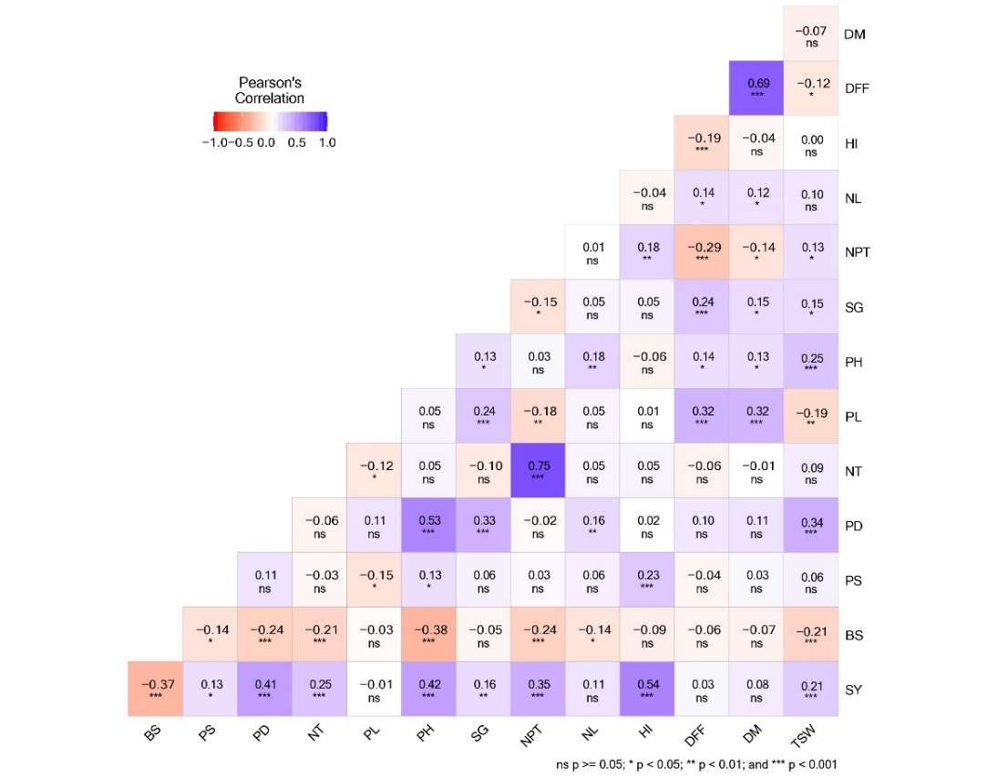

Fig. 1b. Correlations among seed yield, blast disease resistance and other agronomic traits in ENV-II
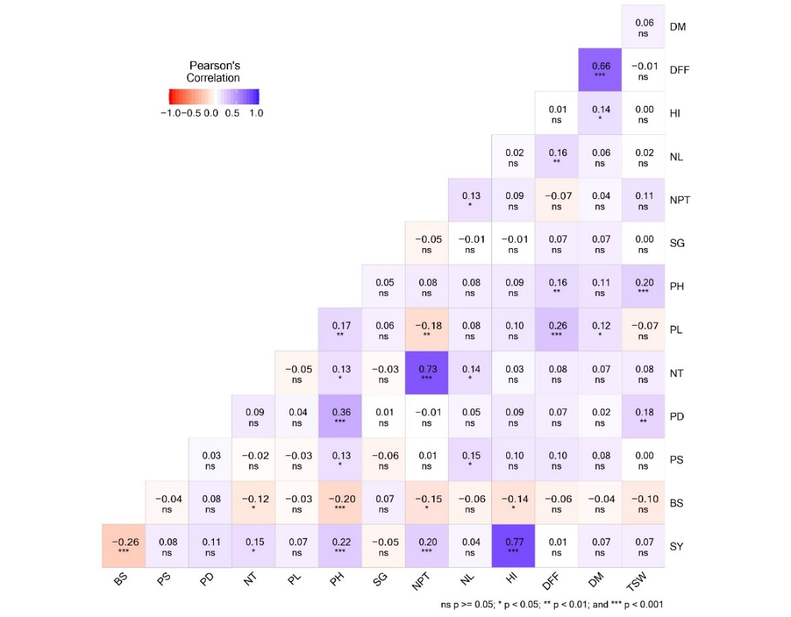

Fig. 1c. Correlations among seed yield, blast disease resistance and other agronomic traits in pooled environment
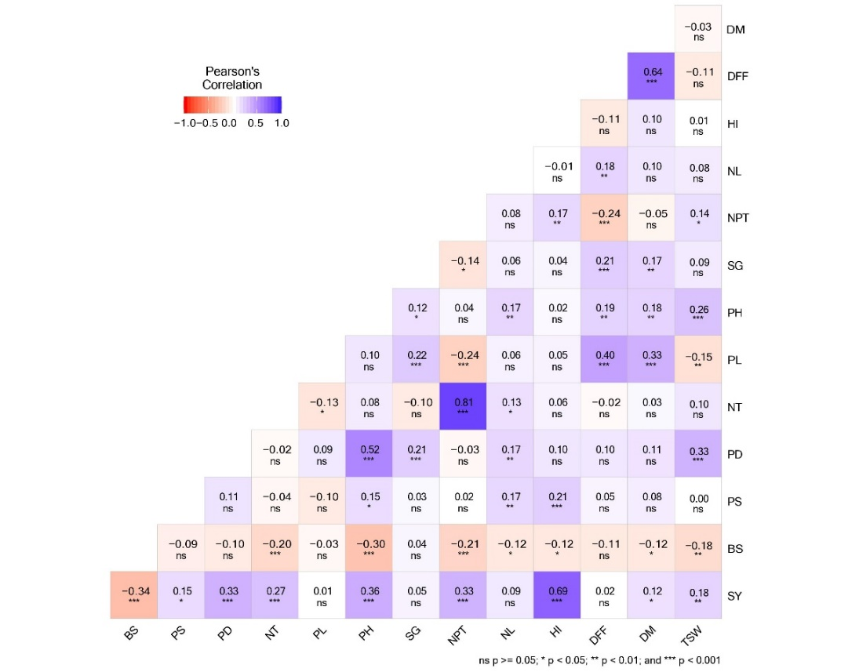

BS - Blast Score, PS - Plant Stand, PD - Panicle Diameter, NT – Number of Tillers, PL – Panicle Length, PH – Plant Height, SG – Stem Girth, NPT – Number of Productive Tillers, NL – Number of Leaves, HI – Harvest Index, DFF – Days to 50% Flowering, DM – Days to Maturity, TSW – Thousand Seed Weight
*, **, *** correlation significance at 0.05, 0.01, 0.001 levels, respectively, ns – Non – Significant.
In the current study, the analysis of variance indicated significant variations for all traits between the lines. Significant variations for all the traits except, NT and NPT between environments and for interactions except, NPT and PH, all other traits exhibited significant variations.
High heritability for days to 50% flowering in ENV-I and ENV-II, as reported by Singh et al. (2014), Sumathi et al. (2016), and Sumathi et al. (2010), suggests effective genetic selection in these environments. While ENV-I and ENV-II show potential for genetic improvement with moderate GAM (Nehra et al., 2017), the low GAM in the pooled environment (Vetriventhan et al., 2007; Sumathi et al., 2010; Ramya et al., 2018) suggests that achieving significant genetic gains might be challenging in a broader range of environments. High heritability for Days to Maturity in ENV-I and ENV-II, supported by Anuradha et al. (2020) and Singh et al. (2014), indicates strong genetic control in these environments. Conversely, Pallavi et al. (2020) reported lower heritability in the pooled environment, suggesting that combining multiple environments may dilute genetic effects. While ENV-I and ENV-II show potential for genetic improvement with low to moderate genetic advance (Pallavi et al., 2020; Sharma et al., 2018; Sumathi et al., 2016), the pooled environment presents challenges due to reduced heritability and varying genetic advance, emphasizing the effectiveness of targeted selection in specific environments. Low heritability and genetic advance for Plant Stand, consistent with Shobha Rani et al. (2019), indicate that genetic improvements may be limited. The high heritability and genetic advance for Plant Height across all environments, as noted by Satya et al. (2014), Annamalai et al. (2020), Dapke et al. (2014), and Vetriventhan et al. (2007), indicate a strong genetic influence on this trait.
High heritability and genetic advance as percent of mean for the Number of Tillers in ENV-I and ENV-II, as reported by Annamalai et al. (2020) and Vetriventhan et al. (2007), indicate these environments are conducive to genetic improvement. High heritability and genetic advance for the Number of Productive Tillers in the Pooled environment, supported by Satya et al. (2014), Annamalai et al. (2020), and Shashibhushan et al. (2022), indicates strong genetic potential for improvement. ENV-I shows moderate heritability and high genetic advance, suggesting favorable conditions for progress (Narasimhulu et al., 2020; Singh et al., 2014). In contrast, ENV-II's moderate heritability and genetic advance (Basavaraj et al., 2017) imply less potential for genetic gain. High heritability for the Number of Leaves in ENV-I and ENV-II indicates these environments offer stable genetic expression, with substantial genetic advance further supporting strong potential for improvement. The high heritability and genetic advance as percent of mean for Panicle Length observed across all environments, supported by Annamalai et al. (2020), Dapke et al. (2014), Vetriventhan et al. (2007), and Sumathi et al. (2010), indicates strong genetic control and significant potential for improvement The high heritability for Panicle Diameter across all environments, as observed by Sumathi et al. (2010), Kumari et al. (2020), and Pallavi et al. (2020), indicates a strong genetic influence. The moderate genetic advance associated with this high heritability suggests potential for improvement through selection, although the gains may be constrained by the trait's low variability.
The moderate heritability for Stem Girth in ENV-I and ENV-II suggests some genetic influence, but the low genetic advance indicates limited potential for improvement through selection. The low heritability in the Pooled environment, as reported by Singh et al. (2014), further restricts the trait's responsiveness to selection. Thousand Seed Weight shows high heritability and genetic advance in all environments, reflecting strong genetic control and improvement potential (Nehra et al., 2017; Kumar et al., 2022; Pallavi et al., 2020). The high heritability and genetic advance for Seed Yield across all environments, supported by Shobha Rani et al. (2019), Nehra et al. (2017), Kumar et al. (2022), and Shashibhushan et al. (2022), indicates strong genetic control and significant potential for improvement through selection. The high heritability and genetic advance for Harvest Index observed across all environments, consistent with findings from Dapke et al. (2014) and Singh et al. (2014), indicates strong genetic control and considerable potential for improvement through selection. The high heritability and genetic advance of Blast score in all environments, consistent with Owere et al. (2015) and Salleh et al. (2022), indicates a strong genetic control over resistance to blast disease, suggesting significant potential for genetic improvement and effectiveness of selection. Low PCV and GCV values DFF (Satya et al., 2014; Dapke et al., 2014; Basavaraj et al., 2017) indicate a minimal environmental impact on this trait. Similarly, low PCV and GCV values for DM (Satya et al., 2014; Sumathi et al., 2016; Dapke et al., 2014) suggest a limited influence of the environment, emphasizing a strong genetic control. Moderate PCV and GCV values (Satya et al., 2014; Anuradha et al., 2020; Ramya et al., 2018) underscore the genetic dominance of this trait despite some environmental variation for PH.
For Number of Tillers, moderate PCV and GCV in the pooled environment (Sumathi et al., 2016; Sumathi et al., 2010) reflects lower variability, contrasting with the high PCV and GCV observed in ENV-I and ENV-II (Annamalai et al., 2020; Kumari et al., 2020), which point to better conditions for genetic expression and variation. The moderate to low PCV and GCV values for Number of Productive Tillers in the Pooled environment (Kumari et al., 2018) suggest limited variability, potentially hindering selection effectiveness. In contrast, moderate PCV and GCV values for Panicle Length (Narasimhulu et al., 2020; Pallavi et al., 2020; Narasimhulu et al., 2019) indicate that selection remains effective due to the trait's strong genetic basis. For Panicle Diameter, low PCV and GCV values (Sumathi et al., 2020; Narasimhulu et al., 2019) reflect limited genetic and phenotypic variability, which may constrain the effectiveness of breeding programs. Similarly, low PCV and GCV values across environments for Stem Girth (Singh et al., 2014) suggest minimal variability, indicating that selection for this trait may be less effective.
High PCV and GCV values for Thousand Seed Weight in ENV-I and ENV-II (Annamalai et al., 2020; Singh et al., 2014) highlight substantial variability, while moderate GCV in the Pooled environment (Satya et al., 2014; Ramya et al., 2018) indicates reduced variability but still presents opportunities for improvement. For Seed Yield, high PCV and GCV values (Ramya et al., 2018; Basavaraj et al., 2017; Kumari et al., 2020; Annamalai et al., 2020) indicate substantial genetic variability, enhancing the prospects for selection. Similarly, for Harvest Index, moderate PCV and GCV in ENV-I and the Pooled environment, alongside high PCV and GCV in ENV-II (Dapke et al., 2014; Singh et al., 2014), suggest greater potential for selection in ENV-II compared to the other environments. Finally, high PCV and GCV values for Blast Score (Owere et al., 2015; Salleh et al., 2022) reflect significant genetic variability, which enhances the potential for selection and breeding for improved resistance to blast disease.
The correlation analysis conducted across various environments reveals that Seed Yield is significantly positively associated with traits such as Thousand Seed Weight, Harvest Index, Number of Productive Tillers, Stem Girth, Plant Height, Number of Tillers, Panicle Diameter, and Plant Stand (Fig. 1a, 1b, 1c). These findings are supported by Annamalai et al., (2020), Anuradha et al., (2020), Singh et al., (2014) for Thousand Seed Weight; Dapke et al., (2014), Singh et al., (2014), and Narasimhulu et al., (2020) for Harvest Index; Annamalai et al., (2020), Anuradha et al., (2020), and Dapke et al., (2014) for Number of Productive Tillers; Dezfouli et al., (2010) and Singh et al., (2014) for Stem Girth; Anuradha et al., (2020), Dapke et al., (2020), and Singh et al., (2014) for Plant Height; Annamalai et al., (2020) and Kumari et al., (2020) for Number of Tillers; Narasimhulu et al., (2020), Narasimhulu et al., (2019), and Shashi Bhushan et al., (2022) for Panicle Diameter; and Narasimhulu et al., (2021) for Plant Stand. Additionally, the positive correlation with Days to Maturity is supported by Sumathi et al., (2016) and Narasimhulu et al., (2019). Conversely, the negative association between Seed Yield and Blast Disease Score is consistent with findings from Kandel et al., (2020), Koutroubas et al., (2009), Chuwa et al., (2015), Owere et al., (2015), Subedi et al., (2022), and Bastiaans (1993), demonstrating that higher disease severity adversely impacts yield by reducing plant health and productivity. This comprehensive understanding of trait correlations with Seed Yield is crucial for informing breeding strategies and management practices aimed at enhancing crop performance and resilience.
The correlation analysis highlights the significant negative impact of Blast Disease on several key agronomic traits, which is crucial for understanding its effect on crop performance. Blast Disease is negatively correlated with Thousand Seed Weight, as indicated by Kandel et al., (2020), Bastiaans (1993), and Salleh et al., (2022), showing that increased disease severity reduces seed weight. The adverse effects on the Number of Productive Tillers align with findings from Koutroubas et al., (2009), and Plant Height is negatively impacted, as supported by Koutroubas et al., (2009), Owere et al., (2015), Ramakrishnan et al., (2016), and Salleh et al., (2022). The reduction in the Number of Tillers is corroborated by Chuwa et al., (2015). Days to Maturity is negatively associated, as Salleh et al., (2022). Kandel et al., (2020) support that Blast Disease is negatively associated with Leaf Length and further illustrates its detrimental effects on plant health. These findings collectively underscore the significant detrimental effects of Blast Disease on key traits, emphasizing the importance of effective management strategies to mitigate its negative impacts and improve overall crop productivity.
4. CONCLUSION
Variability is essential for developing effective breeding strategies, as it provides the basis for selecting and improving traits. This study utilized a multi-faceted analytical approach, including ANOVA, heritability estimation, phenotypic and genotypic coefficients of variation (PCV and GCV), genetic advance as a percentage of the mean (GAM) and correlation analysis to thoroughly assess the pearl millet population. ANOVA highlighted significant variation across all parameters, indicating substantial diversity within the population. PCV slightly exceeds GCV suggests a substantial environmental influence on these traits. High heritability coupled with high GAM, along with medium to high PCV and GCV for traits such as plant height, panicle length, seed yield, harvest index, and thousand seed weight, indicates that these traits are predominantly genetically controlled and can be improved significantly through selection, making them valuable for breeding. Correlation analysis highlighted significant relationships, such as the positive correlation of seed yield with thousand seed weight, days to maturity, harvest index, number of productive tillers, plant height, number of tillers, panicle diameter, and plant stand. Conversely, blast disease was negatively correlated with seed yield, thousand seed weight, days to maturity, harvest index, number of leaves, number of productive tillers, plant height, and number of tillers.

Disclaimer (Artificial intelligence)
Option 1:
Author(s) hereby declare that NO generative AI technologies such as Large Language Models (ChatGPT, COPILOT, etc.) and text-to-image generators have been used during the writing or editing of this manuscript.
Option 2:
Author(s) hereby declare that generative AI technologies such as Large Language Models, etc. have been used during the writing or editing of manuscripts. This explanation will include the name, version, model, and source of the generative AI technology and as well as all input prompts provided to the generative AI technology
Details of the AI usage are given below:
1.
2.
3.

References

Allard RW. Principles of Plant Breeding. John Wiley and Sons Inc., New York. 485.
Annamalai R, Aananthi N, Arumugam Pillai M, Leninraja D. Assessment of variability and character association in pearl millet [Pennisetum glaucum (L.) R. Br.]. International Journal of Current Microbiology and Applied Sciences. 2020;9(6):3247-3259.
Anuradha N, Kranthi Priya P, Patro TSSK, Sandhya Rani Y, Triveni U. Character association, variability and heritability studies for grain yield and its yield attributes in pearl millet (Pennisetum Glaucum (L.) R. Br). International Journal of Chemical Studies. 2020;11:1459-1464.
Basavaraj PS, Biradar BD, Sajjanar GM. Genetic variability studies for quantitative traits of restorer (R) Lines in Pearl millet [Pennisetum glaucum (L.) R. Br.]. International Journal of Current Microbiology and Appiled Sciences. 2017;6(8):3353-3358.
Bastiaans L. Effects of leaf blast on growth and production of a rice crop: 1. Determining the mechanism of yield reduction. Netherlands Journal of Plant Pathology. 1993;99:323-334.
Burton GW, Devane EW. Estimating heritability in tall fescue (Festuca arundiraceae) from replicated clonal material. Agronomy Journal. 1953;45:478-481.
Butler DG, Cullis BR, Gilmour AR, Gogel BJ. ASReml-R reference manual, release 3.0. Technical Report, The State of Queensland, Department of Primary Industries and Fisheries, Brisbane. 2009.
Chuwa CJ, Mabagala RB, Reuben MSOW. Assessment of grain yield losses caused by rice blast disease in major rice growing areas in Tanzania. International Journal of Science and Research. 2015;4(10):2211-2218.
Dapke JS, Shah DS, Pawar GN, Dhembre VM, Kumar M. Genetic variability and character association over environment in pearl millet [Pennisetum glaucum (L.) R. Br.] under dryland conditions of Gujarat. The Bioscan. 2014;9(2):863-867.
Dezfouli AAS, Mehrani A. A study of the relationships between yield and yield components in promising cultivars of foxtail millet (Setaria italica). Iranian Journal of Field Crop Science. 2010;41(2):413-421.
Falconer DS. Introduction to Quantitative Genetics. 2nd ed. Longman, London. 1981.
Fleck H. Introduction to nutrition. Macmillan Publishing Co., Indi. 1981;49(9).
Gupta D, Khandelwal V. Principal component analysis for yield and its attributing characters of pearl millet (Pennisetum glaucum [L.] R. Br.). Annals of Plant and Soil Research. 2022;24(3):408-14.
Hostelling H. Analysis of a complex of statistical variables into principal components. Journal of Educational Psychology. 1933;24:417-441.
Johnson HW, Robinson HF, Comstock RE. Estimate of genetic and environmental variability in Soybeans. Agronomy Journal. 1955;47:314-318.
Kandel M, Gurung SB, Dhami NB, Shrestha J. Assessment of variability of foxtail millet [Setaria italica (L.) Beauv.] genotypes. Bhutan Journal of Natural Resources and Development. 2020;7(2):51-61.
Koutroubas SD, Katsantonis D, Ntanos DA, Lupotto E. Blast disease influence on agronomic and quality traits of rice varieties under Mediterranean conditions. Turkish Journal of Agriculture and forestry. 2009;33(5):487-494.
Kumar M, Rani K, Ajay BC, Patel MS, Mungra KD, Patel MP. Multivariate diversity analysis for grain micronutrients concentration, yield and agro-morphological traits in pearl millet (Pennisetum glaucum (L) R. Br.). International Journal of Current Microbiology and Applied Sciences. 2020;9(3):2209-2226.
Kumar V, Dehnival AK, Vart D, Amit, Sharma R, Rani R. Pearl millet germplasm variability for yield and its attributing traits under rainfed conditions. Forage Research. 2022;48(1):41-45.
Kumari N, Sharma NK, Kajla S, Sanadya, SK. Studies on variability, character association and genetic diversity in R-lines of pearl millet. International Journal of Chemical Studies. 2018;6(5):700-704.
Kumawat KR, Sharma NK, Sharma N. Genetic variability and character association analysis in pearl millet single cross hybrids under dry conditions of Rajasthan. Electronic Journal of Plant Breeding. 2019;10(3):1067-1070.
Maiti RK, Bidinger FR. Growth and development of pearl millet plant. ICRISAT Research Bulletin. 1981;6.
Narasimhulu R, Veeraraghavaiah R. Estimation of genetic parameters and evolving suitable selection criteria for grain yield in pearl millet under rainfed conditions of Andhra Pradesh. Journal of Pharmacognosy and Phytochemistry. 2019;8(6):2580-2583.
Narasimhulu R, Veeraraghavaiah R. Genetic variability and association studies of pearl millet genotypes for yield contributing traits under rainfed conditions of Andhra Pradesh. Journal of Pharmacognosy and Phytochemistry. 2020;9(3):2301-2304.
Narasimhulu R, Sahadeva Reddy B, Tara Satyavathi C, Ajay BC. Performance, genetic variability and association analysis of pearl millet yield attributing traits in Andhra Pradesh’s arid region. Chemical Science Review and Letters. 2021;10(38):177-182.
Nehra M, Kumar M, Kaushik J, Vart D, Sharma RK, Punia MS. Genetic divergence, character association and path coefficient analysis for yield attributing traits in pearl millet [Pennisetum glaucum (L.) R. Br] inbreds. Chemical Science Review and Letters. 2017;6(21):538-543.
Owere L, Tongoona P, Derera J, Wanyera N. Variability and trait relationships among finger millet accessions in Uganda. Uganda Journal of Agricultural Sciences. 2015;16(2):161-176.
Pallavi M, Reddy PS, Krishna KR, Ratnavathi CV, Sujatha P. Genetic variability, heritability and association of grain yield characters in pearl millet (Pennisetum glaucum L). Journal of Pharmacognosy and Phytochemistry. 2020;9(3):1666-1669.
Panse VG, Sukathme PV. Statistical Method for Agricultural Workers. ICAR, New Delhi.1967;381.
Pujar M, Govindaraj M, Gangaprasad S, Kanatti A, Shivade H. Genetic variation and diversity for grain iron, zinc, protein and agronomic traits in advanced breeding lines of pearl millet [Pennisetum glaucum (L.) R. Br.] for biofortification breeding. Genetic Resources and Crop Evolution. 2020;67:2009-2022.
Ramya KR, Sumathi P, Joel AJ. Genetic variability study in pearl millet germplasm (Pennisetum glaucum (L.) R. Br.) for yield and its component traits. Electronic Journal of Plant Breeding. 2018;9(3):1247-1252.
Robinson HF, Comstock RE, Harney PH. Estimates of heritability and degree in corn. Agronomy Journal. 1949;41:353-359.
Salleh SB, Rafii MY, Ismail MR, Ramli A, Chukwu SC, Yusuff O, Hasan NA. Genotype-by-environment interaction effects on blast disease severity and genetic diversity of advanced blast-resistant rice lines based on quantitative traits. Frontiers in Agronomy. 2022;4:990397.
Sathya M, Sumathi P, Senthil N, Vellaikumar S, Joel AJ. Genetic studies for yield and its component traits in RIL population of pearl millet (Pennisetum glaucum [L.] R. Br.). Electronic Journal of Plant Breeding. 2014;5(2):322-326.
Sharma B, Chugh LK, Sheoran RK, Singh VK, Sood M. Study on genetic variability, heritability and correlation in pearl millets germplasm. Journal of Pharmacognosy and Phytochemistry. 2018;7(6):1983-1987.
Sharma R, Upadhyaya HD, Manjunatha SV, Rai KN, Gupta SK, Thakur, RP. Pathogenic variation in the pearl millet blast pathogen Magnaporthe grisea and identification of resistance to diverse pathotypes. Plant Disease. 2013;97:189–195.
Shashibhushan D, Kumar CS, Kondi RKR. Genetic parameters and association studies for yield and yield contributing traits in pearl millet cultivars. In Biol. Forum-Int. J. 2022;14:416-421.
Shobha Rani T, Sameer Kumar CV, Maheswaramma S, Parimal M, Anil Kumar G, Sravanthi K. Selection criteria for grain yield in pearl millet (Pennisetum glaucam L.) in association with yield contributing traits. International Journal of Pure & Applied Bioscience. 2019;7(3):257-262.
Singh B, Upadhyay PK, Sharma KC. Genetic variability, correlation and path analysis in pearl millet (Pennisetum glaucum (L.) R. Br.). Indian Research Journal of Genetics and Biotechnology. 2014;6(4):605-612.
Singh J, Chhabra AK. Genetic variability and character association in advanced inbred lines of pearl millet under optimal and drought condition. Ekin Journal of Crop Breeding and Genetics. 2018;4(2):45-51.
Singh S, Yadav YP, Yadav HP, Vart DEV, Yadav, N. Studies on genetic variability and trait association for grain yield and its components in pearl millet [Pennisetum glaucum (L.) R. Br.]. Forage Research. 2014;40(2):91-94.
Subedi S, Neupane S, Neupane P, Shrestha J. Assessment of Proso millet genotypes against blast caused by Pyricularia grisea (cooke) sacc. under field condition at mid hill region of Nepal. Journal of Nepal Agricultural Research Council. 2022;8:27-34.
Vetriventhan M, Nirmalakumari A. Studies on variability parameters in pearl millet (Pennisetum glaucum (L.) R. Br.). Madras Agricultural Journal. 2007;94:1-6.

