Review Article

Impact of Silicon Fertilization in Crop Production: Enhancing Yield, Stress and Disease Resistance in Agriculture

.
ABSTRACT

Silicon (Si) is a vital macroelement widely present in the environment, playing a crucial role in helping plants recover from environmental stresses. Its primary function is to boost the plant's resistance against biotic and abiotic stress. Furthermore, silicon can enhance soil quality by mitigating the toxicity of heavy metals like iron (Fe), aluminum (Al), and manganese (Mn), while also increasing phosphorus (P) availability. Additionally, it improves plants' tolerance to drought and salinity by promoting the formation of silicified tissues. It is also effective in managing a range of pests and diseases in plants, including those caused by fungi and bacteria. Silicon positively interacts with other applied nutrients, enhancing their effectiveness and improving agronomic performance, particularly in terms of yield. Thus, incorporating silicate-containing fertilizers into agricultural practices is essential for enhancing plant performance and productivity.

Keywords: Drought tolerance, disease resistance, heavy metals, Salinity tolerance, Silicon

1. INTRODUCTION

Climate change is a significant challenge that threatens both our planet and the well-being of future generations. It has the potential to reduce crop yields, particularly in regions that are already most vulnerable to food insecurity [1,2]. This has also increased the presence of heavy metals, which contribute to environmental pollution and pose toxicity risks [3]. The world is grappling with the primary issue of increased greenhouse gas (GHG) emissions in the atmosphere, largely due to human activities such as changes in land use, deforestation, industrialization, transportation, and anaerobic crop cultivation. These factors contribute to a global climate shift, presenting a significant environmental challenge we face today [4,5,6,7]. At the same time, farmers in our country are encountering major difficulties, such as erratic temperature fluctuations caused by global warming, a shortage of arable land, and soil degradation resulting from extended use of chemicals [8]. Although the exact impact of each factor on climate change is not fully known, it is broadly accepted that greenhouse gas emissions are a major contributing factor [9]. To mitigate the adverse effect of climate change and to satisfy the food needs of a rising population at the same time, India must improve agricultural productivity and make more efficient use of its land [10,11] As the Earth's climate system undergoes unprecedented changes, implementing effective strategies to address climate change has become more crucial than ever [12].
Silicon fertilizer has the potential to counter these challenges by boosting crop productivity by improving plant resilience to environmental stressors, such as drought and disease. Silicon (Si) is the second most prevalent element in the Earth's crust and, while not essential, it is beneficial for the growth of crops, particularly those in the Poaceae family. The silicon concentration in plant shoots can vary widely between species, ranging from 0.1% to 10% on a dry weight basis. When soil pH is below 9.0, silicon (Si) primarily exists in the form of monosilicic acid, Si (OH)₄, and is present in soil solution at concentrations between 14 and 20 mg Si/L. Despite being found in considerable amounts across various plant species, silicon is not currently recognized as an essential element for plant growth and development. Traditionally, silicon levels in most soils were not seen as a limiting factor for plant growth. However, with the rise of intensive agricultural practices and increased crop yields, the removal of silicon from the soil has also risen. This has led to decreased soil silicon concentrations, which in turn can restrict plant growth and reduce yields. The influence of plant silicon on soil formation was first demonstrated by Lovering and Engel (1959) [13]. They estimated that a hectare of forest could draw approximately 5,000 tons of silicon over a period of 5,000 years, equivalent to the thickness of a 30-cm basalt layer. As plant litter decomposes, silicon is returned to the soil, contributing significantly to the silicon reservoir in the soil. The quantity of silicon that plants accumulate is a crucial factor in the natural processes of soil development and in regulating rates of continental erosion. One of the primary roles of silicon (Si) is to enhance plant growth and yield, particularly under stress conditions. Silicon helps plants tolerate stress by boosting photosynthesis and optimizing light exposure on leaves. Additionally, silicon plays a significant role in mitigating various abiotic and biotic stresses, including diseases, pathogen attacks, metal toxicity, salinity, and drought. It also aids in protecting plants from extreme temperatures, which are crucial for nodule formation, and contributes to improved mineral composition and enzyme activity in plants [14]. Silicon plays a crucial role in enhancing plant strength, providing protection against pests and diseases, boosting crop yield and quality, stimulating plant immune responses, improving nutrient uptake, increasing resistance to salt stress, and mitigating heavy metal toxicity in acidic soils. When applied as a fertilizer, silicon has a dual impact on the soil-plant system. Firstly, it enhances plant resilience against insect pests and adverse weather conditions. Secondly, it improves soil fertility by optimizing water retention, enhancing soil physical and chemical properties, and maintaining nutrients in forms that are readily available to plants.

2. Uptake and Transport of silicon in Plants

The absorption of silicon (Si) by plants largely depends on the chemical form of silicon available in the soil and the type of plant species. Plants absorb silicon through their roots in the form of dissolved monosilicic acid [Si (OH)₄], which is present in soils with a pH below 9 and silicon concentrations less than 2 mM [15]. Initially, three potential mechanisms for silicon (Si) uptake were proposed: active uptake, where the silicon concentration in the xylem sap is higher than in the growth medium or soil solution; passive uptake, where the silicon concentrations in the growth medium and sap are similar; and rejective uptake, where the silicon concentration in the sap is lower than in the growth medium [16]. Silicon uptake and accumulation in various tissues across different plant species have been extensively studied [17]. These investigations found that all monocots are generally high or intermediate accumulators of silicon, while most dicots are low accumulators. Among monocots, rice can accumulate up to 10% silicon on a dry weight basis [18]. The variation in silicon accumulation between plant species is attributed to differences in root uptake. In addition to soil application, silicon can also be applied via foliar sprays. Various silicon-containing compounds, such as silicates, stabilized silicic acid, and silicon nanoparticles, are used for this purpose. Monocots are typically the plant species with the highest silicon (Si) content, while dicots generally have lower silicon levels, although there are some exceptions.
Despite the presence of significant levels of silicon (Si) in a wide range of plants, research by Hodson et al. (2005) indicates that the concentration of silicon in plants is more strongly influenced by their phylogenetic position than by environmental factors such as soil silicon levels, soil solution, or pH. According to Ma and Takahashi (2002) [19], silicon is abundant in nearly all soils, so environmental conditions have less effect on silicon accumulation in plants. Their research also includes a phylogenetic tree of silicon-accumulating plants, noting that species rich in silicon generally have lower calcium concentrations, and vice versa. They propose the following criteria to distinguish between types of plants:
- "Accumulators" have a silicon concentration greater than 1% and a silicon-to-calcium ratio above 1.
- "Excluders" have a silicon concentration below 0.5% and a silicon-to-calcium ratio below 0.5.
- "Intermediates" do not meet these criteria. The critical value of 0.5% represents the silicon concentration in a plant that would absorb 0.5 L of a solution containing 10 mg Si/L to produce 1 g of dry matter. Additionally, there is significant variation in silicon accumulation among different genotypes within the same species. Foliar application has been shown to increase silicon content in the leaves of rice plants. Like soil applications, foliar sprays of silicon are effective in disease control and growth promotion across different plant species. Positive outcomes from foliar applications have been observed in both silicon-accumulating and non-accumulating plants.

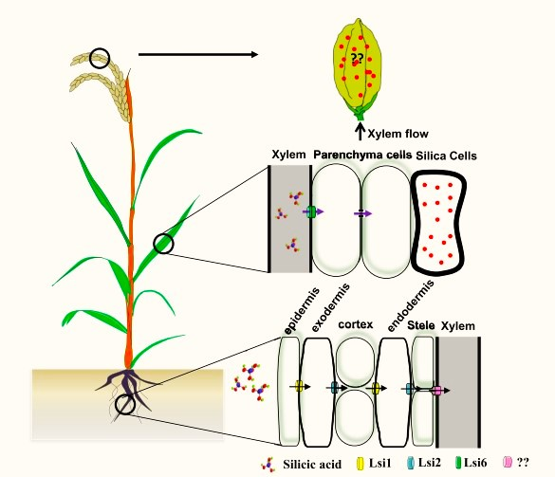

Fig.1. Uptake of Si by root and subsequent transport to aerial tissues in rice
(Source: Shivaraj et al., 2021) [20]

3. IMPACT of Silicon under Biological stresses

For wheat, the beneficial effects of silicon (Si) have been shown in combating several diseases and fungal infections, including powdery mildew (Blumeria graminis), septoria (Phaeosphaeria nodorum and Mycosphaerella graminicola), and eyespot (Oculimacula yallundae) [21]. In rice, silicon has been effective against various issues such as stalk rot (Leptosphaeria salvinii), rice blast (Magnaporthe grisea), fusarium wilt (Fusarium), tan spot (Cochliobolus miyabeanus), melting seedlings (Thanatephorus cucumeris), and leaf spots (Monographella albescens) [19]. When plants are attacked by pathogenic fungi, silicon (Si) activates a swift and comprehensive response from the plant's natural defenses [22]. This response can occur either indirectly, by binding to cations, or directly, by enhancing the activity of certain proteins. For example, in cases of powdery mildew, although the pathogen may still be present after silicon fertilization, the severity of the infection is usually reduced. Research on epidermal cells has revealed that silicon-fertilized plants boost their defenses by producing phenolic compounds, callose, or methylaconitate (phytoalexin). Hunt et al. (2008) [23] demonstrated that grasses fertilized with silicon (Si) were less likely to be consumed by grazing animals, such as wild rabbits and locusts, compared to those that were not fertilized. This effect is likely due to mechanical factors, as leaves with higher silicon content are more resistant to grazing. Additionally, silicon has been shown to be effective against a variety of other pests, including insect borers (Chilo suppressalis), yellow borers (Scirpophaga incertulas), rice chlorops (Chlorops oryzae), rice leafhoppers (Nephotettix bipunctatus cinticeps), brown leafhoppers (Nilaparvata lugens), and spider mites (Tetranychus spp.). In capsicum and chili pepper, the application of silicon (Si) has been shown to reduce the severity of Phytophthora blight (Phytophthora capsici) . Additionally, Jayawardana et al. [24] reported that silicon enhances resistance to anthracnose disease (Colletotrichum gloeosporioides) in chili pepper. In soybean, the absorption of silicon (Si) by leaves across various cultivars was measured and found to correlate with increased resistance to soybean rust (Phakopsora pachyrhizi) [25]. Additionally, research suggested that a delay in the onset of the disease likely contributed to the observed reduction in the area under the curve for soybean rust progression [26]. Applying silicon (Si) to cucumber plants reduced the whitefly population by decreasing the insects' egg-laying, extending their growth cycle, and increasing mortality rates during the nymph stages [27]. Ghareeb et al. [28] observed that silicon (Si) application led to the increased expression of jasmonic acid/ethylene marker genes (JERF3, TSRF1, and ACCO), which enhanced resistance in tomato plants against R. solanacearum infection [29]. Additionally, Si application significantly increased the activities of enzymes such as soil urease and soil acid phosphatase under pathogen-inoculated conditions. The enhanced resistance of tomato leaves to bacterial wilt due to Si application has been linked to the activation of defense-related enzymes like peroxidase (POD) and phenylalanine ammonia lyase (PAL) [30].

4. impact of Silicon under abiotic stresses
The application of silicon (Si) has been shown to enhance various physiological traits in tomatoes, including a 42% improvement in leaf turgor potential, a 20% increase in net photosynthesis rates, a 17% boost in water use efficiency, and a 16% rise in the ratio of plant dry matter to water uptake [31]. Furthermore, combining exogenous Si with phyto-extracts from Melia azadirachta (Chinaberry) has been found to effectively mitigate the detrimental effects of salinity in pea plants [32]. Additionally, research by Tantawy et al. [33] highlighted that nano-silicon (nano-Si) is particularly effective in alleviating salinity stress in sweet pepper plants. Similarly, nano-SiO₂ has been reported to activate the defense mechanisms in squash plants against salinity stress [34]. The alleviation of salinity stress through silicon (Si) application is linked to a notable increase in antioxidant activities and a reduction in electrolyte leakage percentage [35]. Similarly, enhanced antioxidant activities, including those of superoxide dismutase (SOD) and catalase (CAT), have been observed in spinach and bitter gourd plants subjected to salinity stress [36]. Exogenous silicon (Si) application has been shown to enhance seed germination and reduce oxidative stress during the seedling stage of tomatoes [37]. Additionally, it increases the net photosynthetic rate in tomato leaves under water stress conditions [38]. Brenchley and Maskell (1927) [39] observed that silicon (Si) fertilization led to increased barley yields, particularly when phosphorus fertilization was insufficient. They concluded that Si fertilization enhanced the availability of soil phosphorus to plants. Eneji et al. (2008) [40] also found a correlation between silicon and phosphorus uptake, indicating a beneficial effect on soil. Earlier research suggested that the impact of Si under phosphorus deficiency might involve an in-plant mechanism, potentially improving phosphorus utilization through increased phosphorylation.

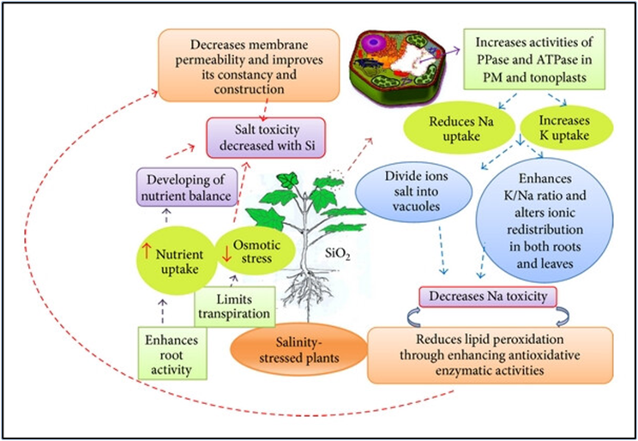

Fig. 2. Interaction mechanism of Si treatment under salt stressed plants
(Source: Sahebi et al., 2015) [41]

Shi et al. [42] proposed that Si helps improve water stress tolerance in tomato plants by reducing membrane oxidative damage, which in turn boosts root hydraulic conductance and water uptake. Furthermore, research by Cao et al. [43] in 2017 demonstrated that Si application positively affects radial hydraulic conductivity and cell wall stability in tomatoes. Shen et al. [44] noted that silicon (Si) application significantly impacts photosynthesis and antioxidant activities, such as catalase and peroxidase, in soybean seedlings under drought stress. Additionally, it has been confirmed that Si application helps mitigate the effects of drought stress on soybean growth [45].

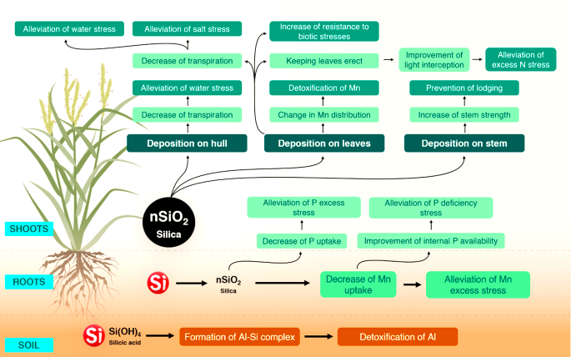

Fig.3. Movement of silica in crop and soil ecosystem
( Source: Shanmugaiah et al., 2023) [46]

5. IMPACT OF SILICON UNDER Mineral Toxicity
Baylis et al. [47] were the first to demonstrate that silicon (Si) alleviates aluminum (Al) toxicity in soybeans. Building on this, Bityutskii et al. [48] emphasized the crucial roles of both iron (Fe) and silicon in preventing aluminum uptake by cucumber plants in acidic soils. More recently, Dorneles et al. [49] showed that silicon partially mitigates aluminum-induced damage to root growth in potatoes by enhancing the activity of antioxidant enzymes like superoxide dismutase (SOD) and peroxidase (POD). In cucumbers, silicon (Si) application under cadmium stress helped safeguard the photosynthetic machinery and enhanced the activity of nitrogen metabolism enzymes, such as nitrogen reductase (NR) and glutamine synthetase (GS) [50]. Similarly, Wu et al. [51] found that Si application reduced cadmium uptake by cucumber roots. In tomatoes, Si application was effective in decreasing the transport of cadmium from roots to shoots. In rice, silicon (Si) seems to enhance the oxidizing capacity of roots, which transforms ferrous iron into ferric iron, thereby reducing excessive iron uptake and limiting its toxicity [19]. It has been proposed that Si might regulate iron uptake from acidic soils by promoting the release of hydroxide ions (OH−) from the roots when Si is supplied [52]. Silicic acid also reduced arsenic (As) levels in rice shoots grown in hydroponic systems. It was observed that arsenite transport in roots utilizes the same efficient pathway as silicon, suggesting that adequate levels of available silicon in the soil can effectively decrease arsenic accumulation in rice shoots [53]. Manganese toxicity is mitigated in plants fertilized with silicon (Si) because Si enhances the binding of manganese (Mn) to cell walls, thereby reducing its concentration in the cytoplasm [54]. Horst et al. (1999) [55] found that Si application decreased the apoplastic Mn concentration in cowpea leaves, though it did not affect the vacuolar Mn levels, indicating that Si might alter the cell walls' capacity to bind cations. Furthermore, Si promotes a more uniform distribution of Mn in the leaves, which helps reduce spot necrosis. Da Cunha and do Nascimento (2009) [56] observed that applying calcium silicate to maize grown in soil contaminated with cadmium (Cd) or zinc (Zn) resulted in reduced concentrations of these metals in the maize shoots and an increase in shoot biomass. They attributed these effects to changes in metal speciation in the soil rather than an increase in pH [57]. Additionally, they noted significant structural changes in the maize shoots and proposed that the deposition of silica in the endodermis and pericycle of the roots contributed to the plant's tolerance to Cd and Zn stress.

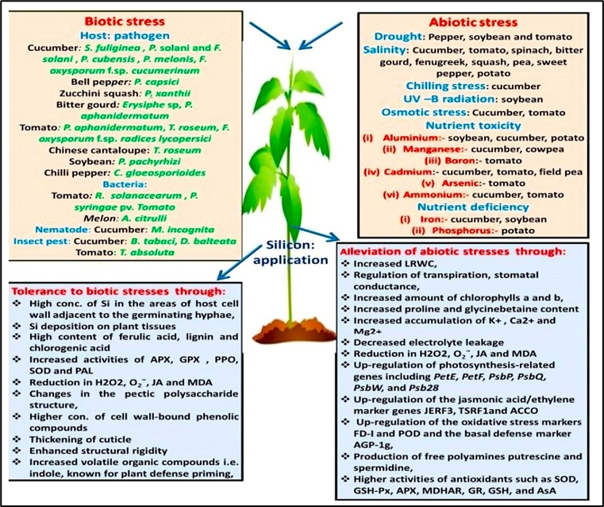

Fig.4. Schematic diagram depicting how silicon application alleviates various biotic and abiotic stresses in plants (Source: Kaushik & Saini, 2019) [58]

6. Benefits from Silicon Supplementation for Poor Accumulators
Silicon (Si) offers numerous benefits to plants, including enhanced tolerance to both biotic and abiotic stresses. Plants that accumulate high levels of Si derive the most significant advantages, though the exact mechanisms through which Si provides these benefits are still being explored. Initially, it was thought that Si functions as a physical barrier by depositing in cell walls, thereby preventing fungal invasion. More recent research indicates that Si also influences plant defense responses through signaling mechanisms. Under abiotic stress, Si supplementation has been found to reduce oxidative stress and lower the levels of reactive oxygen species and ethylene. While the role of Si in stress tolerance is generally understood, the precise mechanisms remain unclear. Many studies have demonstrated the positive effects of Si on high Si-accumulating plants. However, similar benefits have been observed in plants that accumulate low levels of Si. For instance, in tomatoes, Si application has been shown to mitigate salt stress and bacterial wilt. In Arabidopsis, Si enhances defense responses against powdery mildew and alleviates senescence stress. Silicon also aids in the uptake of macro- and micronutrients in both high and low Si-accumulating plants. High Si accumulators benefit from a physical barrier provided by Si, while low accumulators, though not retaining much Si, still experience benefits such as improved nutrient uptake, better photosynthetic efficiency, and increased antioxidant capacity.

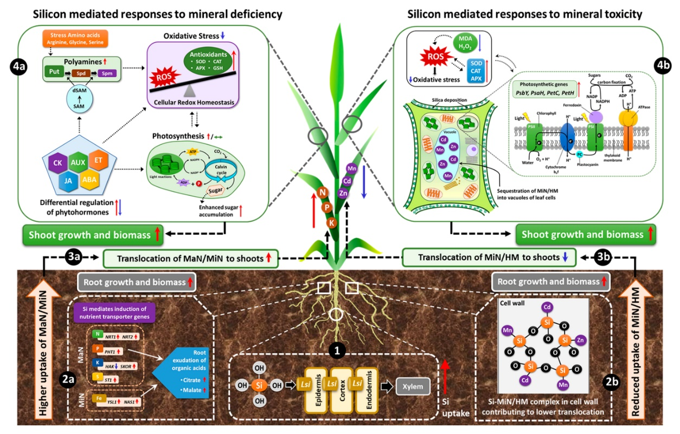

Fig.5. A diagram illustrating the common responses mediated by silicon to nutritional stresses. (Source: Ali et al., 2020) [59]

7. Silicon fertilization

Field trials conducted in Japan demonstrated that applying silicon (Si) fertilizers to rice resulted in a modest increase in panicle number and a yield boost of up to 17% [19]. In wheat, the annual application of Si-containing materials at a rate of 230 g/kg of water-soluble Si led to an increase in grain yield ranging from 4.1% to 9.3% over a four-year field experiment [60]. Various types of silicon (Si) fertilizers have been compared in several studies, including wollastonite (CaSiO₃), blast furnace residues, and rice straw. Among these, rice straw has been shown to provide higher Si concentrations in plants and lead to increased yields, especially when it is ground or combined with an organic matter decomposer [61]. Experiments conducted in Japan indicate that Si from rice straw is not immediately available as a fertilizer but becomes more accessible over time, with availability exceeding 70% in the long term (40 years). In contrast, inorganic silicates impact yields more quickly, as they are directly utilized by plants in the following crop, which has contributed to their widespread use [19]. While foliar applications of inorganic silica have been explored for their efficiency and cost-effectiveness [62], they are not commonly used. Savant et al. (1997) [63] estimated that in 1993, 33 million tons of Si were exported globally with rice straw, suggesting that its reuse as a fertilizer could mitigate Si depletion and yield decline in intensive rice cultivation. Given that rice straw contains substantial amounts of phytoliths, recycling it could serve as a valuable source of bioavailable Si.

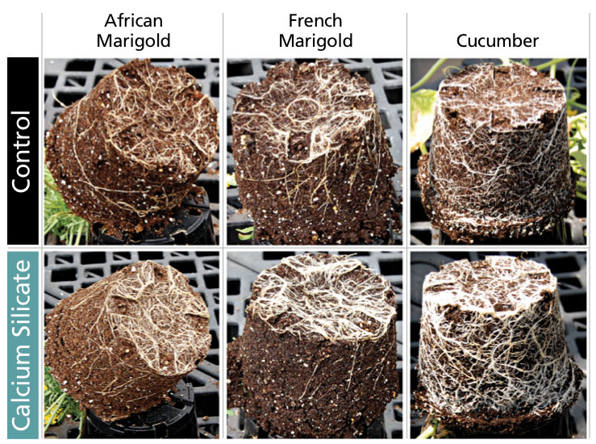
Fig. 6. Plant grown with calcium silicate demonstrated more visible roots compared to control plants (Source: www.growertalks.com )

Table 1. Commercially available silicon fertilizers (Bamboriya et al., 2019) [64]

SL.  No. | Fertilizer Type | Chemical Composition | Nutrient content | Remarks
1. | Solid fertilizer | Calcium  silicate | 24% Si,  31% Ca | • Most important sources for soil application.  • Supply macro-nutrient ‘Ca’ to crop.  • Act as liming material to ameliorate acidic soils.
1. | Solid fertilizer | Potassium silicate | 18% Si,  50% K | • Feed the crop with primary nutrient potassium.  • It is used in nutria-culture for disease control in high value crops
1. | Solid fertilizer | Sodium silicate | 23% Si,  38% Na | • It is used to supply Si in research and high value crops.  • Sodium act as dispersant and degrade soil structure so sodium silicate is not considered as good source of Si.
1. | Solid fertilizer | Calcium magnesium silicate | 17% Si | • Feed the crop with Ca, Mg and Si.  •Application method: Solid fertilizer can easily apply by mixing with NPK fertilizers
2. | Liquid fertilizers | Silicon acid or silicic acid and silicon conditioners | 29-30% Si | • These are mainly used for foliar application, as plants can only absorb silicon in silica acid form. It helps plants to fight disease such as powdery mildew, septoria and eye-spot, insect pests and others.  • Application method: Liquid fertilizers can be used as soil application through drip irrigation/fertigation system and as foliar spray.
3. | Silicon-nano fertilizer | • Increase fertilizer efficiency.  • Significantly reduced root mortality, decay and yield losses due to Pythium ultimum.  • Application method: a) Drenching: Mix 1-2 ml nano fertilizer in 1 liter of water and drench in root zone. b) Spray: Mix 1-2 ml nano fertilizer in 1 liter of water and spray on foliage

Table 2: Industrial and Plant sources of silicon (Sebastian et al., 2013) [65]

Sources | Total silicon % |  | Soluble silicon % |  | Chemical composition
Industrial by product

Iron/steel slag | 5.4 |  | 0.46 |  | CaSiO₃
Electric furnace slag | 21.1 |  | 14.8 |  | CaSiO₃ /MgSiO₃
Blast furnace slag | 17.3 |  | 1.7 |  | CaSiO₃ /MgSiO₃
Processing mud | 6.8 |  | 0.04 |  | -
Fly ash | 29.1 |  | 0.03 |  | -
Plant material-based silica

Miscanthus biochar |  | 38.3 |  | - | SiO₂
Rice hull fresh |  | 7-9.2 |  | - | SiO₂
Rice hull ash |  | >28 |  | - | SiO₂

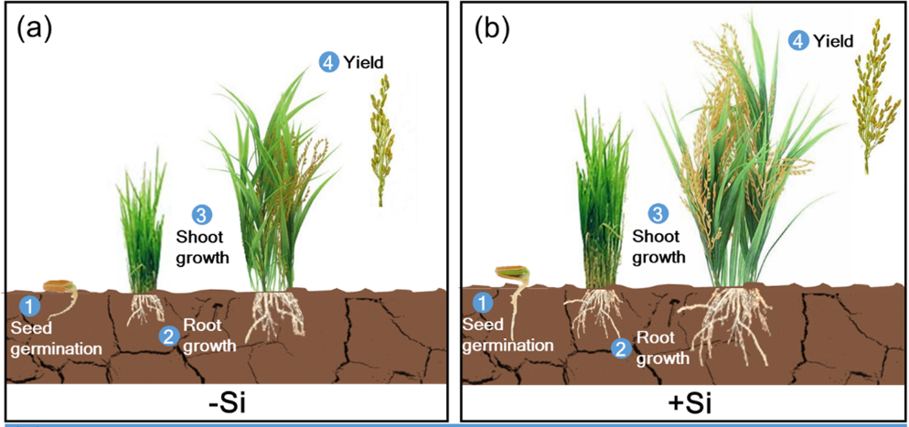

Fig. 7. Plant growth and Yield with and without Silicon fertilization [66]

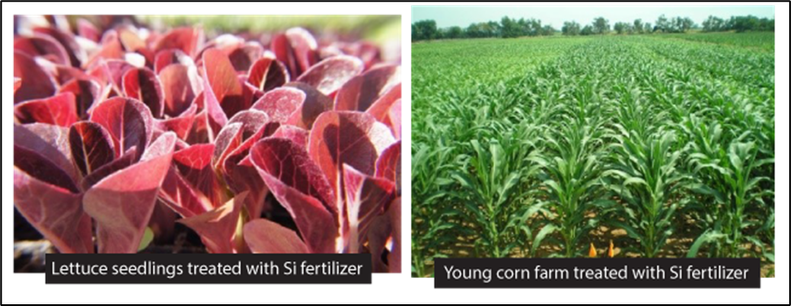

Fig. 8. Lettuce and Maize treated with silicon fertilizer
(Source: www.growertalks.com )

8. Conclusion

Silicon plays a valuable role in crop production by enhancing plant health and resilience. Its ability to strengthen cell walls, improve drought resistance, enhances disease and pest tolerance and boost overall plant growth makes it a beneficial supplement in agriculture. Furthermore, silicon contributes to climate change mitigation by increasing crop tolerance to extreme weather conditions. This multifaceted approach not only fortifies plant defenses but also promotes more sustainable agricultural practices. By incorporating silicon into agricultural systems, we can support both higher crop yields and more resilient farming methods, helping to address the challenges posed by a changing climate.

DISCLAIMER (ARTIFICIAL INTELLIGENCE)

Author(s) hereby declares that NO generative AI technologies such as Large Language Models (ChatGPT, COPILOT, etc.) and text-to-image generators have been used during writing or editing of manuscripts.

References

- Sarma, H. H., Paul, A., Kakoti, M., Talukdar, N., & Hazarika, P. (2024). Climate resilient agricultural strategies for enhanced sustainability and food security: A review. Plant Archives, 24(1), 787-792. https://doi.org/10.51470/PLANTARCHIVES.2024.v24.no.1.108

- Ansari, Z. G., Sarma, H. H., Boruah, A., Doggalli, G., Bahadur, R., Tripathi, U., & Rani, D. V. (2023). Efficacy of Salicylic Acid in Response to Plant Stress Tolerance, Growth and Productivity: A Review. International Journal of Environment and Climate Change, 13(11), 3924-3936. https://doi.org/10.9734/IJECC/2023/v13i113573

- Sarma, H. H., Rajkumar, A., Baro, A., Das, B. C., & Talukdar, N. (2024). Impact of Heavy Metal Contamination on Soil and Crop Ecosystem with Advanced Techniques to Mitigate Them. Journal of Advances in Biology & Biotechnology, 27(6), 53-63. https://doi.org/10.9734/JABB/2024/v27i6865

- Devi, O. R., Laishram, B., Singh, S., Paul, A., Sarma, H. H., Bora, S. S., & Devi, S. B. (2023). A review on mitigation of greenhouse gases by agronomic practices towards sustainable agriculture. International Journal of Environment and Climate Change, 13(8), 278-287. https://doi.org/10.9734/IJECC/2023/v13i81952

- Paul, A., Sarma, H. H., Kakoti, M., Talukdar, N., Dutta, S. K., Hazarika, P., & Goswami, A. (2024). Irrigating with Intelligence: Sensor-Based Strategies for Efficient Agriculture–A review. Ecology, Environment and Conservation, (May Suppl. Issue), 338-343. http://doi.org/10.53550/EEC.2024.v30i03s.058

- Sarma, H. H., Paul, A., Das, O., Goswami, A., Hazarika, P., Borkotoky, B., & Sonowal, S. (2023). The ABCs of natural farming: Principles, components and features: A review. The Pharma Innovation, 12(11), 564-568.

- Sarma, H. H., & Dutta, S. K. (2024). Method of Preparation of Various Inputs used in Natural Farming. Vigyan Varta, 5(7), 88-94.

- Rahman, S., Sarma, H. H., Sarmah, R., & Das, S. (2024). Impact of hydroponics technique on root characteristics and physiological parameters in chrysanthemum. Journal of Advances in Biology & Biotechnology, 27(8), 897-905. https://doi.org/10.9734/jabb/2024/v27i81210

- Sarma, H. H., Borah, S. K., Das, O., Sonowal, S., Talukdar, N., & Das, B. C. (2024). Nano Biochar: Properties, Preparation, Key Features and its Impact on Soil and Crop Ecosystem. Journal of Advances in Biology & Biotechnology, 27(7), 66-78. https://doi.org/10.9734/jabb/2024/v27i7967

- Sarma, H. H., Borah, S. K., Chintey, R., Nath, H., & Talukdar, N. (2024). Site Specific Nutrient Management (SSNM): Principles, Key Features and its Potential Role in Soil, Crop Ecosystem and Climate Resilience Farming. Journal of Advances in Biology & Biotechnology, 27(8), 211-222. https://doi.org/10.9734/jabb/2024/v27i8113

- Sarma, H. H., & Kakoti, M. (2024). Significance of weather forecasting in crop production with respect to Indian scenario. Vigyan Varta, 5(7), 95-102.

- Sarma, H. H., Paul, A., Kakoti, M., Goswami, A., Talukdar, N., Borkotoky, B., Dutta, S. K., & Hazarika, P. (2024). The aerial genesis: Seed bombing for nurturing earth and ecosystem renaissance-A review. The Pharma Innovation Journal, 12(9), 1719-1723.

- Lovering, T. S., & Engel, C. (1959). Significance of accumulator plants in rock weathering. Bulletin of the Geological Society of America, 70, 781-800.

- Epstein, E. (2001). Silicon in plants: facts vs. concepts. In Silicon in Agriculture (Vol. 8, pp. 1-15). Elsevier.

- Yoshida, S., Ohnishi, Y., & Kitagishi, K. (1962). Chemical forms, mobility and deposition of silicon in rice plant. Soil Science and Plant Nutrition, 8, 15-21.

- Takahashi, E., Ma, J., & Miyake, Y. (1990). The possibility of silicon as an essential element for higher plants. Comments on Agricultural and Food Chemistry, 2, 99-102.

- Hodson, M., White, P., Mead, A., & Broadley, M. (2005). Phylogenetic variation in the silicon composition of plants. Annals of Botany, 96, 1027-1046.

- Savant, N. K., Snyder, G. H., & Datnoff, L. E. (1996). Silicon management and sustainable rice production. Advances in Agronomy, 58, 151-199.

- Ma, J. F., & Takahashi, E. (2002). Soil, Fertilizer, and Plant Silicon Research in Japan. Elsevier, Amsterdam, The Netherlands.

- Shivaraj, S. M., Mandlik, R., Bhat, J. A., Raturi, G., Elbaum, R., Alexander, L., ... & Sonah, H. (2022). Outstanding questions on the beneficial role of silicon in crop plants. Plant and Cell Physiology, 63(1), 4-18.
- Rodgers-Gray, B. S., & Shaw, M. W. (2004). Effects of straw and silicon soil amendments on some foliar and stem-base diseases in pot-grown winter wheat. Plant Pathology, 53(6), 733-740.

- Fauteux, F., Remus-Borel, W., Menzies, J. G., & Bélanger, R. R. (2005). Silicon and plant disease resistance against pathogenic fungi. FEMS Microbiology Letters, 249(1), 1-6.

- Hunt, J. W., Dean, A. P., Webster, R. E., Johnson, G. N., & Ennos, A. R. (2008). A novel mechanism by which silica defends grasses against herbivory. Annals of Botany, 102, 653-656.

- Jayawardana, H., Weerahewa, H. L. D., & Saparamadu, M. (2015). Enhanced resistance to anthracnose disease in chili pepper (Capsicum annuum L.) by amendment of the nutrient solution with silicon. Journal of Horticultural Science & Biotechnology, 90, 557-562.

- Kaushik, P., Dhaliwal, M. S., & Kumar, S. (2018). Usefulness of three under-exploited vegetable legumes: A review. International Journal of Current Microbiology and Applied Sciences, 7, 861-870.

- Lemes, E. M., Mackowiak, C. L., Blount, A., Marois, J. J., Wright, D. L., Coelho, L., & Datnoff, L. E. (2011). Effects of silicon applications on soybean rust development under greenhouse and field conditions. Plant Disease, 95, 317-324.

- Correa, R. S., Moraes, J. C., Auad, A. M., & Carvalho, G. A. (2005). Silicon and acibenzolar-S-methyl as resistance inducers in cucumber against the whitefly Bemisia tabaci (Gennadius) (Hemiptera: Aleyrodidae) biotype B. Neotropical Entomology, 34, 429-433.

- Ghareeb, H., Bozsó, Z., Ott, P. G., Repenning, C., Stahl, F., & Wydra, K. (2011). Transcriptome of silicon-induced resistance against Ralstonia solanacearum in the silicon non-accumulator tomato implicates priming effect. Physiological and Molecular Plant Pathology, 75, 83-89.

- Wydra, K., Semrau, J., Dannon, E., & Diogo, R. (2006). Characterization of the interaction of antagonistic bacteria and of silicon (SiO₂) with tomato infected with Ralstonia solanacearum. Mitteilungen-Biologische Bundesanstalt für Land- und Forstwirtschaft, 408, 112.

- Wang, L., Chen, Y., Cai, K., & Wang, G. (2014). Effects of exogenous silicon supply on the activity of antioxidant enzymes of tomato leaves infected by Ralstonia solanacearum. Journal of South China Agricultural University, 35, 74-78.

- Romero-Aranda, M. R., Jurado, O., & Cuartero, J. (2006). Silicon alleviates the deleterious salt effect on tomato plant growth by improving plant water status. Journal of Plant Physiology, 163, 847-855.

- Shahid, M. A., Balal, R. M., Pervez, M. A., Abbas, T., Aqueel, M. A., Javaid, M. M., & Garcia-Sanchez, F. (2015). Foliar spray of phyto-extracts supplemented with silicon: An efficacious strategy to alleviate the salinity-induced deleterious effects in pea (Pisum sativum L.). Turkish Journal of Botany, 39, 408-419.

- Tantawy, A. S., Salama, Y. A. M., El-Nemr, M. A., & Abdel-Mawgoud, A. M. R. (2015). Nano silicon application improves salinity tolerance of sweet pepper plants. International Journal of Chemical and Technical Research, 8, 11-17.

- Siddiqui, M. H., Al-Whaibi, M. H., Faisal, M., & Al Sahli, A. A. (2014). Nano-silicon dioxide mitigates the adverse effects of salt stress on Cucurbita pepo L. Environmental Toxicology and Chemistry, 33, 2429-2437.

- Zhu, Z., Wei, G., Li, J., Qian, Q., & Yu, J. (2004). Silicon alleviates salt stress and increases antioxidant enzymes activity in leaves of salt-stressed cucumber (Cucumis sativus L.). Plant Science, 167(3), 527-533.

- Wang, X., Ou-yang, C., Fan, Z., Gao, S., Chen, F., & Tang, L. (2010). Effects of exogenous silicon on seed germination and antioxidant enzyme activities of Momordica charantia under salt stress. Journal of Animal and Plant Sciences, 6(4), 700-708.

- Shi, Y., Zhang, Y., Yao, H., Wu, J., Sun, H., & Gong, H. (2014). Silicon improves seed germination and alleviates oxidative stress of bud seedlings in tomato under water deficit stress. Plant Physiology and Biochemistry, 78, 27-36.

- Ullah, U., Ashraf, M., Shahzad, S. M., Siddiqui, A. R., Piracha, M. A., & Suleman, M. (2016). Growth behavior of tomato (Solanum lycopersicum L.) under drought stress in the presence of silicon and plant growth promoting rhizobacteria. Soil and Environment, 35, 65-75.

- Brenchley, W. E., & Maskell, E. J. (1927). The inter-relation between silicon and other elements in plant nutrition. Annals of Applied Biology, 14(1), 45-82.

- Eneji, A. E., Inanaga, S., Muranaka, S., Li, J., Hattori, T., An, P., & Tsuji, W. (2008). Growth and nutrient use in four grasses under drought stress as mediated by silicon fertilizers. Journal of Plant Nutrition, 31(2), 355-365.
- Sahebi, M., Hanafi, M. M., Siti Nor Akmar, A., Rafii, M. Y., Azizi, P., Tengoua, F. F., ... & Shabanimofrad, M. (2015). Importance of silicon and mechanisms of biosilica formation in plants. BioMed Research International, 2015(1), 396010.

- Shi, Y., Zhang, Y., Han, W., Feng, R., Hu, Y., Guo, J., & Gong, H. (2016). Silicon enhances water stress tolerance by improving root hydraulic conductance in Solanum lycopersicum L. Frontiers in Plant Science, 7, 196.

- Cao, B.-L., Wang, L., Gao, S., Xia, J., & Xu, K. (2017). Silicon-mediated changes in radial hydraulic conductivity and cell wall stability are involved in silicon-induced drought resistance in tomato. Protoplasma, 254, 2295-2304.

- Shen, X., Li, X., Li, Z., Li, J., Duan, L., & Eneji, A. E. (2010). Growth, physiological attributes and antioxidant enzyme activities in soybean seedlings treated with or without silicon under UV-B radiation stress. Journal of Agronomy and Crop Science, 196, 431-439.

- Hamayun, M., Sohn, E.-Y., Khan, S. A., Shinwari, Z. K., Khan, A. L., & Lee, I.-J. (2010). Silicon alleviates the adverse effects of salinity and drought stress on growth and endogenous plant growth hormones of soybean (Glycine max L.). Pakistan Journal of Botany, 42, 1713-1722.

- Shanmugaiah, V., Gauba, A., Hari, S. K., et al. (2023). Effect of silicon micronutrient on plant’s cellular signaling cascades in stimulating plant growth by mitigating the environmental stressors. Plant Growth Regulation, 100(2), 391-408. https://doi.org/10.1007/s10725-023-00982-6

- Bityutskii, N. P., Yakkonen, K. L., Petrova, A. I., & Shavarda, A. L. (2017). Interactions between aluminum, iron, and silicon in cucumber (Cucumis sativus L.) grown under acidic conditions. Journal of Plant Physiology, 218, 100-108.

- Baylis, A. D., Gragopoulou, C., Davidson, K. J., & Birchall, J. D. (1994). Effects of silicon on the toxicity of aluminum to soybean. Communications in Soil Science and Plant Analysis, 25, 537-546.

- Dorneles, A. O. S., Pereira, A. S., Sasso, V. M., Possebom, G., Tarouco, C. P., Schorr, M. R. W., Rossato, L., Ferreira, P. A. A., & Tabaldi, L. A. (2019). Aluminum stress tolerance in potato genotypes grown with silicon. Bragantia.

- Feng, J., Shi, Q., Wang, X., Wei, M., Yang, F., & Xu, H. (2010). Silicon supplementation ameliorated the inhibition of photosynthesis and nitrate metabolism by cadmium (Cd) toxicity in cucumber (Cucumis sativus L.). Scientia Horticulturae, 123, 521-530.

- Wu, J., Guo, J., Hu, Y., & Gong, H. (2015). Distinct physiological responses of tomato and cucumber plants in silicon-mediated alleviation of cadmium stress. Frontiers in Plant Science, 6, 453.

- Wallace, A. (1993). Participation of silicon in cation-anion balance as a possible mechanism for aluminum and iron tolerance in some Gramineae. Journal of Plant Nutrition, 16, 547-553.

- Ma, J. F., Yamaji, N., Mitani, N., Xu, X. X., Su, Y. H., McGrath, S. P., & Zhao, F. J. (2008). Transporters of arsenite in rice and their role in arsenic accumulation in rice grain. Proceedings of the National Academy of Sciences, 105, 9931-9935.

- Liang, Y. C., Sun, W. C., Zhu, Y. G., & Christie, P. (2007). Mechanisms of silicon-mediated alleviation of abiotic stresses in higher plants: A review. Environmental Pollution, 147, 422-428.

- Horst, W. J., Fecht, M., Naumann, A., Wissemeier, A. H., & Maier, P. (1999). Physiology of manganese toxicity and tolerance in Vigna unguiculata (L.) Walp. Journal of Plant Nutrition and Soil Science, 162, 263-274.

- da Cunha, K. P. V., & do Nascimento, C. W. A. (2009). Silicon effects on metal tolerance and structural changes in maize (Zea mays L.) grown on a cadmium and zinc enriched soil. Water, Air, and Soil Pollution, 197, 323-330.

- da Cunha, K. P. V., do Nascimento, C. W. A., & da Silva, A. J. (2008). Silicon alleviates the toxicity of cadmium and zinc for maize (Zea mays L.) grown on a contaminated soil. Journal of Plant Nutrition and Soil Science, 171, 849-853.

- Kaushik, P., & Saini, D. K. (2019). Silicon as a vegetable crops modulator: A review. Plants, 8(6), 148.

- Ali, N., Réthoré, E., Yvin, J. C., & Hosseini, S. A. (2020). The regulatory role of silicon in mitigating plant nutritional stresses. Plants, 9(12), 1779.

- Liang, Y. C., Ma, T. S., Li, F. J., & Feng, Y. J. (1994). Silicon availability and response of rice and wheat to silicon in calcareous soils. Communications in Soil Science and Plant Analysis, 25, 2285-2297.

- Hossain, K. A., Horiuchi, T., & Miyagawa, S. (2001). Effects of silicate materials on growth and grain yield of rice plants grown in clay loam and sandy loam soils. Journal of Plant Nutrition, 24, 1-13.

- Sarwar, N., Saifullah, Malhi, S. S., Zia, M. H., Naeem, A., Bibi, S., & Farid, G. (2010). Role of mineral nutrition in minimizing cadmium accumulation by plants. Journal of the Science of Food and Agriculture, 90, 925-937.

- Savant, N. K., Datnoff, L. E., & Snyder, G. H. (1997). Depletion of plant-available silicon in soils: A possible cause of declining rice yields. Communications in Soil Science and Plant Analysis, 28, 1245-1252.

- Bamboriya, J. S., Bmaboriya, S. D., Mahala, D. M., & Devi, S. (2019). Silicon fertilization for crop stress management. Popular Khelti, 7(1), 13-17.

- Sebastian, D., Rodrigues, H., Kinsey, C., Korndörfer, G., Pereira, H., Buck, G., & Provance-Bowley, M. (2013). A 5-day method for determination of soluble silicon concentrations in nonliquid fertilizer materials using a sodium carbonate ammonium nitrate extractant followed by visible spectroscopy with heteropoly blue analysis: Single laboratory validation. Journal of AOAC International, 96(2), 251-259.

- Wang, M., Wang, R., Mur, L. A. J., Ruan, J., Shen, Q., & Guo, S. (2021). Functions of silicon in plant drought stress responses. Horticulture Research, 8, 254. https://doi.org/10.1038/s41438-021-00681-1

