Original Research Article
Band-Gap Engineered TiO₂–CuO/Hydroxyapatite Photocatalyst for Efficient Treatment and Dye Degradation in Wastewater Systems

ABSTRACT
In this study, the photocatalytic degradation of methylene blue (MB) under sunlight irradiation was investigated using a TiO₂–CuO/hydroxyapatite (HAp) composite catalyst. To enhance the photocatalytic efficiency of conventional semiconductor photocatalysts, TiO₂–CuO/HAp composites were successfully synthesized via the sol–gel method. The physicochemical properties of the prepared composites were characterized using Fourier Transform Infrared Spectroscopy (FT-IR), X-ray Diffraction (XRD), Scanning Electron Microscopy (SEM) coupled with Energy-Dispersive X-ray Spectroscopy (EDX), Thermogravimetric Analysis (TGA), Brunauer–Emmett–Teller (BET) surface area analysis, and UV–Vis Diffuse Reflectance Spectroscopy (UV–Vis DRS).
Photocatalytic activity tests revealed that the degradation efficiency of the catalysts followed the order: HAp < CuO/HAp < TiO₂/HAp < TiO₂–CuO/HAp. The TiO₂–CuO/HAp composite, exhibiting the lowest bandgap energy (2.89 eV) as determined from the Tauc plot, achieved the highest photocatalytic performance, with a degradation efficiency of 99.83% for an initial MB concentration of 20 mg/L, a catalyst dose of 0.15 g, and an irradiation time of 150 minutes under natural sunlight. Furthermore, the TiO₂–CuO/HAp composite demonstrated the highest apparent first-order rate constant (kapp = 0.0430 min⁻¹) compared to other samples (HAp, CuO, TiO₂, CuO/HAp, and TiO₂/HAp). The reusability test over four successive cycles confirmed the structural stability and catalytic durability of TiO₂–CuO/HAp.
Overall, the incorporation of CuO and HAp into the TiO₂ framework effectively reduced the bandgap energy and enhanced charge separation, thereby improving visible-light responsiveness. These findings underscore the potential of TiO₂–CuO/HAp as an efficient, reusable, and sunlight-driven photocatalyst for the degradation of organic pollutants in wastewater treatment applications.
Keywords: Bandgap, Photodegradation, TiO₂-CuO/Hydroxyapatites, Methylene Blue, Reusability

1.0 INTRODUCTION
Water consumption in industrial processes is almost inevitable, particularly in manufacturing sectors. However, many of these industries, such as dyeing, textile, pharmaceutical, cosmetic, plastic, pulp and paper, and synthetic detergent manufacturing, discharge untreated or inadequately treated effluents containing dye pollutants into the environment [1]. These industrial effluents are typically rich in complex organic compounds that pose significant risks to human health and aquatic ecosystems [1,20]. Consequently, the development of novel, efficient, and cost-effective methods for the treatment of dye pollutants has become an urgent environmental priority.
Several methods have been explored for the treatment of organic dyes, including thermal, physical, biological, and chemical approaches [2,34]. Among these, photocatalytic degradation has emerged as one of the most promising and sustainable techniques due to its ability to completely mineralize organic pollutants into harmless end products under mild conditions. Semiconductor metal oxides are widely studied as photocatalysts in this process, either in their pure form [2,3], doped with metals or non-metals [4,5], or incorporated into composite systems with other materials [6,30].
Semiconductor photocatalysts have found applications in diverse fields such as organic pollutant degradation, CO₂ reduction, water splitting, and selective organic synthesis [2,31]. Among the various semiconductors, titanium dioxide (TiO₂) stands out due to its excellent photocatalytic activity, photochemical stability, non-toxicity, low cost, and abundance [7]. Nevertheless, TiO₂ suffers from a wide band gap of approximately 3.2 eV, which restricts its photoresponse to the ultraviolet region (λ < 387 nm), accounting for only about 5% of solar radiation [8]. This limitation hinders its practical use under visible light irradiation. To overcome this, several modification strategies have been developed to enhance its visible-light activity, including metal and non-metal doping [9,21], formation of composite semiconductors [22], and dye sensitization [23].
Recently, copper oxide (CuO) nanoparticles have gained increasing attention as a promising photocatalyst and TiO₂ modifier due to their narrow band gap (~1.2 eV) and favorable optical, catalytic, and electronic properties [24,25]. CuO is a p-type semiconductor that exhibits broad applicability in fields such as energy conversion, batteries, gas sensing, optoelectronic devices, and heterogeneous catalysis [25]. Furthermore, combining CuO with other semiconductor oxides (e.g., ZnO [26]) has been shown to enhance charge separation and extend light absorption into the visible range.
Another versatile material, hydroxyapatite (HAp), has also attracted considerable interest as a catalyst and catalyst support due to its tunable physical and chemical properties, depending on its synthesis route—such as sol–gel, hydrothermal, solid-state reaction, spray pyrolysis, or microwave irradiation [27]. Chemically represented as Ca₁₀(PO₄)₆(OH)₂, HAp belongs to the apatite family and is a naturally occurring mineral form of calcium phosphate. Its biocompatibility, stability, and surface functionality make it suitable for supporting photocatalysts and improving pollutant adsorption.
Therefore, the development of an efficient and environmentally benign photocatalytic material with a narrow band gap, high chemical stability, low cost, and facile synthesis remains a key research goal for practical wastewater remediation, CO₂ reduction, and water splitting applications [32,33].
In this study, a TiO₂–CuO/HAp composite with an optimized energy band gap was synthesized via an in situ sol–gel method. The resulting photocatalysts were thoroughly characterized using advanced analytical techniques to determine their physicochemical properties and band gap energies. The photocatalytic activity of TiO₂–CuO/HAp was evaluated using methylene blue (MB) as a model dye pollutant under sunlight irradiation. Comparative experiments were conducted with TiO₂, CuO, HAp, CuO/HAp, and TiO₂/HAp as control catalysts. The TiO₂–CuO/HAp composite demonstrated superior photocatalytic performance, attributed to synergistic interactions among its components, enhanced charge separation, and improved visible-light absorption.
This work presents an innovative approach to designing a multi-component metal oxide photocatalyst with superior degradation efficiency for organic pollutants. The findings provide valuable insights into the role of composite semiconductor engineering in advancing sustainable photocatalytic water treatment technologies.

2.0 MATERIALS AND METHODS
2.1 Chemicals and Reagents
Titanium dioxide (TiO₂) nanoparticles (purity ≥ 99.5%), Copper (II) sulfate pentahydrate CuSO₄.5H₂O (purity≥99%), NaOH (purity=98%), Na₂CO₃ (purity = 98%), HCl (purity=95%), Acetone (purity ≥ 95%) Methylene blue (Sigma Aldrich) (purity ≥ 98%) were used for the studies. All chemicals were used in their pure form as received with no further purification.

2.2 Catalysts preparation
2.2.1 Preparation of HAp and TiO₂-CuO/HAp
Hydroxylapatite was synthesized from a natural source by using bovine (cow bones) collected from the abattoir, The bones were washed with hot water and thereafter with acetone, deproteinized, dried, and carbonized at 400⁰C for 1 hour. The carbonized bones were milled, sieved to a uniform size, and then calcined at 900⁰C for 2 hours. The (Ca/P) molar ratio was set at 1.67. The TiO₂-CuO/HAp composite was synthesized by the sol-gel method. Briefly, 1.0g of HAp powder was dissolved in 15 ml deionized water to form a solution and stirred continuously with a magnetic stirrer. Then, 2.50g TiO₂ was separately dissolved in 25 mL deionized water and stirred properly for 25 minutes at room temperature. 2.0g CuSO₄·5H₂O was dissolved separately also in 25 mL of deionized water and then added to the TiO₂ solution and stirred continuously. Thereafter, the resulting solution was added to the HAp solution with continuous stirring at 80⁰C for 1hr, the pH of the solution was adjusted to 10 by adding 0.25M of Sodium Carbonate (Na₂CO₃) solution dropwise. The dark grey precipitate formed was filtered, washed with deionized water, and dried at 80⁰C for 4 hours. Lastly, the dried catalyst sample was subjected to 3hrs calcination time at 400⁰C. Similarly, for the control experiment, the synthesis of TiO₂/HAp and CuO/HAp followed a similar procedure with the use of TiO₂ and CuSO₄·5H₂O precursors, respectively. Similarly, the respective precipitates formed from each synthesis were dried and calcined at 400⁰C for 3 hours as shown in Figure 1.
2.3 Characterization
The characterization of the synthesized materials was done using various techniques. The presence of functional groups was identified by using the Fourier transform infrared (FT-IR) spectrum with a scanning range of 4000 to 1000 cm^{–1}. For the determination of phase and crystallinity of the Hydroxylapatite (HAp) and TiO₂-CuO/HAp composite, X-ray diffraction (XRD) was used, in the range, of 10°–80° at 2θ, also the surface morphologies of the materials were identified using scanning electron microscopy (SEM) joined with energy dispersive X-ray (EDX). The presence of the expected elements in the TiO₂-CuO/HAp composite was ensured by the EDX spectra. Thermogravimetric analysis (TGA) was also carried out on TiO₂-CuO/HAp samples. Lastly, the Brunauer, Emmett, and Teller (BET) technique was used to determine the surface area and the porosity of the synthesized TiO₂-CuO/HAp catalyst.
2.4 Photocatalytic Activities Experimental Procedure
The photocatalytic degradation of methylene blue using the various catalyst samples of HAp, CuO, TiO₂, CuO/HAp, TiO₂/HAp, and TiO₂-CuO/HAp composites was investigated under Sunlight irradiation during the sunlight period of 10:00 am and 2:00 pm. The photocatalysis of methylene blue was carried out in a 250 mL quartz beaker containing 0.15 g catalyst in 50 mL MB solution of concentration 20mg/L, pH of 9 for 150min. The pH was adjusted using HCl (0.1 M) and NaOH (0.1 M) solutions. For each experiment, the mixtures were first kept in the dark for 30 minutes with continuous stirring to attain adsorption-desorption equilibrium before it was carried out under sunlight. Finally, the comparison test and reusability of the TiO₂-CuO/HAp composite were tested in four successive cycles. For each photodegradation experimental run carried out, the degradation efficiency was measured by withdrawing 5ml from the solution at regular time intervals, it was centrifuged for 10mins to remove the catalyst while the residual aliquot was analyzed by UV–Vis spectrophotometer at 664 nm wavelength. The degradation percentage was calculated by the following eq. 1.

$η=\frac{Co-Ct}{Co}X 100$ (1)
Where $η$ is the degradation efficiency, Co is referred to as the initial dye concentration in solution and Ct is the concentration of dye at a specific time (t) [10].

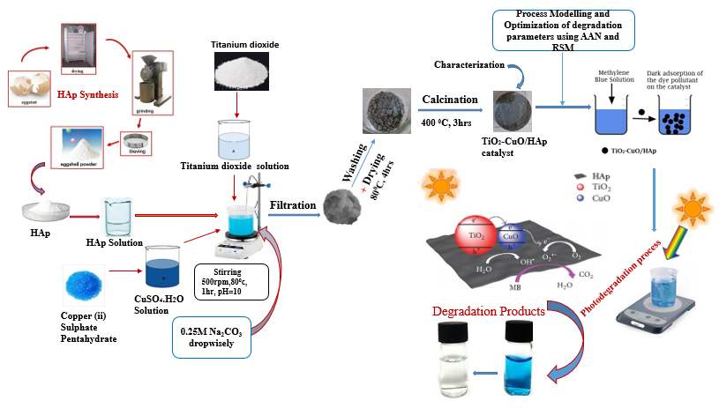

Fig 1: The synthesis and Photocatalytic process of TiO₂–CuO/HAp Catalyst

3.0 RESULTS AND DISCUSSION
3.1 Characterization
3.1.1 Fourier Transform Infra-Red Spectroscopy.
The Fourier Transform Infrared Spectroscopy (FT-IR) analysis was used to identify the surface functional groups. FT-IR spectra of the HAp, CuO/HAp, TiO₂/HAp, and TiO₂-CuO/HAp are shown in Fig. 2. As shown, the characteristic peaks wave numbers of all spectra are approximately identical. The stretching modes of phosphate (${PO}_{4}^{3-}$) ions were detected at around 1025cm⁻¹[11]. The stretching and broad band of OH ions hosted by the apatite were detected at around 3200-3500 cm⁻¹ while the peak at wave number of about 120 cm⁻¹ is attributed to the C-O from carbonate (${CO}_{3}^{2-}$) group in the structure [12]. The introduction of copper or Titanium into the matrix does not modify the spectrum of the Hydroxylapatite support.

Fig. 2: FTIR spectra of as-synthesized HAp-CuO/HAp catalyst

3.1.2 X-ray Diffraction (XRD) analysis
The phase analysis of the prepared HAp and TiO₂-CuO/HAp catalyst was carried out by the X-ray powder diffraction (XRD) technique as shown in Fig. 2. Fig.3(a) shows the X-ray pattern with the characteristic peaks of pure HAp. The peaks were purely crystalline with hexagonal HAp phase with prominent peaks at 2θ=26.5⁰ 32-35⁰,46.2^{0 –} 55⁰ [13,14]. Similarly, Fig. 3(b) shows the XRD pattern of the prepared TiO₂-CuO/HAp composite. The sharp peak at 2θ= 25.3⁰, and similar peaks at 37⁰,47.6⁰,54.1⁰, 63.2⁰ indicate the formation of the anatase phase of TiO₂. Further prominent peaks corresponding to 2θ=26.5⁰, 32⁰-35⁰,46.2⁰-55⁰ are attributed to the presence of the hydroxylapatite group while the peaks at 2θ=35.5⁰ 37⁰,48.2⁰ signify the presence of copper ion indexed to the copper oxide in the composite.
Fig. 3(a): The XRD pattern of Hydroxyapatite (HAp)

Fig. 3(b): The XRD patterns of TiO₂-CuO/HAp composites

3.1.3 Scanning Electron Microscopy (SEM) Analysis
The surface morphology and crystal size of the derived HAp were studied under scanning electron microscopy (SEM). The SEM analysis as shown in Fig.4(a) shows an agglomeration of mixed spherical and round-shaped HAp particles with smooth surfaces likewise, Fig.4(b) shows the scanning electron microscopy (SEM) image of TiO₂-CuO/HAp morphology. The SEM image reveals an irregularly structured material having a flower-like surface with relatively smooth edges that is highly agglomerated into larger sizes [16].
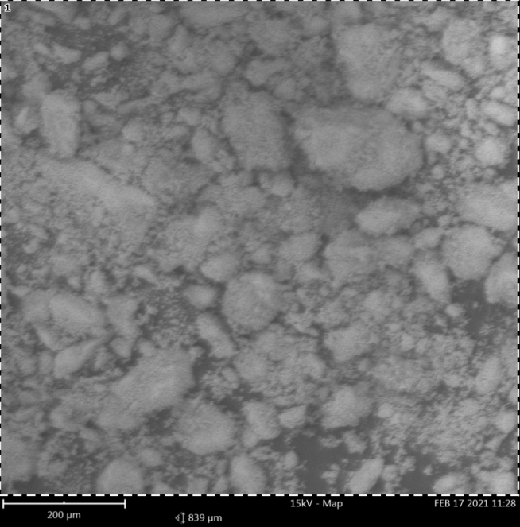
Fig. 4(a): The SEM image of natural HAp from bovine

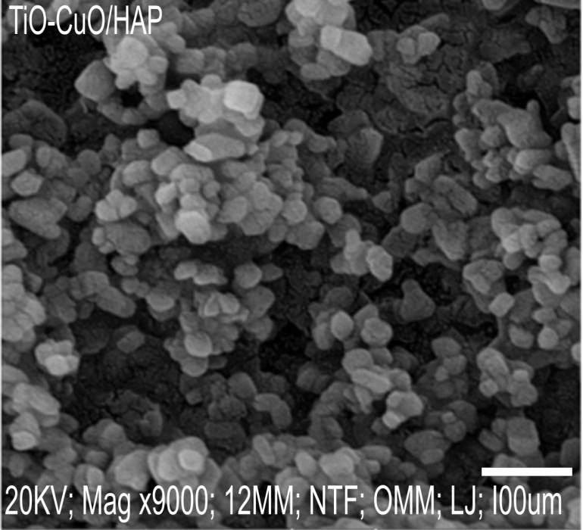
Fig. 4(b): The SEM image of TiO₂-CuO/HAp Catalyst.

3.1.4 Energy dispersive X-ray (EDX) Analysis.
The Energy Dispersive X-ray (EDX) analysis of HAP and TiO₂-CuO/HAp are presented in Figure 5(a-b). Fig. 5(a) shows the EDX spectra of natural HAp while Table 1 shows the attached elemental composition of the HAp synthesized from bovine. It was observed that the peaks of Calcium and Phosphorus are the two prominent peaks in the pattern while the percentage composition of Calcium to Phosphorus corresponds to the Ca/p ratio of 1.67 in the HAp matrix. Furthermore, the EDX analysis of TiO₂-CuO/HAp with prominent peaks of the expected elements in the composites is shown in Fig. 5(b).

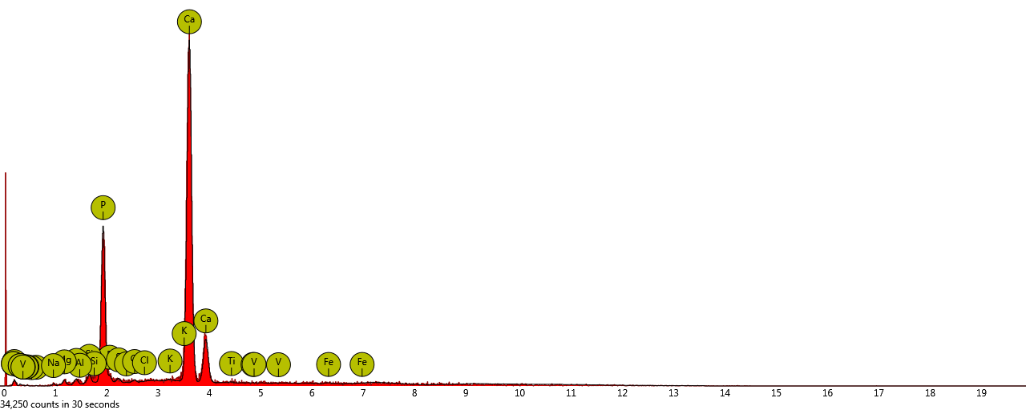
Fig. 5(a): The EDX analysis of natural HAp from bovine.

Table 1: Elemental Compositions of the natural HAp from Bovine.

Element  Number | Element  Symbol | Element  Name | Atomic  Conc.(%) | Weight  Conc.(%)
20 | Ca | Calcium | 67.45 | 74.26
15 | P | Phosphorus | 22.27 | 18.95
26 | Fe | Iron | 0.54 | 0.83
8 | O | Oxygen | 1.76 | 0.78
12 | Mg | Magnesium | 1.14 | 0.76
14 | Si | Silicon | 0.98 | 0.75
13 | Al | Aluminium | 0.83 | 0.62
16 | S | Sulfur | 0.68 | 0.60
7 | N | Nitrogen | 1.44 | 0.56
11 | Na | Sodium | 0.78 | 0.49
17 | Cl | Chlorine | 0.45 | 0.44
6 | C | Carbon | 1.17 | 0.39
19 | K | Potassium | 0.33 | 0.35
22 | Ti | Titanium | 0.18 | 0.24
23 | V | Vanadium | 0.00 | 0.00

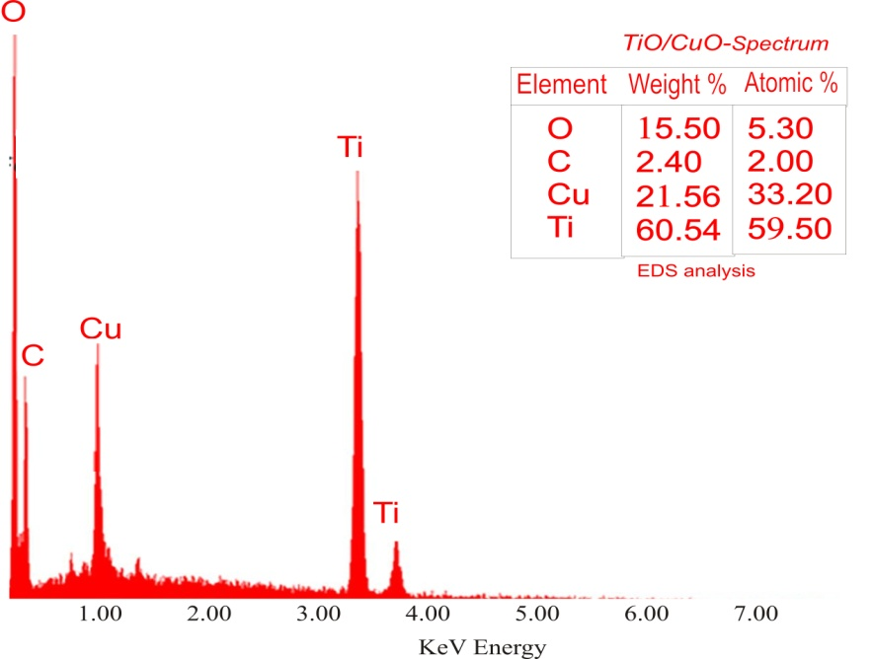
Fig. 5(b): The EDX analysis of TiO₂-CuO/HAp

3.1.5 Thermogravimetric (TGA) Analysis
The Thermogravimetric (TGA) analysis scan was recorded to study the thermal stability of the catalyst composite and to substantiate its potential in high-temperature applications. Thermo-gravimetric analysis (TGA) was carried out with a thermal analyzer and the scan is shown in Fig. 6. The scan shows a two steps weight loss pattern of the catalyst as a function of temperature between 55⁰C and 325⁰C in which the weight loss of 10% percent is largely attributed to the loss of water of crystallization and further weight loss recorded was between temperature 325⁰C and 380⁰C.

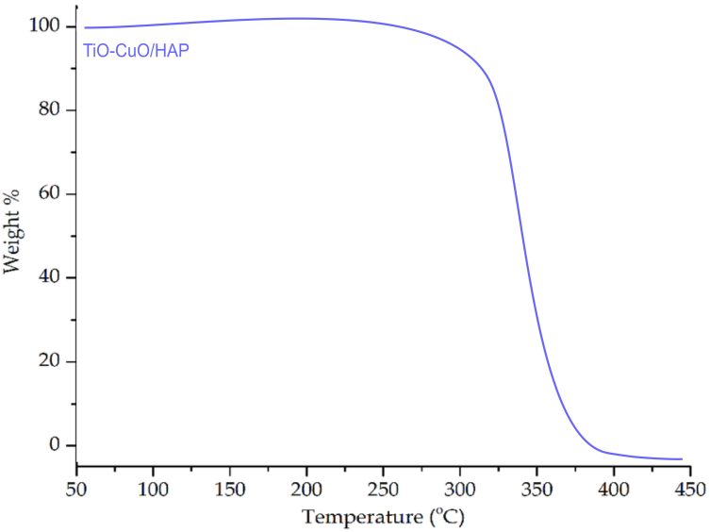
Fig. 6: TGA curve for the prepared TiO₂-CuO/HAp
3.1.6 Brunauer, Emmett and Teller (BET) Analysis
The Brunauer-Emmett-Teller (BET) result in Fig.7 shows that the surface area, pore volume, and pore size of the synthesized TiO₂-CuO/HAp Catalyst to be 249.22(m²/g), 3.85(nm) and 0.150(cm³g⁻¹), respectively. The result shows that the surface area of the synthesized catalyst has been enhanced with the HAp acting as the support material. Furthermore, TiO₂-CuO/HAp shows an increased surface area over each of pure commercial TiO₂ (98.2m²/g) [29], the nanostructured (nanotubes, nanowires, nanosheet and mesoporous) TiO₂ [15] and CuO [16]. The surface area and porosity of the catalyst were investigated by the adsorption/desorption of nitrogen through the BET analysis (Fig.7). The nitrogen adsorption/desorption isotherm plot shape suggests that there is maintenance of structure and maximum adsorption capacity.
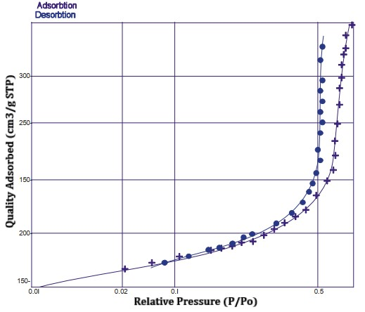
Fig. 7. The BET nitrogen adsorption-desorption isotherm plot

3.2 Optical Band Gap Estimation
The Band gap of a semiconductor material which is also known as energy gap indicates the difference in energy between the top of the valence band filled with electrons and the bottom of the conduction band lacking electrons. It is often described as the energy needed to excite an electron from the valence band to the conduction band. Therefore, the correct determination of the band gap energy is crucial in knowing the photophysical and as well as photochemical properties of semiconductors. The band gap of the prepared catalyst samples was measured with the aid of a UV-vis spectrophotometer joined with Diffuse Reflectance Spectra (DRS). The tauc plot method was used in determining the optical band gap (Eg) of the composites using the following equation:

α. h.ν = A(hν – Eg)^{n} (2)
Where α = absorbance value is attained from the spectra, h = Planck’s constant, = c/λ, v = frequency of the incident wave, λ = wavelength from the spectra, c = velocity of light. A = constant. Eg= energy gap between the valence and conduction bands, and n = the parameter associated with the electronic transition. In this study case, indirect semiconductors n = ½. The Tauc plot showing the wavelength and the bandgaps of the synthesized materials are shown in Fig. 8 and Fig. 9(a-d) respectively. From the plot of (αhυ)^{1/2}versus eυ, the result shows clearly that the bandgap values are 3.12eV, 3.0eV,2.92eV, 2.89eV for HAp, CuO/HAp, TiO₂/HAp, TiO₂-CuO/HAp respectively. Hence, this indicated that TiO₂-CuO/HAp is a better photocatalyst for the photocatalytic degradation of MB under visible sunlight irradiation than the unmodified TiO₂ owing to CuO being a photo-sensitizer. Furthermore, when a metal, semi-conductor catalyst, or compound is loaded to another catalyst, the previous band gap may be shifted to a new band gap [17] which may have enhanced photodegradation efficiency. Lastly, the report also shows that the band gap of the commercial CuO is 1.2eV which makes it an attractive material for light harvesting applications [18]. Therefore, in this present work, CuO is an effective bandgap modifier in the composite that helps absorb more light energy under the visible light region for effective degradation and enhanced efficiency [17,18].
Fig. 8: The UV-Vis DRS spectra of catalyst samples.

Fig. 9(a). The energy gap of HAp Fig. 9(b). The energy gap of CuO/HAp

Fig. 9(c). The energy gap of TiO₂/HAp Fig. 9(d). The energy gap of TiO₂-CuO/HAp

3.3 Performance and Photocatalytic Activity
The results of the photocatalytic activity of TiO₂-CuO/HAp evaluated by the photodegradation of methylene blue (MB) in an aqueous solution under sunlight irradiation with MB having approximately a maximum absorption of 664nm is presented in Fig.10. TiO₂-CuO/HAp photocatalytic activity was compared with the pure HAp, CuO, TiO₂, CuO/HAp, and TiO₂/HAp under optimum conditions and their respective photodegradation percentages were recorded in Fig.10. The result shows the least percentage degradation to be 15.52% under blank, next to this on the increasing order of photodegradetion percentages was 55.23% with pure HAp which may be associated with its higher band gap energy. Pure CuO shows 66.36% while pure TiO₂ was 75.09%. Similarly, CuO/HAp shows only 79.34% MB degradation compared to TiO₂/HAp (82.21%) as shown in Fig. 10. Finally, TiO₂-CuO/HAp composites with the lowest band gap energy had 99.83% MB degradation, which reveals that formation of the composite improves the overall photocatalytic activity of the catalyst. This also revealed a good separation of e⁻/h⁺ pairs in the TiO2-CuO/HAp composite, with an enhancement in surface area and active sites for an efficient degradation reaction [19]. Similarly, Fig.11(a) shows the concentration ratios of methylene blue degradation using the various catalysts with maximum degradation of MB by TiO₂-CuO/HAp after 150 minutes, likewise Fig. 11(b) shows the apparent first-order kinetics plots of form -ln(C/C0) =k_{appt}. The activity of the TiO₂-CuO/HAp photocatalysts can be evaluated by comparing the apparent first-order rate constants (k_{app}) shown in Table 2. The TiO₂-CuO/HAp composites have maximum apparent rate constants of 0.0430 min^{-1,} and it decrease in the order of TiO₂/HAp˃ CuO/HAp ˃ TiO₂ ˃ CuO ˃ HAp progressively.
Fig. 10: Photocatalytic degradation efficiencies of MB

Fig. 11(a): The plot of 𝐶/𝐶0 versus reaction time for MB degradation

Fig. 11(b): The Plot of apparent first-order linear transforms

Table 2 : The apparent first-order rate constants (kapp) of MB degradation from the plot of -ln(C/C0) = k_{app}t.
Photocatalyst | -ln(C/C₀)=k_{app}t | k_{app} (min⁻¹)
HAp | -ln(C/C₀)=0.0094t | 0.0094
CuO | -ln(C/C₀)=0.0142t | 0.0142
TiO₂-CuO/HAp | -ln(C/C₀)=0.0430t | 0.0430
TiO₂ | -ln(C/C₀)= 0.0182t | 0.0182
TiO₂/HAp | -ln(C/C₀)= 0.0346t | 0.0346
CuO/HAp | -ln(C/C₀)= 0.0226t | 0.0226

3.4 Reusability Study of the Catalyst
The stability and reusability of the prepared TiO₂-CuO/HAp catalyst were assessed by recycling the catalyst for four successive runs for the degradation of methylene blue as shown in Fig. 12. In each experimental cycle, the catalyst was separated from its suspension by centrifugation and then washed with deionized water before it was finally dried. The degradation efficiency of the MB was evaluated and the result shows that 99.53% efficiency was achieved in the first run while 95.32% in the second run, 91.15% was recorded in the third run, and 87.67% during the fourth cycle with each experiment carried out under sunlight light irradiation for 150 minutes. The slight decrease in the subsequent photocatalytic activity may be attributed to a small amount of metal ions leached from the catalyst surface or some intermediates adsorb on the surface of the catalyst [20]. Nevertheless, the degradation efficiency was relatively close for the four runs which demonstrates that the catalytic performance of TiO₂-CuO/HAp may be replicated in successive runs without much significant drop in the efficiency.
Fig.12: The photocatalytic degradation rate of MB with the TiO₂-CuO/HAp catalyst at different
recycling times.

3.5 Possible Photocatalytic Mechanism
A possible photocatalytic mechanism of the TiO₂-CuO/HAp composite is shown in Fig.13. TiO₂ is an n-type semiconductor and the band gap between the valance band (VB) and the conduction band (CB) is 3.2 eV while that of CuO is 1.2eV [28]. Under light irradiation, electrons, and holes are generated on the surface of TiO₂ and CuO. The electrons in the CB of TiO₂ are easily transferred to the CB of CuO because the CB of CuO is located below that of TiO₂. On the other hand, through the anchoring of TiO₂ and CuO on the Hydroxylapatite (HAp) support, the photoelectrons of TiO₂ and CuO are enhanced via improved active sites for reaction which in turn may lower the electron-hole recombination rate. Results show that TiO₂-CuO/HAp composite can exhibit an effective electron-hole separation under solar irradiation and consequently facilitate the surface redox process via the photogenerated electrons and holes. Hence, a significant improvement in the photocatalytic activity of the catalyst. The electron–hole pair generation under sunlight light irradiation inside the CB and VB helps in the degradation of dye molecules (MB) with the generation of water molecules (H₂O) and carbon dioxide (CO₂) as by-products.

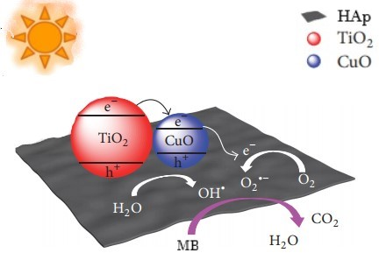
Fig.13. The photocatalytic mechanism of the TiO₂-CuO/HAp composite.

4.0 CONCLUSIONS
TiO₂-CuO/HAp catalyst was synthesized via the sol-gel method and characterized by the following techniques: FT-IR, XRD, SEM, EDX, TGA, and BET. The analysis indicates that the samples were composed of HAp, TiO₂, and CuO nanoparticles. The experiments on photocatalytic degradation of methylene blue showed that the TiO₂-CuO/HAp exhibited higher degradation percentage and MB absorption as compared to HAp, CuO, TiO₂, CuO/HAp, and TiO₂/HAp composites with a high apparent first-order rate constant (k_{app}) of 0.0430min⁻¹. The bandgap of the synthesized TiO₂-CuO/HAp was determined to be 2.89eV. Hence, through the band gap engineering technique, the wide band gap of TiO₂ can be modified to facilitate its operation within the visible light range. This suggests that methylene blue can be degraded efficiently with the catalyst efficiently with use of sunlight Irradiation. Therefore, the use of sunlight may be a promising process for reducing operating costs as compared to the use of artificial visible light.

AVAILABILITY OF DATA AND MATERIALS

The research data associated with this paper will be made available upon request.

DISCLAIMER (ARTIFICIAL INTELLIGENCE)
Author(s) hereby declare that NO generative AI technologies such as Large Language Models (ChatGPT, COPILOT, etc.) and text-to-image generators have been used during the writing or editing of this manuscript.

REFERENCES
[1] Thuan, D.V., Ngo, H. L., Thi, H. P., Chu, H. T. (2023). Photodegradation of hazardous organic pollutants using titanium oxides-based photocatalytic: A review. Environmental Research, 229, 116000 https://doi.org/10.1016/j.envres.2023.116000
[2] Singh, N. K., Saha, S., Pal, A. (2014). Methyl red degradation under ultra-violet illumination and catalytic action of commercial ZnO: A parametric study. Desalination and Water Treatment, 56,1–11. https://doi.org/10.1080/19443994.2014.942380
[3] Yu, J., Yu, X. (2008). Hydrothermal synthesis and photocatalytic activity of zinc oxide hollow spheres, Environ. Sci. Technol., 42 (13), 4902–4907. DOI: 10.1021/es800036n
[4] Wang, M., Huang, C., Huang, Z., Guo, W., Huang, J., He, H., Wang, H., Cao, Y., Liu, Q., Liang, J. (2009). Synthesis and photo-luminescence of Eu-doped ZnO microrods prepared by hydrothermal method, Optical Material, 31 (10), 1502–1505. https://doi.org/10.1016/j.optmat.2009.02.009
[5] Zhang, X., Liu, Y., Ren, M., Yang, G., Qin, L., Guo, Y., Meng, J. (2022). Precise carbon doping regulation of porous graphitic carbon nitride nanosheets enables elevated photo-catalytic oxidation performance towards emerging organic pollutants. Chem. Eng. J., 433, https://doi.org/10.1016/J.CEJ.2022.134551 134551.
[6] Chen, T., Zheng, Y., Lin, J.-M., Chen, G. (2008). Study on the photocatalytic degradation of methyl orange in water using Ag/ZnO as a catalyst by liquid chromatography-electrospray ionization ion-trap mass spectrometry, J. Am. Soc. Mass Spectrom., 19 (7), 997–1003
[7] Lu, D., Zhang, G. K. & Wan, Z. (2015). Visible-light-driven g-C₃N₄/Ti³⁺-TiO₂ photocatalyst co-exposed {001} and {101} facets and its enhanced photocatalytic activities for organic pollutant degradation and Cr(VI) reduction. Appl. Surf. Sci., 358, 223–230. https://doi.org/10.1016/j.apsusc.2015.08.240

[8] Low, J. X., Cheng, B. & Yu, J. G. (2017). Surface modification and enhanced photo-catalytic CO₂ reduction performance of TiO₂: a review. Appl. Surf. Sci., 392, 658–686. https://doi.org/10.1016/j.apsusc.2016.09.093
[9] Wen, J. Q., Li, X., Liu, W., Fang, Y., Xie, J., Xu, Y. (2015). Photocatalysis fundamentals and surface modification of TiO₂ nanomaterials. Chinese. J. Catal., 36, 2049–2070 (2015). https://doi.org/10.1016/S1872-2067(15)60999-8
[10] Saravanan, R. Sacari, E. Gracia, F. Khan, M.M., Mosquera, E., Gupta, V.K. (2016). Conducting PANI stimulated ZnO system for visible light photocatalytic degradation of color dyes, J. Mol. Liquids, 221, 1029–1033. https://doi.org/10.1016/j.molliq.2016.06.074
[11] Ning, Z.L., Chang, Z.D., Li, W.J., Sun, C.Y., Zhang, J.H., Liu, Y. (2012). Solvothermal synthesis and optical performance of one-dimensional strontium hydroxyapatite nanorod, J. Chem. Eng., 20, 89–94 https://doi.org/10.1016/S1004-9541(12)60367-X
[12] Landi, E., Celotti, G., Logroscino, G., Tampieri, A. (2003). Carbonated hydroxyapatite as a bone substitute, J. Eur. Ceram. Soc. 23, 2931–2937. https://doi.org/10.1016/S0955-2219(03)00304-2
[13] Padmanabhan, P. V., Kulandaivelu, R., Panneer, D.S., Vivekananthan, S., Sagadevan, S. & Lett., J. A. (2019). Microwave synthesis of hydroxyapatite encumbered with ascorbic acid intended for drug leaching studies, Materials Research Innovations, 1-7. DOI:10.1080/14328917.2019.1624940
[14] Manalu, J. L., Soegijono, B., Indrani, D. J. (2015). Characterization of Hydroxyapatite Derived from Bovine Bone. Asian Journal of Applied Sciences, 03(4), 758-765, www.ajouronline.com.
[15] Sasaki, T., Nakano, S., Yamauchi, S. and Watanabe, M. (1997). Fabrication of titanium dioxide thin flakes and their porous aggregate, Chem. Mater., 9, pp. 602-608. DOI:10.1021/cm9604322
[16] Xu, L., Xu, H-Y., Wang, F., Zhang, F-J., Meng, Z-D., Zhao, W., and Oh, W-C. (2012). Microwave-Assisted Synthesis of Flower-like and Plate-like CuO Nanopowder and their photocatalytic activity for polluted lake water, Journal of the Korean Ceramic Society, 49(2), pp 151-154.
http://dx.doi.org/10.4191/kcers.2012.49.2.151
[17] Karim, K.R., Jebi, M.P., Ong, H.R., Abdullah, H., Tarek, M., Cheng, C. K., Khan. M.R. (2018). CuO-TiO₂ as a visible light responsive photocatalyst for the photo- electroreduction of CO₂ to methanol, Conference Paper December, 103-111.https://www.researchgate.net/publication/329876632
[18] Dhineshbabu, N. R., Rajendran, V., Nithyavathy, N., Vetumperumal. R. (2016). Study of structural and optical properties of cupric oxide nanoparticles, Appl. Nanosci., 6:933–939.
doi:10.1007/s13204-015-0499-2
[19] Alafif, Z.A., Anjum, M., Kumar, R., Abdelbasir, S.M., Barakat, S.A. (2018). Synthesis of CuO–GO/TiO₂ visible light photocatalyst for 2 chlorophenol degradation, pretreatment of dairy wastewater, and aerobic digestion. J. of Appl. Nanosci., 1-13, doi.org/10.1007/s13204-018-0921-7.
[20] Ahmed, Y. Y., Yaakob, Z., and Akhtar, P. (2016). Degradation and mineralization of methylene blue using a heterogeneous photofenton catalyst under visible and solar light irradiation. The Royal Society of Chemistry, Catalysis Science and Technology, 6, 1222-1232, doi: 10.1039/c5cy01494h.
[21] Yang, Y. F., Ma, Z., Xu, L., Wang, H., Fu, N. (2016) Preparation of reduced graphene oxide/meso-TiO₂/AuNPs ternary composites and their visible-light-induce photocatalytic degradation of methylene blue. Appl. Surf. Sci., 369, 576–583, https://doi.org/10.1016/j.apsusc.2016.02.078
[22] Li, Y. F., Zhang, W., Shen, X., Peng, P., Xiong, L., Yu, Y. (2015). Octahedral Cu₂O-modified TiO₂ nanotube arrays for efficient photocatalytic reduction of CO₂. Chinese. J. Catal., 36, 2229-2236
https://doi.org/10.1016/S1872-2067(15)60991-3
[23] Qi, K. Z., Selvaraj, R., Al-Fahdi, T., Al-Kindy, S., Kim, Y., Wang, G. C., Tai, C. W., Sillanpaa, M. (2016). Enhanced photocatalytic activity of anatase-TiO₂ nanoparticles by fullerene modification: A theoretical and experimental study. Appl. Surf. Sci., 387,750–758. https://doi.org/10.1016/j.apsusc.2016.06.134
[24] Singh, J., Kaur, G. and Rawat, M. (2016). A brief review on synthesis and characterization of copper oxide nanoparticles and its applications. Journal of Bioelectronics and Nanotechnology, 1(1): 9, DOI: 10.13188/2475-224X.1000003
[25] Darezereshki, E. and Bakhtiari, F. (2011). A novel technique in the synthesis of tenorite (CuO) nanoparticles from low concentratIon cuso4 Solution. J. Min. Metall. Sect. B-Metall., 47 (1) B, 73 - 78
[26] Widiarti, N., Sae, J. K. and Wahyuni, S. (2017). Synthesis of CuO-ZnO nanocomposite and its
application as an antibacterial agent. Materials Science and Engineering, 172, 012-036,
doi:10.1088/1757-899X/172/1/012036
[27] Linh, T.-T, Hong, S., and No, K. (2019). Evaluation of the Role of Hydroxyapatite in TiO₂/Hydroxyapatite Photocatalytic Materials. J. of Intech.Open., 1-11, http://dx.doi.org/10.5772/intechopen.81092.
[28] Etape, E.P., Ngolui, L.J., Foba-Tendo, J., Yufanyi, D.M. and Namondo, B.V. (2017). Synthesis and characterization of CuO, TiO_{2,} and CuO-TiO₂ mixed characterization of CuO, TiO_{2,} and CuO-TiO₂ mixed Oxide by a modified oxalate route. Journal of Applied Chemistry, 7,2017, 1-10. https://doi.org/10.1155/2017/4518654
[29] Drunka, R., Grabis, J., Krumina, A. (2016). Microwave Assisted Synthesis, Modification with Platinum, and Photocatalytic Properties of TiO₂ Nanofibers, 22(1),138-141.
http://dx.doi.org/10.5755/j01.ms.22.1.7353
[30] Zhao, G., Li, W., Zhang, H., Wang, W., Ren, Y. (2022). Single-atom Fe-dispersed graphitic carbon nitride (g-C3N4) as a highly efficient peroxy-mono sulfate photocatalytic activator for sulfamethoxazole
degradation. Chem. Eng. J., 430, https://doi.org/10.1016/J.CEJ.2021.132937 132937
[31] Zhao, B., Gao, D., Liu, Y., Fan, J., Yu, H. (2022). Cyano-group enriched crystalline graphitic carbon nitride photocatalyst: Ethyl acetate-induced improved ordered structure and efficient hydrogen evolution activity. J. Colloid Interface Sci. 608, 1268–1277. https:// doi.org/10.1016/J.JCIS.2021.10.108
[32] Zhang, J., Fu, J., Dai, K. (2022). Graphitic carbon nitride/antimonide van der Waals heterostructure with enhanced photocatalytic CO₂ reduction activity. J. Mater. Sci. Technol. 116, 192–198. https://doi.org/10.1016/J.JMST.2021.10.045
[33] Cheng, L., Zhang, P., Wen, Q., Fan, J., Xiang, Q. (2022). Copper and platinum dual single atoms supported on crystalline graphitic carbon nitride for enhanced photocatalytic CO₂ reduction. Chinese J. Catal., 43, 451–460. https://doi.org/10.1016/S1872-2067(21) 63879-2.
[34] Oladoye, P.O., Kadhom, M., Khan, I., Hama Aziz, K. H., Alli, Y. A. (2024). Advancements in adsorption and photo-degradation technologies for rhodamine B dye wastewater treatment: Fundamentals, applications, and future directions. Journal of Green Chemical Engineering, 5(4), 440-460. https://doi.org/10.1016/j.gce.2023.12.004

